Variables precedence order

Whenever we are giving the variables for the terraform script, the script takes the variables in precedence order

Ex:--

If I am giving the variables to terraform file from 3 different ways

Priority | Source | Example
1 | Command-line -var and -var-file | terraform apply -var="instance_type=t2.large"
2 | *.auto.tfvars and *.auto.tfvars.json (loaded automatically, alphabetical order) | production.auto.tfvars
3 | terraform.tfvars.json | terraform.tfvars.json
4 | terraform.tfvars | terraform.tfvars
5 | Environment Variables (TF_VAR_<name>) | export TF_VAR_region=us-east-1
6 | Default value in variables.tf | default = "t2.micro"

Earlier we have given the variables using variable.tf and directly at the command line and user inputs

If we give all at a time then the first priority will be for CLI

Then for *.auto.tfvars
Then terraform.tfvars and json
Then for environment variables
And last for variable.tf

Lets use environmental variables

We will be using the environmental variables with the command EXPORT

Syntax :--

export TF_VAR_instance_type="t2.micro"
export TF_VAR_region="us-east-1"

These are the environmental variables
And directly used for terraform scripts

Event though I variable.tf file declared the variables for the file

But after passing the environmental variables it has changed to the environmental variable values

This is because of precedence order

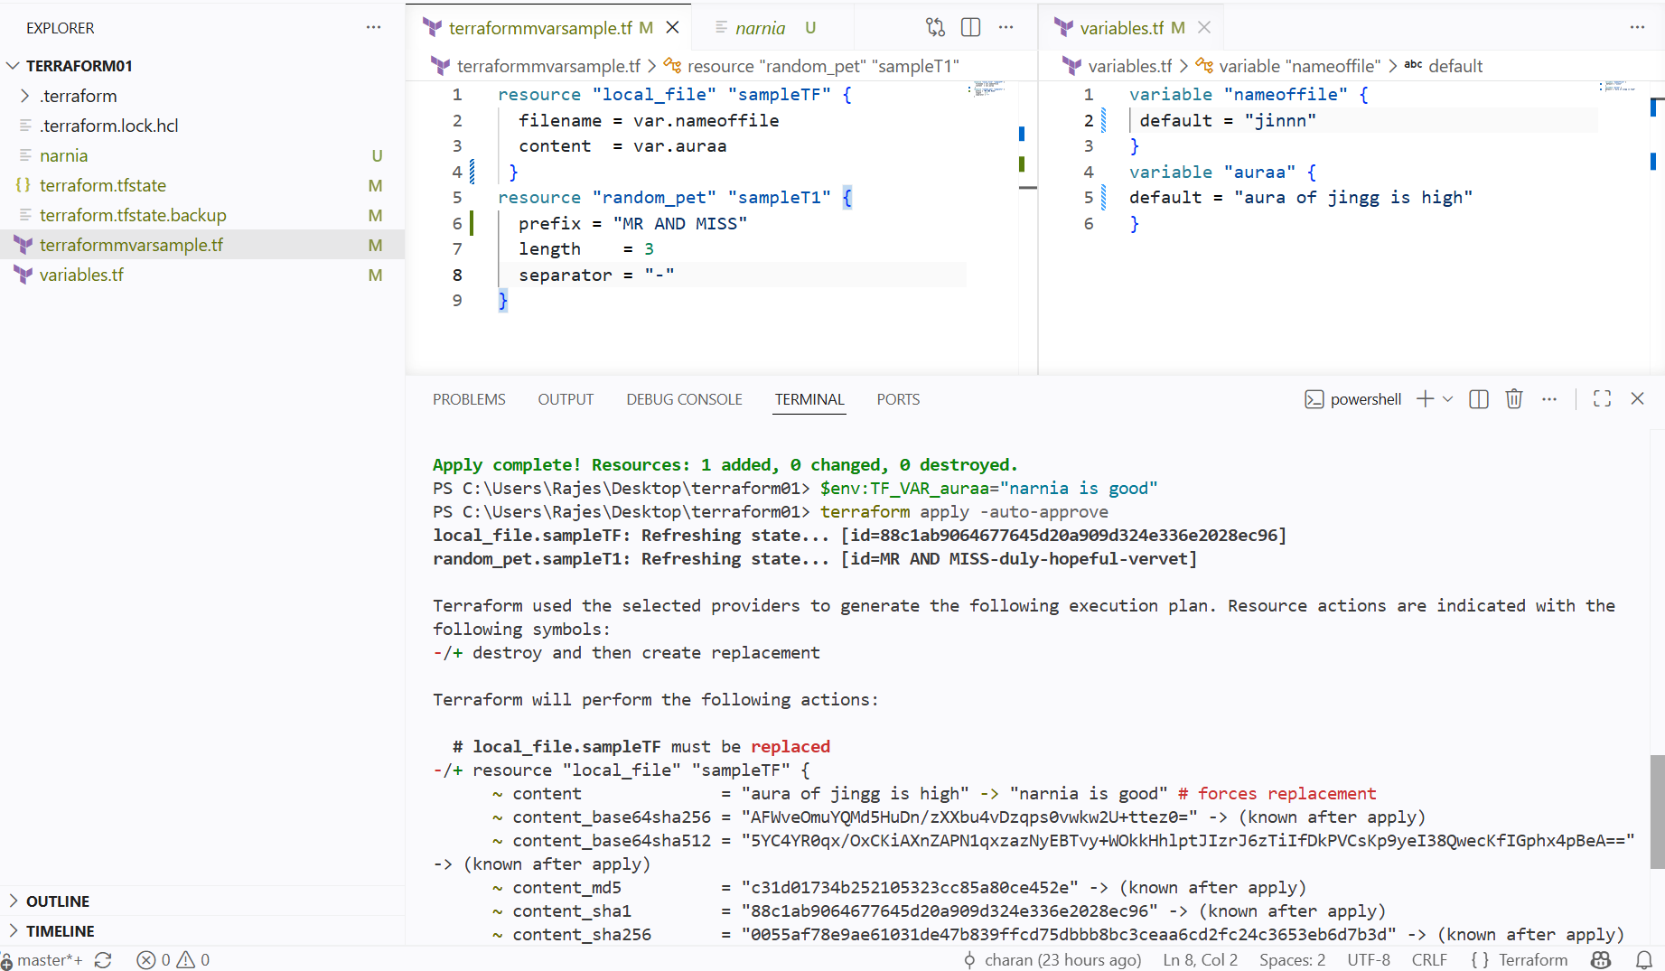

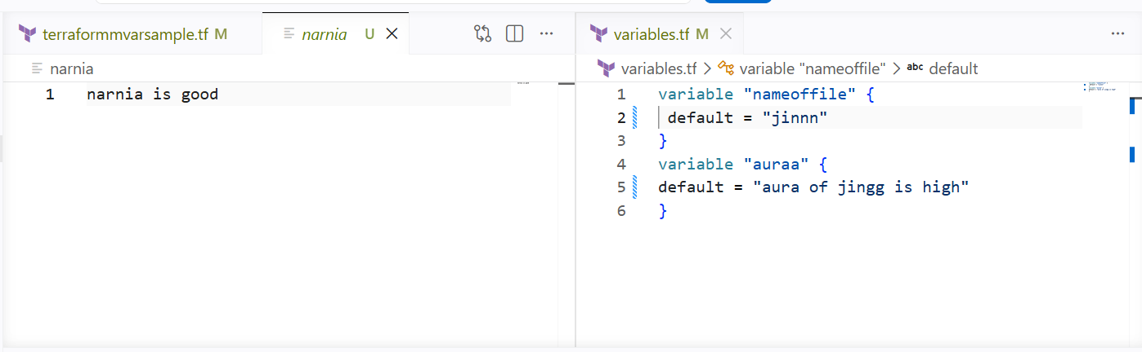
Now I have already given the environmental variables before the terraform apply now I will be giving the command line flag variables

Now the CLI variables will overwrite the variables from the environmental variables

We can see the changed content and name of file even by having the variable.tf file and environmental variables

The cli flags has overidden the given variables

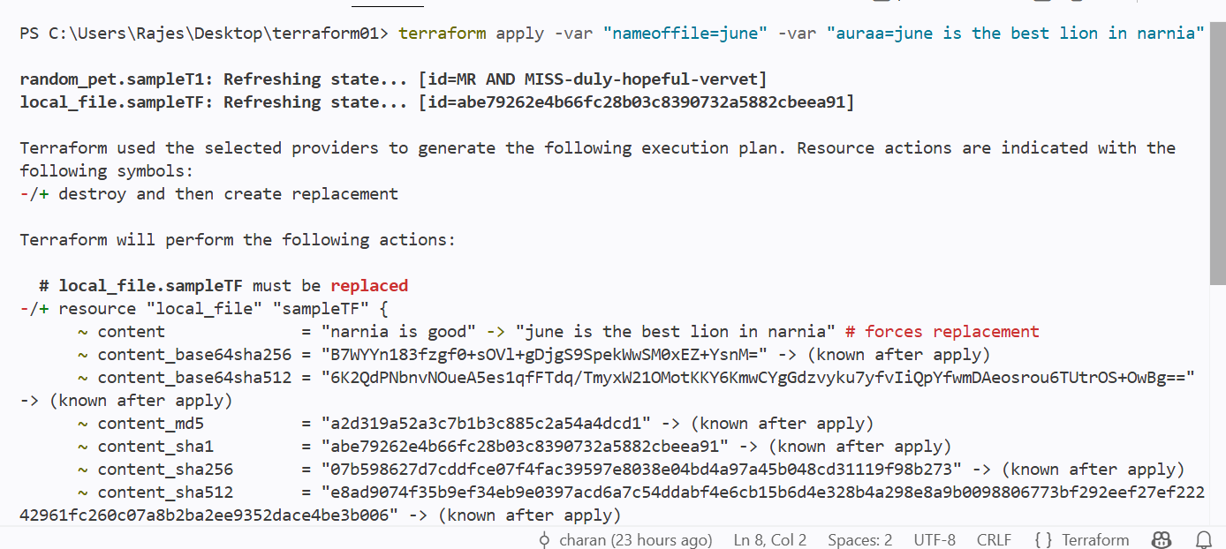
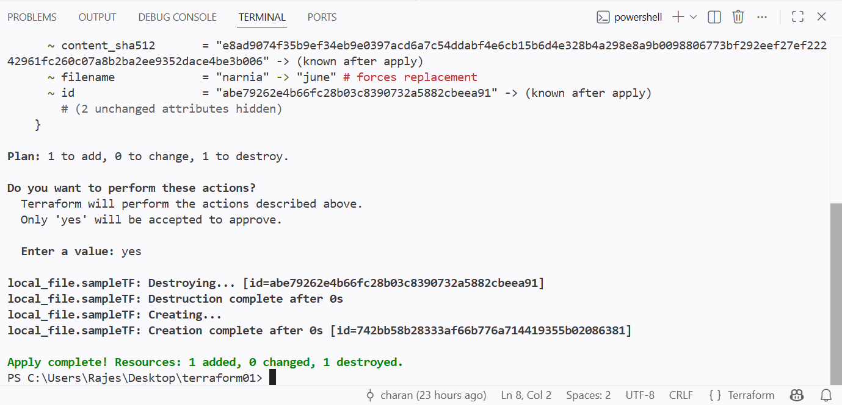

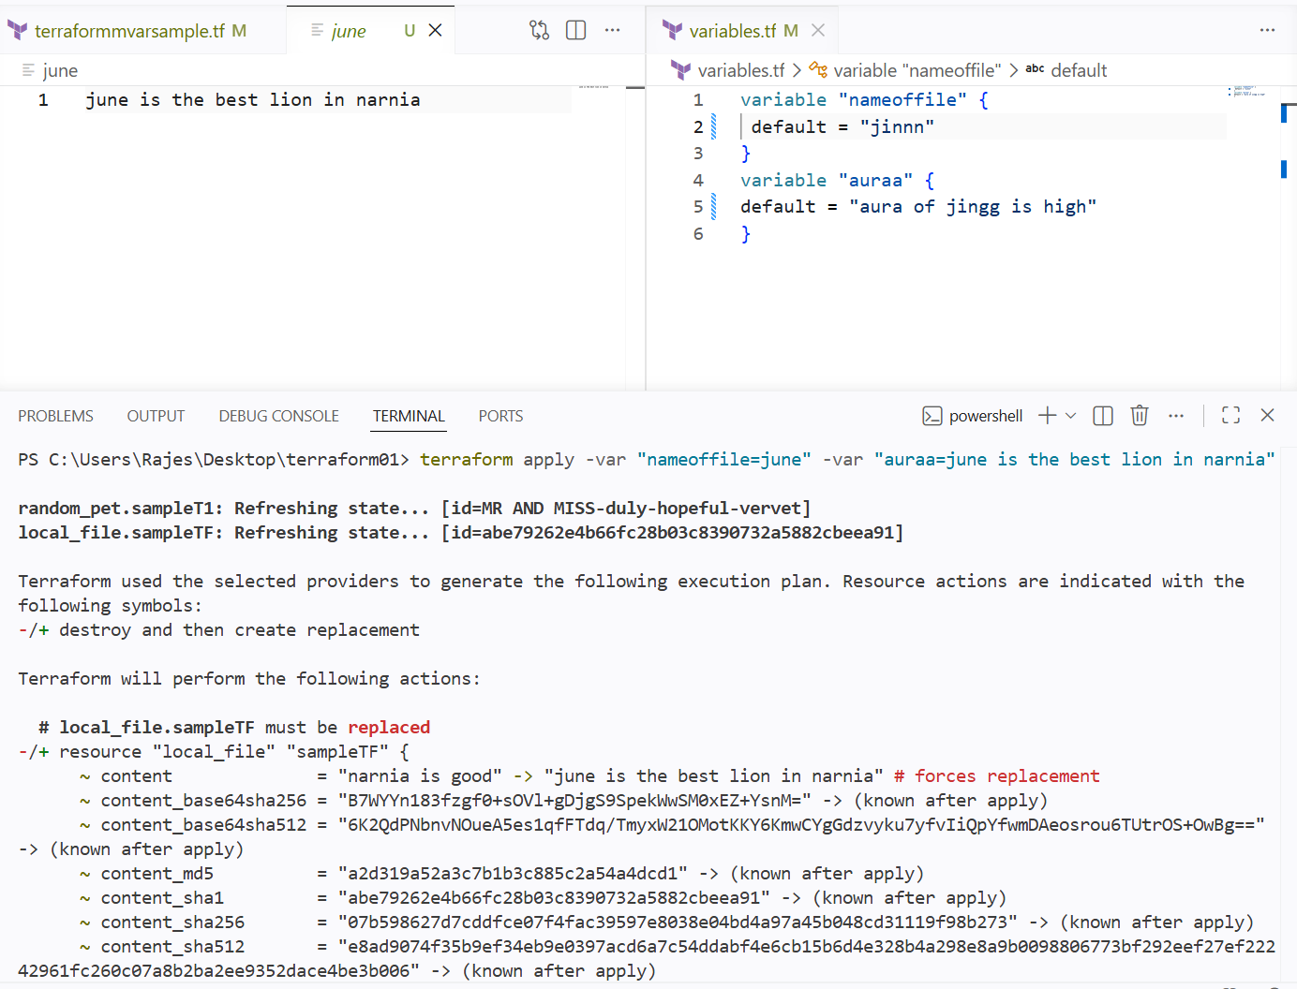

And I want to see the output of a particular resource

I will be using the id generated by the resource

And using the id to get the output

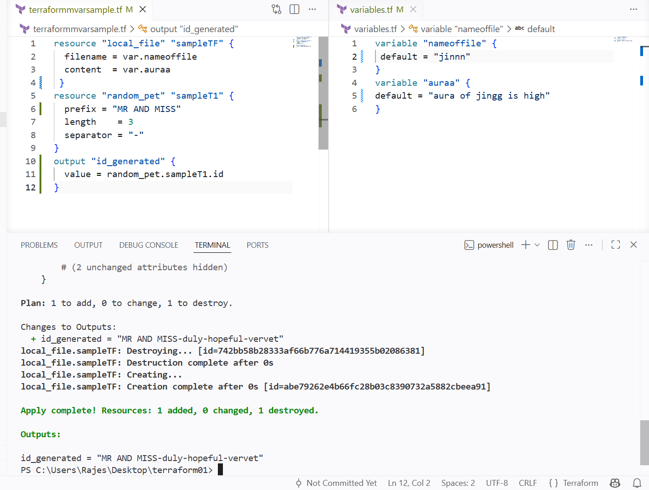

Here notice that when I use terraform apply then it is said that it will be replacing the content of my file because

In command line I havent given the variabale flags so it automatically took the environmental variables that I have passed earlier

And it excluded the variable.tf variables

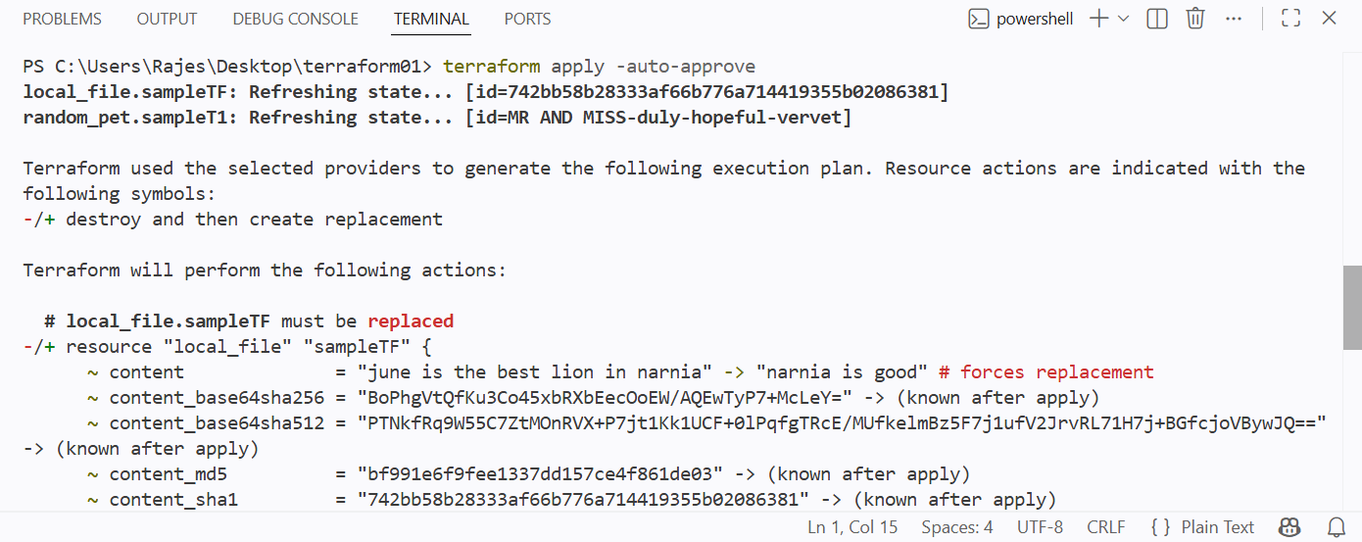

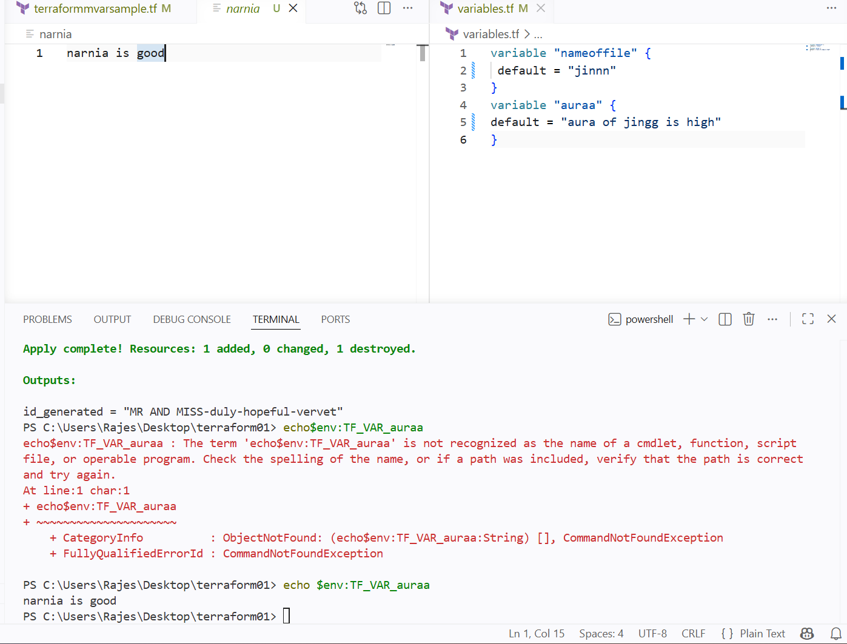

Integrating the terraform with jenkins pipeline

Pushed my terraform files to github repo and using repo I have configured the pipeline

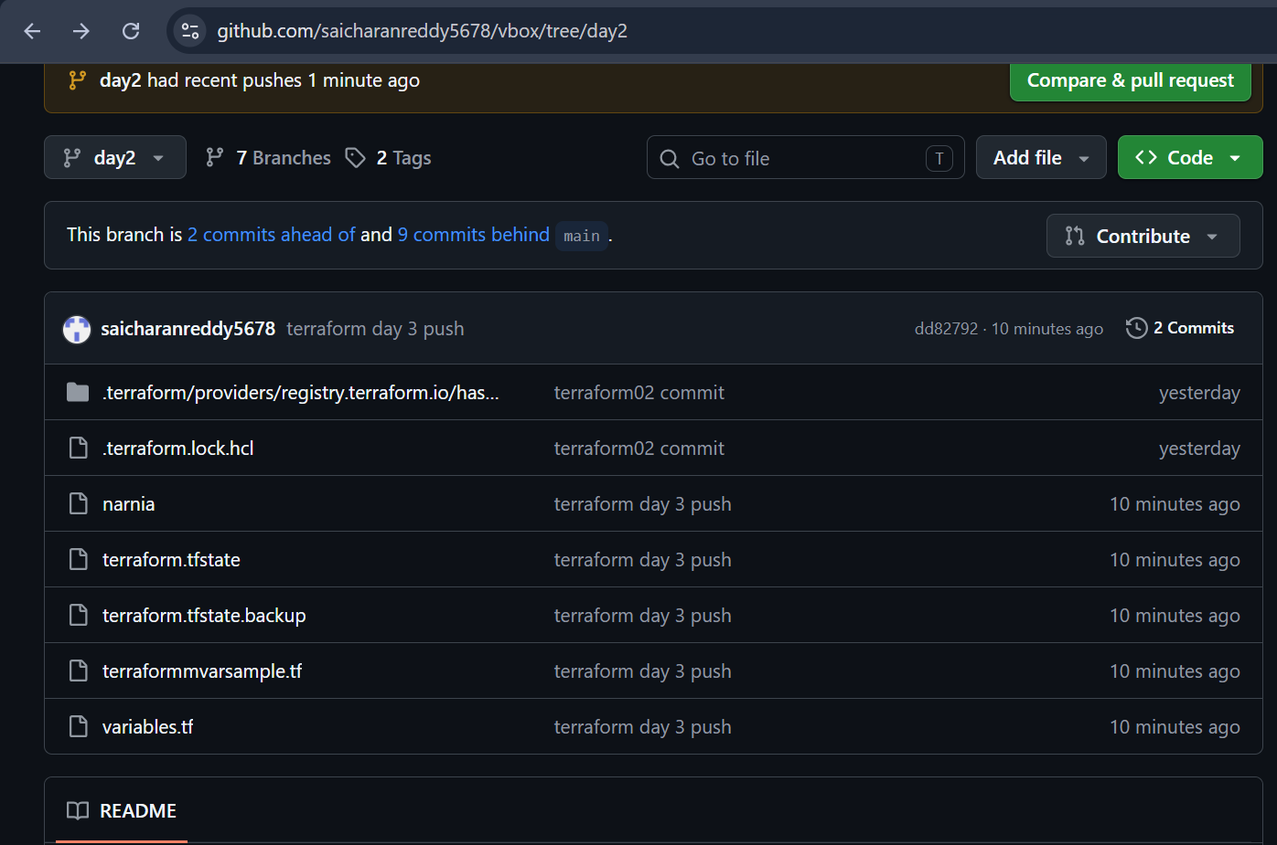

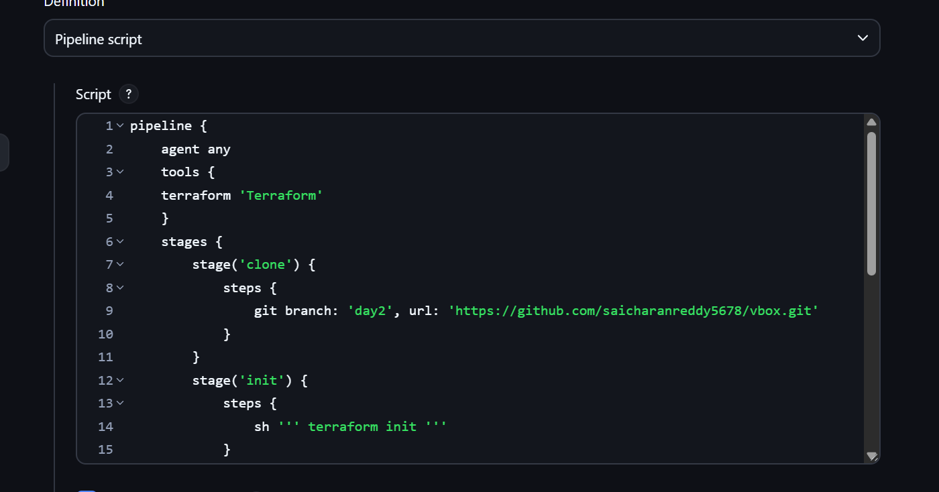

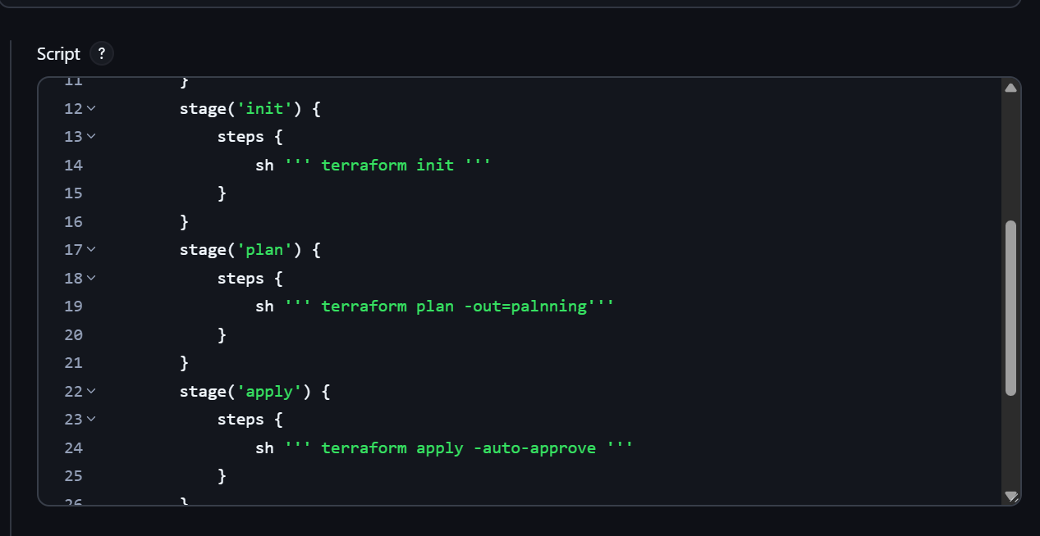
And ouput also can bee seen the console output

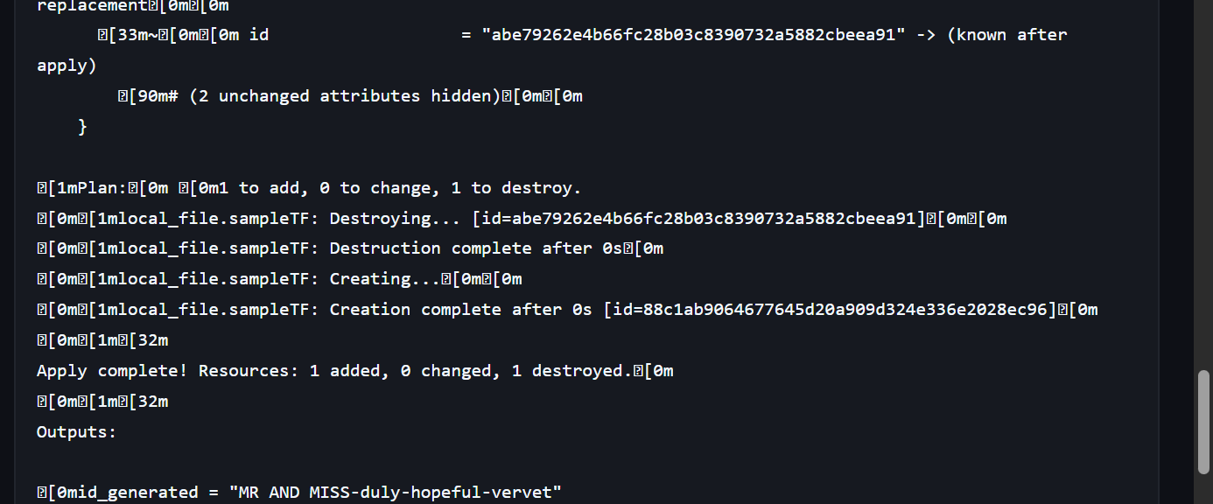

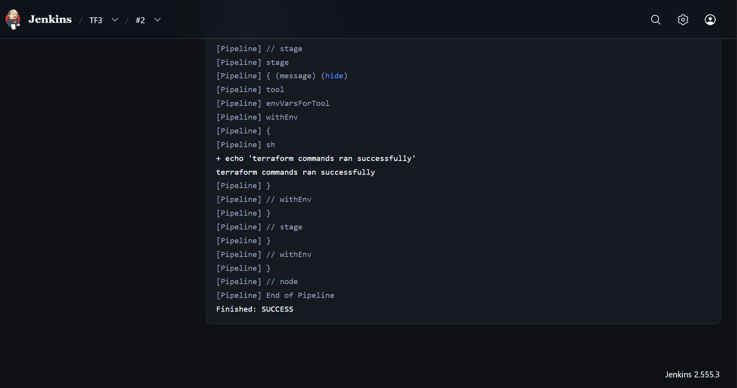

The new file has been generated in the workspace

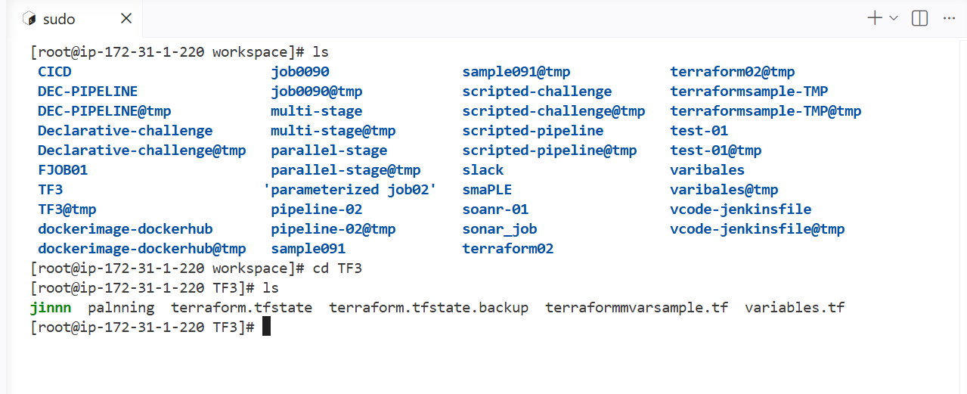

Create one Jenkins job using Maven Project for the code below with two stages:
- Stage 1:Git clone
- Stage 2:Maven CompilationCode

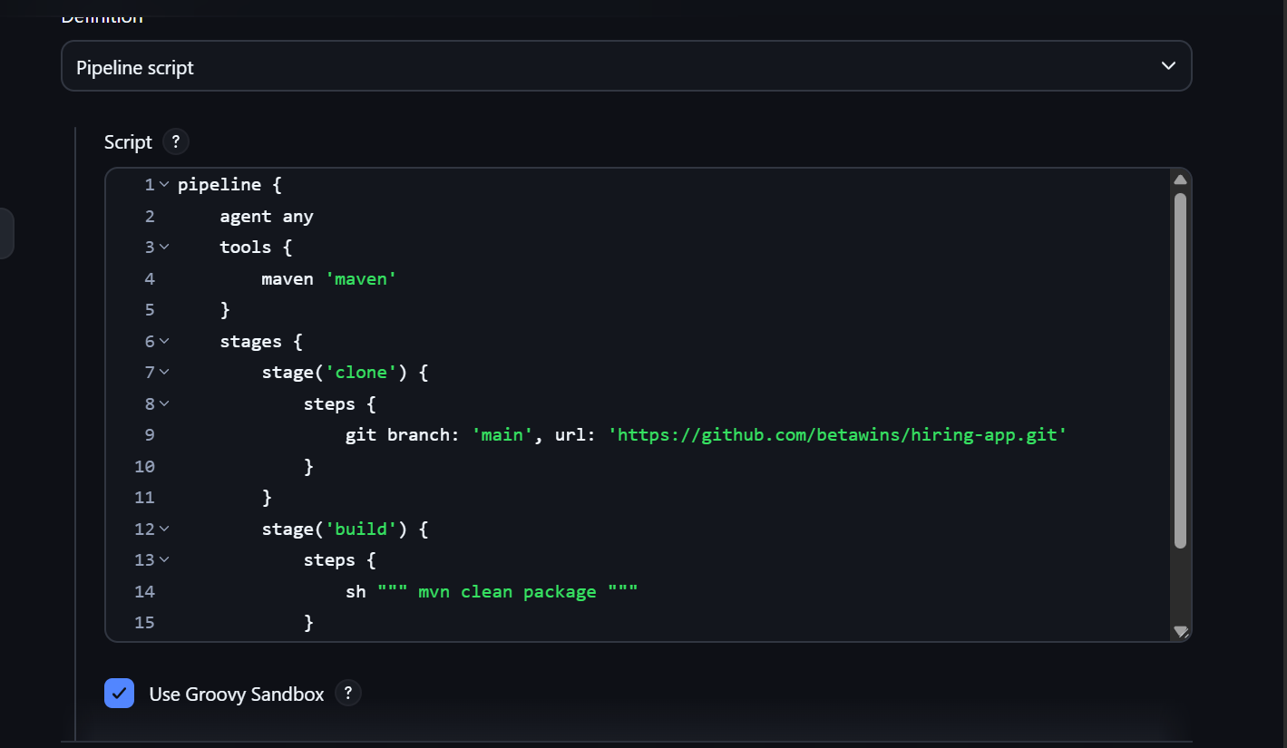

Mavenbuild has been completed

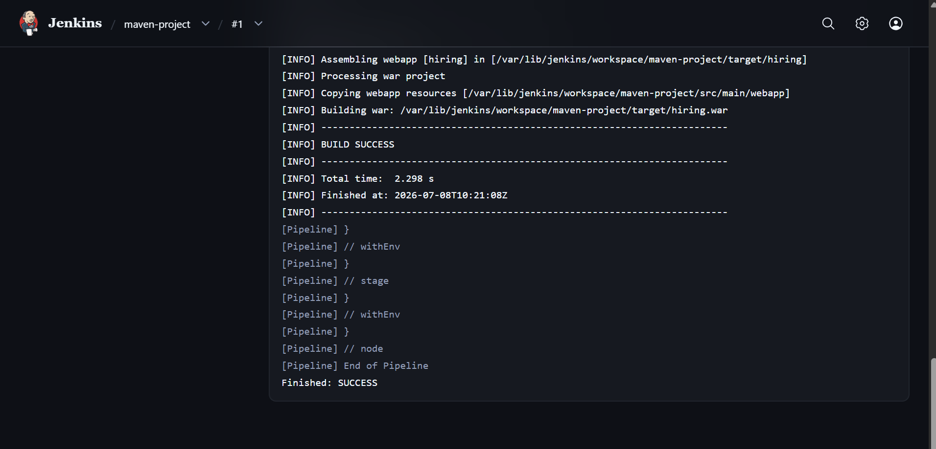

Use the same code and create a parameterized job in Jenkins with:
- Stage 1:Git clone
- Stage 2:Maven CompilationCode:

I am using the password parameter for my job

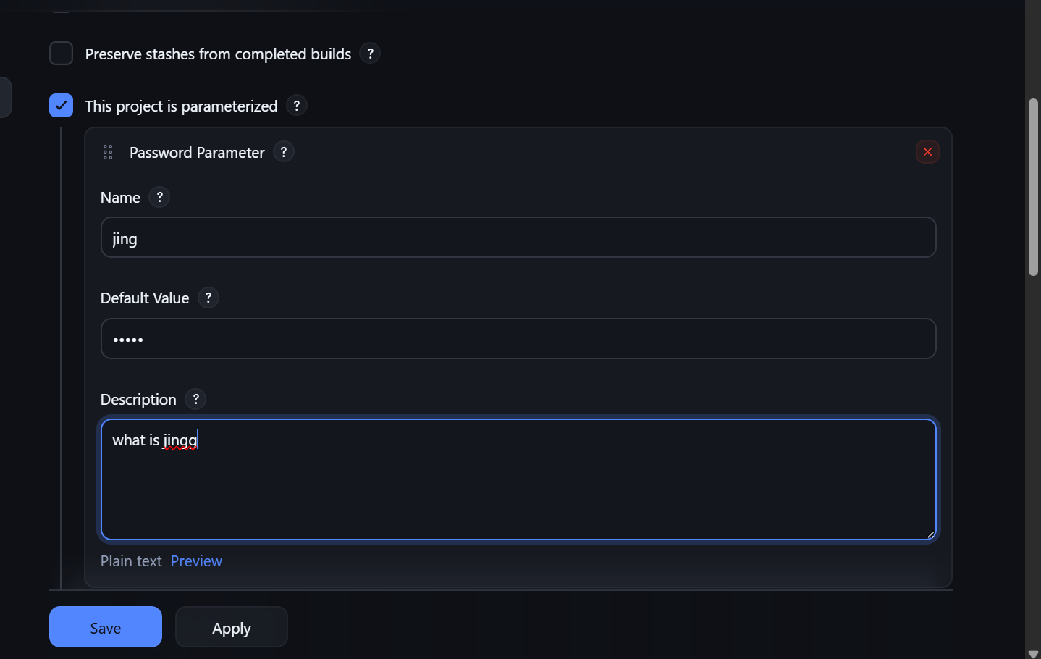

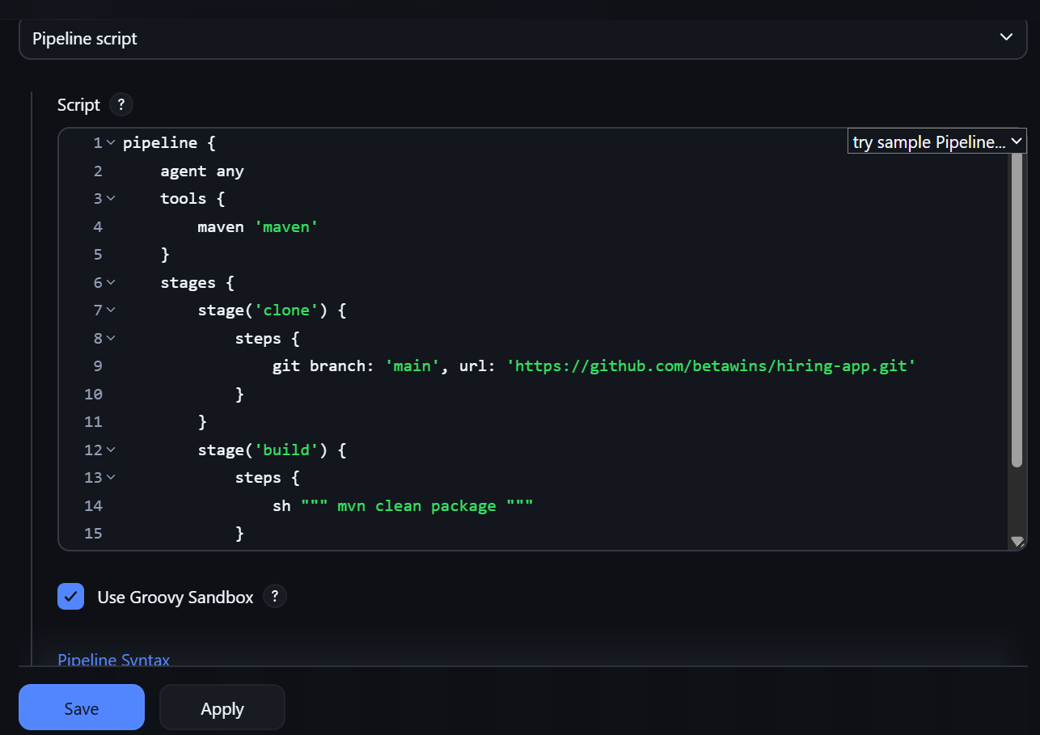

We can see the password is required to run the job

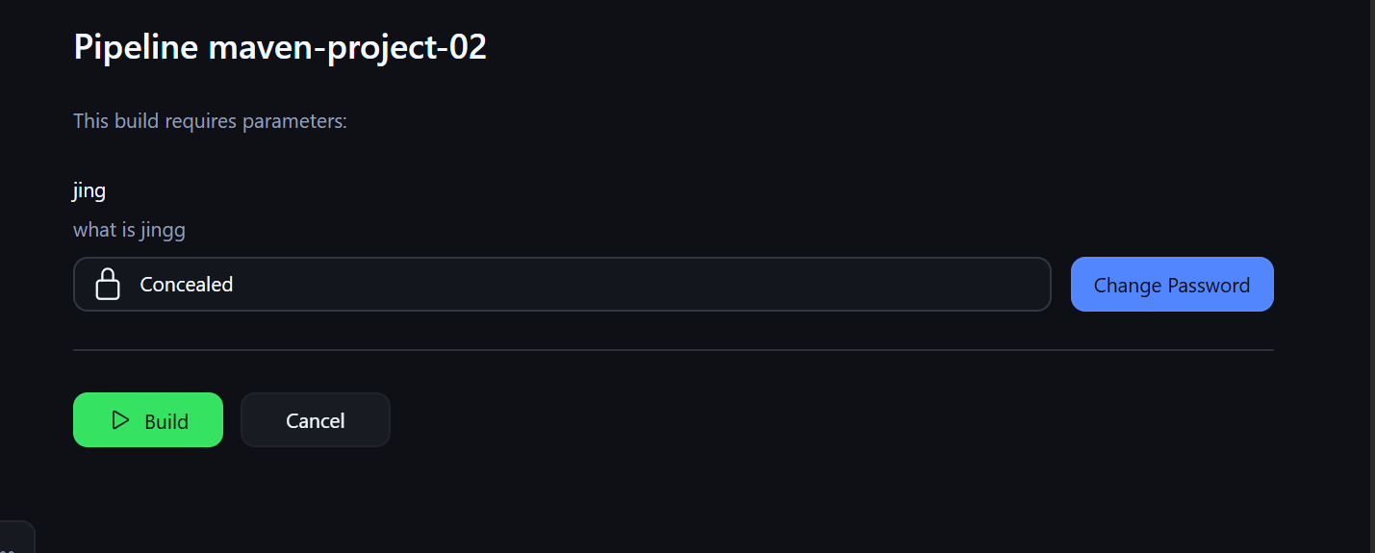

GLOBAL VARIABLES IN JENKINS

Jenkins provides many global environment variables that are automatically available in jobs and pipelines. You can access them as:
- Pipeline (Groovy): env.VARIABLE_NAME
- Shell (Linux) : $VARIABLE_NAME
- Batch (Windows) : %VARIABLE_NAME%

Common Jenkins Global Variables
Variable | Description
BUILD_NUMBER | Current build number (e.g., 15)
BUILD_ID | Unique build ID (often same as build number)
BUILD_DISPLAY_NAME | Display name of the build
BUILD_TAG | Build tag like jenkins-jobname-15
BUILD_URL | URL of the current build
JOB_NAME | Name of the Jenkins job
JOB_BASE_NAME | Job name without folder path
JOB_URL | URL of the job
JENKINS_URL | Base URL of the Jenkins server
NODE_NAME | Agent/node executing the build
NODE_LABELS | Labels assigned to the agent
EXECUTOR_NUMBER | Executor number running the build
WORKSPACE | Workspace directory
WORKSPACE_TMP | Temporary workspace directory
HOME | Home directory of the Jenkins user
USER | Current OS user (if available)

Git Variables (after Git checkout)
Variable | Description
GIT_COMMIT | Latest commit hash
GIT_BRANCH | Current branch
GIT_URL | Repository URL
GIT_PREVIOUS_COMMIT | Previous commit hash
GIT_PREVIOUS_SUCCESSFUL_COMMIT | Last successful commit

Multibranch Pipeline Variables
Variable | Description
BRANCH_NAME | Branch name
CHANGE_ID | Pull request ID
CHANGE_TARGET | Target branch
CHANGE_BRANCH | Source branch
CHANGE_AUTHOR | PR author
TAG_NAME | Git tag name

