To restrict the version of terraform

If we run terraform init directly for the tf file then we will be seeing the new version downloaded

So to restrict which version to use or download for the script we will be using version restriction block

Version resource block in the script

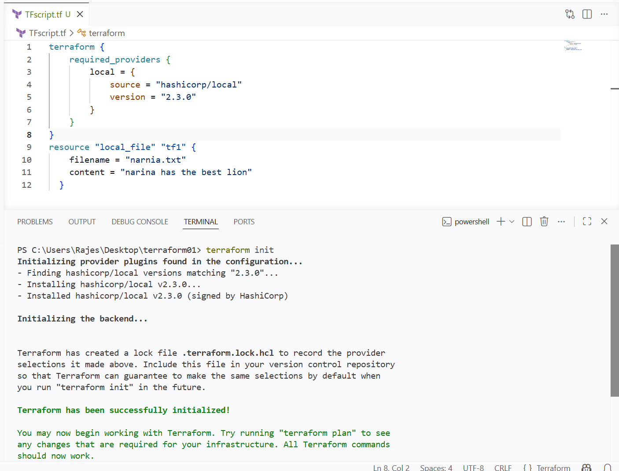

As I have mentioned the specific version in the block so it has downloaded the given version

We can configure versions in 5 ways

Operator | Meaning | Example
= | Exactly equal | = 5.0.1
!= | Not equal | != 5.0.2
> | Greater than | > 5.0.0
>= | Greater than or equal | >= 5.0.0
< | Less than | < 6.0.0
<= | Less than or equal | <= 5.5.0
~> | Pessimistic constraint | ~> 5.0

By using the operation along with version tag we can use that version

Reading the content of other files created using other editors or application

If I have a file that has created and edited by notepad ++

And I want to read the content of that file in my terraform script

Or using that file for my terraform

I can read or use the content of other files in my script using data block

--->

I have created a new file from notepad

Now I want this content to read in my terraform script

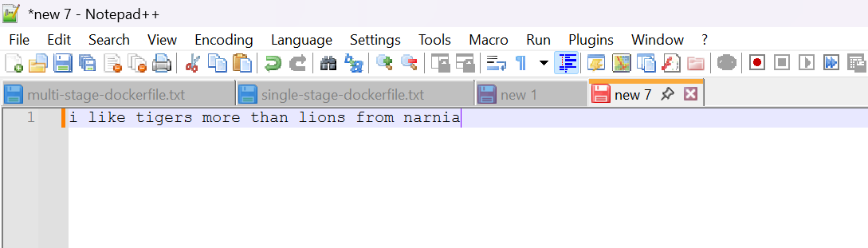

I have added data block that has file location

And giving the data block as input to the content of my file

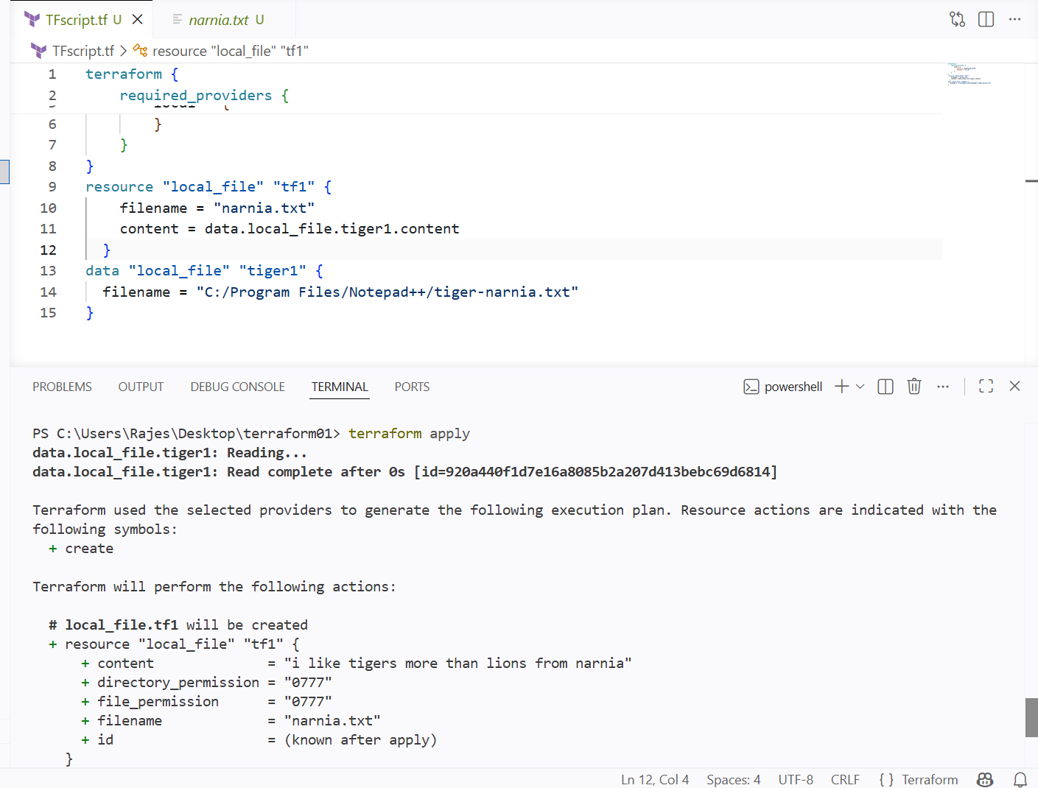

Using terraform apply we can see that it has read the content of notepad ++ file and displayed

And it has given as input to the narnia.txt file

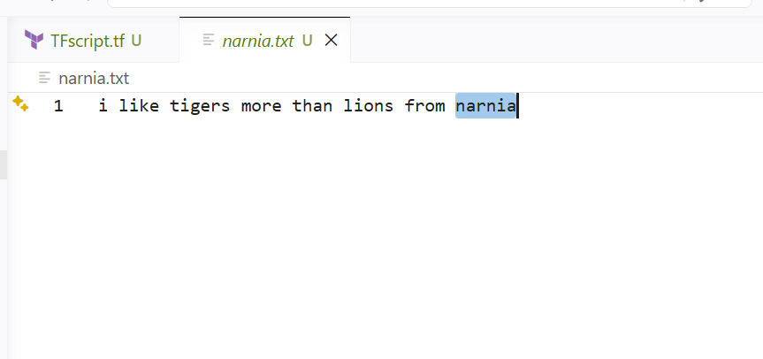

META-ARGUMENTS

Meta-Arguments helps us to configure the resources

And by using META-ARGUMENTS we can aslo create multiple resource

Meta-Argument | Used With | Purpose
count | Resource, Module | Creates multiple instances using a number.
for_each | Resource, Module | Creates multiple instances from a map or set.
depends_on | Resource, Module | Defines explicit dependencies.
provider | Resource | Selects a specific provider configuration.
lifecycle | Resource | Controls resource creation, update, and deletion behavior.
providers | Module | Passes provider configurations to a child module.

Example using a single resource I want to create multiple files

Then I will be using count meta-argument

-->

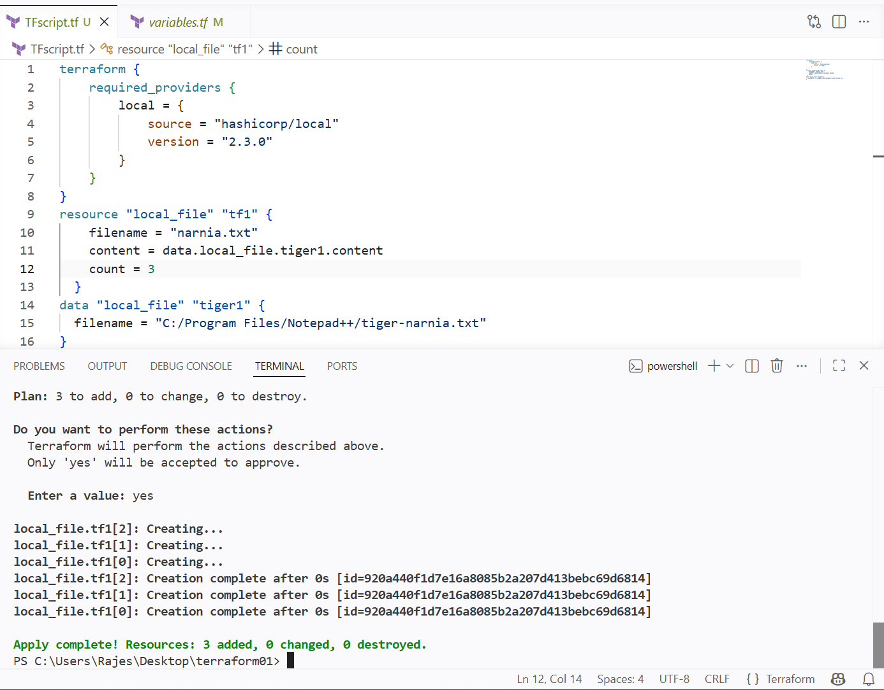

I have just added count to my resource block

During terraform apply we can see 3 new arrays has been created

It has created 3 but I we cant see any new files

I want to create 3 new files with the count meta-argument,
so I will be using the variable block to give the filenames to the count and it will help creating new files witih names

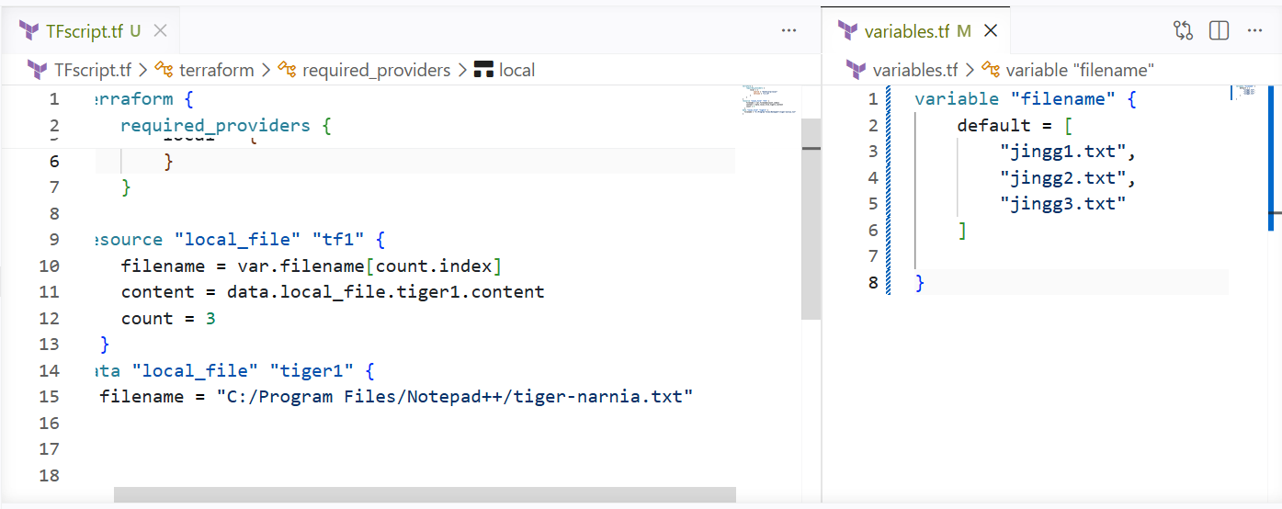

I have given variable block default 3 file names

In script I have changed my filename value to var.filename[count.index]

What it does is, it takes the count varibale names from variable block and gives the input to the filename

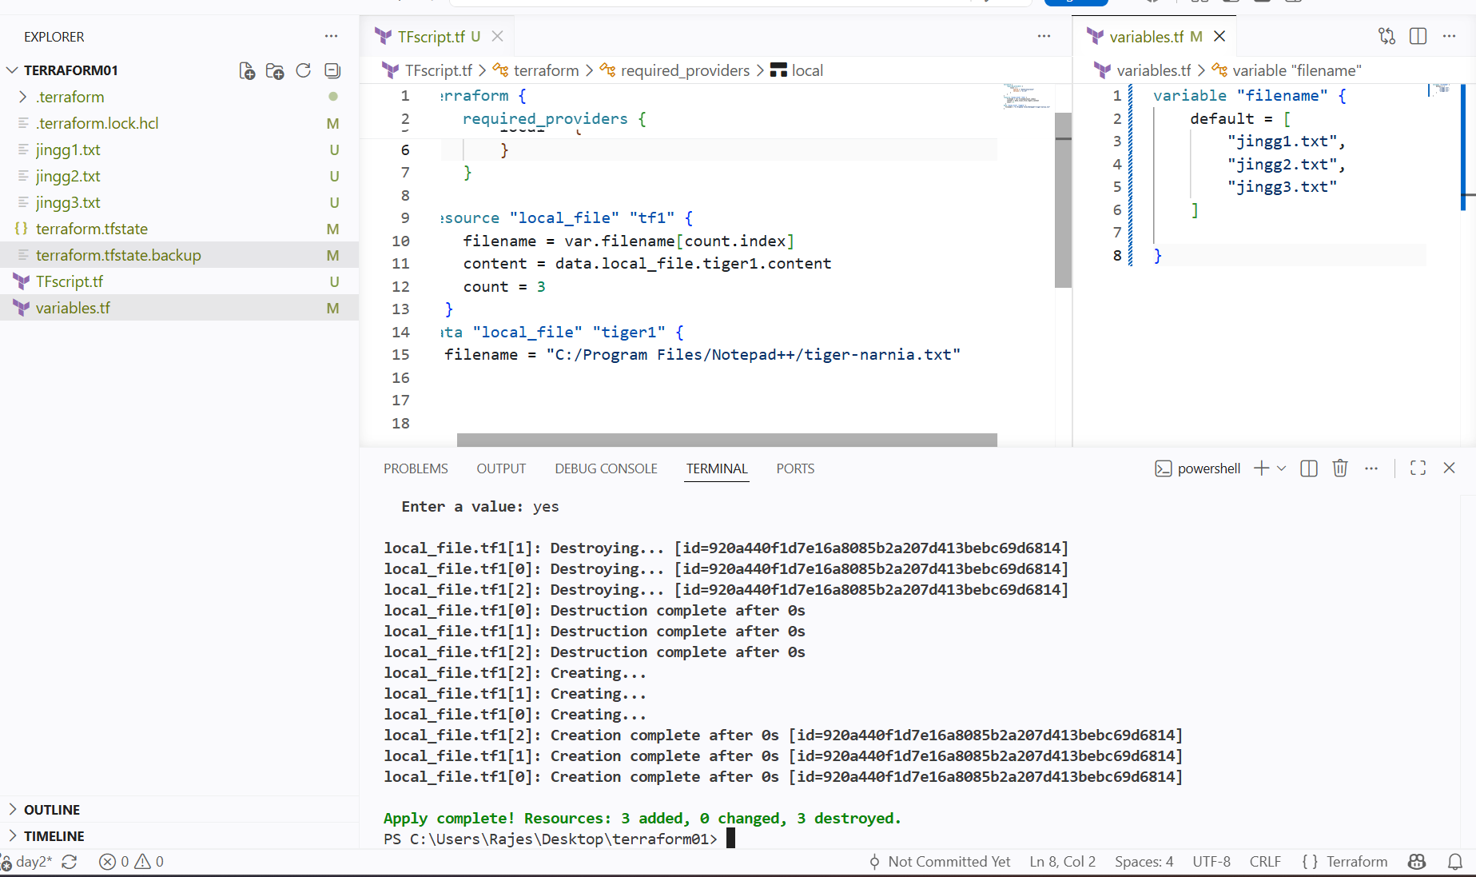

Left side we can see 3 new files has been created using single resource block

Or at count if we don’t want to sepcify any number and I want to create depending upon given values in variables.tf

I can use count = length(var.filename)

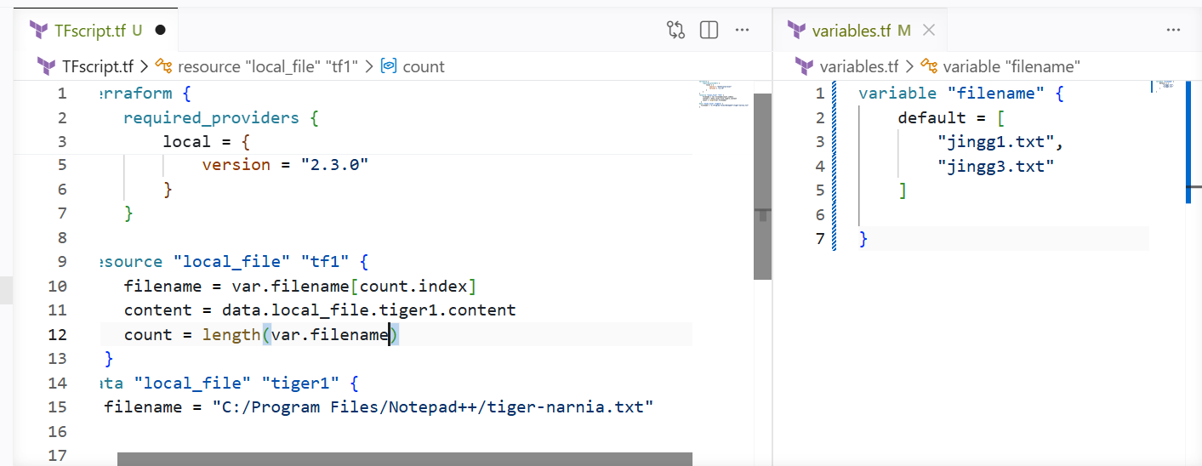

It has created 2 files depending upon the varibales given

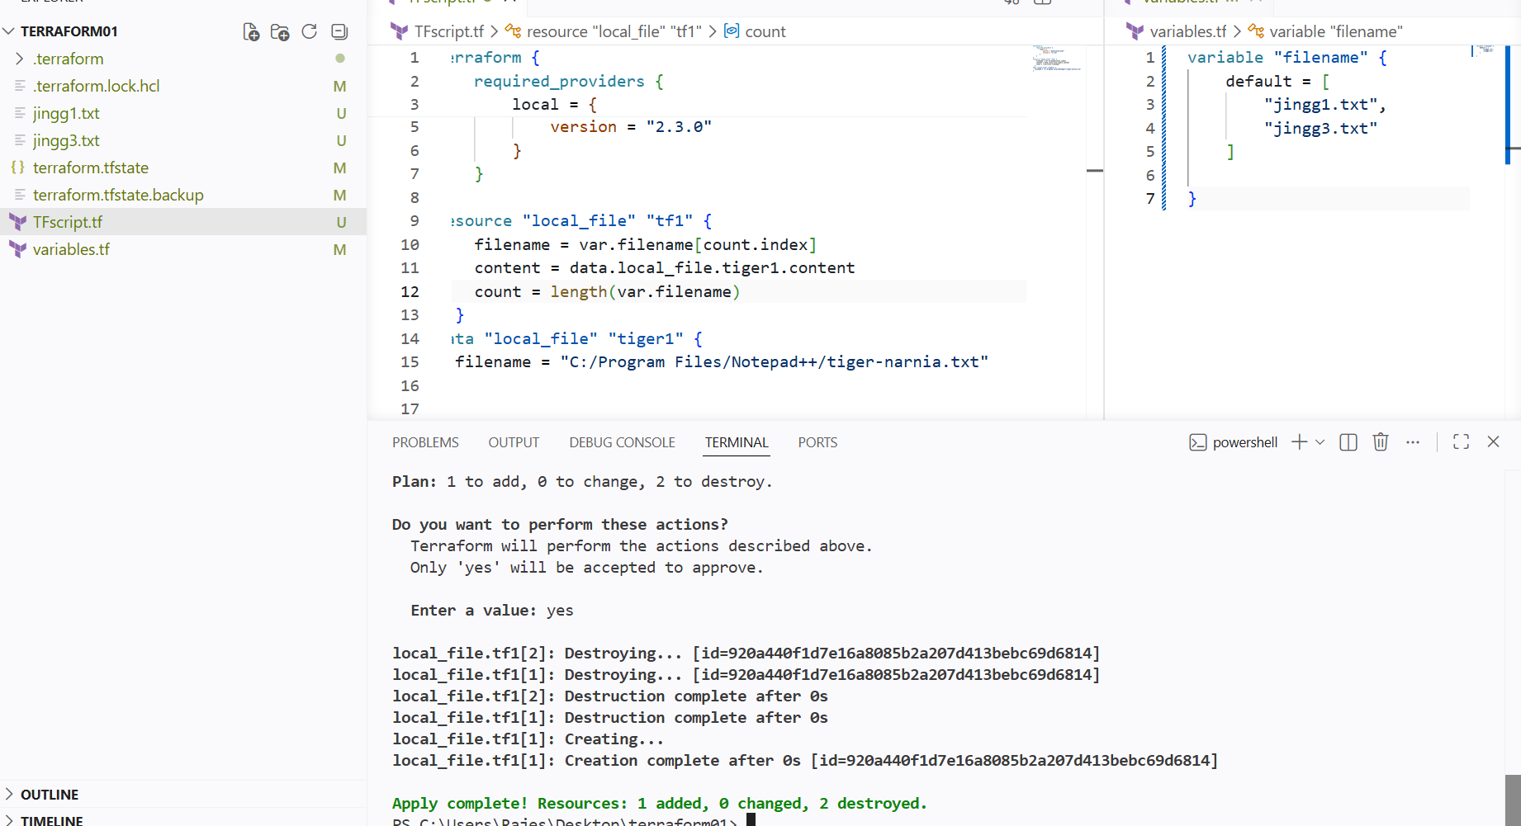

For_each

Using count it depend upon index values like for creating a n number of instance using same configs

For_each can be used if we have different names and for each instance diff configs

For_each is more preferred than count

--->

I want to create 2 new instances with different instance types

So I have used for_each meta-argument
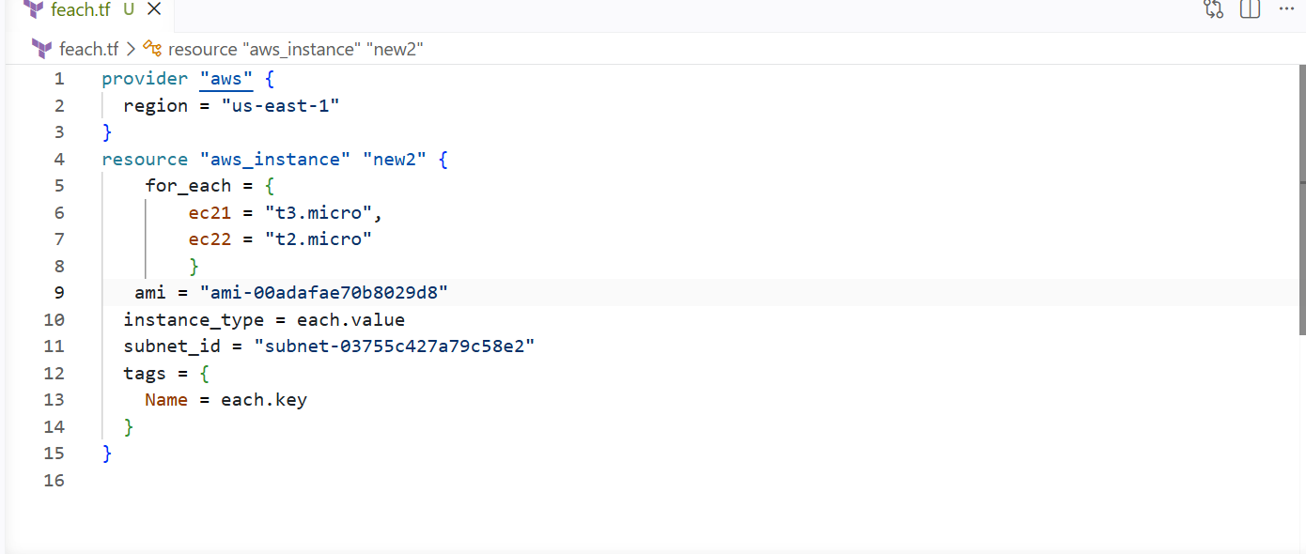

Using for_each for creating instance for each instance type

And to create an instance I have specified ami and subnet_id and
Innstance type is for_each value so I have mentioned each.value

And names also mentioned in the for_each so in tags given the value as each.key

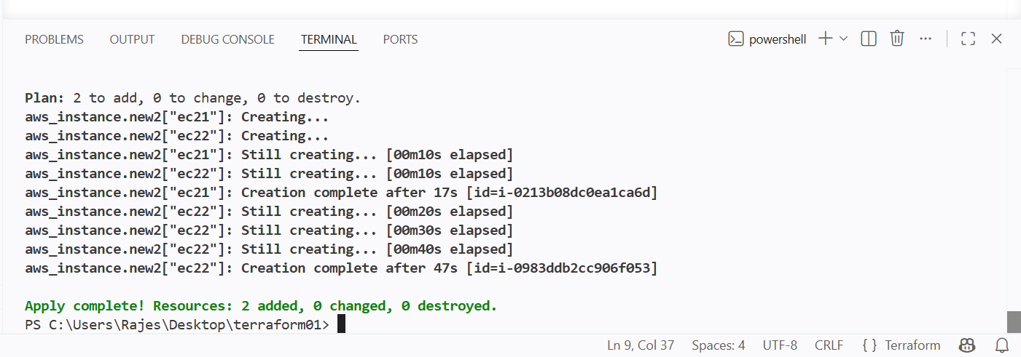
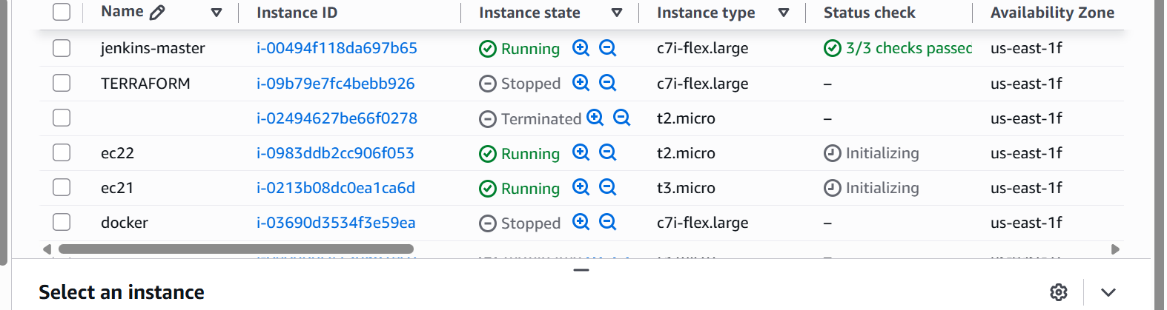

Integrate Terraform in Jenkins using the Terraform plugin

I have manually applied the terraform script now I will use jenkins to automatically create new instances.

Pushing the terraform code to the git hub and using pipelines for automation of my instance

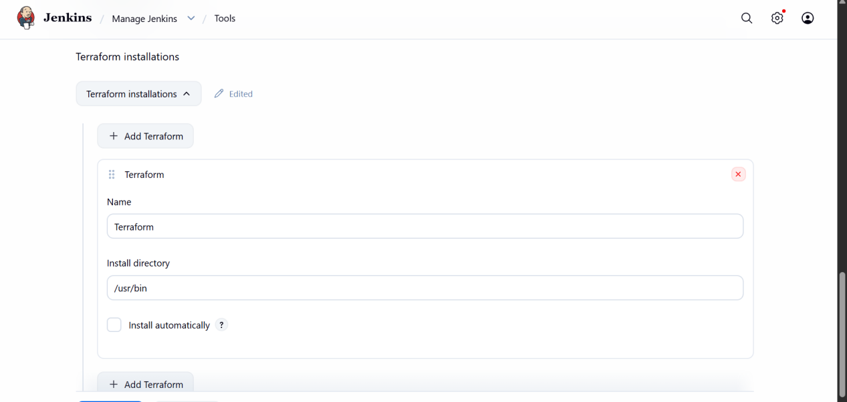

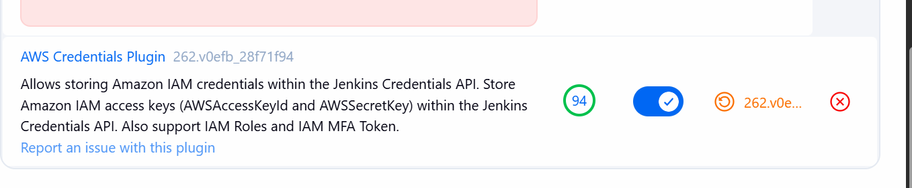

Create a CI/CD pipeline for a Nodejs Application

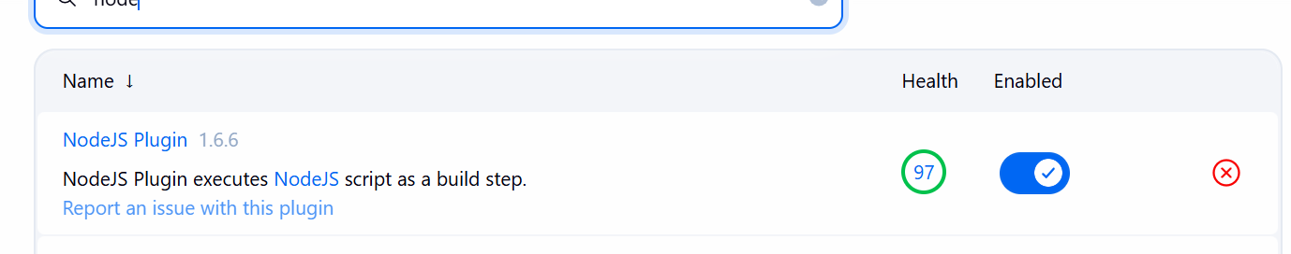

Install nodejs plugin

Ass the source code requires the nodejs tool

Configure tools

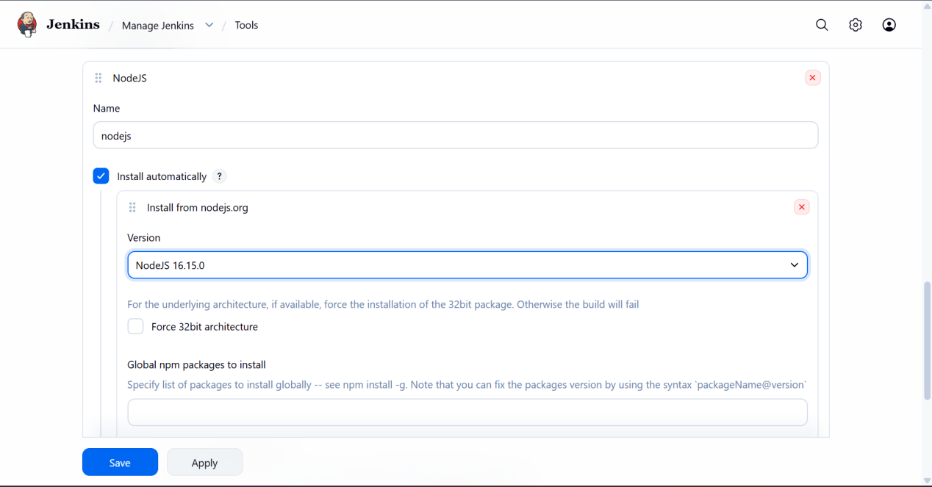

Or

I can write my docker file for nodejs application

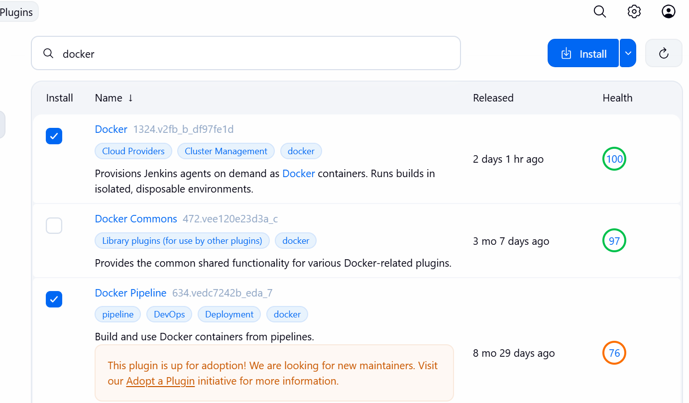

Install docker plugins

And the docker should be installed in our jenkins server and docker should be added in jenkins group

In th repo writing a docker file for the nodejs application and using this building the image

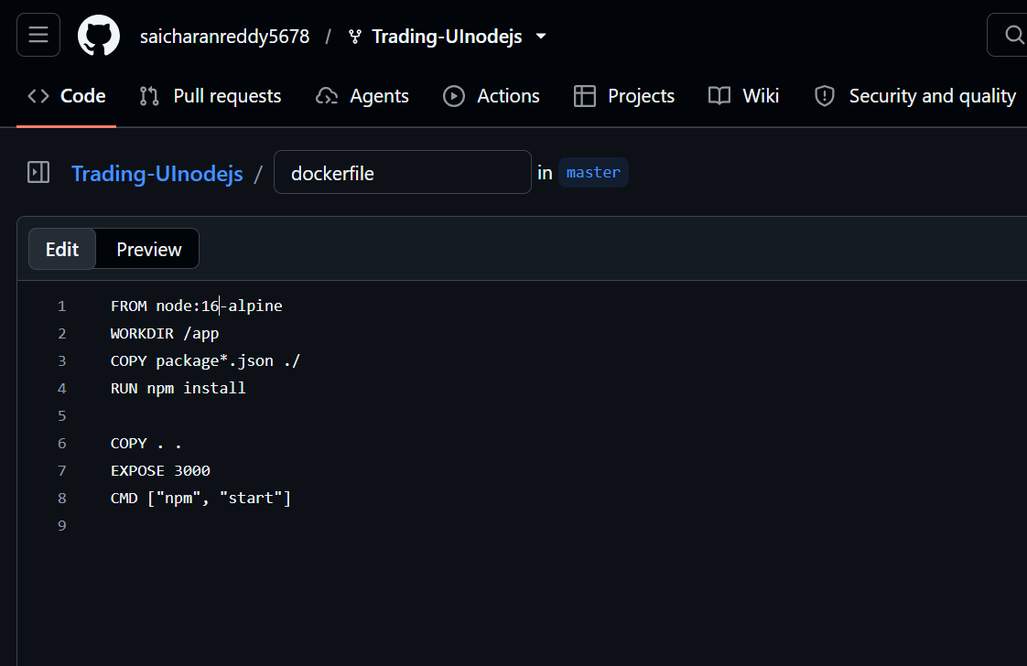

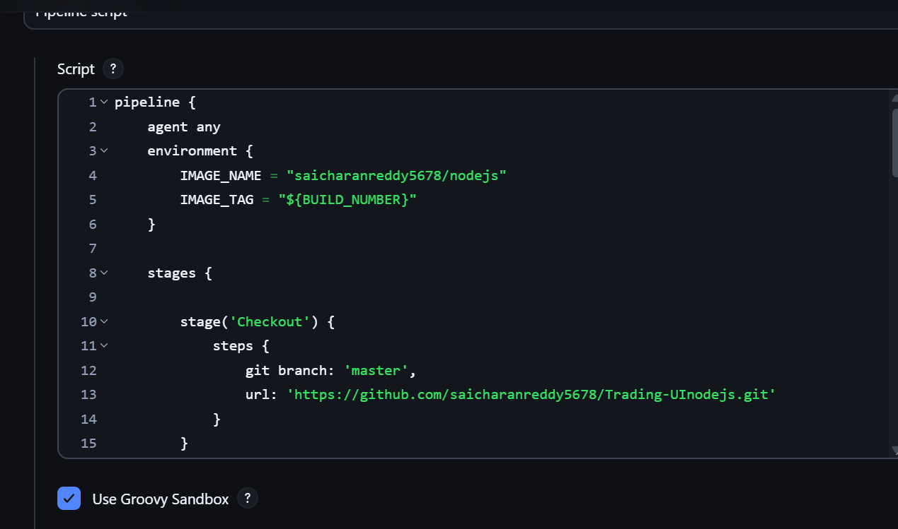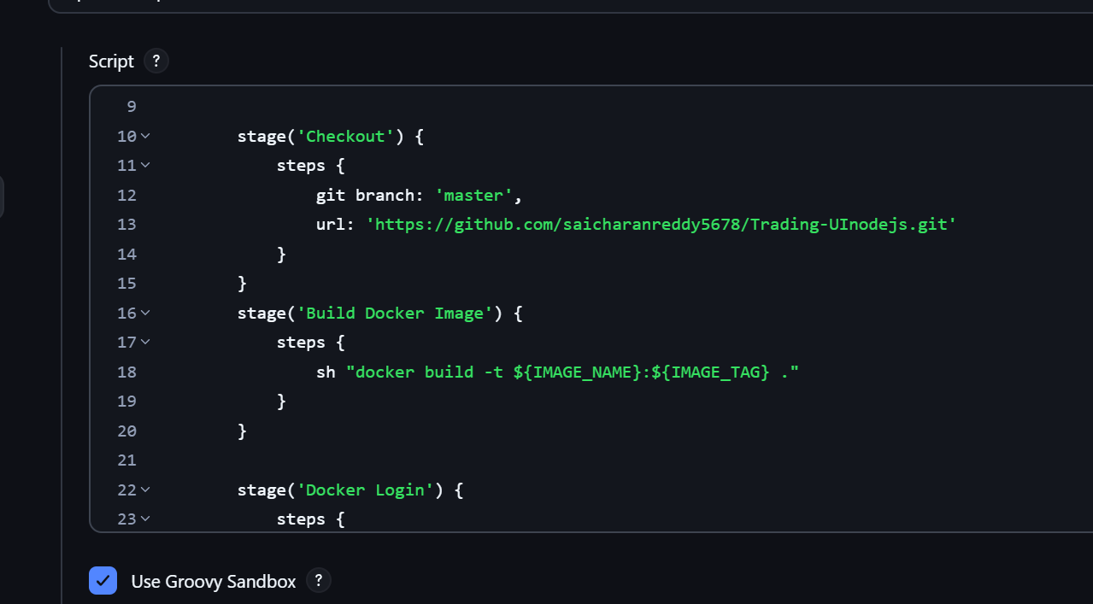

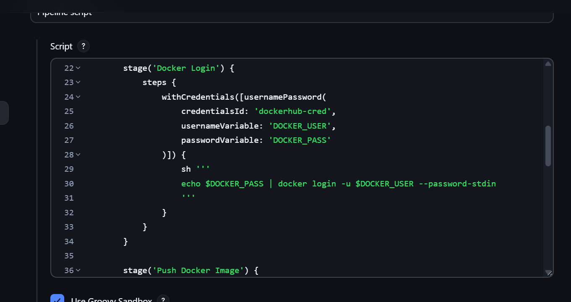

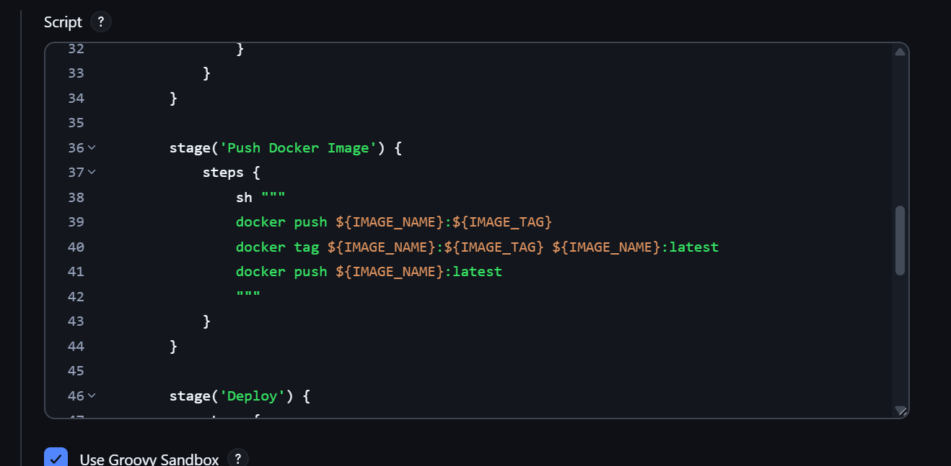

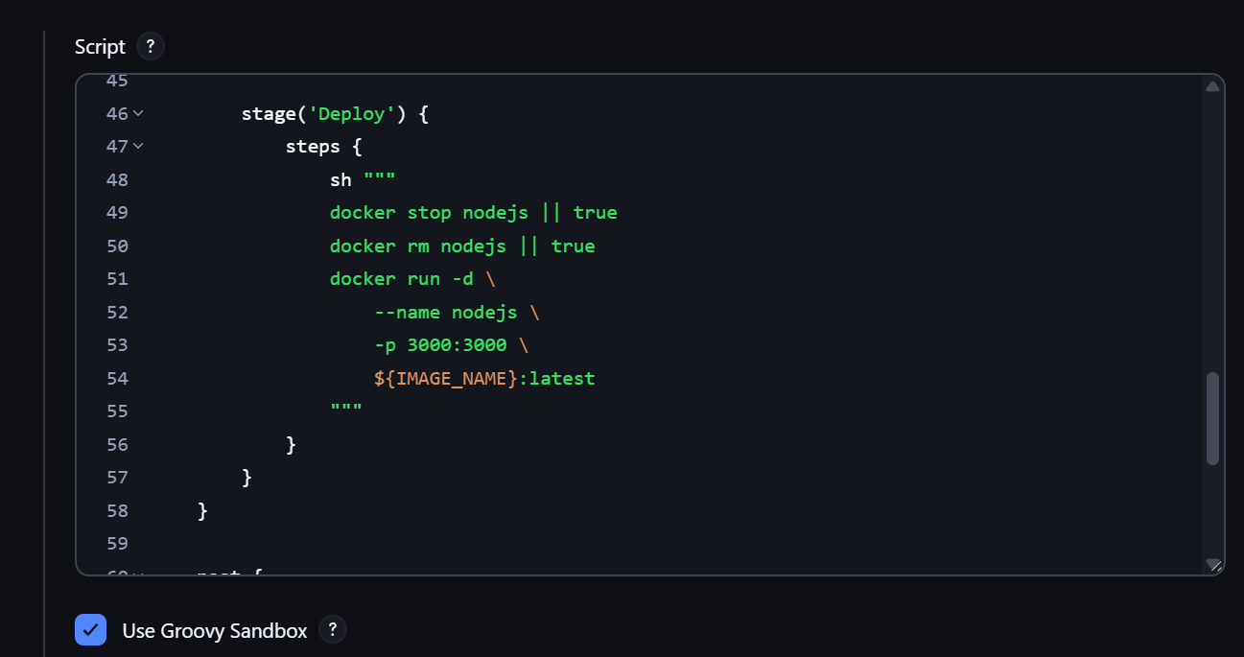

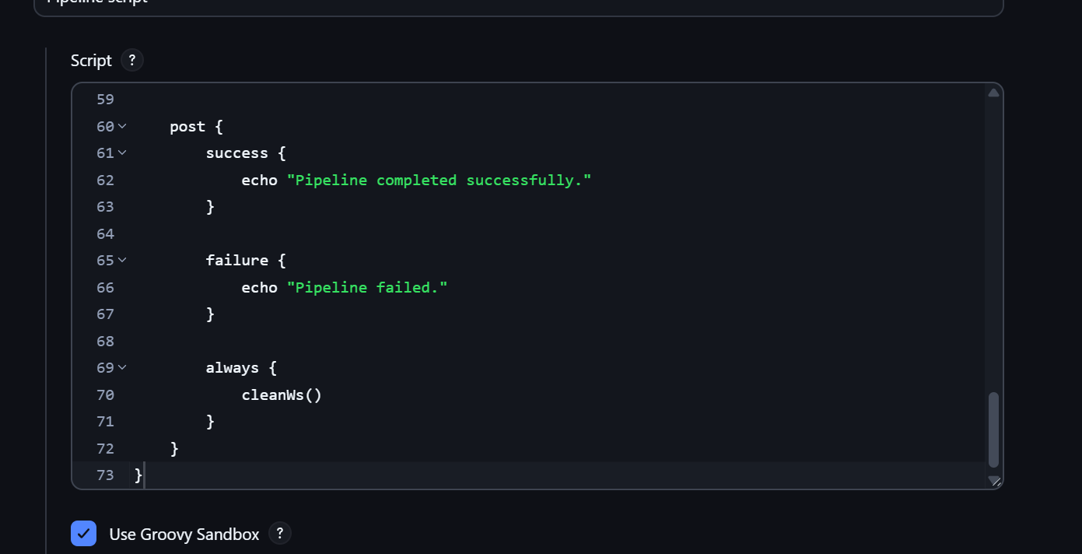

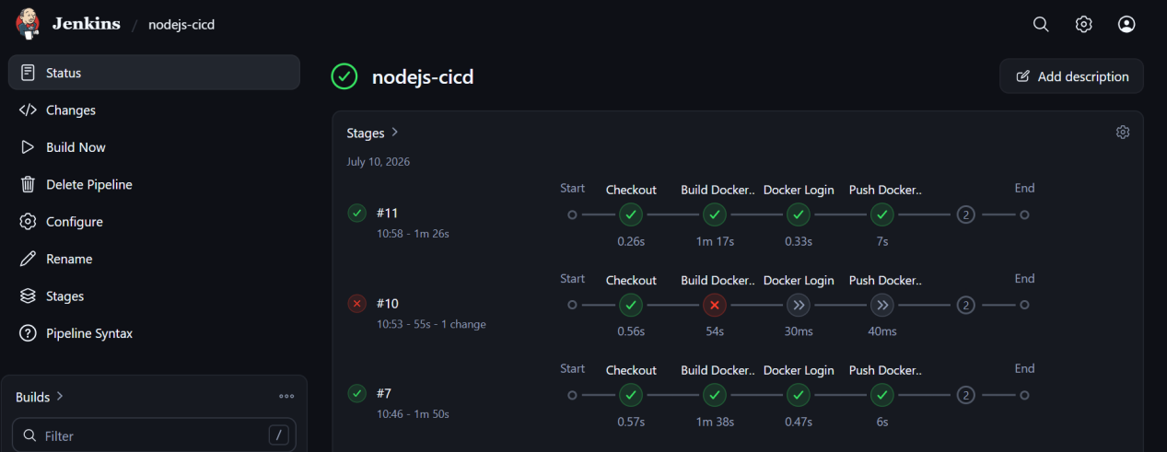
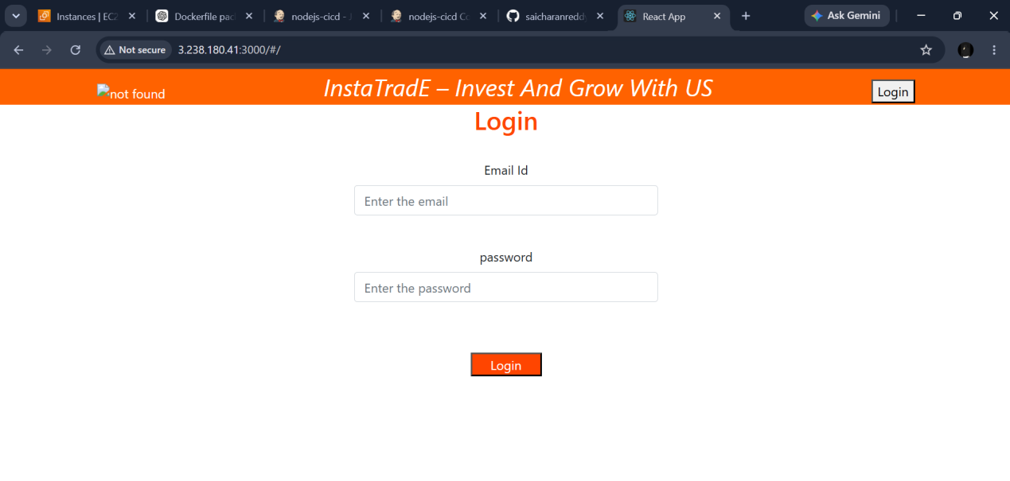

10.maven commands

- mvn validate :
Validates project structure and pom.xml.
Example: mvn validate
- mvn compile :
Compiles source code.
Example: mvn compile
- mvn test :
Runs unit tests.
Example: mvn test
- mvn package :
Packages into JAR/WAR.
Example: mvn package
- mvn install :
Installs artifact to local repository.
Example: mvn install
- mvn clean:
Deletes target directory.
Example: mvn clean
- mvn clean install :
Clean,build, test, install.
Example: mvn clean install
- mvn clean package:
Clean and package.
Example: mvn clean package
- mvn dependency:
tree Shows dependency hierarchy.
Example: mvn dependency:tree
- mvn deploy :
Deploys artifact to remote repository.
Example: mvn deploy

