AWS LAMBDA

AWS Lambda is a cloud computing service provided by Amazon Web Services (AWS) that lets you run code without managing, provisioning, or paying for a permanent server. It is widely referred to as a server-less or Function-as-a-Service (FaaS) model

We can call lambda as automated cron jobs

To use lambda we need to create a function

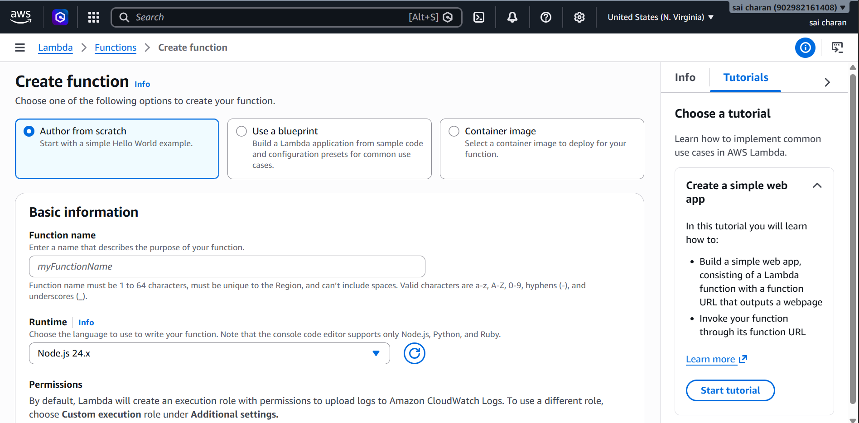

With Lambda, you give AWS your code, and it sits there completely turned off. When a user or an event has request then it runs your code instantly,after completing its job then it will be in off state You only pay for the exact milliseconds your code runs

Understanding the basic python code

def lambda_handler(event, context):
return {
'statusCode': 200,
'body': 'Hello World!'
}

Lambda_handler :- this is the first function that aws lambda looks for before executing the script
Event:- This is a Python dictionary that contains information about why the function was triggered
Context:- this contains system information about the running environment (like how much time is left before AWS shuts the function down)
Return:- it return the answer to whoever sends the request

Creating a simple function that takes two numbers, adds them together, and returns the result

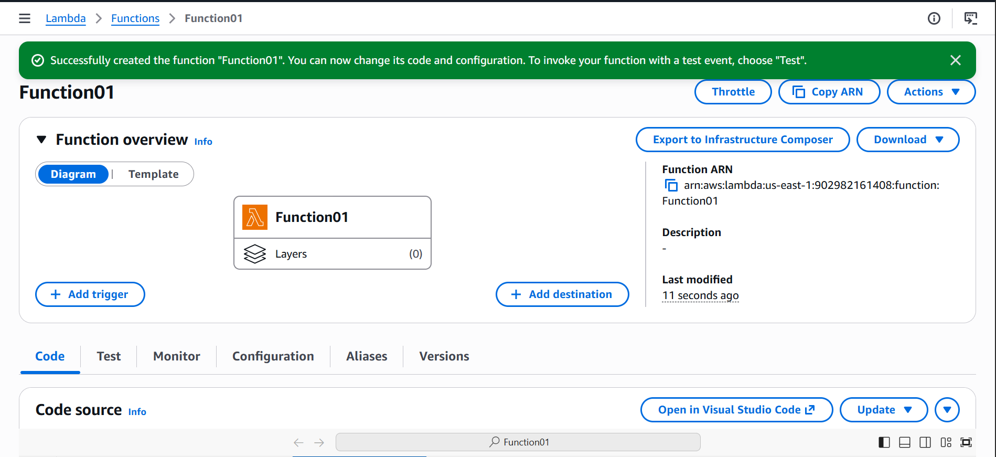

Then here we need to write our code

import json

def lambda_handler(event, context):
# 1. Grab numbers out of the incoming 'event' trigger
number1 = event.get('num1', 0)
number2 = event.get('num2', 0)

# 2. Do the math
total = number1 + number2

# 3. Send back the answer
return {
'statusCode': 200,
'body': json.dumps(f"The total sum is: {total}")
}

I have used above code to math

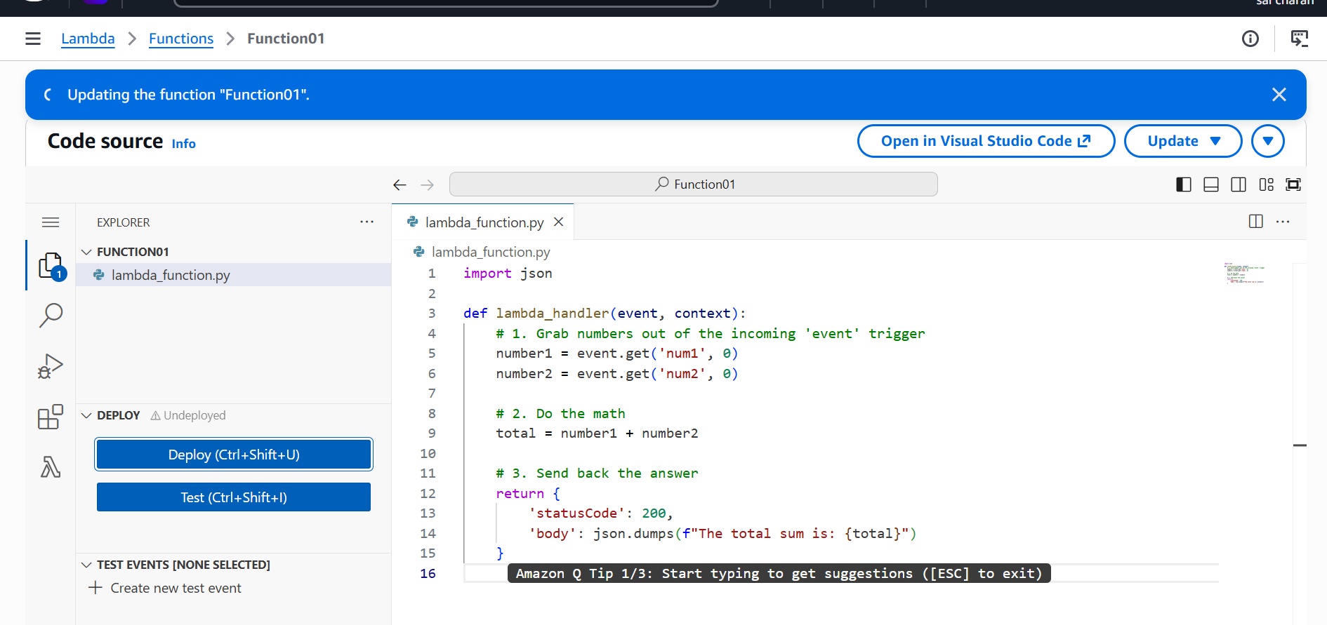

Then click deploy

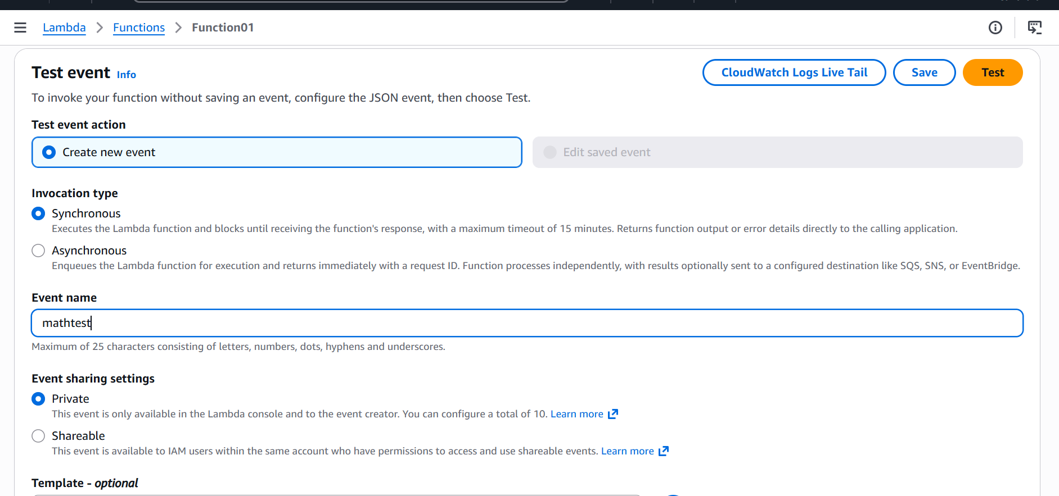

Then I am creating a test

In real time we wont be using test, for seeing the result iam using test

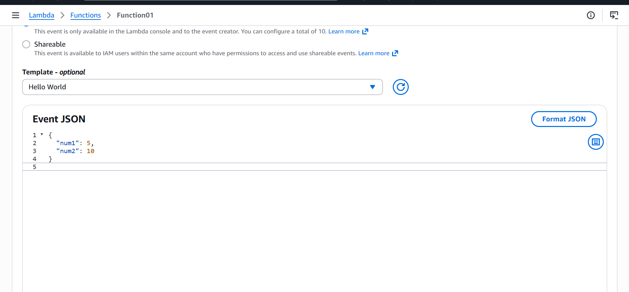

Then give number inputs to perform test

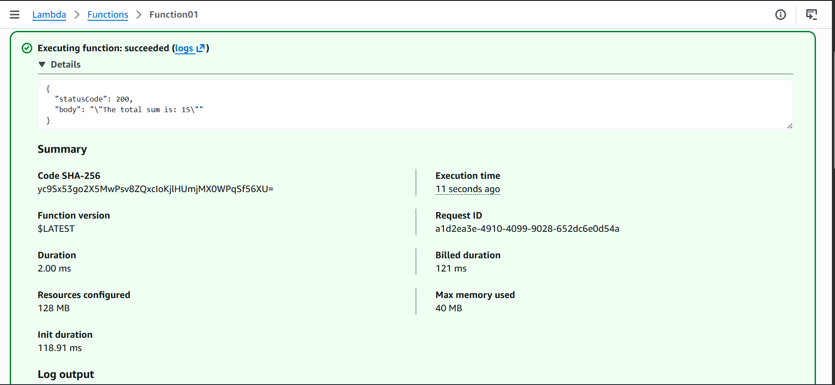

We can see it performed function that I have written and gave the result

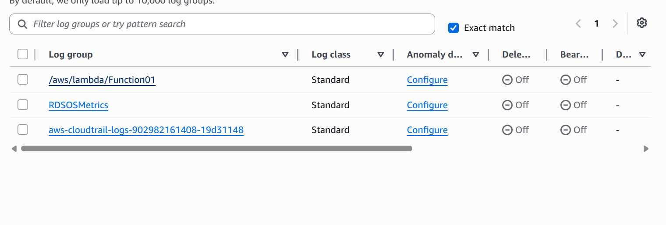

And the logs will be stored in cloudwatch logs

API GATEWAY

An API Gateway is a centralized server or software component that acts as a single entry point ("front door") for all incoming client requests to your backend services

If a user makes a request the api checks the security and access for the user

If I have to use api gateway and load balancer and instance for user the request flow as shown in below

[ Public Internet ]
│
▼
┌─────────────────────────────────┐
│ Amazon API Gateway │ <-- Manages Auth, Throttling, & Public HTTPS
└───────────────┬─────────────────┘
│
▼ (Secure VPC Link)
┌─────────────────────────────────┐
│ Application Load Balancer (ALB)│ <-- Private / Internal Load Balancer
└───────────────┬─────────────────┘
│
┌───────┴───────┐
▼ ▼
┌───────────────┐┌───────────────┐
│ EC2 App 1 ││ EC2 App 2 │ <-- Isolated Backend Instances (Private Subnets)
└───────────────┘└───────────────┘

First the traffic is distributed to the available servers equally
then the allowed traffic is checked by the api gateway
then it allows to the instance

I will be creating a loadbalncer and api gateway for my instance

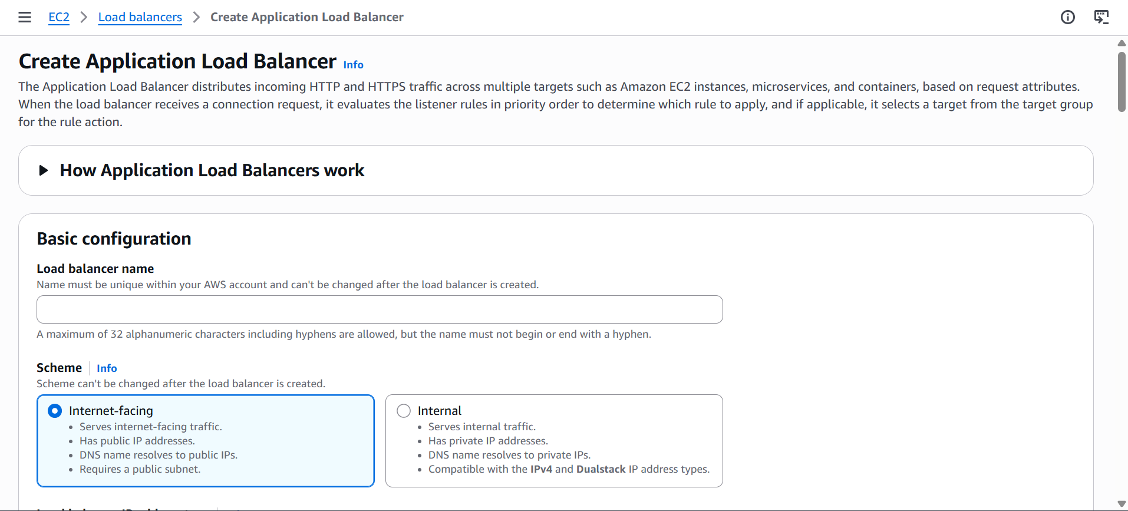

First I will be creating a load balancer with instance target group and later adding it to the api gateway

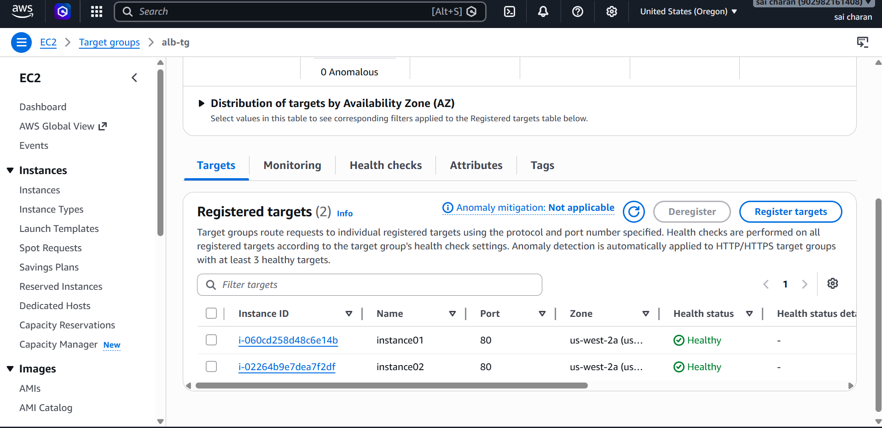

And added target groups then add the load balancer dns to the api gateway

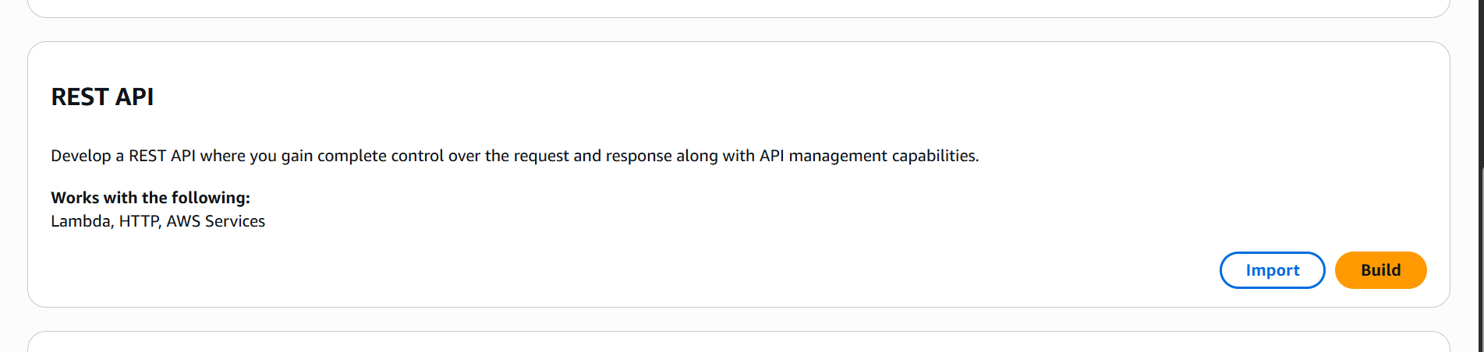

Choose rest api

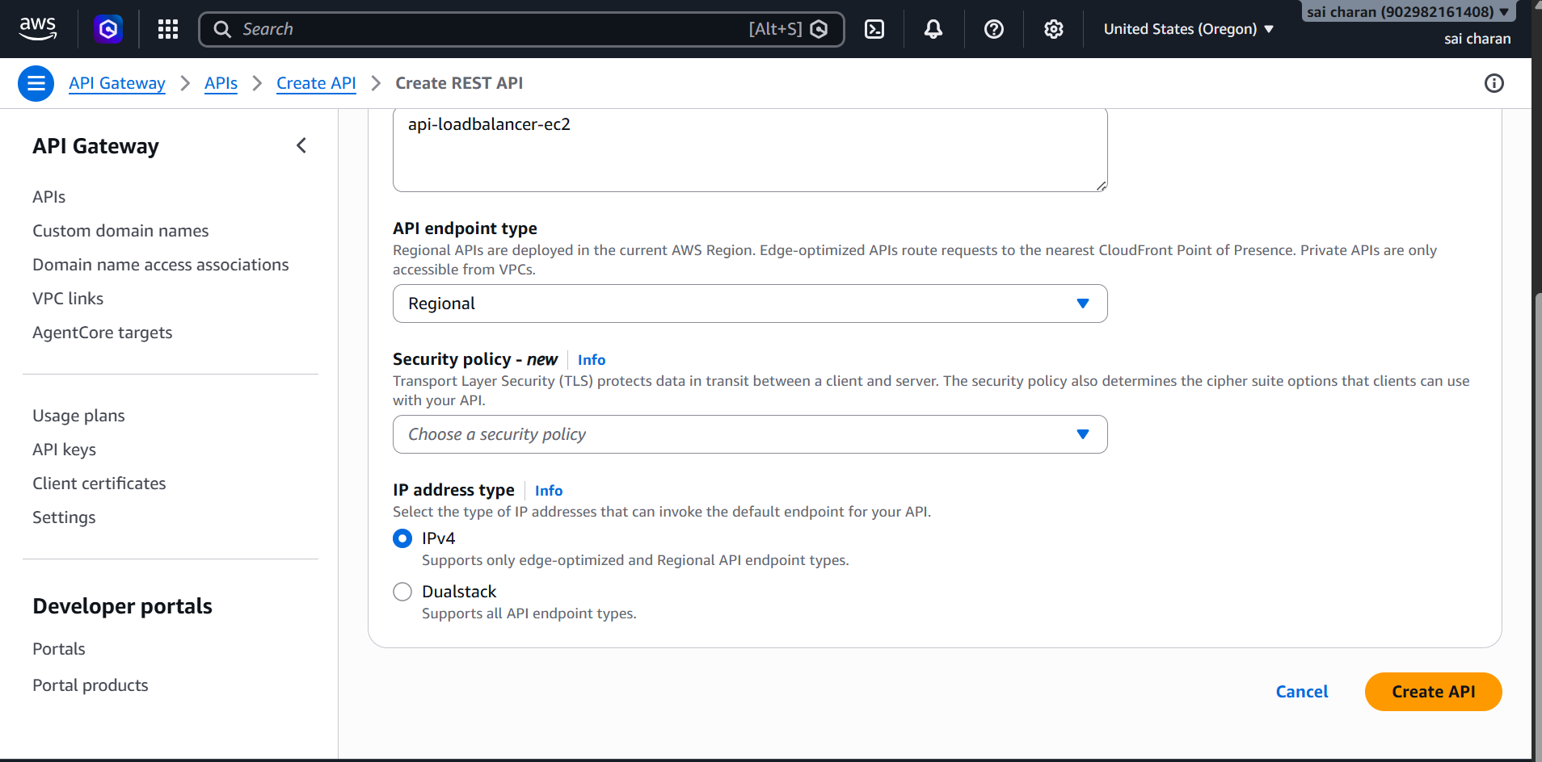

Click on create api

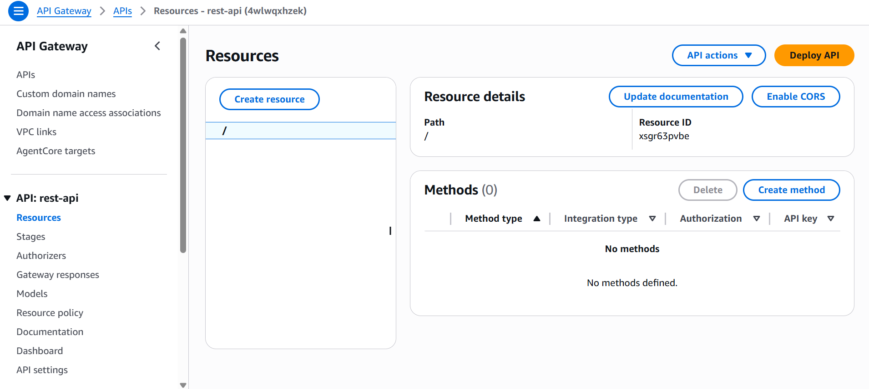

In resource add APPLICATION LOAD BALANCER DNS

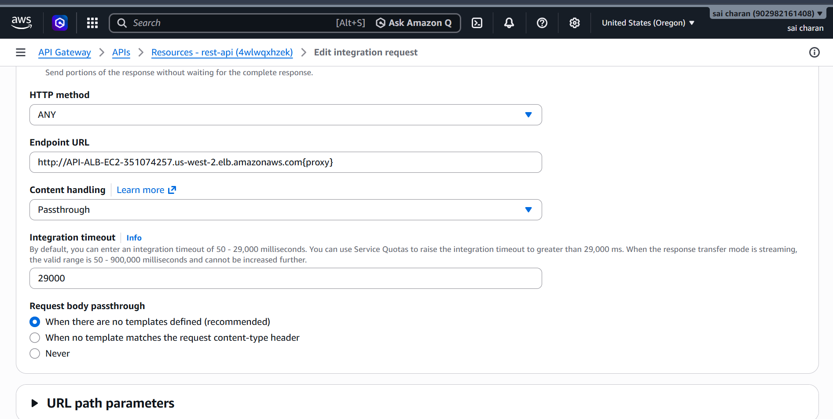

Paste the ALB DNS here

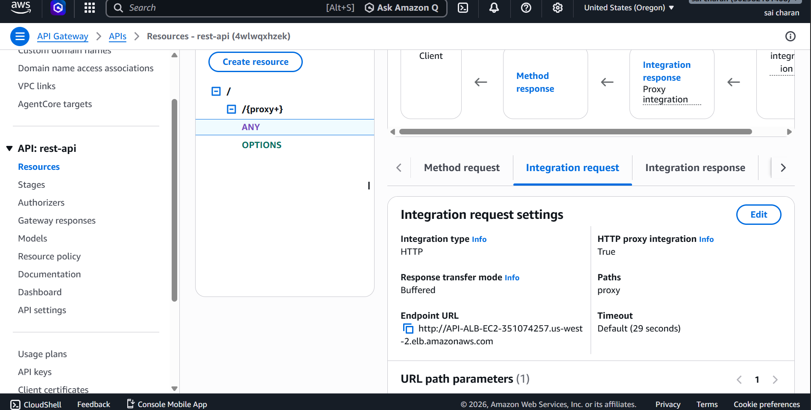

After creating the endpoint url

Click on deploy api

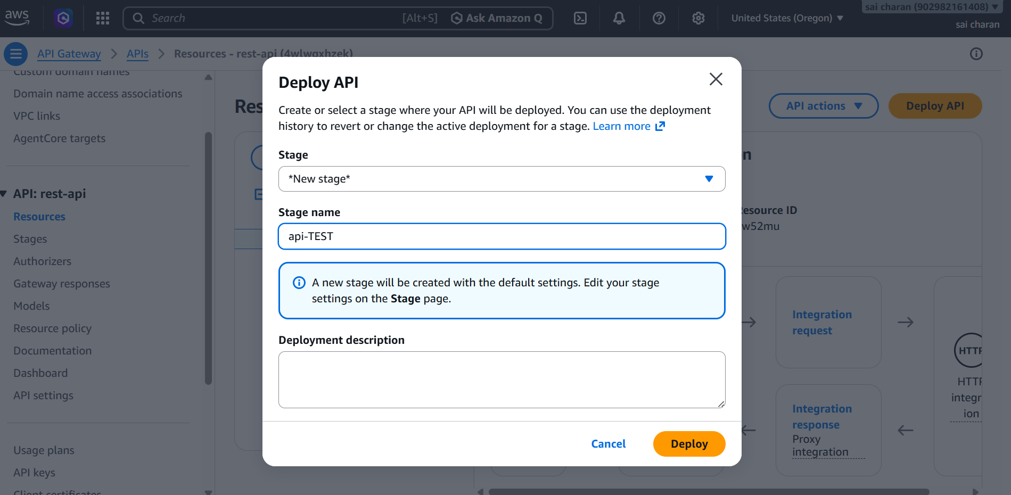

After deploying use invoke url and add our index path into it

Then it should load our index.html page and should change whenver I do refresh it should switch b/w instances in the load balancer

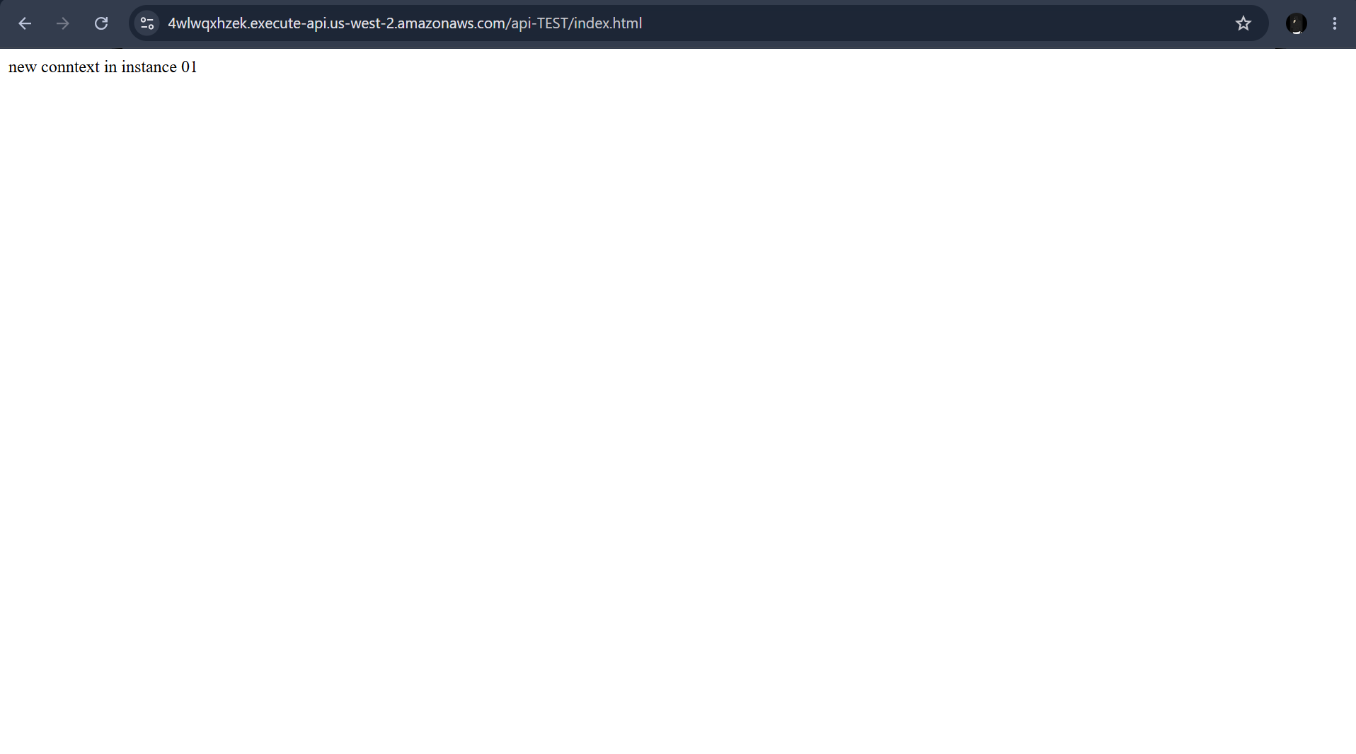

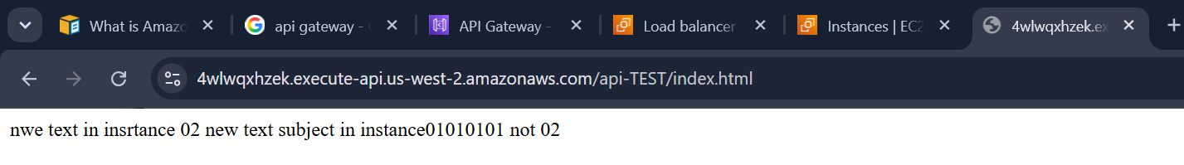

Then instead of this url I can map my domain name

And use my custom domain name

AWS KEY MANAGEMENT SERVICE

AWS KMS is a fully managed service used to create, control, and manage cryptographic keys across AWS applications.

Key Architecture
- Symmetric Keys: 256-bit keys (AES-GCM) used for standard data encryption and decryption.
- Asymmetric Keys: RSA or ECC key pairs used for encryption, decryption, or digital signatures.
- HMAC Keys: Symmetric keys used to generate and verify message authentication codes.

Key Types & Governance
- Customer Managed: Keys you create and control ($1/month base cost). You manage policies and rotation.
- AWS Managed: Created automatically by AWS services (e.g., S3, EBS). Free to store; you only pay for API usage.
- AWS Owned: Internal AWS keys used to protect infrastructure. Invisible in your account and completely free

Use case example

If I upload a object to a bucket
I will be creating a bucket with sse-kms that is managed by aws
Now my files are protected by kms

I will be uploading a new file to a bucket that has key enabled

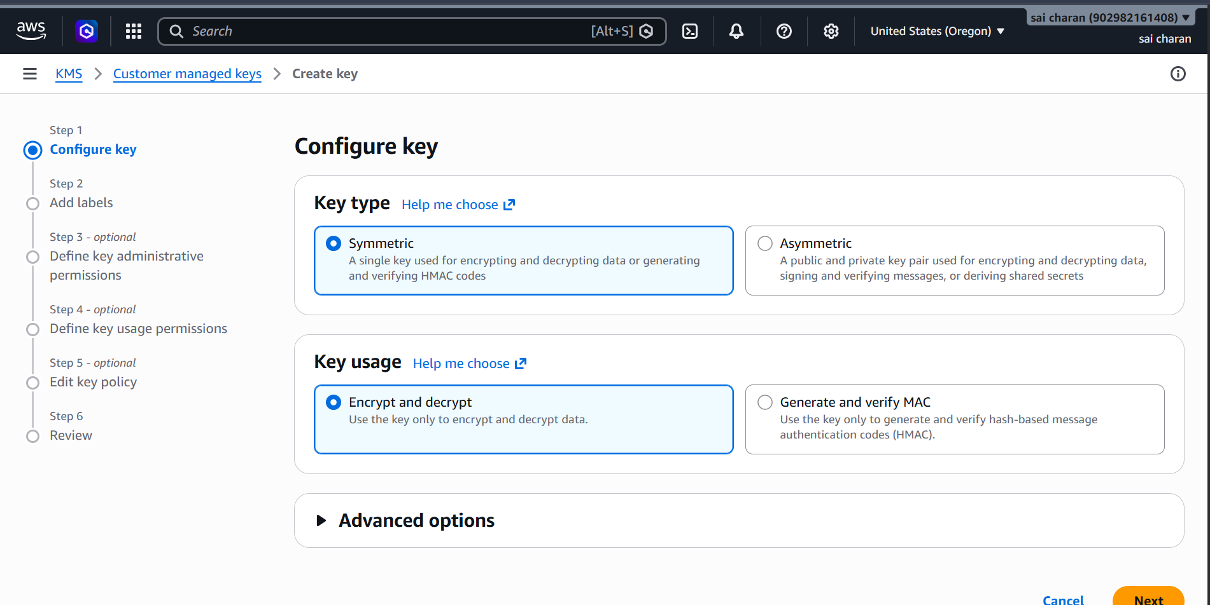

We can also replicate this key in other regions

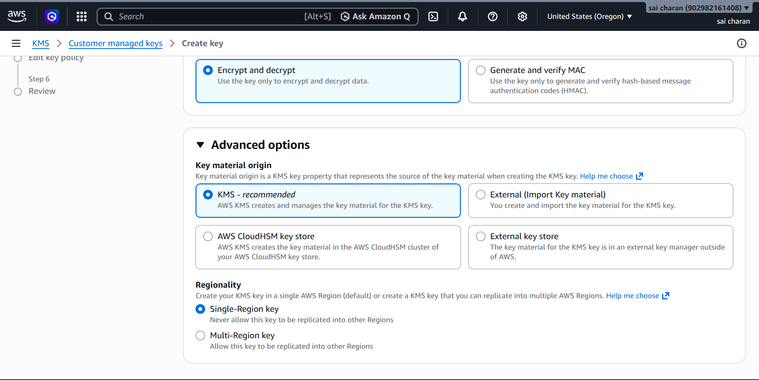

We can give which user can usee or delete this key
Or
What access can this can have

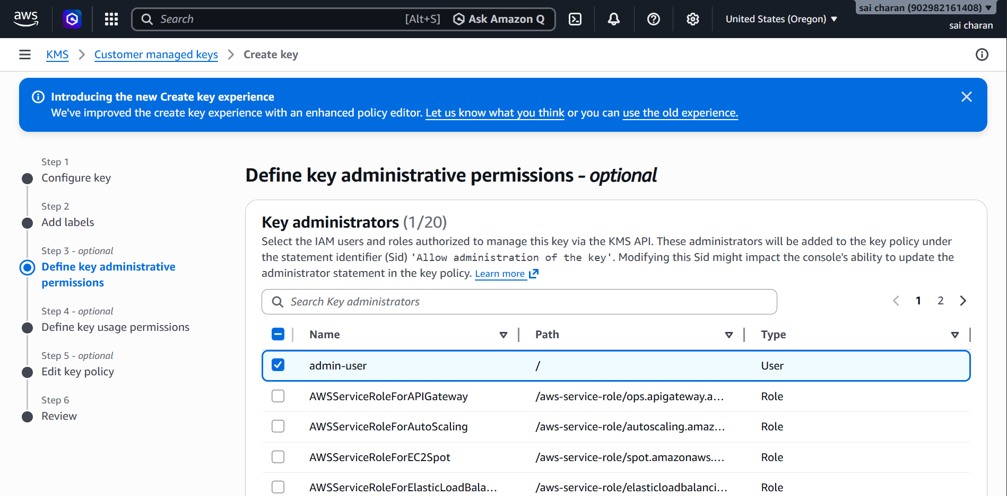

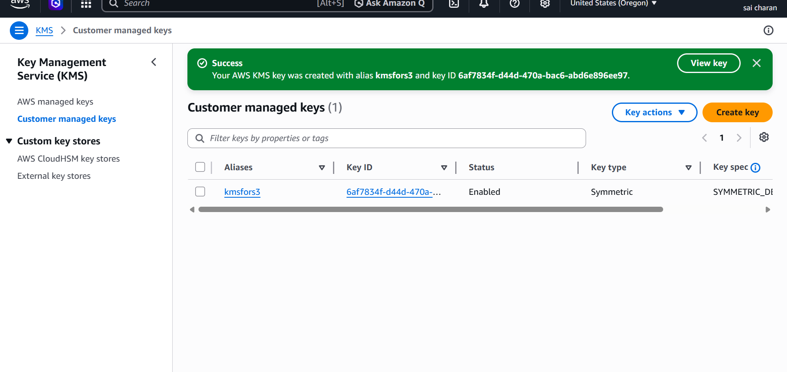

Now we can attach this key to any s3 bucket

And whoever has this key access can delete this key or to view this key

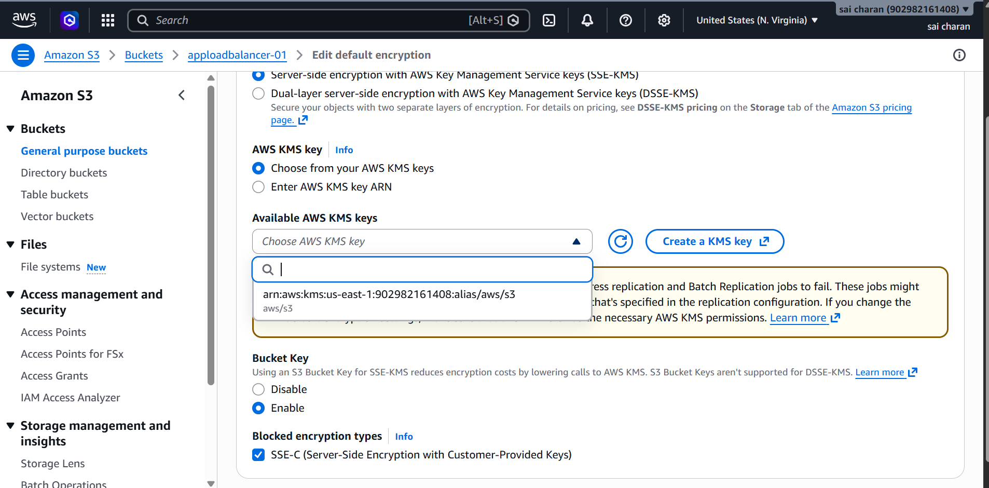

Now we can use this key for any bucket we want

And select from the available SSM-KMS keys

