Setup a virtual machine using Ubuntu image

Install using ubuntu iso image and virutal box application

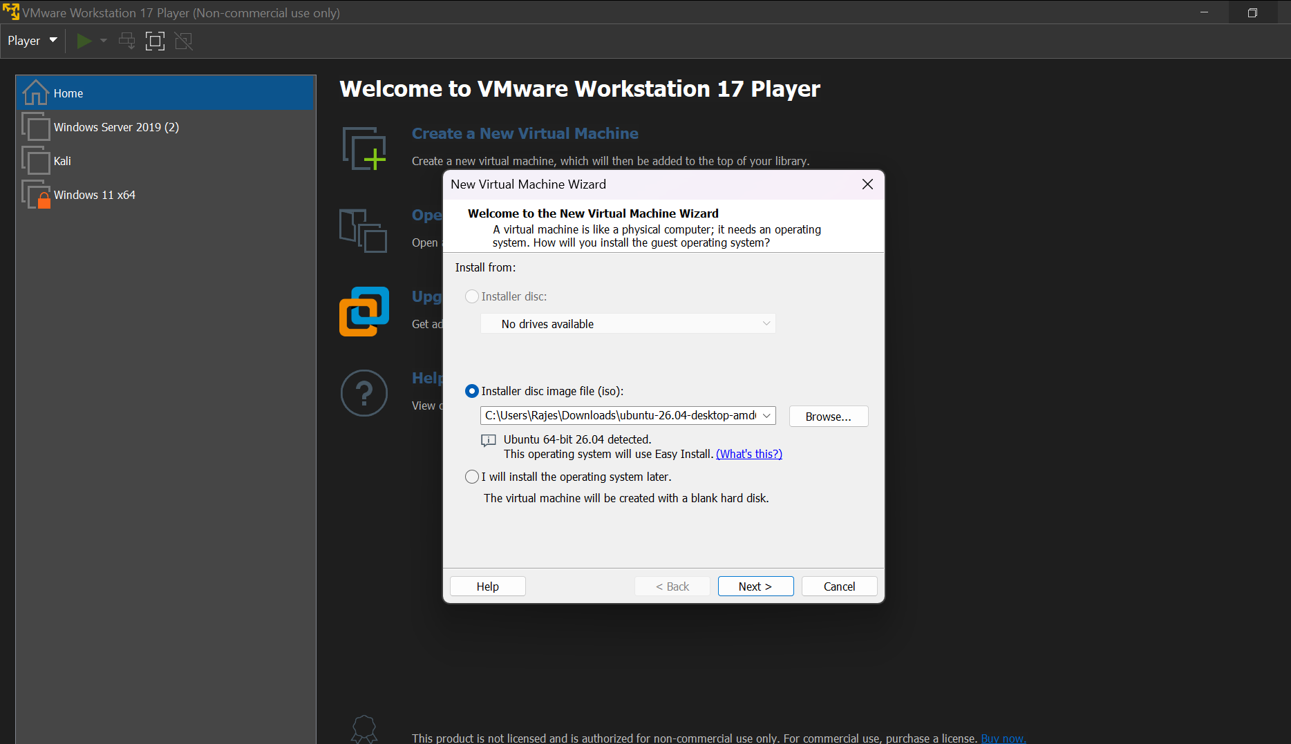

I have given 2 core cpu and 20gb memory

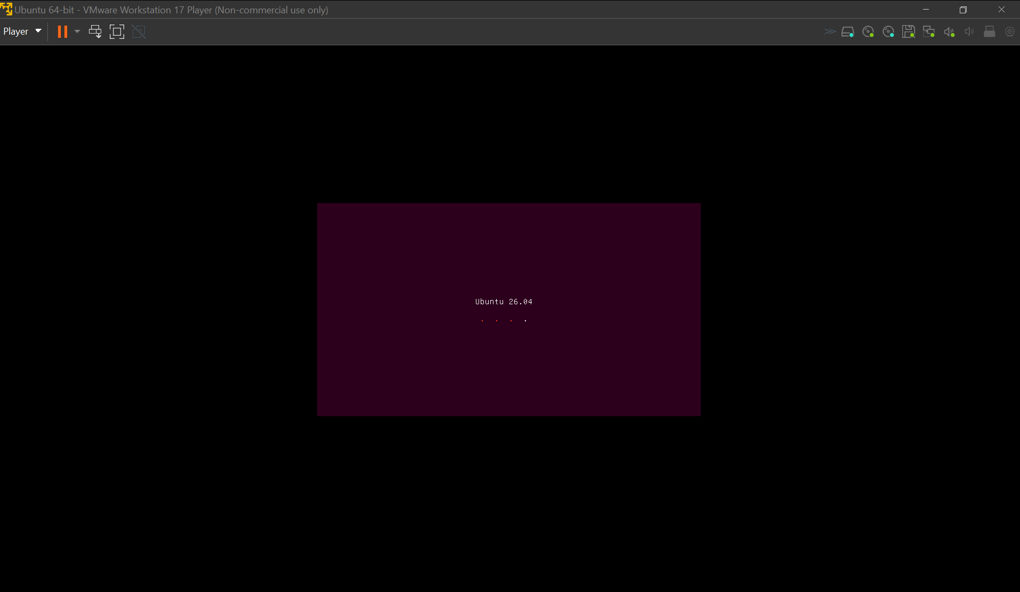

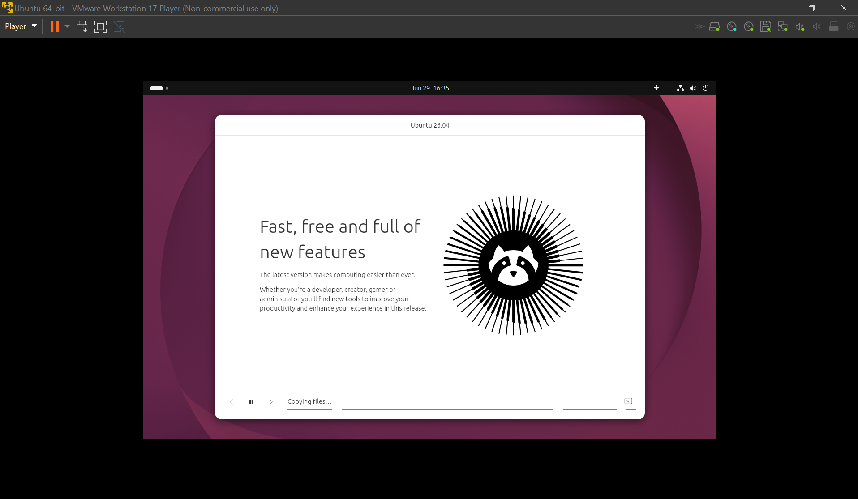

Install docker on ec2

Creating a new instance and downloading docker service in the instance

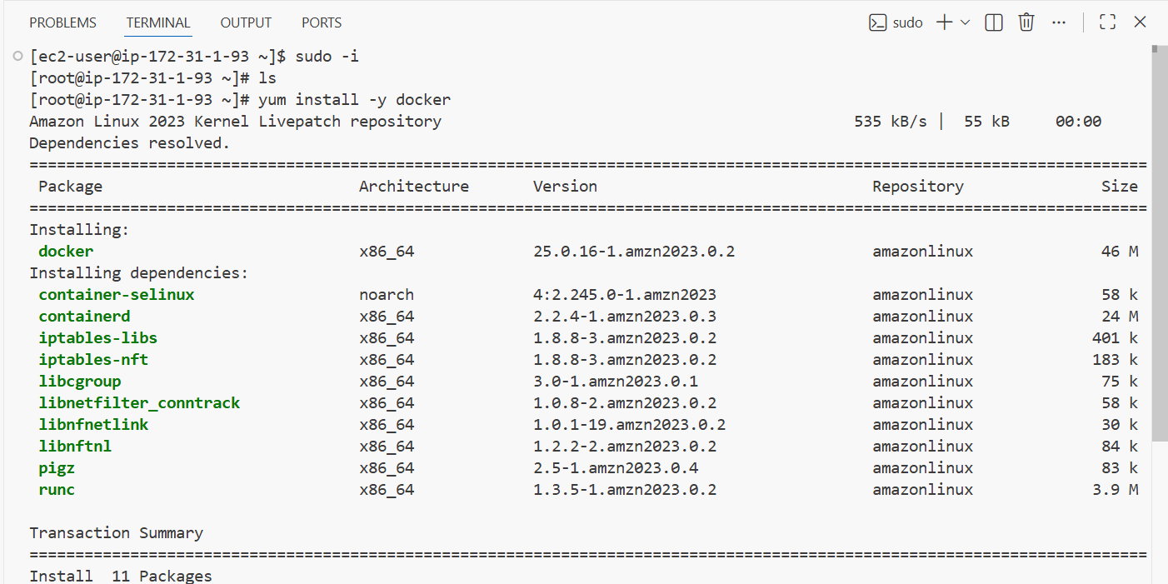

I have installed docker using yum install docker in an amazon linux os instance

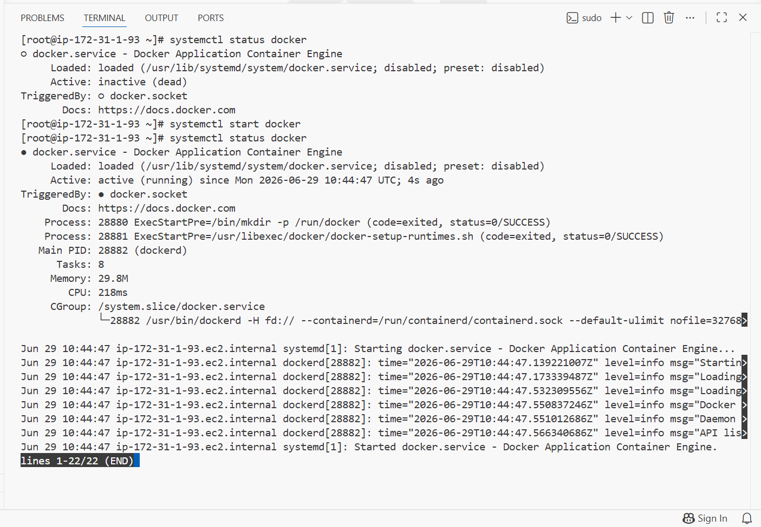

Installed docker successfully and it is running

Pull 5 docker images. (nginx, Apache tomcat, ubuntu, Jenkins, SonarQube)

Using docker pull I will be pulling above 5 images

Docker pull nginx
It installs the latest nginx image availabe in registry
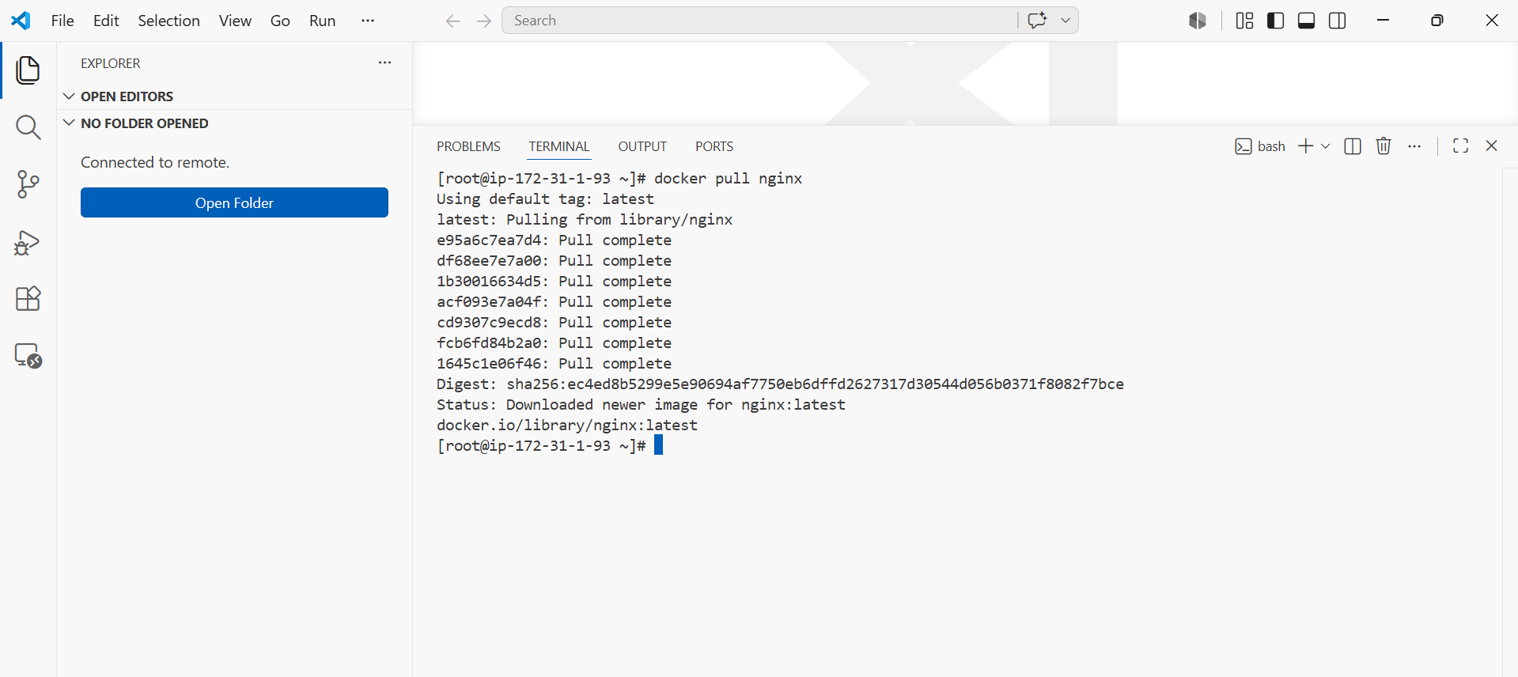

I have pulled tomcat 9 version image by using

Docker pull tomcat:9

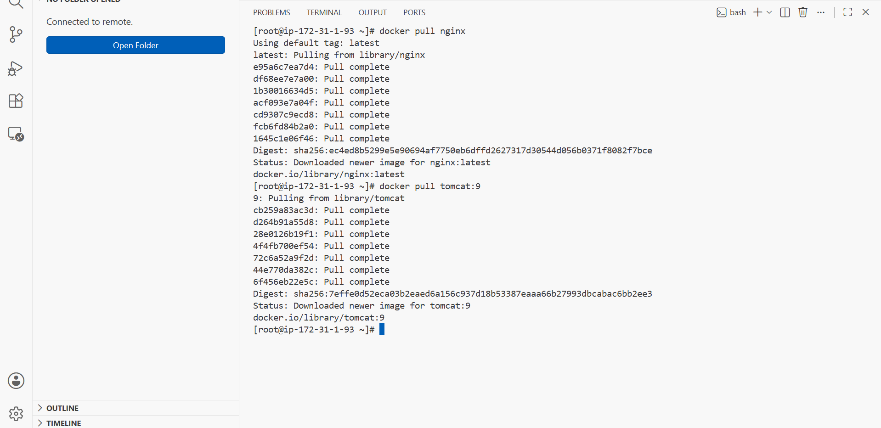

Docker pull ubuntu

It installs the latest image available in registry

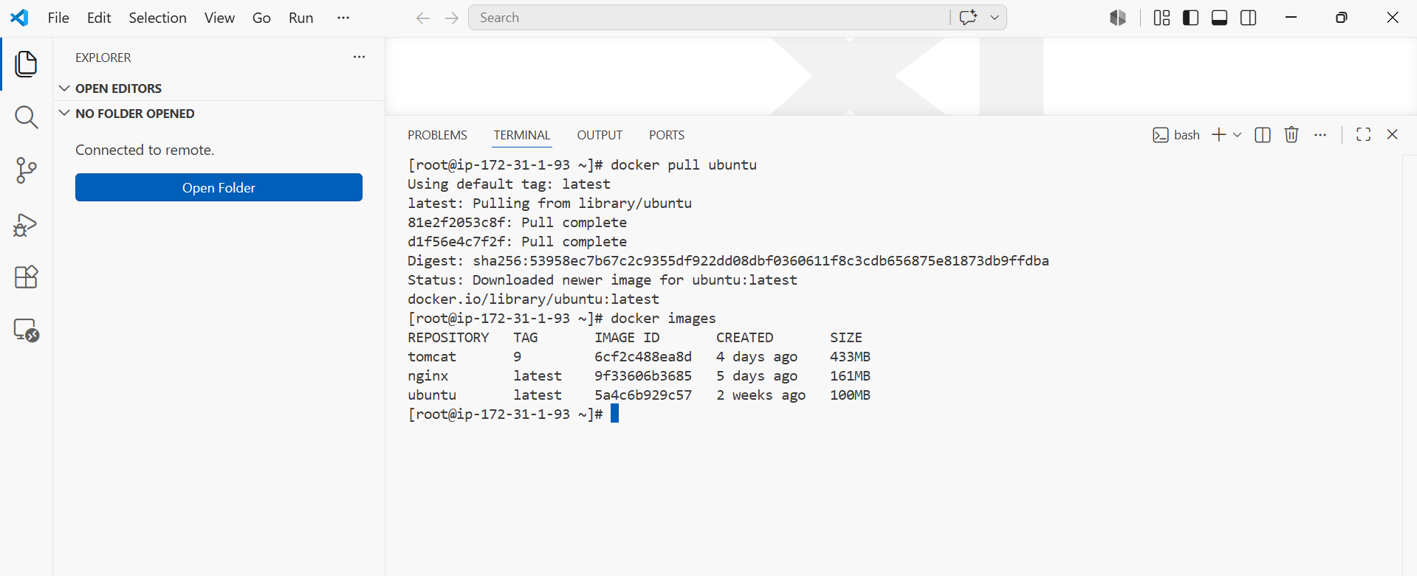

For jenkins the latest tag version is not available in registry

We need to check in docker hub which version tag is available and pull thhat with the same tag name

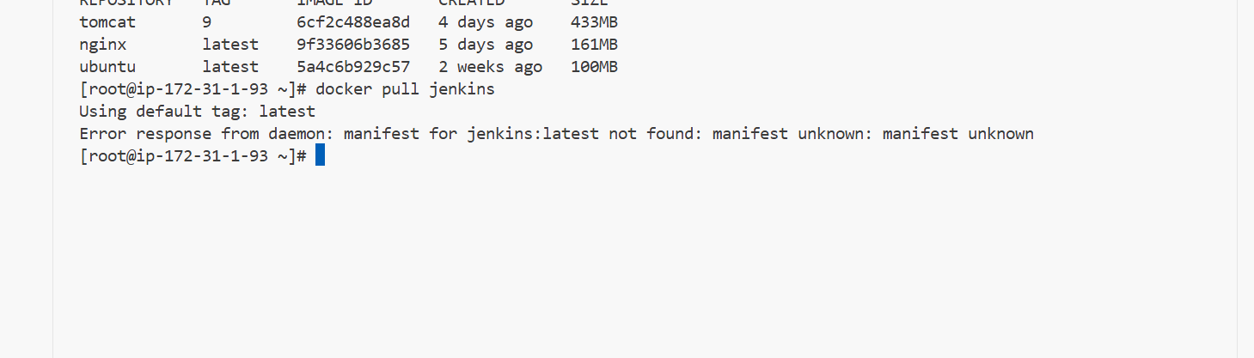

We need to see which version is available with tag in docker hub

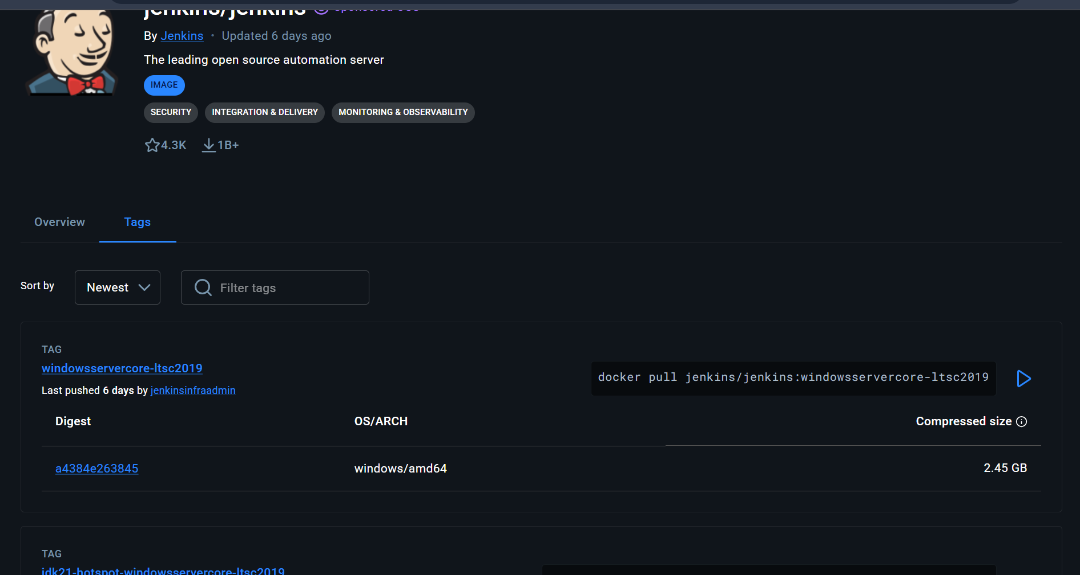

The below version is compatible to linux and is latest so I will be pulling this image from dockerr registry
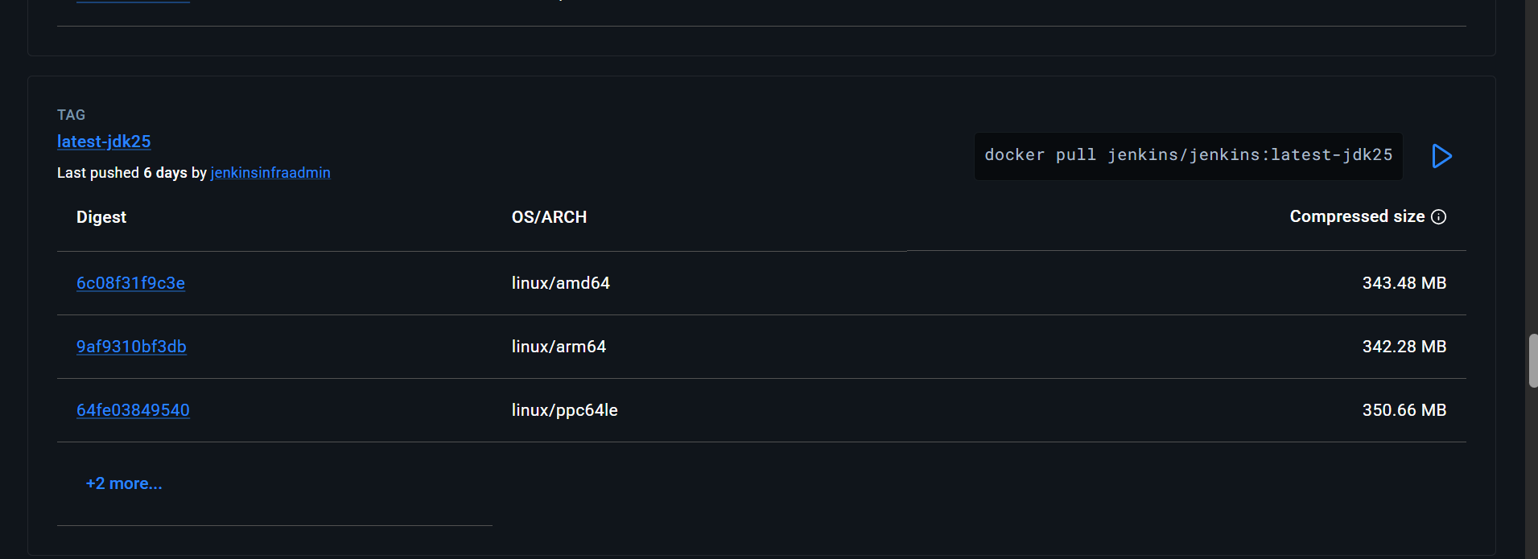

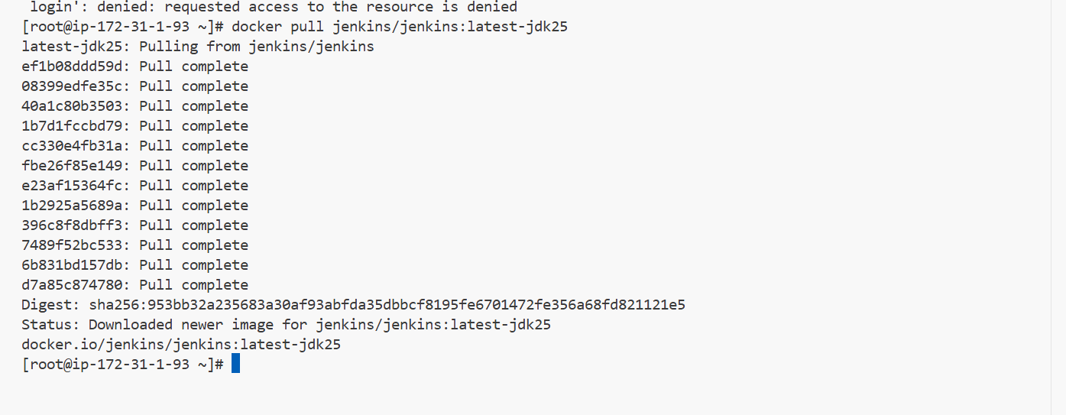

Docker pull sonarqube

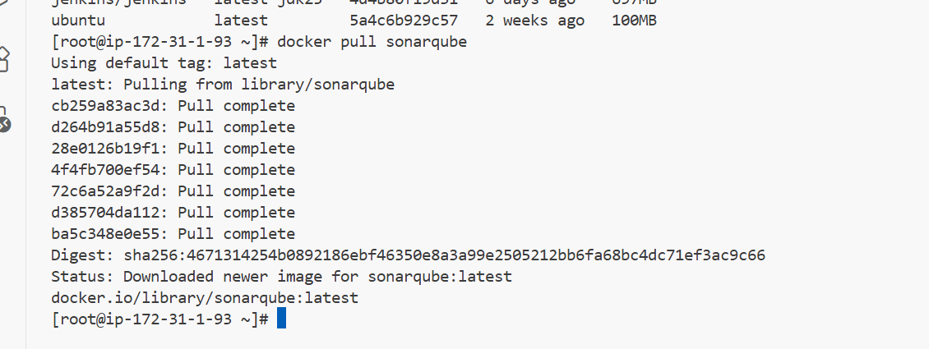
Run nginx container and expose on port 81

We have downloaded thee nginx image a from docker
And I will be running a container from the nginx image

I have used

Docker run -itd -p 81:80 nginx

To run the container from the image

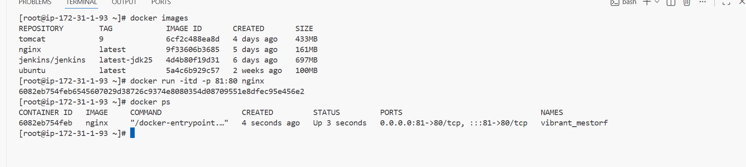

We can see nginx is up and running

By using inspect I can also see the nginx ip and that ip is specific for the container

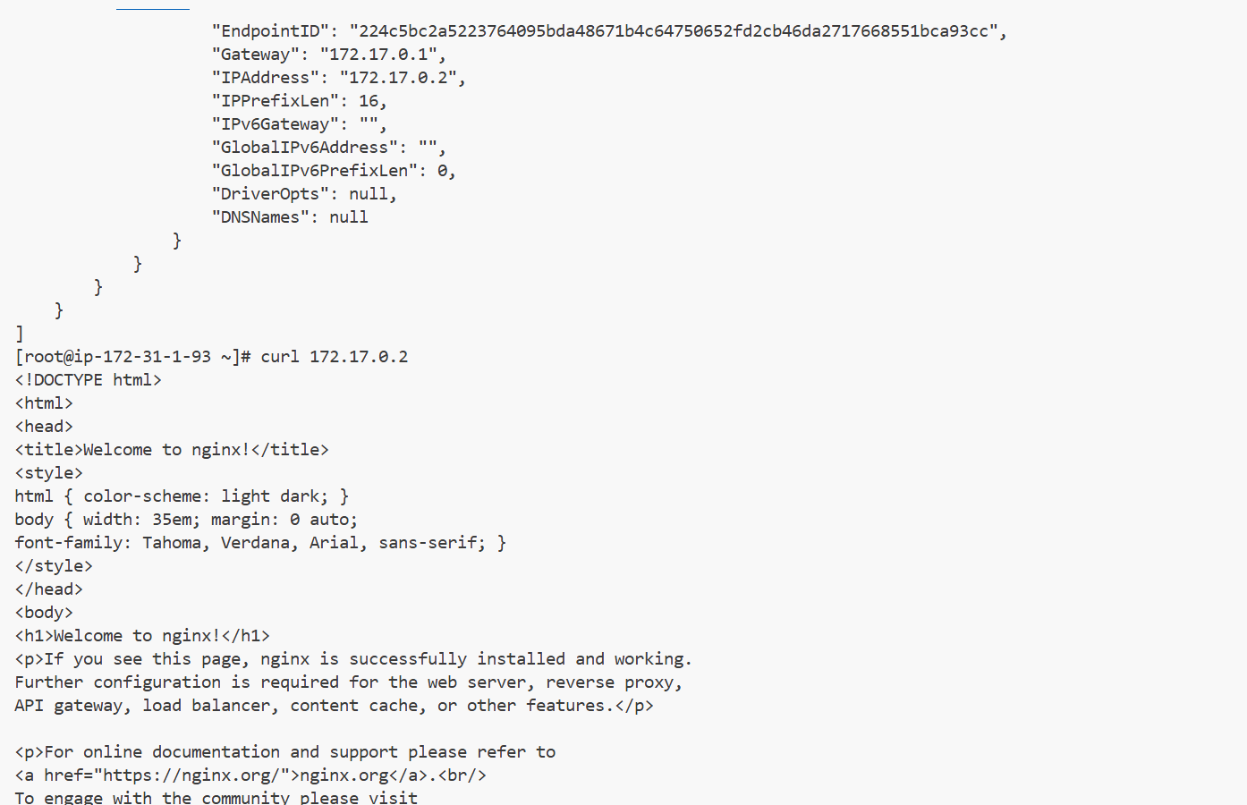

We can see nginx in browser using instance ip:portnumber

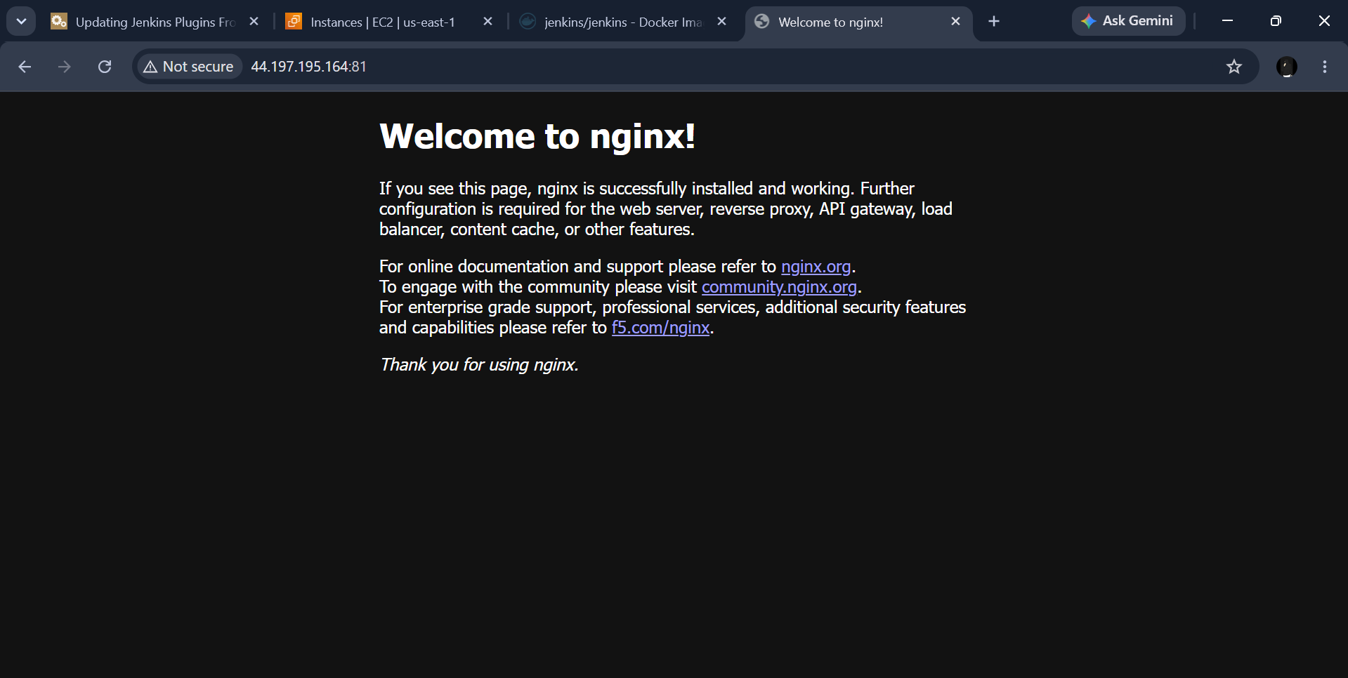

Delete the Apache tomcat image from local

I have previously downloaded a tomcat:9 image and now I will be deleting the image

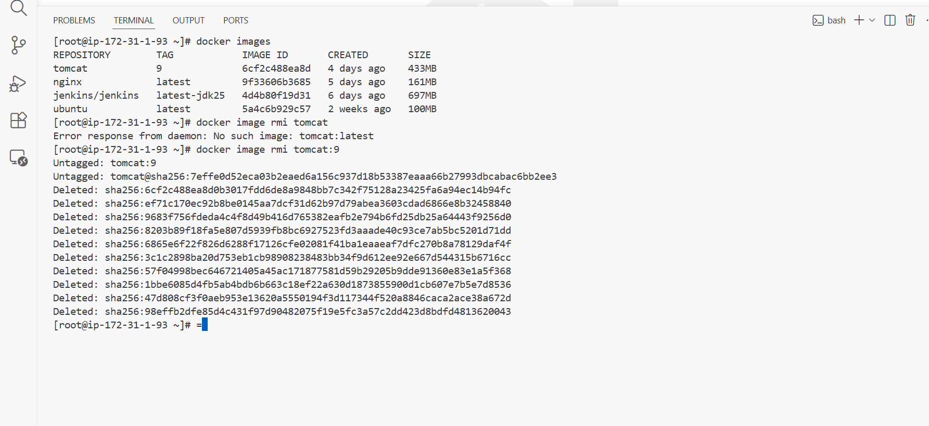

I have used syntax

Docker image rmi tomcat:9

Here tomcat:9 is tag of tomcat image

And we can also use

Docker image rmi imageid

Inspect the Jenkins image, SonarQube image

By using inspect we can see details of the images

We can also use inspect for conatiners

Docker inspect imageID

Docker inspect containerID

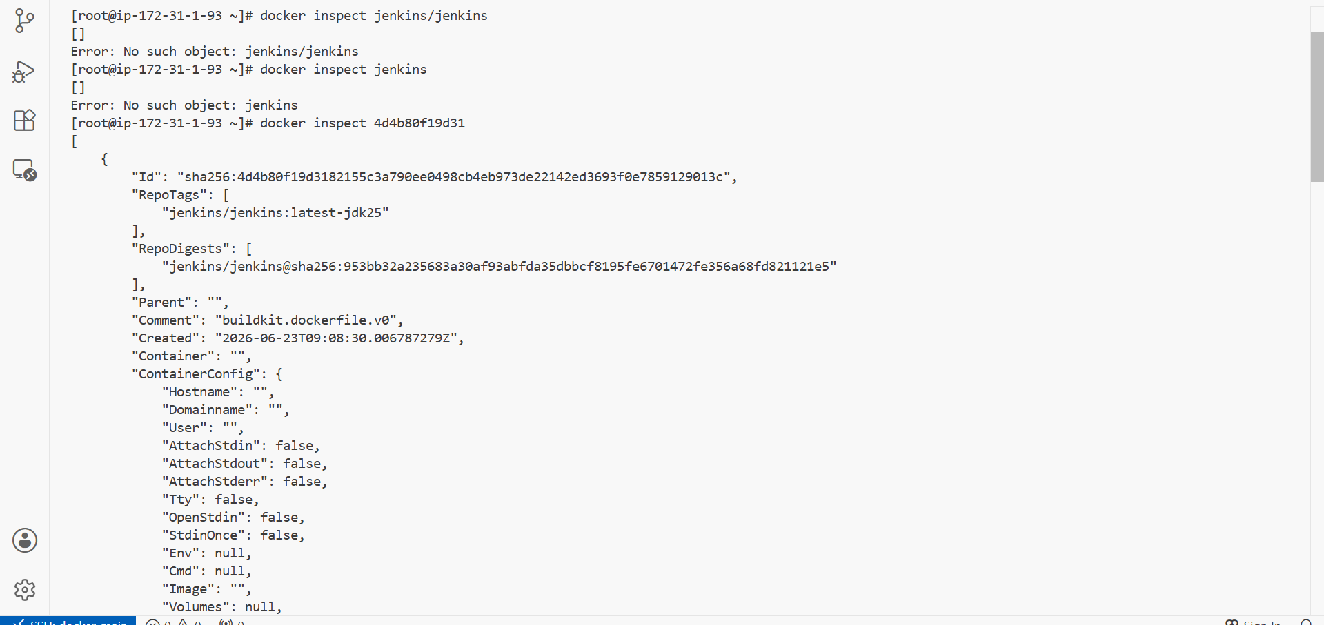

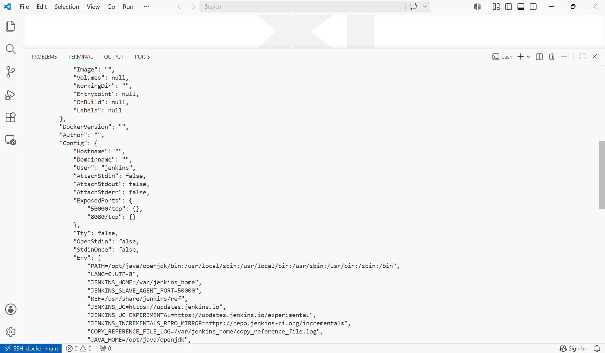

For sonarqube

Docke inspect sonarqubeimageID
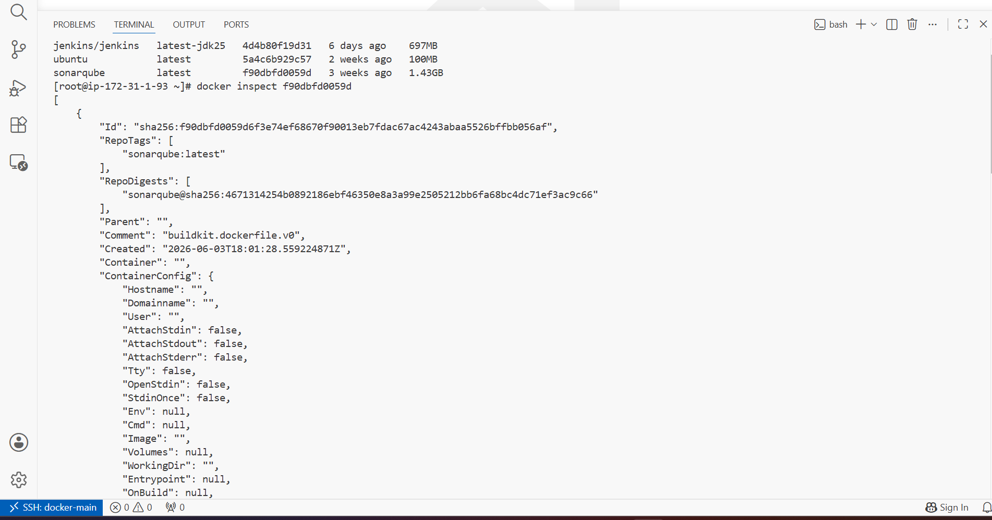
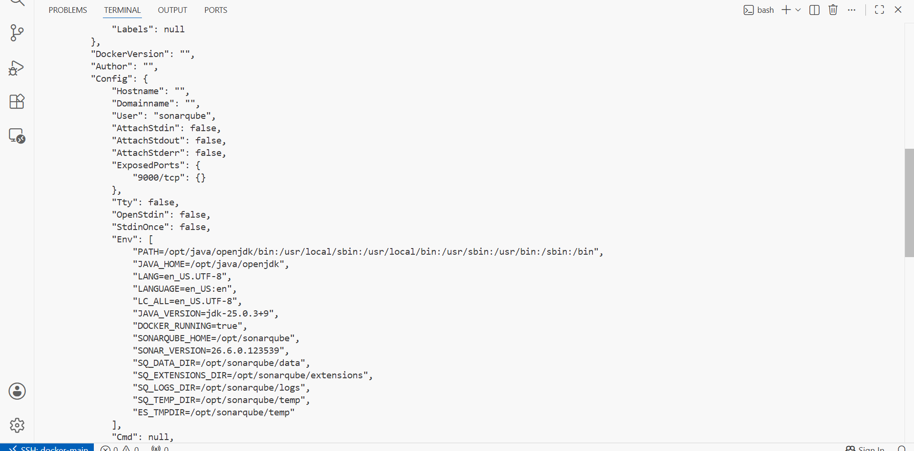

Run Jenkins container and run one sample job

As I already have an jenkins image I will be running a container image

Docker run -itd -p 8080:8080 jenkins or imageID

I have used syntax

Docker run -d -p 8080:8080 --name jenkins-container imageIDofjenkins

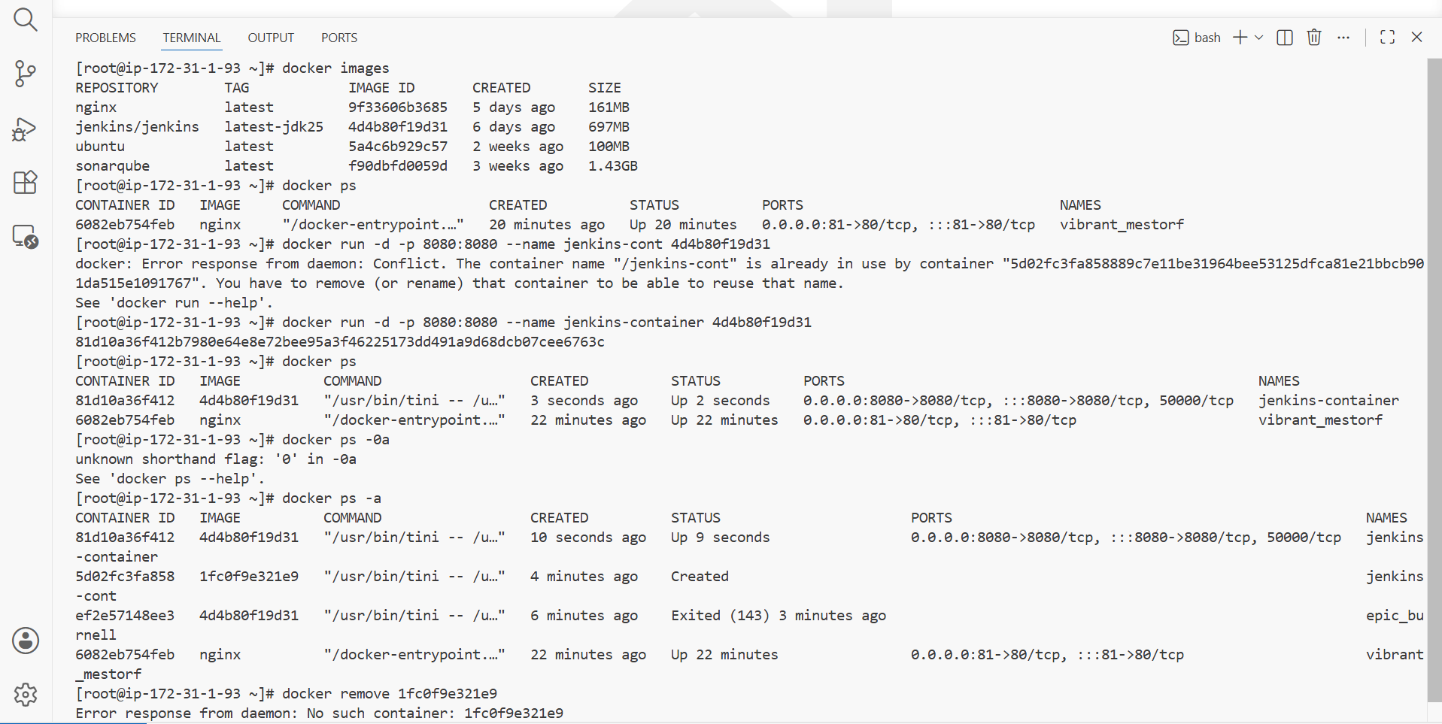

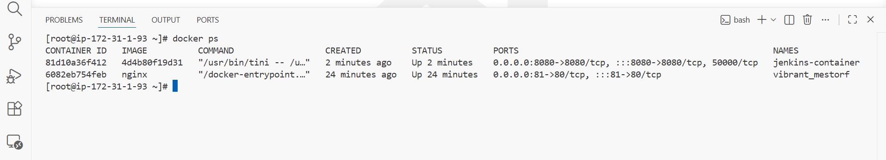
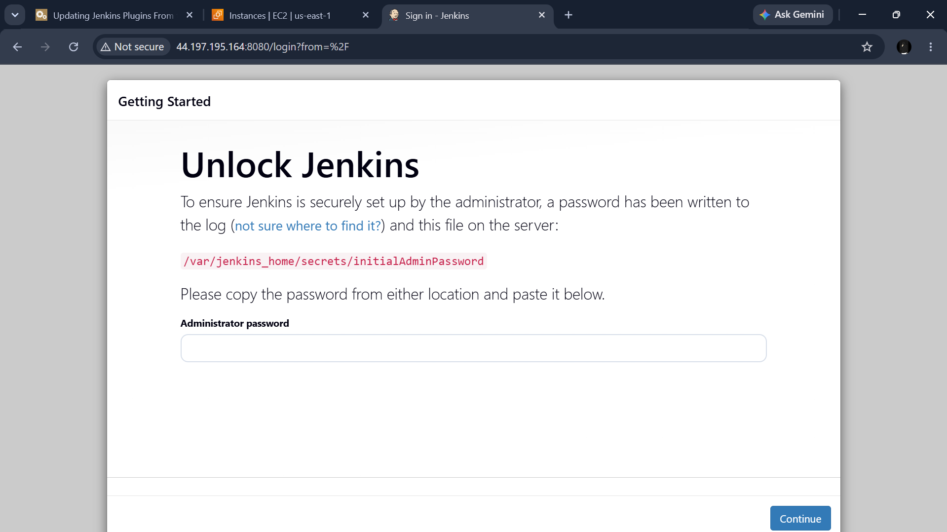

Now the setup can be seen

But to get password we need to enter into the container

To enter into the container I have used syntax

Docker exec -it containerID bash

-it === interactive terminal

Container id

Bash === to run the bash commands inside the container

If bash Is not supported then we can sh

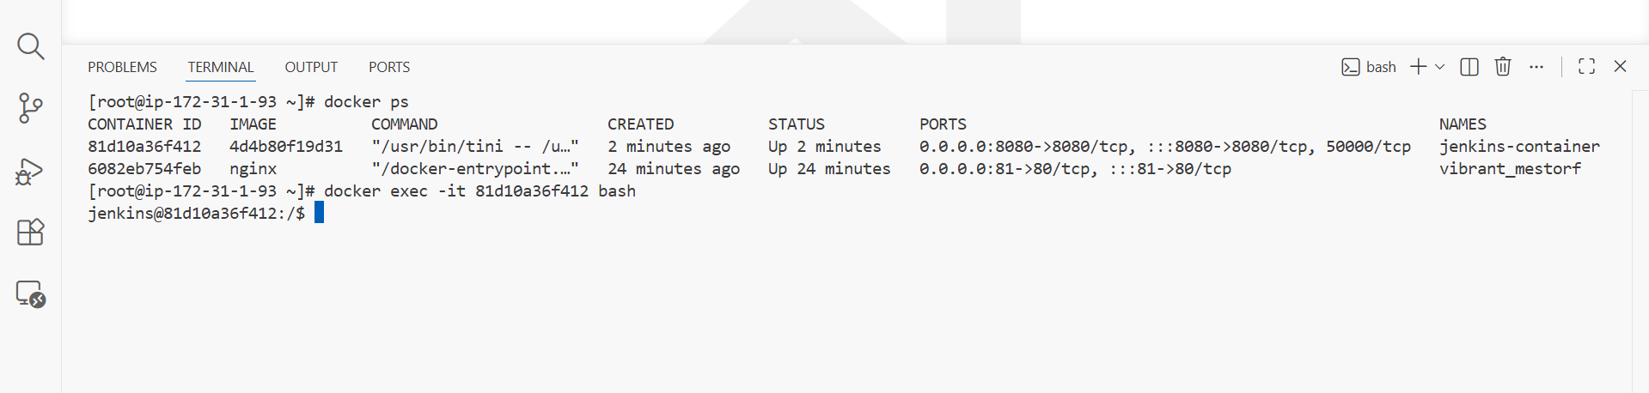

Now we can get the secret initial password and enter into jenkins

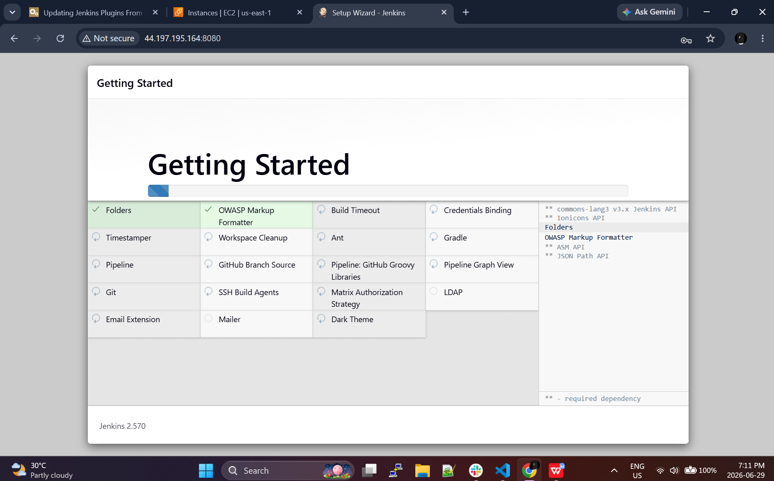

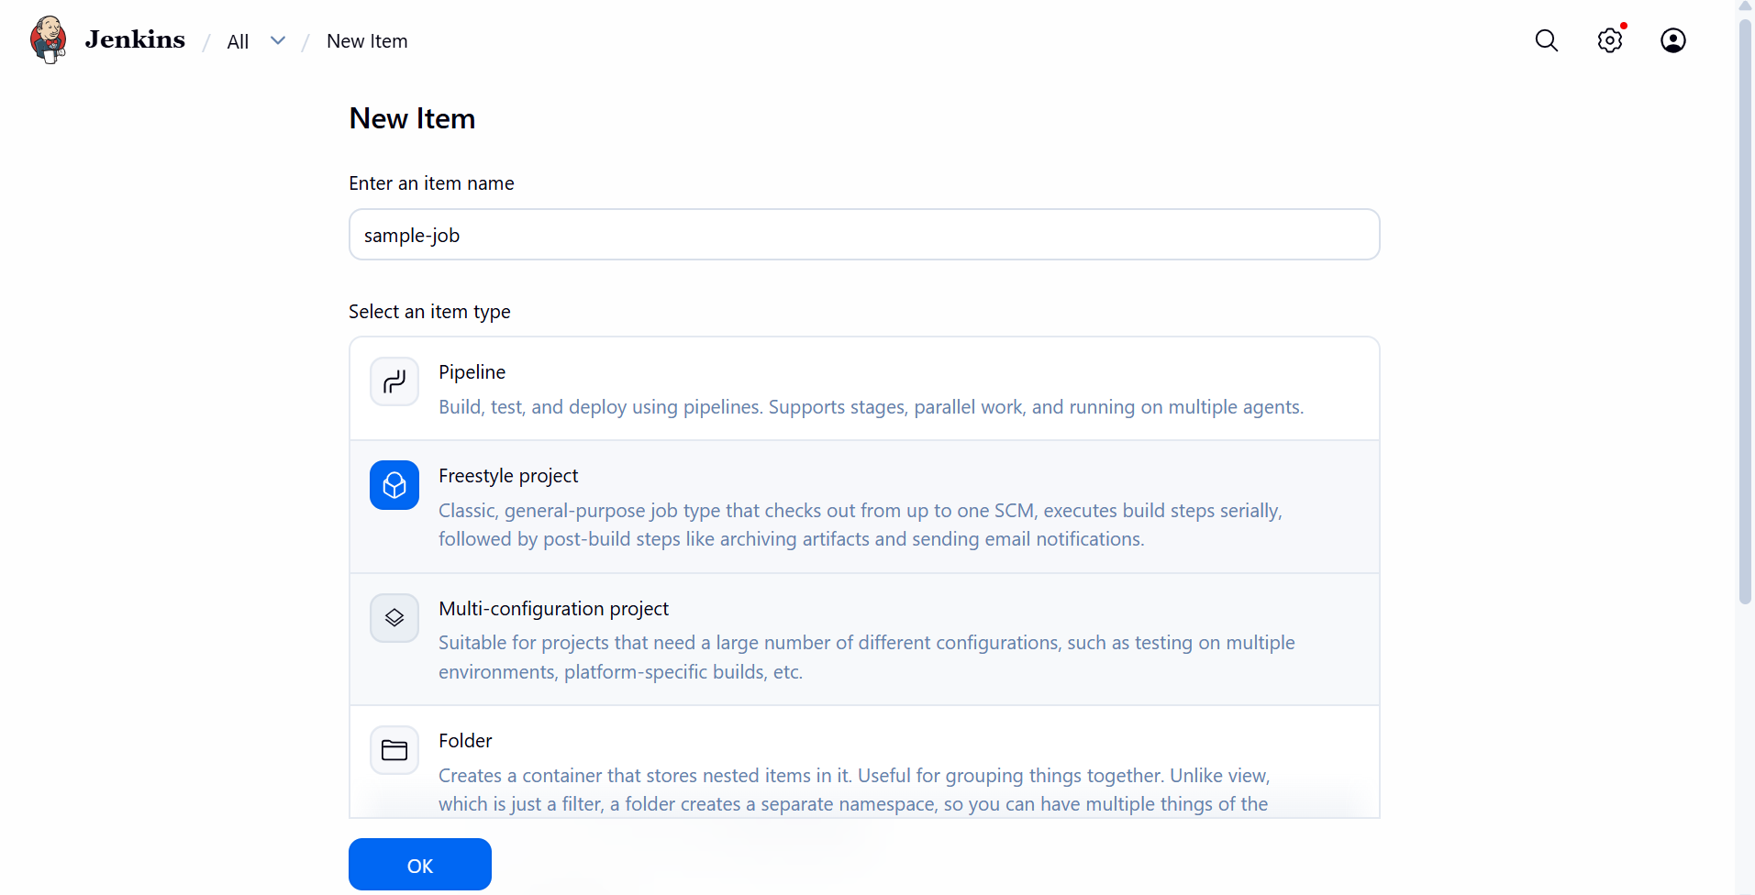

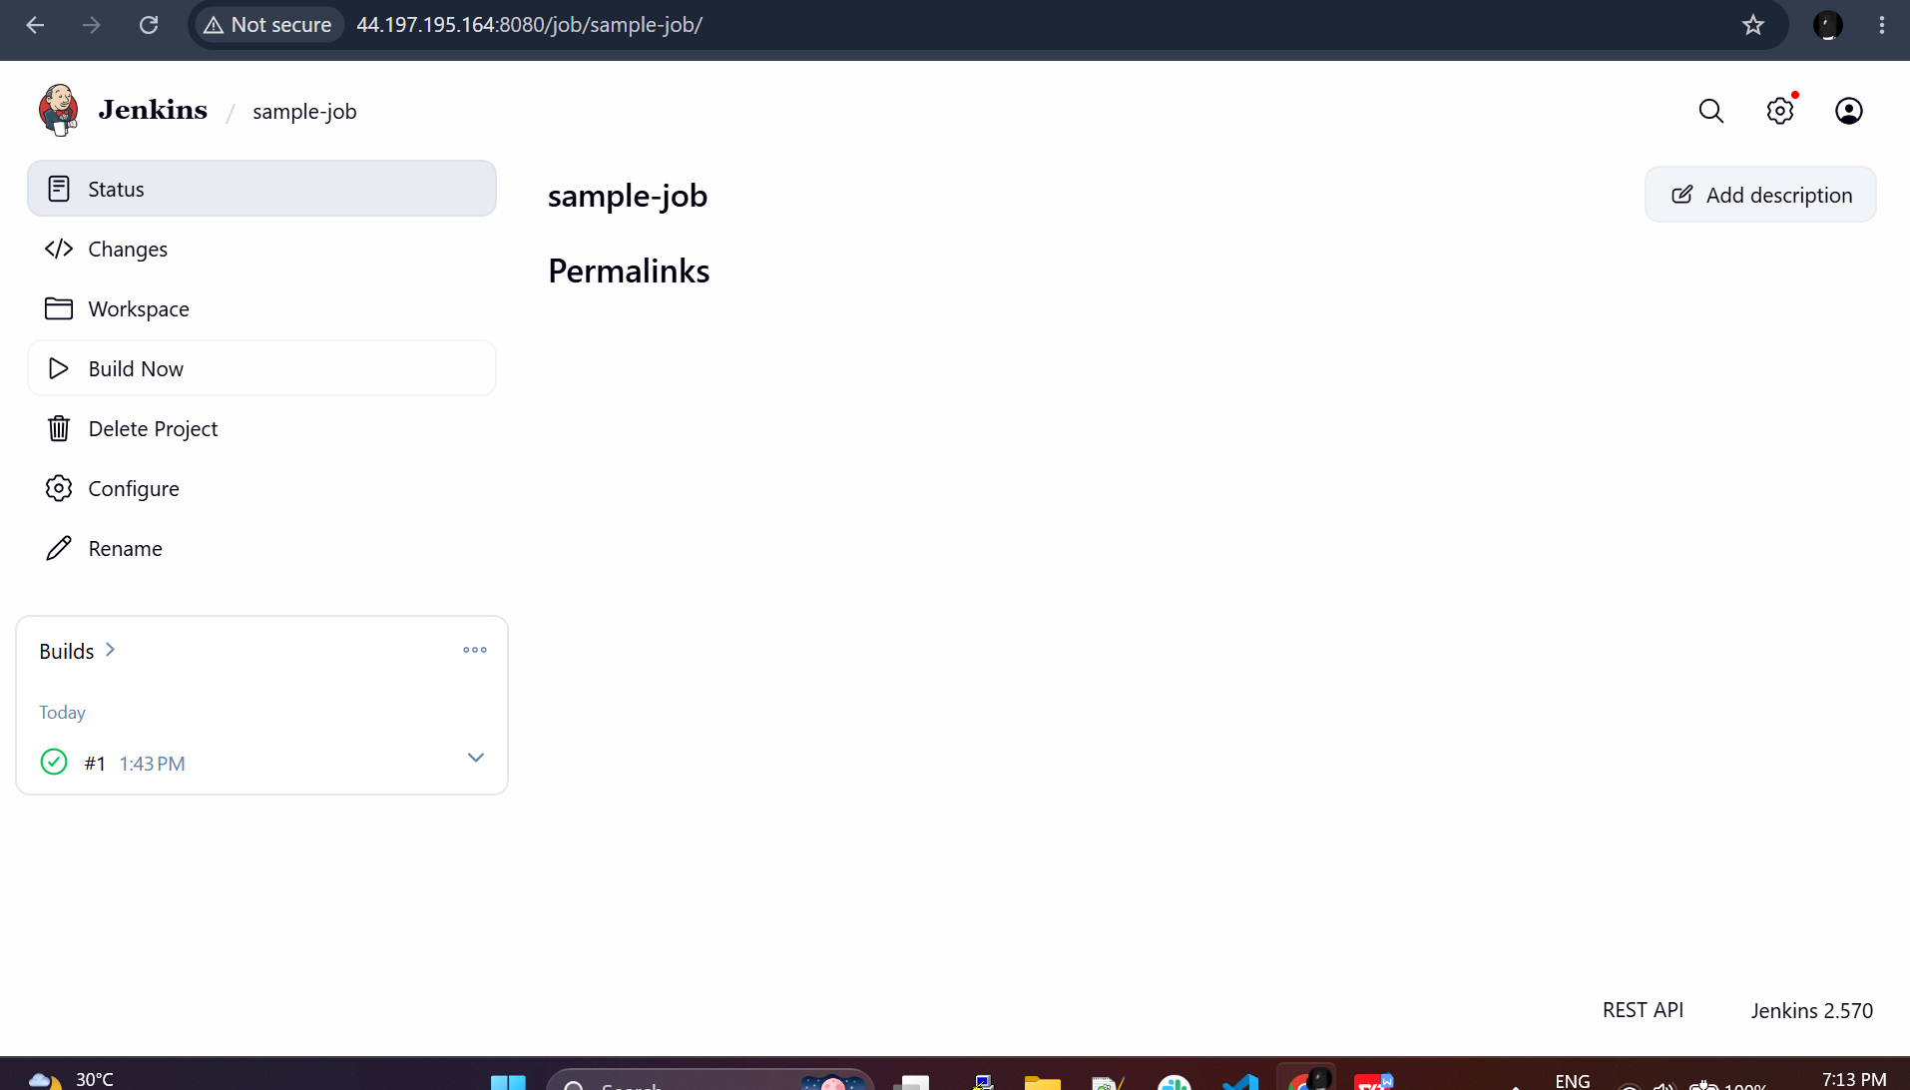

A sample job has been build and it was successfull

