Create a image from running container

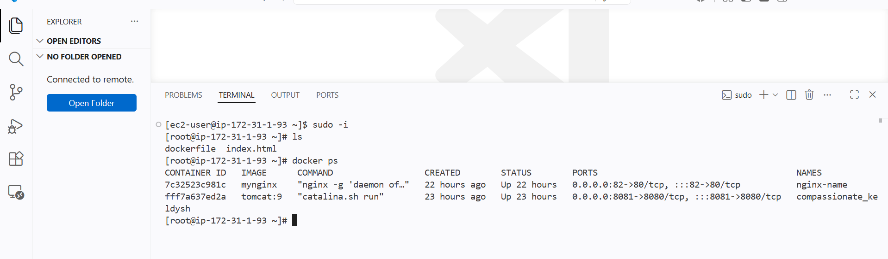

I have running containers now I will create image using this container

Syntax

Docker commit CID
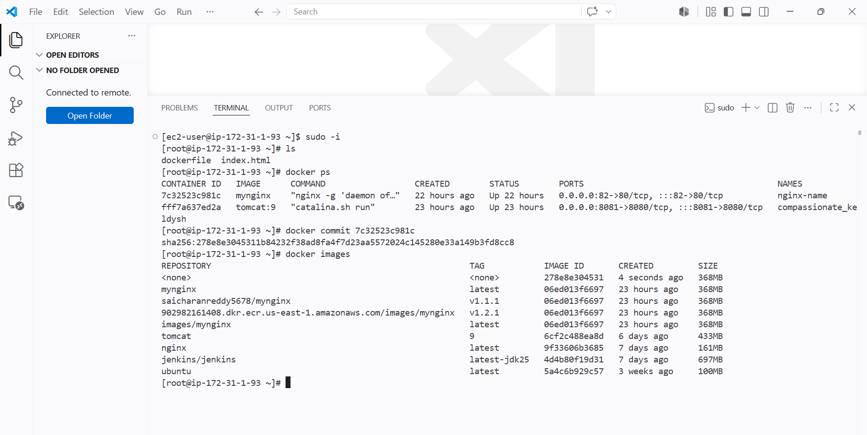

We can see new docker image has been creating with name none from a container

We can rename the image if we want by using tag

Copy image from local machine to docker server and load the image

Now If my docker machine does not have access to the internet

We can scp the tar file of a image

Then in server we can untar and it will create a new image without the internet

Now I will create a docker image in desktop and sent it to the server

For this I need to have docker desktop insatlled to pull images in windows terminal

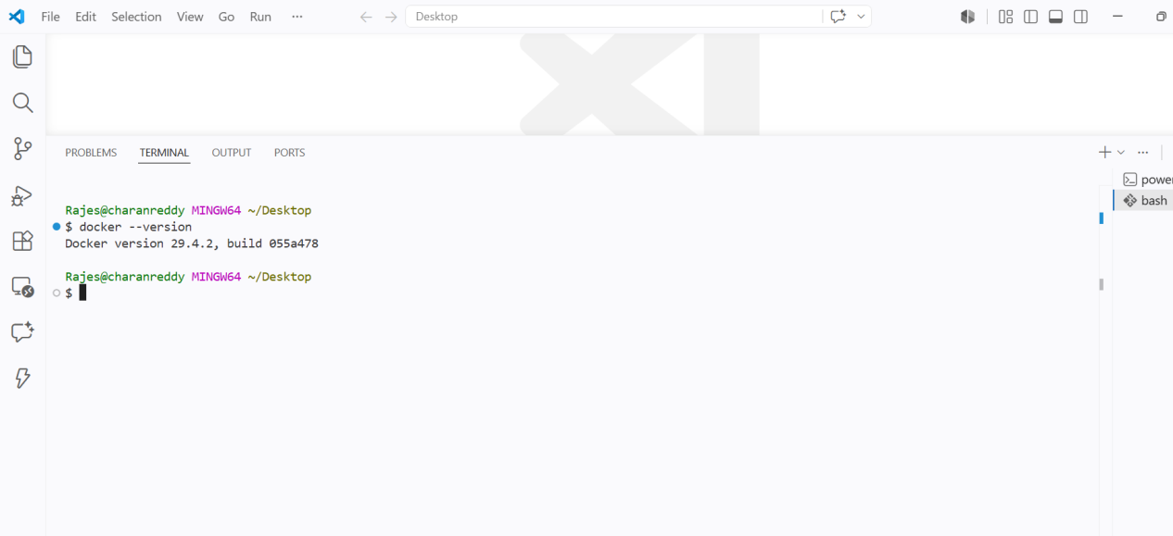

First we need to see if docker is available or not in terminal if it is available then pull the image and do tar

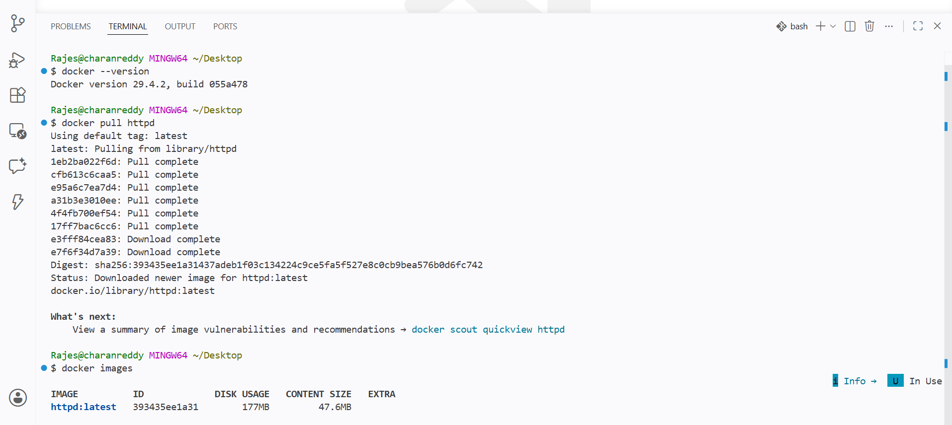

Then use the syntax

Docker save -o name.tar imageid or name

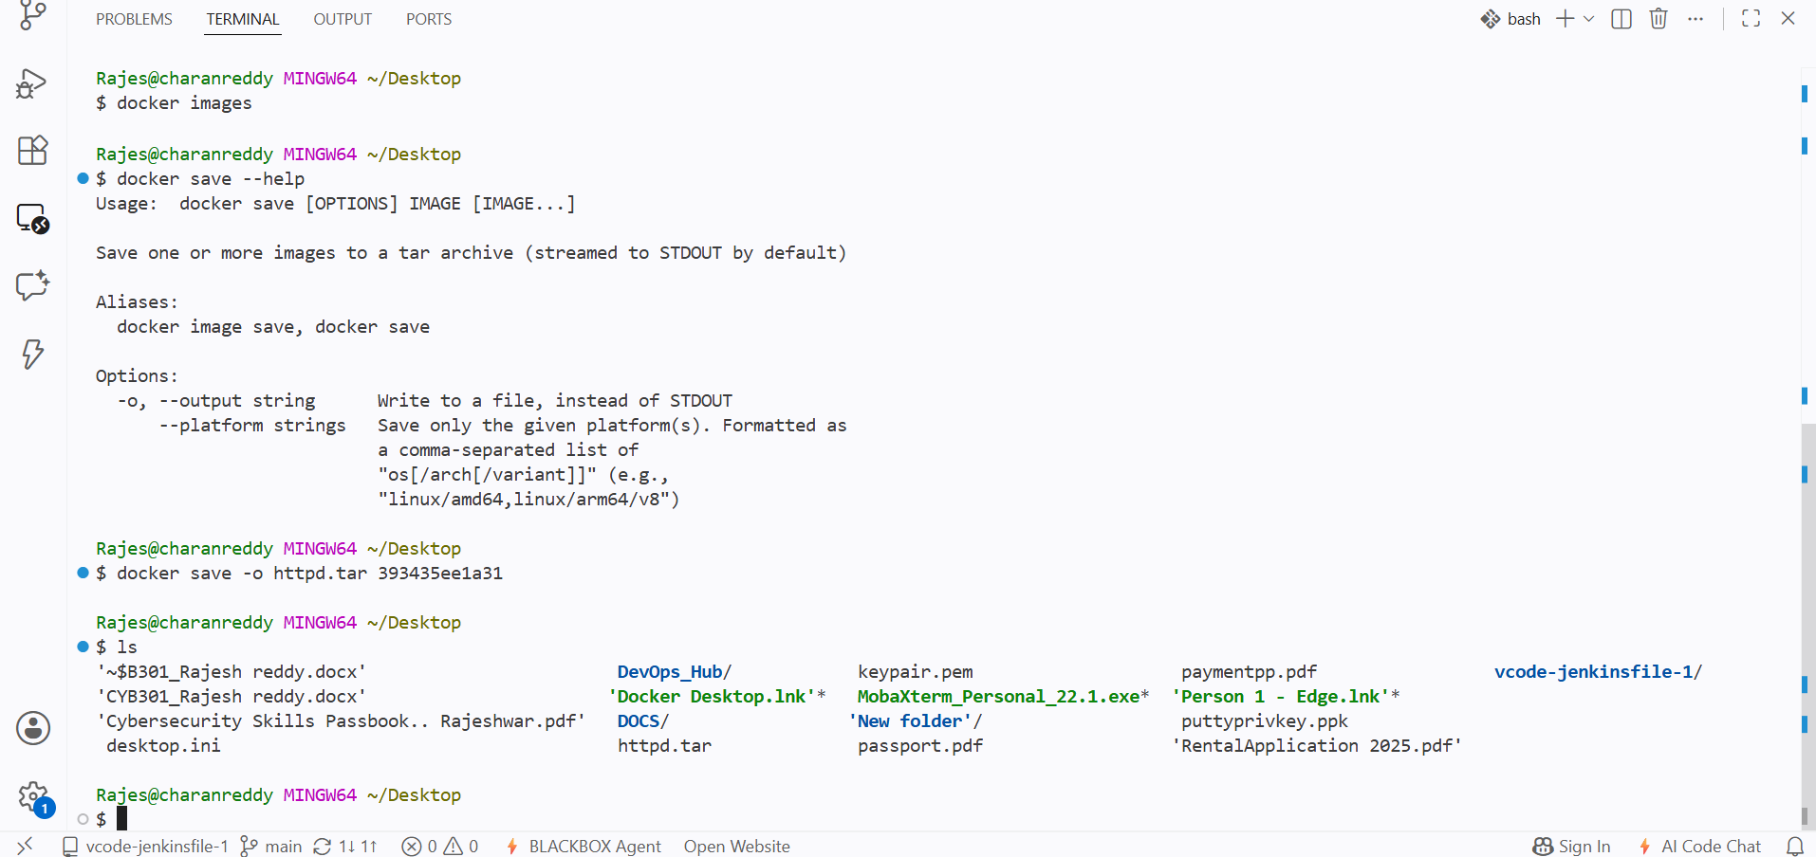

Now scp to the server

I have sent this file to tmp location in server

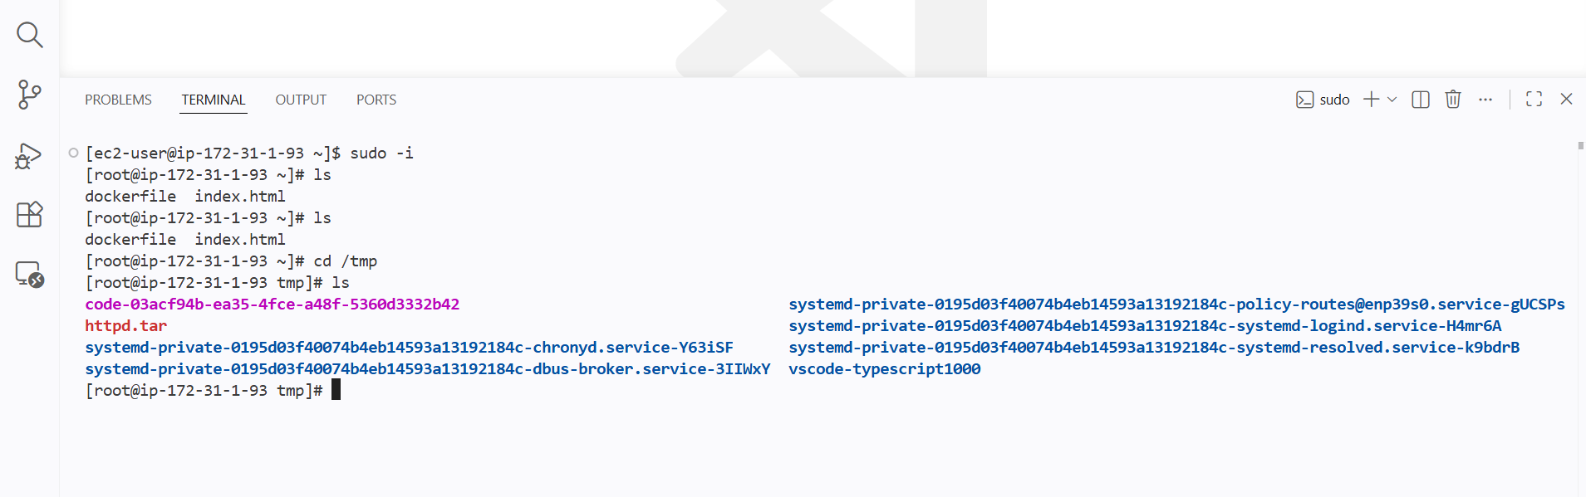

We file has been copied

Now I need to create image from the image tar file

Synatx

Docker load -i tarfile

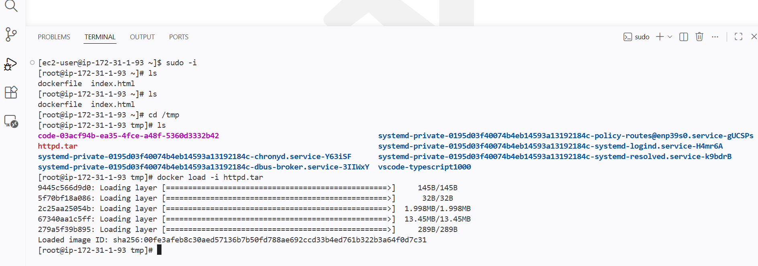

The image has been created from the file that has been copied from local

Create Docker image using alpine and customize with tomcat

Using alpine the image will be less in size

I will be writing the docker file
And the base should be alpine

I will be mentioning my workdir of tomcat
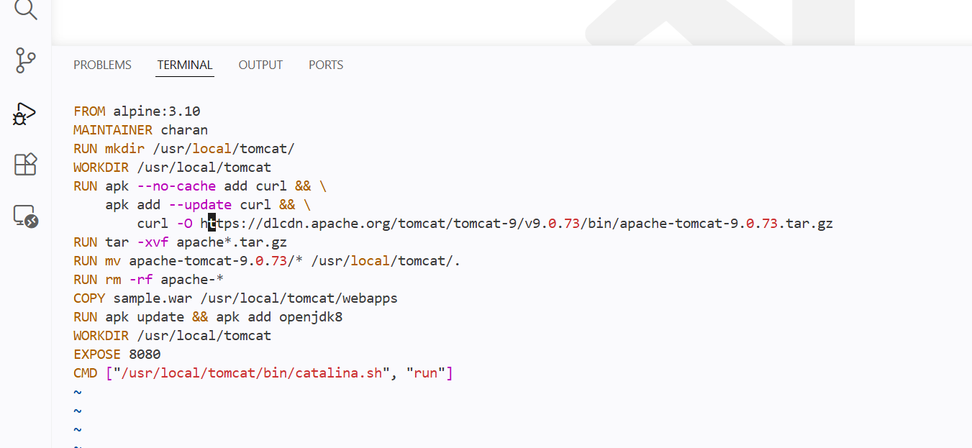

To directly run the docker file of tomcat image I will be mentioning the sample.war in COPY

By this the war package will be directly stored in the tomcat deployment folder

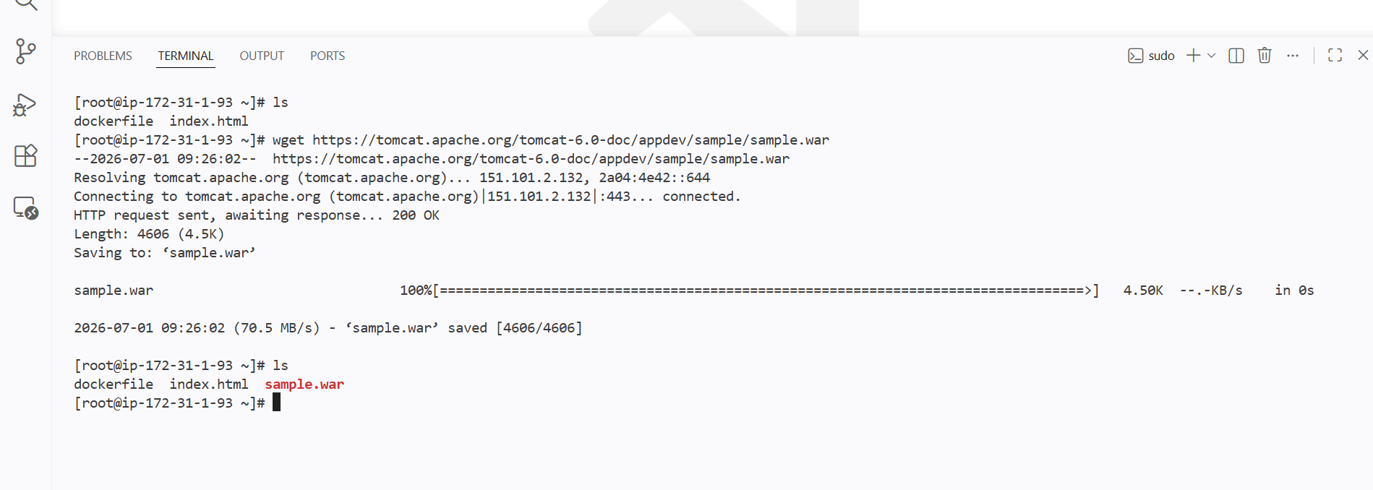

Tomcat image has been built

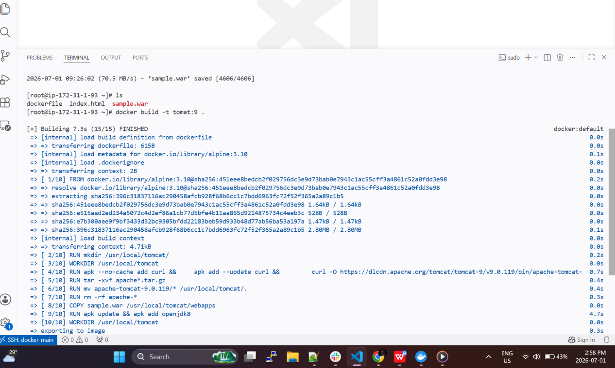

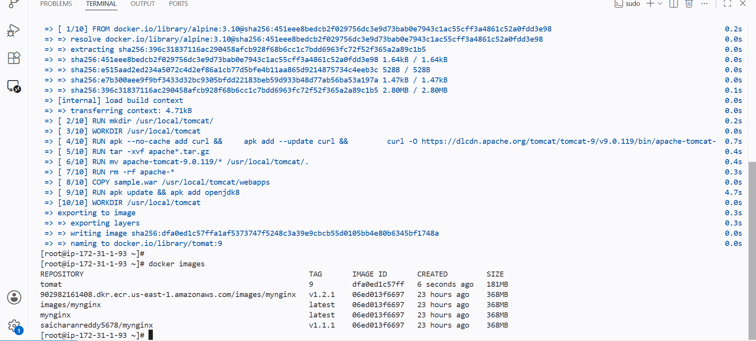

In docker file I have exposed on port 8080

Now run the container and expose port to host port and tomcat war file can be seen in browser

Create single stage and multi stage docker file using this source code: https://github.com/betawins/multi-stage-example.git

First I will be cloning the github repo
To my dir in server and then write a docker file for the source code

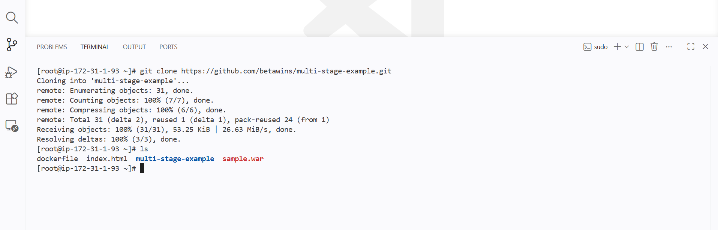

Now I will be writing the docker file

For the source code and creating an image for src

Creating with alpine as base image for size compressionand making it as builder stage

Creating the new directory for the image and making it as workingdir using RUN and WORKDIR
Compiling the code as jar file using mvnw clean package

Now

I will be taking my builder stage as base and copying the compiled source code from the builder stage and copying it to the main stage and exposing it on 8080 and added entrypoint

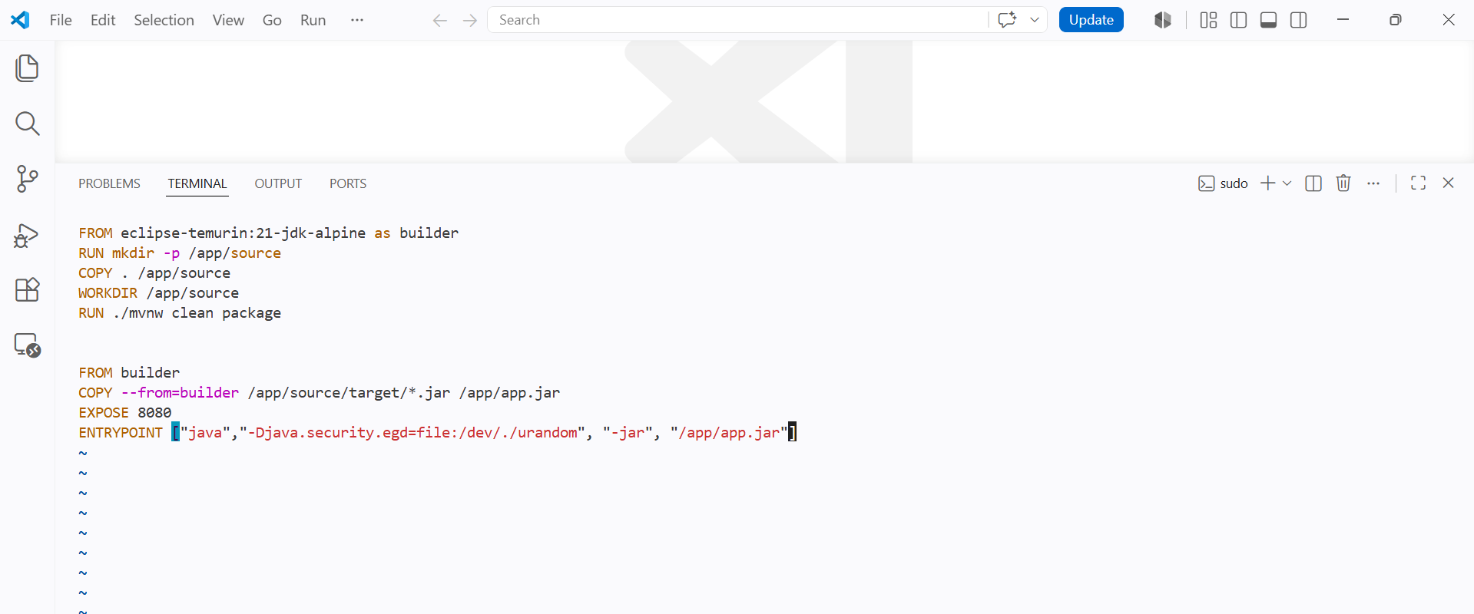

Created a multi stage docker file and built an image

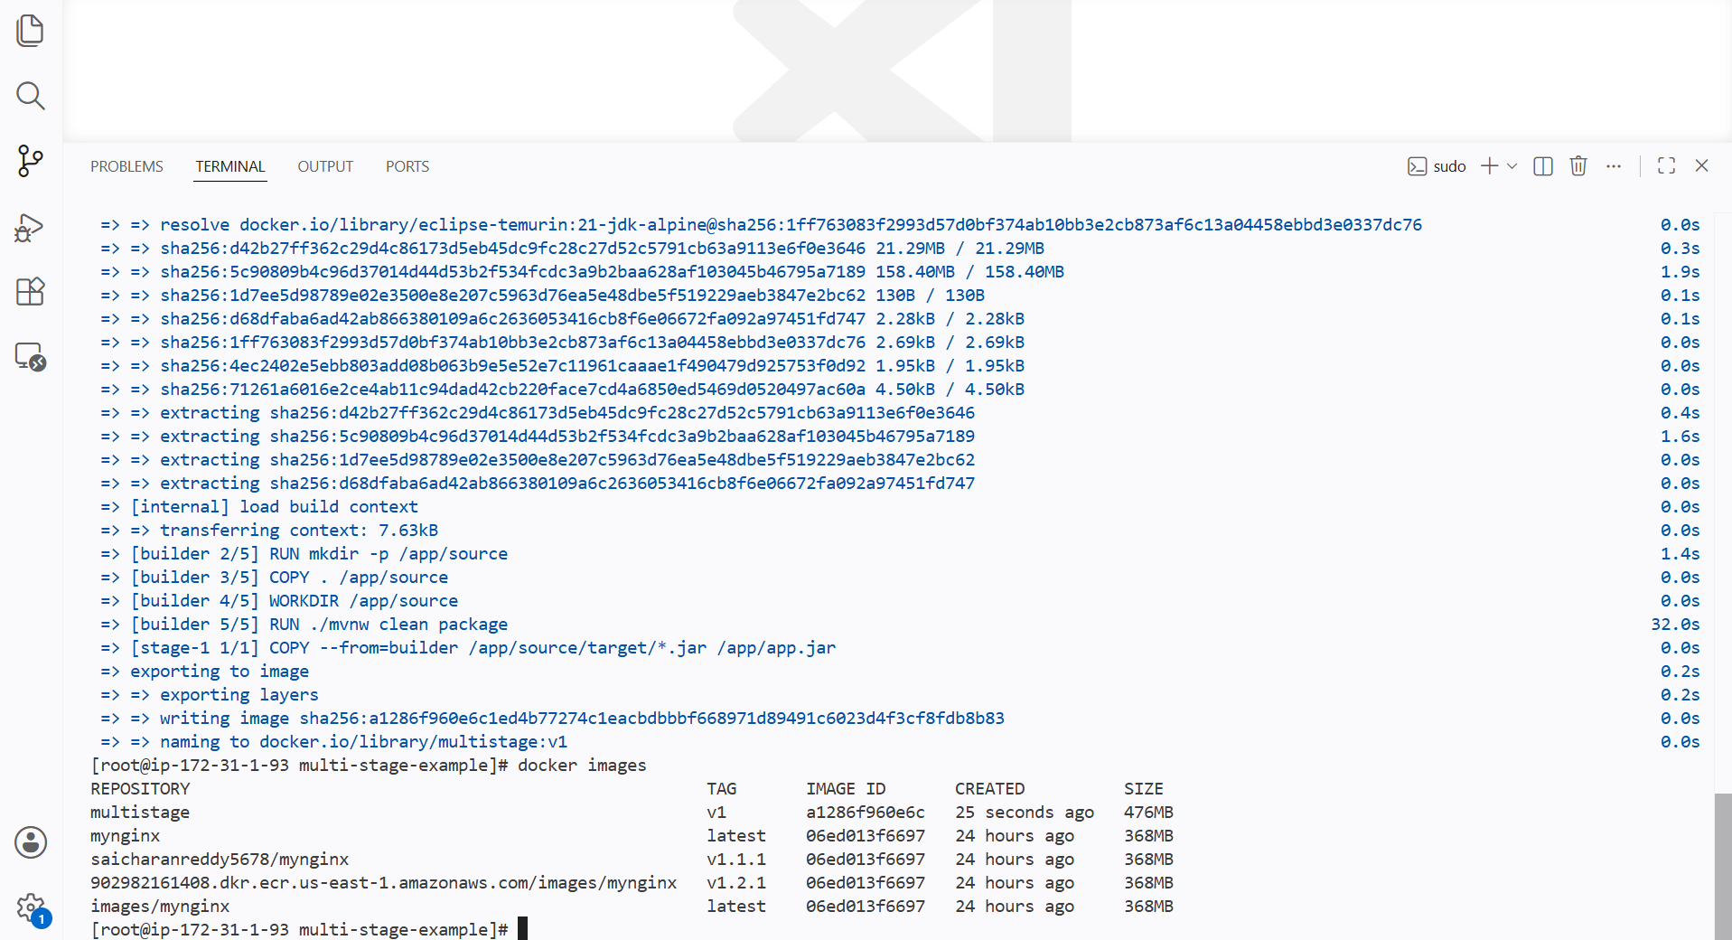

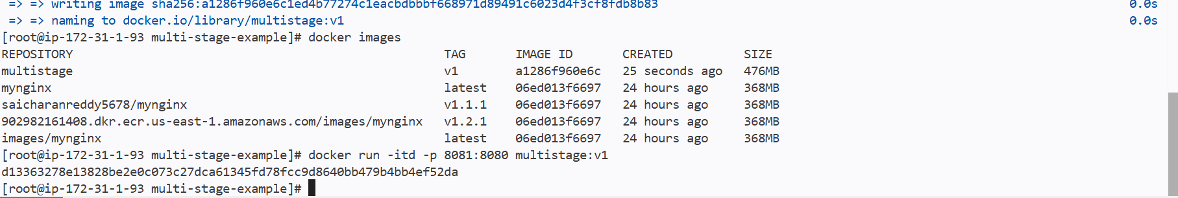
Now if I can run this image container and my jar file can be seen in browser



Same for single stage but I wil be using just only one base module

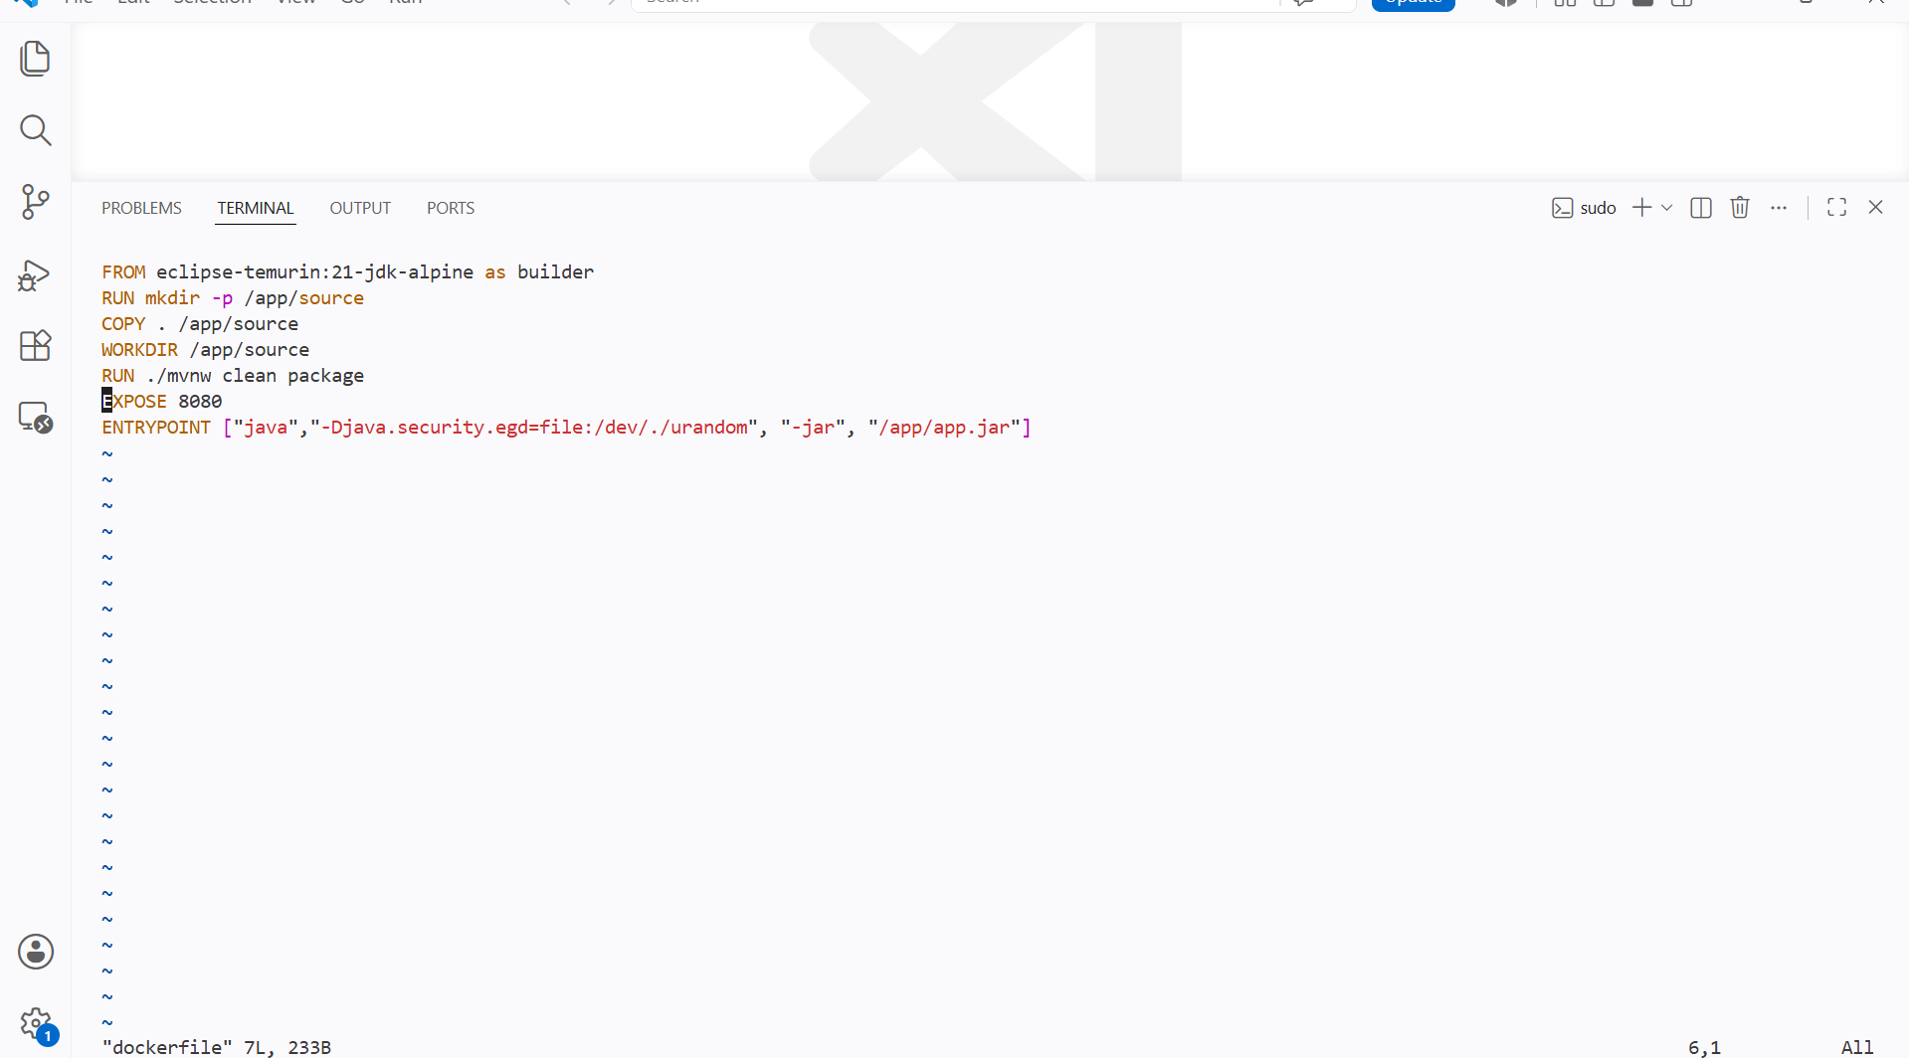

Now the code has been compiled using mvnw and copied to the image working directory

And if we run the container then it will be accessible on host port from mapping with container port

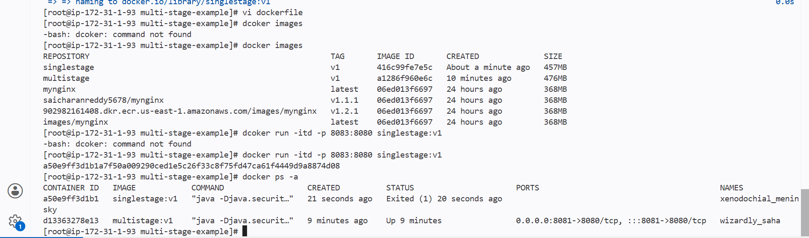

Install docker compose and execute sample application

Compose is used manily for scal in and scale out of containers

the main use case is defining and running a multi-container application using a single configuration file compose.yml or docker-compose.yml

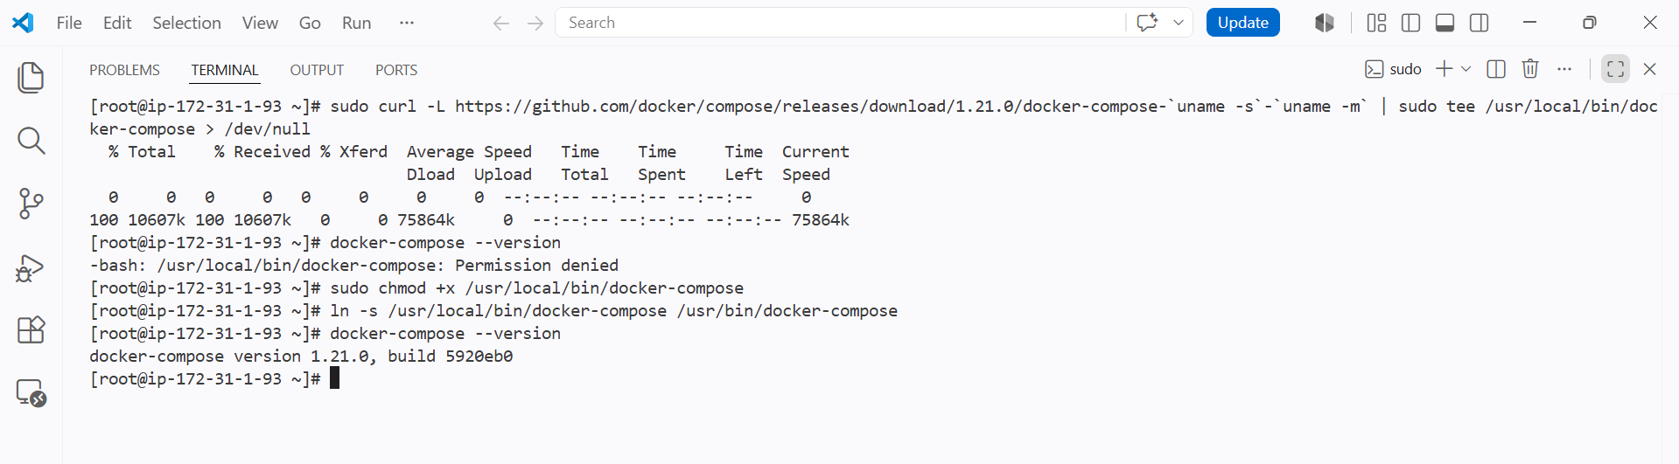

Created anew file named docker-compose.yml

And written an samplefile
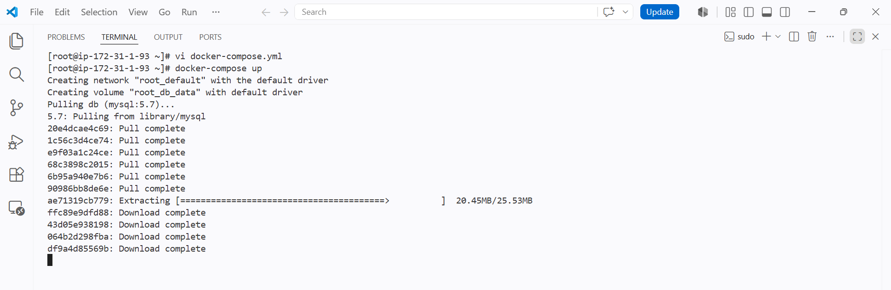

After creating the compose file

I have use docker-compose up syntax

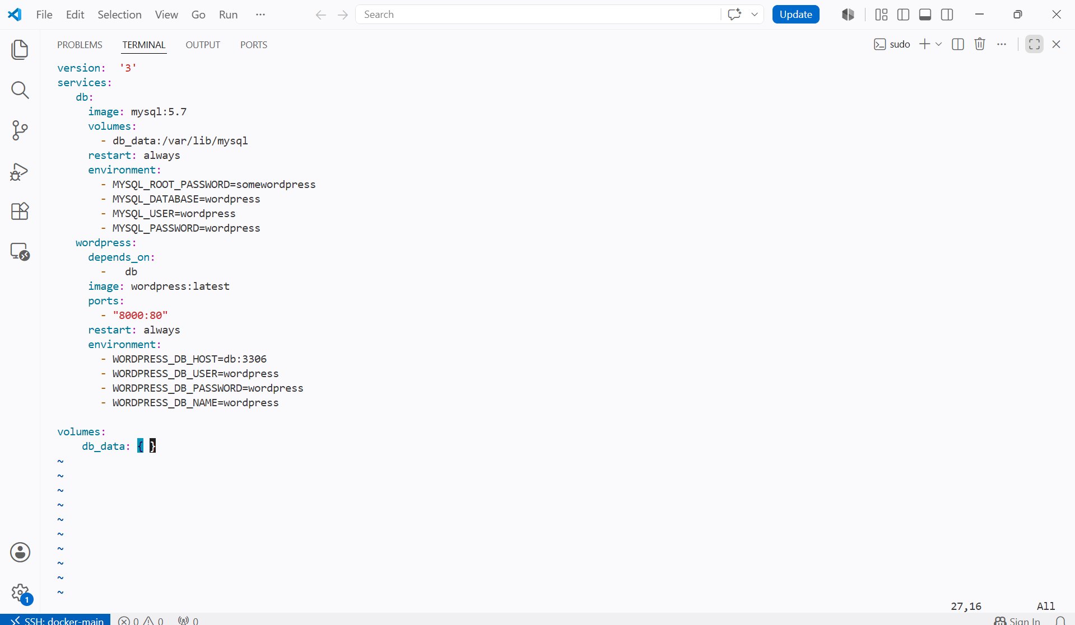

With docker compose up
We can see compose file has been running and container has been created

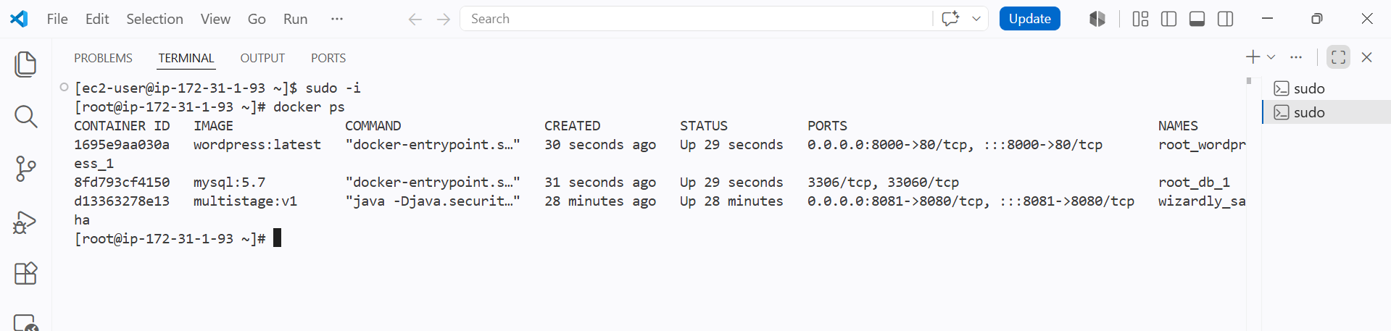

We can see the container is up and running

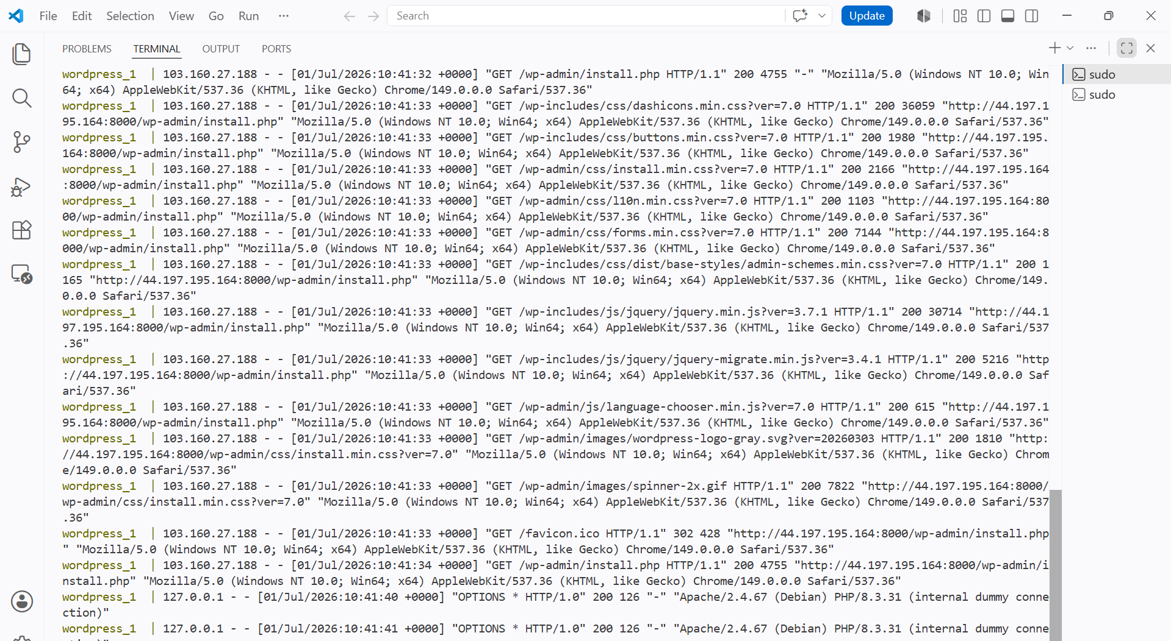

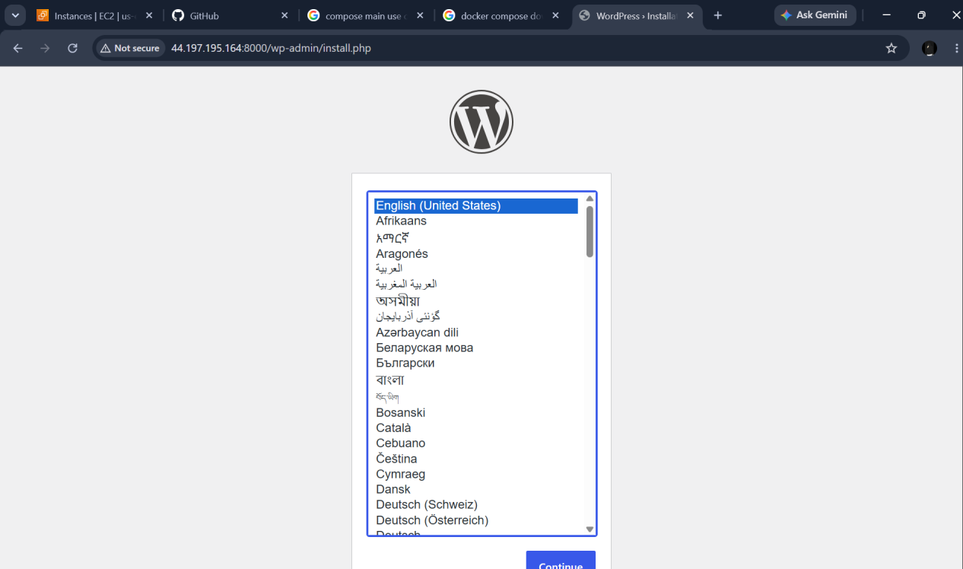

We can see the running compose containers

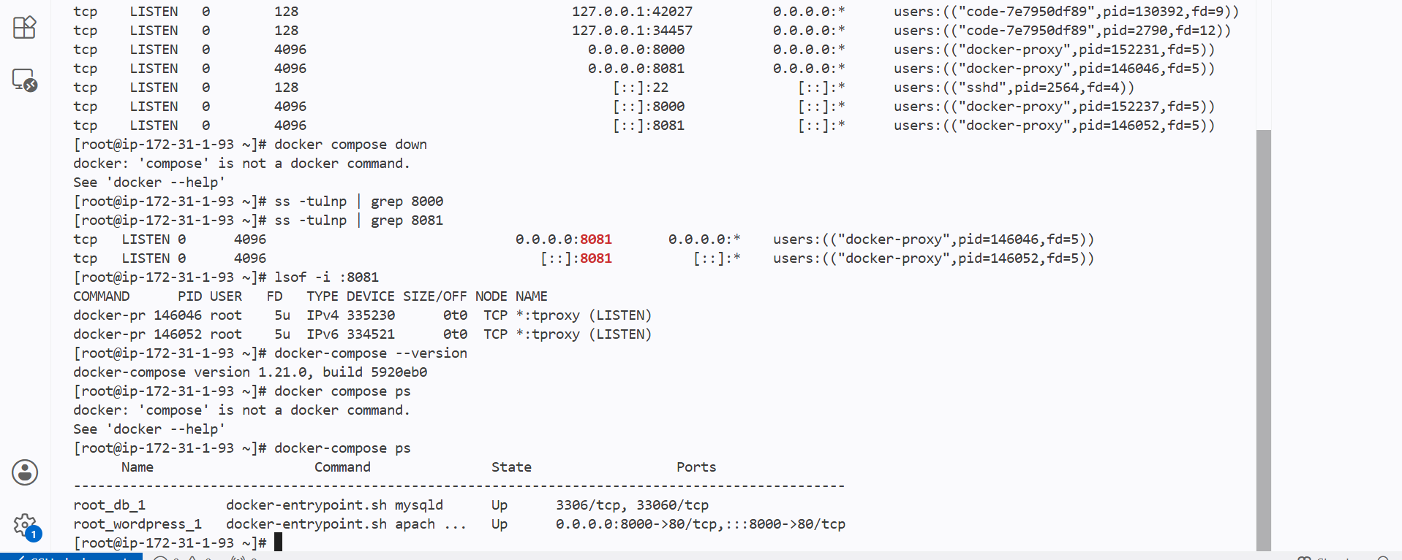

Implement solution to scan images when pushed to docker registry

I can check the vulnerabilites of an image in docker hub

By activating the scan for images

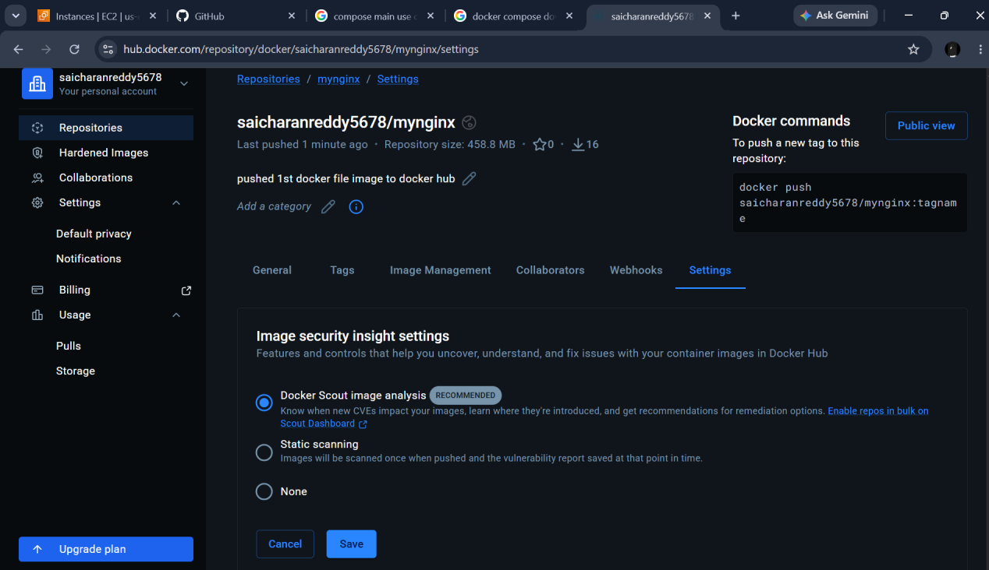

Now whenever I push the images to docker hub then it will scan for any vulnerabilites

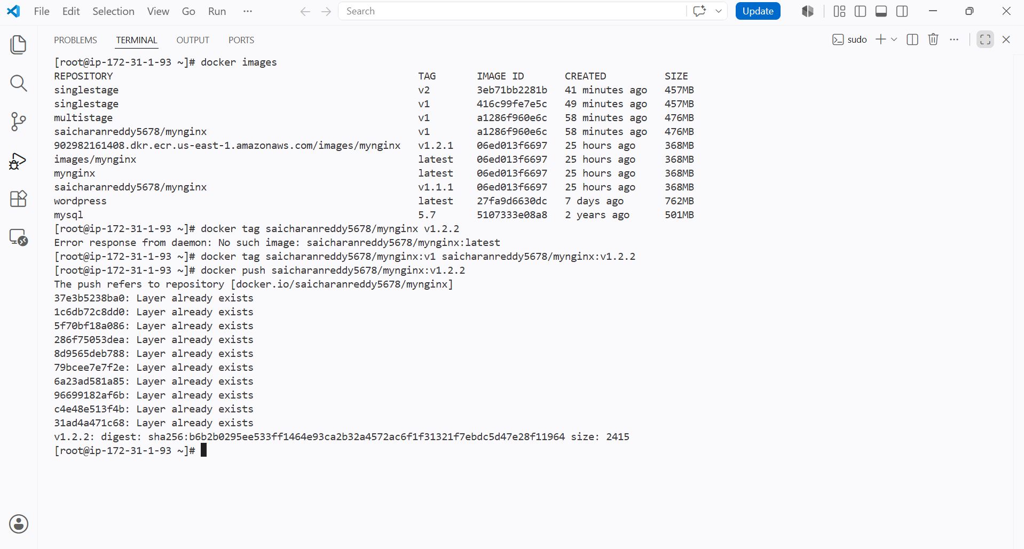

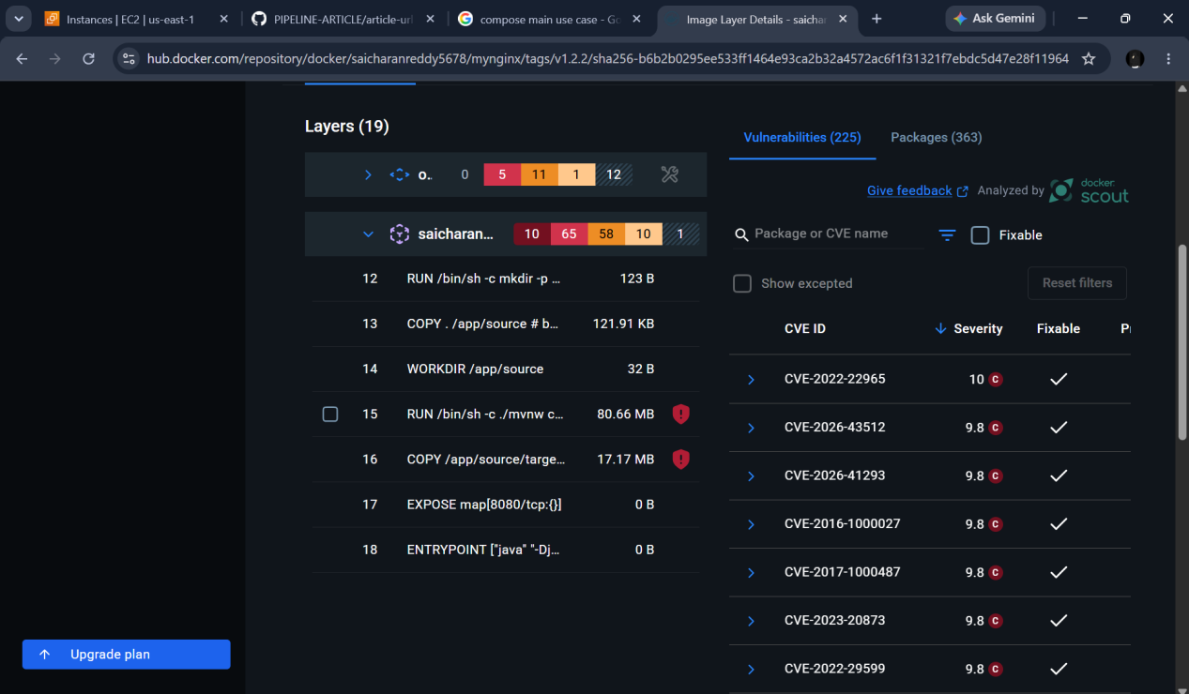

As we can see docker has scanned the uploaded image

Implement solution to scan images when pushed to AWS ECR

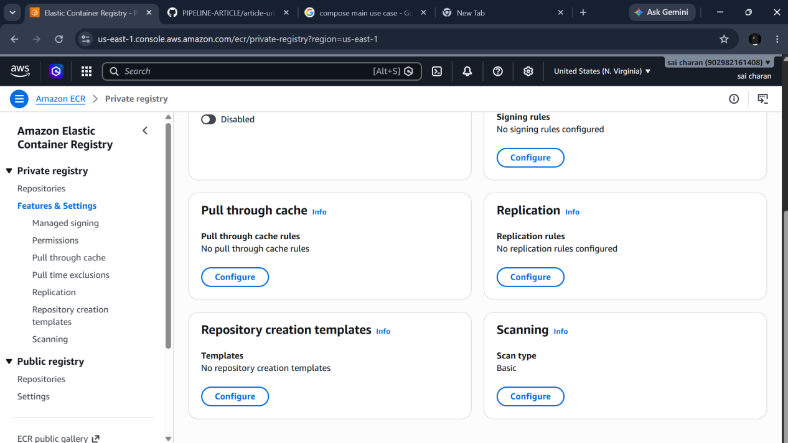

First I will be enabling the scan option in ecr

Then when ever I push a new image to the repo it check the image

I have pushed to my ecr repo

And enabled scanning to my repo

Now it will scan for every push made to the repo

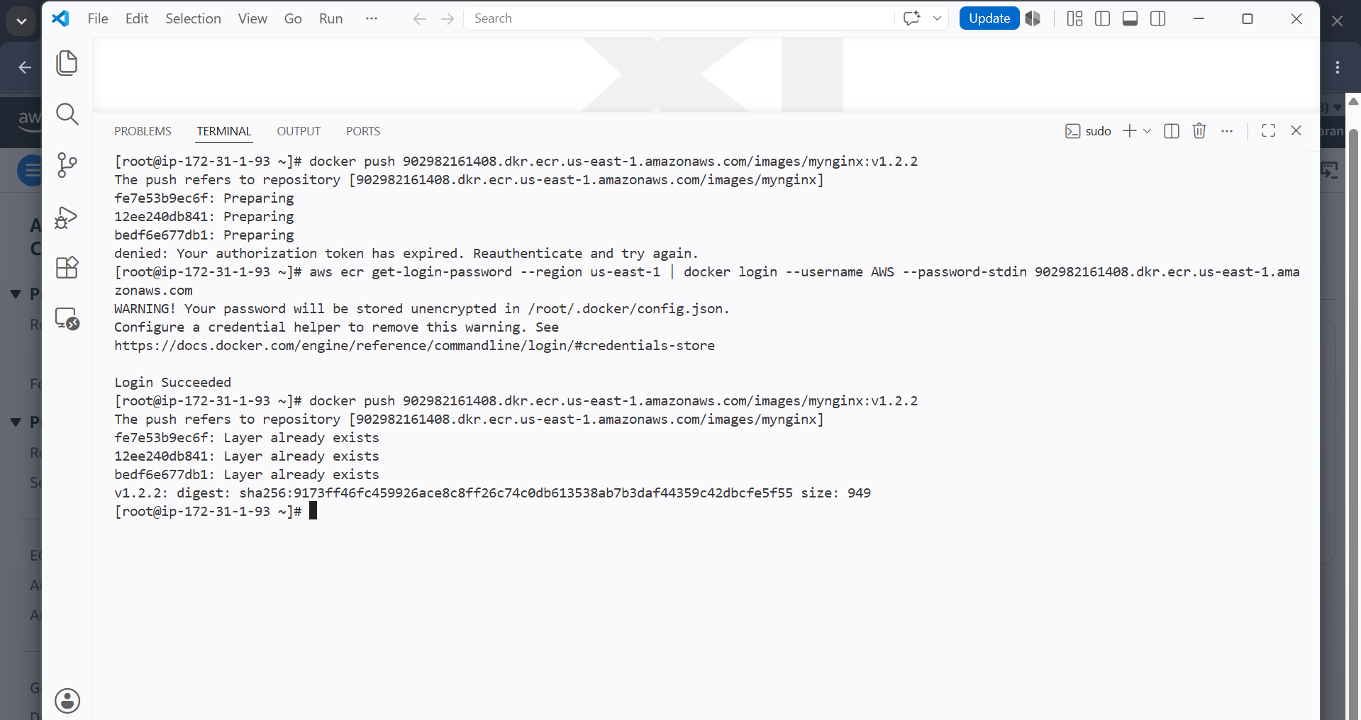

We can see I have pushed my image

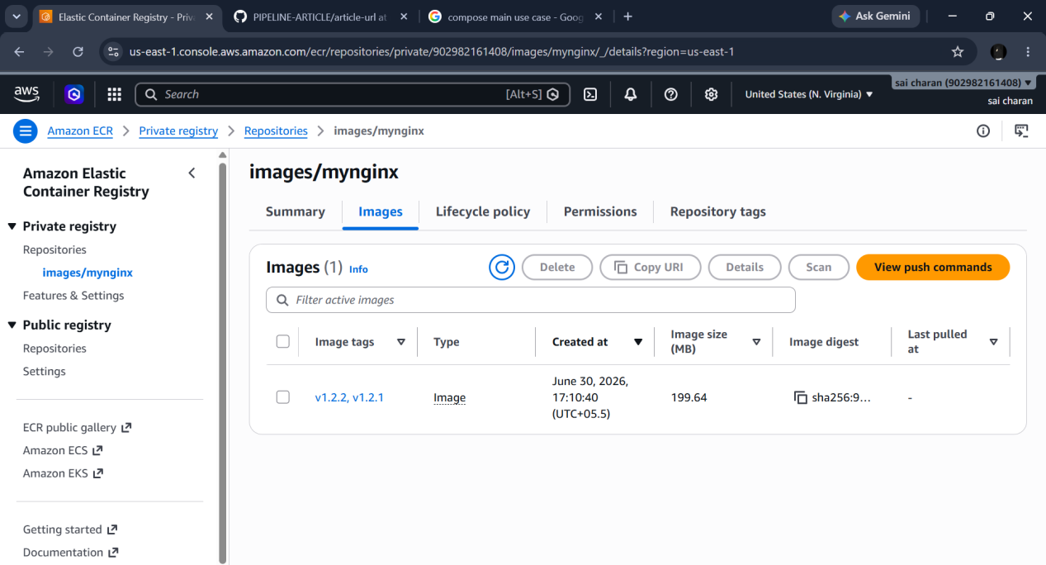

And we can see the scanned result

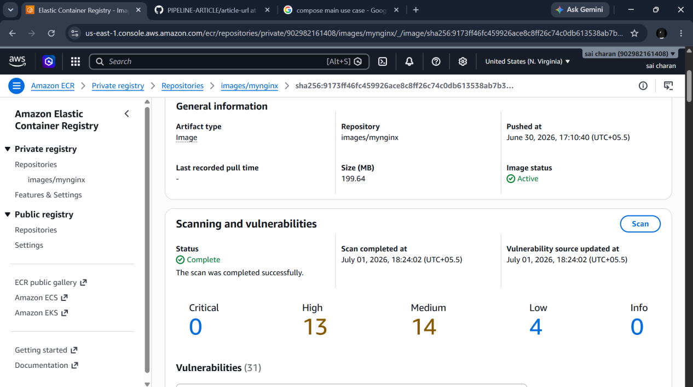

Jenkins pipeline to create docker image and push it to dockerhub

First I should add dockerhub credentials in jenkins

And should see if my jenkins has docker installed

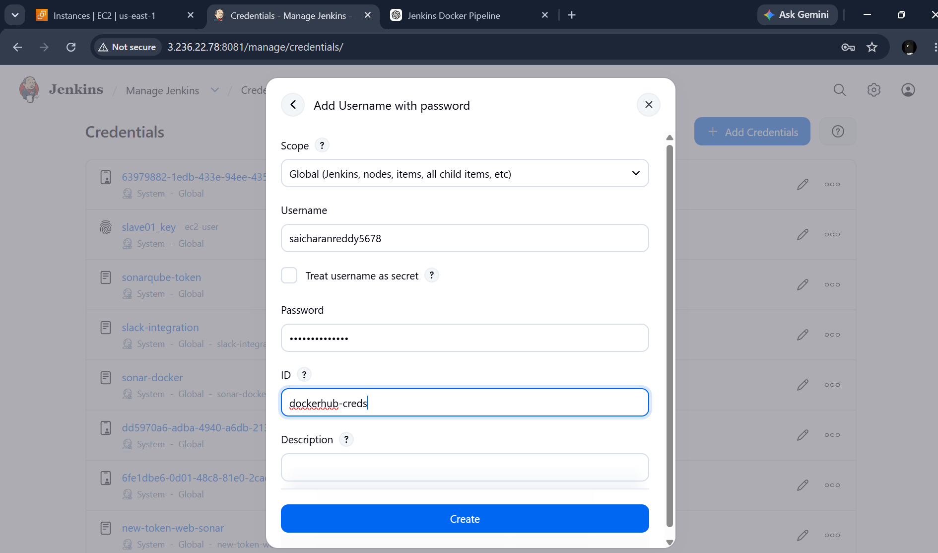

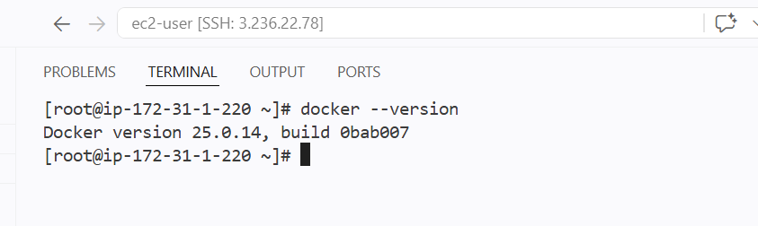

I have docker installed in my jenkins server

I need to add jenkins to the docker group so that jenkins can access the docker
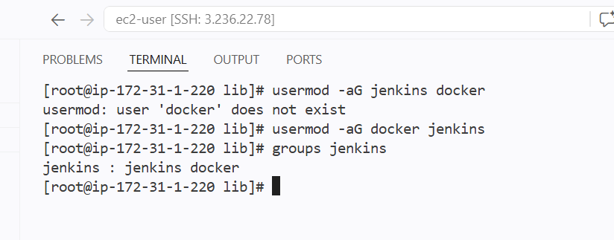

I am cloning my git repo which has docker file and building the image using the file

As I have multistage docker file in my repo I will be cloning the repo and using maven I will compile src and build the new image

If I want to build an nginx image or avaiable images I will simply create a new docker file in git repo and in docker file I will use base as nginx:tag and clone the repo that has only one dockerfile and if I use any copy commands to copy index.html file to build image I should have that file in my repo

I am using environment variable for my username and image tag

Because I can just the variable in more places

And image tag as ${BUILD_NUMBER} because every time I run job my build changes and I can upload my build number as tag to my repo

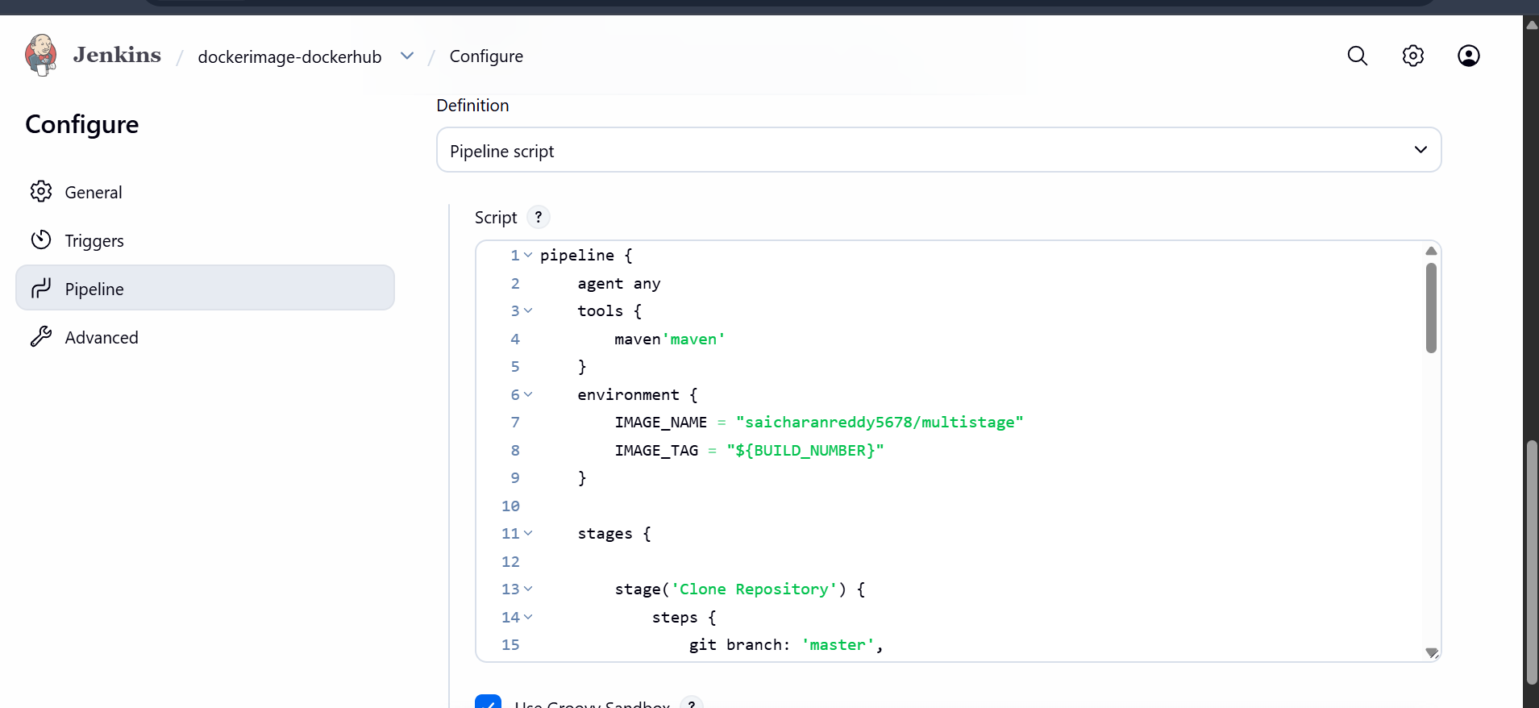

After cloning the repo I will build the image using dockerfile

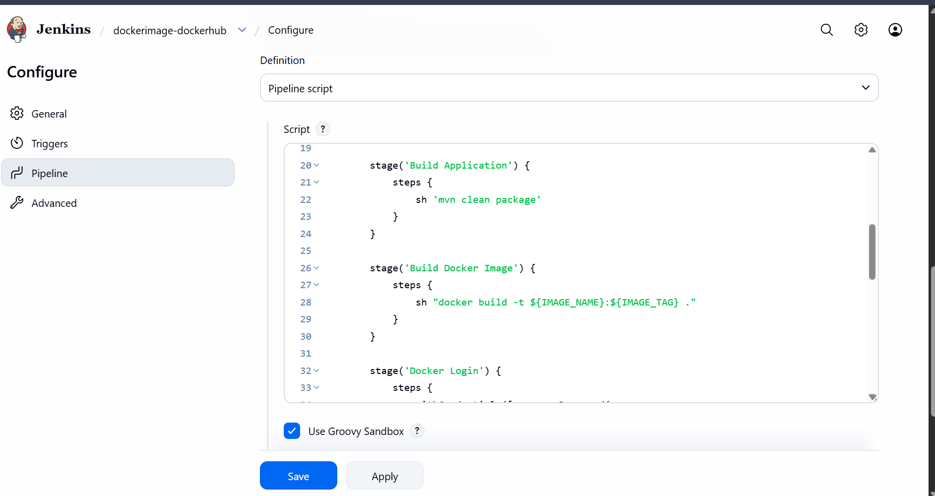

Giving the docker hub credentials

I $DOCKER_USER will automatically fetches my username from the dockerhub creds and gives me message at console output and given passsword as stdin
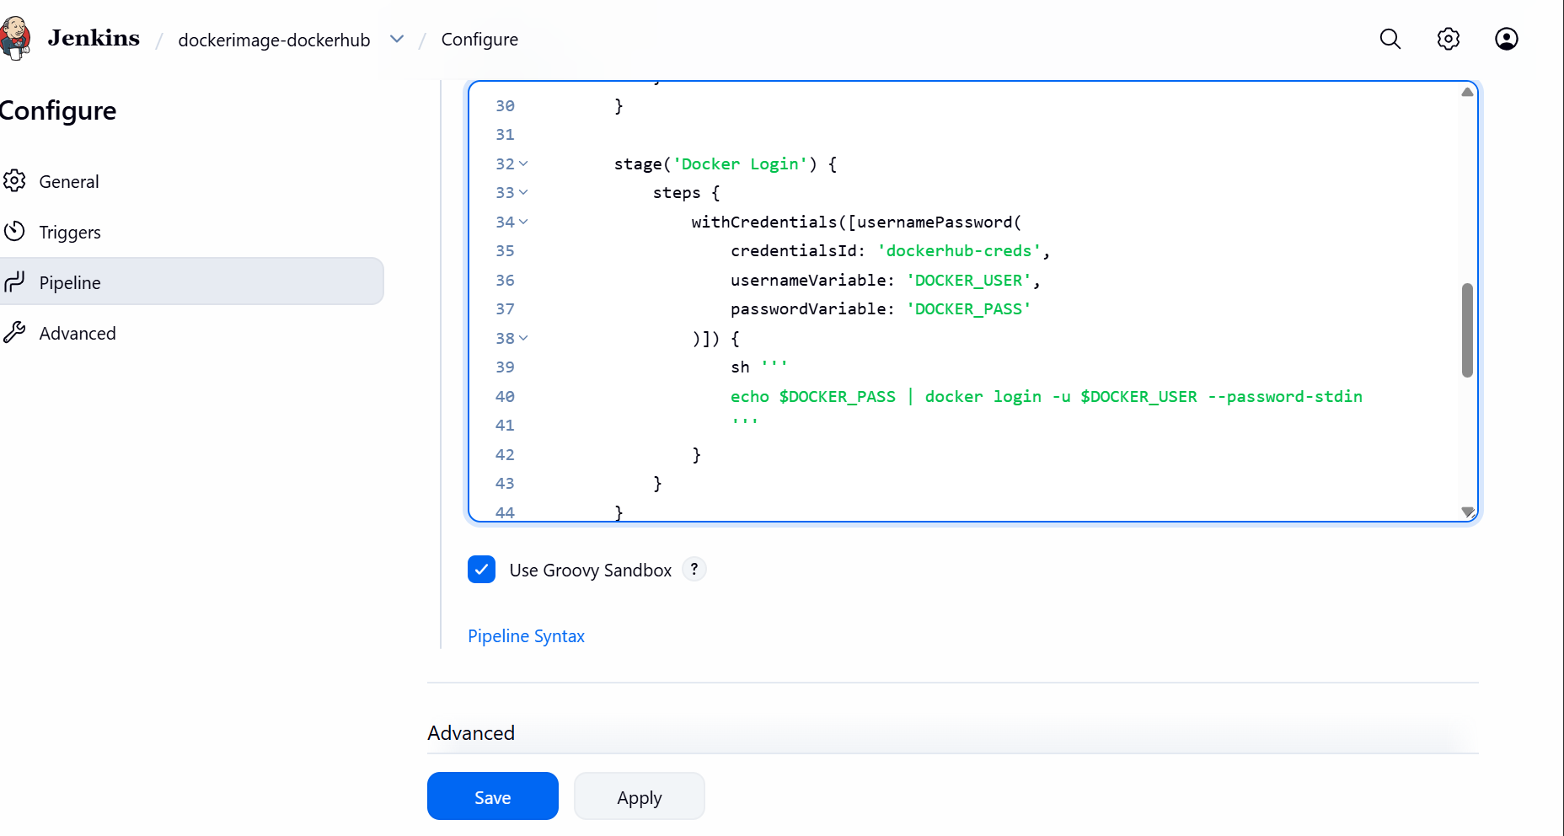

And I have pushed the just by calling the variables image_name and image_tag
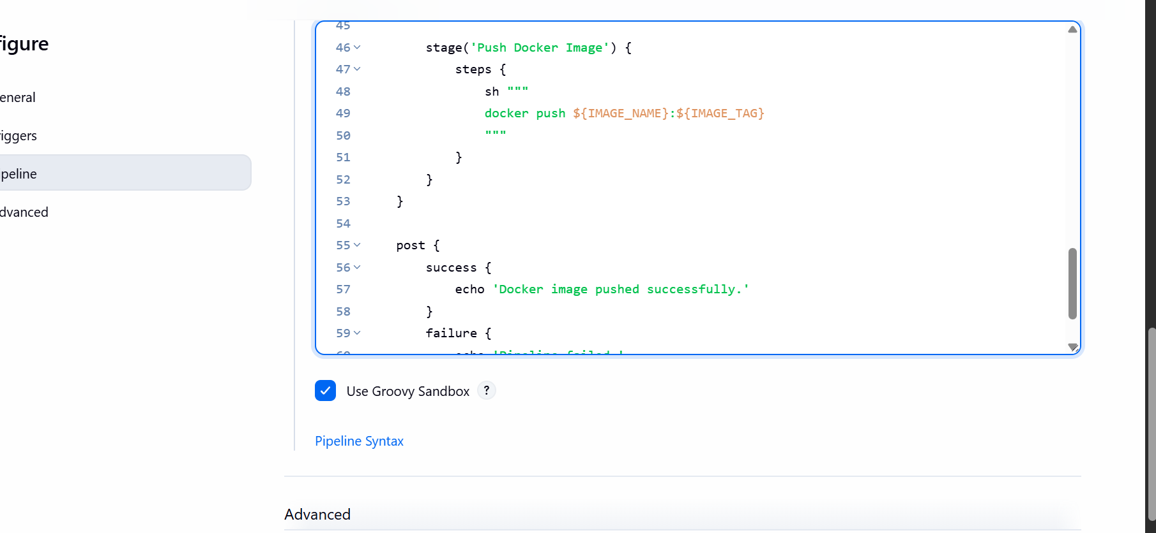

And giving post as success or failure

We can see the job was success and docker has been pushed to the docker hub



