Create one Jenkins job using the below code and create three stages

- stage1: Git clone to download the source code.
- stage2: Sonarqube Integration to check the quality of code.
- stage3: Slack Integration to send the alerts to slack.

First I will clone the repo using by job
Create a new job

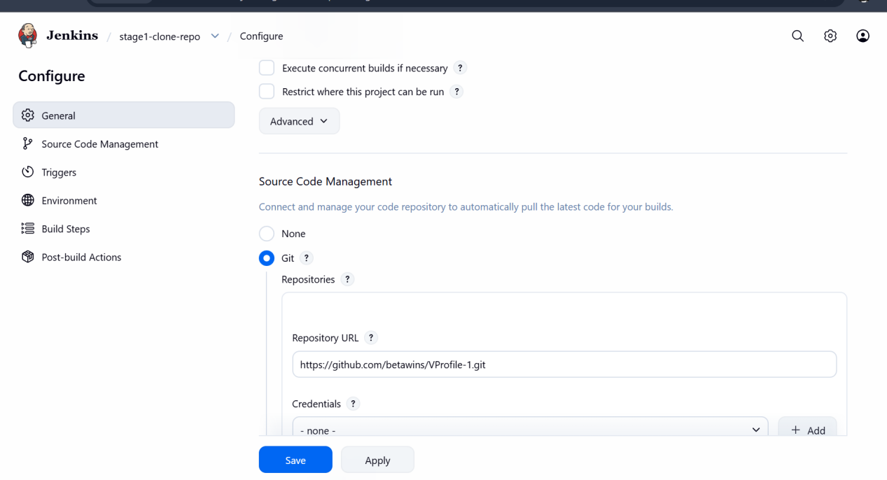

Successfully cloned the repo

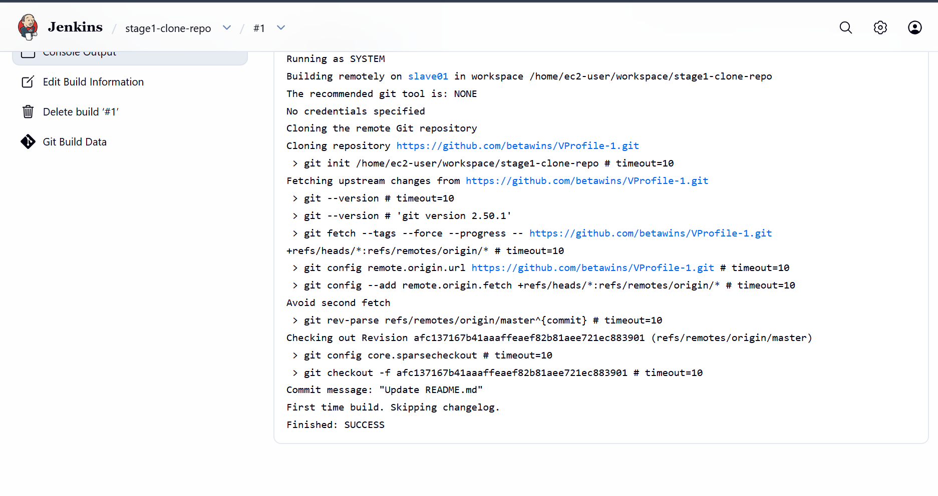

STAGE 2: Sonarqube Integration to check the quality of code

I will be installing sonarqube
For this I will be taking a new server with t2large
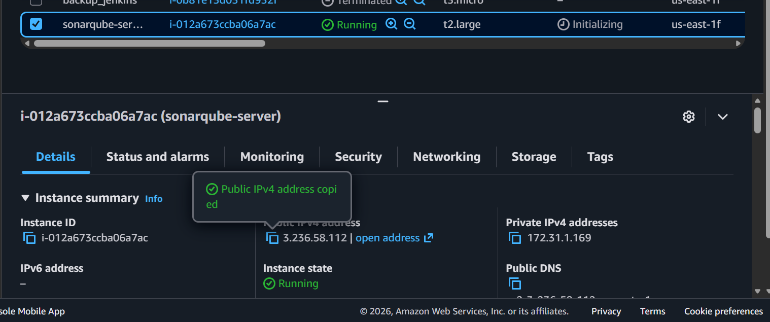

Installing java-21
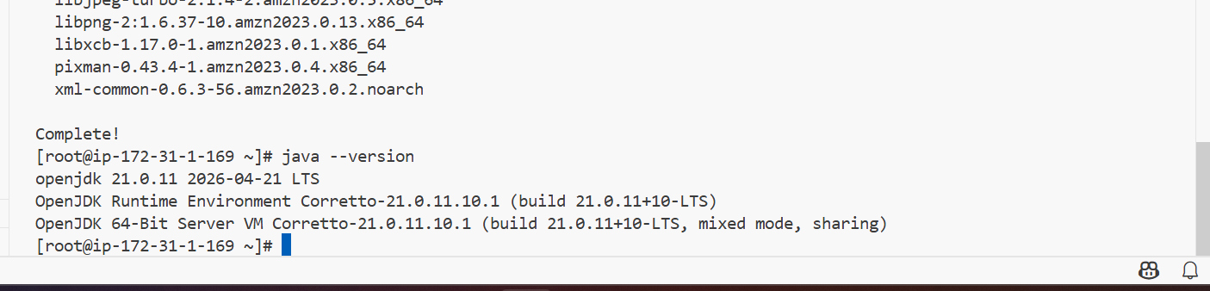

Then I will be installing postgresSQL in sonar instance

For installing postgres I will be allowing traffic to the postgresql on port number 5432 TCP in security group of sonar instance
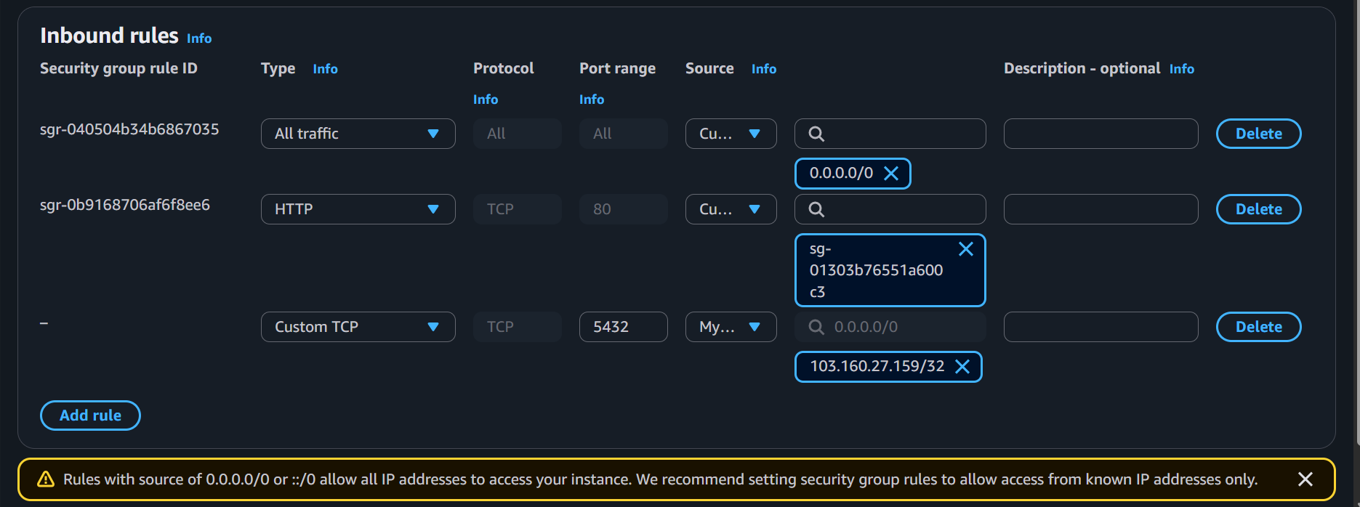

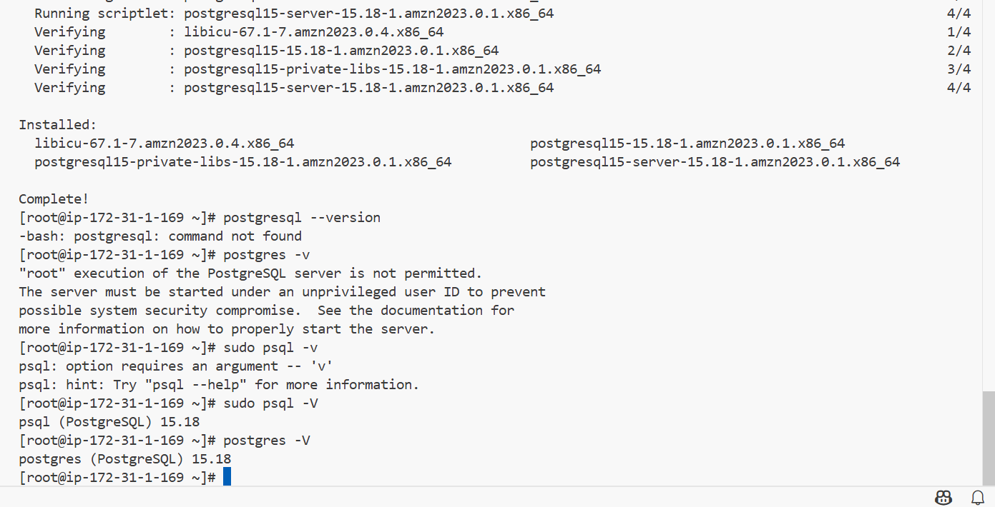

Installed postgresql with version 15.18

# Update system packages
sudo dnf update -y

# Install the PostgreSQL server package
sudo dnf install postgresql15-server -y

# Initialize the internal database cluster metadata
sudo postgresql-setup --initdb

# Start and enable the service on boot
sudo systemctl enable postgresql --now

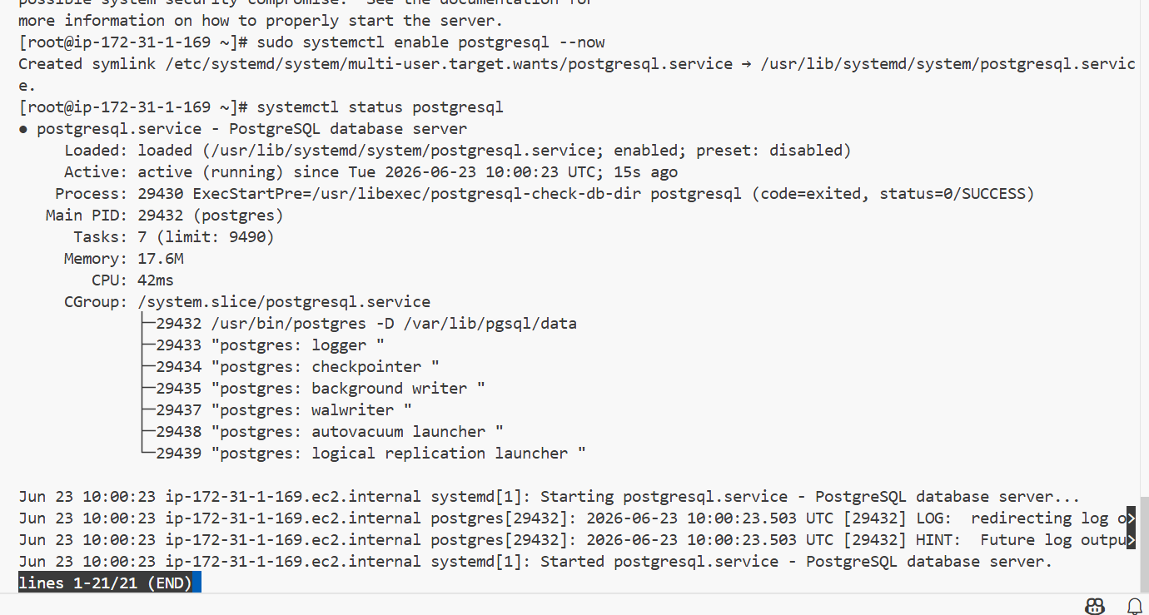

---------
sudo -u postgres psql
---------
To login to postgres
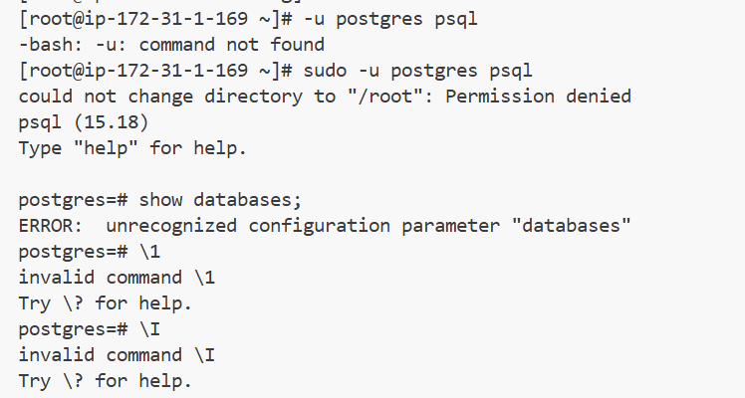
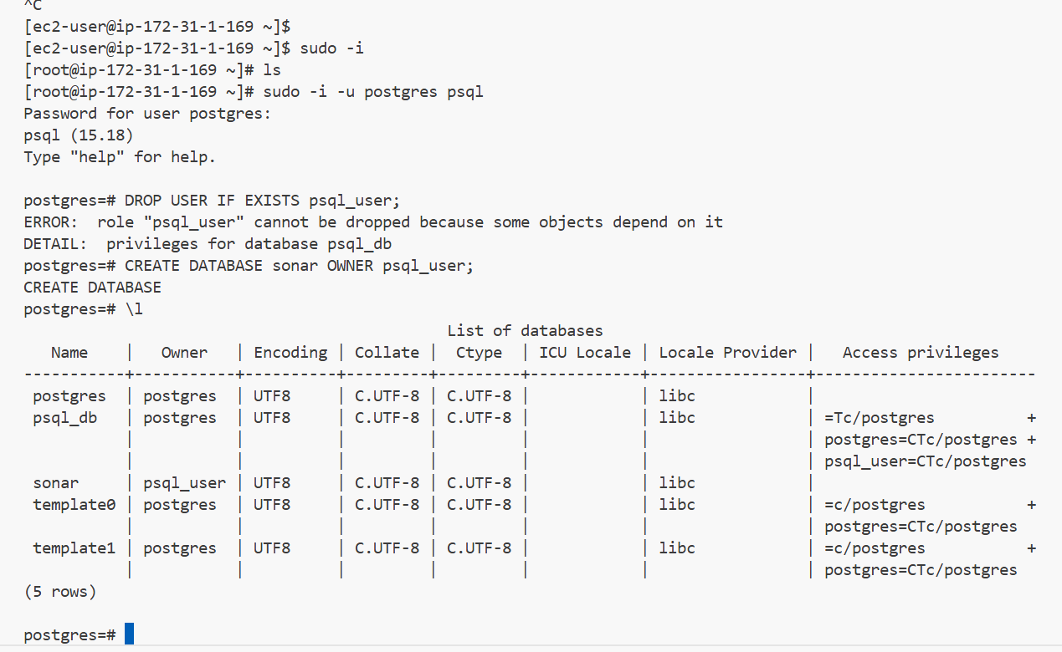
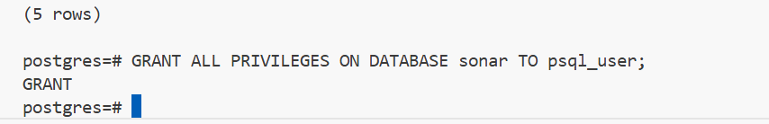
Then I will be creating a new database and adding a new user with password
Then granting all permissions for that database to the new user

CREATE DATABASE my_ec2_db;
CREATE USER my_db_user WITH PASSWORD 'AnotherStrongPassword';
GRANT ALL PRIVILEGES ON DATABASE my_ec2_db TO my_db_user;

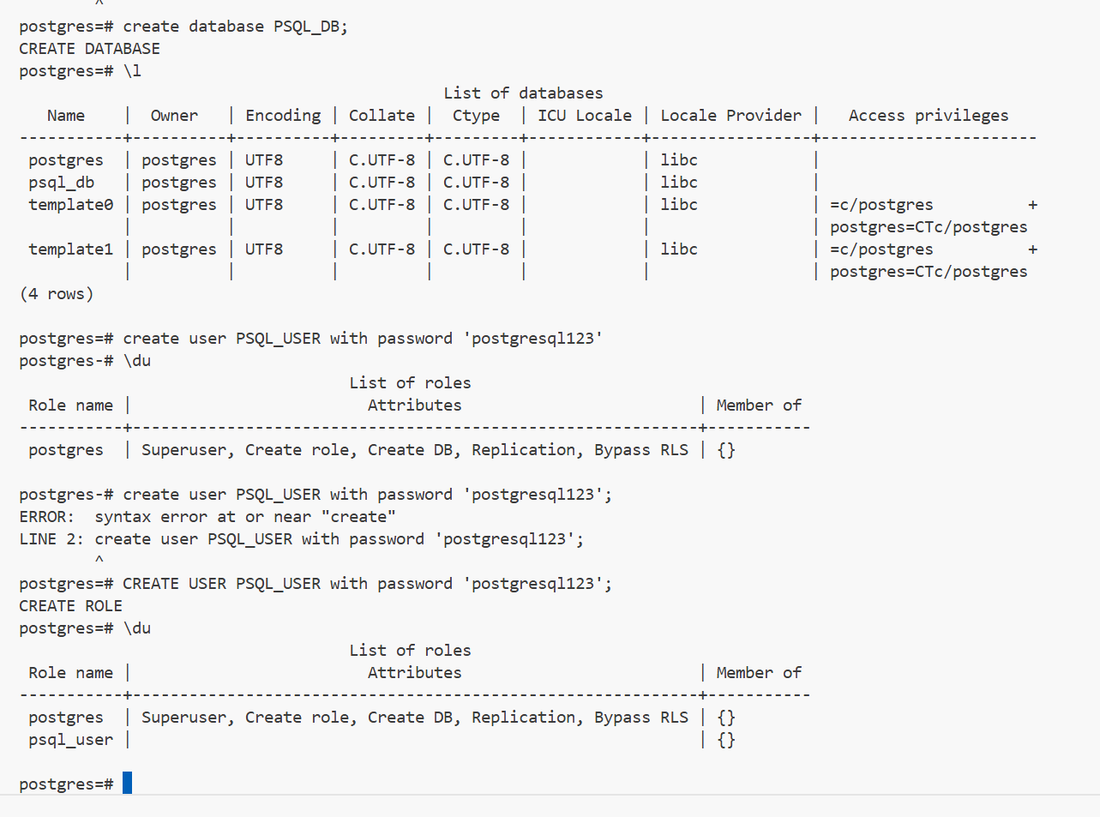

Created a new datbase,user and will be giving this user complete database privileges

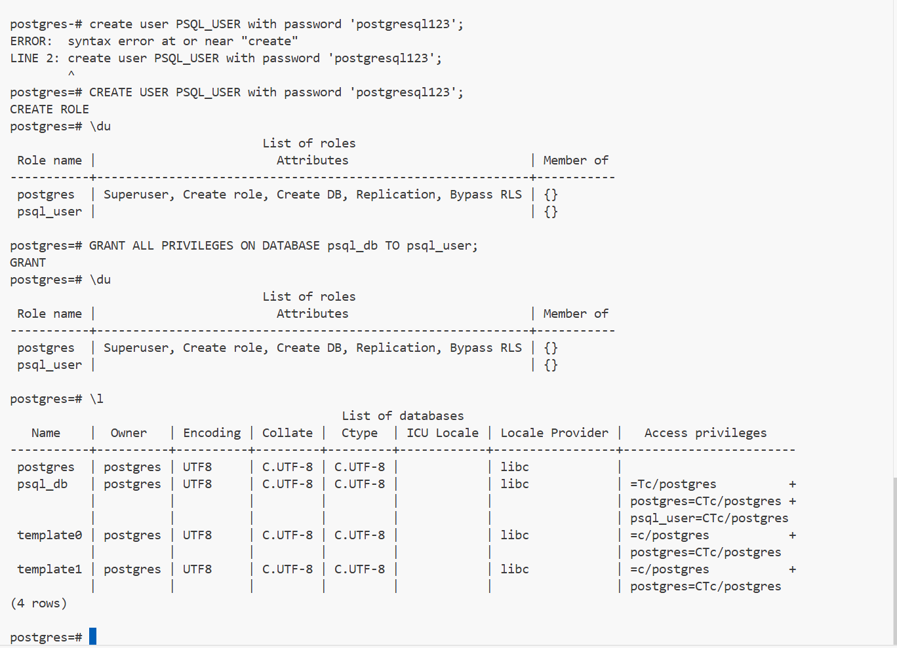

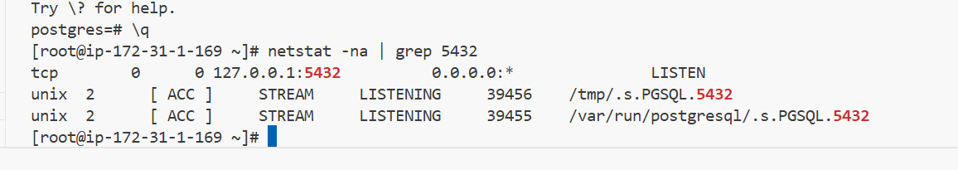

Postgresql has been installed successfully with all access to the new user for the database

https://binaries.sonarsource.com/Distribution/sonarqube/sonarqube-25.6.0.109173.zip

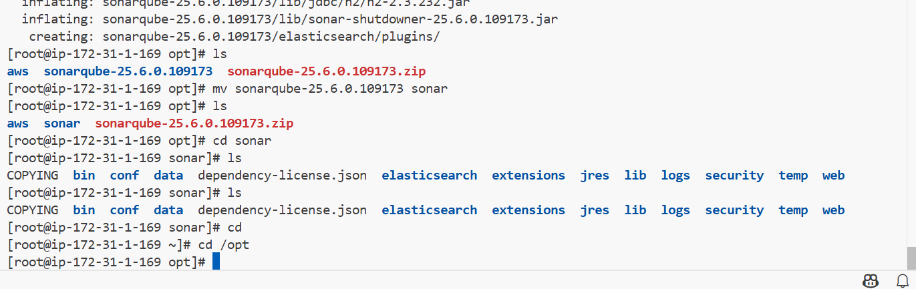

Installed using wget link

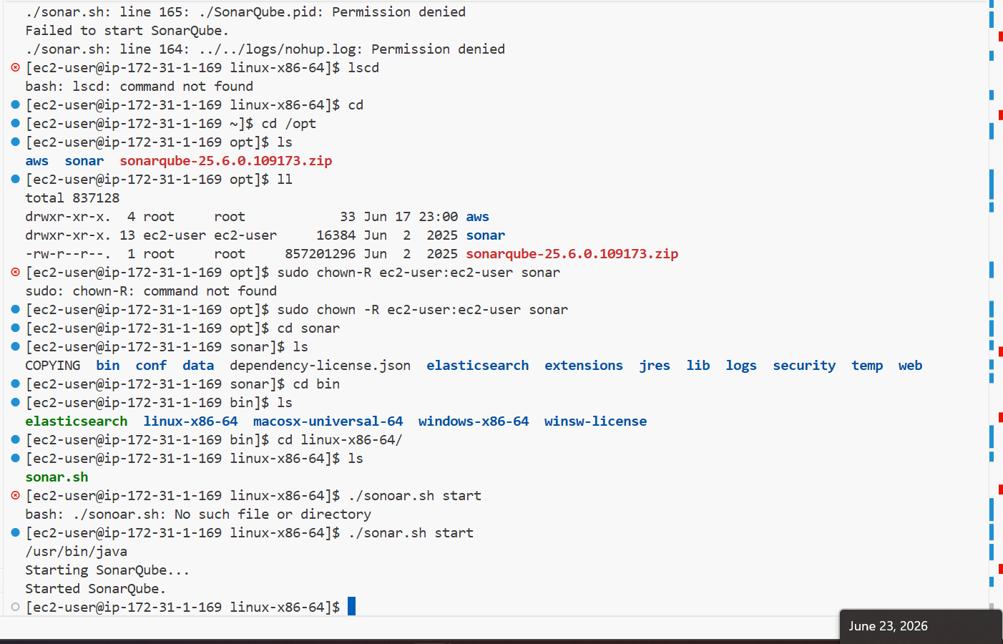

I have created a new user called sonar and gave all permissions

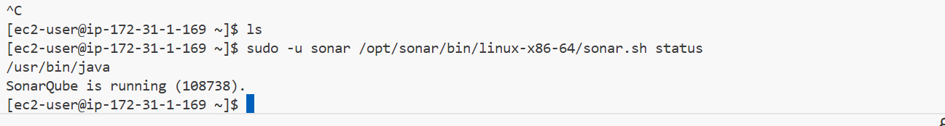

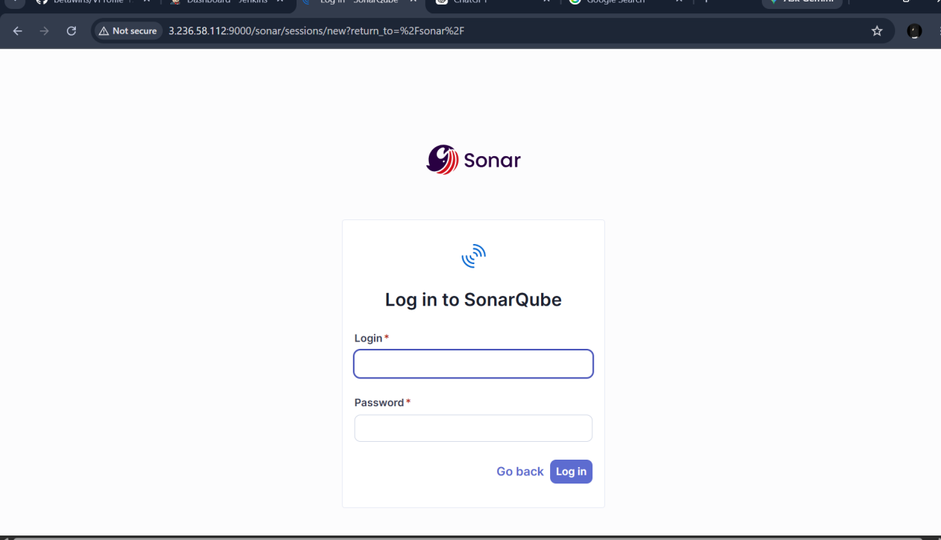

Default username and password

Admin
Admin

New password

Sonarqube@123

After logging into the sonarqube install the plugins in the jenkins ui
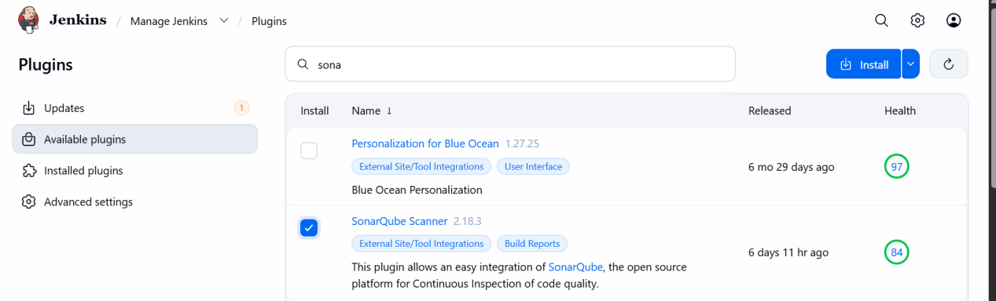

I have installed above pulgin
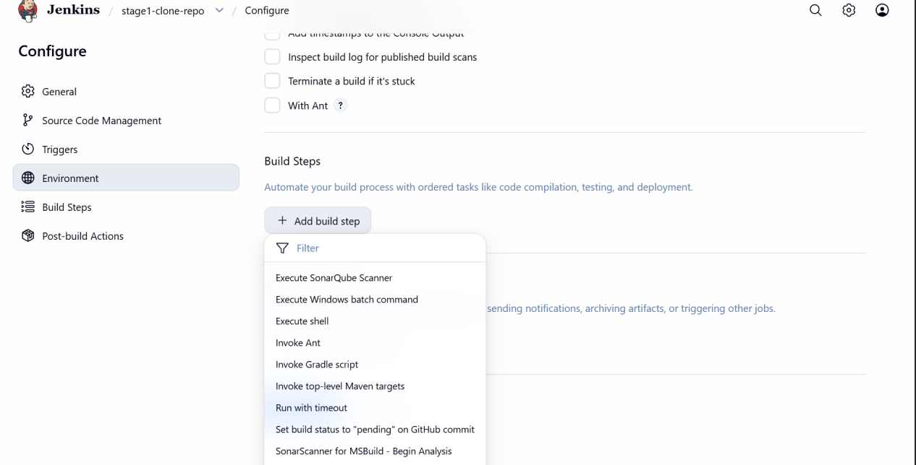

Then we will see a new build has been installed

First we need to link the sonarqube url to the jenkins

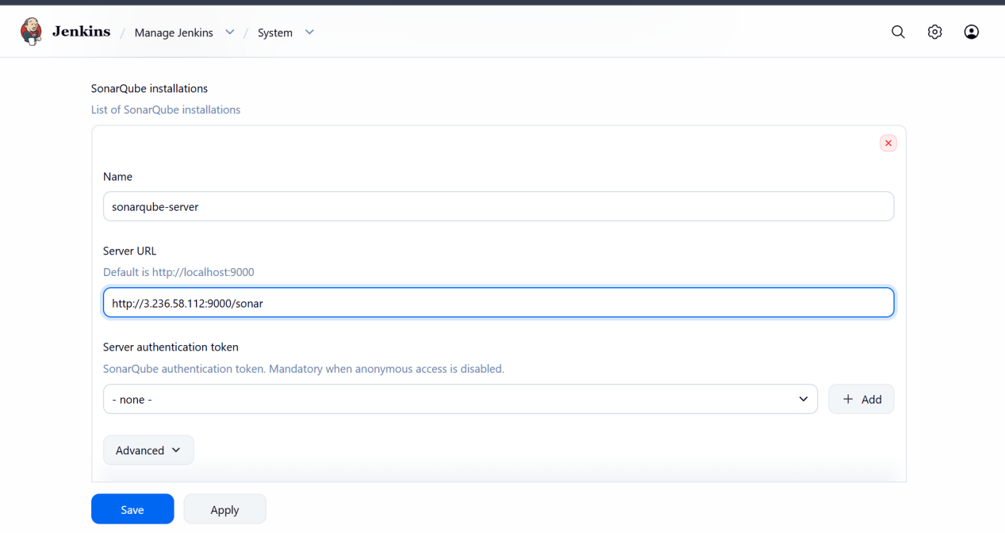

Add the server url
Then create a new token in sonarqube server
Then attach that new token for credentials part
By this we will be attaching the sonarqube server to the jenkins
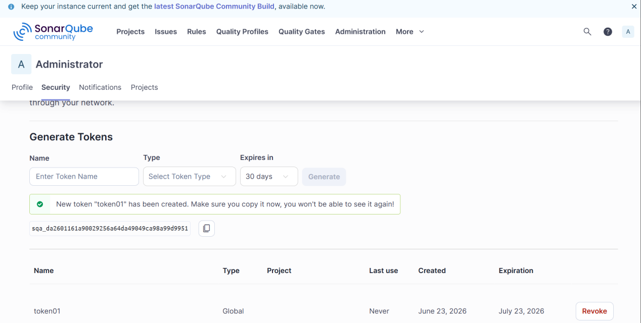

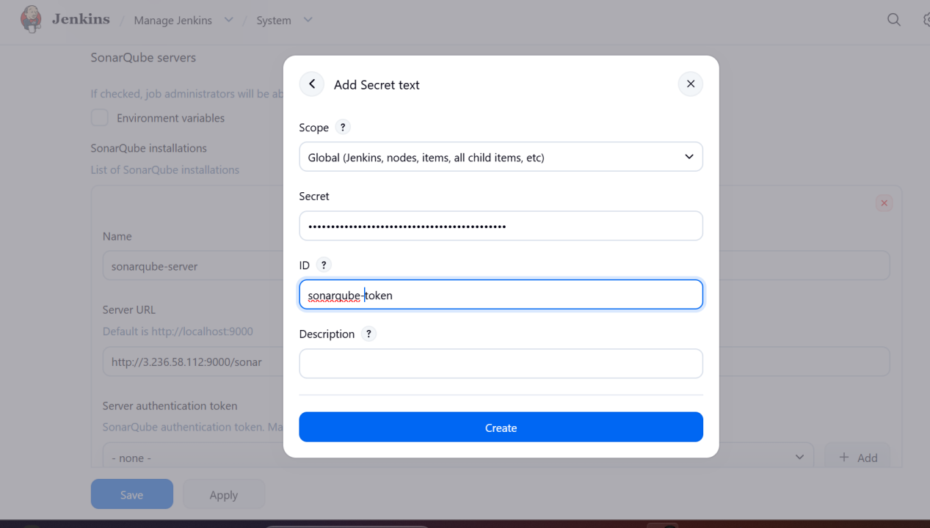

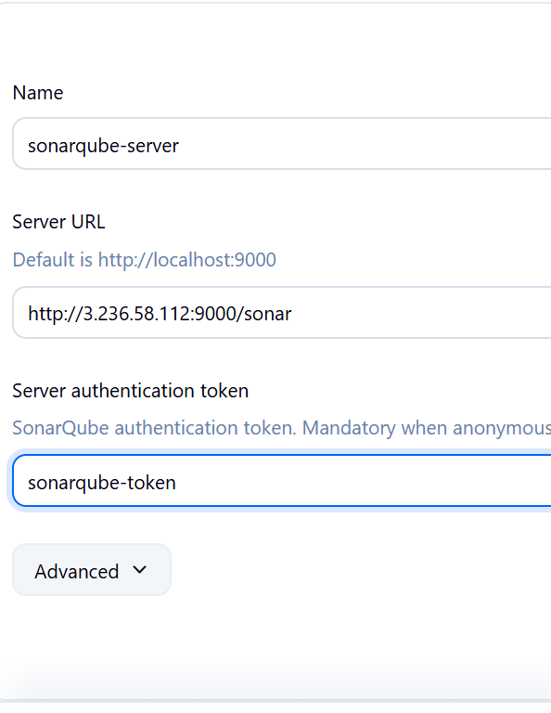

Then we can send the code to sonarqube for quality test

Now we need to install the sonar scanner in jenkins server CLI

wget https://binaries.sonarsource.com/Distribution/sonar-scanner-cli/sonar-scanner-cli-8.0.1.6346-linux-x64.zip

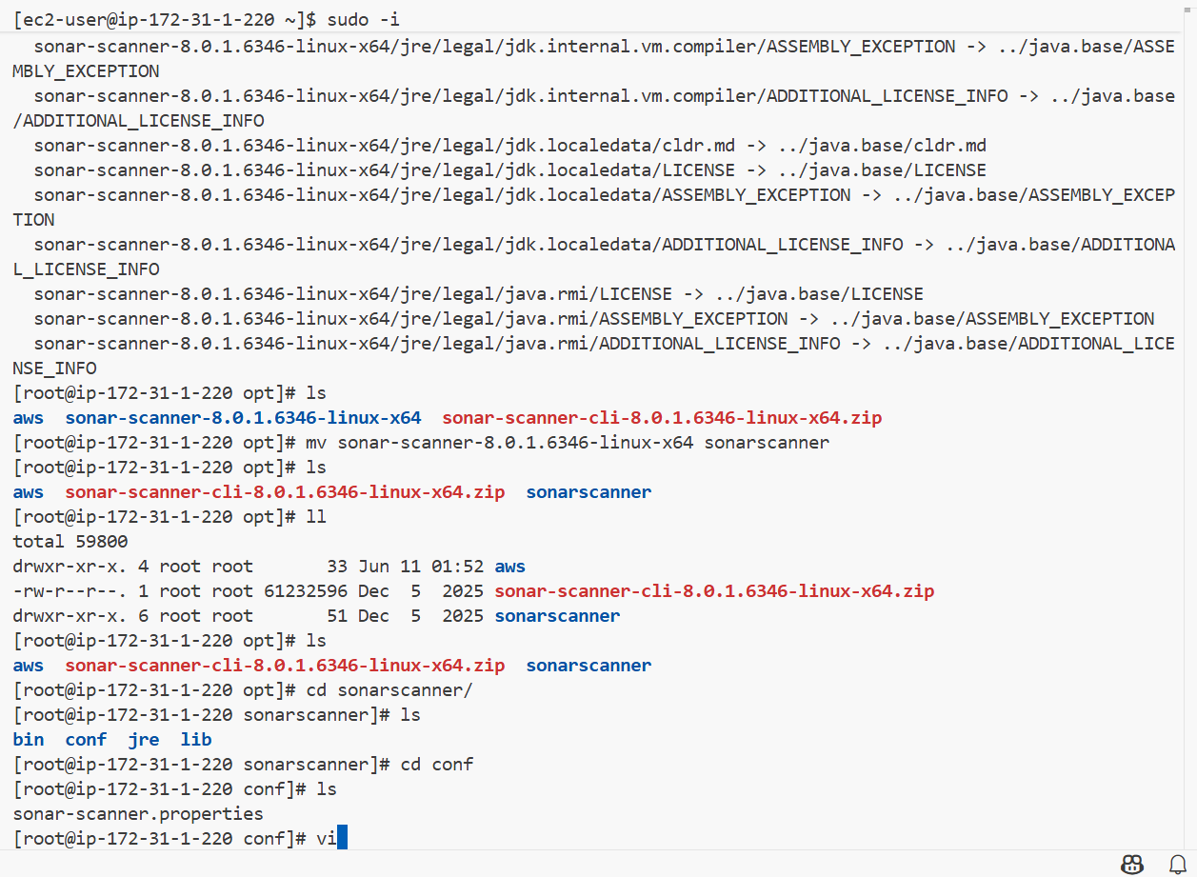

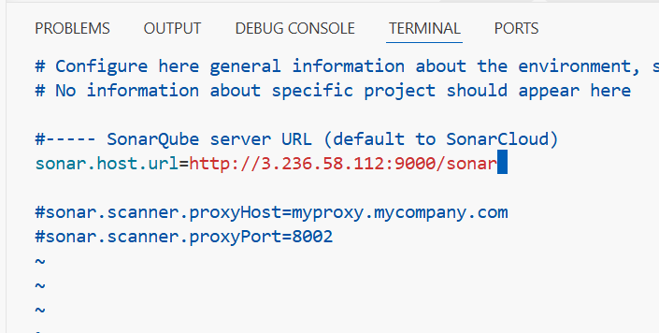

then go to jenkins ui add sonarqube scanner in settings

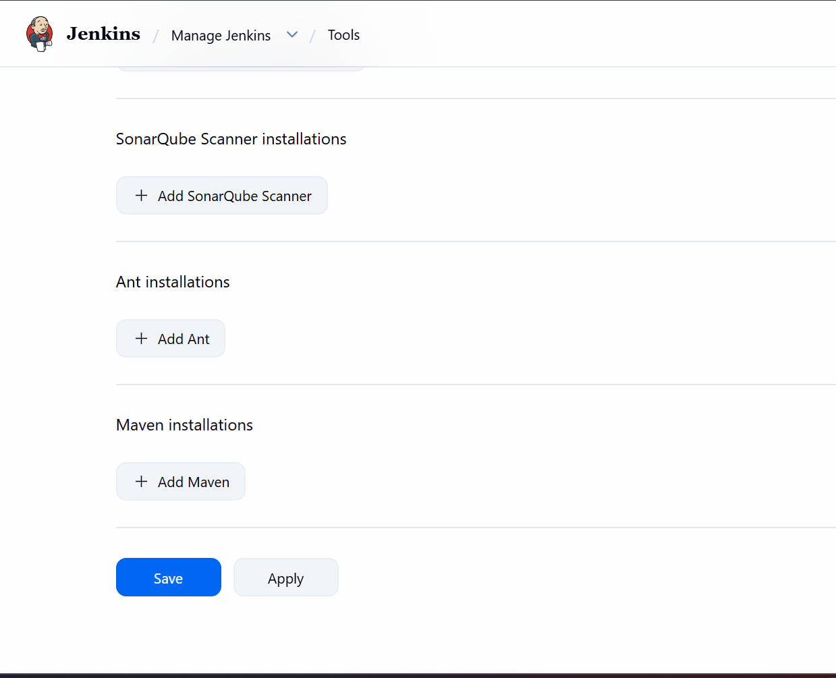

We need to give sonar-scanner path from jenkins server
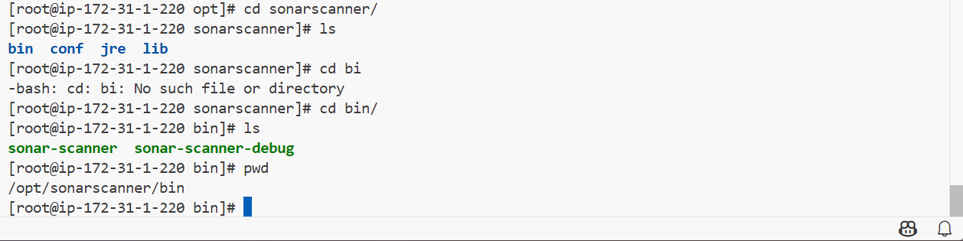
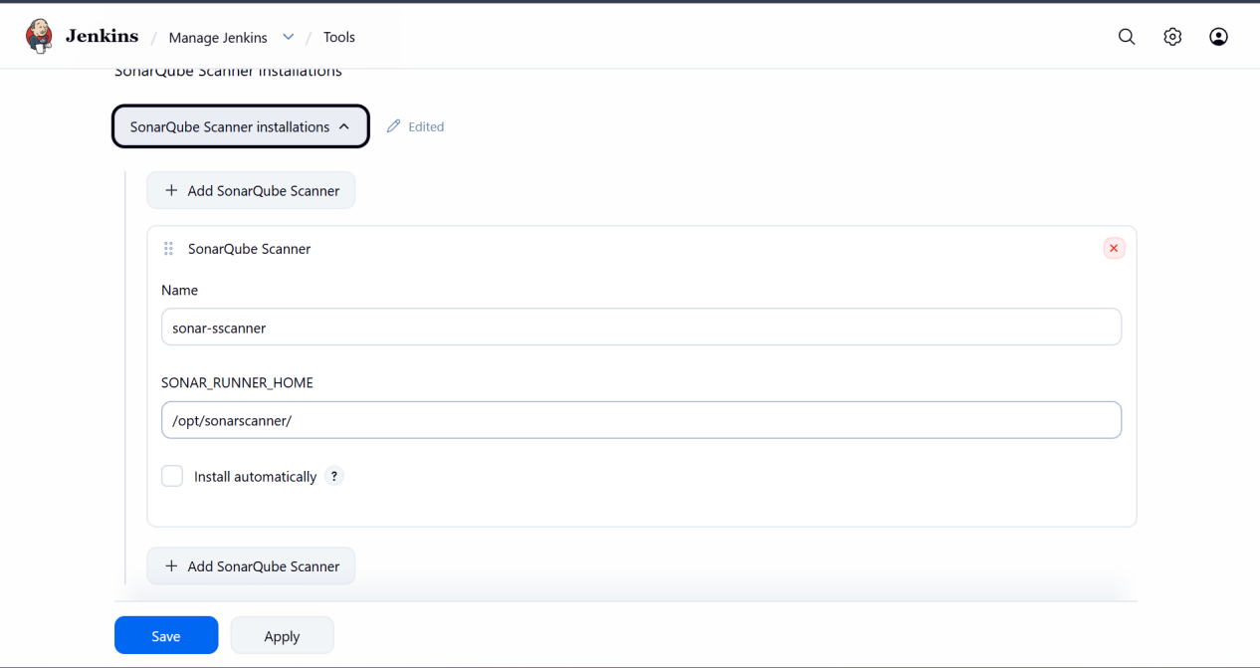
Then run the job with sonar scanner build step

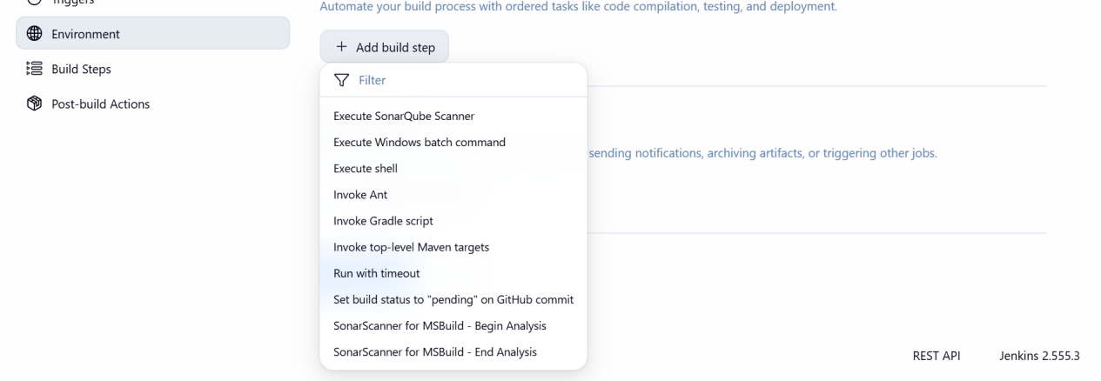

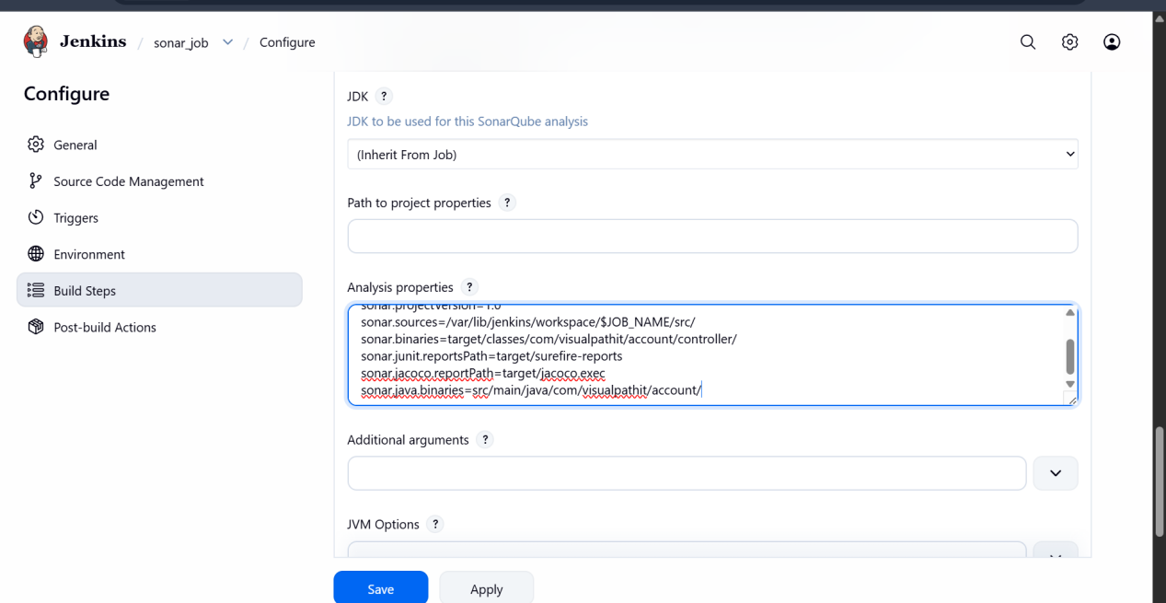
I have used analysis properties from read me file

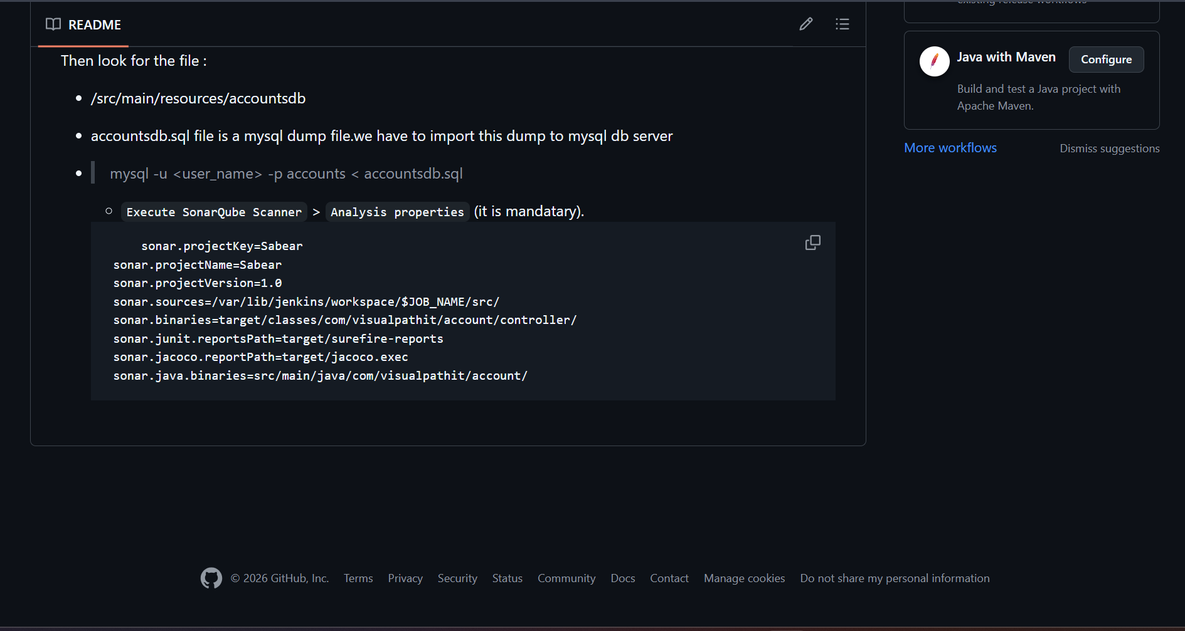
The job has been changed to sonarqube
Now after building this the sonarqube should quality test the source code

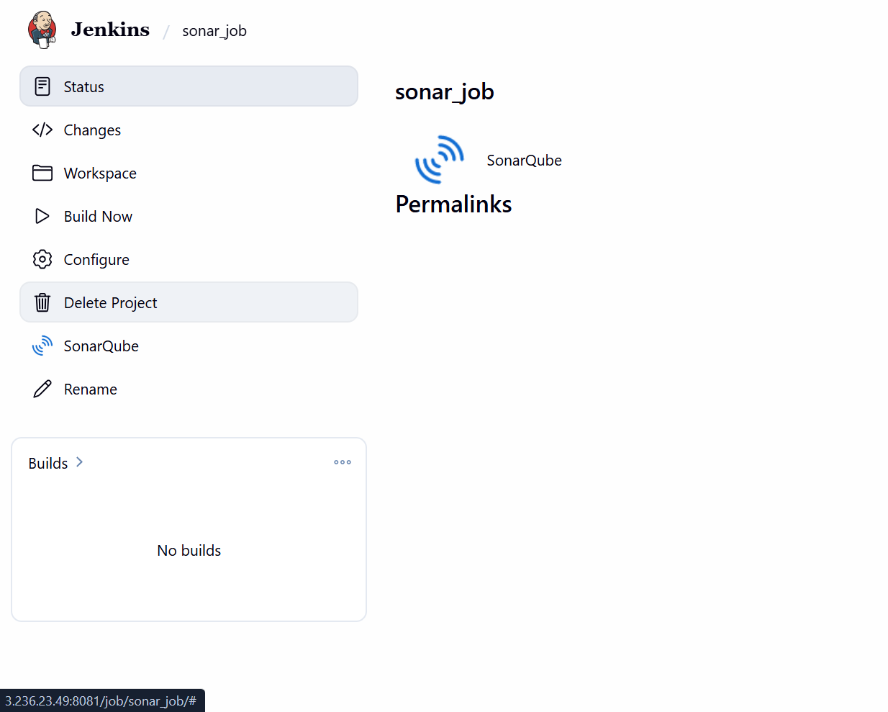

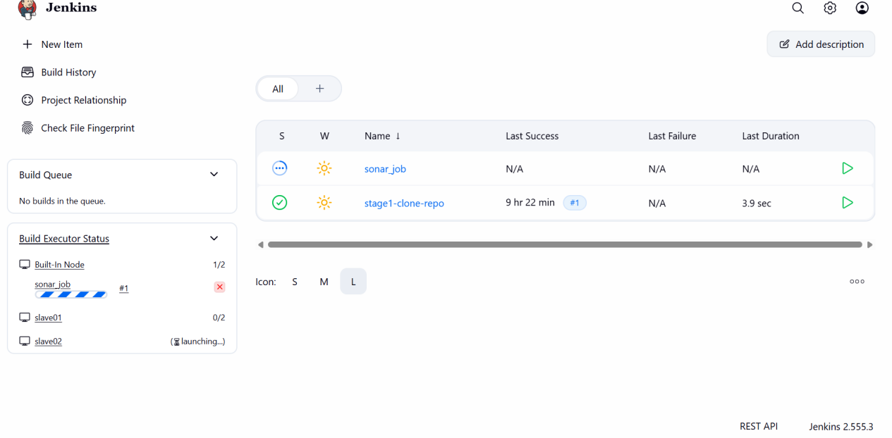
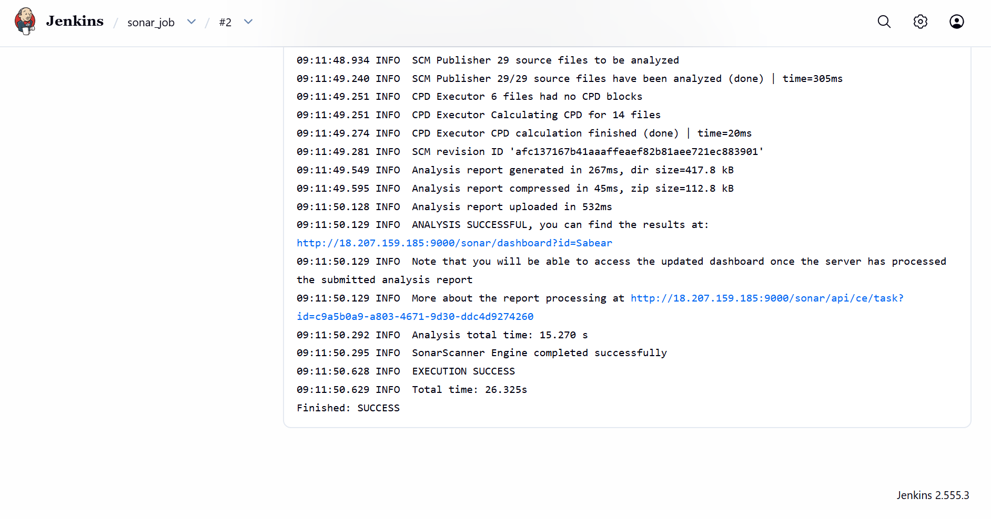
We can see it has been successful and should be checked in sonarqube website for scm quality
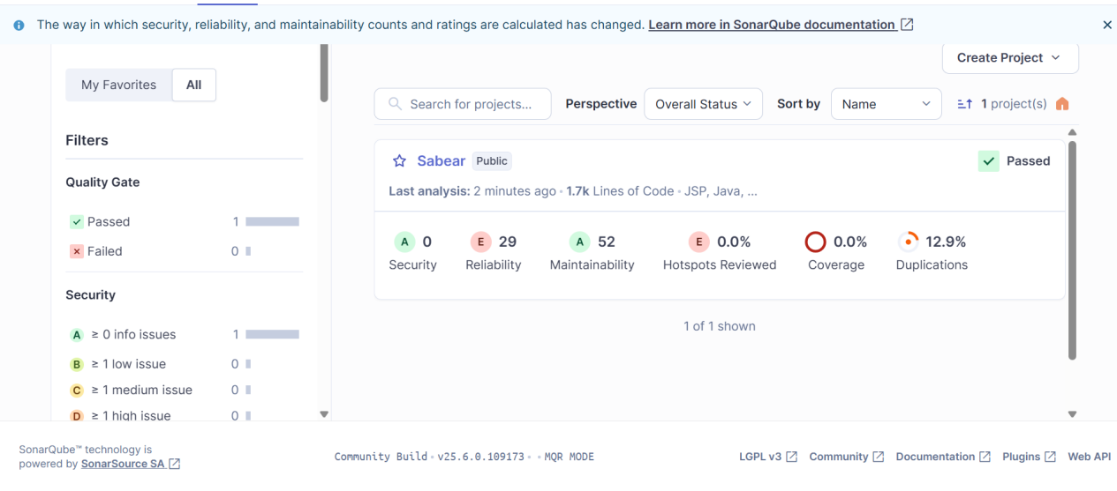

We can see the quality of code

stage3: Slack Integration to send the alerts to slack

I will be installing the slack pulgin in jenkins

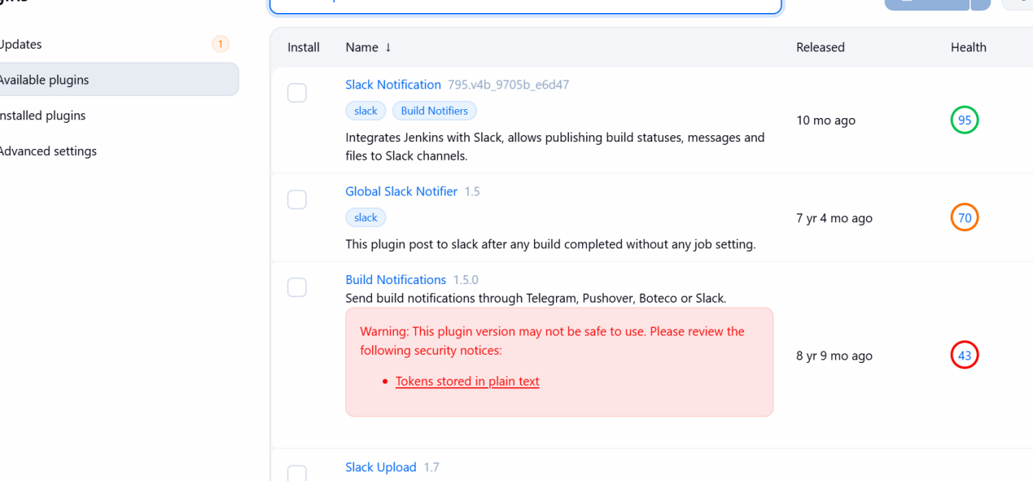

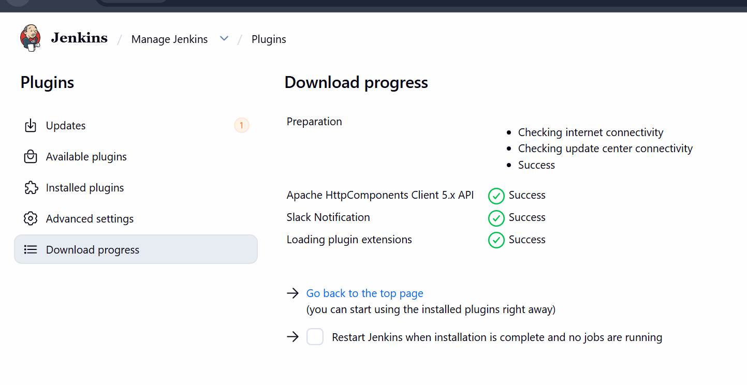

Now add jenkins in slack application

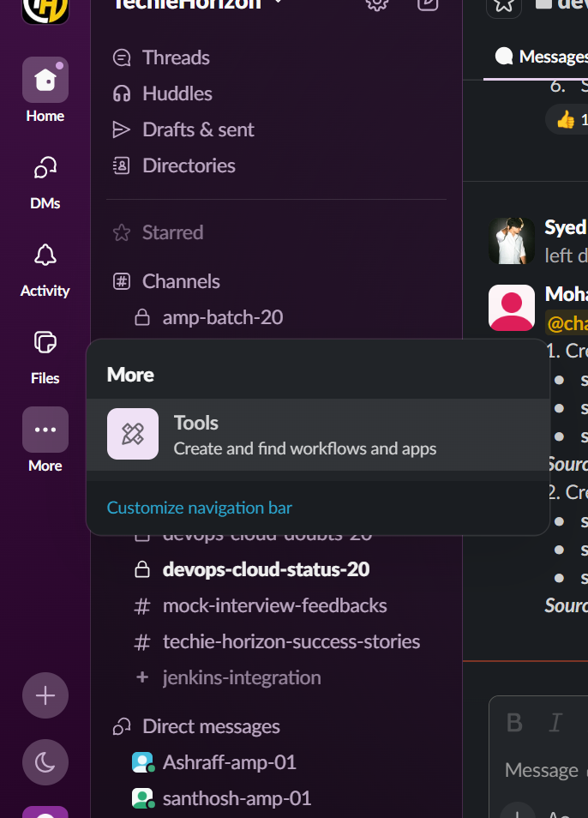

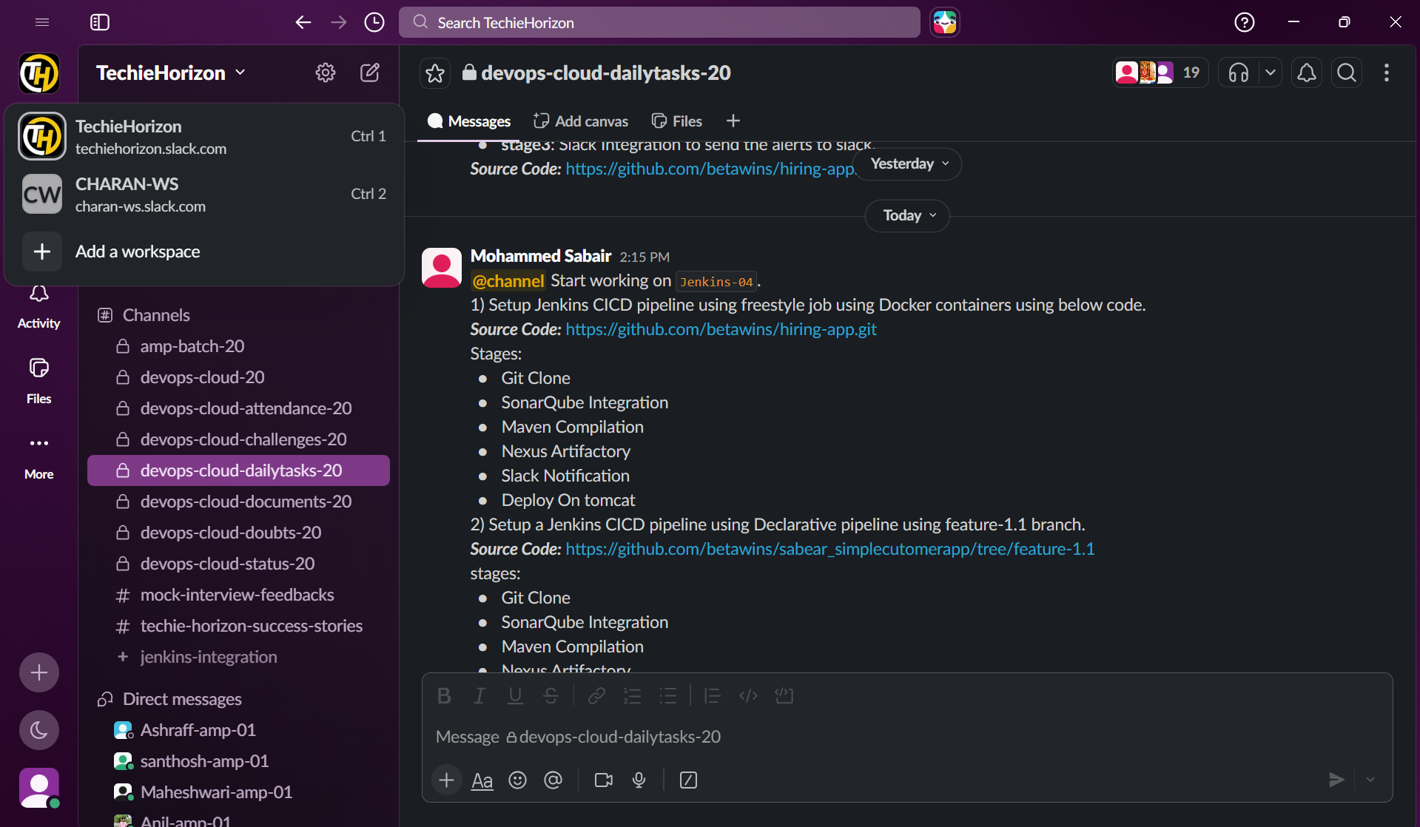

Now I will be adding it the post build actions to get notifications of my jobs in slack channel

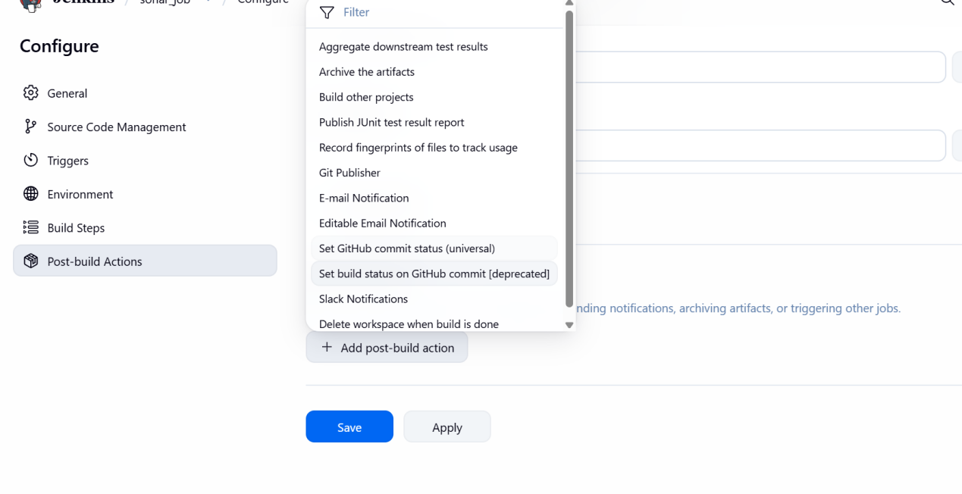
For slack integration I will be creating a new workspace

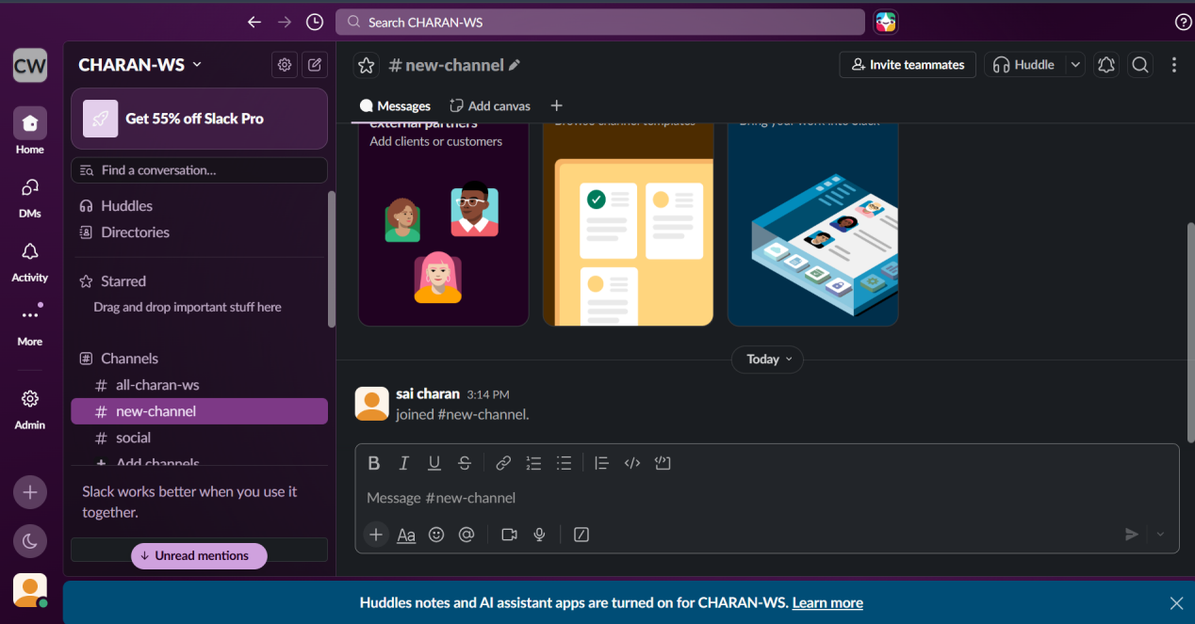

Created a new workspace
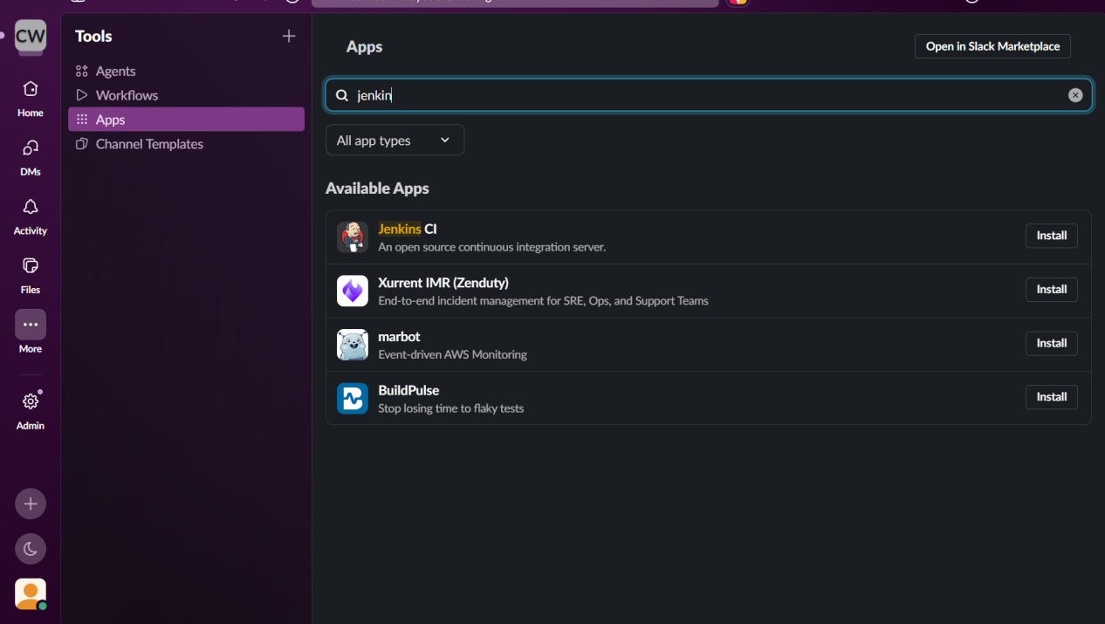

Install jenkins ci in slack ws

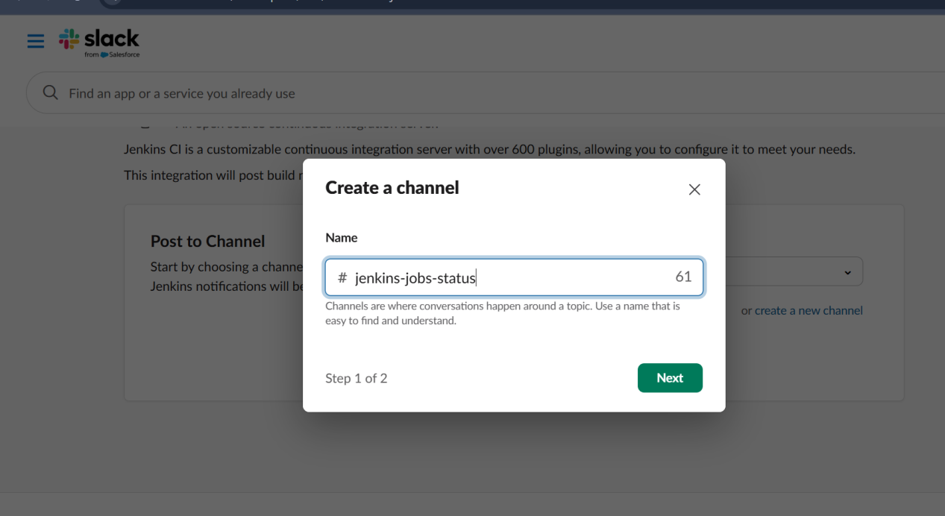

After giving the channel name configure in jenkins ui
And add integration token secret

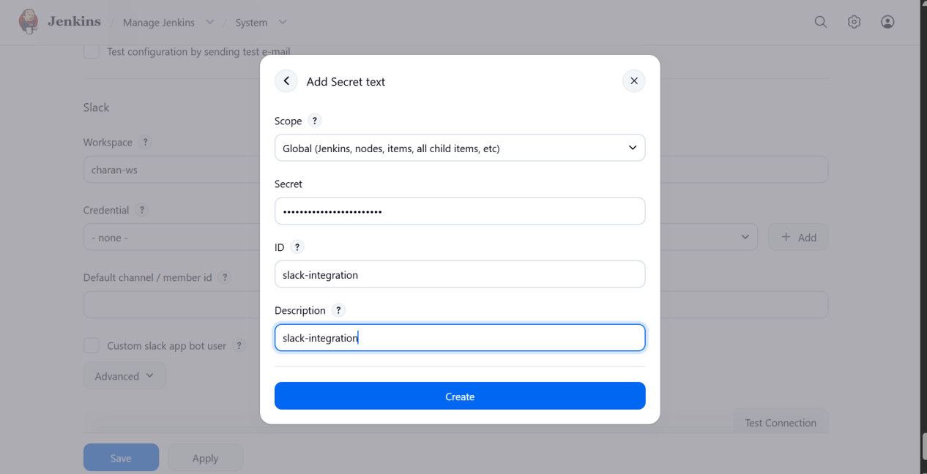

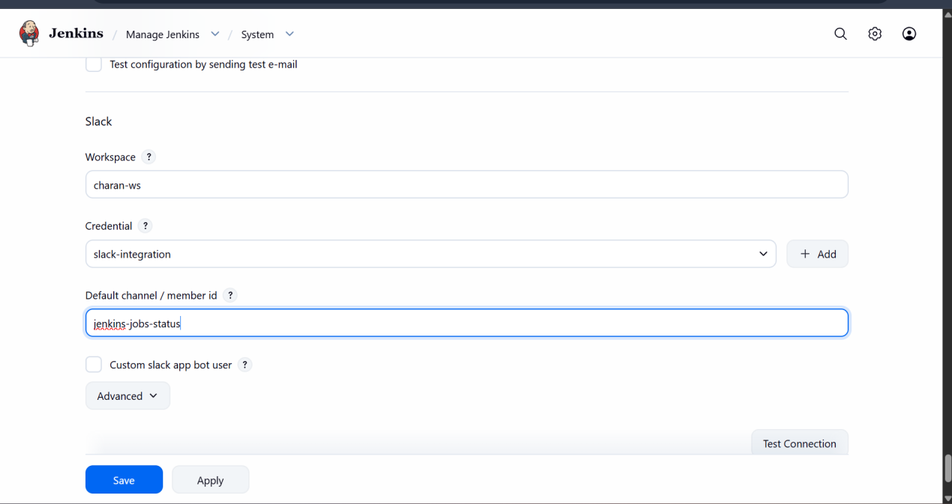

We can a test connection has been successful

Now we will be adding it to the job post build

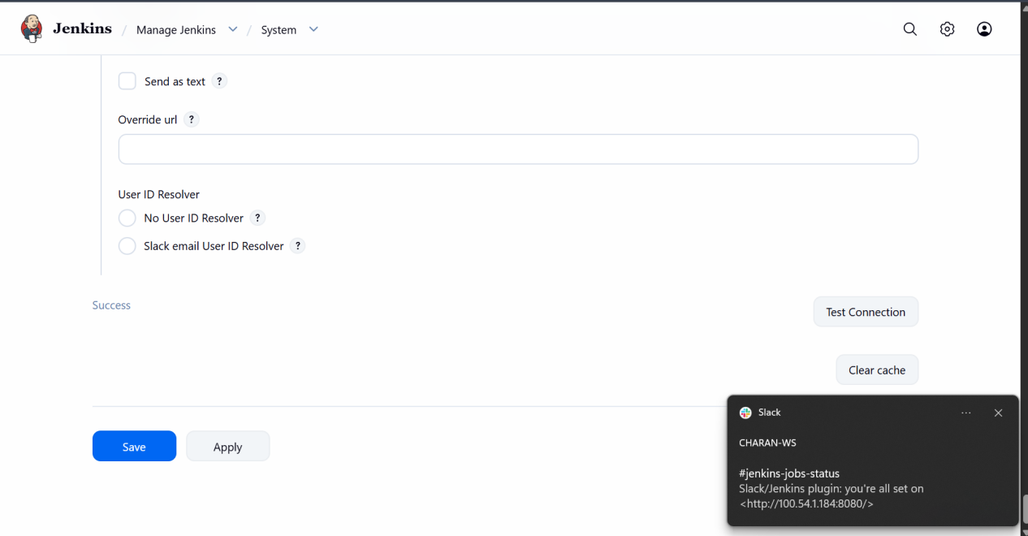

As we can see a new slack noti has been sent for job success

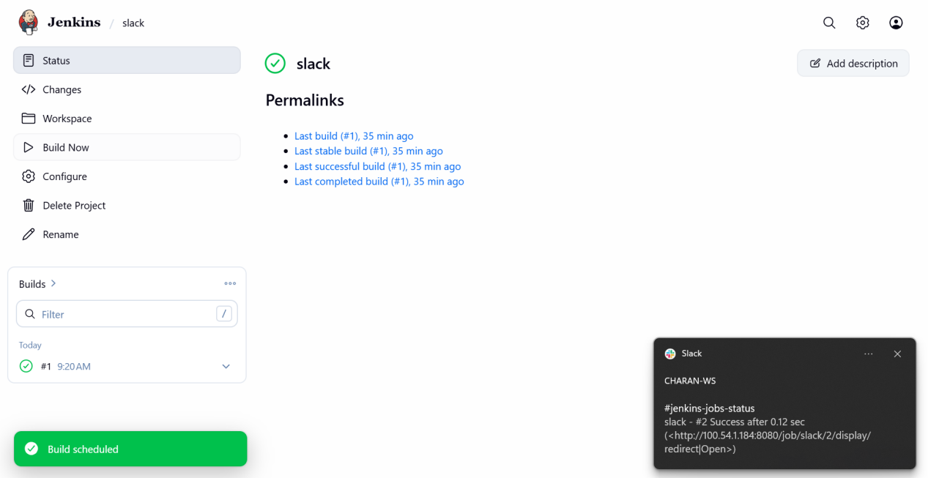

Create one Jenkins job using the below code and create three stages.

- stage1: Git clone to download the source code.
- stage2: Sonarqube Integration to check the quality of code.
- stage3: Slack Integration to send the alerts to slack

I will be creating a new job for above three stages

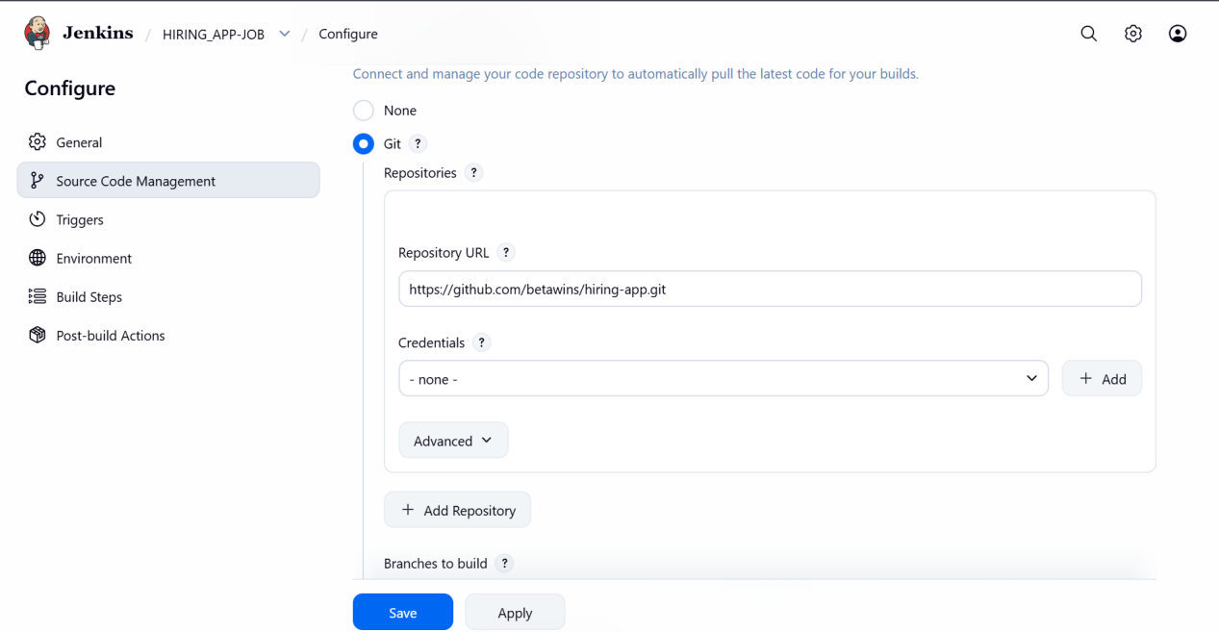

Added git repo

Then in build steps I will be adding the sonarscanner for testing the quality of the code

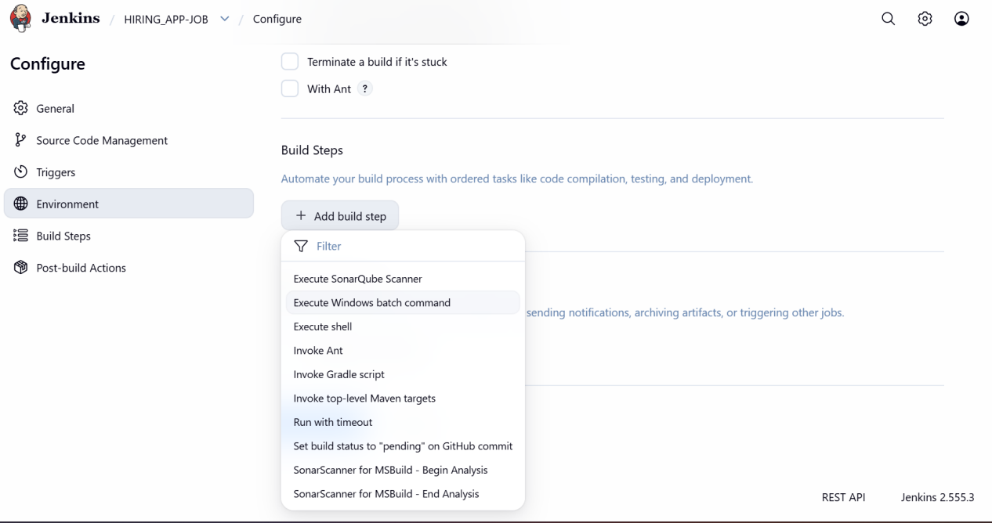

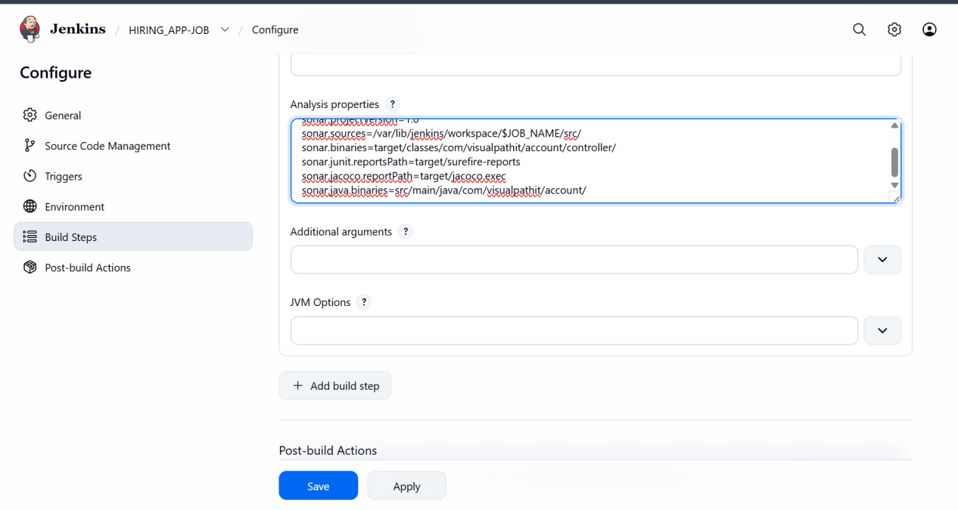

Added the analysis properties from read me file from git repo

Now in next stage I will adding post build actions for slack notifications

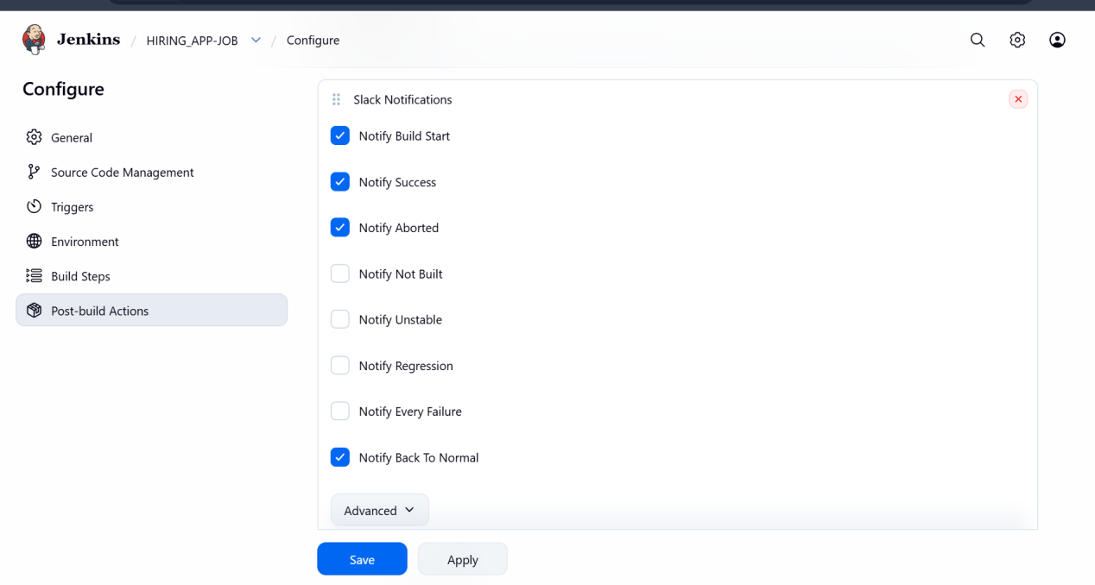

Successfully started the build and got slack notification

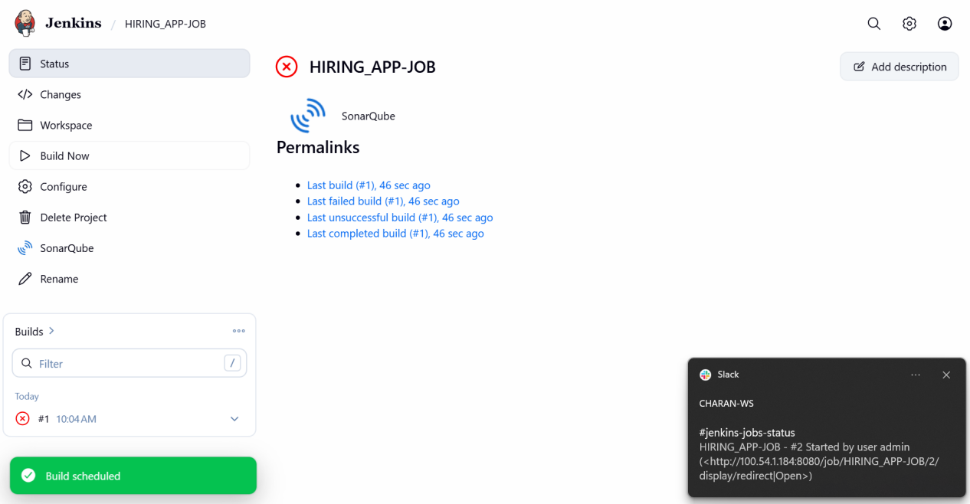

Confirmation slack notification has been received



