Configure 2 slave machines in the Jenkins master

Slave machines are used for offloading the load from master server
I can configure the slave servers to master server

I can configuree which jobs should be build on which slave or master by using label names

To do:

Creating two new servers and naming them slave and attaching it to the jenkins

And in 2 servers I have to install java

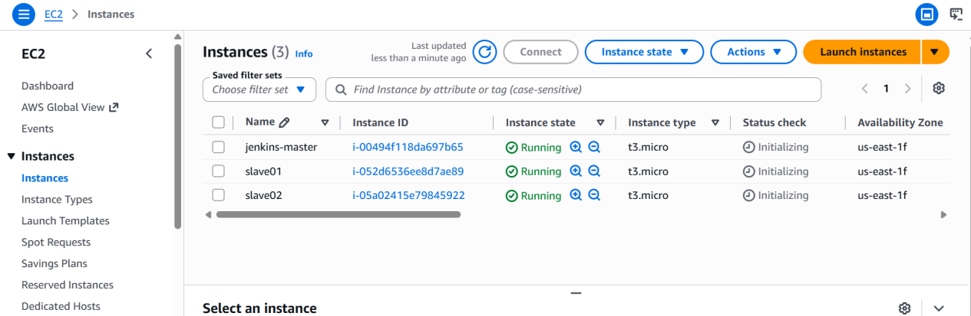

First I will be creating new keygen
Ssh-keygen
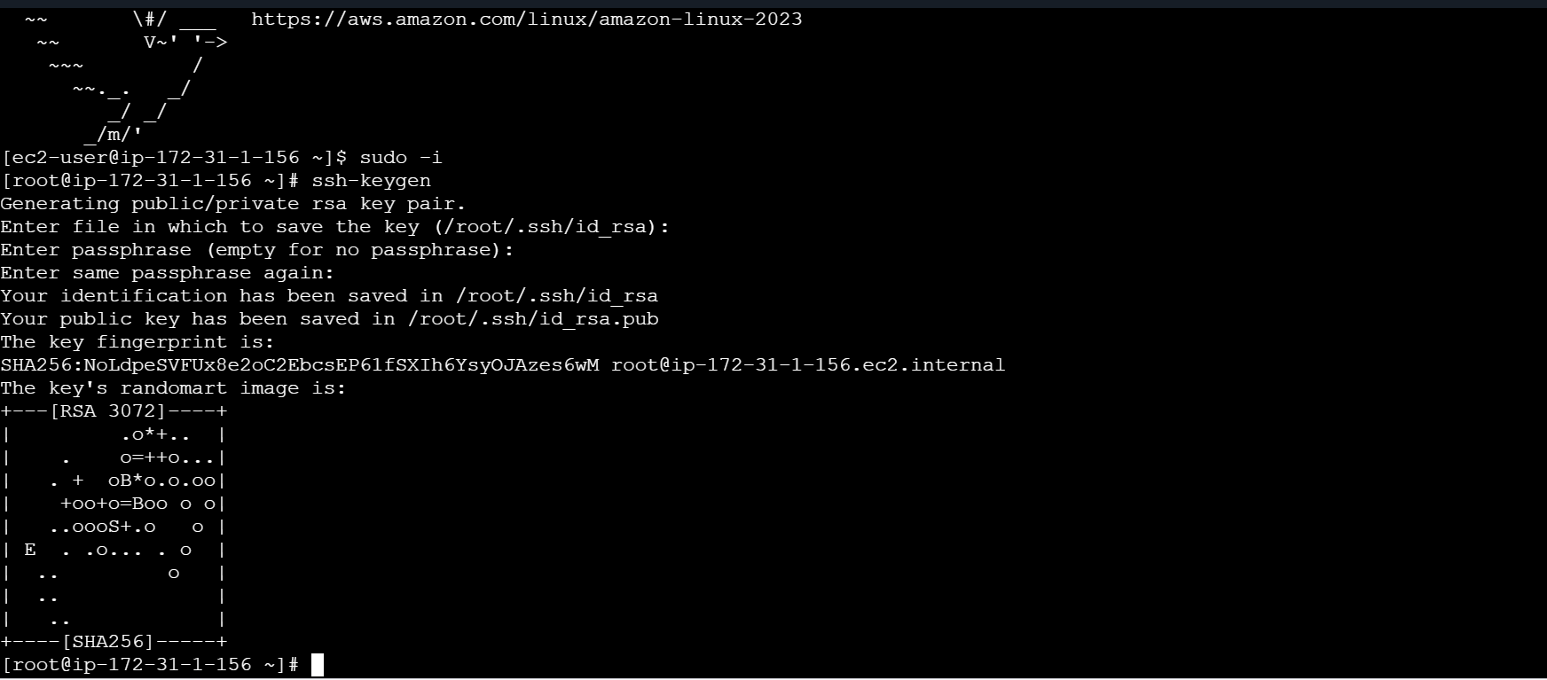
cat id_rsa.pub > authorized_keys
Then copying to the authorized keys

chmod 700 authorized_keys
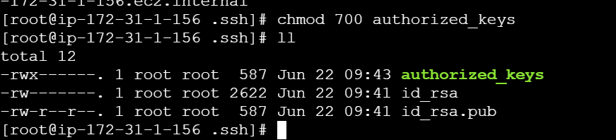

Then we need to copy this key to master or do ssh-keyscan from master

Login to master machine
switch to root user.
mkdir -p /var/lib/jenkins/.ssh
cd /var/lib/jenkins/.ssh
ssh-keyscan -H SLAVE-NODE-IP-OR-HOSTNAME >>/var/lib/jenkins/.ssh/known_hosts
# ssh-keyscan -H 172.31.38.42 >>/var/lib/jenkins/.ssh/known_hosts
chown jenkins:jenkins known_hosts
#we need to change the owner as we ran ssh-keyscan command using “root” user.
# default user of Jenkins will be “jenkins”
chmod 700 known_hosts

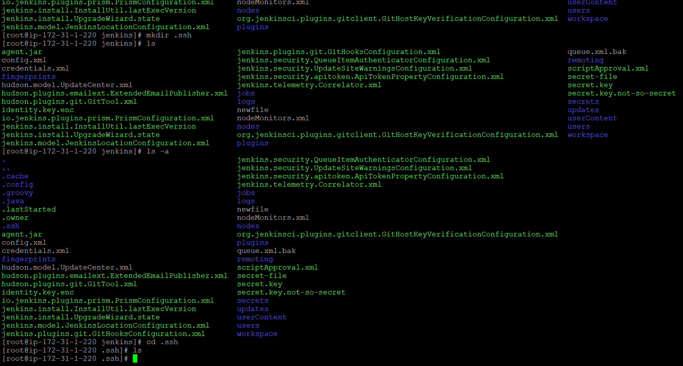

After creating a .ssh DIR in master

We will be doing keyscan form master to slave server using ssh-keyscan

ssh-keyscan -H SLAVE-NODE-IP-ORHOSTNAME >>/var/lib/jenkins/.ssh/known_hosts

The scanned key will be copied to known_hosts because in jenkins gui while creating a new node it will check for knownhosts file for any keys

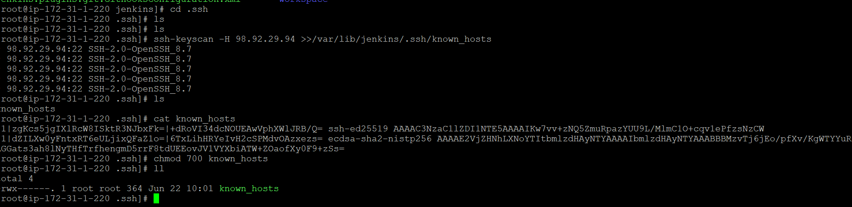

Then going to jenkins ui and creating a new node slav01

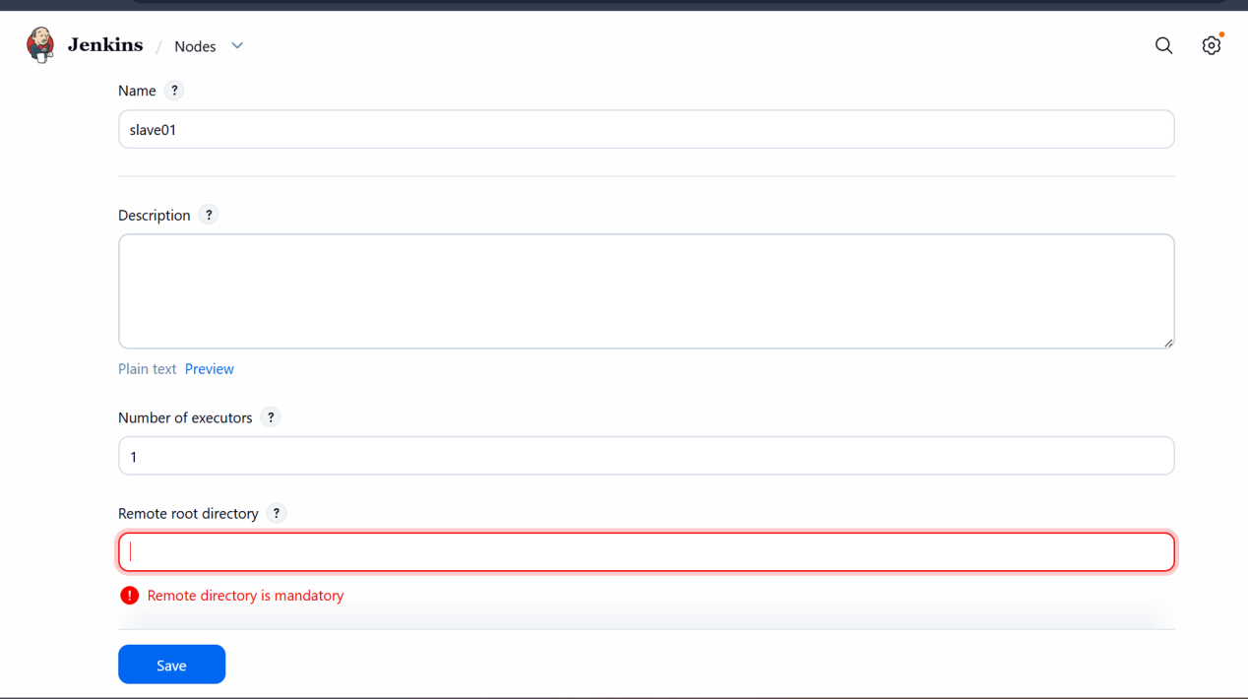

I will be giving ec2-user path
/home/ec2-user

Because if I give root path of server

Then the jenkins wont have permission for the root access of the slave server so I will be giving the ec2-user path

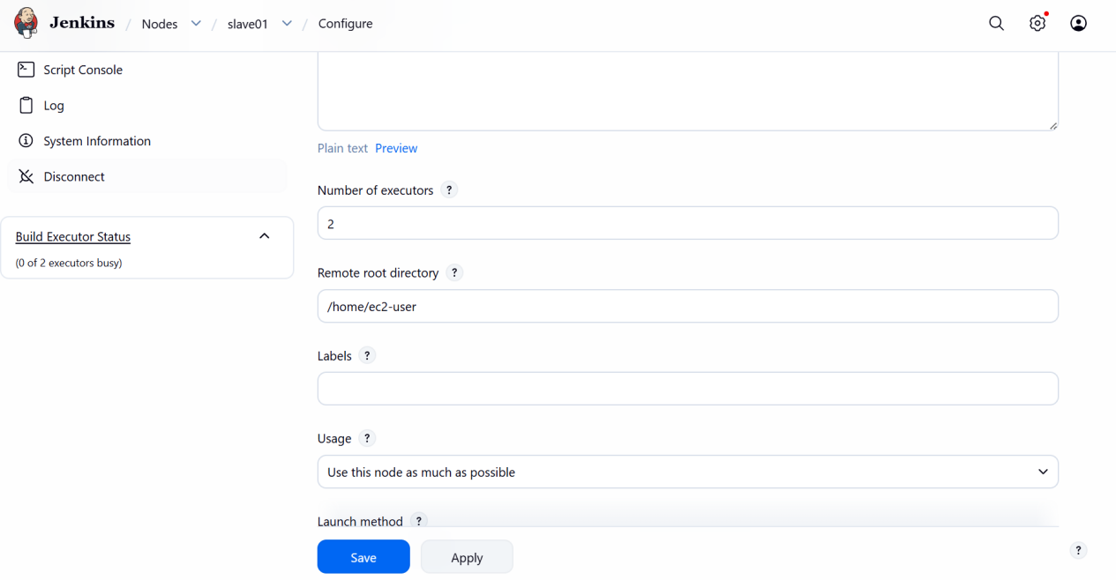

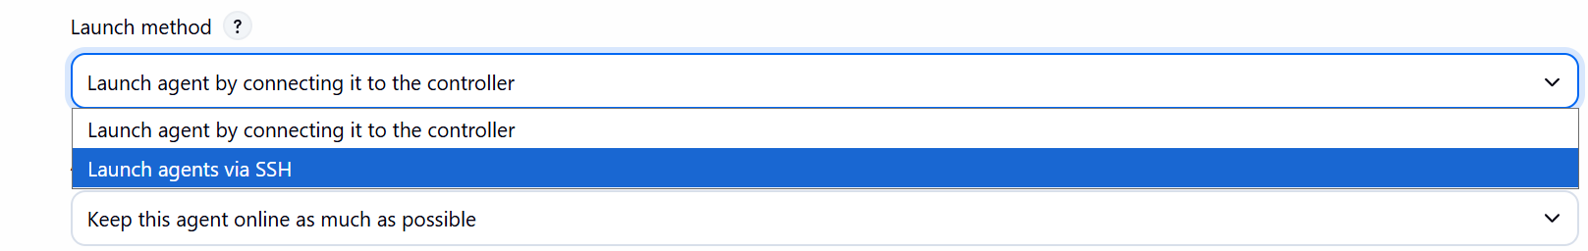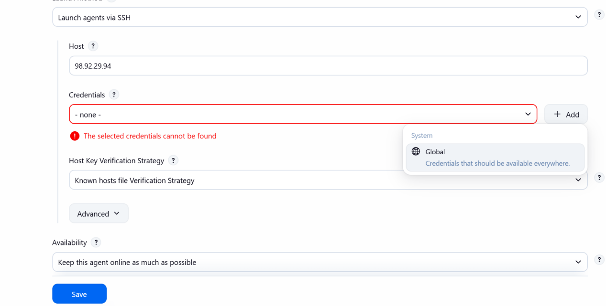

After giving slave server ip then add new credentials for connecting to the server and the password will be keypair

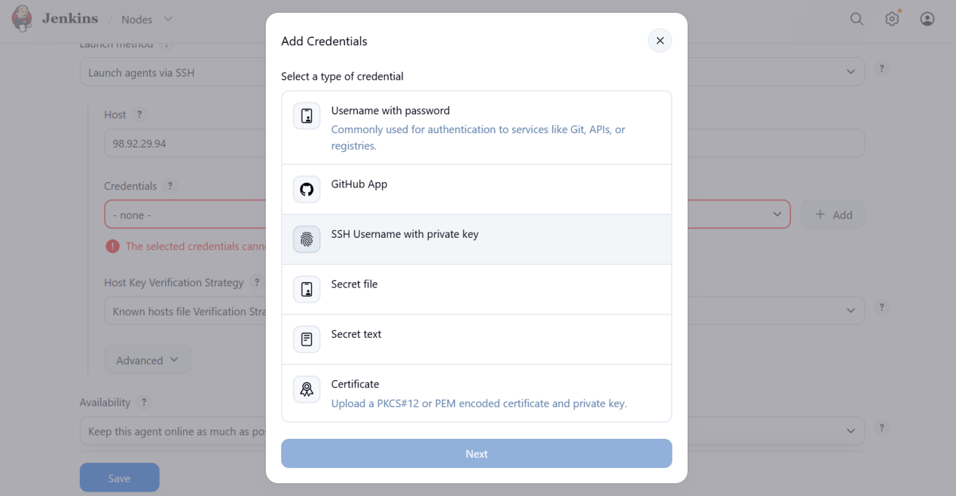

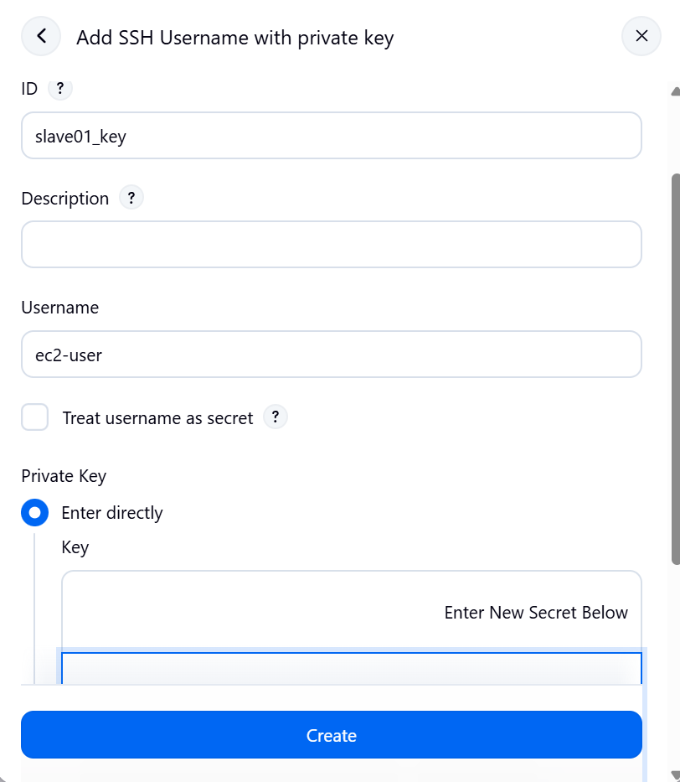

And I will directly copy my pem key here
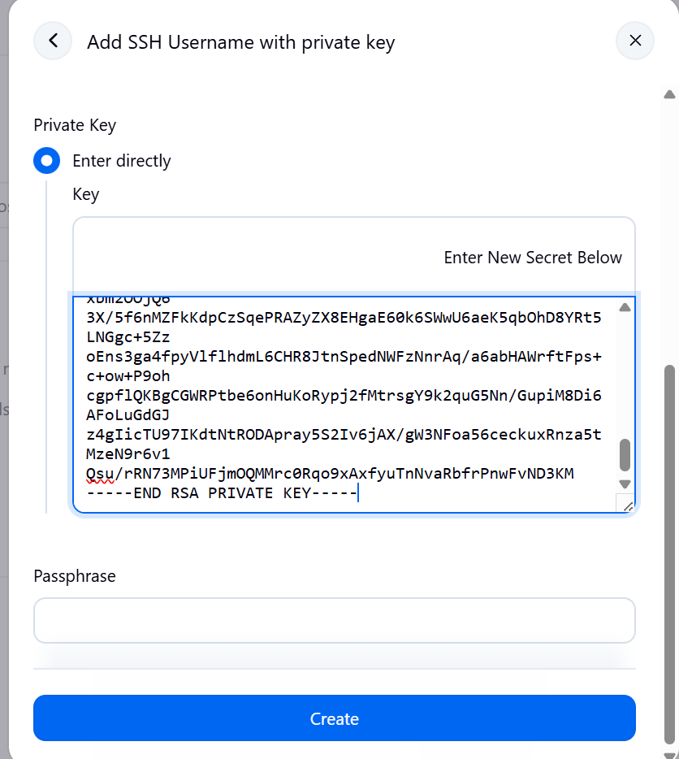
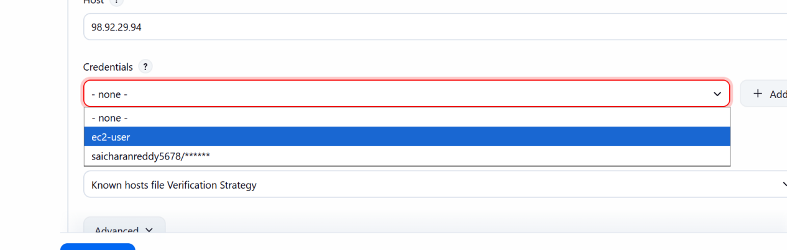

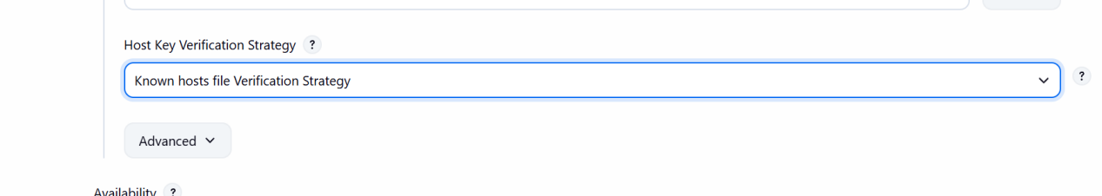
Before we have copied the key to the known_hosts now we can see that jenkins checks this path by this section

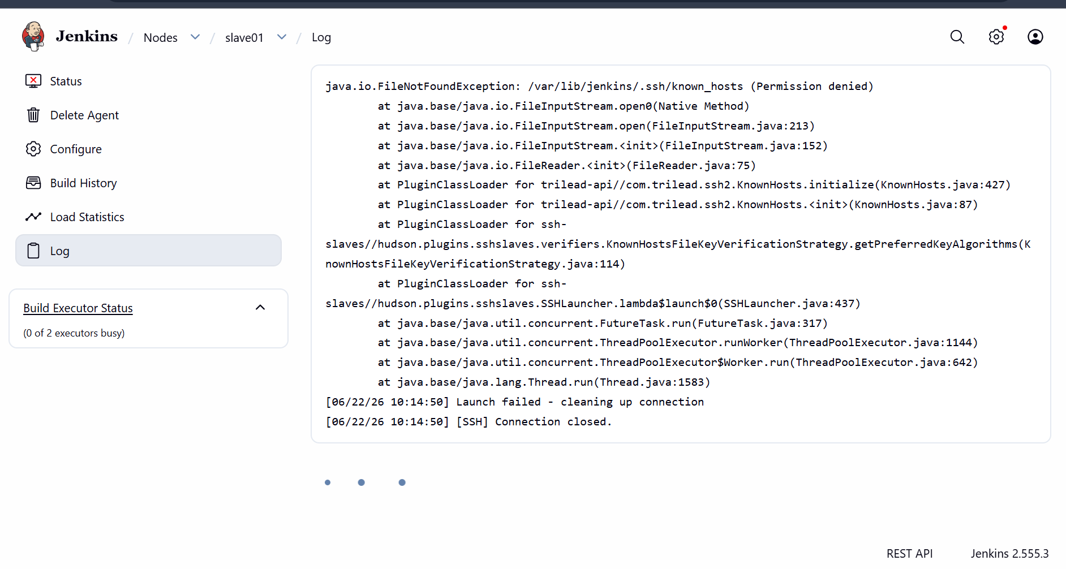
We can see the error because it cannot check the known_hosts because it has no permission for known_hosts
Now I will give permission to jenkins and change from root to jenkins
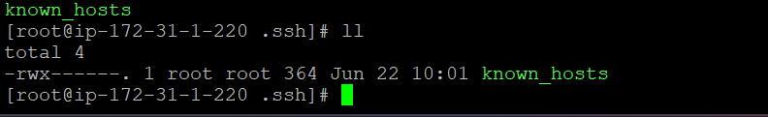

Will be changed to jenkins

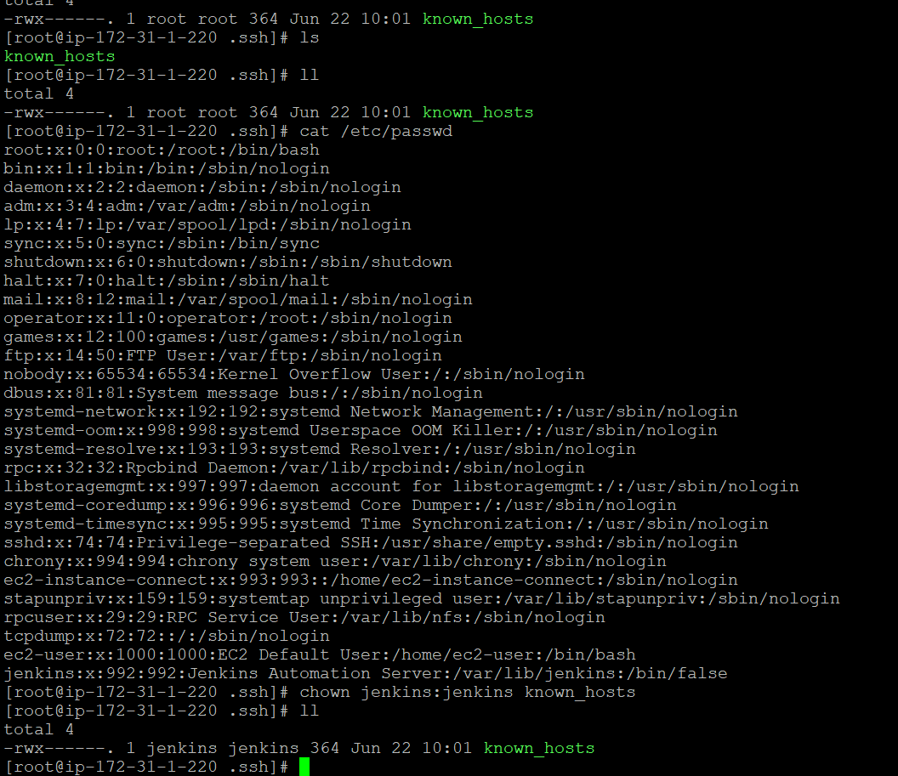

I have change the owner for known_hosts

And need to check the path of the remote path in slave configuration

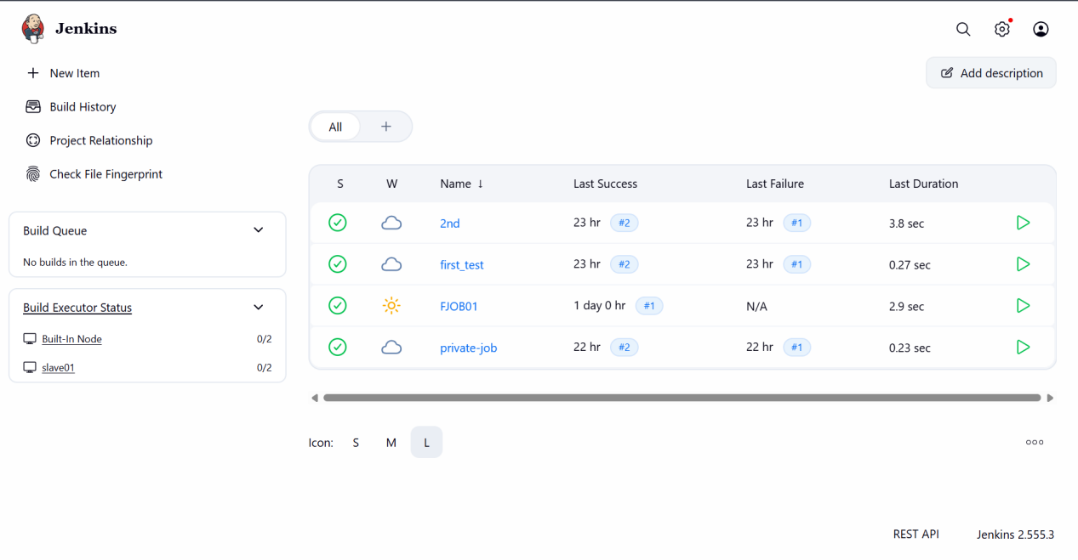

The same process I will be doing for another slave server naming it slave02

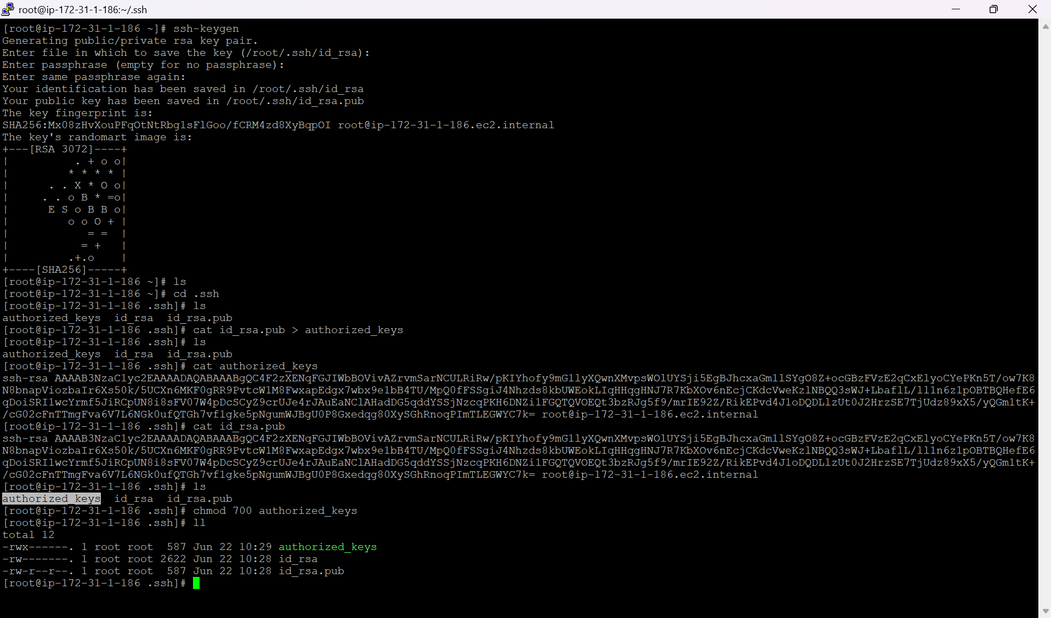

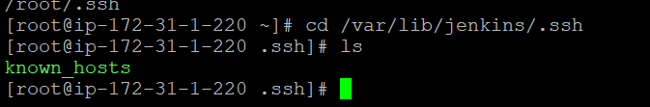

Do keyscan from master and copy its key to the known_hosts

ssh-keyscan -H 3.238.180.215 >>/var/lib/jenkins/.ssh/known_hosts
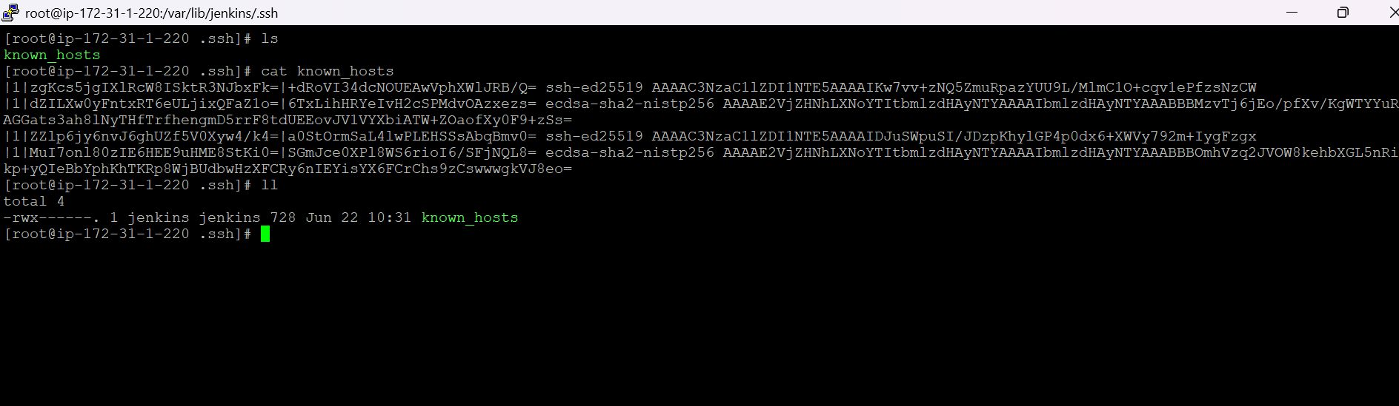

Now create new node in jenkins gui

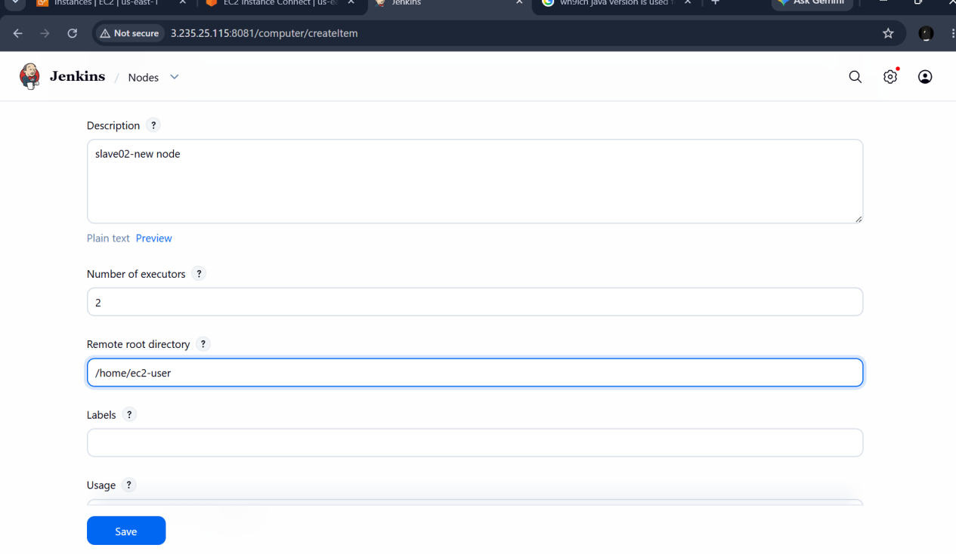
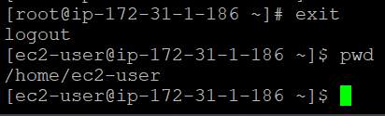

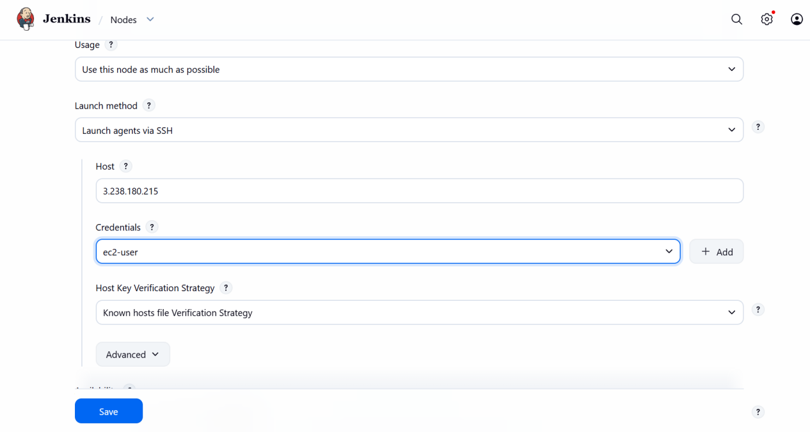
Iam using previously created credentials because I have sam keypair for both servers

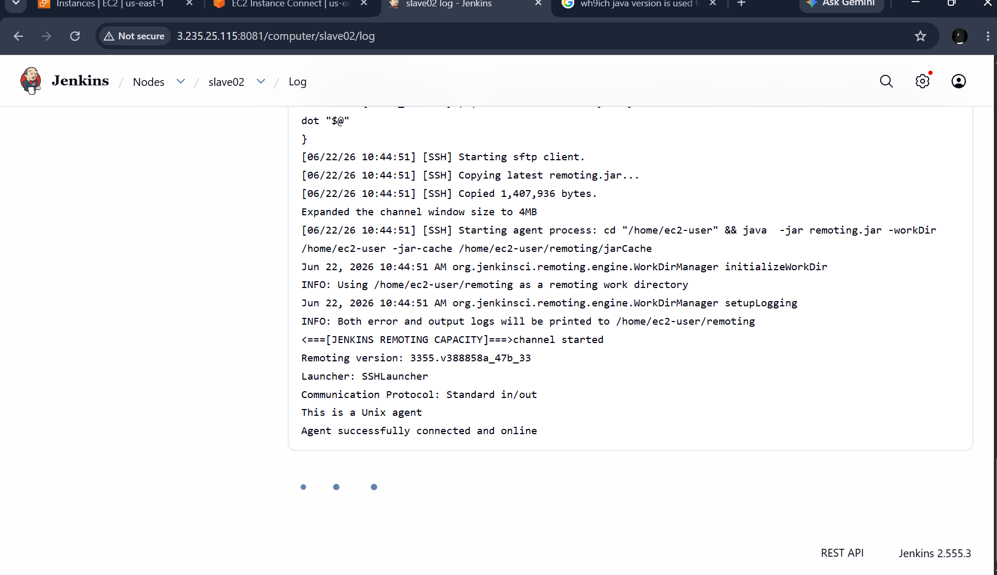

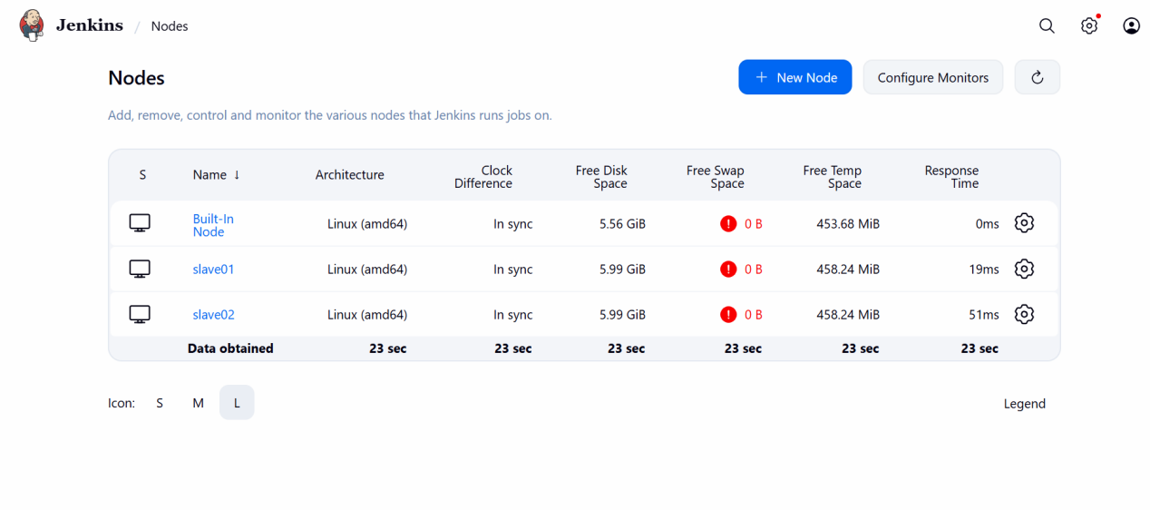

We can see new 2 slave server has been attached to the master

Configure webhooks to the Jenkins job

Webhooks are used for jenkins jobs

Whenever a new code or any changes has been made in the github then automatically the job will be run

That is the use case of webhooks

To do

I will be creating a new webhooks in github

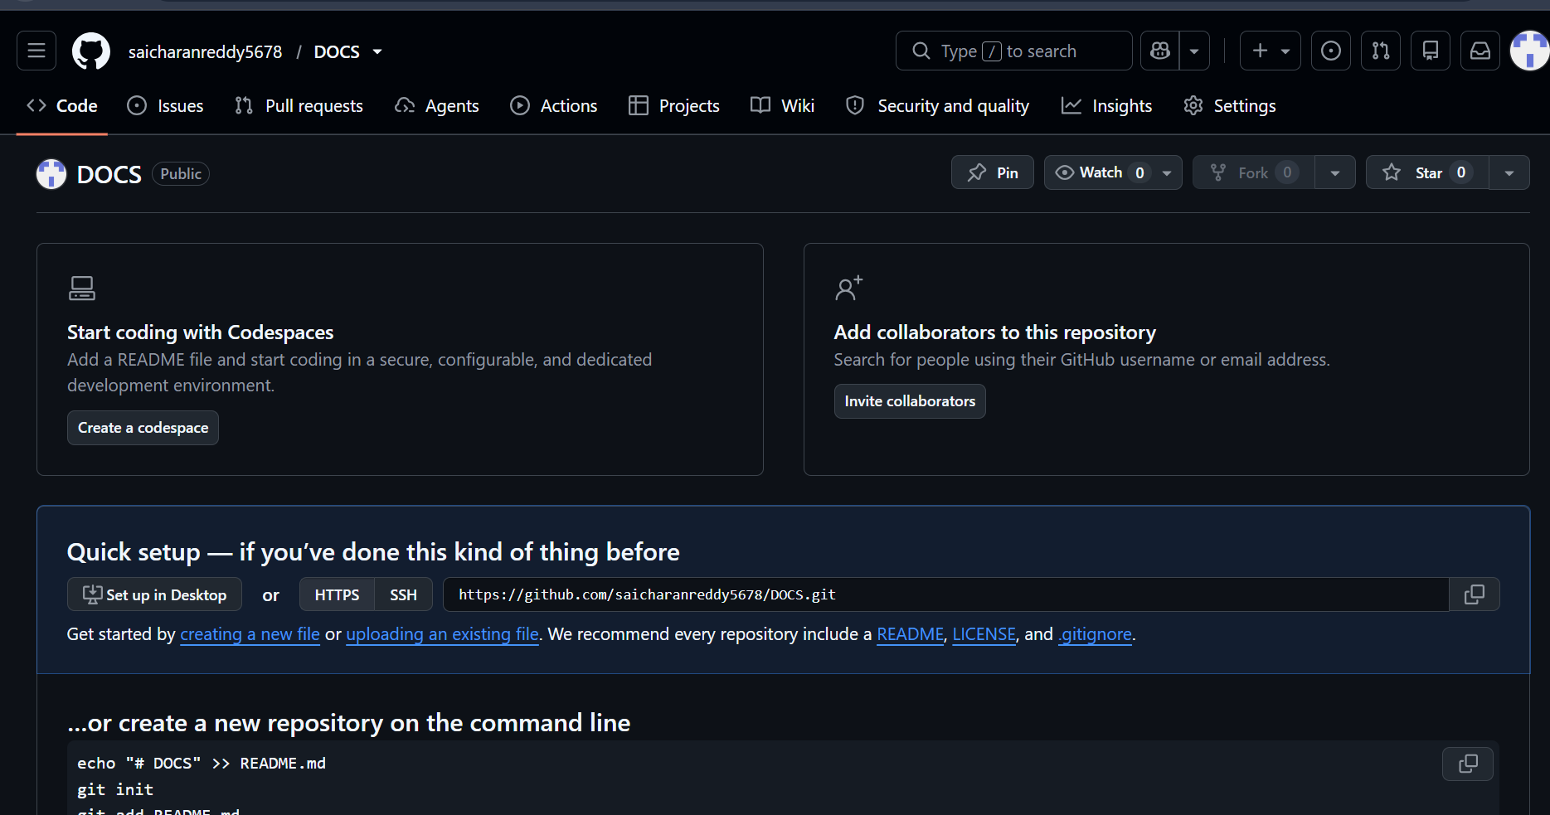

I will be creating a new webhook for this particular repo

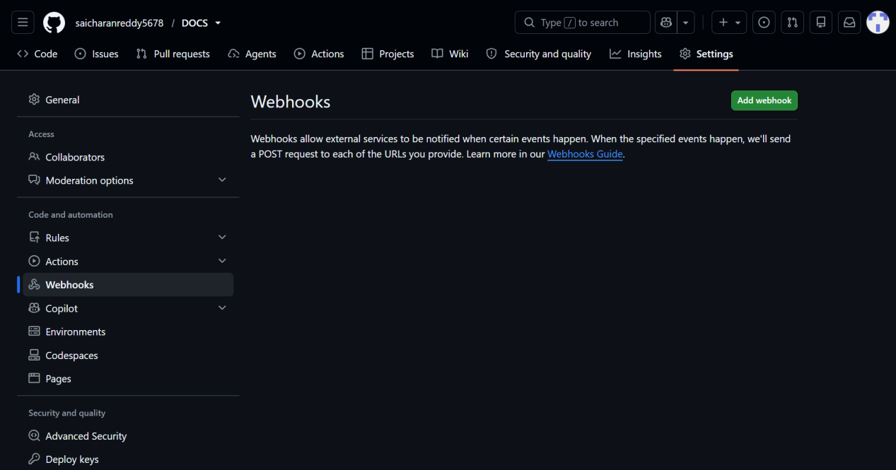

We need to give jenkins url

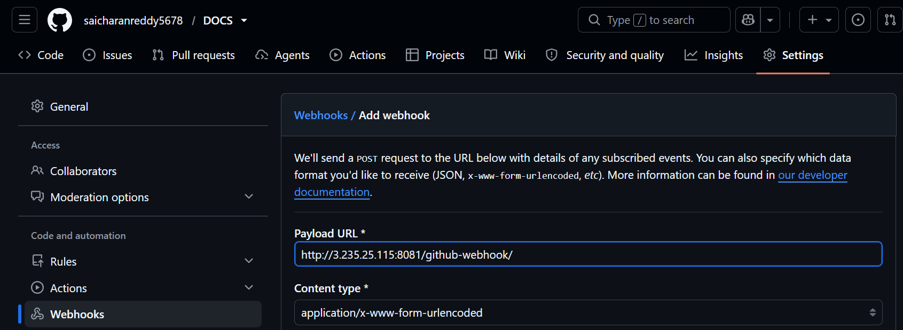

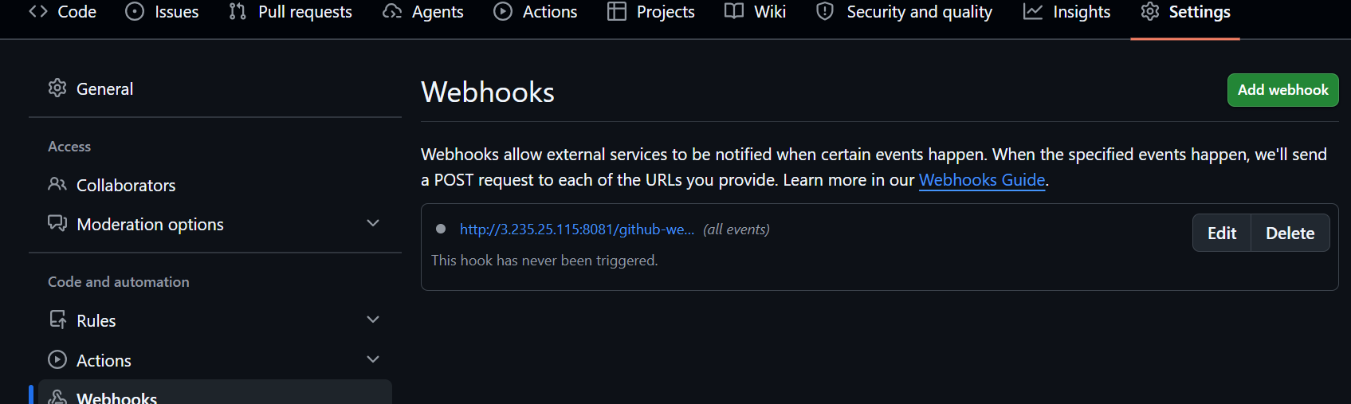

We can see the trick mark after it is successfully connected to the jenkins

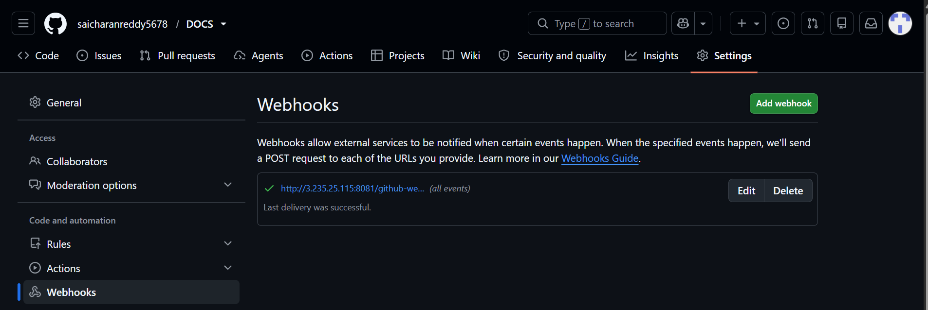

After this I will be adding it to the job

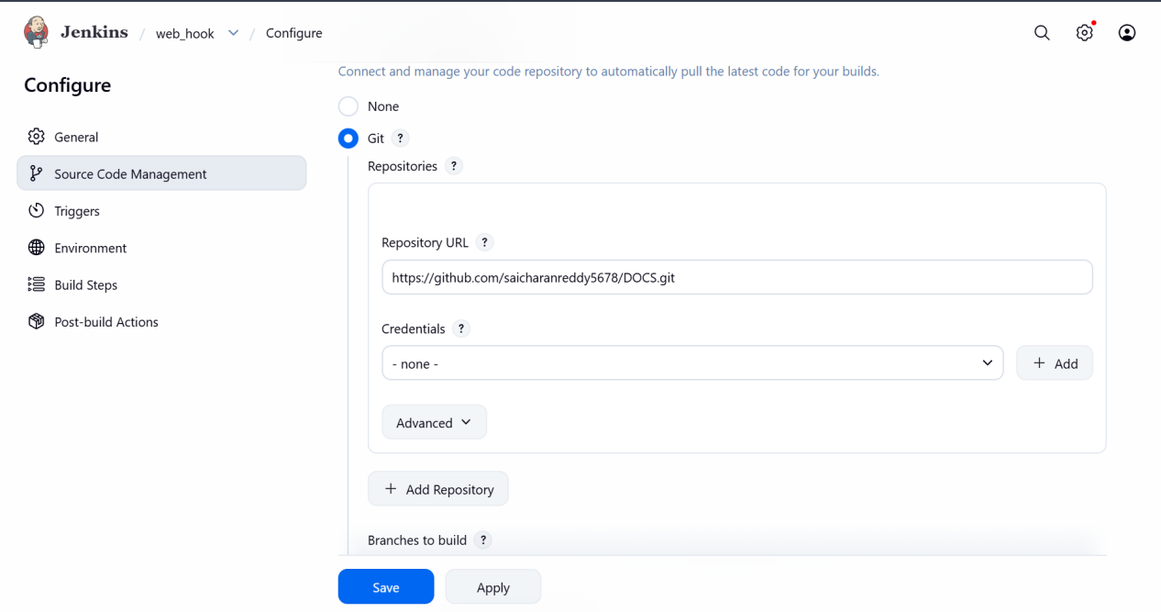

I need to have webhook for that particular repo

If I have webhooks for different repo and in job I have different repo url then the webhooks wont trigger

So we need to check whether the given repo has webhooks activated or not github

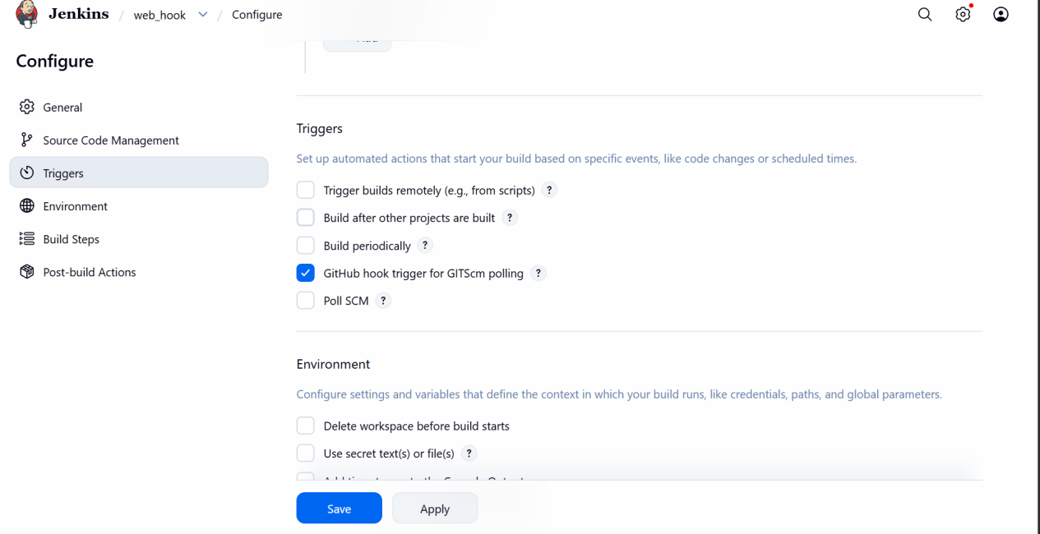

Need to enable github hook

I have made changes in the github repo and automatically the job has been sheduled

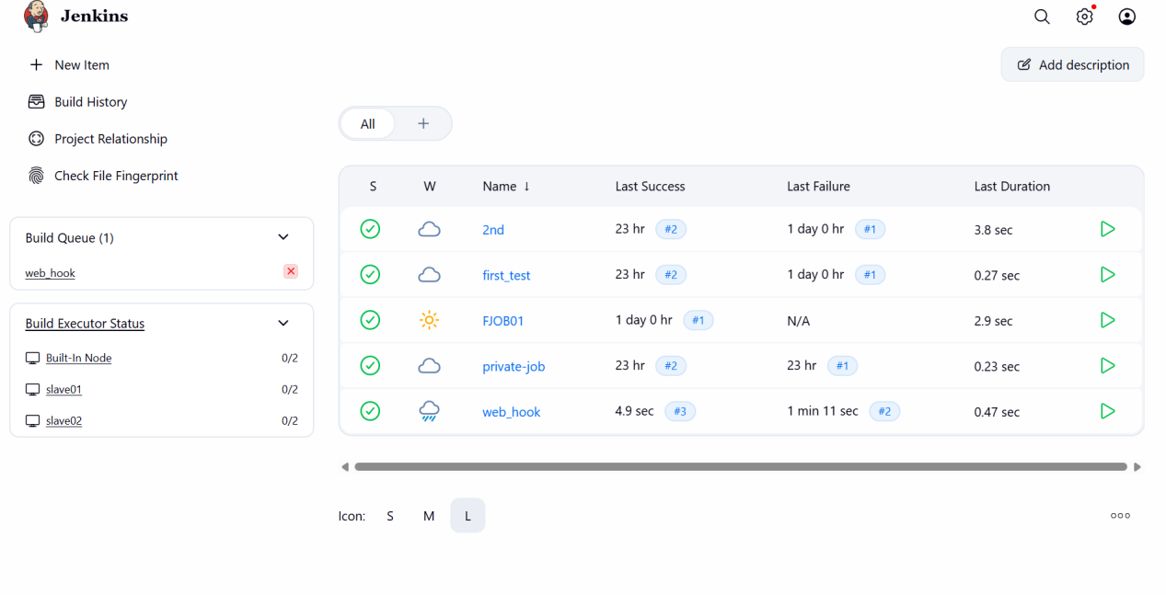

Configure Poll SCM and Build Periodically options in the Jenkins job

Poll SCM and BUILD PERIODICALLY are quite similar but both have minor changes

Poll SCM shedules the job using same like cronjob

But first it will check for any changes at the time in github if it had any changes then the job will be built, if there is no chnages then the job will not be build

BUILD PERIODICALLY does not check for any changes in github repo it will directly shedules the job and builts even if there is no changes

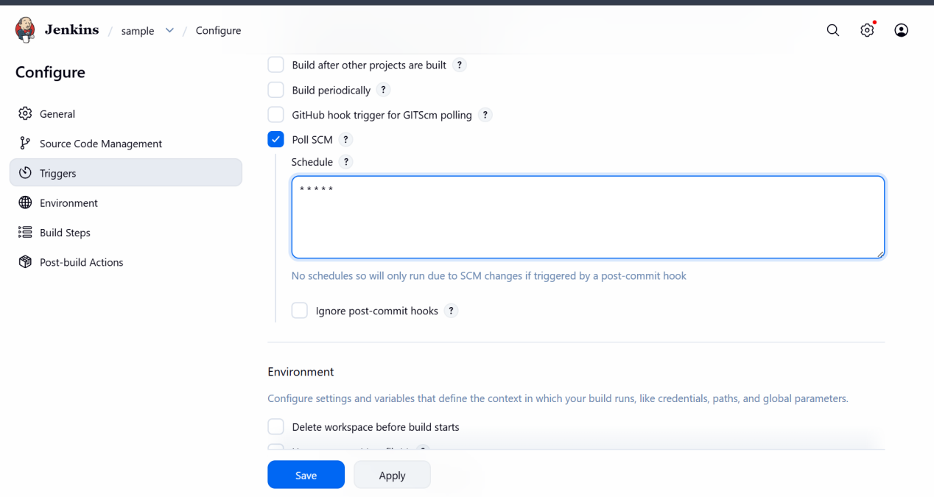

Now after adding the poll scm shedule it will check for any changes in repo for every minute

If no changes then the job wont be build

If changes the job will be build

I have deleted a file from repo

Then the job will be sheduled

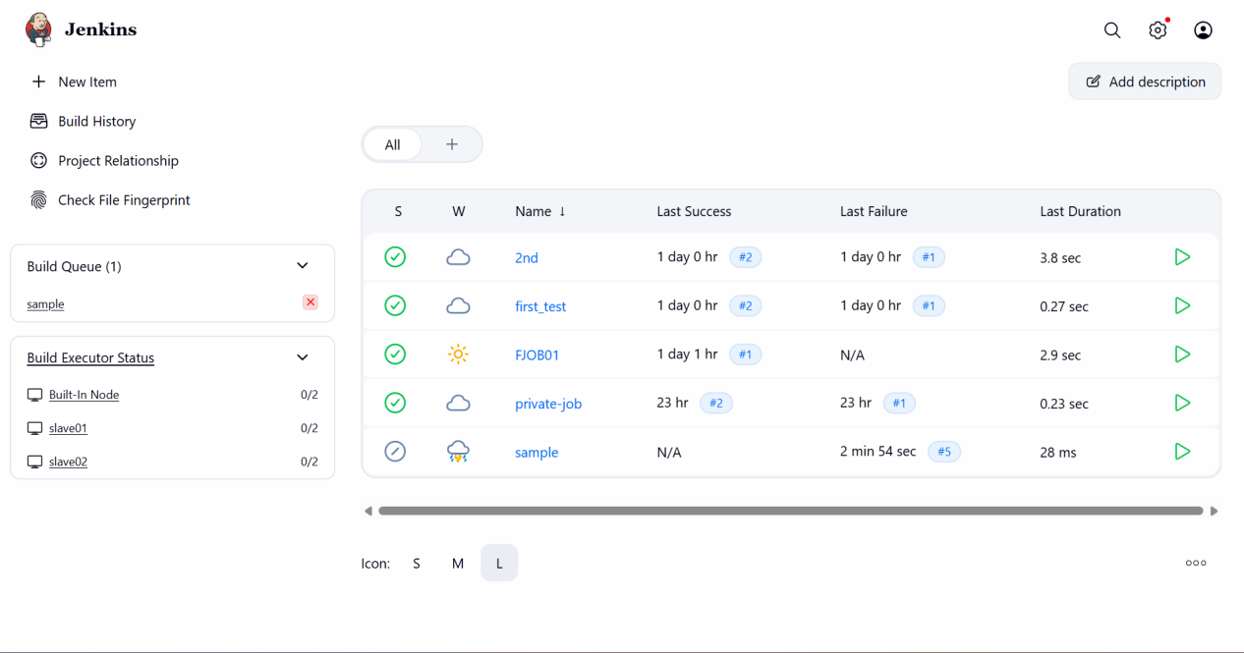

Now we can see the new job has been sheduled as it has checked the repo for chnages
As I have made changes then the job has been run

Now I will be sheduling the build periodically and will be giving the shedules for the job
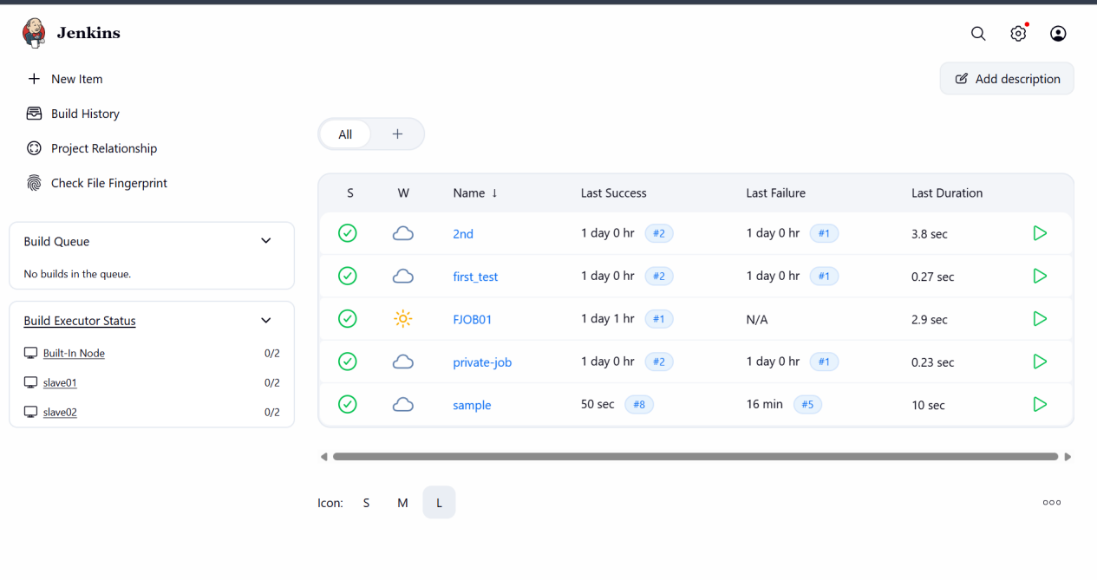
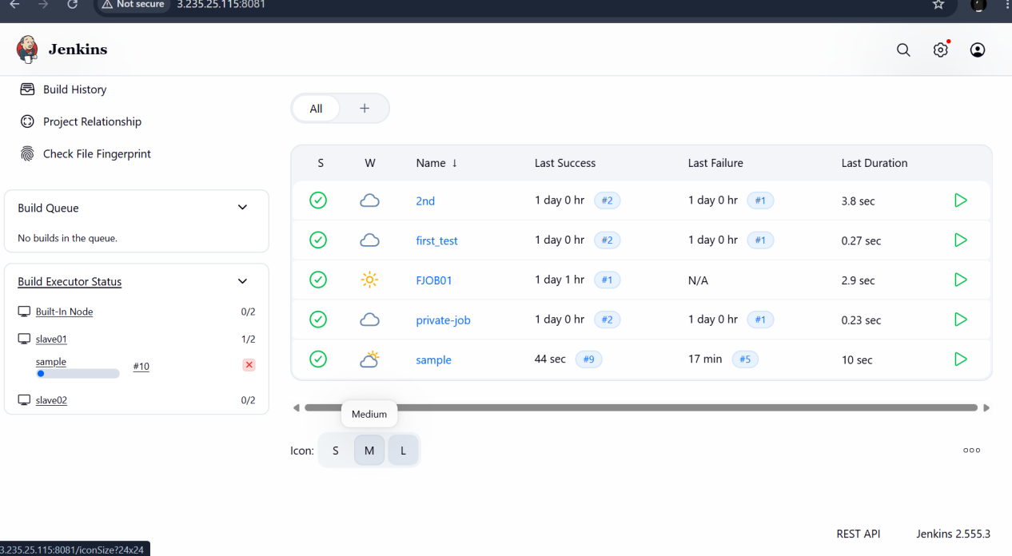

So the job will be build for every minute even though we have not made any changes in github repo

Take a backup of the Jenkins server using a bash-script

First I want to see to which server I want to send the backup file of my current jenkins server

Step 1

Create backup of jenkins server
Tar -cvf backup.tar jenkins
And send this backup to the other server periodically

So I will be using the cron job for this

I will be sheduling the job for my current bashscript

Take a backup of Jenkins using the ThinBackup plugin

We can also use thinbackup plugin for taking the backup of the master server

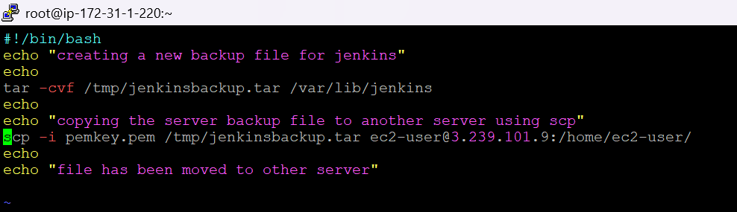

Wrote a simple bash script to just compress and send the file to other server

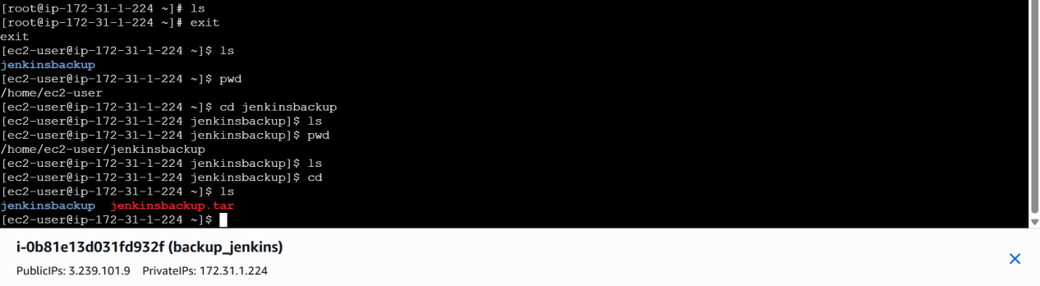

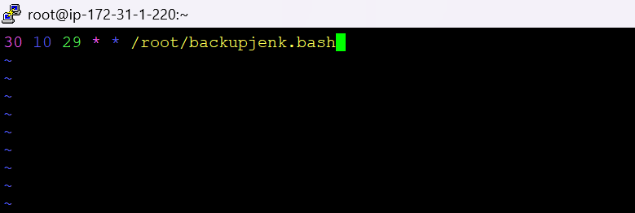

- Minute: 30
- Hour: 10 (10:30 AM)
- Day of Month: 29
- Month: * (Every month)
- Day of Week: * (Every day of the week)
This cron job will only run once a month on the 29th day at 10:30 AM

I have sheduled the backup and it will send to the remote server at sheduled time

THIN BACKUP

Instead of bashscript we can also use thinbackup for our master server backup

By this we can restore our master server backup on other server

First install thinbackup plugin

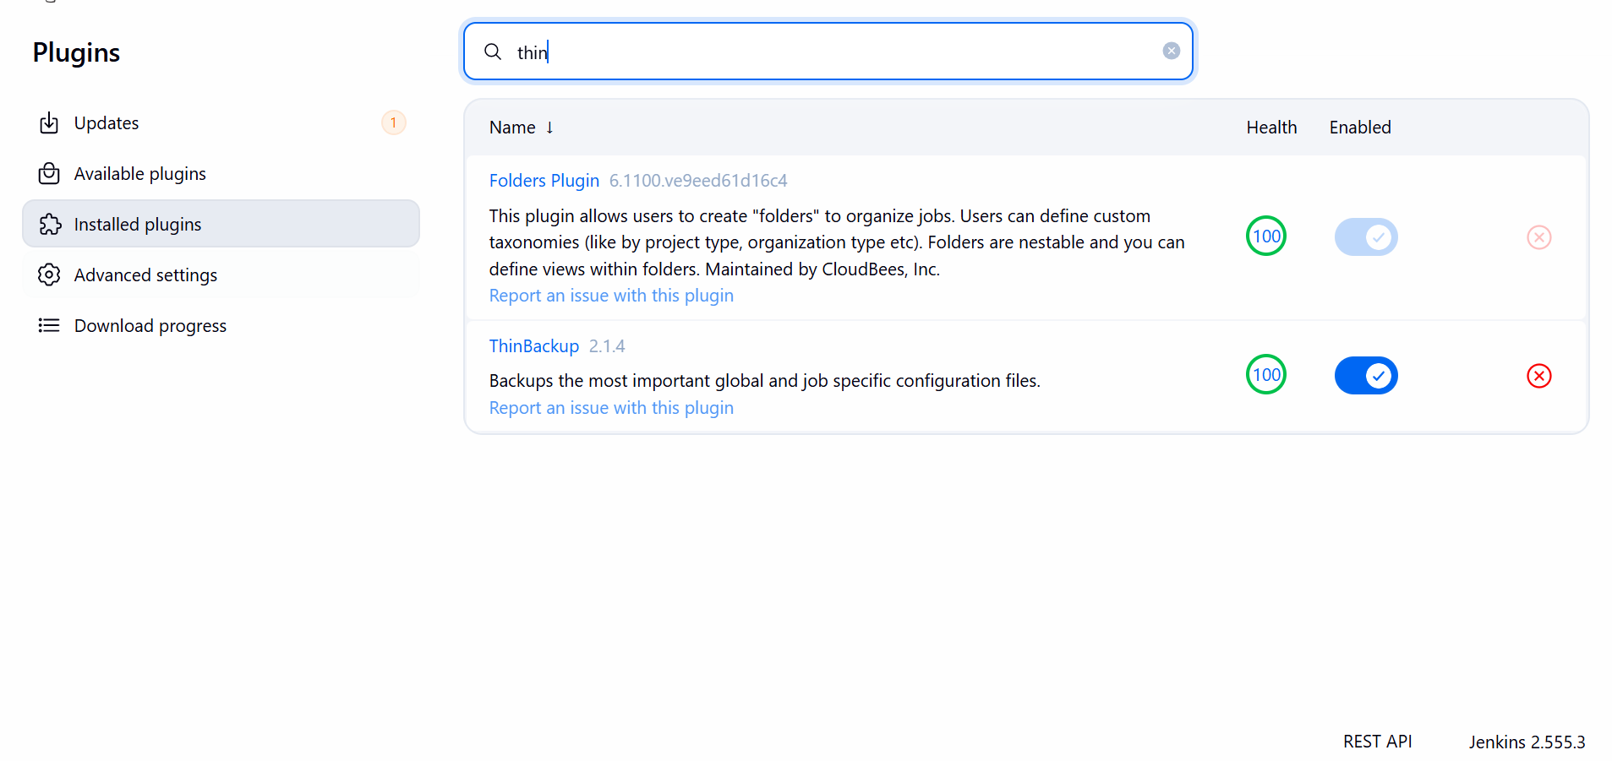

In system go to thinbackup

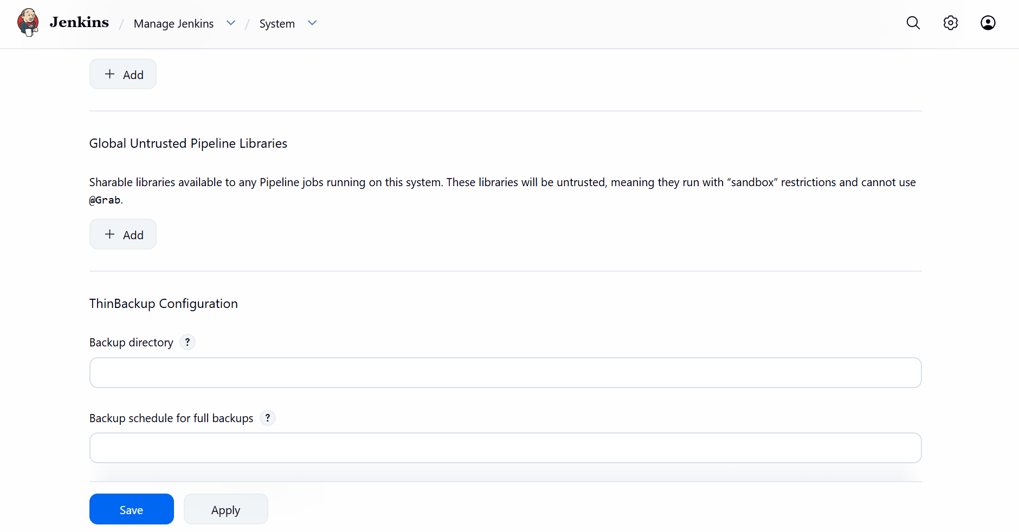

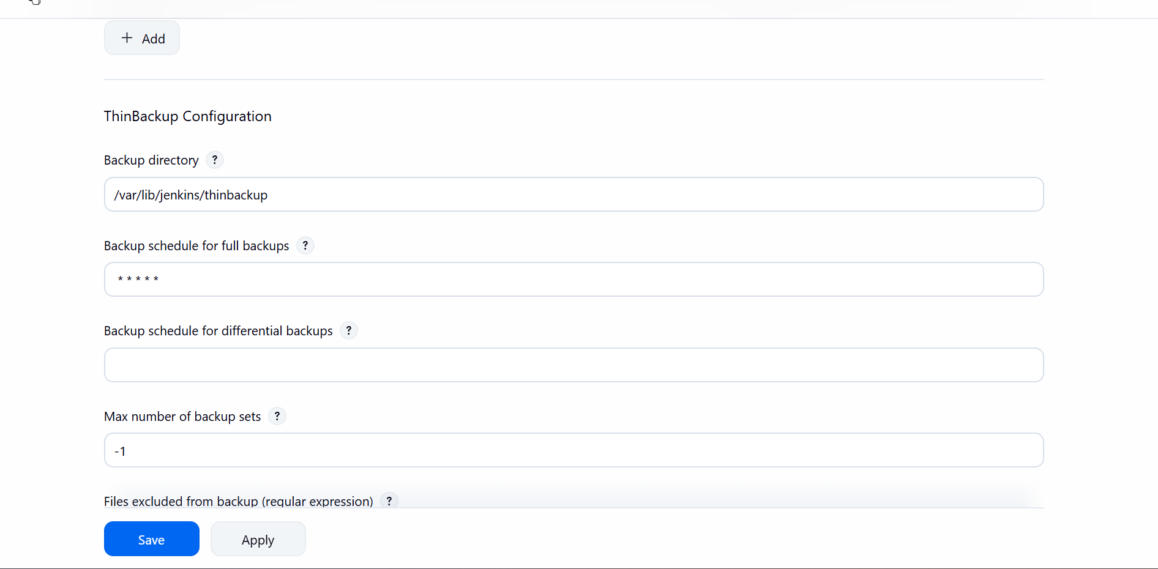

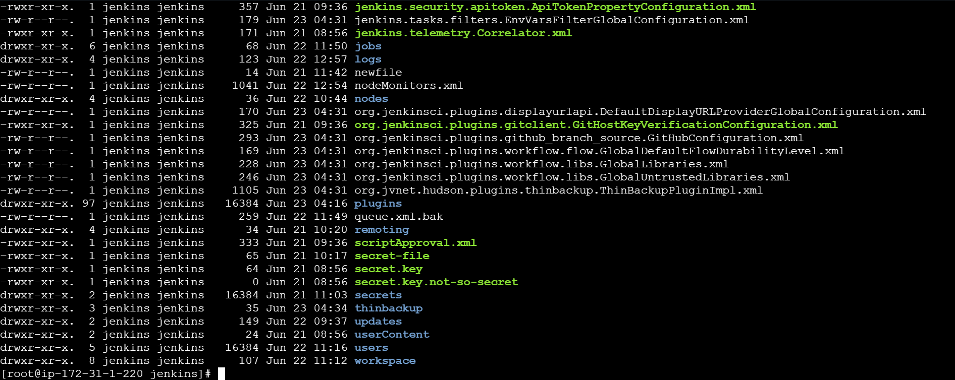

Set up a new Jenkins server and restore the backup

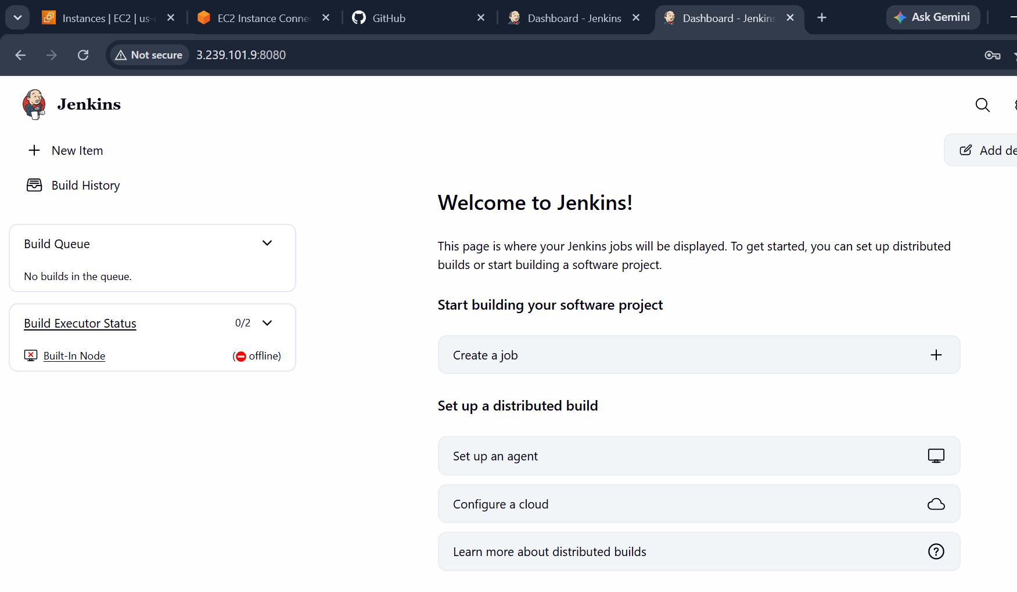

I have already sent the backup file from master server to backup server using bashscript and will be setting this as master server

I need to unzip the backup file in this server

Then we can see all jobs and configurations from master server in this backup server

Just by unzipping the file we can the jobs and configurations in backup server

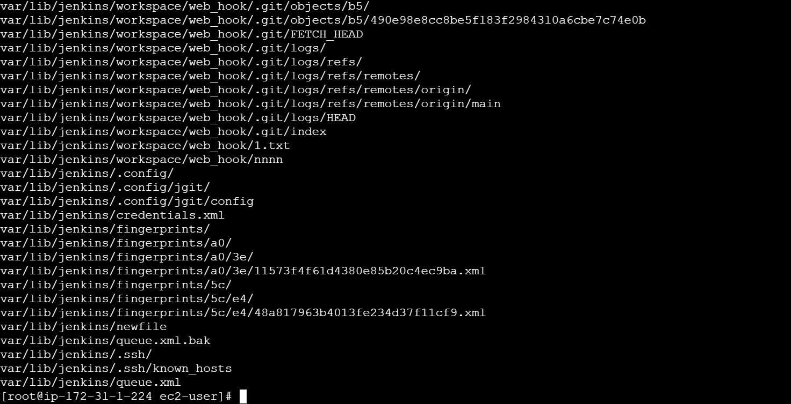

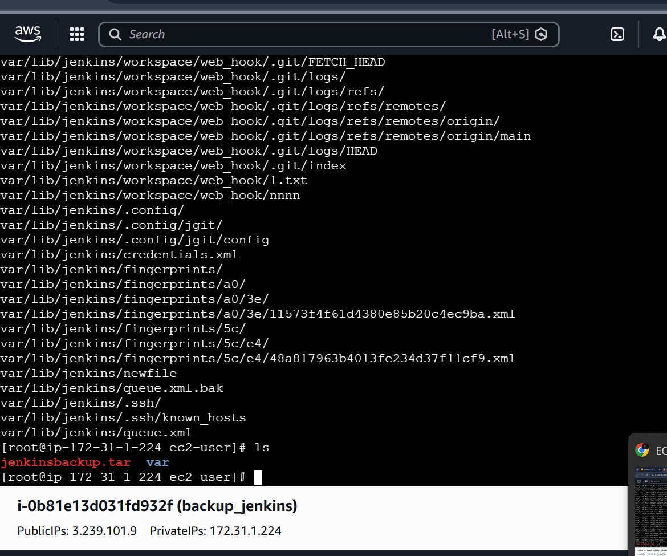

Now we can see new backup server has been created for main jenkins

Copy the jenkins backup always in root /var/lib



