Create one Declarative pipeline job

Declarative pipeline are standard pipelines

Creating a new pipeline job with declarative pipeline

The declarative pipeline I have done to push the code to sonarqube
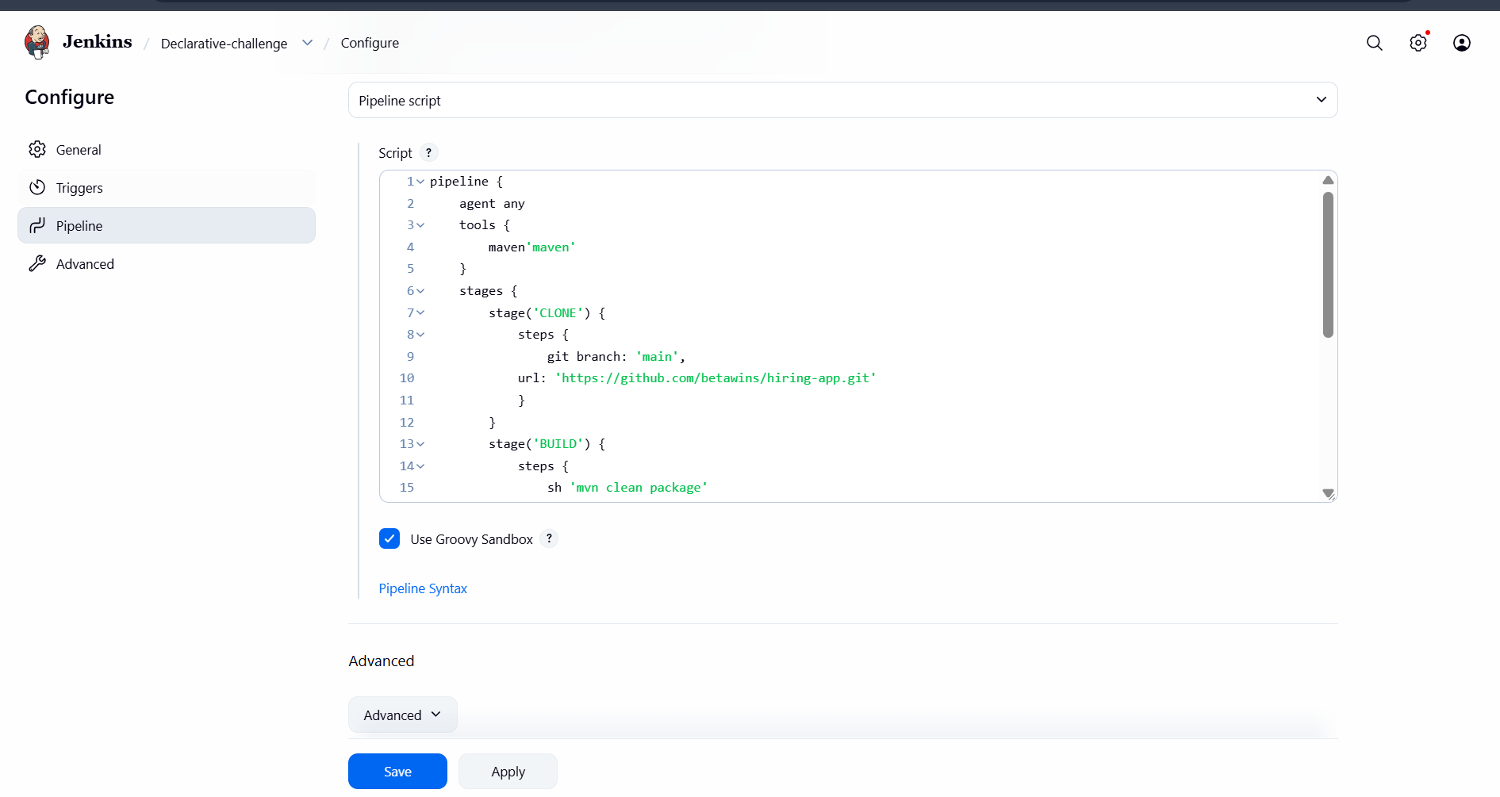

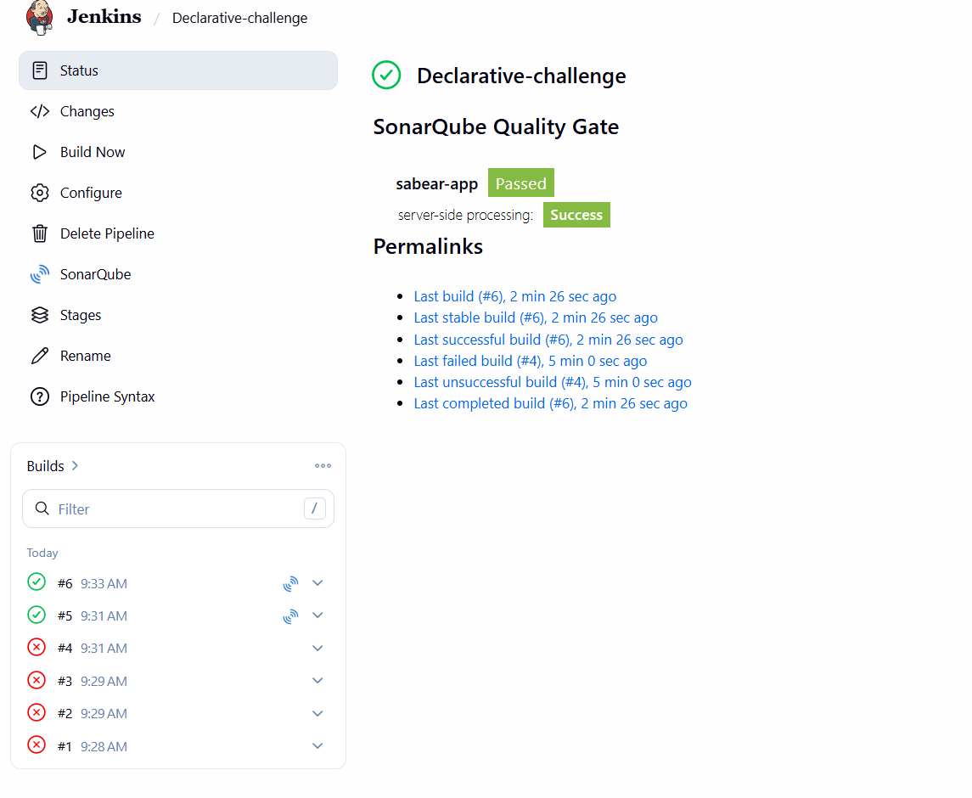

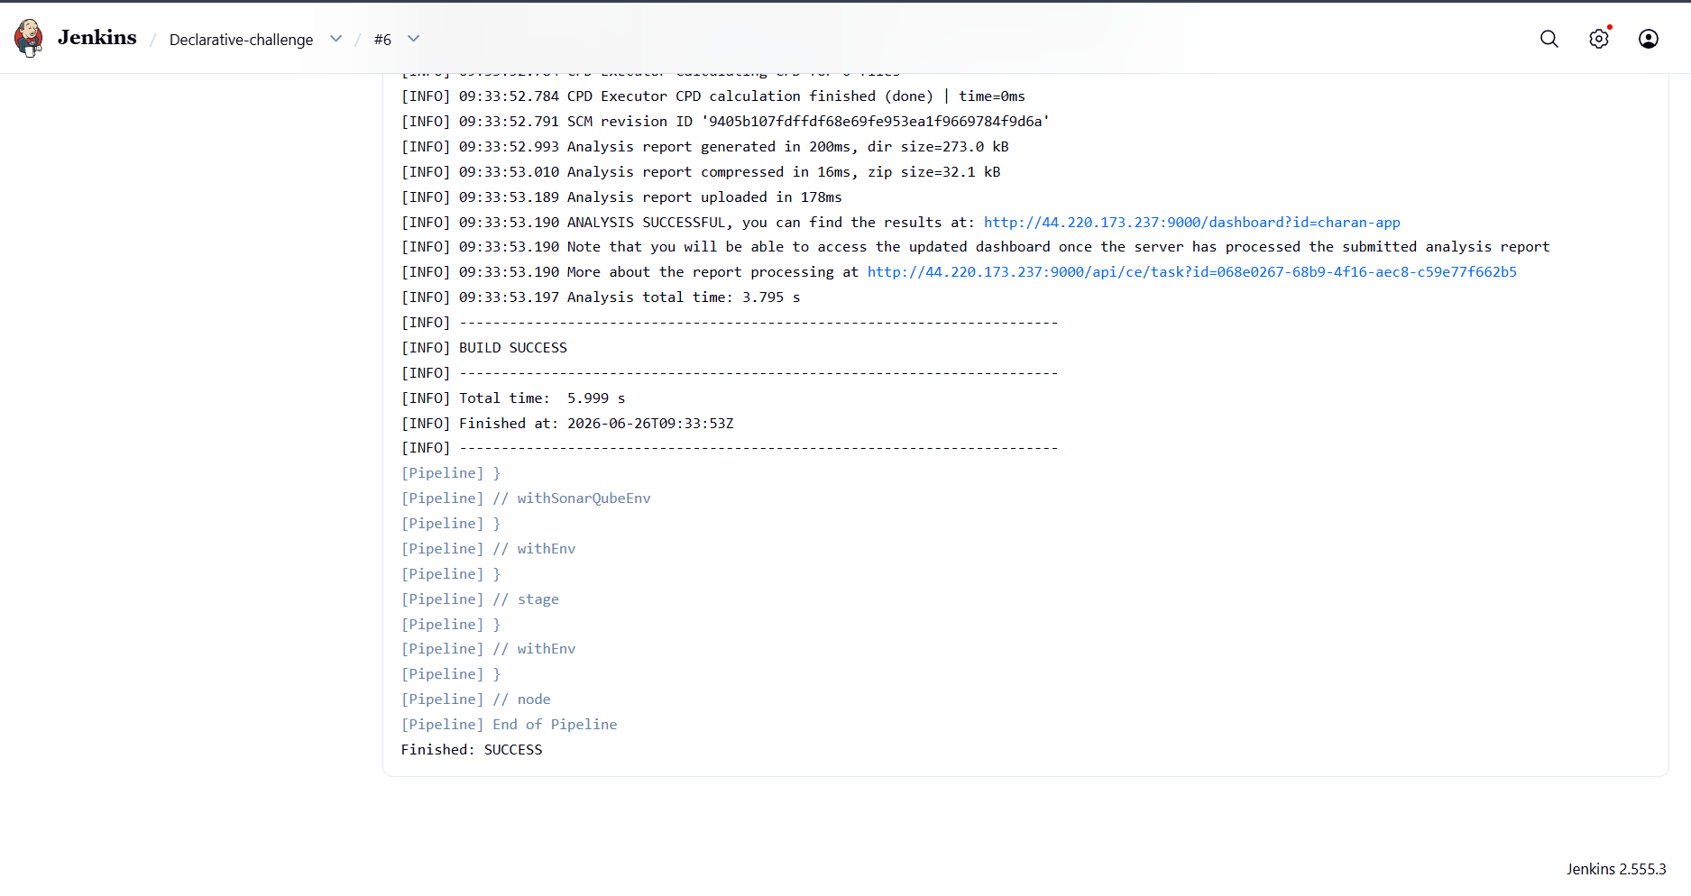

And the code has been pushed to sonarqube fro quality test

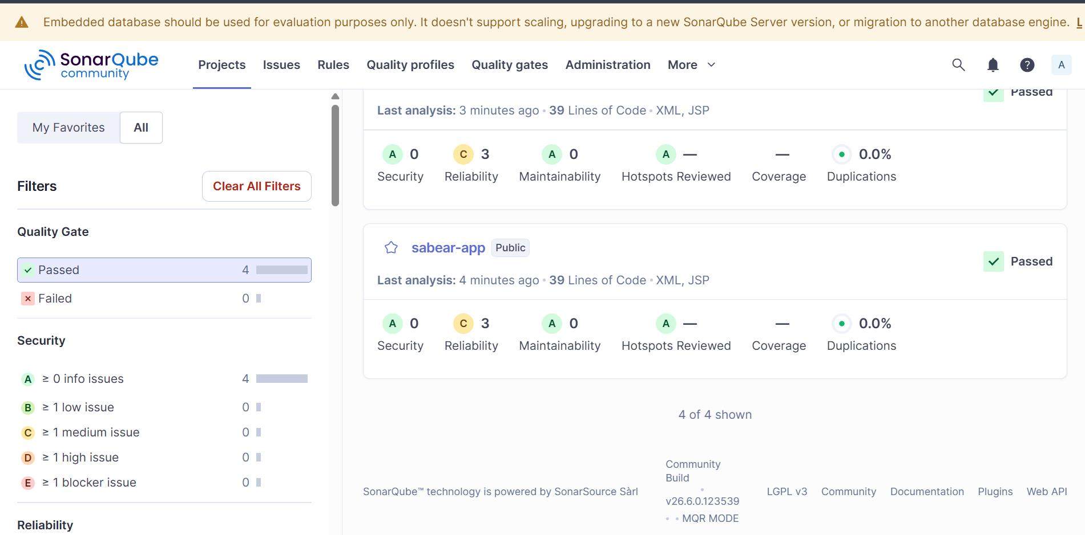

Create one Scripted pipeline job

Creating a new job with pipeline plugin

And giving the scripted pipeline
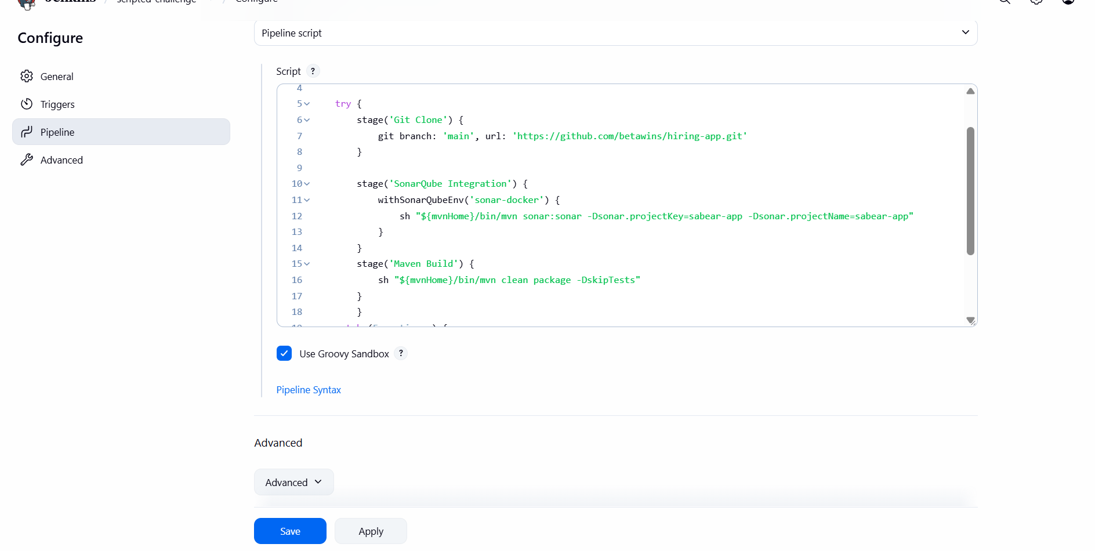

This is scripted pipeline for cloning the repo and pushing the code to sonarqube
And
Compiling the code using maven after quality checks

And the build was successful

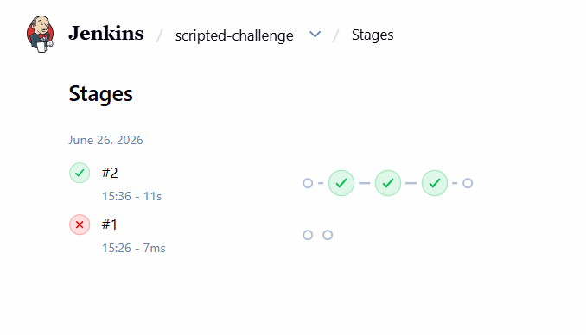

And we can see three stages was successful

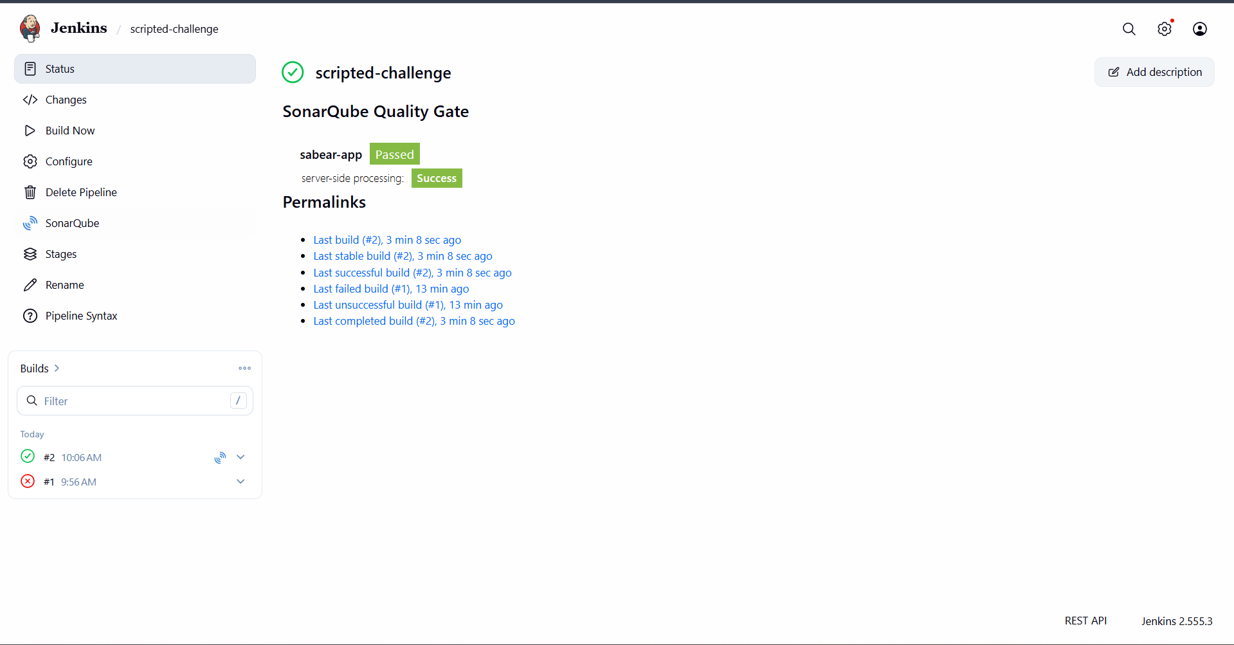

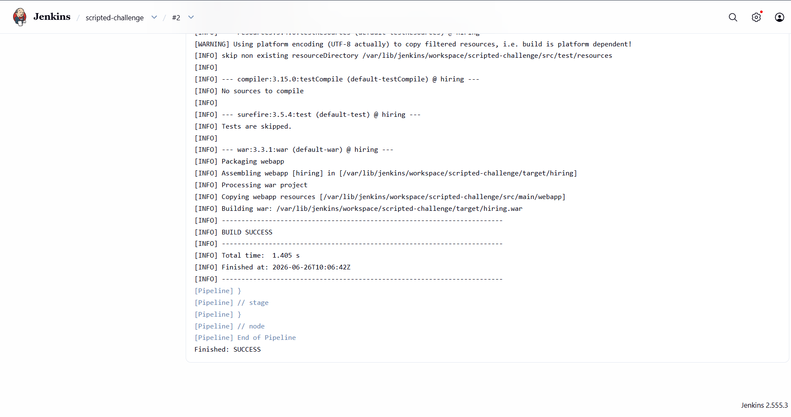

Create one multi stage pipeline job

A multistage pipeline is nothing but in a single pipeline it has multistages

We can call it is as BUILD,TEST

I will create a new job and the pipeline has multiple stages I will be using 3 stages, cloning, quality checks and compiling the code using the declarative pipelines

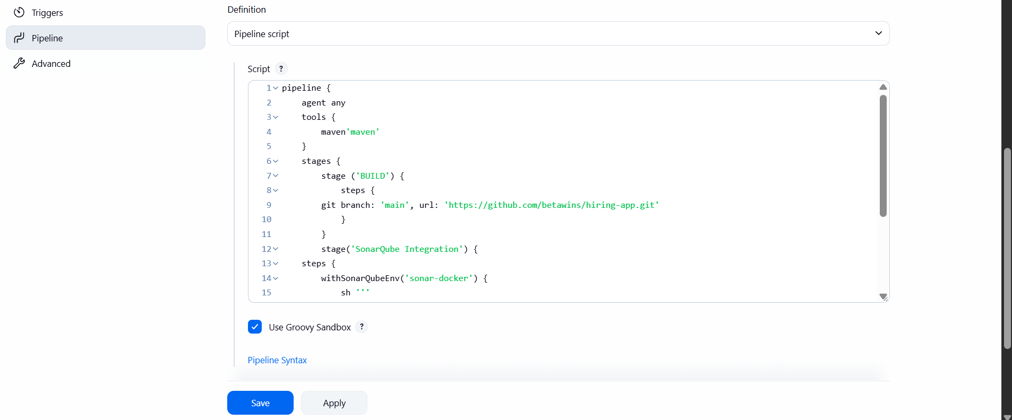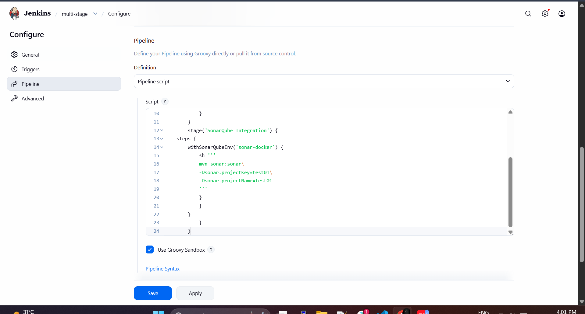

The build was successful
And code was pushed to the sonarqube and quality checks will be done

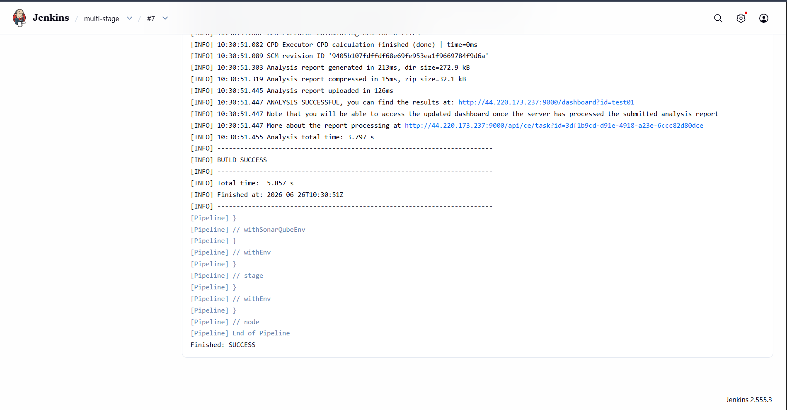

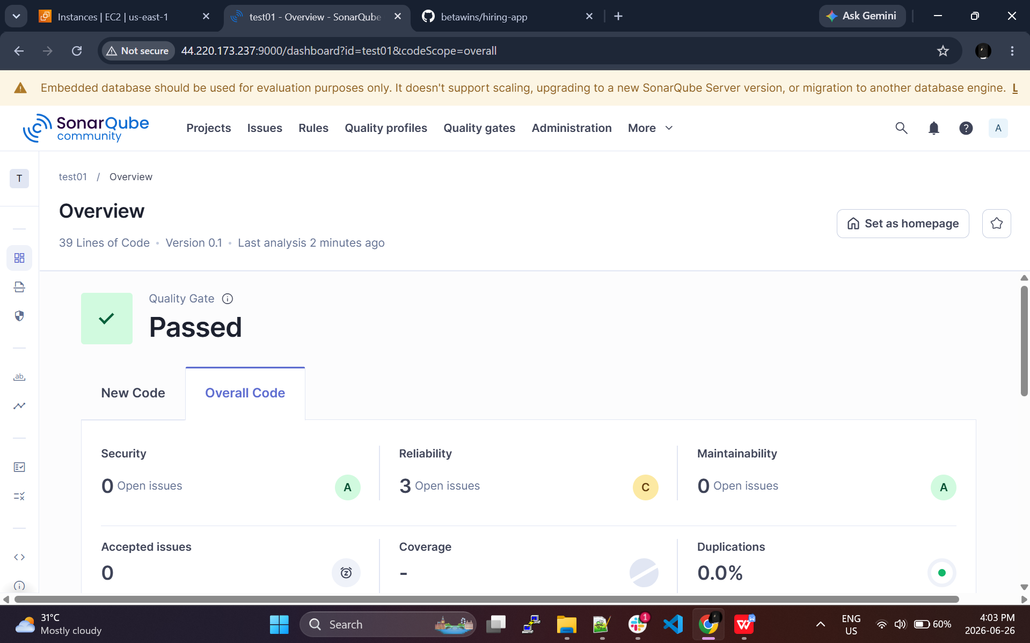

Create one parallel stage pipeline job

We use parallel stage for saving the time of stages that has not interlinked with another build

I have use parallel stage for maven and sonarqube

Or even I can use other stage for my parallel stage to run parallelly at the same time

This helps to save time and completes the build faster

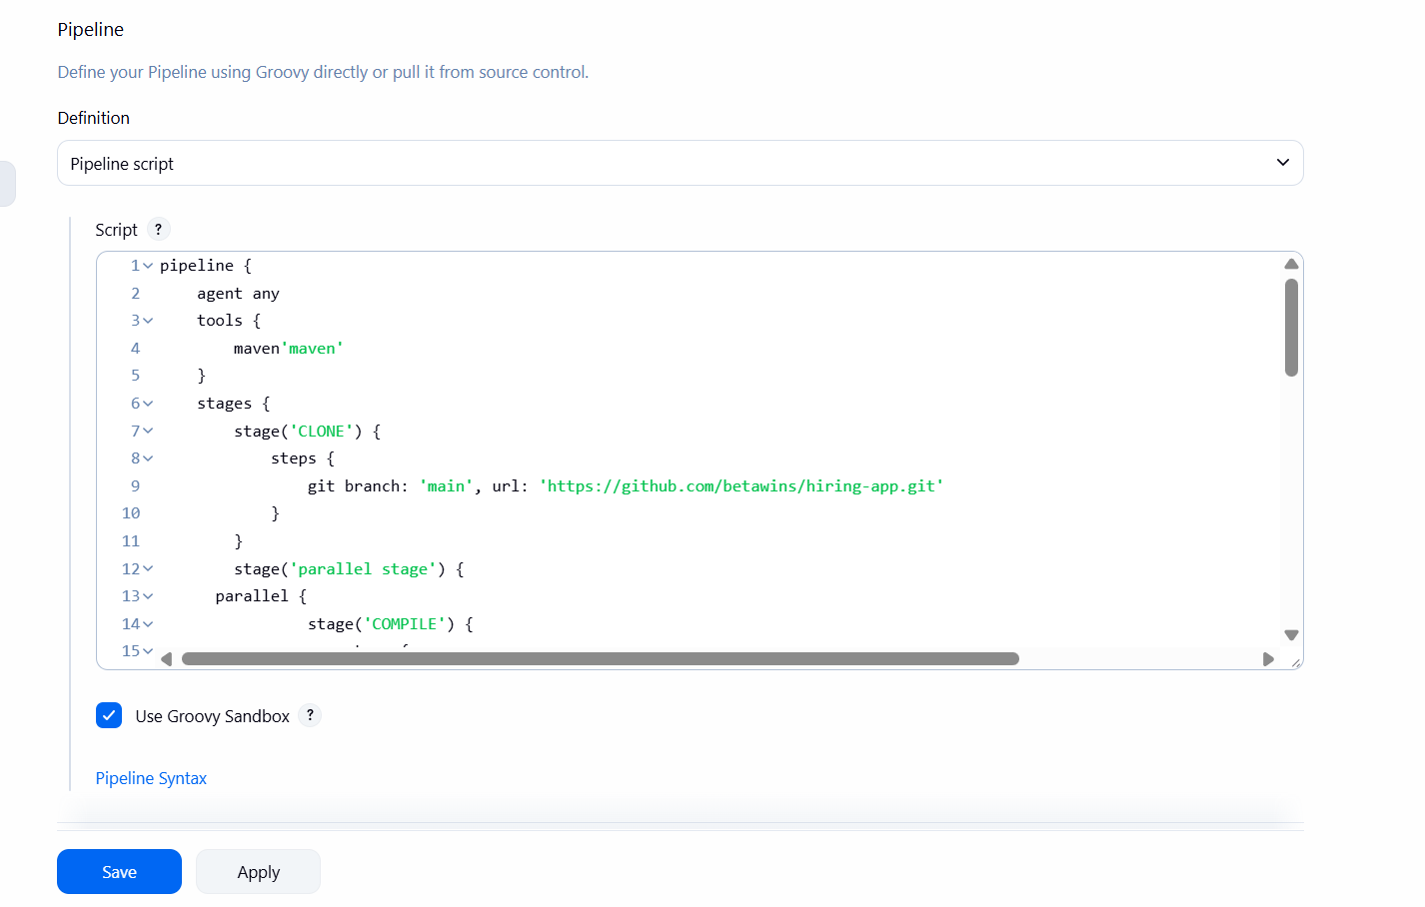

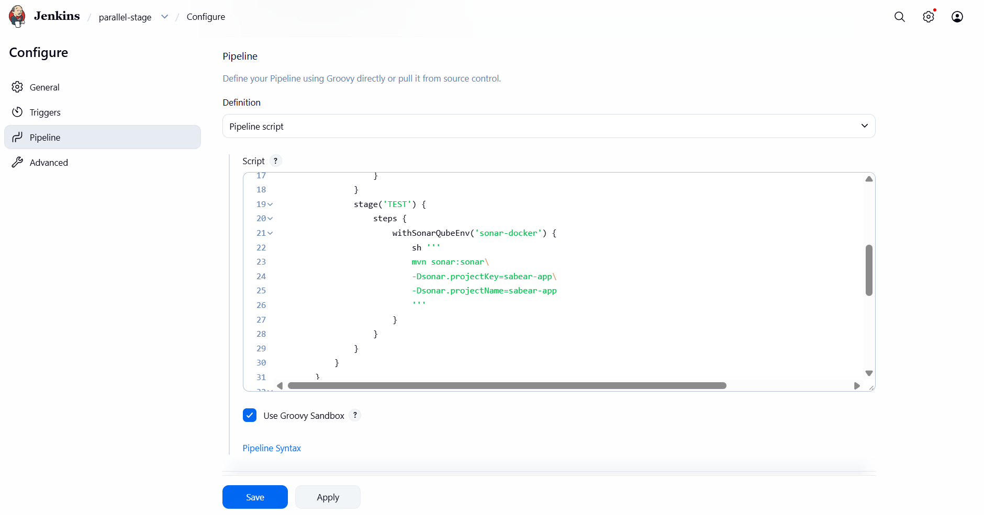

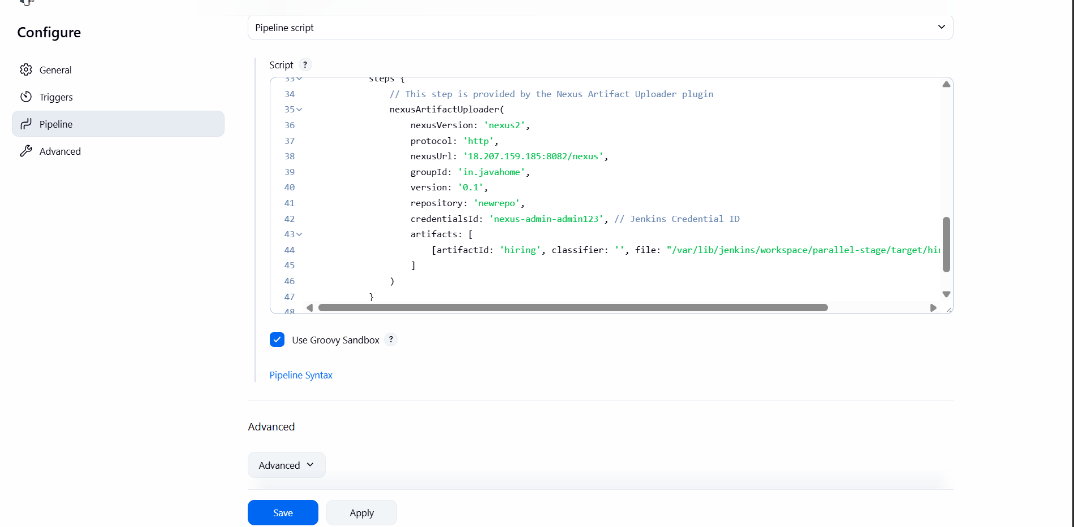

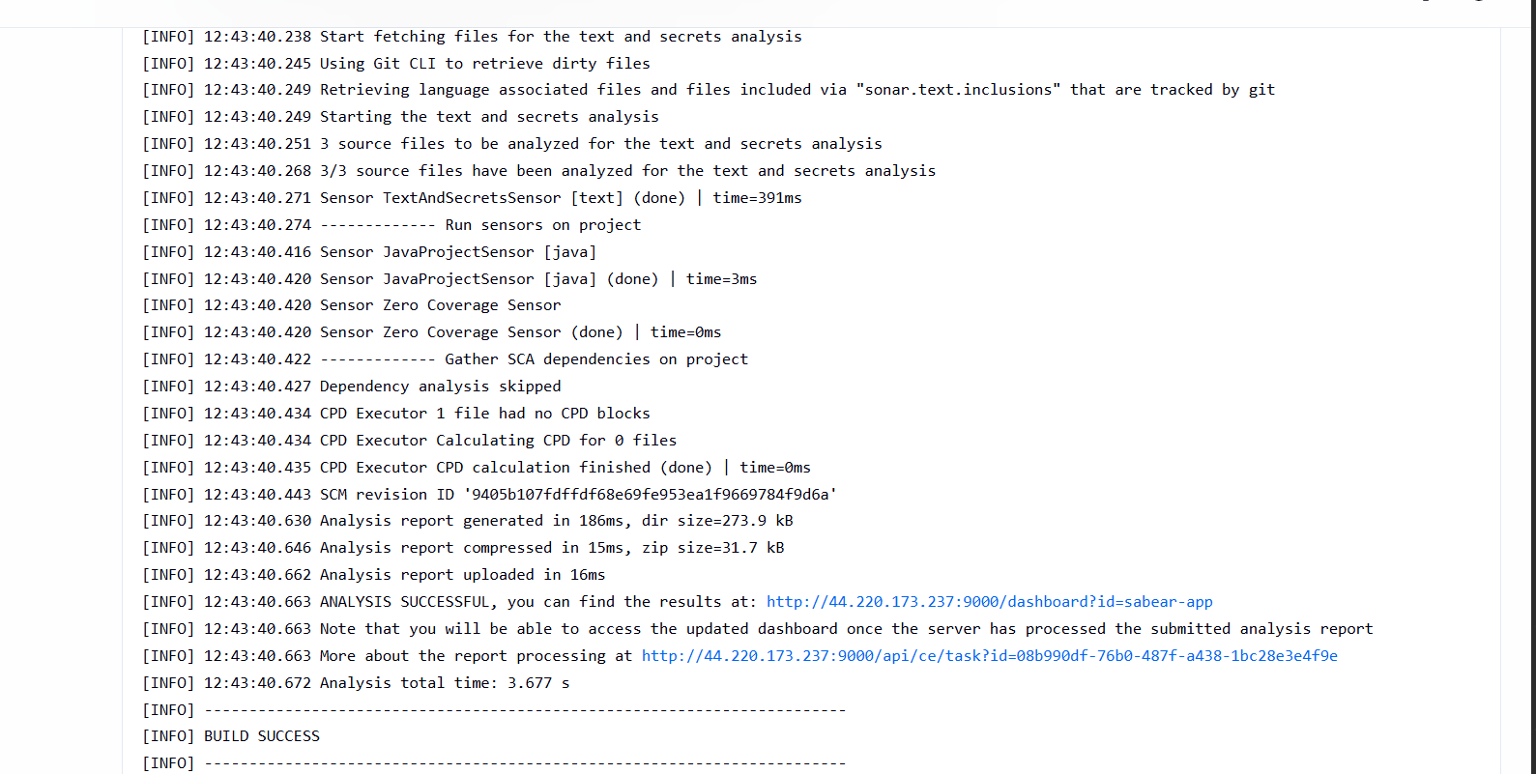

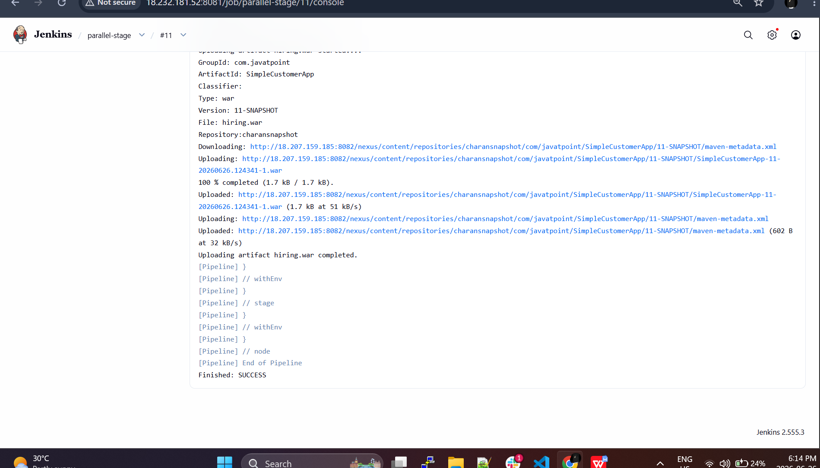

We can see package has been deployed to nexus2



