Terraform-05

To do:--

Terraform remote state and state locking
Terraform provisioner
Terraform taint and untaint
De-bugging
Terraform import

Terraform remote state and state locking

We can store terraform statefiles and configuration files in github or any other repository

We use s3, terraform storage, hashicorp consul to store the state files

State locking is used to lock the state file so that no two users can excute at the same time

Steps:---

Using backend block in the script and I will be creating new s3 bucket and dynamodb

Here s3 bucket is used to store the state file and dynamodb is used for lock

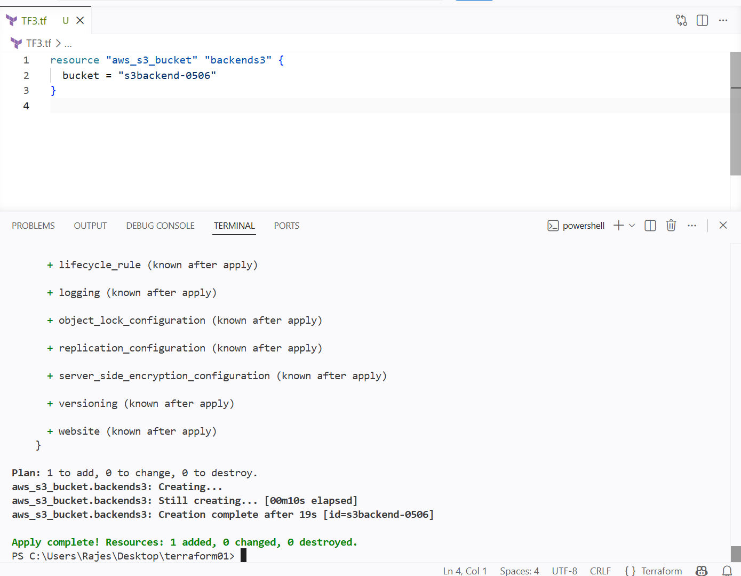
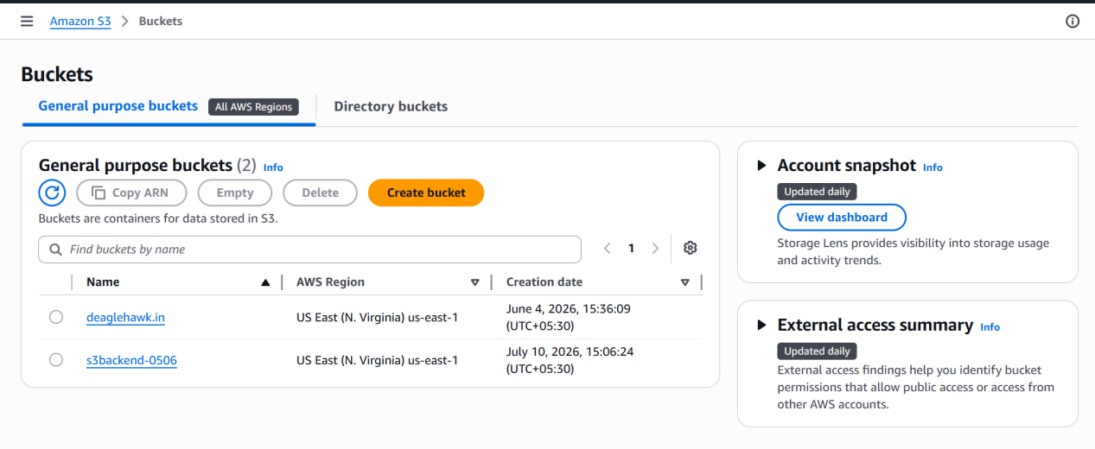

New bucket has been created

And creating a new dynamodb using the resource block

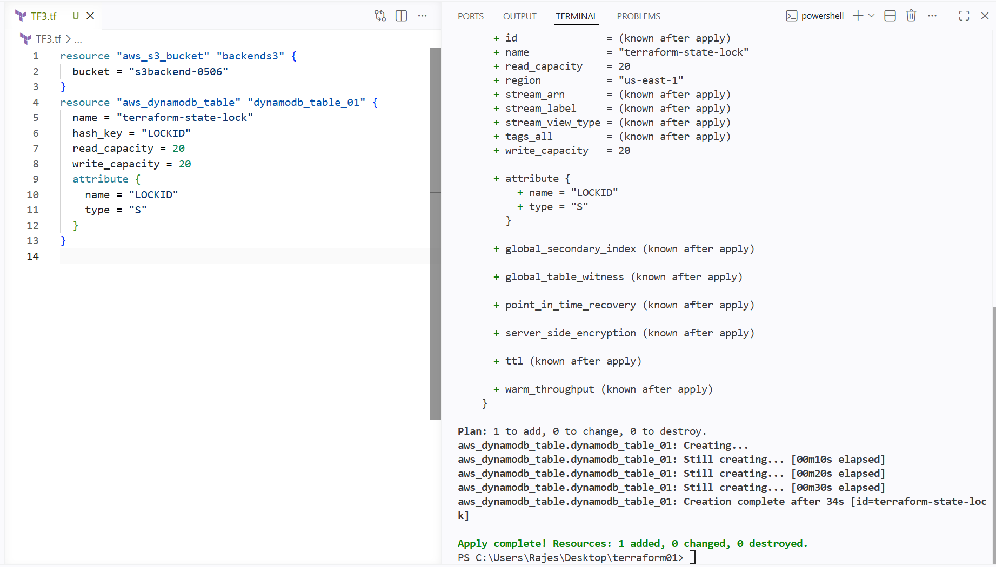

Dynamodb has been created

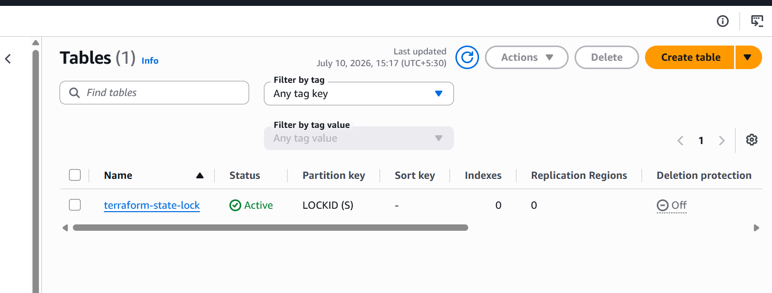

Now I will be using s3 for storing the state file and dynamo db to lock the file, this secures the statefile

Configuring the backend for statefile

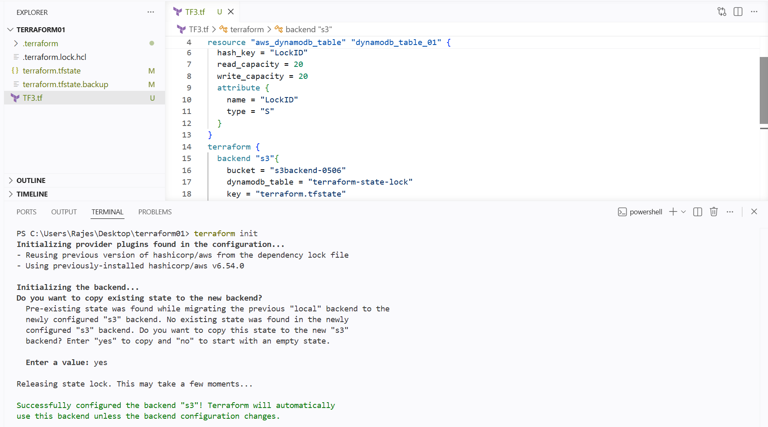

When we do init it will be asking for the confirmaation of doing state lock file

We can see the tfstate in local is empty as it haas been stored in the s3 bucket and dynamodb locking

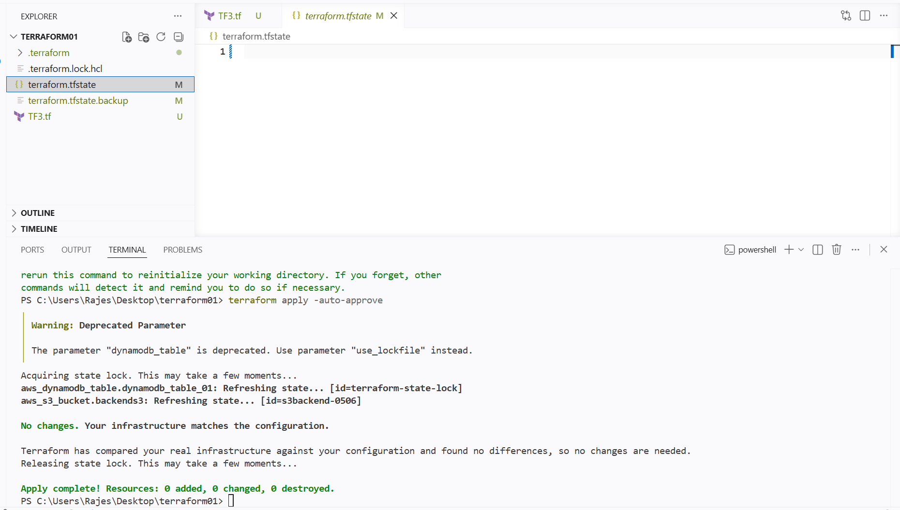

TERRAFORM PROVISIONERS

Terraform provisioner helps us to execute the commands while doint the terraform apply

- REMOTE PROVISIONER
- LOCAL PROVISIONER

Provissioners will be written inside the resource block

I have used local-exec to execute the command and the new file was created

I have used provisioner local-exec
And under command the creation of new file command

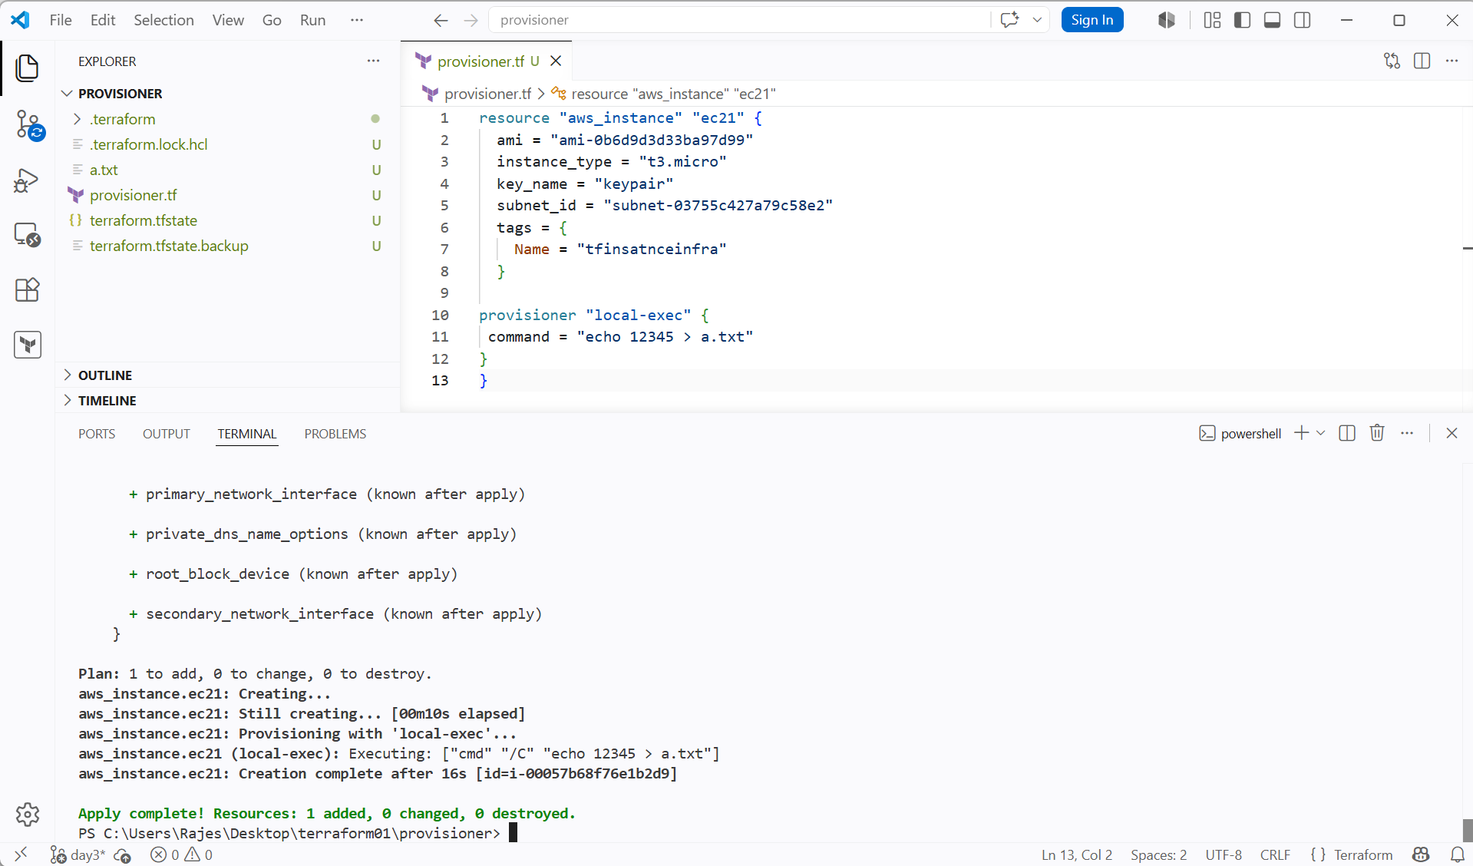

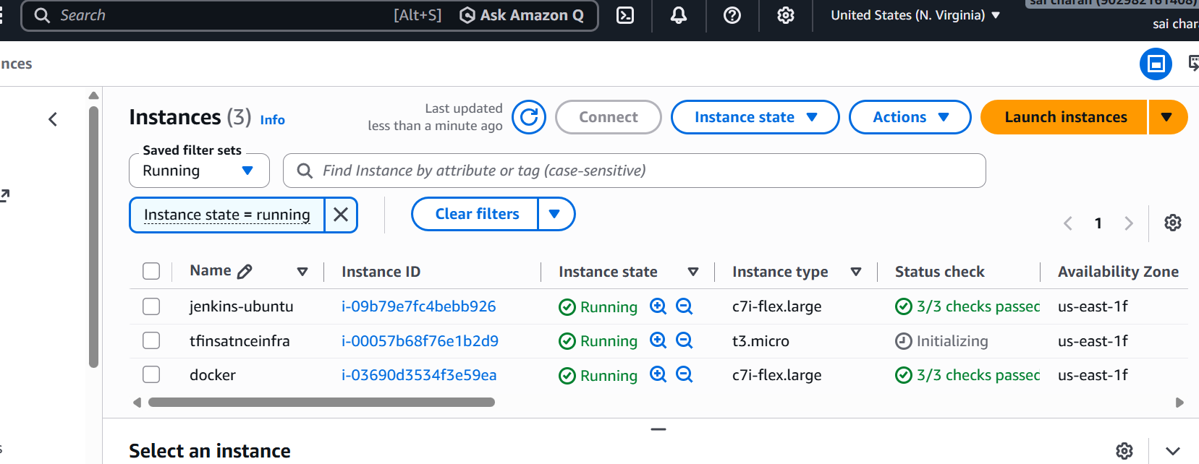

TERRAFORM TAINT AND UNTAINT

we can manually taint and untaint the resource in state file

terraform taint resourcename.name
terraform untaint resourcename.name

DE-BUGGING

Terraform provides the basic logs of an error

But if we need the deep logs then terraform provides 5 types of logs

- Info
- Warning
- Error
- Debug
- Trace

Export TF_LOG=TRACE
Set-item -path env:TF_LOG -value “TRACE”

To store the logs permanently we can export a path

Export TF_LOG_PATH=/tmp/terraform.log
Set-item -path env:TF_LOG_PATH -value “terraform.log”

Giving the log file path for infrastructure

Then what type of debugging log we want to pass we can pass and all logs will be store in the log file we have just given

Set_item -path env:TF_LOG -value “trace”

I am using trace for deep logs

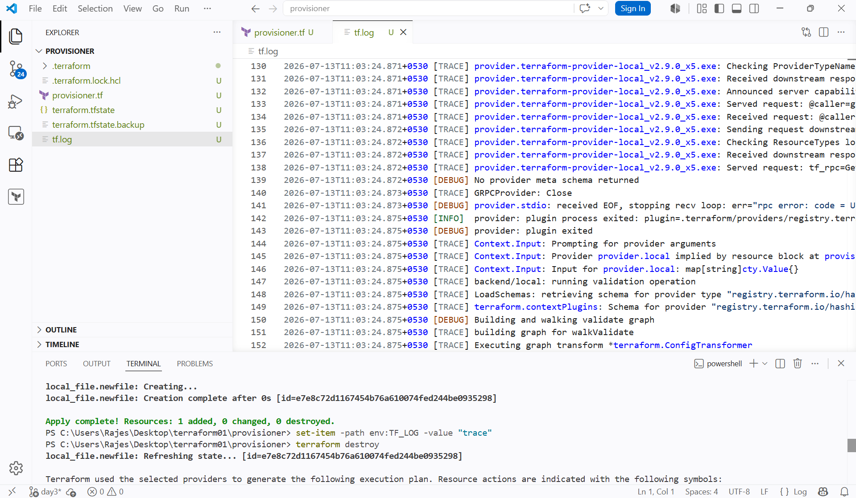

TERRAFORM IMPORT

If we have manually created a resource outside and I want to manage it using terraform

We can use terraform import

Terraform import <aws_instance.name> instanceid

Ex..

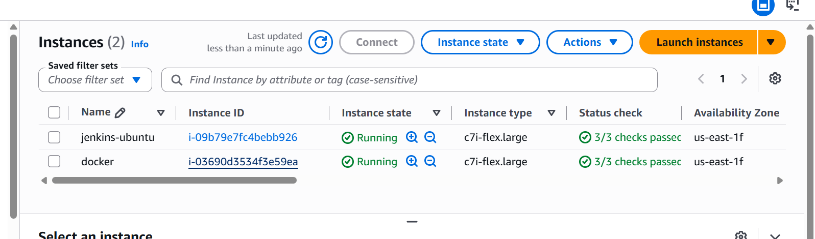

I have created this instance manually then I can import this instance to my terraform and manage

And also we need to add it in script

1st add it in script then import

Added it in the resource block used the cli command for import

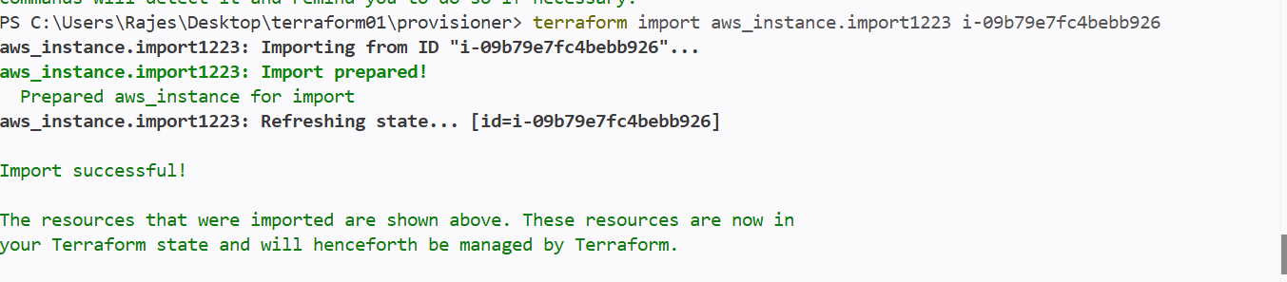

Then I want to change the name of my instance so I changed the name and used terraform apply

Then the instance name has been changed

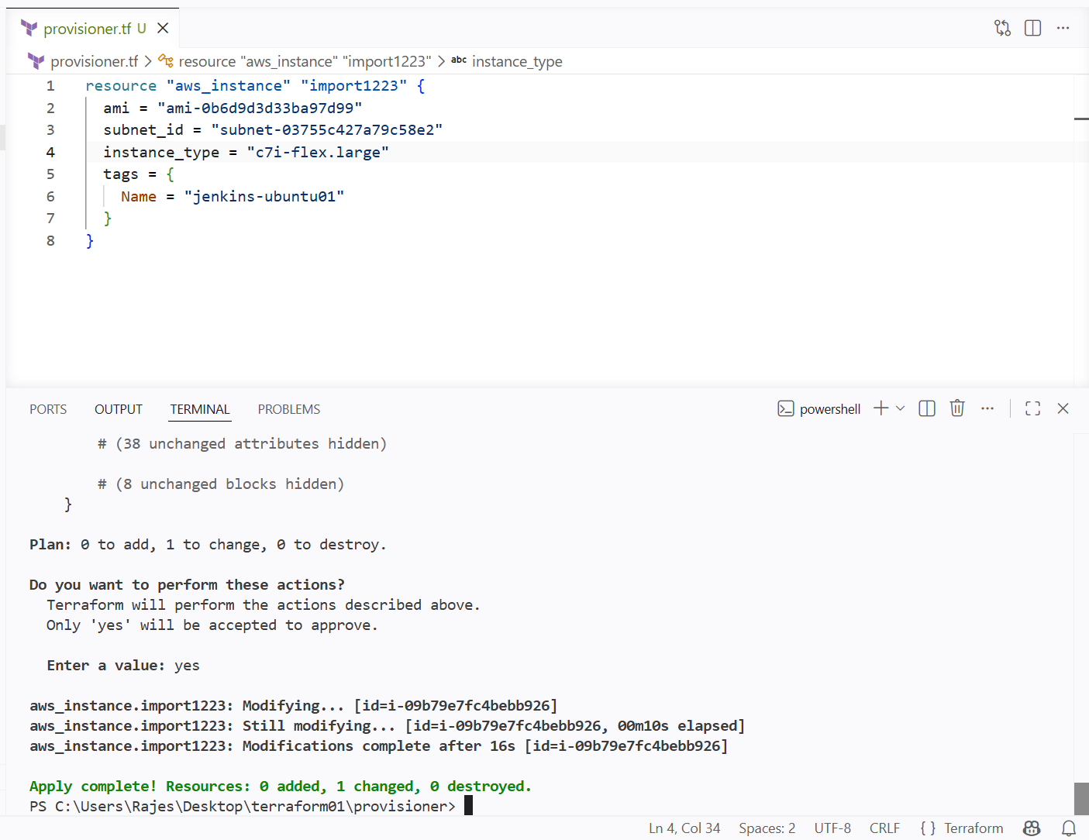

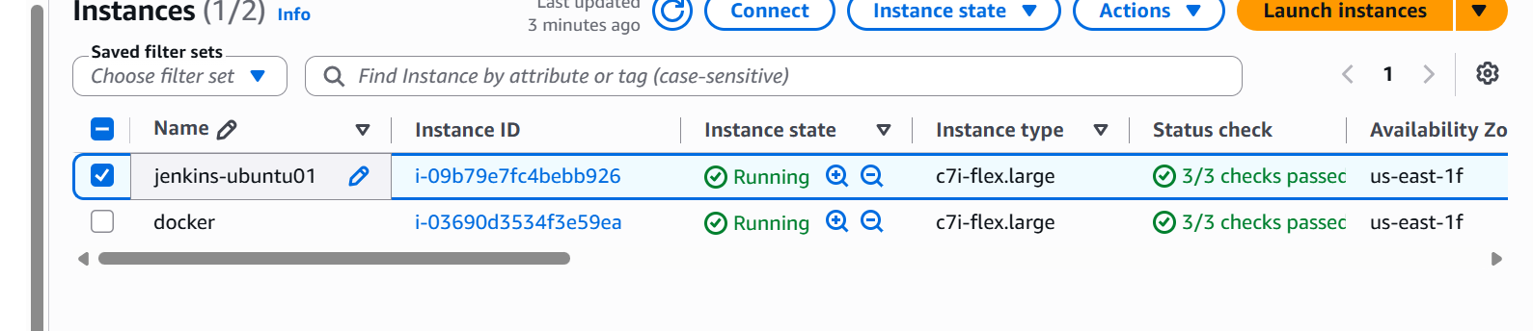

Create one EC2 instance with httpd installed using a Terraform script.

Installed one ubuntu os and httpd using user data

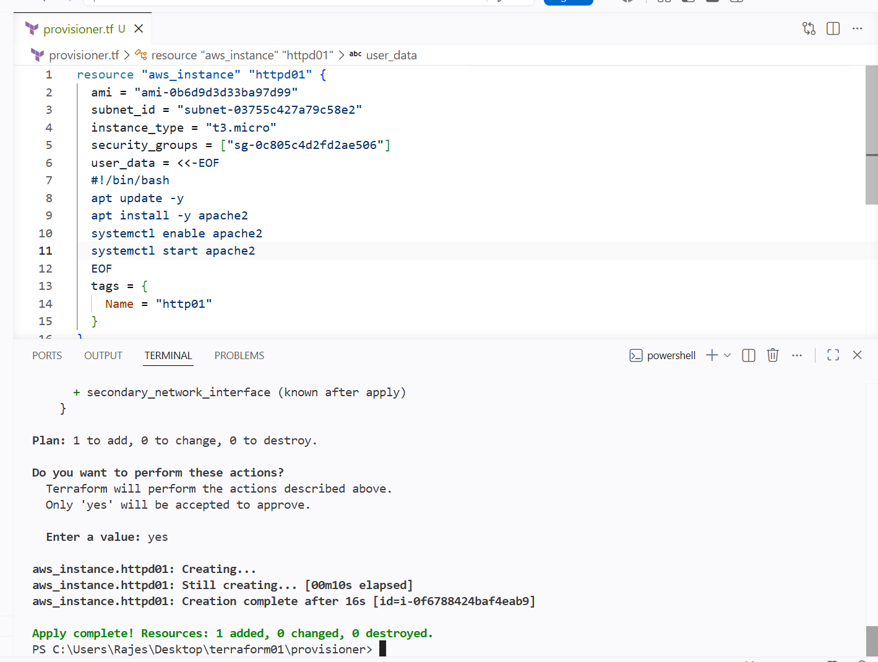

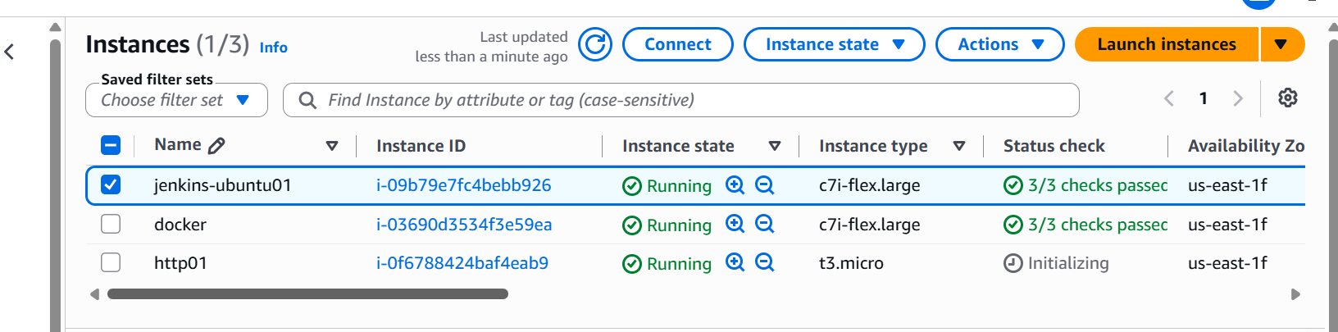

New instance has been created using terraform infrastructure

Set up S3 as backend for task 3

I will be storing my state file for my terraform infra of new created instance in s3 using backend

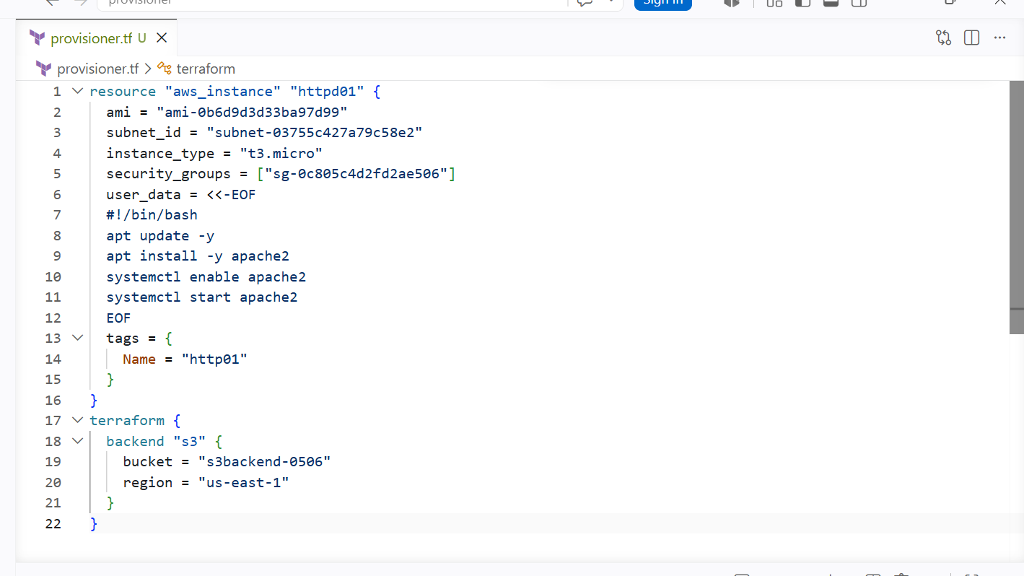

Then do terraform apply

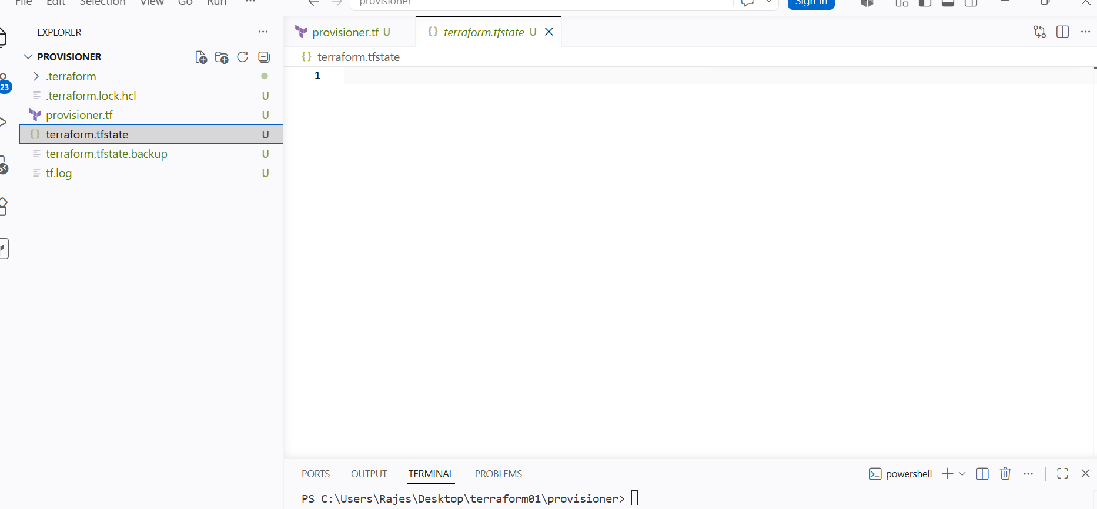

As we can see there Is nothing in the local state file
As I have stored it in s3

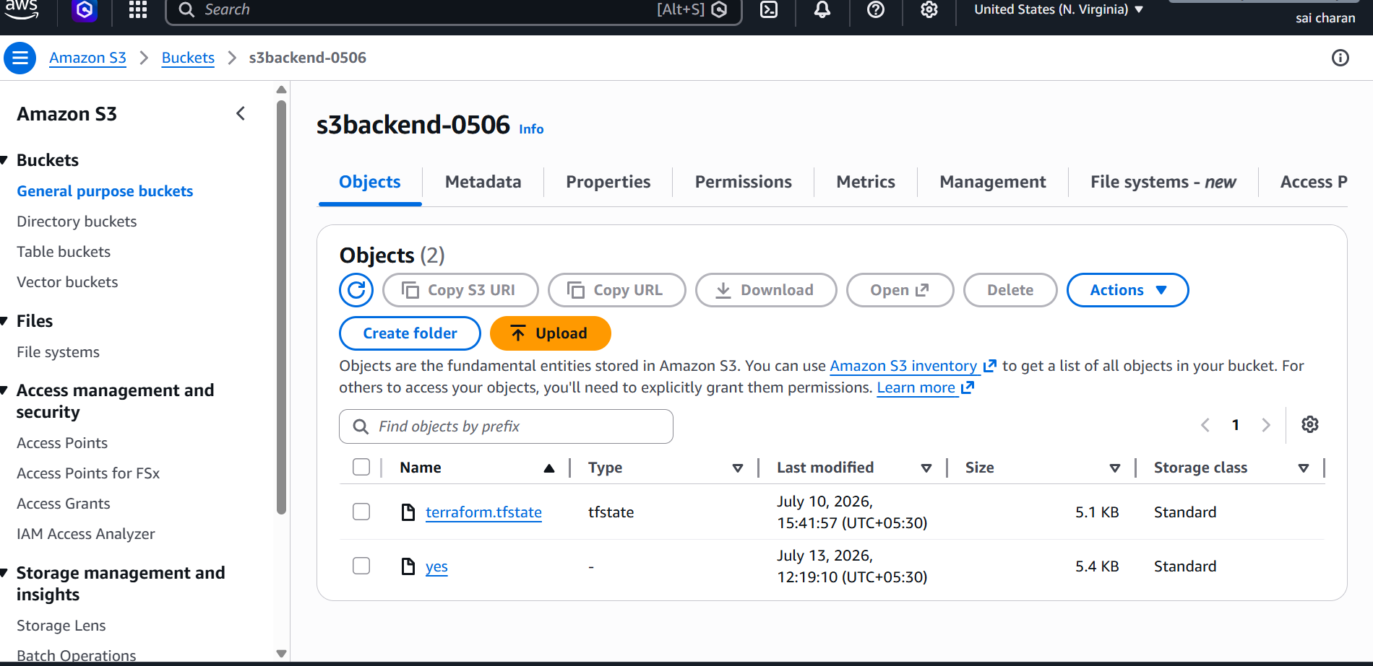

The state file has been store in the s3

Locking the state file using the Dynamodb

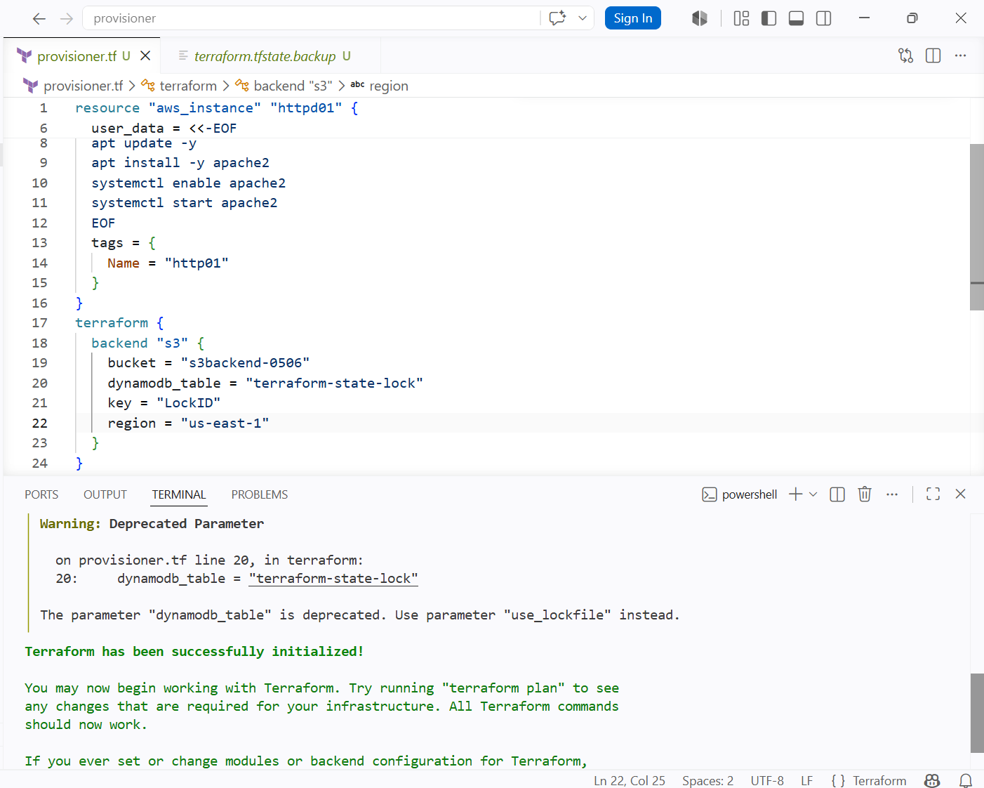

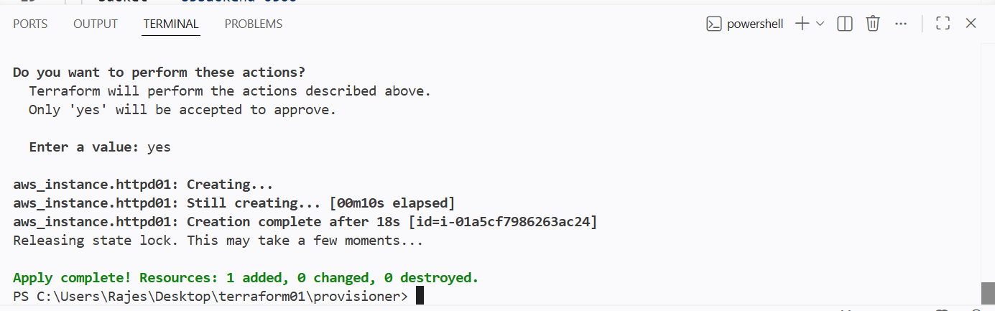

And the state file has been locked using the dynamodb



