Install Apache on Ubuntu Using Ansible
Simple step-by-step guide using notify and handlers

1. Install Ansible on the control node
sudo apt update
sudo apt install ansible -y
ansible --version

2. Create the inventory
vi inventory.ini
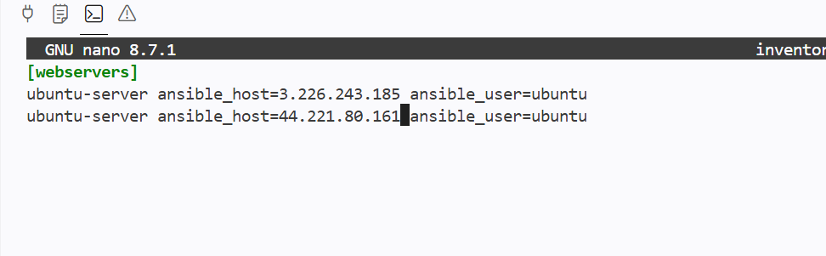
Add the worker server details:

3. Test the connection
ansible webservers -i inventory.ini -m ping
The expected response contains: pong
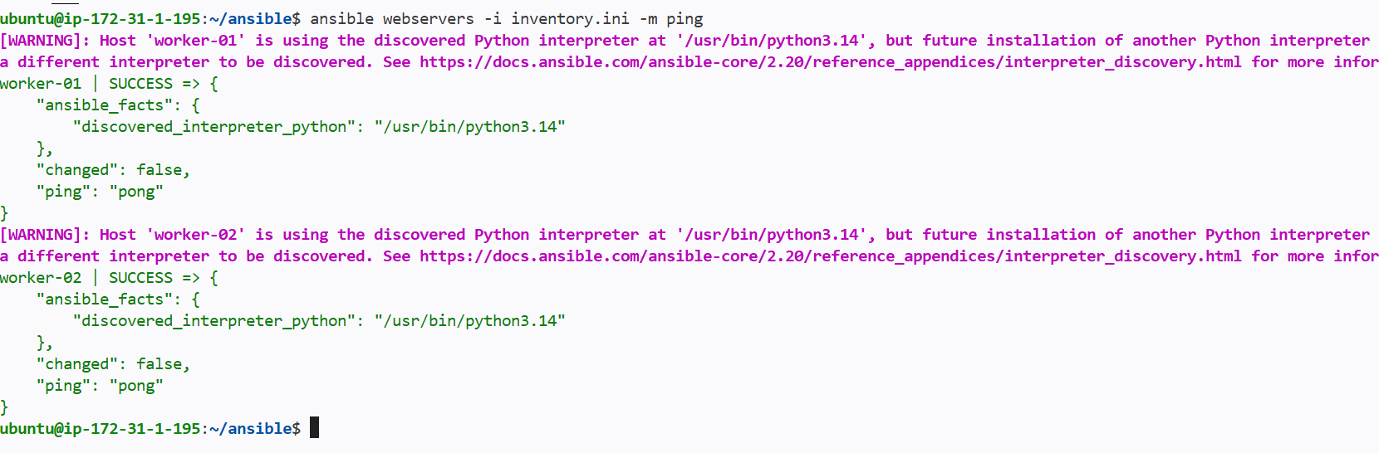

4. Create the playbook
vi install-apache.yml

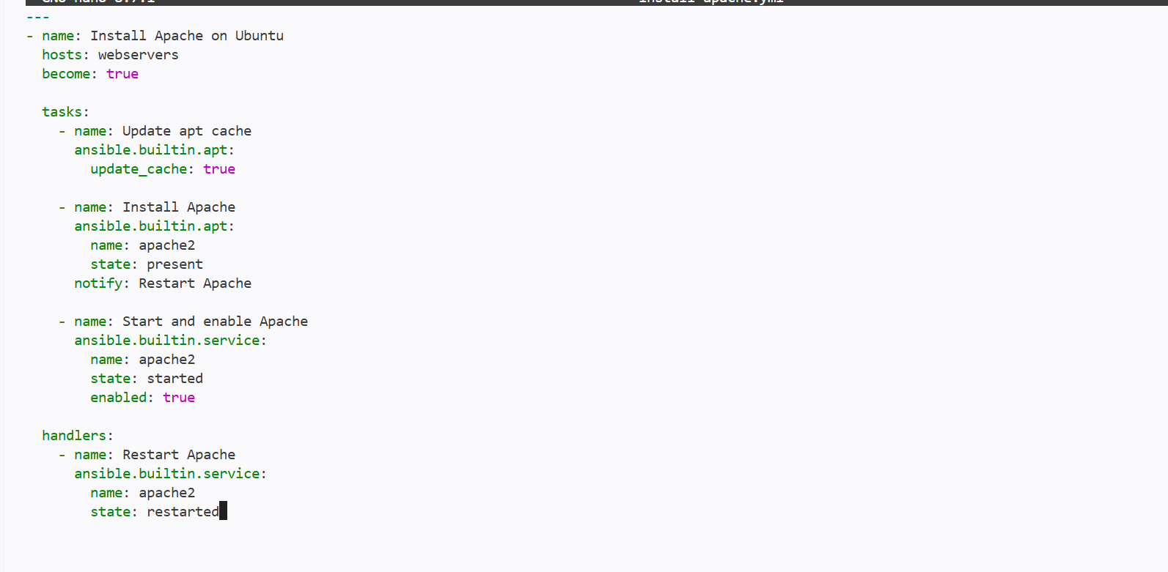

5. Run the playbook
ansible-playbook -i inventory.ini install-apache.yml

6. Verify Apache
ansible webservers -i inventory.ini -b -m command -a "systemctl is-active apache2"
curl http://192.168.1.20

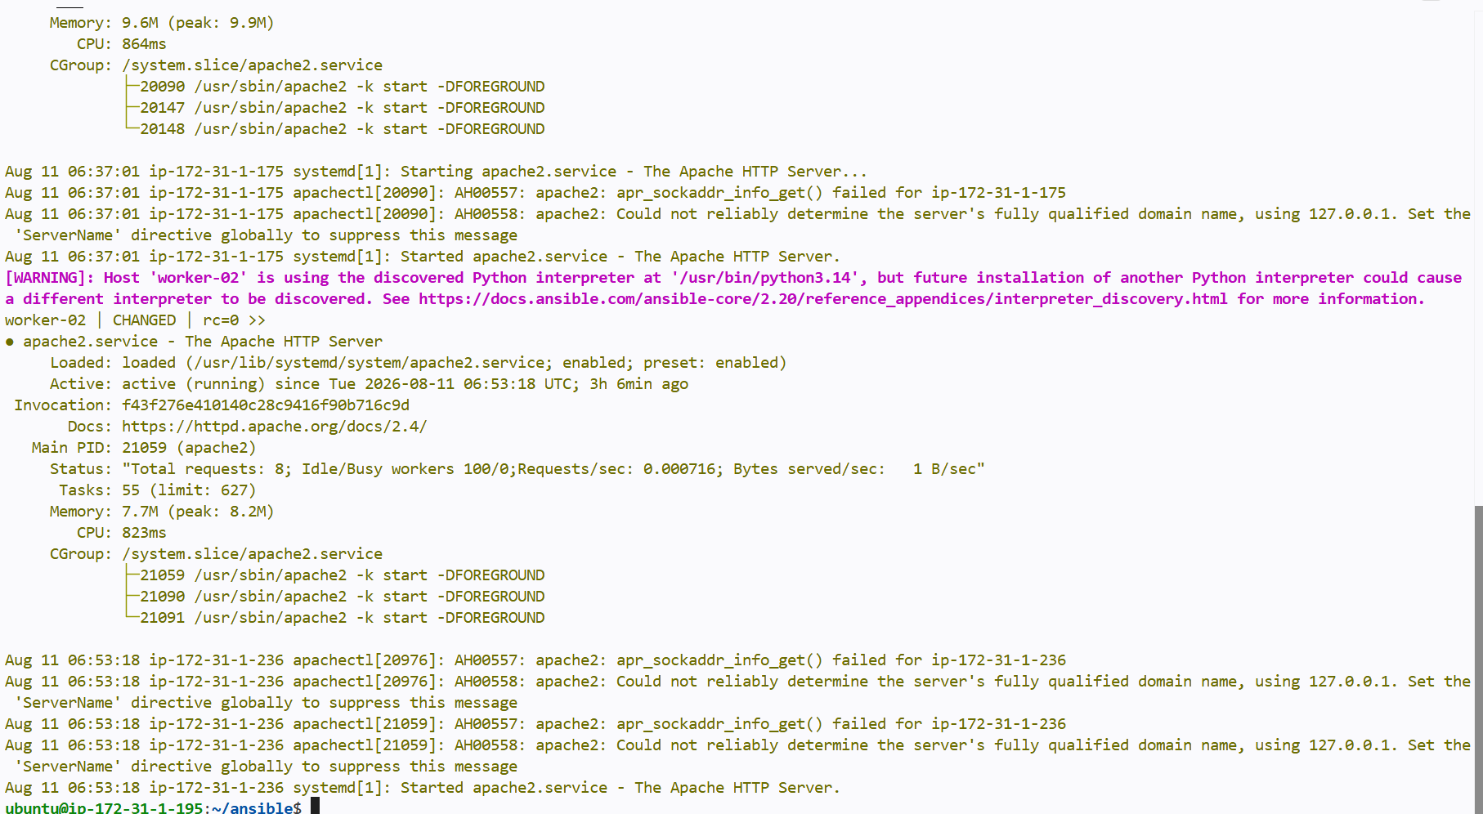
You can also open http://192.168.1.20 in a browser. Make sure TCP port 80 is allowed in the firewall or cloud security group.
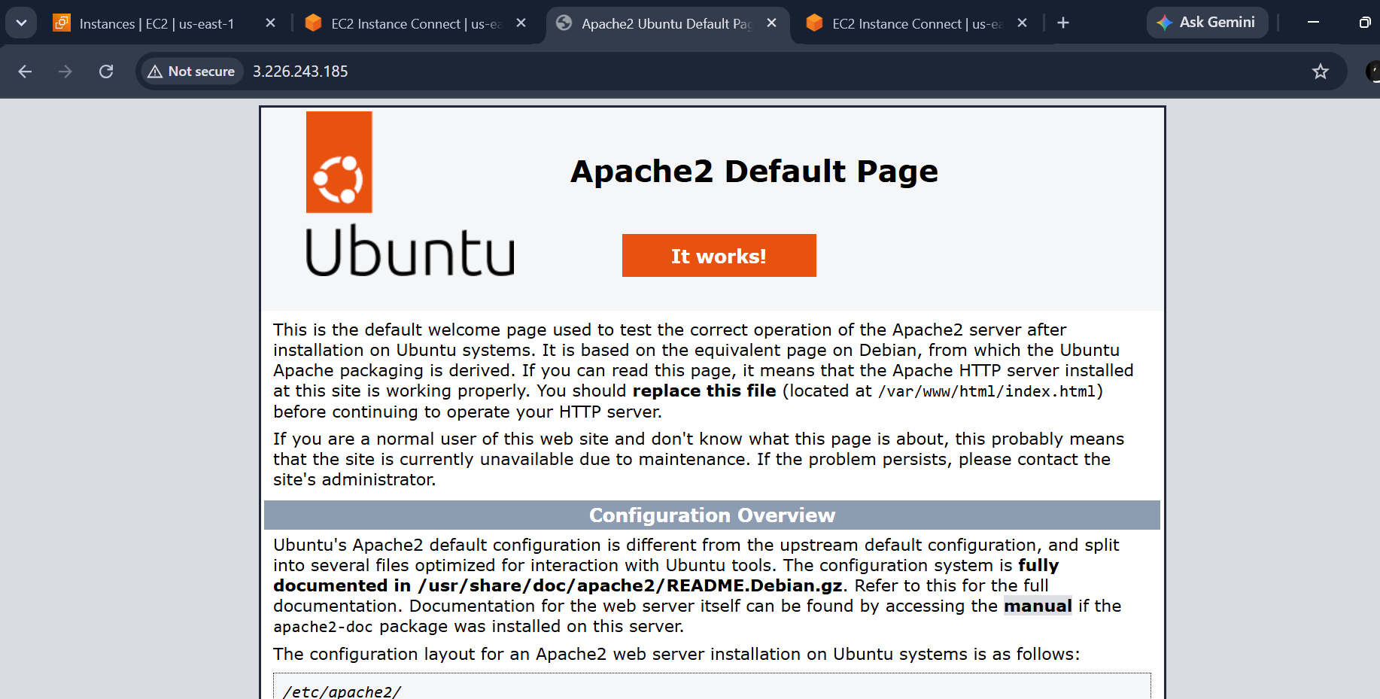

How the handler works
When the Apache installation task changes the server, notify calls the Restart Apache handler. The handler runs once at the end of the play.

Write a ansible playbook to install apache tomcat

Creating a new yaml file for installing apache tomcat

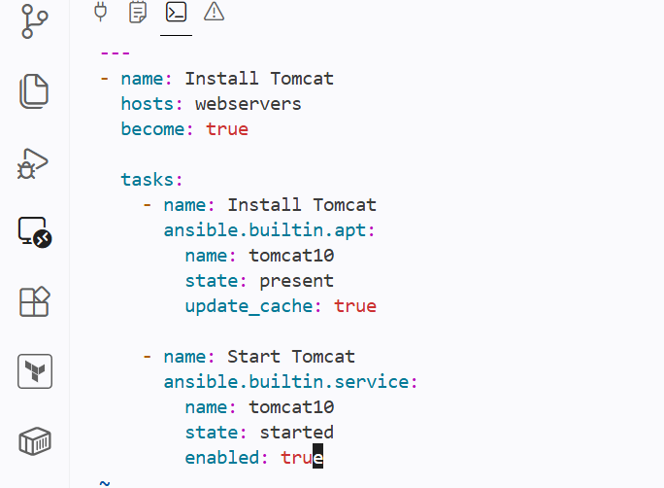

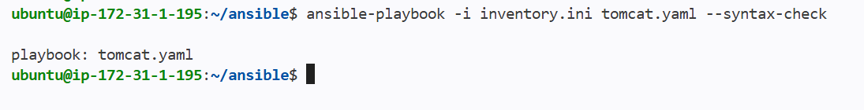

Syntax check for tomcat.yaml file

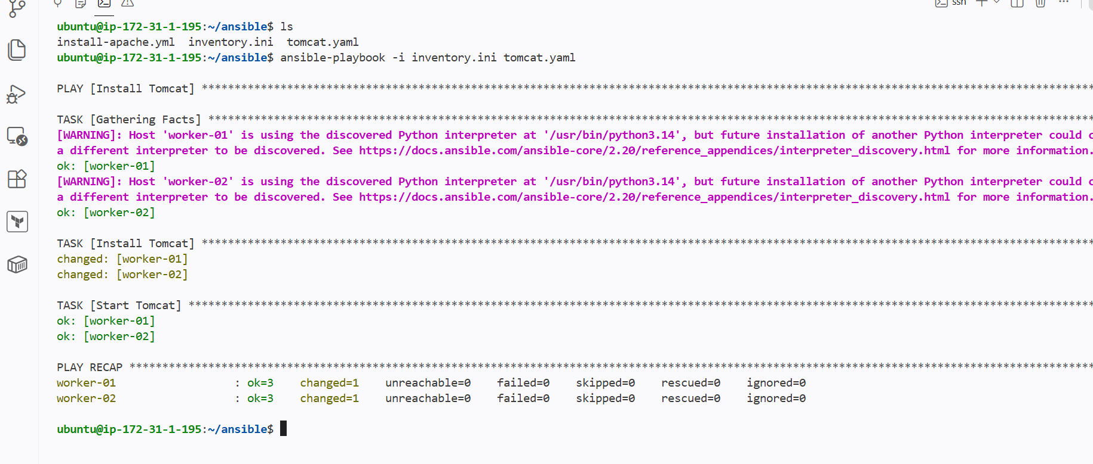

Tomcat has been installed in both worker nodes

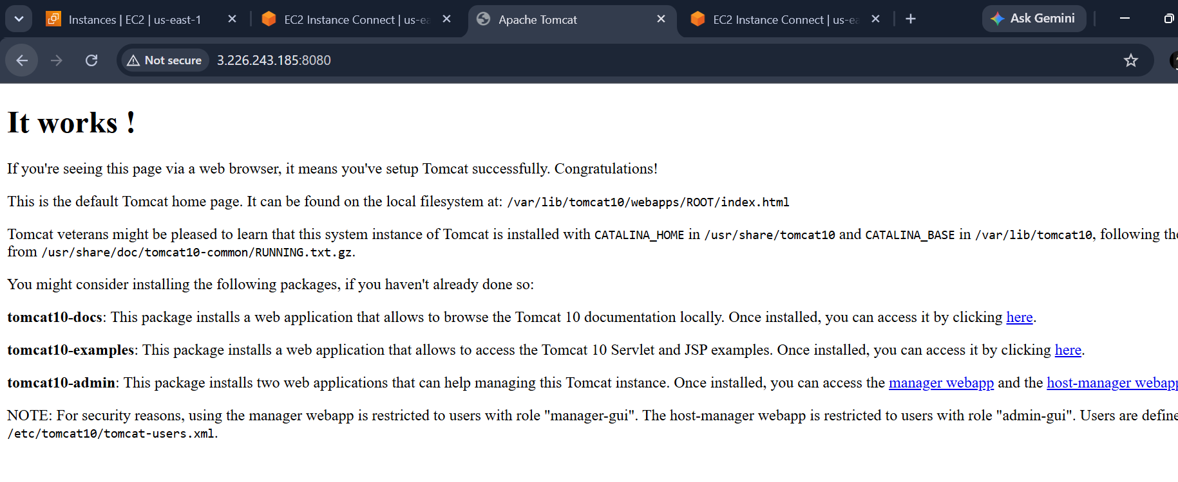

Write a ansible playbook to provision one ec2 on aws
Installing awscli in master node
Then configuring the aws account credentials using secret and access key

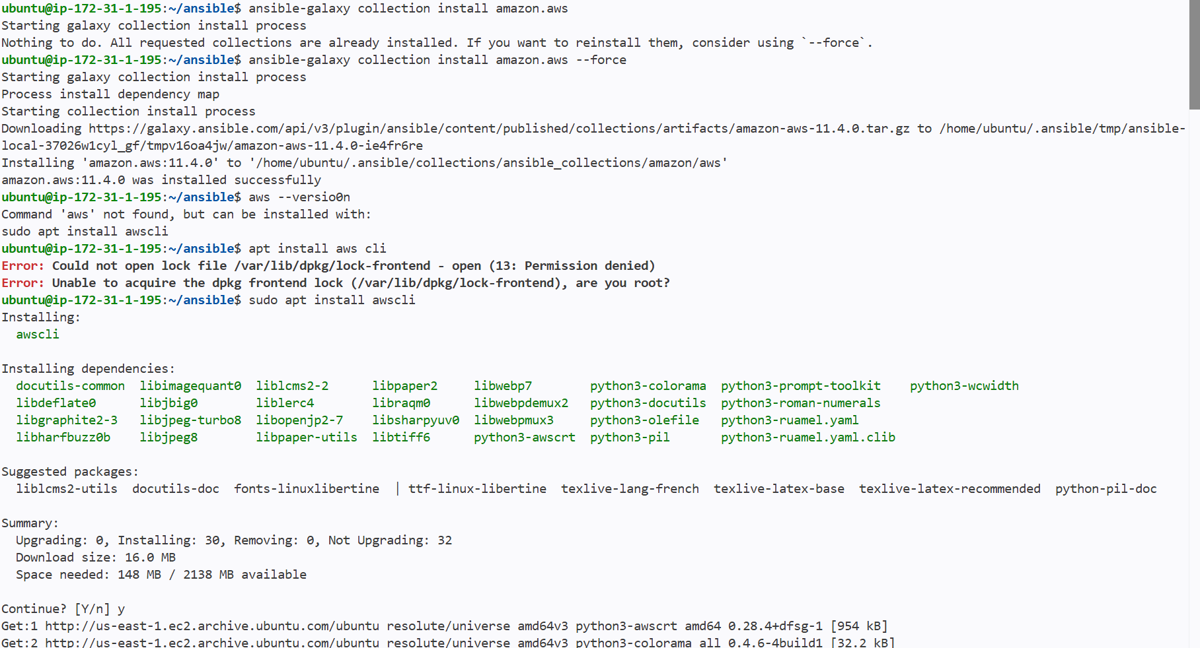

Installed the requirements
ansible-galaxy collection install amazon.aws
sudo apt update
sudo apt install python3-boto3 awscli -y

Configure AWS access
Recommended: attach an IAM role with EC2 permissions to the Ansible control server. For a lab, you can configure the AWS CLI:
aws configure
Do not put AWS access keys directly inside the playbook.
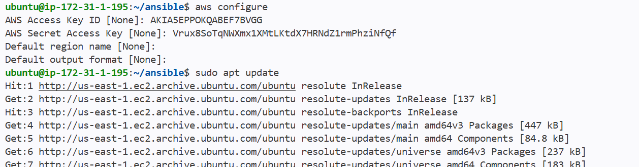

Create the playbook
nano create-ec2.yml

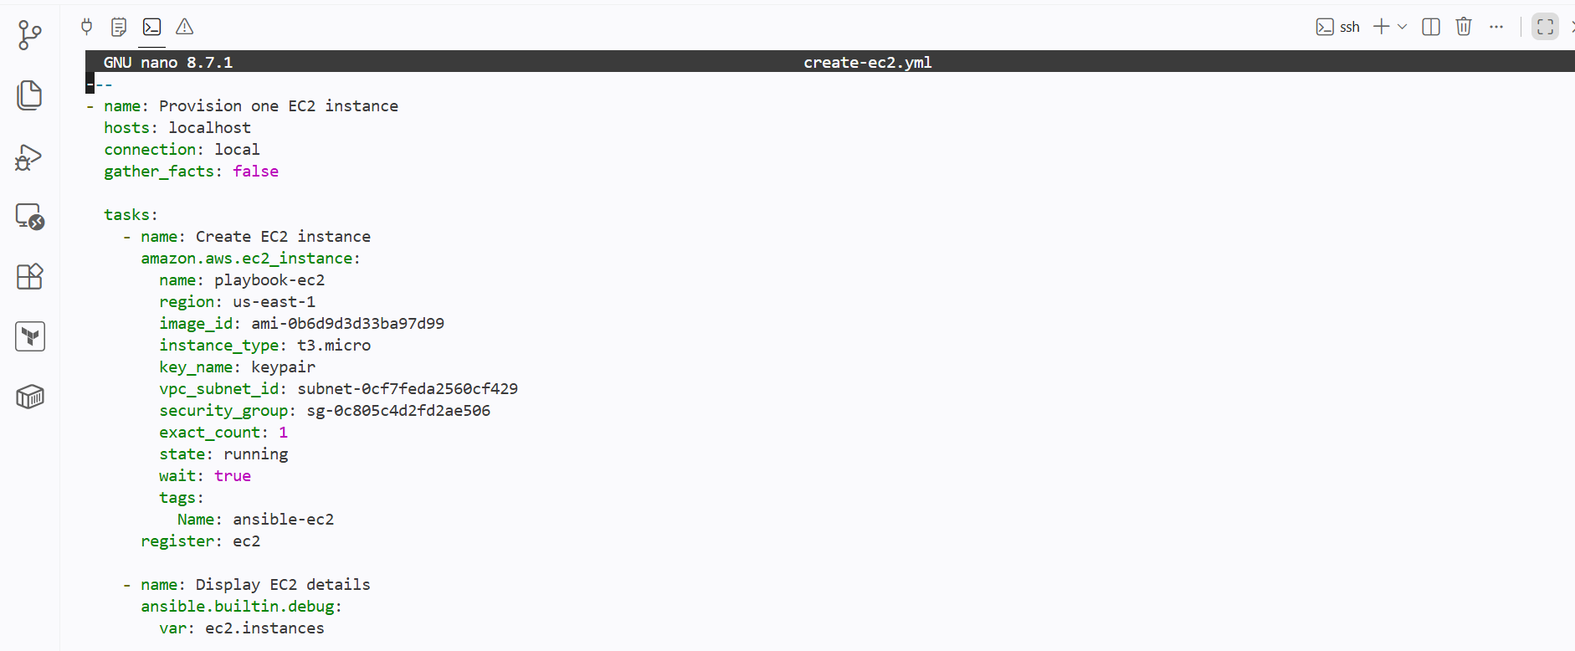

Check the syntax
ansible-playbook create-ec2.yml --syntax-check
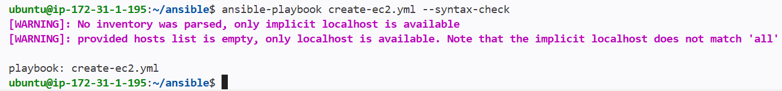

Run the playbook
ansible-playbook create-ec2.yml
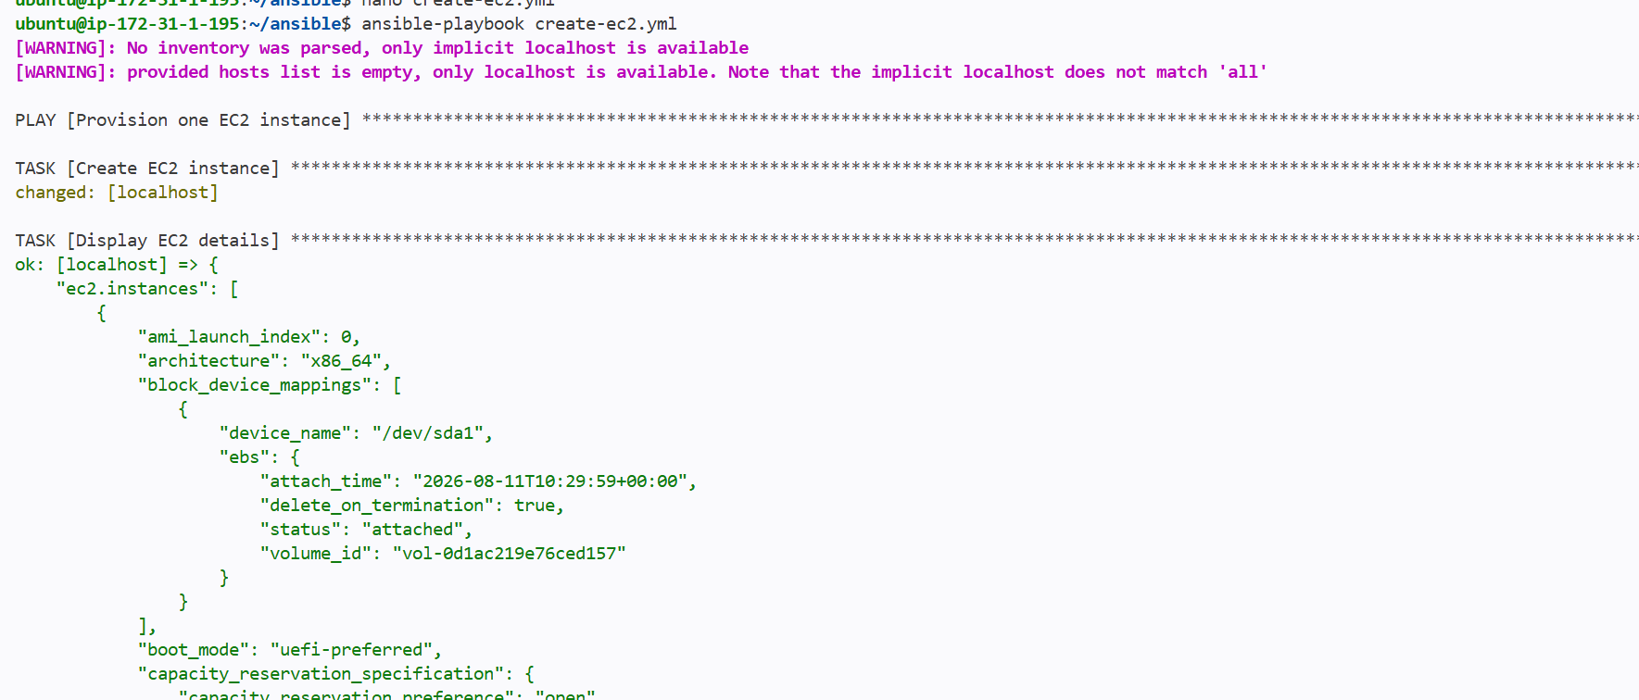
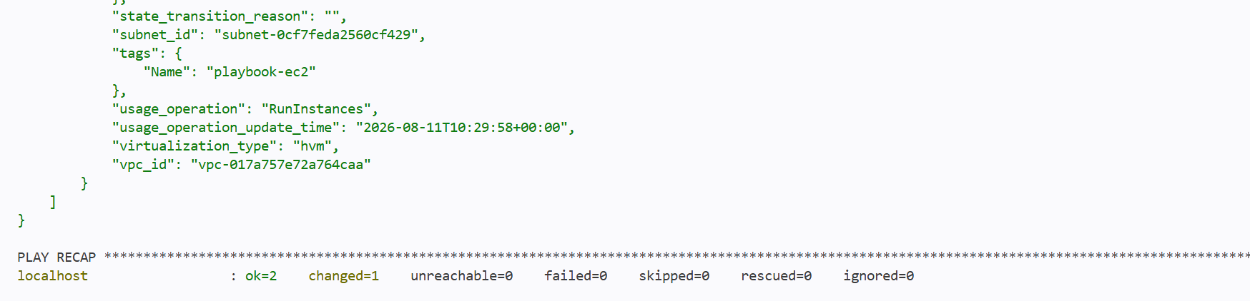

Verify
Open AWS Console, go to EC2, and select Instances. One running instance named ansible-ec2 should appear.

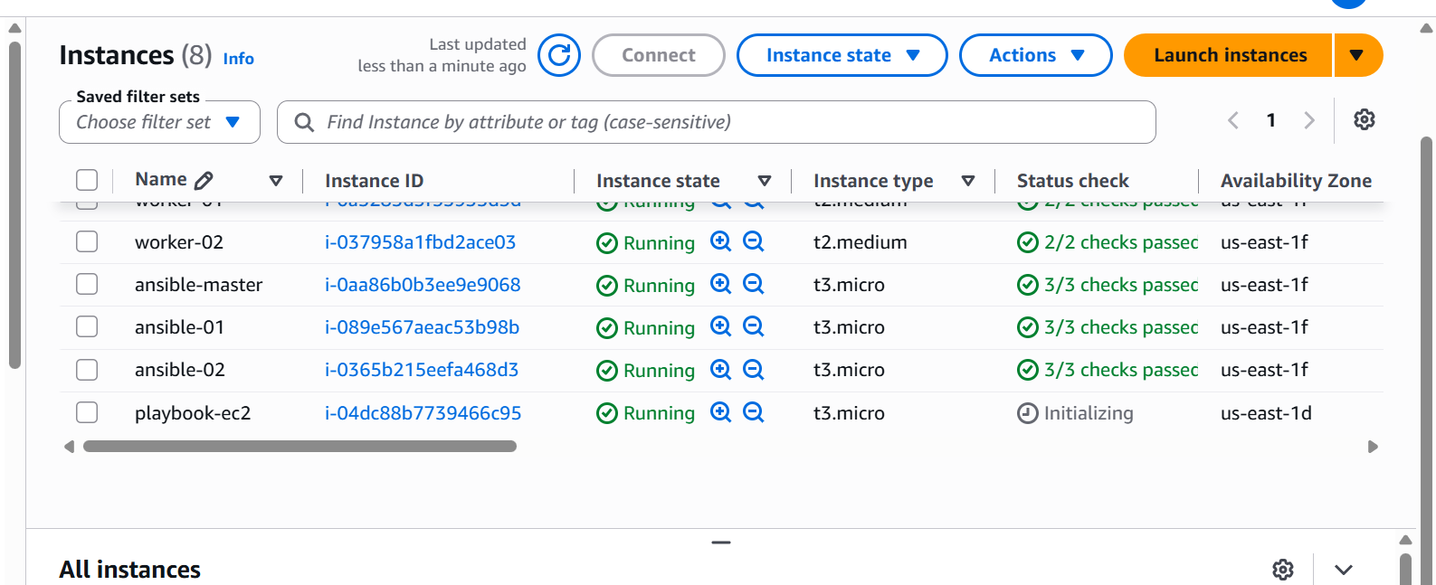

Important
The playbook uses exact_count: 1 so repeated runs keep one matching instance. Stop or terminate the instance when it is no longer required to avoid charges

Write a ansible playbook to copy one file from node-1 to node-2
Flow: Node-1 -> Ansible control node -> Node-2

1. Create a test file on node-1

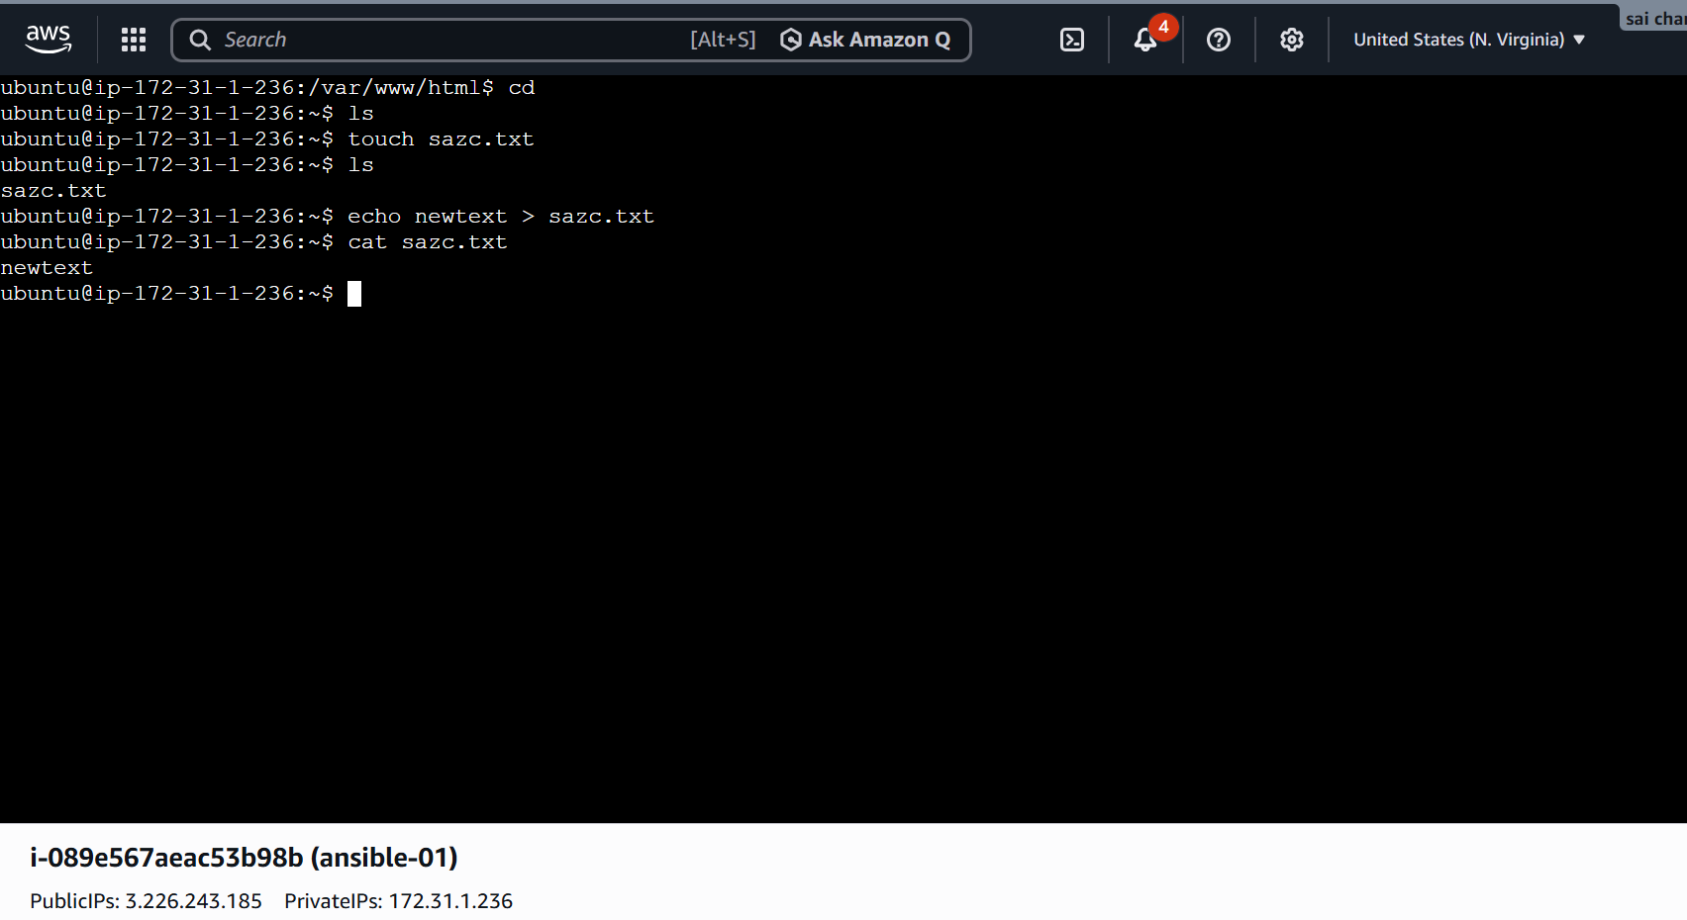2. Create new inventory
nano inventory02.ini
[source]
node-1 ansible_host=172.31.1.175
[destination]
node-2 ansible_host=172.31.1.236
[all:vars]
ansible_user=ubuntu
ansible_ssh_private_key_file=/home/ubuntu/.ssh/id_ed25519
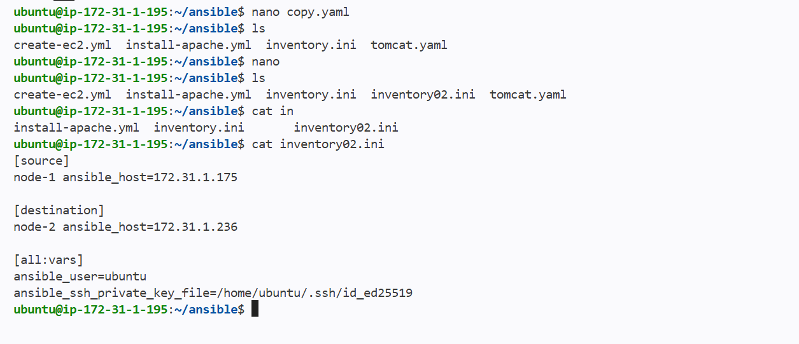

3. Create the playbook
nano copy-file.yml
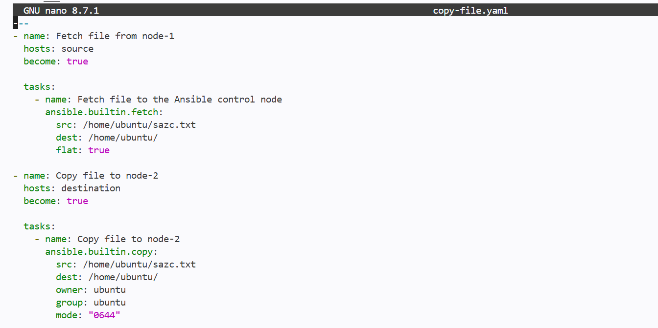

4. Check and run
ansible-playbook -i inventory02.ini copy-file.yaml --syntax-check
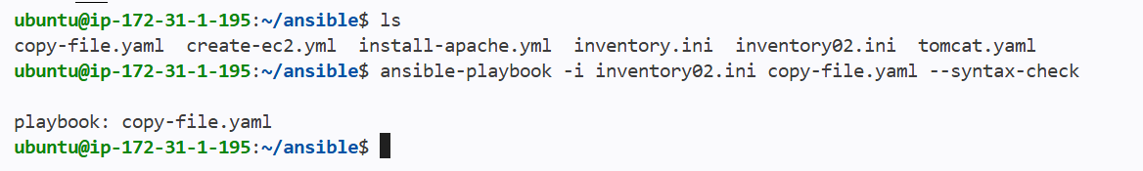

ansible-playbook -i inventory02.ini copy-file.yaml

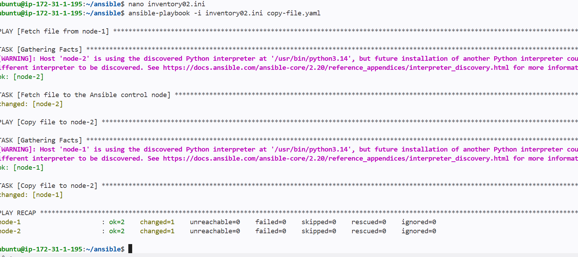

5. Verify on node-2
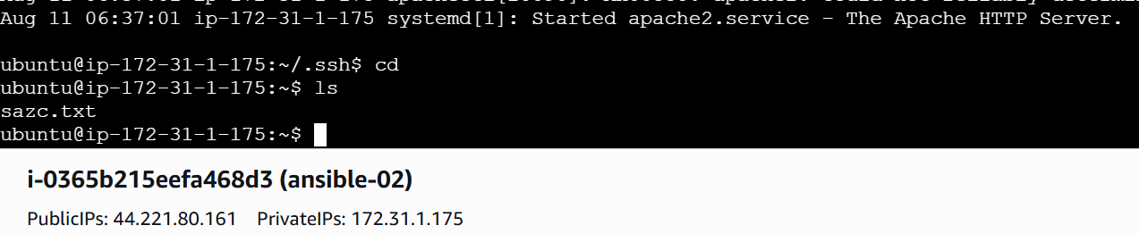

Important
The fetch task first downloads the file from node-1 to the Ansible control node. The copy task then uploads it from the control node to node-2.

Write a ansible playbook to create different files with different names using single playbook
Create a new yaml file
And hosts as webservers that contains the ips of worker nodes

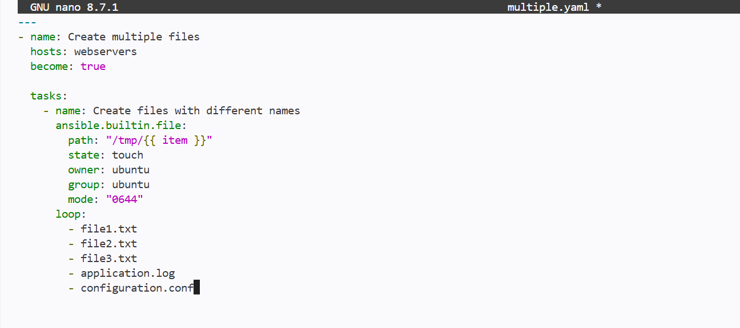

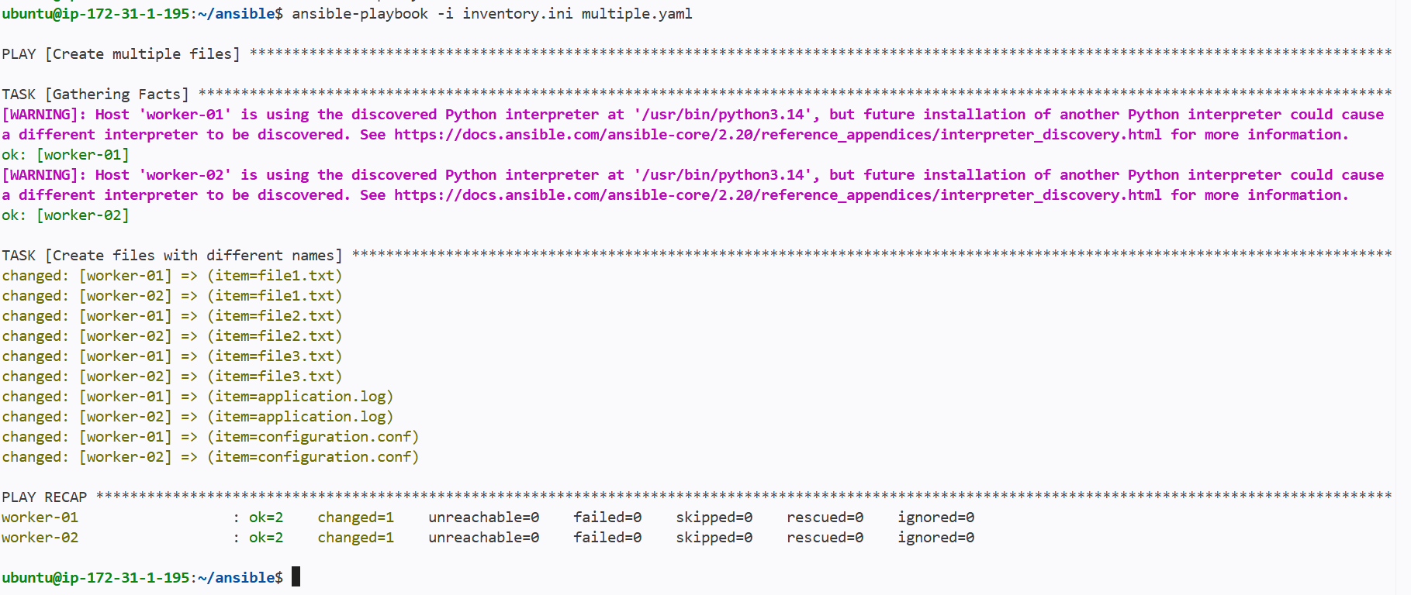
Created multiple files using the ansible playbook

