Setup ARGO CD

Setting up argocd in cluster

Argo CD setup on Kubernetes

1. Verify the cluster
kubectl get nodes
kubectl cluster-info
All required nodes should be Ready.

2. Install Argo CD
kubectl create namespace argocd
kubectl apply -n argocd \
--server-side \
--force-conflicts \
-f https://raw.githubusercontent.com/argoproj/argo-cd/stable/manifests/install.yaml

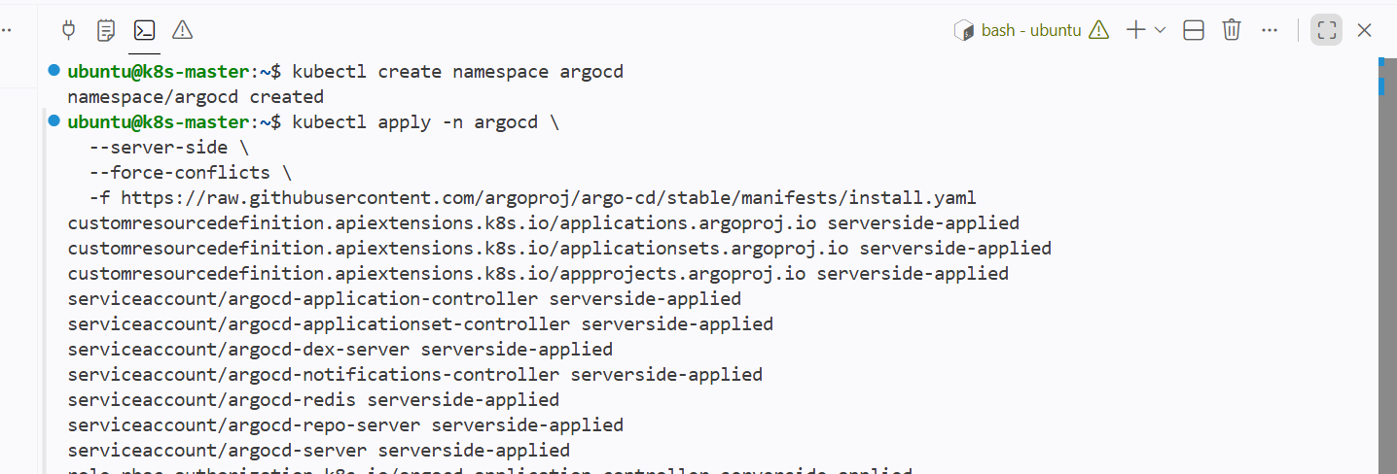

Check the installation:
kubectl get pods -n argocd

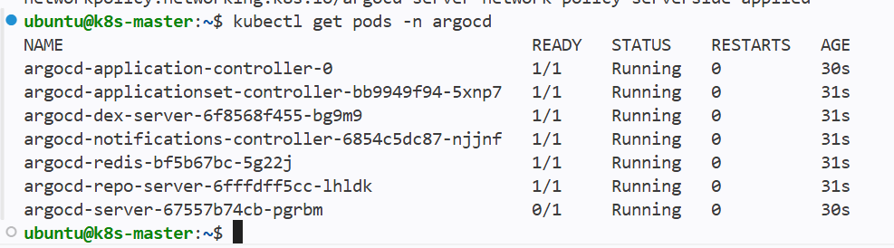
Wait until the pods show Running:
kubectl wait --for=condition=Ready pods \
--all \
-n argocd \
--timeout=300s

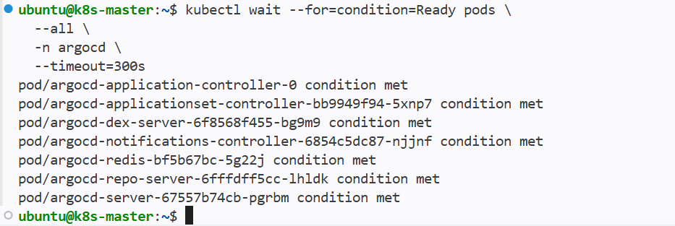

Default namespace for kubectl config must be set to argo cd This is only needed for the following commands since the previous commands have -n argocd already

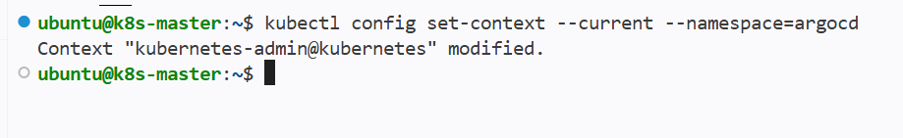

Port Forwarding¶
kubectl port-forward can also be used to connect to the API server without exposing the service.

Use localhost:8080 to login to ui

Install ardo cd cli

kubectl -n argocd get secret argocd-initial-admin-secret \
-o jsonpath="{.data.password}" | base64 --decode

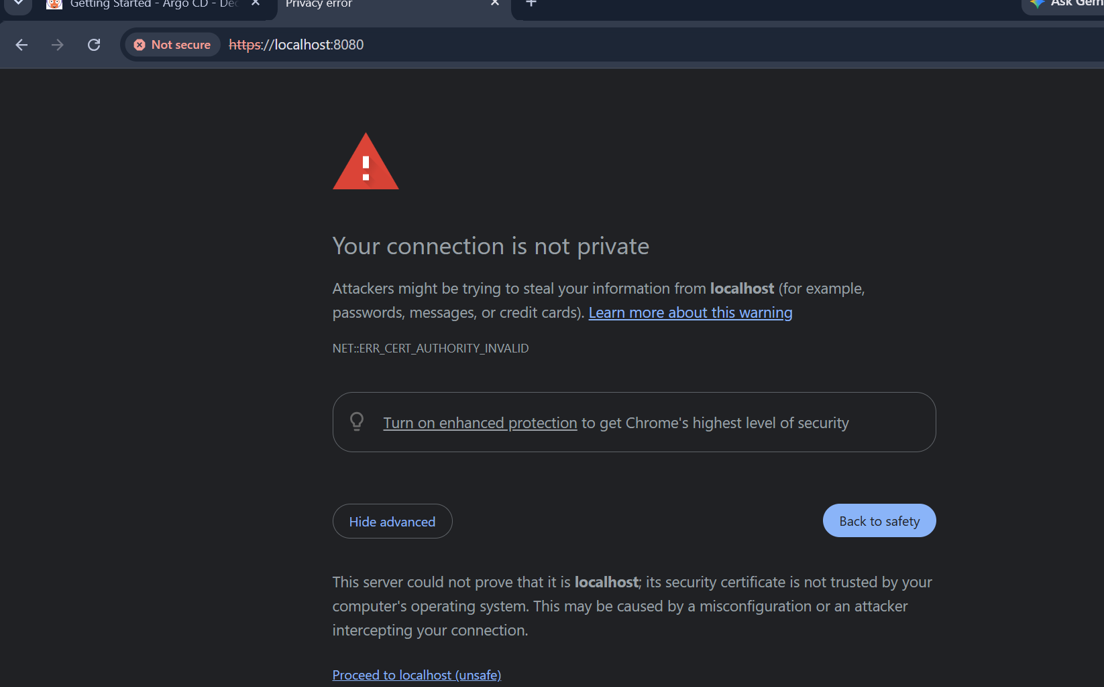

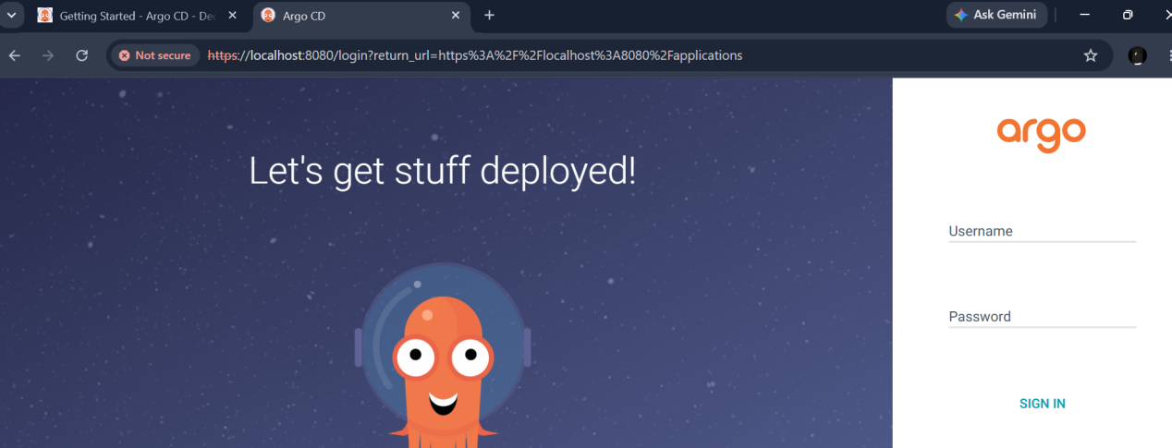

4. Get the initial password
Username:
admin
Password:
argocd admin initial-password -n argocd

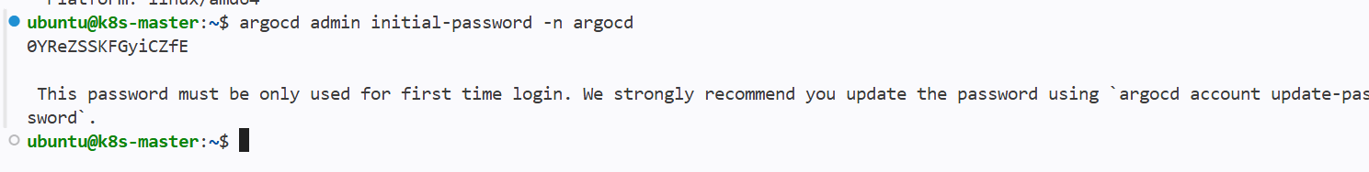

If the Argo CD CLI is unavailable:
kubectl -n argocd get secret argocd-initial-admin-secret \
-o jsonpath="{.data.password}" | base64 --decode

To install argocd in master

curl -sSL -o argocd-linux-amd64 \
https://github.com/argoproj/argo-cd/releases/latest/download/argocd-linux-amd64

sudo install -m 555 argocd-linux-amd64 /usr/local/bin/argocd

rm argocd-linux-amd64

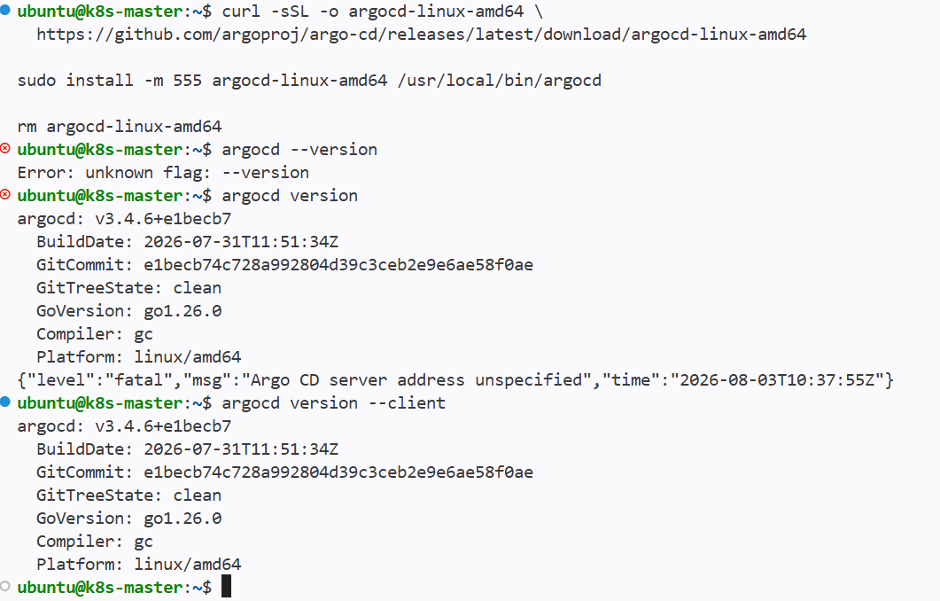

Then use port forward from cli

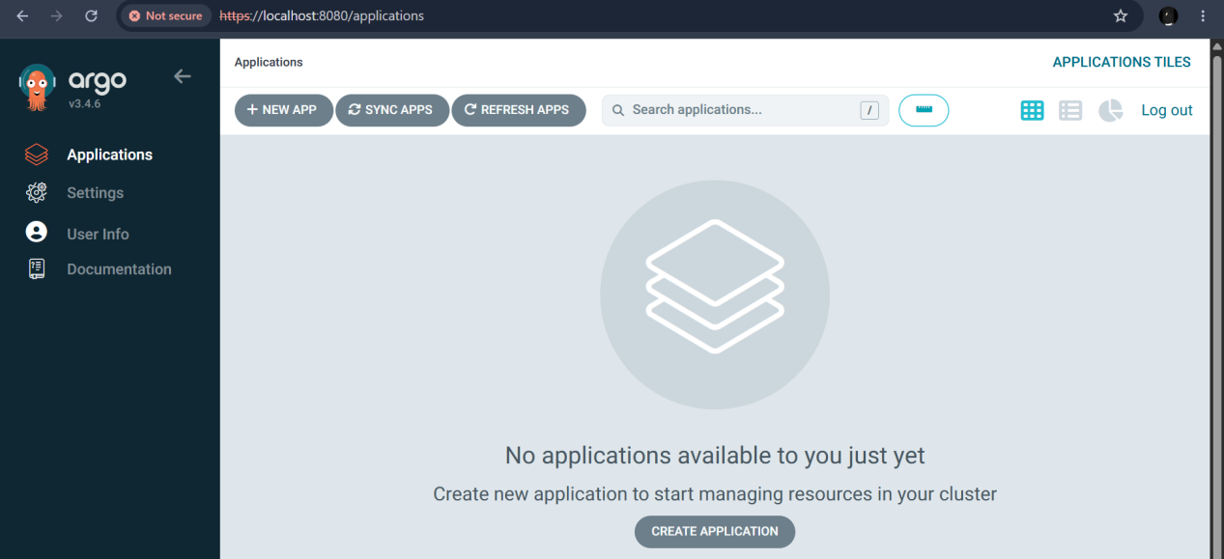

We can also login through cli using argo cd or directly from browser

5. Log in through the CLI
argocd login localhost:8080 \
--username admin \
--insecure
Change the initial password:
argocd account update-password
After changing it, remove the initial-password secret:
kubectl delete secret argocd-initial-admin-secret -n argocd

6. Connect a Git repository
For a public repository:
argocd repo add https://github.com/USERNAME/REPOSITORY.git
For a private GitHub repository:
argocd repo add https://github.com/USERNAME/REPOSITORY.git \
--username USERNAME \
--password GITHUB_TOKEN
Use a secure token mechanism and avoid placing the token in scripts or Git.
Developer pushes Kubernetes YAML to GitHub
↓
Argo CD detects it
↓
Argo CD applies it to Kubernetes
↓
Application becomes synchronized

Jenkins ci pipeline job

Git repo cloning in stage 1

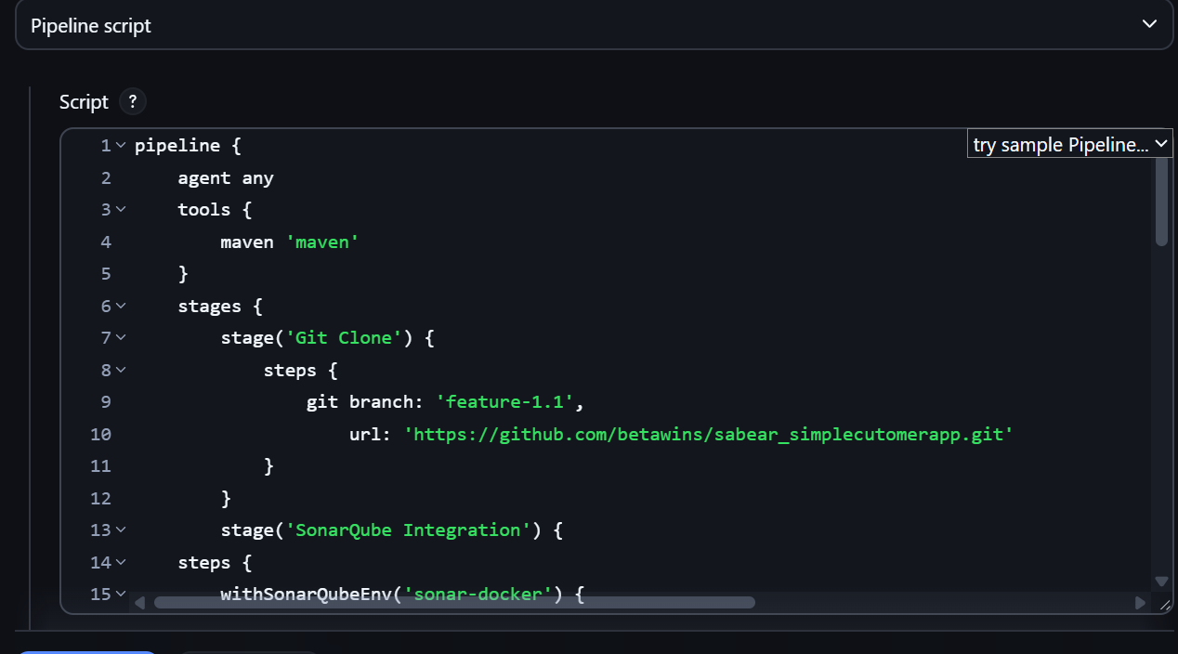

Checking for code quality using sonarqube

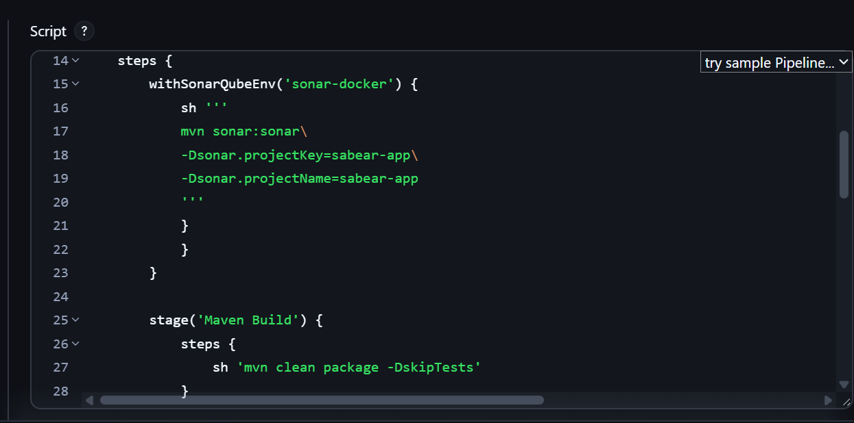

Building the package using maven
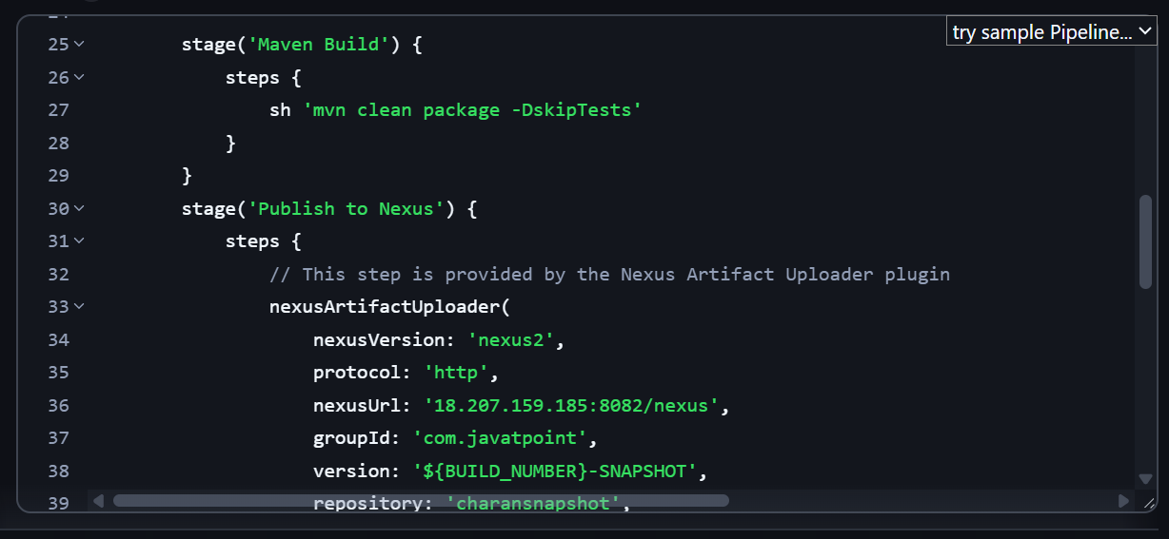

Uploading the package to nexus repo

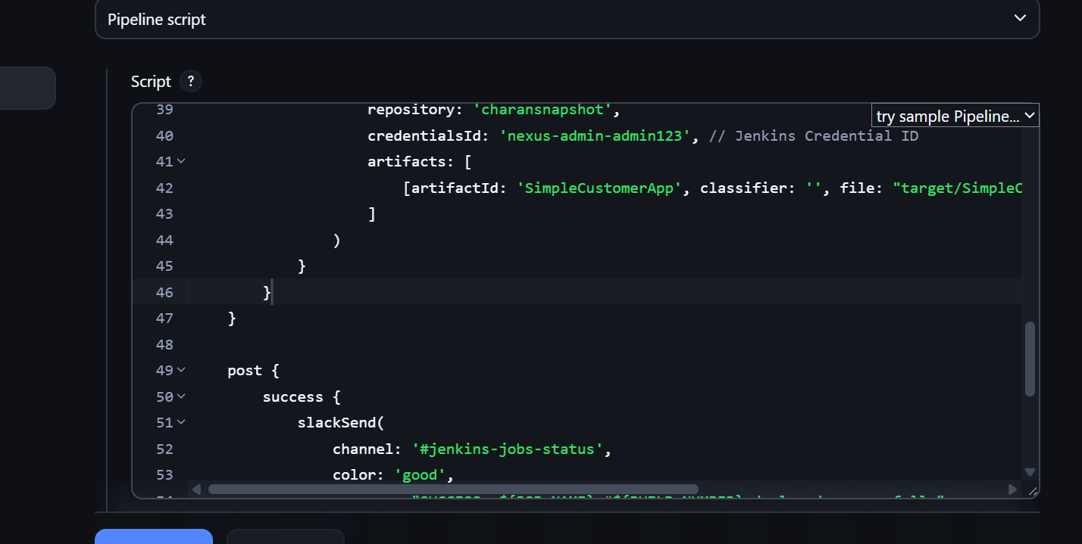

Create Jenkins job to create docker image and build image.

Steps:
- Created a pipeline, hr-app_docker with the below code:
pipeline {
agent any
environment {
IMAGE_NAME = "ashraff452/docker2"
IMAGE_TAG = "v1.${BUILD_NUMBER}"
}

stages {

stage('Git Checkout') {
steps {
git branch: 'main',
url: 'https://github.com/ashrafff452/hiring-app_argocd'
}
}

stage('Docker Build') {
steps {
sh '''
docker build -t $IMAGE_NAME:$IMAGE_TAG .
'''
}
}

stage('Docker Login') {
steps {
withCredentials([
usernamePassword(
credentialsId: 'Docker_credentials',
usernameVariable: 'DOCKER_USER',
passwordVariable: 'DOCKER_PASS'
)
]) {
sh '''
echo "$DOCKER_PASS" | docker login \
-u "$DOCKER_USER" \
--password-stdin
'''
}
}
}

stage('Docker Push') {
steps {
sh '''
docker push $IMAGE_NAME:$IMAGE_TAG
'''
}
}

stage('Logout') {
steps {
sh '''
docker logout
'''
}
}
stage('Docker Run') {
steps {
sh '''
docker rm -f docker_container || true
docker run -d \
--name docker_container \
-p 8080:8080 \
${IMAGE_NAME}:${IMAGE_TAG}
'''
}

}

}

post {
success {
echo 'Docker image pushed successfully.'
}

failure {
echo 'Pipeline failed.'
}
}
}

Now I have forked the repo, https://github.com/betawins/hiring-app.git & renamed used the new repo, https://github.com/ashrafff452/hiring-app_argocd with Docker file as mentioned below:

FROM tomcat:8.0.20-jre8
# Define environment variables for Nexus repository and the artifact to download
ENV NEXUS_REPO_URL="http://3.237.61.178:8081/repository/Hiring_app/"
ENV ARTIFACT_PATH="in/javahome/hiring/0.1/hiring-0.1.war"

# Download the WAR file from Nexus and copy it to the Tomcat webapps directory
ADD $NEXUS_REPO_URL$ARTIFACT_PATH /usr/local/tomcat/webapps/hiring.war

# Expose port 8080 (Tomcat's default port)
EXPOSE 8080
# Start Tomcat
CMD ["catalina.sh", "run"]

Now build the job , hr-app_docker & once successful we can see that from Dockerfile the image is built & deployed in tomcat container

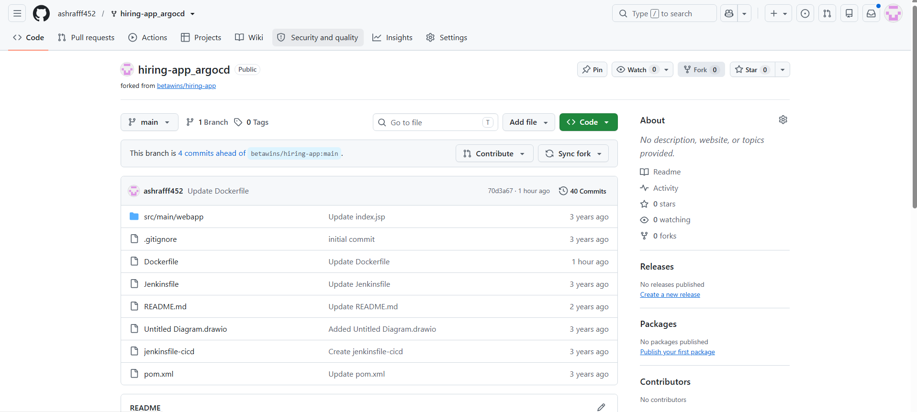

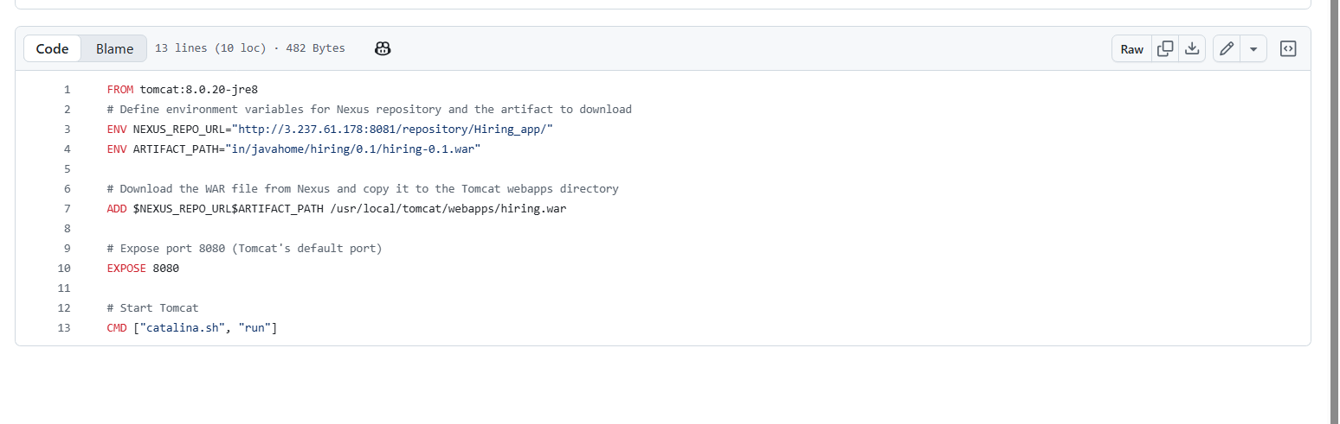
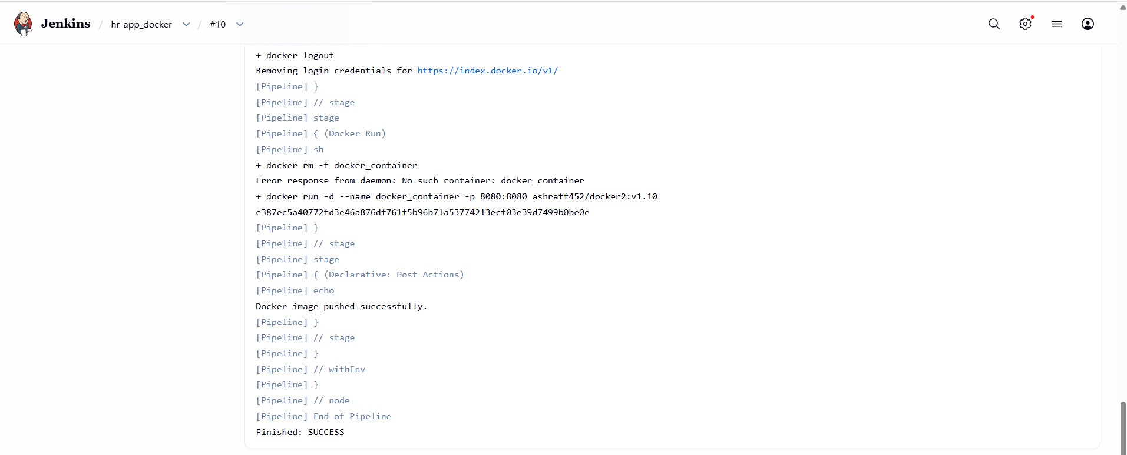

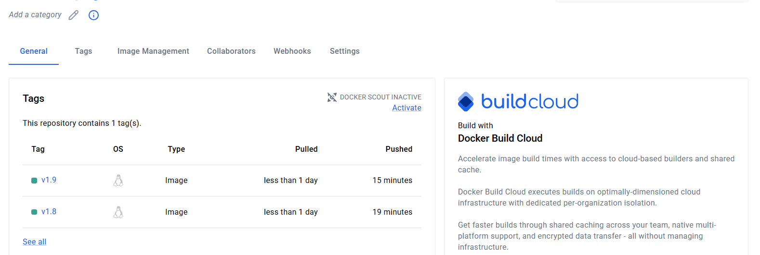

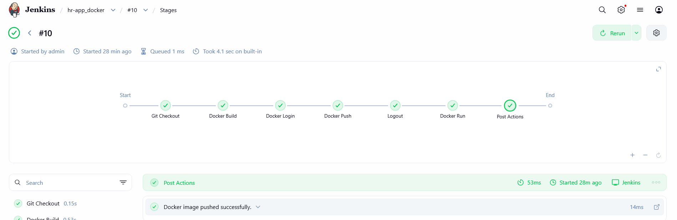

Create ArgoCD job to deploy on ek8s cluster.

PURPOSE:
- Automate Kubernetes deployments.
- Implement GitOps using Argo CD.
- Synchronize Kubernetes manifests from GitHub to EKS.
- Reduce manual deployments.
- Enable continuous delivery.

OBJECTIVE: To automate the deployment of a containerized application to an Amazon EKS cluster using Argo CD by implementing GitOps principles.

ARCHITECTURE:

Developer
│
▼
GitHub Repository
│
▼
ArgoCD
│
▼
Amazon EKS Cluster
│
▼
Application Pods

PREREQUISITES:
- Amazon EKS Cluster
- kubectl configured
- ArgoCD installed
- GitHub Repository
- Kubernetes Deployment YAML
- Kubernetes Service YAML
- Docker image available in Docker Hub/ECR

EXPECTED OUTCOME:

- After synchronization:
GitHub Repository
│
▼
ArgoCD detects changes
│
▼
Synchronizes manifests
│
▼
Deploys application to Amazon EKS
│
▼
Pods become Running
│
▼
Service exposes application

FOLDER STRUCTURE:
- We have to first clone the repo from the central hub and then we have to create this folder structure to setup our configuration manifest in the central repo.
- Then after editing all these things, we have to push the repo to the central hub then we have to sync the argo cd with this command -> argocd app sync hiring-app

argocd/
│
|-─ deployment.yaml
|── service.yaml
|-─ namespace.yaml

DEPLOYMENT.YAML

apiVersion: apps/v1
kind: Deployment
metadata:
name: hiring-app
spec:
replicas: 2
selector:
matchLabels:
app: hiring-app
template:
metadata:
labels:
app: hiring-app
spec:
containers:
- name: hiring-app
image: nginx:latest
ports:
- containerPort: 8080

SERVICE.YAML:

apiVersion: v1
kind: Service
metadata:
name: hiring-service
spec:
selector:
app: hiring-app
ports:
- port: 80
targetPort: 8080
type: LoadBalancer

- Install ArgoCD
kubectl create namespace argocd

kubectl apply -n argocd \
-f https://raw.githubusercontent.com/argoproj/argo-cd/stable/manifests/install.yaml
- kubectl get pods -n argocd
kubectl get pods -n argocd
- Expose ArgoCD
kubectl patch svc argocd-server \
-n argocd \
-p '{"spec":{"type":"LoadBalancer"}}'
- Login to ArgoCD
kubectl -n argocd get secret argocd-initial-admin-secret \
-o jsonpath="{.data.password}" | base64 -d
- Create Application using CLI
argocd app create hiring-app \
--repo https://github.com/krishnasanthosh6160/argocd.git \
--path . \
--dest-server https://kubernetes.default.svc \
--dest-namespace default
- Synchronize Application
argocd app sync hiring-app

- Verify Deployment
- kubectl get deployments
- kubectl get pods
- kubectl get svc

Learning Outcome

After completing this exercise, you will be able to:
- Install and configure Argo CD.
- Connect Argo CD to an Amazon EKS cluster.
- Store Kubernetes manifests in GitHub.
- Create and manage Argo CD Applications.
- Use automatic synchronization for GitOps deployments.
- Verify application deployment on EKS.
- Understand the end-to-end GitOps workflow from GitHub to EKS.

End-to-End CI/CD + GitOps Workflow

Developer
│
▼
GitHub
│
▼
Jenkins Pipeline
│
├── Checkout Code
├── SonarQube Analysis
├── Maven Build
├── Nexus Upload
├── Docker Image Build
├── Push Image to Docker Hub/ECR
└── Update Kubernetes Manifest (new image tag)
│
▼
GitHub (Manifest Repository)
│
▼
ArgoCD
│
▼
Amazon EKS Cluster
│
▼
Running Application



