Create one Declarative pipeline job

Declarative pipeline are standard pipelines

Creating a new pipeline job with declarative pipeline

The declarative pipeline I have done to push the code to sonarqube
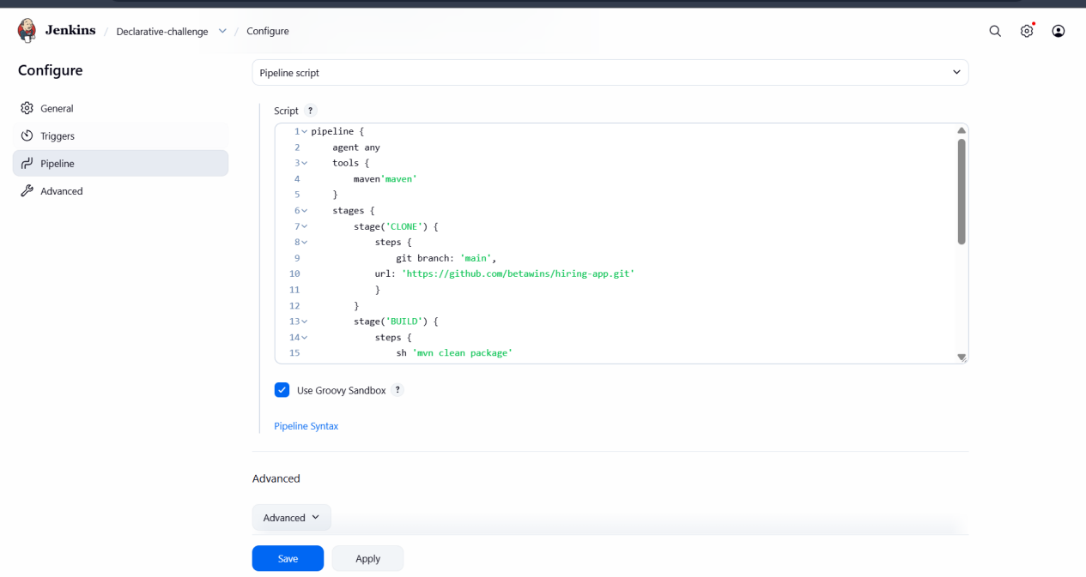

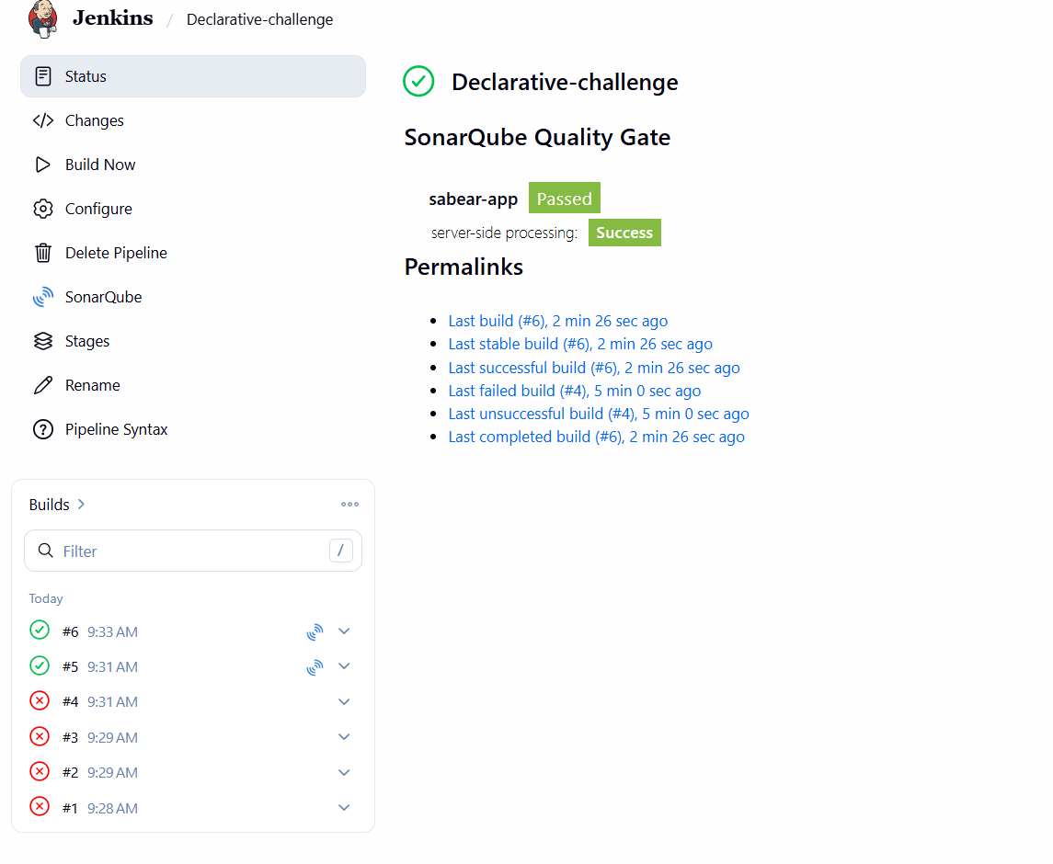

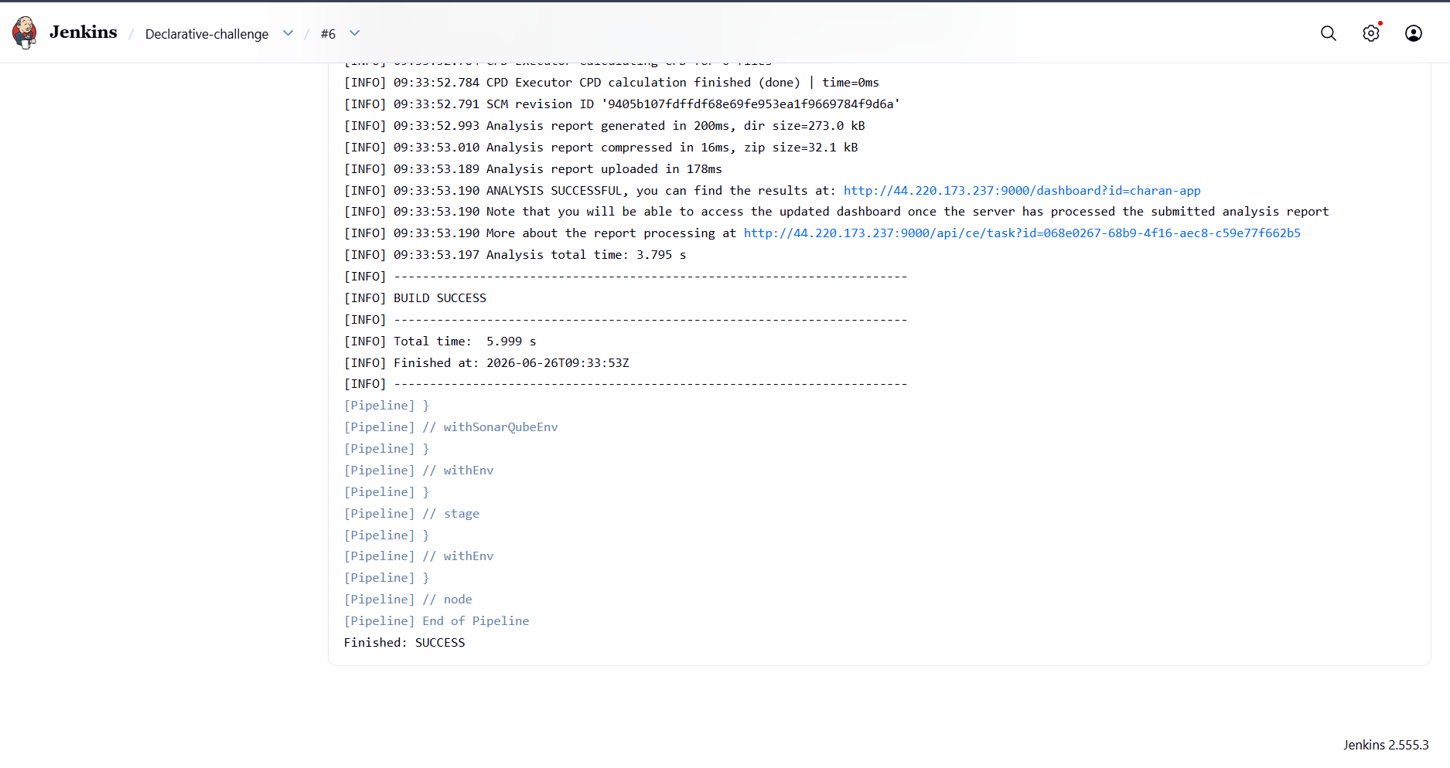

And the code has been pushed to sonarqube fro quality test

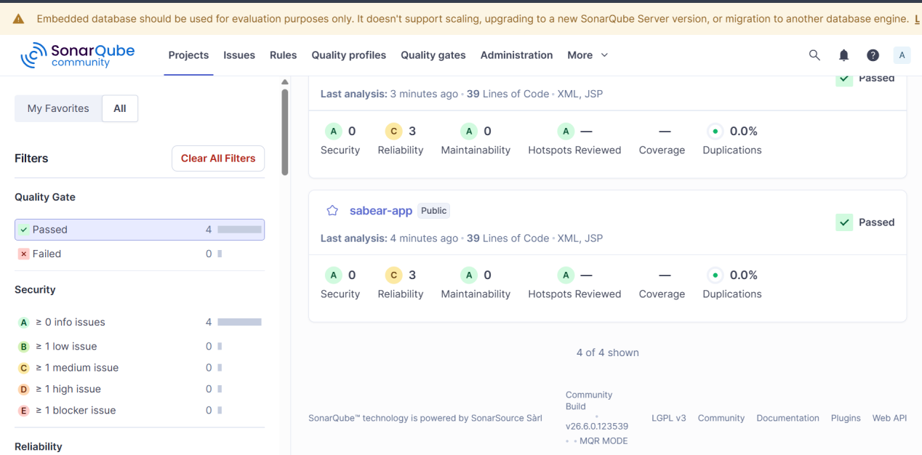

Create one Scripted pipeline job

Creating a new job with pipeline plugin

And giving the scripted pipeline
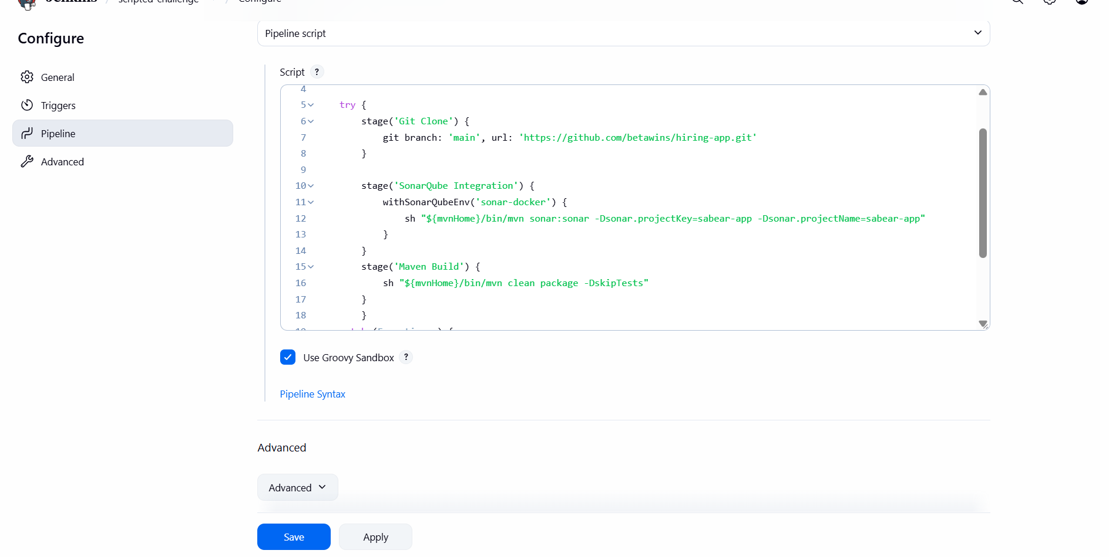

This is scripted pipeline for cloning the repo and pushing the code to sonarqube
And
Compiling the code using maven after quality checks

And the build was successful

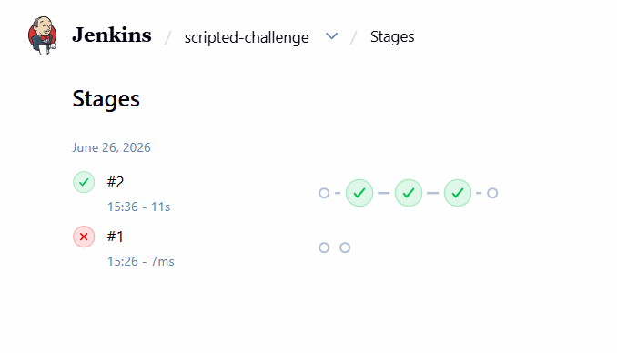

And we can see three stages was successful

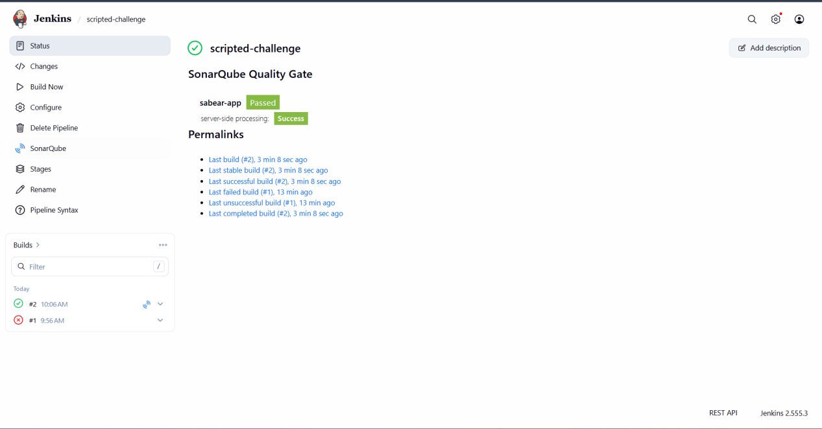

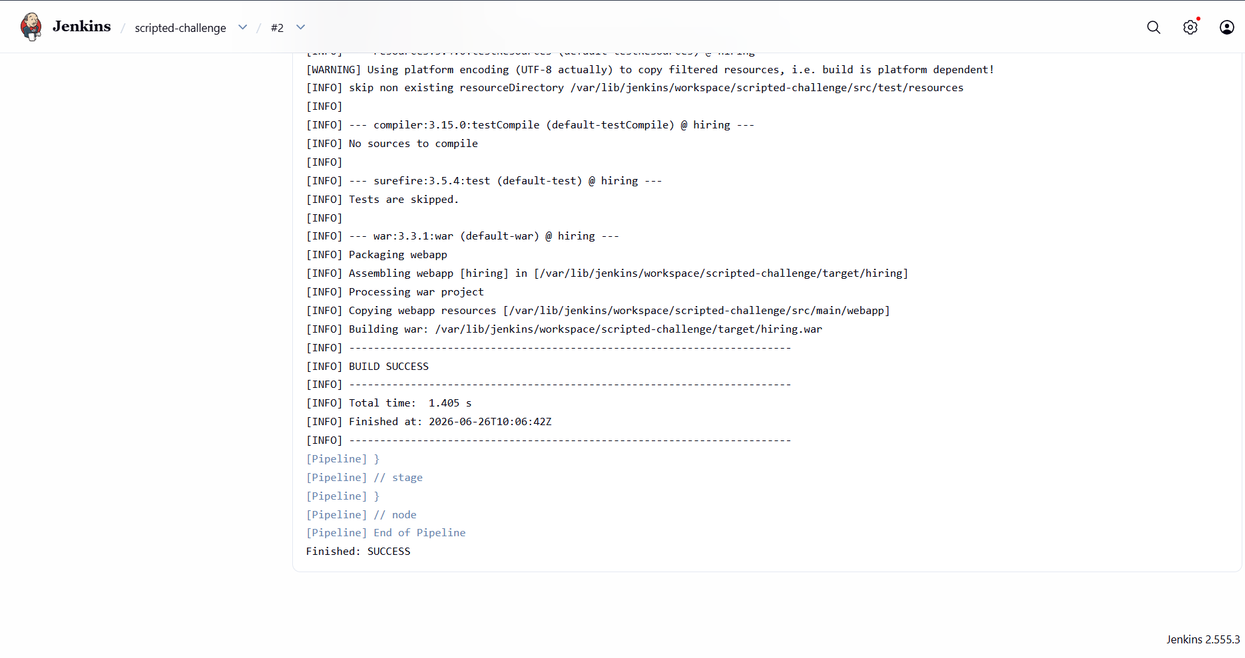

Create one Parameterized job

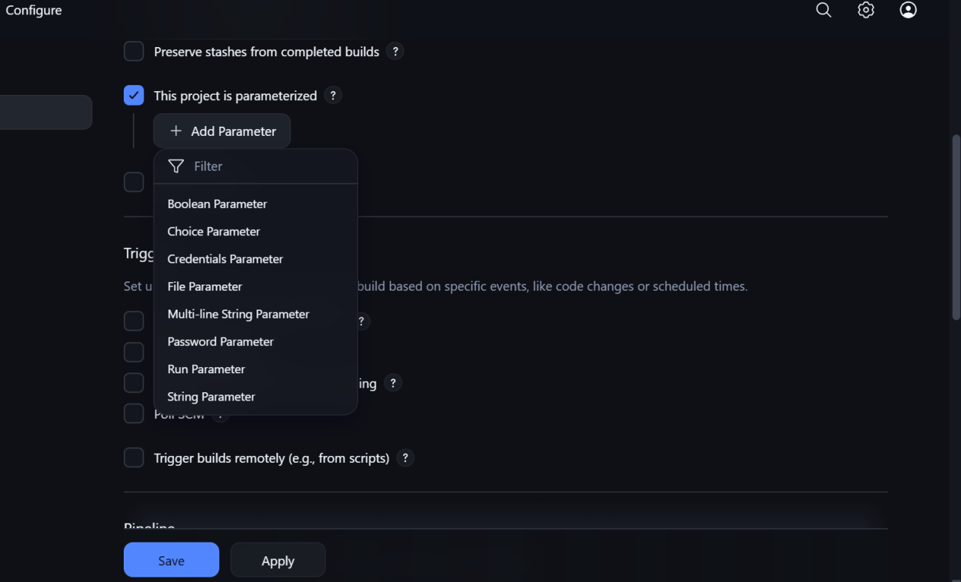

Using string parameter

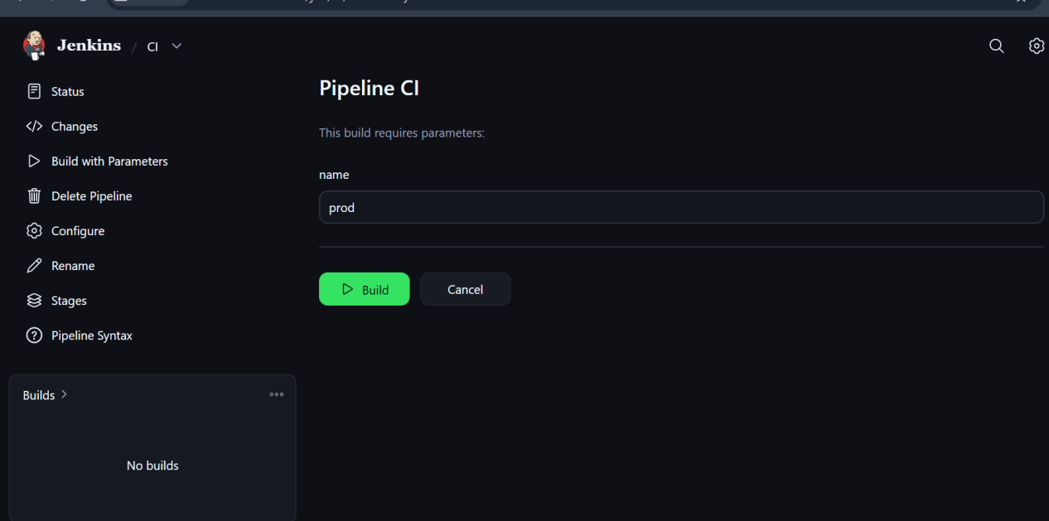

Then by using build with parameters we can shedule the job

Write sample skeleton for Declarative and Scripted pipelines

Declarative pipeline

pipeline {
agent any

environment {
APP_NAME = 'my-app'
}

stages {
stage('Checkout') {
steps {
checkout scm
}
}

stage('Build') {
steps {
sh 'echo "Building application"'
}
}

stage('Test') {
steps {
sh 'echo "Running tests"'
}
}

stage('Deploy') {
steps {
sh 'echo "Deploying application"'
}
}
}

post {
success {
echo 'Pipeline completed successfully'
}

failure {
echo 'Pipeline failed'
}

always {
cleanWs()
}
}
}

Scripted pipeline

node {
def appName = 'my-app'

try {
stage('Checkout') {
checkout scm
}

stage('Build') {
sh 'echo "Building application"'
}

stage('Test') {
sh 'echo "Running tests"'
}

stage('Deploy') {
sh 'echo "Deploying application"'
}

echo 'Pipeline completed successfully'
} catch (Exception error) {
echo "Pipeline failed: ${error.message}"
currentBuild.result = 'FAILURE'
throw error
} finally {
cleanWs()
}
}

Create one Declarative job

Source code:

https://github.com/betawins/sabear_simplecutomerapp/tree/feature-1.1

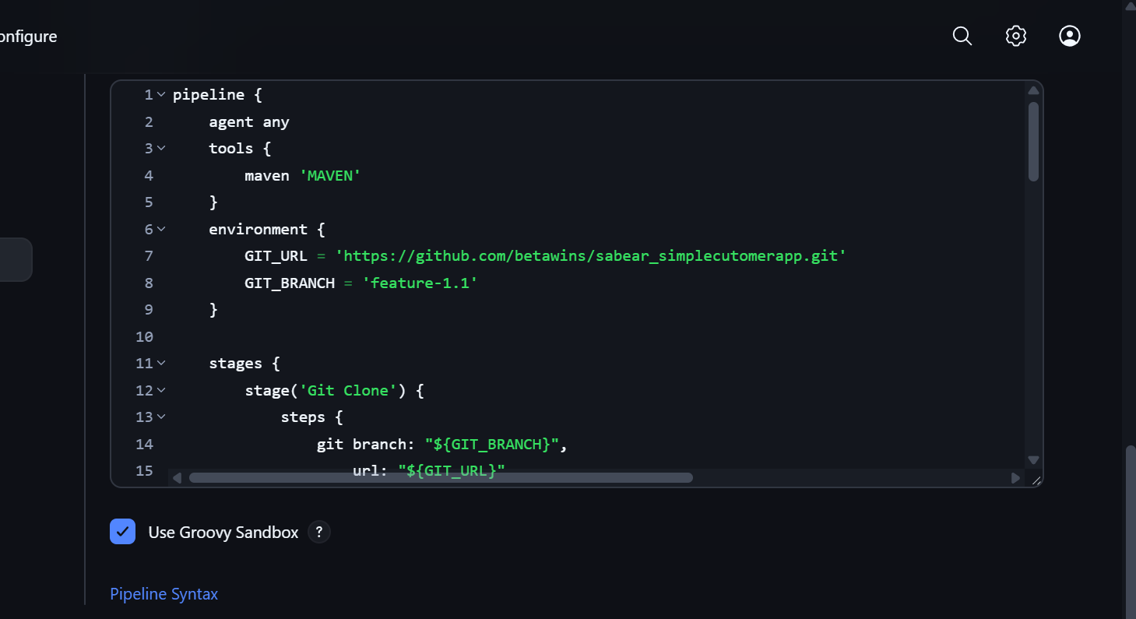

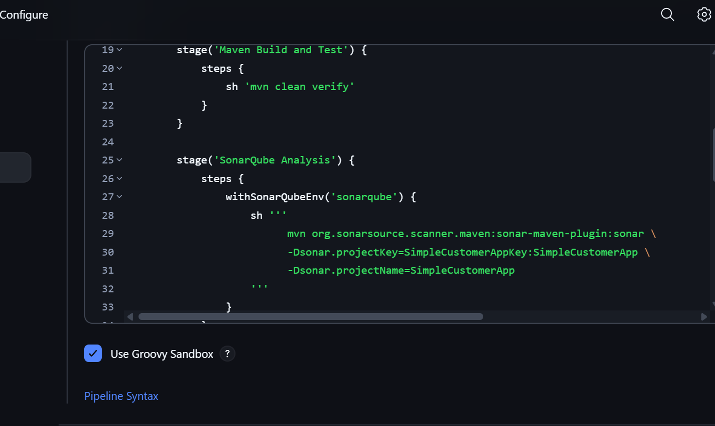

Gave sonar credentials in the system and using withsonarqubeenv it takes creds automatically
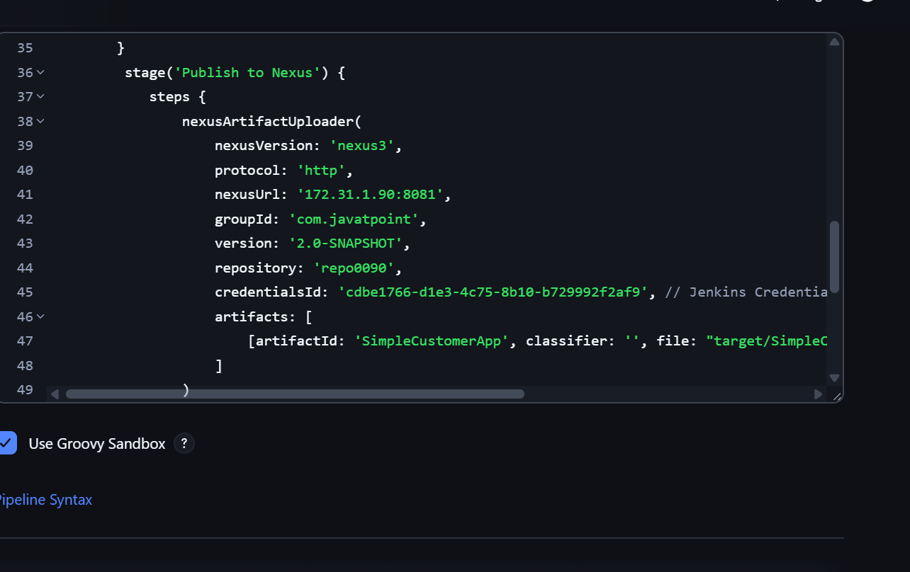

Build was successful

And uploaded to nexus

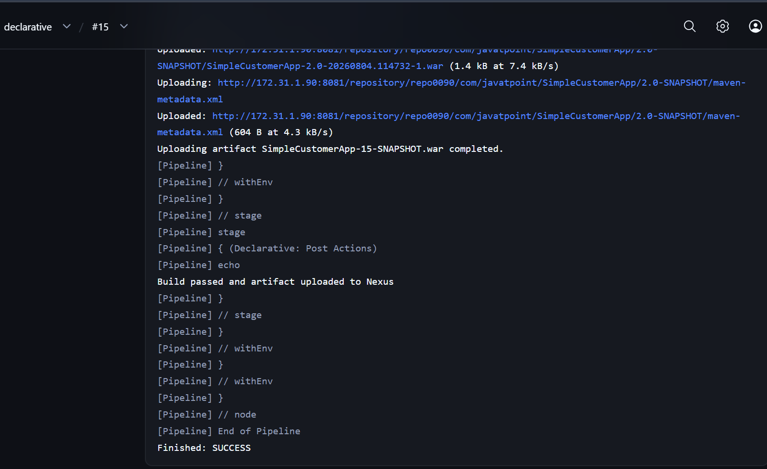

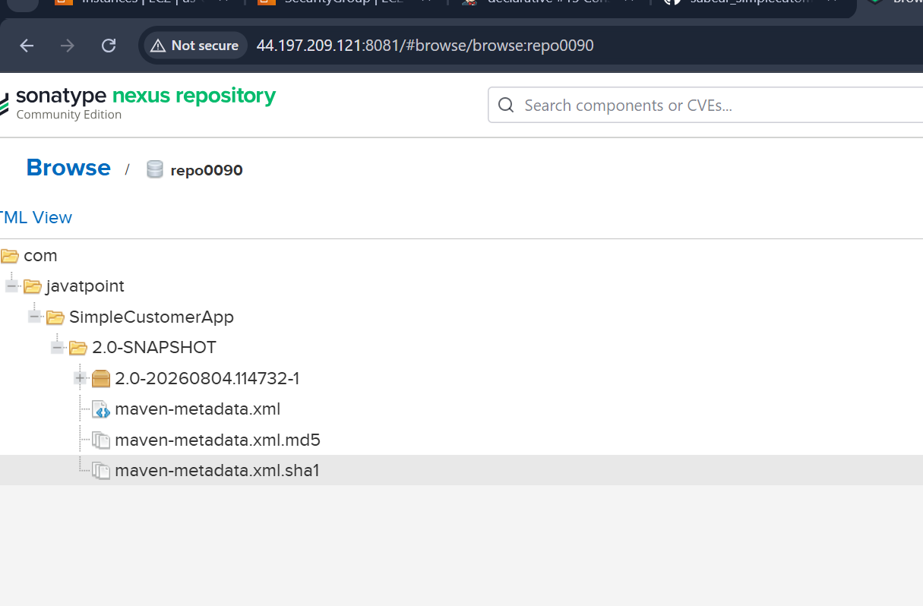

Jenkins pipeline stages using shared libraries

Structure

jenkins-shared-library/
├── vars/
│ └── ciPipeline.groovy
└── resources/

vars/ciPipeline.groovy

def call(Map config = [:]) {
pipeline {
agent any

environment {
IMAGE_NAME = "${config.imageName}"
IMAGE_TAG = "${env.BUILD_NUMBER}"
}

stages {
stage('Checkout') {
steps {
checkout scm
}
}

stage('Build') {
steps {
sh config.buildCommand
}
}

stage('Unit Test') {
steps {
sh config.testCommand
}
}

stage('SonarQube Analysis') {
steps {
withSonarQubeEnv('sonarqube') {
sh config.sonarCommand
}
}
}

stage('Build Docker Image') {
steps {
sh "docker build -t ${IMAGE_NAME}:${IMAGE_TAG} ."
}
}

stage('Push Docker Image') {
steps {
withCredentials([
usernamePassword(
credentialsId: 'dockerhub-credentials',
usernameVariable: 'DOCKER_USER',
passwordVariable: 'DOCKER_PASSWORD'
)
]) {
sh '''
echo "$DOCKER_PASSWORD" | docker login \
-u "$DOCKER_USER" --password-stdin
docker push "$IMAGE_NAME:$IMAGE_TAG"
'''
}
}
}

stage('Deploy') {
steps {
sh """
kubectl set image deployment/${config.deploymentName} \
${config.containerName}=${IMAGE_NAME}:${IMAGE_TAG} \
-n ${config.namespace}

kubectl rollout status deployment/${config.deploymentName} \
-n ${config.namespace} --timeout=180s
"""
}
}
}

post {
success {
echo 'Pipeline completed successfully.'
}

failure {
echo 'Pipeline failed. Check the stage logs.'
}

always {
cleanWs()
}
}
}
}

Application Jenkinsfile

@Library('jenkins-shared-library') _

ciPipeline(
imageName: 'your-dockerhub-user/payment-api',
buildCommand: 'mvn clean package -DskipTests',
testCommand: 'mvn test',
sonarCommand: 'mvn sonar:sonar',
deploymentName: 'payment-api',
containerName: 'payment-api',
namespace: 'production'
)

