Setup eks cluster using eksctl

To create a eks cluster we need to use eksctl from cli

Creating a eks cluster using the yaml file

First installing the eksctl in the cli on local machine

Installing using powershell and also we can use git bash

$arch = "amd64"
$zip = "$env:TEMP\eksctl_Windows_$arch.zip"
$installDir = "$env:USERPROFILE\bin"

Invoke-WebRequest `
-Uri "https://github.com/eksctl-io/eksctl/releases/latest/download/eksctl_Windows_$arch.zip" `
-OutFile $zip

New-Item -ItemType Directory -Force -Path $installDir
Expand-Archive -Path $zip -DestinationPath $installDir -Force

$userPath = [Environment]::GetEnvironmentVariable("Path", "User")
if ($userPath -notlike "*$installDir*") {
[Environment]::SetEnvironmentVariable(
"Path",
"$userPath;$installDir",
"User"
)
}

$env:Path += ";$installDir"
eksctl version

Usign above commands to install eksctl in powershell

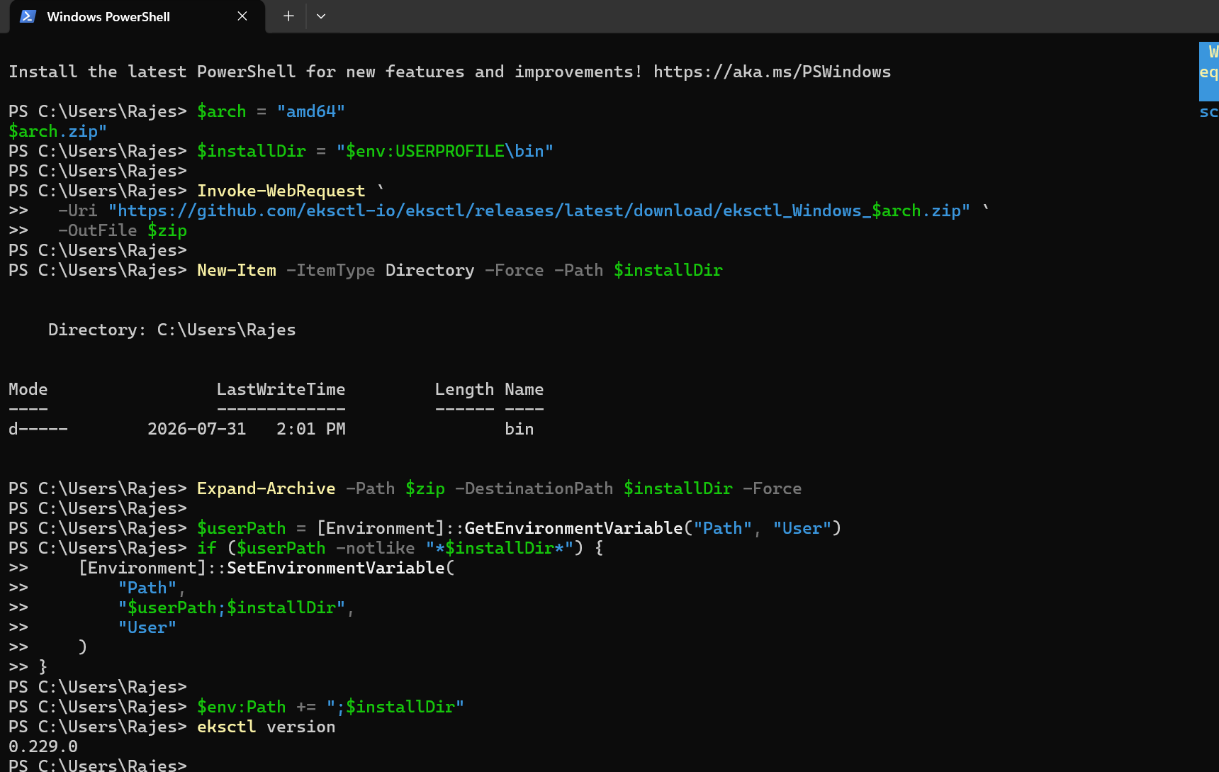
Eksctl has been installed in localmachine using powershell

Then using yaml file creating the eks cluster

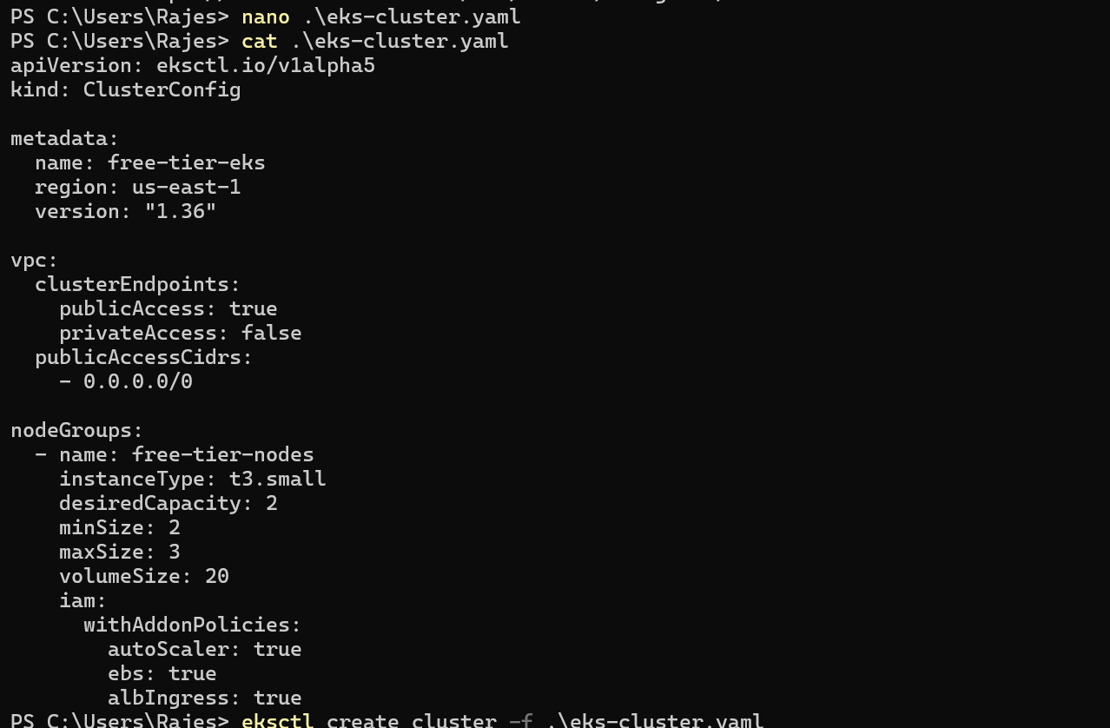

Then use eksctl create cluster -f filename.yaml

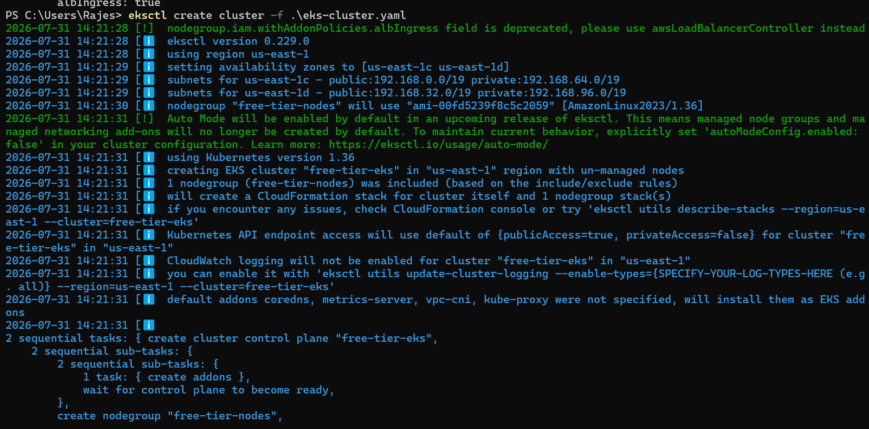

Then cluster is getting created and also we can check in the cloudfromation

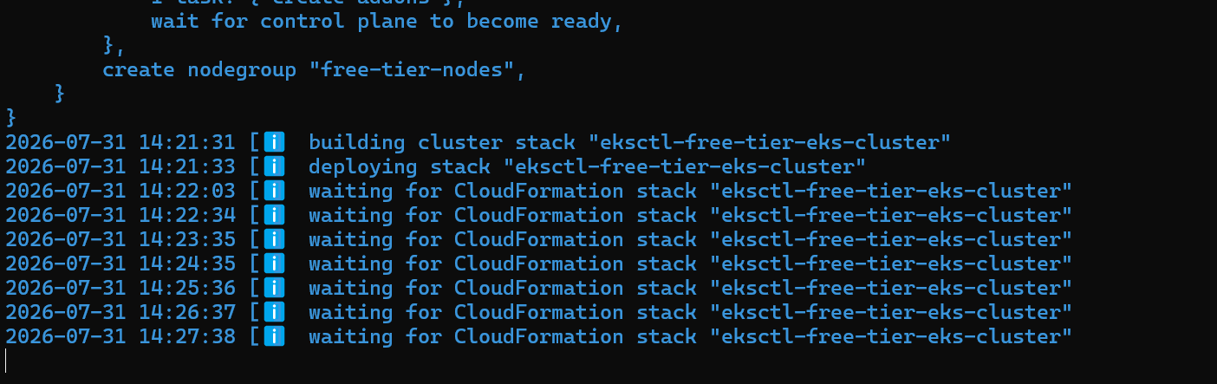

Cloudformation stack is waiting for cluster creation

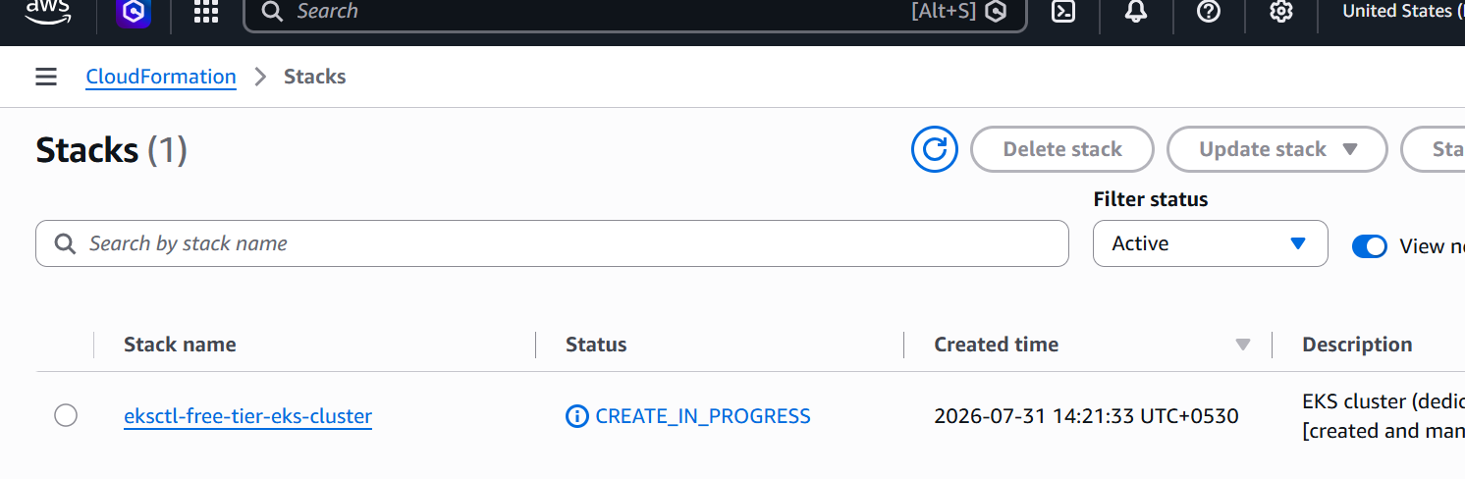

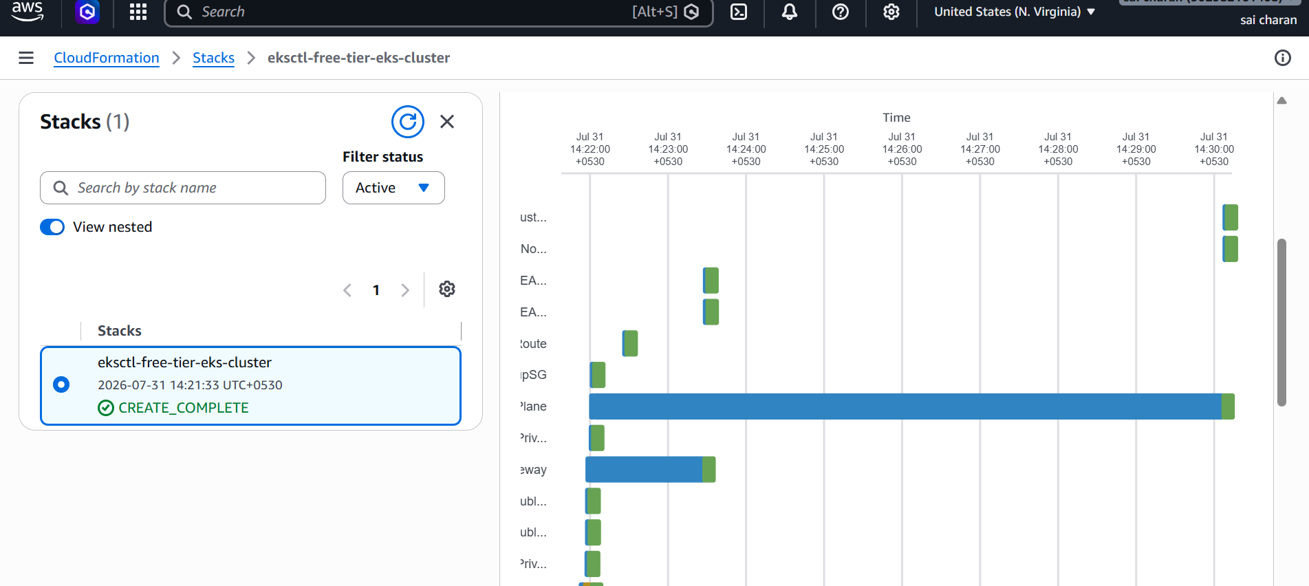

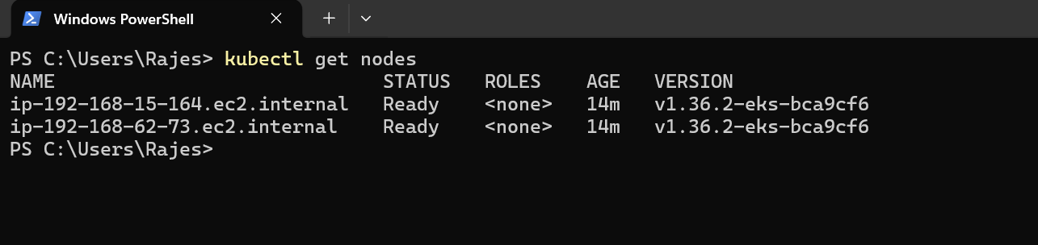

Two worker nodes has been created

setup eks cluster using console

Creating a new eks cluster using aws console

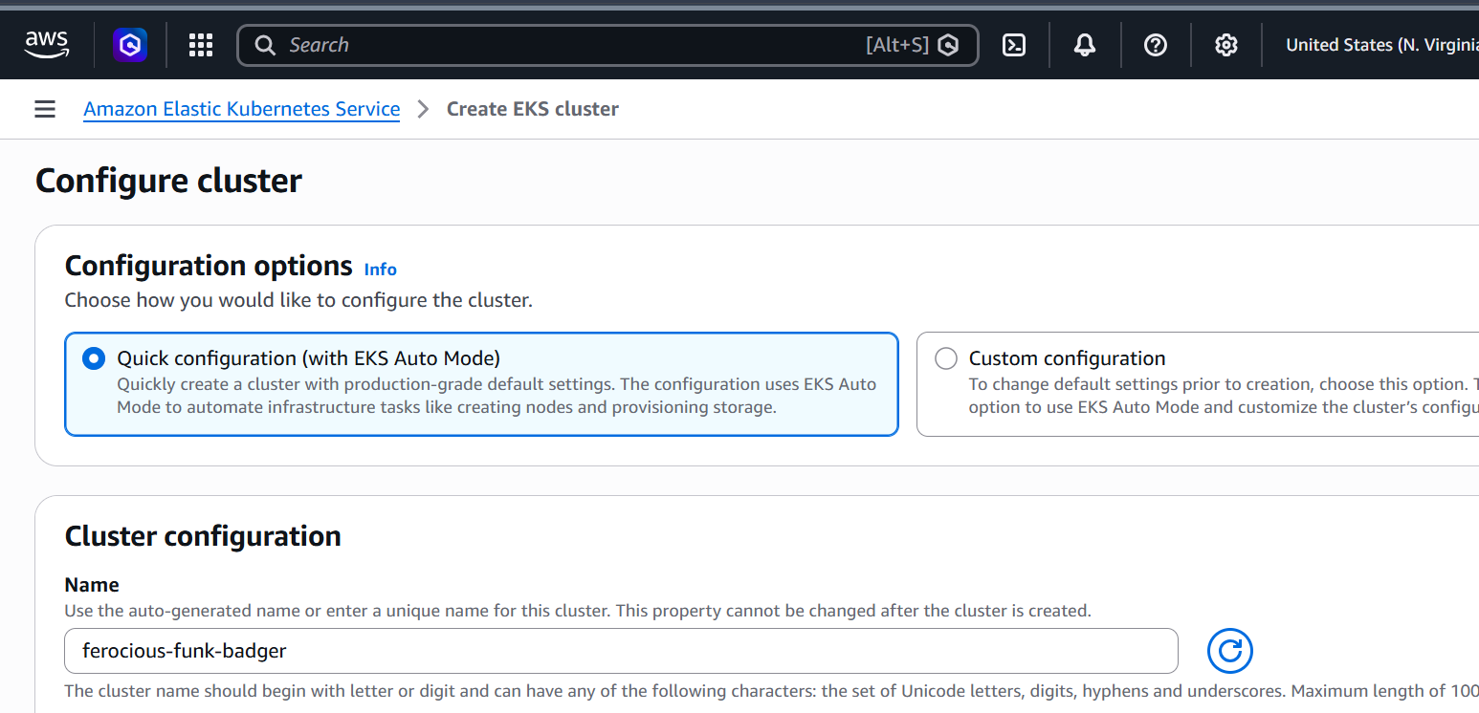

Go to eks and create a new cluster
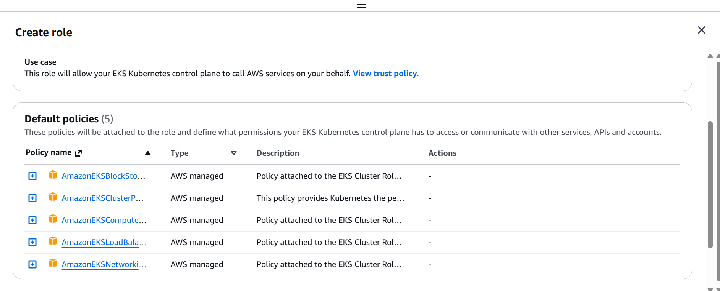
Created a new cluster role
Now create a new node role
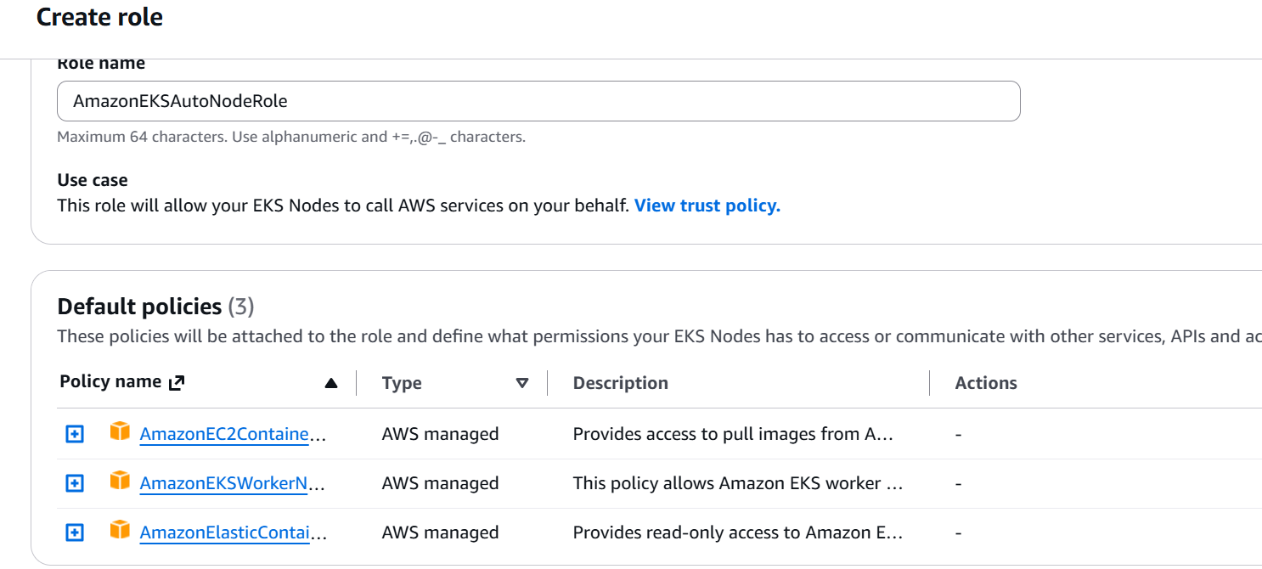

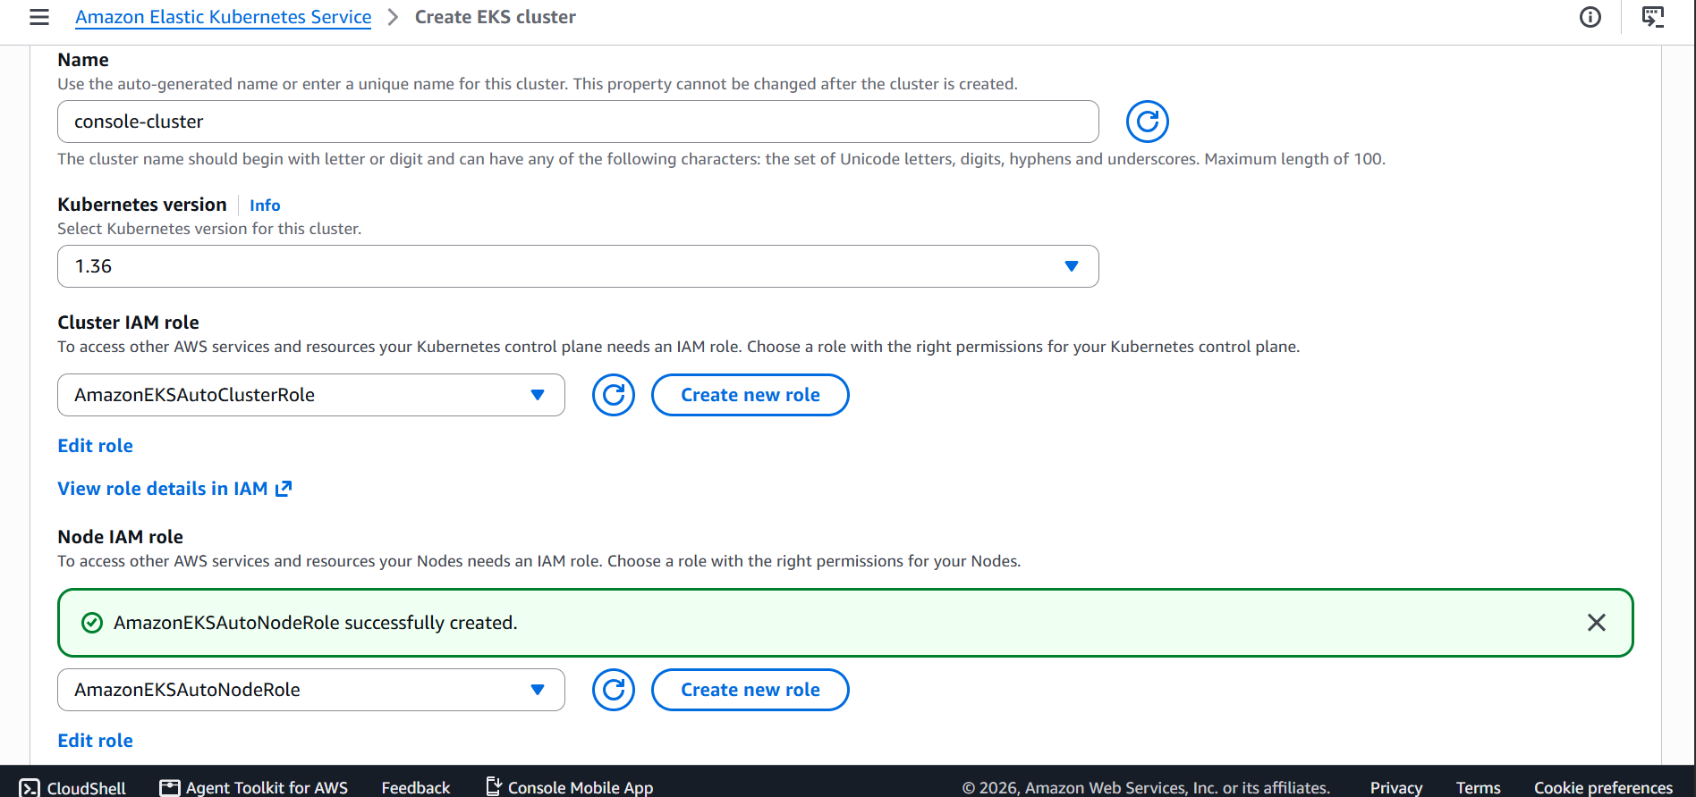

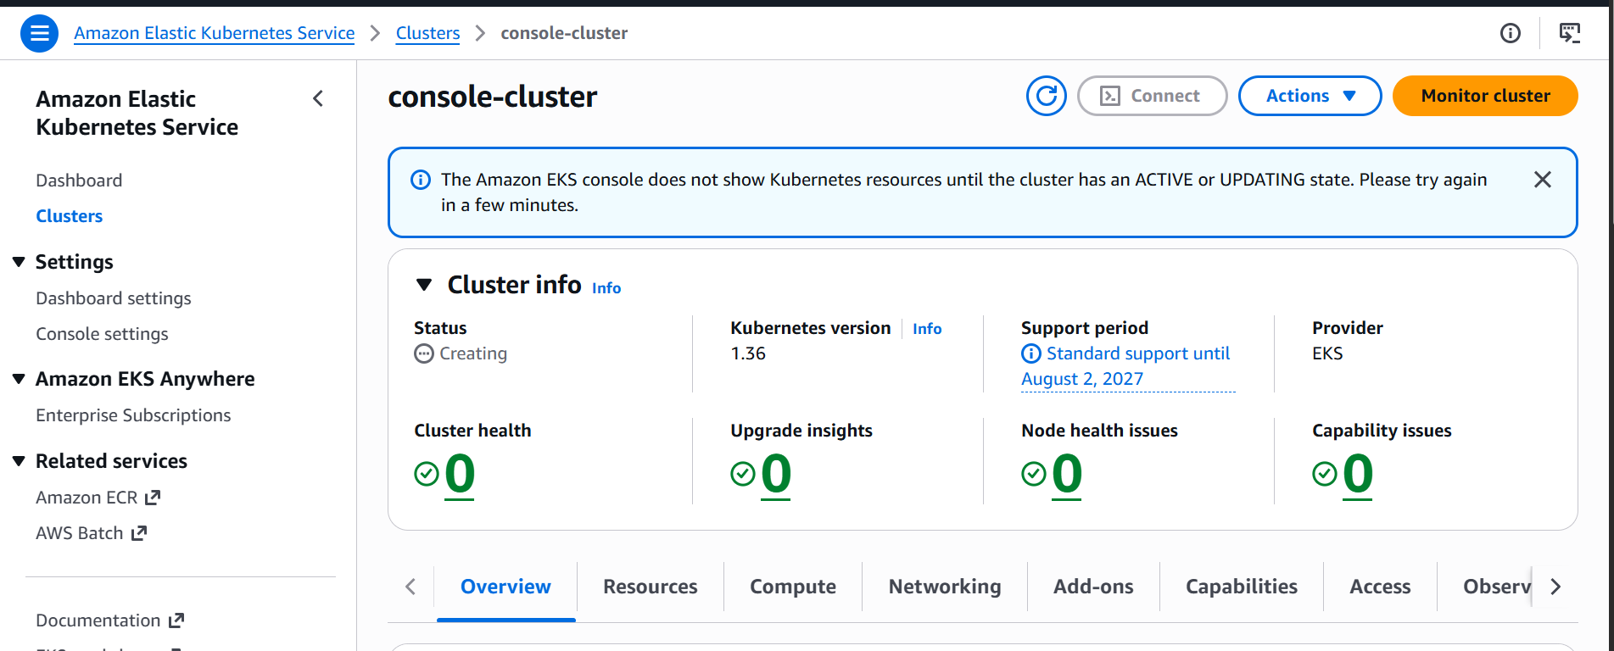

New cluster has been created by using console

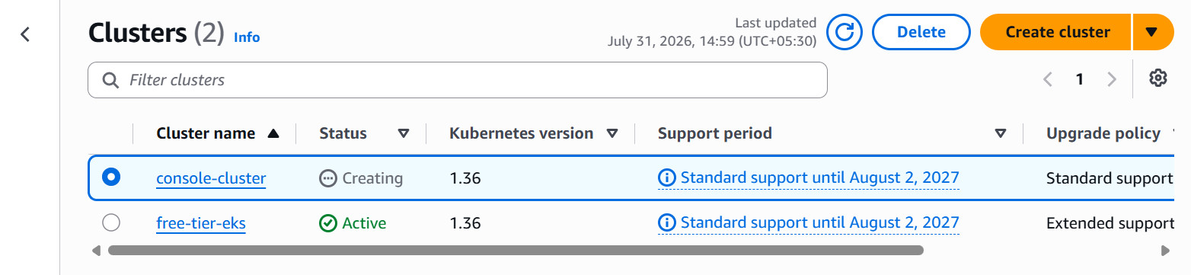

Setup HPA

HPA:

Horizontal pod autoscaler, this will helps to automatically Scale number of pods based on metrics.

Based on cpu metrics or request per second

First creating a new pod and assinging it to the hpa

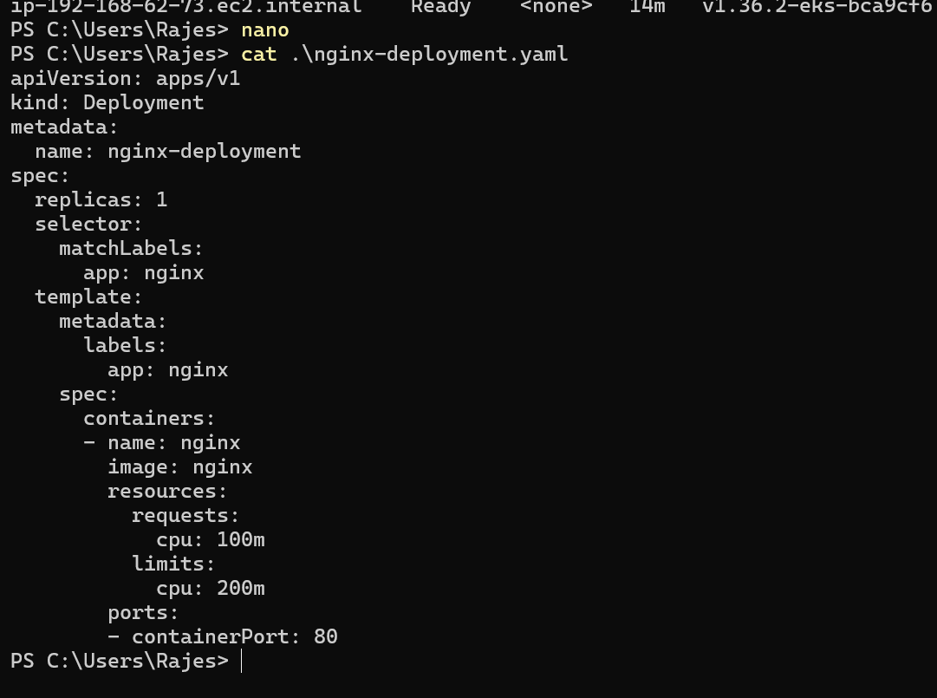

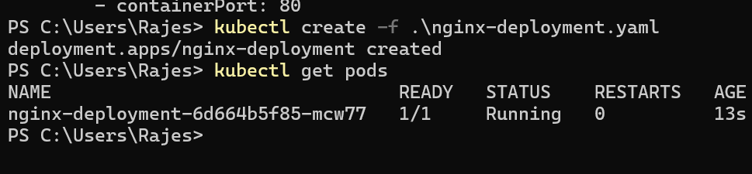

Pod has been created

Then create a new hpa using yaml file

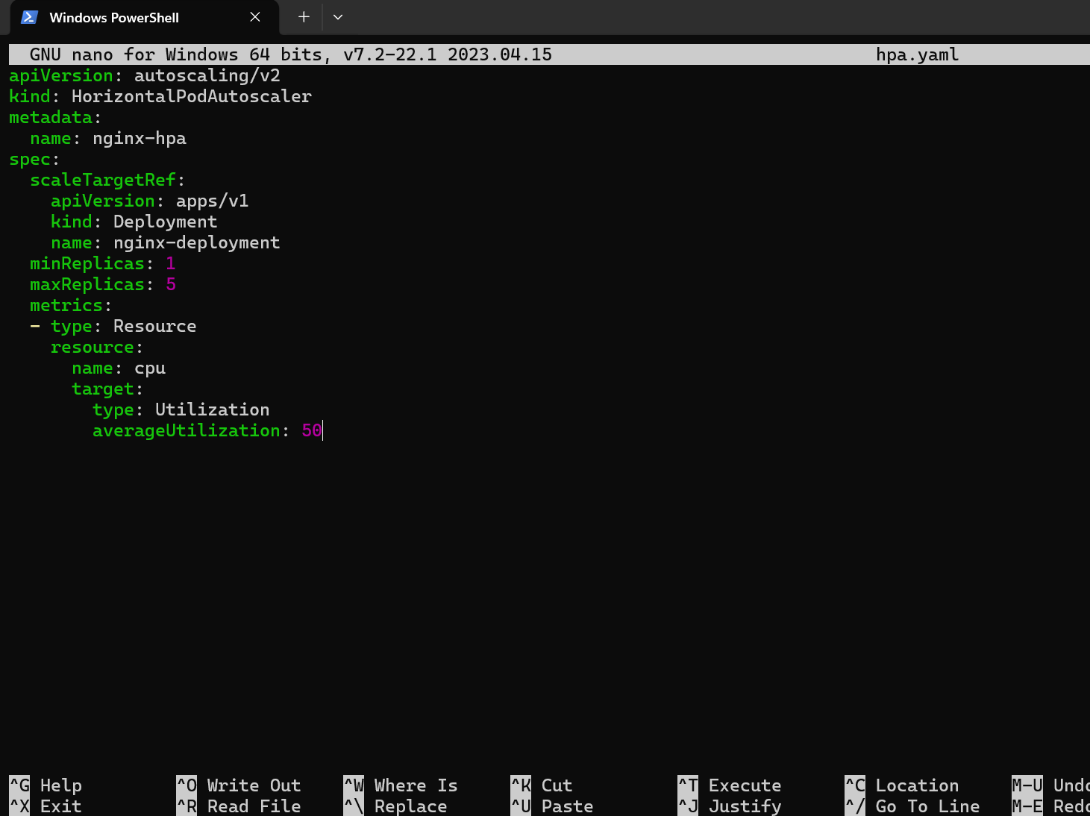

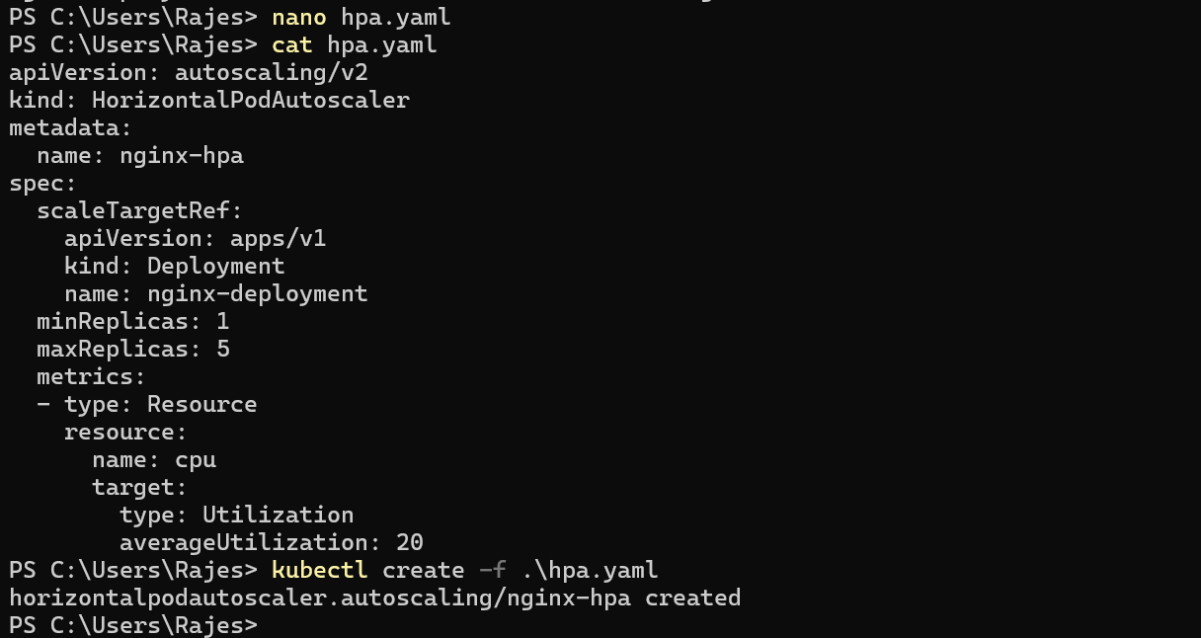

Hpa has been created to the pod

Creating a new service using yaml file
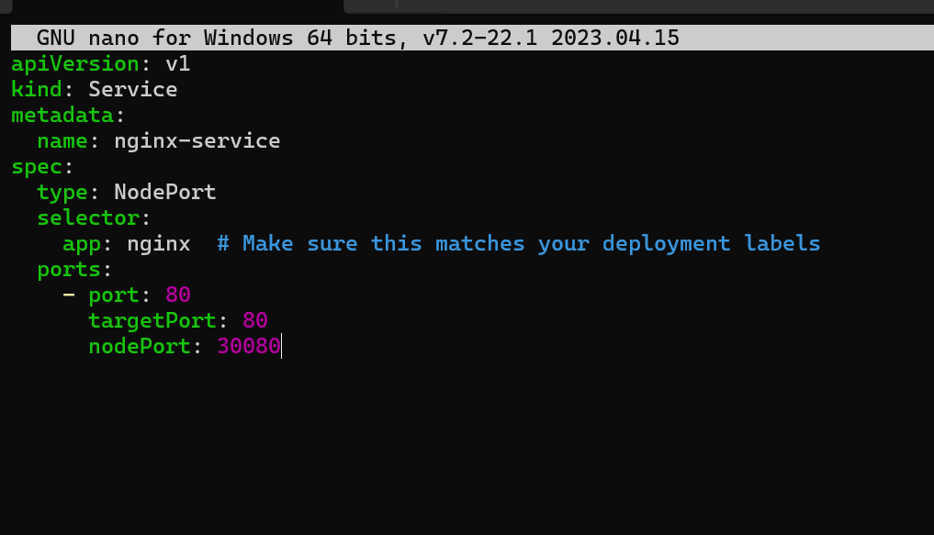

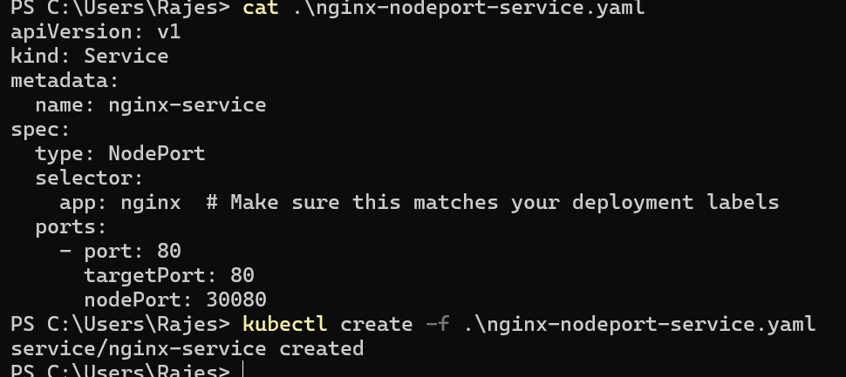

Service nodeport has been exposed

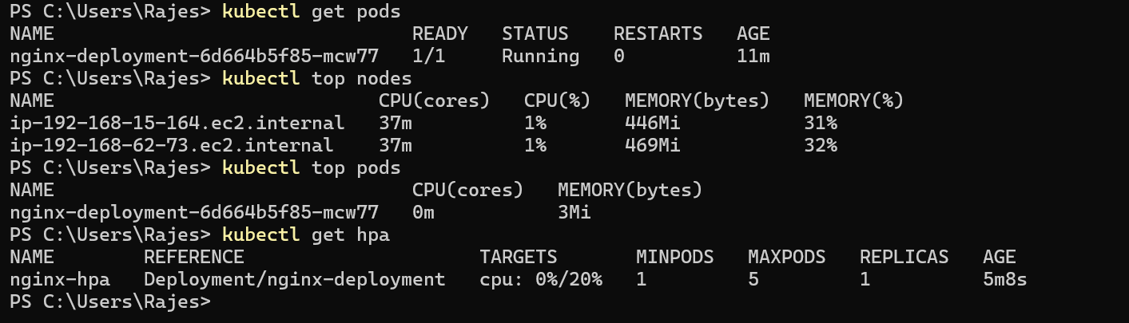

As I have configure as 20 threshold if cpu increases more than 20 then the new pods need to be created

So to check adding the fake load to pods

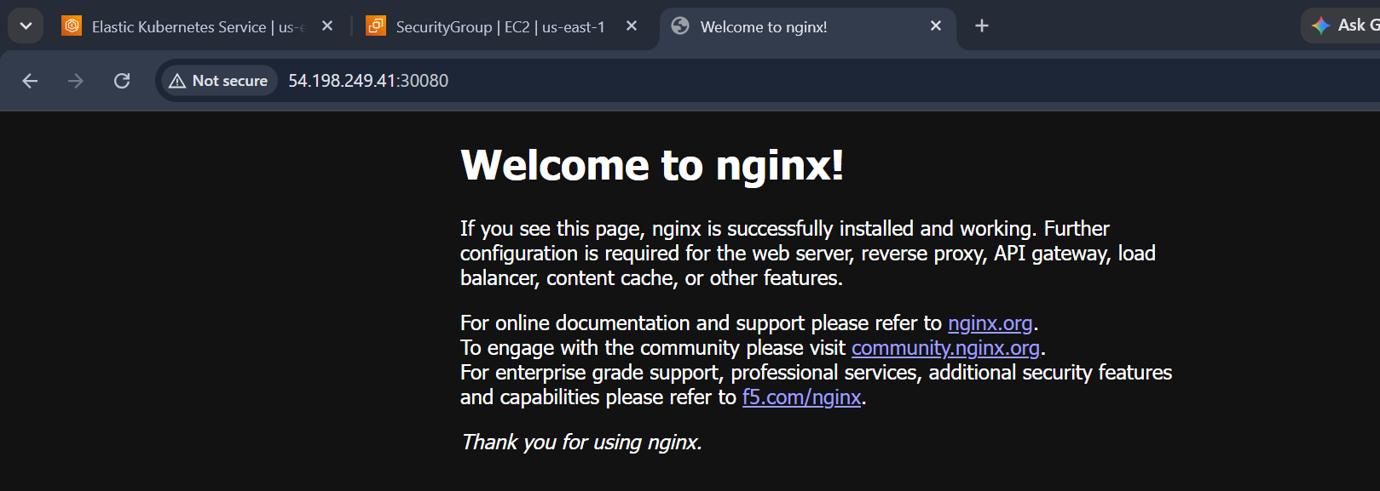

The pod has been exposed now giving the fake load and testing the autoscaling of pods using hpa

Using the command for fake load

kubectl exec -it <pod-name> -- sh -c "while true; do :; done"

It has created 4 new pods for heavy tarffic

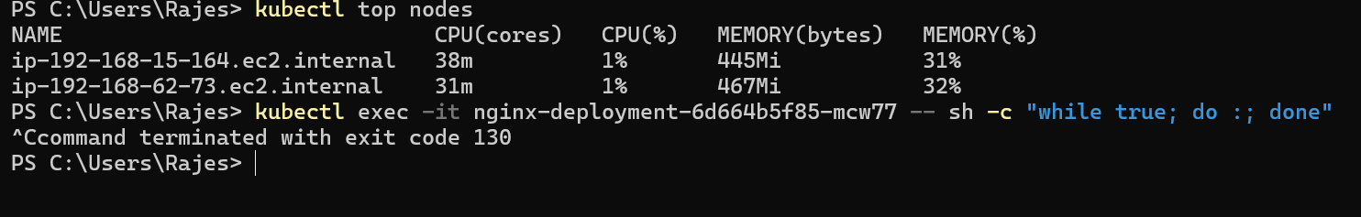

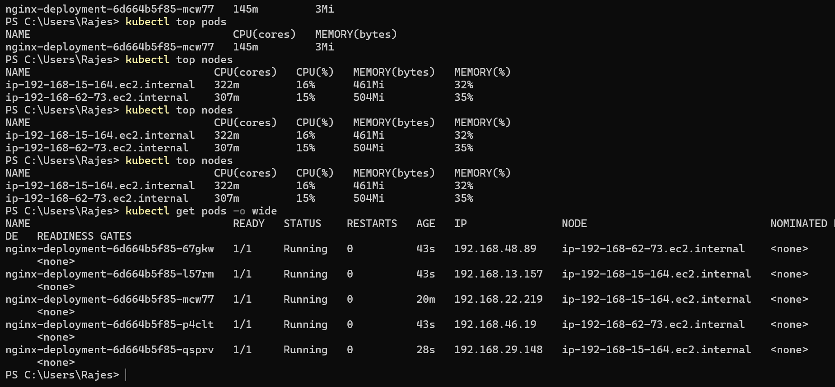

Setup cluster autoscale

This will help you to scale number of worker nodes based on pending pods

If using hpa the pods has been increased or more replicated pods has been created and if the nodes doesn’t have the memory or storage for new pods

Then we can scale up the nodes using cluster autoscale

Now I have increased my pods more than the current node storage then some pods will be in pending state only

Newly created cluster will check for the pods that are pending

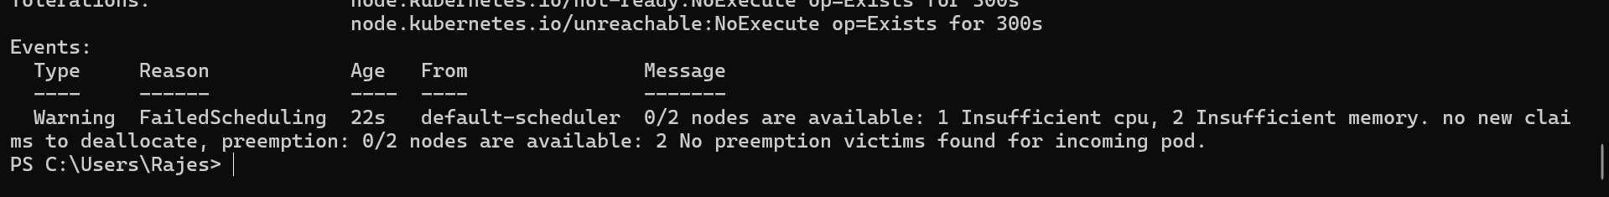

I have created a new pod and my cpu has no space and now newly created CA will check for these pending pods and assigns them to their nodes

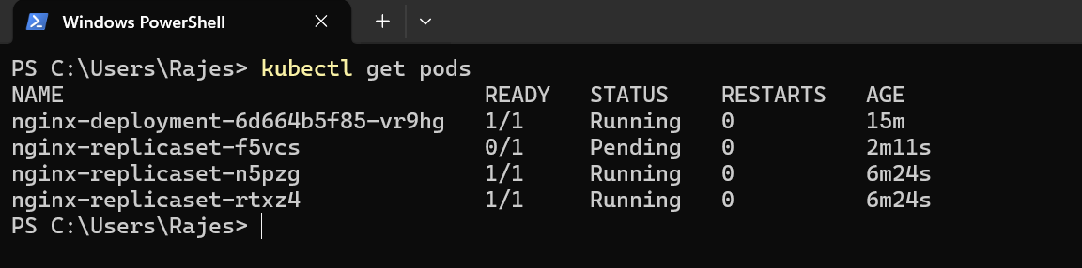

Creating the cluster autoscaling

First get the autoscaling group name

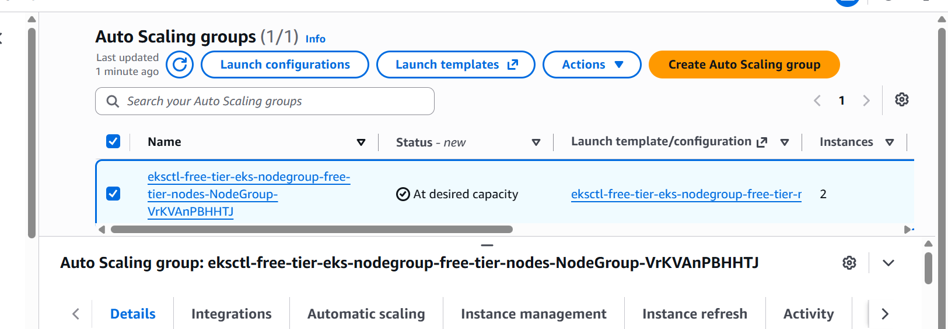

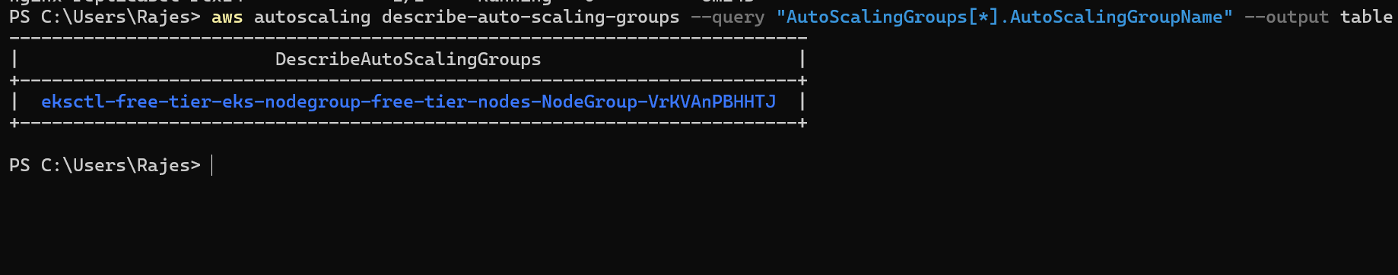
Or we can alos cli to get asg

Then update the tags

aws autoscaling create-or-update-tags --tags \
ResourceId=<ASG_NAME>,ResourceType=auto-scaling-group,Key=k8s.io/cluster-autoscaler/enabled,Value=true,PropagateAtLaunch=true \
ResourceId=<ASG_NAME>,ResourceType=auto-scaling-group,Key=k8s.io/cluster-autoscaler/medium-eks-cluster,Value=owned,PropagateAtLaunch=true

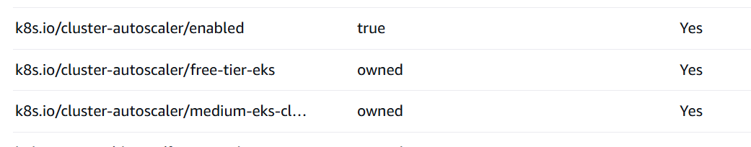

Tags has been updated

Creating an iam policy for cluster auto scaling

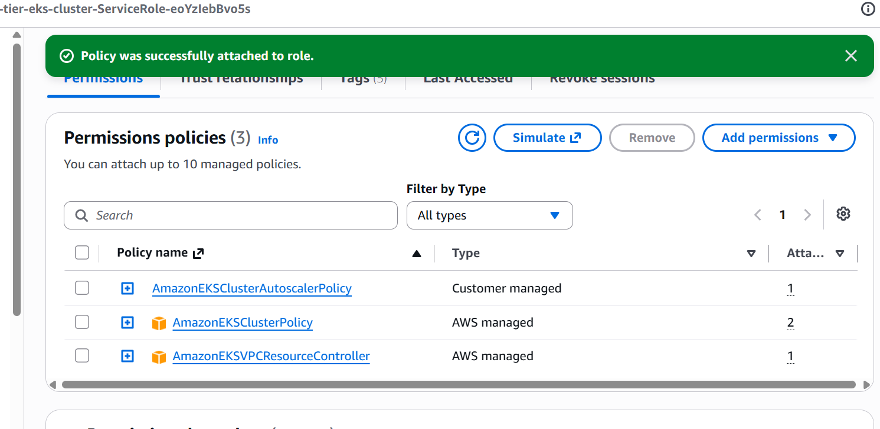

New policy has been attached to the cluster

Enable OIDC provider first

eksctl utils associate-iam-oidc-provider `
--region us-east-1 `
--cluster free-tier-eks `
--approve

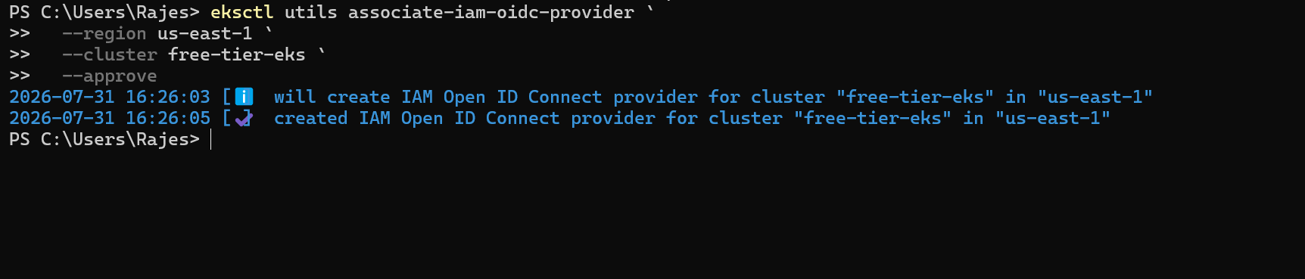

Then create a service account for autoscaler

eksctl create iamserviceaccount `
--cluster <your-cluster-name> `
--namespace kube-system `
--name cluster-autoscaler `
--attach-policy-arn arn:aws:iam::<AWS_ACCOUNT_ID>:policy/AmazonEKSClusterAutoscalerPolicy `
--approve

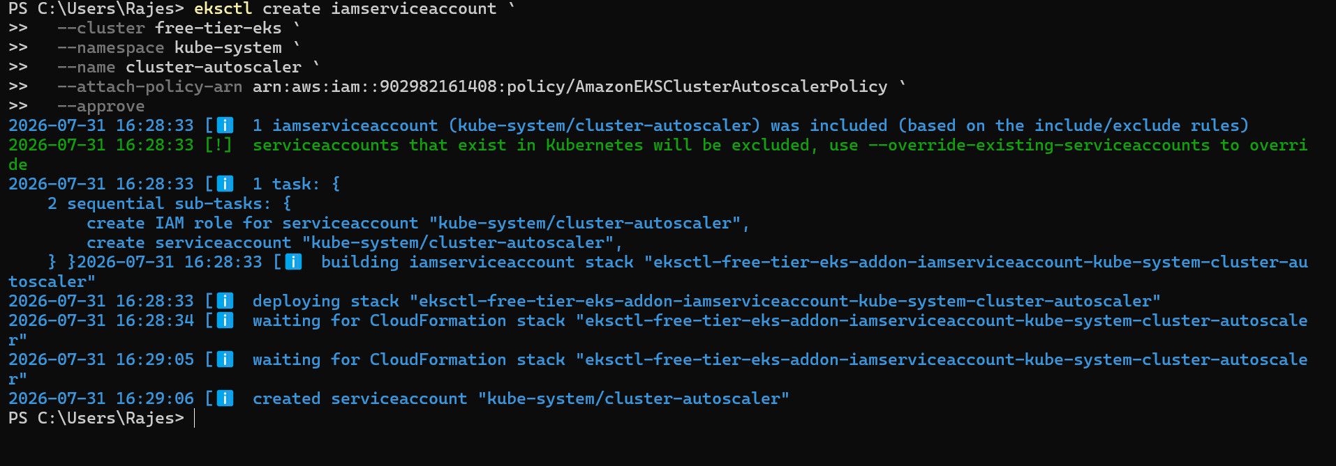

Service account has been created for the cluster

Install Cluster Autoscaler in the EKS Cluster

kubectl apply -f https://raw.githubusercontent.com/kubernetes/autoscaler/cluster-autoscaler-1.29.0/cluster-autoscaler/cloudprovider/aws/examples/cluster-autoscaler-autodiscover.yaml

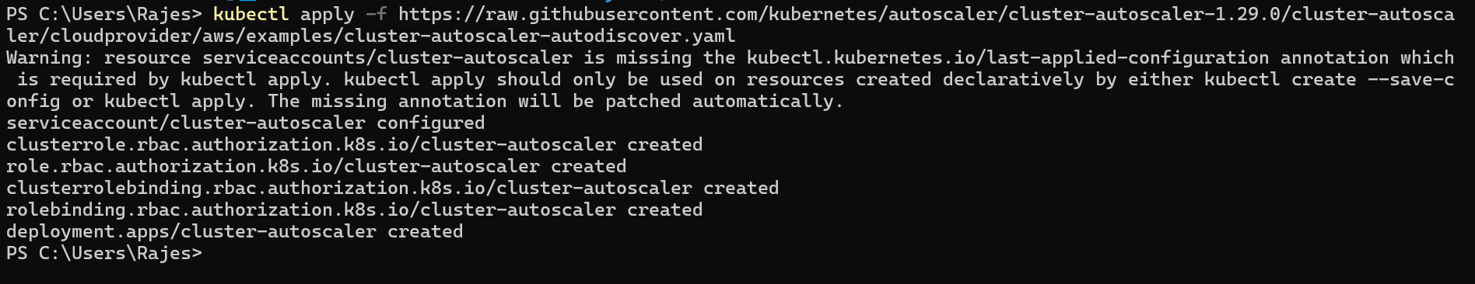

Once the Cluster Autoscaler is deployed, we will need to patch the deployment to ensure it's properly configured with your cluster name and the right settings.

kubectl -n kube-system edit deployment.apps/cluster-autoscaler

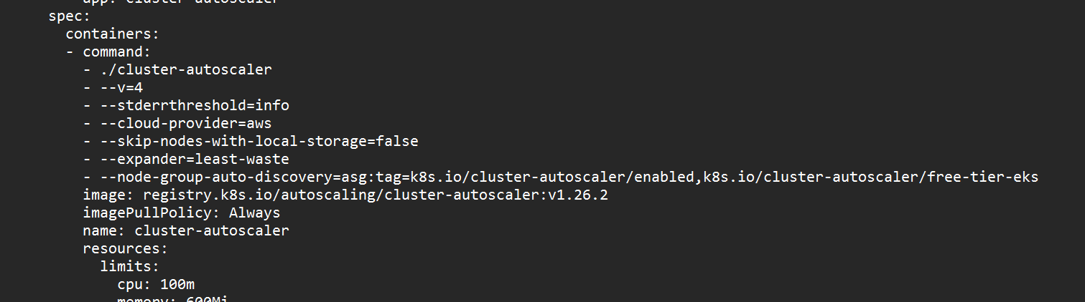

Change the name to our cluster name for the cluster-autoscaler

Verify the Deployment by checking logs.

kubectl -n kube-system logs deployment/cluster-autoscaler

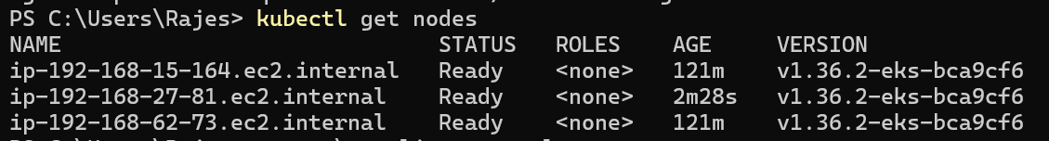

New node has been created

Setup cronjob and job

Cronjob runs at given sheduled time

The below cronjob should run every minute

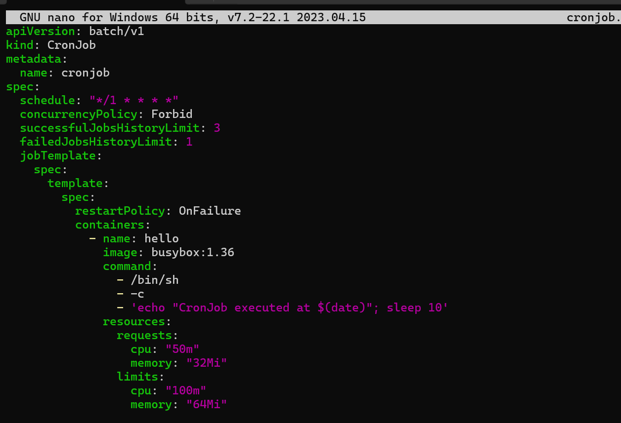

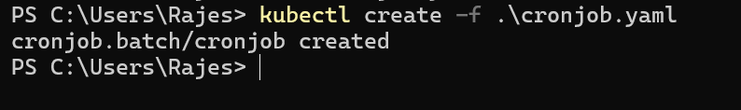

Cronjob has been created

And to check the jobs we use kubectl get cronjobs

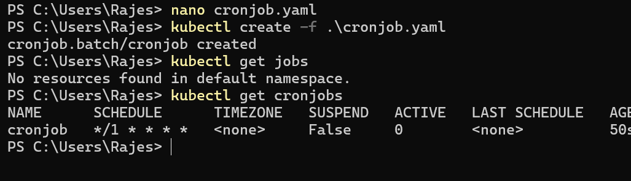

We can see through get jobs also

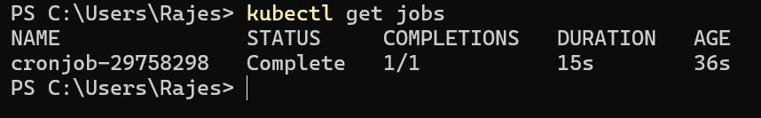

If we check the logs of jobs we can see the commands executed

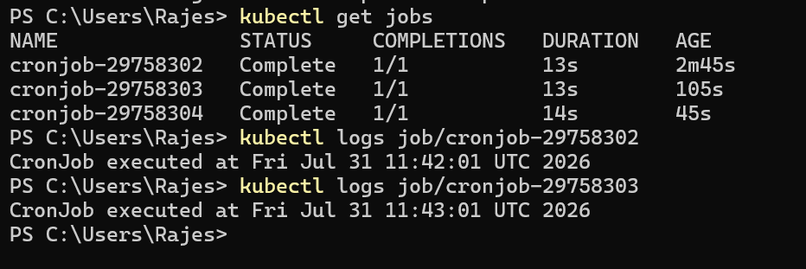

Same for the job

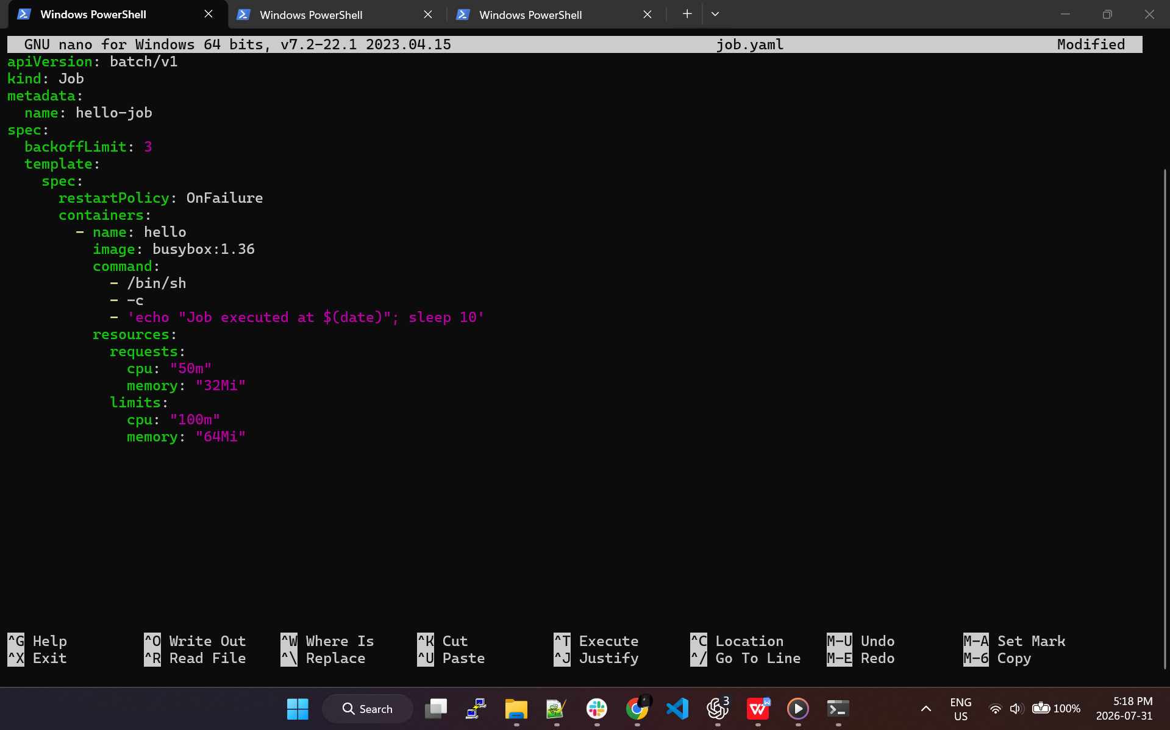

This job will be executed once but cronjob are executed repeatedly

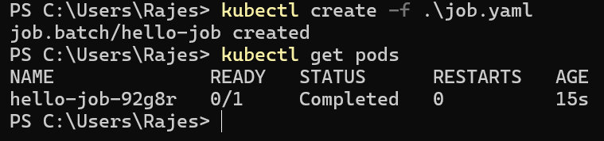

The job is executed once and completed after 10 sec
And after the pod is stopped

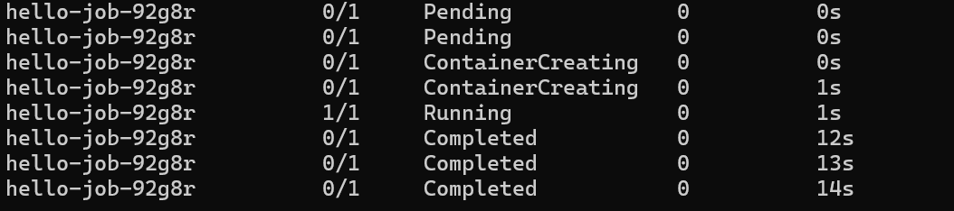

Create secret and inject inside pod

Using secrets manager

Aws secret manager will help you to store any secret data and also rotates

Creating a secret in secrets manager

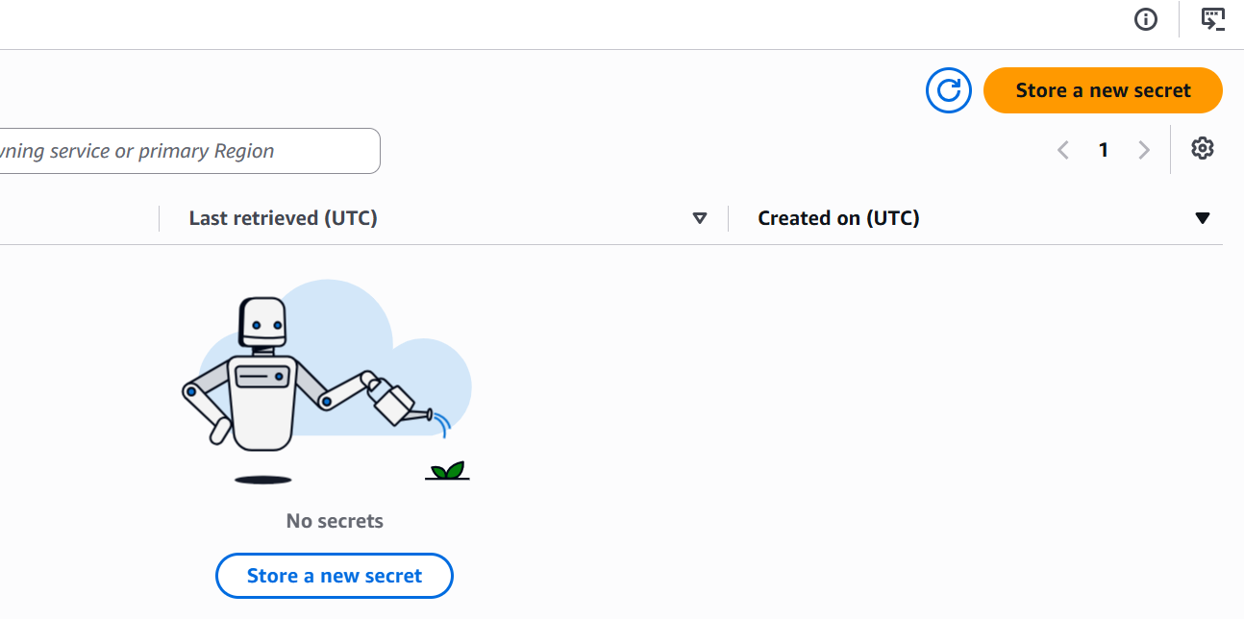

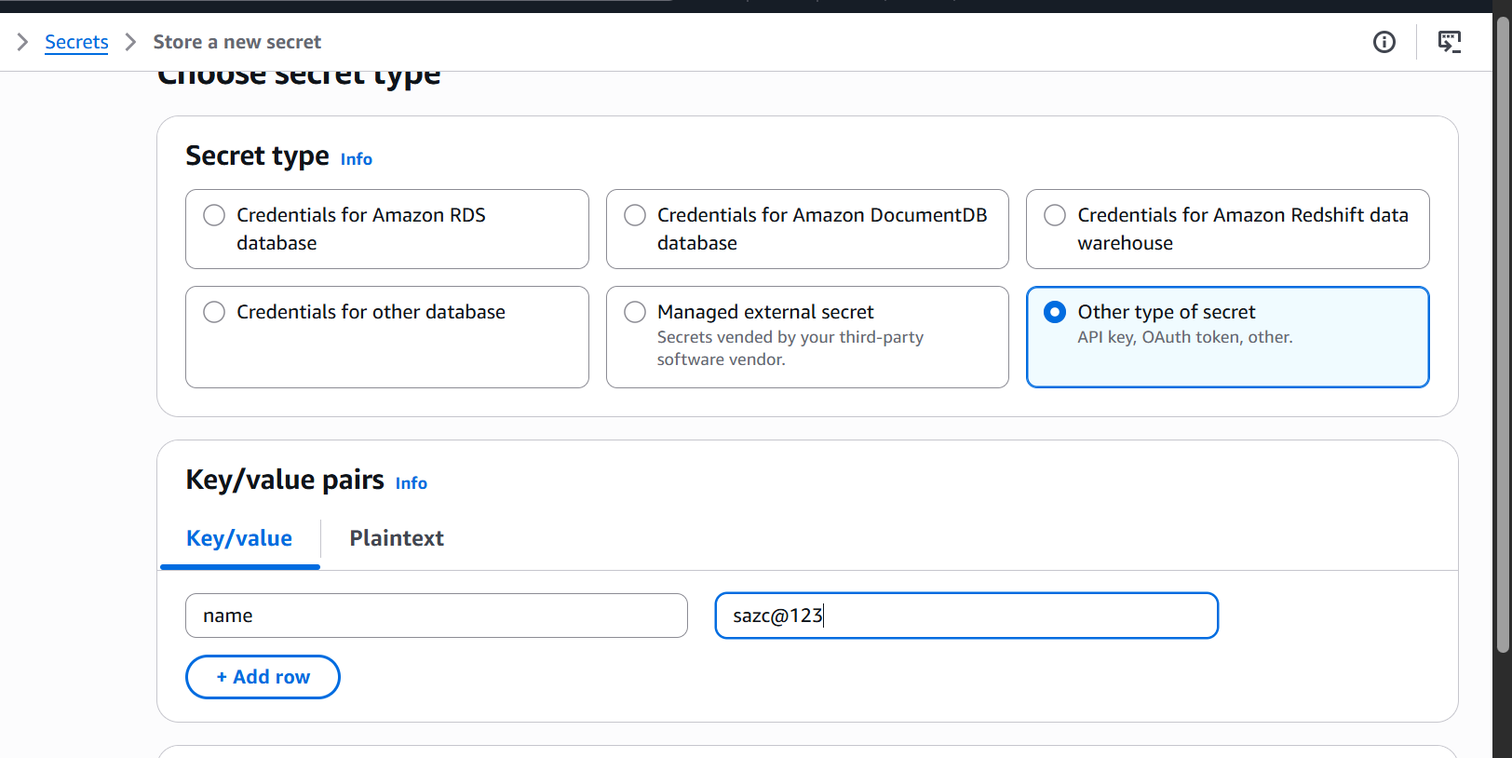

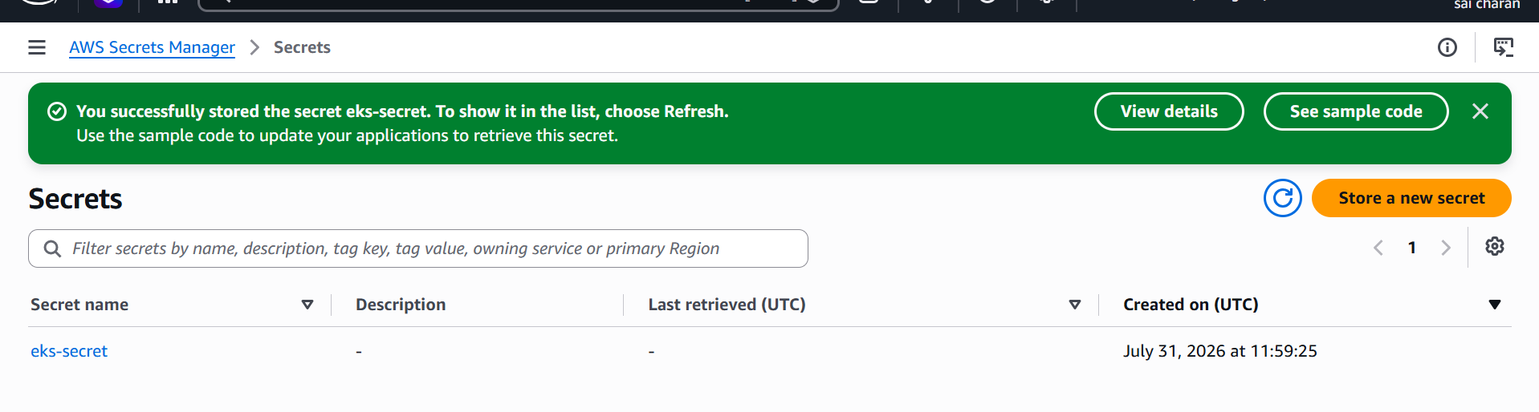

Created a new secret

Enable the OIDC connector for the cluster

Create a new policy and create a new role and attach the created policy

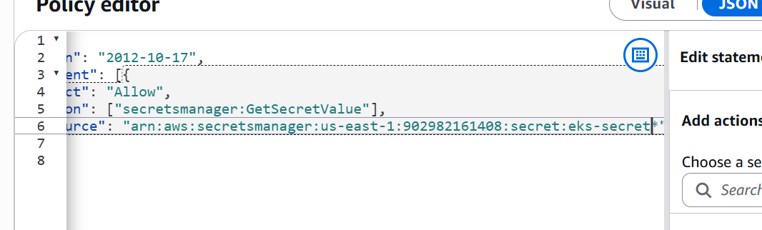

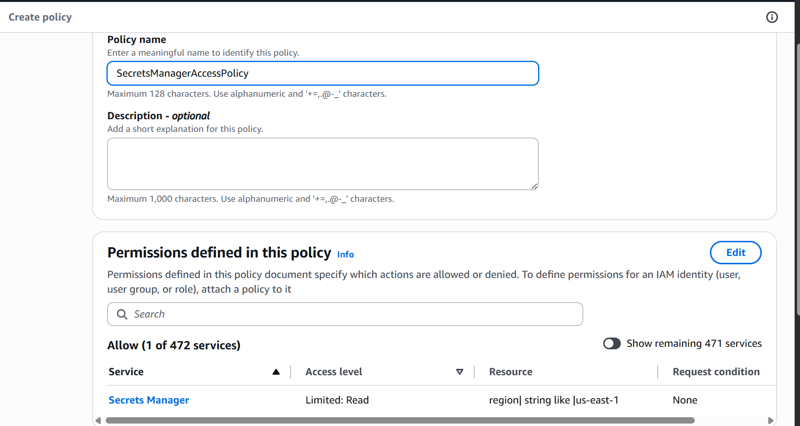

Attach this policy to a new role

And role json script we need to give oidc and service account name

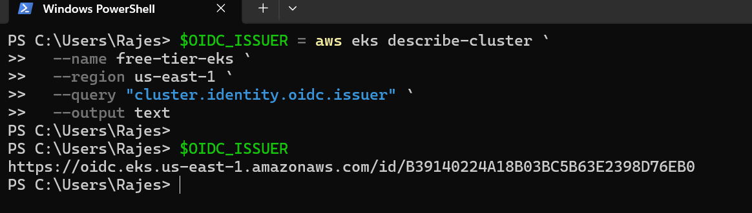

And create a service account

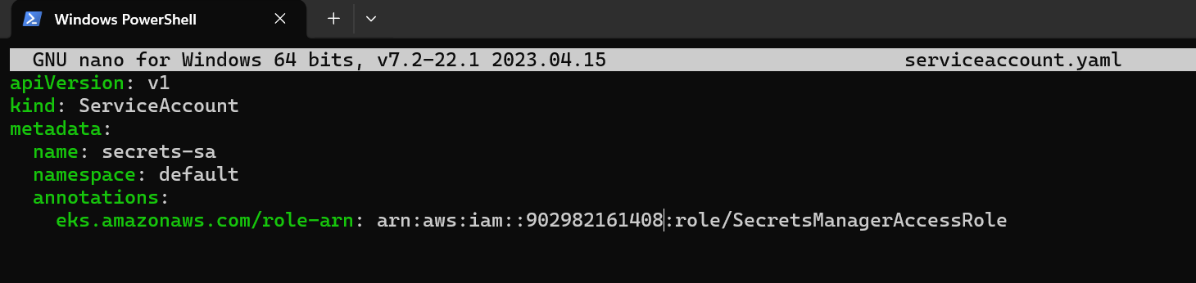

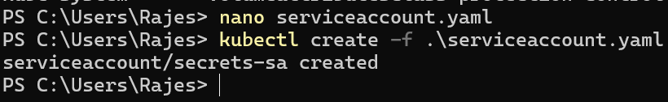

Role json script

{
"Version": "2012-10-17",
"Statement": [{
"Effect": "Allow",
"Principal": {
"Federated": "arn:aws:iam::902982161408:oidc-provider/oidc.eks.us-east-1.amazonaws.com/id/B39140224A18B03BC5B63E2398D76EB0"
},
"Action": "sts:AssumeRoleWithWebIdentity",
"Condition": {
"StringEquals": {
"oidc.eks.us-east-1.amazonaws.com/id/B39140224A18B03BC5B63E2398D76EB0:sub": "system:serviceaccount:default:secrets-sa"
}
}
}]
}

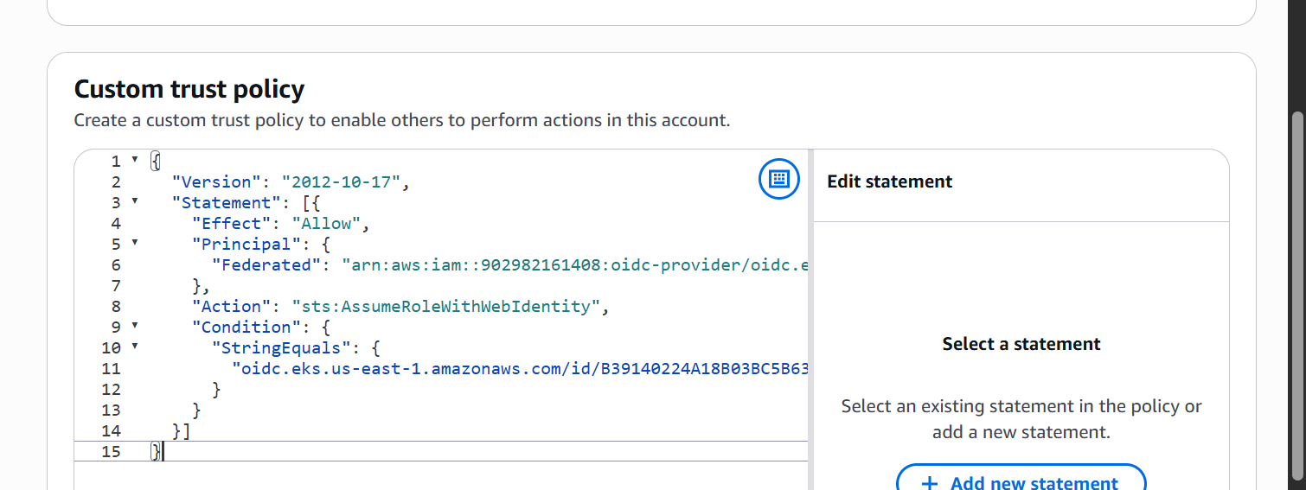

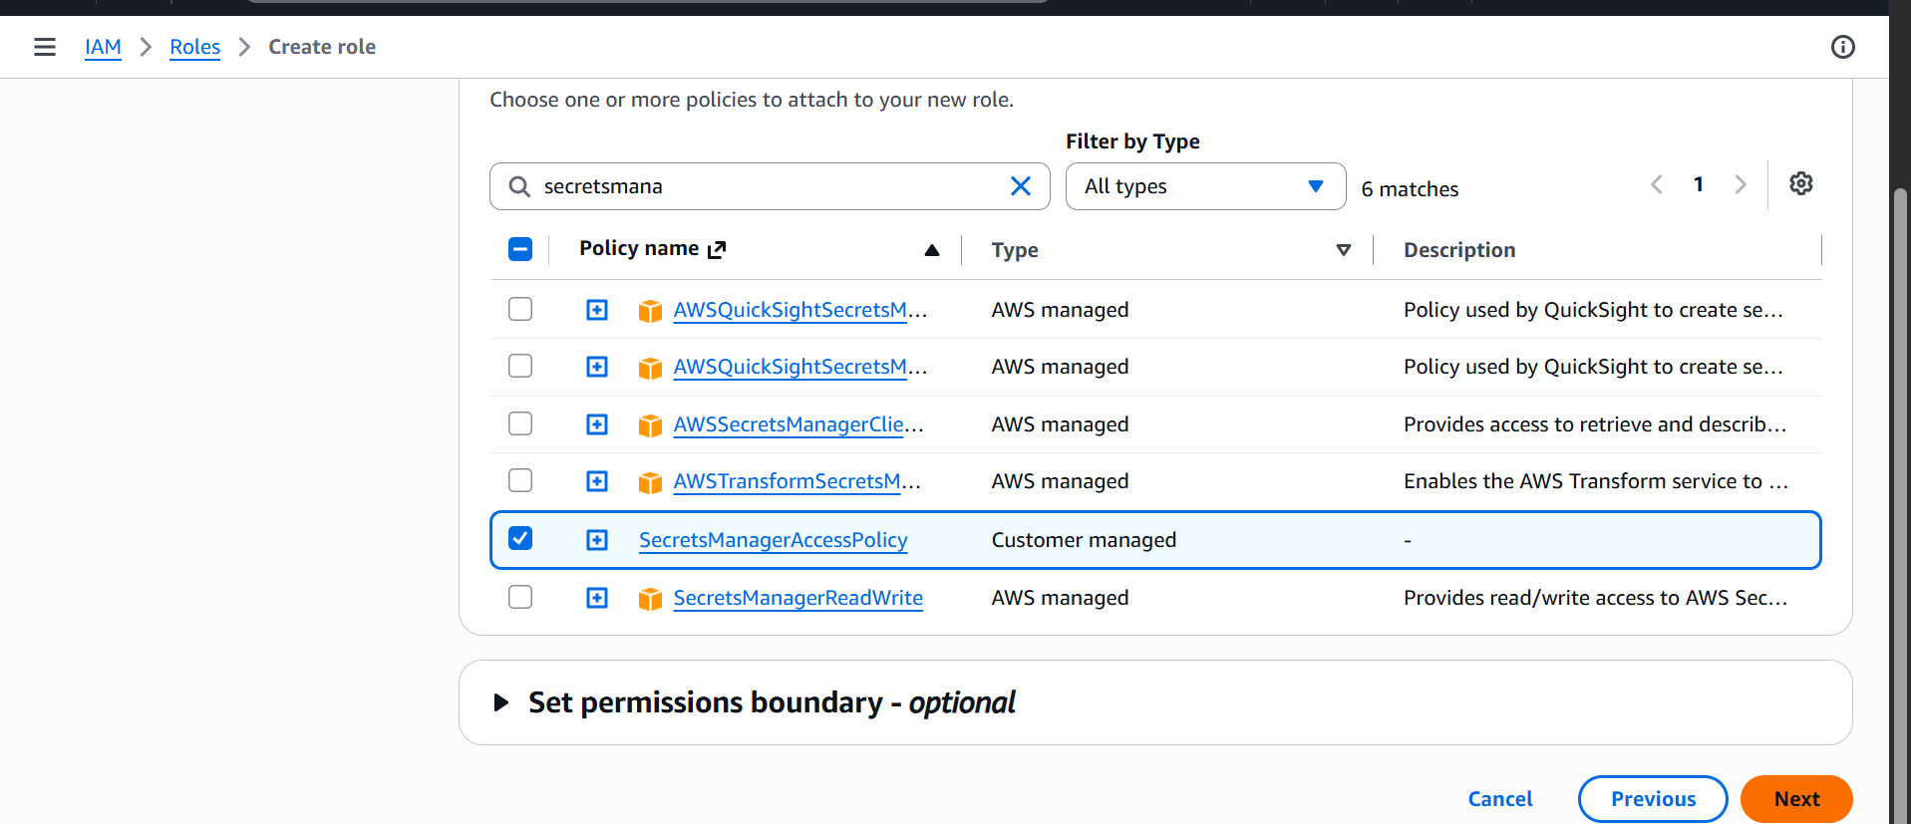
Add the policy previously created

New role named SecretsManagerAccessRole has been created

Now deploy a pod using service and check the logs for injected secrets

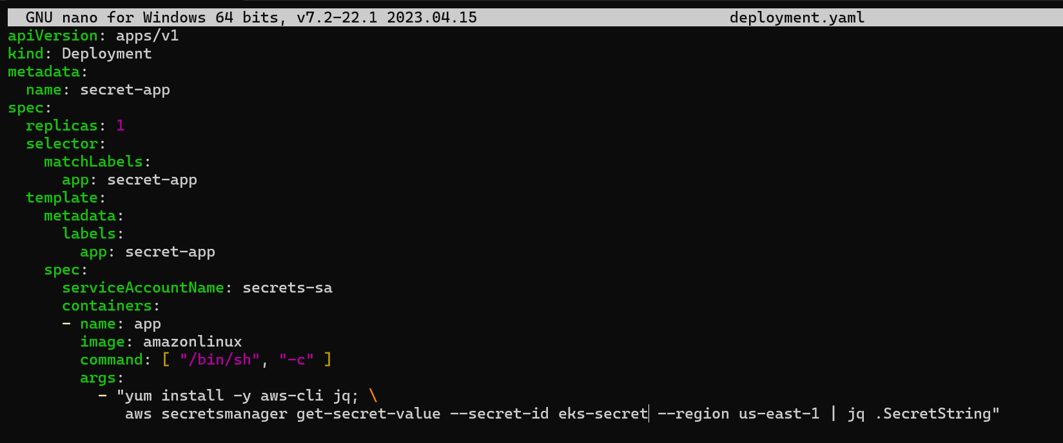

Creating a new pod with secrets attached to it

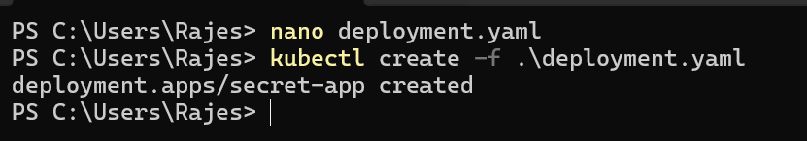

Test the credentials by checking logs.

kubectl logs -l app=secret-app

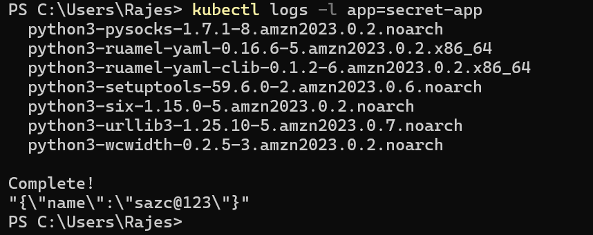

We can see the secrets has been displayed in the logs

Check differen add-ons available on eks

Common AWS EKS add-ons include:
- vpc-cni — Pod networking
- coredns — cluster DNS
- kube-proxy — Service networking
- aws-ebs-csi-driver — EBS volumes
- aws-efs-csi-driver — EFS volumes
- eks-pod-identity-agent — EKS Pod Identity
- amazon-cloudwatch-observability — logging and monitoring
- aws-secrets-store-csi-driver-provider — Secrets Manager integration
- metrics-server — resource metrics
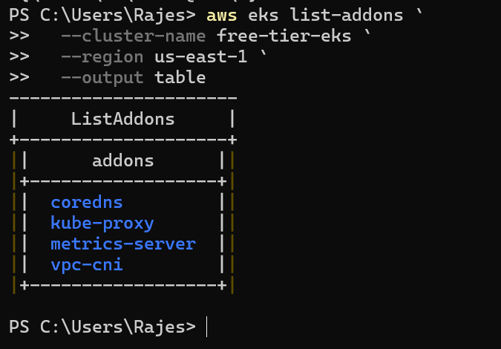

The above are the installed addons

Upgrade eks cluster

Objective
Upgrade an existing Amazon EKS cluster to the next supported Kubernetes version.

Current Environment
Cluster name: free-tier-eks
Region: us-east-1
Current version: 1.36
Node group: free-tier-nodes
Node group type: Unmanaged
Amazon EKS 1.36 is currently the latest supported version. Perform the following steps when EKS 1.37 becomes available.

1. Check Current Versions
aws eks describe-cluster `
--name free-tier-eks `
--region us-east-1 `
--query "cluster.{Version:version,Platform:platformVersion,Status:status}" `
--output table
Check worker nodes:
kubectl get nodes

2. Check Cluster Health
kubectl get nodes
kubectl get pods -A
eksctl get addon --cluster free-tier-eks
All nodes should be Ready, and system Pods should be Running.

3. Upgrade the Control Plane
Upgrade only one minor version at a time:
eksctl upgrade cluster `
--name free-tier-eks `
--region us-east-1 `
--version 1.37 `
--approve
Verify:
kubectl version

4. Upgrade Worker Nodes
Because free-tier-nodes is unmanaged, create a replacement node group:
eksctl create nodegroup `
--cluster free-tier-eks `
--region us-east-1 `
--name free-tier-nodes-v2 `
--managed=false `
--node-type t3.small `
--nodes 3 `
--nodes-min 2 `
--nodes-max 4
Verify new nodes:
kubectl get nodes
Delete the old node group after workloads move successfully:
eksctl delete nodegroup `
--cluster free-tier-eks `
--region us-east-1 `
--name free-tier-nodes

5. Update Add-ons
eksctl get addon --cluster free-tier-eks
Update required add-ons:
eksctl update addon --cluster free-tier-eks --name vpc-cni
eksctl update addon --cluster free-tier-eks --name coredns
eksctl update addon --cluster free-tier-eks --name kube-proxy

6. Final Verification
kubectl get nodes
kubectl get pods -A
eksctl get addon --cluster free-tier-eks

Expected Result
- Control plane upgraded successfully.
- New worker nodes are Ready.
- Applications run normally.
- EKS add-ons show ACTIVE.
- Old node group is removed.
Do not attempt the 1.37 upgrade until AWS makes it available. Also resolve the existing EC2 vCPU quota before creating the replacement node group.

