Create a ClusterIP service for an Apache web server pod

Creating a service that has clusterip

Cluster ip is used to communicate inside the cluster

Attaching the service to a apache web server pod

I have created both pod and service in single yaml file

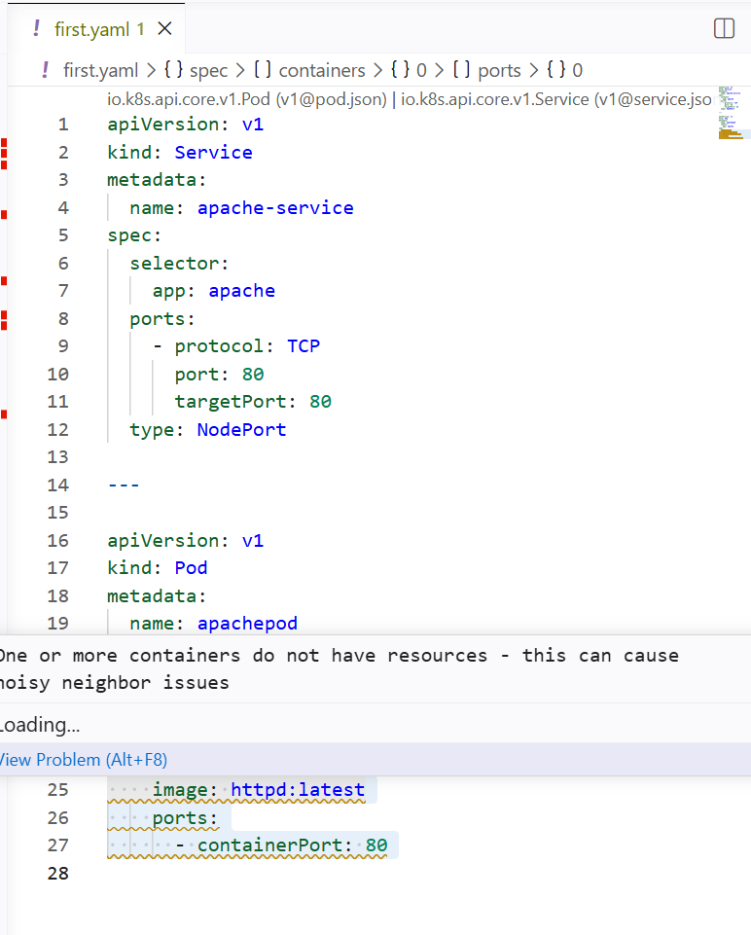

And added pod label as selector in the service

So that the pod will be attached to the service

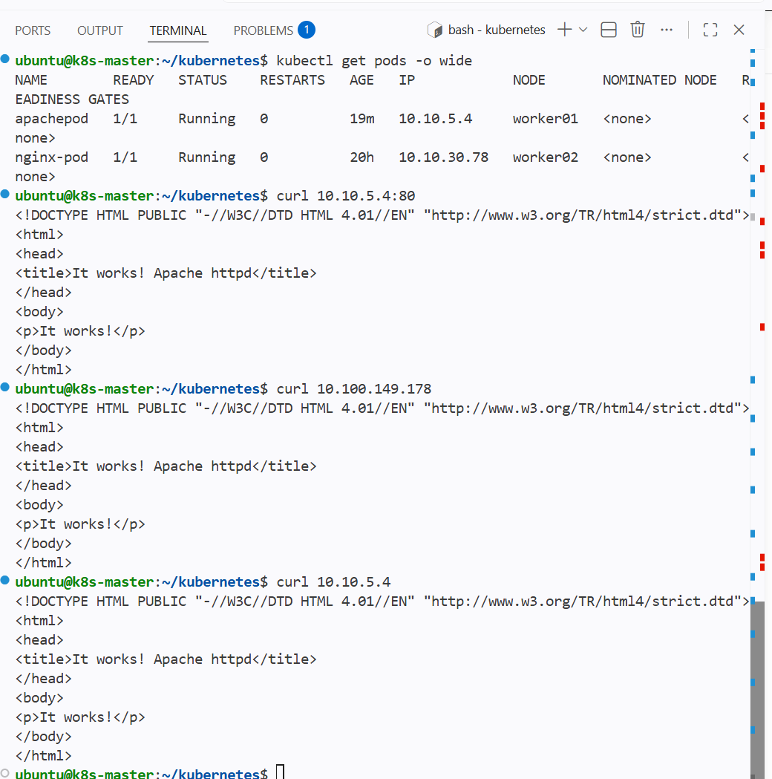

And httpd is working using the service nodeport

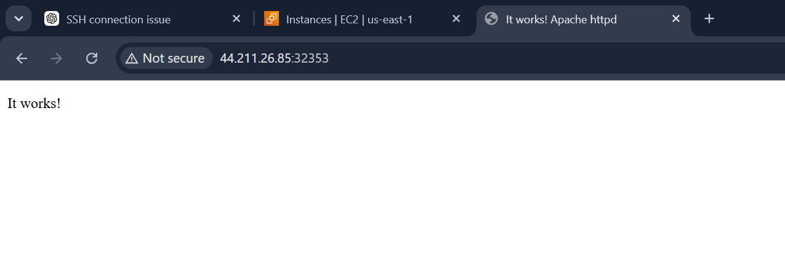

Expose an Nginx pod externally using a NodePort service

Exposing the nginx pod externally

I will be using the nodeport in the service for the pod

Attaching the pod to the service using the labels and selector

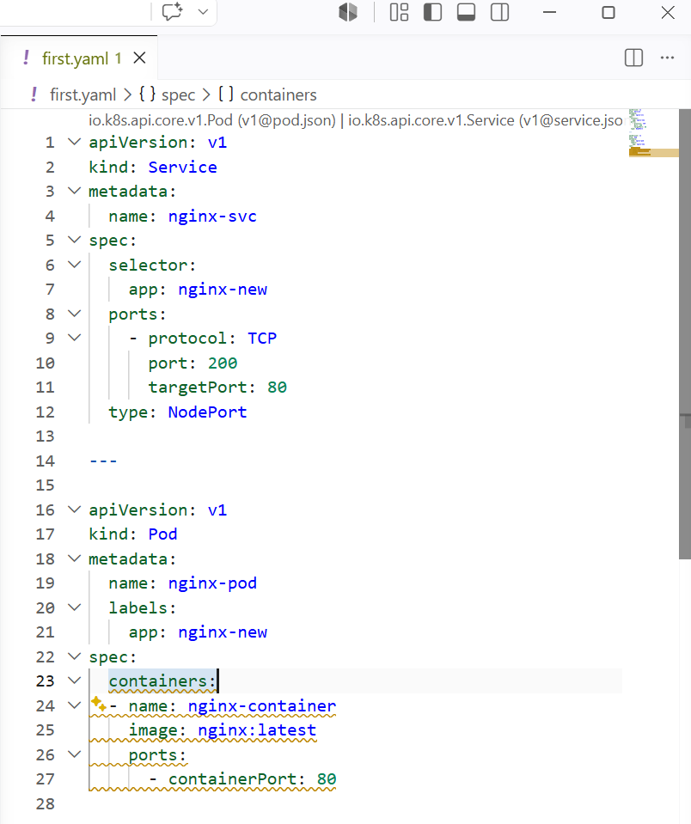

I have created a new pod and svc and attached to the service using labels and seletor

And using nodeport we can expose the pod to the internet

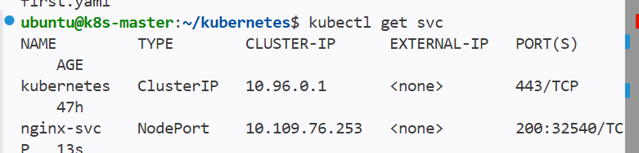

And nodeport was assigned on 32540 and using this it will expose externally

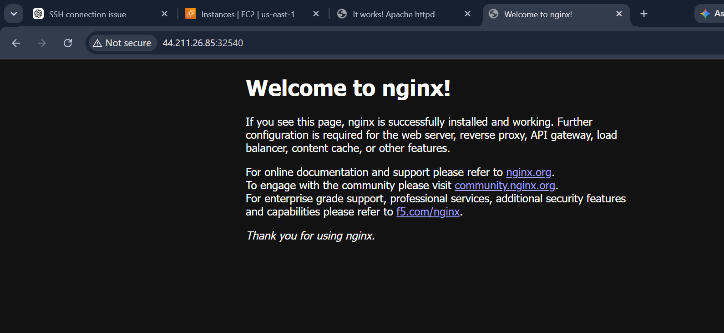

Deploy a ReplicationController to maintain 3 replicas of an Nginx pod

Creating a new yaml file for replicationcontroller

And it should maintain 3 replicas of nginx pod

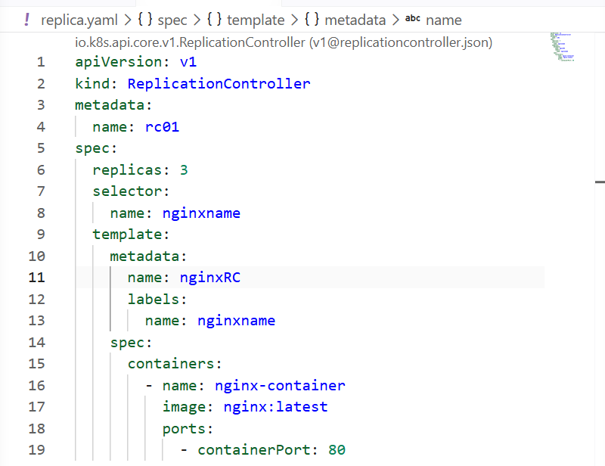

I have given replication replicas as 3

Name of the pod is rc01 and k8s attached random name for all 3 pods starting with rc01

Added labels for the pods so that rc and service will be attached to the pods with labels and selectors

Pod image as nginx

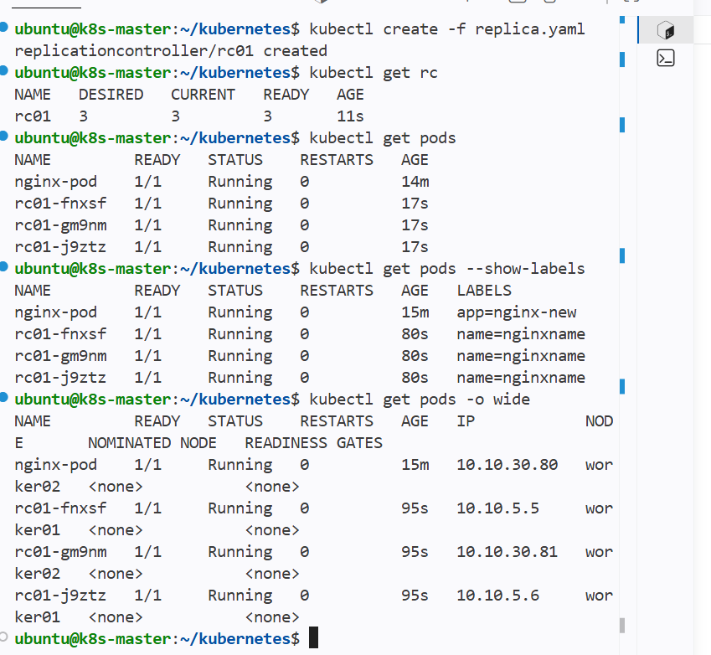

We can see new 3 pods has been created through replication controller and selector is pod labels

Scale the ReplicationController from 3 replicas to 5 replicas

As I have previously created replicas using yaml

Scaling it up to 5 for the nginx pods

Editing the yaml file for replicas

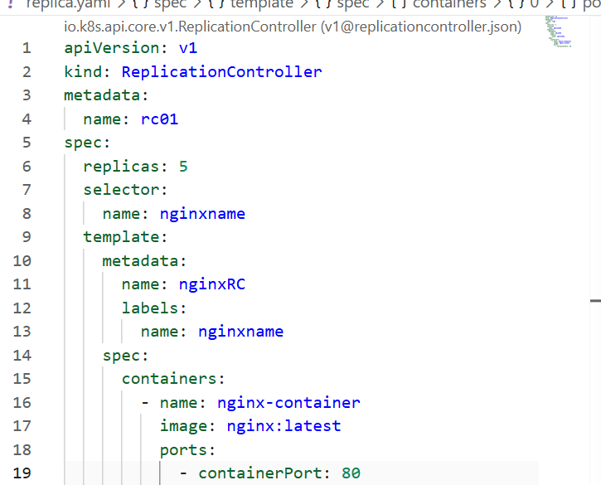

Increased the replicas to 5 from 3 in yaml file
And
Kubectl apply -f replica.yaml
By this changes mad to yaml file will be configured

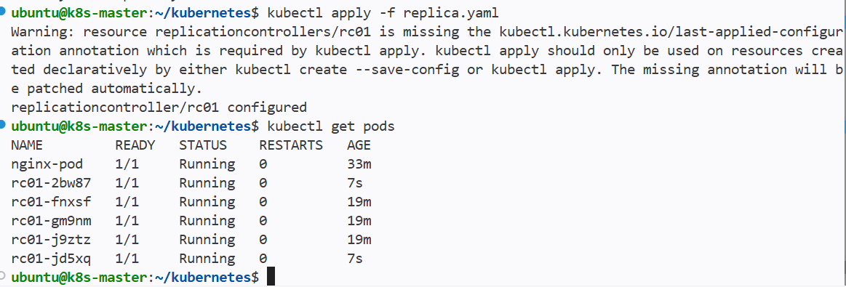

And 2 new pods have been created using replicas

Create a ReplicaSet to manage pods based on multiple labels (prod and test)

Replica set is similar to replication controller

It is updated version of rc

Mainly we replicaset for managing the pods

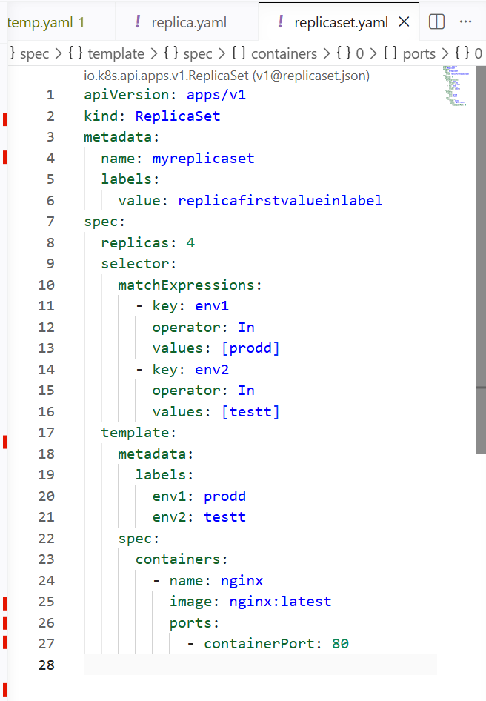

I have use matchespressions or I can use matchlabels
And operatorin it is used for allowing the label name for this pod and other pods with same labels

I have given 4 replicas of nginx pod and
Labels for pod same as match expressions

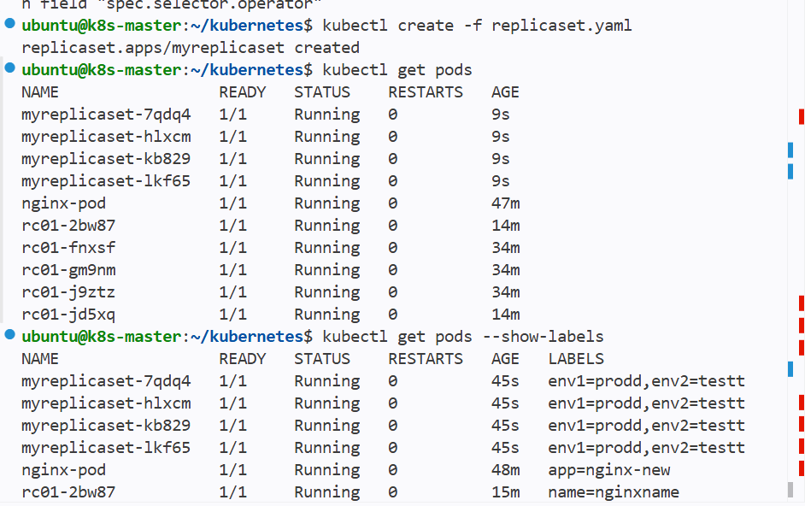

New 4 pods has been created with replica set and wee can see the labels

Now if I create another pod with same labels manually then deploy the pod will not be created because the replica set is managing all pods with matching labels

Ex--
This is new pod yaml file with same labels
And when I create we can see the ouput

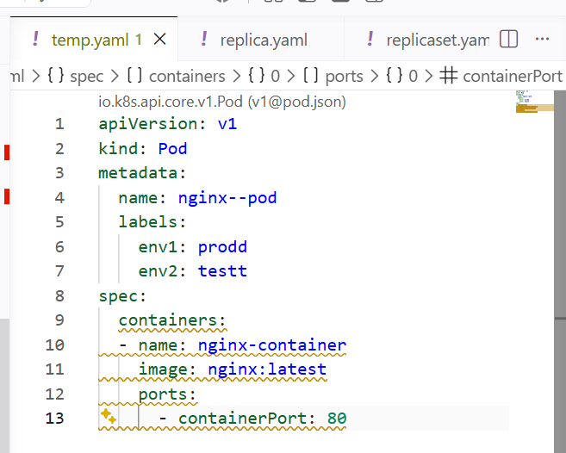

It says pod created but we cannot see any pod

And if I do describe pod it says not found

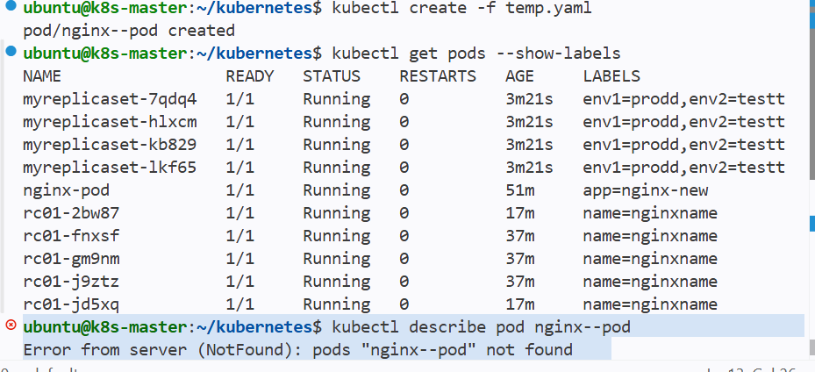

Deploy a ReplicaSet that excludes pods with the label backend

I will be writing the replicaset using yaml file

And the repplicaset should exclude the pods with label backend

I have added a new match expression operatore as notin

By this it will exclude the labels with backend as it is notin

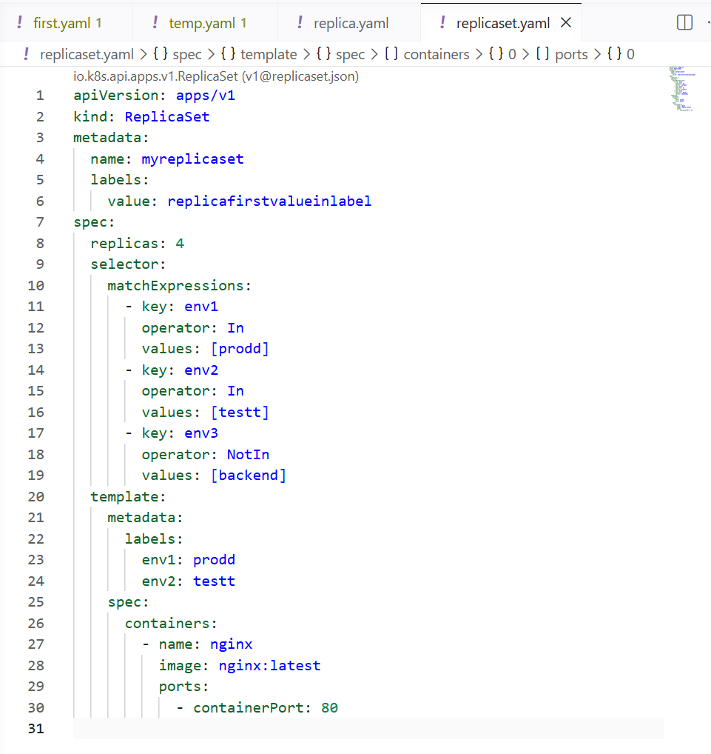

We can see pods has been created with repplicaset matchexpressions operator in values and not with notin values

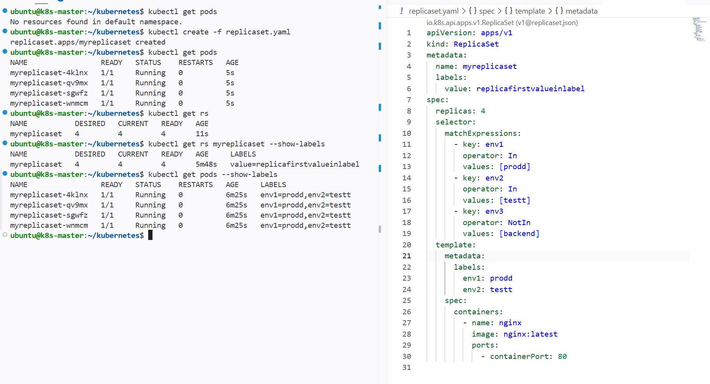

And If I create a new pod with backend as label name the replicaset will ignore that pod and will checkfor only values for in operator

I have added a new label for a manual pod
And the replicaset should ignore this pod let this pod to be created
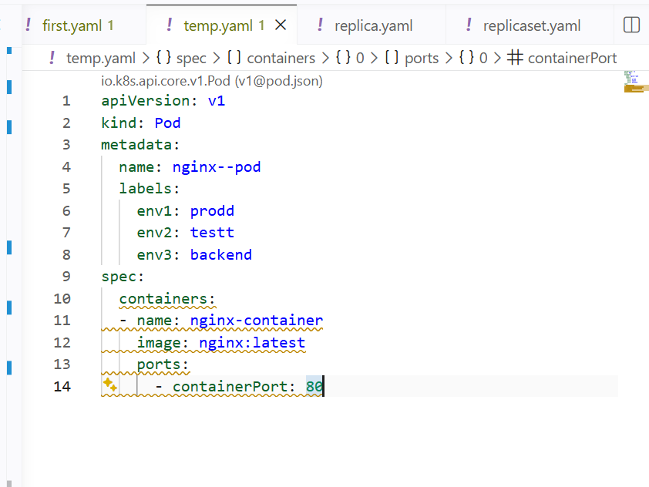

We can see that the pod with backend label has been created and replicaset did not manage this pod as it has backend label

And this pod has been created manually and replicaset will not manage

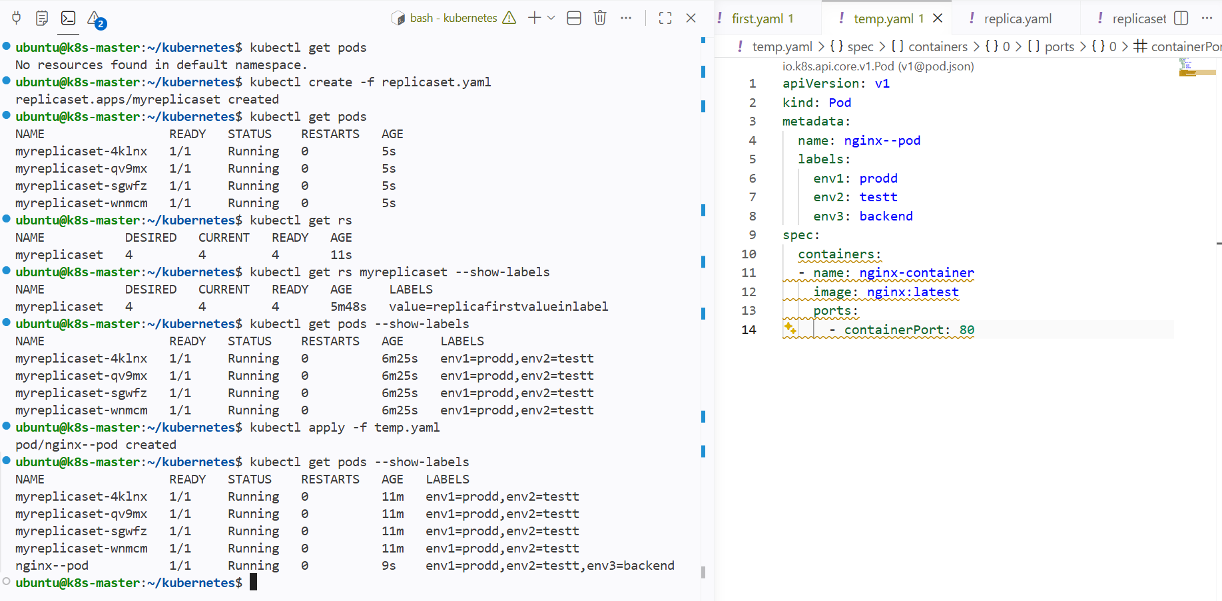

Test load balancing across multiple pods using a NodePort service

I cuurrently have 4 pods created by a replicaset

And in each pod it has nginx image

And the pods are not exposed externally

So now I will create a service with nodeport and give the selectors same as pod labels

By this the pods will be managed by the service and will be exposed to internet

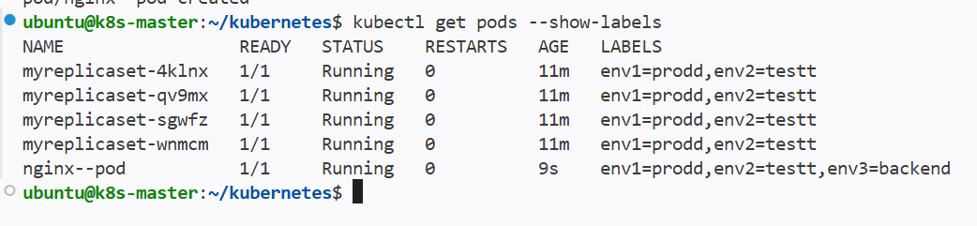

Now I will be giving a service selector same as replciaset pod labels

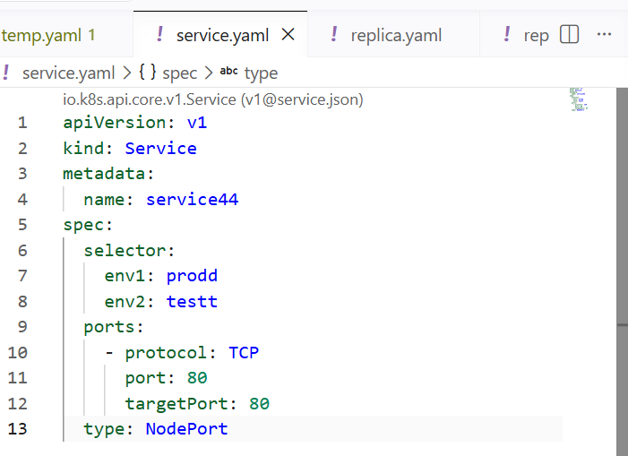

Now this service will be attached to the pod that has same labels as services selector

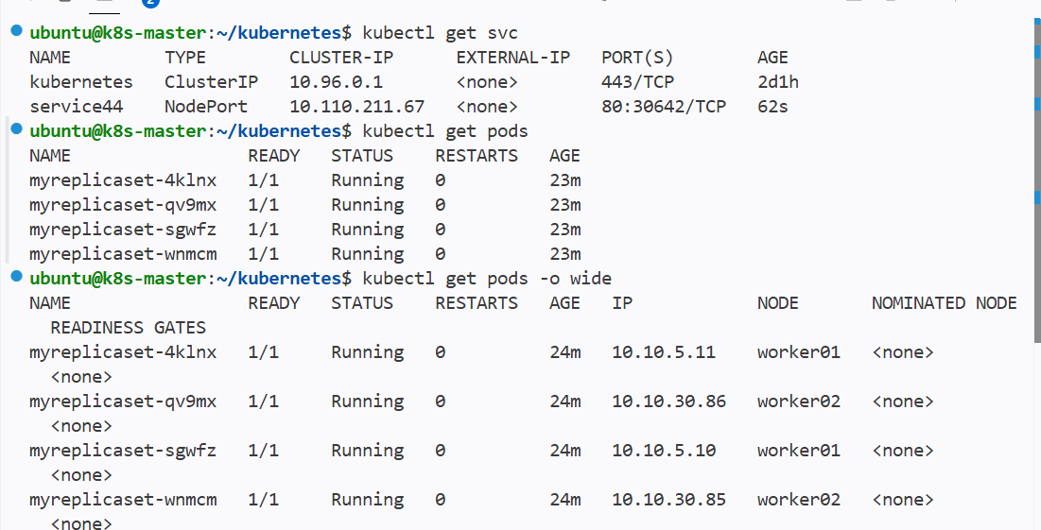

All the pods has same labels
So this pods will be exposed externally

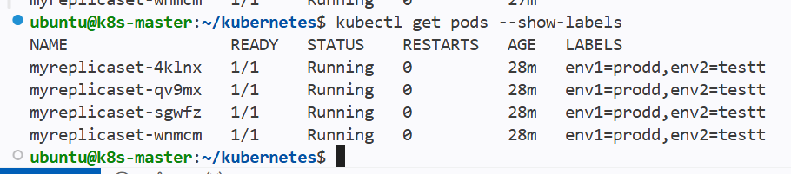

And also we caan see the endpoints for the svc

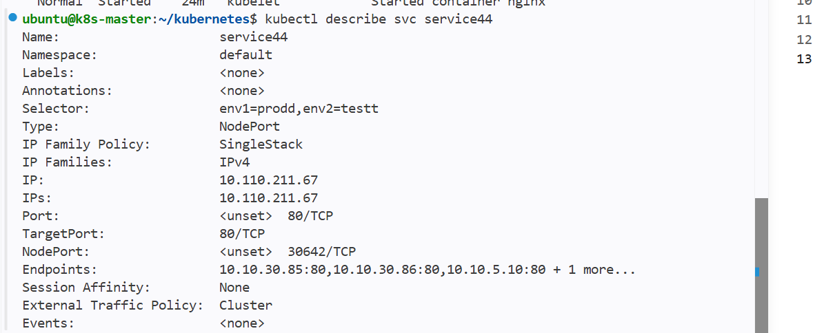

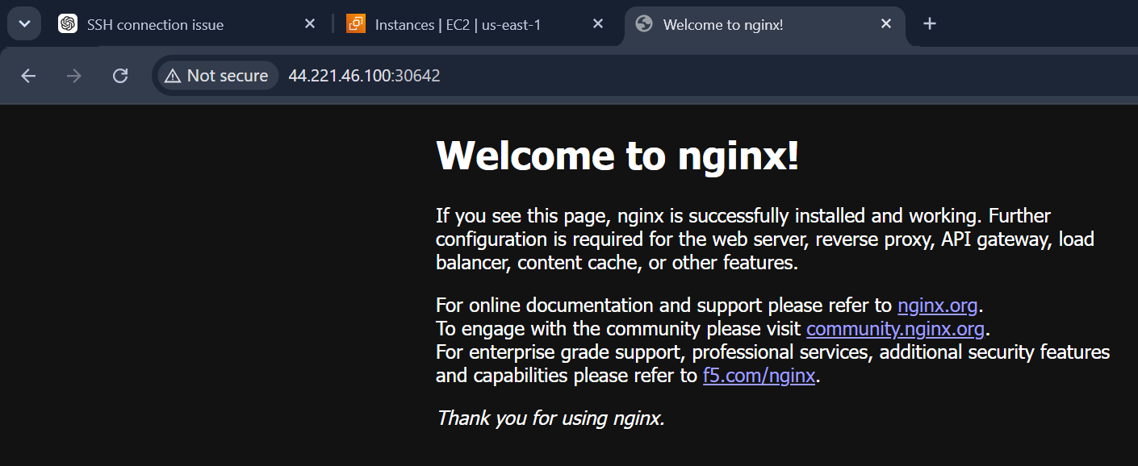

And it will acts as load balancer it contains all 4 pods attached to same service

And if I have replaced nginx and added httpd image in one of pod then the outcome will 3 times nginx and one httpd

That is

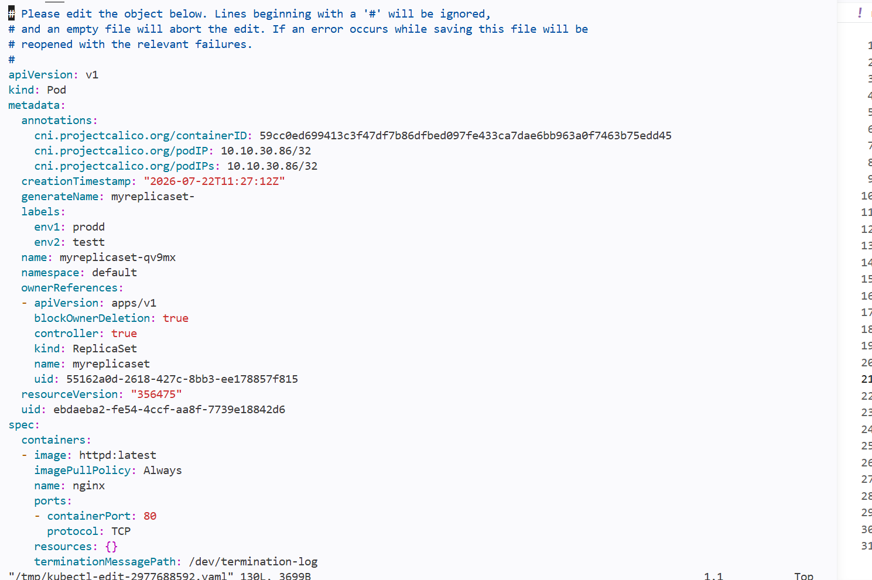

I have changed the image of one pod that replicaset controlls

And we can see that the brower when refreshed it displayed httpd and nginx
randomly

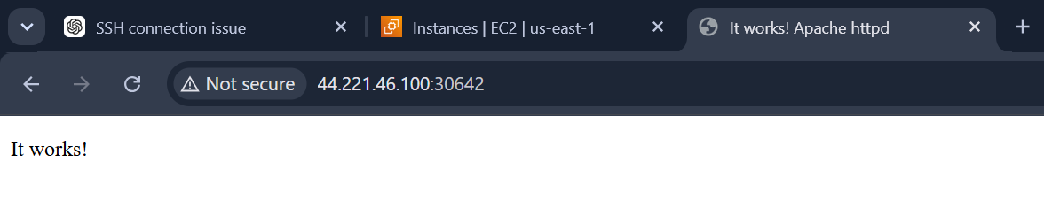

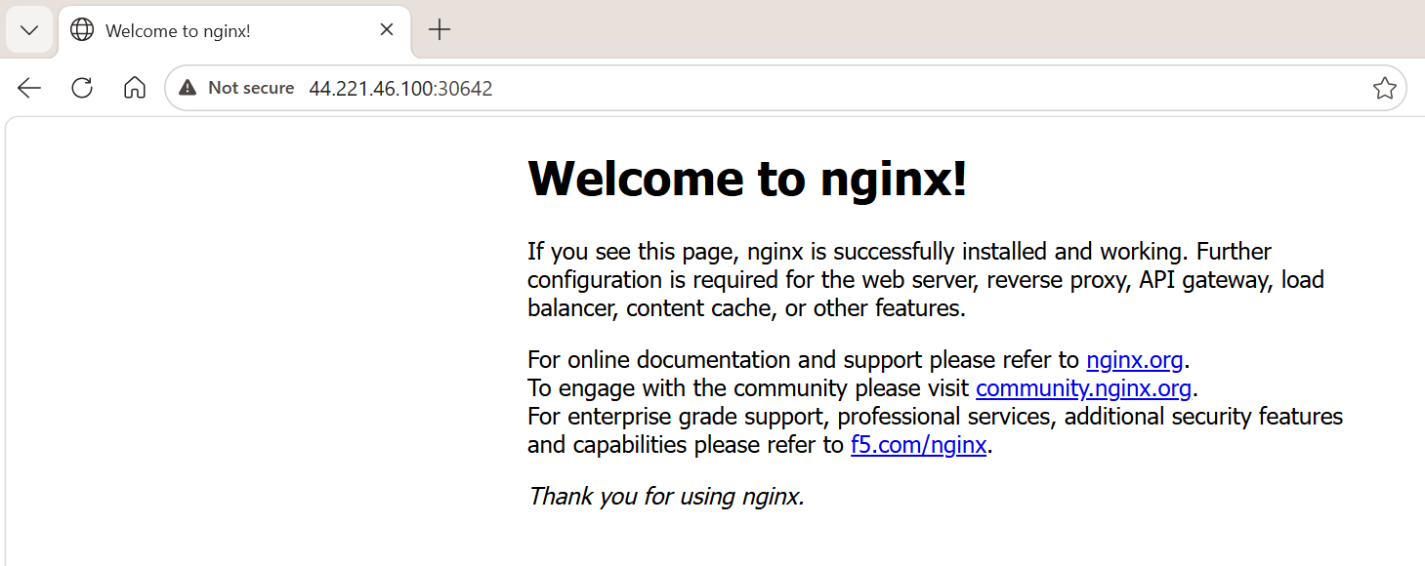

Two different web servers can be seen through same public ip

Delete a ReplicationController without affecting the running pods

For example I am creating a replication controller that creates 3 pods

But whenever I delete rc the pods attached to the rc will also gets deleted

We can prevent this from happening by using a command

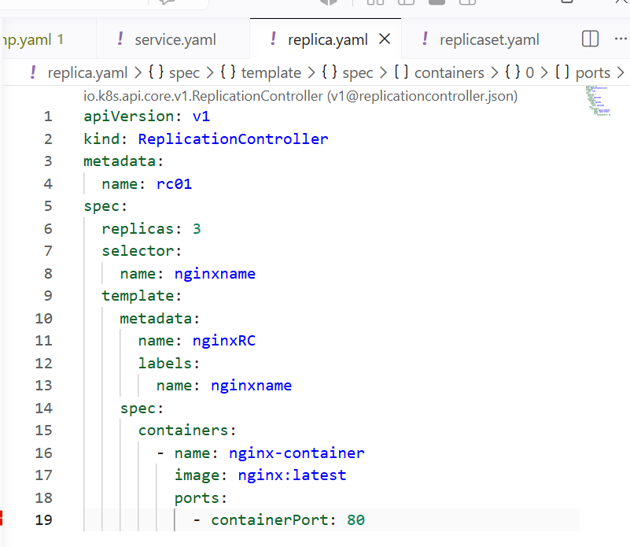

I have created a new rc and 3 pods have been created now if I delete the 3 pods will get deleted

Inorder to prevent from pods getting deleted
I will use synatx
kubectl delete rc <replication-controller-name> --cascade=orphan
We can use this same for replica set
kubectl delete rs <replicaset-name> --cascade=orphan

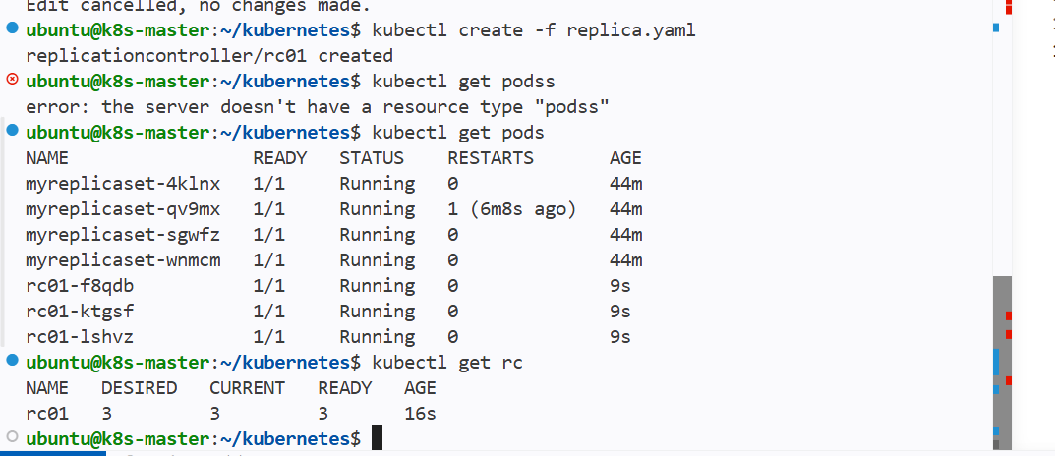

See the rc has been deleted and pods are as it is



