Create an EC2 Instance on AWS Cloud using the below-mentioned ubuntu AMI and instance_type

Creating a infrasturcture using terraform for ec2 instance

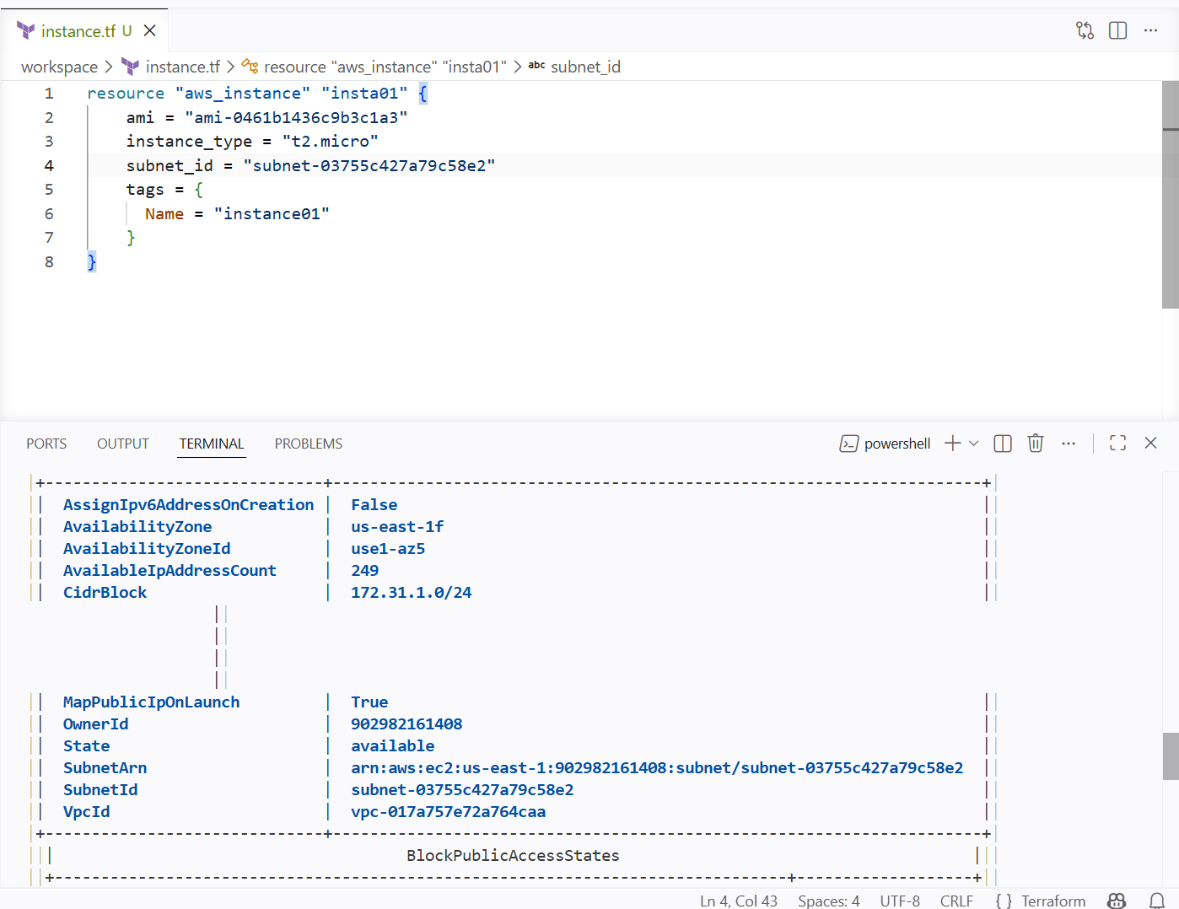

For creating the instance I have given the required inputs
Subnet-id,instance type, ami id

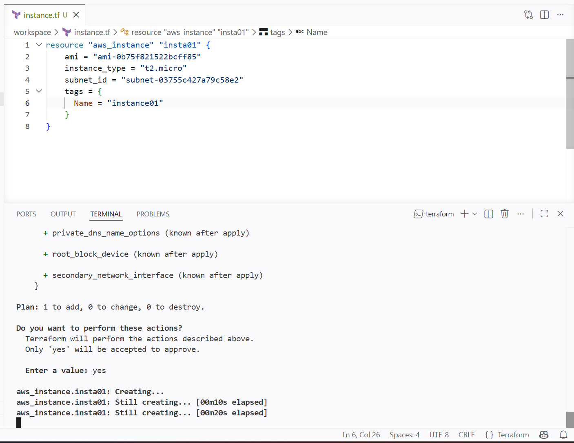

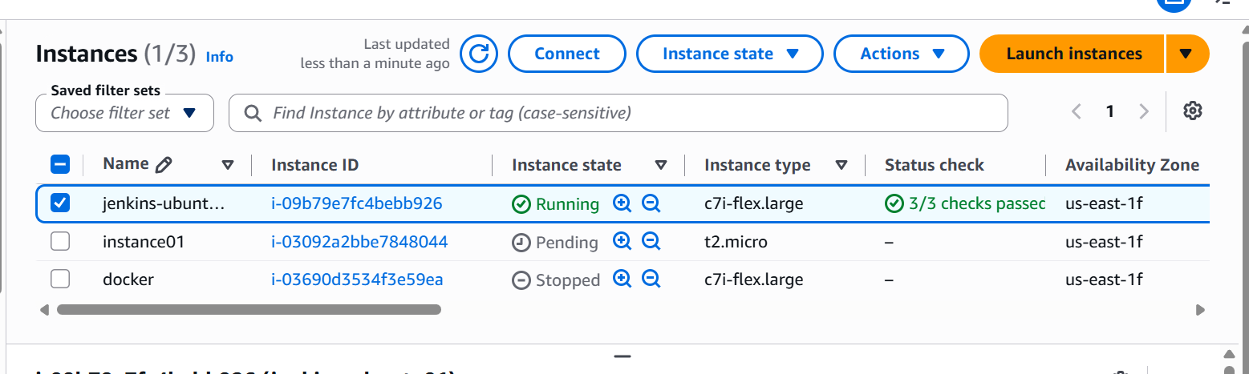

New instance has been created using terraform

Install a web server on the same EC2 Instance. The web server should listen on port 8080

Using terraform I am modifying my instance and adding the user data for installing a web server

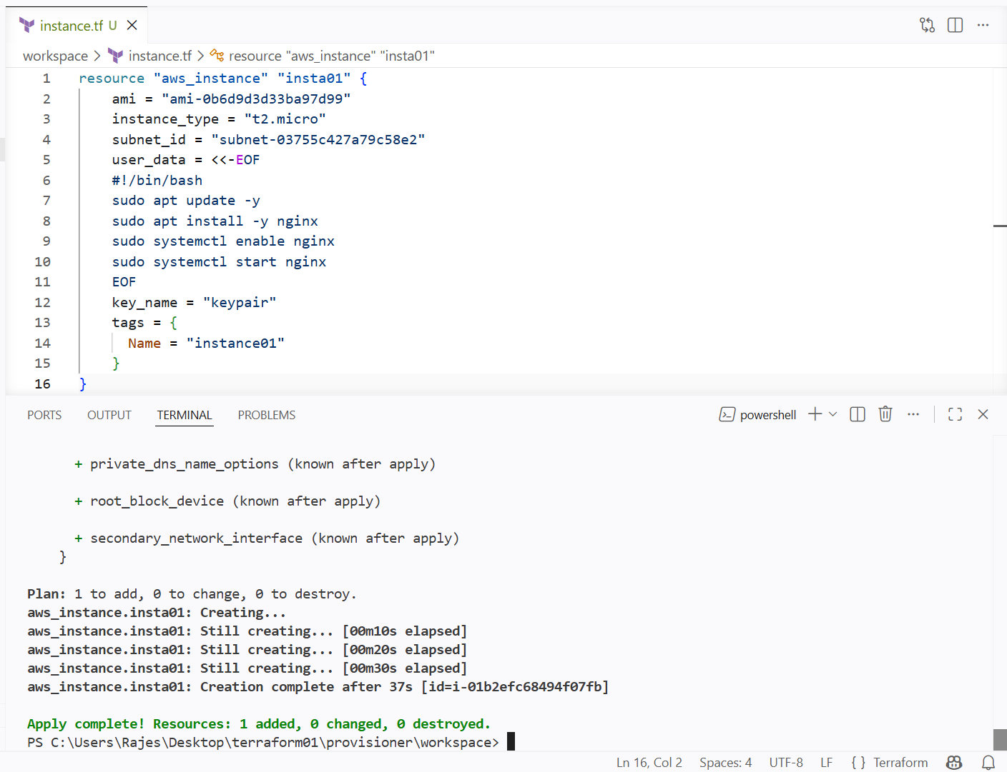

Nginx is running by using terraform

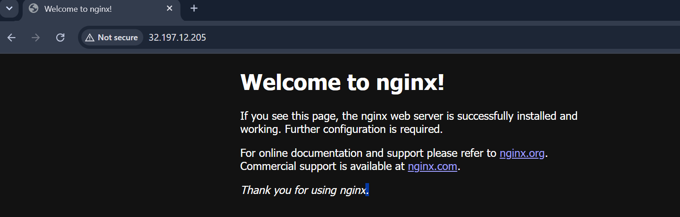

Create a Docker-compose file for the project:https://github.com/betawins/cricbuzz-docker-hello-world.gitand point it to port 8000

Using terraform creating a docker compose file and pointing it to the port 8000

I have already created a instance using the terraform I will be modifying the infra to create the docker compose file

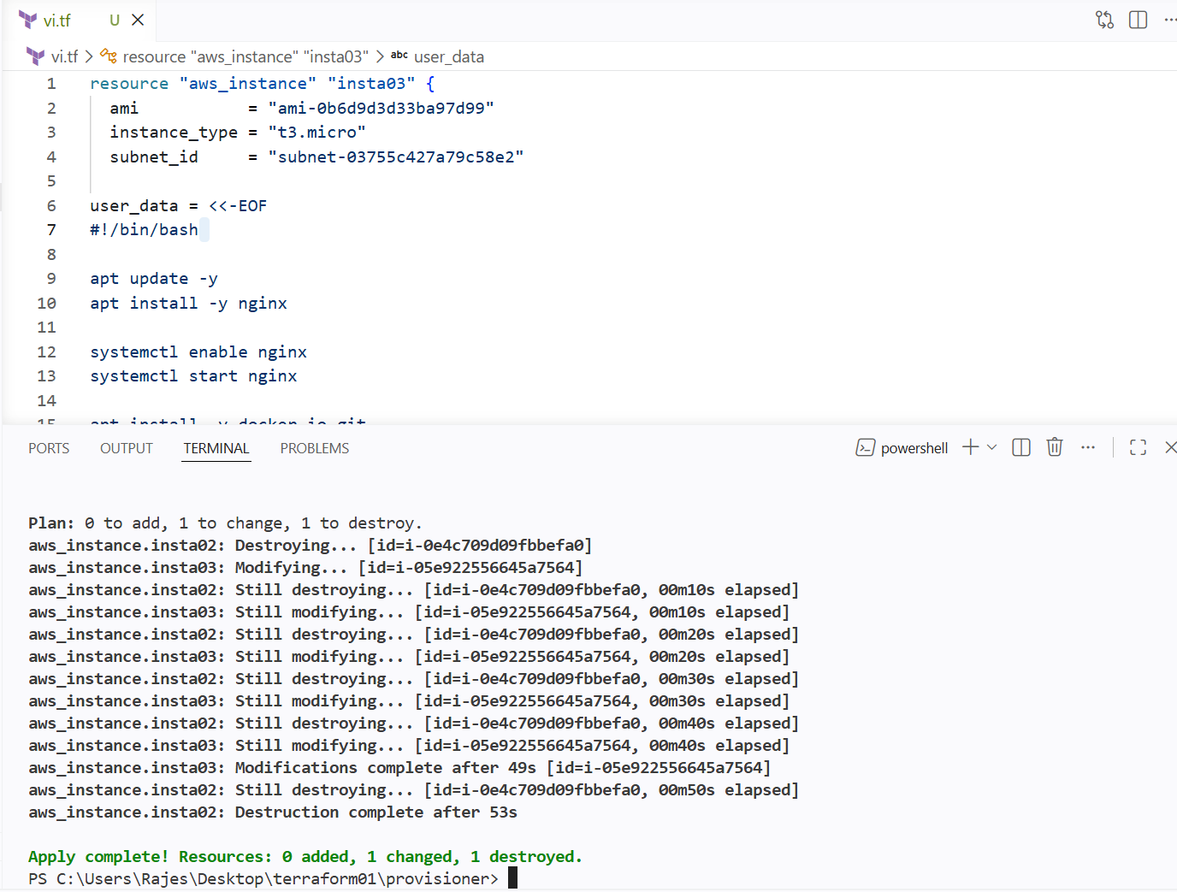

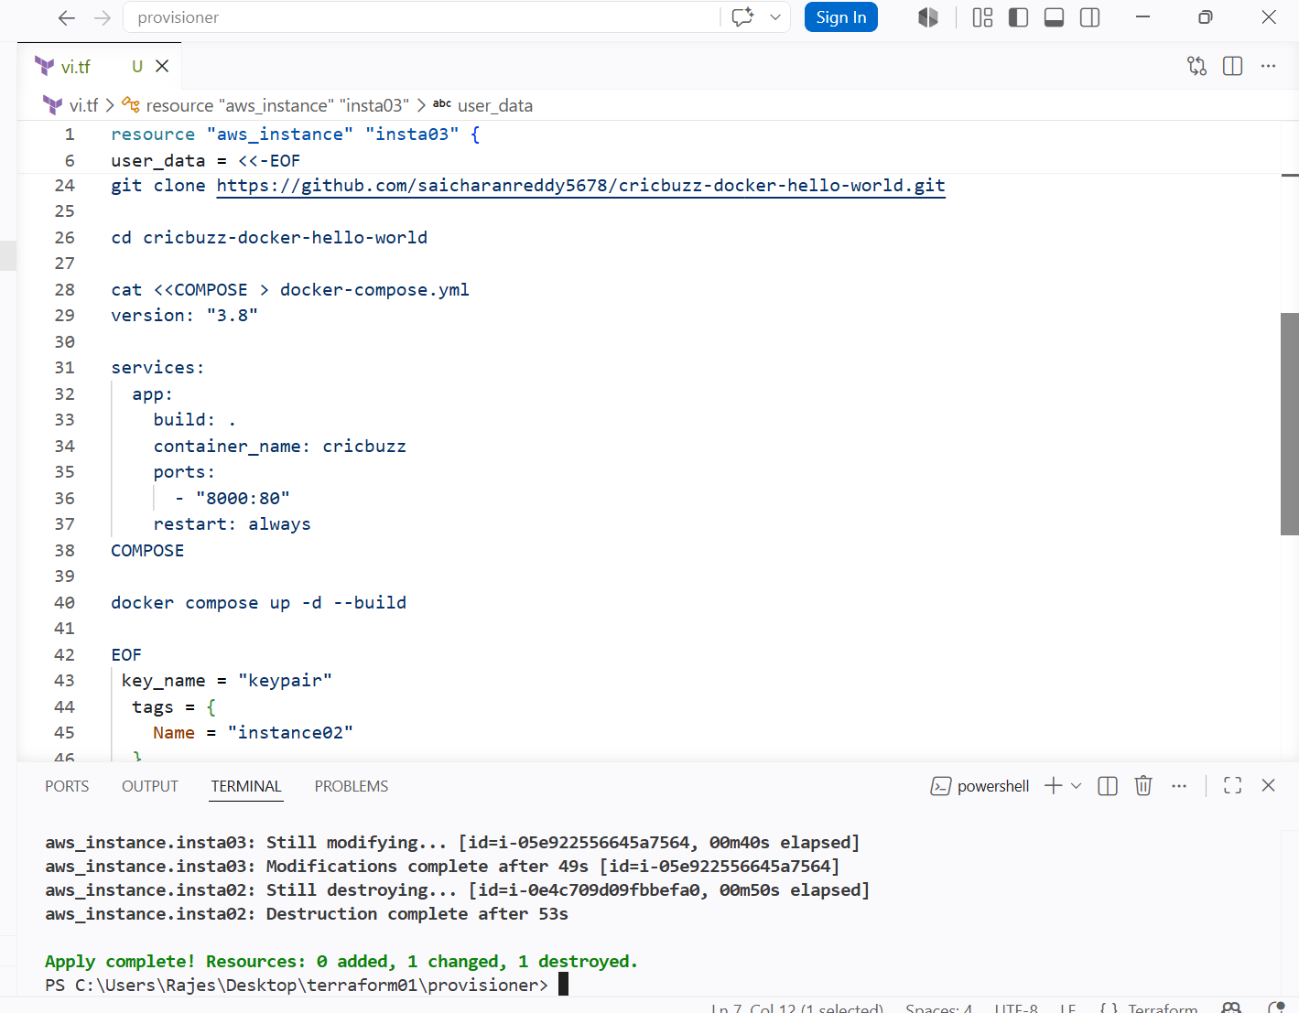

Gave user data for docker compose file and using the docker file for docker compose

And directly from docker compose running the containers

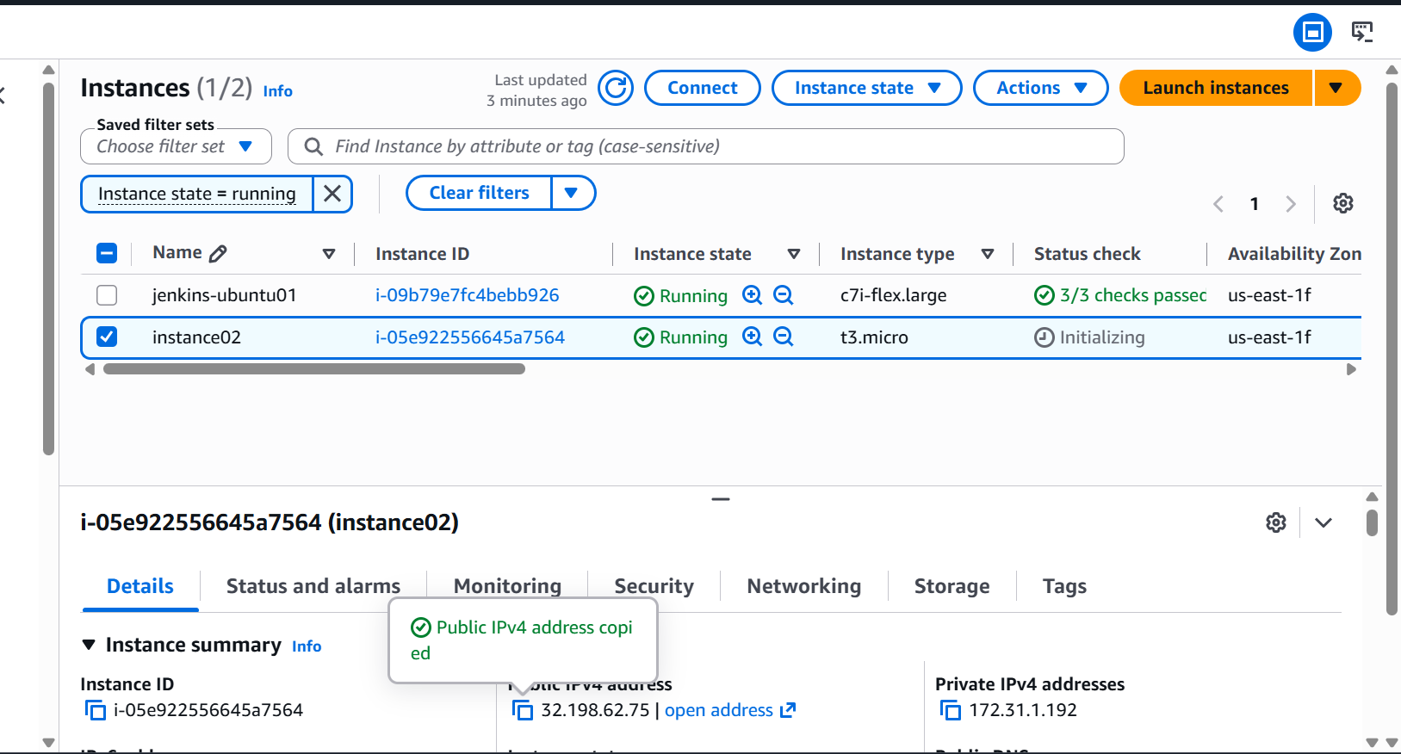

Make the web server point to the above service so that 8080 returns the response from the Docker service

I will be adding nginx as reeverse proxy for my docker service

User ----- nginx ------ docker container ---------application

So I will be adding the nginx above my docker conatiner so that it will be acting as reverse proxy

I will be creating a new fille docker-app
And adding the new lines for reverse proxy

I will be adding the reverse proxy commands to the user data block for nginx conf

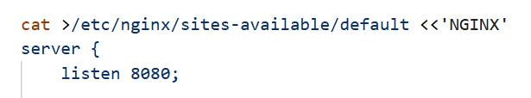

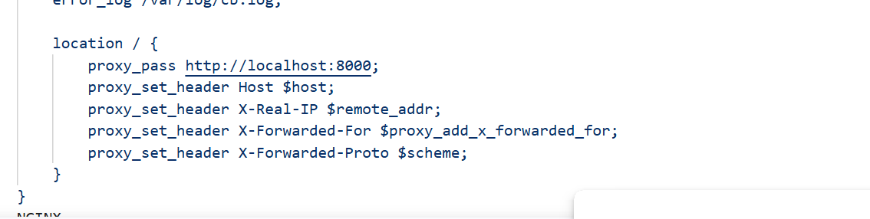

Added new lines for my docker-app so that nginx will take the request first and it will act as reverse proxy

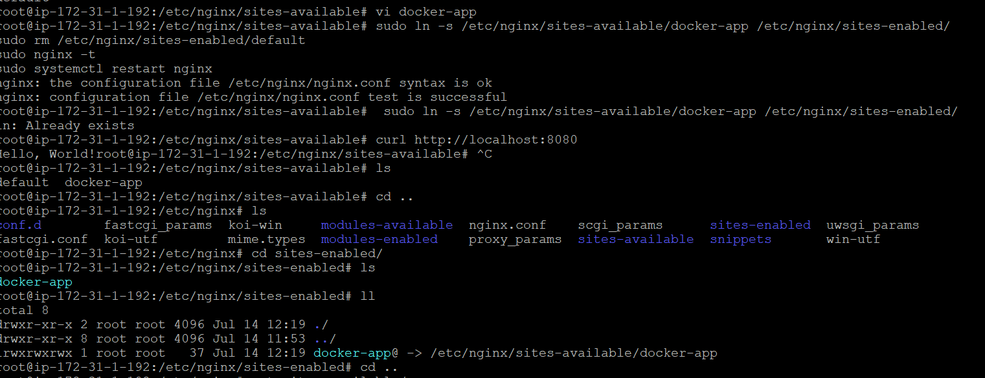

The above ss is for manual process and

Using user data we can eliminate the manual interaction

And directly apply from terraform

Removing the default from the sites enabled and adding the docker-app file
Then adding the symbolic link of the docker-app file to the another dir named sites-enabled

Then restart the nginx

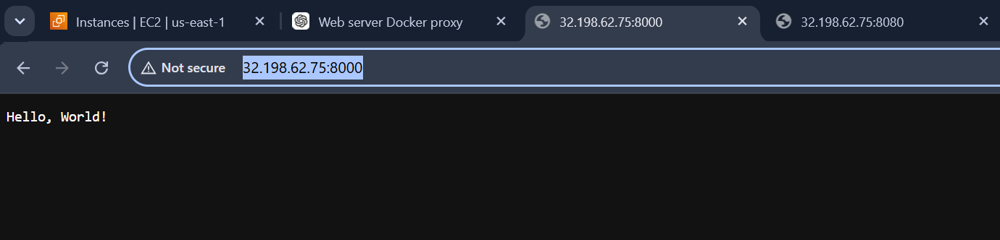

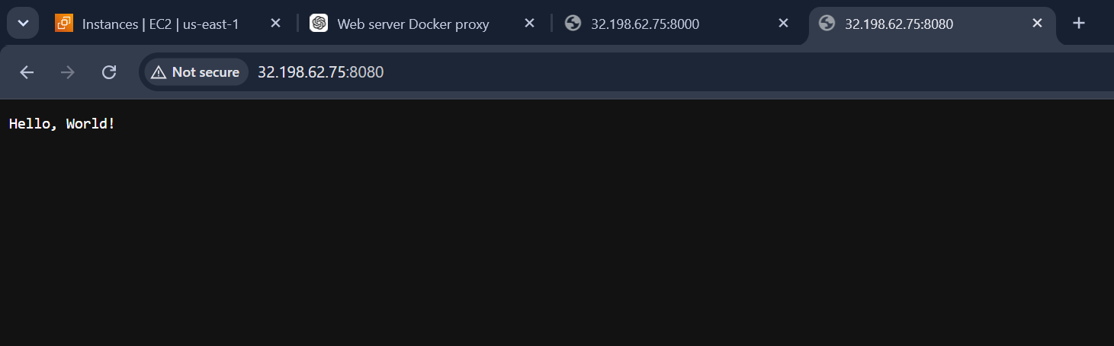

Now we can access using two port number from nginx and from docker service

Configure to Save the Logs in the location /var/log/cb.log

Changing the logs location for the nginx

By directly giving the logs location to cb.logs

Now all the access logs and error logs will be stored in the cb.logs of nginx

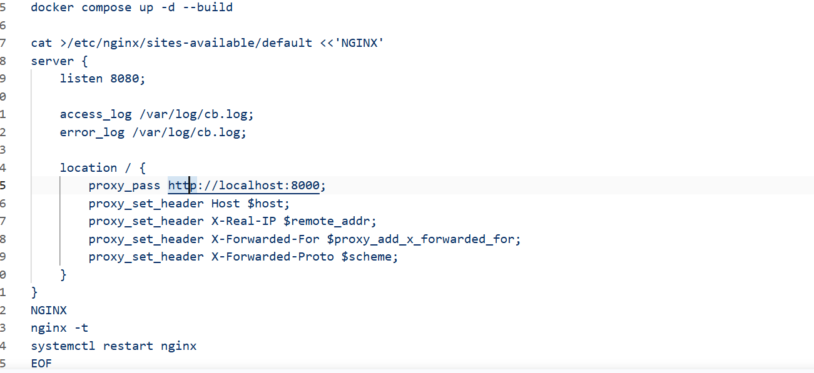

We can see the log location has been changed in the sites-avaible/default

Directly from the user data

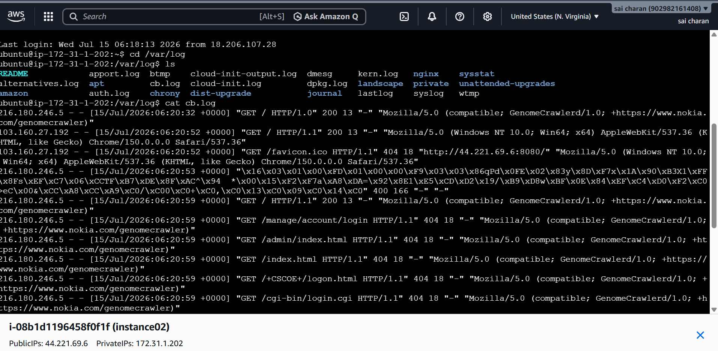

The new log files will be stored in cb.log
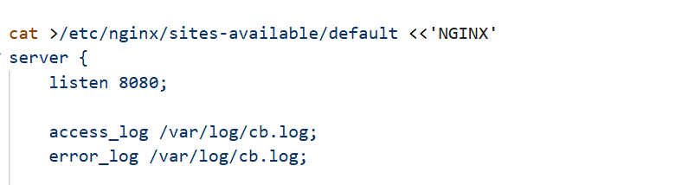

I have added the commands directly to the use data

Log rotation for the above logs

Log rotation for the cb.logs

I have installed log rotate using the user data in terraform

And mentioned when to rotate the logs and shedule

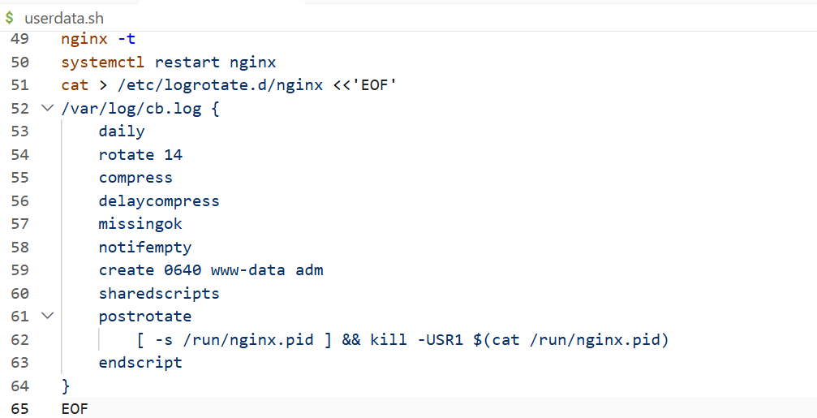

User data for log rotation

And it has been executed in the server and can see logrotate in /etc dir

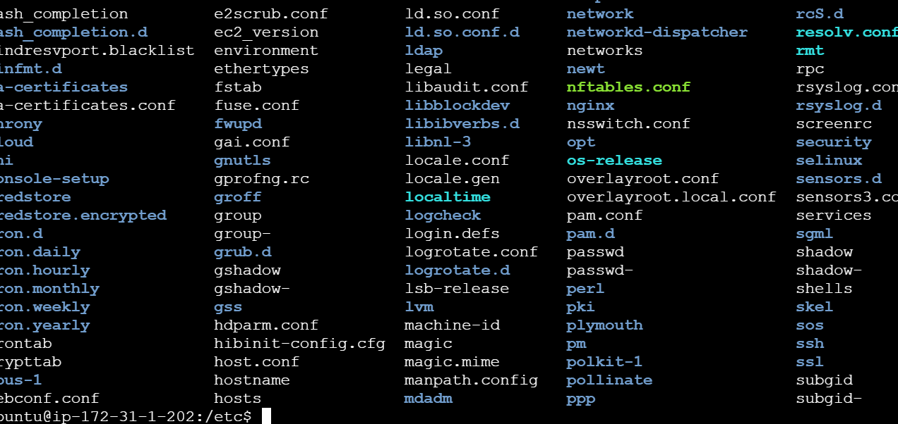

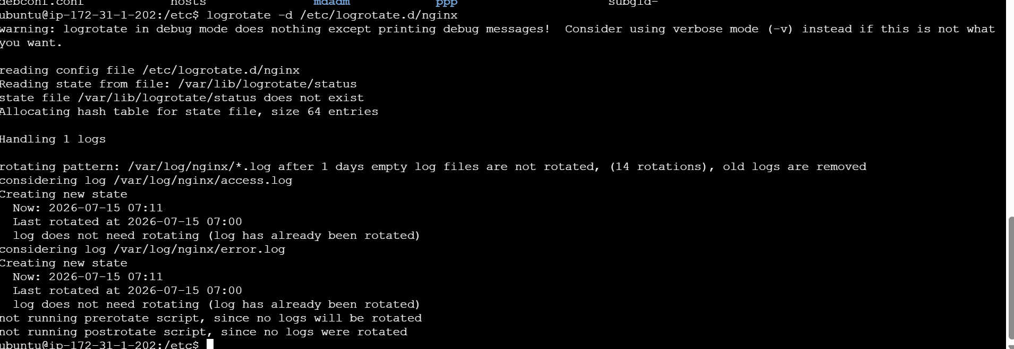

If manually do log rotate it says it has already been log rotated by terraform

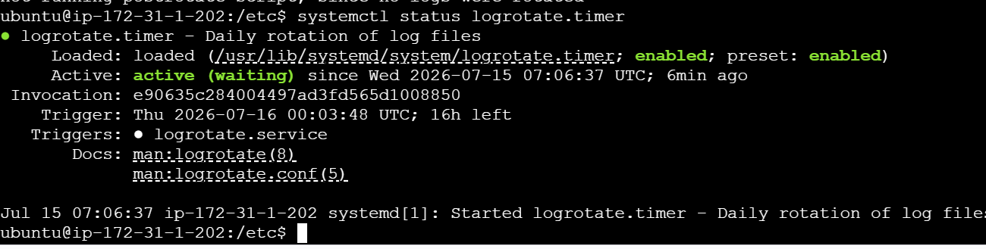

We can also see the logrotate.timer is active

