TERRAFORM CHALLENGE -03

First building images locally and using terraform push to the hub

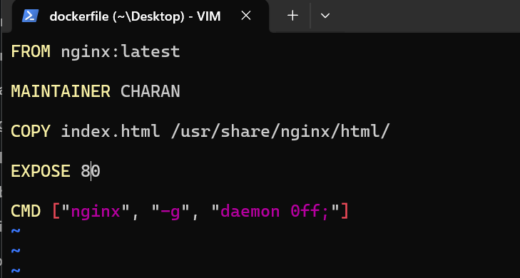

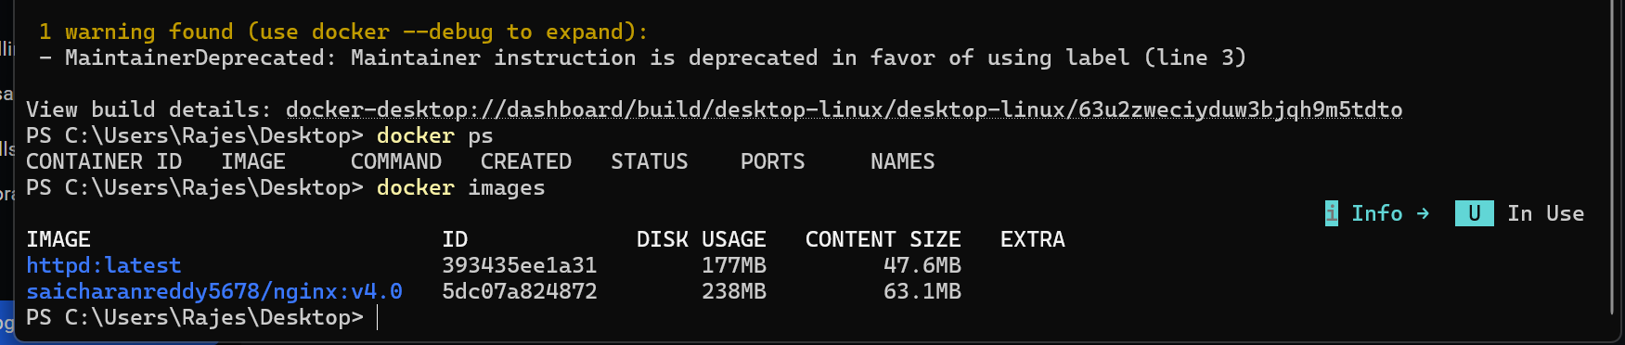

Image has been created locally and using terraform pushing it to the hub

Created a new docker folder and calling the docker script as module for my main script

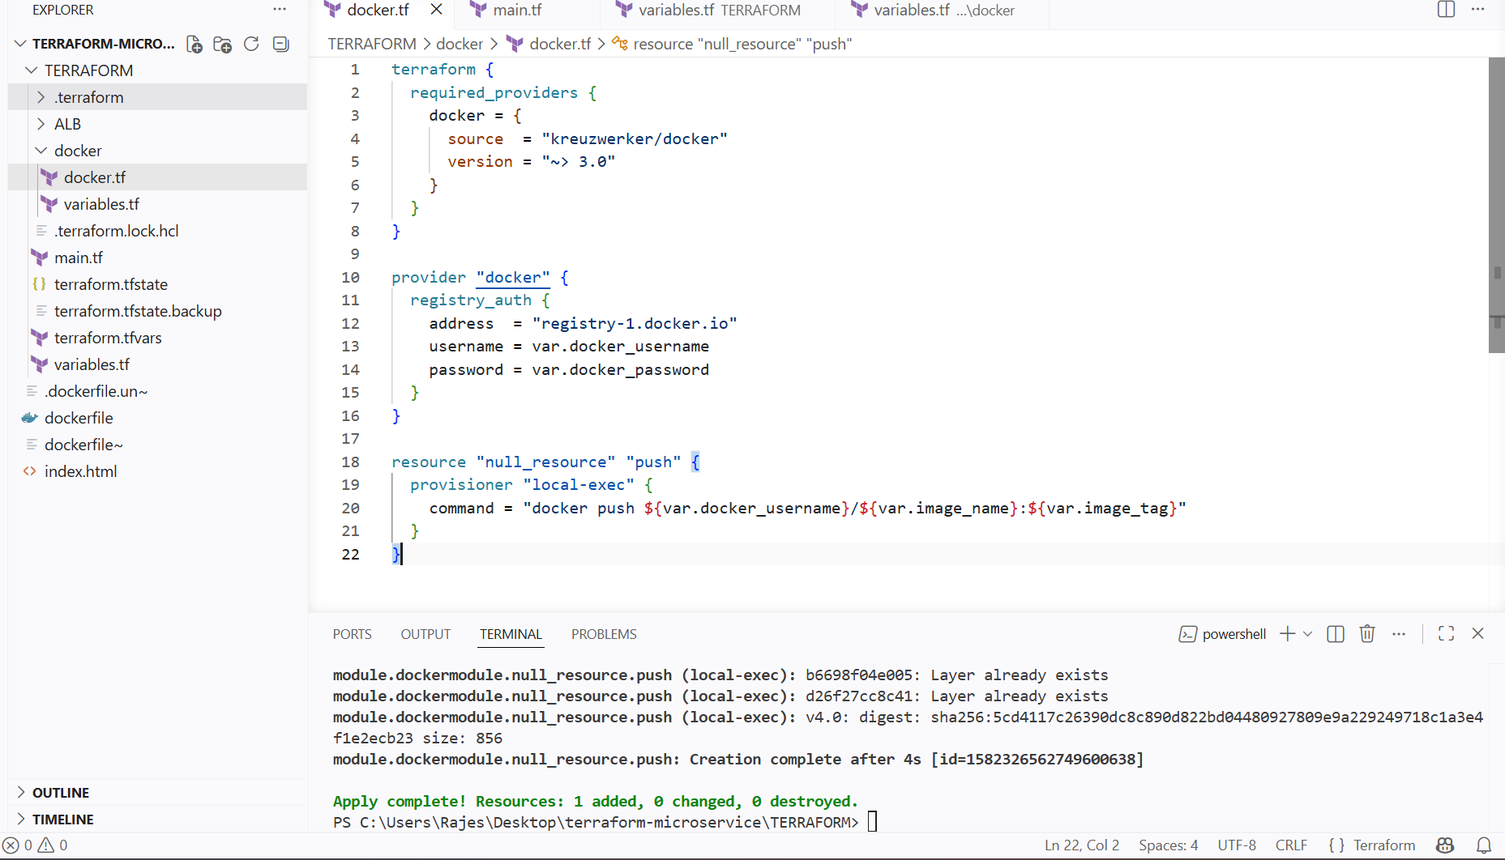

Gave variables.tf and terraform.tfvars as varibales for docker script and main

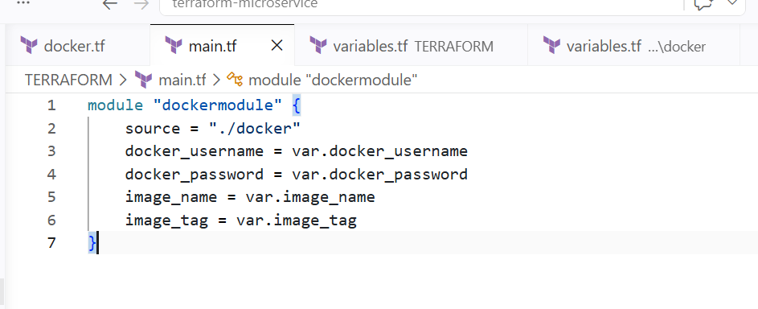

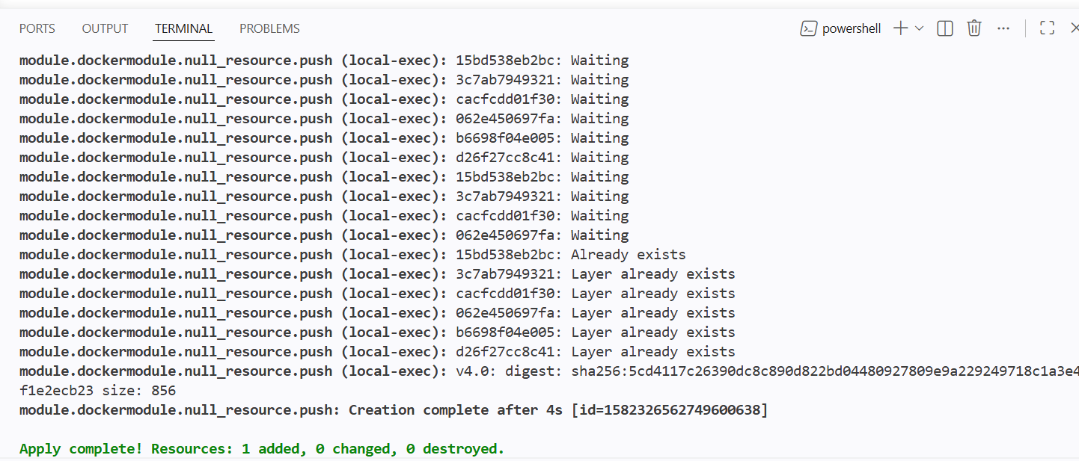

Locally built images has been pushed to the docker hub

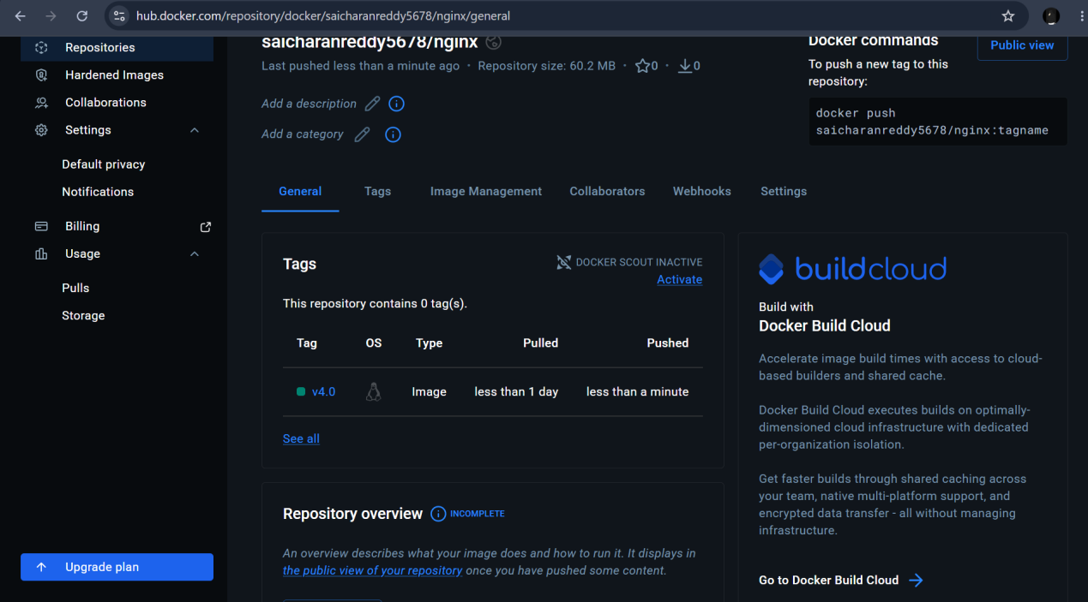

Creating a vpc

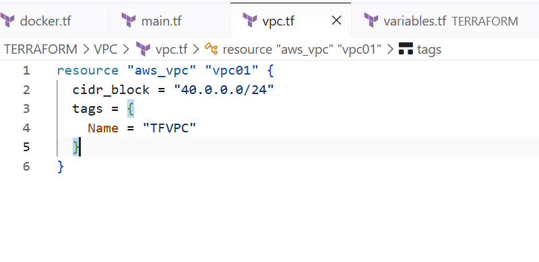

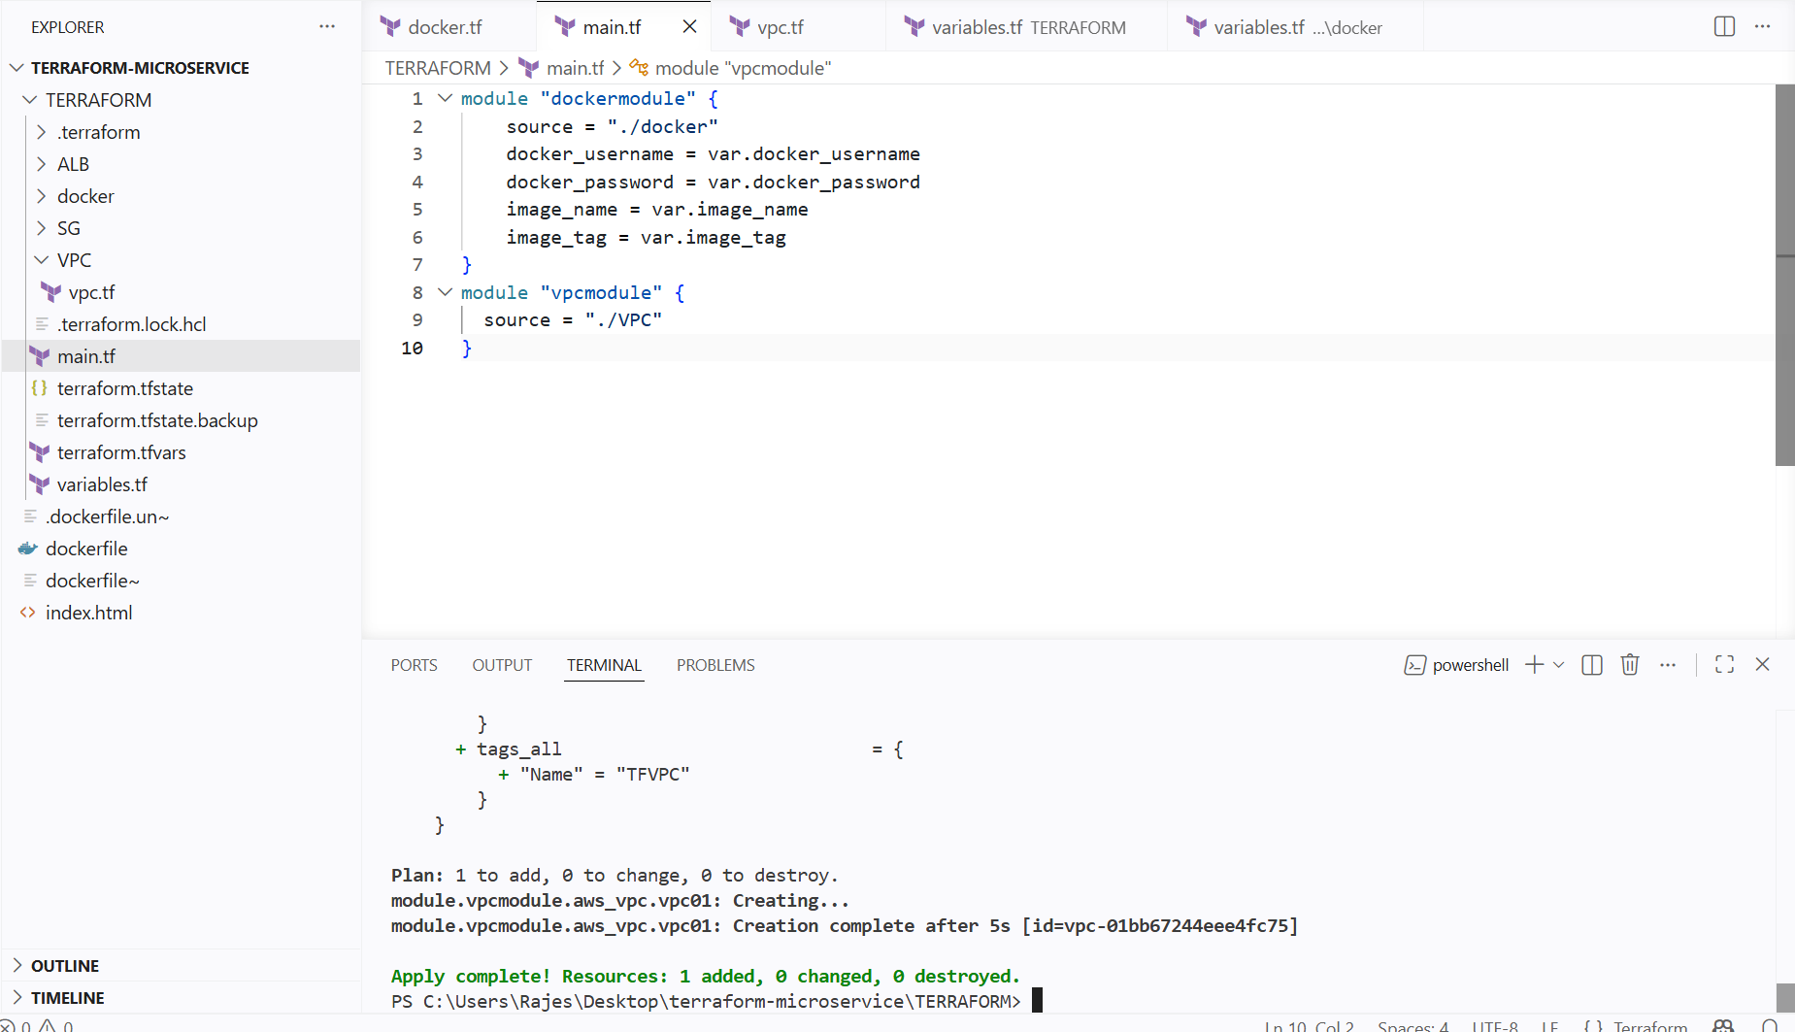

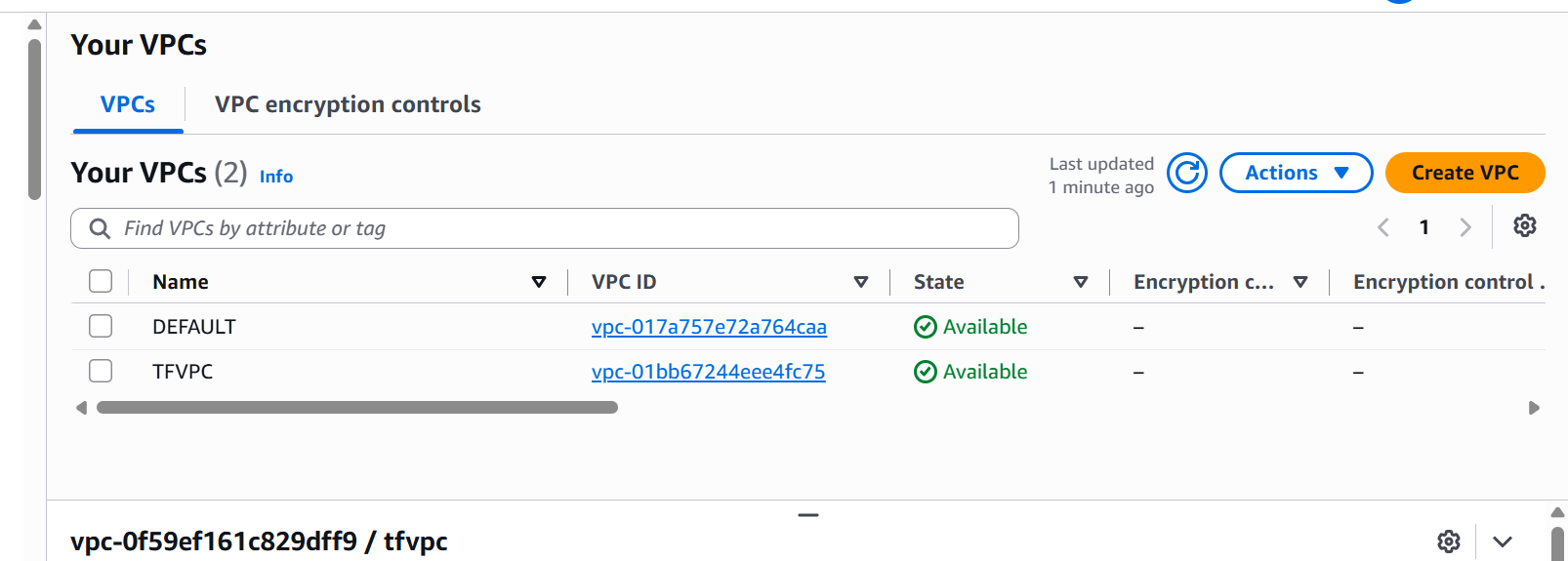

Creating security groups for ec2 instance and alb

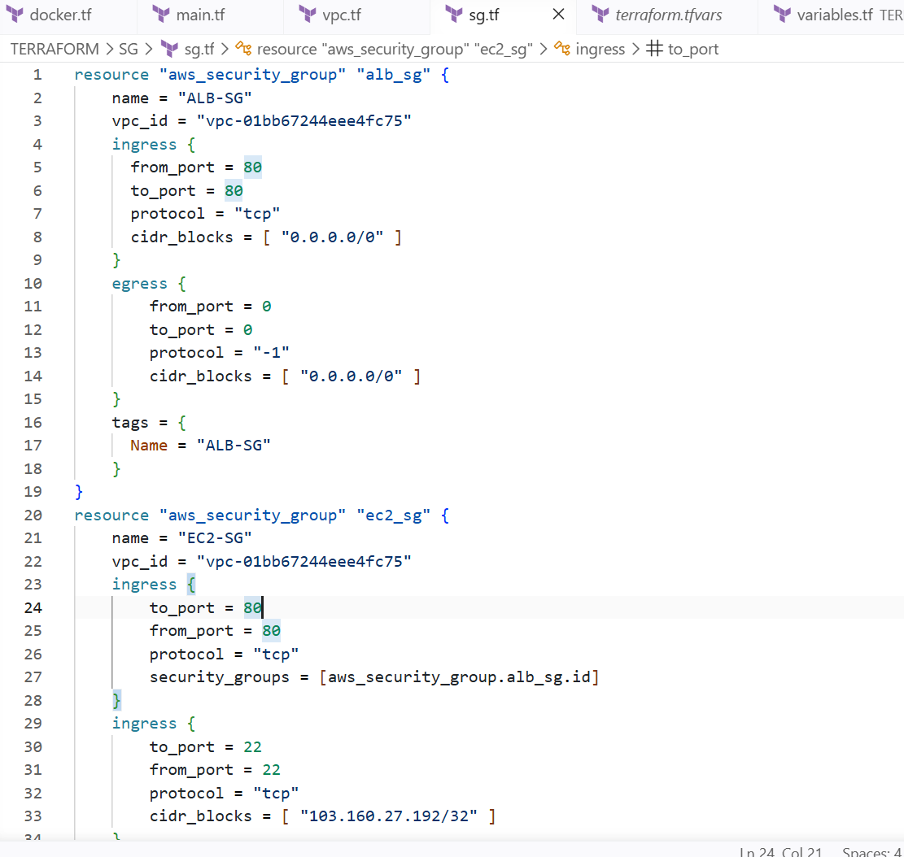

Using the module for security groups

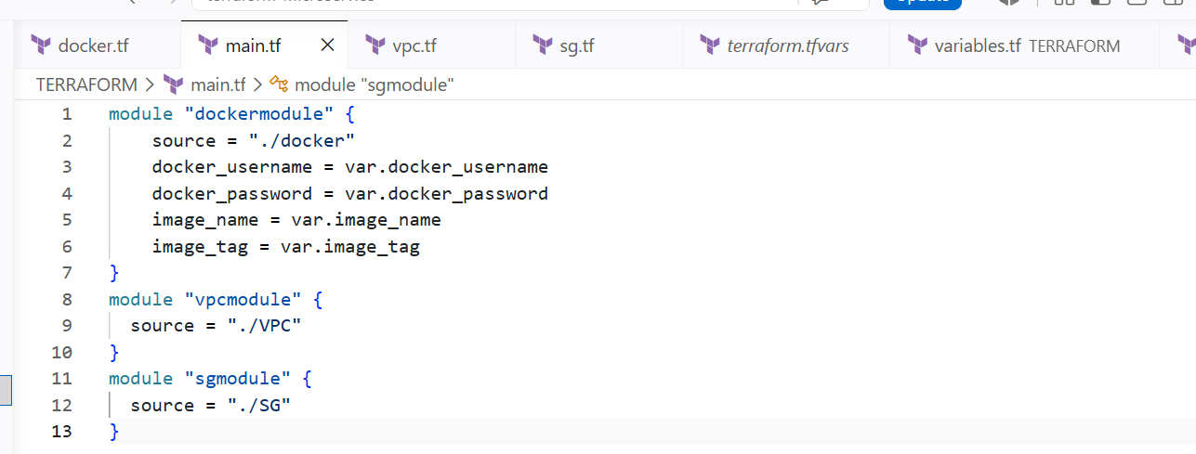

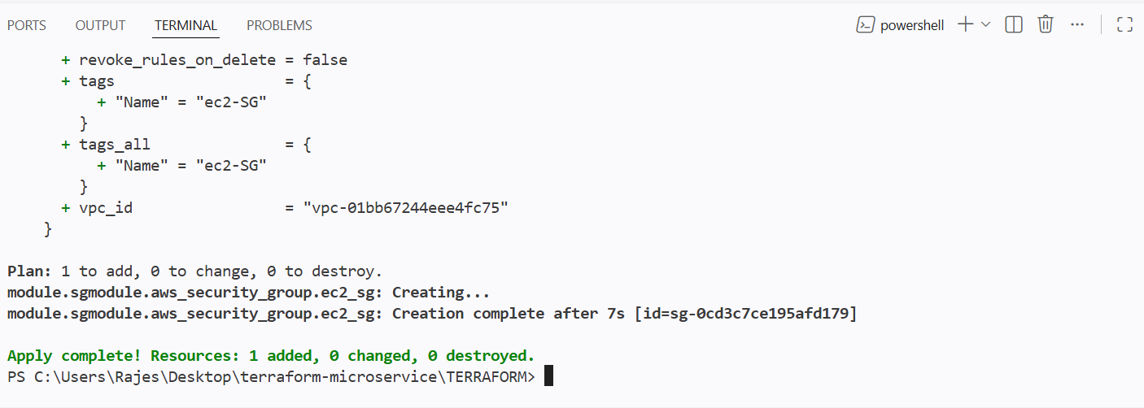

Two security groups have been created

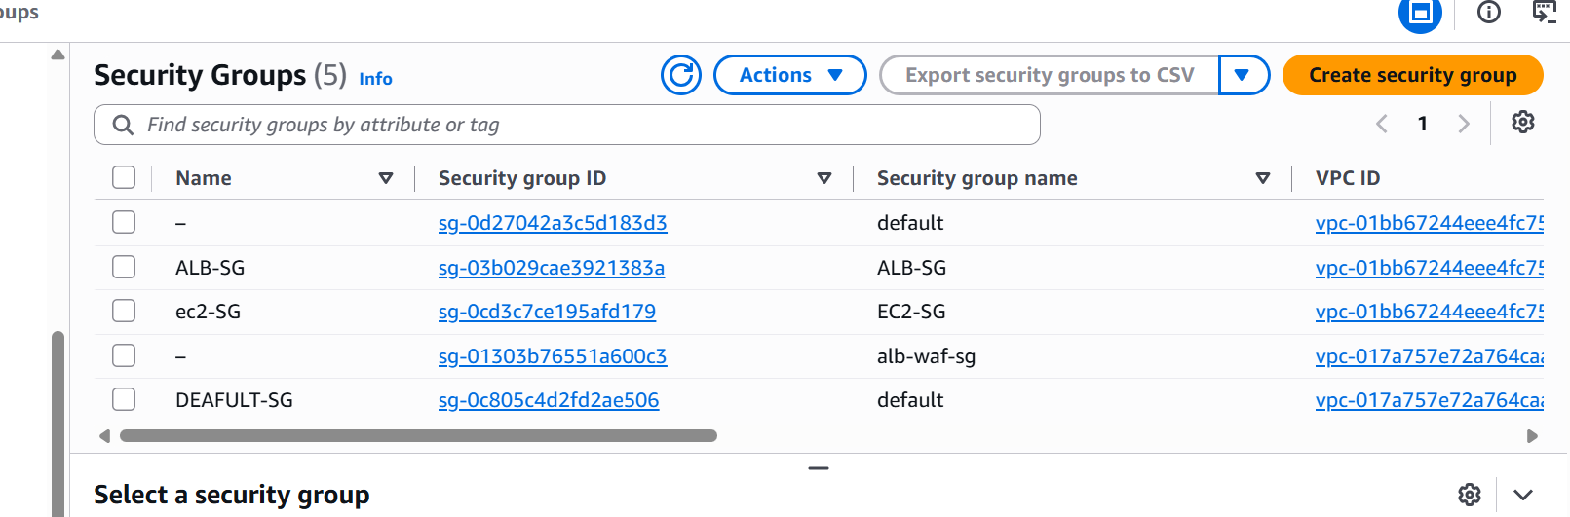

With only 80 port number allowed

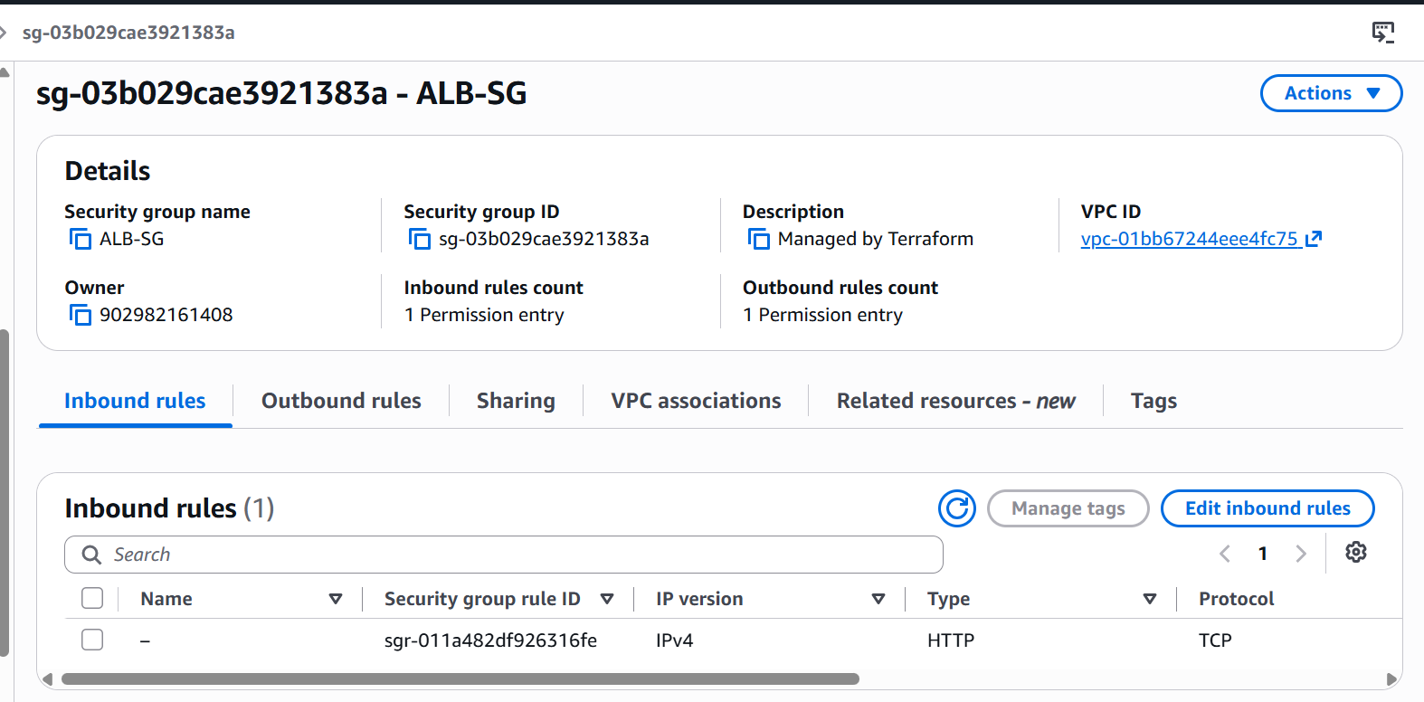

And for ec2-security group
Two port numbers have been allowed from alb and one for ssh from my ip
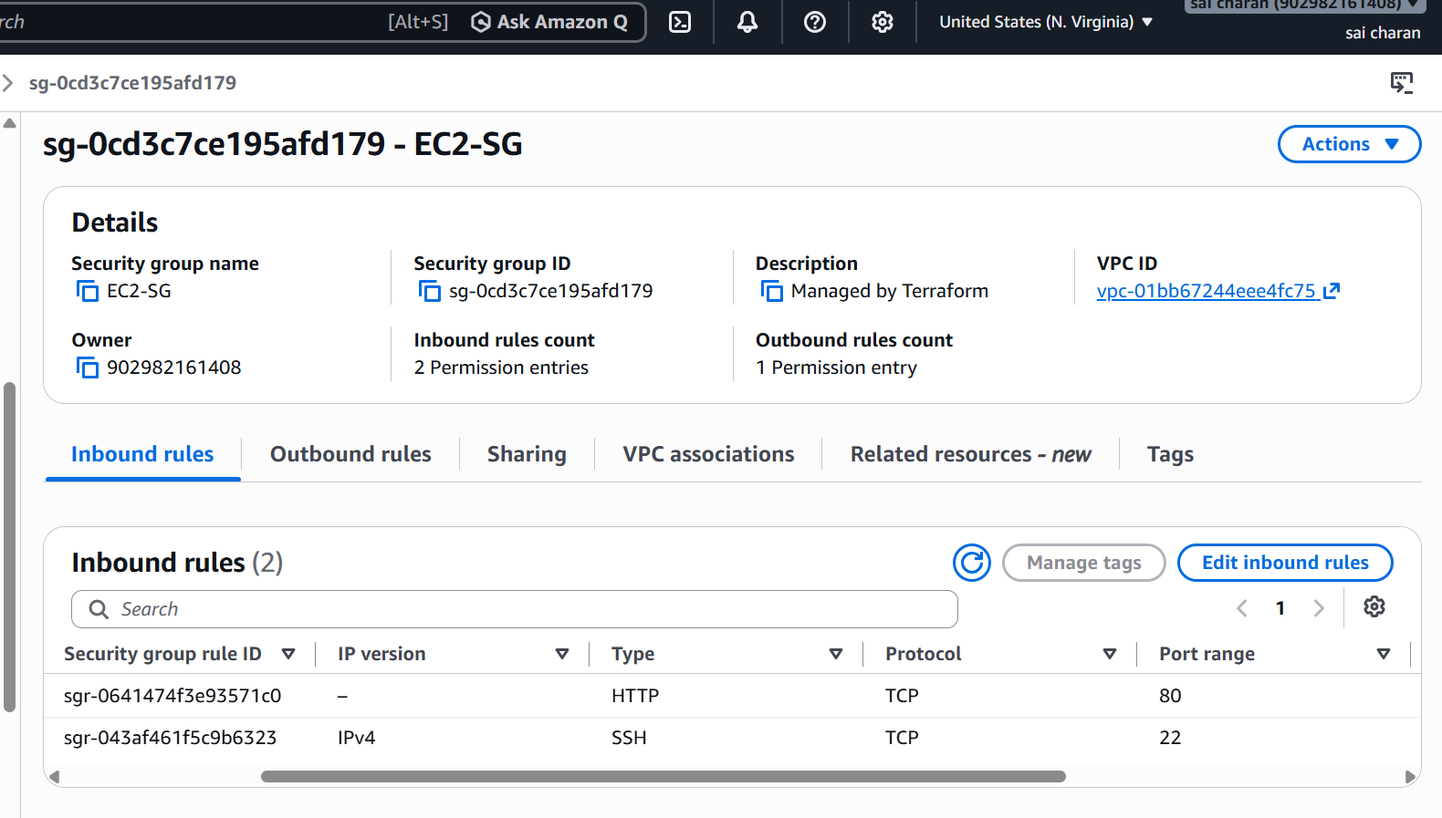

Creating 3 subnets
- public subnets and 1 private subnet
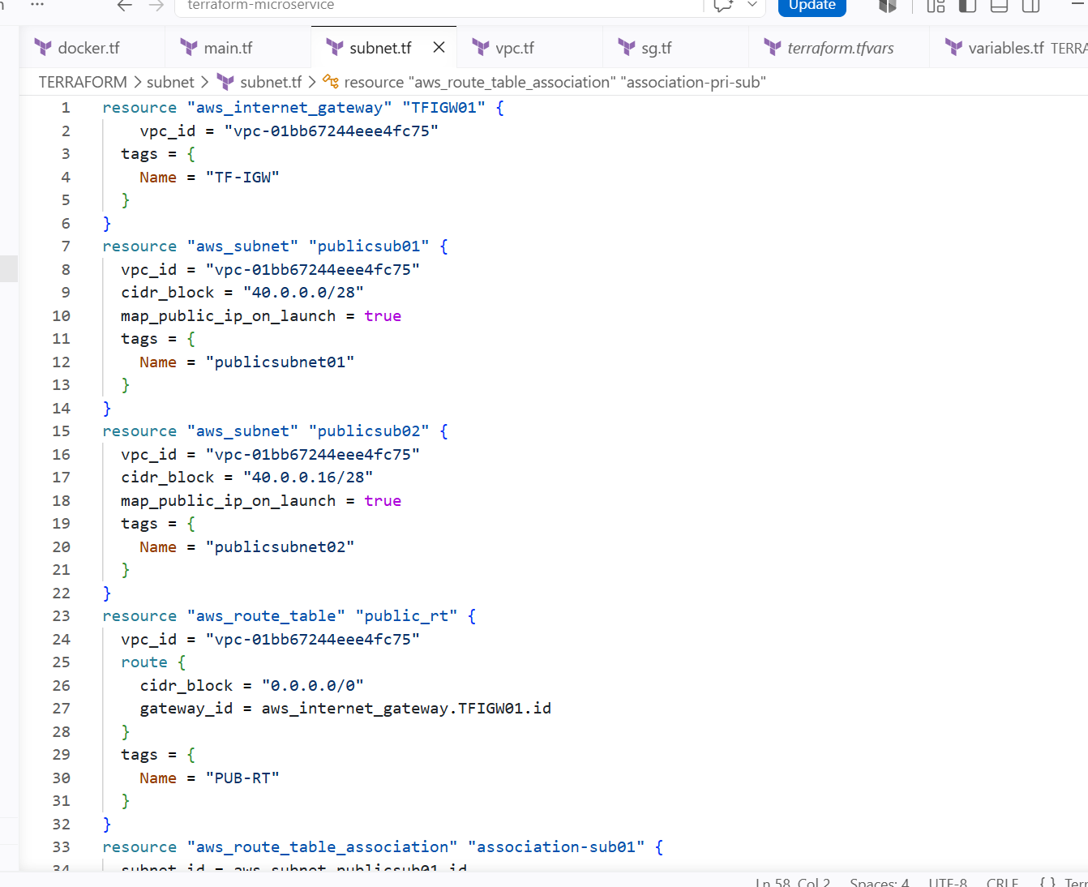

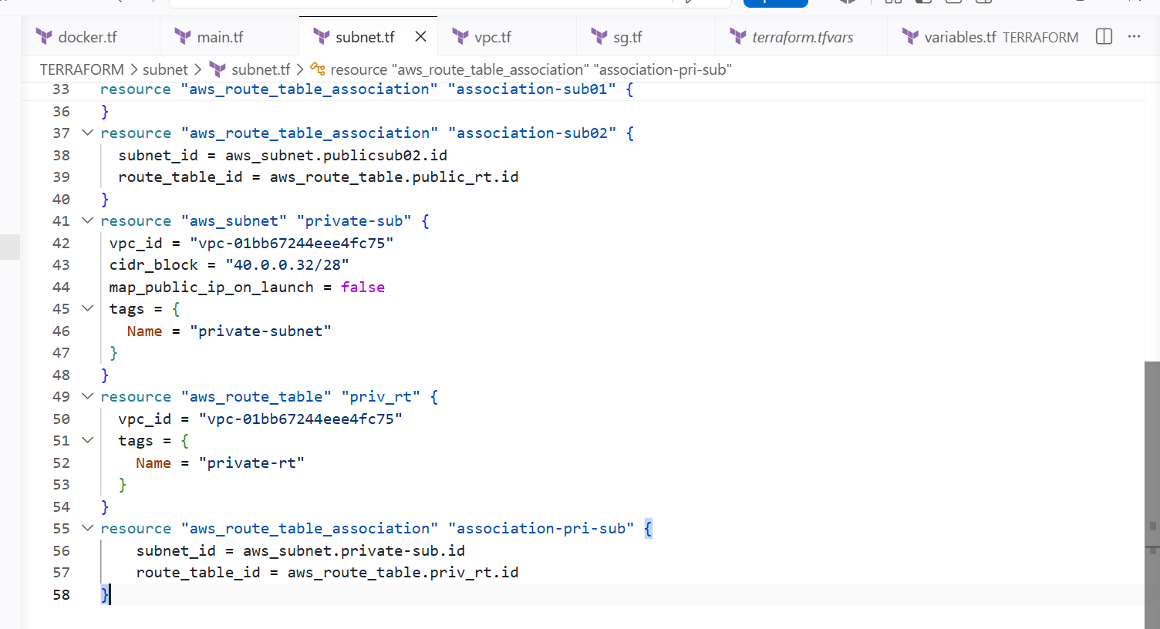

Created 3 subnets

And added subnets to the route tables

And for private subnet did not attach internet gateway

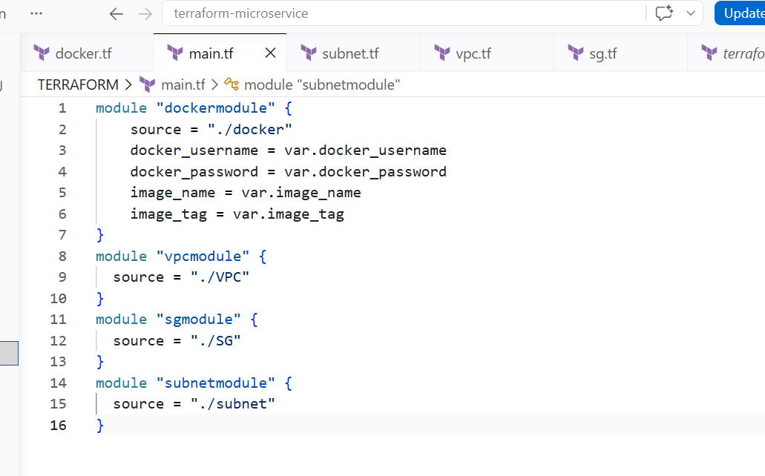

Calling the subnets resource from main using module

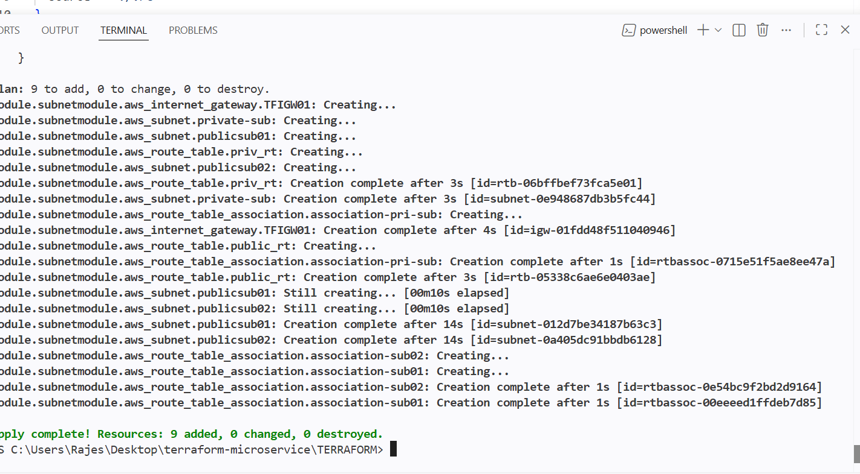
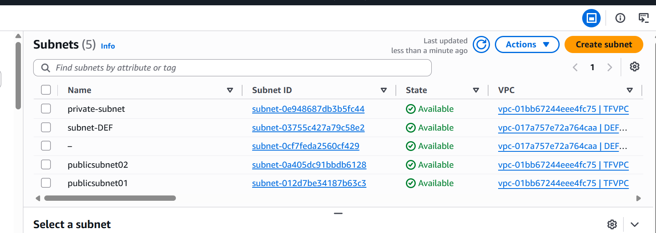

And creating nat gateway on public subnet and allowing traffic to the private subnet

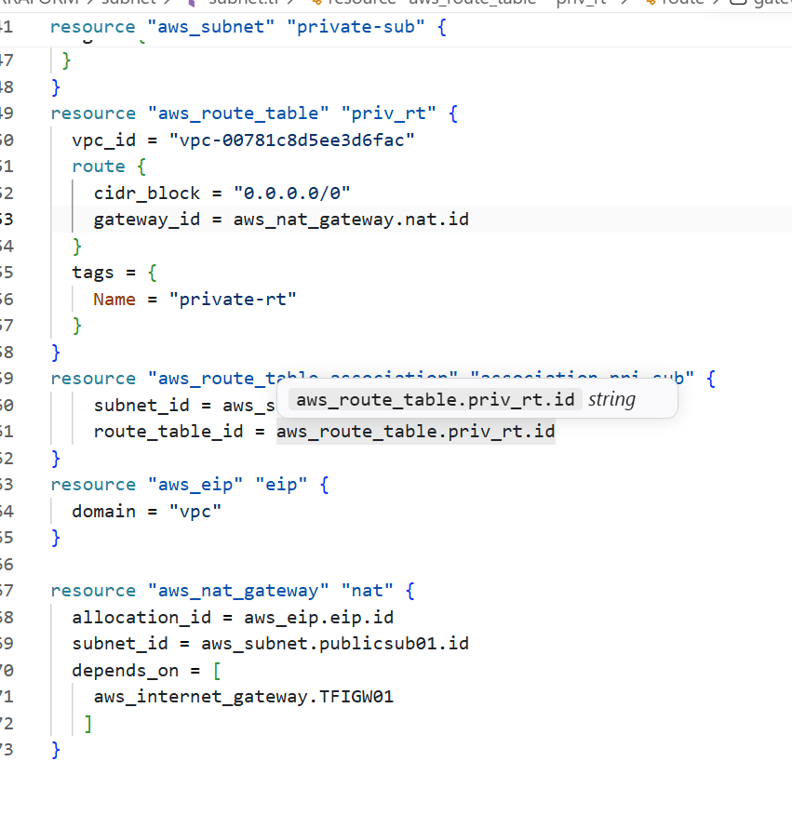
And allowing traffic to the private subnet

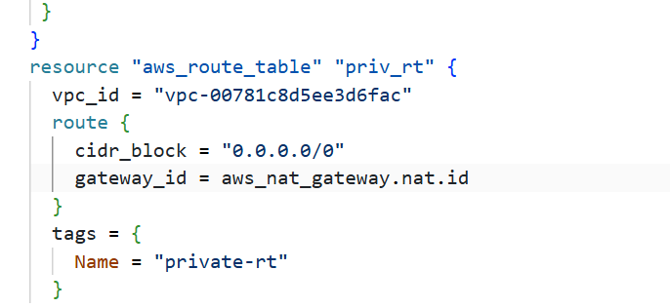

And giving a locally created key to the newly created instance
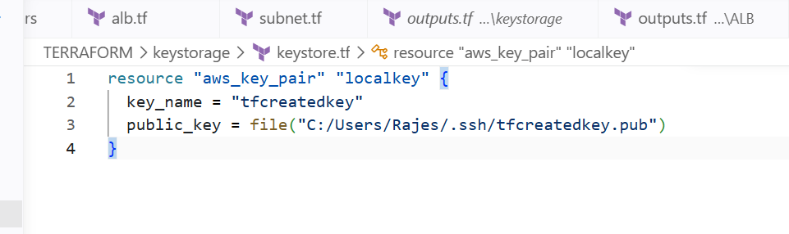

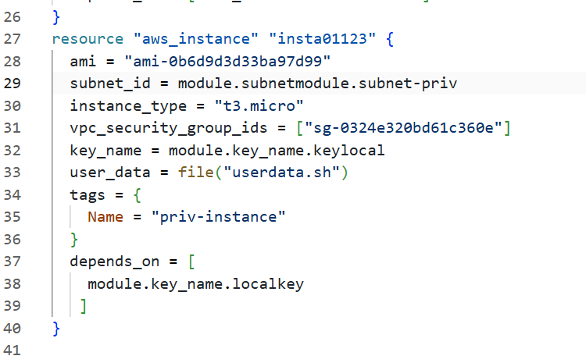

Here we need to mention the key that we taken from local and calling through the module

CREATING A TARGET GROUP AND ATTACHING IT TO THE LOAD BALANCER

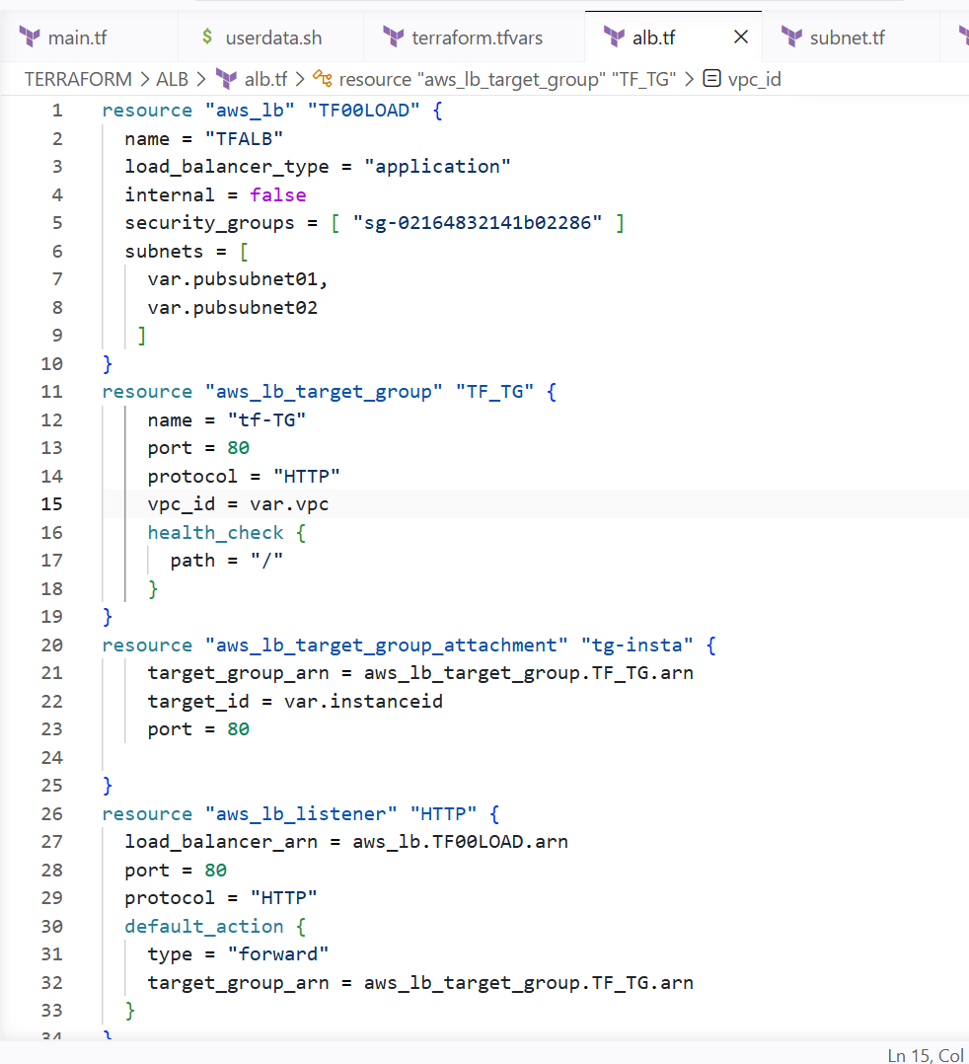

Outputs and variables have been mentioned
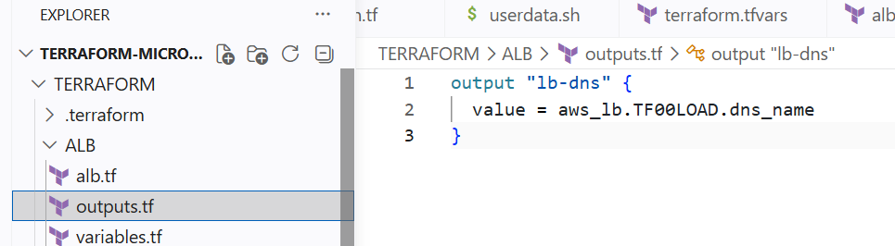

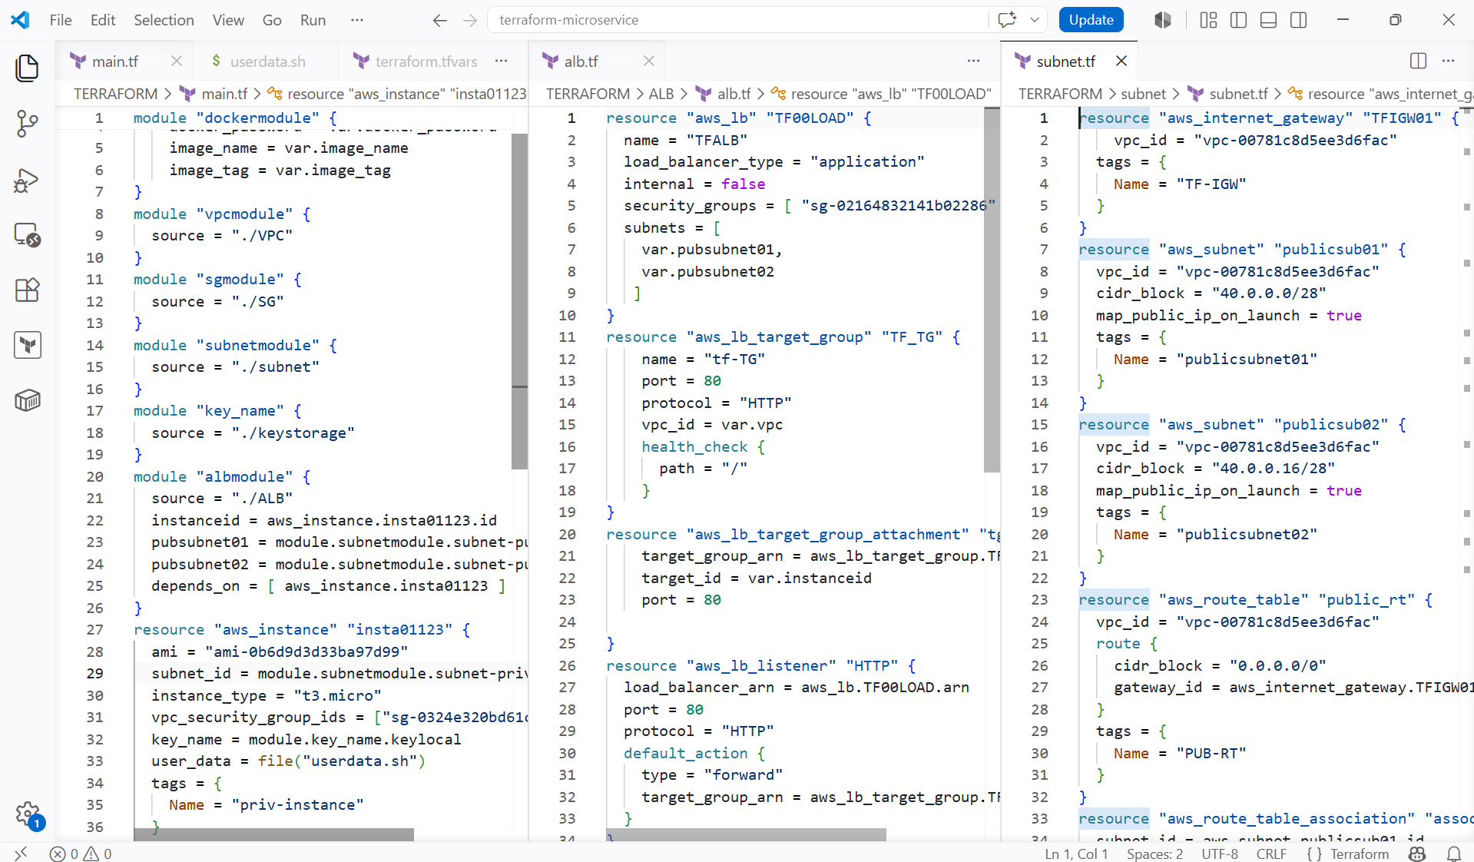

I have called all the resources to the main block by using modules

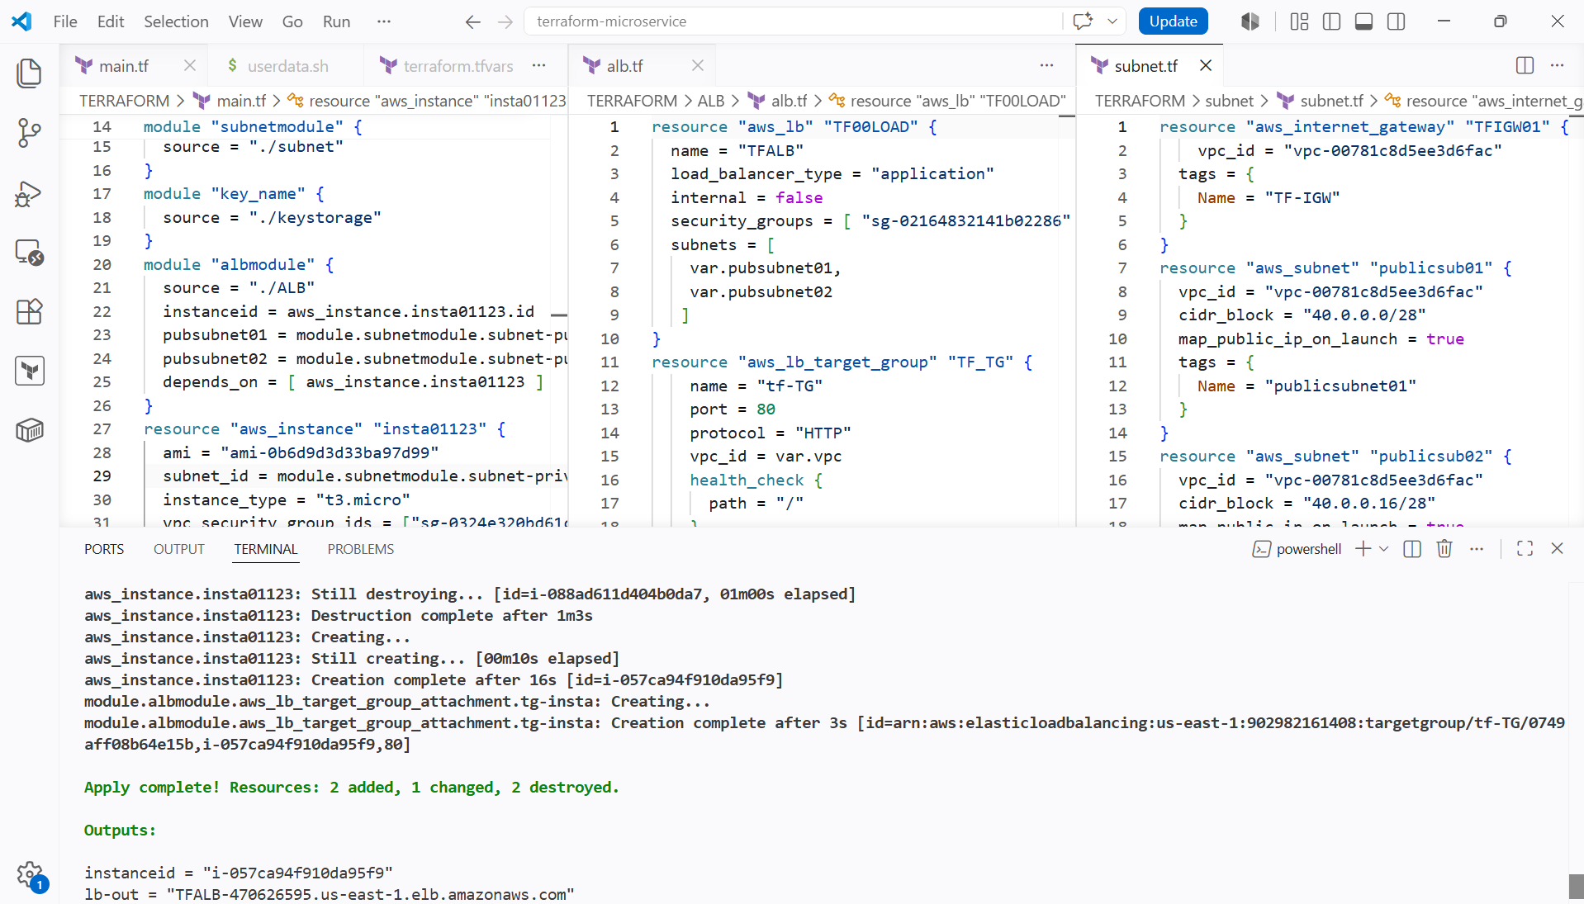

Alb has been created and dns name has been generated

We need to see the output of the lb dns name

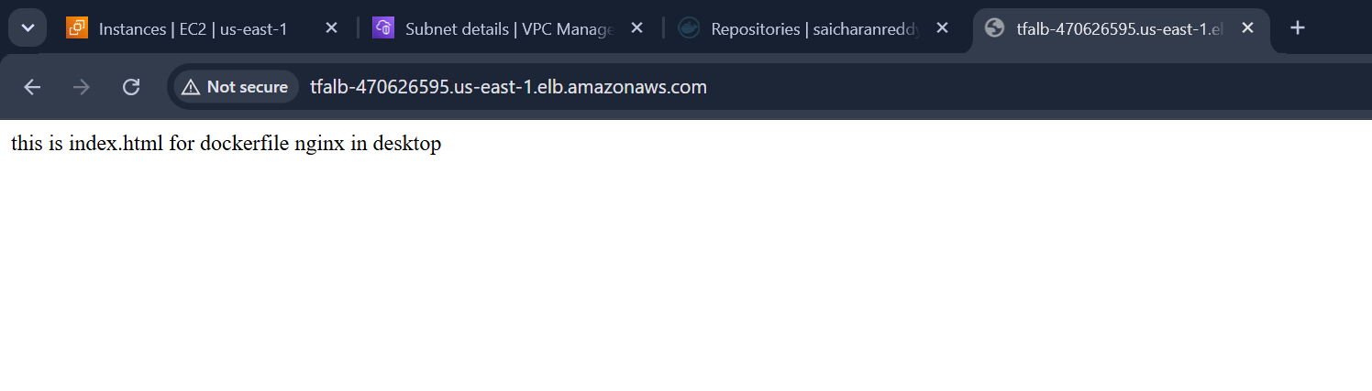

And now we have done load balancer attached to the instance and instance is private and cannot be accessed by the internet so we created a natgateway on public subnet of the load balancer and allowed it to the private subnet through route table

And allowed only traffic from load balancer to the instance

