Create VPC

Creating a new vpc using terraform

Used aws_vpc provider and cidr block with range

And name for vpc

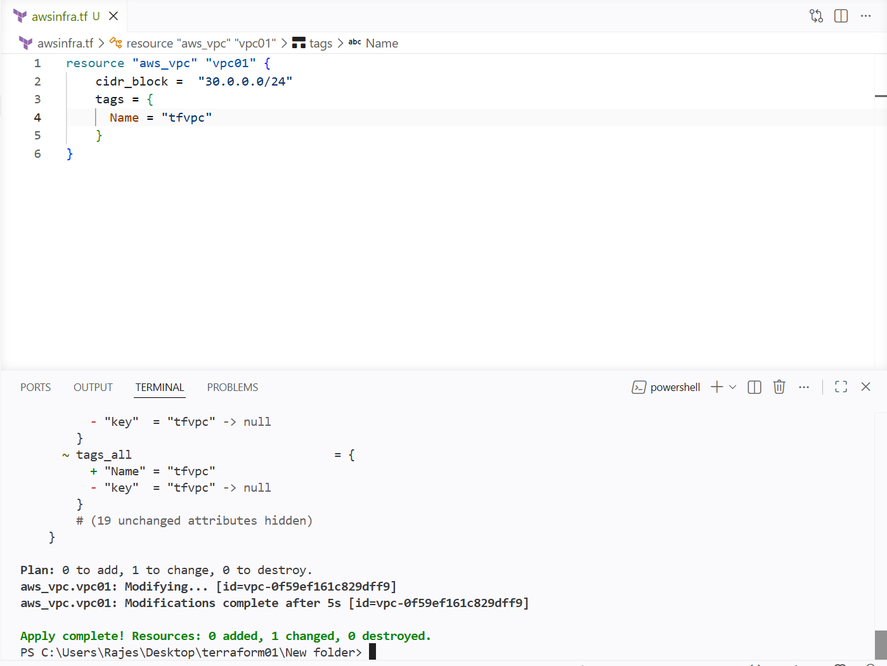

And new vpc has been created

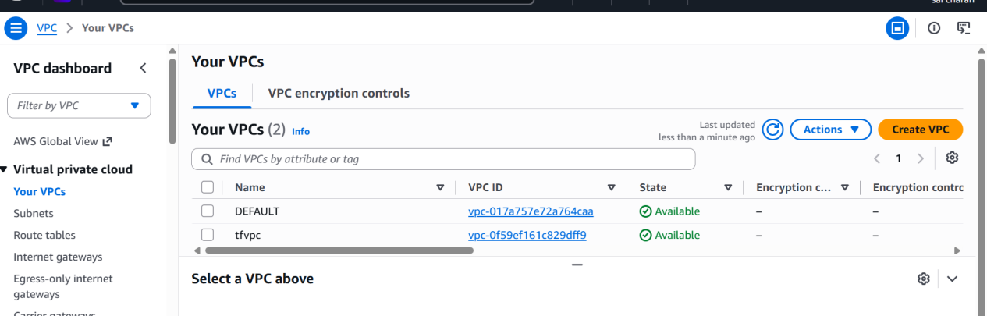

Create Internet gateway

Creating a new internet gateway from the terraform

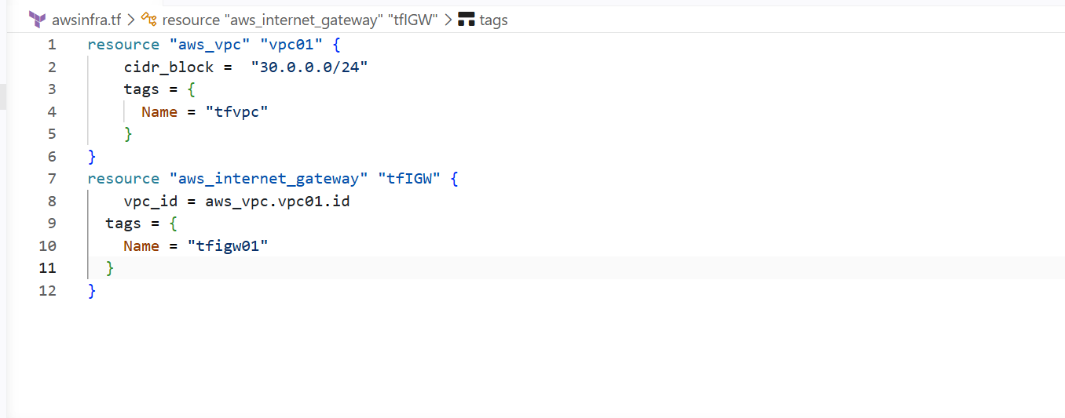

I have created a new internet gateway from the terraform

And

Internet gateway should be attached to a vpc

So

I have mentioned the vpc in my internet gateway block from my previously created vpc

That is vpc.id

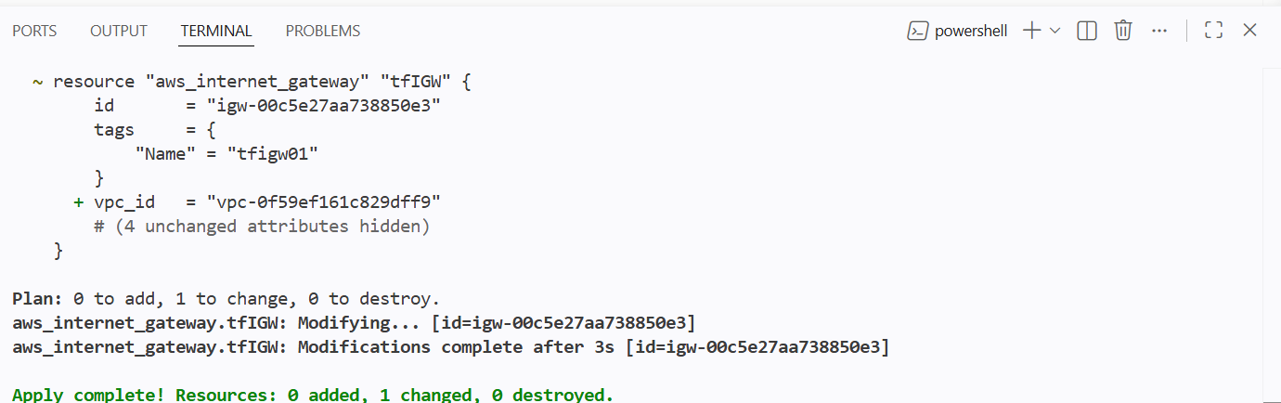

And new IGW has been created and attached to the vpc

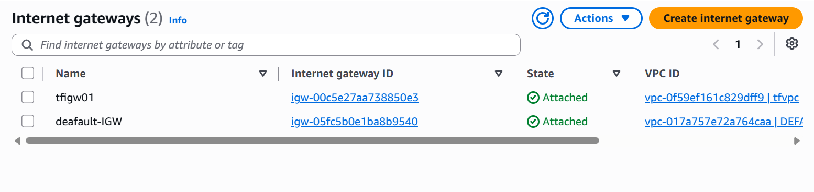

Create Custom Route Table

Creating the new route table using the terraform

For this I need to attach the vpc to the route table

So I have given vpc.id from tf or direct vpc.id

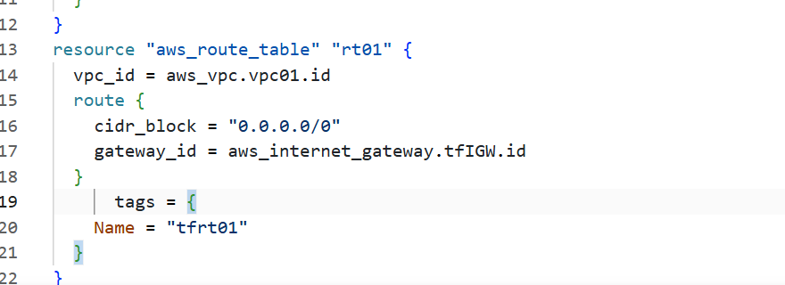

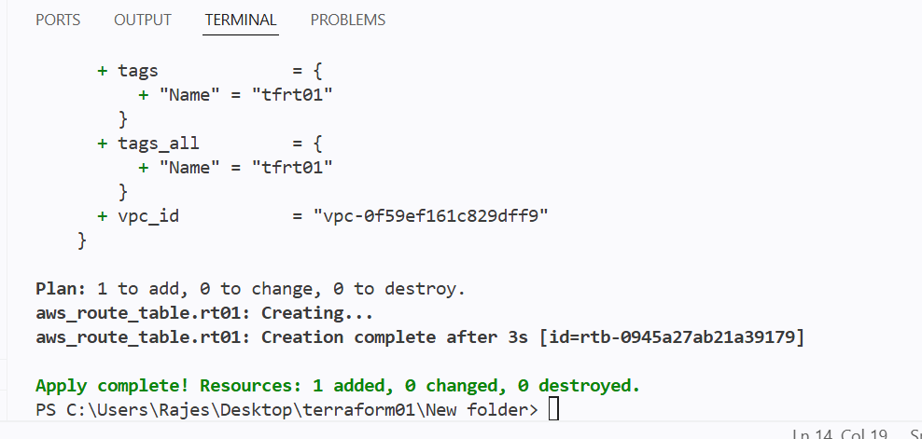

New route atble has been created and attached to the vpc

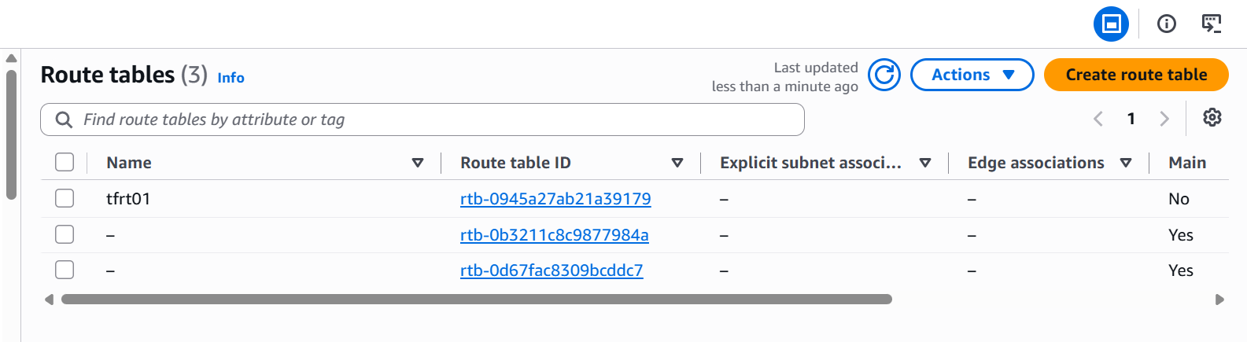

And internet gateway route has been given

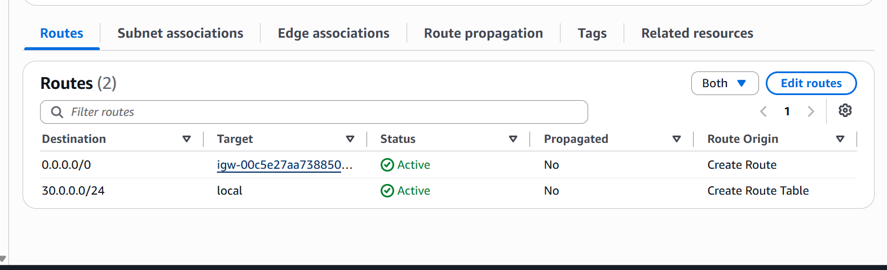

Create Subnet

Creating a new subnet using terraform

For creating the subnet we need to give vpc id , cidr-block for subnet and tag

We can also give AZ

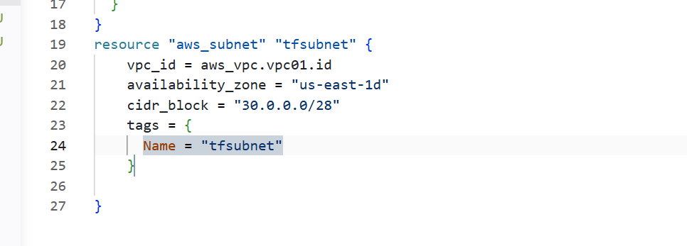

Now the subnet is attached to vpc and its cidr block has been created with the new name in an AZ

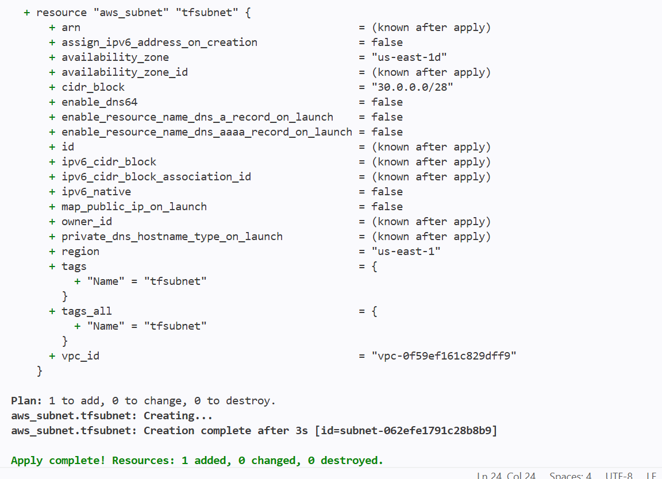

New subnet has been created using the terraform

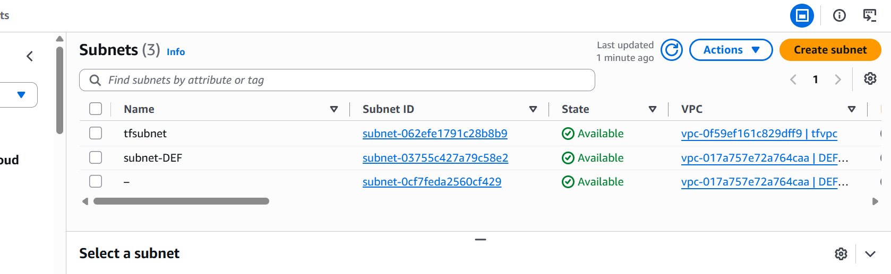

Associate subnet with Route Table

Attaching the newly created subnet to the route table

I will be changing the resource block that I have created for the subnet and adding a route table in it

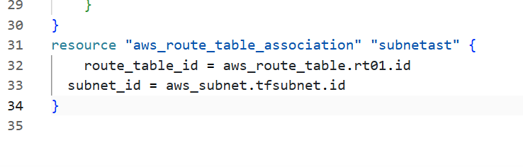

Creating a new resource block for the subnet associating with route table

And adding the two ids of the subnet and route table

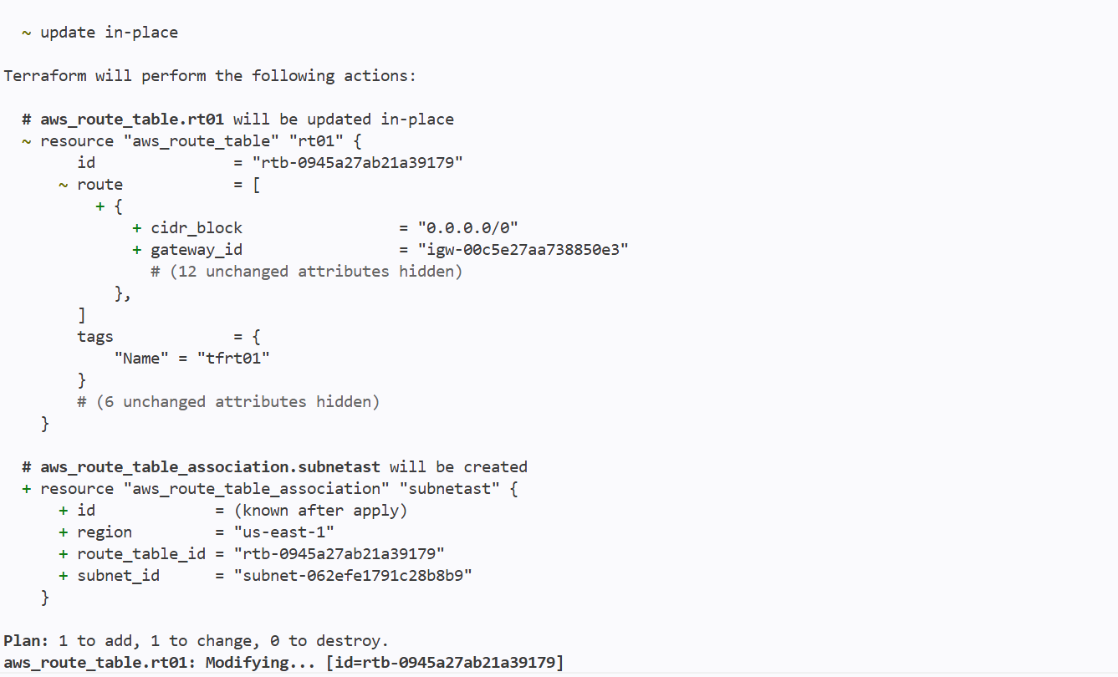

We can see subnet has been added to the route table

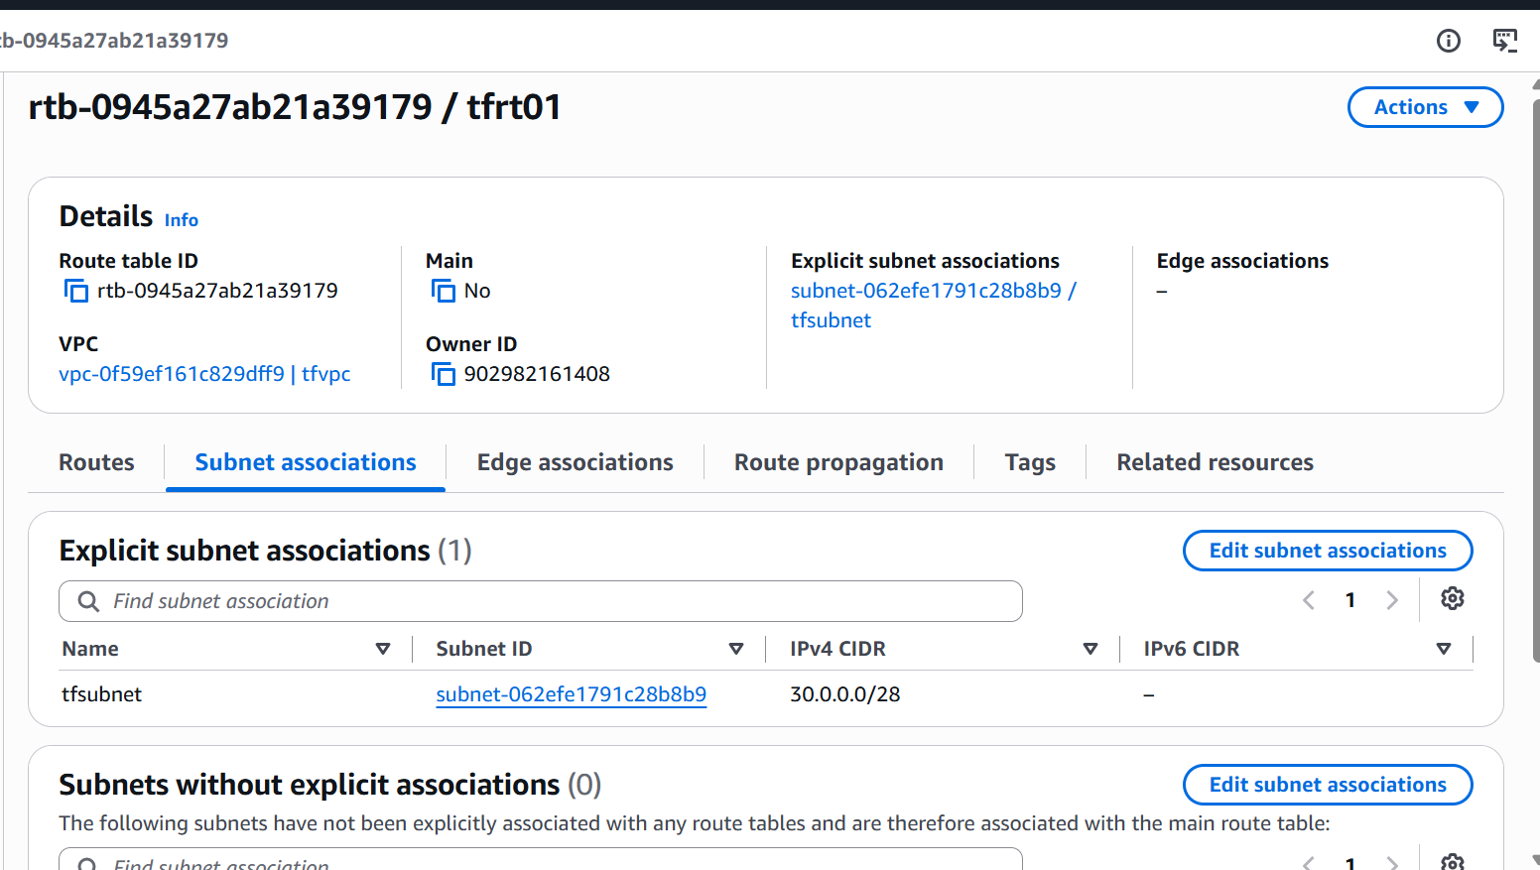

Create Security Group to allow port 22.80,443

Creating a new security group and allowing port numbers 22,80,443

So I will be adding the port numbers in ingress
And outbound in egress

Ingress and outgress should contain

Description
From_port
To_port
Protocol
Cidr_blocks

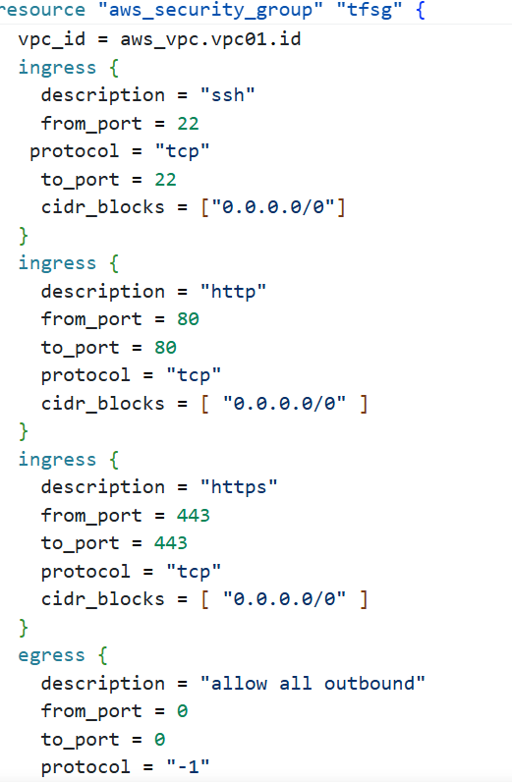

New security group with given tag has been created

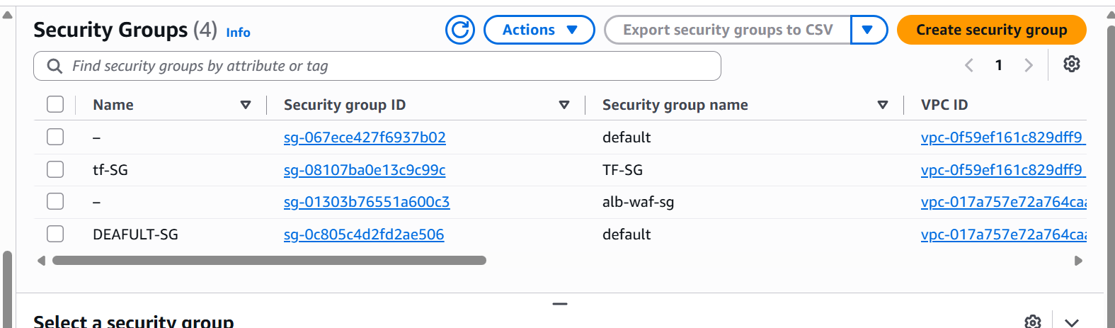

And inbound rules has been opened for the given port numbers

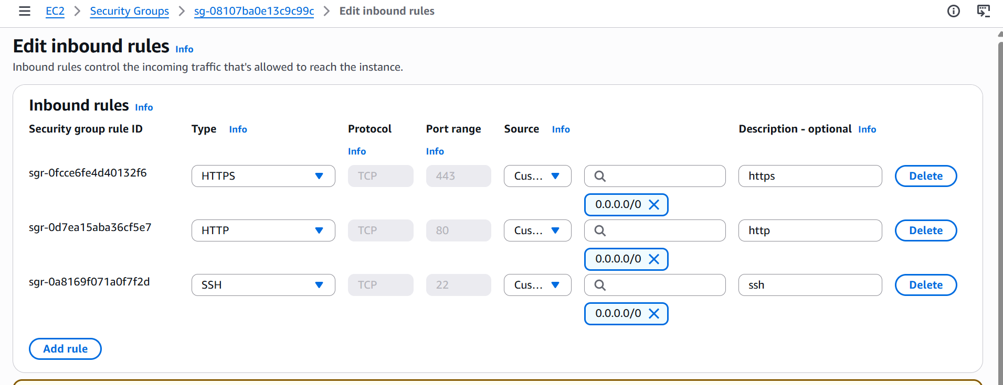

Create a network interface with an ip in the subnet that was created in step 4

We should be giving the subnet id and security group for th network interface

It is optional to give private Ip

We don’t mention the private ip then aws will automatically asssign one ip

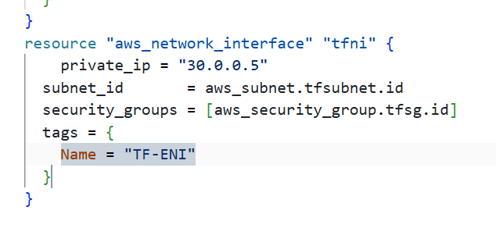
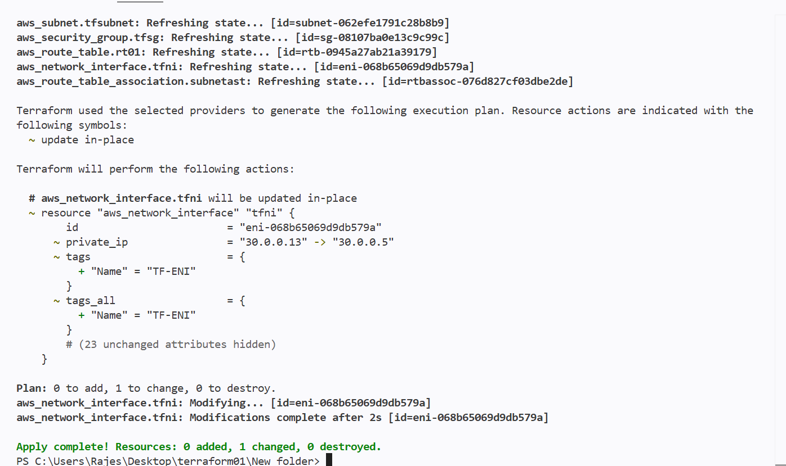

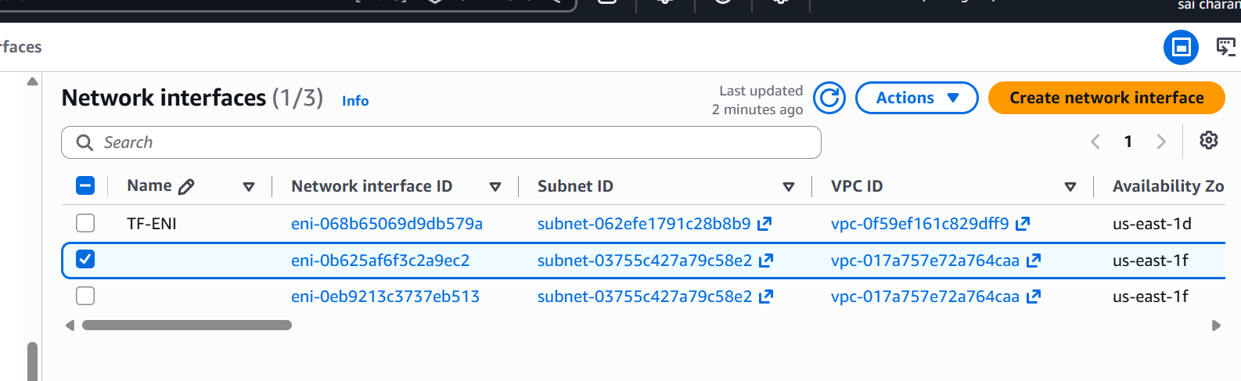

We havent attached it to any instance so it is showing as available

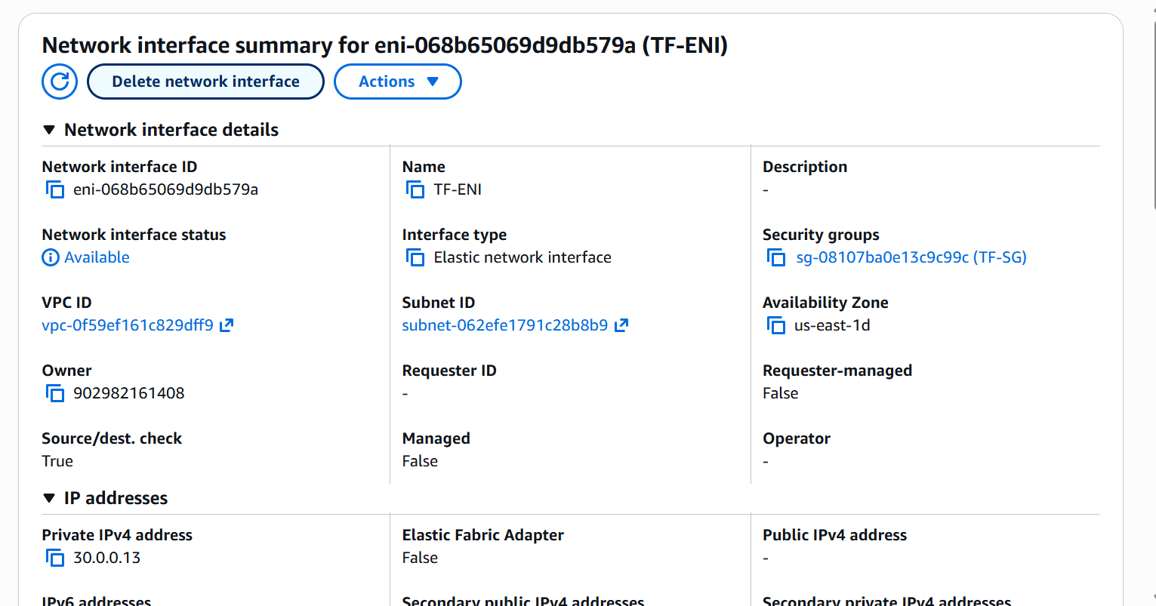

Assign an elastic IP to the network interface

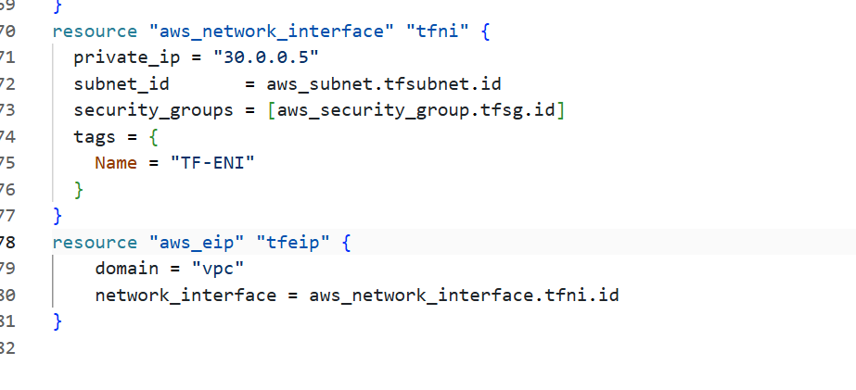

I have used aws_eip for assing an elastic ip to the network interface

I have used domain as vpc
And given network interface id

If I have multiple eni private ips then I will mention which private ip to attach to the elastic ip
I will use associate_with_private ip and given private ip which one to assign the eip

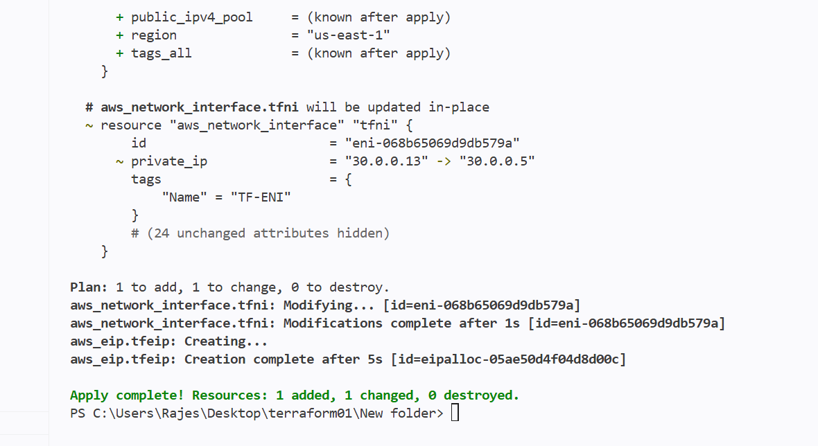
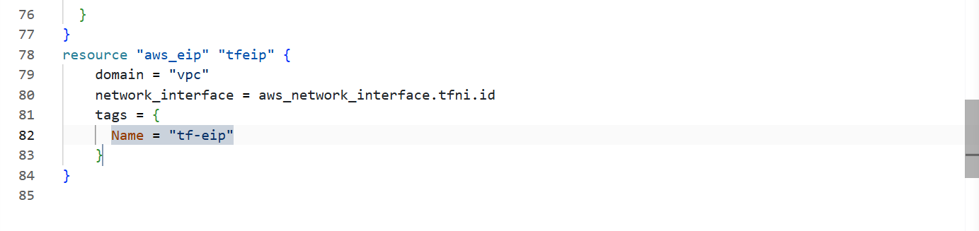

New eip has been created

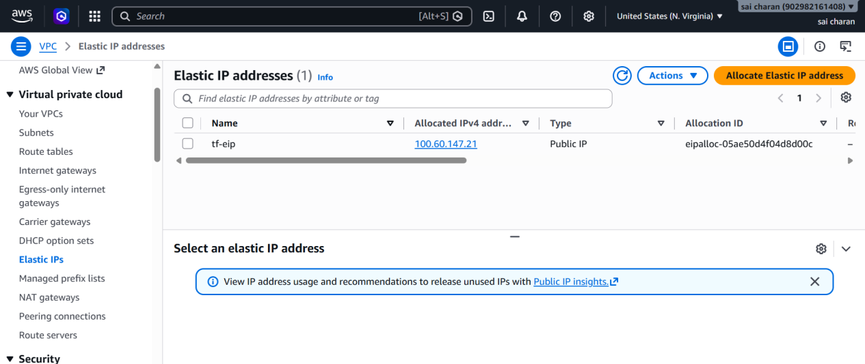

Create Ubuntu server and install/enable apache2

Writing a resource block to create a new instance and installing apache2

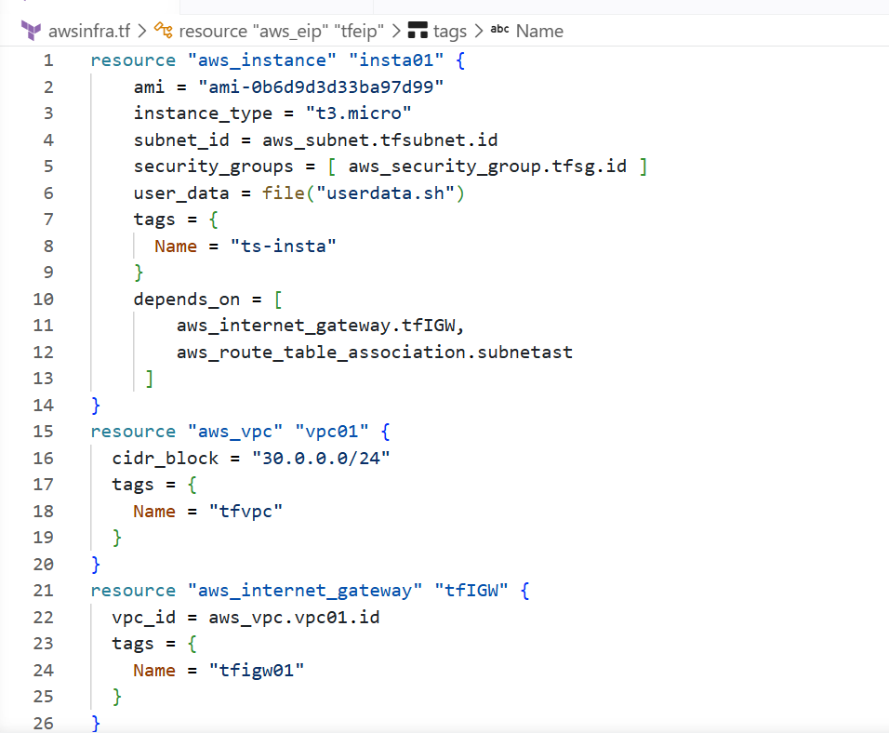

Calling the user data from other location so I have used

User_data = file(“filename”)

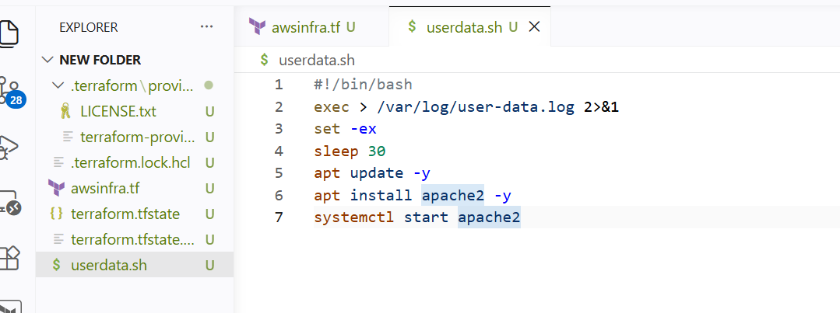

Also attached the eip to the instance

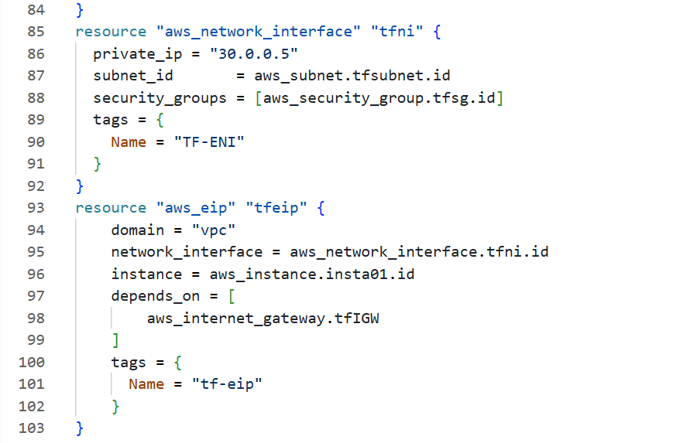

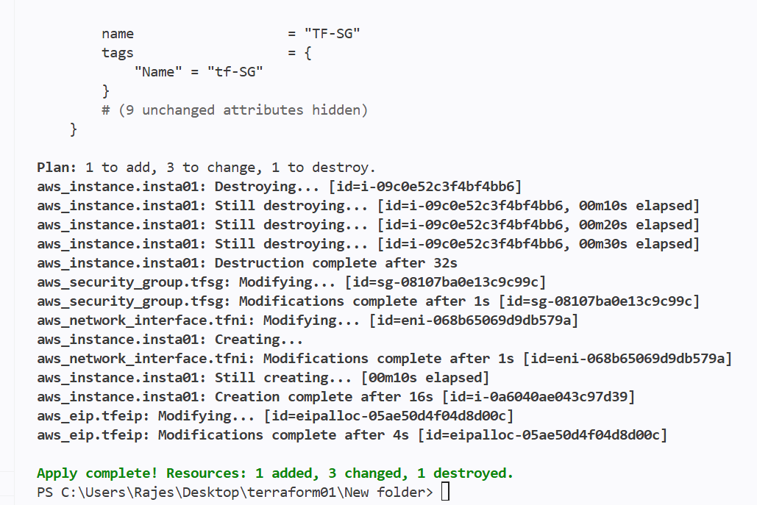

And the apache page can be accessed through 80 port number



