Setup Jenkins CICD pipeline using freestyle job using Docker containers using below code.
Source code : https://github.com/betawins/hiring-app.git
Stages:
- Git Clone
- SonarQube Integration
- Maven Compilation
- Nexus Artifactory
- Slack Notification
- Deploy On tomcat

Installing the docker in jenkins main server

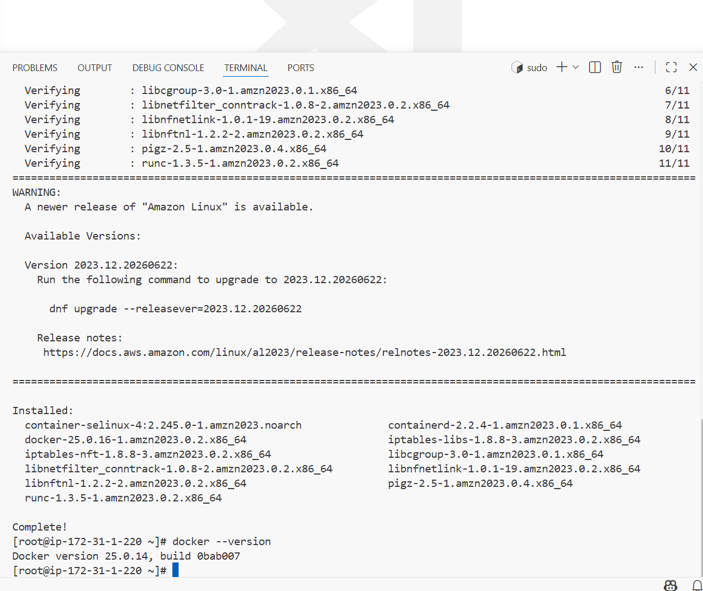

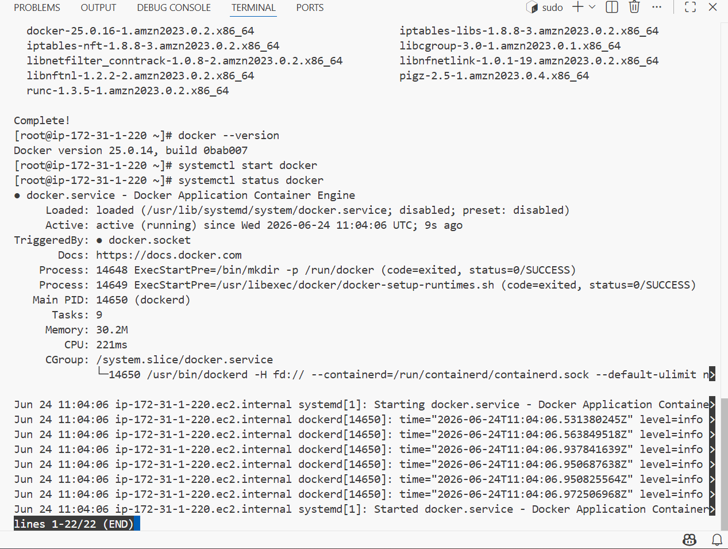

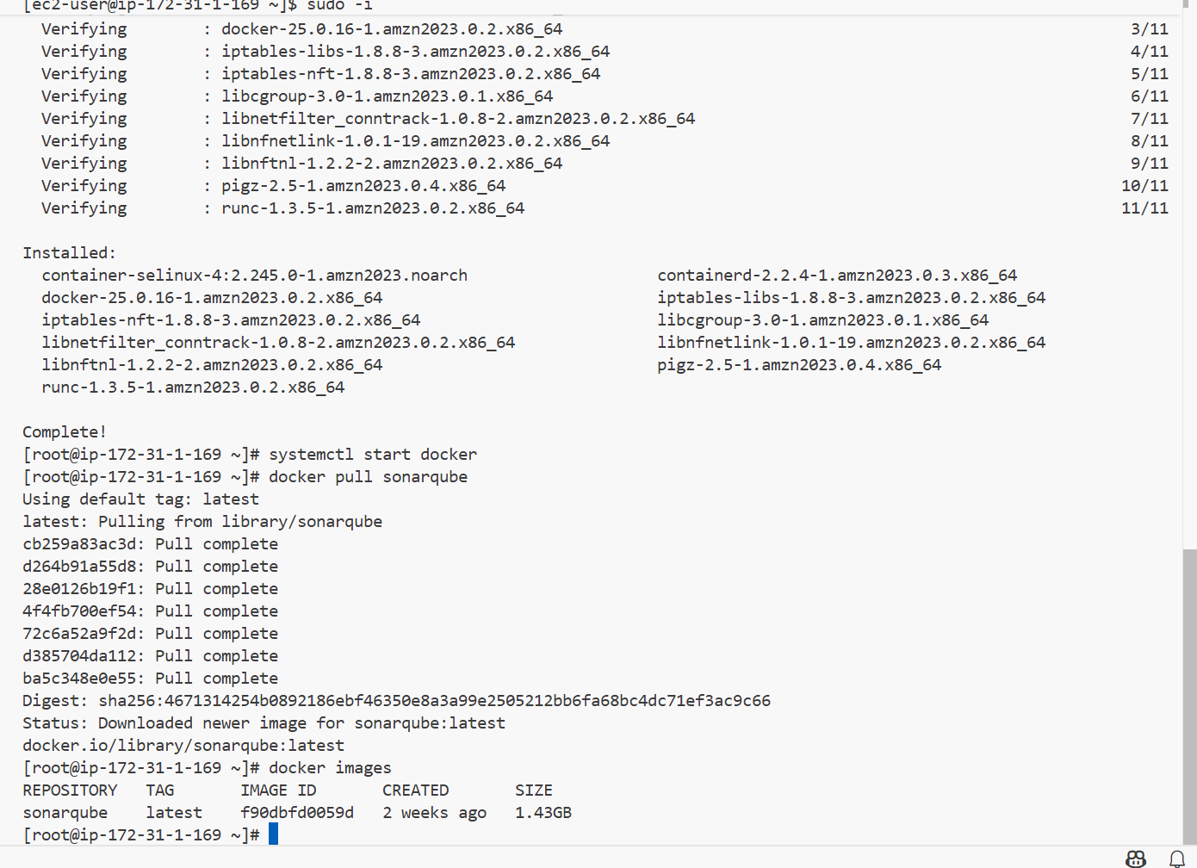

Now after pulling the docker I will be running the sonarqube on diff port number because already old sonarqube is running on 9000

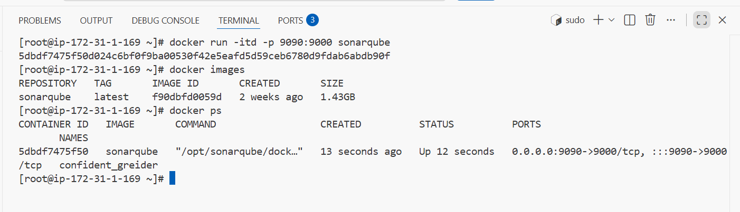

I have installed tomcat:9 from docker

Docker pull tomcat:9

Docker run -itd -p 8090:8080 tomcat:9

Then docker ps

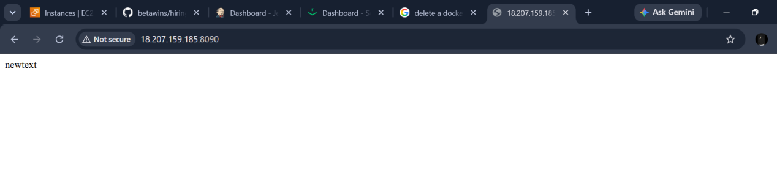

docker run -d -p 8081:8081 sonatype/nexus3

And to login to the conatiner

Use :-- docker exec -it container id shell

I have installed nexus using docker
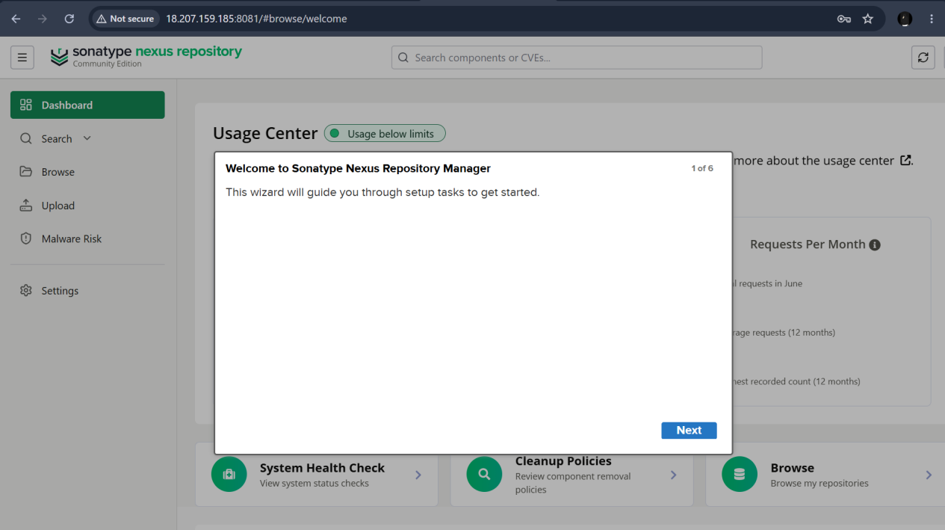

I have 3 images running as containers

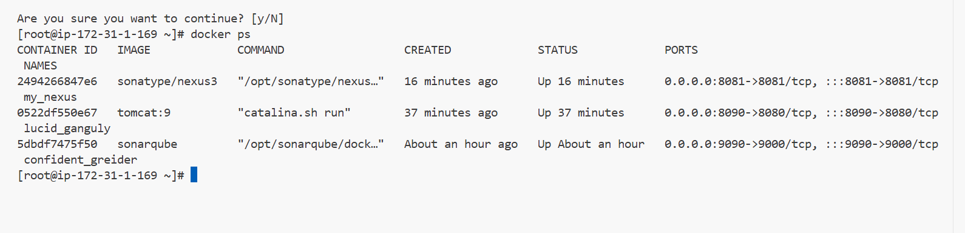

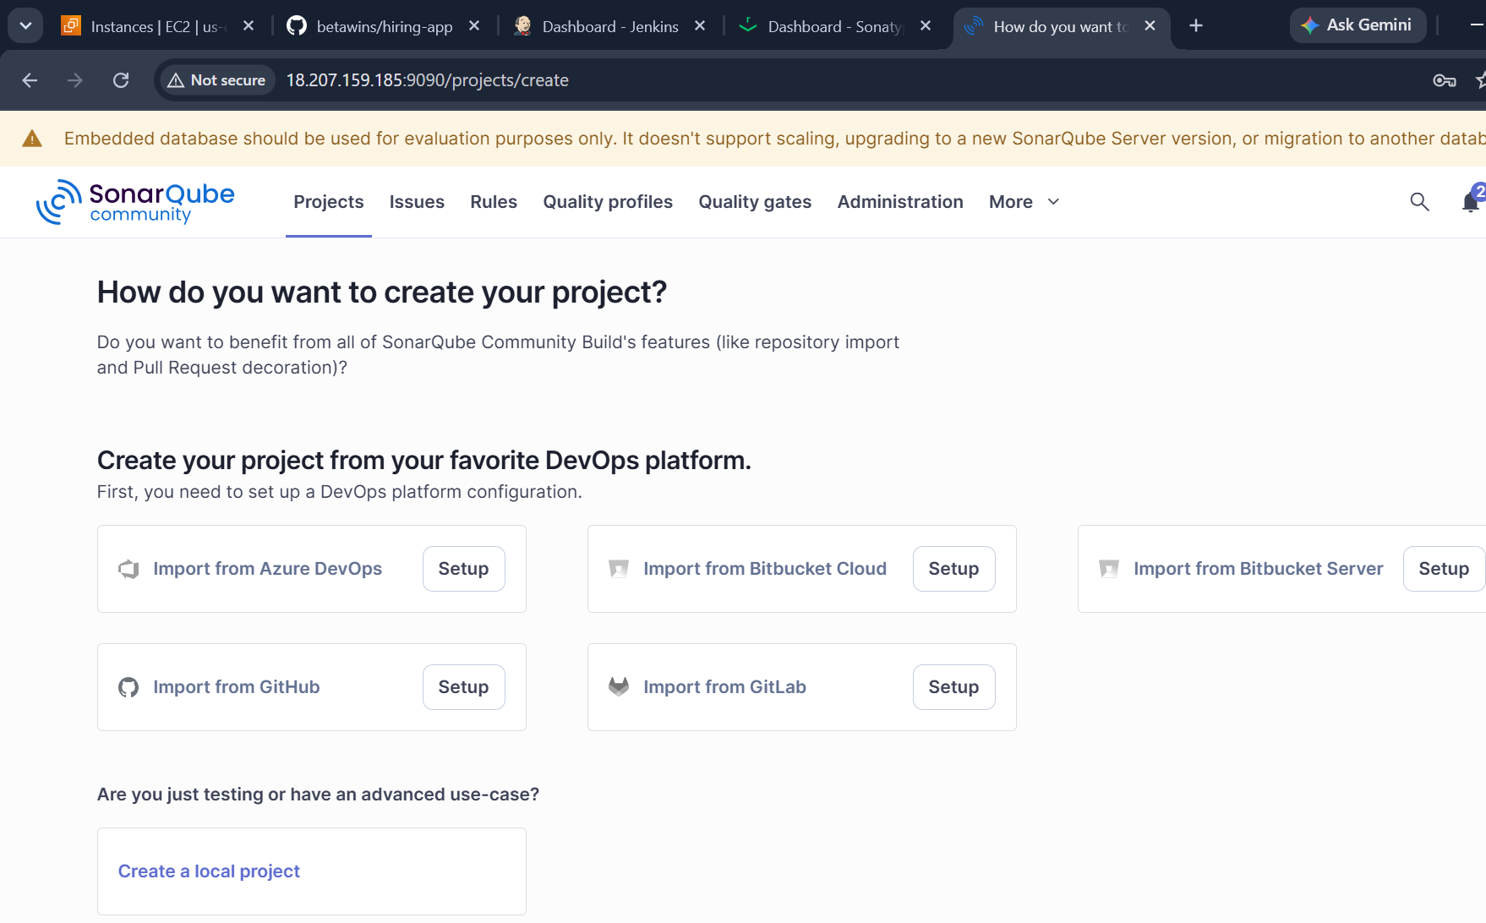
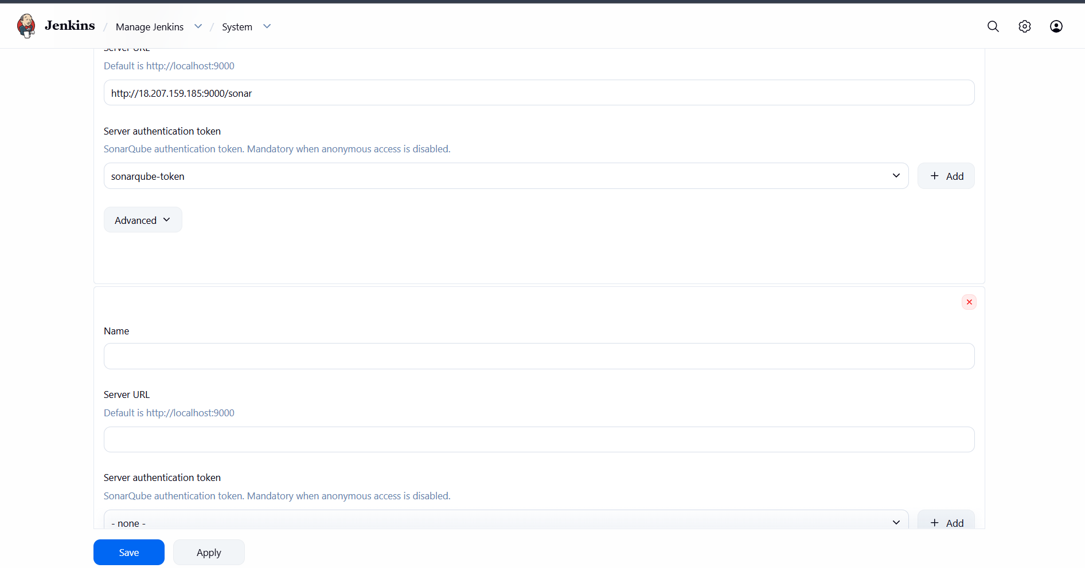

And we need to configure new sonarqube in jenkins ui for this we need a new token

And I havae my old sonarqube settings and will add new section for new docker sonarqube

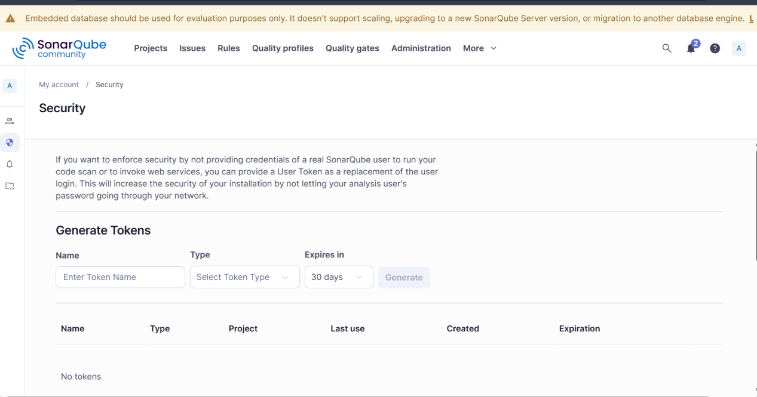

After giving sonarqube token
We are good with sonarqube

Installing maven in jenkins cli

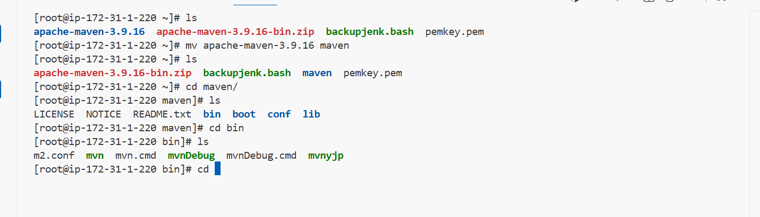

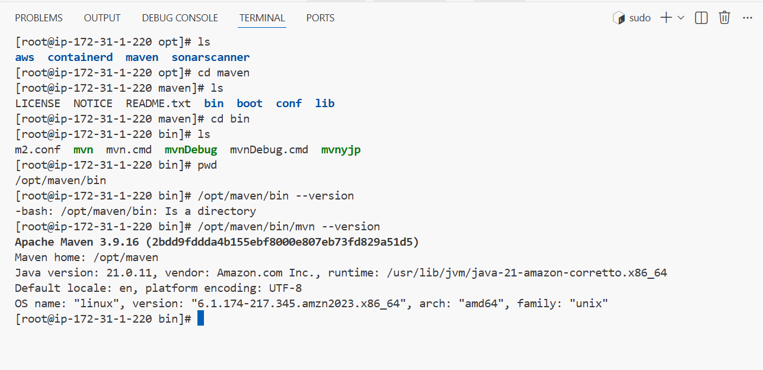

Changing the bash profile

Vi ./bash_profile
Because direct mvn command wont be working because it is downloaded using link
So I will be giving mvn path Ie; /opt/maven/bin/mvn

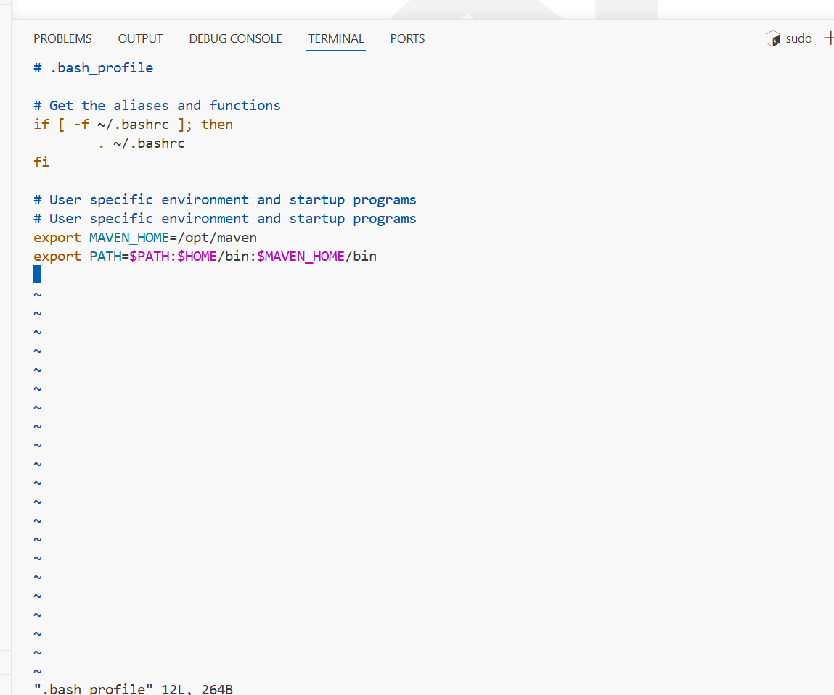

Now mvn --version will run
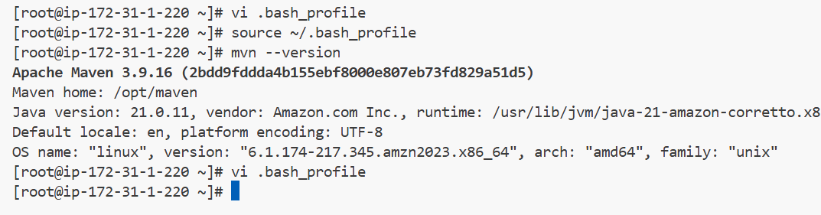

Then I will be installing the maven plugins in the jenkins ui and will be configuring
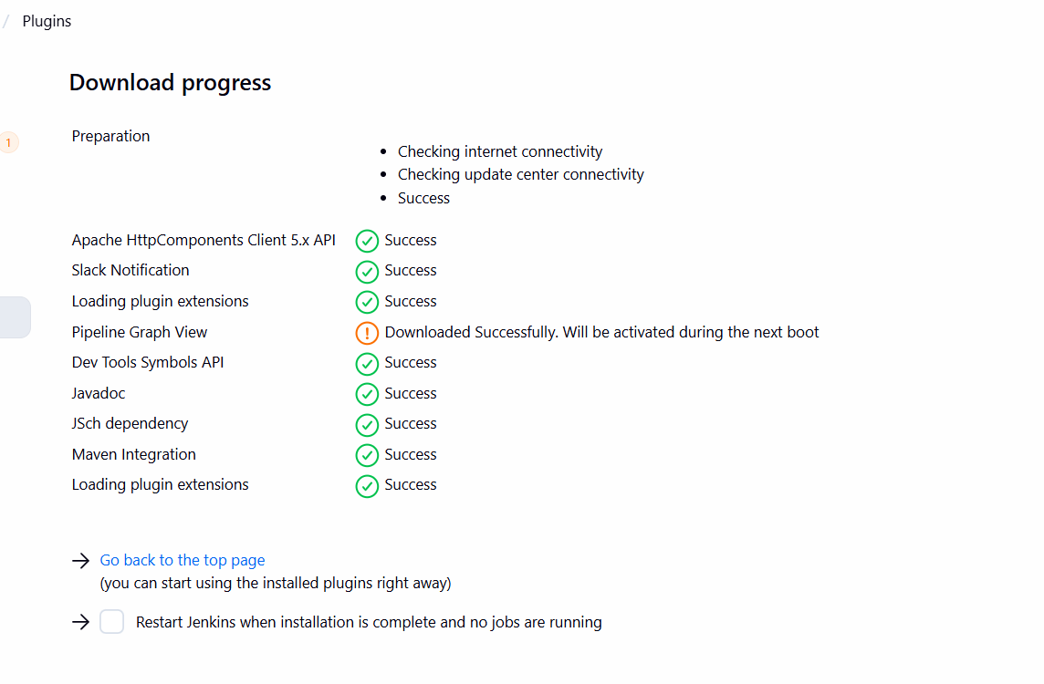

And will also be installing nexus plugins
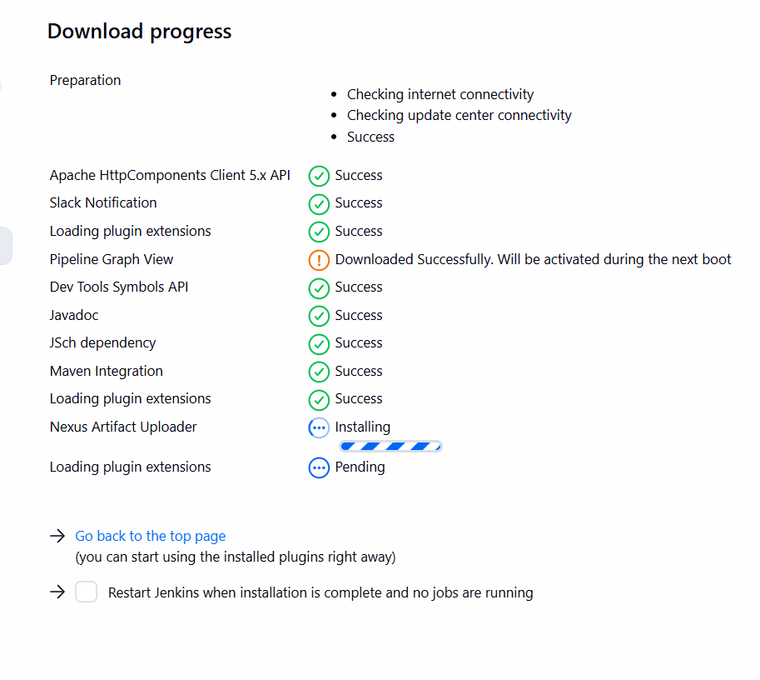

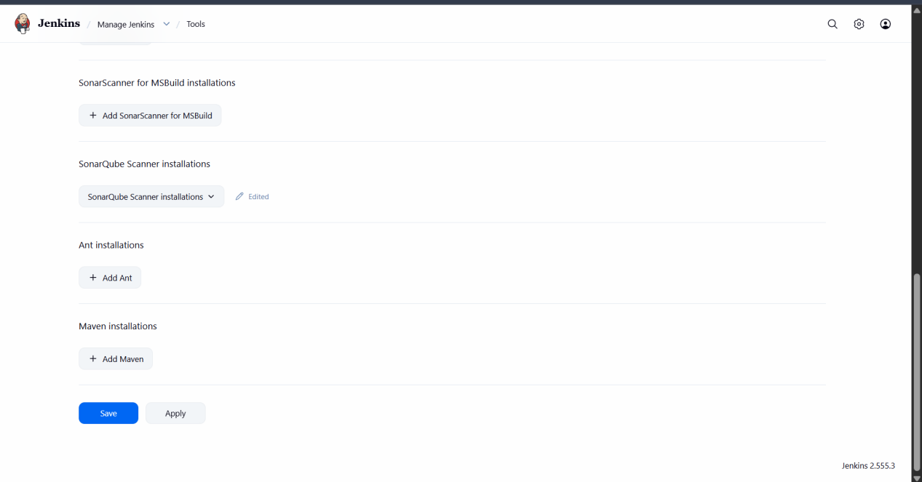

Then configure the maven

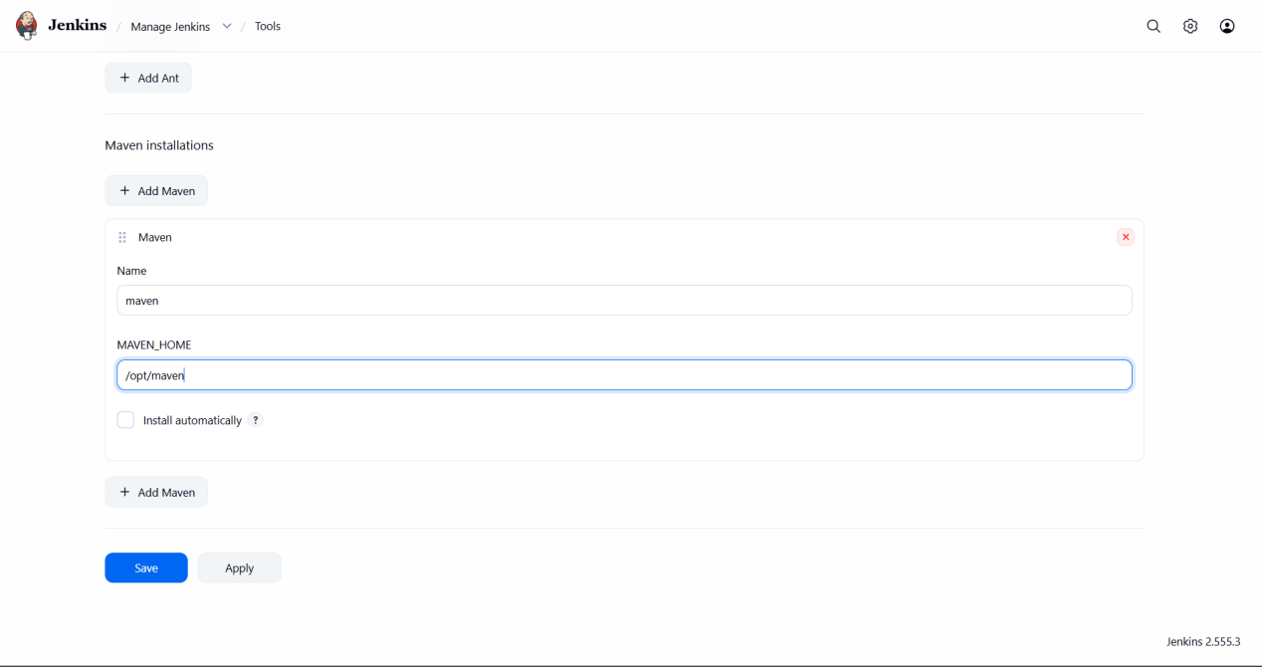

We have to give the downloade maven path

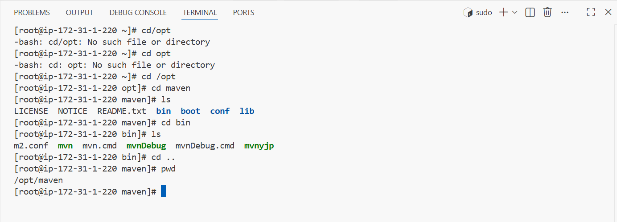

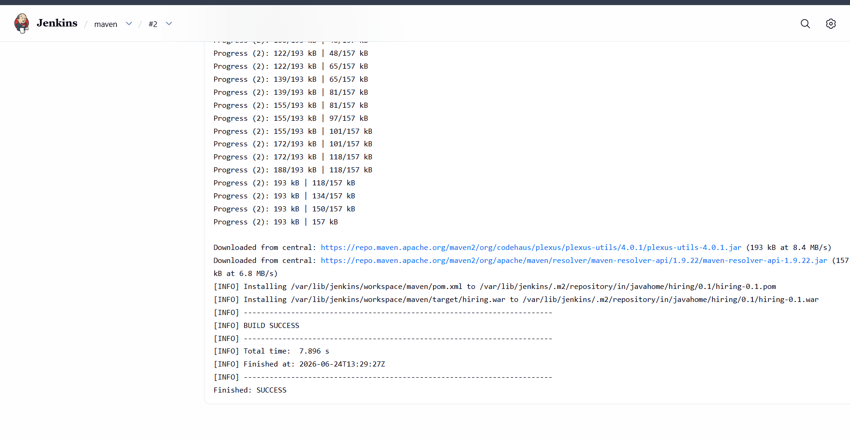

Maven has been successfully buit

Now configuring nexus for artifacts deployment

As I have installed using docker now I need to configure in jenkins ui

Install the plugin nexus artifact uploader

Now are all good for CI/CD job

I will be using clone,sonarqube,maven,nexus,slack noti, and finally deploy to tomcat

Creating a new job

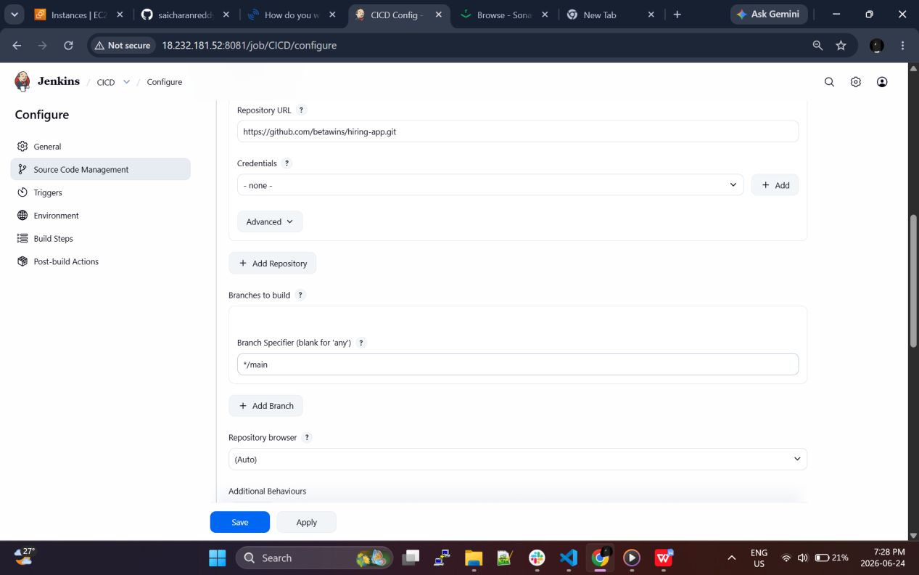

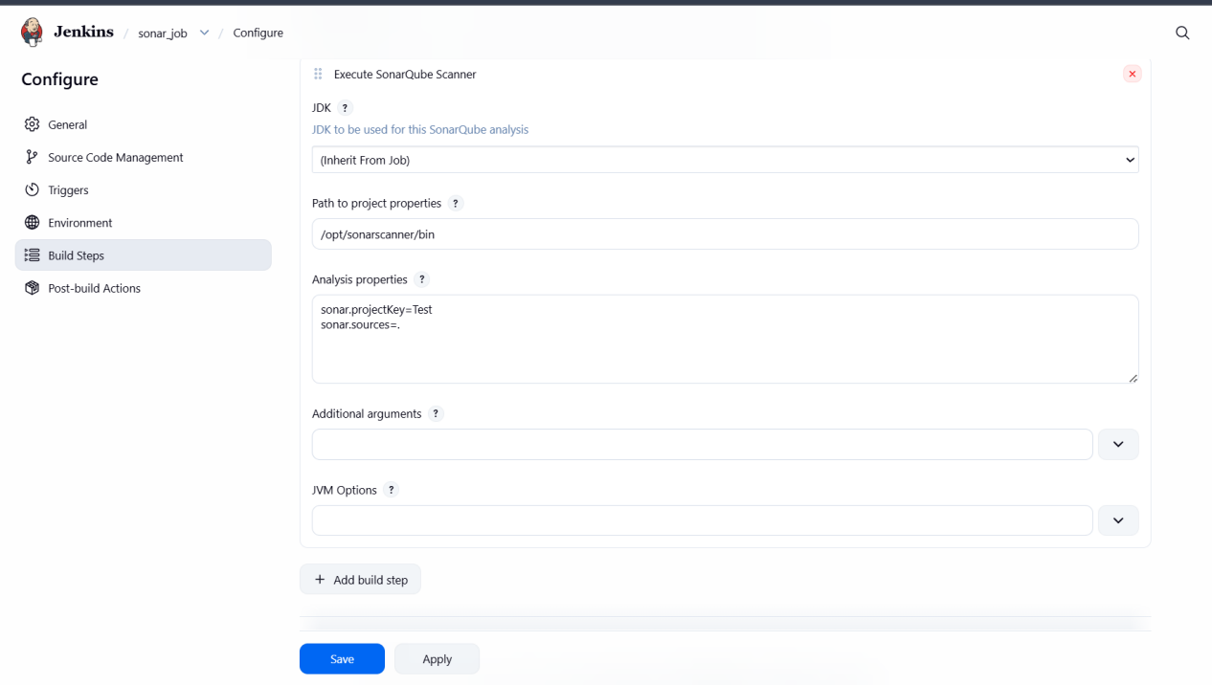

Gave sonarqube attachments

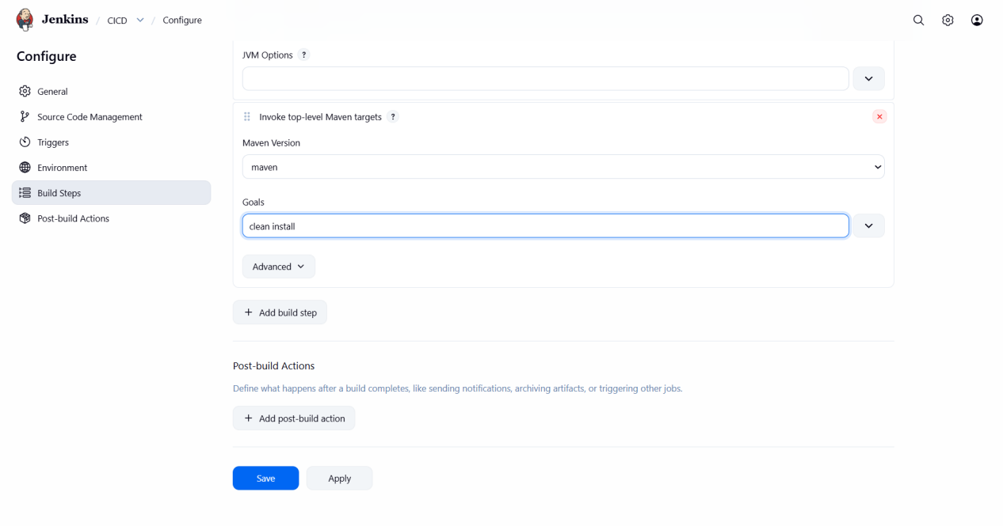

Group id and version will be seen in pom.xml file

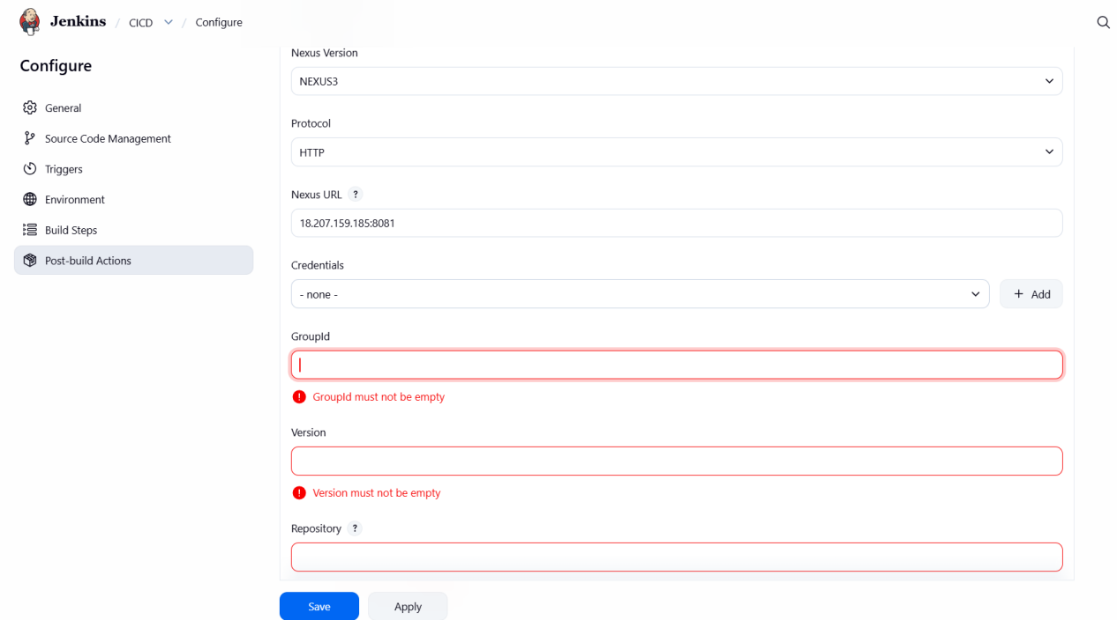

Create a new repo and give this repo name in nexus repositary name

I have reinstalled nexus as my old nexus is not working so now I have down loaded nexus2

And to login

Ip:portnumber/nexus
For nexus2
The deafult credentials for nexus2 is admin & admin123

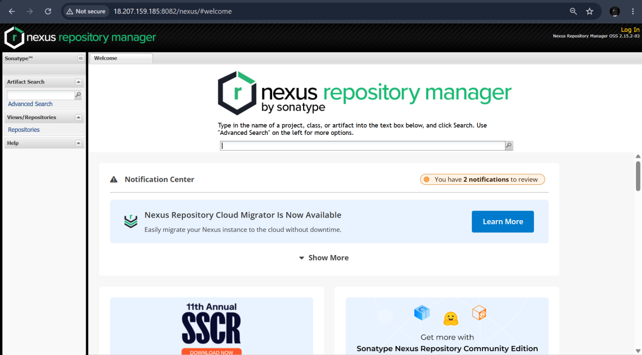

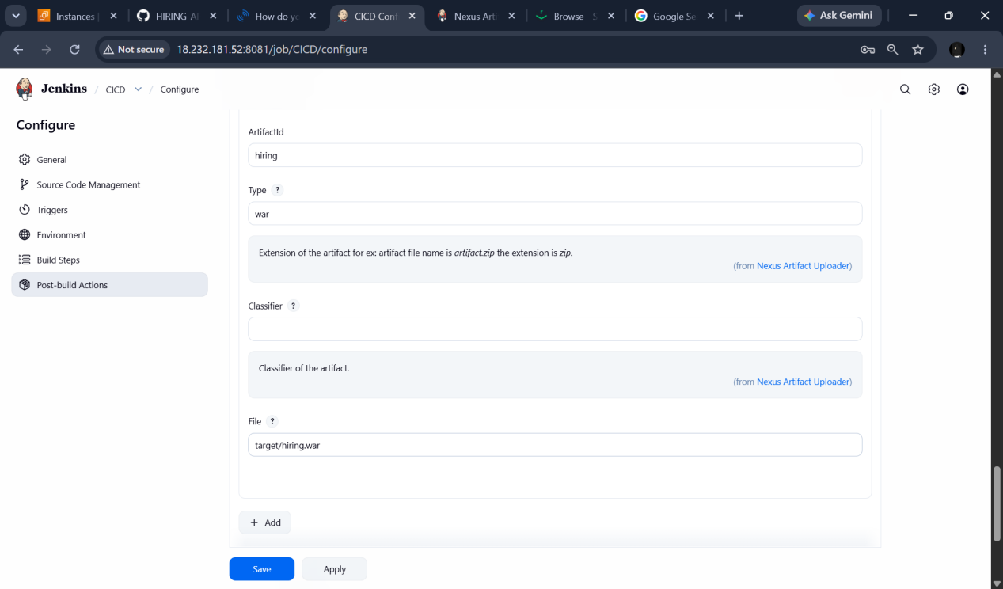

Now to deploy to tomcat I will be installing deploy war/ear file to container

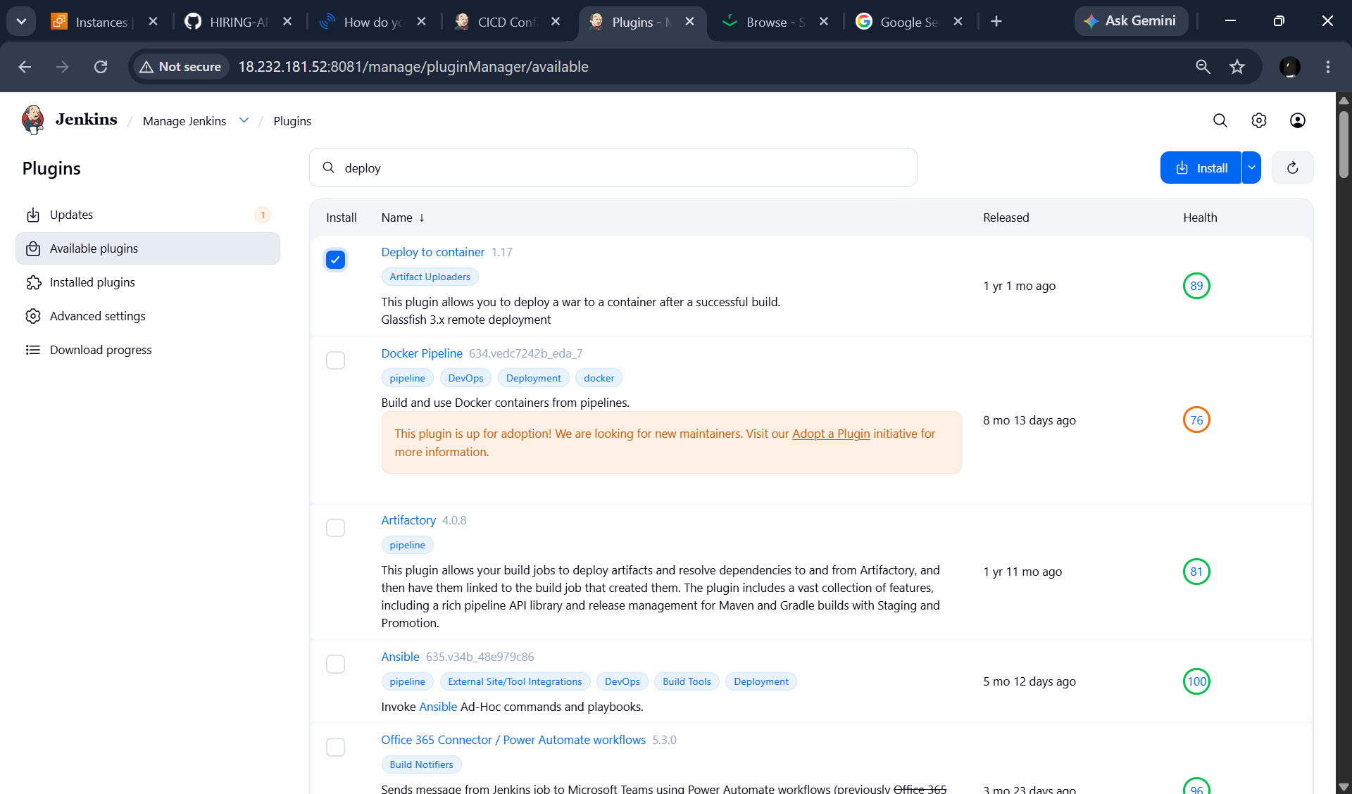

And also we need to add new roles in the tomcat-users.xml file

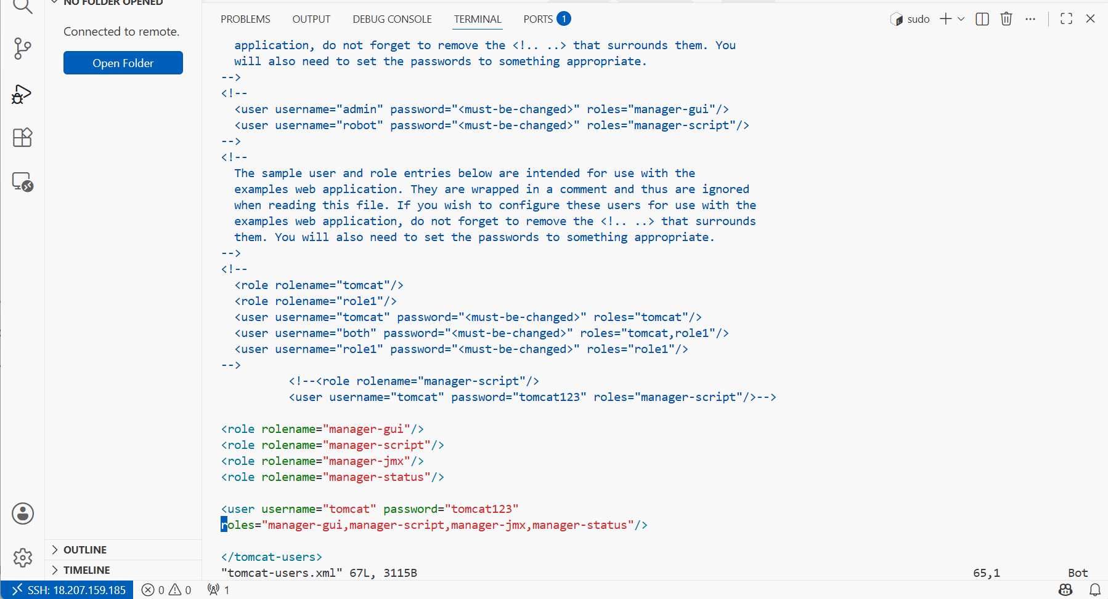

Move the contents from webapps to webapps.bak

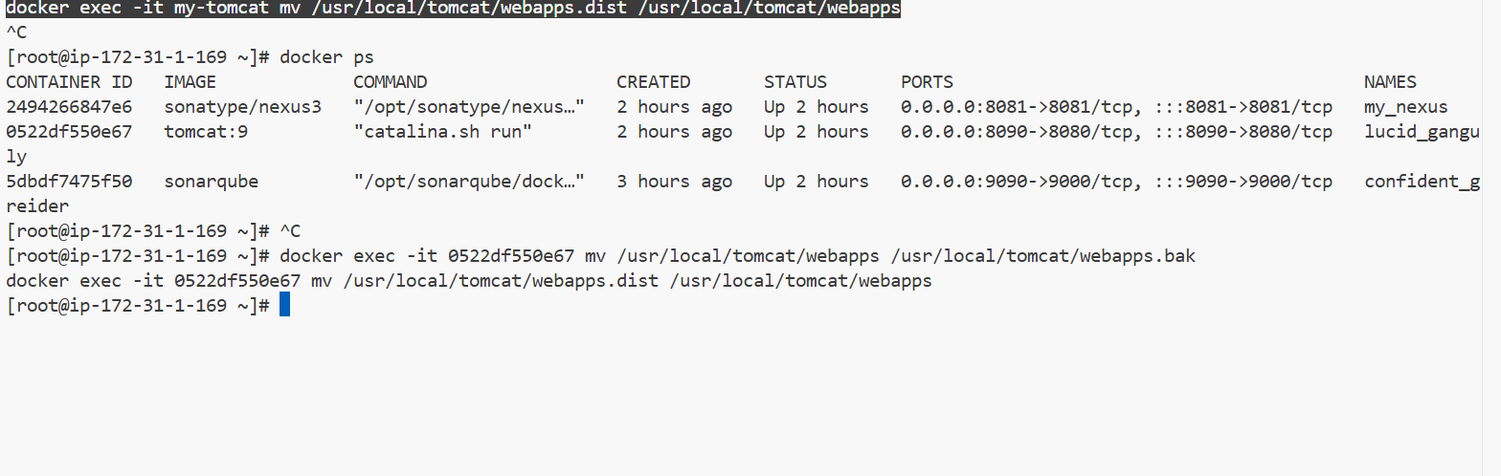

Change the manager configuration file inside the tomcat

Change the context.xml and comment on value

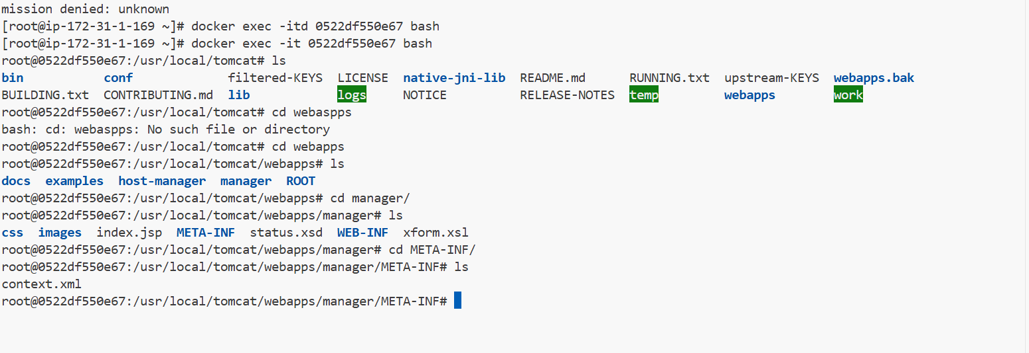

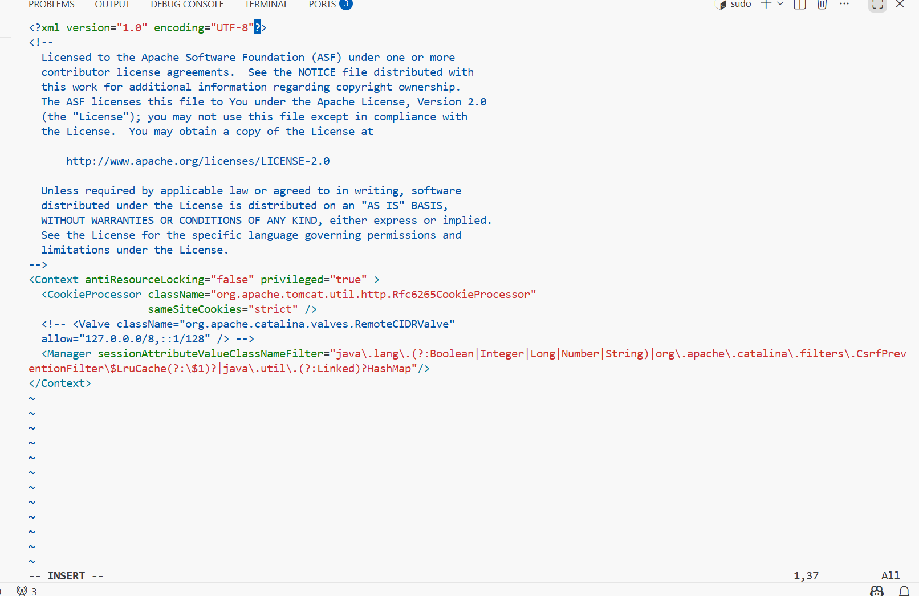

Also we need copy all webapps to webapps.bak

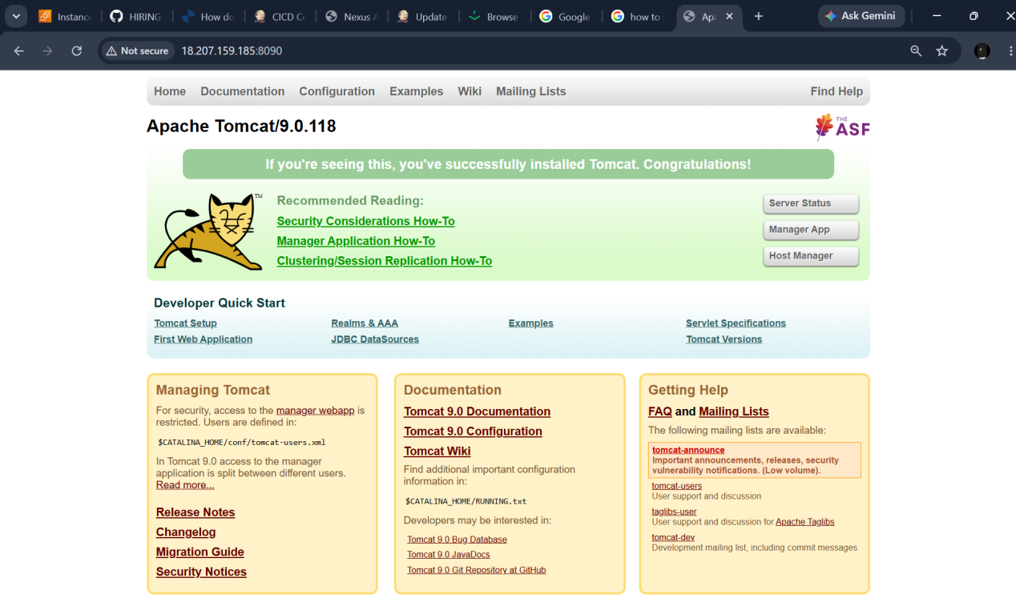

Now we need to create a job for CICD

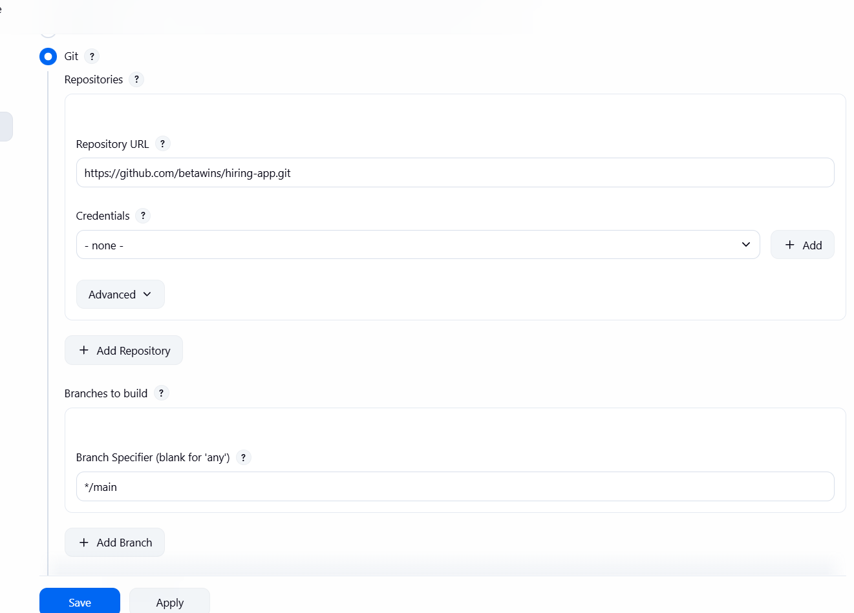

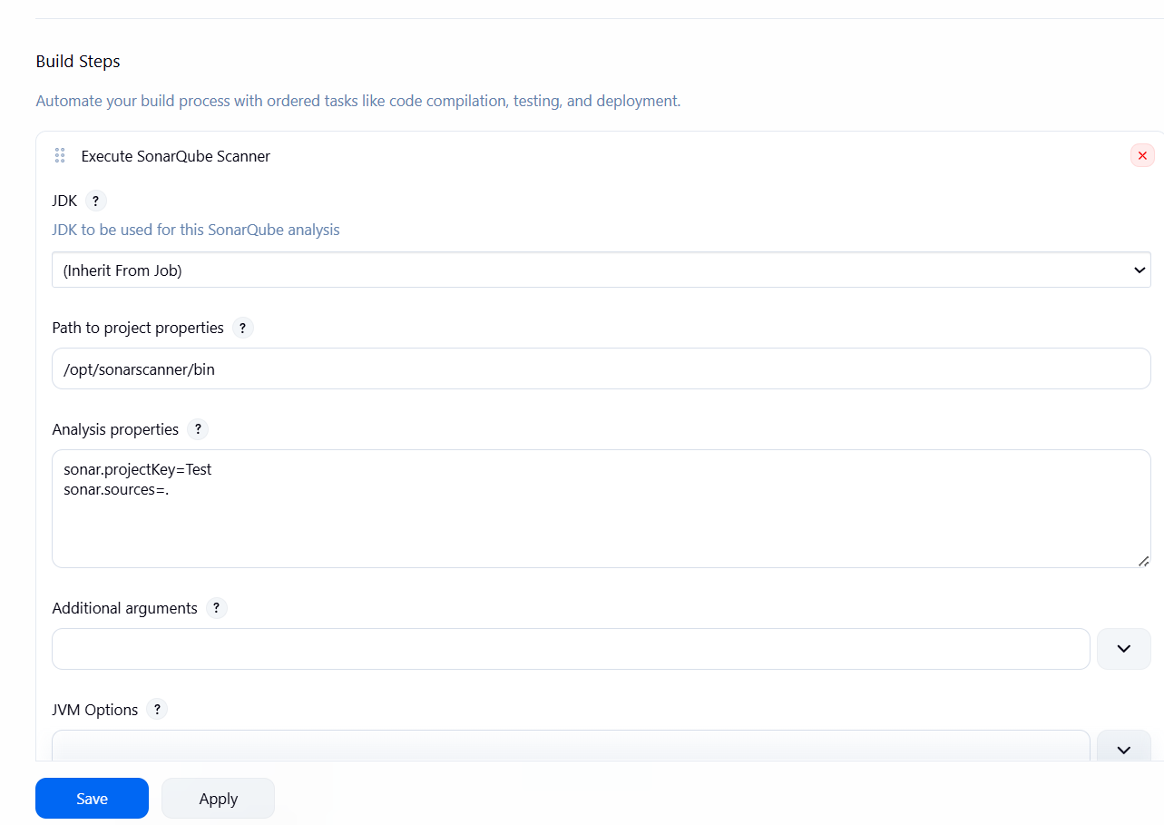

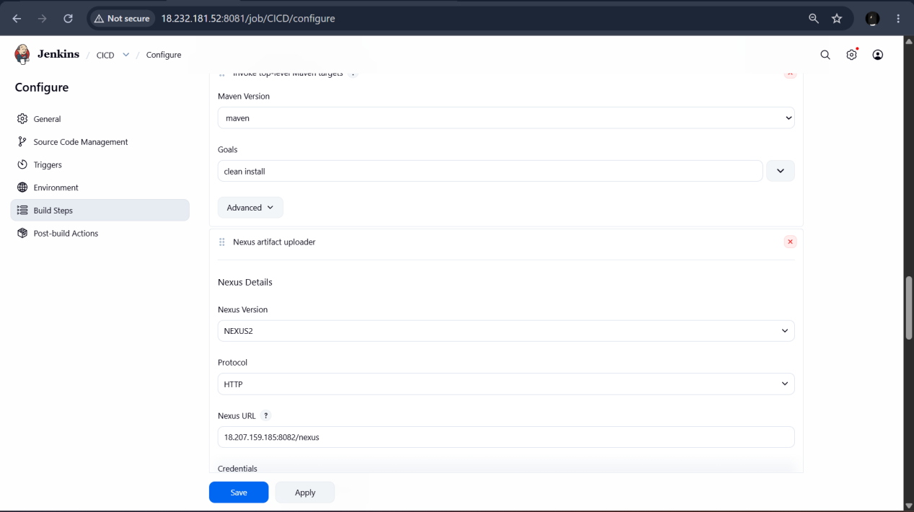

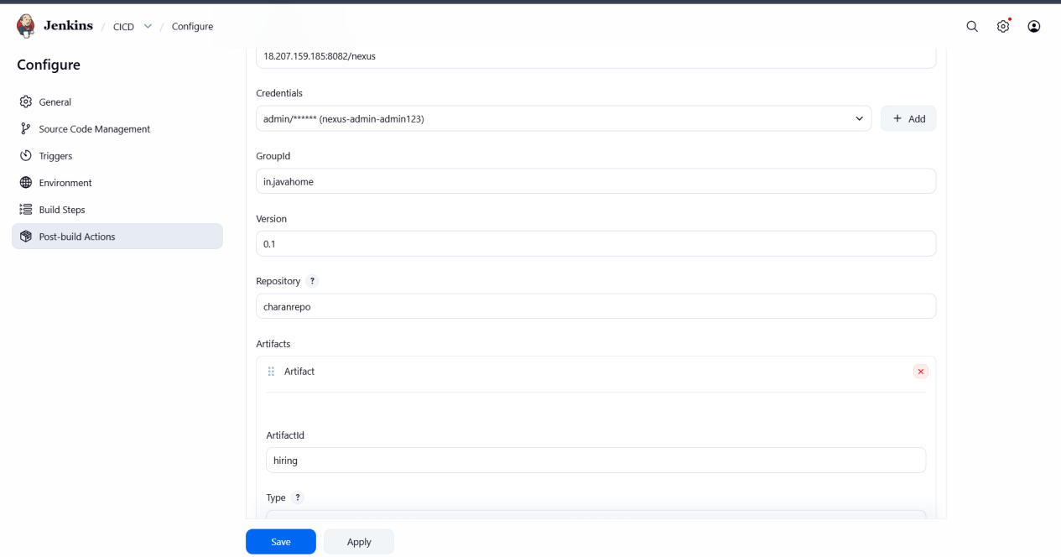

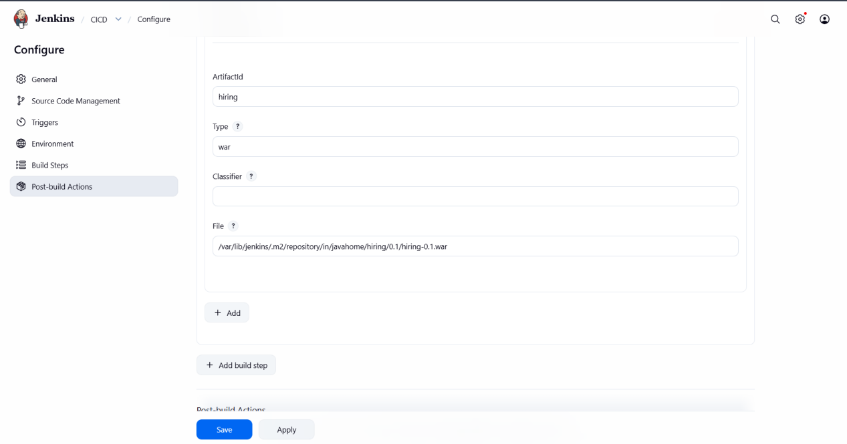

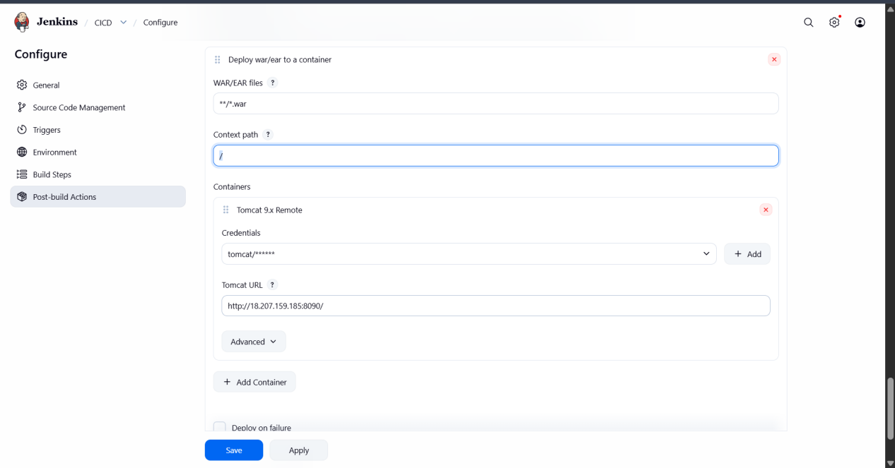

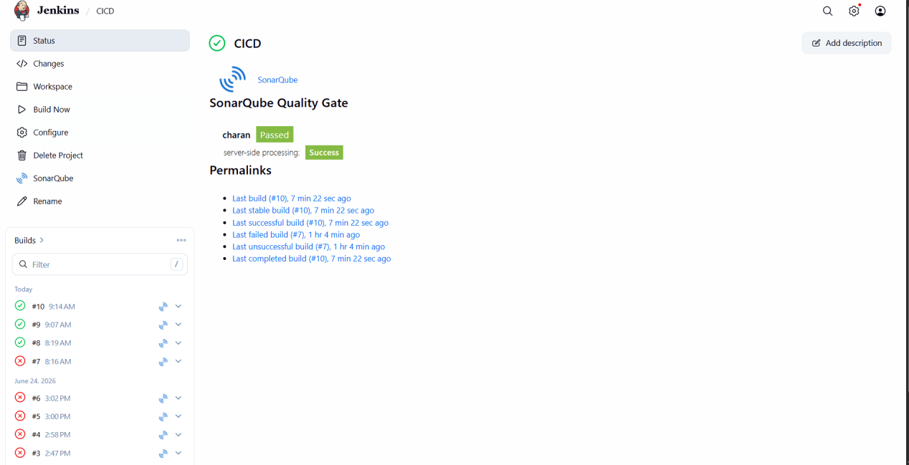

Job has been successful

Now we be checking SONARQUBE AND NEXUS AND TOMCAT

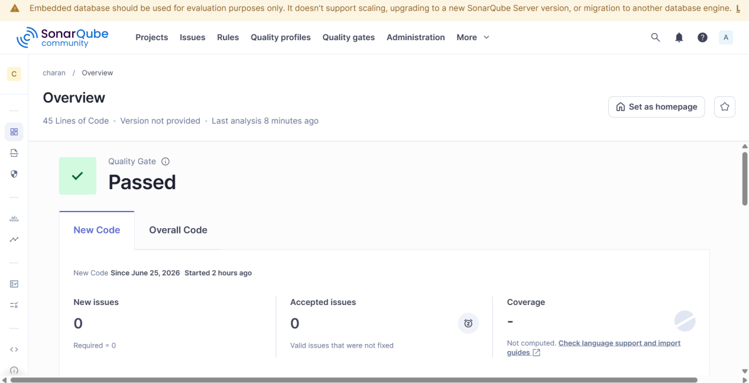

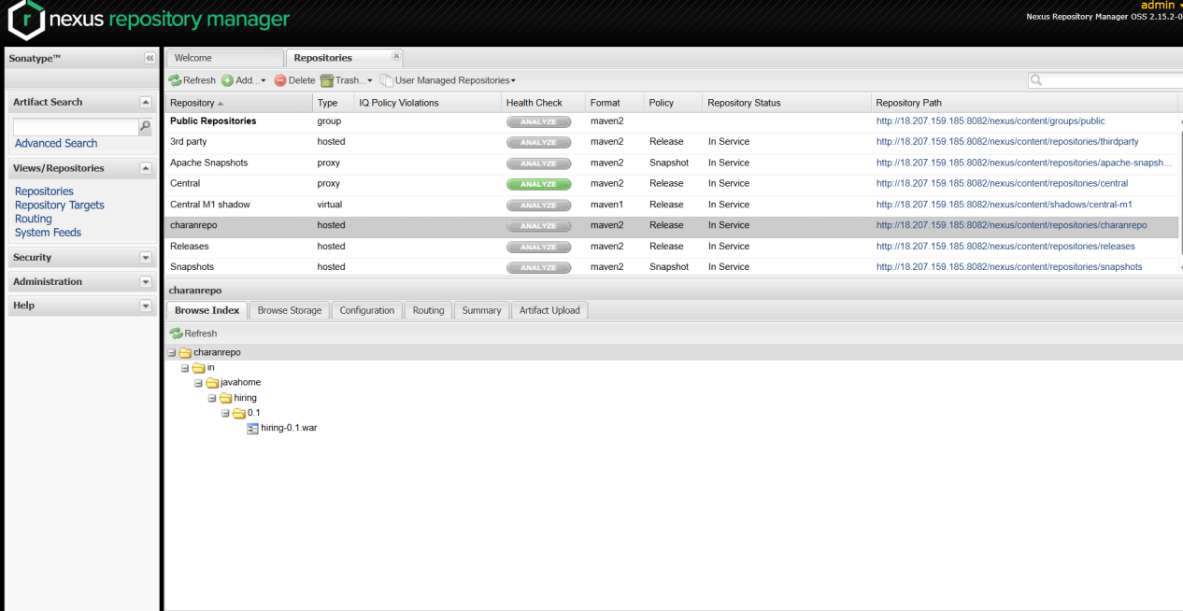

I have successfully deployed from nexus to tomcat and hiring.war file can be seen

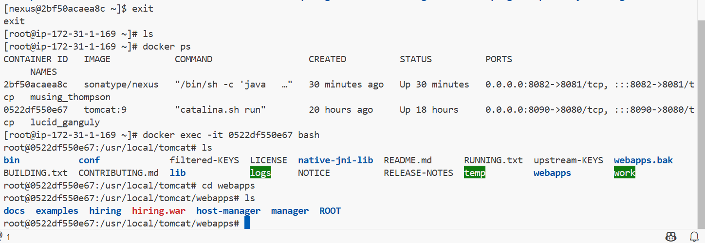

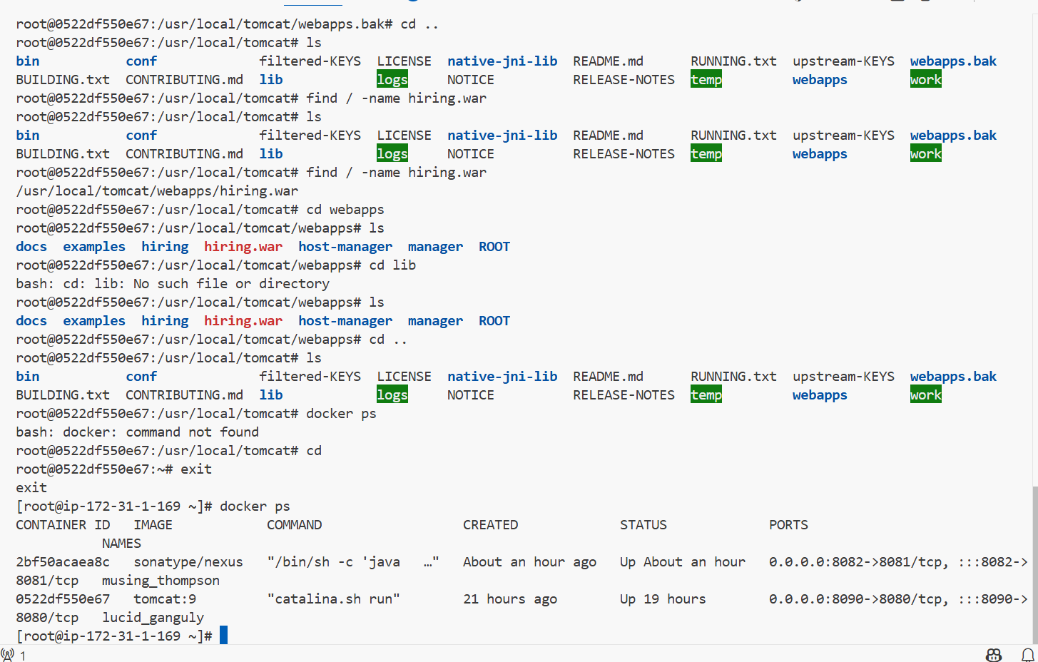

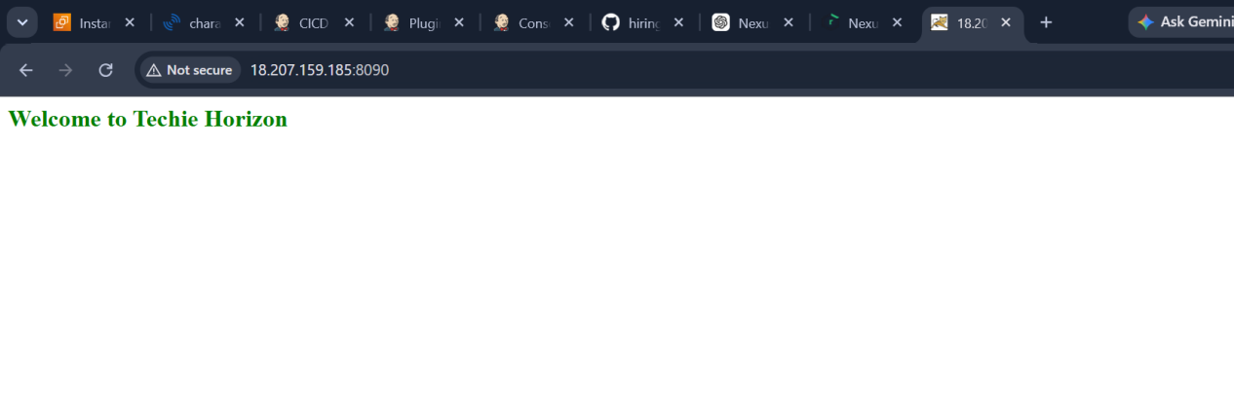

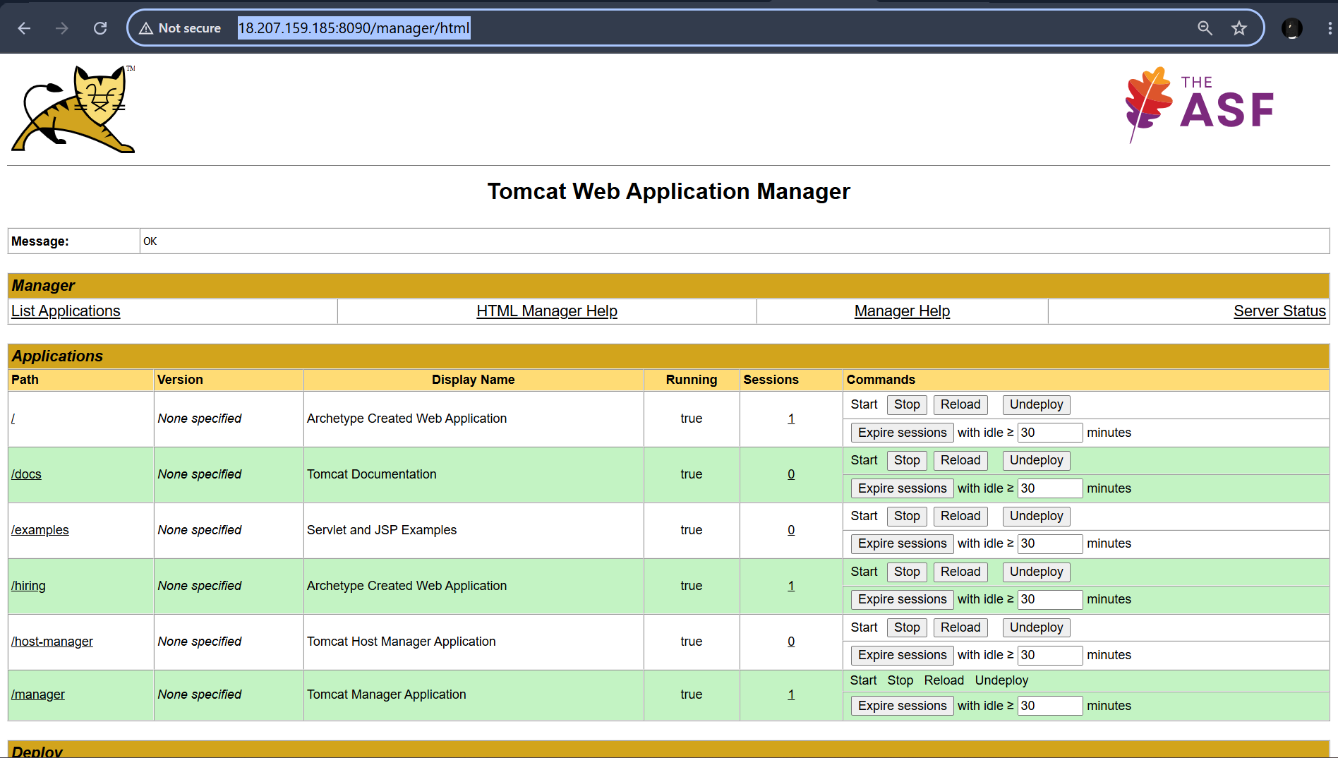

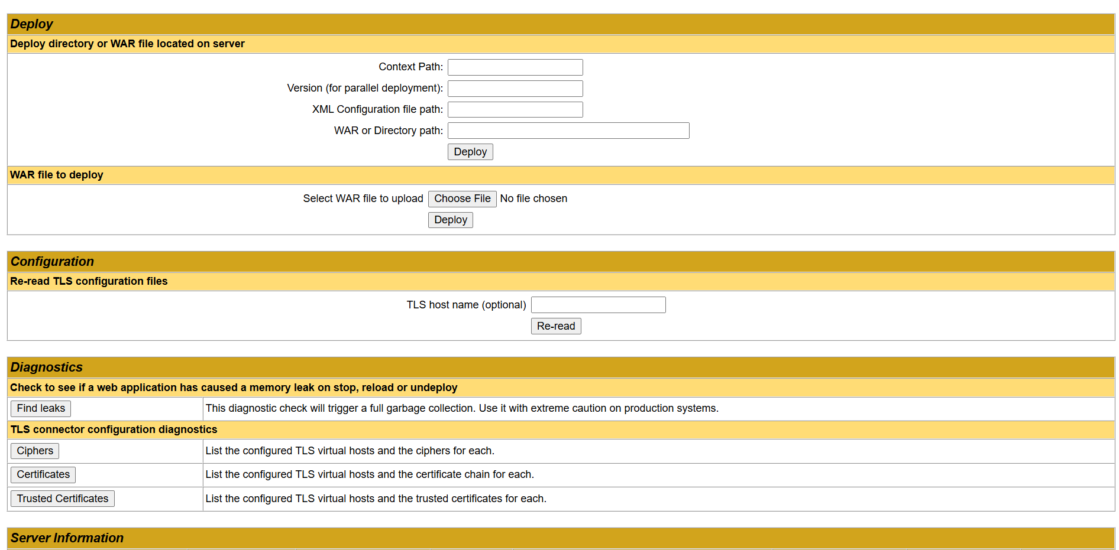
And we can also see manager/html

Now I have completed continous integration and continous deployment using the freestyle job

Setup a Jenkins CICD pipeline using Declarative pipeline using feature-1.1 branch

Create a new job with pipeline plugin

Added git clone

Gave whatever maven I have configured in my jenkins
For feature branch I need give separate branch

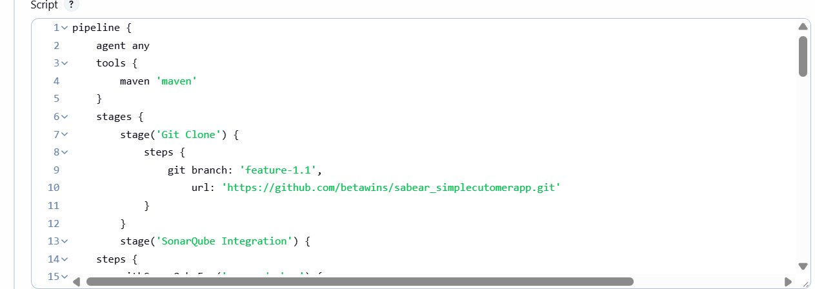

Gave sonarqube credentials

I need to give sonar name what I have I have saved in my jenkins configurations

And pass the analysis properties

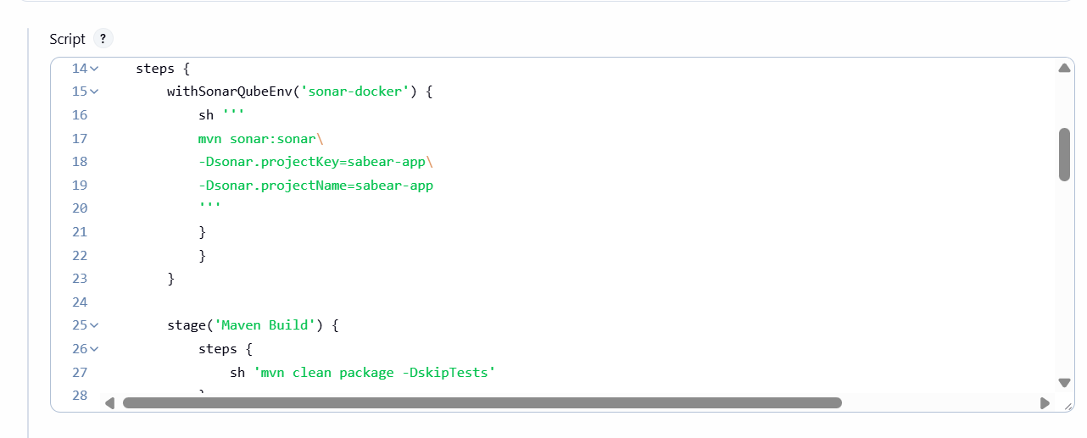

Need to give exact nexus repo name and the repo should be a snapshot not release so I have created a new nexus repo and selected snapshot for my nexus repo and gave my snapshot repo name in pipeline

As I am using nexus 2 in url I need to give url:8082/nexus
And in place of credentials I need to give my credential name what I have give my credentials name

And add groupid and versions from pom.xml
Artifact id from pom.xml

File the that has to store in .m2 and artifact id folder

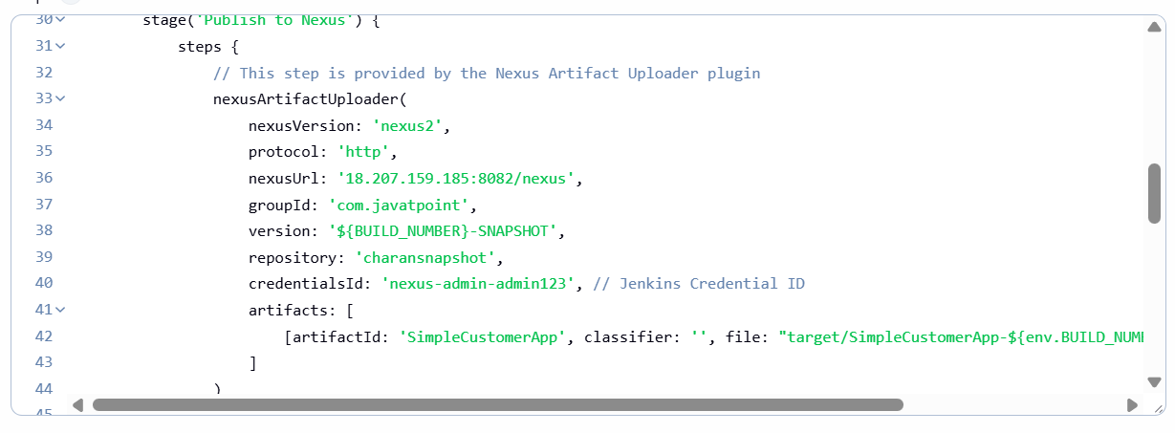
Added tomcat credentials with credentials name from jenkins and url

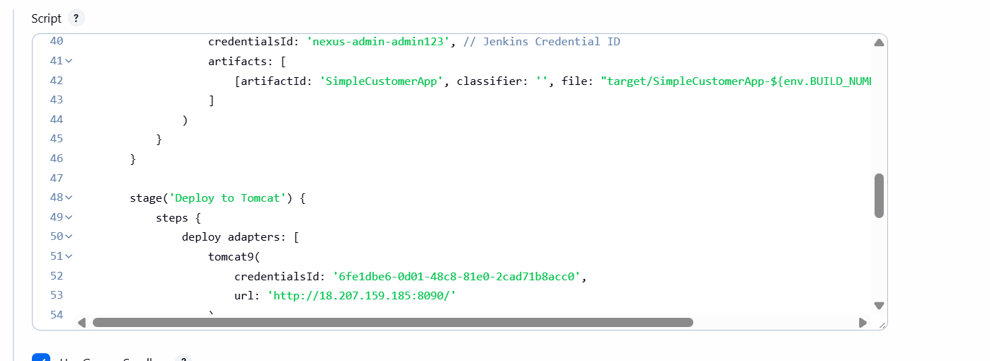

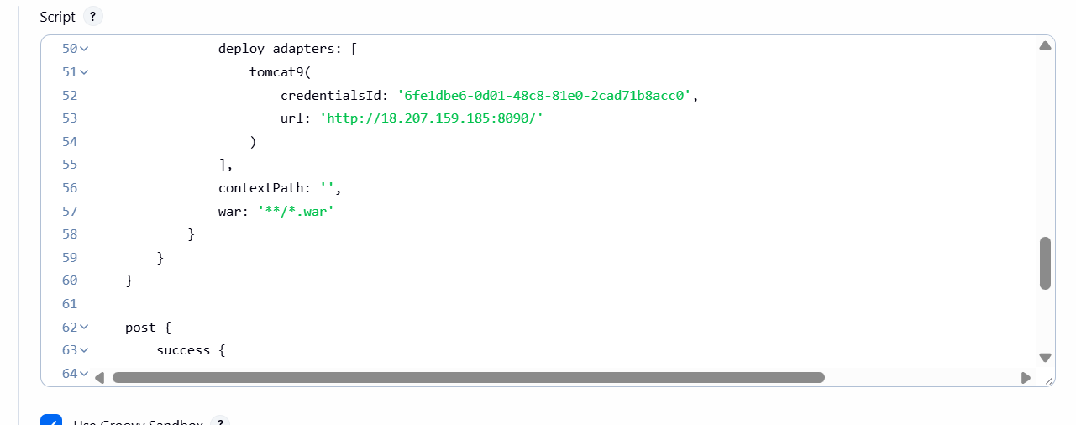

And added slack notfications for successful and failure of jobs
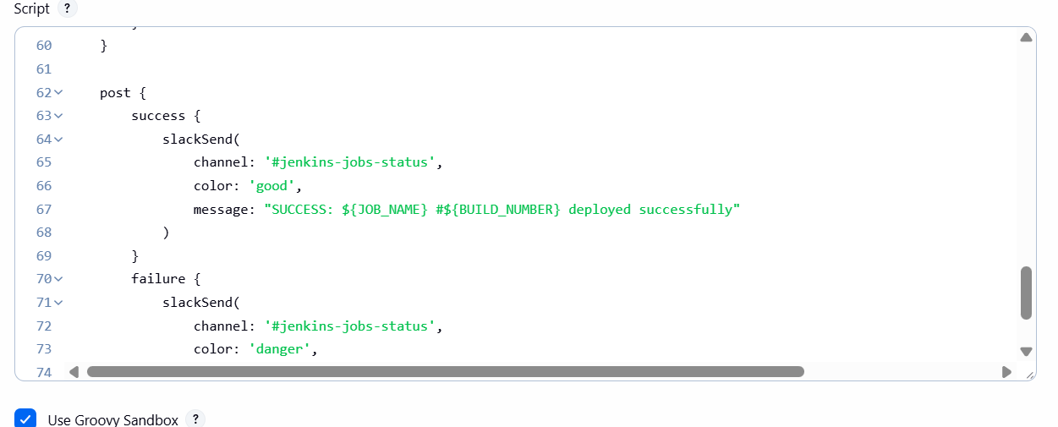

War file has been deployed to tomcat but it does not have index.html

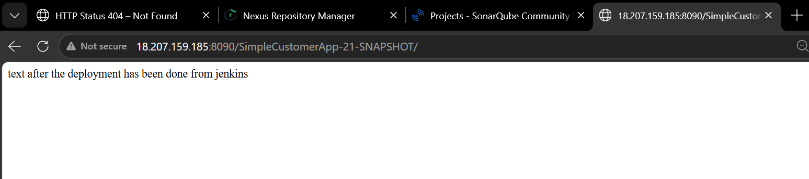

Setup a Jenkins CICD pipeline using Scripted pipeline using
feature-1.1 branch
Source Code: https://github.com/betawins/sabear_simplecutomerapp/tree/feature-1.1
stages:
- Git Clone
- SonarQube Integration
- Maven Compilation
- Nexus Artifactory
- Slack Notification
- Deploy On tomcat

The scripted pipeline for all the stages

The scripted script
For all the stages I have wrote a pipeline

Giving maven version
And cloning the repo
Sonarqube name as configured in the jenkins

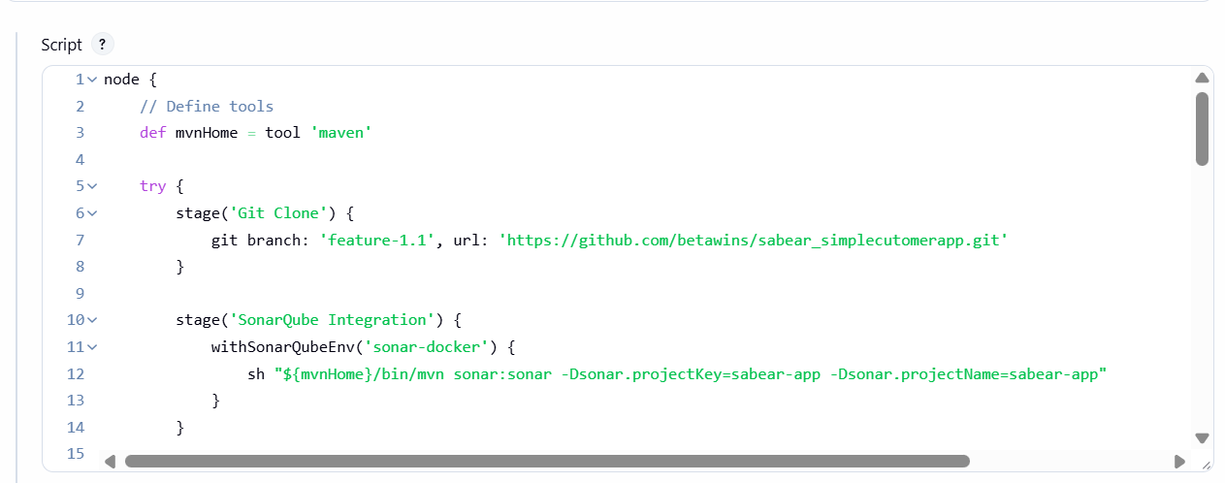

Nexus artifact id and versiona ned group id has been mentioned in the script
And the nexus credentials has ben given

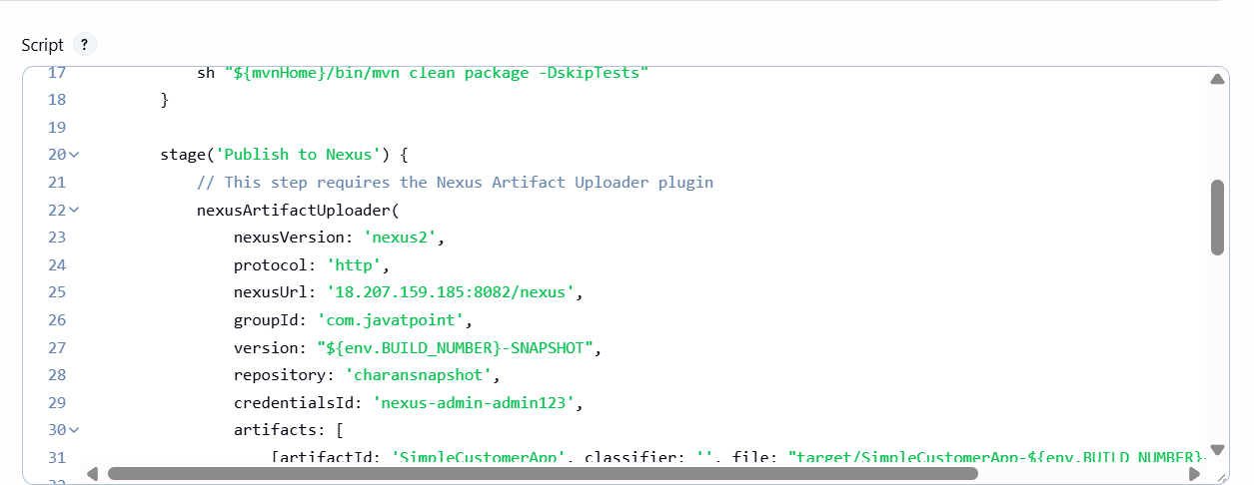

Created a new tomcat server and added new credentials and gave the credential name in the script
And the context path ‘/’
And then slack notifications ahs been configured

If context path is blank ‘ ‘ then we can see in webapps as simple customer app

I fi give context path ‘/’ then we can see ROOT.war
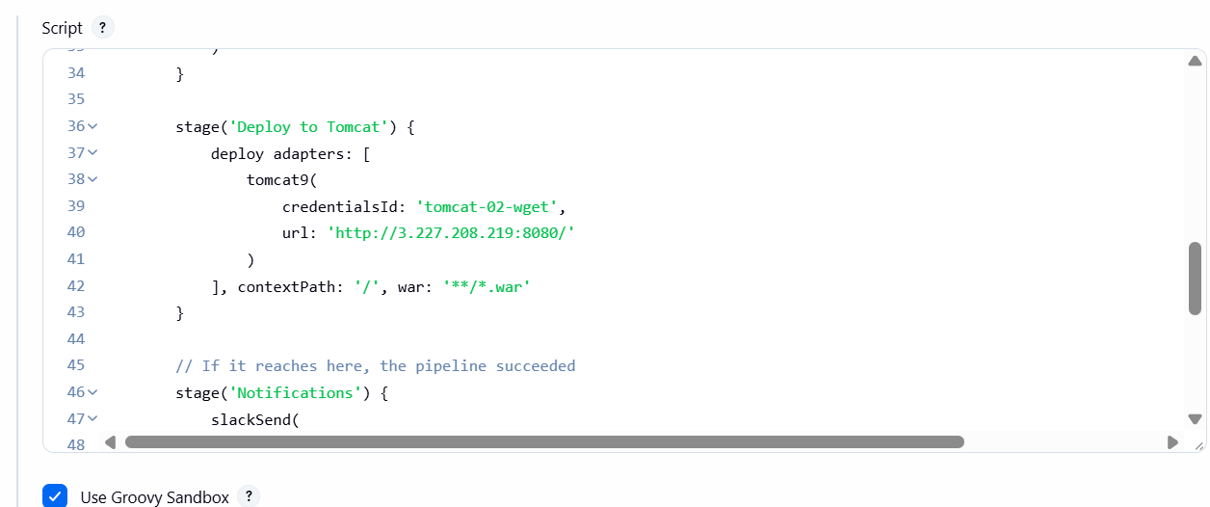

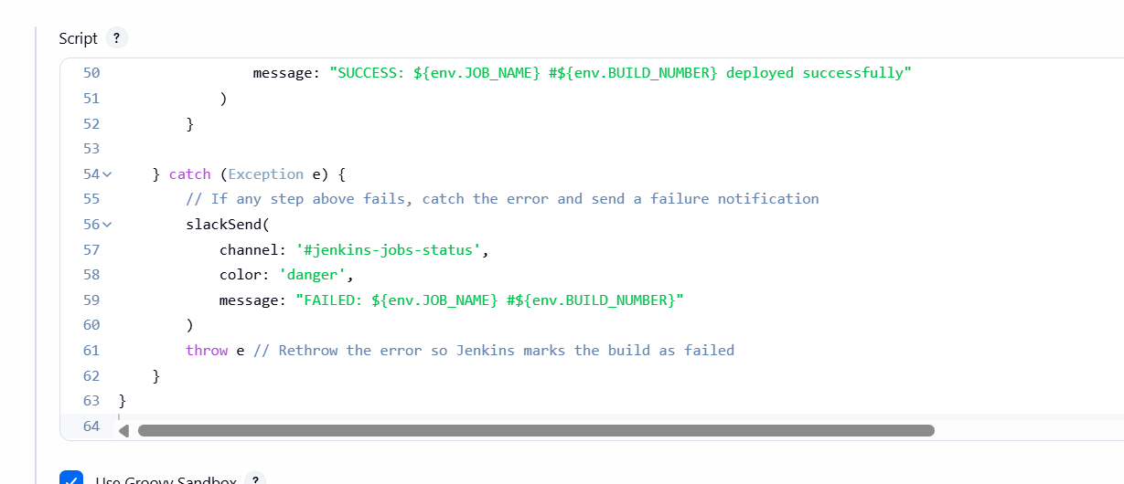

And the build was succesful and it has been deployed to tomcat webapps

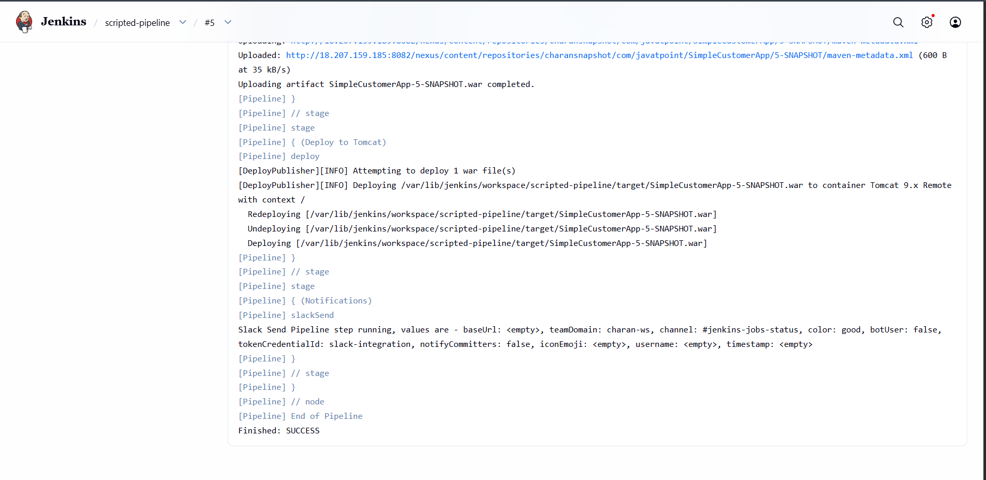

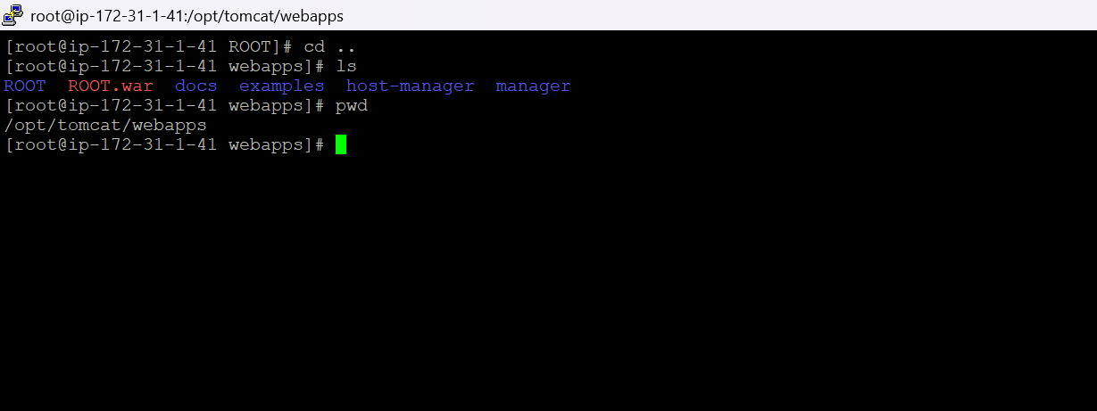

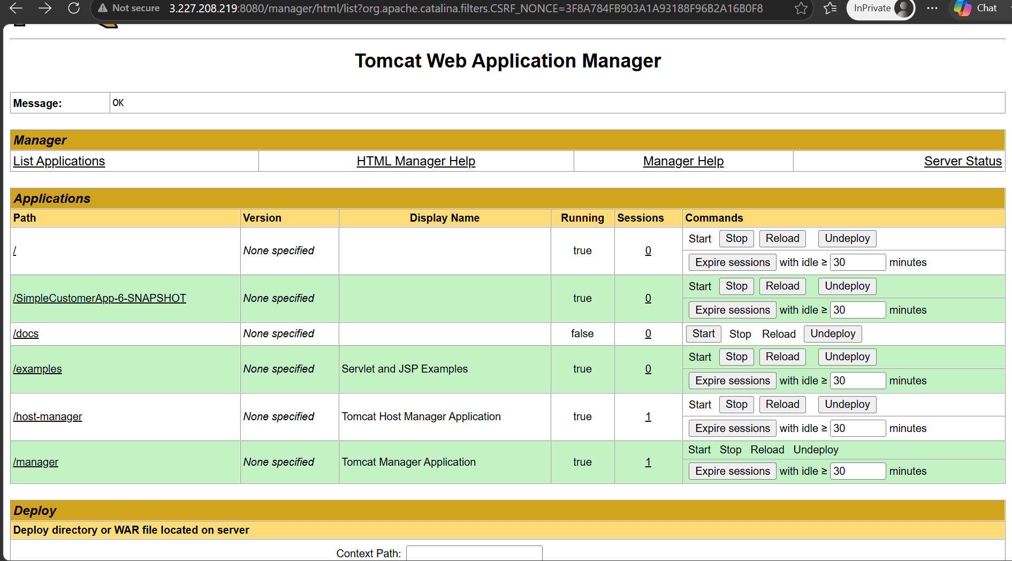

We can in manager we can see the deployed war file

SAMPLE SKELETON PIPELINE

Below is the sample pipeline for a jenkins job
I have given maven in tools so tha t I will be declaring that which maven version has been installed in my server and configure in jenkins

Environment : If want to give any varibales then I will be mentioning it in environment
Example :--username = admin or home = path

Then stages
In stages we have stage then in stage we have steps

Stage ( name off the stage ) and in steps actual commands to execute the build

pipeline {
agent any

tools {
maven 'Maven3'
jdk 'JDK17'
}

environment {
// Variables
}

stages {

stage('Git Clone') { ## cloning the repo to the job
steps {
}
}

stage('SonarQube Analysis') { ## checking the quality of the code in sonarqube
steps { ### give the credential id of SQ in jenins credentials
}
}

stage('Maven Build') { ## build the src from git to .war or given file name
steps { ## compiles the code
}
}

stage('Upload to Nexus') { ## the compiled code will be store in the artifact repo
steps {
}
}

stage('Deploy to Tomcat') { ## deployed to the tomcat server and need to give credentialID
steps { ## we need to give then diployer creds that ha spermissions to
} deploy the war file in webapps check tomcat-users.xml
}

stage('Slack Notification') { ### slack notification will be sent on wether the build is success
steps { or failed we can configue it as post build
}
}
}

post {
success {
}

failure {
}

always {
cleanWs()
}
}
}

PARAMETERIZED JOB

Create a new job and will be giving some parameters how to run and where to run

I will be using the sting parameter

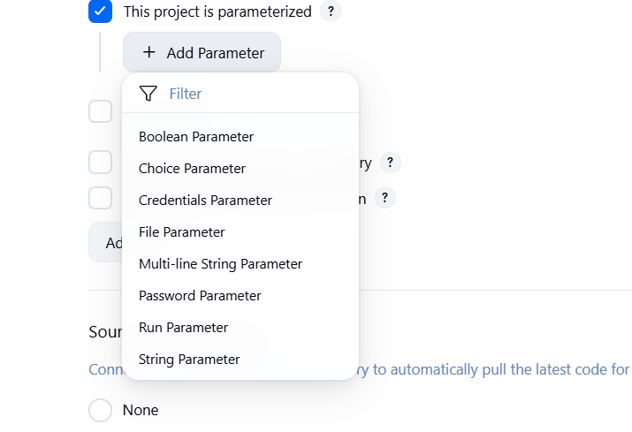

Click on string parameter

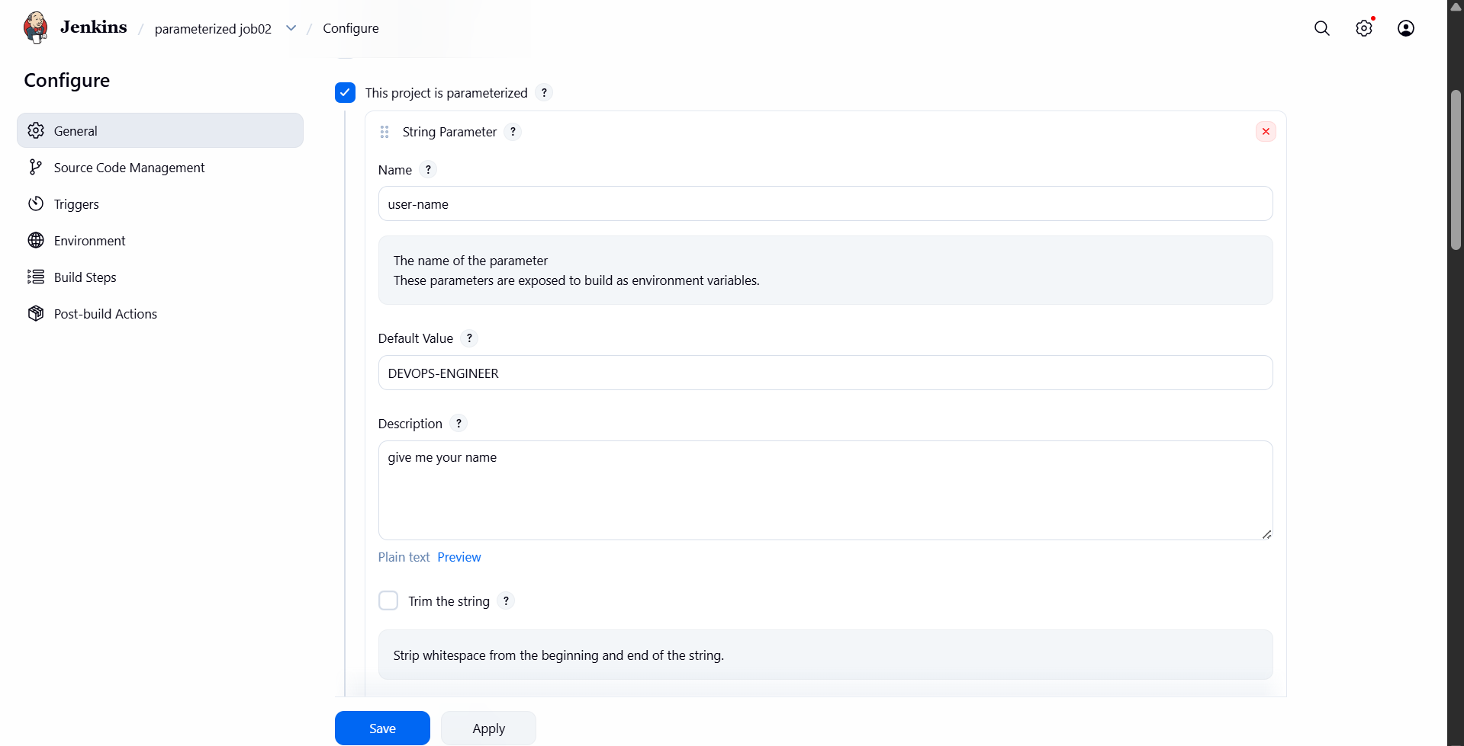

I have given the string parameters and we can whenever I click on build it is asking for parameters
We can use string parameters for different options example for git branch and we can also use choice parameters for different stages of builds

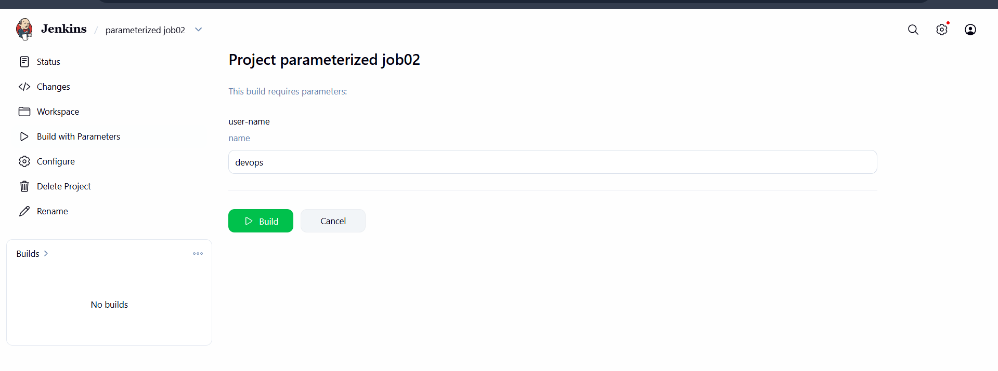

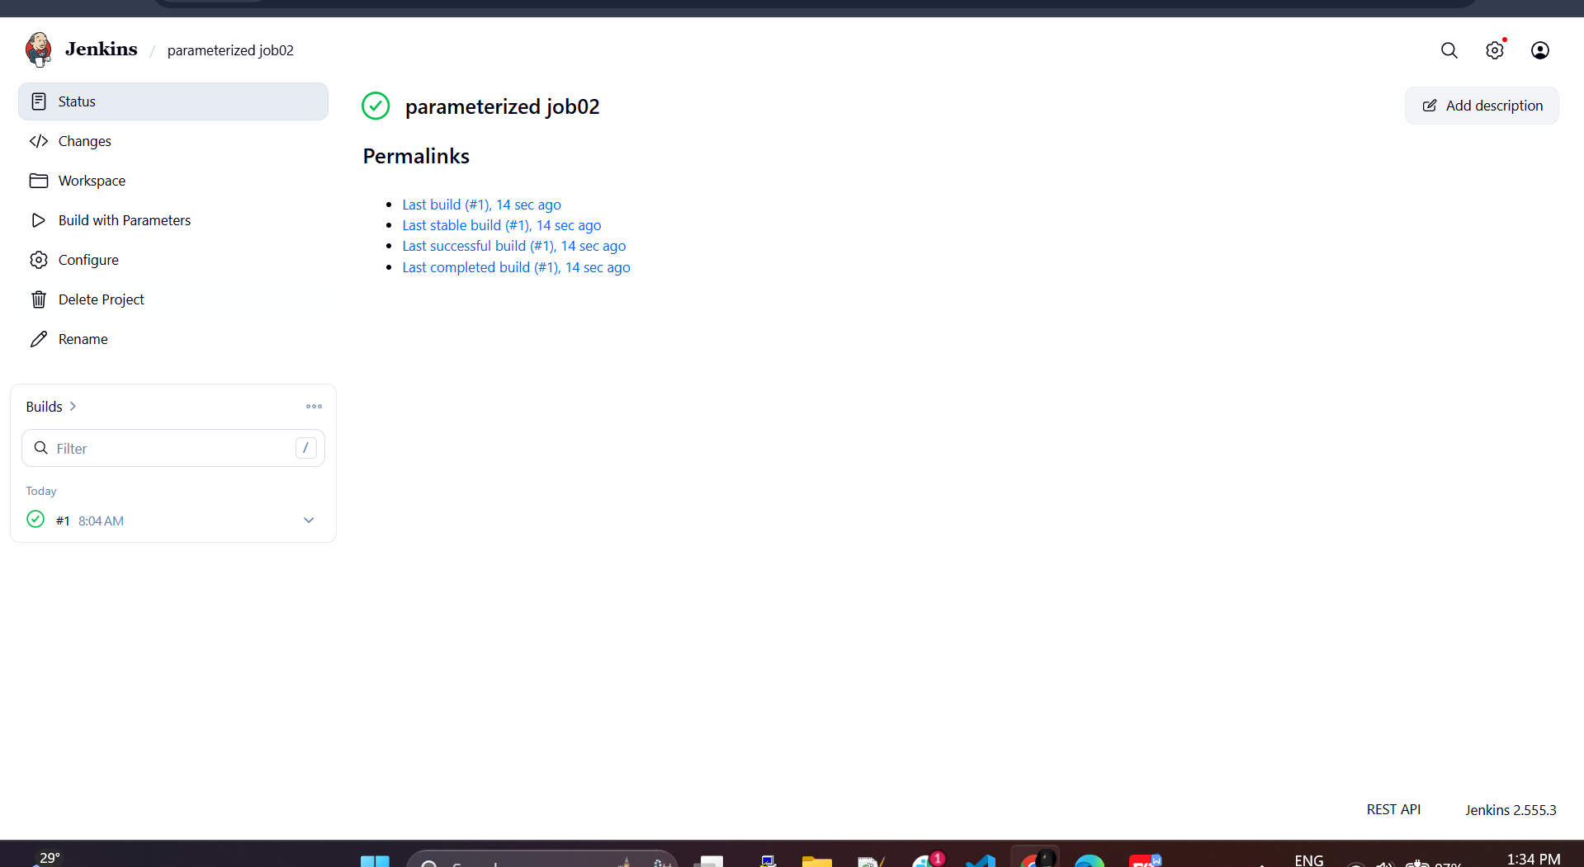

SETTING A NEW SLAVE SERVER FOR MY MASTER JENKINS

Created a new instance and I will be making it as a slave for my master sever
So that my new jobs can be conffigured to run on this agent

Pre requisites :--- java-21

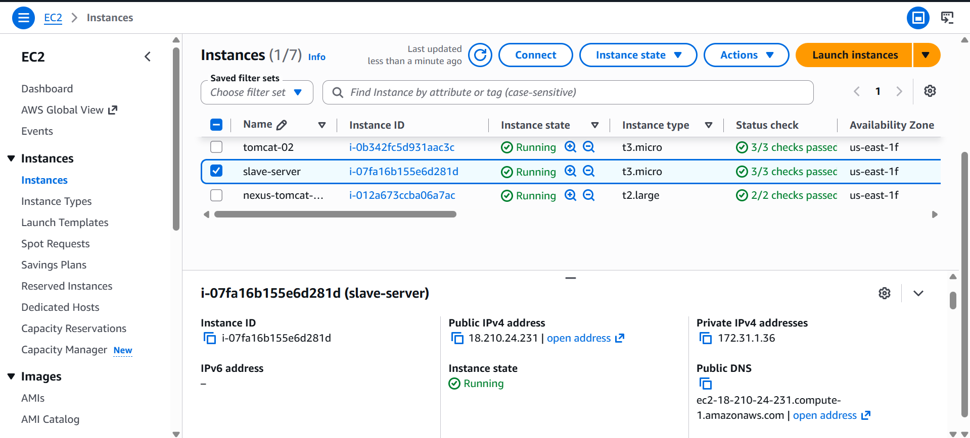

Java has been installed as an pre requisite
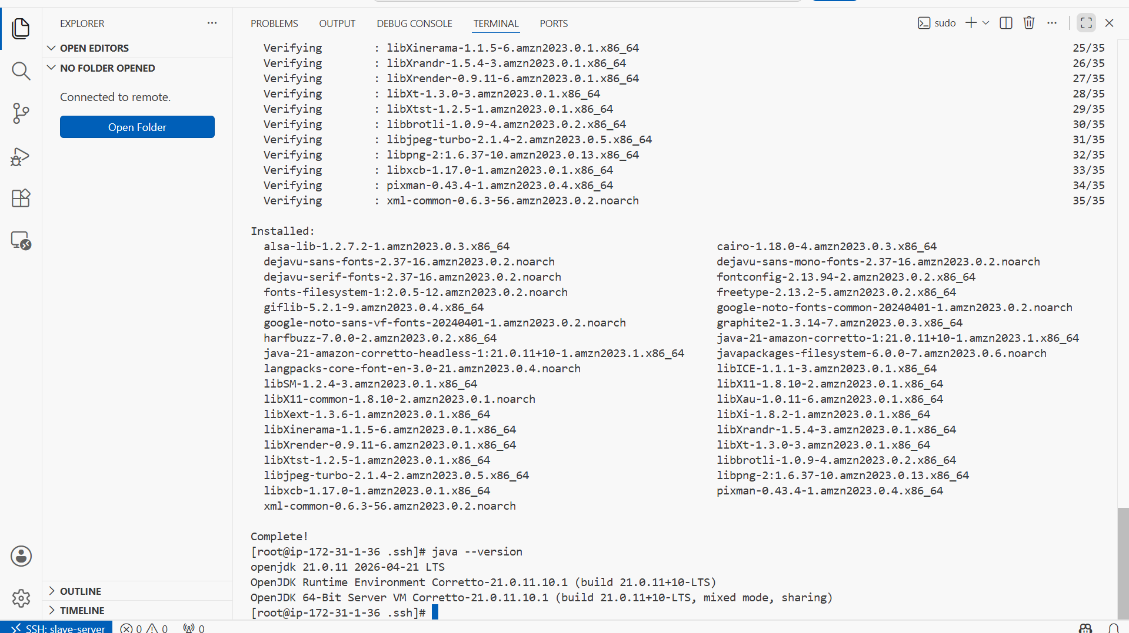

Create a ssh key using ssh-keygen

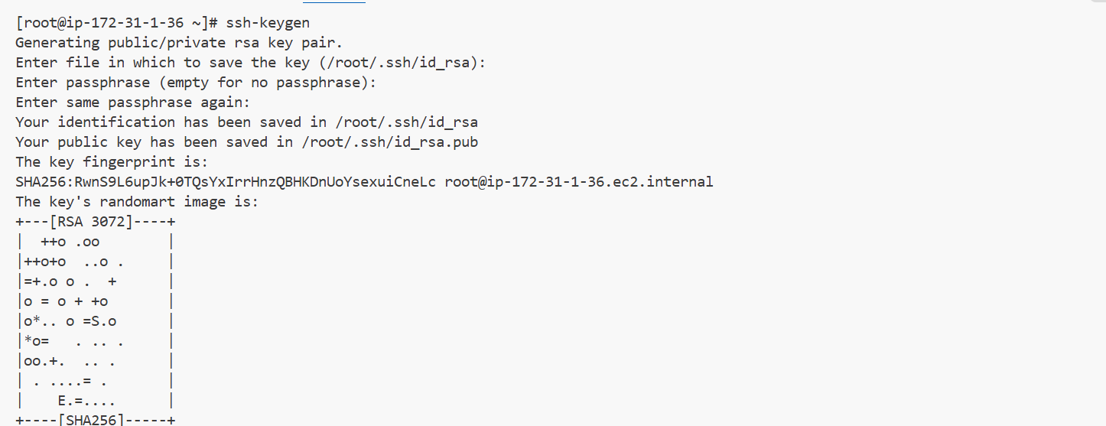

Copy the key to the authorized_keys

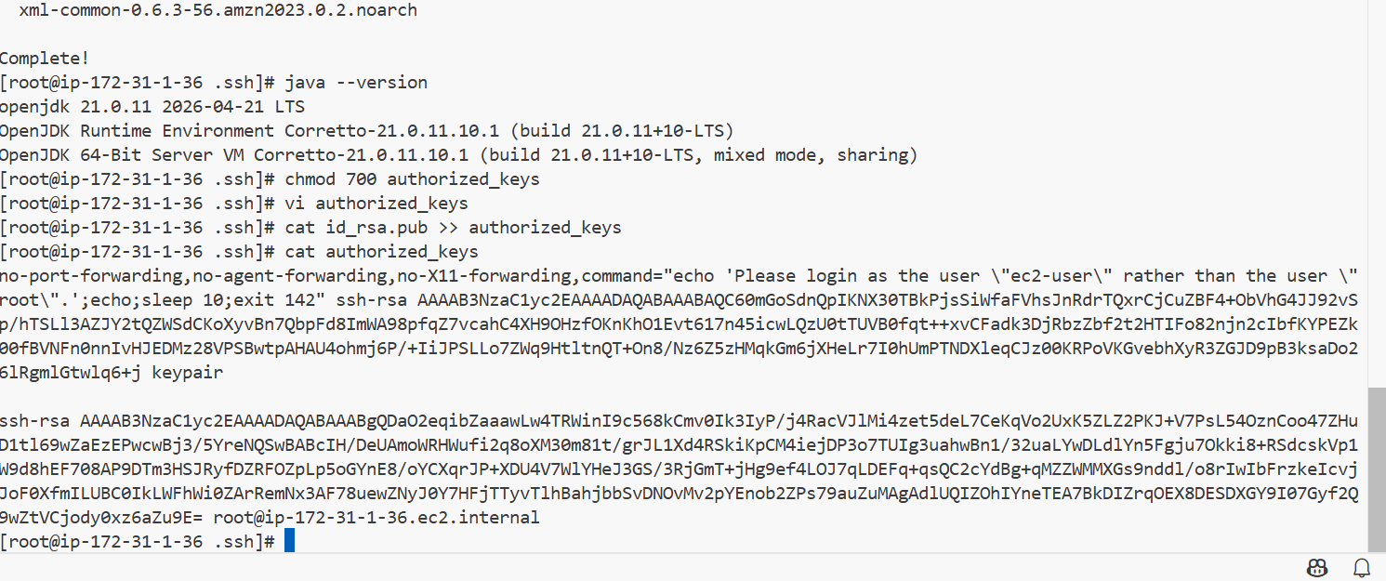

Give 700 permission to authorized _keys

Then I will be doing a keyscan from jenkins master using ssh-keyscan

Ssh-keyscan -H ip >> path to known_hosts

Here whenever I create a new node then it will check for knownhosts in jenkinsmaster .ssh
And if the new slave ssh key has been added to the known_hosts file then it will add the slave server

Go to

cd /var/lib/jenkins/.ssh

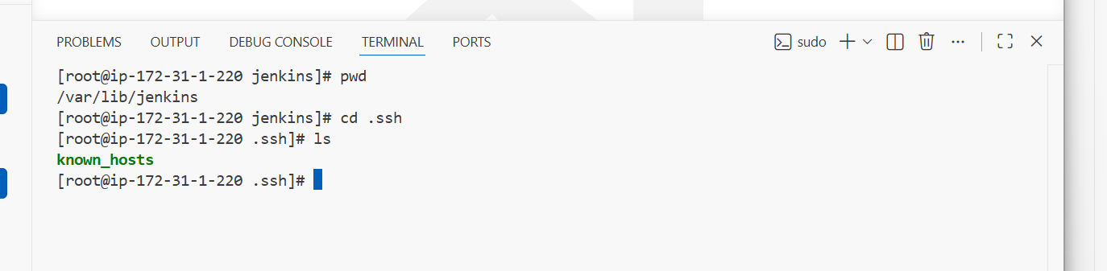

Now do

ssh-keyscan -H SLAVE-NODE-IP-OR-HOSTNAME >>/var/lib/jenkins/.ssh/known_hosts

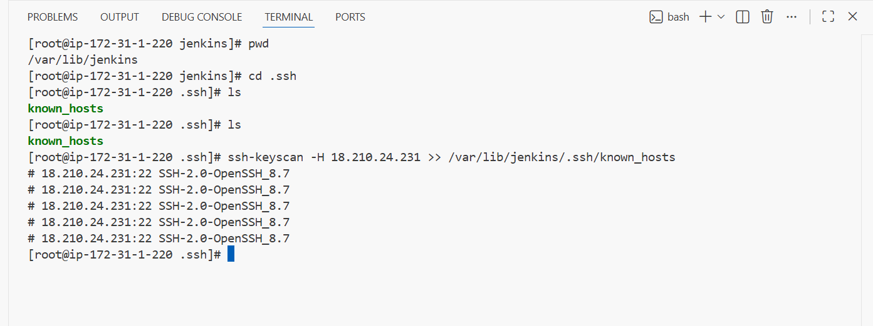

Now the ssh has scanned a key from authorizerd_keys slave server to the jenkins master server

We need to check for the owner permissions fro known hosts file if it is root owner change to jenkins owner

Because when jenkins checks for known_hosts file and if the owner is root then jenkins wont have permissions for known_hosts

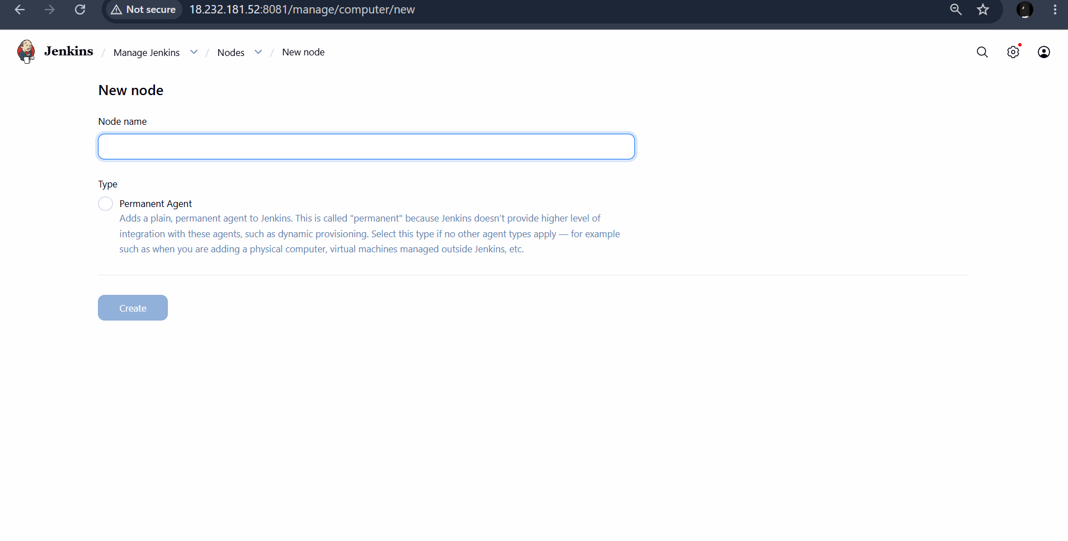

Then go to jenkins and create a new node

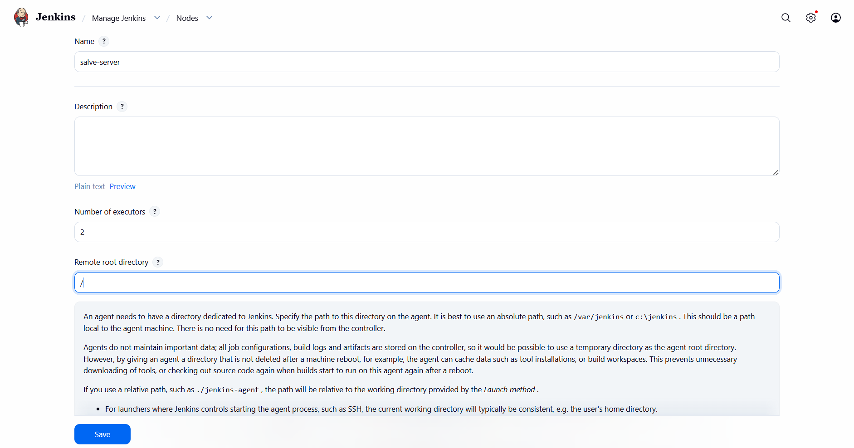

We need to give remote root directory of the slave server we cant give root because the jenkins wont have permission for other server root

That will be /home/ec2-user

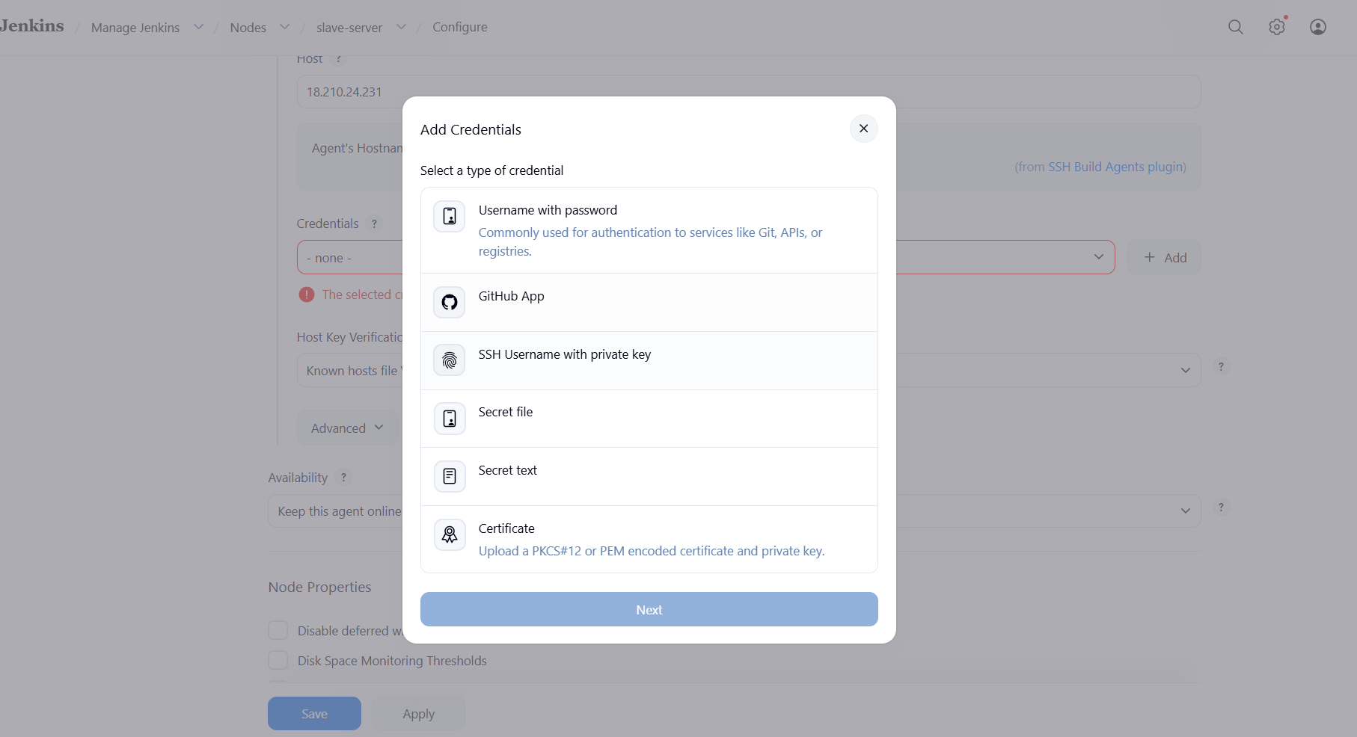

Give slave server Ip address and add credentials using ssh username and private key

Give user name for which os we are using

Username:-- ec2-user
Password :--pemkey
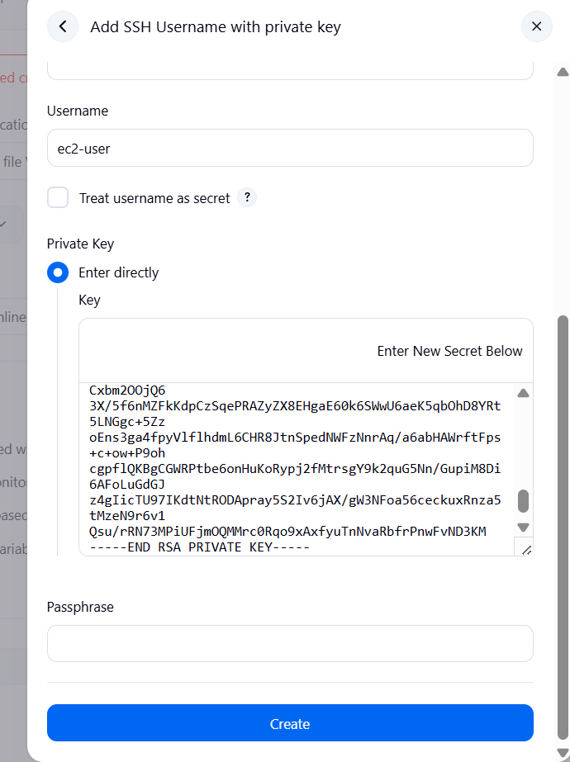

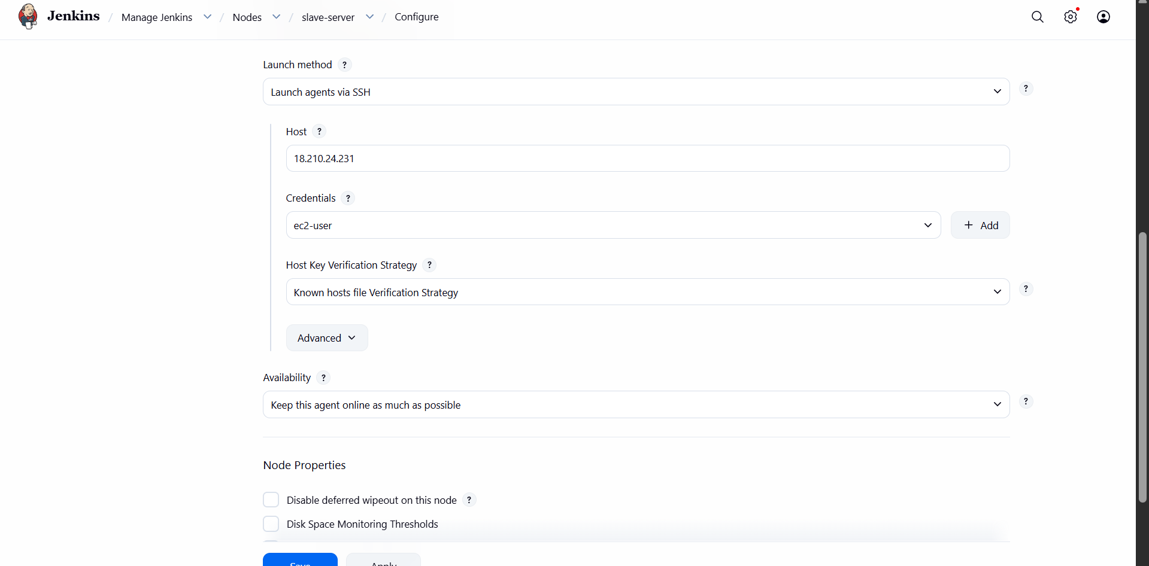

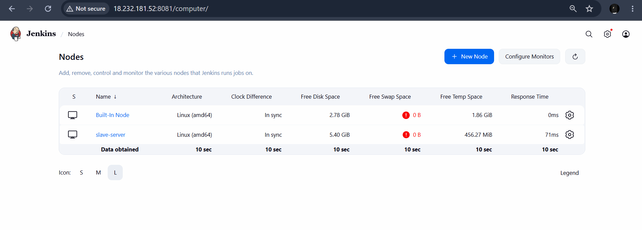

We can see slave server has been added

Add ons-----

Tomcat changes for user and deployer access

Give comment <!-- --> at values

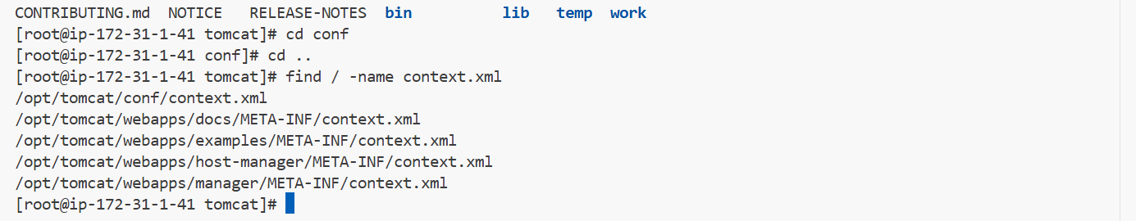
Give user access in tomcat-useers.xml



