Create a tomcat container on 8080 and deploy sample application in tomcat

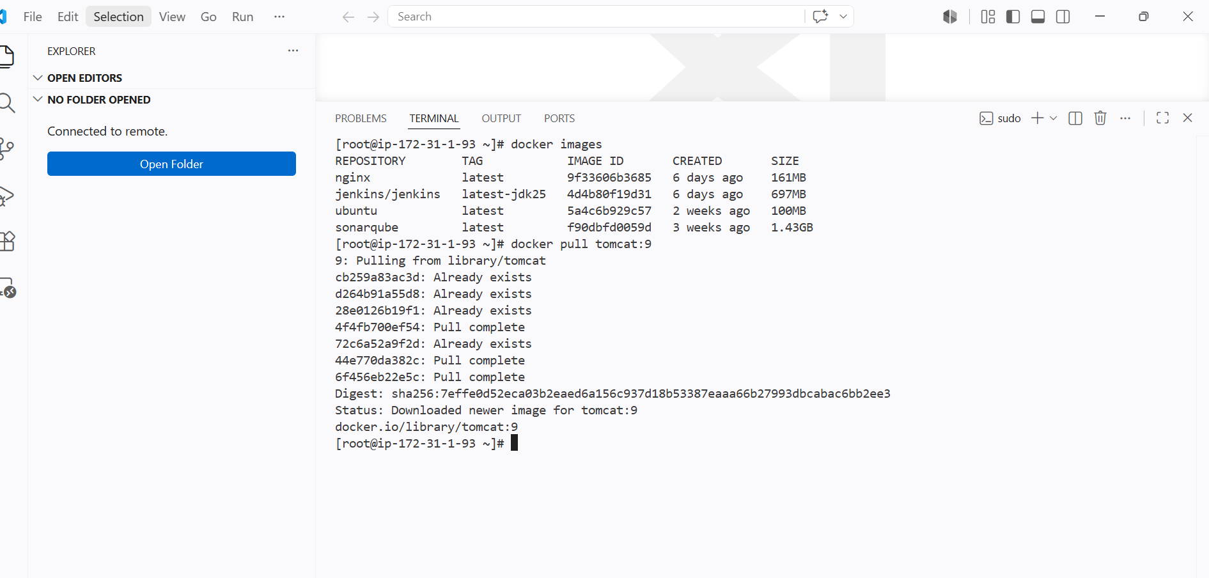

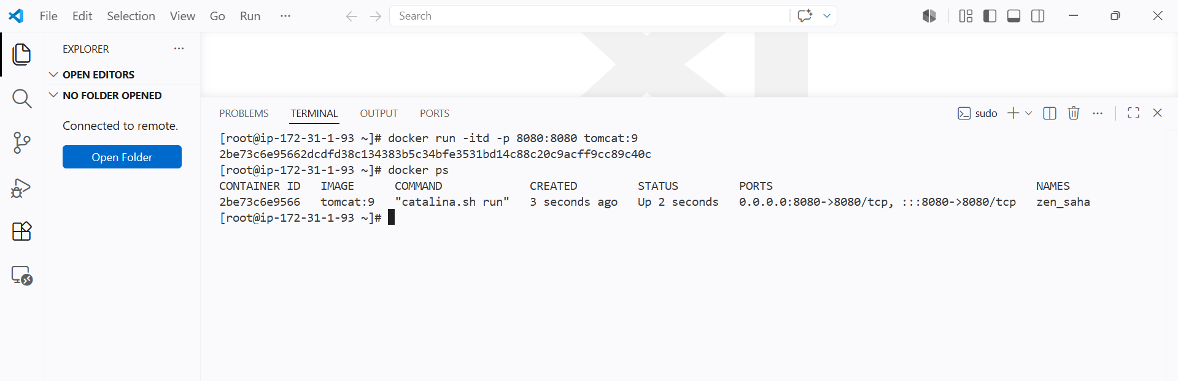

Tomcat is running on port 8080

Used
docker run -itd -p 8080:8080 tomcat:9

Deploying a sample war in tomcat

For this we need to enter into the conatiner
Docker exec -it containerID bash

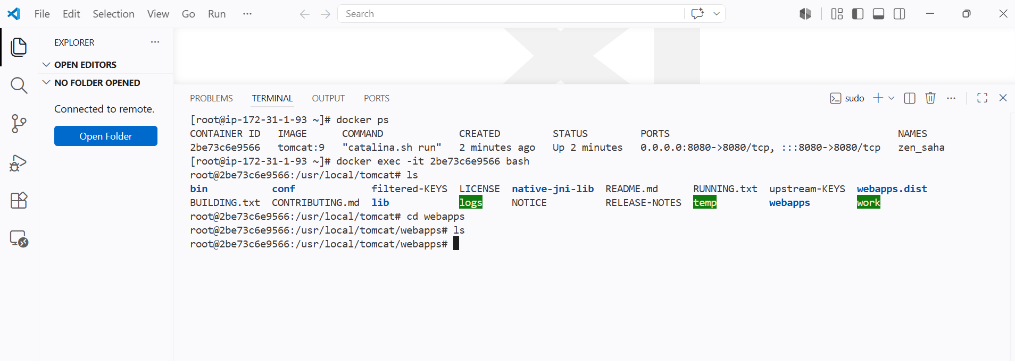

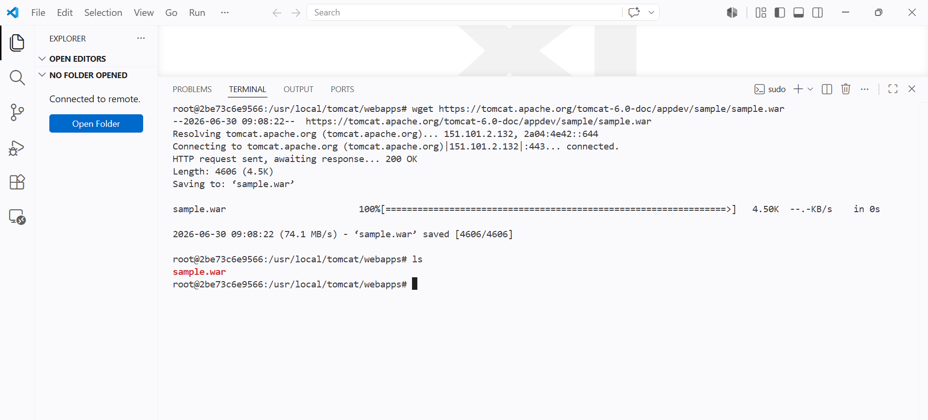

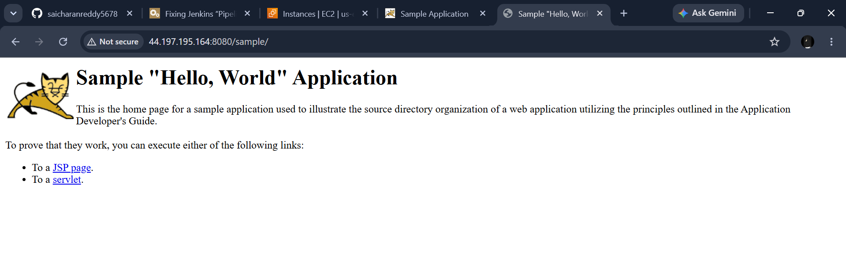
Create volume and deploy tomcat container on port 8081

Creating a new volume and attaching it to a container

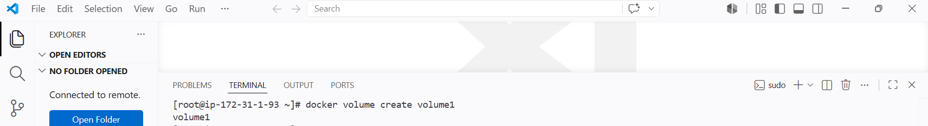

I have created a new volume named volume1

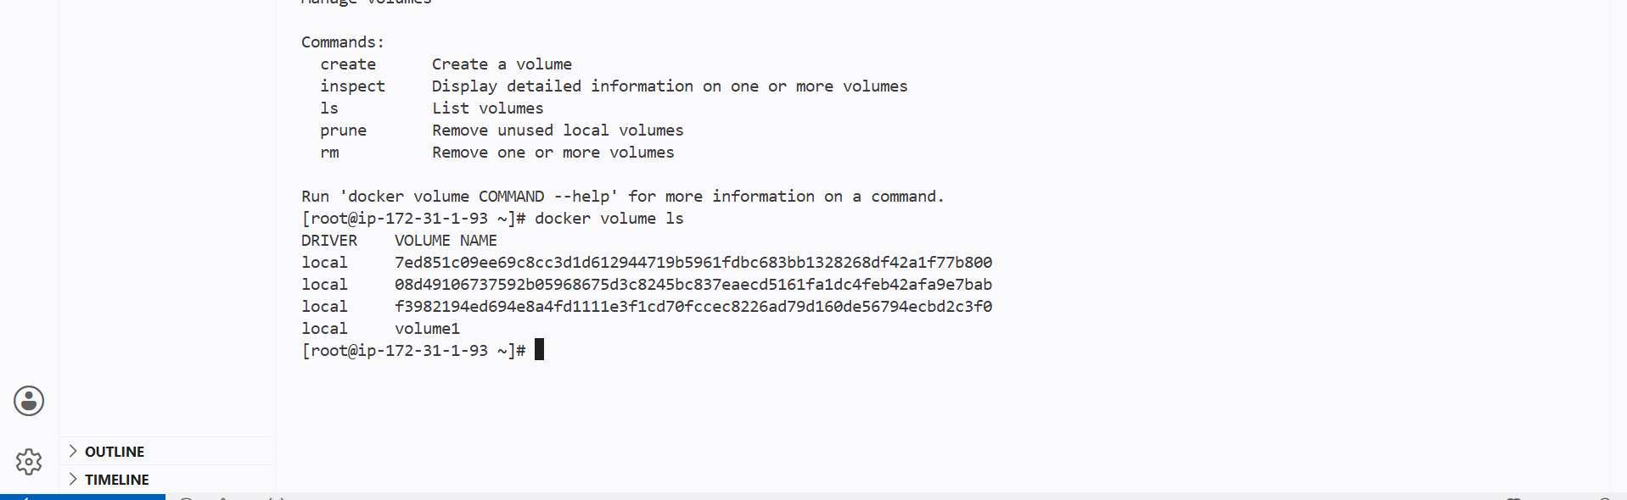

I will be attaching this volume to a new container

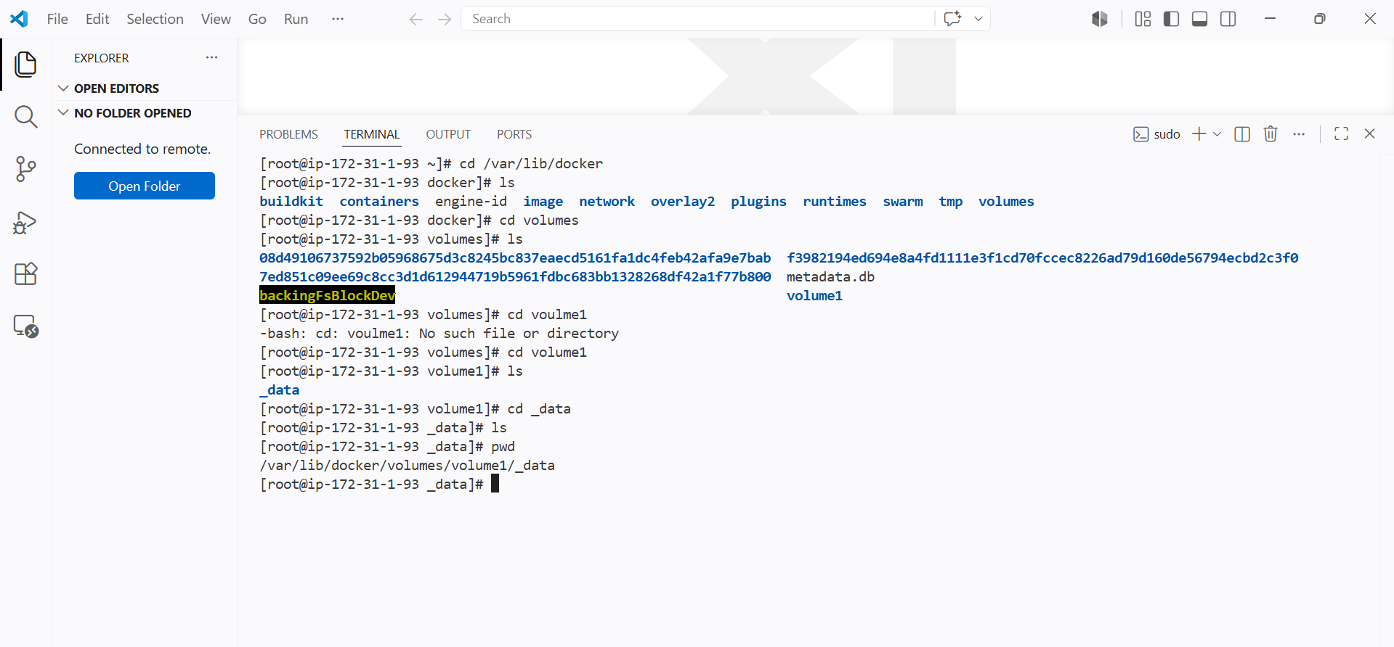

I will be attaching this volume path to the tomcat container deployment path

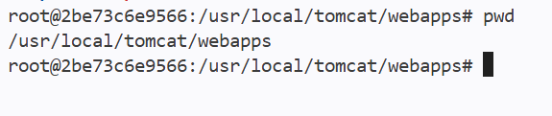
Above is my default tomcat deployment location

Now I will be attaching the volume for new container with same path

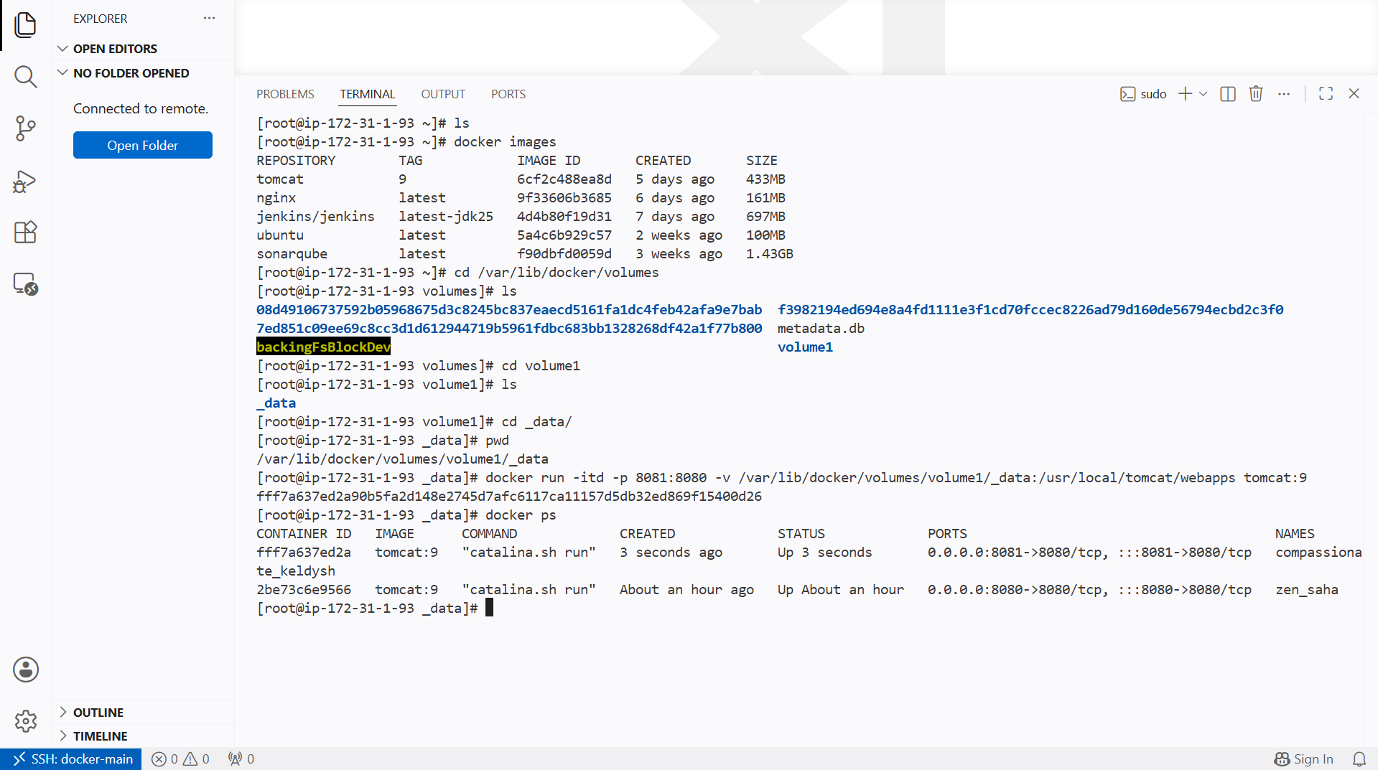

I have attached the volume to new tomcat deployment location

Now I will be giving a sample war file in volume and it should be copied to webapps and tomcat should run

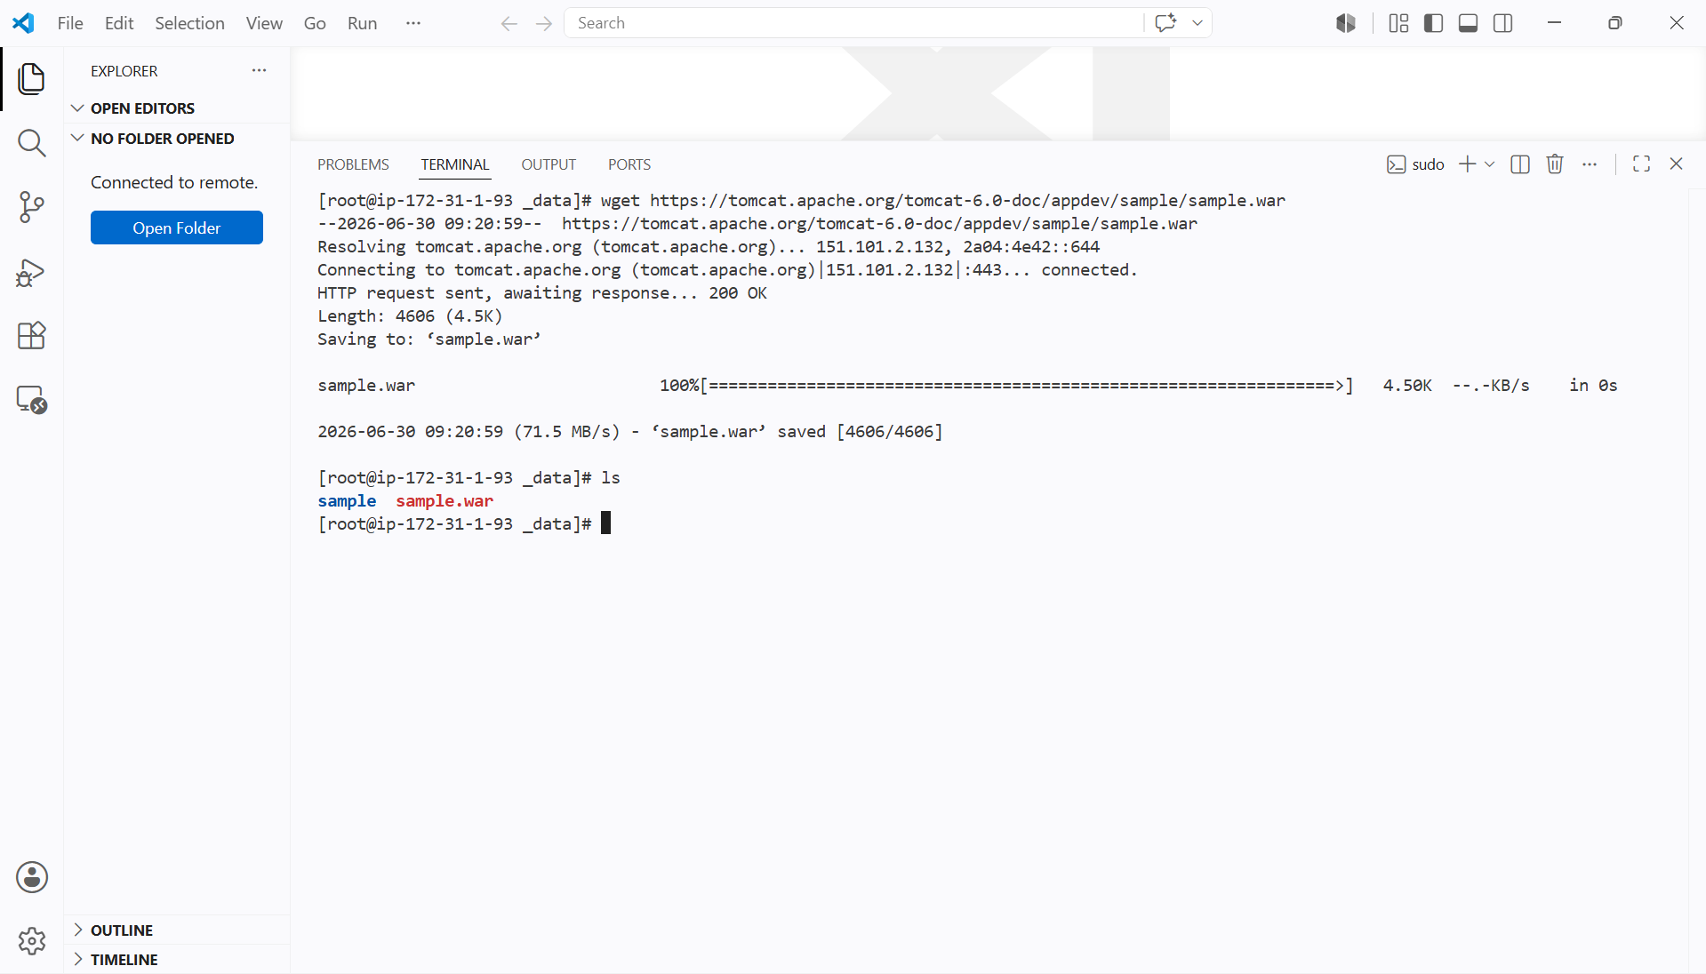

I have deployed a sample war file in volume

And the tomcat page is open to 8081 and I can see the war file in browser

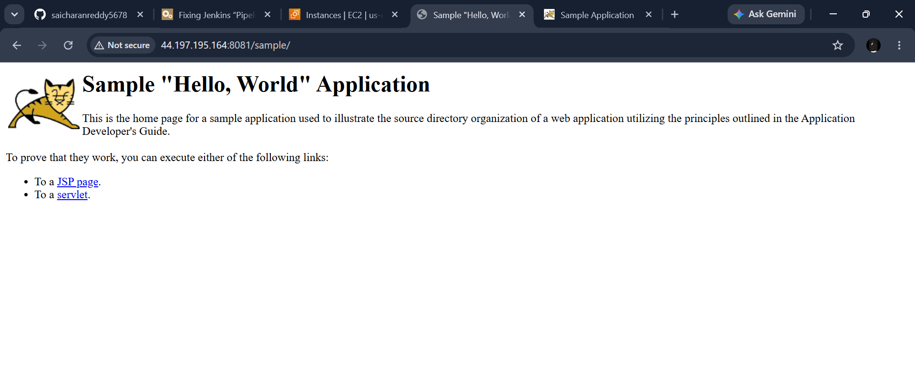

Also we need to see sample.war file in webapps inside the tomcat container

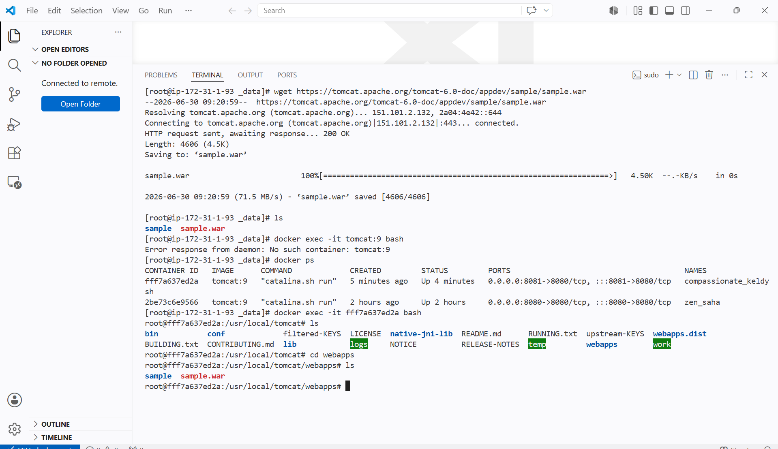

Same file can be seen in webapps

And vice versa if we deploy any files directly in webapps it can be seen in volumes

Limit the nginx container to 500 MB

I already have an nginx image

Now I will be creating a new container and limiting the size of container to 500MB
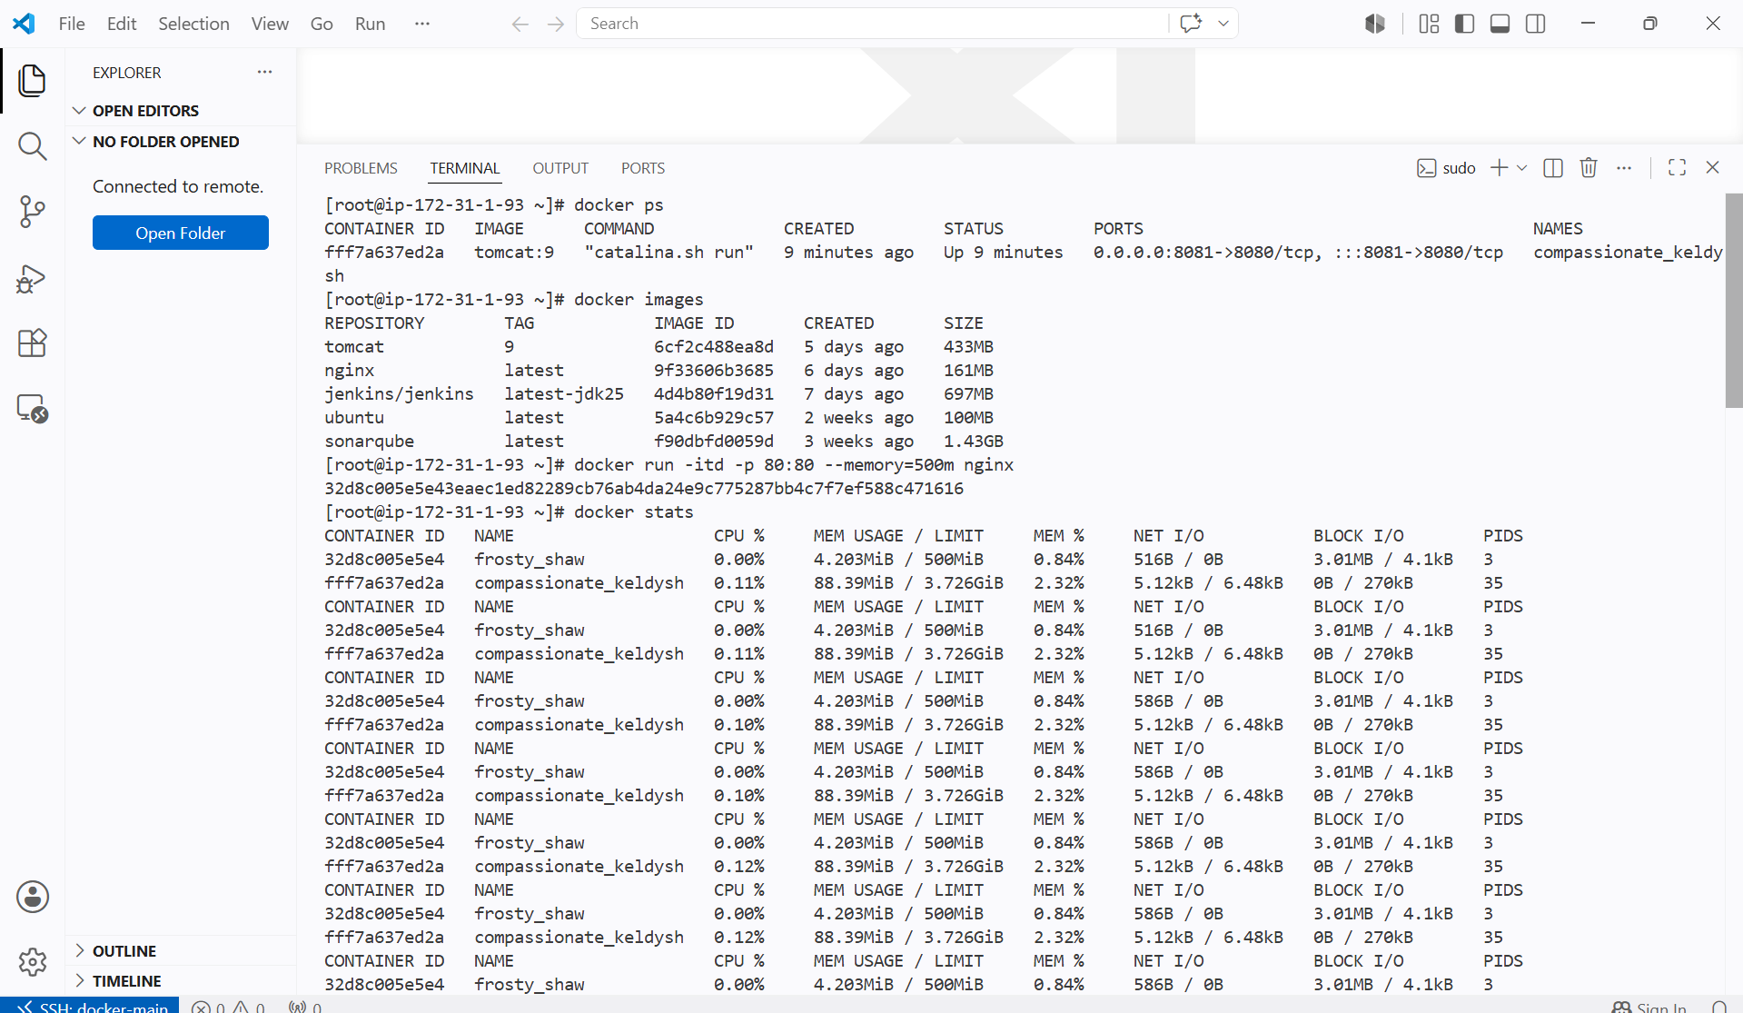

We can see the container memory limit is capped at 500m

Syntax

Docker run -itd -p 80:80 --memory=500m nginx

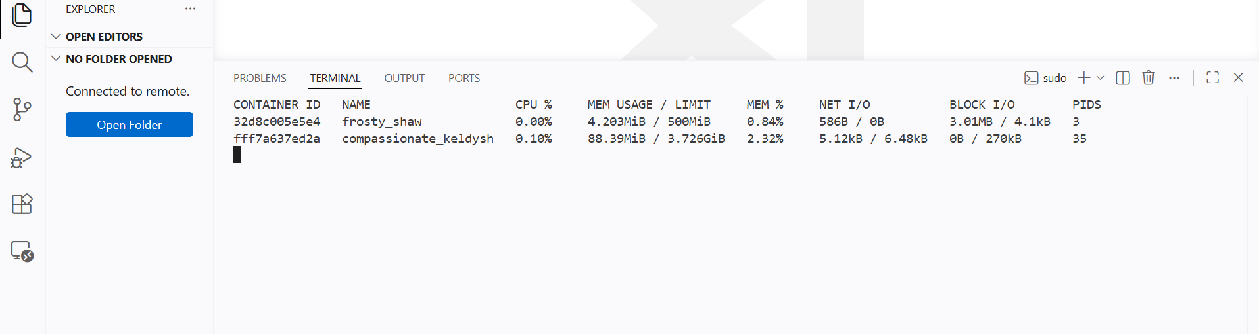
And nginx is up
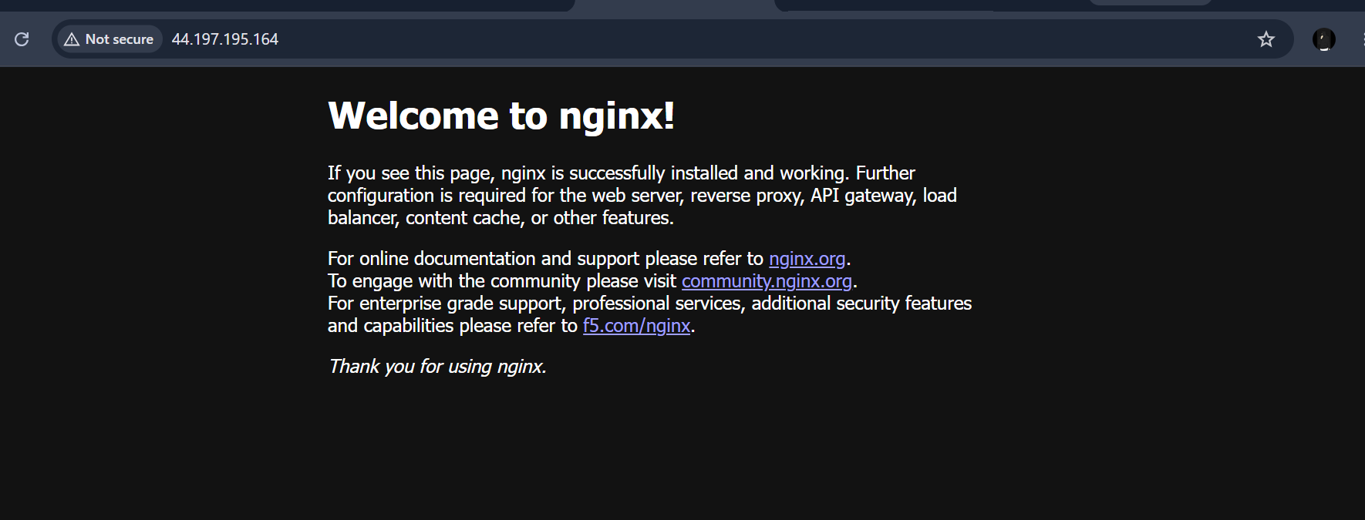

Create a sample docker file using below instructions
- Base module as amazonlinux:latest
- Maintainer you name
- Install nginx
- COPY one index.html file to image
- Expose on port 80
- Command to start the nginx container

Docker file is used to create a new docker image and from docker image to the container

Docker file containes modules by using modules I will be creating the docker file

First I will create a file and giving the modules in that file

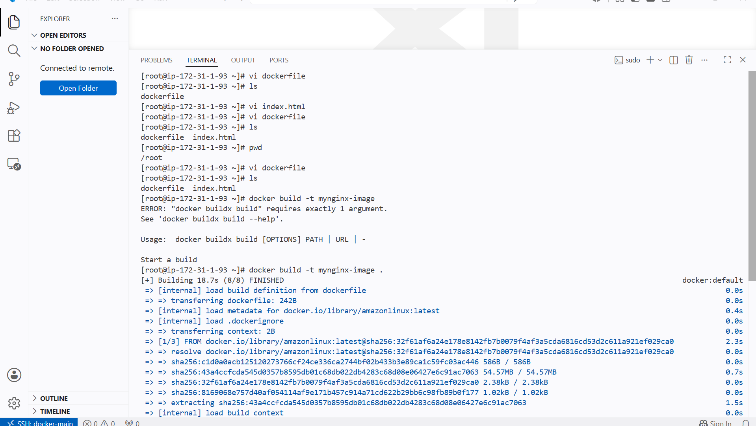

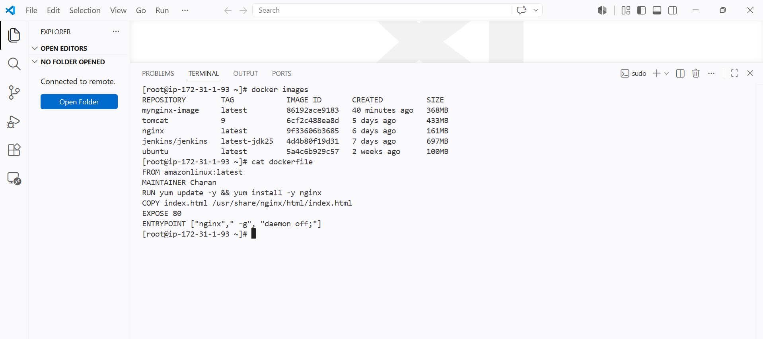

I have used entrypoint for executing commands by this container runs and nginx will run in background

By this the container will stay alive and nginx will be active and run background

We can alos use CMD it can be overwritten so I will be using entrypoint

I have created a new image using dockerfile and created a new image from the docker file.

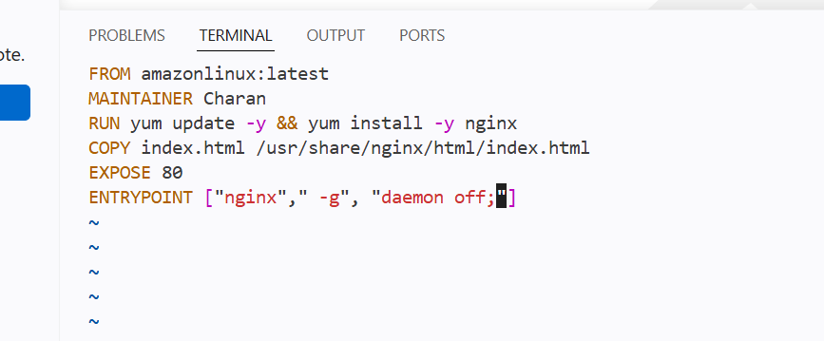

We can a new image has been created
Created a new container from the image
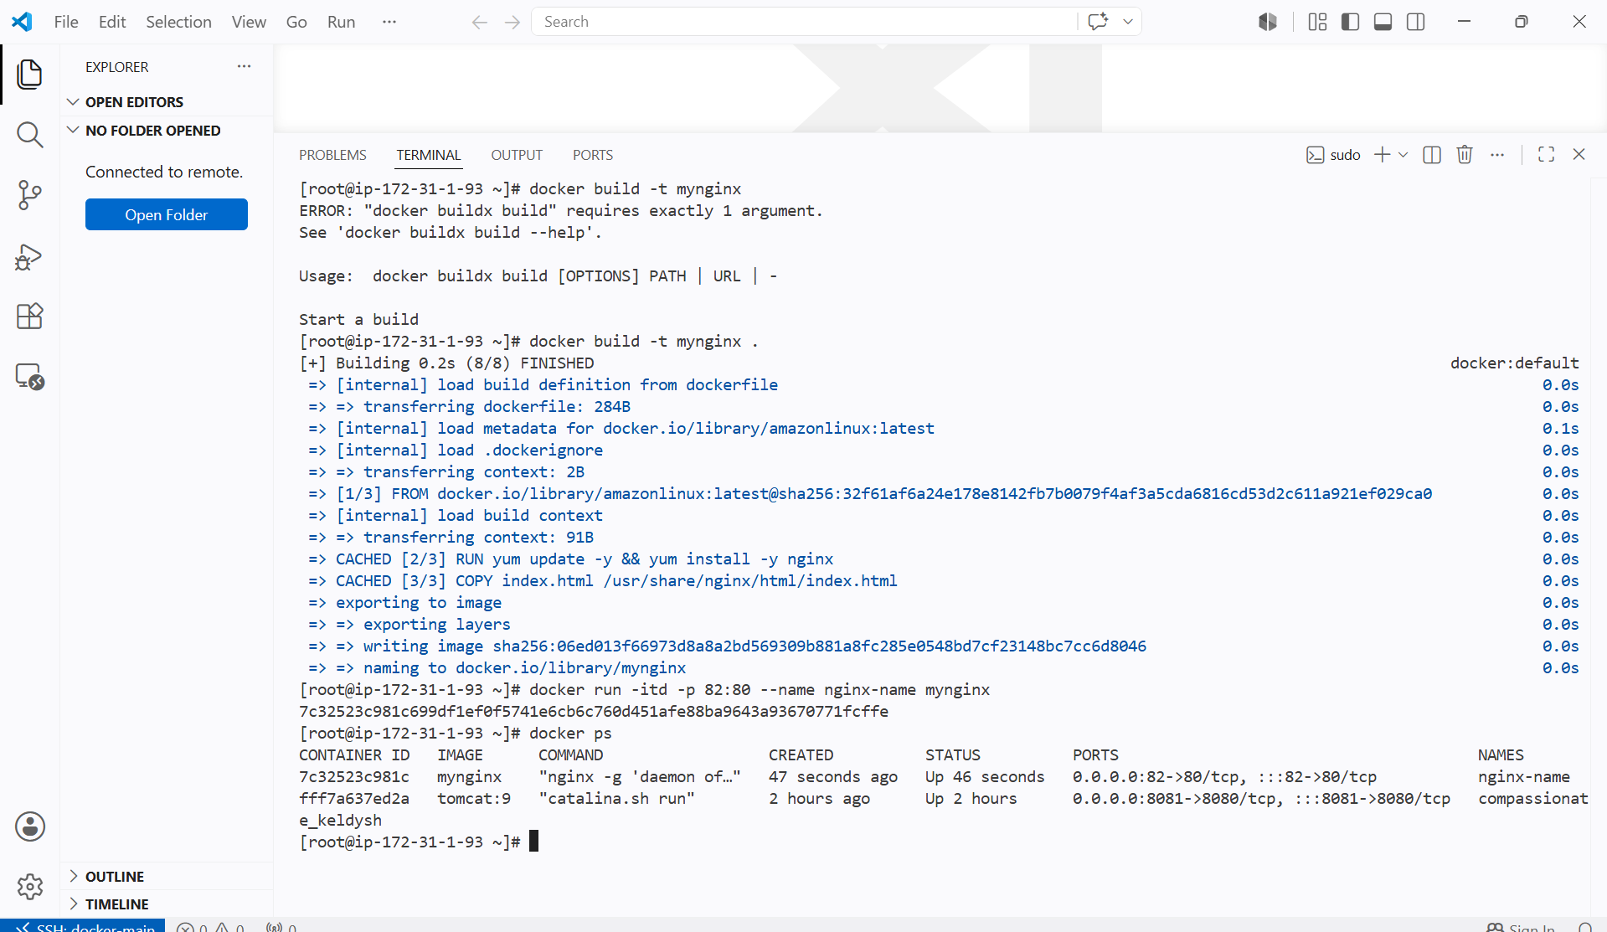

I have used copy command in the docker file and the file has been copied to the nginx deployment location

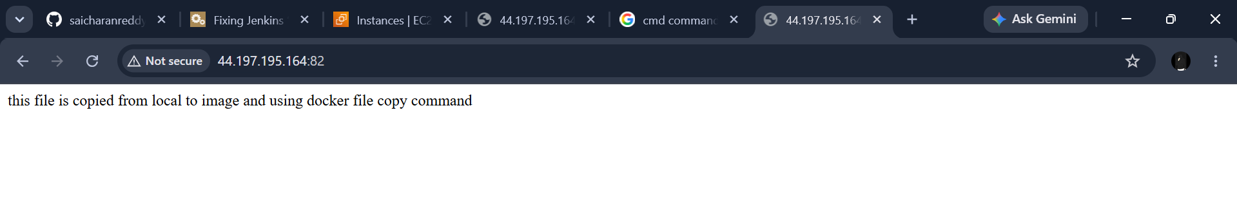

Push image to Docker hub

Pushing my newly created image to docker hub

For this I need to configure the login details to my dockerhub account

And using DOCKER LOGIN I will attach my docker hub

Then using docker push I will push to hub

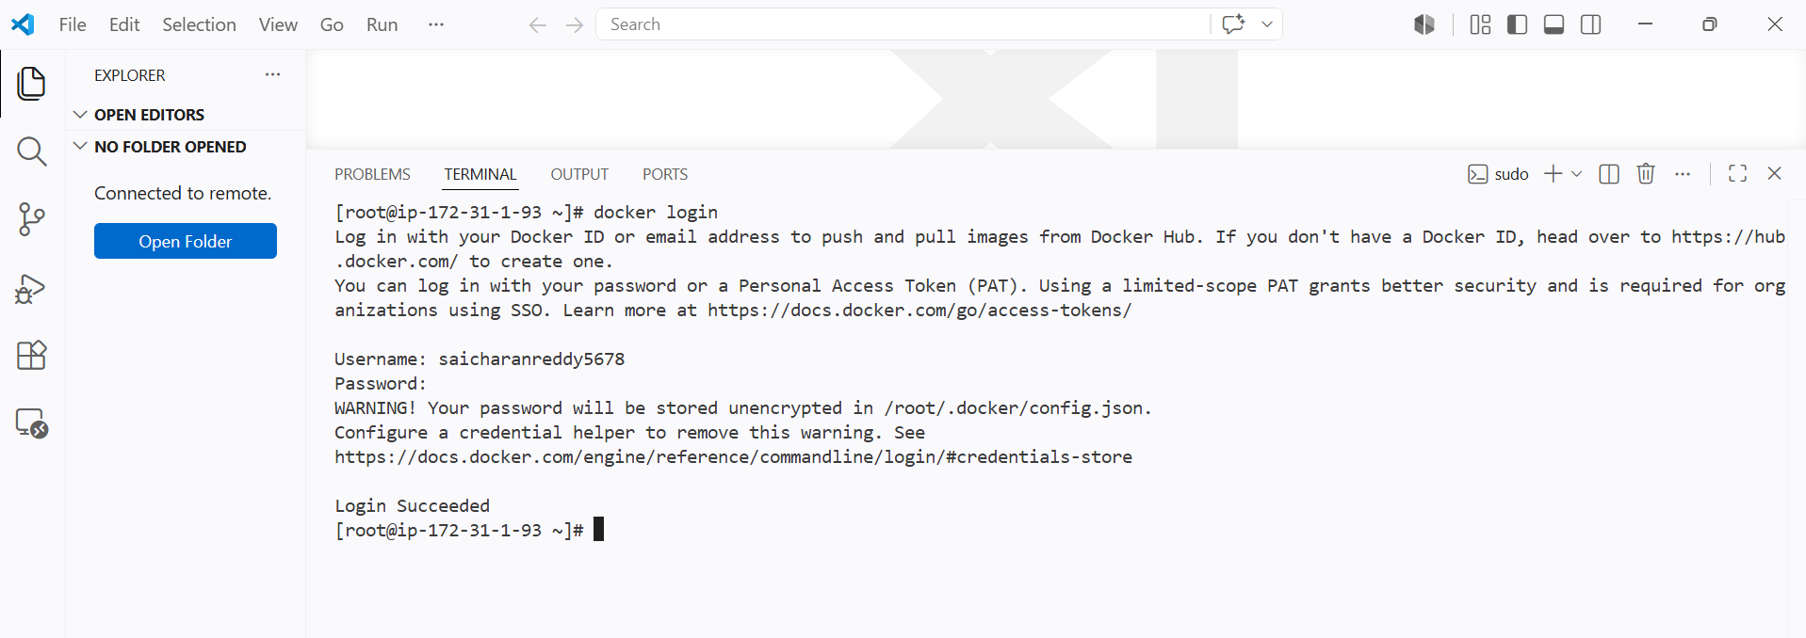

Login was successful

Now using push I will push it to the repo

And the image name and repo name should be same

First I will be changing my tag for image using

Docker tag source:tag reponame:newtag

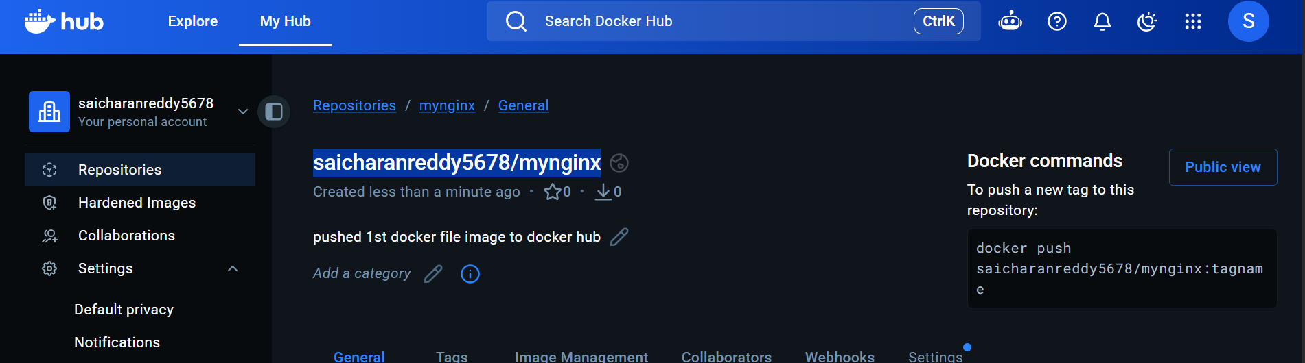

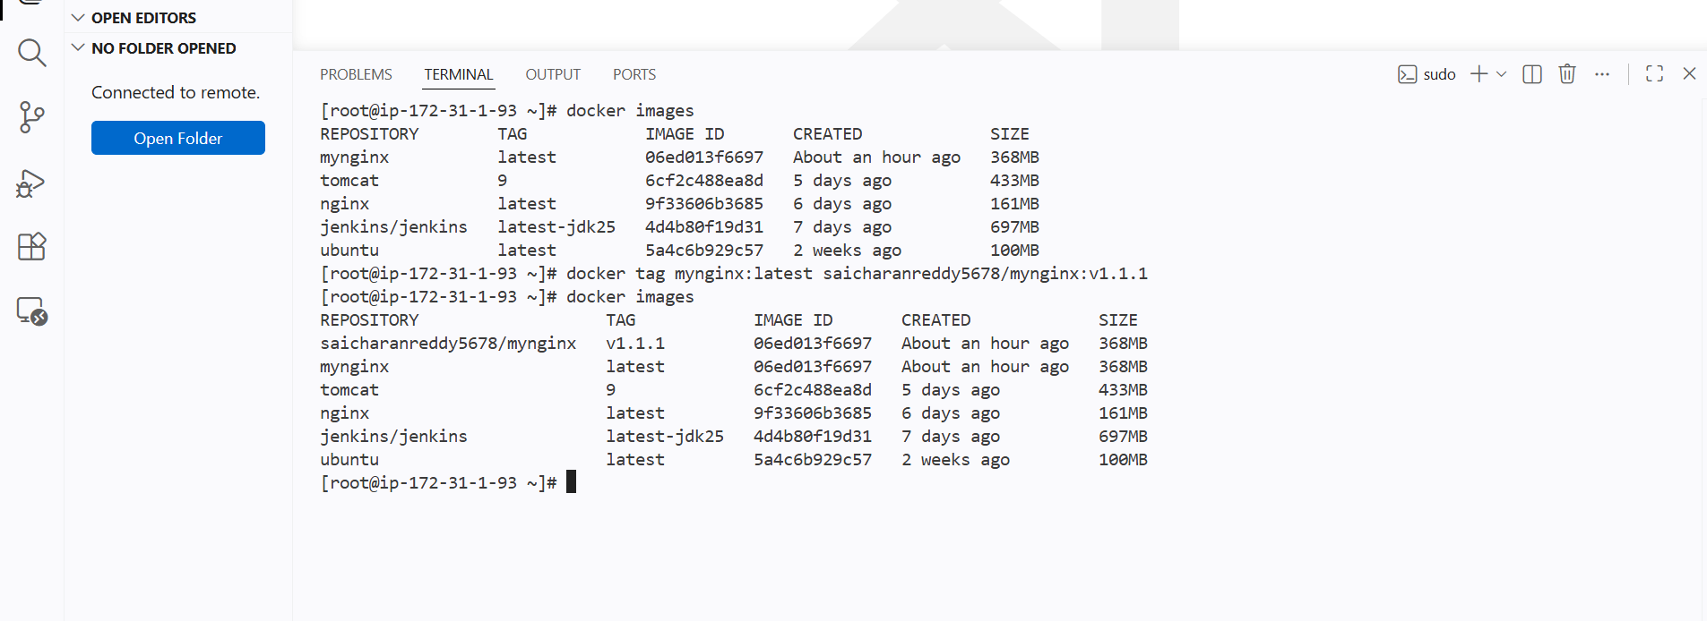

It 2 images has been created with repo name and given tag

Now I will push newly created image with tag v1.1.1

Succesfully pushed to the docker hub

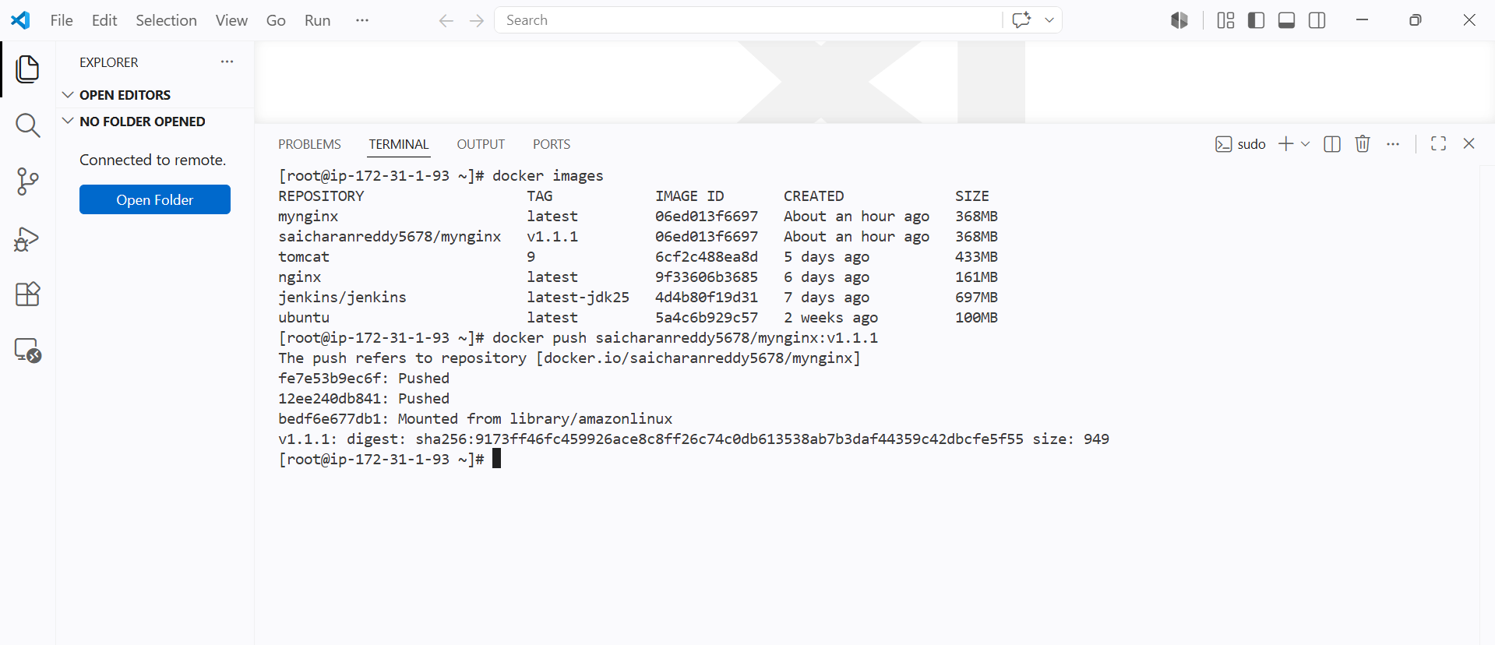

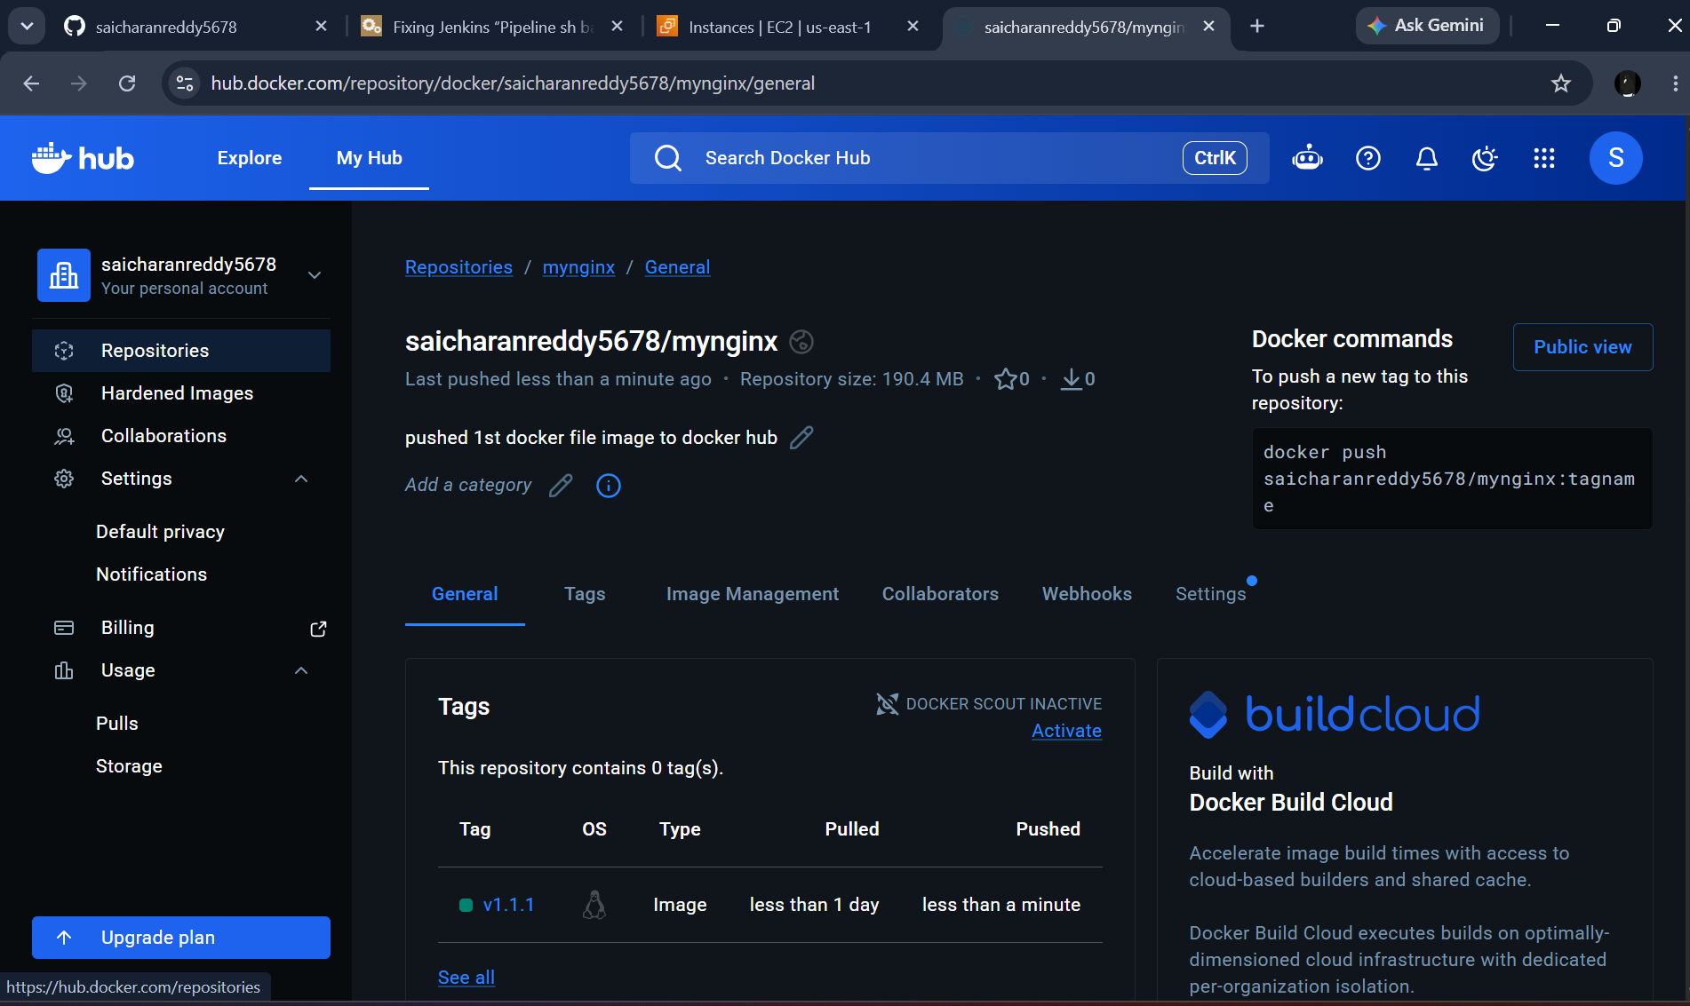

push image to AWS ECR

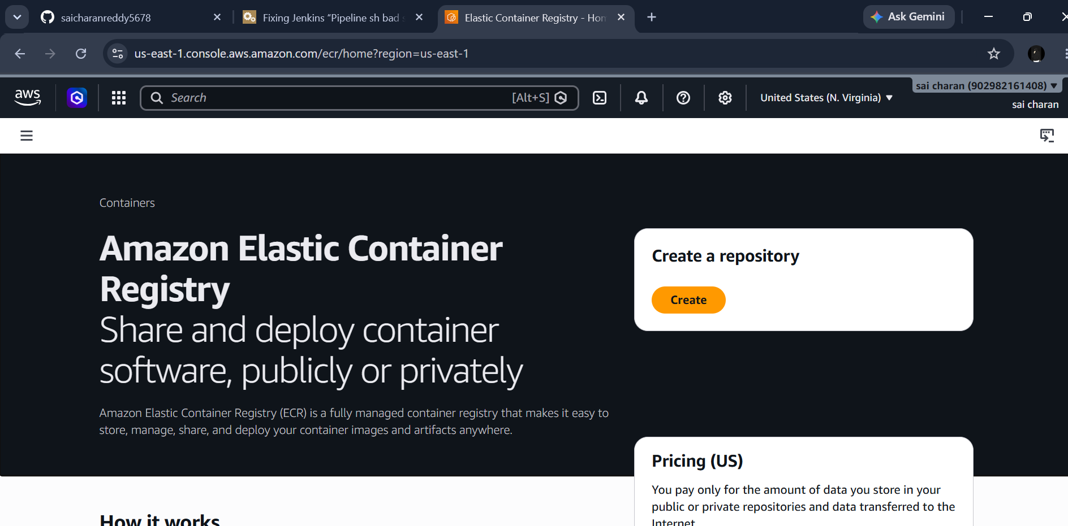

Create a new repo in ECR AWS

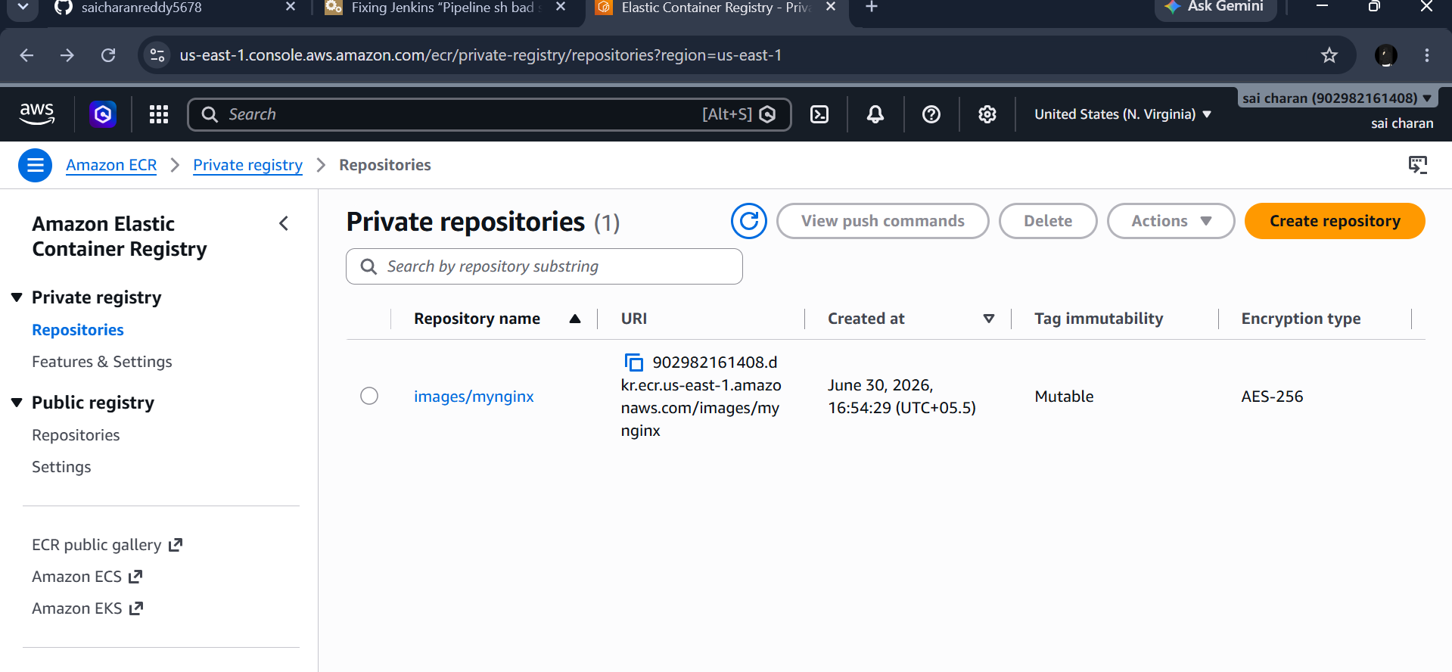

Now push the image to ecr from docker

First configure aws login credentials using secret key and access key

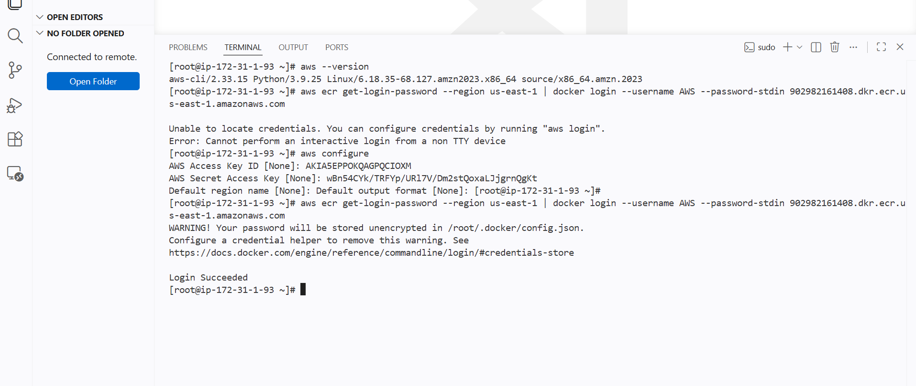

Retrieve an authentication token and authenticate your Docker client to your registry. Use the AWS CLI:

aws ecr get-login-password --region us-east-1 | docker login --username AWS --password-stdin 902982161408.dkr.ecr.us-east-1.amazonaws.com

Then build our image with the repo tag name
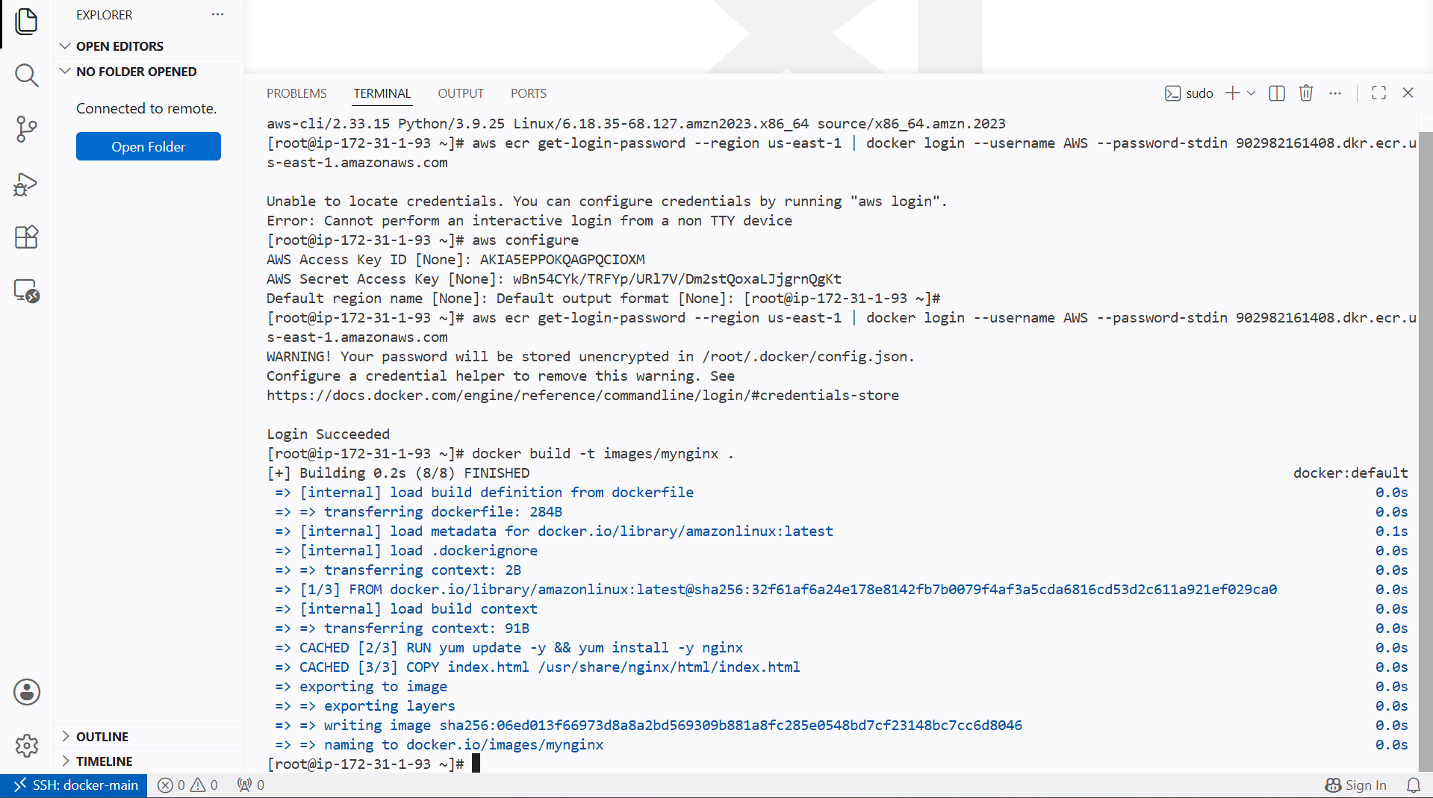

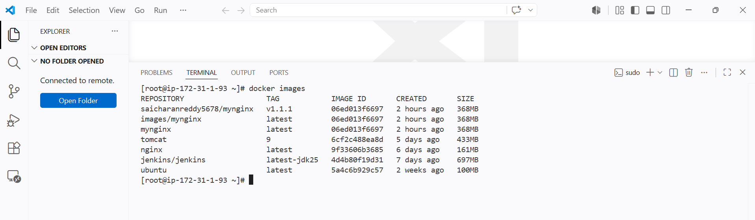

New image has been created with ecr repo name

Now we need to attach the tag to our image same as ECR

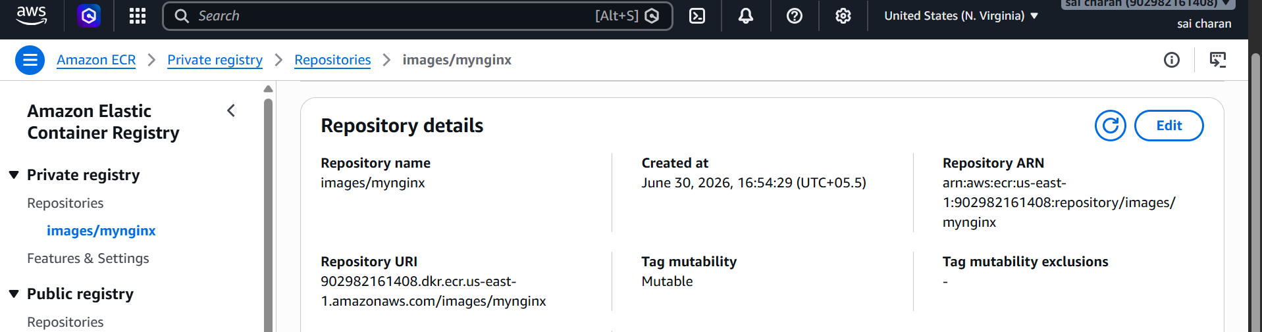

We need to give ecr repo url as name to our image and modify our own tag

Then it will look like in below image

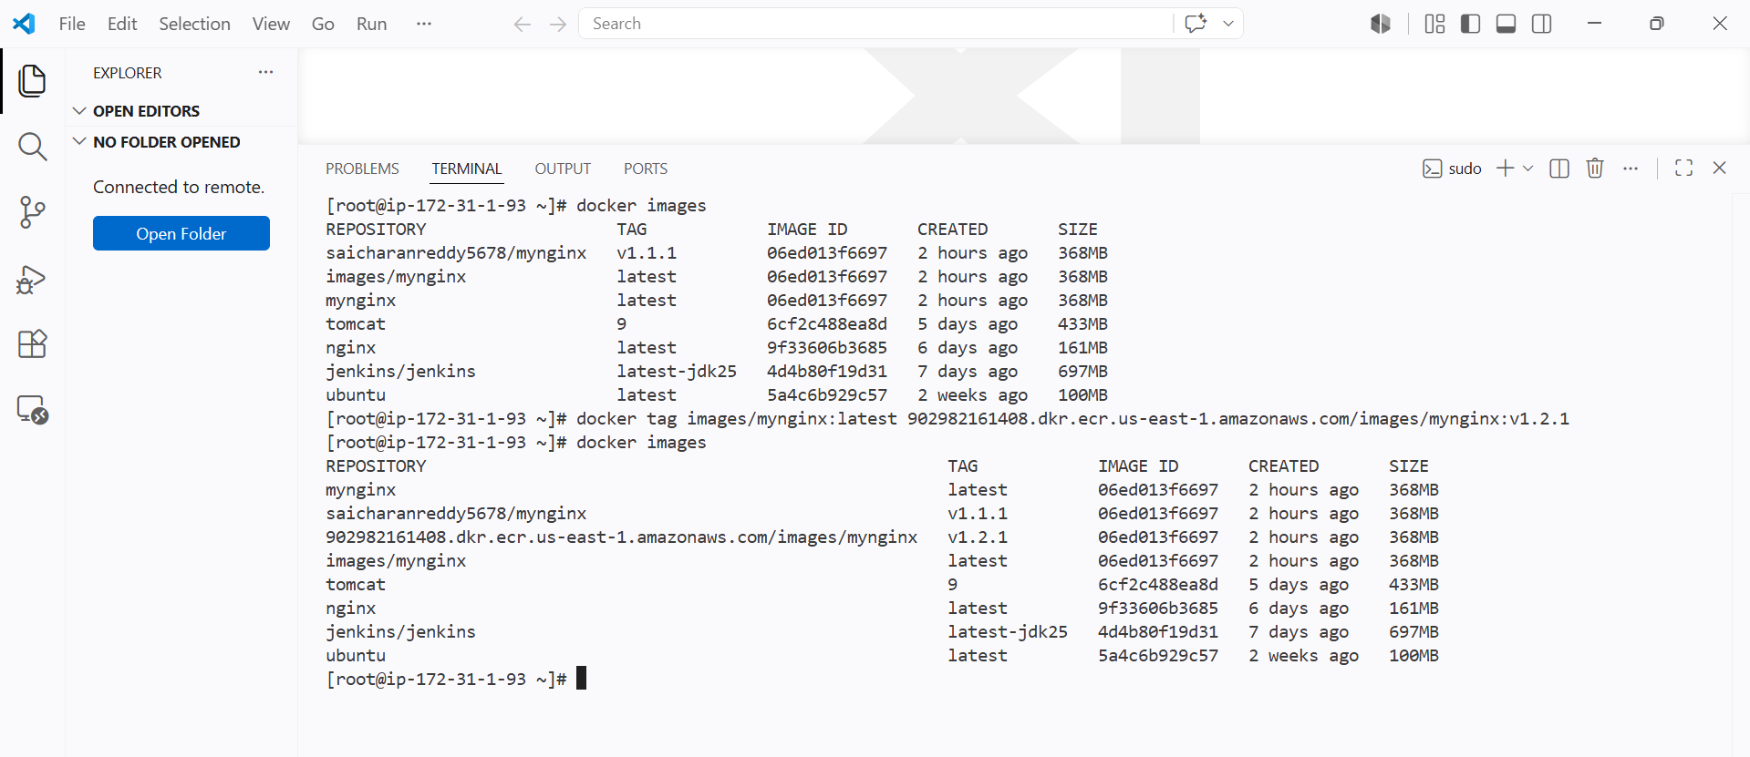

Now after giving the push command it will pusuh to the ecr repo

docker push 902982161408.dkr.ecr.us-east-1.amazonaws.com/images/mynginx:v1.2.1

Docker push repourl:tag
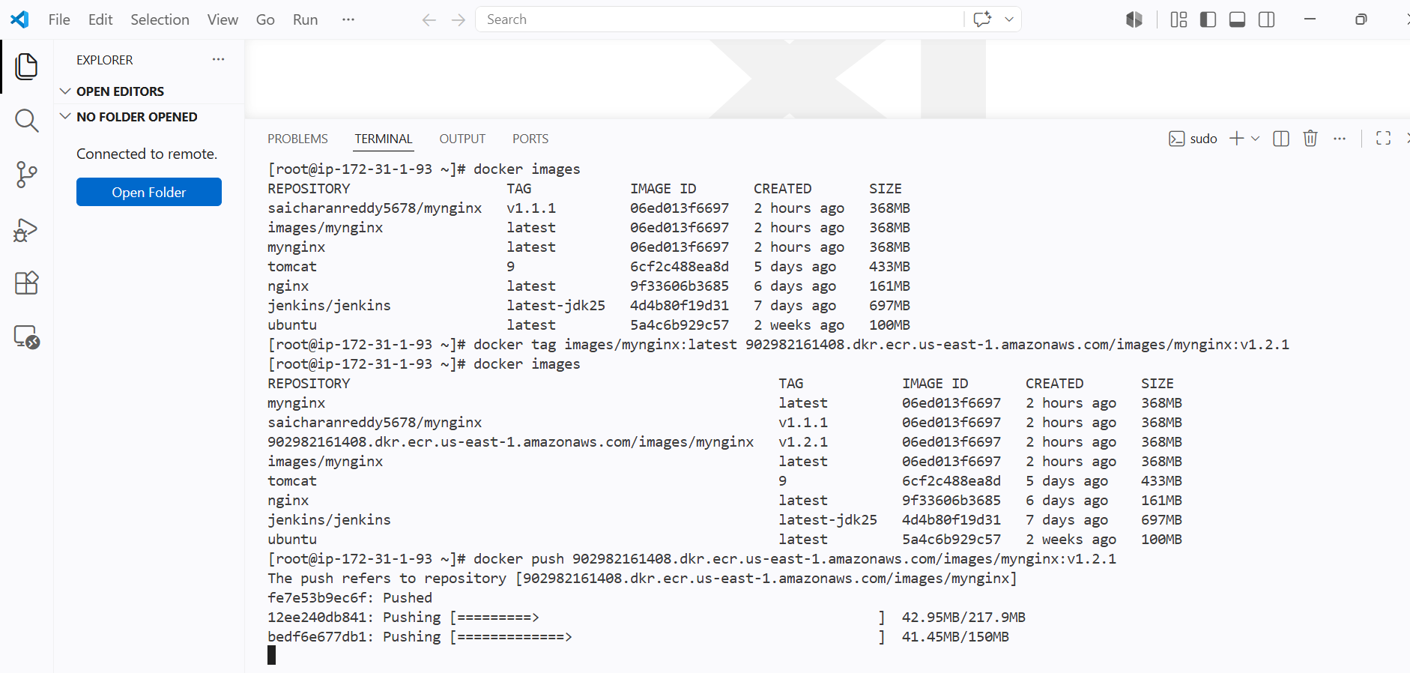

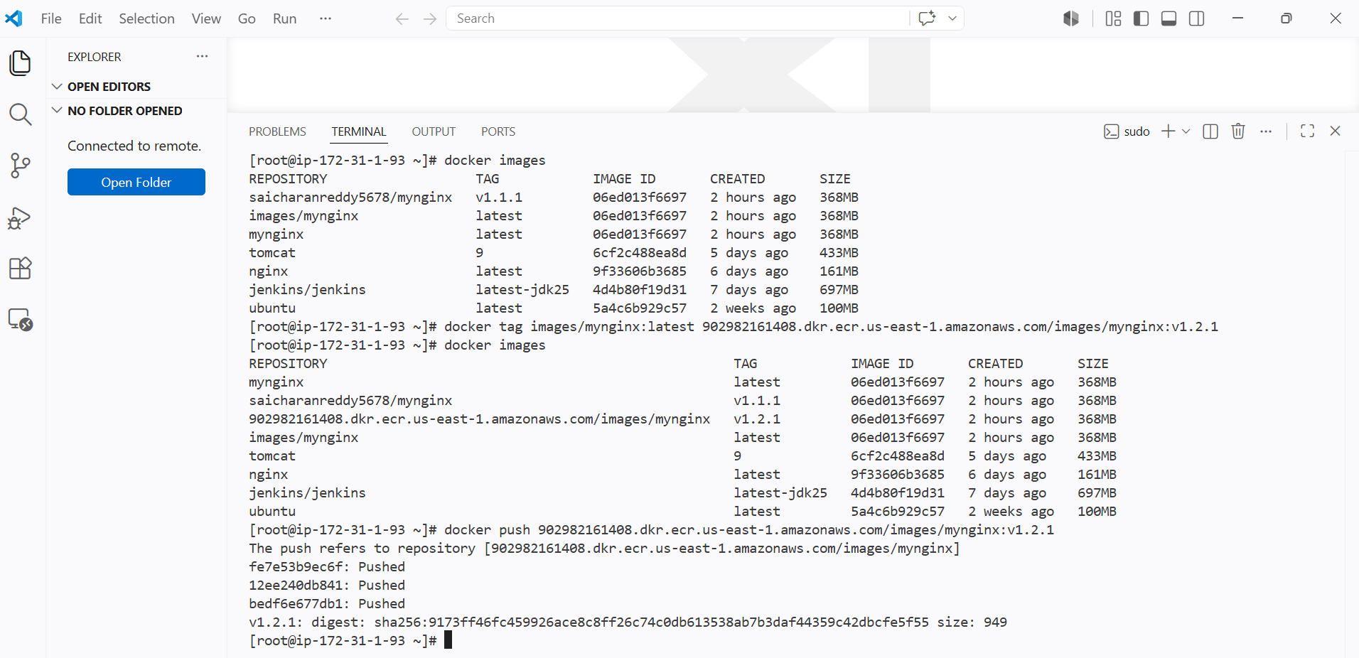

We can see the image has been uploaded to ECR



