EXPERIMENT NO: 1 (a)
AIM: Simulate FCFS CPU scheduling algorithm

DESCRIPTION: It is a non-preemptive scheduling algorithm. Its implementation is based on FIFO queue. Easy to understand and implement. FCFS is an operating system scheduling algorithm that automatically executes queued requests and processes in order of their arrival. In this type of algorithm, processes which requests the CPU first get the CPU allocation first.
Advantages of FCFS:
- Here, are pros/benefits of using FCFS scheduling algorithm:
- The simplest form of a CPU scheduling algorithm
- Easy to program
- First come first served
Disadvantages of FCFS:
- Here, are cons/ drawbacks of using FCFS scheduling algorithm:
- It is a Non-Preemptive CPU scheduling algorithm, so after the process has been allocated to the CPU, it will never release the CPU until it finishes executing.
- The Average Waiting Time is high.
- Not an ideal technique for time-sharing systems.
- Because of its simplicity, FCFS is not very efficient.
PROGRAMMING LANGUAGE USED: PYTHON
LIBRARIES USED: No libraries are used in the code.
SYNTAX:
PROGRAM:
n = int(input("enter the number of processes: "))
times = []
for i in range(n):
times.append([int(input("enter burst time of process " +str(i+1)+ ": "))])
for i in range(n):
times[i].append(int(input("enter arrival time of process " +str(i+1)+ ": ")))
# fcfs starts
times.sort(key = lambda x: x[1])
bt = [i[0] for i in times]
at = [i[1] for i in times]
tt = []
wt = []
et = []
cs = n-1
wt.append(0)
tt.append(bt[0])
t = bt[0]+at[0]
et.append(t)
for i in range(1,n):
if t>at[i]:
wt.append(t-at[i])
else:
wt.append(0)
t = at[i]
t += bt[i]
tt.append(t-at[i])
et.append(t)
Te
# fcfs ends
print()
print('turnaround time: '+'\t'.join(map(str,tt)))
print('waiting time: '+'\t'.join(map(str,wt)))
print('end time: '+'\t'.join(map(str,et)))
print()
print('average waiting time:', sum(wt)/n)
print('average turnaround time:', sum(tt)/n)
print('number of context switches:', cs)
OUTPUT:

enter the number of processes: 4
enter burst time of process 1: 21
enter burst time of process 2: 3
enter burst time of process 3: 6
enter burst time of process 4: 2
enter arrival time of process 1: 0
enter arrival time of process 2: 0
enter arrival time of process 3: 0
enter arrival time of process 4: 0

turnaround time: 21 24 30 32
waiting time: 0 21 24 30
end time: 21 24 30 32

average waiting time: 18.75
average turnaround time: 26.75
number of context switches: 3

Test case 2:

enter the number of processes: 5
enter burst time of process 1: 6
enter burst time of process 2: 3
enter burst time of process 3: 8
enter burst time of process 4: 3
enter burst time of process 5: 4
enter arrival time of process 1: 2
enter arrival time of process 2: 5
enter arrival time of process 3: 1
enter arrival time of process 4: 0
enter arrival time of process 5: 4

turnaround time : 3 10 15 17 19
waiting time : 0 2 9 13 16
end time : 3 11 17 21 24

average waiting time: 8.0
average turnaround time: 12.8
number of context switches: 4
Output Screenshots:
output 1:
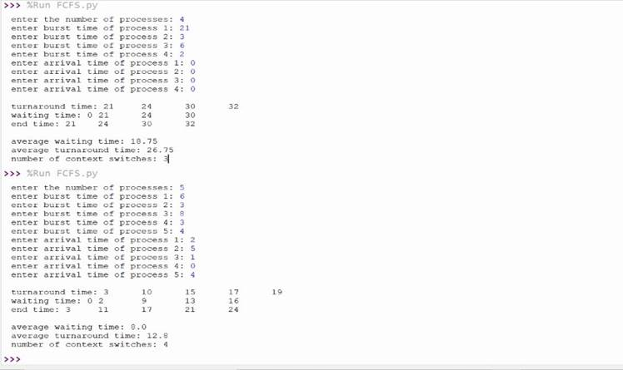

EXPERIMENT NO: 1 (b)

AIM : Simulate Non Premptive SJF CPU scheduling algorithm

DESCRIPTION : Shortest Job First (SJF) is an algorithm in which the process having the smallest execution time is chosen for the next execution. This scheduling method can be preemptive or non-preemptive. It significantly reduces the average waiting time for other processes awaiting execution.
In non-preemptive scheduling, once the CPU cycle is allocated to process, the process holds it till it reaches a waiting state or terminated.
Advantages of SJF:
- Here are the benefits/pros of using SJF method:
- SJF is frequently used for long term scheduling.
- It reduces the average waiting time over FIFO (First in First Out) algorithm.
- SJF method gives the lowest average waiting time for a specific set of processes.
- For Short-Term Scheduling, we need to predict the value of the next burst time.
Disadvantages of SJF:
- Here are some drawbacks of SJF algorithm:
- Job completion time must be known earlier, but it is hard to predict.
- It is often used in a batch system for long term scheduling.
- This algorithm may cause very long turnaround times or starvation.
- Requires knowledge of how long a process or job will run.
- It leads to the starvation that does not reduce average turnaround time.
- It is hard to know the length of the upcoming CPU request.
PROGRAMMING LANGUAGE USED: PYTHON
LIBRARIES USED: No libraries are used in the code.
SYNTAX:
PROGRAM:
def findall(at, t):
res = []
for i in range(len(at)):
if at[i]<=t:
res.append(i)
return res

def find(bt, indices):
ans = indices[0]
m = bt[ans]
for i in indices[1:]:
if m>bt[i]:
m = bt[i]
ans = i
return ans

n = int(input("enter the number of processes: "))
times = []
for i in range(n):
times.append([int(input("enter burst time of process " +str(i+1)+ ": "))])
for i in range(n):
times[i].append(int(input("enter arrival time of process " +str(i+1)+ ": ")))
#sjf non preemtive start

indx = [i for i in range(n)]
bt = [i[0] for i in times]
at = [i[1] for i in times]
tt = [None for _ in times]
wt = tt[:]
et = tt[:]
cs = n-1
t = min(at)
while at:
indices = findall(at, t)
ind = find(bt, indices)
currat = at.pop(ind)
currbt = bt.pop(ind)
reali = indx.pop(ind)
if t>currat:
wt[reali] = t-currat
else:
wt[reali] = 0
t = currat
t += currbt
tt[reali] = t-currat
et[reali] = t
#sjf ends

print()
print('turnaround time: '+'\t'.join(map(str,tt)))
print('waiting time: '+'\t'.join(map(str,wt)))
print('end time: '+'\t'.join(map(str,et)))
print()
print('average waiting time:', sum(wt)/n)
print('average turnaround time:', sum(tt)/n)
print('number of context switches:', cs)

OUTPUT:

Test case 1:

enter the number of processes: 5
enter burst time of process 1: 7
enter burst time of process 2: 3
enter burst time of process 3: 2
enter burst time of process 4: 10
enter burst time of process 5: 8
enter arrival time of process 1: 1
enter arrival time of process 2: 3
enter arrival time of process 3: 6
enter arrival time of process 4: 7
enter arrival time of process 5: 9

turnaround time: 7 10 4 24 12
waiting time: 0 7 2 14 4
end time: 8 13 10 31 21

average waiting time: 5.4
average turnaround time: 11.4
number of context switches: 4

Test case 2:
enter the number of processes: 5
enter burst time of process 1: 6
enter burst time of process 2: 2
enter burst time of process 3: 8
enter burst time of process 4: 3
enter burst time of process 5: 4
enter arrival time of process 1: 2
enter arrival time of process 2: 5
enter arrival time of process 3: 1
enter arrival time of process 4: 0
enter arrival time of process 5: 4

turnaround time: 7 6 22 3 11
waiting time: 1 4 14 0 7
end time: 9 11 23 3 15

average waiting time: 5.2
average turnaround time: 9.8
number of context switches: 4

Output screenshots:
output 1:
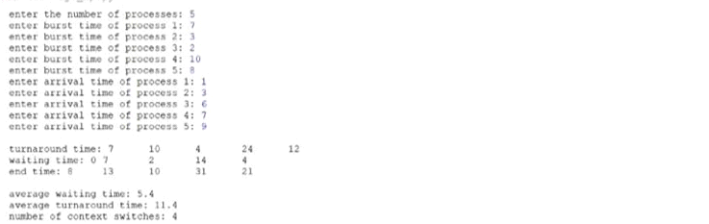
output 2:
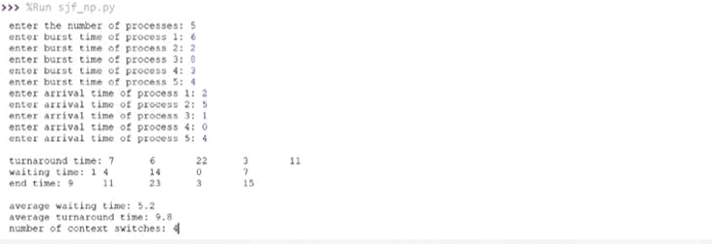
EXPERIMENT NO: 1 (c)

AIM : Simulate Premptive SJF CPU scheduling algorithm

DESCRIPTION : In Preemptive SJF Scheduling, jobs are put into the ready queue as they come. A process with shortest burst time begins execution. If a process with even a shorter burst time arrives, the current process is removed or preempted from execution, and the shorter job is allocated CPU cycle.
PROGRAMMING LANGUAGE USED: PYTHON
LIBRARIES USED: No libraries are used in the code.
SYNTAX:
PROGRAM:
n=int(input('Ask User number of processes:'))
a,b=[],[]
b1=[]
wt,tat=[],[]
ct=[]
count=0
i1,c=0,0
temp1=-1
print('Ask user Burst time of each process')
for i in range(0,n):
b.append(int(input('enter Burst Time of process %d :'%(i+1))))
print('Ask user Arrival time of each process')
for i in range(0,n):
a.append(int(input('enter Arrival Time of process %d :'%(i+1))))
total=sum(b)
for i in range(0,n):
tat.append(0)
wt.append(0)
ct.append(0)
b1.append(0)
for i in range(0,n):
b1[i]=b[i]
while(i1<total+c):
index=-1
mini=99999
for j in range(0,n):
if(i1>=a[j] and b[j]>0):
if(mini>b[j]):
index=j
mini=b[j]
if(index==-1):
c=c+1
i1=i1+1
else:
b[index]-=1
if(b[index]==0):
tat[index]=i1+1
if(i1==0):
temp1=index
elif(temp1!=index):
count+=1
temp1=index
i1+=1
for i in range(0,n):
tat[i]-=a[i]
ct[i]=tat[i]+a[i]
wt[i]=tat[i]-b1[i]
print('Process\tBurstTime\tArrivalTime\tTurnAroundTime\tWaitingTime\tExitTime')
for i in range(0,n):
print('P%d'%(i+1),'\t',b1[i],'\t\t',a[i],'\t\t',tat[i],'\t\t',wt[i],'\t\t',ct[i])
print('Average waiting time is:',(sum(wt)/n))
print('Average Turn around time is:',(sum(tat)/n))
print('Number of context switches:',count)

OUTPUT:
Test case 1:

Ask User number of processes:3
Ask user Burst time of each process
enter Burst Time of process 1 :1
enter Burst Time of process 2 :2
enter Burst Time of process 3 :6
Ask user Arrival time of each process
enter Arrival Time of process 1 :0
enter Arrival Time of process 2 :1
enter Arrival Time of process 3 :5
Process BurstTime ArrivalTime TurnAroundTime WaitingTime ExitTime
P1 1 0 1 |  | 0 1
P2 2 1 2 |  | 0 3
P3 6 5 6 |  | 0 11
Average waiting time is: 0.0
Average Turn around time is: 3.0
Number of context switches: 2

Test case 2:
Ask User number of processes:4
Ask user Burst time of each process
enter Burst Time of process 1 :5
enter Burst Time of process 2 :4
enter Burst Time of process 3 :2
enter Burst Time of process 4 :4
Ask user Arrival time of each process
enter Arrival Time of process 1 :0
enter Arrival Time of process 2 :2
enter Arrival Time of process 3 :2
enter Arrival Time of process 4 :4
Process BurstTime ArrivalTime TurnAroundTime WaitingTime ExitTime
P1 5 0 7 |  | 2 7
P2 4 2 9 |  | 5 11
P3 2 2 2 |  | 0 4
P4 4 4 11 |  | 7 15
Average waiting time is: 3.5
Average Turn around time is: 7.25
Number of context switches: 4
Output screen shot:
output 1:
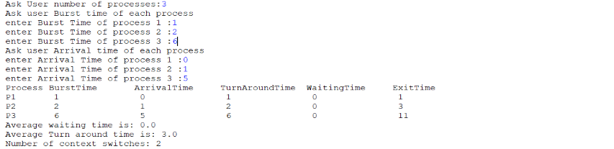output 2:
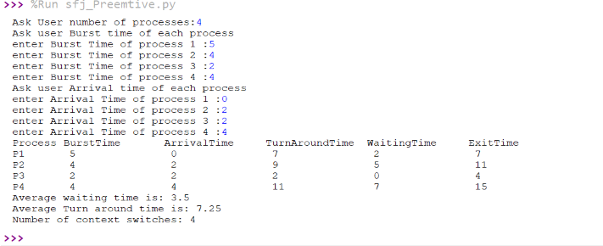

EXPERIMENT NO: 1 (d)

AIM : Simulate Non Preemptive Priority CPU scheduling algorithm

DESCRIPTION : In the Non Preemptive Priority scheduling, The Processes are scheduled according to the priority number assigned to them. Once the process gets scheduled, it will run till the completion. Generally, the lower the priority number, the higher is the priority of the process.
It can be used in various hardware applications where waiting will not cause any serious issues.
PROGRAMMING LANGUAGE USED: PYTHON
LIBRARIES USED: No libraries are used in the code.

SYNTAX:

PROGRAM:
def findall(at, t):
res = []
for i in range(len(at)):
if at[i]<=t:
res.append(i)
return res

def find(p, indices):
ans = indices[0]
m = p[ans]
for i in indices[1:]:
if m>p[i]:
m = p[i]
ans = i
return ans
n = int(input("enter the number of processes: "))
times = []
for i in range(n):
times.append([int(input("enter burst time of process " +str(i+1)+ ": "))])
for i in range(n):
times[i].append(int(input("enter arrival time of process " +str(i+1)+ ": ")))
for i in range(n):
times[i].append(int(input("enter priority of process " +str(i+1)+ ": ")))
#sjf non preemtive start
indx = [i for i in range(n)]
bt = [i[0] for i in times]
at = [i[1] for i in times]
p = [i[2] for i in times]
tt = [None for _ in times]
wt = tt[:]
et = tt[:]
cs = n-1
t = min(at)
while at:
indices = findall(at, t)
ind = find(p, indices)
currat = at.pop(ind)
currbt = bt.pop(ind)
currp = p.pop(ind)
reali = indx.pop(ind)
if t>currat:
wt[reali] = t-currat
else:
wt[reali] = 0
t = currat
t += currbt
tt[reali] = t-currat
et[reali] = t
#sjf ends
print()
print('turnaround time: '+'\t'.join(map(str,tt)))
print('waiting time: '+'\t'.join(map(str,wt)))
print('end time: '+'\t'.join(map(str,et)))
print()
print('average waiting time:', sum(wt)/n)
print('average turnaround time:', sum(tt)/n)
print('number of context switches:', cs)

OUTPUT:
Test case 1:

enter the number of processes: 4
enter burst time of process 1: 5
enter burst time of process 2: 4
enter burst time of process 3: 2
enter burst time of process 4: 4
enter arrival time of process 1: 0
enter arrival time of process 2: 2
enter arrival time of process 3: 2
enter arrival time of process 4: 4
enter priority of process 1: 4
enter priority of process 2: 2
enter priority of process 3: 6
enter priority of process 4: 3

turnaround time: 5 7 13 9
waiting time: 0 3 11 5
end time: 5 9 15 13

average waiting time: 4.75
average turnaround time: 8.5
number of context switches: 3

Test case 2:

enter the number of processes: 4
enter burst time of process 1: 8
enter burst time of process 2: 5
enter burst time of process 3: 3
enter burst time of process 4: 6
enter arrival time of process 1: 0
enter arrival time of process 2: 0
enter arrival time of process 3: 0
enter arrival time of process 4: 0
enter priority of process 1: 2
enter priority of process 2: 3
enter priority of process 3: 1
enter priority of process 4: 4

turnaround time: 11 16 3 22
waiting time: 3 11 0 16
end time: 11 16 3 22

average waiting time: 7.5
average turnaround time: 13.0
number of context switches: 3

Output screenshot s:

Outout 1:

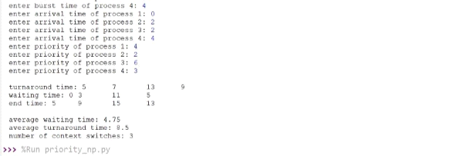
output 2:
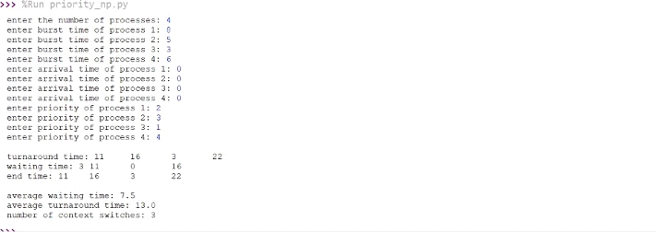

EXPERIMENT NO: 1 (e)

AIM : Simulate Premptive Priority CPU scheduling algorithm

DESCRIPTION :
In Preemptive Priority Scheduling, at the time of arrival of a process in the ready queue, its Priority is compared with the priority of the other processes present in the ready queue as well as with the one which is being executed by the CPU at that point of time. The One with the highest priority among all the available processes will be given the CPU next.
The difference between preemptive priority scheduling and non preemptive priority scheduling is that, in the preemptive priority scheduling, the job which is being executed can be stopped at the arrival of a higher priority job.
PROGRAMMING LANGUAGE USED: PYTHON
LIBRARIES USED: No libraries are used in the code.
SYNTAX:

PROGRAM:
def findall(at, t):
res = []
for i in range(len(at)):
if at[i]<=t:
res.append(i)
return res
def find(p, indices):
ans = indices[0]
m = p[ans]
for i in indices[1:]:
if m>p[i]:
m = p[i]
ans = i
return ans

n = int(input("enter the number of processes: "))
times = []
for i in range(n):
times.append([int(input("enter burst time of process " +str(i+1)+ ": "))])
for i in range(n):
times[i].append(int(input("enter arrival time of process " +str(i+1)+ ": ")))
for i in range(n):
times[i].append(int(input("enter priority of process " +str(i+1)+ ": ")))
#priority start
indx = list(range(n))
bt = [i[0] for i in times]
at = [i[1] for i in times]
p = [i[2] for i in times]
tt = [None]*len(times)
wt = [0]*len(times)
et = tt[:]
t = min(at)
cs = 0
reali=None
while at:
indices = findall(at, t)
ind = find(p, indices)
temp = indx[ind]
if temp != reali and reali != None:
cs+=1
reali = temp
for i in indices:
wt[indx[i]] += 1
wt[reali] -= 1
bt[ind] -= 1
t += 1
if bt[ind]==0:
tt[reali] = t-at[ind]
et[reali] = t
at.pop(ind)
bt.pop(ind)
p.pop(ind)
indx.pop(ind)
#priority end
print()
print('turnaround time: '+'\t'.join(map(str,tt)))
print('waiting time: '+'\t'.join(map(str,wt)))
print('end time: '+'\t'.join(map(str,et)))
print()
print('average waiting time:', sum(wt)/n)
print('average turnaround time:', sum(tt)/n)
print('number of context switches:', cs)

OUTPUT:
Test case 1:
enter the number of processes: 5
enter burst time of process 1: 8
enter burst time of process 2: 1
enter burst time of process 3: 3
enter burst time of process 4: 2
enter burst time of process 5: 6
enter arrival time of process 1: 0
enter arrival time of process 2: 1
enter arrival time of process 3: 2
enter arrival time of process 4: 3
enter arrival time of process 5: 4
enter priority of process 1: 3
enter priority of process 2: 1
enter priority of process 3: 2
enter priority of process 4: 3
enter priority of process 5: 4

turnaround time: 12 1 3 11 16
waiting time: 4 0 0 9 10
end time: 12 2 5 14 20

average waiting time: 4.6
average turnaround time: 8.6
number of context switches: 5

Test case 2:
enter the number of processes: 4
enter burst time of process 1: 5
enter burst time of process 2: 4
enter burst time of process 3: 2
enter burst time of process 4: 4
enter arrival time of process 1: 0
enter arrival time of process 2: 2
enter arrival time of process 3: 2
enter arrival time of process 4: 4
enter priority of process 1: 4
enter priority of process 2: 2
enter priority of process 3: 6
enter priority of process 4: 3

turnaround time: 13 4 13 6
waiting time: 8 0 11 2
end time: 13 6 15 10

average waiting time: 5.25
average turnaround time: 9.0
number of context switches: 4
Output screenshots :
output 1:
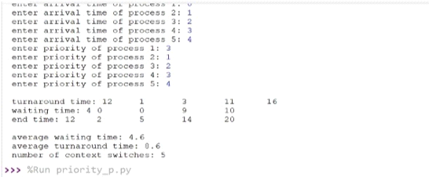
output 2:
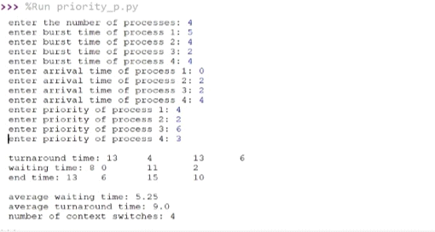

EXPERIMENT NO: 1 (f)

AIM : Simulate Round Robin CPU scheduling algorithm

DESCRIPTION : Round Robin scheduling algorithm is one of the most popular scheduling algorithm which can actually be implemented in most of the operating systems. This is the preemptive version of first come first serve scheduling. The Algorithm focuses on Time Sharing. In this algorithm, every process gets executed in a cyclic way. A certain time slice is defined in the system which is called time quantum. Each process present in the ready queue is assigned the CPU for that time quantum, if the execution of the process is completed during that time then the process will terminate else the process will go back to the ready queue and waits for the next turn to complete the execution.
PROGRAMMING LANGUAGE USED: PYTHON
LIBRARIES USED: No libraries are used in the code.

SYNTAX:

Program :
def find(at, t):
res = None
ind = None
for i in range(len(at)):
if at[i]<=t and (res==None or res>at[i]):
res = at[i]
ind = i
return ind
n = int(input("enter the number of processes: "))
times = []
for i in range(n):
times.append([int(input("enter burst time of process " +str(i+1)+ ": "))])
for i in range(n):
times[i].append(int(input("enter arrival time of process " +str(i+1)+ ": ")))
qt = int(input('enter quantum time: '))
bt = [i[0] for i in times]
at = [i[1] for i in times]
at_old = at[:]
indx = list(range(n))
tt = [0]*n
wt = [0]*n
et = [0]*n
cs = 0
t = min(at)
reali = None

while at:
ind = find(at, t)
if ind==None:
t+=1
continue
temp = indx[ind]
if temp != reali and reali != None:
cs+=1
reali = temp
if t>at[ind]:
wt[reali] += t-at[ind]
else:
t = at[ind]
at.pop(ind)
if bt[ind]>qt:
t += qt
at.append(t)
bt.append(bt.pop(ind) - qt)
indx.append(indx.pop(ind))
else:
t += bt[ind]
tt[reali] = t-at_old[reali]
et[reali] = t
bt.pop(ind)
indx.pop(ind)
# fcfs ends
print()
print('turnaround time: '+'\t'.join(map(str,tt)))
print('waiting time: '+'\t'.join(map(str,wt)))
print('end time: '+'\t'.join(map(str,et)))
print()
print('average waiting time:', sum(wt)/n)
print('average turnaround time:', sum(tt)/n)
print('number of context switches:', cs)

Output:

Test Case1:
enter the number of processes: 4
enter burst time of process 1: 5
enter burst time of process 2: 4
enter burst time of process 3: 2
enter burst time of process 4: 4
enter arrival time of process 1: 0
enter arrival time of process 2: 2
enter arrival time of process 3: 2
enter arrival time of process 4: 4
enter quantum time: 2

turnaround time: 13 10 4 11
waiting time: 8 6 2 7
end time: 13 12 6 15

average waiting time: 5.75
average turnaround time: 9.5
number of context switches: 7

Test Case2:
enter the number of processes: 5
enter burst time of process 1: 8
enter burst time of process 2: 1
enter burst time of process 3: 3
enter burst time of process 4: 2
enter burst time of process 5: 6
enter arrival time of process 1: 0
enter arrival time of process 2: 1
enter arrival time of process 3: 2
enter arrival time of process 4: 3
enter arrival time of process 5: 4
enter quantum time: 1

turnaround time: 19 1 10 6 16
waiting time: 11 0 7 4 10
end time: 19 2 12 9 20

average waiting time: 6.4
average turnaround time: 10.4
number of context switches: 19

Output screen shots :

output 1:

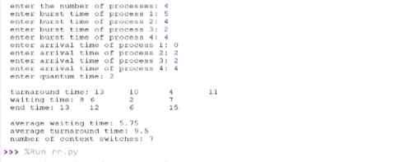
Output 2:
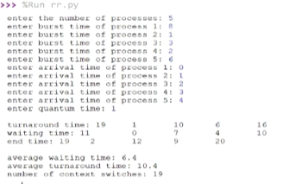

EXPERIMENT NO: 2 (a)

AIM : Design a c program to implement the multiprogramming memory management implementation of Fork() by using System call.

DESCRIPTION : Fork system call use for creates a new process, which is called child process, which runs concurrently with process (which process called system call fork) and this process is called parent process. After a new child process created, both processes will execute the next instruction following the fork() system call. A child process uses the same pc(program counter), same CPU registers, same open files which use in the parent process.
It takes no parameters and returns an integer value. Below are different values returned by fork().
Negative Value: creation of a child process was unsuccessful.
Zero: Returned to the newly created child process.
Positive value: Returned to parent or caller. The value contains process ID of newly created child process.

PROGRAMMING LANGUAGE USED: C

LIBRARIES USED: stdio.h, sys/types.h, unistd.h

SYNTAX: fork()

PROGRAM 1:

#include <stdio.h>
#include <sys/types.h>
#include <unistd.h>
int main()
{

// make two process which run same
// program after this instruction
fork();

printf("Hello world!\n");
return 0;
}
OUTPUT 1:
Hello world!
Hello world!

OUTPUT SCREEN SHOTS:
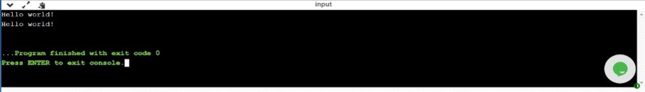

PROGRAM 2:
#include <stdio.h>
#include <sys/types.h>
int main()
{
fork();
fork();
fork();
printf("hello\n");
return 0;
}
OUTPUT 2:
hello
hello
hello
hello
hello
hello
hello
hello

OUTPUT SCREEN SHOTS:
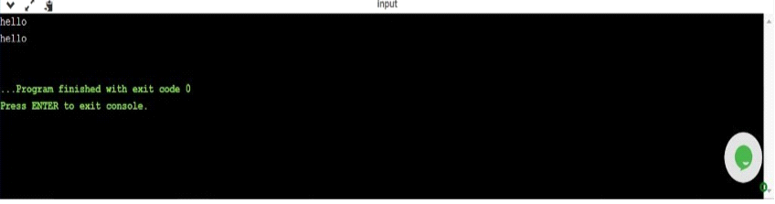

PROGRAM 3:
#include <stdio.h>
#include <sys/types.h>
#include <unistd.h>
void forkexample()
{
// child process because return value zero
if (fork() == 0)
printf("Hello from Child!\n");

// parent process because return value non-zero.
else
printf("Hello from Parent!\n");
}
int main()
{
forkexample();
return 0;
}

OUTPUT 3:
1.
Hello from Child!
Hello from Parent!
(or)
2.
Hello from Parent!
Hello from Child!

OUTPUT SCREEN SHOTS:
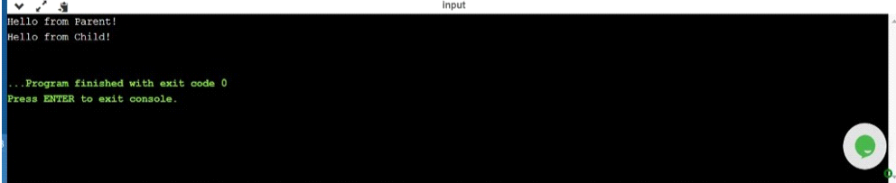

PROGRAM 4:
#include<stdio.h>
#include <sys/types.h>
#include <unistd.h>

void forkexample()
{
int x = 1;

if (fork() == 0)
printf("Child has x = %d\n", ++x);
else
printf("Parent has x = %d\n", --x);
}
int main()
{
forkexample();
return 0;
}

OUTPUT 4:
Parent has x = 0
Child has x = 2
(or)
Child has x = 2
Parent has x = 0

OUTPUT SCREEN SHOTS:
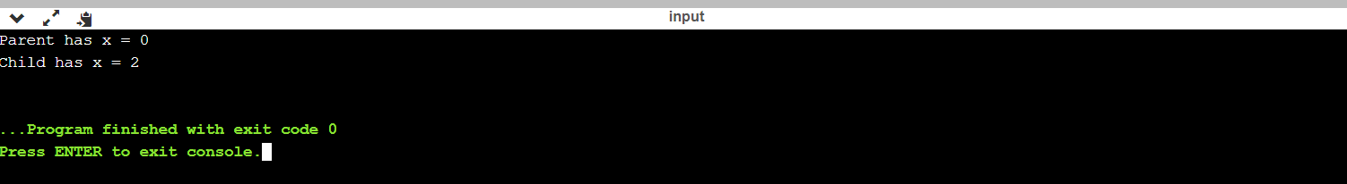

EXPERIMENT NO: 2 (b)

AIM : Design a c program to implement the multiprogramming memory management implementation of exit() by using System call.

DESCRIPTION :
exit() terminates the process normally.
status: Status value returned to the parent process. Generally, a status value of 0 or EXIT_SUCCESS indicates success, and any other value or the constant EXIT_FAILURE is used to indicate an error. exit() performs following operations.
* Flushes unwritten buffered data.
* Closes all open files.
* Removes temporary files.
* Returns an integer exit status to the operating system.
When exit() is called, any open file descriptors belonging to the process are closed and any children of the process are inherited by process 1, init, and the process parent is sent a SIGCHLD signal.
The mystery behind exit() is that it takes only integer args in the range 0 – 255 . Out of range exit values can result in unexpected exit codes. An exit value greater than 255 returns an exit code modulo 256.
For example, exit 9999 gives an exit code of 15 i.e. (9999 % 256 = 15).

PROGRAMMING LANGUAGE USED: C
LIBRARIES USED: sys/types.h, sys/wait.h
SYNTAX:
void exit ( int status );

PROGRAM 1:
#include<sys/types.h>
#include<sys/wait.h>

int main(void)
{
pid_t pid = fork();
if ( pid == 0 )
{
exit(9999); //passing value more than 255
}
int status;
waitpid(pid, &status, 0);
if ( WIFEXITED(status) )
{
int exit_status = WEXITSTATUS(status);
printf("Exit code: %d\n", exit_status);
}
return 0;
}

OUTPUT 1:
Exit code: 15

OUTPUT SCREEN SHOTS:
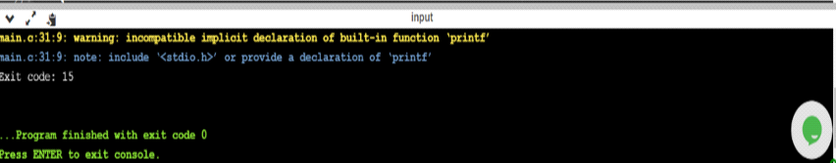

EXPERIMENT NO: 2 (c)

AIM : Design a c program to implement the multiprogramming memory management implementation of exec() by using System call.

DESCRIPTION : The exec family of functions replaces the current running process with a new process. It can be used to run a C program by using another C program. It comes under the header file unistd.h. There are many members in the exec family which are shown below with examples.
- execvp : Using this command, the created child process does not have to run the same program as the parent process does. The exec type system calls allow a process to run any program files, which include a binary executable or a shell script .
• execv : This is very similar to execvp() function in terms of syntax as well.Let us see a small example to show how to use execv() function in C. This example is similar to the example shown above for execvp() . We will have two .C files , EXEC.c and execDemo.c and we will replace the execDemo.c with EXEC.c by calling execv() function in execDemo.c .
• execlp and execl : These two also serve the same purpose
The same C programs shown above can be executed with execlp() or execl() functions and they will perform the same task i.e. replacing the current process the with a new process.
• execvpe and execle : These two also serve the same purpose but the syntax of them are a bit different from all the above members of exec family.
• envp:This argument is an array of pointers to null-terminated strings and must be terminated by a null pointer. The other functions take the environment for the new process image from the external variable environ in the calling process.

PROGRAMMING LANGUAGE USED: C

LIBRARIES USED: stdio.h, sys/types.h, unistd.h

SYNTAX:
int execvp (const char *file, char *const argv[]);
file: points to the file name associated with the file being executed.
argv: is a null terminated array of character pointers.

int execv(const char *path, char *const argv[]);
path: should point to the path of the file being executed.
argv[]: is a null terminated array of character pointers.

int execlp(const char *file, const char *arg,.../* (char *) NULL */);
int execl(const char *path, const char *arg,.../* (char *) NULL */);
file: file name associated with the file being executed
const char *arg and ellipses : describe a list of one or more pointers to null-terminated strings that represent the argument list available to the executed program.

PROGRAM 1:
#include<stdio.h>
#include<unistd.h>

int main()
{
int i;

printf("I am EXEC.c called by execvp() ");
printf("\n");

return 0;
}

//execDemo.c

#include<stdio.h>
#include<stdlib.h>
#include<unistd.h>
int main()
{
//A null terminated array of character
//pointers
char *args[]={"EXEC",NULL};
execvp(args[0],args);
/*All statements are ignored after execvp() call as this whole
process(execDemo.c) is replaced by another process (EXEC.c)
*/
printf("Ending-----");
return 0;
}

OUTPUT 1:
gcc EXEC.c -o EXEC
gcc execDemo.c -o execDemo

./execDemo
I am EXEC.c called by execvp()

OUTPUT SCREEN SHOTS:

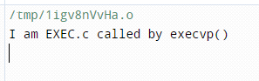

PROGRAM 2:

//EXEC.c

#include<stdio.h>
#include<unistd.h>

int main()
{
int i;

printf("I am EXEC.c called by execv() ");
printf("\n");
return 0;
}

//execDemo.c

#include<stdio.h>
#include<stdlib.h>
#include<unistd.h>
int main()
{
//A null terminated array of character
//pointers
char *args[]={"./EXEC",NULL};
execv(args[0],args);

/*All statements are ignored after execvp() call as this whole
process(execDemo.c) is replaced by another process (EXEC.c)
*/
printf("Ending-----");

return 0;
}

OUTPUT 2:
gcc EXEC.c -o EXEC
gcc execDemo.c -o execDemo
./execDemo
I am EXEC.c called by execv()

OUTPUT SCREEN SHOTS:

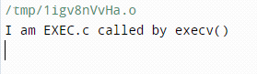

EXPERIMENT NO: 2 (d)

AIM : Design a c program to implement the multiprogramming memory management implementation of wait() by using System call.

DESCRIPTION :
call to wait() blocks the calling process until one of its child processes exits or a signal is received. After child process terminates, parent continues its execution after wait system call instruction.
Child process may terminate due to any of these:
- It calls exit();
- It returns (an int) from main
- It receives a signal (from the OS or another process) whose default action is to terminate.
If any process has more than one child processes, then after calling wait(), parent process has to be in wait state if no child terminates.
If only one child process is terminated, then return a wait() returns process ID of the terminated child process.
If more than one child processes are terminated than wait() reap any arbitrarily child and return a process ID of that child process.
When wait() returns they also define exit status (which tells our, a process why terminated) via pointer, If status are not NULL.
If any process has no child process then wait() returns immediately “-1”.
Child status information:
Status information about the child reported by wait is more than just the exit status of the child, it also includes
• normal/abnormal termination
• termination cause
• exit status
For find information about status, we use
WIF….macros
1. WIFEXITED(status): child exited normally
• WEXITSTATUS(status): return code when child exits
2. WIFSIGNALED(status): child exited because a signal was not caught
• WTERMSIG(status): gives the number of the terminating signal
3. WIFSTOPPED(status): child is stopped
• WSTOPSIG(status): gives the number of the stop signal

PROGRAMMING LANGUAGE USED: C
LIBRARIES USED: stdio.h ,stdlib.h ,sys/types.h, sys/wait.h
SYNTAX:
pid_t wait(int *stat_loc);
void psignal(unsigned sig, const char *s);
pid_t waitpid (child_pid, &status, options);

PROGRAM 1:
#include<stdio.h>
#include<stdlib.h>
#include<sys/wait.h>
#include<unistd.h>

int main()
{
pid_t cpid;
if (fork()== 0)
exit(0); /* terminate child */
else
cpid = wait(NULL); /* reaping parent */
printf("Parent pid = %d\n", getpid());
printf("Child pid = %d\n", cpid);

return 0;
}
OUTPUT 1:
Parent pid = 14546
Child pid = 14547

OUTPUT SCREEN SHOTS:

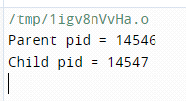

PROGRAM 2:
#include<stdio.h>
#include<sys/wait.h>
#include<unistd.h>

int main()
{
if (fork()== 0)
printf("HC: hello from child\n");
else
{
printf("HP: hello from parent\n");
wait(NULL);
printf("CT: child has terminated\n");
}

printf("Bye\n");
return 0;
}

OUTPUT 2:
HC: hello from child
HP: hello from parent
Bye
CT: child has terminated
Bye
(or)
HP: hello from parent
HC: hello from child
Bye
CT: child has terminated // this sentence does
Bye // not print before HC
// because of wait.

OUTPUT SCREEN SHOTS:
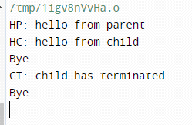

PROGRAM 3:
#include<stdio.h>
#include<stdlib.h>
#include<sys/wait.h>
#include<unistd.h>

void waitexample()
{
int stat;

// This status 1 is reported by WEXITSTATUS
if (fork() == 0)
exit(1);
else
wait(&stat);
if (WIFEXITED(stat))
printf("Exit status: %d\n", WEXITSTATUS(stat));
else if (WIFSIGNALED(stat))
psignal(WTERMSIG(stat), "Exit signal");
}

// Driver code
int main()
{
waitexample();
return 0;
}

OUTPUT 3:
Exit status: 1

OUTPUT SCREEN SHOTS:

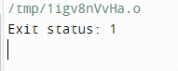
PROGRAM 4:
#include<stdio.h>
#include<stdlib.h>
#include<sys/wait.h>
#include<unistd.h>

void waitexample()
{
int i, stat;
pid_t pid[5];
for (i=0; i<5; i++)
{
if ((pid[i] = fork()) == 0)
{
sleep(1);
exit(100 + i);
}
}

// Using waitpid() and printing exit status
// of children.
for (i=0; i<5; i++)
{
pid_t cpid = waitpid(pid[i], &stat, 0);
if (WIFEXITED(stat))
printf("Child %d terminated with status: %d\n",
cpid, WEXITSTATUS(stat));
}
}

// Driver code
int main()
{
waitexample();
return 0;
}

OUTPUT 4:
Child 4483 terminated with status: 100
Child 4484 terminated with status: 101
Child 4485 terminated with status: 102
Child 4486 terminated with status: 103
Child 4487 terminated with status: 104

OUTPUT SCREEN SHOTS:
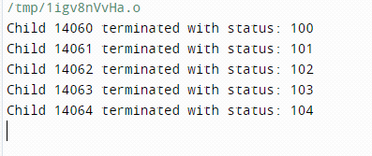

EXPERIMENT NO: 3(a)
AIM : Simulate Multiprogramming with a fixed number of tasks (MFT)

DESCRIPTION : MFT (Mulprogramming with a Fixed number of Tasks) is one of the old memory management techniques in which the memory is paroned into fixed size parons and each job is assigned to a paron. The memory assigned to a paron does not change.
PROGRAMMING LANGUAGE USED :- C ++
LIBRARIES USED:iostream
SYNTAX:
PROGRAM-1:
#include<iostream>
using namespace std;
int main()
{
int fragment[20],b[20],p[20],i,j,nb,np,temp,lowest=9999,flags[10], allocation[10],pm,highest=0,temp1;
static int barray[20],parray[20],bar[20],par[20];
cout<<"Enter the size of physical memory for user processes:";
cin>>pm;
cout<<"\nBEST FIT";
cout<<"\nEnter the number of partitions:";
cin>>nb;
cout<<"Enter the number of processes:";
cin>>np;
cout<<"\nEnter the size of the partitions:-\n";
for(i=1;i<=nb;i++)
{
cout<<"Partition no."<<i<<":";
cin>>b[i];
}
cout<<"\nEnter the size of the processes :-\n";
for(i=1;i<=np;i++)
{
cout<<"Process no. "<<i<<":";
cin>>p[i];
}
for(i=1;i<=np;i++)
{
for(j=1;j<=nb;j++)
{
if(barray[j]!=1)
{
temp=b[j]-p[i];
if(temp>=0)
if(lowest>temp)
{
parray[i]=j;
lowest=temp;
}
}

}
fragment[i]=lowest;
barray[parray[i]]=1;
lowest=10000;
}
cout<<"\nProcess_no\tProcess_size\tBlock_no\tBlock_size\tFragment";
for(i=1;i<=np && parray[i]!=0;i++)
cout<<"\n"<<i<<"\t\t"<<p[i]<<"\t\t"<<parray[i]<<"\t\t"<<b[parray[i]]<<"\t\t"<<fragment[i];
for(i = 0; i < 10; i++)
{
flags[i] = 0;
allocation[i] = -1;
}
for(i = 1; i <= np; i++) //allocation as per first fit
for(j = 1; j <= nb; j++)
if(flags[j] == 0 && b[j] >= p[i])
{
allocation[j] = i;
flags[j] = 1;
break;
}
//display allocation details
cout<<"\n\nFIRST FIT";
cout<<"\nBlock no.\tsize\t\tprocess no.\t\tsize\t\tInternal-Fragmentation";
for(i = 1; i <=nb; i++)
{
cout<<"\n"<< i<<"\t\t"<<b[i]<<"\t\t";
if(flags[i] == 1)
cout<<allocation[i]+1<<"\t\t\t"<<p[allocation[i]]<<"\t\t\t"<<b[i]-p[allocation[i]];
else
cout<<"Not allocated";
}
cout<<"\n\nWORST FIT";
for(i=1;i<=np;i++)
{
for(j=1;j<=nb;j++)
{
if(bar[j]!=1)
{
temp1=b[j]-p[i];
if(temp1>=0)
if(highest<temp1)
{
par[i]=j;
highest=temp1;
}
}
}
fragment[i]=highest;
bar[par[i]]=1;
highest=0;
}
cout<<"\nProcess_no\tProcess_size\tBlock_no\tBlock_size\tFragment";
for(i=1;i<=np && par[i]!=0;i++)
cout<<"\n"<<i<<"\t\t"<<p[i]<<"\t\t"<<par[i]<<"\t\t"<<b[par[i]]<<"\t\t"<<fragment[i];
return 0;
}
OUTPUT:
Enter the size of physical memory for user processes:500
BEST FIT
Enter the number of partitions:4
Enter the number of processes:4
Enter the size of the partitions:-
Partition no.1:100
Partition no.2:80
Partition no.3:120
Partition no.4:200
Enter the size of the processes :-
Process no. 1:70
Process no. 2:90
Process no. 3:110
Process no. 4:150
Process_no Process_size Block_no Block_size Fragment
1 70 2 80 10
2 90 1 100 10
3 110 3 120 10
4 150 4 200 50

FIRST FIT
Block no. size process no. size Internal-Fragmentation
1 100 2 70 30
2 80 Not allocated
3 120 3 90 30
4 200 4 110 90

WORST FIT
Process_no Process_size Block_no Block_size Fragment
1 70 4 200 130
2 90 3 120 30
OUTPUT SCREEN SHOTS:
Output 1:
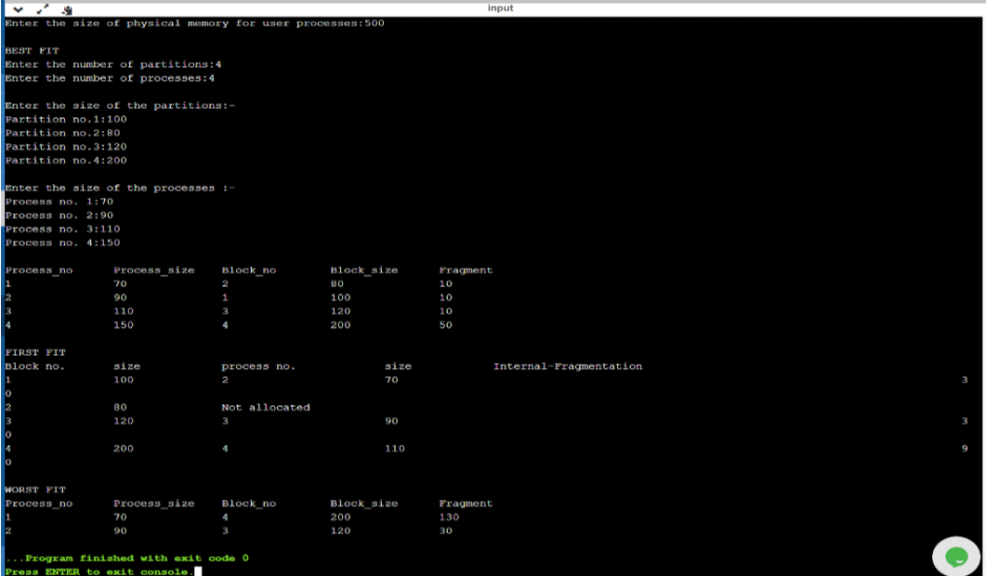Output 2:

EXPERIMENT NO: 3 (b)
AIM : Simulate Multiprogramming with a variable number of tasks (MVT)

DESCRIPTION : :MVT (Mulprogramming with a Variable number of Tasks) is the memory management technique in which each job gets just the amount of memory it needs. That is, the paroning of memory is dynamic and changes as jobs enter and leave the system. MVT is a more ``efficient’’ user of resources.

LIBRARIES USED: None
PROGRAMMING LANGUAGE USED :- C++
SYNTAX: None

PROGRAM-1:
#include<iostream>
using namespace std;
int main()
{
int ms,mp[10],i, temp,n=0;
char ch = 'y';
cout<<"\nEnter the size of physical memory for user processes:";
cin>>ms;
temp=ms;
for(i=0;ch=='y';i++,n++)
{
cout<<"\nEnter memory required for process"<<i+1<<":";
cin>>mp[i];
if(mp[i]<=temp)
{
cout<<"\nMemory is allocated for Process"<<i+1<<":";
temp = temp - mp[i];
}
else
{
cout<<"\nMemory is Full";
break;
}
cout<<"\nDo you want to continue(y/n) -- ";
cin>>ch;
}
cout<<"\n\nTotal Memory Available:"<<ms;
cout<<"\n\n\tPROCESS\t\t MEMORY ALLOCATED ";
for(i=0;i<n;i++)
cout<<"\n \t"<<i+1<<"\t\t"<<mp[i];
cout<<"\n\nTotal Memory Allocated is:"<<ms-temp;
cout<<"\nTotal External Fragmentation is:"<<temp;

}
OUTPUT :
Enter the size of physical memory for user processes:500
Enter memory required for process1:70
Memory is allocated for Process1:
Do you want to continue(y/n) -- y
Enter memory required for process2:90
Memory is allocated for Process2:
Do you want to continue(y/n) -- y
Enter memory required for process3:110
Memory is allocated for Process3:
Do you want to continue(y/n) -- y
Enter memory required for process4:150
Memory is allocated for Process4:
Do you want to continue(y/n) -- n
Total Memory Available:500
PROCESS MEMORY ALLOCATED
1 70
2 90
3 110
4 150
Total Memory Allocated is:420
Total External Fragmentation:80
OUTPUT SCREEN SHOTS:
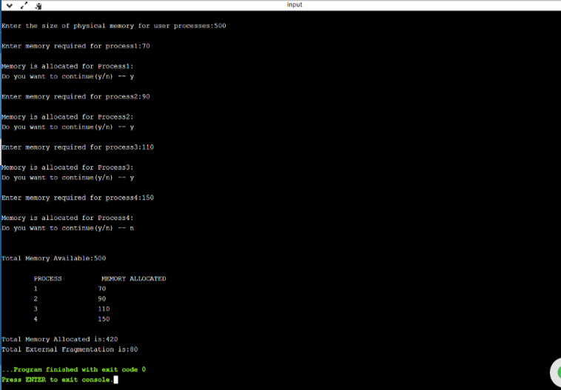

Experiment No-4
Aim: Simulate Bankers Algorithm for Dead Lock Avoidance
Description: Deadlock is a situation where in two or more competing actions are waiting f or the other to finish, and thus neither ever does. When a new process enters a system, it must declare the maximum number of instances of each resource type it needed. This number may exceed the total number of resources in the system. When the user request a set of resources, the system must determine whether them allocation of each resources will leave the system in safe state. If it will the resources are allocation; otherwise the process must wait until some other process release the resources.
Data structures
n-Number of process, m-number of resource types.
Available: Available[j]=k, k – instance of resource type Rj is available.
Max: If max[i, j]=k, Pi may request at most k instances resource Rj.
Allocation: If Allocation [i, j]=k, Pi allocated to k instances of resource
Rj Need: If Need[I, j]=k, Pi may need k more instances of resource type
Rj, Need[I, j]=Max[I, j]-Allocation[I, j];
Safety Algorithm
1. Work and Finish be the vector of length m and n respectively,
Work=Available and Finish[i] =False.
2. Find an i such that both
Finish[i] =False
Need<=Work
If no such I exists go to step 4.
3. work= work + Allocation, Finish[i] =True;
4. if Finish[1]=True for all I, then the system is in safe state. Resource request algorithm
Let Request i be request vector for the process Pi, If request i=[j]=k, then process Pi wants k instances of resource type Rj.
1. if Request<=Need I go to step 2. Otherwise raise an error condition.
2. if Request<=Available go to step 3. Otherwise Pi must since the resources are available.
3. Have the system pretend to have allocated the requested resources to process Pi by modifying the state as follows;
Available=Available-Request I;
Allocation I =Allocation +Request I; Need i=Need i-Request I;
If the resulting resource allocation state is safe, the transaction is completed and process Pi is allocated its resources. However if the state is unsafe, the Pi must wait for Request i and the old resource-allocation state is restored.
ALGORITHM:
1. Start .
2. Get the values of resources and processes.
3. Get the avail value.
4. After allocation find the need value.
5. Check whether its possible to allocate.
6. If it is possible then the system is in safe state.
7. Else system is not in safety state.
8. If the new request comes then check that the system is in safety.
9. or not if we allow the request.
10. stop .

Syntax:
#include<stdlib.h>
int main(){
}
Libraries used:
<stdlib.h>
h is the header of the general purpose standard library of C programming language which includes functions involving memory allocation, process control, conversions and others. It is compatible with C++ and is known as cstdlib in C++. Thename "stdlib" stands for "standard library".
Program:
#include<stdio.h>
#include <stdlib.h>
int main()
{
int Max[10][10], need[10][10], alloc[10][10], avail[10], completed[10], safeSequence[10];
int p, r, i, j, process, count;
count = 0;

printf("Enter the no of processes : ");
scanf("%d", &p);

for(i = 0; i< p; i++)
completed[i] = 0;

printf("\n\nEnter the no of resources : ");
scanf("%d", &r);

printf("\n\nEnter the Max Matrix for each process : ");
for(i = 0; i < p; i++)
{
printf("\nFor process %d : ", i + 1);
for(j = 0; j < r; j++)
scanf("%d", &Max[i][j]);
}

printf("\n\nEnter the allocation for each process : ");
for(i = 0; i < p; i++)
{
printf("\nFor process %d : ",i + 1);
for(j = 0; j < r; j++)
scanf("%d", &alloc[i][j]);
}

printf("\n\nEnter the Available Resources : ");
for(i = 0; i < r; i++)
scanf("%d", &avail[i]);

for(i = 0; i < p; i++)

for(j = 0; j < r; j++)
need[i][j] = Max[i][j] - alloc[i][j];

do
{

process = -1;

for(i = 0; i < p; i++)
{
if(completed[i] == 0)//if not completed
{
process = i ;
for(j = 0; j < r; j++)
{
if(avail[j] < need[i][j])
{
process = -1;
break;
}
}
}
if(process != -1)
break;
}

if(process != -1)
{
printf("\nProcess %d runs to completion!", process + 1);
safeSequence[count] = process + 1;
count++;
for(j = 0; j < r; j++)
{
avail[j] += alloc[process][j];
alloc[process][j] = 0;
Max[process][j] = 0;
completed[process] = 1;
}
}
}
while(count != p && process != -1);
if(count == p)
{
printf("\nThe system is in a safe state!!\n");
printf("Safe Sequence : < ");
for( i = 0; i < p; i++)
printf("p%d ", safeSequence[i]);
printf(">\n");
}
else
printf("\nThe system is in an unsafe state!!");

}
Output:
ubuntu@ip-172-31-23-196:~$ gcc bankersalgorithm.c
ubuntu@ip-172-31-23-196:~$ ./a.out
Enter the no of processes : 3

Enter the no of resources : 3

Enter the Max Matrix for each process :
For process 1 : 2 2 3

For process 2 : 2 1 4

For process 3 : 4 3 1

Enter the allocation for each process :
For process 1 : 1 2 2

For process 2 : 2 0 2

For process 3 : 1 1 1

Enter the Available Resources : 0 1 2

Process 2 runs to completion!
Process 1 runs to completion!
Process 3 runs to completion!
The system is in a safe state!!
Safe Sequence : < p2 p1 p3 >

Output Screenshot:
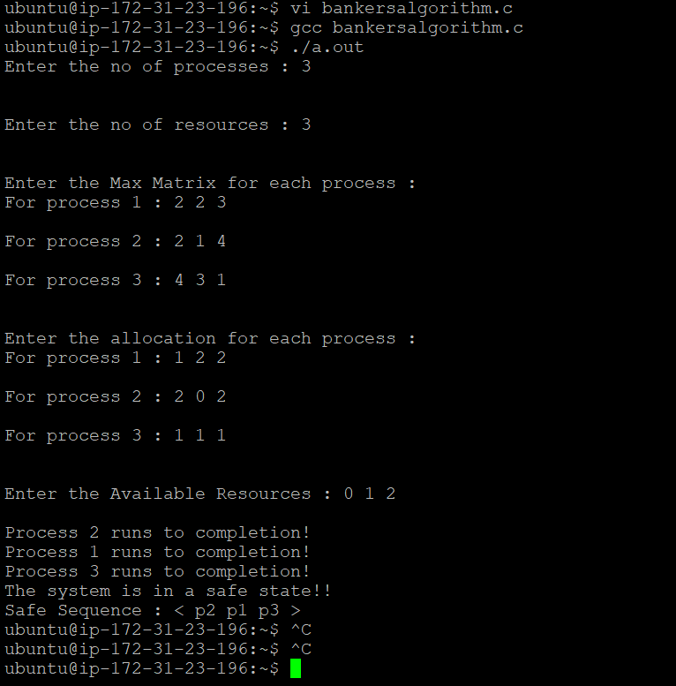

EXPERIMENT NO: 5(a)
AIM :Simulate the Sequenced File allocation strategy.
DESCRIPTION :In the Sequential File Allocation method, the file is divided into smaller chunks and these chunks are then allocated memory blocks in the main memory. These smaller file chunks are stored one after another in a contiguous manner, this makes the file searching easier for the file allocation system.The Contiguous(Sequential) File Allocation is one of the File Allocation Methods in the Operating System. The Other File Allocation Method is the Non-contiguous File Allocation which also has two types – first is the Linked File Allocation and the second is the Indexed File Allocation.
PROGRAMMING LANGUAGE USED: JAVA
LIBRARIES USED:
Java.util, java.lang packages
SYNTAX:
PROGRAM:
import java.util.*;
import java.lang.*;

class FileObj
{
String fileName;
int startPos;
int length;

FileObj(String fileName,int startPos,int length)
{
this.fileName=fileName;
this.startPos=startPos+1;
this.length=length;
}

}

public class SequenceAllocation
{
int[] hardDisk;

ArrayList<FileObj> fileTable=new ArrayList<>();

public SequenceAllocation(int hardDiskSize)
{
hardDisk=new int[hardDiskSize];
}

public boolean checkSize(int noOfBlocks)
{
int i=0;
while(i<hardDisk.length)
{
if(hardDisk[i]==0)
{
break;
}
i+=1;
}
if(hardDisk.length-i>=noOfBlocks)
{
return true;
}
else
{
return false;
}
}

public void allocateFile(String fileName,int noOfBlocks)
{
int i=0;
while(i<hardDisk.length)
{
if(hardDisk[i]==0)
{
break;
}
i+=1;
}
for(int j=0;j<noOfBlocks;j++)
{
hardDisk[i+j]=1;
}
fileTable.add(new FileObj(fileName,i,noOfBlocks));
System.out.println("File is Allocated to the disk");
}

public static void main(String[] args)
{
Scanner sc = new Scanner(System.in);
int hardDiskSize;
int sizeOfBlock;
String fileName;
int fileSize;
int noOfBlocks;
System.out.println("Enter HardDisk Size");
hardDiskSize=sc.nextInt();

SequenceAllocation obj = new SequenceAllocation(hardDiskSize);

System.out.println("Enter size of each block(in KB)");
sizeOfBlock = sc.nextInt();

boolean flag=true;
while(flag)
{
System.out.println("Enter file name");
fileName=sc.next();
System.out.println("Enter file size");
fileSize=sc.nextInt();
noOfBlocks=(int)Math.ceil(fileSize/sizeOfBlock);

boolean check=obj.checkSize(noOfBlocks);
if(!check)
{
System.out.println("File cannot be allocated");
}
else
{
obj.allocateFile(fileName,noOfBlocks);
}
System.out.println("Do you want to add Other file?");
System.out.println("Press 1 for Yes, 0 for No");
int choice=sc.nextInt();
if(choice==0)
{
flag=false;
}
}
System.out.println("File Table is");
System.out.print("File Name\t\t");
System.out.print("Start Position\t\t\t");
System.out.println("Length");

for(int i=0;i<obj.fileTable.size();i++)
{
System.out.print(obj.fileTable.get(i).fileName+"\t\t\t");
System.out.print(obj.fileTable.get(i).startPos+"\t\t\t\t");
System.out.println(obj.fileTable.get(i).length);

}

}
}
OUTPUT:
ubuntu@ip-172-31-23-196:~$ java SequenceAllocation
Enter HardDisk Size
12
Enter size of each block(in KB)
1
Enter file name
FileA
Enter file size
4
File is Allocated to the disk
Do you want to add Other file?
Press 1 for Yes, 0 for No
1
Enter file name
FileB
Enter file size
4
File is Allocated to the disk
Do you want to add Other file?
Press 1 for Yes, 0 for No
0
File Table is
File Name Start Position Length
FileA 1 4
FileB 5 4

ubuntu@ip-172-31-23-196:~$ java SequenceAllocation
Enter HardDisk Size
8
Enter size of each block(in KB)
1
Enter file name
FileB
Enter file size
10
File cannot be allocated
Do you want to add Other file?
Press 1 for Yes, 0 for No
1
Enter file name
FileC
Enter file size
8
File is Allocated to the disk
Do you want to add Other file?
Press 1 for Yes, 0 for No
0
File Table is
File Name Start Position Length
FileC 1 8
ubuntu@ip-172-31-23-196:~$ ^C
ubuntu@ip-172-31-23-196:~$
Output screenshots:

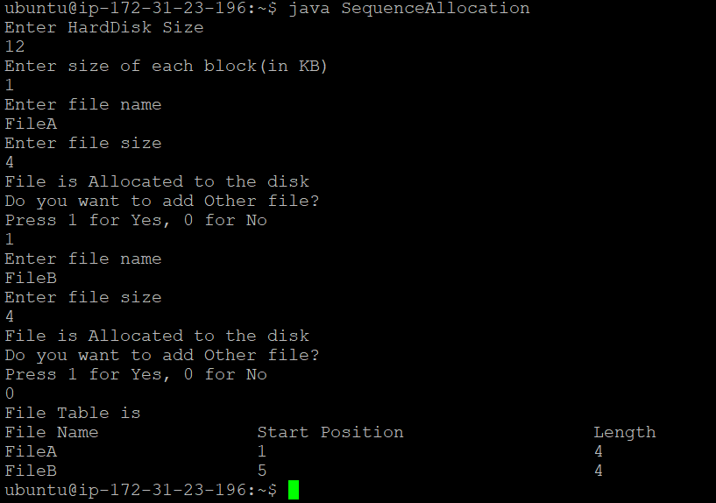
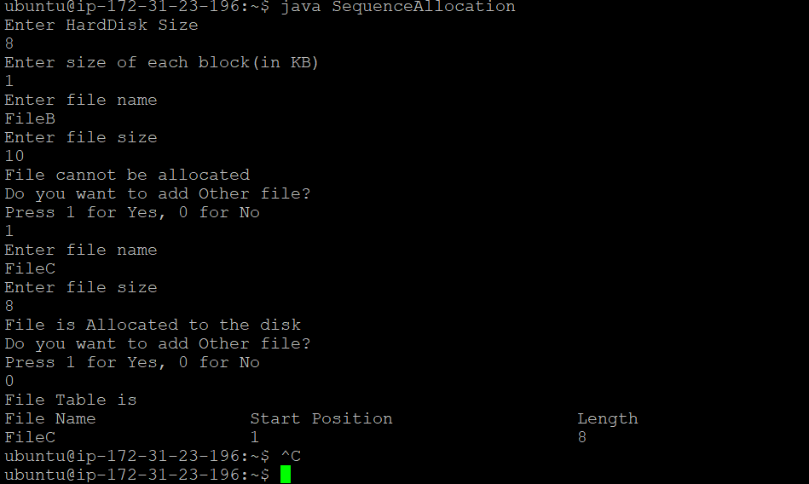

EXPERIMENT NO: 5(b)
AIM : Simulate the Indexed File allocation strategy.
DESCRIPTION :The Indexed File Allocation stores the file in the blocks of memory, each block of memory has an address and the address of every file block is maintained in a separate index block. These index blocks point the file allocation system to the memory blocks which actually contains the file.The Indexed File Allocation is one of the File Allocation Methods in the Operating System. The Indexed File Allocation comes under Non-contiguous memory allocation, the other method in the Non-contiguous memory allocation is the Linked File Allocation, and the last is the Contiguous Memory Allocation.
PROGRAMMING LANGUAGE USED: JAVA
LIBRARIES USED:
java.util,java.lang packages
SYNTAX:
PROGRAM:
import java.util.*;
import java.lang.*;

class File1
{
String fileName;
HashMap<Integer,ArrayList<Integer>> indexTable = new HashMap<>();

File1(String fileName, int index, ArrayList<Integer> indices)
{
this.fileName=fileName;
this.indexTable.put(index,indices);
}
}

public class IndexedAllocation
{
int[] hardDisk;
ArrayList<File1> fileTable=new ArrayList<>();

public IndexedAllocation(int hardDiskSize)
{
hardDisk = new int[hardDiskSize];
}

public boolean checkSize(int noOfBlocks)
{
int i=0;
int j=0;
while(i<hardDisk.length)
{
if(hardDisk[i]==0)
{
j+=1;
}
if(j>=noOfBlocks)
{
return true;
}
i+=1;
}
return false;
}

public int generateRandom()
{
Random rand = new Random();
int index=rand.nextInt(hardDisk.length);
while(hardDisk[index]==1)
{
index+=1;
if(index==hardDisk.length)
{
index=0;
}
}
return index;
}

public void allocateFile(String fileName,int noOfBlocks)
{
int indTableLoc = generateRandom();
hardDisk[indTableLoc]=1;
int count=0;
ArrayList<Integer> indices = new ArrayList<>();
while(count<noOfBlocks)
{
int index=generateRandom();
hardDisk[index]=1;
if(index==0)
{
index=12;
}
indices.add(index);
count+=1;
}
if(indTableLoc==0)
{
indTableLoc=12;
}
fileTable.add(new File1(fileName,indTableLoc,indices));
System.out.println("File is Allocated to the disk");
}

public static void main(String[] args)
{
Scanner sc = new Scanner(System.in);
int hardDiskSize;
int sizeOfBlock;
String fileName;
int fileSize;
int noOfBlocks;
System.out.println("Enter HardDisk Size");
hardDiskSize=sc.nextInt();

IndexedAllocation obj = new IndexedAllocation(hardDiskSize);

System.out.println("Enter size of each block(in KB)");
sizeOfBlock = sc.nextInt();

boolean flag=true;
while(flag)
{
System.out.println("Enter file name");
fileName=sc.next();
System.out.println("Enter file size");
fileSize=sc.nextInt();
noOfBlocks=(int)Math.ceil(fileSize/sizeOfBlock);

boolean check=obj.checkSize(noOfBlocks);
if(!check)
{
System.out.println("File cannot be allocated");
}
else
{
obj.allocateFile(fileName,noOfBlocks);
}
System.out.println("Do you want to add Other file?");
System.out.println("Press 1 for Yes, 0 for No");
int choice=sc.nextInt();
if(choice==0)
{
flag=false;
}
}

System.out.println("File Table is");
System.out.print("File Name\t\t");
System.out.print("Index Table Location\t\t");
System.out.println("Indices");

for(int i=0;i<obj.fileTable.size();i++)
{
System.out.print(obj.fileTable.get(i).fileName+"\t\t\t");
Set keys= obj.fileTable.get(i).indexTable.keySet();
Iterator j =keys.iterator();
System.out.print(j.next()+"\t\t\t\t");
Collection getValues = obj.fileTable.get(i).indexTable.values();
Iterator k = getValues.iterator();
while (k.hasNext()) {
System.out.println(k.next());
}
}
}
}
OUTPUT:
ubuntu@ip-172-31-23-196:~$ javac IndexedAllocation.java
ubuntu@ip-172-31-23-196:~$ java IndexedAllocation
Enter HardDisk Size
12
Enter size of each block(in KB)
2
Enter file name
FileA
Enter file size
5
File is Allocated to the disk
Do you want to add Other file?
Press 1 for Yes, 0 for No
1
Enter file name
FileB
Enter file size
12
File is Allocated to the disk
Do you want to add Other file?
Press 1 for Yes, 0 for No
0
File Table is
File Name Index Table Location Indices
FileA 1 [9, 10]
FileB 7 [8, 4, 11, 2, 12, 5]
OUTPUT SCREEN SHOTS:
Output Screenshot:
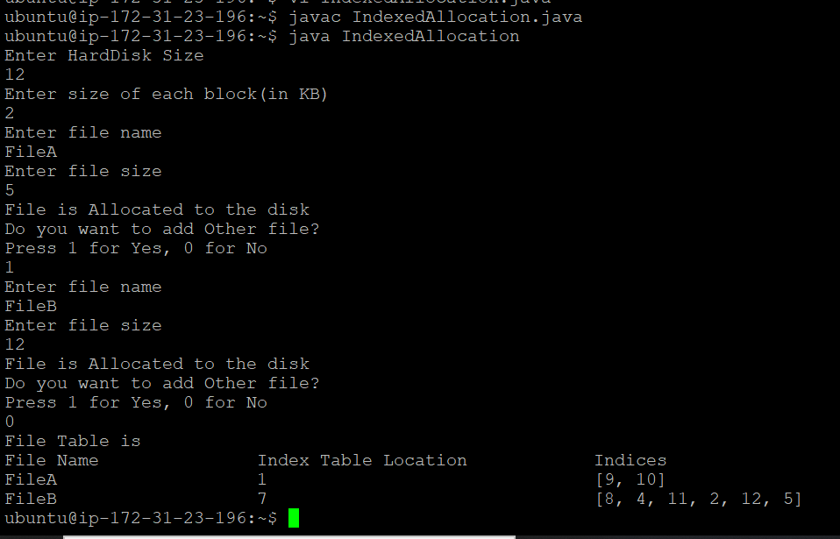

EXPERIMENT NO: 5(c)
AIM :Simulate the Linked File allocation strategy.
DESCRIPTION :It is easy to allocate the files because allocation is on an individual block basis. Each block contains a pointer to the next free block in the chain. Here also the file allocation table consisting of a single entry for each file. Using this strategy any free block can be added to a chain very easily. There is a link between one block to another block,that’s why it is said to be linked allocation. We can avoid the external fragmentation.
PROGRAMMING LANGUAGE USED: JAVA
LIBRARIES USED:
Java.util, java.lang packages
SYNTAX:
PROGRAM:
Enter file size
4
File is Allocated to the disk
Do you want to add Other file?
Press 1 for Yes, 0 for No
1
Enter file nameimport java.util.*;
import java.lang.*;

class File
{
String fileName;
Node startPos;
Node endPos;

File(String fileName,Node startPos,Node endPos)
{
this.fileName=fileName;
this.startPos=startPos;
this.endPos=endPos;
}

}

class Node
{
String fileName;
int index;
Node next;

public Node(String fileName,int index)
{
this.fileName=fileName;
this.index=index+1;
if(index==0)
{
this.index=12;
}
next=null;
}
}

public class LinkedAllocation
{
int[] hardDisk;
ArrayList<File> fileTable=new ArrayList<>();

public LinkedAllocation(int hardDiskSize)
{
hardDisk = new int[hardDiskSize];
}

public boolean checkSize(int noOfBlocks)
{
int i=0;
int j=0;
while(i<hardDisk.length)
{
if(hardDisk[i]==0)
{
j+=1;
}
if(j>=noOfBlocks)
{
return true;
}
i+=1;
}
return false;
}

public int generateRandom()
{
Random rand = new Random();
int index=rand.nextInt(hardDisk.length);
while(hardDisk[index]==1)
{
index+=1;
if(index==hardDisk.length)
{
index=0;
}
}
return index;
}

public void allocateFile(String fileName,int noOfBlocks)
{
int startIndex=generateRandom();
hardDisk[startIndex]=1;
Node start = new Node(fileName,startIndex);
Node temp=start;
int count=1;
while(count<noOfBlocks)
{
int index=generateRandom();
hardDisk[index]=1;
Node node =new Node(fileName,index);
temp.next=node;
temp=node;
count+=1;
}

Node end=temp;

fileTable.add(new File(fileName,start,end));
System.out.println("File is Allocated to the disk");
}

public static void main(String[] args)
{
Scanner sc = new Scanner(System.in);
int hardDiskSize;
int sizeOfBlock;
String fileName;
int fileSize;
int noOfBlocks;
System.out.println("Enter HardDisk Size");
hardDiskSize=sc.nextInt();

LinkedAllocation obj = new LinkedAllocation(hardDiskSize);

System.out.println("Enter size of each block(in KB)");
sizeOfBlock = sc.nextInt();

boolean flag=true;
while(flag)
{
System.out.println("Enter file name");
fileName=sc.next();
System.out.println("Enter file size");
fileSize=sc.nextInt();
noOfBlocks=(int)Math.ceil(fileSize/sizeOfBlock);

boolean check=obj.checkSize(noOfBlocks);
if(!check)
{
System.out.println("File cannot be allocated");
}
else
{
obj.allocateFile(fileName,noOfBlocks);
}
System.out.println("Do you want to add Other file?");
System.out.println("Press 1 for Yes, 0 for No");
int choice=sc.nextInt();
if(choice==0)
{
flag=false;
}
}
System.out.println("File Table is");
System.out.print("File Name\t\t");
System.out.print("Start Index\t\t\t");
System.out.println("End Index");

for(int i=0;i<obj.fileTable.size();i++)
{
System.out.print(obj.fileTable.get(i).fileName+"\t\t\t");
System.out.print(obj.fileTable.get(i).startPos.index+"\t\t\t\t");
System.out.println(obj.fileTable.get(i).endPos.index);

}

}
}
OUTPUT:
ubuntu@ip-172-31-23-196:~$ vi LinkedAllocation.java
ubuntu@ip-172-31-23-196:~$ javac LinkedAllocation.java
ubuntu@ip-172-31-23-196:~$ java LinkedAllocation
Enter HardDisk Size
12
Enter size of each block(in KB)
1
Enter file name
FileA

FileB
Enter file size
5
File is Allocated to the disk
Do you want to add Other file?
Press 1 for Yes, 0 for No
0
File Table is
File Name Start Index End Index
FileA 4 5
FileB 6 3
ubuntu@ip-172-31-23-196:~$ java LinkedAllocation
Enter HardDisk Size
10
Enter size of each block(in KB)
1
Enter file name
FileA
Enter file size
6
File is Allocated to the disk
Do you want to add Other file?
Press 1 for Yes, 0 for No
1
Enter file name
FileD
Enter file size
8
File cannot be allocated
Do you want to add Other file?
Press 1 for Yes, 0 for No
0
File Table is
File Name Start Index End Index
FileA 4 8
ubuntu@ip-172-31-23-196:~$
OUTPUT SCREEN SHOTS:
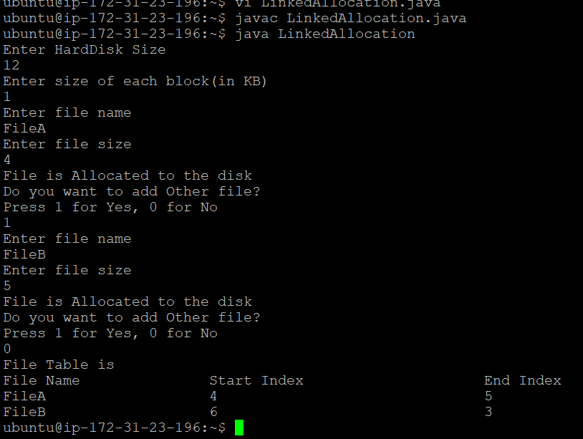
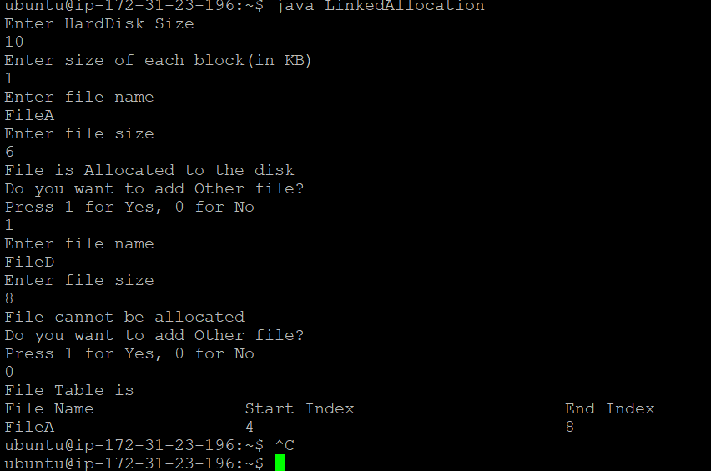
EXPERIMENT NO: 6(a)
AIM: Simulate the FIFO page replacement algorithm.
DESCRIPTION:
First In First Out commonly known as FIFO, is an asset-management and valuation method in which assets produced or acquired first are sold, used, or disposed of first.
The FIFO method is used for cost flow assumption purposes. In manufacturing, as items progress to later development stages and as finished inventory items are sold, the associated costs with that product must be recognized as an expense. Under FIFO, it is assumed that the cost of inventory purchased first will be recognized first. The dollar value of total inventory decreases in this process because inventory has been removed from the company’s ownership. The costs associated with the inventory may be calculated in several ways — one being the FIFO method.
PROGRAMMING LANGUAGE USED: c ++
PROGRAM:
#include<bits/stdc++.h>
using namespace std;
int main(){
int n,m,i,j,k,hit=0;
cout<<"Enter number of frames allocated:";
cin>>n;
cout<<"Enter number of processes:";
cin>>m;
vector<int> p(m);
vector<int> hi(m);
cout<<"Enter the pages that need to be accessed:";
for(i=0;i<m;i++){
cin>>p[i];
}
vector<vector<int>> a(n);
for(i=0;i<n;i++){
a[i]=vector<int>(m,-1);
}
map <int, int> mp;
for(i=0;i<m;i++){
vector<pair<int,int>> c;
for(auto q: mp){
c.push_back({q.second,q.first});
}
sort(c.begin(),c.end());
bool hasrun=false;
for(j=0;j<n;j++){
if(a[j][i]==p[i]){
hit++;
hi[i]=1;
mp[p[i]]++;
hasrun=true;
break;
}
if(a[j][i]==-1){
for(k=i;k<m;k++)
a[j][k]=p[i];
mp[p[i]]++;
hasrun=true;
break;
}
}
if(j==n||hasrun==false){
for(j=0;j<n;j++){
if(a[j][i]==c[c.size()-1].second){
mp.erase(a[j][i]);
for(k=i;k<m;k++)
a[j][k]=p[i];
mp[p[i]]++;
break;
}
}
}
for(auto q:mp){
if(q.first!=p[i]){
mp[q.first]++;
}
}
}
cout<<"Process ";
for(i=0;i<m;i++){
cout<<p[i]<<"";
}
cout<<'\n';
for(i=0;i<n;i++){
cout<<"Frame "<<i<<"";
for(j=0;j<m;j++){
if(a[i][j]==-1)
cout<<"E ";
else
cout<<a[i][j]<<"";
}
cout<<'\n';
}
for(i=0;i<m;i++){
if(hi[i]==0)
cout<<" ";
else
cout<<hi[i]<<"";
}
cout<<"\n";
cout<<"Hit "<<hit<<'\n'<<"Page Fault "<<m-hit<<'\n';
return 0;
}
OUTPUT 1:
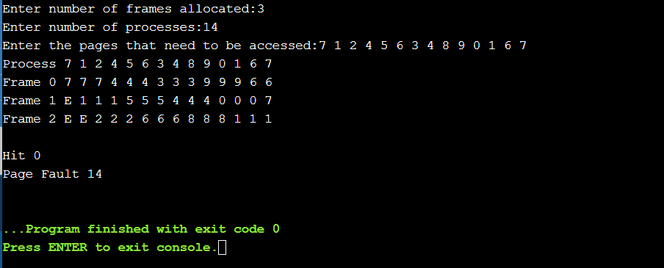
OUTPUT 2:
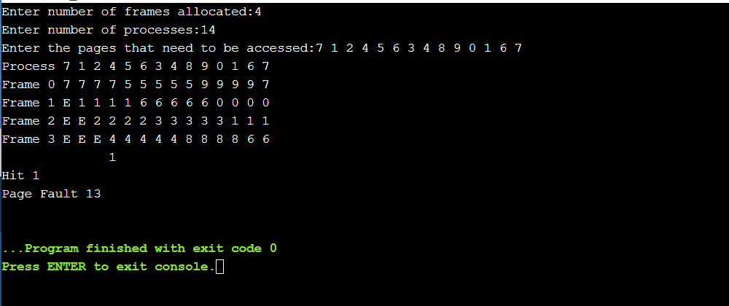

EXPERIMENT-6(b)
AIM: Simulate the OPTIMAL page replacement algorithm.
DESCRIPTION:
In operating systems, whenever a new page is referred and not present in memory, page fault occurs and Operating System replaces one of the existing pages with newly needed page. Different page replacement algorithms suggest different ways to decide which page to replace. The target for all algorithms is to reduce number of page faults.
In this algorithm, OS replaces the page that will not be used for the longest period of time in future.
In this algorithm, pages are replaced which would not be used for the longest duration of time in the future.
PROGRAMMING LANGUAGE USED: c ++
PROGRAM:
#include<bits/stdc++.h>
using namespace std;
int main(){
int n,m,i,j,k;
cout<<"Enter number of frames allocated:";
cin>>n;
cout<<"Enter number of processes:";
cin>>m;
vector<int> p(m);
cout<<"Enter the pages need to be accessed:\n";
for(i=0;i<m;i++){
cin>>p[i];
}
vector<vector<int>> a(n,vector<int>(m,-1));
map <int, int> mp;
for(i=0;i<m;i++){
vector<int> op;
vector<pair<int,int>> c;
for(auto q: mp){
c.push_back({q.second,q.first});
}
for(int q=i+1;q<m;q++){
for(j=0;j<n;j++){
if(a[j][i]==p[q]){
op.push_back(p[q]);
}
}
}
sort(op.begin(),op.end());
op.erase(unique(op.begin(),op.end()),op.end());
bool dontCall=true;
if(op.size()==n){
dontCall=false;
}
sort(c.begin(),c.end());
bool hasrun=false;
for(j=0;j<n;j++){
if(a[j][i]==p[i]){
mp[p[i]]++;
hasrun=true;
break;
}
if(a[j][i]==-1){
for(k=i;k<m;k++)
a[j][k]=p[i];
mp[p[i]]++;
hasrun=true;
break;
}
}
if(j==n||hasrun==false){
for(j=0;j<n;j++){
if(dontCall==true){
if(a[j][i]==c[c.size()-1].second){
mp.erase(a[j][i]);
for(k=i;k<m;k++)
a[j][k]=p[i];
mp[p[i]]++;
break;
}
}
else if(dontCall==false){
if(a[j][i]==op[op.size()-1]){
mp.erase(a[j][i]);
for(k=i;k<m;k++)
a[j][k]=p[i];
mp[p[i]]++;
break;
}
}
}
}
for(auto q:mp){
if(q.first!=p[i]){
mp[q.first]++;
}
}
}
int hit=0;
vector<int> hitv(m);
for(i=1;i<m;i++){
for(j=0;j<n;j++){
if(p[i]==a[j][i-1]){
hit++;
hitv[i]=1;
break;
}
}
}
cout<<"Process ";
for(i=0;i<m;i++){
cout<<p[i]<<"";
}
cout<<'\n';
for(i=0;i<n;i++){
cout<<"Frame "<<i<<"";
for(j=0;j<m;j++){
if(a[i][j]==-1)
cout<<"E ";
else
cout<<a[i][j]<<"";
}
cout<<'\n';
}
cout<<"HIT ";
for(i=0;i<hitv.size();i++){
if(hitv[i]==0)
cout<<" ";
else
cout<<hitv[i]<<"";
}
cout<<"\n";
cout<<"Hit "<<hit<<'\n'<<"Page Fault "<<m-hit<<'\n';
return 0;
}
OUTPUT 1:
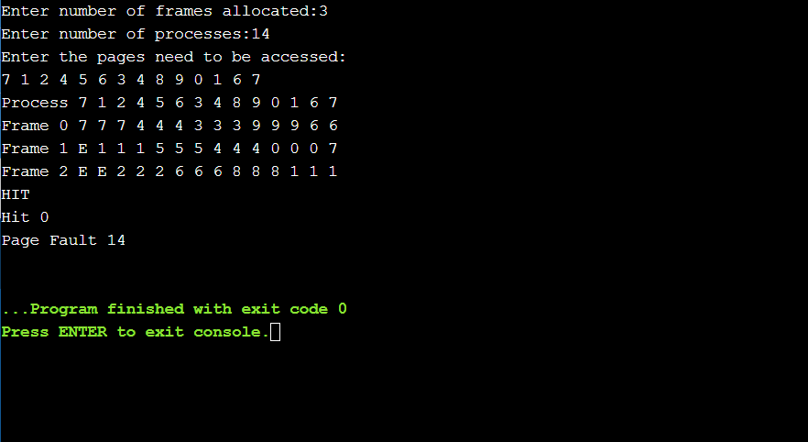
OUTPUT 2:
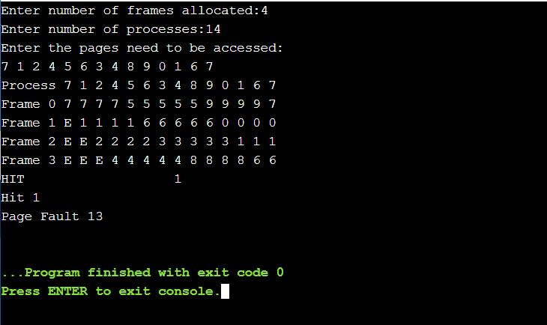

EXPERIMENT NO: 6(c)
AIM: Simulate the LRU page replacement algorithm.
DESCRIPTION:
In operating systems that use paging for memory management, page replacement algorithm are needed to decide which page needed to be replaced when new page comes in. Whenever a new page is referred and not present in memory, page fault occurs and Operating System replaces one of the existing pages with newly needed page. Different page replacement algorithms suggest different ways to decide which page to replace. The target for all algorithms is to reduce number of page faults.
In Least Recently Used (LRU) algorithm is a Greedy algorithm where the page to be replaced is least recently used. The idea is based on locality of reference, the least recently used page is not likely
PROGRAMMING LANGUAGE USED: c ++
PROGRAM:
#include<bits/stdc++.h>
using namespace std;
int main(){
int n,m,i,j,k,hit=0;
cout<<"Enter number of frames allocated:";
cin>>n;
cout<<"Enter number of processes:";
cin>>m;
vector<int> p(m);
vector<int> hi(m);
cout<<"Enter the pages need to be accessed:";
for(i=0;i<m;i++){
cin>>p[i];
}
vector<vector<int>> a(n);
for(i=0;i<n;i++){
a[i]=vector<int>(m,-1);
}
map <int, int> mp;
for(i=0;i<m;i++){
vector<pair<int,int>> c;
for(auto q: mp){
c.push_back({q.second,q.first});
}
sort(c.begin(),c.end());
bool hasrun=false;
for(j=0;j<n;j++){
if(a[j][i]==p[i]){
hit++;
hi[i]=1;
mp[p[i]]=1;
hasrun=true;
break;
}
if(a[j][i]==-1){
for(k=i;k<m;k++)
a[j][k]=p[i];
mp[p[i]]++;
hasrun=true;
break;
}
}
if(j==n||hasrun==false){
for(j=0;j<n;j++){
if(a[j][i]==c[c.size()-1].second){
mp.erase(a[j][i]);
for(k=i;k<m;k++)
a[j][k]=p[i];
mp[p[i]]++;
break;
}
}
}
for(auto q:mp){
if(q.first!=p[i]){
mp[q.first]++;
}
}
}
cout<<"Process ";
for(i=0;i<m;i++){
cout<<p[i]<<"";
}
cout<<'\n';
for(i=0;i<n;i++){
cout<<"Frame "<<i<<"";
for(j=0;j<m;j++){
if(a[i][j]==-1)
cout<<"E ";
else
cout<<a[i][j]<<"";
}
cout<<'\n';
}
for(i=0;i<m;i++){
if(hi[i]==0)
cout<<" ";
else
cout<<hi[i]<<"";
}
cout<<"\n";
cout<<"Hit "<<hit<<'\n'<<"Page Fault "<<m-hit<<'\n';
return 0;
}
OUTPUT 1:
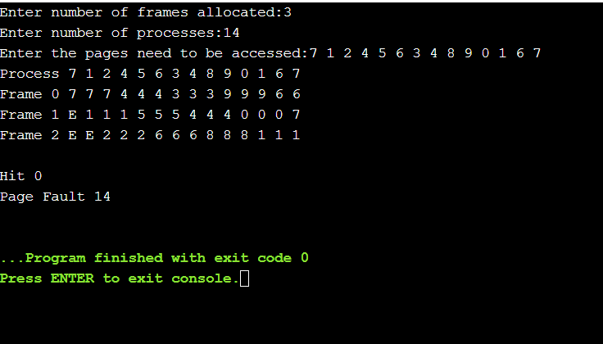
OUTPUT 2:

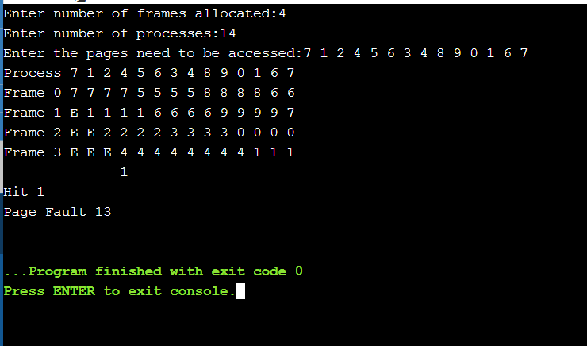

EXPERIMENT NO: 6(d)
AIM: Simulate the LFU page replacement algorithm.
DESCRIPTION:
Least Frequently Used (LFU) is a caching algorithm in which the least frequently used cache block is removed whenever the cache is overflowed. In LFU we check the old page as well as the frequency of that page and if the frequency of the page is larger than the old page we cannot remove it and if all the old pages are having same frequency then take last that means FIFO method for that and remove that page.
PROGRAMMING LANGUAGE USED: c ++
PROGRAM:
#include<bits/stdc++.h>
using namespace std;
int main(){
int n,m,i,j,k;
cout<<"Enter number of frames allocated:";
cin>>n;
cout<<"Enter number of processes:";
cin>>m;
vector<int> p(m);
cout<<"Enter the pages need to be accessed:";
for(i=0;i<m;i++){
cin>>p[i];
}
vector<vector<int>> a(n,vector<int>(m,-1));
map <int, int> mp,lfmp;
for(i=0;i<m;i++){
vector<int> op;
vector<pair<int,int>> c,lf;
for(auto q: mp){
c.push_back({q.second,q.first});
}
for(auto q:lfmp){
lf.push_back({q.second,q.first});
}
sort(lf.begin(),lf.end());
bool dontCall=true;
if(lf.size()>2){
if(lf[0].first!=lf[1].first){
dontCall=false;
}
}
sort(c.begin(),c.end());
bool hasrun=false;
for(j=0;j<n;j++){
if(a[j][i]==p[i]){
mp[p[i]]++;
lfmp[p[i]]++;
hasrun=true;
break;
}
if(a[j][i]==-1){
for(k=i;k<m;k++)
a[j][k]=p[i];
mp[p[i]]++;
lfmp[p[i]]++;
hasrun=true;
break;
}
}
if(j==n||hasrun==false){
for(j=0;j<n;j++){
if(dontCall==true){
int q;
if(lf[lf.size()-1].second==c[c.size()-1].second&&lf[lf.size()-1].first>1){
if(a[j][i]==c[c.size()-2].second){
mp.erase(a[j][i]);
lfmp.erase(a[j][i]);
for(k=i;k<m;k++)
a[j][k]=p[i];
mp[p[i]]++;
lfmp[p[i]]++;
break;
}

}
else{
if(a[j][i]==c[c.size()-1].second){
mp.erase(a[j][i]);
lfmp.erase(a[j][i]);
for(k=i;k<m;k++)
a[j][k]=p[i];
mp[p[i]]++;
lfmp[p[i]]++;
break;
}
}
}
else if(dontCall==false){
if(a[j][i]==lf[0].second){
mp.erase(a[j][i]);
lfmp.erase(a[j][i]);
for(k=i;k<m;k++)
a[j][k]=p[i];
mp[p[i]]++;
lfmp[p[i]]++;
break;
}
}
}
}
for(auto q:mp){
if(q.first!=p[i]){
mp[q.first]++;
}
}
}
int hit=0;
vector<int> hitv(m);
for(i=1;i<m;i++){
for(j=0;j<n;j++){
if(p[i]==a[j][i-1]){
hit++;
hitv[i]=1;
break;
}
}
}
cout<<"Process ";
for(i=0;i<m;i++){
cout<<p[i]<<"";
}
cout<<'\n';
for(i=0;i<n;i++){
cout<<"Frame "<<i<<"";
for(j=0;j<m;j++){
if(a[i][j]==-1)
cout<<"E ";
else
cout<<a[i][j]<<"";
}
cout<<'\n';
}
cout<<"HIT ";
for(i=0;i<hitv.size();i++){
if(hitv[i]==0)
cout<<" ";
else
cout<<hitv[i]<<"";
}
cout<<"\n";
cout<<"Hit "<<hit<<'\n'<<"Page Fault "<<m-hit<<'\n';
return 0;
}
OUTPUT 1:
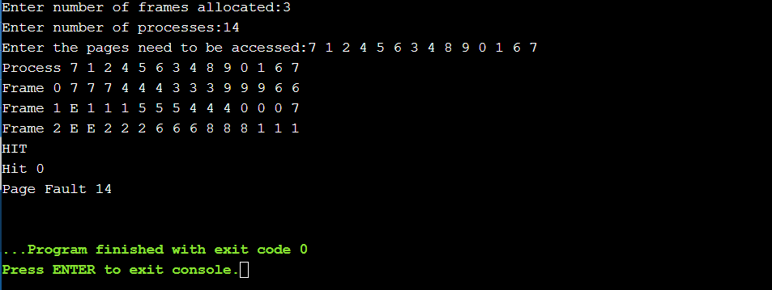
OUTPUT 2:
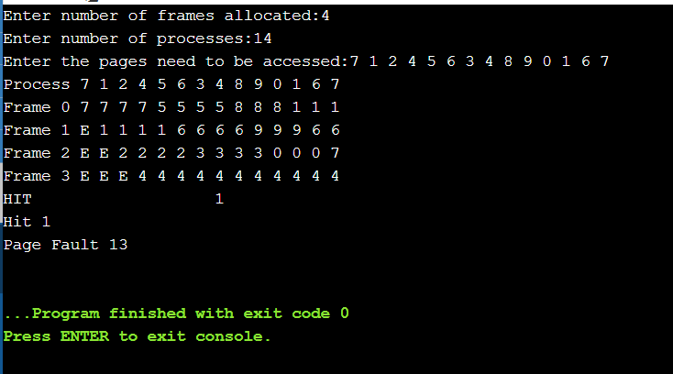
EXPERIMENT-7(a)
AIM: Simulate FCFS disk scheduling algorithm
DESCRIPTION:Disk scheduling is done by operating systems to schedule I/O requests arriving for the disk and the algorithm used for the disk scheduling is called Disk Scheduling Algorithm.First Come First Serve, also known as FCFS Disk Scheduling Algorithm and also write a program for FCFS disk scheduling algorithm. As the name suggests, the I/O requests are addressed in the order of their arrival.
LANGUAGE USED:C++
LIBRARIES USED:
#include<bits/stdc++.h>
PROGRAM:
#include<bits/stdc++.h>
using namespace std;
int main(){

int i,j,k,n,m,sum=0,x,y,h;
cout<<"Enter the size of disk\n";
cin>>m;
cout<<"Enter number of requests\n";
cin>>n;
cout<<"Enter the requests\n";

// creating an array of size n
vector <int> a(n);
for(i=0;i<n;i++){
cin>>a[i];
}
for(i=0;i<n;i++){
if(a[i]>m){
cout<<"Error, Unknown position "<<a[i]<<"\n";
return 0;
}
}
cout<<"Enter the head position\n";
cin>>h;

// head will be at h at the starting
int temp=h;
cout<<temp;
for(i=0;i<n;i++){
cout<<" ->"<<a[i]<<' ';
// calculating the difference for the head movement
sum+=abs(a[i]-temp);
// head is now at the next I/O request
temp=a[i];
}
cout<<'\n';
cout<<"Total head movements = "<< sum<<'\n';
return 0;
}

OUTPUT:
Enter the size of disk
1300
Enter number of requests
5
Enter the requests
23 45 56
789 560
Enter the head position
78
78 -> 23 -> 45 -> 56 -> 789 -> 560
Total head movements = 1050
OUTPUT SCREENSHOTS:
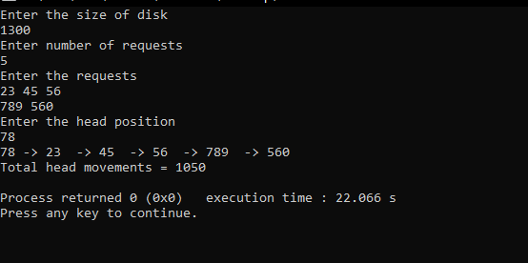
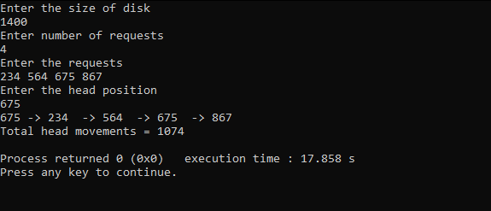

EXPERIMENT-7(b)
AIM: Simulate SSTF disk scheduling algorithm.
DESCRIPTION:Disk Scheduling is done by operating systems to schedule I/O requests arriving for the disk and the algorithm used for the disk scheduling is called Disk Scheduling Algorithm Shortest Seek Time First Disk Scheduling Algorithm. As the name suggests, the I/O requests are addressed in the order where the distance between the head and the I/O request is least.
LANGUAGE USED: C++
LIBRARIES USED:
#include <bits/stdc++.h>
PROGRAM:
#include <bits/stdc++.h>
using namespace std;
const int N=100005;
int n;
int head;
int done[N];
int positions[N];

void sstf(void)
{
int movement,shortest,index;

movement = 0;
for(int i=0; i<n; i++)
{
index = 0;
shortest = INT_MAX;

for(int k=0; k<n; k++)
{
if(abs(head - positions[k]) < shortest && !done[k])
{
index = k;
shortest = abs(head - positions[k]);
}
}
done[index] = true;
movement += shortest;
head = positions[index];
}
printf("Total Head Movement %d Cylinders\n",movement);
return;
}
int main()
{
cout<<"Initial Head Position: ";
cin>>head;
cout<<"Queue Size: ";
cin>>n;
cout<<"Queue:\n";
for(int i=0; i<n; i++) cin>>positions[i];
sstf();
return 0;
}
OUTPUT:
Initial Head Position: 54
Queue Size: 5
Queue:
456
344
56
54
689
Total Head Movement 635 Cylinders
OUTPUT SCREENSHOTS:
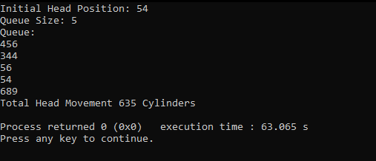
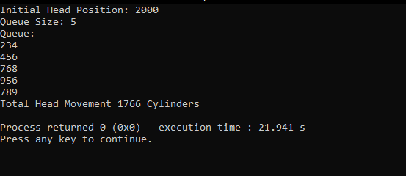

EXPERIMENT-7(c)
AIM: Simulate Scan Scheduling algorithm.
DESCRIPTION: Disk scheduling is done by operating systems to schedule I/O requests arriving for the disk and the algorithm used for the disk scheduling is called Disk Scheduling Algorithm.SCAN Disk Scheduling Algorithm and also write a program for SCAN disk scheduling algorithm. In SCAN algorithm the disk arm moves into a particular direction and services the requests coming in its path and after reaching the end of the disk, it reverses its direction and again services the request arriving in its path. So, this algorithm works as an elevator and hence also known as the elevator algorithm. As a result, the requests at the midrange are serviced more and those arriving behind the disk arm will have towait.
LANGUAGE USED: C++
LIBRARIES USED:
#include<bits/stdc++.h>
PROGRAM:
#include<bits/stdc++.h>
using namespace std;
int main(){
int i,j,k,n,m,sum=0,x,y,h;
cout<<"Enter the size of disk\n";
cin>>m;
cout<<"Enter number of requests\n";
cin>>n;
cout<<"Enter the requests\n";
vector <int> a(n),b;
for(i=0;i<n;i++){
cin>>a[i];
}
for(i=0;i<n;i++){
if(a[i]>m){
cout<<"Error, Unknown position "<<a[i]<<"\n";
return 0;
}
}
cout<<"Enter the head position\n";
cin>>h;
int temp=h;
a.push_back(h);
a.push_back(m);
a.push_back(0);
sort(a.begin(),a.end());
for(i=0;i<a.size();i++){
if(h==a[i])
break;
}
k=i;
if(k<n/2){
for(i=k;i<a.size();i++){
b.push_back(a[i]);
}
for(i=k-1;i>=0;i--){
b.push_back(a[i]);
}
}
else{
for(i=k;i>=0;i--){
b.push_back(a[i]);
}
for(i=k+1;i<a.size();i++){
b.push_back(a[i]);
}
}
temp=b[0];
cout<<temp;
for(i=1;i<b.size();i++){
cout<<" ->"<<b[i];
sum+=abs(b[i]-temp);
temp=b[i];
}
cout<<'\n';
cout<<"Total head movements = "<< sum<<'\n';
cout<<"Average head movement = "<<(float)sum/n<<'\n';
return 0;
}
OUTPUT:
Enter the size of disk
1500
Enter number of requests
4
Enter the requests
234 566 78 900
Enter the head position
900
900 -> 566 -> 234 -> 78 -> 0 -> 900 -> 1500
Total head movements = 2400
Average head movement = 600

OUTPUT SCREENSHOTS:
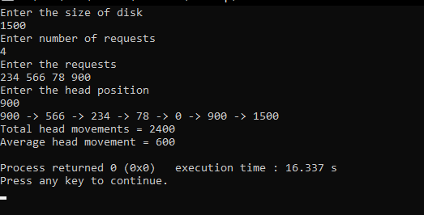
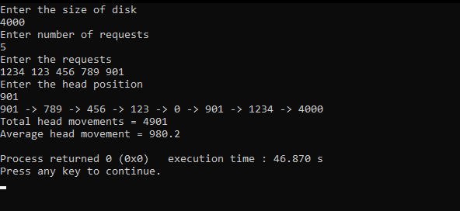

EXPRIMENT-7(d)
AIM: Simulate C-SCAN disk scheduling algorithm
Description:Disk Scheduling is done by operating systems to schedule I/O requests arriving for the disk and the algorithm used for the disk scheduling is called Disk Scheduling Algorithm.CSCAN Disk Scheduling Algorithm and also write a program for SCAN disk scheduling algorithm. In CSCAN algorithm, the disk arm instead of reversing its direction goes to the other end of the disk and starts servicing the requests from there. So, the disk arm moves in a circular fashion and this algorithm is also similar to CSCAN algorithm and hence it is known as C-SCAN (Circular SCAN).
LANGUAGE USED: C++
LIBRARIES USED:
#include<bits/stdc++.h>
PROGRAM:
#include<bits/stdc++.h>
using namespace std;
int main(){
int i,j,k,n,m,sum=0,x,y,h;
cout<<"Enter the size of disk\n";
cin>>m;
cout<<"Enter number of requests\n";
cin>>n;
cout<<"Enter the requests\n";
vector <int> a(n),b;
for(i=0;i<n;i++){
cin>>a[i];
}
for(i=0;i<n;i++){
if(a[i]>m){
cout<<"Error, Unknown position "<<a[i]<<"\n";
return 0;
}
}
cout<<"Enter the head position\n";
cin>>h;
int temp=h;
a.push_back(h);
a.push_back(m);
a.push_back(0);
sort(a.begin(),a.end());
for(i=0;i<a.size();i++){
if(h==a[i])
break;
}
k=i;
if(k<n/2){
for(i=k;i<a.size();i++){
b.push_back(a[i]);
}
for(i=0;i<=k-1;i++){
b.push_back(a[i]);
}
}
else{
for(i=k;i>=0;i--){
b.push_back(a[i]);
}
for(i=a.size()-1;i>=k+1;i--){
b.push_back(a[i]);
}
}
temp=b[0];
cout<<temp;
for(i=1;i<b.size();i++){
cout<<" ->"<<b[i];
sum+=abs(b[i]-temp);
temp=b[i];
}
cout<<'\n';
cout<<"Total head movements = "<< sum<<'\n';
cout<<"Average head movement = "<<(float)sum/n<<'\n';
return 0;
}
OUTPUT:
Enter the size of disk
3000
Enter number of requests
4
Enter the requests
234 567 546 1333
Enter the head position
567
567 -> 546 -> 234 -> 0 -> 3000 -> 1333 -> 567
Total head movements = 6000
Average head movement = 1500
OUTPUT SCREENSHOTS:
