Resume-Job Matching & Talent-Marketplace Engine

Project Report submitted for the partial fulfilment of grade for the course
Data Structures and Algorithms -3 (25CS2103E)
in
A.Y. 2026-2027

Submitted by
CH. Ganesh (2520090112)
A. Sai Charan Teja (2520080044)

Team Number: 27
Section: 10

Under the guidance of
Mrs. K. Chandusha
Assistant Professor, Department of CS&IT


Hyderabad-500090, Telangana, India.
K L (Deemed to be) University
DEPARTMENT OF CS&IT AND AI&DS

DECLARATION
The Mini Project Report entitled “Resume-Job Matching & Talent-Marketplace Engine” is a record of Bonafide work of CH. Ganesh – 2520090112, A. Sai Charan Teja – 2520080044 submitted in partial fulfillment for the award of B. Tech in the Department of CS&IT and AI&DS to the K L University. The results embodied in this report have not been copied from any other departments/University/Institute.

CH. Ganesh – 2520090112
A. Sai Charan Teja – 2520080044
K L (Deemed to be) University
DEPARTMENT OF CS&IT AND AI&DS
CERTIFICATE
This is to certify that the mini project based report entitled “Resume-Job Matching & Talent-Marketplace Engine” is a bonafide work done and submitted by CH. Ganesh – 2520090112, A. Sai Charan Teja – 2520080044 in partial fulfillment of the requirements for the award of the degree of BACHELOR OF TECHNOLOGY in the Department of CS&IT and AI&DS, K L (Deemed to be University), during the academic year 2026-2027.

Signature of the Supervisor

Signature of the HOD Signature of the External Examiner
ACKNOWLEDGEMENT
The success in this project would not have been possible but for the timely help and guidance rendered by many people. Our wish to express our sincere thanks to all those who have assisted us in one way or the other for the completion of our project.
Our greatest appreciation to our guide, Mrs. K. Chandusha, Assistant Professor, Department of CS&IT, which cannot be expressed in words for her tremendous support, encouragement and guidance for this project.
We express our gratitude to Dr. Khaja Shareef (CSIT) and Dr. Sreenath Itikela (AI&DS), Heads of the Department of Computer Science and Information Technology and the Department of Artificial Intelligence and Data Science respectively, for providing us with adequate facilities, ways and means by which we were able to complete this project-based Lab.
We thank all the members of teaching and non-teaching staff members, and also who have assisted us directly or indirectly for successful completion of this project. Finally, we sincerely thank our parents, friends and classmates for their kind help and cooperation during our work.

CH. Ganesh – 2520090112
A. Sai Charan Teja – 2520080044
TABLE OF CONTENTS

S.No. | Contents | Page no.
1. | Abstract | 6
2. | Introduction | 7
3. | Literature survey | 8
4. | Problem Statement and Objectives | 10
5. | Hardware and Software requirements | 11
6. | Implementation | 12
7. | Results & Discussion | 15
8. | Conclusion & Future Scope | 18
9. | References | 19

1. ABSTRACT
Modern hiring platforms struggle to process large volumes of resumes and job postings that use inconsistent wording for skills and experience. This project presents TalentMatch, a talent-matching engine designed to make recruitment faster, clearer, and more accurate. Skills in resumes and job descriptions are first normalised and de-duplicated using a hash-based skill extractor (HashMap and HashSet). Each candidate is then scored against a job using the Wagner-Fischer edit distance, so that typing mistakes and spacing differences such as “java script” still match the required skill. The fit score is the percentage of required job skills that a candidate matches, and the engine also reports which skills are matched and which are missing. Candidates are ranked with a stable Merge Sort, and a Max-Heap based Top-K selection is provided for shortlisting from large pools. The logic is exposed through a Java REST API built without frameworks, and a web dashboard lets the recruiter manage jobs and candidates, upload PDF resumes and view an algorithm trace of every score. Optimal candidate-to-role assignment using bipartite matching and team building using set cover are planned as future extensions. Together, these components create a structured, explainable, and algorithmically grounded platform that reduces recruiter workload.
Team Name: Team 27
Team Logo (if any): TalentMatch (project brand name)
Team Members:
- CH. Ganesh, 2520090112
- A. Sai Charan Teja, 2520080044

2. INTRODUCTION
Recruiters receive hundreds of resumes for every opening, and every resume lists skills in its own way: “JavaScript”, “Java script”, or even “Javascrpt” with a spelling mistake. Reading each resume by hand and comparing it with a job description does not scale, and simple keyword matching fails the moment a skill is spelled slightly differently.
What: TalentMatch is a web-based engine that extracts skills from resumes and job posts, scores how well every candidate fits every job, and ranks the candidates with a clear explanation of matched and missing skills.
Why: hiring teams need fast, fair and explainable screening. A typo in a resume should not decide whether a good candidate is shortlisted, and a recruiter should be able to see exactly why a score was given.
How: the project applies three classic algorithmic ideas to this real problem – hashing (HashMap / HashSet) for skill normalisation, dynamic programming (Wagner-Fischer edit distance) for typo-tolerant comparison, and sorting / heaps (Merge Sort and Max-Heap) for ranking. A Java backend exposes the logic as a REST API, and a JavaScript dashboard lets the recruiter manage jobs, candidates and PDF resumes.
The rest of this report is organised as follows: Section 3 reviews similar work, Section 4 states the problem and objectives, Section 5 lists the requirements, Section 6 presents the implementation, Section 7 shows the results, Section 8 gives the conclusion and future scope, and Section 9 lists the references.

3. LITERATURE SURVEY
The following existing projects and techniques were studied before designing TalentMatch. Their links are given in the References section.
1. Resume Matcher (srbhr): An open-source tool that parses a resume and a job description with Python and gives a match score, keyword highlighting and suggestions to improve the resume. It uses vector similarity to measure how close the two documents are. It is aimed at job seekers tailoring one resume, whereas TalentMatch is aimed at recruiters ranking many candidates for a job using exact algorithms whose steps can be traced. [Ref 1]
2. pyresparser: A Python library that extracts details such as name, email, skills, experience, college and designation from PDF and DOCX resumes using spaCy and NLTK. It focuses on parsing a single resume into structured fields and does not rank candidates against jobs. TalentMatch borrows the idea of automatic skill extraction but combines it with scoring and ranking. [Ref 2]
3. OpenResume: An open-source resume builder and resume parser that uses PDF.js to read the content of a resume PDF and tests whether an ATS can read it. Its parser works step by step on text pulled from PDFs, which is the same first step TalentMatch uses (PDF.js) before matching skills against a dictionary. [Ref 3]
4. thefuzz (fuzzy string matching): A Python library that compares strings with Levenshtein edit distance to find approximate matches between texts. It shows that edit distance is a practical way to handle typos and inconsistent wording. TalentMatch implements the same Wagner-Fischer dynamic programming idea from scratch for skill names and adds a normalised threshold. [Ref 4]
5. Jobscan (ATS resume scanner): A commercial online service that compares a resume with a job description and reports a match rate and missing keywords, mainly to help applicants pass applicant tracking systems. It validates the usefulness of showing missing skills, which TalentMatch provides as its skill-gap analysis, but it is closed-source and gives no view of the algorithm. [Ref 5]
6. ESCO skills classification: The European skills, competences, qualifications and occupations classification, which provides a standard vocabulary of skills. It shows why converting free-text skills into one standard list is important, which is what the SkillExtractor module in TalentMatch does with normalised lowercase hash sets. [Ref 6]
7. Wagner-Fischer algorithm: The classic bottom-up dynamic programming algorithm for edit distance, taught in the DSA-3 syllabus (Module 3). It fills an (m+1) × (n+1) table with minimum insert, delete and replace costs in O(m × n) time. It forms the core of the fit score in this project. [Ref 7]
8. Hungarian algorithm (assignment problem): A polynomial-time method for assigning workers to tasks with minimum total cost, i.e. weighted bipartite matching. It is the standard approach for choosing which candidate should get which role and is identified as the main future extension of TalentMatch after the per-job ranking. [Ref 8]

4. PROBLEM STATEMENT AND OBJECTIVES
Problem Statement: To build an engine that fairly scores and ranks candidates against job postings even when resumes contain typing mistakes and inconsistent skill names.
Problem Description: Resumes and job descriptions are free text, so exact keyword matching misses good candidates and manual screening of large pools is slow. The system must normalise skills, compute a typo-tolerant fit score, rank candidates, and show which required skills are matched or missing.
Objectives:
- Normalise and de-duplicate skills in O(n) time using HashMap / HashSet.
- Score every candidate–job pair with Wagner-Fischer edit distance so small typos and spacing differences still match (threshold 0.35).
- Rank candidates in descending order of fit using stable Merge Sort, and support Top-K shortlisting with a Max-Heap.
- Provide skill-gap analysis showing matched and missing skills for each candidate.
- Provide a Java REST API (no frameworks) and a recruiter dashboard with PDF resume upload.

5. HARDWARE AND SOFTWARE REQUIREMENTS
Hardware Requirements:
- Processor: dual-core (Intel i3 or equivalent) or better
- RAM: 4 GB minimum
- Disk space: about 200 MB free
- Display and internet connection (to load PDF.js in the browser)
Software Requirements:
- Operating system: Windows 10/11 (run.bat provided), Linux or macOS
- Java Development Kit (JDK) 11 or later (uses the built-in com.sun.net.httpserver package)
- Modern web browser: Chrome, Edge or Firefox
- HTML5, CSS3 and JavaScript (vanilla) with the PDF.js library
- Visual Studio Code (editor)

6. IMPLEMENTATION
The project has three layers: a Java backend (model, algorithm and HTTP handler classes), a JavaScript module (app.js) that mirrors the same algorithms in the browser, and the dashboard pages. Four main modules are shown below. The full source files are provided with the project submission.

Module 1: Skill Extraction (SkillExtractor.java – HashMap / HashSet)
Splits raw comma-separated text, trims and lower-cases each skill and stores it as a key in a HashMap so that duplicates disappear. Time O(n), space O(n).
public static Set<String> extract(String rawText) {
Map<String, String> skillMap = new HashMap<>();
String[] tokens = rawText.split(",");
for (String token : tokens) {
String normalized = token.trim().toLowerCase();
if (!normalized.isEmpty())
skillMap.put(normalized, normalized); // duplicates overwrite
}
return new HashSet<>(skillMap.keySet());
}

Module 2: Fit Scoring (EditDistanceScorer.java – Wagner-Fischer DP)
Computes the edit distance table, normalises it by the longer skill length, and counts a job skill as matched if the best candidate skill is within 0.35. Score = matched ÷ total job skills × 100. Time O(m × n) per skill pair.
public static int editDistance(String a, String b) {
int m = a.length(), n = b.length();
int[][] dp = new int[m + 1][n + 1];
for (int i = 0; i <= m; i++) dp[i][0] = i;
for (int j = 0; j <= n; j++) dp[0][j] = j;
for (int i = 1; i <= m; i++)
for (int j = 1; j <= n; j++)
dp[i][j] = a.charAt(i-1) == b.charAt(j-1)
? dp[i-1][j-1]
: 1 + Math.min(dp[i-1][j-1],
Math.min(dp[i-1][j], dp[i][j-1]));
return dp[m][n];
}

public static Result score(Candidate candidate, Job job) {
List<String> matched = new ArrayList<>(), missing = new ArrayList<>();
for (String jobSkill : job.skills) {
boolean found = false;
for (String candSkill : candidate.skills)
if (normalizedEditDistance(jobSkill, candSkill) <= 0.35) {
found = true; break;
}
if (found) matched.add(jobSkill); else missing.add(jobSkill);
}
int pct = job.skills.isEmpty() ? 0
: (int) Math.round((double) matched.size() / job.skills.size() * 100);
return new Result(candidate, pct, matched, missing);
}

Module 3: Ranking (CandidateRanker.java – Merge Sort and Max-Heap)
Merge Sort gives a stable descending ranking in O(n log n); the Max-Heap based topK returns the K best candidates for large pools.
public static List<Result> sort(List<Result> results) {
if (results.size() <= 1) return new ArrayList<>(results);
int mid = results.size() / 2;
List<Result> left = sort(results.subList(0, mid));
List<Result> right = sort(results.subList(mid, results.size()));
return merge(left, right);
}

private static List<Result> merge(List<Result> l, List<Result> r) {
List<Result> out = new ArrayList<>();
int i = 0, j = 0;
while (i < l.size() && j < r.size())
out.add(l.get(i).score >= r.get(j).score ? l.get(i++) : r.get(j++));
while (i < l.size()) out.add(l.get(i++));
while (j < r.size()) out.add(r.get(j++));
return out;
}

public static List<Result> topK(List<Result> results, int k) {
PriorityQueue<Result> maxHeap =
new PriorityQueue<>((a, b) -> b.score - a.score);
maxHeap.addAll(results);
List<Result> top = new ArrayList<>();
int count = Math.min(k, maxHeap.size()); // fixed once, before polling
for (int i = 0; i < count; i++) top.add(maxHeap.poll());
return top;
}

Module 4: REST API (Main.java – HttpServer)
Exposes GET /api/candidates, GET /api/jobs and GET /api/match?jobId=<id>. The match handler runs the pipeline: find job → score each candidate → merge sort → return JSON. A JavaScript fallback in app.js (runJSMatch) gives the same result when the server is not running.
static void handleMatch(HttpExchange ex) throws IOException {
int jobId = parseJobId(ex.getRequestURI().getQuery());
Job job = jobs.stream().filter(j -> j.id == jobId).findFirst().orElse(null);
if (job == null) { sendJson(ex, 404, "{\"error\":\"Job not found\"}"); return; }

List<Result> results = new ArrayList<>();
for (Candidate c : candidates)
results.add(EditDistanceScorer.score(c, job)); // Edit Distance DP

List<Result> ranked = CandidateRanker.sort(results); // Merge Sort
// ... build JSON array (rank, candidate, score, matched, missing)
sendJson(ex, 200, json);
}

7. RESULTS & DISCUSSION
The Java backend was run on its seeded data (3 jobs and 6 candidates) with a match threshold of 0.35. The ranked results are shown below, followed by the output screens of the application.

7.1 Ranked match results
Job | Ranked candidates (score %)
Senior Java Developer | Priya Sharma 83, Rohan Mehta 67, Divya Nair 67, Ananya Iyer 17, Karan Patel 0, Arjun Reddy 0
Frontend Engineer | Karan Patel 83, Arjun Reddy 83, Priya Sharma 17, Rohan Mehta 0, Ananya Iyer 0, Divya Nair 0
Data Analyst | Ananya Iyer 67, Divya Nair 33, Priya Sharma 17, Rohan Mehta 17, Karan Patel 0, Arjun Reddy 0

Discussion: candidates with equal scores (for example Rohan and Divya for the Java job) keep their original order, which shows the Merge Sort is stable. The scoring shows the expected behaviour: Java developers rank highest for the Java role and frontend developers for the frontend role.

7.2 Fuzzy matching examples
Skill A | Skill B | Distance | Normalised | Match?
javascript | java script | 1 | 0.09 | Yes
python | pyhton | 2 | 0.33 | Yes
typescript | typscript | 1 | 0.10 | Yes
docker | dockr | 1 | 0.17 | Yes
spring boot | springboot | 1 | 0.09 | Yes
react | angular | 7 | 1.00 | No

Discussion: small typos and spacing differences are accepted, while genuinely different skills are rejected, which exact keyword matching could not do. The threshold is relative to the skill length, so very short or look-alike skills can still give false matches (for example “spring” and “sprint” differ by only one letter and would also be accepted); tuning the threshold or adding a skill dictionary is left as future work.

7.3 Output screens
Figure 7.1: Landing page (index.html)
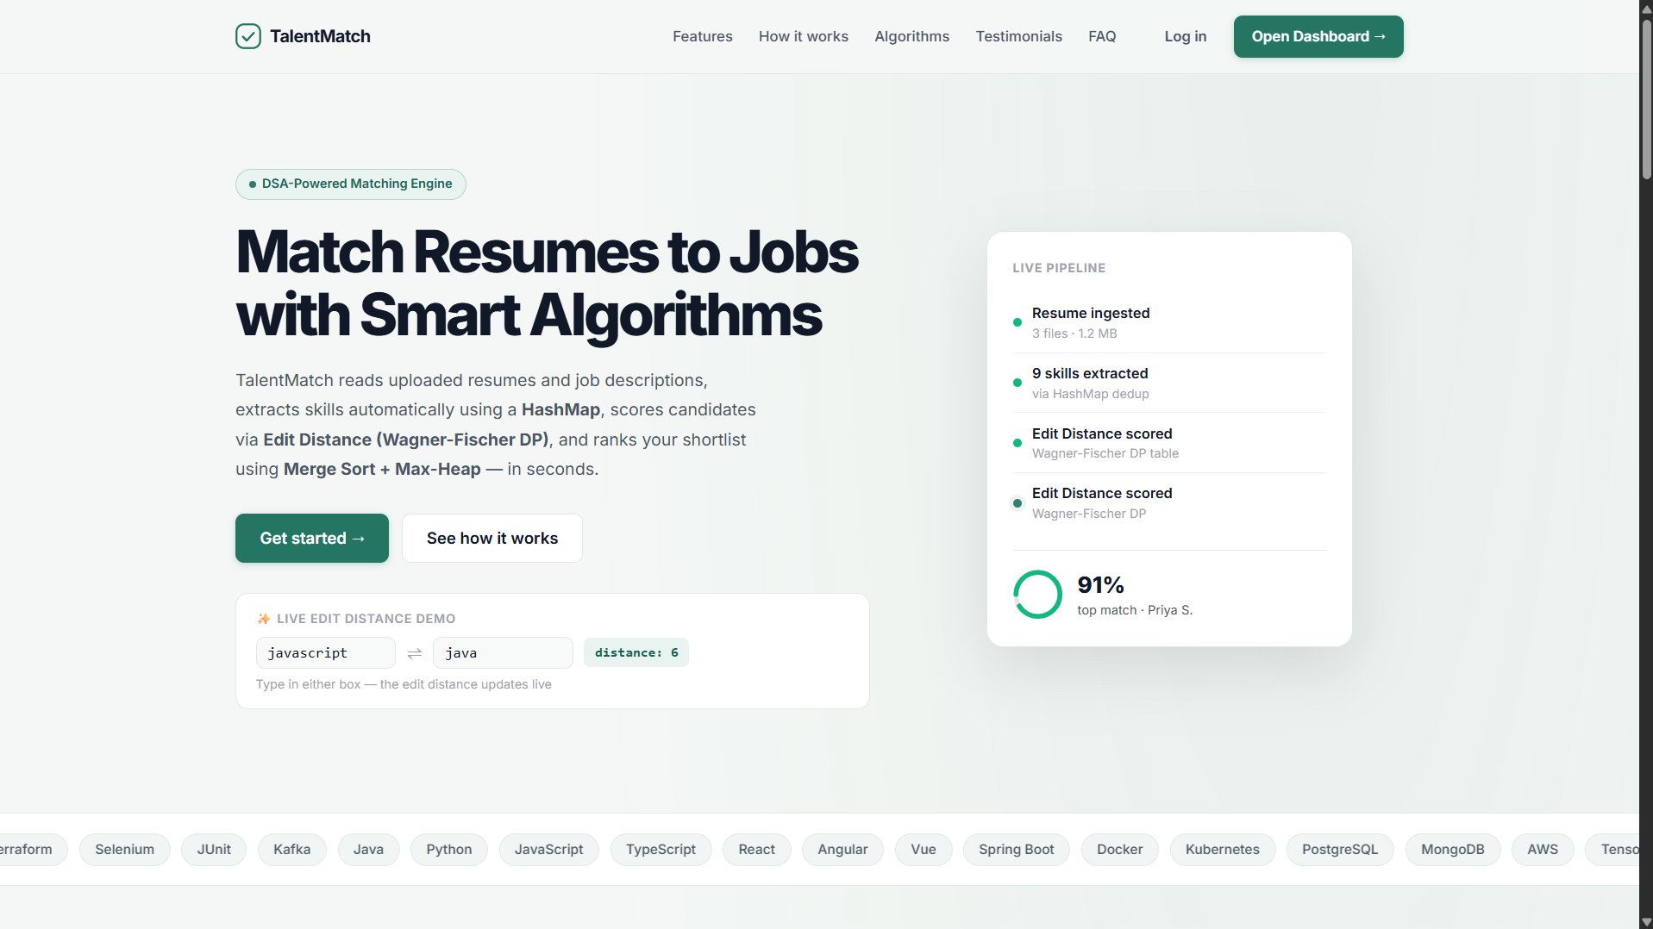
The landing page introduces TalentMatch, its features and the algorithms used. The Open Dashboard button takes the recruiter to the dashboard.
Figure 7.2: Dashboard overview
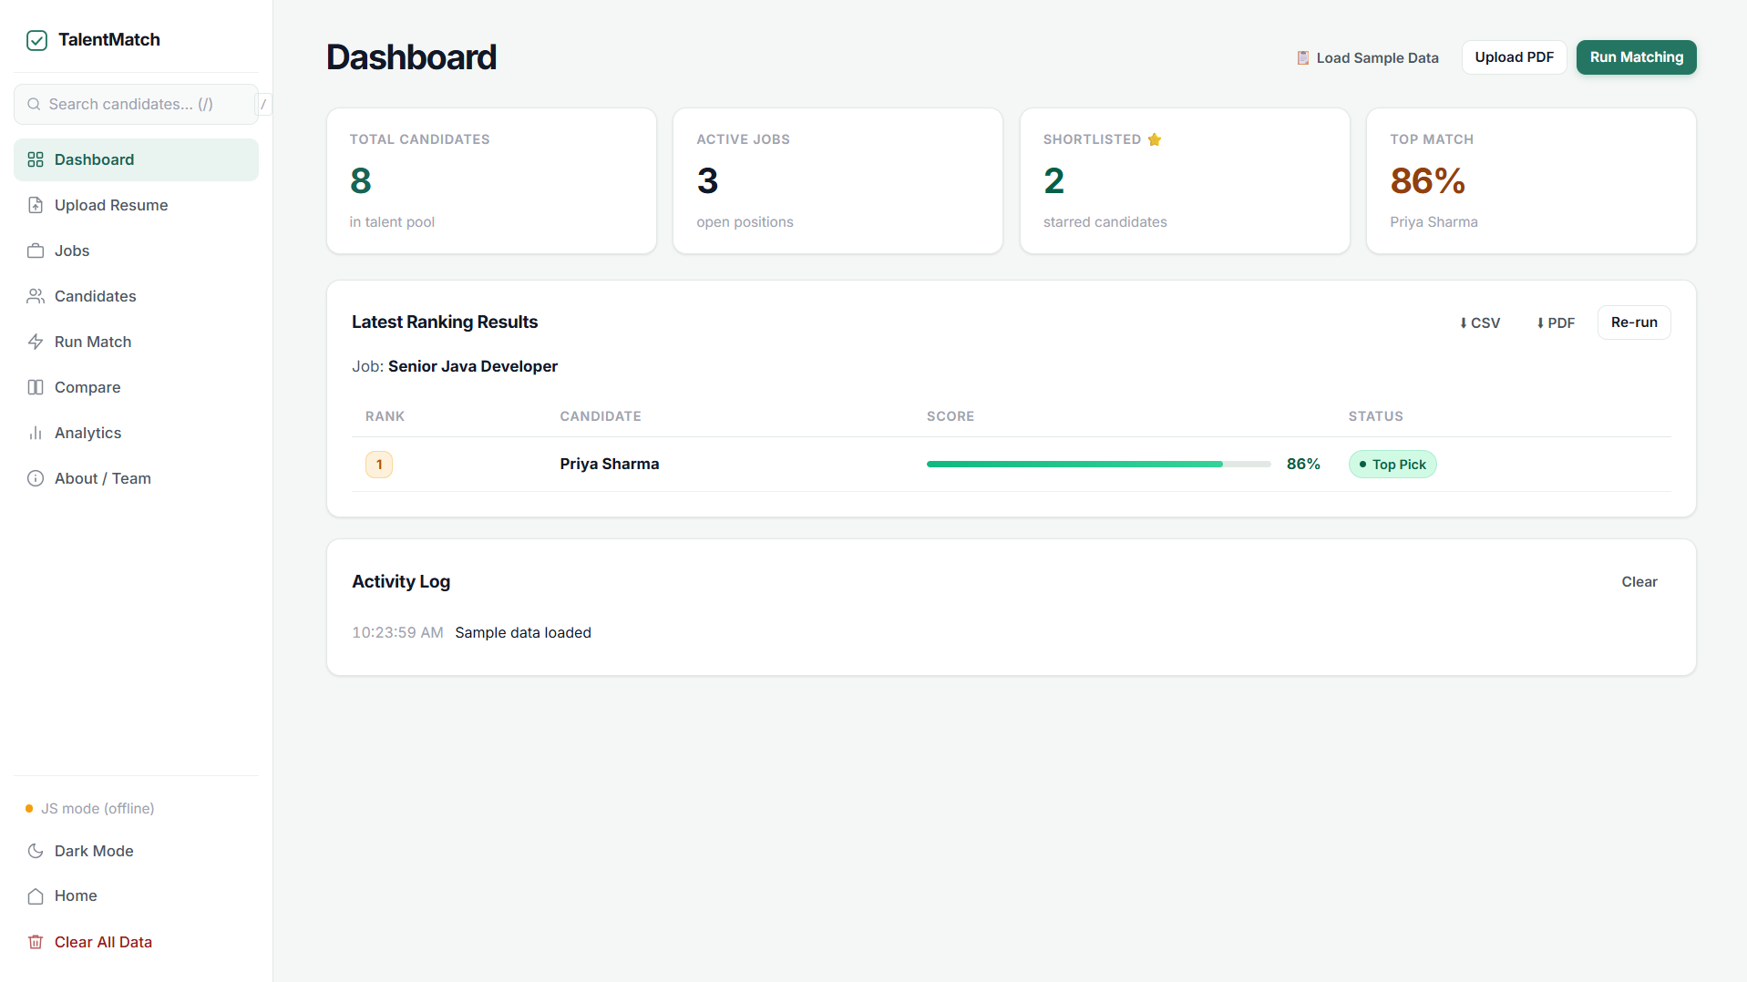
The overview shows statistics for jobs and candidates and the latest match results. The sidebar gives access to every module.
Figure 7.3: Upload Resume (PDF)
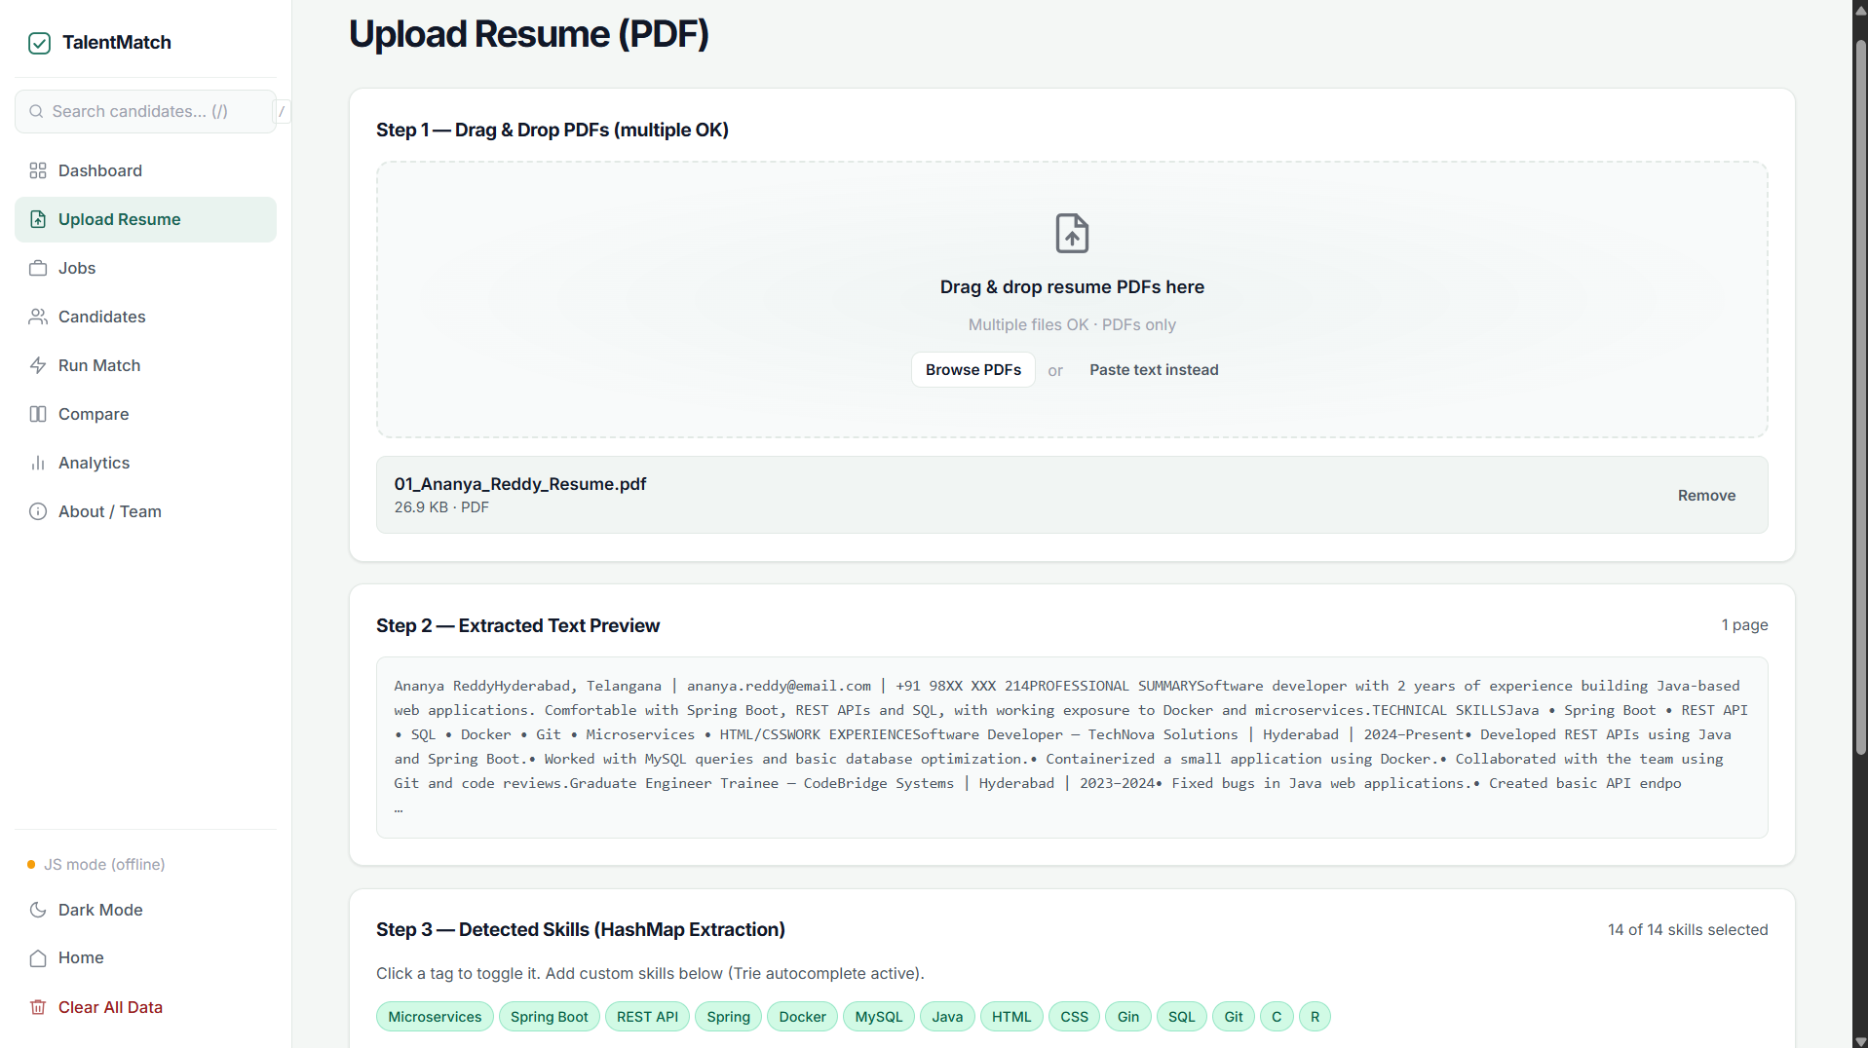
A PDF resume is read with PDF.js and its skills are detected using the skill dictionary. The recruiter can toggle skills before adding the candidate.
Figure 7.4: Jobs and Candidates pages
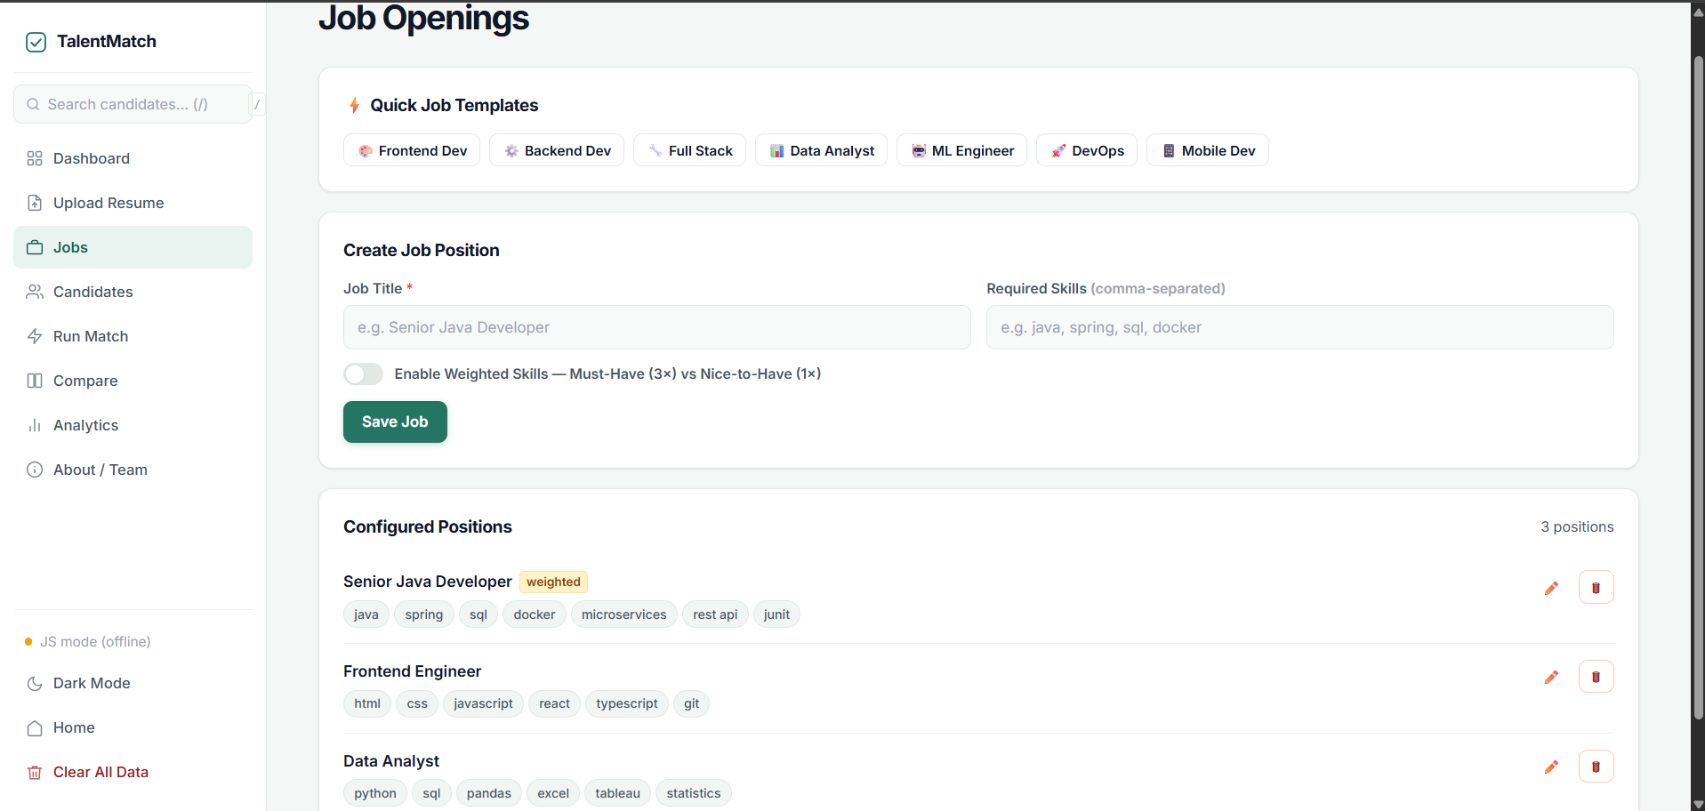
Jobs and candidates can be added or deleted with their skills as tags. Skills are normalised with the hash-based extractor.
Figure 7.5: Match results and algorithm trace
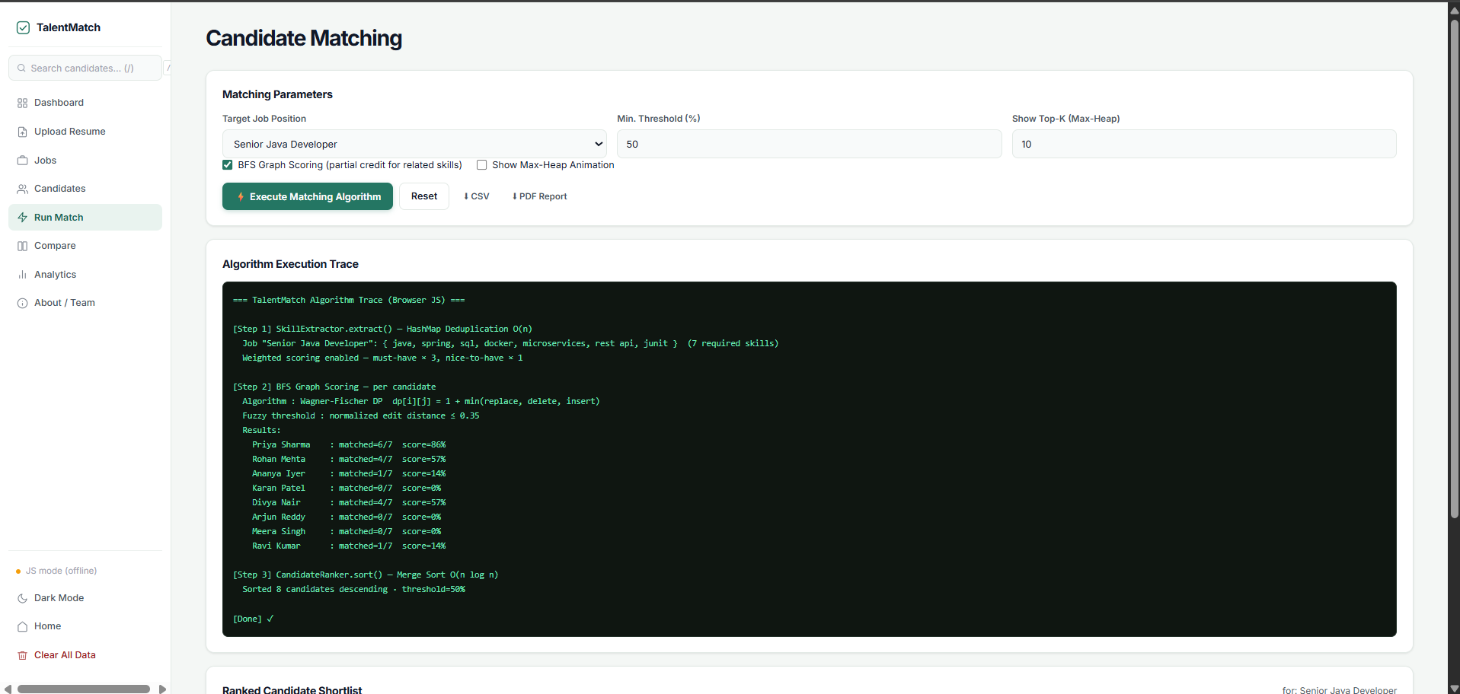
Candidates are ranked with scores and coloured matched / missing skill tags. The trace panel explains how each score was calculated.
Figure 7.6: Backend console and /api/match output
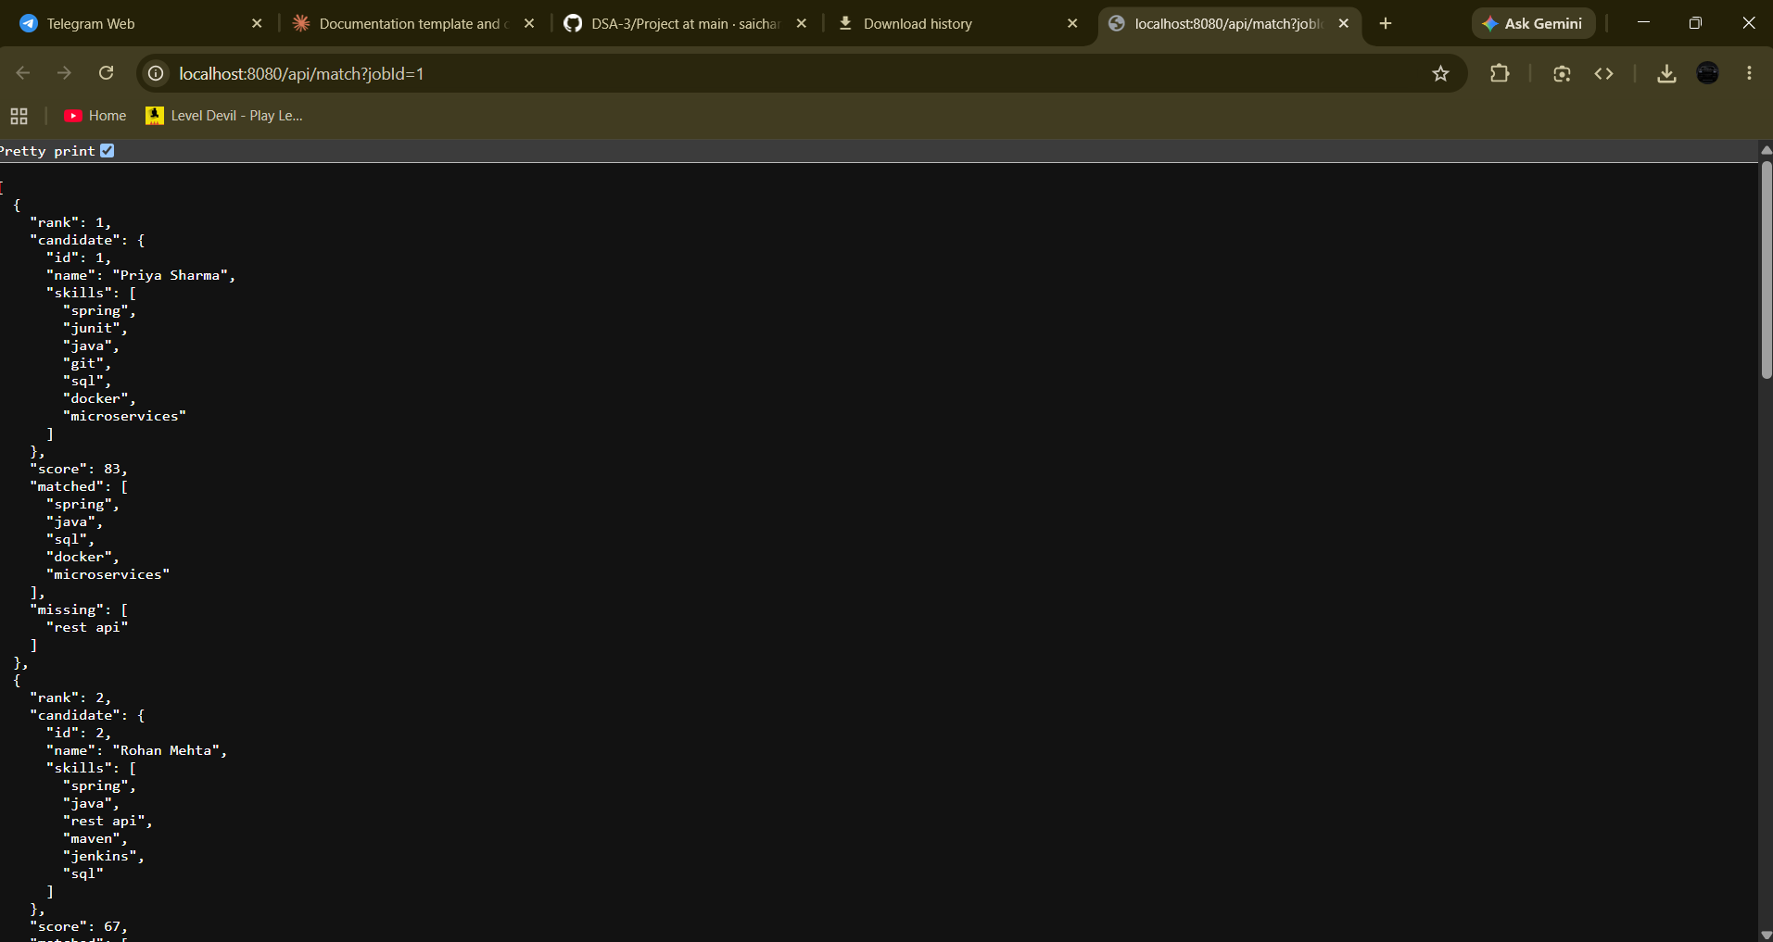
The Java server starts on port 8080 and returns ranked JSON for the selected job. This confirms the backend and algorithms work end to end.

8. CONCLUSION & FUTURE SCOPE

Conclusion
The objectives of the project were met. TalentMatch normalises skills with hashing, scores candidates with a typo-tolerant Wagner-Fischer edit distance, ranks them with a stable Merge Sort (with Max-Heap Top-K available), and explains each score with matched and missing skills. The Java REST API and the recruiter dashboard, including PDF resume upload, make the engine usable in practice, and the JavaScript fallback lets it work even without the server. The project showed how classic DSA topics – hashing, dynamic programming, sorting and heaps – solve a real hiring problem efficiently.

Future Scope
Near term:
- Add a synonym dictionary so that abbreviations such as “JS” and “JavaScript” are treated as the same skill (edit distance alone cannot match them), and bring the weights for mandatory and optional skills, already available in the dashboard, into the Java backend.
- Use the Top-K heap in the API so that only the best candidates are returned for very large pools.
- Add simple login and role-based access.
Medium term:
- Optimal candidate-to-role assignment using weighted bipartite matching (Hungarian algorithm or max-flow).
- Team building: find the smallest set of skills that covers all roles using set cover with a greedy approximation.
- Store data in a database such as MySQL or MongoDB instead of memory and localStorage.
Long term:
- Semantic skill matching with word embeddings in addition to edit distance.
- Cloud deployment with Docker and an integration with job portals.
- Automatic resume ranking dashboards with analytics for hiring teams.

9. REFERENCES
1. Resume Matcher (srbhr), GitHub – https://github.com/srbhr/Resume-Matcher
2. pyresparser (Omkar Pathak), GitHub – https://github.com/OmkarPathak/pyresparser
3. OpenResume (xitanggg), GitHub – https://github.com/xitanggg/open-resume
4. thefuzz – fuzzy string matching in Python, GitHub – https://github.com/seatgeek/thefuzz
5. Jobscan – ATS resume scanner – https://www.jobscan.co
6. ESCO – European Skills, Competences, Qualifications and Occupations – https://esco.ec.europa.eu
7. Wagner–Fischer algorithm, Wikipedia – https://en.wikipedia.org/wiki/Wagner%E2%80%93Fischer_algorithm
8. Hungarian algorithm, Wikipedia – https://en.wikipedia.org/wiki/Hungarian_algorithm
9. PDF.js, Mozilla – https://github.com/mozilla/pdf.js
10. Merge sort, Wikipedia – https://en.wikipedia.org/wiki/Merge_sort

