**Topics: Normal distribution, Functions of Random Variables**

1. The time required for servicing transmissions is normally distributed with *μ* = 45 minutes and *σ* = 8 minutes. The service manager plans to have work begin on the transmission of a customer’s car 10 minutes after the car is dropped off and the customer is told that the car will be ready within 1 hour from drop-off. What is the probability that the service manager cannot meet his commitment?
2. 0.3875
3. 0.2676
4. 0.5
5. 0.6987

Mean(*μ)* = 45 minutes

Standard Deviation(*σ)* = 8 minutes.

Time until the car needs to be ready=1hour=60 minutes

Time after drop-off to start work=10 minutes

The time required for servicing transmissions is normally distributed with *μ* = 45 minutes and *σ* = 8 minutes.

To find the probability that the service manager cannot meet the commitment of having the car ready within 1 hour from drop-off,we need to calculate the probability that the serving time exceeds the remaining time after starting work on the car.

Let *X* be the total time required for servicing the transmission.

The time remaining after starting work on the car = Total time - Time after drop-off to start work = 60 - 10 = 50 minutes.

We want to find *P*(*X*>50).

Using z-score formula: Z=X−*μ/* *σ*

Z=50−45/8=5/8=0.625

Now, we find the probability using the standard normal distribution table (or calculator) for Z=0.625, which gives us the probability to the left of this value.

P(X>50)=1−*P*(*X*≤50)

Looking up *Z*=0.625 in the standard normal distribution table, we find that *P*(*X*≤50)≈0.7340.

Therefore,

*P*(*X*>50)=1−*P*(*X*≤50)=1−0.7340≈0.266.

*Therefore,the probability that the service manager cannot meet the commitment is approximately 0.266 or 26.6%*

*Therefore,the answer is B (0.2676).*

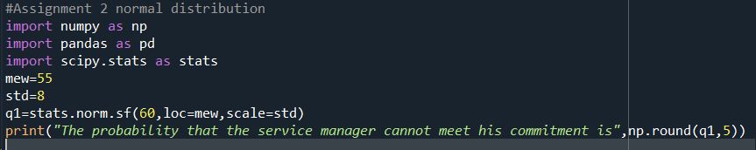



2.The current age (in years) of 400 clerical employees at an insurance claims processing center is normally distributed with mean *μ* = 38 and Standard deviation *σ* =6. For each statement below, please specify True/False. If false, briefly explain why.

1. More employees at the processing center are older than 44 than between 38 and 44.
2. A training program for employees under the age of 30 at the center would be expected to attract about 36 employees.

Let's analyze the given statements:

1. More employees at the processing center are older than 44 than between 38 and 44.

Given, mean *μ* = 38 and Standard deviation *σ=6.*

Probability of being older than 44:

*P*(Age>44)=1−*P*(Age≤44)

*Z*=644−38​=66​=1

Using the standard normal distribution table,*P*(*Z*>1)≈0.1587.

Probability of being between 38 and 44: *P*(38<Age<44)=*P*(Age<44)−*P*(Age≤38)

Z44=44−38/6=6/6=1

*Z*38​=38−38/6​=0

Using the standard normal distribution table, *P*(*Z*<1)≈0.8413 and *P*(*Z*≤0)=0.5.

Comparing the probabilities:

*P*(Age>44)≈0.1587 and *P*(38<Age<44)≈0.3413.

So, False. More employees are between the ages of 38 and 44 than are older than 44.

B. A training program for employees under the age of 30 at the center would be expected to attract about 36 employees.

To find the proportion of employees under the age of 30: *Z*=30−38/6​=−1.33

Using the standard normal distribution table, *P*(*Z*<−1.33)≈0.0912.

So, the proportion of employees under the age of 30 is approximately 0.0912 * 400 ≈ 36.48, which is close to 36.

Therefore, True. A training program for employees under the age of 30 at the center would be expected to attract about 36 employees.

Top of Form

3.If *X1* ~ *N*(μ, σ2) and *X*2 ~ *N*(μ, σ2) are *iid* normal random variables, then what is the difference between 2 *X*1 and *X*1 + *X*2? Discuss both their distributions and parameters.

4.Let X ~ N(100, 202). Find two values, *a* and *b*, symmetric about the mean, such that the probability of the random variable taking a value between them is 0.99.

1. 90.5, 105.9
2. 80.2, 119.8
3. 22, 78
4. 48.5, 151.5
5. 90.1, 109.9

The probability of getting value between a & b is 0.99

So,the probability of getting value outside a & b is 1-0.99=0.01

The probability towards left of a=-0.01/2=-0.05

The probability towards right of b=0.01/2=0.05

Since we have probabilities of a & b,we need calculate the probability of X-the random variable at a & b which has these probabilities.

By finding Standard Normal Variable(z),need to calculate X:

Z=(X=Mue)/Sigma

For a probability 0f 0.005,z values is -2.57

Z\**σ+μ=x*

-(2.57)*20+100=151.4

(-2.57)*20+100=48.6

Option D is the correct answer.

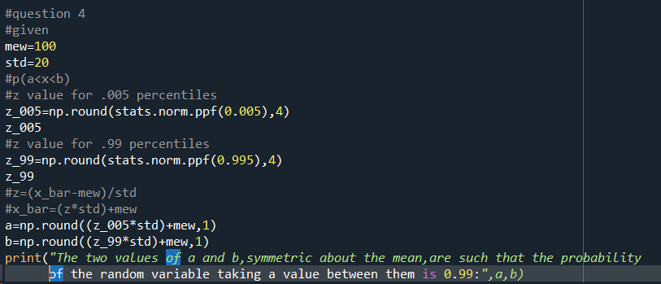

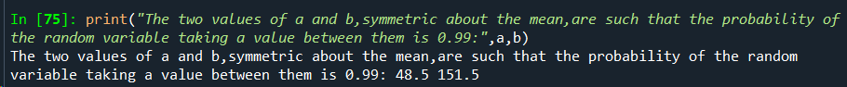

5.Consider a company that has two different divisions. The annual profits from the two divisions are independent and have distributions Profit1 ~ N(5, 32) and Profit2 ~ N(7, 42) respectively. Both the profits are in $ Million. Answer the following questions about the total profit of the company in Rupees. Assume that $1 = Rs. 45

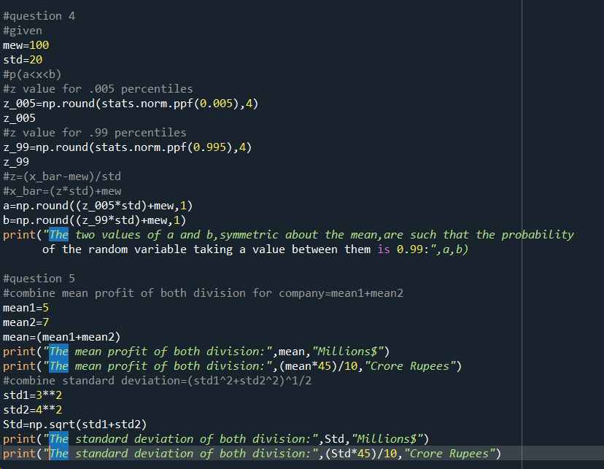

A.Specify a Rupee range (centered on the mean) such that it contains 95% probability for the annual profit of the company.

1. Specify the 5th percentile of profit (in Rupees) for the company
2. Which of the two divisions has a larger probability of making a loss in a given year?