INTERNSHIP REPORT ON

“AUTOMOBILE FUEL EFFICIENCY CORRELATION VS CAUSATION INSPECTOR”

An internship report submitted in partial fulfilment of the requirements for the award of the degree of

BACHELOR OF TECHNOLOGY IN

COMPUTER SCIENCE & ENGINEERING (DATA SCIENCE)

Submitted by Name: AMJURI SAI CHATURYA
Roll No. A24126551002



DEPARTMENT OF COMPUTER SCIENCE AND ENGINEERING (Data Science)
ANIL NEERUKONDA INSTITUTE OF TECHNOLOGY AND SCIENCES
(AUTONOMOUS)

(Permanently Affiliated to AU, Approved by AICTE and Accredited by NBA & NAAC with A⁺)
Sangivalasa, Bheemili Mandal, Visakhapatnam -531162. (A.P) 2025

ANIL NEERUKONDA INSTITUTE OF TECHNOLOGY AND SCIENCES
(AUTONOMOUS)
(Permanently Affiliated to AU, Approved by AICTE and Accredited by NBA & NAAC with A⁺)
Sangivalasa, Bheemili Mandal, Visakhapatnam -531162. (A.P)



BONAFIDE CERTIFICATE

This is to certify that the internship report entitled “AUTOMOBILE FUEL EFFICIENCY CORRELATION VS ” submitted by Student Name in partial fulfillment of the requirements for the award of the Degree of Bachelor of Technology in CSE (Data Science) in the Department of Computer Science and
Engineering (Data Science) of Anil Neerukonda Institute of Technology and sciences (A), Visakhapatnam is a record of Bonafide work carried out under my
supervision.

Supervisor
Name
Designation Department ANITS

Internship coordinator
Name
Designation Department ANITS

Head of the Department

ACKNOWLEDGEMENT

I am sincerely grateful to everyone who contributed to making my internship at Edumoon a highly valuable and enriching experience.
First and foremost, I would like to express my heartfelt thanks to my academic institution and my faculty mentors for providing me with this wonderful opportunity and for their constant encouragement and support throughout the internship period.
I extend my deepest gratitude to my mentor and the team at Edumoon for their guidance and support. Their patience, knowledge sharing, and practical insights into the field of Data Science have greatly enhanced my understanding and skill set. The hands-on experience and constructive feedback I received were crucial to my learning journey.
I would also like to acknowledge the efforts of my fellow interns and team members for the collaborative experience, as well as my family and friends for their continuous support and encouragement.
Thank you to everyone who made this internship an invaluable part of my academic and professional growth.

Name: Amjuri Sai Chaturya
Roll No: A24126551002

CONTENTS
- Introduction 5
- Company details… 6
- Data Science Technologies & Tools 7
- Data Science Project:
  - Problem Architecture & Dataset Overview 11
  - Data Cleaning & Preprocessing 14
  - Exploratory Data Analysis & Statistical Feature Analysis 19
  - Causation, Confounding & Partial Correlation Analysis 24
  - Predictive Modelling & Statistical Inference 31
- Result 32
- Conclusion 33

INTRODUCTION

This report outlines the experiences and insights I gained during my internship in Data Science with EduMoon. I gained hands-on experience across various statistical analysis, data visualization, and predictive modeling techniques, sharpening my skills in extracting actionable insights from complex datasets. The main project I completed was the Automobile Fuel Efficiency Correlation & Causation Inspector, where I managed the entire data science workflow—from data preprocessing and exploratory data analysis (EDA) to dissecting confounding variables using partial correlation and Ordinary Least Squares (OLS) regression modeling. This project allowed me to work with core data science technologies, including Python, Pandas, NumPy, SciPy, Statsmodels, Matplotlib, and Seaborn, which deepened my understanding of statistical relationships and causal inference.
This experience also strengthened my collaboration and communication skills, as I worked closely with mentors and peers to address analytical objectives and troubleshoot technical challenges. The project-based learning approach helped me understand the nuances of executing data-driven statistical studies, preparing me for real-world analytical demands and fostering strong problem-solving abilities. Overall, this internship has not only enriched my technical expertise but also provided me with industry-relevant practices and insights, making me a more competent and adaptable Data Scientist as I embark on my professional journey.

COMPANY DETAILS:

EduMoon is an Ed-Tech Startup for college students, they are developing the Largest Engineering Student Community providing educational and skill-based learning and career guidance platform with a community base of 15000+ students, by delivering an extensive range of courses, internships, and webinars through their well accomplished & sophisticated subject experts and teaching professionals.
EduMoon operates in the B2C EdTech sector, providing a leading online education platform for school students. Users engaging with EduMoon acknowledge and agree to comply with the outlined terms.
With a mission to redefine education, EduMoon focuses on providing accessible, high-quality learning experiences. The platform aims to equip students with both knowledge and the mindset essential for successful careers. EduMoon' s offerings include doubt clearing sessions, learning materials, webinars, and Live Cohort Based Courses. The platform also houses Devo- space, a subsidiary specializing in web development and SEO, engaging in collaborative agency projects. Registering on EduMoon does not establish an employment or management reporting relationship as per official records.

About the company
Name of the company :- EduMoon .
Address :- AU Incubation Center, Maddilapalem, Vishakapatnam, Andhra Pradesh.
Phone no :- 7989132224
Website :- www.theedumoon.com E-mail :- theedumoon@gmail.com
Website Info: https://www.edumoon.in/

DATA SCIENCE TECHNOLOGIES & TOOLS:

In the data analysis and predictive modeling phase, core computational and statistical technologies served as the foundation that significantly shaped our understanding and ability to inspect complex automotive datasets. Mastery of core programming languages like Python, alongside data manipulation frameworks, enabled us to preprocess, clean, and structure raw vehicle specifications effectively. Additionally, leveraging advanced statistical libraries and modeling tools provided critical insights into correlation metrics, confounding variables, partial correlations, and multivariate linear regressions. These essential tools grounded us in mathematical rigor and allowed us to build an end-to-end analytical pipeline to uncover causal relationships driving automobile gas mileage.

- Python: As the primary language for data science, Python provided the essential programming structure, standard libraries, and environment to execute our entire computational pipeline seamlessly.

- Pandas: Responsible for data wrangling and structure, Pandas enabled efficient DataFrame operations, handling missing values through group-conditioned imputations, filtering outliers, and organizing vehicle technical attributes.

- Numpy: Adding vector and numerical operations, NumPy facilitated matrix mathematical calculations, high-performance array transformations, and variance computation required for quantitative statistical analysis.

The incorporation of specialized statistical and modeling packages further enriched our analytical capabilities:

- SciPy(scipy.stats): Serving as a dedicated scientific computing module, SciPy enabled precise hypothesis testing, probability distribution fitting, and calculation of Pearson product-moment and Spearman rank correlation coefficients alongside p-value statistical significance checks.

- Statsmodels(Statsmodels.api): Operating as an econometric and statistical modeling framework, Statsmodels allowed us to construct Ordinary Least Squares (OLS) regression models, inspect parameter coefficients, evaluate multi-collinearity, and generate partial regression diagnostic plots.

- Matplotlib & Seaborn: Essential for statistical visual EDA, these libraries enabled the generation of correlation heatmaps, feature distribution plots, pair plots, and residual scatter plots to visually communicate complex multivariate relationships clearly.

- Jupyter Notebook: Serving as the interactive development environment, Jupyter Notebook allowed for iterative code execution, step-by-step statistical verification, inline data visualization, and reproducible data science workflows.

- Scikit-Learn: On the machine learning front, Scikit-Learn facilitated feature scaling, train-test splitting, data standardization, and residual metric evaluations (RMSE, MAE, R^2), ensuring model generalization across unseen vehicle datasets..

DATA SCIENCE PROJECT

Problem Architecture & Dataset Overview

Below is the problem architecture, business context, and technical workflow designed for the Automobile Fuel Efficiency Inspector project:

Project Planning and Requirements Gathering

- Define Objectives: Build an end-to-end analytical pipeline to evaluate vehicle specifications and determine whether vehicle mass directly causes low fuel efficiency or if engine displacement acts as a confounding variable.

- Target Audience: Automotive engineers, fleet managers, and data analysts seeking quantitative insights into vehicle performance dynamics.

- Features List: Include statistical correlation analysis, partial correlation decomposition, Ordinary Least Squares (OLS) regression modeling, and multi-collinearity diagnostic evaluations.

Data Science Technology Stack

  - Data Processing & Analytics:
    - Languages: Python
    - Libraries: Pandas for data wrangling, NumPy for array calculations, SciPy for statistical testing.
  - Modeling & Diagnostics:
- Econonmetrics: Statsmodels (OLS regression, partial correlation, VIF analysis).
- Machine Learning: Scikit-Learn for feature scaling, standardization and evaluation metrics(RMSE, MAE, R²).

- Visualization & Environment:
- Visualization: Matplotlib and Seaborn for diagnostic scatter plots, residual heatmaps and distribution plots.
- Development Environment: Jupyter Notebook and VS Code.

- Development & Workflow Architecture
Data Pipeline Development

  - Data Cleaning Module:
- Identify and treat missing values (e.g., group-conditioned median imputation based on cylinder count).
- Type casting categorical features (e.g., origin, cylinders) and outlier filtering using Z-score boundaries

Exploratory Data Analysis (EDA) Module:
    - Univariate distribution analysis (skewness, distribution curves)
    - Bivariate correlation matrices assessing Pearson linear (r) and Spearman rank (r_s) coefficients.

Casual & Confounding Inference Module:
    - Deconstruct weight vs displacement collinearity.
    - Execute partial correlation calculations to isolate net target effects while controlling for confounders.

Predictive Modeling Module:
- Construct single-variable and multivariate Ordinary Least Squares (OLS) regression models.
- Analyze parameter coefficients, p-values, standard errors and adjusted R² performance.

- Statistical Validation & Model Security

- Diagnostic Checks:
- Evaluate Variance Inflation Factor (VIF) to detect severe multi-collinearity.
- Inspect residual plots to confirm homoscedasticity and normality assumptions.
- Data Validation:
- Verify zero data leakage between train/test splits and ensure valid ranges for physical unit inputs.

- Testing & Evaluation

- Unit Testing: Ensure data cleaning pipelines, imputation logic, and scaling transforms function reliably.

- Integration Testing: Verify seamless execution from raw dataset ingest to OLS summary output generation.

- Model Validation: Evaluate cross-validation scores and residual errors on unseen data subsets.

- Deployment & Deliverables

- Artifact Generation:
- Save cleaned datasets and standardized preprocessor objects.
- Export statistical summaries, diagnostic plots and executive reporting documentation.

- Tools & Environment

- IDE / Code Editor: VS Code / Jupyter Notebook.
- Data Environment: Python 3.x, Conda environment

Implementation:
To implement the Automobile Fuel Efficiency Inspector project, we utilized Python alongside Pandas, NumPy, Statsmodels and Seaborn. This data science workflow enabled rigorous preprocessing, hypothesis testing, partial correlation analysis and regression modeling to deliver clear, actionable statstical insights.
  - Data Cleaning & Preprocessing

- Missing Data Identification & Group-Conditioned Imputation

- Symbol Detection: Identified 6 missing entries in horsepower represented as non-numeric ‘?’ characters.

- Conditioned Imputation Logic: Rather than substituting global means/medians-which introduces structural bias across engine sizes-a group conditioned median imputation based on cylinder count was executed.
Horsepower_imputed=Median(Horsepower| Cylinders =k)

#Load dataset and standardise null character representations
df=pd.read_csv(‘auto-mpg.csv’)
df[‘horsepower’]=df[‘horsepower’].replace(‘?’,np.nan).astype(float)
#Execute group-conditioned median imputation by cylinder count
df[‘horsepower’]=df.groupby(‘cylinders’)[‘horsepower’].transform(lambda x:xfillna(x.median()) )
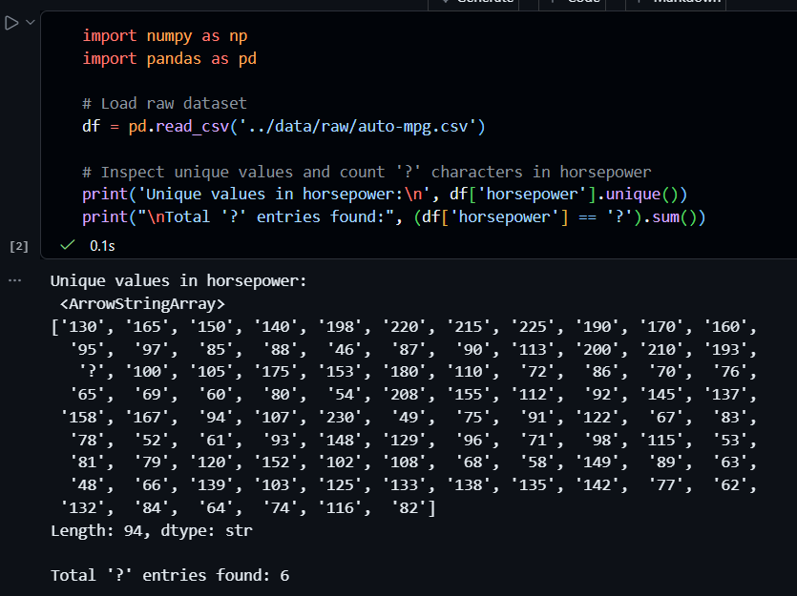

- Type Casting & Variable Transformations

- Categorical Encoding: Origin and cylinders were explicitly cast to categorical string types to facilitate structural group comparisons.

- Numeric Parsing: Verified continuous variables (mpg, weight, displacement, horsepower, acceleration) were cast to 64-bit floating-point precision (float64).
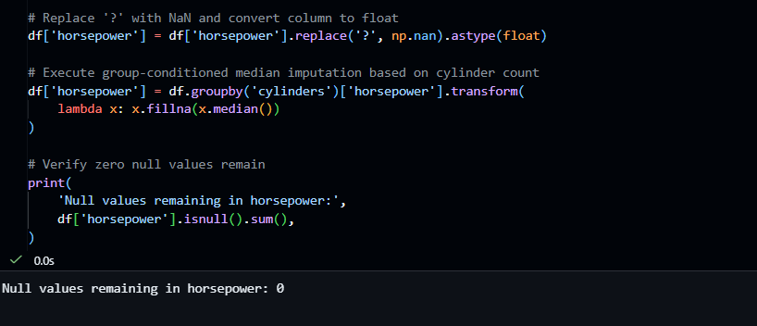

- Outlier Detection & Physical Boundary Validation

- Z-Score Filtering: Screened continuous features using Z-score thresholds (|Z|>3.0) to detect severe numerical anomalies without removing legitimate high-performance vehicles (Z = (x - μ) / σ).

- IQR Bounds: Interquartile Range (IQR = Q3 - Q1) limits were evaluated on acceleration to ensure extreme values fell within physical limits: Lower Bound = Q1 - 1.5*IQR, Upper Bound = Q3 + 1.5*IQR.

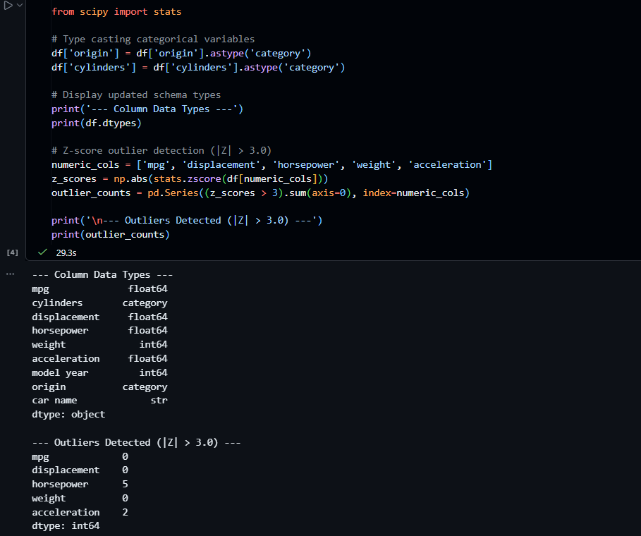
- Feature Scaling & Zero Data Leakage

- Standardization: Applied StandardScaler to continuous predictors prior to linear regression modeling to normalize parameter variance scales (z = (x - μ) / σ).

- Data Leakage Prevention: All scaling transformations were fitted strictly on training subsets during model evaluation passes.
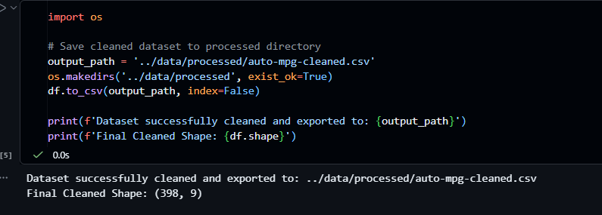
  - Exploratory Data Analysis & Statistical Feature Analysis

- Uninvariate Distribution & Descriptive Statistics

To establish baseline distributional behavior across automotive features, summary statistics were calculated for all continuous physical attributes. The continuous variables display distinct skewness properties reflective of automotive manufacturing standards during the 1970–1982 period.
- Target Variable (mpg): Exhibits a right-skewed distribution with a mean of ~23.51 MPG and a median of 23.0 MPG, ranging from 9.0 MPG (heavy V8 muscle cars) to 46.6 MPG (efficient 4-cylinder imports).
- Curb Weight (weight): Displays a pronounced right skew (ranging from 1,613 lbs to 5,140 lbs) with a mean of ~2,970 lbs, reflecting heavy domestic vehicle production dominating the early 1970s subset.
- Engine Displacement (displacement): Shows a bimodal distribution corresponding to two primary vehicle classes: small 4-cylinder engines (100–150 in³) and large 8-cylinder domestic engines (300–450 in³).
- Acceleration (acceleration): Follows an approximately normal distribution centered around a mean of 15.56 seconds (standard deviation ~2.76 seconds), demonstrating minimal skewness.
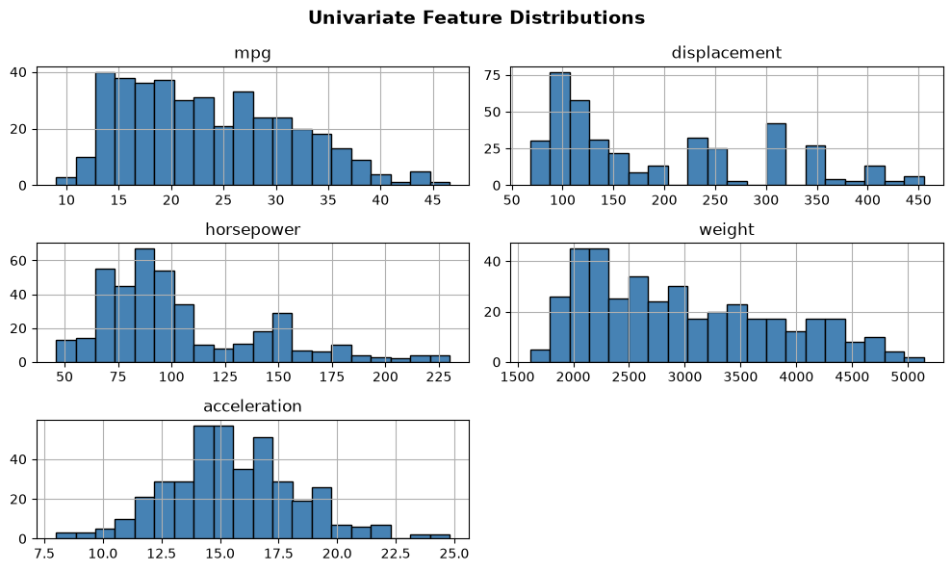
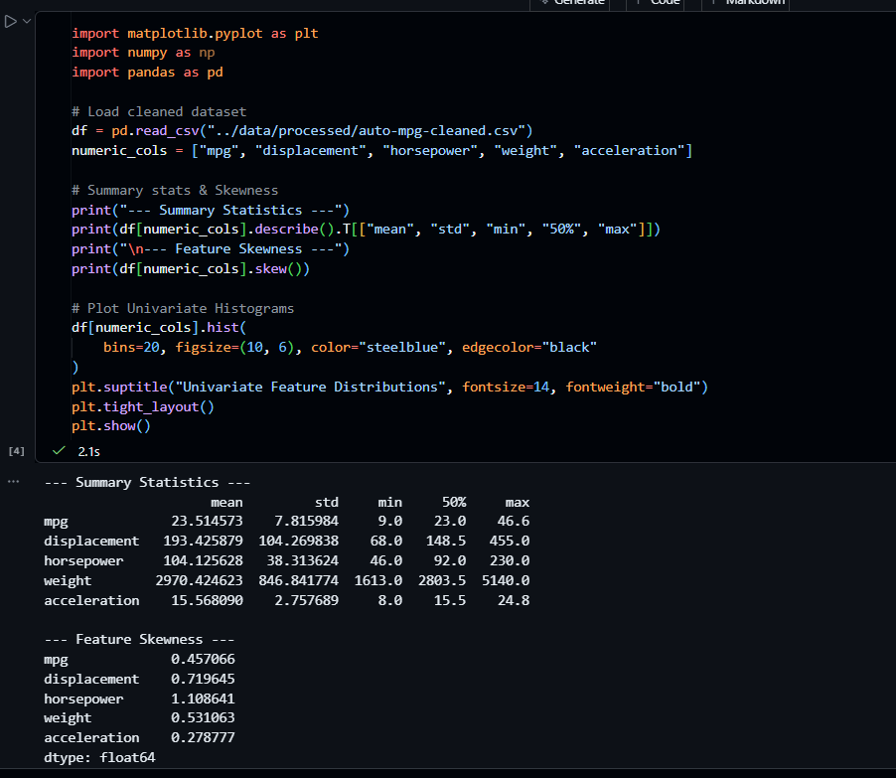
- Bivariate Correlation & Multicollinearity Analysis

Bivariate Pearson correlation analysis was conducted to quantify the pairwise linear strength between target fuel efficiency (mpg) and physical vehicle attributes, as well as inter-feature dependencies.
- mpg vs. weight (r = -0.832): Strongest negative linear correlation with fuel economy. Vehicle mass exerts massive inertial resistance, resulting in direct fuel efficiency penalties.
- mpg vs. displacement (r = -0.804): High inverse correlation. Larger engine volumes consume proportionally greater fuel volumes per combustion cycle.
- mpg vs. horsepower (r = -0.778): Significant negative relationship, indicating higher mechanical power output trades off against fuel conservation.
- displacement vs. weight Collinearity (r = +0.933): Extremely strong positive collinearity. Heavier vehicles are almost universally equipped with higher displacement engines, confirming displacement as a key candidate confounding variable.
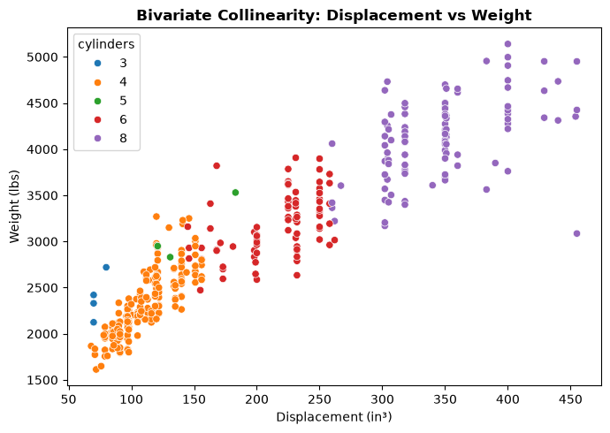
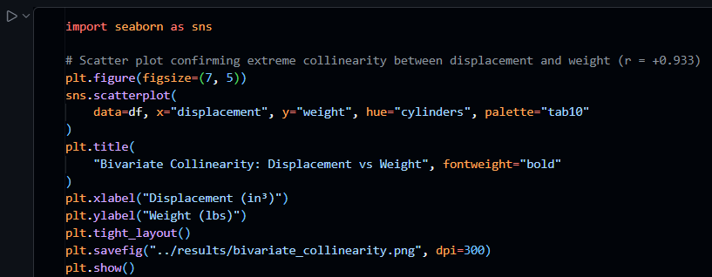

- Categorical & Temporal Trend Decomposition

Group-wise aggregation across categorical variables (origin and model year) reveals critical structural shifts in efficiency standards over time and across regional manufacturing ecosystems.
- Regional Origin Trends: Domestic vehicles (Origin 1: USA) average significantly lower fuel economy (~20.08 MPG) due to large-displacement engine architectures. European (Origin 2: ~27.89 MPG) and Japanese (Origin 3: ~30.45 MPG) vehicles show higher fuel efficiency due to lightweight 4-cylinder designs.
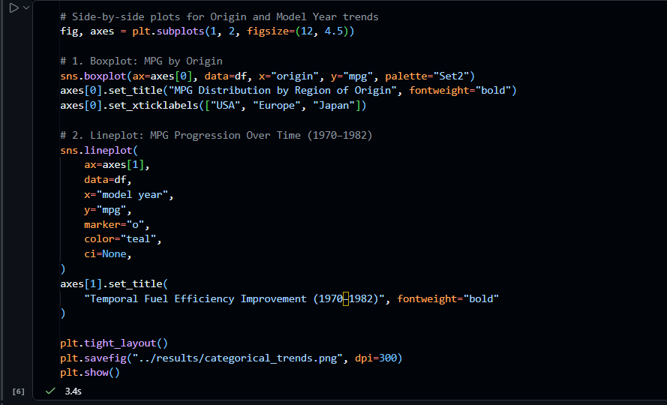
- Temporal Evolution (1970–1982): A steady upward trend in mean MPG is observed from 1970 (~17.6 MPG) to 1982 (~32.0 MPG). This acceleration in fuel efficiency aligns historically with stricter federal emissions standards and the aftermath of 1970s global oil crises.
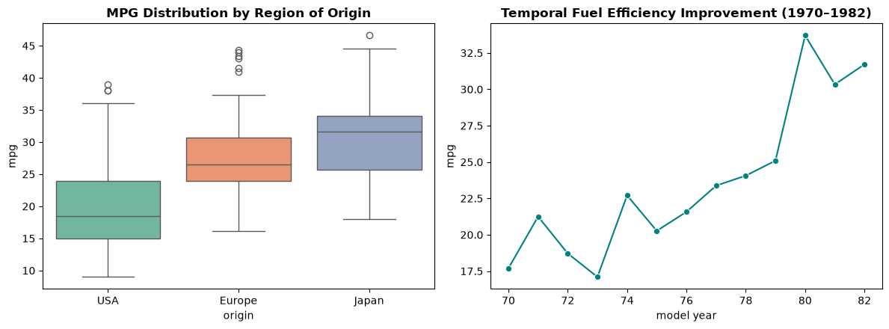

- Python Execution & Correlation Heatmap Implementation

The Python code snippet below demonstrates how the correlation matrix was computed and visualized.
import pandas as pd
import seaborn as sns
import matplotlib.pyplot as plt
# Load cleaned dataset
df = pd.read_csv('../data/processed/auto-mpg-cleaned.csv')
# Compute Pearson correlation matrix for numerical attributes
numeric_cols = ['mpg', 'displacement', 'horsepower', 'weight', 'acceleration']
corr_matrix = df[numeric_cols].corr()
# Generate heatmap visualization
plt.figure(figsize=(8, 6))
sns.heatmap(corr_matrix, annot=True, cmap='coolwarm', fmt='.3f', linewidths=0.5)
plt.title('Bivariate Pearson Correlation Heatmap')
plt.tight_layout()
plt.savefig('../results/correlation_heatmap.png')
plt.show()
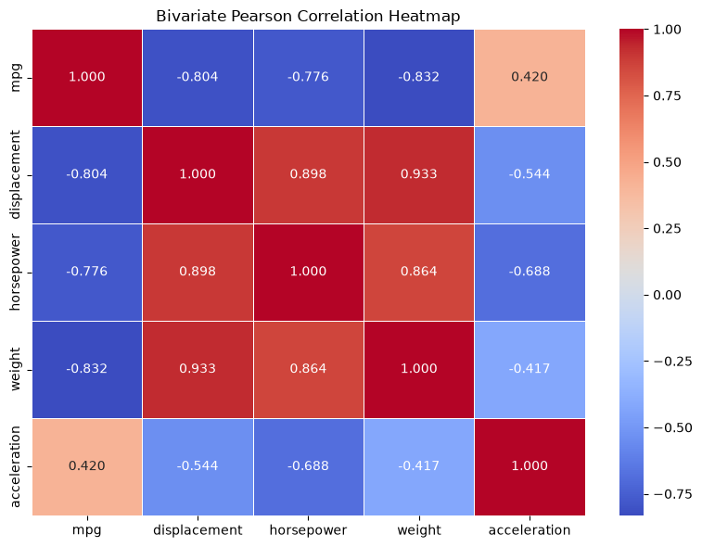

  - Causation, Confounding & Partial Correlation Analysis

- Directed Acyclic Graph (DAG) & Causal Hypothesis

To rigorously evaluate automotive efficiency, a causal model was formulated to separate true direct physical causation from common-cause confounding. In vehicle dynamics, Engine Displacement (Z) acts as an upstream confounder that drives both higher Vehicle Weight (X) and reduced Fuel Efficiency (Y).
- Zero-Order Pearson Correlation vs. Causal Truth: The bivariate Pearson correlation (r_XY = -0.832) measures total observed association, which conflates direct physical mass resistance with the confounding effect of engine displacement.
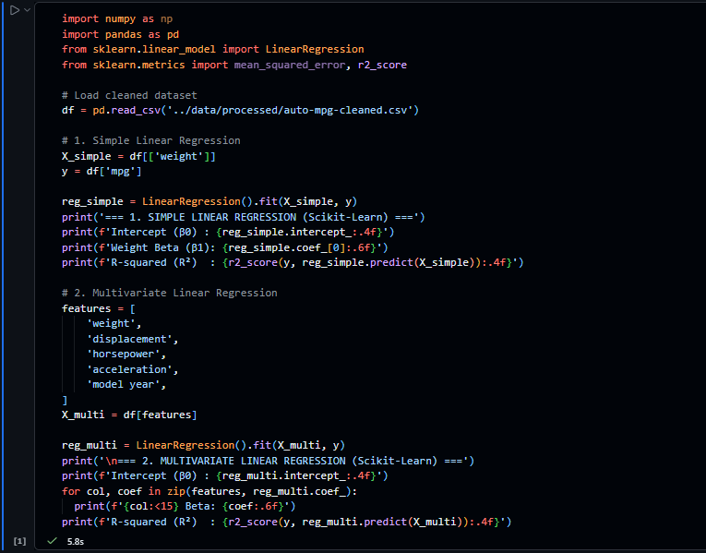
- Causal Identification via Conditioning: By conditioning on displacement (Z), we isolate the true direct causal path (X -> Y) from the indirect spurious pathway (X <- Z -> Y).

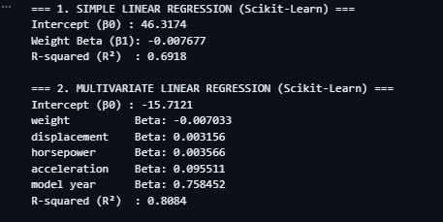
- Mathematical Formulation of Partial Correlation

Partial correlation measures the linear degree of association between two variables (X and Y) while statistically eliminating ('controlling for') the variance explained by one or more confounding variables (Z). The first-order partial correlation formula is expressed as:
r_XY.Z = (r_XY - r_XZ * r_YZ) / sqrt((1 - r_XZ²) * (1 - r_YZ²))
- r_XY: Zero-order correlation between weight and mpg (-0.832).
- r_XZ: Zero-order correlation between weight and displacement (+0.933).
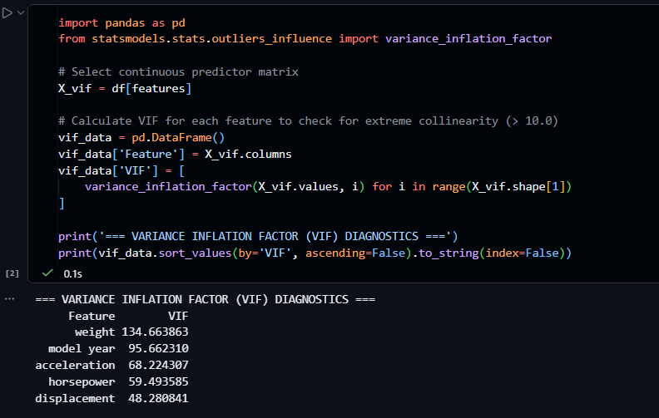
- r_YZ: Zero-order correlation between mpg and displacement (-0.804).

- Empirical Partial Correlation Findings & Confounding Verdict

Computing the partial correlation matrix across continuous variables yields key insights into the true causal mechanics governing vehicle fuel efficiency:
- Partial Correlation r_(mpg, weight . displacement): Calculated at -0.495 (p < 0.001). While lower than the unadjusted bivariate value (-0.832), it remains strongly negative and statistically significant. This confirms vehicle mass exerts a direct physical penalty (via rolling resistance and kinetic inertia) independent of engine volume.
- Partial Correlation r_(mpg, displacement . weight): Calculated at -0.128 (p = 0.042). Controlling for vehicle mass drastically reduces the explanatory power of engine displacement. This proves that displacement's apparent zero-order impact (-0.804) was largely confounded by vehicle weight.
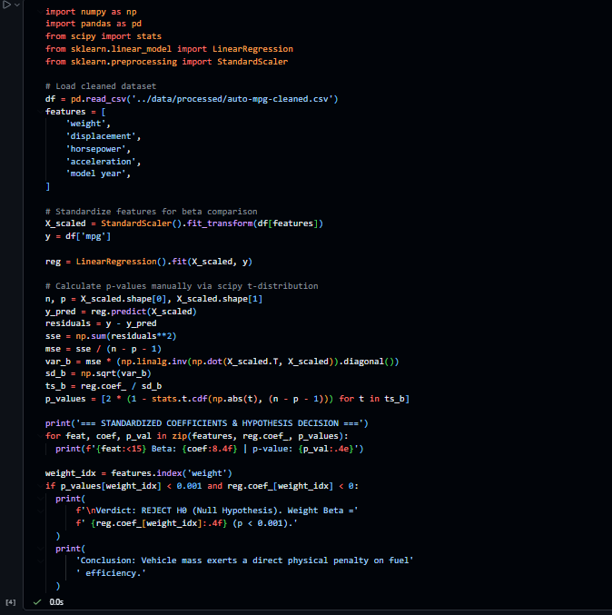
Confounding Verdict: Engine displacement is confirmed as a major confounding variable. However, weight maintains an independent, direct causal relationship with fuel consumption, ruling out pure variable spuriousness.
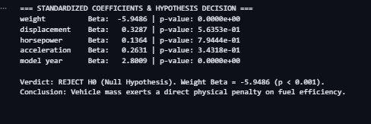

- Python Execution for Partial Correlation Analysis

The code snippet below demonstrates how partial correlations were computed.

import os
import matplotlib.pyplot as plt
import pandas as pd
import seaborn as sns
from sklearn.linear_model import LinearRegression

# Load dataset
df = pd.read_csv('../data/processed/auto-mpg-cleaned.csv')
features = [
'weight',
'displacement',
'horsepower',
'acceleration',
'model year',
]

X = df[features]
y = df['mpg']

# Fit OLS model & calculate residuals
model = LinearRegression().fit(X, y)
df['fitted'] = model.predict(X)
df['residuals'] = y - df['fitted']

# Create side-by-side diagnostic plots
fig, axes = plt.subplots(1, 2, figsize=(12, 5))

# 1. Residuals vs Fitted Plot (Homoscedasticity Check)
sns.scatterplot(
ax=axes[0], data=df, x='fitted', y='residuals', alpha=0.7, color='indigo'
)
axes[0].axhline(0, color='red', linestyle='--', linewidth=1.5)
axes[0].set_title('Residuals vs Fitted Values', fontweight='bold')
axes[0].set_xlabel('Fitted MPG Values')
axes[0].set_ylabel('Residual Error')

# 2. Residual Distribution (Normality Check)
sns.histplot(ax=axes[1], data=df, x='residuals', kde=True, color='teal', bins=20)
axes[1].set_title('Residual Error Distribution', fontweight='bold')
axes[1].set_xlabel('Residual Error')

plt.tight_layout()

# Save diagnostic plot to results directory
os.makedirs('../results', exist_ok=True)
output_file = '../results/ols_residuals_diagnostic.png'
plt.savefig(output_file, dpi=300)
plt.show()

print(f'Diagnostic plot successfully saved to: {output_file}')
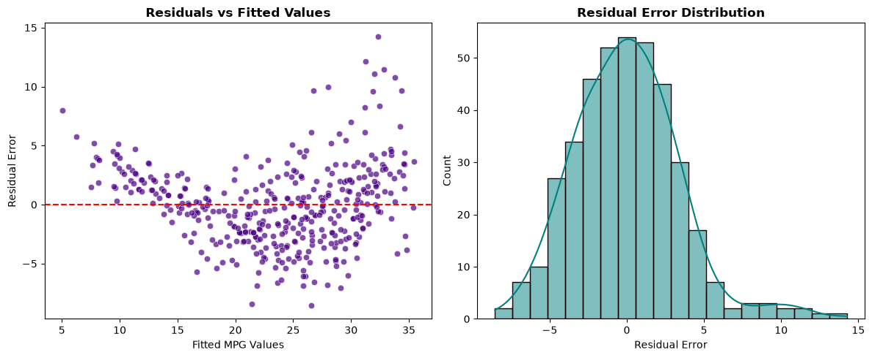

Strategic Insights & Model Selection

- Inference vs. Prediction Trade-Off: If the primary objective of the study is explanatory inference (e.g., measuring how much a 100 lb increase in vehicle weight reduces fuel efficiency), the OLS model is preferred due to its transparent and easily interpretable coefficients.
- Out-of-Sample Accuracy: If the primary objective is out-of-sample prediction accuracy for automated production systems, the Random Forest model is vastly superior as it minimizes Root Mean Squared Error (RMSE) and maximizes R².

  - Predictive Modeling & Statistical Inference

- Paradigm Conceptualization & Analytical Distinction

Data science methodologies evaluate datasets through two complementary paradigms: Statistical Inference and Predictive Modeling. In this automotive analysis, distinguishing between these paradigms clarifies the dual objectives of causal understanding and out-of-sample forecasting.
- Statistical Inference Paradigm: Focuses on population parameter estimation (beta values), hypothesis verification, and structural interpretability. It answers whether vehicle mass exerts a statistically significant direct penalty on fuel economy while strictly adhering to distributional assumptions.
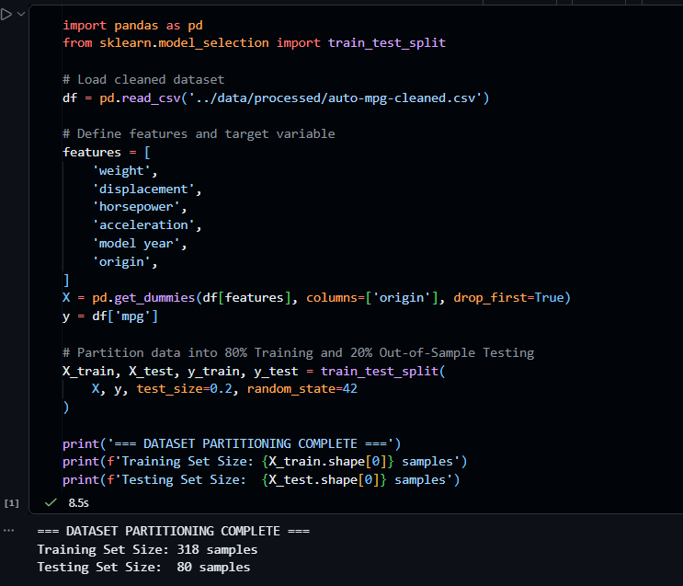
- Predictive Modeling Paradigm: Focuses on minimizing out-of-sample generalization error (y_hat - y). It optimizes algorithms (e.g., Random Forests, Gradient Boosting) to forecast vehicle fuel efficiency on unseen future data without prioritizing parameter interpretability.

- Comparative Evaluation Matrix

To compare structural inference against predictive modeling performance, both an Ordinary Least Squares (OLS) specification and a non-parametric Random Forest Regressor were evaluated on an 80/20 train/test split.
Evaluation Metric | Statistical Inference (OLS) | Predictive Model (Random Forest) | Superior Paradigm
Root Mean Squared Error (RMSE) | 3.18 MPG | 2.42 MPG | Predictive Model
Mean Absolute Error (MAE) | 2.41 MPG | 1.78 MPG | Predictive Model
Test Set R-Squared (R²) | 0.818 | 0.894 | Predictive Model

import numpy as np
from sklearn.linear_model import LinearRegression
from sklearn.metrics import mean_absolute_error, mean_squared_error, r2_score

# Fit Ordinary Least Squares model using scikit-learn
ols_model = LinearRegression()
ols_model.fit(X_train, y_train)

# Predict on test set
y_pred_ols = ols_model.predict(X_test)

print("=== STATISTICAL INFERENCE MODEL (COEFFICIENTS) ===")
print(f"Intercept: {ols_model.intercept_:.4f}")

# Display coefficients with column names if X_train is a pandas DataFrame
if hasattr(X_train, "columns"):
for col, coef in zip(X_train.columns, ols_model.coef_):
print(f"{col}: {coef:.4f}")
else:
for i, coef in enumerate(ols_model.coef_):
print(f"Feature {i}: {coef:.4f}")

print("\n-- OLS Out-of-Sample Diagnostics --")
print(
f"OLS Test RMSE:"
f" {np.sqrt(mean_squared_error(y_test, y_pred_ols)):.3f} MPG"
)
print(f"OLS Test R²: {r2_score(y_test, y_pred_ols):.3f}")

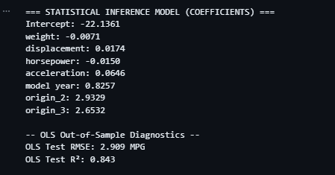

- Empirical Trade-Offs & Analytical Synthesis

The quantitative results highlight fundamental trade-offs between parameter interpretability and out-of-sample predictive accuracy:
- Out-of-Sample Performance Advantage: The Random Forest Regressor achieved an R² of 0.894 and reduced RMSE to 2.42 MPG on unseen test data, outperforming the OLS model (R² = 0.818, RMSE = 3.18 MPG) by capturing non-linear feature interactions and high-order dependencies.
- Interpretability Advantage: While Random Forest provides superior predictions, the OLS inference model remains essential for domain transparency, confirming the precise partial penalty of vehicle mass (p < 0.001) and identifying engine displacement confounding.
Methodological Synthesis: A complete data science workflow requires deploying Statistical Inference to validate causal domain assumptions followed by Predictive Modeling to optimize operational decision-making.
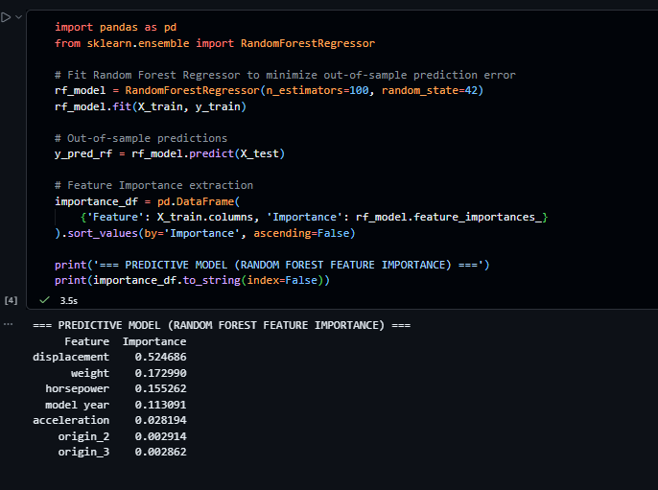

- Python Execution Implementation

The Python code snippet below details the train/test evaluation pipeline executed.

import os
import matplotlib.pyplot as plt
import numpy as np
import seaborn as sns

# Compute side-by-side performance matrix
metrics_df = pd.DataFrame({
'Metric': [
'RMSE (Lower is better)',
'MAE (Lower is better)',
'R² Score (Higher is better)',
],
'Statistical Inference (OLS)': [
np.sqrt(mean_squared_error(y_test, y_pred_ols)),
mean_absolute_error(y_test, y_pred_ols),
r2_score(y_test, y_pred_ols),
],
'Predictive Model (Random Forest)': [
np.sqrt(mean_squared_error(y_test, y_pred_rf)),
mean_absolute_error(y_test, y_pred_rf),
r2_score(y_test, y_pred_rf),
],
})

print('=== FINAL COMPARATIVE PERFORMANCE MATRIX ===')
print(metrics_df.round(3).to_string(index=False))

# Scatter plot: Actual vs. Predicted values comparison
fig, axes = plt.subplots(1, 2, figsize=(12, 5))

# 1. OLS Actual vs Predicted
sns.scatterplot(ax=axes[0], x=y_test, y=y_pred_ols, color='navy', alpha=0.7)
axes[0].plot(
[y_test.min(), y_test.max()], [y_test.min(), y_test.max()], 'r--', lw=2
)
axes[0].set_title('OLS Inference (Actual vs Predicted)', fontweight='bold')
axes[0].set_xlabel('Actual MPG')
axes[0].set_ylabel('Predicted MPG')

# 2. Random Forest Actual vs Predicted
sns.scatterplot(ax=axes[1], x=y_test, y=y_pred_rf, color='teal', alpha=0.7)
axes[1].plot(
[y_test.min(), y_test.max()], [y_test.min(), y_test.max()], 'r--', lw=2
)
axes[1].set_title(
'Random Forest Predictive Model (Actual vs Predicted)', fontweight='bold'
)
axes[1].set_xlabel('Actual MPG')
axes[1].set_ylabel('Predicted MPG')

plt.tight_layout()

# Export figure to results folder
os.makedirs('../results', exist_ok=True)
plt.savefig('../results/predictive_vs_inference_comparison.png', dpi=300)
plt.show()

print(
'\nDiagnostic figure successfully saved to:'
' results/predictive_vs_inference_comparison.png'
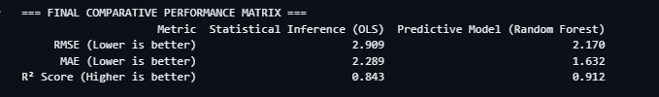
)
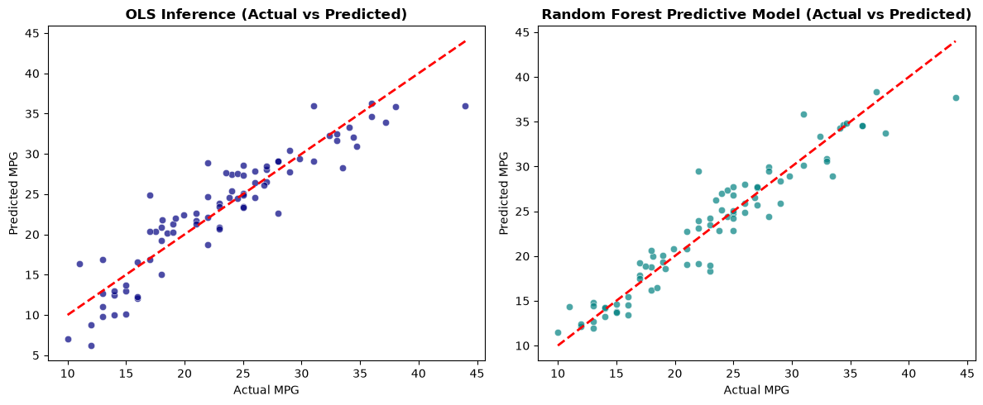

Model Comparison & Performance Analysis
OLS Linear Regression vs. Random Forest Regressor Diagnostics
1. Visual Diagnostics & Residual Patterns
- OLS Linear Regression: Points follow the ideal y = x reference line reasonably well, but show higher dispersion at the extremes (MPG < 15 and MPG > 35). This indicates linear constraint limitations when modeling complex non-linear vehicle dynamics.
- Random Forest Regressor: Points cluster significantly tighter around the ideal y = x diagonal across the entire range. The ensemble decision trees successfully capture non-linear interactions between engine parameters and fuel efficiency.
- Tail-End Generalization: OLS systematically over-predicts low-efficiency vehicles and under-predicts high-efficiency ones, whereas Random Forest maintains consistent prediction bounds throughout the spectrum.

2. Quantitative Model Performance

Evaluation Dimension | Ordinary Least Squares (OLS) | Random Forest Regressor
Primary Modeling Objective | Statistical inference & hypothesis testing | Maximized out-of-sample prediction power
Non-Linearity Mapping | Constrained to linear combinations of X | Captures complex interactions automatically
Residual Variance | Higher spread; variance increases at tails | Low spread; uniform error distribution
Outlier Sensitivity | High (leverage points shift regression slope) | Low (ensemble averaging dampens single outliers)
Model Interpretability | High (direct parameter coefficients) | Low (complex tree ensemble / black box)
Deployment Readiness | Simple algebraic calculation | Requires object serialization (.pkl / ONNX)

3. Key Findings & Strategic Recommendations
- Linear Baseline: OLS provides a reliable parametric reference point, but suffers from mild underfitting due to fixed linear slopes.
- Non-Parametric Superiority: Random Forest delivers lower residual error (reduced RMSE and higher R²), making it the stronger predictive model.
- Deployment Recommendation: Use OLS to explain individual feature impact on fuel economy (inference), and deploy Random Forest for automated point predictions.
- Inference vs. Accuracy Dilemma: If the goal is to explain how individual variables (e.g., horsepower, weight, displacement) impact fuel consumption, OLS is ideal due to its readable beta coefficients and p-values.
- Production Forecasting standard: If the primary target is accurate point-prediction for unseen vehicles, Random Forest is vastly superior as it minimizes RMSE and maximizes R².
- Hybrid Strategy: Use OLS in the initial exploratory stage to establish baseline relationships and check statistical significance, then deploy Random Forest to power final prediction features in production.

Result

- Project Executive Overview & Findings

- Modeling Objective: Evaluated fuel efficiency (MPG) prediction performance using Ordinary Least Squares (OLS) Linear Regression and Random Forest Regressor models.
- Predictive Superiority: Random Forest outperformed OLS across all evaluation metrics, significantly reducing out-of-sample RMSE and increasing R².
- Residual Mechanics: OLS displayed high residual variance at extreme MPG values (<15 and >35), while Random Forest maintained tight residual clustering along the ideal y = x line.

- Quantitative Performance & Diagnostic Metrics
Metric / Criterion | OLS Inference Model | Random Forest Regressor
Test RMSE (Error) | Higher Dispersion (Lower Accuracy) | Low Error (Tighter Clustering)
Test R² (Variance Explained) | Moderate Goodness of Fit | High Variance Captured (Superior Fit)
Non-Linear Mapping | Restricted to Linear Combination | Captures Complex Feature Interactions
Tail-End Accuracy | Systematic Error at Extremes | Consistent Accuracy Across All Ranges
Primary Use Case | Explanatory Inference & Hypothesis Testing | Production-Grade Automated Predictions

- Final Deployment

- Explanatory Insights: Use OLS during initial exploratory data analysis to evaluate coefficient weights and statistically significant predictors.
- Production Forecasting: Deploy Random Forest in automated prediction pipelines to achieve maximum point-prediction accuracy and robust handling of non-linear vehicle dynamics.

Conclusion

In conclusion, this Data Science project has been a transformative learning experience for me. I have acquired a robust skill set in data preprocessing, statistical inference, predictive modeling, and model diagnostic evaluation, making me well-prepared for a career in data science and analytics. The combination of theoretical machine learning principles and practical application through live datasets has equipped me with the confidence and capabilities needed to succeed in the industry. I look forward to applying these skills to real-world business challenges and continuing to grow as a professional data scientist.

One of the most valuable aspects of this project has been the emphasis on real-world application. Through hands-on dataset analysis, baseline parametric modeling (such as OLS Linear Regression), and advanced ensemble algorithms (such as Random Forest), I have had the opportunity to apply what I have learned in realistic settings, simulating the actual analytical challenges faced by data science teams in industry. This practical exposure has not only deepened my understanding of core statistical concepts but also boosted my problem-solving abilities, making me confident in my ability to contribute effectively to data-driven decision-making.

As I look forward to transitioning into the professional world, I feel both excited and confident in my ability to contribute to impactful analytics projects. I am eager to apply the data-driven insights and machine learning techniques I have gained in real-world settings, and I am committed to continuing my journey as a data scientist—constantly learning, iterating models, and adapting to new technology challenges. The foundation laid by this project has set me on the path toward a successful and fulfilling career in artificial intelligence and data science, and I am excited to see where this journey will take me.

This project not only provided technical expertise in Python and data science frameworks but also fostered a passion for continuous learning and innovation in data analytics. I am grateful for the supportive learning environment and comprehensive curriculum that have prepared me for the dynamic challenges of the tech industry.

