Nmap Scan Documentation – Penetration Testing Lab

Target Machine
- Victim OS: Ubuntu (Docker-hosted OWASP Juice Shop)
- IP Address: 192.168.38.128
- Attacker Machine: Kali Linux
- IP Address: 192.168.38.129

1. Basic Port Scan
Command Executed:
nmap -sS -Pn 192.168.38.128 -oN nmap_basic.txt

Purpose:
Performs a SYN stealth scan without host discovery to quickly identify open TCP ports.
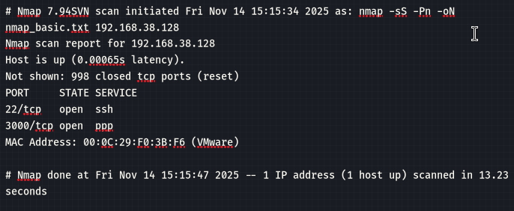

2. Service Version Detection Scan
Command Executed:
nmap -sV -sS -Pn 192.168.38.128 -oN nmap_versions.txt

Purpose:
Detects service versions running on open ports.
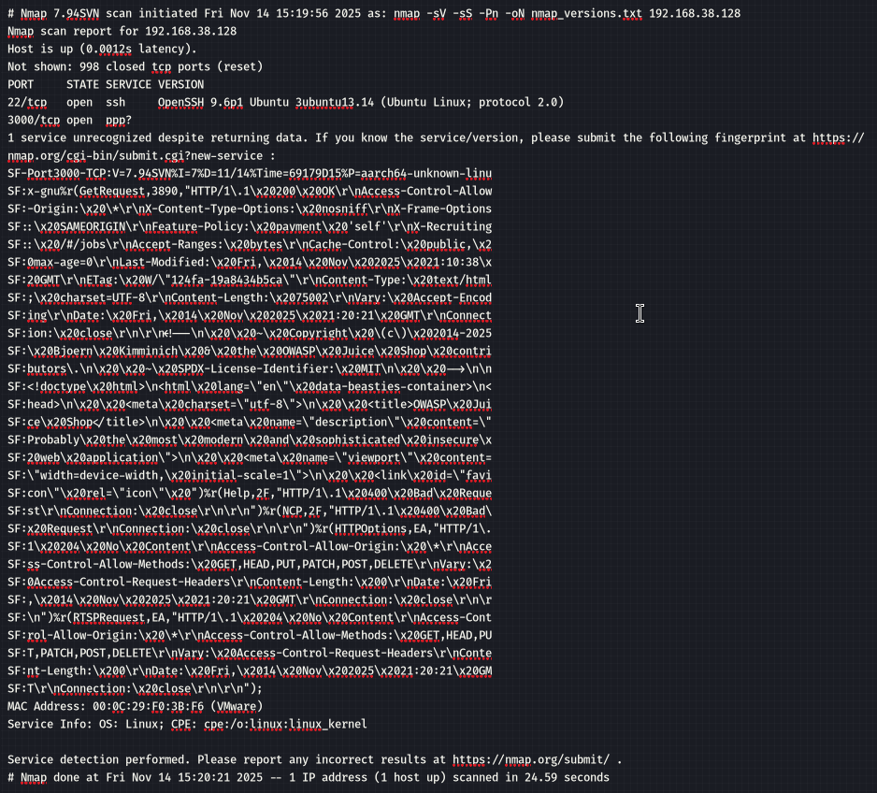

3. Full TCP Port Sweep (All Ports)
Command Executed:
nmap -p- -sS -Pn 192.168.38.128 -oN nmap_full.txt

Purpose:
Scans all 65,535 TCP ports.

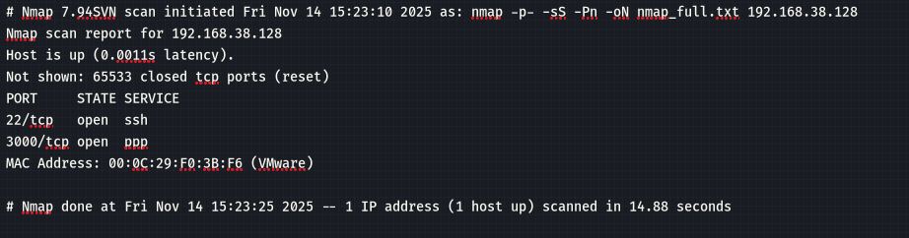

4. Aggressive Scan (OS + Services + Scripts)
Command Executed:
nmap -A -sS -Pn 192.168.38.128 -oN nmap_aggressive.txt
Purpose:
Performs OS detection, script scanning, and traceroute.
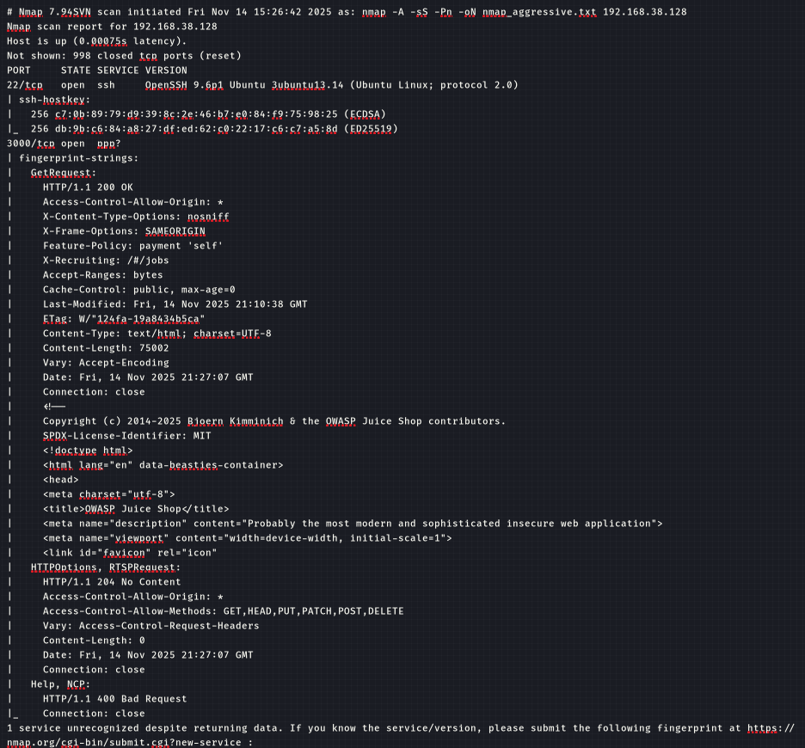
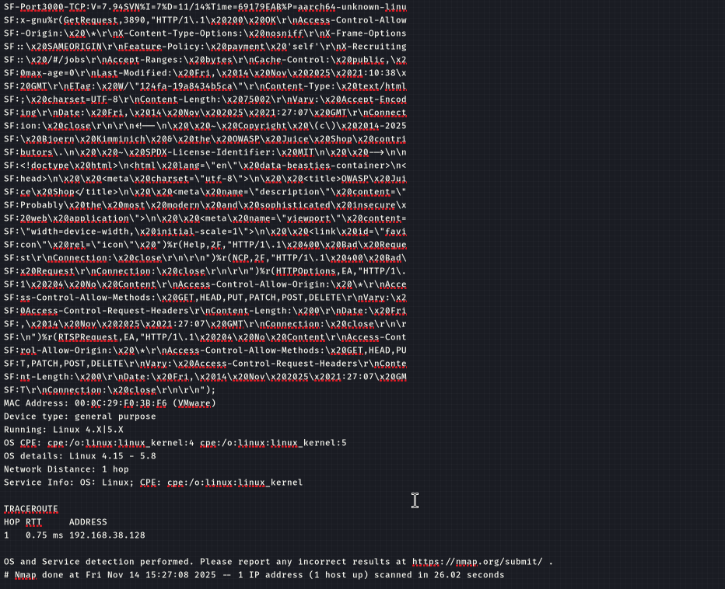

5. Vulnerability Script Scan
Command Executed:
nmap --script vuln -Pn 192.168.38.128 -oN nmap_vuln.txt

Purpose:
Runs NSE vulnerability detection scripts.
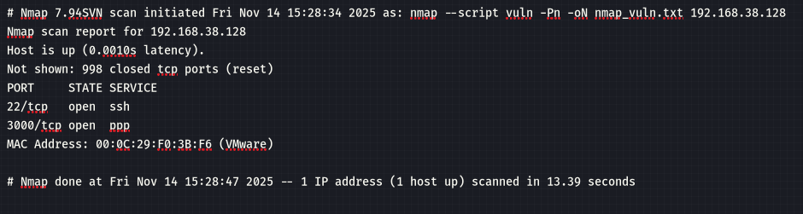

Summary of Results
(Write a summary of all identified ports, services, and potential weaknesses.)

Conclusion
(Write your final interpretation of the Nmap scan results.)

