LUMINA v3 - Project Links & References
Smart India Hackathon 2026 (Problem Statement: SIH26166)
Represented by LumaInit
__________________________________________________

Live Digital Twin (Vercel)
The fully interactive WebGL 3D Mission Control and Telemetry Dashboard.
URL: https://lumina-zeta-sand.vercel.app
 | 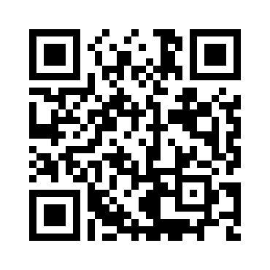

Project Source Code (GitHub)
The complete source code, README, architectures, and Next.js frontend.
URL: https://github.com/saichintamani/Lumina-
 | 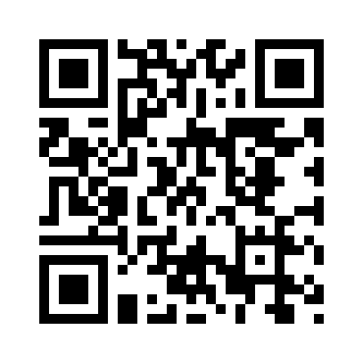

AI Pipeline (Kaggle Notebook)
Deep Learning LoFTR scale-invariant feature matching and Random Forest Ice Classification.
URL: https://www.kaggle.com/code/saichintamaniai/isro-lunar-surface-loftr-feature-matching
 | 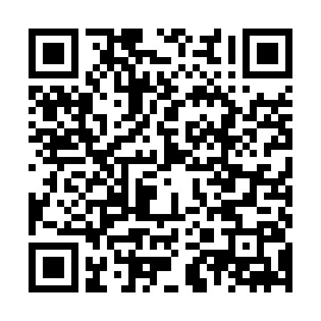

Synthetic Lunar Data (Kaggle Dataset)
The custom dataset containing synthetic TMC, OHRC, and DFSAR polarimetry images.
URL: https://www.kaggle.com/datasets/saichintamaniai/isro-lunar-surface-matching
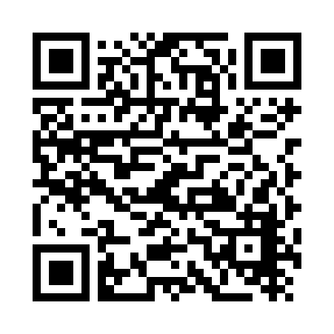

Official ISRO Data Archive (PRADAN)
The original Indian Space Science Data Center portal used to source Chandrayaan-2 TMC and DFSAR baseline data.
URL: https://pradan.issdc.gov.in
