RESEARCH AND REFERENCES
Smart India Hackathon 2026 (SIH26166) | Team: LumaInit (StormBreaker)

PUBLIC DATASETS & RESEARCH
[ISRO DATA] Chandrayaan-2 DFSAR Radar backscatter & elevation data — https://pradan.issdc.gov.in
[ISRO DATA] Chandrayaan-2 CLASS (X-Ray Spectrometer) elemental abundance maps — https://pradan.issdc.gov.in
[NASA DATA] NASA LRO LOLA Altimeter digital elevation models — https://pds-geosciences.wustl.edu
[NASA DATA] NASA JPL Horizons Ephemeris – real lunar orbital physics — https://ssd.jpl.nasa.gov/horizons/
[KAGGLE DATA] Lumina Synthetic Lunar Surface Matching Dataset — https://www.kaggle.com/datasets/saichintamaniai/isro-lunar-surface-matching
[KAGGLE CODE] Lumina Deep Learning LoFTR Feature Matching Pipeline — https://www.kaggle.com/code/saichintamaniai/isro-lunar-surface-loftr-feature-matching
[ALGORITHM] Craig W. Reynolds, 'Flocks, Herds, and Schools: A Distributed Behavioral Model' — SIGGRAPH 1987
[OFFICIAL] ISRO Official Portal – Bharatiya Antariksh Hackathon problem statement — https://isro.gov.in

OPEN & REPRODUCIBLE PIPELINE
Every dataset used is public and every claim in this submission is independently verifiable.
PROJECT REPOSITORY (GITHUB)  https://github.com/saichintamani/Lumina-  SCAN → GITHUB REPO  Full source code, README & architecture docs  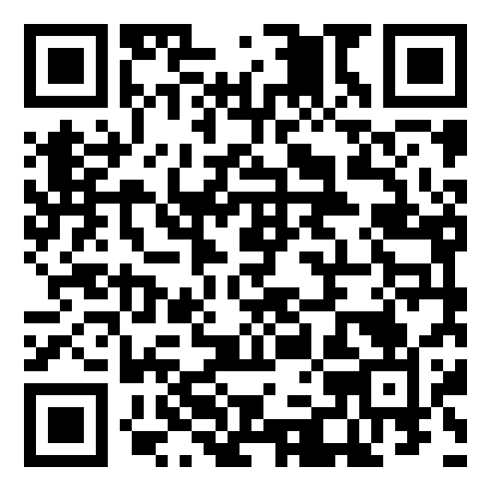 | LIVE DEPLOYMENT (VERCEL)  https://lumina-zeta-sand.vercel.app  SCAN → LIVE DEMO  Try the working 3D prototype instantly, no install  