**PIMPRI CHINCHWAD UNIVERSITY**

School of Engineering & Technology

**CEP REPORT**

**Project Title :** Paw Raksha - Smart Pet Health & Wellness Tracker

**Student Details:**

| **NAME** | **ROLL NO** | **ENROLLMENT NO** |
| --- | --- | --- |
| Sai Surve | 33 | SOE23201010325 |
| Tanishka Pol | 32 | SOE23201010164 |
| Divya Matkar | 31 | SOE23201010134 |
| Rutuja Pachangane | 30 | SOE23201010107 |

**Guide Name :** Dr Sagar Pande

**GitHub Repository :** <https://github.com/saicodes64/PawRaksha>

**TABLE OF CONTENT**

**ACKNOWLEDGEMENT** **3**

**ABSTRACT** **3**

**INTRODUCTION** **4**

**LITERATURE REVIEW** **5**

**DESIGN & IMPLEMENTATION** **9**

**RESULTS & DISCUSSION** **12**

**CONCLUSION & FUTURE SCOPE** **20**

**ADVANTAGES** **21**

**LIMITATIONS** **22**

**REFERENCES** **23**

**APPENDICES** **24**

**COST ANALYSIS** **25**

# 

# **ACKNOWLEDGEMENT**

We, the group building PawRaksha - Smart Pet Health & Wellness Tracker. A Web-Based Pet Care Management System, wish to extend deep appreciation to all people that helped and advised us for the length of this attempt.

First and foremost, we are indeed thankful to our mentor, Dr. Sagar Pande, for the indispensable guidance, continuous encouragement, as well as perceptive suggestions at each stage of this project. His mentorship had played some major role in the effort to shape all our ideas. We shaped them into a meaningful system that was also functional.

We would also like to extend our sincere thanks to Pimpri Chinchwad University for providing us with the opportunity as well as necessary resources for undertaking this project for the part of our curriculum. Our learning experience did stem from the support and setting.

Lastly, we do acknowledge the combined effort and dedication from our team members — Sai Surve, Tanishka Pol, Rutuja Pachangane, and Divya Matkar. Each person gave a large amount, and this project was made a success due to teamwork

# **ABSTRACT**

PawRaksha is a smart web-based platform designed to enhance the health and wellness of pets through an integrated ecosystem of features and IoT hardware support. This project enables users to monitor, manage, and track various aspects of pet care, such as vaccinations, feeding schedules, health history, and wellness reminders. A login system authenticates users before granting access to the main homepage. Key modules include a vaccination recommendation system based on AAHA (American Animal Hospital Association) and WSAVA (World Small Animal Veterinary Association) guidelines, a ‘Feed Now’ button linked with NodeMCU to control pet feeding remotely, and personalized pet care reminders delivered via email. The platform is built using HTML, CSS, JavaScript, and Node.js. Data-driven automation like bill generation and health history tracking further improves efficiency and accuracy. The goal of PawRaksha is to offer a centralized, smart, and scalable solution for pet owners to ensure their pet's well-being using modern web and IoT technologies.

# **INTRODUCTION**

* **Background:**

In recent years, pet ownership has witnessed a significant rise around the world. Pets have become more than just animals; they are considered important members of the family. However, as people become increasingly busy with work, studies, and social obligations, managing the day-to-day needs of pets can become a challenge. Many pet owners struggle to maintain consistent routines for feeding, grooming, vaccinations, and regular health check-ups.

Traditionally, these tasks are managed manually—through physical notebooks, calendar apps, or simply by memory—which can be unreliable. Missing a vaccination date or a feeding schedule could lead to negative health consequences for the pet. There is a clear need for a solution that helps streamline these responsibilities and ensures the well-being of pets.

* **Importance:**

This project addresses a practical and emotional need: helping pet owners provide better care for their animals through technology. By building an intelligent pet care management system, PawRaksha empowers users to track and manage all essential aspects of pet care from one centralized platform.

The platform helps:

* + - Automate repetitive tasks like setting feeding and vaccination reminders.
    - Digitally organize pet profiles, health records, and care routines.
    - Enhance the reliability of pet care by using email notifications and a database to keep everything structured and accessible.
    - This not only saves time but also improves the quality of life for both pets and their owners.
* **Objectives**:

To create a clever pet care site called PawRaksha.

For helping pet owners to oversee almost all aspects of animal tending digitally.

For certain pets to receive due attention about feeding, cleaning, and vaccinations.

* **Scope:**

The platform is designed for most domestic pet owners. It backs basic pet health needs and lets future growth into phone apps, IoT (like clever feeders), and merging with vet data banks.

# **LITERATURE REVIEW**

The development of PawRaksha – Smart Pet Health and Wellness Tracker – is inspired by a blend of existing veterinary guidelines, web development practices, and IoT hardware integration. Key references and technologies explored during the research and development phase include:

* Vaccination Guidelines: The vaccination scheduling system in PawRaksha is modeled on standardized guidelines provided by AAHA (American Animal Hospital Association) and WSAVA (World Small Animal Veterinary Association), which offer breed- and age-specific vaccination protocols. These guidelines ensure accuracy and reliability in the pet’s vaccination timeline.
* Web Technologies: JavaScript has been adopted for both frontend interactions and backend server-side scripting. HTML and CSS were employed for structuring and styling the user interface, ensuring a seamless and responsive user experience.
* Backend & Server: Node.js was chosen as the primary backend technology due to its asynchronous capabilities and efficiency in handling API requests, routing, and email integrations (e.g., Nodemailer). It also plays a crucial role in managing interactions with IoT components.
* IoT Communication Protocols: REST APIs were implemented to bridge communication between the PawRaksha web interface and the NodeMCU-based pet feeder. Though MQTT was considered, REST API was selected for its simplicity and stability in real-time HTTP request handling.
* Email Notification System: Nodemailer was integrated into the Node.js backend to enable real-time email delivery of pet care reminders, vaccination bills, and task confirmations. This proved to be more manageable and customizable than third-party APIs like SendGrid or Firebase for the project scope.
* Microcontroller & Actuation: NodeMCU ESP8266 was used as the core microcontroller to control the pet feeder. A servo motor (MG995) was employed to dispense food when a user clicks the “Feed Now” button on the website. The NodeMCU was connected to the internet via its onboard Wi-Fi module (ESP8266), enabling remote control over the feeder system.
* Existing Systems Comparison: Most existing pet care platforms provide either scheduling or health tracking features but lack a holistic, integrated approach combining medical reminders, IoT feeding systems, and real-time billing. PawRaksha attempts to bridge this gap by offering an all-in-one, customizable, and connected solution for modern pet parents.

**METHODOLOGY**

PawRaksha was developed using a modular web-based architecture with the following components:

* Frontend Technologies: HTML and CSS were used to design responsive, user-friendly interfaces for all key web pages including the login page, homepage, vaccination dashboard, pet profile, feed controller, billing, and reminder management.
* Backend & Scripting: JavaScript and Node.js were used to implement all server-side logic, route handling, and API interactions. Express.js was used for backend routing and file management, while Nodemailer was used for sending notifications and bills through email.
* User Authentication System: A secure login system was built to validate users before they could access the main homepage. This ensures that only registered users can access pet-specific data and functionalities.
* Vaccination Management: The vaccination recommendation module was created based on predefined AAHA (American Animal Hospital Association) and WSAVA (World Small Animal Veterinary Association) guidelines. Users input breed and age details, and the system suggests appropriate vaccines. Each vaccination entry also generates a bill that is sent via email.
* IoT Integration: A NodeMCU ESP8266 microcontroller was programmed and linked to a ‘Feed Now’ button available on the PawRaksha homepage. When clicked, it sends a request to the NodeMCU’s IP address, triggering a servo motor to dispense food from the connected feeder system. This allows users to feed their pets remotely from the web interface.
* Health Record Management: Each pet profile contains editable logs of health history including completed vaccinations, clinic visits, and notes from owners. This module ensures a centralized view of the pet’s medical timeline.
* Pet Care Reminders: Users can schedule daily, weekly, or monthly tasks such as walking, grooming, or feeding. After a task is completed, users receive a reminder confirmation via email, which is generated through Nodemailer integration in the backend.
* Email Integration: All reminders, vaccination bills, and completion alerts are sent to the registered email ID of the user. This ensures real-time notification and traceability of all activities performed through the system.

# 

# 

# **DESIGN & IMPLEMENTATION**

#### **System Architecture Diagram**

* 1. The PawRaksha system is composed of a web-based frontend interface and a backend server powered by Node.js, with an integrated IoT component for remote pet feeding. The user interacts with the login page, which authenticates credentials and redirects to the main dashboard. From the dashboard, users can access vaccination schedules, pet health records, reminders, and the "Feed Now" functionality. The backend also handles all data processing, vaccination logic, and email notifications. The IoT pet feeder is triggered by a request from the server to the NodeMCU using its IP address.

#### **Block Diagram / Circuit Diagram**

* 1. The hardware setup includes a NodeMCU ESP8266 microcontroller connected to a Servo Motor (MG995) to dispense food. A 5V power adapter powers the NodeMCU, and a 16x2 LCD display with I2C module is used for status display. The Wi-Fi module on NodeMCU ensures seamless communication with the web server. A simplified block diagram shows:
  2. Web App → Server (Node.js) → NodeMCU IP
  3. NodeMCU → Servo Motor (food dispensing)
  4. NodeMCU → LCD Module (status)
  5. User → Email Notification System
  6. 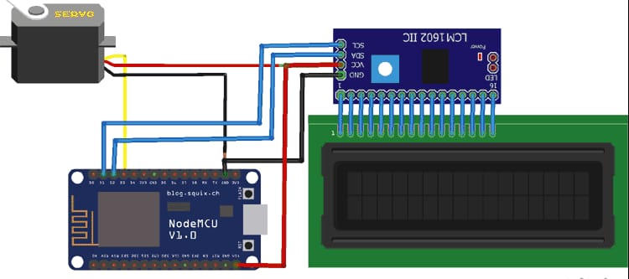

#### **Algorithm / Flowchart**

* 1. **Login Authentication**:
     1. User enters credentials
     2. Server verifies data
     3. On success, redirect to homepage
  2. **Vaccination Scheduler**:
     1. Select pet breed and age
     2. Use pre-defined guidelines
     3. Display schedule and due vaccines
  3. **Feed Now Function**:
     1. User clicks Feed Now
     2. Server sends request to NodeMCU IP
     3. NodeMCU triggers Servo Motor to dispense food
  4. **Reminder Notification**:
     1. User sets a pet care task (e.g., walk, grooming)
     2. Reminder is stored in backend
     3. Email sent on due date using Nodemailer
  5. **Bill Generation**:
     1. On vaccination completion, bill is auto-generated
     2. Bill sent via email in PDF/HTML format

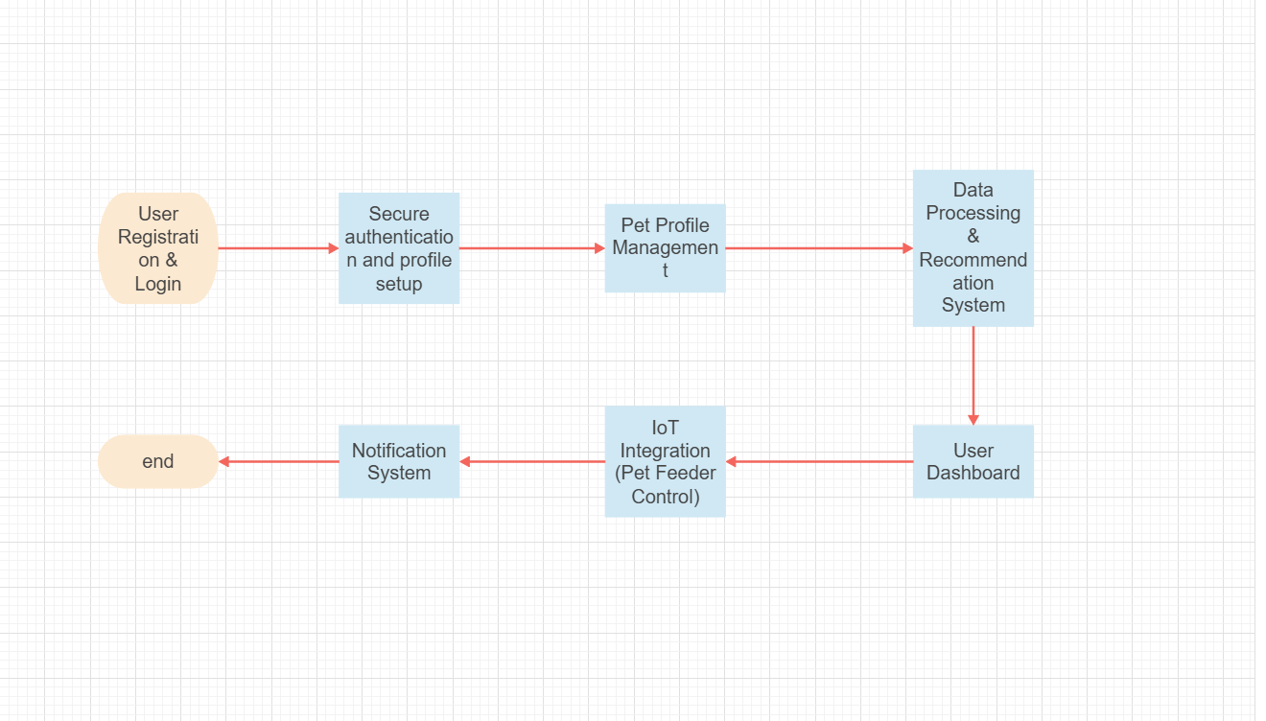

1. **Coding/Prototyping Details**
   1. Dashboard:
      1. The main page features four key modules: "Feed Your Pet", "Pet Care Reminders", "Vaccination Tracker", and "Health Records".
   2. Feed Your Pet Module:
      1. Allows users to remotely feed their pets.
      2. Functionality includes selecting the pet type, entering the pet’s name, and specifying the portion size.
      3. Includes a food inventory section with a progress bar for tracking remaining food.
   3. Pet Care Reminders Module:
      1. Enables users to set reminders for bathing, grooming, nail trimming, and other pet care activities.
      2. The UI shows existing reminders with details, but there are "undefined" reminder issues that need addressing.
   4. Vaccination Tracker Module:
      1. Generates vaccination bills with pet and owner information.
      2. Allows users to select the vaccine type, price, and vaccination date.
   5. Health Records Module:
      1. Provides a placeholder for maintaining a history of pet health records.
      2. Users can add new health records, but no records are stored yet.
2. **Testing Methods and Results:**
   1. Unit Testing: Each module was tested individually to ensure proper functionality.
   2. Integration Testing: The integration of modules was tested to ensure smooth data flow and interaction.
   3. Results: Key functionalities such as scheduling feeding, setting reminders, and generating vaccination bills were successfully implemented. UI issues and missing functionalities (e.g., storing health records) need to be addressed.

# **RESULTS & DISCUSSION**

1. **Observations and Analysis:**
   1. The PawRaksha system successfully implements the key features of remote pet feeding, setting pet care reminders, vaccination tracking, and providing a placeholder for health records.
   2. The "Feed Your Pet" module allows users to schedule feedings.
   3. The "Vaccination Tracker" module generates vaccination bills.
   4. The "Health Records" module provides a foundation for managing pet health data.
   5. However, the "Pet Care Reminders" module has UI issues with "undefined" reminders, indicating a need for debugging and data validation.
2. **Performance Evaluation:**
   1. Response Time:
      1. The system's response time for loading pages and executing functions is generally acceptable. However, further optimization may be needed to improve the user experience.
   2. Reliability:
      1. The reliability of the system is good, with key functionalities working as expected. However, issues with the reminders need to be addressed to improve reliability.
3. **Comparison :**
   1. In comparison to existing pet management systems, PawRaksha provides a unified platform for managing various aspects of pet care. While some existing solutions offer similar features, PawRaksha integrates them into a single, user-friendly interface.
   2. Many existing apps focus on specific areas, such as activity tracking or vet appointments, while PawRaksha aims to provide a more comprehensive solution.
   3. PawRaksha differentiates itself by focusing on remote feeding, vaccination tracking, and general health records in one integrated system.

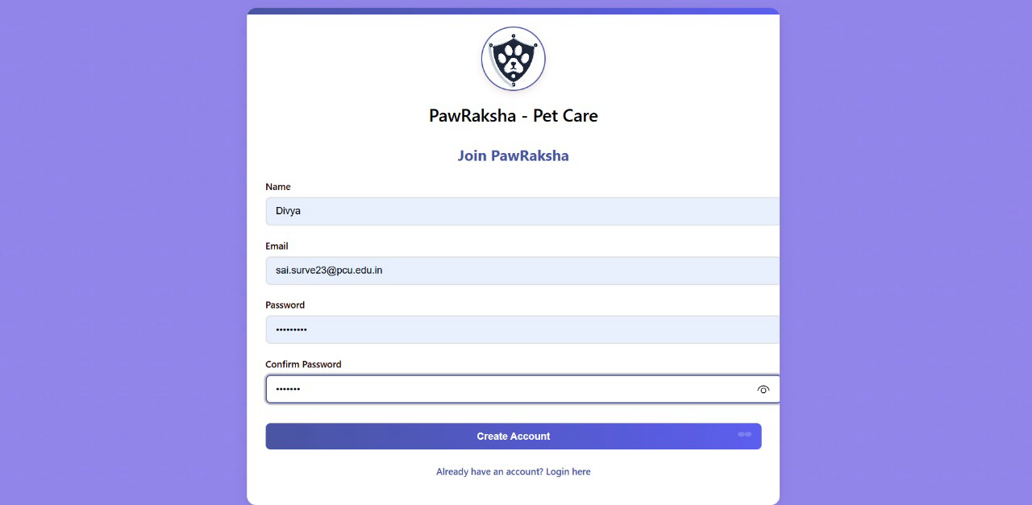Fig. Sign up Page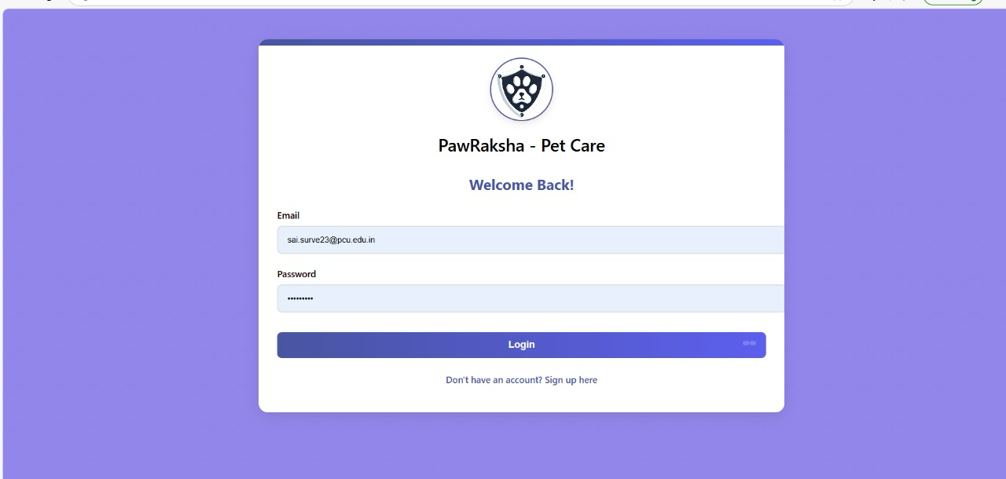Fig. Login Page

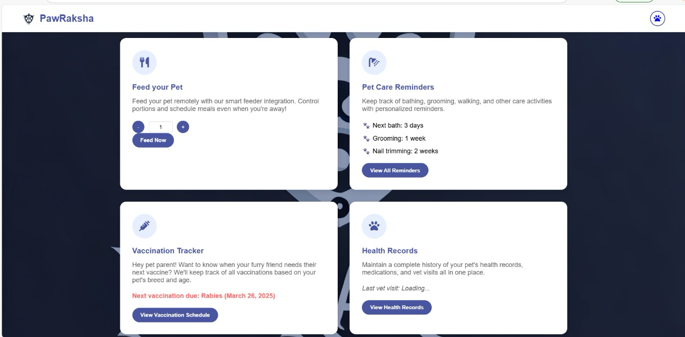Fig. Features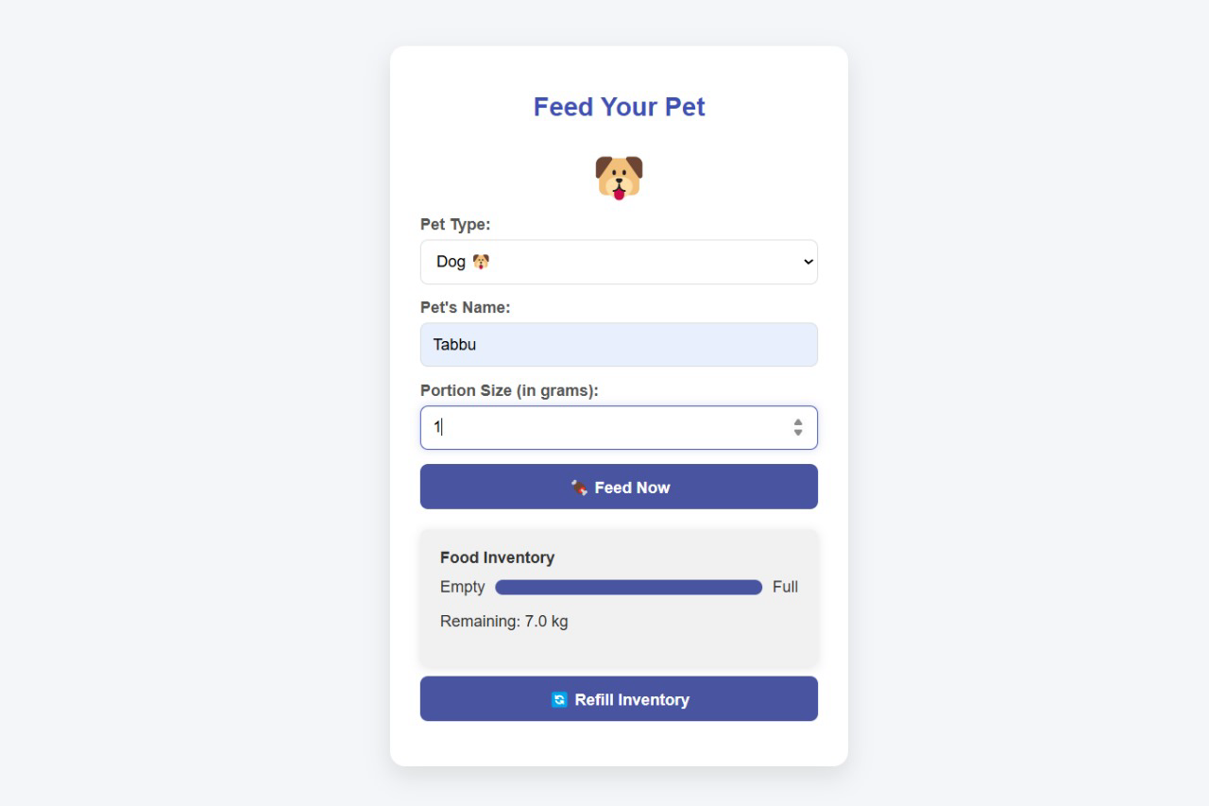Feature: Feed My Pet

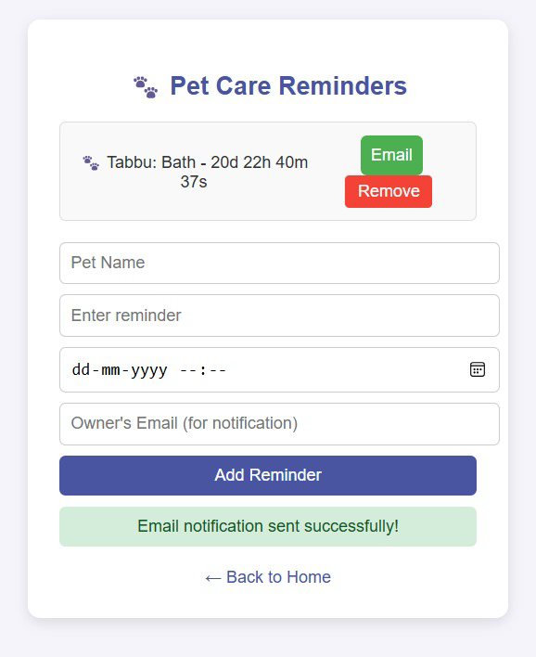

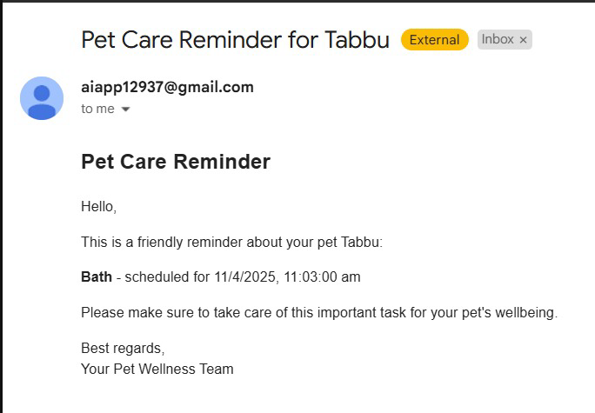

Fig: Email notification sent successfully

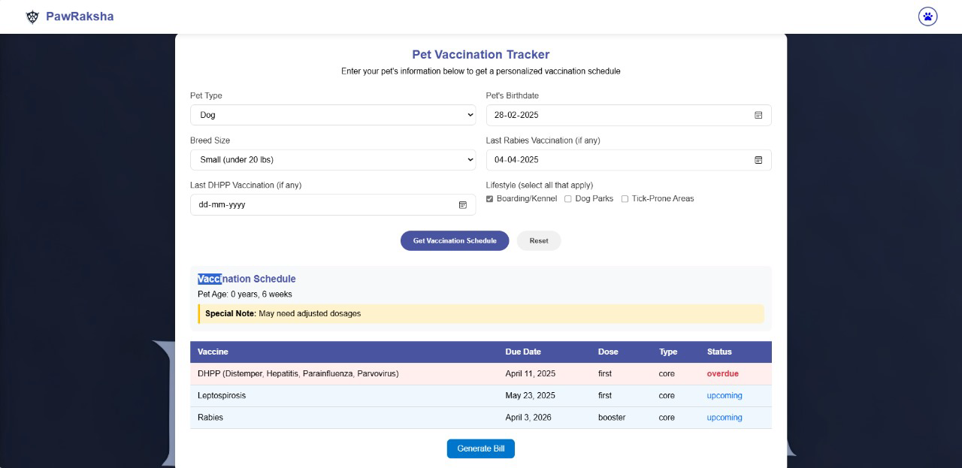

Feature: Vaccination Schedule

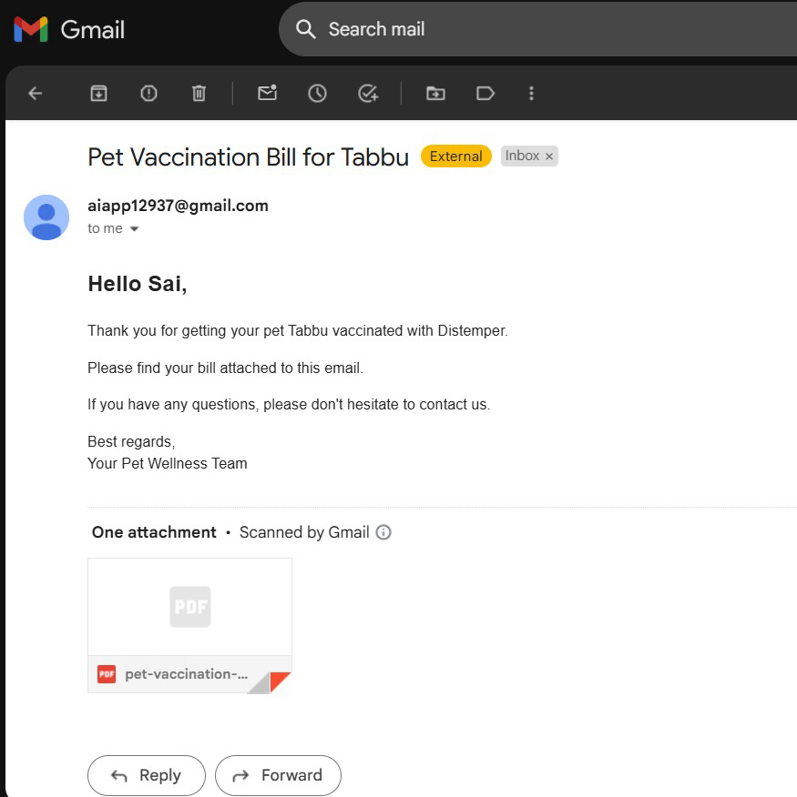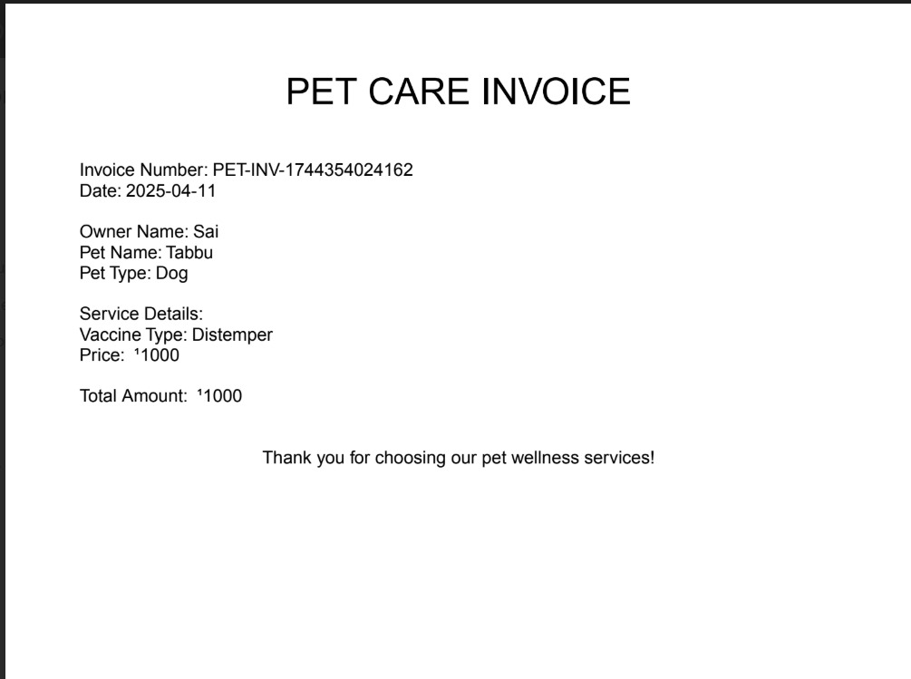

Fig. Bill Generation

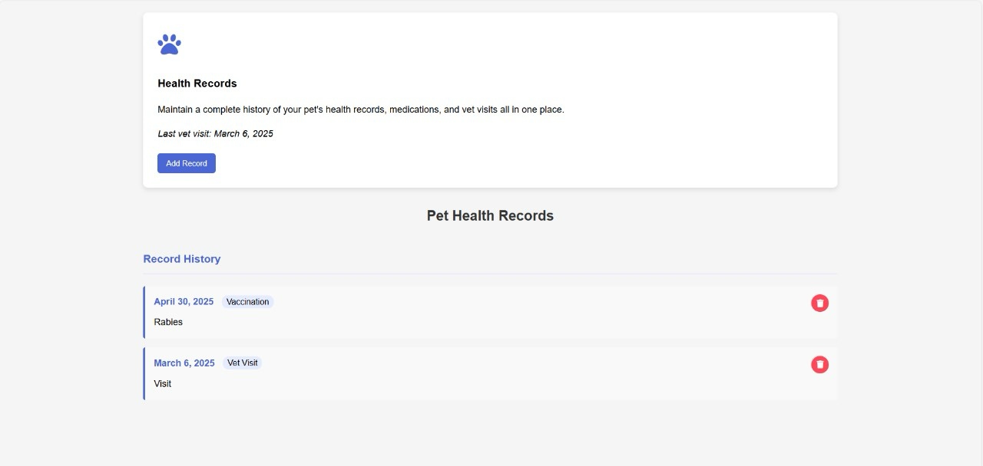

# Fig. Health Records

# 

# 

# 

# 

# 

# 

# **CONCLUSION & FUTURE SCOPE**

1. **Summary of Findings:**
   1. PawRaksha is a comprehensive web application designed to help pet owners manage their pets' health and wellness. It integrates key features such as remote pet feeding, reminders, vaccination tracking, and health records management.
2. **Limitations and Improvements:**
   1. **Limitations:**
      1. The "Pet Care Reminders" module displays "undefined" reminders, indicating a need for debugging and data validation.
      2. There is a lack of integration **with external devices.**
      3. **The Health Records section has limited functionality, lacking data storage.**
   2. **Possible Improvements:**
      1. Enhance the Health Records section by implementing data storage and retrieval.
      2. Integrate with wearable devices to track real-time health metrics.
      3. Develop a mobile application.
3. **Future Developments/Applications:**
   1. Mobile App Development: Develop a dedicated mobile application.
   2. Integration with Wearable Devices:
      1. Enable integration with smart collars and other wearable devices.
   3. Advanced Analytics and AI:
      1. Implement AI-driven insights.
   4. Telemedicine Integration:
      1. Integrate with telemedicine platforms for remote veterinary consultations.
   5. Gamification: Implement game-like elements to encourage consistent pet care and engagement.
   6. Community Features: Enable community forums for users to connect and share information.
   7. Expand Pet Types: Offer support for a wider range of pet types.

# 

# **ADVANTAGES**

1. Centralized Pet Health Monitoring  
    PawRaksha allows users to track vaccinations, health records, and wellness activities in a single platform.
2. IoT Integration for Automated Feeding  
    Users can remotely feed their pets using the "Feed Now" button integrated with the NodeMCU-based IoT feeder.
3. Personalized Vaccination Schedule  
    Vaccines are recommended based on breed and age using ASABA (American Small Animal Veterinary Association) guidelines.
4. Pet Care Reminders with Email Notifications  
    Automatic reminders are sent for feeding, walking, exercise, nail trimming, and more through email.
5. User Authentication for Data Security  
    The login system ensures secure access to personal pet profiles and related information.
6. Email-Delivered Bills and Records  
    Vaccination bills and reminders are generated and sent to the user’s email for easy tracking.

# **LIMITATIONS**

1. Limited to Internet-Connected Environments  
    The system relies heavily on internet connectivity for both web access and IoT feeder functionality.
2. Hardware Dependency for IoT Features  
    Feeding automation requires functional and correctly connected IoT hardware, which may need maintenance.
3. Platform Compatibility Constraints  
    Currently designed as a web application, it may lack optimization for mobile devices or tablets.
4. Email Reliability Issues  
    Some emails may land in spam/junk folders, leading to missed reminders or bills.
5. No AI-based Analysis  
    The system doesn’t currently include intelligent health tracking or recommendations beyond preset rules.

# 

# **REFERENCES**

1. AVMA (American Small Animal Veterinary Association) – Guidelines for Pet Vaccinations  
    <https://www.aaha.org/guidelines/canine-vaccination-guidelines/>
2. WSAVA (World Small Animal Veterinary Association) Vaccination Guidelines  
   <https://www.wsava.org/Guidelines/Vaccination-Guidelines>
3. Node.js Official Documentation  
   <https://nodejs.org/en/docs/>
4. JavaScript MDN Web Docs  
   <https://developer.mozilla.org/en-US/docs/Web/JavaScript>
5. HTML & CSS Tutorial – W3Schools  
   <https://www.w3schools.com/>
6. ESP8266 Wi-Fi Module Documentation  
   <https://www.espressif.com/en/products/socs/esp8266>
7. Adafruit IO – IoT Platform for Adafruit Devices  
   <https://io.adafruit.com/>
8. SendGrid Email API Documentation  
   <https://docs.sendgrid.com/>
9. Arduino UNO & Servo Motor Control  
   <https://www.arduino.cc/en/Guide/HomePage>
10. Claude Sonnet

<https://claude.com>

1. ChatGPT 4.0

<https://chatgpt.com>

1. Copyright Office

<https://copyright.gov.in/frmStatusGenUser.aspx>

# 

# **APPENDICES**

Appendix A: **Software Copyright Registration**

This project, PawRaksha – Smart Pet Health & Wellness Tracker, has been officially registered under the Indian Copyright Office. The copyright protects the software components, user interface, and backend logic developed during the course of this project. This registration was completed under the guidance of our mentor, Dr. Sagar Pande.

Diary Number: 7839/2025-CO/L

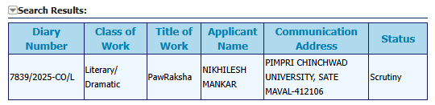

# 

# **COST ANALYSIS**

This section provides a breakdown of the hardware and software expenses involved in the PawRaksha – Smart Pet Health & Wellness Tracker project.

1. Hardware Costing  
   🧮 Total Hardware Cost: ₹1,250

| **Component** | **Quantity** | **Unit Price (₹)** | **Total Price (₹)** |
| --- | --- | --- | --- |
| NodeMCU ESP8266 | 1 | ₹300 | ₹300 |
| Servo Motor MG995 | 1 | ₹200 | ₹200 |
| 16×2 LCD with I2C Module | 1 | ₹250 | ₹250 |
| ULN2003 Motor Driver Module | 1 | ₹100 | ₹100 |
| Breadboard + Jumper Wires | 1 set | ₹150 | ₹150 |
| 5V Power Adapter + Extension | 1 | ₹150 | ₹150 |
| Miscellaneous (cables, glue, etc.) | — | ₹100 | ₹100 |

1. Software Costing

| **Software / Service** | **Cost (₹)** | **Remarks** |
| --- | --- | --- |
| Node.js, HTML, CSS, JavaScript | ₹0 | All are open-source and free for development |
| Adafruit IO | ₹0 | Free tier used for educational project |
| Email Notification System (e.g., Nodemailer or SMTP) | ₹0 | Free open-source tools |
| Software Copyright Registration (Diary No. 7839/2025-CO/L) | ₹500 | Registered under Indian Copyright Office |

🧮 Total Software Cost: ₹500

Grand Total (Hardware + Software): ₹1,750