Mehmet Said Yolcu – 2018400117
Mustafa Emre Erengül – 2020400336

1. Introduction

In this project we are deveoping an application that will compress the given image files and decompress them. During this process the original images and the results of the compressions will be shown to the user.

There are 2 different compression algorithms used in this project. One is the fractal compression. Other is the <sth here>.

2. Fractal Compression

Fractal compression is a lossy algorithm. When the fractal compression is performed, part of the data in the original image is lost for good.

a. Algorithm:

Fractal compression is a lossy image compression technique based on splitting an image into parts that can each be represented by fractals. The representation of an image by a fractal consists of finding an image transformation that, when applied iteratively to any initial image at the decoder, produces a sequence of images that converges to a fractal approximation of the original. Essentially the encoding of the image is then an encoding of the transformation for each part of the image parts, and a description of the decomposition into parts. Fractal compression is computationally intensive. It has the ability to render images that appear lossless at one extreme and on the other hand the compressed images can be very small in size while still producing recognizable images.

b. Explanation of Code:

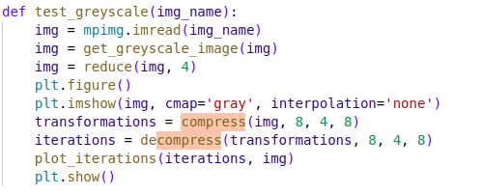
test_grayscale function performs the compression and decompression operations for the input image “img_name”. At the first line of the function, image is read into “img”. Then its greyscale version is obtained. Then its size is reduced by a factor of four for ease of operation. Then the compress function is called.

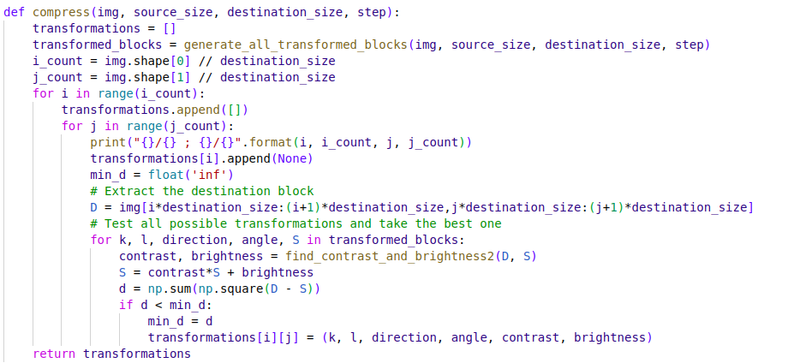

In the compress function, firstly via calling the generate_all_transformed_blocks, the imageis downsized and partiotioned into blocks and multiple version of these blocks are generated. There are 8 versions for each block, with direction either 1 or -1 and angles 0, 90, 180, 270. Later in the program these direction values will be used to flip the images and angle values will be used to rotate images.

After generate_all_transformed_blocks are called, the image is iterated through block by block. At each iteration of the original image, the transformed_blocks are also iterated. And the best fit for the original block is choosed from the transformed_blocks. The transformation from the original block to the transformed_block is recorded in a transformations list.

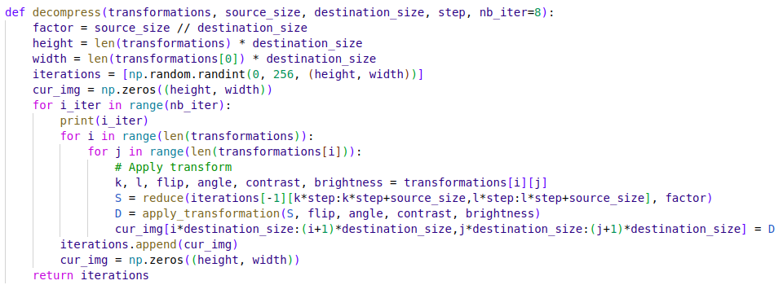
After the compress function is called in the test_greyscale function, decompress function is called. In this function an iterations 2-d list is created and filled with random numbers. Then in the for loop the corresponding transformation is applied to each block of randomly filled image 8 times. Each time the transformation is applied, the image gets closer to the original image. After the for loop the transformed blocks are returned.

After the decompress function is called in the test_greyscale function, the eight steps of the transformations are shown with a call to the plot_iterations function.

c. How to Run:

Open the project folder in the terminal window and run the following command for inverting an image to greyscale, then compressing and decompressing it:

python3 compression.py -f <file> -o fractal-grey -t png

or for gif extensioned images:

python3 compression.py -f <file> -o fractal-grey -t gif

To run the compression for colored png images

python3 compression.py -f <file> -o fractal-rgb -png

or for gif extensioned images:

python3 compression.py -f <file> -o fractal-rgb -gif

d. Results:

Original Image (Downsized by 4):

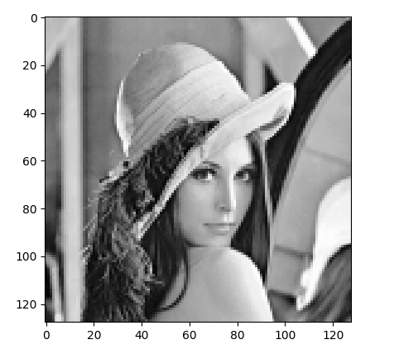

Transformation Steps:
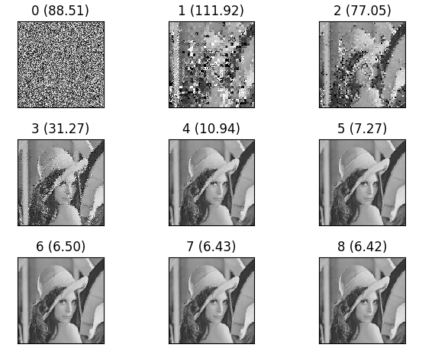

e. Reflection and Self-Feedback:

The fractal compression functionality of the program first compresses the input image. Then it decompresses it and shows each transformation in the decompression step. But it has certain drawbacks. For example it only works with the gif extensioned images. And the colored fractal compression option uses the functions written for the greyscale compression. This leads to some independency between color channels and reduces the quality of the final result of the decompression.

f. References:

- https://www.encyclopedia.com/computing/dictionaries-thesauruses-pictures-and-press-releases/fractal-image-compression

- https://github.com/said-yolcu/compression_py

