3. Run Length Encoding Compression

a. Algorithm:

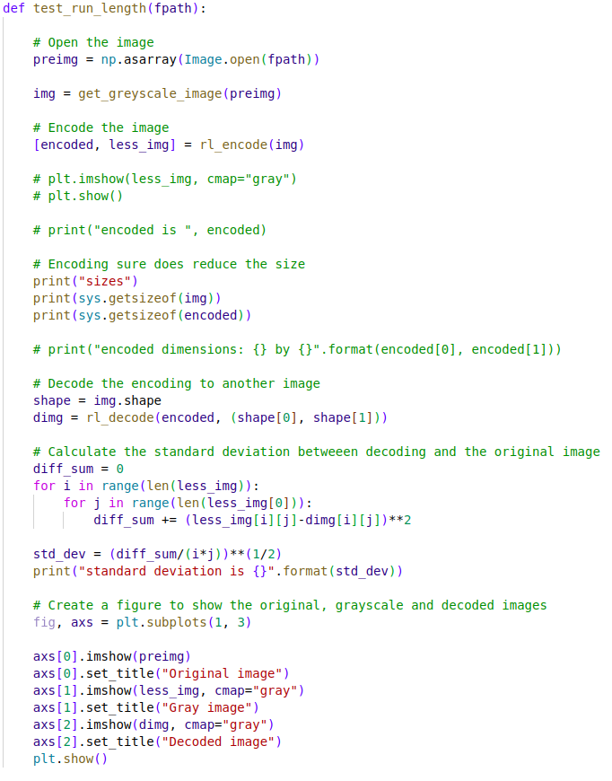
b. Explanation of Code:
test_run_length is the main central function for the run-length encoding compression functionality. It opens the image with the given file path fpath, greyscales it, then encodes the image. Then it decodes the encoding, prints the standard deviation and prints it to the console. Also displays the original and decoded images on a window.

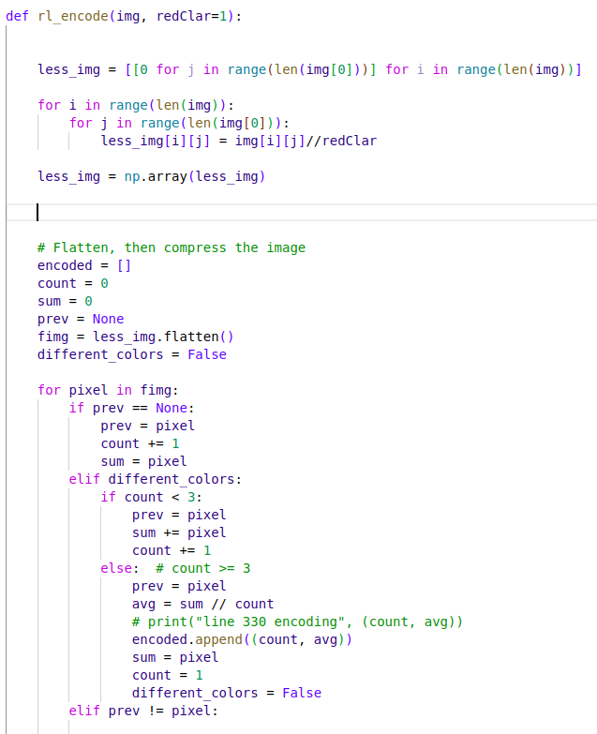

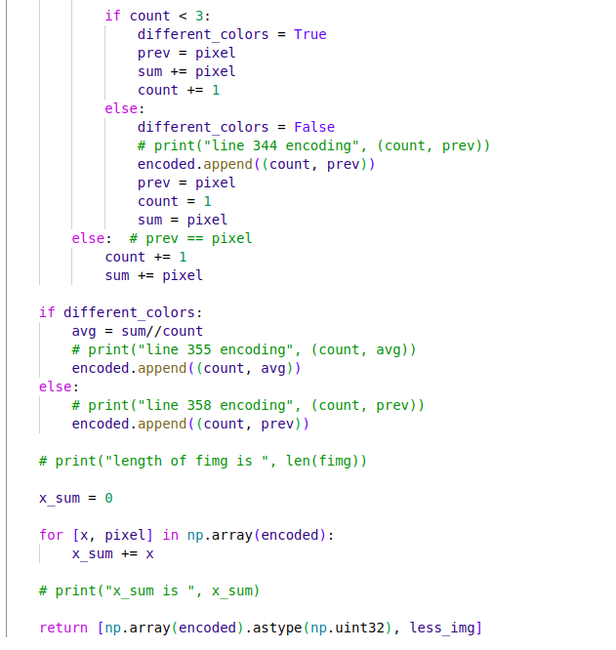

The rl_encode function, basically passes over each pixel and counts the same-values pixels. Then it creates a run-length encoding representation of the original image.

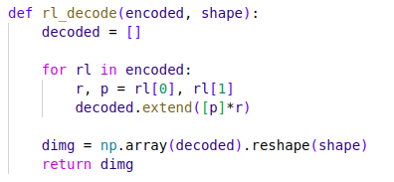

rl_decode function creates an image with the given encoding.

test_run_length_rgb function does the same things for each channel of the image instead of just a single one. This way it creates a colored image.

c. How to Run:

Open the project folder in the terminal window and run the following command for run-length encoding compression and decompression:

python3 compression.py -f <file> -o run-length-grey

or for colored implementation

python3 compression.py -f <file> -o run-length-rgb

There are no typed for this functionality. The run-length encoding compression is only tested on png extensioned files.

d. Results:

When the following command is run

python3 compression.py -f ./images/pacman_monster.png -o run-length-rgb

A window with the below images pops out

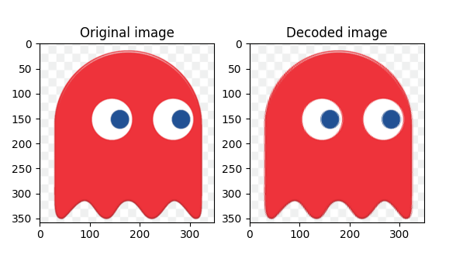
e. Reflection and Self-Feedback:

The run-length encoding algorithm is a much more simple algorithm than the fractal compression. It also reduces the size of the original image by a considerable amount. But there are some arbitrary parts of my code that I can change. For example , when going over the pixels and creating run-length encoding for them, I may encounter neighbouring pixels that have dissimilar values. Because of the nature of the algorithm, this may lead to compression of an image needing more storage place than the original image. But most of the time not all neighboring pixels are of different values and there are sufficient number of arrays of same-valued pixels that performing this compression is reasonable. But even in a normal case, to counteract the disadvantage caused by the too many dissimilar pixels close together, I decided to encode a list of pixels when it is at least a list of three. But the pixels in a list may have different values. Therefore when faced with such a situation, I take the average of the list. This leads to some data being lost.

f. References:

- https://q-viper.github.io/2021/05/24/coding-run-length-encoding-in-python/

