**Vault Dragon**

|  |  |
| --- | --- |
| **MachPayments** | **API Access use process third party payments and integrate with applications** |

This info for your testing purpose you can test as your wish

|  |  |  |
| --- | --- | --- |
| TITLE | DESCRIPTION | CALL/API |
| Create Payment | This API Call is use to create payment | [http://machpayments.m-tutr.com/api/app/create_payment?account_id=03894956&sid=f98b2fd2e5df6d0954&orderId=OR12345&Amount=20&ccNo=4000000000000002&expMonth=10&expYear=2019&Cvv=123&cardHolderName=smith&Address1=Abc Street Unit 90&Address2=Jons Town&City=Singapore&Country=SG&phoneNo=888888&pinCode=SG2233&txnMode=PG2CO](http://machpayments.m-tutr.com/api/app/create_payment?account_id=03894956&sid=f98b2fd2e5df6d0954&orderId=OR12345&Amount=20&ccNo=4000000000000002&expMonth=10&expYear=2019&Cvv=123&cardHolderName=smith&Address1=Abc%20Street%20Unit%2090&Address2=Jons%20Town&City=Singapore&Country=SG&phoneNo=888888&pinCode=SG2233&txnMode=PG2CO) |
| Transaction History (byDate) | This API Call is use to check transaction history followed by given dates | <http://machpayments.m-tutr.com/api/app/transactions?account_id=03894956&sid=f98b2fd2e5df6d0954&from_date=28-12-2016&to_date=30-12-2016> |
| Transaction Details (byId) | This API Call is use to check transaction details by transactionId | <http://machpayments.m-tutr.com/api/app/transaction_info?account_id=03894956&sid=f98b2fd2e5df6d0954&transaction_id=222222> |
| Account Details | This API is use to check session id (SId) active/inactive status | <http://machpayments.m-tutr.com/api/app/account_info?account_id=03894956&sid=f98b2fd2e5df6d0954> |
| Test Transaction | This API Call is use to create test payments | [http://machpayments.m-tutr.com/api/app/test_payment?account_id=03894956&sid=f98b2fd2e5df6d0954&orderId=OR12345&Amount=20&ccNo=4000000000000002&expMonth=10&expYear=2019&Cvv=123&cardHolderName=smith&Address1=Abc Street Unit 90&Address2=Jons Town&City=Singapore&Country=SG&phoneNo=888888&pinCode=SG2233&txnMode=PG2CO](http://machpayments.m-tutr.com/api/app/test_payment?account_id=03894956&sid=f98b2fd2e5df6d0954&orderId=OR12345&Amount=20&ccNo=4000000000000002&expMonth=10&expYear=2019&Cvv=123&cardHolderName=smith&Address1=Abc%20Street%20Unit%2090&Address2=Jons%20Town&City=Singapore&Country=SG&phoneNo=888888&pinCode=SG2233&txnMode=PG2CO) |

**Note :** e.g. orderId=OR12345 should be dynamic must not match with previous

**API Parameters (For HTML Form)**

Request attributes submit as form (post method),make sure you not missing the following attribute/values.

|  |  |  |
| --- | --- | --- |
| ATTRIBUTE | DESCRIPTION | VALUE (E.G) |
| sid | Your agent sid value | 8fa8d01ffb9b7eeab7 |
| account_id | Your agent account_id value | 72163809 |
| c_holder_name | The name appears on your credit/debit card | Gil Christ |
| pb_address1 | Your card address line1 | 123 Main Street |
| pb_address2 | Your card address line2 | Townsville |
| pb_city | Your card city name | Kuala Lumpur |
| pb_country | The country code in 2-3 charaters length | MY |
| pb_phone | Your contact number without country code | 888888888 |
| pb_pincode | Your pincode | KL8892 |
| gt_mode | This value you can see from your payment gateway account, it is nothing but which payment gateway been assigned to your account. | PG2CO (*) |
| ccNo | Your credit/debit card number | 4000000000000002 |
| expMonth | Your credit/debit card expire month in numeric value | 09 |
| expYear | Your credit/debit card expire year in numeric value | 2018 |
| cvv | Your credit/debit 3 digits code appears on card backside | 123 |
| amount | How much amount your processing | 50 |
| c2o_wallet_order | Custom order number for your reference | ITM001 (*) |

**HTML Form Based Integration (Sample Screen)**

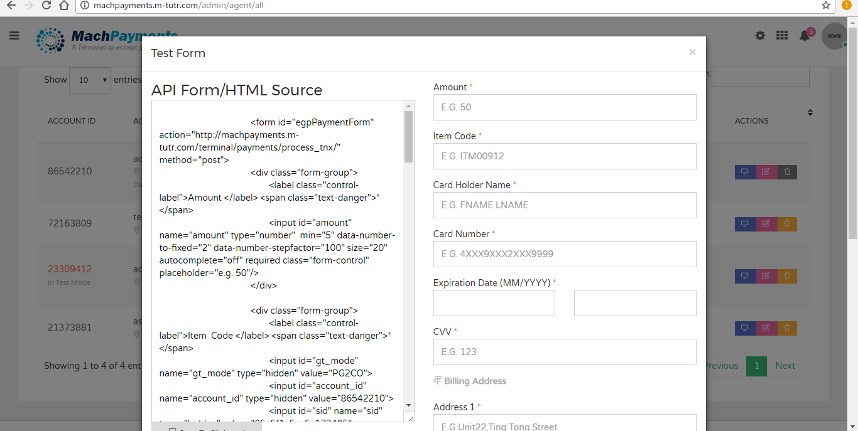

**To monitor API Calls**

|  |  |
| --- | --- |
| URL | Credentials |
| http://machpayments.m-tutr.com/agent/login | Agent ID : 03894956  Password : hehenopassword |