 | SAIDA.D   Sr. Application Programmer/Lead  9+ Yrs of Hands on Experience | Email : softpro.saida@gmail.com  Phone : +673-8851269  Bandar Seri Begawan, Brunei Darussalam

Earn challenging roles in the world to establish my own personal brand in my work, to show the possibilities that can be achieved from the high level of skill that I bring to my work. I have been exposed to experiences in the industry with high end programming capabilities in web app development, mobile application development, application architecture design (SDLC/Agile methodologies), in rich internet applications for the past 9 years.
   | Career Objective
   | Education
  Master of Computer Applications
  Vinayaka Missions University , Grade A+ (2005-2008)
  Bachelors of Computer Science
  Acharya Nagarjuna University (2002-2005)

 | Technology Skills

Php/Mysql |  | Expertise  In Product Development  (As Independent)  Featured Products
Angular Js / NodeJs
Ionic 2 / Typescript (Visual Studio)
HTML5/CSS3, Adobe Tools
Bootstrap /SaaS
Codeigniter/Laravel
Joomla/Opencart
NoSQL/Firebase
Javascript/Jquery/NodeJs/Json & Ajax
AWS, CDN, Could Hosting, Shared Hosting, Dedicated Hosting, Domain DNS,CPanel, WHMCS,Linux Admin
RestAPI, API Development, Auth0,JWT
SVN, Github
Payment Gateway, SMS Gateway , Other third party Integration

   | Work Experience
  Mach Telecommunications Systems Sdn.Bhd | As a Sr.Application Programmer/Lead  (Nov 2015 to Present)
  Alif Technologies Sdn.Bhd | Sr.Application Programmer/Analyst  (Sep 2011 to Sep 2015)
  Axon Networks Solutions  Pvt.Ltd | Sr.Software Engineer  (Mar 2011 to Sep 2011)
  Iris Idea Technologies Pvt.Ltd | Software Engineer  (Jun 2010 to Mar 2011)
  Solutions Infini India Pvt.Ltd | Software Engineer  (July 2009 to Jun 2010)
  Adodis Technologies Pvt.Ltd | Jr.Software Engineer  (Jun2008 to July 2009)
   | Current Roles & Responsibilities
  - Analysis & Application Architecture Design
  - Preparing Database Design / ER Diagrams
  - Applying SDLC & Agile methodology depends on client and use cases
  - Application Development (Web/Mobile)
  - Finalizing UI /Template Design (Web/Mobile)
  - Assign & monitoring team tasks
  - Communicating with client meetings
  - Linux Administrating & Monitoring Internal/Cloud Servers, Domain DNS
  - Monitor and commit tasks to project repository
  - Continuing product development (independent) besides monitoring team tasks
  - Documenting/ report submission to project department
  - Take full responsibility until project kickoff
  - Besides involved in application support

 | Portfolio (Some of projects)

S.No | Project | Client | Status /URL
1 | Flash Text (SMS Marketing) | Product (Mach Telecommunications)
  Online | 
2 | MachPayments (Payment Gateway Terminal Provider) | Product (Mach Telecommunications)
  Going
  Going
3 | E-Tendering Online | Petroleum BRUNEI (Internal/ Special access)
  Online
4 | BNNIC (Brunei Darussalam Network Information Centre) | AITI (Authority for Info-communications Technology Industry of Brunei Darussalam)
  Online
5 | Perpustakaan Islam Brunei Darussalam (IDLS Portal) | State Mufti - Prime Minister Office  Govt.of Brunei Darussalam
  Online
6 | DCMS – Digital Online System | State Mufti - Prime Minister Office  Govt.of Brunei Darussalam
  Online
7 | e-Kiosk System ( Touch Screen ) | Ministry Of Religious Affairs  Govt.of Brunei Darussalam
  Desktop
8 | SME Management System | Department of Agriculture & Agri food  Govt.of Brunei Darussalam
  Intranet
9 | eZ Support System (HelpDesk) | Alif Technologies (Clients/Staff Use)
  Online
10 | eZ HRMS (LMS) | Alif Technologies (Staff Use)
  Online
11 | MOF- Official Web Application | Ministry Of Finance  Govt. of Brunei Darussalam
  Online
12 | DCMS (Digital Collections Management System) | University Brunei Darussalam (UBD)
  Online
  Online
13 | Koha (Library Management System) | Institut Tahfiz Al-Qur'an Sultan  Haji Hassanal Bolkiah (TAHFIZ)  Brunei Darussalam
  Intranet
14 | mTutr Online Store | Mach Telecommunications (E-Store)
  Online
15 | Duners Corporate | Duners Sdn.Bhd (Brunei Darussalam)
  Online
16 | Hoysala Projects | Hoysala Projects (India)
  Online
17 | mTutr Corporate | Mach Telecommunications Product
  Online
18 | Forevision Corporate | Forevision India
  Online

Technology Trending
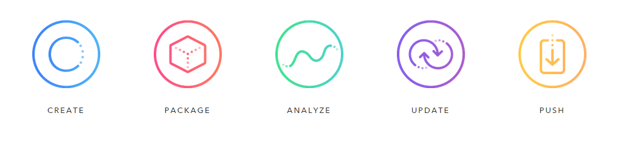
Slogan
Only technology can change your life style, so chase it and prove it.

