SIH 2020 Project Idea Proposal

Organization name – CDK Global

Problem Statement - Portal for Farmers to sell the produce at a better rate

Problem Statement no. - RA27

Team Name – NOVUS
Team Leader Name – Ajitesh Panda

College Code -

PROBLEM STATEMENT DESCRIPTION

Portal for Farmers to sell the produce at a better rate

• Problem statement in Description
o System that provides farmers an interface to sell their produce, and connect with the buyers all over India
o Simple interface that works on mobile, SMS to upload produce details and respond via phone and SMS (taking care of digital divide)
o Interface for anyone to buy the produce/vegetable – initially visit the place and buy or have courier service integrated to deliver the vegetables
o Farmers can get a better price for their produce, no additional cost spent in marketing and delivery of goods , however they can choose to charge more by delivering the items themselves

• Purpose of this analysis and who will benefit
o Farmers, Restaurant owners, Buyers , Courier Companies, Delivery Agencies, Vegetable Vendors

• How does it help the nation
o Better rates for the vegetables, Make the Farmers live with pride and make additional income

• Practical and reasons why this idea could be a challenge
o Brokers , Govt rules
o Overall profitability in the deal for the buyer to purchase directly from farm , excluding transportation

• How does this help CDK : What’s in it for us
o No Direct link

• Technology that can be used as a platform for connecting car buyer to Seller Domain Bucket
o Agriculture
o E-Commerce
o Payment

• Technology Bucket
o Integration across systems – Integration platform across systems with security model for data extraction
o SMS and Mobile Computing
o Analytics & Data Science (if possible) - Bigdata/Hadoop, AI / ML
o Data Aggregation
o Visualization

PROPOSED SOLUTION

Indian farmers continue to face the problem of unfair pricing. This is mainly due to presence of intermediate traders and brokers who try to maximise their profits, leaving the farmers with low income. Even after implementation of numerous schemes (like MSP) by the Government of India, the intermediates do not let the benefits reach the farmers by means of manipulation. Thus they face financial distress and are rarely benefitted from just the schemes on selling price of farm products in the market.

We bring forward a solution to this problem with the help of our application Kartvest, which provides a platform inviting all the farmers of our country to come and sell their produce directly to the consumers. [some more description]

The key benefits that Kartvest will serve are:

1. Direct connection of Farmers to Buyers – This platform will provide a one-to-one connection between farmers and the consumers and vendors of the farm products. It will help the farmers choose a fair price for themselves whose complete profit can be taken by them.

2. Eradication of intermediates – Through the establishment of a direct connection between the farmer and the buyer, the role of intermediate traders and brokers will no longer be required, thus saving farmers from manipulation in pricing.

3. Freedom of choice of delivery – The buyer of the produce can choose whether to have the items delivered or they can visit and get them in person, thus ensuring customer satisfaction.

4. Consumer affordability – With the removal of intermediates, the chain of profitmakers and manipulators will vanish, keeping the farm products pricing to minimum. Hence, the buyers will also be benefitted by the reduced marketing price of crops and other farm products. This will provide food affordability to consumers with lower income as well.

5. Direct benefit of Government Schemes – Having the intermediate traders removed, farmers will be able to take direct benefit from government schemes on market price, as they will directly be receiving the market price as their income.

6. Time Saving – Selling the products by means of intermediates also consumes a lot of time along with money. Using the platform of Kartvest, farmers can save their time and consumers can be provided with fresher farm products.

7. Easy price comparison – With the of public product tiles and average price in past purchases, both buyers and farmers can get the most out of the deals by the farmers placing suitable prices and buyers choosing the best deal. This will keep any Pricing Monopoly in check.

8. Hindi Translation availability -

-sms
-

PROTOTYPE DESCRIPTION

We have developed the We have made extensive use of technology available today and have tried to make things easier for the farmers of India as well as the buyers. We have taken care of the cost and convinience involved to ensure successful implementation of our prototype.

1. Registration/Sign-up.
We will validate every registration using email. The app will assign a UID (Unique ID Number) to all the registered clients. An entire database of all the registered clients and their details will be maintained in full privacy in the back-end. After successful registration process user can easily login to the app any time using their username and password.

2. Dashboard - Here all the farmer and buyer clients can see the posts made by various farmers about their latest farm products. These posts will be visible in form of tiles with available filters for convinience in searching an item.

3. Product Post – The famer can mention various details about the product like its availability in stock, the date of production / best before and other specifications (like variety / breed of crop, method used to sow, etc.) in the description along with its name and offered price. This will allow the farmer to present the best they have to offer and the consumer a basis to choose from various posts from different farmers on a single product.

4. Average price in Last 5 Purchases - (proposed)

5. Choice of Delivery – (proposed) The buyers will by default be displayed a price for direct purchase from the farm. However, they can choose to have the product delivered instead of buying in-person or using some delivery agency themselves. They can provide their address details and contact the farmer to have the product delivered, where farmer may offer a transport charge prior to the deal.

6. Farm / Godown Location Visibility – For in-person purchases, the Farm / Godown location provided by the farmer will be visible with the product information.

7. Integration of Delivery Agencies – (proposed) The app will have a page for different registered delivering agencies and courier services. Both the buyers and the farmers can choose to use them for the delivery of products.

8. Notification on low purchase - (proposed)

9. Feedback systems – After complete procedure of purchase, both the farmer and the buyer will be asked to provide feedback against the service. Farmers will have to rate the user and the buyer will rate the farmer and product (separately).

10.

The working of our solution prototype is summed up in the following map diagram :

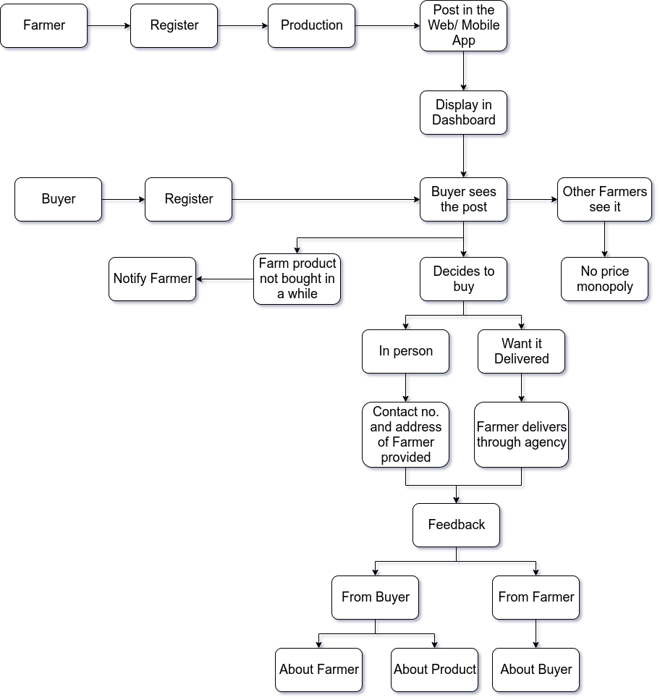

TECHNOLOGY STACK

This section lists all the technologies we have used in developing Kartvest as well as those that we plan to use in its further development.

FRONT-END:

- HTML , CSS
- JAVASCRIPT
- BOOTSTRAP
- JQUERY
- PARTICLE.js

BACK-END:

- NODE.js (Web)
- EXPRESS.Jjs (Web)
- JAVA (Android Development)
- GPS and GOOGLE MAPS API
- CLOUD MESSAGING
- FIREBASE:
  - Authentication
  - Storage
  - Realtime database
  - ML Kit
  - Hosting

IMAGE PROCESSING:

- To predict the quality of available product for better customer experience from uploaded images.
- Improvise seller-technology and seller-customer interaction by recommending the universal names of the available product, since we live in India with a vast diversity in languages.
- Tools and Packages:
  - Tensorflow
  - CNN(Convolutional Neural Networks)
  - SVM(Support Vector Machines)
  - Pandas, Numpy

FIREBASE:

- Real-time Database:
It has been used as a real-time data storage cloud application to integrate the web and mobile application data.

- Firebase Storage:

We have used Firebase Storage to secure file uploads and downloads for our app, regardless of network quality, to be used for storing images, audio, video, or other user-generated content.

- Firebase Auth:
We have used it for user registration and authentication from the real time database. Users can use e-mail, password or Google credentials to log-in.

- ML Kit:

We will be using this for cloud implementation of ML model used in the app (for user convinience).

- Cloud Messaging:

It will be used in OTP and messaging services and notifications through cloud for better User Experience.

- Crashlytics:

We will be using Crashlytics for creating detailed reports of the errors in the app. It will group errors into clusters of similar stack traces and triaged by the severity of impact on app users.

NODE.JS:

It is a platform we have used for building fast and scalable network. The backend of our web-app is entirely implemented (and integrated with Firebase) in Node.js. We have also used Express.js, which is a Framework for Node.js and increases feasibility for backend development.

GOOGLE LOCATION API:

It enables location services like real-time location fetching and location update.
It has been used to give the buyer the location of the farmer.

BOOTSTRAP:

For making responsive and attractive layout for the web-app. jQuery and CSS CDNs are used for added features.

USE CASES

Kartvest will come useful in the following situations :

- For purchasing household grain stock of wheat, rice etc.
- To purchase daily stock by vegetable vendors, fruit vendors, etc.
- For raw material purachasing by farm dependent industries of food product manufacturing.

DEPENDENCIES AND SHOWSTOPPER

OUR VISION

Not only will this platform benefit the farmers in our country, but also various delivery agencies and other farm – products dependent agencies.

Benefits:
Pricing, proper reaching effects of government schemes, Regular profit and ease of lifestyle
ease of delivery of product, Easy affordability, vendors and consumers

Solution and aim– remove brokers and intermediates,
Benefit if MSP to farmers
Regular profit and ease of lifestyle

ease of delivery of product
vendors and consumers

- app features
- Registeration, menu features
- crop/farm product description
- choice in delivery
- user ratings
- date of production and duration of crop availability
- farmer contact
-hindi

- farm/godown location
- delivery agency/ courier service integration
- crop recommendation system (?)

- working flowchart

- crop generic naming
-

