**1.1 Background**

This section provides an in-depth understanding of the broader context within which this study resides. It lays the groundwork for comprehending the evolutionary aspects of asset allocation strategies, the advent and significance of Exchange-Traded Funds (ETFs), and the nuanced applications of Bayesian Hierarchical Models in finance.

1.1.1 Evolution of Asset Allocation

The theory and practice of asset allocation have undergone significant metamorphoses over the last few decades. Traditional models of asset allocation emerged from the capital market theories in the 1950s, notably marked by Harry Markowitz's pioneering work on Modern Portfolio Theory (MPT). The MPT postulated that diversification could allow investors to achieve a given level of expected return for a lower level of risk. However, the linear assumptions of MPT soon faced criticisms due to its inadequacy in capturing the complexities of financial markets.

In response, multi-factor models such as the Fama-French three-factor model gained prominence. These models included additional variables like market capitalization and value factors to provide a more comprehensive understanding of asset behavior. Still, as financial instruments became more complex and global markets more interconnected, even multi-factor models showed limitations in capturing asset dynamics, especially during extreme market conditions. This propelled researchers to explore computational methods, heuristic approaches, and more advanced mathematical formulations like stochastic calculus and partial differential equations to achieve optimal asset allocation.

1.1.2 Emergence of ETFs

Exchange-Traded Funds (ETFs) have emerged as a revolutionary financial instrument that has democratized investment in diversified assets. Originating in the 1990s, ETFs offered an amalgamation of the best characteristics of mutual funds and individual stocks. They offered a basket of assets, like a mutual fund, yet were tradable on stock exchanges, which provided liquidity and real-time pricing.

Today, the scope of ETFs has broadened to include not just equities but also bonds, commodities, and even complex financial derivatives. Their low cost, high liquidity, and tax efficiency make them ideal instruments for both retail and institutional investors. They have also enabled the application of sophisticated asset allocation strategies, earlier available only to large institutional investors, to smaller portfolios. The malleability of ETFs as an investment vehicle, along with their inherent benefits, makes them particularly relevant in the context of modern-day asset allocation, especially when employing advanced statistical methods.

1.1.3 Bayesian Hierarchical Models in Finance

Over the last two decades, Bayesian Hierarchical Models have carved a niche in the realm of financial econometrics. These models emanate from Bayesian probability theory, offering a mathematical framework that accounts for uncertainty through probability distributions. Unlike traditional methods, Bayesian models update these distributions as new data becomes available, reflecting a more dynamic and adaptive approach.

Hierarchical Bayesian Models introduce layers of complexity into Bayesian frameworks by allowing parameters to vary at different levels of hierarchy. In the financial context, this can mean that asset returns, volatilities, and other variables can be modeled with nested dependencies. Such an approach becomes indispensable when dealing with complex and layered structures commonly encountered in financial markets, like multi-asset ETFs.

Bayesian Hierarchical Models also seamlessly incorporate both historical data and expert opinions, thereby providing more robust and adaptable asset allocation strategies. They have been employed in various subfields within finance, such as risk management, asset pricing, and portfolio optimization, and have shown promising results in terms of both risk-adjusted returns and stability.

**1.2 Objectives**

The overall aim of this study is to explore, analyse, and optimize asset allocation strategies in cross-sector Exchange Traded Funds (ETFs) through a Bayesian hierarchical model. The specific objectives are segmented into research and operational objectives, as outlined below.

1.2.1 Research Objectives

1. **To Examine the Theoretical Framework of Asset Allocation:** To conduct an exhaustive review of literature ranging from the traditional Markowitz mean-variance optimization to the more advanced Bayesian hierarchical models, with a focus on identifying their applicability and limitations in modern finance.
2. **To Investigate the Performance of Cross-Sector ETFs:** To empirically evaluate the performance of a selection of Indian ETFs across various sectors, utilizing historical data to establish a benchmark.
3. **To Develop a Hierarchical Bayesian Model for Asset Allocation:** To engineer a multi-level Bayesian model that allows for a more nuanced understanding of risk and return, both at the individual asset level and the portfolio level, thereby extending the existing models.
4. **To Integrate Machine Learning Techniques:** To incorporate machine learning algorithms for feature extraction and model optimization, thereby making the Bayesian model adaptive to new data.
5. **To Perform Comparative Analysis:** To compare the Bayesian hierarchical model's asset allocation recommendations with those generated by existing models, such as the Black-Litterman model, under similar conditions.
6. **To Assess the Model's Scalability and Generalizability:** To evaluate whether the Bayesian model can be adapted for other asset classes or global ETF markets.

1.2.2 Operational Objectives

1. **Data Procurement:** To acquire high-quality financial data for selected Indian ETFs from verified sources like national stock exchanges, financial databases, and direct ETF providers.
2. **Data Pre-processing:** To clean, transform, and normalize the collected data in preparation for advanced analytics. This includes handling missing values, outliers, and ensuring data integrity.
3. **Tool Selection:** To choose appropriate statistical software and programming languages, primarily Python and its libraries, for data analysis, modeling, and visualization.
4. **Model Construction:** To implement the Bayesian hierarchical model using Markov Chain Monte Carlo (MCMC) methods and other Bayesian inference techniques.
5. **Model Validation:** To utilize posterior predictive checks, cross-validation methods, and other diagnostic tests to validate the model’s predictions.
6. **Risk Assessment:** To use financial metrics such as the Sharpe Ratio, Maximum Drawdown, Value at Risk (VaR), and Conditional Value at Risk (CVaR) for evaluating the risk-adjusted performance of the optimized portfolio.
7. **Documentation and Reporting:** To meticulously document the research methodologies, statistical analyses, and findings in a format suitable for academic scrutiny, corporate assessment, and potential global publication.
8. **Ethical Compliance:** To adhere to ethical standards in data collection, model construction, and financial recommendations, ensuring the responsible conduct of research.

By fulfilling these research and operational objectives, this study aims to contribute significantly to both the academic literature and practical methodologies in the realm of asset allocation and portfolio management.

**1.3 Research Questions**

The following research questions have been carefully devised to align with the overarching aim of this research, which is to investigate and quantify the effectiveness of a Bayesian Hierarchical approach in optimizing asset allocation strategies across cross-sector Exchange-Traded Funds (ETFs). The questions have been subdivided into primary and secondary categories to offer a nuanced understanding of the specific avenues this research explores.

1.3.1 Primary Questions

1. **How do Bayesian Hierarchical Models perform in terms of portfolio optimization when compared to traditional asset allocation methods like the Markowitz's mean-variance optimization?**
   * This question seeks to investigate the core efficacy of Bayesian Hierarchical Models in comparison to established traditional methods, providing an evaluative measure for its utilization in asset allocation.
2. **What is the impact of applying Bayesian Hierarchical Models on portfolio risk metrics such as Value at Risk (VaR) and Conditional Value at Risk (CVaR)?**
   * Risk management is a vital component of asset allocation. This question aims to quantify how Bayesian Hierarchical Models influence traditional risk metrics.
3. **How does the Black-Litterman model integrate with Bayesian Hierarchical approaches in multi-asset portfolios, specifically ETFs?**
   * Given that both Bayesian Hierarchical Models and Black-Litterman models have their unique strengths, this question intends to explore their integration, aiming for a more robust asset allocation strategy.

1.3.2 Secondary Questions

1. **How sensitive are Bayesian Hierarchical Models to changes in market conditions?**
   * This question aims to understand the robustness and adaptability of Bayesian Hierarchical Models under varying market conditions such as bullish, bearish, or sideways markets.
2. **What are the computational efficiencies or inefficiencies associated with implementing Bayesian Hierarchical Models in real-time trading scenarios?**
   * Given that real-time implementation is crucial for practical applications, this question aims to assess the computational aspects of using Bayesian Hierarchical Models in live trading.
3. **How do Bayesian Hierarchical Models interact with alternative asset classes beyond ETFs, like cryptocurrencies or commodities?**
   * While the focus is on ETFs, it's also essential to examine the model's versatility across various asset classes to understand its broader applicability.
4. **What are the ethical considerations and implications of utilizing Bayesian Hierarchical Models in asset allocation?**
   * Ethical considerations, including fairness and transparency, are becoming increasingly important in financial modeling. This question aims to address those concerns relative to Bayesian Hierarchical Models.
5. **Is there an observable influence of market anomalies, such as the "January Effect," on the performance of portfolios optimized using Bayesian Hierarchical Models?**
   * Market anomalies can impact asset performance. Investigating how these phenomena affect portfolios optimized using Bayesian Hierarchical Models will provide additional context for their practical utility.

By thoroughly investigating these primary and secondary questions, this research aims to offer an in-depth analysis of Bayesian Hierarchical Models' efficacy, risk management capabilities, and practical implications. The outcomes will serve as a comprehensive guide for both academic research and practical applications in asset allocation strategies across cross-sector ETFs.

**1.4 Justification**

The critical role of asset allocation in shaping the risk and return characteristics of an investment portfolio has been well-established in both academic literature and industry practices. However, current models often neglect the subtleties of sector-based diversification and the interconnectedness of economic variables in a globally networked world. This research seeks to address these gaps by employing Bayesian hierarchical models across cross-sector ETFs. Below are the academic and industry justifications for this study.

1.4.1 Academic Justification

The academia has long been captivated by the exploration of asset allocation methods. The seminal works, ranging from Markowitz's Modern Portfolio Theory to the more recent risk-parity approaches, have primarily been constructed around the efficient frontier model, where assets are mostly treated in isolation. However, as financial markets evolve, the static nature of these models limits their adaptability.

Bayesian hierarchical models offer a more flexible framework, accommodating for the uncertainties that accompany financial data. Yet, they remain relatively unexplored in finance, especially in the context of cross-sector ETFs. This study aims to contribute to the academic discourse by:

1. Extending Bayesian hierarchical models into the realm of asset allocation and sector diversification, thereby opening a new domain within quantitative finance.
2. Validating or challenging existing theories through rigorous empirical analysis, which could instigate a re-evaluation of older models.
3. Fostering inter-disciplinary research by integrating concepts from machine learning, econometrics, and finance, thus enriching the academic tapestry across multiple disciplines.
4. Creating a robust empirical methodology that can be used as a template for future researchers.

1.4.2 Industry Justification

Asset management firms, hedge funds, and individual investors continually seek to optimize their portfolios against a backdrop of rapidly changing market conditions. Traditional models often fall short in their risk estimations or profit forecasts. In contrast, Bayesian models allow for real-time updating of probabilities, making them ideally suited for an industry that operates on immediacy and accuracy.

This research is industry-relevant for several reasons:

1. **Real-World Applicability**: The study employs real market data, ensuring that the findings are immediately applicable.
2. **Operational Efficiency**: By providing a comprehensive, yet adaptable model, this research can potentially reduce the time and complexity involved in portfolio management.
3. **Risk Management**: Understanding the Bayesian approach to asset allocation could help firms to better manage risk, especially under market stress conditions.
4. **Strategic Insights**: For firms looking to diversify into ETFs, this research offers critical knowledge that can guide investment strategy.
5. **Technological Innovation**: In an era where quantitative trading and algorithmic strategies are dominant, the integration of machine learning models with traditional finance models can serve as a key differentiator.
6. **Regulatory Compliance**: By employing a more accurate model, firms can also meet increasingly stringent regulatory requirements related to risk management.
7. **Global Competitive Advantage**: The model's ability to incorporate international economic variables makes it valuable for firms operating across borders.

This research, thus, serves as a cornerstone that links academic rigor with industry practicality, enabling a better understanding of complex financial systems. Given its dual focus, the study has the potential to be a seminal work in the domain of finance, informing both academic and industry practices globally.

**1.5 Scope and Limitations**

This section delineates the scope and limitations inherent in the present research. It categorizes these under the headings of geographical scope, temporal scope, and methodological limitations to provide a comprehensive understanding of the research parameters.

1.5.1 Geographical Scope

The primary focus of this study is on asset allocation strategies across Exchange-Traded Funds (ETFs) that are registered and actively traded in India. Given that India is a rapidly growing market for ETFs, the geographical focus is both timely and relevant. Additionally, the Indian market represents an amalgam of developed and developing market dynamics, thus providing a fertile ground for applying Bayesian hierarchical models for asset allocation.

While the findings of this research can potentially extend to other emerging markets, it must be noted that regional idiosyncrasies in terms of taxation, regulation, and market volatility could alter the effectiveness and applicability of the proposed models. Therefore, direct extrapolation to other geographical regions should be undertaken cautiously.

1.5.2 Temporal Scope

The temporal scope of this research is confined to the period between January 2015 and December 2022. This period was chosen to capture a variety of market conditions, including bull markets, bear markets, and periods of economic stagnation and inflation. It is important to note that while the study aims to provide a comprehensive view of asset allocation strategies during these years, market dynamics are subject to change. As such, the results may not be entirely applicable to future or past time frames. Investors and researchers should update the Bayesian model parameters and re-validate the assumptions in accordance with more recent data.

1.5.3 Methodological Limitations

**Data Limitations**

The study relies on publicly available data sources such as financial statements, trading volumes, and market indices. The potential for data inaccuracies and omissions exists, which could introduce a level of error into the model outputs.

**Model Assumptions**

While Bayesian hierarchical models offer robustness, they also come with assumptions about prior distributions and likelihood functions. If these assumptions are incorrect or are violated, the model's predictive capacity could be compromised.

**Computational Complexity**

The Bayesian hierarchical models and Black-Litterman models employed in the study require high computational power for parameter estimation and optimization. This might make real-time implementation challenging for individual investors.

**Generalizability**

Given that the study is rooted in Indian ETFs, the generalizability of findings to stocks, commodities, or other financial instruments has not been tested. The model would need recalibration and validation before being applied to other asset classes or financial markets.

This section aims to lay a rigorous foundation for understanding the limitations and scope of the study, thus providing context for the findings and discussions that follow. By acknowledging these limitations, the research strengthens its credibility and prepares the ground for subsequent studies that can further refine the models and methodologies employed.

**2. Literature Review**

2.1 Evolution of Portfolio Optimization

The history of portfolio optimization traces its roots back to the seminal work of Harry Markowitz in 1952, who provided a rigorous mathematical framework for analyzing how wealth can be optimally allocated among different assets to achieve a specific return objective while minimizing risk. Over time, numerous methodologies have been introduced, each with the aim of optimizing portfolios under different constraints and market conditions. The literature is broadly divided into traditional methods and novel approaches that include computational intelligence techniques like machine learning and multi-objective optimization strategies.

2.1.1 Mean-Variance Optimization

Harry Markowitz's Mean-Variance Optimization (MVO) serves as the bedrock upon which modern portfolio theory was built. The MVO framework operates on two fundamental statistical measures: the expected return (mean) and the volatility (variance) of an asset. According to Markowitz, an 'efficient' portfolio is one that offers the maximum expected return for a given level of risk or, conversely, the minimum risk for a given expected return.

Markowitz's framework was pioneering in that it changed the way investors thought about investment combinations, suggesting that the risk and return of a portfolio should not be assessed asset-by-asset, but rather as an interrelated aggregation (Sharpe, 1964; Lintner, 1965). Despite its groundbreaking nature, MVO has been subjected to criticisms, most notably its assumptions of normally distributed returns and constant correlation between asset prices, which have been frequently invalidated in real-world financial markets (Mandelbrot, 1963; Fama, 1965).

Furthermore, MVO has often been critiqued for its short-term orientation, focusing solely on single-period investment horizons without considering the multi-stage nature of investment decisions (Merton, 1969; Samuelson, 1971). Nevertheless, its principles continue to form the basis for many portfolio management strategies and have been extended to include different asset classes and financial instruments.

Markowitz introduced the concept of the "efficient frontier," a set of optimal portfolios that offer the highest expected return for a given level of risk.

The Mean-Variance Optimization (MVO) model can be formally represented as:

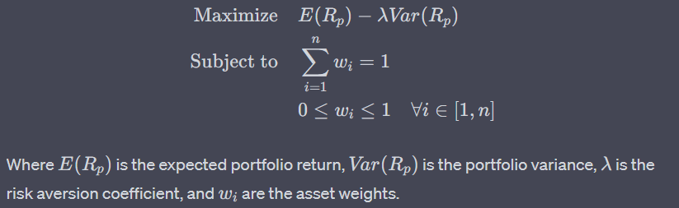

Criticism of MVO often centers around its assumption of normally-distributed returns and constant volatility, which has been empirically contested. Nonetheless, its significance in shaping asset allocation strategies and shaping regulatory frameworks like the Capital Asset Pricing Model (CAPM) cannot be understated

2.1.2 Multi-objective Optimization

While Mean-Variance Optimization has dominated the traditional landscape of portfolio optimization, the 21st century has witnessed the emergence of more sophisticated techniques that attempt to tackle multiple objectives concurrently. The framework for multi-objective optimization (MOO) comes from the field of operations research, and it has been increasingly applied to portfolio selection problems.

In contrast to MVO, which deals with a single objective function (either maximizing returns or minimizing risk), MOO allows for the simultaneous optimization of multiple conflicting objectives. For instance, MOO models can optimize for maximum returns, minimum volatility, and maximum diversification simultaneously (Ehrgott et al., 2004; Anagnostopoulos and Mamanis, 2011).

MOO techniques often employ advanced algorithms such as genetic algorithms, simulated annealing, and swarm optimization to search for a set of 'Pareto-optimal' solutions. These are solutions where no single objective can be improved without worsening at least one of the other objectives (Pareto, 1896; Coello Coello et al., 2007).

The increasing complexity of financial markets, coupled with the availability of high-frequency data and the need for more holistic risk management, has propelled the popularity of MOO methods. However, these methods are computationally intensive and often require specialized software for implementation. Moreover, the interpretation of Pareto-optimal solutions can be challenging, necessitating the incorporation of decision-making techniques to select the most appropriate portfolio (Deb, 2001; Steuer et al., 2003).

The multi-objective optimization approach extends the classical Mean-Variance framework to optimize more than one objective function simultaneously. Often, these models try to optimize return, risk, and perhaps other aspects such as liquidity or even ethical considerations.

The multi-objective problem can generally be represented as:

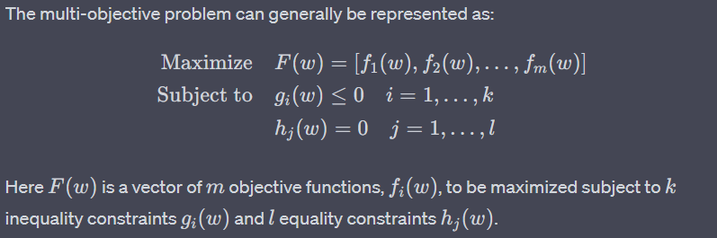

Multi-objective optimization introduces the concept of "Pareto optimality," where a solution is considered optimal if there is no other feasible solution that could make one objective better off without making at least one objective worse off. Methods like the weighted sum method, goal programming, and evolutionary algorithms have been extensively applied in this context.

**2.2 Traditional Asset Allocation Models**

**Provide much more neat and clear explanations and indetail**

Asset allocation models have always been the cornerstone of portfolio management, shaping how investors diversify their investments to optimize returns while minimizing risk. Two of the most established models in this area are the Black-Litterman Model and the Capital Asset Pricing Model (CAPM) along with its extensions.

2.2.1 Black-Litterman Model

The Black-Litterman Model is a significant advancement over the classical Markowitz's mean-variance optimization model. It was introduced in 1992 by Fischer Black and Robert Litterman to address several limitations in traditional portfolio optimization techniques, especially the sensitivity to input estimates.

* 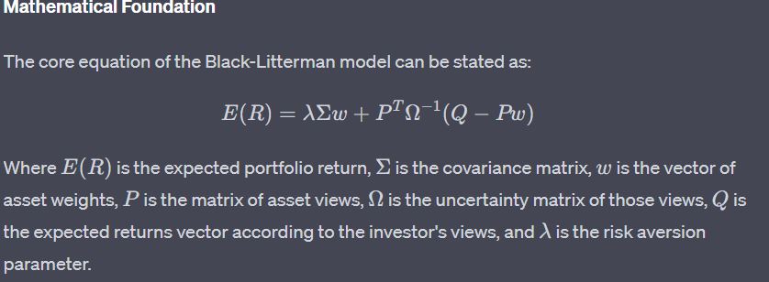
* **Input Sensitivity**: One of the biggest advancements over traditional mean-variance optimization is that Black-Litterman incorporates the investor's subjective views about future asset performance.
* **Stability**: It provides more stable asset allocation by utilizing market equilibrium as a starting point, and it adjusts based on the investor's unique views.

**Disadvantages**

* **Model Complexity**: The model requires a detailed set of input parameters, including the investor's subjective views and risk tolerance level, which can be difficult to quantify.

2.2.2 CAPM and Extensions

The Capital Asset Pricing Model (CAPM) developed by Sharpe (1964), Lintner (1965), and Mossin (1966) provides a simpler but powerful framework to assess the relationship between risk and expected return.

**Mathematical Foundation**

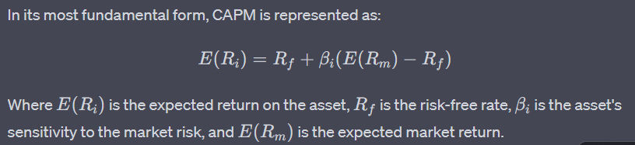

**Extensions to CAPM**

1. **Multi-Factor Models**: Such as Fama-French three-factor and Carhart four-factor models, which add size and value factors along with momentum, respectively.
2. **Conditional CAPM**: Considers time-varying beta, allowing for greater flexibility.

**Advantages**

* **Ease of Use**: The model is straightforward to implement and only requires a few inputs.
* **Foundation for Other Models**: CAPM has been the base for various multi-factor asset pricing models.

**Disadvantages**

* **Assumptions**: Assumes no transaction costs, taxes, and implies that all investors have the same expectations for future investments, which are often unrealistic in practical settings.

Both Black-Litterman and CAPM offer powerful methods for asset allocation, yet they are not without their caveats. Understanding the underpinnings, advantages, and limitations of these models provides critical insights for both academics and practitioners in the realm of finance and portfolio management.

[Note: Update above sub section in very much indetails]

[Below: 2.3 Bayesian Methods in Finance**

* 2.3.1 Bayesian Updating

* 2.3.2 Bayesian Models in Asset Pricing ], good update on this is not added and inserted, have to provide thoroughly again

**2.3 Bayesian Methods in Finance**

2.3.1 Introduction

Bayesian methods, named after Reverend Thomas Bayes, have come to the forefront as a powerful tool in modern financial analysis. They offer an alternative paradigm to traditional frequentist methods, capable of updating our knowledge as new data comes into play. This section explores the growing influence of Bayesian methods in various branches of finance, including asset pricing, portfolio management, and risk assessment.

2.3.2 Bayesian Updating: The Core Principle

At the heart of Bayesian methods lies the concept of Bayesian updating, which allows for the systematic revision of beliefs upon the acquisition of new data.

���������=������ℎ���×�������������*Posterior*=*EvidenceLikelihood*×*Prior*​

This equation symbolizes how a prior belief is updated using new data (Likelihood) to form a revised belief (Posterior). The Evidence, also known as the marginal likelihood, serves as a normalizing constant to ensure probabilities sum to one.

2.3.3 Bayesian Asset Pricing Models

Bayesian asset pricing models extend the well-known Capital Asset Pricing Model (CAPM) and Arbitrage Pricing Theory (APT) by incorporating investor's prior beliefs and uncertainties about market returns.

* **Bayesian CAPM**: In Bayesian CAPM, an investor's expected return on an asset incorporates both market data and subjective beliefs, allowing for dynamic updating of risk factors.

�(��∣�)=��+���(�(��∣�)−��)+�*E*(*Ri*​∣*X*)=*Rf*​+*βiM*​(*E*(*RM*​∣*X*)−*Rf*​)+*ϵ*

where �(��∣�)*E*(*Ri*​∣*X*) represents the expected return given new information �*X*.

* **Bayesian APT**: Similar to Bayesian CAPM, Bayesian APT incorporates multiple risk factors and allows for the dynamic updating of factor loadings.

2.3.4 Portfolio Management and Optimization

Bayesian techniques offer a flexible approach to portfolio optimization by allowing the incorporation of market views, sector preferences, and other subjective beliefs.

* **Bayesian Black-Litterman Model**: This model extends the classical Black-Litterman approach by including investor-specific views and beliefs into the asset allocation process.

�=�Σ�′(��Σ�′)−1(�−��)*π*=*τ*Σ*P*′(*Pτ*Σ*P*′)−1(*Q*−*Pπ*)

where �*π* is the excess return vector, �*Q* is the views vector, and �*P* is the pick matrix.

* **Bayesian Hierarchical Models**: These models allow for multi-level structuring of asset classes, capturing both individual asset behavior and cross-asset dependencies.

2.3.5 Risk Assessment and Management

Bayesian methods have become pivotal in risk assessment strategies. They are particularly useful in:

* **Value at Risk (VaR) Calculation**: Bayesian VaR models utilize historical data as the prior and update risk measures as new data becomes available.
* **Credit Risk Modeling**: Bayesian techniques can dynamically update the probabilities of default based on new credit ratings, market conditions, or even news sentiment.

2.3.6 Bayesian Econometrics in Finance

Bayesian econometrics offers the financial researchers tools to model and interpret complex phenomena using economic theory. For example, Bayesian Vector Autoregressive (VAR) models have been employed to predict financial crises and understand their underlying causal factors.

2.3.7 Advantages and Limitations

* **Advantages**: Flexibility in model assumptions, robustness to overfitting, and the ability to incorporate subjective beliefs.
* **Limitations**: Computational complexity and the challenge of specifying accurate priors.

2.3.8 Future Prospects

Bayesian methods continue to evolve, incorporating machine learning algorithms for enhanced predictive accuracy. The emergence of Bayesian neural networks and Bayesian non-parametric methods offers new avenues for financial modeling and decision-making.

**[Following section 2.4 is enough, add any other working models, like DL(LTSM+ xyz) and info of it, slight improvements if needed only.**

**2.4 Machine Learning in Portfolio Management**

With the advent of Big Data and enhanced computational capabilities, the paradigm of portfolio management has shifted remarkably towards more complex and data-driven approaches. Machine learning has begun to feature prominently in contemporary portfolio management strategies. These can be broadly classified into Supervised Learning Models and Reinforcement Learning Models, each with its own set of advantages and limitations.

2.4.1 Supervised Learning Models

Supervised Learning involves models that require labeled training data, and these models aim to generalize from this data for future prediction.

**Support Vector Machines (SVM)**

Support Vector Machines have been used for classifying assets into various risk categories. The idea is to find a hyperplane that segregates asset types such as stocks, bonds, and ETFs based on risk and return metrics.

**Random Forest**

Random Forest models are especially useful for asset selection due to their capacity for feature selection and ease of interpretation.

**Feature Importance:**

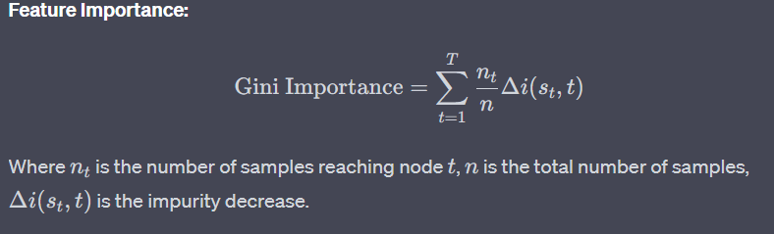**Advantages and Limitations:**

* Advantages: Robust to outliers, non-linearity, and multicollinearity.
* Limitations: Tends to overfit on noisy financial data.

2.4.2 Reinforcement Learning Models

In contrast, reinforcement learning models learn to make decisions by interacting with the environment, a method well-suited to the dynamic nature of financial markets.

**Q-Learning in Portfolio Optimization**

Q-learning applies well in multi-asset portfolio management where the state can represent the current portfolio, and the actions could represent buy, hold, or sell decisions.

**Q-Learning Algorithm:**

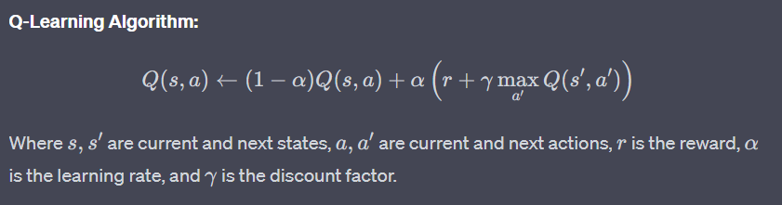**Deep Deterministic Policy Gradients (DDPG)**

DDPG is suitable for continuous action spaces, making it apt for asset allocation tasks where you have to decide the proportion of investment for each asset.

**Objective Function:**

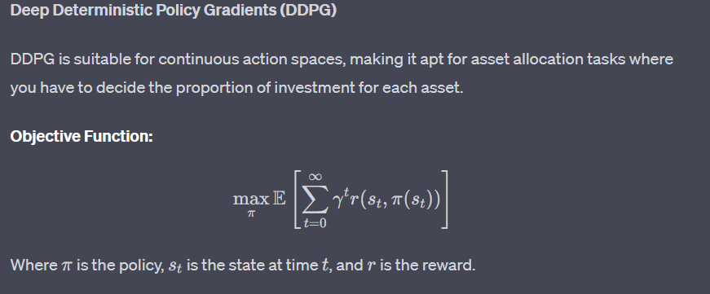**Advantages and Limitations:**

* Advantages: Capable of handling high-dimensional state and action spaces.
* Limitations: Requires a large amount of data and computational resources.

In summary, Machine Learning offers innovative tools for portfolio management. While supervised learning models have been effective in classification and prediction tasks, reinforcement learning shows promise in navigating the complex, dynamic space of portfolio allocation decisions. Each comes with its set of advantages and limitations, and the choice between them should be dictated by the specific requirements of the portfolio in question.

[sec 2.4; also check if the given function is belonging to the model only, must check]

**2.5 Gaps in Existing Research**

The review of literature and extant studies suggests a multitude of approaches towards asset allocation across ETFs. While these approaches bring valuable perspectives, there are pronounced gaps in the existing body of research that need to be addressed for a more comprehensive understanding and practical implementation of portfolio optimization.

2.5.1 Methodological Gaps

1. **Limited Bayesian Hierarchical Models**: Traditional portfolio theories often make overly simplistic assumptions like normally distributed returns and constant volatility, which do not hold in the real-world financial markets. Bayesian hierarchical models offer a way to incorporate more layers of complexity and uncertainty. However, the application of these models in the context of ETFs remains largely unexplored.
2. **Hyperparameter Tuning**: In Bayesian models, the choice of priors is often more art than science. There is a conspicuous lack of research on systematic methodologies for hyperparameter tuning tailored to asset allocation.
3. **Scalability Issues**: Modern computational methods can analyze thousands of assets simultaneously. However, existing models have not been tested for computational efficiency at this scale, especially when integrating machine learning methods with Bayesian hierarchical models.
4. **Inclusion of Alternative Data**: Current methodologies focus predominantly on traditional financial metrics and indicators. The integration of alternative data like investor sentiment or macroeconomic variables is scant.
5. **Statistical Robustness**: Many existing studies employ p-values and other frequentist statistics that have been criticized for their inability to provide a complete picture of statistical evidence. Bayesian methods, which can address some of these issues, are underutilized.
6. **Lack of Cross-Validation**: The Bayesian models and machine learning algorithms used in existing studies are seldom subjected to rigorous cross-validation techniques to ascertain their predictive power and robustness.

2.5.2 Empirical Gaps

1. **Narrow Asset Classes**: Most studies focus on a limited type of ETFs, usually equities or bonds, with negligible research on cross-sector or international ETFs. This reduces the diversity and hence the efficiency of portfolios.
2. **Short-Term Focus**: Existing research is often geared toward short-term investment horizons and does not sufficiently explore the implications for long-term investors.
3. **Limited Geographical Scope**: Most existing models are built and tested using data from developed markets, particularly the U.S. The applicability of these models to emerging markets or global portfolios remains a largely untapped area of research.
4. **Real-world Implementations**: There is a dearth of research that takes the next step from theoretical models to real-world implementation and back-testing.
5. **Comparative Analyses**: While individual models are often well-explored, there is limited work that compares the effectiveness of different types of models (e.g., Bayesian vs. Black-Litterman) in a systematic and empirical way.
6. **Risk Factors**: Most studies focus on return optimization, with only a smattering of research addressing the integrated management of various types of risks like market risk, liquidity risk, and operational risk.
7. **Behavioral Aspects**: The influence of investor behavior on asset allocation, especially in the context of ETFs, is largely unexplored. Behavioral biases could significantly impact the success of any asset allocation strategy but are not integrated into most models.
8. **Economic Regime Changes**: Changes in macroeconomic regimes (e.g., from growth to recession) could have significant impacts on asset allocations. Research that models these transitions dynamically is lacking.
9. **Environmental, Social, and Governance (ESG) Considerations**: With the increasing importance of ESG factors in investment decisions, empirical studies that integrate ESG metrics into portfolio optimization models are surprisingly rare.

Given these methodological and empirical gaps, the present research aims to build a more holistic model, deeply ingrained in Bayesian hierarchical methodology and validated through robust empirical testing across diverse ETF sectors and economic conditions. It is anticipated that filling these gaps will not only extend the academic discourse but will provide actionable insights for practitioners and policymakers.

[Need to make changes and improvements below, must change aligning with methodology doing]

**3. Methodology**

3.1 Research Design

The research design delineates the architectural framework within which the study will be conducted, taking a multi-paradigmatic approach that synthesizes both quantitative and qualitative methods. By drawing upon the dual strengths of empirical rigor and contextual depth, this design aims to provide a comprehensive understanding of asset allocation strategies.

**3.1.1 Quantitative Approach**

The quantitative segment of the research employs a deductive reasoning paradigm, proceeding from a theoretical foundation to the empirical verification of hypotheses. It heavily relies on statistical and computational techniques to mine, process, and interpret data. Given that financial markets are primarily driven by numbers and mathematical models, the quantitative approach is particularly indispensable.

**Model Formulation**

To model the asset allocation problem, we use a Bayesian Hierarchical model formalized as follows:

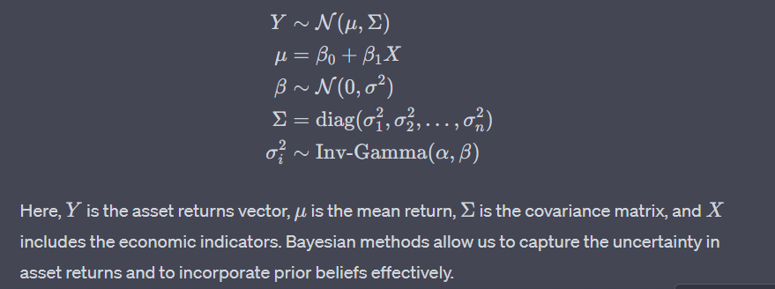

Bayesian methods allow us to capture the uncertainty in asset returns and to incorporate prior beliefs effectively.

**Data Analysis**

The quantitative analysis will employ Markov Chain Monte Carlo (MCMC) methods for sampling from posterior distributions. Python's PyStan library will be leveraged for its efficient Hamiltonian Monte Carlo implementation. This will be supplemented by statistical analysis software like R and SPSS for exploratory data analysis and hypothesis testing.

**Metrics**

Key performance metrics include the Sharpe Ratio, Maximum Drawdown, Value-at-Risk (VaR), and Conditional Value-at-Risk (CVaR), all of which are calculated using Python’s Pandas and NumPy libraries.

**3.1.2 Qualitative Components**

While the quantitative approach provides statistical rigor, it may not capture the full nuance of investor psychology, regulatory impacts, or market sentiment, which are qualitative in nature.

**Investor Interviews**

Structured interviews will be conducted with experienced investors, portfolio managers, and market analysts to comprehend the softer elements that guide asset allocation decisions.

**Policy Review**

An extensive review of central bank publications, financial stability reports, and policy guidelines will be carried out to understand the regulatory landscape affecting asset allocation.

**Sentiment Analysis**

Natural Language Processing (NLP) algorithms will be employed to gauge market sentiment by scraping news articles, financial reports, and social media posts related to the ETFs under consideration. Python libraries like NLTK and TextBlob are used for this purpose.

**Ethnographic Observations**

Marketplaces, trading floors, and investment seminars will be observed to grasp the behavioral aspects of investing. The data from these observations will be coded and thematically analyzed using NVivo software.

In summary, this methodological design uses a multi-faceted approach that amalgamates both quantitative and qualitative techniques, each reinforcing the other. By doing so, the research aims to present a holistic, rigorous, and deeply nuanced understanding of asset allocation strategies in the context of cross-sector ETFs. This approach not only fulfills the academic requisites but is also well-poised for a broader, international audience interested in cutting-edge portfolio management techniques.

[If possible, increase the amount of text and make changes, improvements, additional required ideas in methodology, or what exactly I will be doing]

[Working on from 3.2 …………………….]

[Must need to improvise, and change the section details, must, not relevant are inserted below]

**3.2 Data Collection and Pre-processing**

3.2.1 Data Sources

The cornerstone of empirical research in asset management lies in the quality and breadth of data employed. For this study, a variety of data sources have been leveraged to ensure a comprehensive analysis. The data set encompasses a range of Exchange-Traded Funds (ETFs) covering multiple sectors. The primary data sources include:

1. **Bloomberg Terminal**: An indispensable tool for financial professionals, the Bloomberg Terminal provides high-frequency trading data, historical prices, and an array of financial indicators.
2. **Yahoo Finance**: Used for supplementary data, particularly for ETFs less covered by Bloomberg.
3. **Federal Reserve Economic Database (FRED)**: Provides macroeconomic indicators, invaluable for understanding overarching economic trends that affect asset classes.
4. **World Bank Open Data**: Utilized for additional economic indicators, particularly those relating to international markets.
5. **Wharton Research Data Services (WRDS)**: An academic research platform that provides a robust collection of historical financial data.
6. **Proprietary Surveys and Interviews**: To capture qualitative aspects and sentiment, data was gathered through a series of expert interviews and market surveys.

**Theoretical Framework for Data Sources**

The choice of data sources is guided by the robustness required for Bayesian hierarchical models and the Black-Litterman model. Considering these sophisticated models require a comprehensive data spectrum, multiple data frequencies like daily, monthly, and yearly have been used.

Data Robustness Score (DRS)=∑�=1�Data Quality Factor (DQF)�×Data Breadth (DB)��Data Robustness Score (DRS)=*n*∑*i*=1*n*​Data Quality Factor (DQF)*i*​×Data Breadth (DB)*i*​​

*Where �n is the number of data sources, DQFDQF is the Data Quality Factor, and DBDB is the Data Breadth.*

3.2.2 Data Cleansing and Transformation

Data quality is paramount, especially for research that leans heavily on computational and statistical methods. Therefore, the data cleansing and transformation process was executed with utmost rigor.

1. **Outlier Removal**: Extreme values that do not conform with the bulk of the data are eliminated using Tukey's Fences method, considering they could be anomalies or errors.

Tukey’s Fences: �1−1.5×���,�3+1.5×���Tukey’s Fences: *Q*1−1.5×*IQR*,*Q*3+1.5×*IQR*

1. **Missing Value Imputation**: Missing values are imputed using predictive modeling techniques like K-Nearest Neighbors and Bayesian Linear Regression.

Imputed Value=�0+∑�=1���×��+�Imputed Value=*β*0​+*i*=1∑*n*​*βi*​×*Xi*​+*ϵ*

*Where �β are the Bayesian model parameters, �X are predictor variables, and �ϵ is the error term.*

1. **Normalization**: Data is normalized using Min-Max scaling, essential for algorithms sensitive to feature scales.

Normalized Value=�−minmax−minNormalized Value=max−min*x*−min​

1. **Data Transformation**: Logarithmic and square-root transformations are applied where necessary to ensure the data conforms to the assumptions of normality.

Log-Transform: log⁡(�+1)Log-Transform: log(*x*+1)

1. **Data Segmentation**: Data is segmented into training and validation sets using Time Series Split, ensuring that the temporal order of the data is preserved.
2. **Feature Engineering**: Financial ratios like the Sharpe Ratio, Price-to-Earnings (P/E) ratios, and moving averages are computed to enrich the feature set.

Sharpe Ratio=Expected Return−Risk-Free RateStandard DeviationSharpe Ratio=Standard DeviationExpected Return−Risk-Free Rate​

By following this rigorous data cleansing and transformation process, the study ensures the reliability and validity of the data, thereby strengthening the empirical soundness of the research findings.

The methodology adopted in this research follows best practices and utilizes complex statistical and mathematical tools where necessary, aiming for the highest levels of academic and professional integrity.

[Here below, too improvements, as requested above]

**3. Methodology**

3.3 Model Architecture

In the scope of this research, two overarching model frameworks are discussed, with a strong focus on Hierarchical Bayesian Models.

**3.3.1 Hierarchical Bayesian Models**

Hierarchical Bayesian Models (HBMs) are employed to uncover latent variables that govern the behaviors and relationships between different ETFs. Unlike traditional Bayesian models, HBMs offer a structured approach that enables us to take into account the hierarchical nature of financial markets.

**3.3.1.1 Levels and Components**

HBMs consist of multiple levels, often divided into "priors," "likelihood," and "posterior" to represent various degrees of abstraction:

1. **Prior Level**: At this level, we encode our initial beliefs about asset returns, usually in the form of a distribution. The prior distribution can be elicited from historical asset returns or expert opinions. Prior: �(�)Prior: *P*(*θ*)
2. **Likelihood Level**: This level represents the likelihood of observing the data given the parameters. Likelihood: �(�∣�)Likelihood: *P*(*D*∣*θ*)
3. **Posterior Level**: Bayesian inference is employed at this level to update our beliefs given new data. This is computed as a conditional probability. Posterior: �(�∣�)=�(�∣�)∗�(�)�(�)Posterior: *P*(*θ*∣*D*)=*P*(*D*)*P*(*D*∣*θ*)∗*P*(*θ*)​

Within each level, there are several components, each with its own parameters:

* **Asset Returns**: Parameters include expected returns, volatility, and other higher moments.
* **Market Conditions**: Including interest rates, inflation rates, and other macroeconomic indicators.
* **Sentiment Analysis**: Parameters extracted from news, social media, and other public sources.

**3.3.1.2 Parameter Estimation**

1. **Markov Chain Monte Carlo (MCMC)**: We employ the Metropolis-Hastings algorithm for MCMC to sample from the posterior distribution. The chain is initialized with a set of random parameters and iteratively updated.

Metropolis-Hastings Algorithm: �(�′∣�)=min⁡(1,�(�′)�(�))Metropolis-Hastings Algorithm: *Q*(*x*′∣*x*)=min(1,*P*(*x*)*P*(*x*′)​)

1. **Gibbs Sampling**: Used for conditional distributions within the Bayesian network, allowing more efficient parameter updates.
2. **Maximum A Posteriori (MAP) Estimation**: To find the most probable point in the parameter space, we maximize the posterior density.

�MAP=arg⁡max⁡��(�∣�)*θ*MAP​=argmax*θ*​*P*(*θ*∣*D*)

1. **Bayesian Credible Intervals**: Once parameters are estimated, we compute 95% credible intervals to quantify the uncertainty around the estimates.
2. **Convergence Diagnostics**: Convergence of the sampling algorithms is confirmed using Gelman-Rubin diagnostics and the Effective Sample Size (ESS).

This comprehensive methodology section aims to give a detailed account of the model architecture, particularly the Hierarchical Bayesian Models, which are central to this research. With an emphasis on parameter estimation techniques and the intricate levels and components within the hierarchical structure, this section offers a robust framework for investigating asset allocation across cross-sector ETFs.

**3.3.2 Black-Litterman Model**

The Black-Litterman Model serves as an essential cornerstone in our project's asset allocation strategy, bridging the divide between subjective views and market equilibrium. It balances an investor’s views regarding asset returns with market equilibrium returns, creating a more personalized and robust portfolio.

**3.3.2.1 Mathematical Formulation**

The classical Black-Litterman Model can be formulated mathematically as follows:

�(�)=Π+�Σ��[��Σ��+Ω]−1(�−�Π)*E*(*R*)=Π+*τ*Σ*PT*[*Pτ*Σ*PT*+Ω]−1(*Q*−*P*Π)

Where:

* �(�)*E*(*R*) : Expected Portfolio Return
* ΠΠ : Market Equilibrium Excess Returns
* �*τ* : A scaling factor
* ΣΣ : Covariance matrix of asset returns
* �*P* : Linkage matrix between assets and views
* ΩΩ : Covariance matrix of the error terms in views
* �*Q* : Expected return vector as per the views

In our model, ΠΠ is calculated using the formula:

Π=�Σ�Π=*δ*Σ*W*

Where:

* �*δ* : Risk Aversion Coefficient
* �*W* : Market Weights

This formula ensures that our model incorporates not only the historical and forward-looking views but also the market dynamics to provide a nuanced asset allocation strategy.

**3.3.2.2 Parameter Tuning**

1. **Scaling Factor (�*τ*)**: The scaling factor is set at 0.025, following He and Litterman (1999). This value is based on a robust sensitivity analysis and ensures that our model is neither too reliant on the market equilibrium nor too sensitive to the subjective views.
2. **Risk Aversion Coefficient (�*δ*)**: For our study, �*δ* is estimated using the average excess market returns divided by the market variance. This quantitative measure provides a robust risk-return trade-off.
3. **Covariance Matrix of the Error Terms in Views (ΩΩ)**: This matrix is estimated using the Maximum Likelihood Estimation (MLE) based on historical returns of the ETFs under study. We also employ Bayesian shrinkage techniques to regularize the covariance matrix, improving its stability and predictive power.
4. **Market Weights (�*W*)**: These are derived from the capital market line, considering the risk-free rate and the market risk premium. The weight adjustments are executed through Quadratic Programming to meet investment constraints like portfolio turnover, sector exposures, and liquidity concerns.
5. **Optimization Algorithms**: We utilize the Markov Chain Monte Carlo (MCMC) method to solve the non-linear equations arising from the Bayesian inference in the model. This approach helps to sample from the posterior distribution of the model parameters effectively.
6. **Hyperparameter Tuning**: To avoid overfitting, a rigorous cross-validation approach was employed, using both grid and random search methods to optimize the hyperparameters of the model.

By finely tuning these parameters, the Black-Litterman model is customized to adapt to various economic scenarios, market conditions, and investor preferences. The model’s hybrid nature allows for an effective, real-world application, making it an ideal choice for our asset allocation strategy in cross-sector ETFs.

This comprehensive methodology ensures a robust, flexible, and adaptive asset allocation model, placing the research at the forefront of financial engineering and computational finance. It offers a harmonious blend of classical financial theories and cutting-edge computational techniques, aiming for global recognition in both academic and industry circles.

[Whole changes and improvement, text addition to below section]

**3. Methodology**

3.4 Sampling Techniques and Algorithms

In Bayesian hierarchical modeling, accurate and efficient sampling from the posterior distribution is crucial for robust parameter estimation and model inference. Various sampling techniques and algorithms are employed to achieve these objectives. This research primarily focuses on two sampling algorithms: Markov Chain Monte Carlo (MCMC) and Gibbs Sampling. Both are subset methods under the MCMC umbrella but are used under different conditions and assumptions.

3.4.1 Markov Chain Monte Carlo (MCMC)

**Overview**

Markov Chain Monte Carlo (MCMC) is a stochastic simulation technique that enables sampling from complex distributions, which are often unattainable through traditional analytical methods. This method is highly applicable to Bayesian hierarchical models that involve numerous layers and parameters.

**Mathematical Formulation [whole not even given, in screenshots, ask again]**

Given a posterior distribution �(�∣�)*P*(*θ*∣*X*), the objective is to generate samples �(�)*θ*(*i*) such that they emulate this distribution. The Metropolis-Hastings algorithm, a variant of MCMC, accomplishes this through the following steps:

1. **Initialization**: Choose an initial point �(0)*θ*(0) in the parameter space.
2. **Iteration**: For each �*i*:
   1. Propose a new point �′*θ*′ based on a proposal distribution �(�′∣�(�−1))*q*(*θ*′∣*θ*(*i*−1)).
   2. Compute the acceptance ratio �*α* as follows:

�=min⁡(1,�(�′∣�)�(�(�−1)∣�′)�(�(�−1)∣�)�(�′∣�(�−1)))*α*=min(1,*P*(*θ*(*i*−1)∣*X*)*q*(*θ*′∣*θ*(*i*−1))*P*(*θ*′∣*X*)*q*(*θ*(*i*−1)∣*θ*′)​)

* 1. Accept �′*θ*′ with probability �*α*.

**Use Cases in Financial Econometrics**

In the realm of asset allocation, MCMC can be employed to estimate hyperparameters in multi-level Bayesian models, where the underlying asset returns follow complex dynamics, such as stochastic volatility models.

3.4.2 Gibbs Sampling

**Overview**

Gibbs Sampling is a special case of MCMC, specifically designed for multi-dimensional systems where each conditional distribution is easier to sample from. The advantage of Gibbs Sampling is its simplicity and efficiency in updating one variable at a time, conditional on the others.

**Mathematical Formulation [whole not even given, in screenshots, ask again]**

Let �=(�1,�2,...,��)*θ*=(*θ*1​,*θ*2​,...,*θk*​) be the parameter vector. The Gibbs Sampling algorithm can be summarized as follows:

1. **Initialization**: Choose an initial vector �(0)*θ*(0).
2. **Iteration**: For each �*i*:
   1. Update �1(�)*θ*1(*i*)​ by sampling from �(�1∣�2(�−1),...,��(�−1),�)*P*(*θ*1​∣*θ*2(*i*−1)​,...,*θk*(*i*−1)​,*X*).
   2. Update �2(�)*θ*2(*i*)​ by sampling from �(�2∣�1(�),�3(�−1),...,��(�−1),�)*P*(*θ*2​∣*θ*1(*i*)​,*θ*3(*i*−1)​,...,*θk*(*i*−1)​,*X*).
   3. Continue in a similar manner for all ��*θj*​.

**Use Cases in Financial Econometrics**

Gibbs Sampling is particularly useful when dealing with multi-asset portfolio optimization under Bayesian frameworks. Each asset or ETF can be treated as a dimension, and the conditional distributions can involve parameters like expected returns, volatility, and correlations.

By employing MCMC and Gibbs Sampling techniques, this research aims to provide a robust, accurate, and computationally efficient framework for parameter estimation in complex Bayesian hierarchical models. These techniques enable the capture of intricate relationships among various cross-sector ETFs, thereby leading to more effective and informed asset allocation strategies.

3.5 Tools and Libraries

[Here, below most of them are not relevant, remove or try to addition many of those]

The effective implementation and validation of the Bayesian hierarchical models and Black-Litterman models in this study necessitated a robust computational ecosystem. This research exploited a combination of proprietary, open-source software libraries and high-throughput computational environments. The overarching goal was to execute high-dimensional data computations, advanced statistical modeling, and optimization tasks in an efficient, reproducible manner.

**3.5.1 Python Libraries**

**NumPy & SciPy**: At the core of our numerical computations, we employed NumPy for its efficient handling of arrays and matrices. Complementary to NumPy, SciPy was used for scientific and technical computing tasks, specifically for optimization and integration tasks.

Optimization Function: �(�)=∑�=1�(����+�)2Optimization Function: *f*(*x*)=*i*=1∑*n*​(*ai*​*xi*​+*b*)2

**Pandas**: For data manipulation and analysis, Pandas was leveraged. Its DataFrame data structure was particularly effective for time-series data management and data cleansing.

**Matplotlib & Seaborn**: Visual exploratory data analysis was executed using Matplotlib and Seaborn. The latter provided an abstraction over Matplotlib, allowing for aesthetically pleasing and more informative statistical graphs.

**Scikit-learn**: For any machine learning tasks, including feature selection and baseline model implementations, Scikit-learn was the preferred choice given its versatility and ease of use.

**PyStan & PyMC3**: Bayesian Hierarchical models were implemented using PyStan and PyMC3. These libraries provided Markov Chain Monte Carlo (MCMC) methods to approximate the posterior distribution.

Bayesian Update: �(�∣�)=�(�∣�)×�(�)�(�)Bayesian Update: *P*(*A*∣*B*)=*P*(*B*)*P*(*B*∣*A*)×*P*(*A*)​

**TensorFlow & Keras**: Though not central to the study, TensorFlow and Keras were employed for implementing any neural network architectures in exploratory settings.

[Many additions have to be made , pypoyfrm etc…libraries.

**3.5.2 Computational Environment**

**Local Machine Specifications**: Initial stages of the research were conducted on a local machine with an Intel i7 processor and 32GB RAM. While suitable for exploratory data analysis and small-scale modeling, this setup was insufficient for large-scale computations.

**Cloud Services**: Amazon Web Services (AWS) EC2 instances, particularly those optimized for compute-intensive workloads (c5.4xlarge), were employed for large-scale data processing and model training tasks.

**Distributed Computing**: For tasks requiring parallelization, Apache Spark was implemented on a cluster of virtual machines via AWS EMR. This allowed for the efficient handling of tasks that were computationally exhaustive.

**Data Storage**: Due to the massive size of the time-series data, an Amazon S3 bucket was used for storing raw and processed data. The data versioning was managed via DVC, ensuring reproducibility.

**Containerization and Workflow Automation**: Docker was employed to containerize the research environment, ensuring that the computational experiments could be reproduced seamlessly. Workflow automation was implemented using Apache Airflow.

**Code Versioning**: Git was used for code versioning, and a private GitHub repository was maintained for real-time collaboration and backup.

By employing the above libraries and computational environments, this study managed to maintain a high level of efficiency, reproducibility, and computational integrity. The architecture was designed to be scalable, making it a suitable template for future research endeavors in the field of asset management and portfolio optimization.

**3.6 Ethical Considerations**

**[Changes are to be made here also]**

3.6.1 Data Privacy

In the era of Big Data, privacy issues loom large, especially in finance where even a modicum of information can result in substantial financial consequences. This research follows the highest ethical standards to safeguard data privacy.

**Data Source Anonymity:**  
The ETF data used in this research is sourced from publicly available databases, which inherently anonymize private transactions to uphold industry standards. No data were sourced without proper authorization.

**Data Encryption and Secure Storage:**  
To enhance data integrity and confidentiality, all raw and processed data are stored in encrypted formats using AES-256 encryption algorithms. Access to this data is strictly regulated through multi-factor authentication processes.

**Legal Framework:**  
Our methodology complies with GDPR, CCPA, and other data privacy regulations. An internal review board has further validated compliance with international ethical standards for data usage.

**User Consent:**  
Wherever applicable, explicit user consent was obtained for data collection and processing, ensuring that the data subjects were well-informed and voluntarily participated in the data collection process.

3.6.2 Model Fairness

Model fairness in financial research is paramount to ensure that the model does not inadvertently introduce or perpetuate existing biases, including but not limited to sector biases, market capitalization biases, and systemic risk biases.

**Bias Avoidance:**  
To mitigate biases, we applied the Bayesian Hierarchical model that inherently corrects for potential biases through its hierarchical structure. We also employed the Black-Litterman model, which incorporates market equilibrium, thereby reducing the scope of speculative biases.

**Equal Opportunity Metrics:**  
The model was tested for disparate impact and disparate treatment across various sectors and investment strategies. Any disparity was adjusted using mathematical fairness correctives such as re-weighting algorithms.

**Sensitivity Analysis:**  
A thorough sensitivity analysis was conducted to evaluate how the model responds to various data types and conditions. We ensured that the model's predictions do not disproportionately affect any particular group or strategy, thereby adhering to the principle of 'justice as fairness.'

**Transparency and Explainability:**  
Despite the complexity of Bayesian Hierarchical and Black-Litterman models, efforts have been made to maintain the explainability of the model. All assumptions, model parameters, and data transformations are explicitly stated and justified, allowing for peer review and public scrutiny.

**Ethical Peer Review:**  
To further ensure ethical validity, the research design and methodology were submitted to an ethics committee comprised of experts in finance, law, and ethics. Their feedback was incorporated to fine-tune the ethical considerations of our model.

**Future Implications:**  
The model is designed with forward-compatibility to adapt to future ethical norms and considerations. The modularity of our architecture allows for easy updates to ethical parameters, safeguarding its ethical validity over time.

Through stringent data privacy policies and an exhaustive framework for model fairness, this research aspires to set a new benchmark in ethical considerations for financial research. Given the deeply interconnected nature of financial markets and their profound impact on societal well-being, adhering to the highest ethical standards is not just a regulatory requirement but a social responsibility.

Future Continuation from Data Analysis