**MEDIGUIDE**

*A*

*Mini Project Report*

*Submitted in partial fulfilment of the*

*Requirements for the award of the degree of*

**BACHELOR OF ENGINEERING**

IN

**INFORMATION TECHNOLOGY**

By

**Kalthi Reddy Gayathri (1602-19-737-013)**

**Jampelly Sai Rishitha (1602-19-737-036)**

**Aare Sai Deepika (1602-19-737-305)**

*Under the guidance of*

**B. Leelavathy**

**Assistant Professor**



**Department of Information Technology**

**Vasavi College of Engineering (Autonomous)**

**(Affiliated to Osmania University) Ibrahimbagh**

**Hyderabad-31**

**2021-2022**

**Vasavi College of Engineering(Autonomous)**

**(Affiliated to Osmania University) Ibrahimbagh**

**Hyderabad-500031**

**Department of Information Technology**



**DECLARATION BY THE CANDIDATES**

We, **Kalthi Reddy Gayathri, Jampelly Sai Rishitha, Aare Sai Deepika**, bearing hall ticket numbers **1602-19-737-013, 1602-19-737-036, 1602-19-737-305**, hereby declare that the project report entitled “MEDIGUIDE” under the guidance of **Ms. B. Leelavathy**, Department of Information Technology, Vasavi College of Engineering, Hyderabad, is submitted in fulfilment of the requirement for the award of the degree of **Bachelor of Engineering** in **Information Technology**.

This is a record of bonafide work carried out by us and the results embodied in this project report have not been submitted to any other university or institute for the award of any other degree or diploma.

**Kalthi Reddy Gayathri (1602-19-737-013)**

**Jampelly Sai Rishitha (1602-19-737-036)**

**Aare Sai Deepika (1602-19-737-305)**

**Vasavi College of Engineering(Autonomous)**

**(Affiliated to Osmania University) Ibrahimbagh**

**Hyderabad-500031**

**Department of Information Technology**



**BONAFIDE CERTIFICATE**

This is to certify that the project entitled “**MEDIGUIDE**” was submitted by **Kalthi Reddy Gayathri, Jampelly Sai Rishitha, Aare Sai Deepika** bearing **1602-19-737-013, 1602-19-737-036, 1602-19-737-305** in fulfilment of the requirements for the completion of **MINI PROJECT** of Bachelor of Engineering in Information Technology is a record of bonafide work carried out by them under my guidance.

**Ms. B. Leelavathy Dr. K. Ram Mohan Rao**

**Internal Guide HOD, IT**

**ACKNOWLEDGEMENT**

It is our privilege and pleasure to express a profound sense of respect and gratitude to our guide Ms. **B.Leelavathy**, Assistant Professor, Department of Information Technology, Vasavi College of Engineering, for her indefatigable inspiration, guidance, cogent discussion and encouragement throughout this dissertation work.

We express our sincere gratitude to **Dr.** **K. Ram Mohan Rao**, Professor & Head, Department of Information Technology, Vasavi College of Engineering, for his suggestions, motivations and co-operation for the successful completion of the work.

We extend our sincere thanks to **Dr. S. V.Ramana,** Principal, Vasavi College of Engineering for his encouragement.

Our sincere regards to the entire faculty and staff of the Department of Information Technology, Vasavi College of Engineering, for their cooperation and help.

**TABLE OF CONTENTS**

ABSTRACT ………………………………………………………………………….............. 6

INTRODUCTION …………………………………………………………………………..... 7

* 1. Overview ……………………………………………………………………………. 7
  2. Objective ……………………………………………………………………………. 7

RELATED WORK ……………………………………………………………………………... 8

2.1 Areas to be added …………………………………………………………………. 8

PROPOSED WORK ………………………………………………………………………….. 9

3.1 Use Cases ………………………………………………………………….…………… 9

3.2 UI Screenshot ………………………………………………………………………. 12

3.3 Architecture ………………………………………………………………………… 12

3.4 Technology …………………………………………………………………………. 13

3.5 Design …………………………………………………………………………………. 13

3.5.1 UML Class Diagram ……………………………………………………….. 13

3.5.2 UML Sequence Diagram ………………………………………………… 14

3.6 Implementation ………………………………………………………………….. 15

3.6.1 Main modules ……………………………………………………………….. 15

3.6.2 Github link …………………………………………………………………….. 20

RESULTS ………………………………………………………………………………………. 21

DISCUSSION AND FUTURE WORK ………………………………………………… 24

5.1 Discussion …………………………………………………………………………… 24

5.2 Future Work ……………………………………………………………………….. 24

REFERENCES ……………………………………………………………………………….. 24

**ABSTARCT**

India is a big country where the migration rate is very high. Due to this many of the migrants does not have a clear idea about the medical services around them. Also many people are unaware of the government schemes for availing medical facilities.

MediGuide web application helps those people in need who are unaware of the medical services around them. This application helps people to check for the availability of medical facilities, based on search criteria and related government schemes .

**INTRODUCTION**

* 1. **Overview**

Basically search based applications filters all the contents and outputs the results that matches the search content of the user. These applications are used to retrieve the desired content faster using a keyword. This web application is designed to output desired content based on the search keyword of the user.

* 1. **Objective**

Mediguide is a search-based web application that is used to retrieve hospitals list using either the state name, city name or the pincode of the area. Also, user can know what are all the government schemes and the information related to them like eligibility criteria etc present in a particular state by just giving the state name .

**RELATED WORK**

**2.1 Areas to be added**

The present web application filters and outputs the hospitals list or the government schemes list based on one keyword (state name, city name or pincode of an area) given by the user. Further, we would like to extend the features of this application by making it interactive like, we would like to take a quiz to check for all the government schemes which are applicable to the user based on the information given by the user such as the age, native of him/her etc.

**PROPOSED WORK**

**3.1 Use Cases**

**1.** 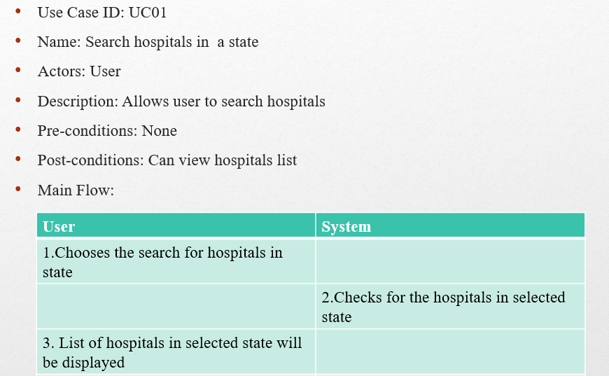

**2.**

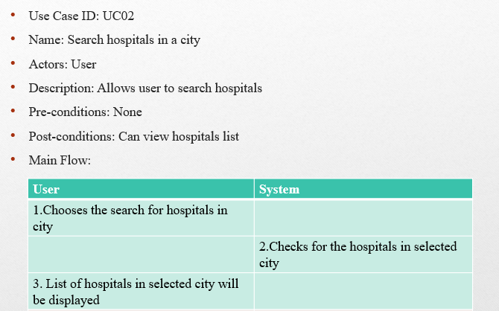

**3.**

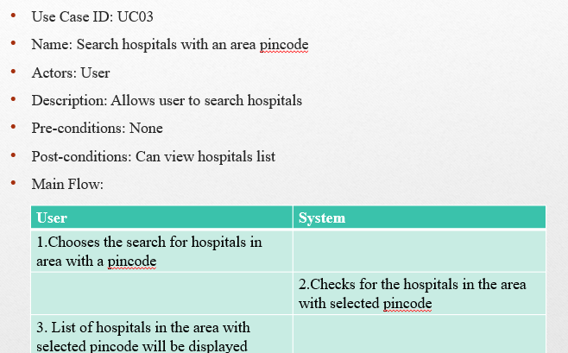

**4.**

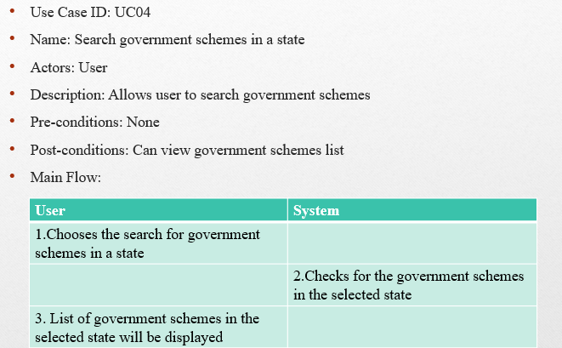

**5.**

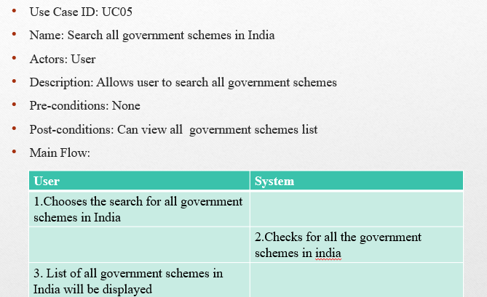

**3.2 UI Screenshot**

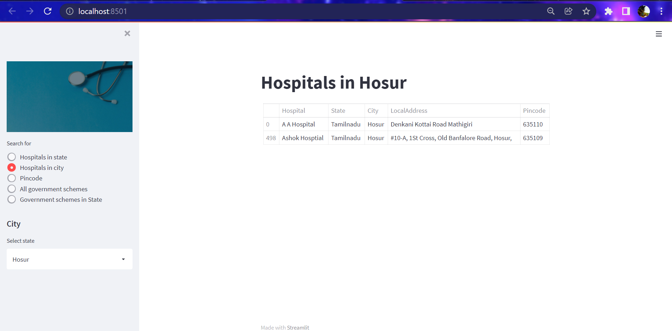

**3.3 Architecture**

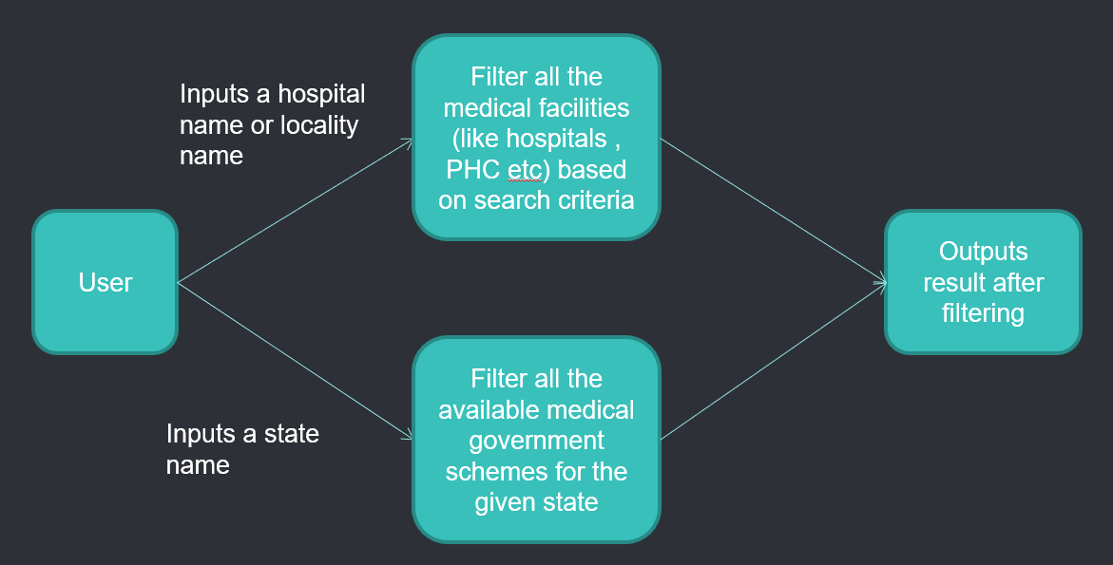

**3.4 Technology**

**Software Requirements :**

* Streamlit
* Python
* Flask

**Hardware Requirements :**

* Operating system : windows/linux
* RAM : 2GB
* Hard drive : 16Gb

**3.5 Design**

**3.5.1 UML Class Diagram**

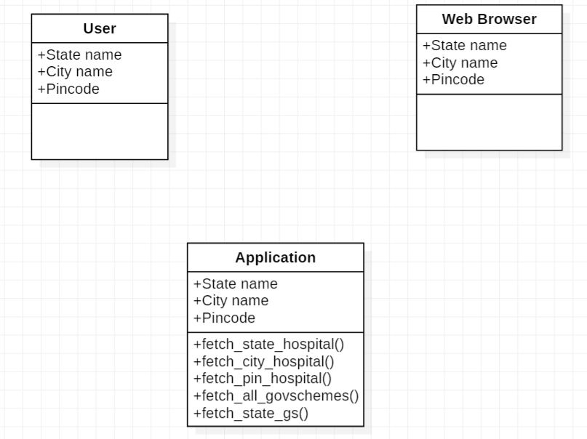

**3.5.1 UML Flowchart**

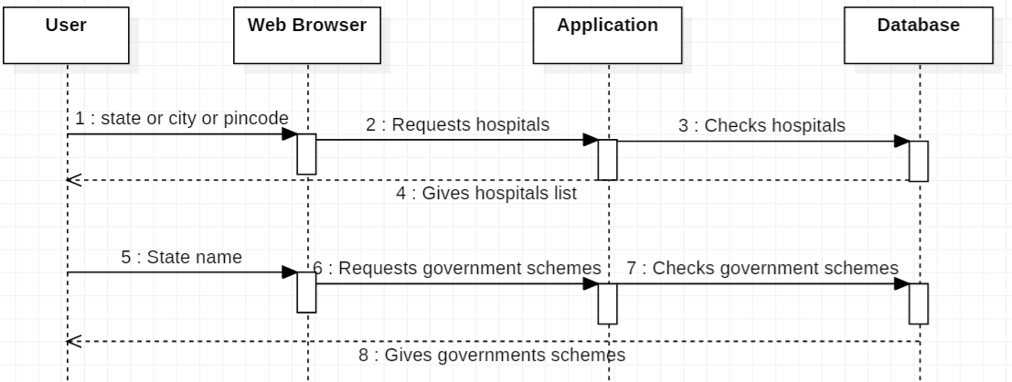

**IMPLEMENTATION**

**3.6.1 Main modules**

**application.py :**

import streamlit as st

import pandas as pd

import help

df = pd.read_csv('hospitals.csv')

gdf = pd.read_csv('GovernmentSchemes.csv', encoding='windows-1252')

st.sidebar.image(

'16.jpg')

user_menu = st.sidebar.radio(

'Search for',

('Hospitals in state', 'Hospitals in city', 'Pincode','All government schemes','Government schemes in State')

)

if user_menu == 'Hospitals in state':

st.sidebar.header('State')

state = help.search_state(df)

selected_state = st.sidebar.selectbox("Select state", state)

statewise_hospitals = help.fetch_state_hospital(df, selected_state)

st.title("Hospitals in " + selected_state)

st.table(statewise_hospitals)

if user_menu == 'Hospitals in city':

st.sidebar.header('City')

city = help.search_city(df)

selected_city = st.sidebar.selectbox("Select state", city)

citywise_hospitals = help.fetch_city_hospital(df, selected_city)

st.title("Hospitals in " + selected_city)

st.table(citywise_hospitals)

if user_menu == 'Pincode':

st.sidebar.header('Pincode')

pin = help.search_pincode(df)

selected_pincode = st.sidebar.selectbox("Select Pincode", pin)

pin_hospitals = help.fetch_pin_hospital(df, selected_pincode)

st.title("Hospitals with area pincode " + str(int(selected_pincode)))

st.table(pin_hospitals[['State','City','Hospital']])

if user_menu == 'All government schemes':

st.sidebar.header('All government schemes in India')

allGS = help.search_allgs(gdf)

allGovschemes = help.fetch_all_govschemes(gdf)

st.title("All the government schemes in India")

st.table(allGovschemes[['State','Scheme','Details','Eligibility','Website/Apply at']])

if user_menu == 'Government schemes in State':

st.sidebar.header('Government schemes')

sgs = help.search_stategs(gdf)

selected_stategs = st.sidebar.selectbox("Select state", sgs)

statewise_gs = help.fetch_state_gs(gdf, selected_stategs)

st.title("Government schemes in " + selected_stategs)

st.table(statewise_gs[['Scheme','Details','Eligibility','Website/Apply at']])

**helper.py :**

import numpy as np

import io

def search_state(df):

state = df['State'].unique().tolist()

return state

def fetch_state_hospital(df, state):

global temp_df

temp_df = df.drop_duplicates(subset=[ 'State'])

x = df.loc[df['State']==state]

x['Pincode'] = x['Pincode'].astype('int')

return x

def search_city(df):

city = df['City'].unique().tolist()

return city

def fetch_city_hospital(df, city):

global temp_df

temp_df = df.drop_duplicates(subset=['City'])

x = df.loc[df['City'] == city]

x['Pincode'] = x['Pincode'].astype('int')

return x

def search_pincode(df):

pincode = df['Pincode'].unique().tolist()

return pincode

def fetch_pin_hospital(df, pincode):

global temp_df

x = df[df['Pincode'] == (pincode)]

x['Pincode'] = x['Pincode'].astype('str')

return x

def search_allgs(gdf):

allGS = gdf['State'].unique().tolist()

return allGS

def fetch_all_govschemes(gdf):

global temp_df

return gdf

def search_stategs(gdf):

allGS = gdf['State'].unique().tolist()

return allGS

def fetch_state_gs(gdf, sgs):

global temp_df

x = gdf[gdf['State'] == sgs]

return x

**3.6.2 Github links**

* <https://github.com/gayathri0124/MediGuide.git>
* <https://github.com/saideepika28/MediGuide>

**RESULTS**

1. **Search for hospitals in a particular state**

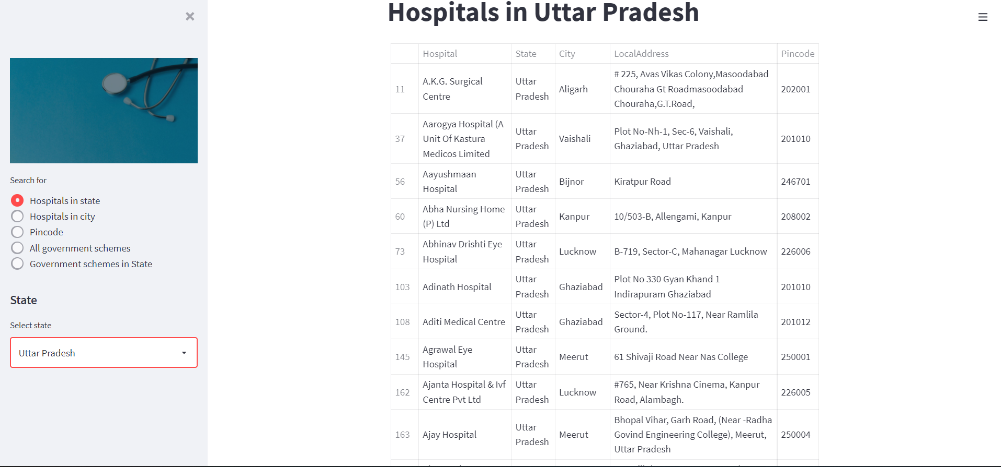

1. **Search for hospitals in a particular state**

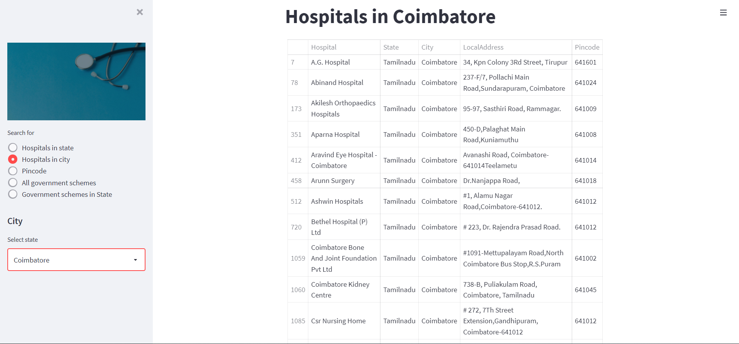

1. **Search for hospitals with a area pincode**

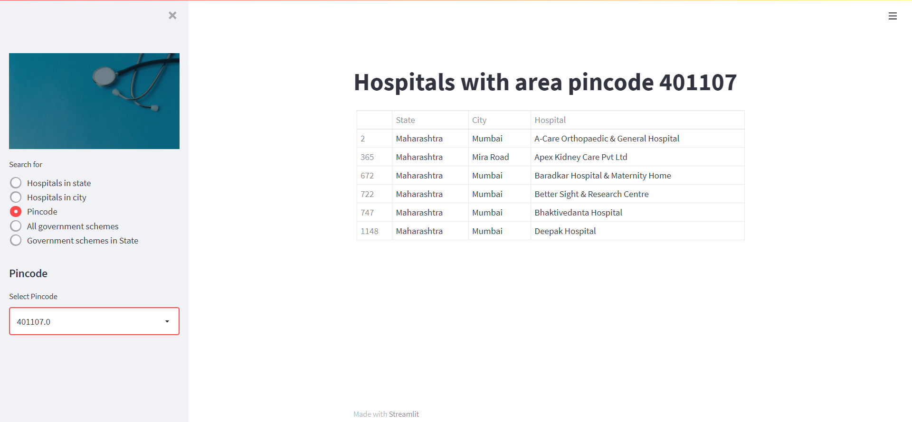

1. **Display government schemes in India**

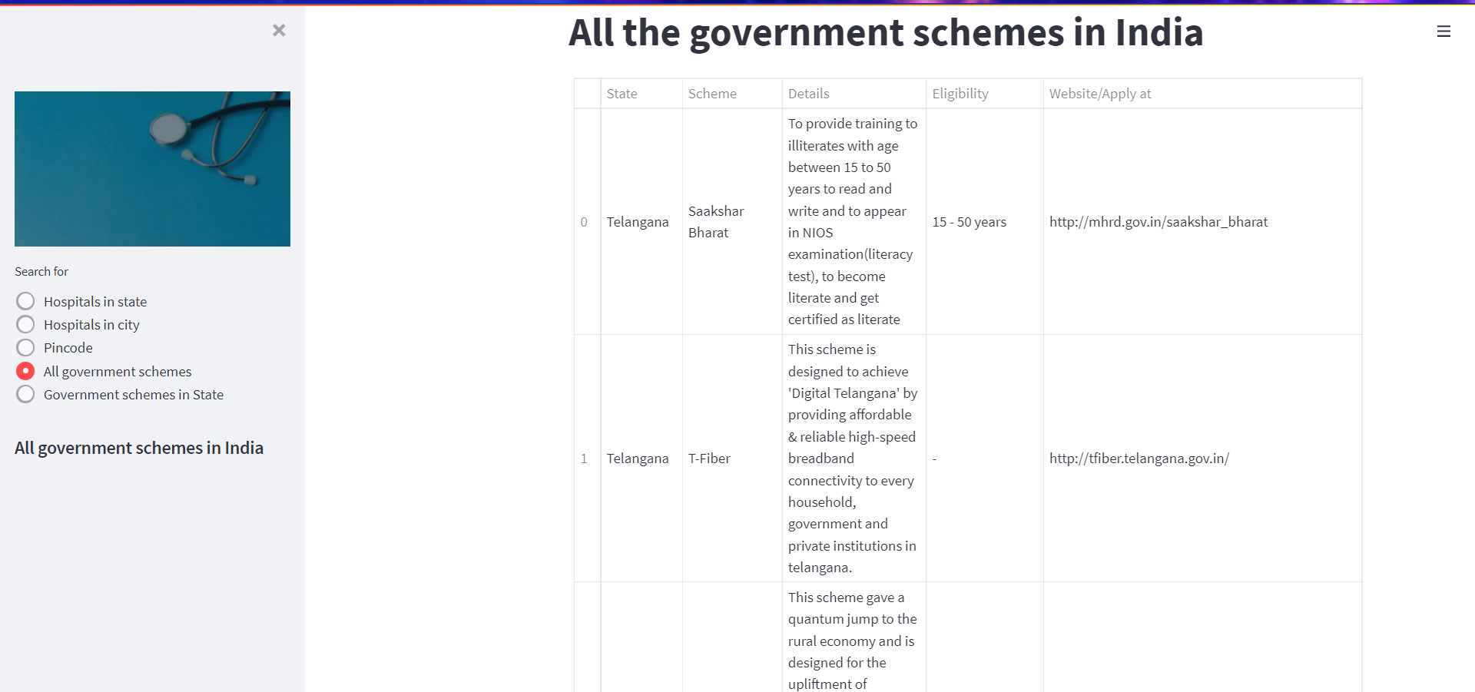

1. **Display government schemes in a particular state**

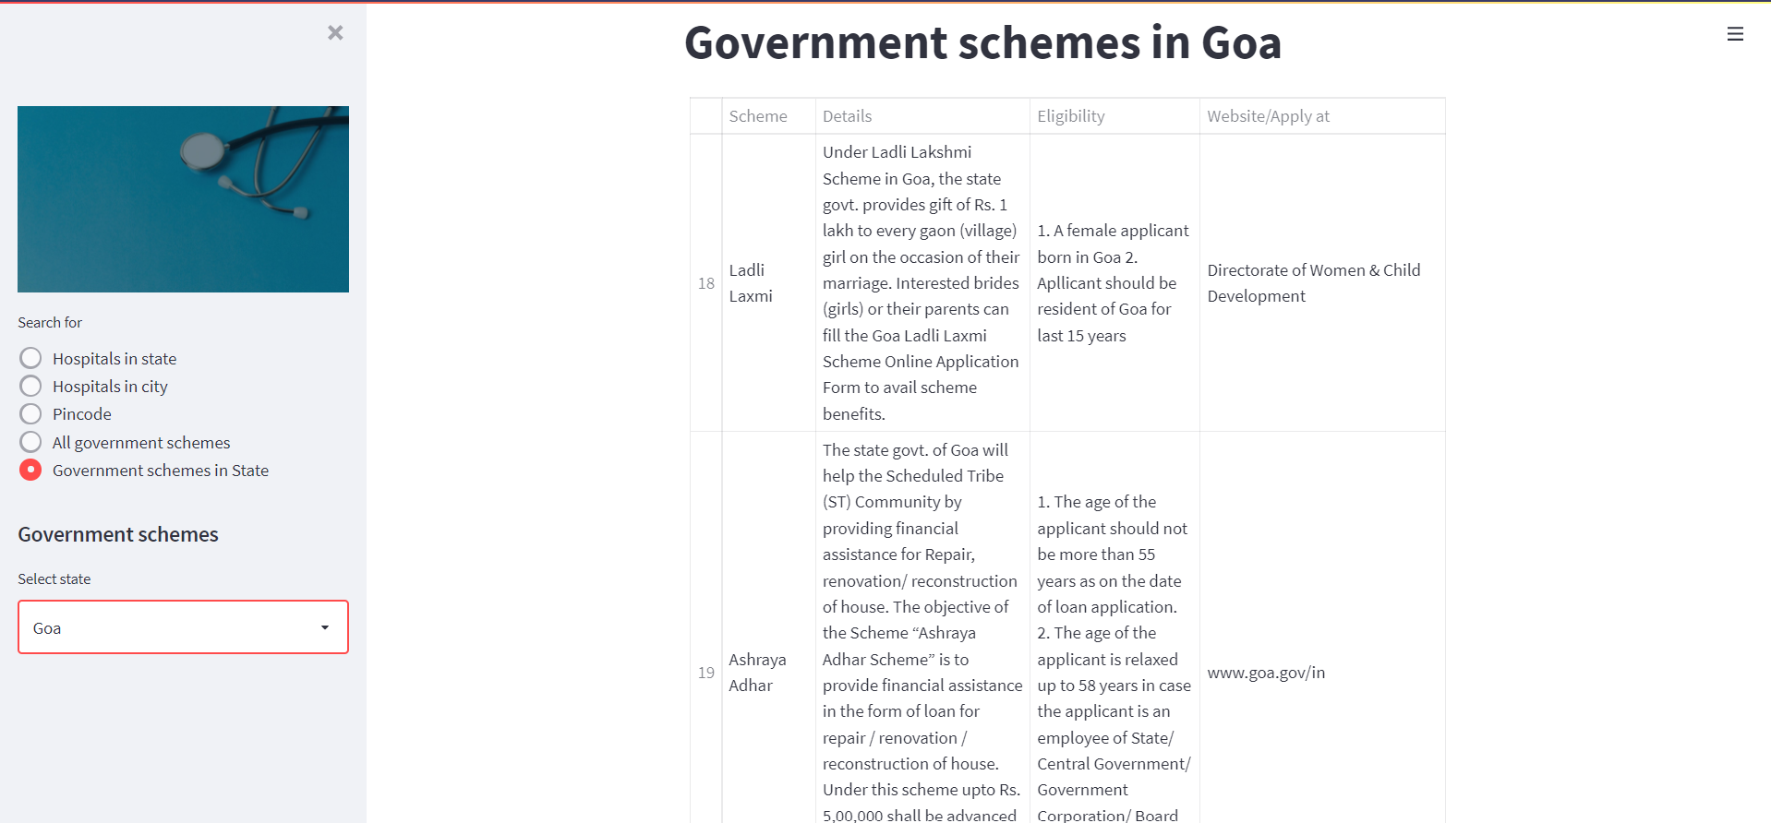

**DISCUSSION AND FUTURE WORK**

**5.1 Discussion**

The web application completely meets the objectives and requirements of the system. The application could successfully output the hospitals based on the input (state name, city name or area pincode) given and it could successfully output the government schemes based on the input given by the user.

* 1. **Future Work**
* To add features like quizzes to know the user more and output government schemes

**REFERNCES**

* <https://towardsdatascience.com/create-a-simple-search-engine-using-python-412587619ff5>
* <https://www.searchenginejournal.com/search-engines/machine-learning/>