**Assignment 1**

A1.

1. public class RectArea { - 4 lexemes

2. public static double area( double length, double width){ - 12 lexemes

3. double area = 0.0; - 5 lexemes

4. try { -2 lexemes

5. area = width*height; - 6 lexemes

6. } catch (Exception e) { - 7 lexemes

7. System.out.println("Error in RectArea.area: " + -8 lexemes

8. e.getMessage()); - 7 lexemes

9. System.exit(1); - 7 lexemes

10. } – 1 lexeme

11. return area; - 3 lexemes

12. } – 1 lexeme

13. } – 1 lexeme

A2.

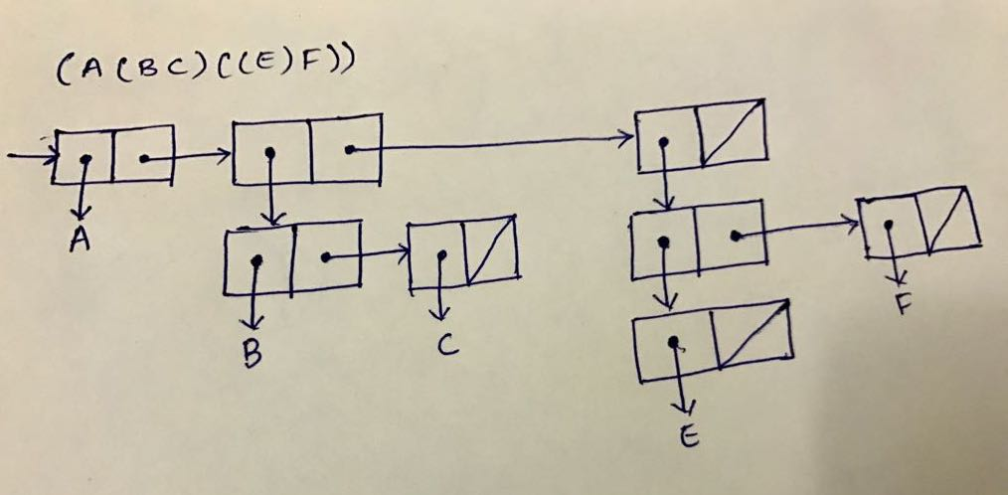

A3.

Benefits:

Typeless languages are easy to learn as the data types are internally managed. Also, it is easy to write complex programs. Moreover, it is easy to make changes as the change in the variable data type need not be explicitly done. The change can be automatically accommodated.

Drawbacks:

It is difficult to understand a program in typeless language as it is ambiguous and confusing to understand the programmer’s intent to create the variable. It is also difficult to maintain. Typeless language may be less reliable as there is a great scope for errors. For example, multiplying one string with another generates an error in a typed language but a typeless program will not result in a crash.

A4.

Pros:

Distinguishing uppercase and lowercase identifiers will give more possible identifiers. Also, we can use different convention to distinguish between variables and constants. It avoids confusion caused when two names that are represented different are considered same.

Cons:

It makes the program less readable as the variables which look very similar are entirely different.

Q5.

a) True

b) 1.(DEFUN equal_lists (lis1 lis2)

2. (COND

3. ((ATOM lis1)(EQ lis1 lis2))

4. ((ATOM lis2) NIL)

5. ((equal_lists(CAR lis1) (CAR lis2))

6. (equal_lists(CDR lis1)(CDR lis2)))

7. (T NIL)

8. )

9.)

Number of Calls: 5

Recursion Tree:

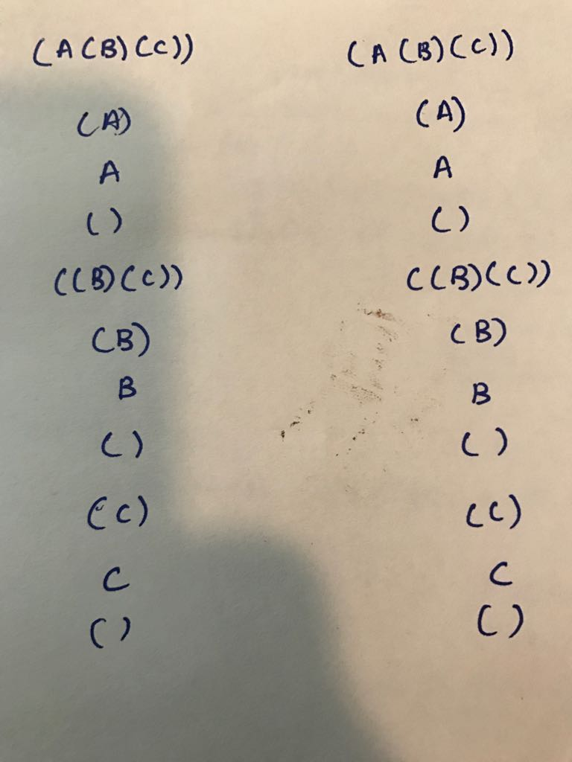

A6.

Line 4: Syntax Eror. int[] arr1 = new int [{65,7,21,14,18};

Line 6: Semantic Error. selectionSort(arr2); arr2 is not declared.

Line 11: Semantic Error. for (int j =0; j =i-1; j++). An integer value of i-1 is being assigned instead of a Boolean value (the condition part of the for loop).

Line 16: Semantic Error. int temp = arr[j]; The variable j is not available in the if block.

Line 21: Syntax Error. System.out.println("Sorted array: +Arrays.toString(arr)); Missing closing quotations.