ASSIGNMENT 2

1. Rightmost derivation:

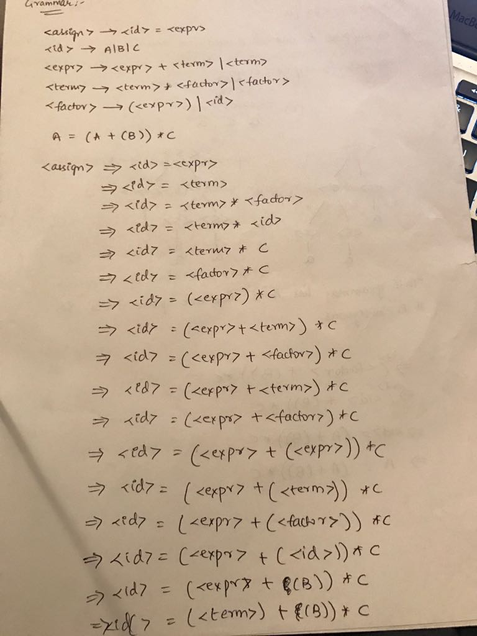

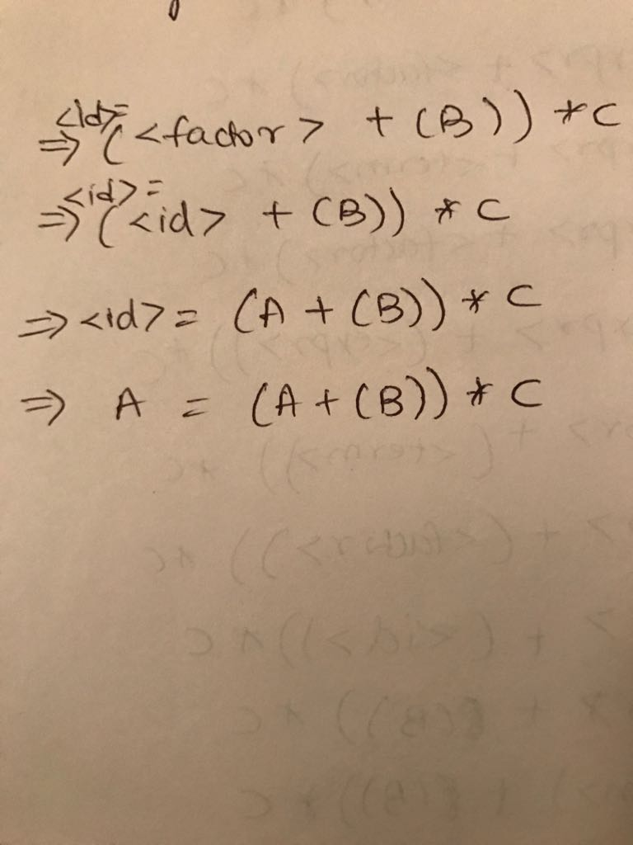

Parse Tree:

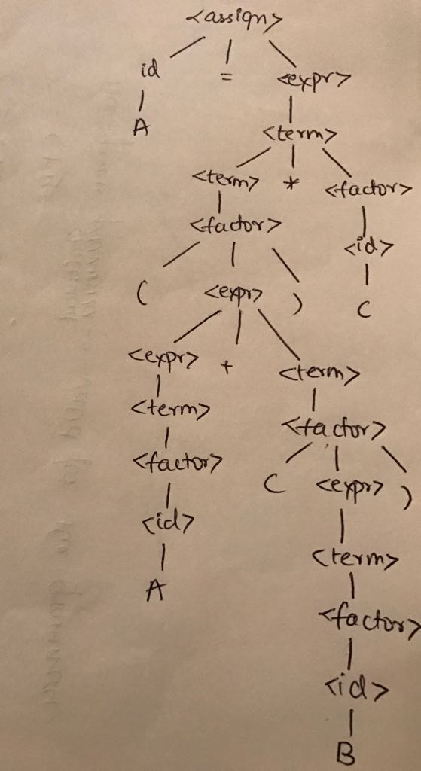

2.

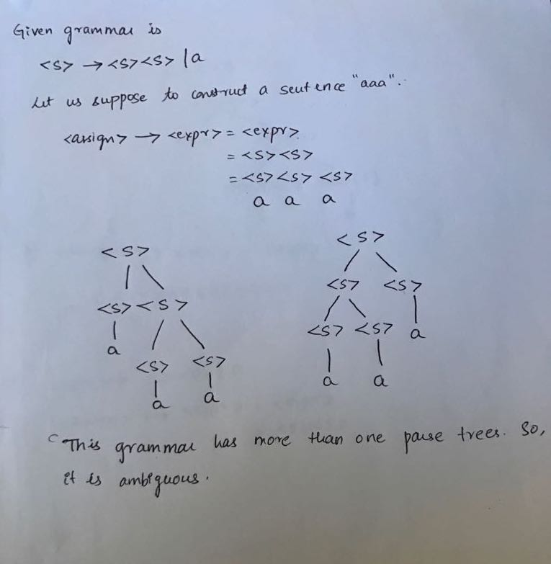

3. Converting EBNF to BNF

a.) <procedure-heading -> procedure-id

| procedure-id <formal-parameter-list>

<formal-parameter-list> -> ( <new-type> )

<new-type> -> formal-parameter-section

| formal-parameter-section ; <new-type>

identifier -> letter | letter <new>

<new> -> letter <new> | digit <new>

4. Converting BNF to EBNF

<formal parameter part> <empty>? <parameter delimiter> + <formal parameter list>? <identifier>

5.

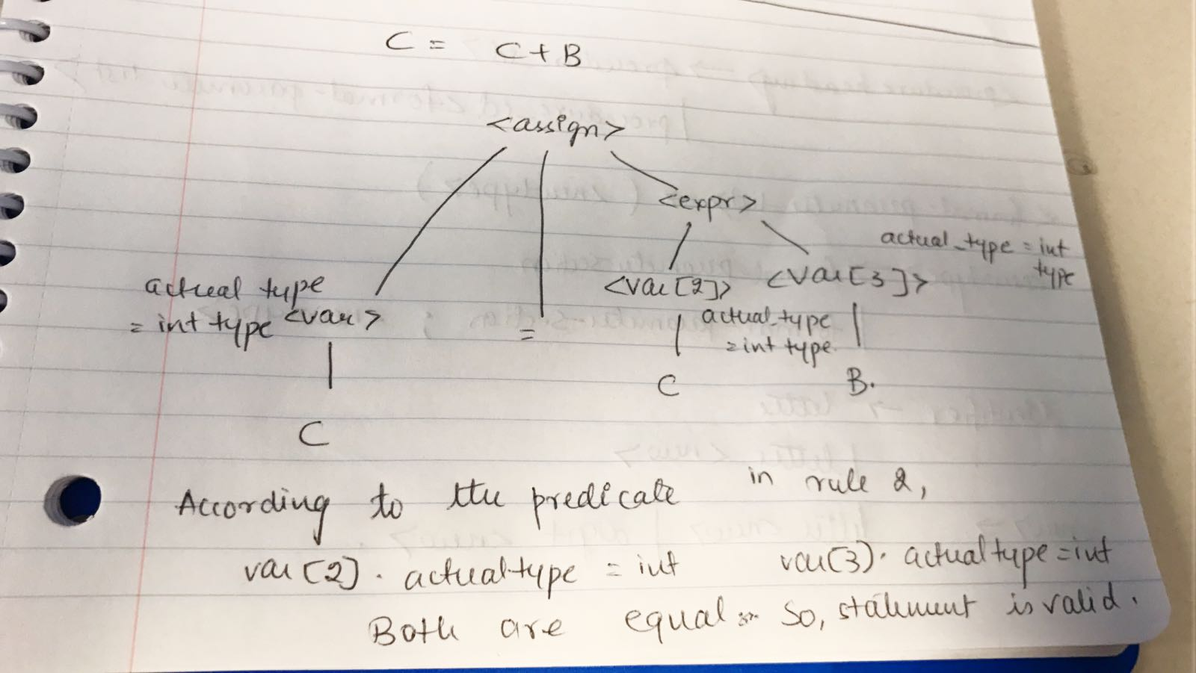

6.

Given: while i <= j do

n = n \* 3;

i = i + 1;

end {n = 3j}

a.) j must be greater than i in any scenario. As the loop has to end or j must not be less than i.

Since j>=1 keeps decreasing and I keeps increasing.

So, j will become j = i+1 or i+2. On looping, I = i+1 and J = I or i+1 where I and J are the computed new values such that I = J or J+1 for the loop to end.

b.) The invariant in this problem is that i+j remains same.