Documentation of how to install and run the project.

1. Download the zip file that is uploaded in the canvas.
2. Unzip/ extract the file and save it in any drive folder. Ex: C-drive
3. Open VSCode and click on file -> open folder and select the unzipped folder and click select folder.(make sure python is installed)
4. Now click on Terminal -> New Terminal and type cd .\django_quiz-main\
5. Type Python –m venv venv
6. Type .\venv\Scripts\activate

If you get an error like Unauthorized Access .\venv\Scripts\activate : File D:\django_quiz-main\django_quiz-main\venv\Scripts\Activate.ps1 cannot be loaded because running scripts is disabled on this system.

For more information, see about_Execution_Policies at https:/go.microsoft.com/fwlink/?LinkID=135170.

At line:1 char:1

+ ~~~~~~~~~

+ CategoryInfo : SecurityError: (:) [], PSSecurityException

+ FullyQualifiedErrorId : UnauthorizedAccess

Go to windows powershell and run as Administrator and type set-executionpolicy remotesigned and Enter and type A.

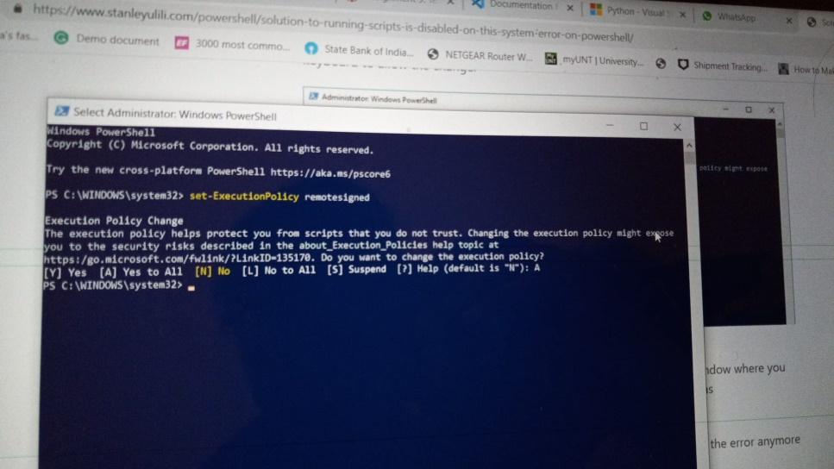

Now go back to VSCode and run .\venv\Scripts\activate again.

1. Type pip install –r .\requirements.txt and wait for the requirements /packages to install.
2. Type cd. \quiz_project\
3. Type python .\manage.py runserver and enter

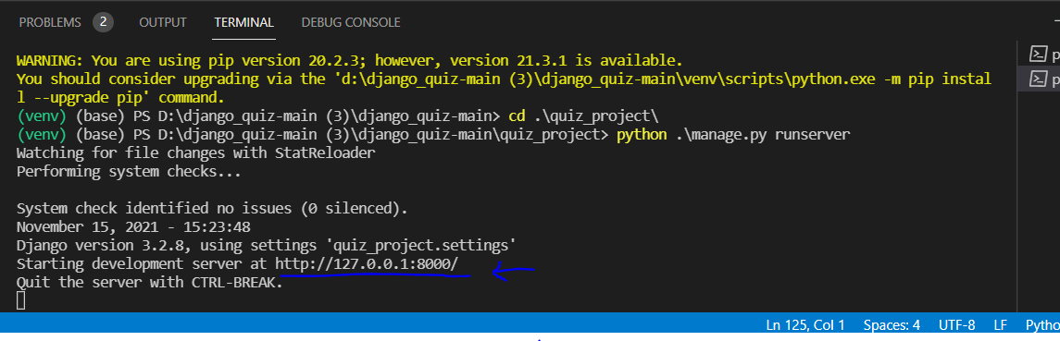

1. Click ctrl+http://127.0.0.1:8000/ hyperlink and the application will open in a new browser window.

