SNAKE GAME


An
Object-Oriented Programming through Java Course Project Report
in partial fulfilment of the degree

Bachelor of Technology
in
Computer Science & Engineering

By

J. Akshay Kumar 2103A51L14
N. Sai Dikshith 2103A51L25

Submitted to

DEPARTMENT OF COMPUTER SCIENCE & ENGINEERING

CERTIFICATE

This is to certify that the Object Oriented Programming through Java - Course Project Report entitled “SNAKE GAME” is a record of bonafide work carried out by the students J. Akshay Kumar, N. Sai Dikshith bearing Roll No(s) 2103A51L14 , 2103A51L25 during the academic year 2019-20 in partial fulfillment of the award of the degree of Bachelor of Technology in Computer Science & Engineering by the Jawaharlal Nehru Technological University, Hyderabad.

Lab In-charge Head of the Department

TABLE OF CONTENTS

TITLE | PAGE NO
Abstract | 1
Objective | 2
Definition of elements used in project | 3 - 6
Design | 7
Implementation of Code | 8 – 17
Result Screens | 18 - 21
Conclusions | 22

ABSTRACT

The Project entitled “Snake Game” is a simple console application without graphics. In this project you can play the popular “Snake Game” just like you played it elsewhere. You have to use the up, down, right or left arrows to move the snake. Food are provided at the several co-ordinates of the screen for the snake to eat. Every time the snake eats the food, its length will by increased by one element along with the score. I have used Java as Programming language for writing the code for the project and Eclipse IDE for writing the programs.
This project is a game written in java based on the game called “snake” which has been around since the earliest days of home computing and has re-emerged in recent years on mobile phones. This project aims to bring more fun and simplicity of snake game. In this it will calculate the score.

OBJECTIVE

Snake game is one of the most popular arcade games of all the time. In this game, the main objective is to catch the maximum number of apples without hitting itself or to the wall (edges of the frame).
Use arrows keys to control the snake.
The snake moves to the right, timer is set to some amount of time, and if manage to press up, down, left, right arrows then very fast (when the timer hasn’t gone off), the snake will move backwards and finally eat itself.
Most of the game doesn’t allow you to change from right to left (up or down) in one step, but this is allowed in this game and can played by one player , who has the objective of obtaining the highest score possible. The player is in a control of the snake which is constantly moving around the board. The snake is go on increasing its height according to eating the food. If it touches the border or its tail the game is over.
It isn’t the world’s greatest game, but it does give you an idea of what you can achieve with a relatively java programming, and perhaps the basis by which to extend the principles and create more interesting games on your own.

DEFINITIONS OF THE ELEMENTS USED

- Event Queue :
Event Queue is a platform-independent class that queues events, both from the underlying
peer classes and from trusted application classes. There is only one Event Queue for the
system.
It encapsulates asynchronous event dispatch machinery which extracts events from the
queue and dispatches them to the appropriate client program. The particular behavior of
this machinery is implementation-dependent. The only requirements are that events which
were actually en-queued to this queue (note that events being posted to the Event Queue
can be collapsed are dispatched:
Sequentially,
That is, it is not permitted that several events from this queue are dispatched
simultaneously. In the same order as they are en-queued.
That is, if AWT Event A is en-queued to the Event Queue before AWT Event B then
event B will not be dispatched before event A.

- Action Event :
This class inherits methods from the following classes:
java.awt.AWTEvent
java.util.EventObject
java.lang.Object
An action event occurs, whenever an action is performed by the user. Examples: When
the user clicks a button, chooses a menu item, presses Enter in a text field. The result is
that an action Performed message is sent to all action listeners that are registered on the
relevant component.

- Action Listener :
The Java Action Listener is notified whenever you click on the button or menu item. It
is notified against Action Event. The Action Listener interface is found in
java.awt.event package. It has only one method: actionPerformed().
The class which processes the Action Event should implement this interface. The object
of that class must be registered with a component. The object can be registered using
the addActionListener() method. When the action event occurs, that object's
action Performed method is invoked.

Interface Declaration
Following is the declaration for java.awt.event.ActionListener interface −
public interface ActionListener extends EventListener

Key Adapter :
java.lang.Object
java.awt.event.KeyAdapter
All Implemented Interfaces:
KeyListener, EventListener
public abstract class KeyAdapter
extends Object
implements KeyListener
An abstract adapter class for receiving keyboard events. The methods in this class are empty. This class exists as convenience for creating listener objects.
Extend this class to create a KeyEvent listener and override the methods for the events of interest.
(If you implement the KeyListener interface, you have to define all of the methods in it. This abstract class defines null methods for them all, so you can only have to define methods for events you care about.)
Create a listener object using the extended class and then register it with a component using the component's addKeyListener method. When a key is pressed, released, or typed, the relevant method in the listener object is invoked, and the KeyEvent is passed to it.

- JFrame :
JFrame is a Swing’s top-level container that renders a window on screen. A frame is a
base window on which other components rely, such as menu bar, panels, labels, text
fields, buttons, etc. Almost every Swing application starts with JFrame window. This
article provides a summary of common practices when using JFrame in Swing
development.
When we create a JFrame object, by default, it is not visible. We have to call
its setVisible(boolean visible) method to make it visible. true parameter makes the frame
visible, to hide the frame pass false to the set Visible method.

- JPanel :
JPanel, a part of the java swing package, is a container that can store a group of components.
The main task of JPanel is to organize components, various layouts can be set in JPanel
which provide better organization of components, however, it does not have a title bar.

- JLabel :
The object of JLabel class is a component for placing text in a container. It is used to display a single line of read only text. The text can be changed by an application but a user cannot edit it directly. It inherits JComponent class.
JLabel class declaration
public class JLabel extends JComponent implements SwingConstants, Accessible
JLabel is a class of java Swing . JLabel is used to display a short string or an image
icon. JLabel can display text, image or both. JLabel is only a display of text or image
and it cannot get focus . JLabel is inactive to input events such a mouse focus or
keyboard focus.

- JButton :
The JButton class is used to create a labeled button that has platform independent
implementation. The application result in some action when the button is pushed. It
inherits AbstractButton class. The class JButton is an implementation of a push button. This component has a label
and generates an event when pressed. It can also have an Image.
The JButton is the class that is used to create a button in a JavaSE application.Use
to send actions to your application whenever a user interacts with the button by either
clicking, hovering, etc

- JTextField :
The object of a JTextField class is a text component that allows the editing of a single line
text. It inherits JTextComponent class.
JTextField are a very useful part of your Swing Toolkit. Simply put, the TextField lets the
user enter text into your program without using a command line prompt.
JTextField is also a feature of Java Swing.which allows the single line editing of the text. The
main intention is to keep its stability and compatibility intact with java.awt.TextField and
forms an integral part of the javax.swing package.

DESIGN
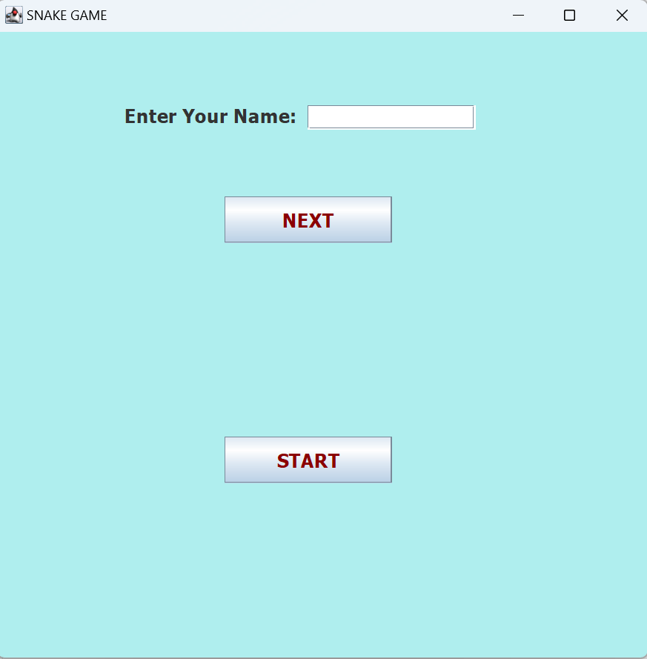

The above screen contains the operations to be performed. As mentioned the operations are.Enter your name and the name can be entered in the textfield as input and button next is specified when you click it the label displays the name entered with welcome and display the message (to play click start).when you click the start button the game starts and new frame will appears.

IMPLEMENTATION

Main Method:

// Snake game class with main method ()

public class SnakeGame {

public static void main(String[] args) {
new Home();
}

}
Home page:

import java.awt.EventQueue;
import javax.swing.JFrame;
import javax.swing.JTextField;
import javax.swing.JButton;
import java.awt.Font;
import java.awt.event.ActionEvent;
import java.awt.event.ActionListener;
import java.awt.Color;
import javax.swing.JLabel;
import javax.swing.UIManager;

public class Home {

private JFrame Frame1;
private JTextField txt;

/**
* Launch the application.
*/
public static void main(String[] args) {
EventQueue.invokeLater(new Runnable() {
public void run() {
try {
Home window = new Home();
window.Frame1.setVisible(true);
} catch (Exception e) {
e.printStackTrace();
}
}
});
}

/**
* Create the application.
*/
public Home() {
initialize();
}

/**
* Initialize the contents of the frame.
*/
private void initialize() {
Frame1 = new JFrame();
Frame1.getContentPane().setBackground(new Color(175, 238, 238));
Frame1.setTitle("SNAKE GAME");
Frame1.setBounds(310, 80, 600, 600);
Frame1.setDefaultCloseOperation(JFrame.EXIT_ON_CLOSE);
Frame1.getContentPane().setLayout(null);

JLabel lb = new JLabel("Enter Your Name:");
lb.setFont(new Font("Tahoma", Font.BOLD, 17));
lb.setBounds(115, 65, 155, 20);
Frame1.getContentPane().add(lb);

txt = new JTextField();
txt.setFont(new Font("Tahoma", Font.BOLD, 13));
txt.setColumns(10);
txt.setBounds(280, 66, 151, 22);
Frame1.getContentPane().add(txt);

final JLabel lb1 = new JLabel(" ");
lb1.setForeground(new Color(255, 0, 0));
lb1.setFont(new Font("Calibri", Font.BOLD, 23));
lb1.setBounds(69, 245, 478, 74);
Frame1.getContentPane().add(lb1);

JButton btn = new JButton("NEXT");
btn.setBackground(UIManager.getColor("Button.background"));
btn.setForeground(new Color(139, 0, 0));
btn.setFont(new Font("Tahoma", Font.BOLD, 17));
btn.addActionListener(new ActionListener() {

@Override
public void actionPerformed(ActionEvent e) {
String name=txt.getText();
lb1.setText("Welcome "+name+" to play game click on start");
}
});
btn.setBounds(205, 148, 151, 42);
Frame1.getContentPane().add(btn);

JButton btn1 = new JButton("START");
btn1.setForeground(new Color(139, 0, 0));
btn1.setFont(new Font("Tahoma", Font.BOLD, 17));
btn1.addActionListener(new ActionListener() {
public void actionPerformed(ActionEvent e) {
new GameFrame();
Frame1.dispose();
}
});
btn1.setBounds(205, 364, 151, 42);
Frame1.getContentPane().add(btn1);

}
}

OUTPUT:

Game Frame:

import javax.swing.JFrame;

public class GameFrame extends JFrame {

GameFrame(){

this.add(new GamePanel());
this.setTitle("SNAKE GAME");
this.setDefaultCloseOperation(JFrame.EXIT_ON_CLOSE);
this.setResizable(false);
this.pack();
this.setVisible(true);
this.setLocationRelativeTo(null);
}

}

OUTPUT:
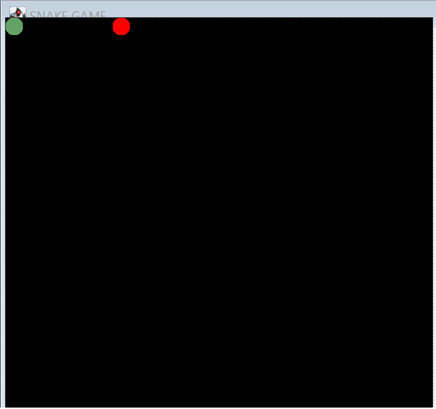
Game Panel:
import java.awt.*;
import java.awt.event.*;
import javax.swing.*;
import java.util.Random;
import javax.swing.JPanel;
public class GamePanel extends JPanel implements ActionListener
{

static final int SCREEN_WIDTH = 600;
static final int SCREEN_HEIGHT =600;
static final int UNIT_SIZE = 25;
static final int GAME_UNITS = (SCREEN_WIDTH*SCREEN_HEIGHT)/UNIT_SIZE;
static final int DELAY = 150;
final int x[] = new int[GAME_UNITS];
final int y[] = new int[GAME_UNITS];
int bodyParts = 8;
int applesEaten;
int appleX;
int appleY;
char direction = 'R';
boolean running = false;
Timer timer;
Random random;

GamePanel(){
random = new Random();
this.setPreferredSize(new Dimension(SCREEN_WIDTH,SCREEN_HEIGHT));
this.setBackground(Color.black);
this.setFocusable(true);
this.addKeyListener(new MyKeyAdapter());
startGame();
}
public void startGame() {
newApple();
running = true;
timer = new Timer (DELAY,this);
timer.restart();
}
public void paintComponent(Graphics g) {
super.paintComponent(g);
draw(g);
}
public void draw(Graphics g) {
if(running) {
g.setColor(Color.red);
g.fillOval(appleX, appleY, UNIT_SIZE, UNIT_SIZE);

for(int i = 0; i< bodyParts;i++) {
if(i == 0) {
g.setColor(Color.green);
g.fillOval(x[i], y[i], UNIT_SIZE, UNIT_SIZE);
}
else {
g.setColor(new Color(45,180,0));
g.setColor(new Color(random.nextInt(255),random.nextInt(255),random.nextInt(255)));
g.fillOval(x[i],y[i],UNIT_SIZE, UNIT_SIZE);
}
}
}
else {
GameOver(g);
}
}

public void newApple() {
appleX = random.nextInt((int)(SCREEN_WIDTH/UNIT_SIZE))*UNIT_SIZE;
appleY = random.nextInt((int)(SCREEN_HEIGHT/UNIT_SIZE))*UNIT_SIZE;
}
public void move() {
for(int i = bodyParts;i>0;i--) {
x[i] = x[i-1];
y[i] = y[i-1];
}

switch(direction) {
case 'U':
y[0] = y[0] - UNIT_SIZE;
break;
case 'D':
y[0] = y[0] + UNIT_SIZE;
break;
case 'L':
x[0] = x[0] - UNIT_SIZE;
break;
case 'R':
x[0] = x[0] + UNIT_SIZE;
break;
}
}
public void checkApple() {
if((x[0] == appleX) && (y[0] == appleY)) {
bodyParts++;
applesEaten++;
newApple();

}
}
public void checkCollisions() {
//checks if head collides with body
for(int i = bodyParts;i>0;i--) {
if((x[0] == x[i]&& (y[0] == y[i]))){
running = false;
}
}
//check if head touches left border
if(x[0] < 0) {
running = false;
}
//check if head touches right border
if(x[0] > SCREEN_WIDTH) {
running = false;
}
//check if head touches top border
if(y[0] < 0) {
running = false;
}
//check if head touches bottom border
if(y[0] > SCREEN_HEIGHT) {
running = false;
}

if(!running) {
timer.stop();
}
}
public void GameOver(Graphics g) {
//Score
g.setColor(Color.blue);
g.setFont( new Font("Ink Free",Font.BOLD,40));
FontMetrics metrics1 = getFontMetrics(g.getFont());
g.drawString(" Your "+"score is: "+applesEaten, (SCREEN_WIDTH - metrics1.stringWidth("Score: "+applesEaten))/3, g.getFont().getSize());
//Game Over text
g.setColor(Color.red);
g.setFont( new Font("Times New Roman",Font.BOLD, 75));
FontMetrics metrics2= getFontMetrics(g.getFont());
g.drawString("Game Over", (SCREEN_WIDTH - metrics2.stringWidth("Game Over"))/2, SCREEN_HEIGHT/2);
}

@Override
public void actionPerformed(ActionEvent e) {

if(running) {
move();
checkApple();
checkCollisions();
}
repaint();
}

public class MyKeyAdapter extends KeyAdapter{
@Override
public void keyPressed(KeyEvent e) {
switch(e.getKeyCode()) {
case KeyEvent.VK_LEFT:
if(direction != 'R') {
direction = 'L';
}
break;
case KeyEvent.VK_RIGHT:
if(direction != 'L') {
direction = 'R';
}
break;
case KeyEvent.VK_UP:
if(direction != 'D') {
direction = 'U';
}
break;
case KeyEvent.VK_DOWN:
if(direction != 'U') {
direction = 'D';
}
break;
}
}
}

}

RESULT SCREENS

Screen – 1:-

This is the Home page of snake game.

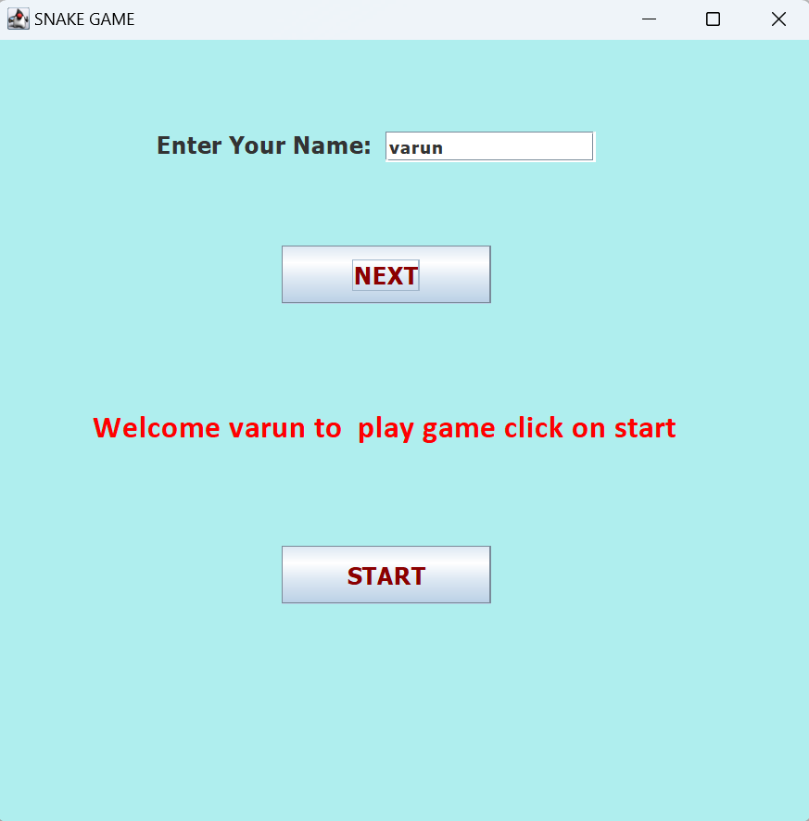

Screen – 2:-

This is the page where the user can paly the game

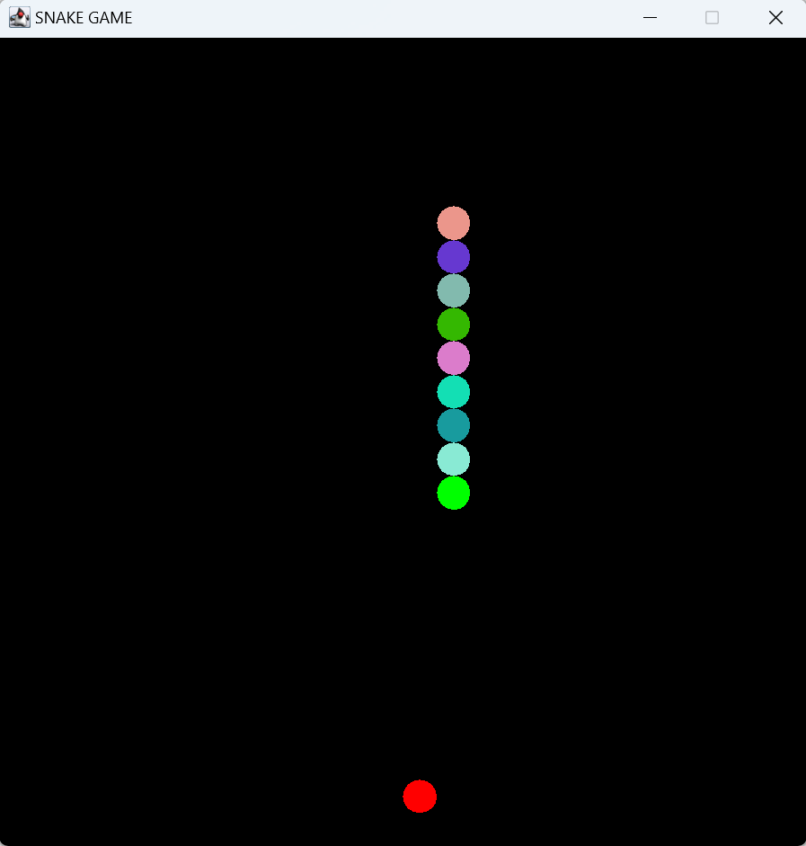

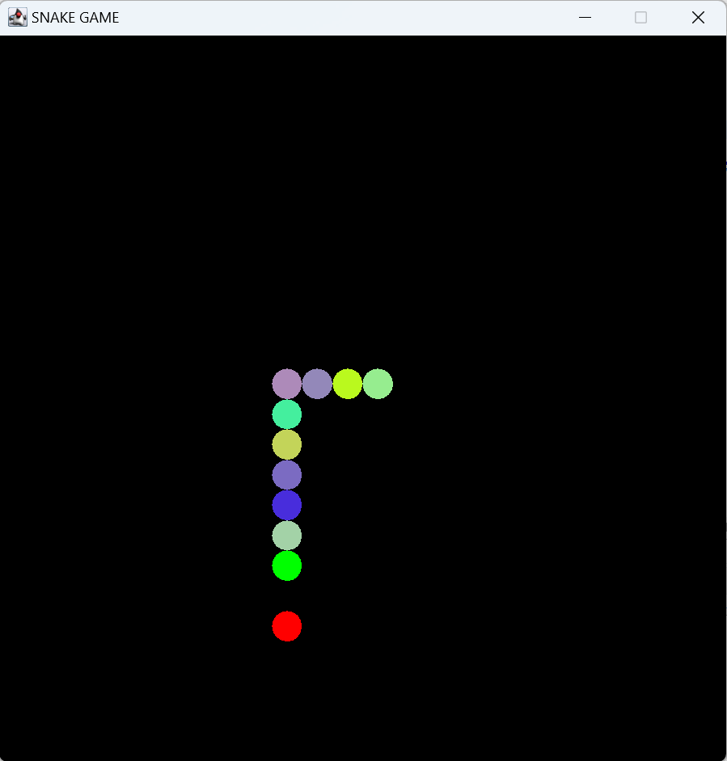

when the snake eat the apple the size will be increased by one

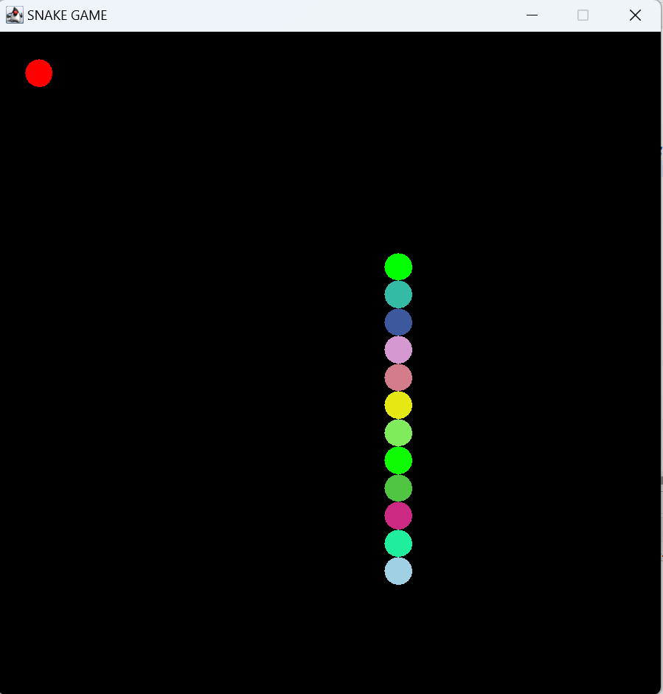

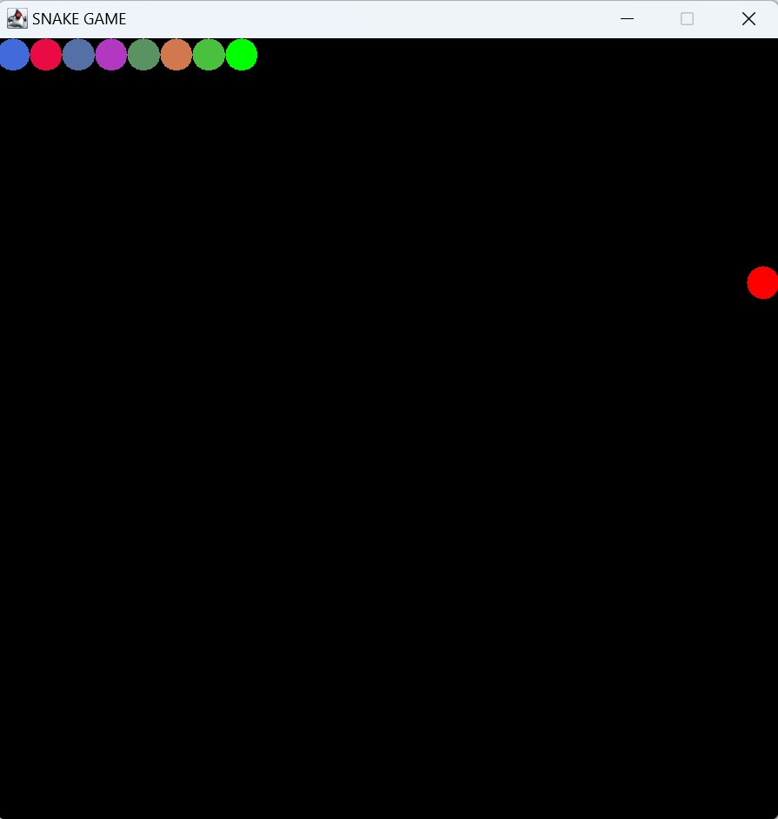

Screen – 3:-

If the snake in the frame touches itself and when it his the frame border of four side then the game is over and display the score which is number of the apples the snake has eaten.

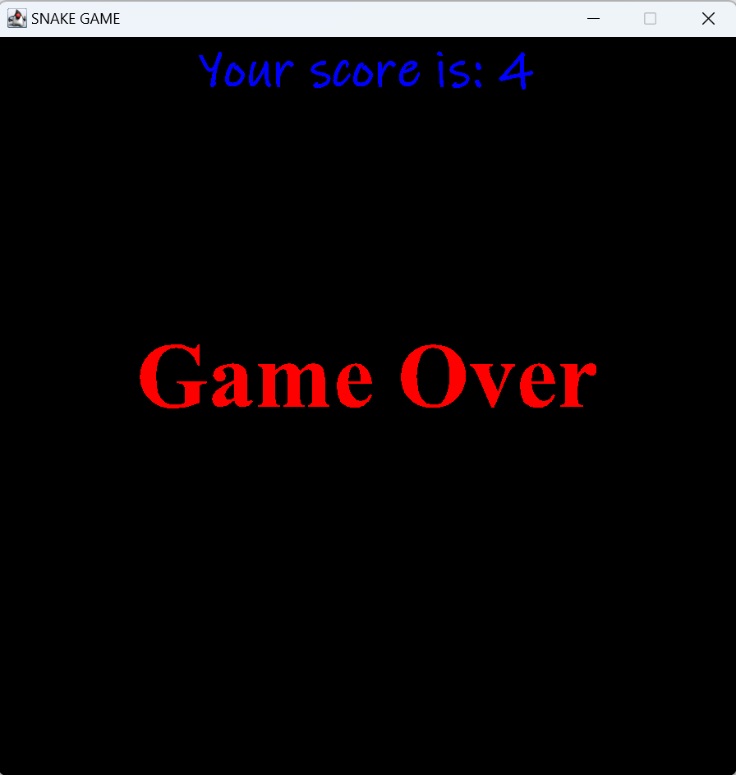

CONCLUSIONS

The project in java programming of Snake Game is a simple console application with very simple graphics. In this project, you can play the popular “Snake Game” just like you played it elsewhere. You have to use the up, down, right, or left arrows to move the snake. Foods are provided at the several co-ordinates of the screen for the snake to eat. Every time the snake eats the food, its length will be increased by one element along with the score.
And this project gives us more thrilling experience and more excitement. It helps us in many sectors like planning, programming skills and can be played by any one with using the arrows keys easily.

