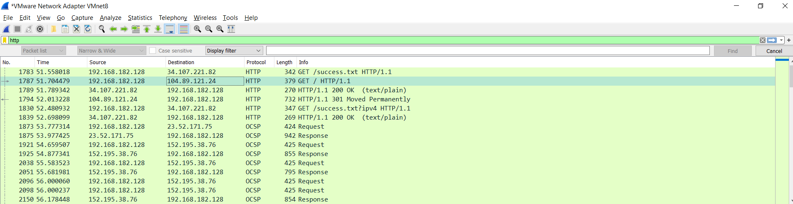

I have recorded the browsing history for some time and accessed http protocol

For the visited websites such as redhat I have added it hear.