Session: https://app-automate.browserstack.com/builds/sessions/02094d03333cf2dfa476cb2a47fd04bcceb2f0b8
Booking flow: Selected seat A1 (VIP, $120) at Neon Skyline → Riverside Arena → proceeded through discount and payment screens. Payment total showed USD 120.00 correctly (no discount applied). Tapped "Pay Now" — spinner appeared and never resolved (same payment hang as all previous sessions). Navigated back without completing payment; seat A1 remained available (40 of 40 still shown on event details), confirming the PRD rule that no seat is held until payment completes.
Other Riverside Arena events — seat availability check:
Event | Venue | VIP price | Standard price | Available
Neon Skyline (evt-01) | Riverside Arena | $120 | $65 | 40/40
Arena Anthems (evt-18) | Riverside Arena | $110 | $60 | 40/40
Nothing unexpected about seat availability — both events show all 40 seats available, and the seat map layout (rows A-B VIP, rows C-E Standard, 8 seats per row) is identical across both events at the same venue, consistent with the PRD rule that each venue has one fixed seat map. Prices differ between events at the same venue, which is also correct per the PRD ("what the venue charges for that particular event"). No cross-event seat contamination or unexpected booked seats were found.

Session Starting:

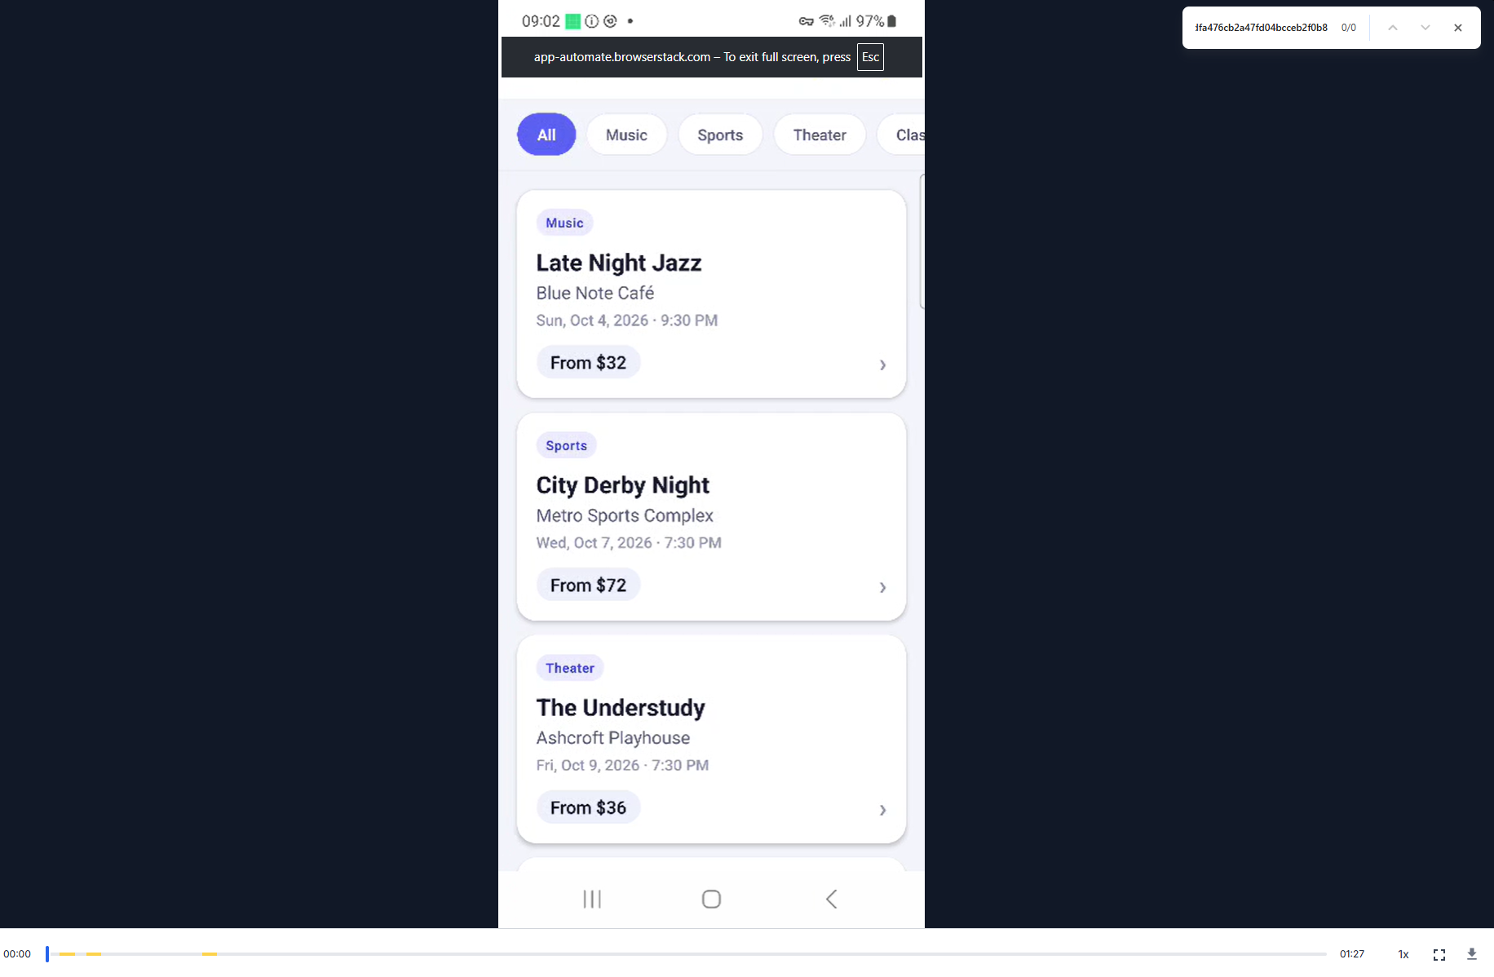
Session Ending: