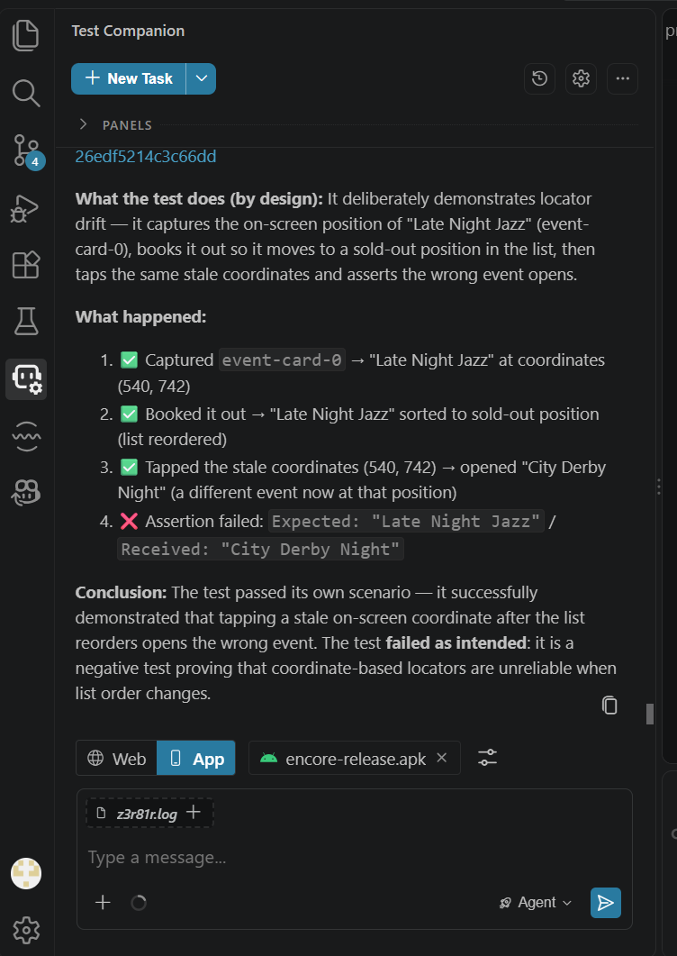

This is not an app bug. The test is a deliberately constructed negative test that proves a known automation anti-pattern:

1. It captures the screen coordinates of "Late Night Jazz" at position (540, 742)
2. It books that event out, causing the list to reorder (sold-out events move to the bottom)
3. It taps the same stale coordinates which now point to a different event ("City Derby Night")
4. The assertion `Expected: "Late Night Jazz" / Received: "City Derby Night"` fires as intended

Verdict: Automation Issue specifically, the test is demonstrating that coordinate-based or index-based locators break when list content changes. The app behaved correctly: it reordered the list after a sell-out (expected behaviour per PRD), and the event that opened was genuinely the one at those coordinates. The "failure" is the test catching its own anti-pattern, not the app doing something wrong.

The correct fix (if this were a real test rather than a demo) would be to use a stable resource-id selector (`event-card-evt-XX`) rather than captured coordinates, so the locator follows the element regardless of its position in the list.

