Description:

In this task, we must create a database management system (DBMS) in order to create tables and databases. In this case, we must build a total of 5 Tables in a single database. Because the database name isn't specified in this job, we can give it any name we like. Customer information, Product information, Supplier information, Sales information, and Store information are the five tables. Three to four properties are integrated for each table or object. First One is Product Info- Part Number, Quantity, Cost. The second one is Customer info- Customer Name, Customer ID, First Sale Date, And Total sales number.

The third one is supplier info- Supplier Name, Time of Delivery, Next date of delivery, Expected quantity. The fourth one is sales info- item sold, date, price, profit. The last one is Store info- Employee Names, Employee Roles, Employee ID. There are many entities relationships that also take place in this task between customer & store, Customer & Sales, Product & Sales, etc. Primary & Foreign keys are also used in this task like ID#.

Query:

SELECT Customer_name,Customer_id, Total_Sales_Number from customer_info where Total_Sales_Number >100 ORDER BY `customer_info`.`Customer_name` ASC

Output:

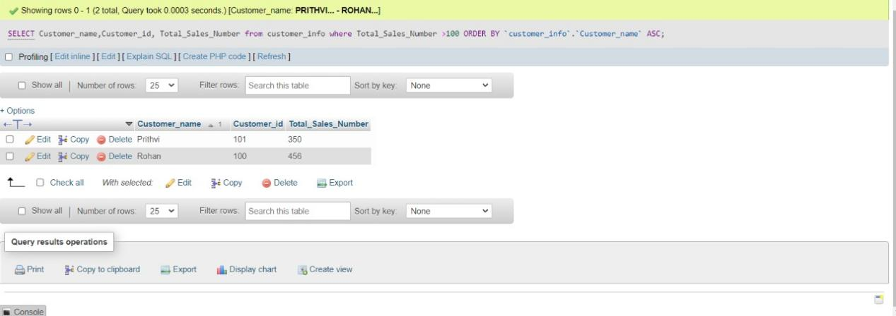

SELECT Part_Number,Quantity,Cost FROM product_info where product_info.Quantity<=30 GROUP BY Part_Number,cost, Quantity ASC

Output:

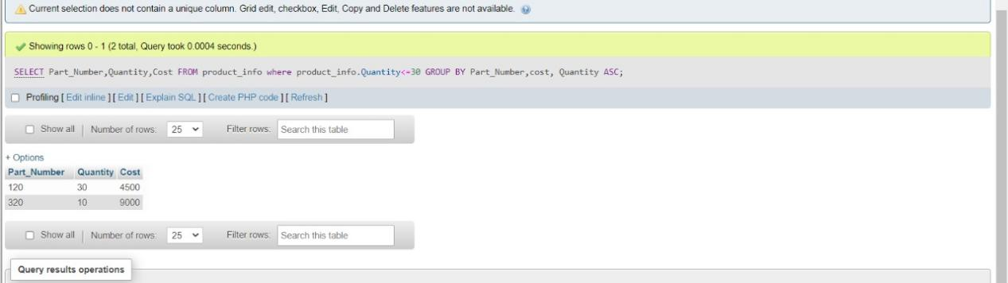

SELECT SUM(Profit) as total_profit FROM sales_info WHERE Date>'2021/10/12';

Output:

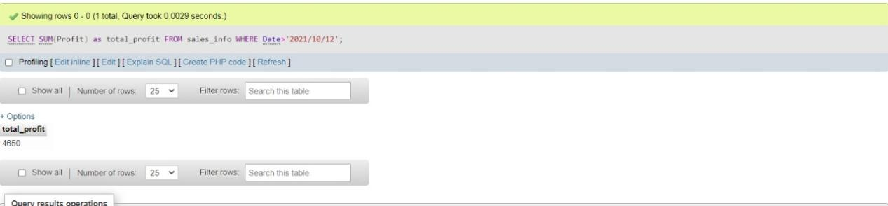

SELECT * FROM store_info where Employee_name LIKE 'T%';

Output:

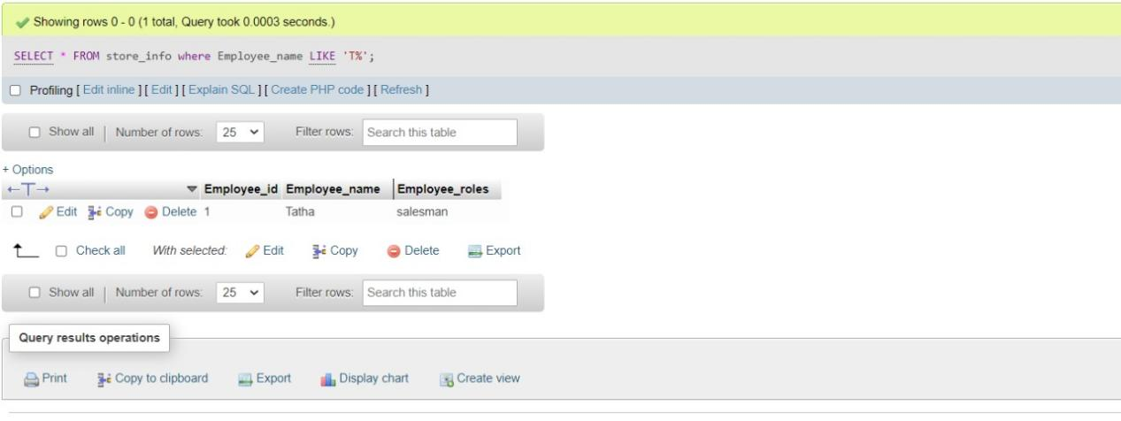

SELECT AVG(Expected_qty) as Average_expectation from supplier_info where Next_delivery_date>'2021/12/10';

Output:

