# 

**After Customer Chooses “Book Button” Show Seat Selection screen: Web app link:** <https://www.buenoexpresstransport.com/#!/Seats>

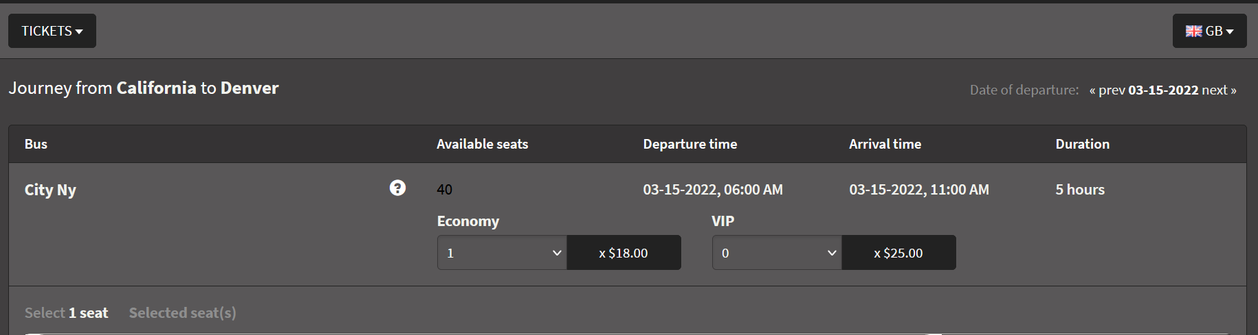

# After Check out screen next screen is

|  |  |  |
| --- | --- | --- |
|  |  |  |
|  |  |  |

**After check out page then comes Booking Details Entry page were the customers enter their information**

**Web app link: https://www.buenoexpresstransport.com/#!/Checkout**

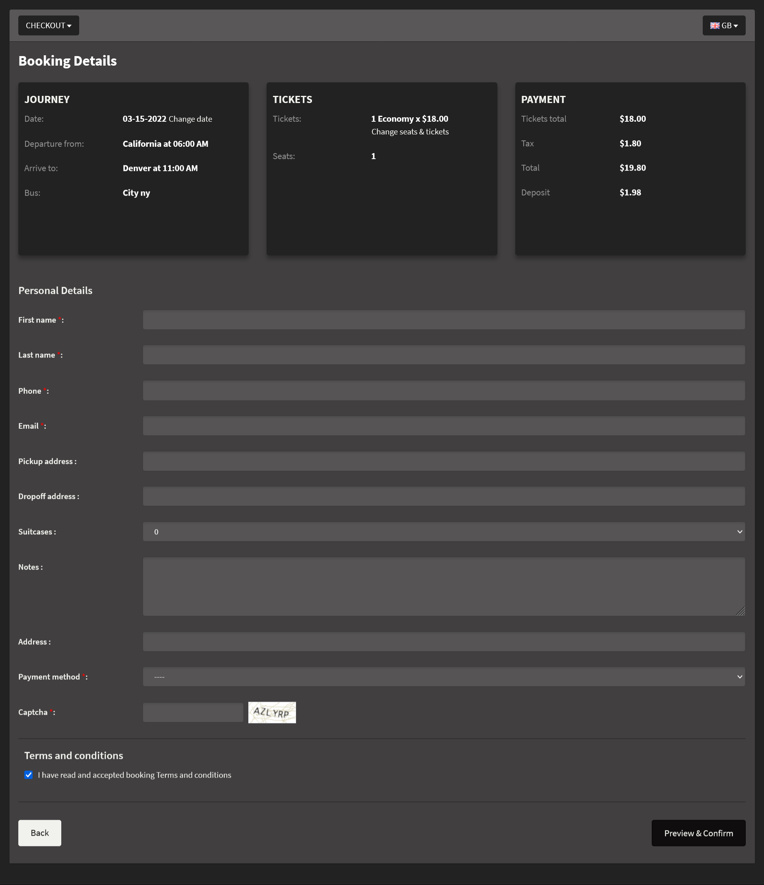

## NEXT SCREEN IS A CONFIRMATION PAGE A PREVIEW OF ALL THE BOOKING DETAILS WEB APP LINK:

## <https://www.buenoexpresstransport.com/#!/Preview>

## Can a pop up window be created when they click confirm it can say a general Message *“ Thank you for your booking Please check your email for Ticket information”.*

## 

## Please make these two options responsive they both can say the following message “ Please check your Email for Trip and Ticket Details”

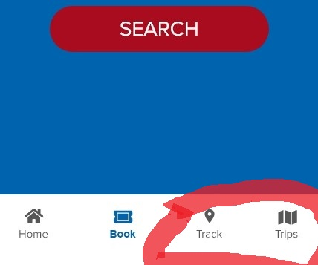

## Side menu Tabs respond with selection but they don’t highlight example

## HOME button on side menu is the only thing that highlights white if you can please make side menu responsive and highlight when selected.

## side menu

**If customers have to pay or make payment make it possible to redirect to payments**