Hybrid Flatness- and Passivity-Based Control with Adaptive RBF Compensation for a 2 MW Direct-Drive PMSG Wind Energy Conversion System
Said Regani, Manal Messadi and Karim Kemih*
L2EI Laboratory, Jijel University, BP 98, Ouled Aissa, Jijel 18000, Algeria;
said.regani@univ-jijel.dz (S.R.); manal.messadi@univ-jijel.dz (M.M.)
* Correspondence: karim_kemih@univ-jijel.dz
Abstract: This paper proposes a hybrid nonlinear control scheme for a 2 MW direct-drive wind energy conversion system based on a permanent magnet synchronous generator (PMSG) connected to the grid through a back-to-back converter. The scheme combines three layers with distinct roles. Flatness-based control (FBC) generates the references of the rotor speed and of the energy stored in the DC link and in the filter, so that the torque and grid-current references are computed directly from the model. Passivity-based control (PBC) regulates the currents of both converters by energy shaping and damping injection while keeping the workless coupling terms of the machine and of the filter. An adaptive radial basis function (RBF) neural network estimates online the lumped aerodynamic-torque and parameter uncertainty and compensates it in the flat speed law without retuning the nominal gains. A composite Lyapunov analysis shows that all closed-loop signals remain bounded, that the current errors converge to zero, and that the speed error converges to a neighborhood of zero whose size depends on the approximation error of the network. The scheme is evaluated with realistic measurements (sensor noise and grid voltage harmonics) under step wind, random wind, parameter uncertainty and a 50 % grid voltage dip. All controlled variables track their references, the DC-link voltage remains within 0.8 % of its reference outside the dip, the grid-current distortion stays below 4 %, and the neural compensation reduces the integral absolute speed error by 26.5 to 44.8 % with the same captured energy.
Keywords: wind energy conversion systems; direct-drive PMSG; differential flatness; passivity-based control; adaptive RBF neural network; Lyapunov stability

1. Introduction
Wind energy has become one of the main sources of the transition towards low-carbon electricity generation [1, 2, 3]. Among the variable-speed technologies, the permanent magnet synchronous generator (PMSG) based wind energy conversion system (WECS) is a preferred structure for multi-megawatt turbines: in the direct-drive configuration it removes the gearbox, which improves the efficiency and the reliability [4, 5], and its full-scale back-to-back converter decouples the generator from the grid [6]. This structure is, however, a multivariable nonlinear system. The aerodynamic torque depends nonlinearly on the wind speed and on the rotor speed, the electrical dynamics contain speed-dependent couplings, and the system is subject to wind variations, torque disturbances, parameter uncertainty and grid disturbances [7, 8].
The machine-side converter (MSC) and the grid-side converter (GSC) are usually controlled by cascaded proportional-integral (PI) loops in rotating frames, i.e., field-oriented control (FOC) [9, 10, 11]. These controllers are simple to implement, but they are tuned on a linearized model, so their performance degrades with the nonlinearity and with the variation of the parameters. Nonlinear alternatives have therefore been proposed to improve the tracking, the power quality and the robustness. Sliding mode control (SMC) was applied to wind turbines with an exponential reaching law [12] and, for a chaotic PMSG in an offshore turbine, in a chattering-free terminal form [13]. Backstepping was used at low wind speeds [14], predictive control was applied to a chaotic PMSG [15], and a fuzzy state-feedback control was designed for a fractional-order direct-drive PMSG with uncertain parameters [16].
Two model-based methods are particularly suited to the structure of the WECS. Differential flatness [17] expresses all the variables of a system from a flat output and its derivatives; it therefore generates the references of the inner variables directly from the desired trajectory, which is valuable during transients and sudden wind changes. Aimene et al. [8] showed that flatness-based control improves the transients of a grid-connected PMSG system with respect to FOC, and Thounthong et al. [18] showed that, with the stored energy as flat output, the DC-bus dynamics become a linear power balance. Passivity-based control (PBC) [19, 20] shapes the energy of the closed loop and injects damping while keeping the physical, workless couplings instead of cancelling them, which gives a robust current control with a clear energy interpretation. Both methods use a model, and their weak point is the aerodynamic torque, which is not measured, and the parameters of the generator.
Learning-based approximators can address this weak point. RBF networks are universal approximators [21] whose weights can be adapted online by a Lyapunov-based law [22, 23]. They were combined with terminal sliding mode control [24], with observer-based adaptive control [25] and with data-driven tuning under real wind profiles [26]. In our previous work [27], an adaptive neural network compensated the residual tracking error of a nonlinear state-feedback controller without retuning its gains, but measurement noise and grid disturbances were not considered. To the authors’ knowledge, a scheme in which flatness generates the references, PBC guarantees the energy structure and the damping of the current loops of both converters, and an adaptive RBF network compensates the uncertainty, evaluated under realistic measurements and grid disturbances, has not been reported for a multi-megawatt direct-drive PMSG.
The main contributions of this work are as follows:
- Flatness-based reference generation: the rotor speed and the energy of the DC link and of the filter are used as flat outputs; the torque and grid-current references are computed directly from the model, and the DC-link dynamics become a linear power balance.
- Passivity-based inner control: the currents of both converters are controlled by energy shaping and damping injection, with a storage function that proves the convergence of the current errors.
- Adaptive RBF compensation: an RBF network estimates online the lumped aerodynamic-torque and parameter uncertainty and compensates it in the flat speed law, with the nominal gains unchanged.
- Composite Lyapunov stability analysis: the boundedness of all closed-loop signals and the convergence of the tracking errors to a neighborhood of zero are proved.
- Realistic numerical validation: the scheme is evaluated with sensor noise and grid harmonics under step wind, random wind, parameter uncertainty and a grid voltage dip, without and with the neural compensation.
The paper is organized as follows. Section 2 describes and models the system. Section 3 states the control objectives and the MPPT strategy. Sections 4, 5 and 6 present the flatness-based reference generation, the passivity-based inner control and the adaptive RBF compensation. Section 7 analyzes the stability. Section 8 presents and discusses the simulation results, and Section 9 concludes the paper.

2. System Description and Modeling

2.1. System Configuration
The overall configuration of the studied system is shown in Figure 1. The wind turbine drives the PMSG directly, without gearbox. The MSC rectifies the generator voltages and controls the generator currents, the DC link decouples the two converters, and the GSC injects the power into the 690 V, 50 Hz grid through an $L$ filter. The parameters are given in Table 1.
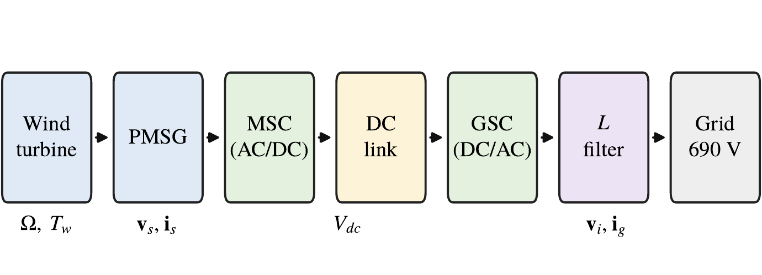
Figure 1. Overall configuration of the 2 MW direct-drive PMSG wind energy conversion system.

2.2. Wind Turbine Aerodynamics
The tip-speed ratio, the mechanical power and the aerodynamic torque are [29, 8]
 | $$λ=\frac{ΩR}{v}, P_{w}=\frac{1}{2}ρπR^{2}C_{p}\left(λ,β\right) v^{3}, T_{w}=\frac{P_{w}}{Ω},$$ | (1)
where $ρ$ is the air density, $R$ the rotor radius, $v$ the wind speed, $Ω$ the rotor speed and $β$ the pitch angle. The power coefficient is
 | $$C_{p}=0.5176\left(\frac{116}{λ_{i}}−0.4β−5\right)e^{−21/λ_{i}}+0.0068λ, \frac{1}{λ_{i}}=\frac{1}{λ+0.08β}−\frac{0.035}{β^{3}+1}.$$ | (2)
For $β=0$, $C_{p}$ reaches $C_{p,max}=0.48$ at $λ^{⋆}=8.1$. For $P_{n}=2$ MW and $R=40$ m, the rated wind speed given by $P_{n}=\frac{1}{2}ρπR^{2}C_{p,max}v_{n}^{3}$ is $v_{n}=11.0$ m/s, the rated speed is $Ω_{n}=λ^{⋆}v_{n}/R=2.23$ rad/s and the rated torque is $T_{n}=P_{n}/Ω_{n}=0.897$ MN$⋅$m. Since the wind remains below $v_{n}$ in this study, the pitch angle is kept at zero.

2.3. PMSG Model in the $dq$ Frame
In the rotor $dq$ frame (amplitude-invariant transformation, $d$ axis aligned with the magnet flux), with the receptor convention and $L_{d}=L_{q}=L_{s}$ [8],
 | $$v_{sd}=R_{s}i_{sd}+L_{s}\frac{di_{sd}}{dt}−ω_{e}L_{s}i_{sq},$$ | (3)
 | $$v_{sq}=R_{s}i_{sq}+L_{s}\frac{di_{sq}}{dt}+ω_{e}L_{s}i_{sd}+ω_{e}ψ_{f},$$ | (4)
 | $$T_{e}=\frac{3}{2}p ψ_{f} i_{sq},$$ | (5)
where $ω_{e}=pΩ$, $p$ is the number of pole pairs and $ψ_{f}$ the magnet flux; $T_{e}<0$ and $i_{sq}<0$ in generating mode. With $i_{s}={\left[i_{sd} i_{sq}\right]}^{T}$, $v_{s}={\left[v_{sd} v_{sq}\right]}^{T}$, $e_{q}={\left[0 1\right]}^{T}$ and the skew-symmetric matrix $J=\left[\begin{matrix}0 & 1 \\ −1 & 0\end{matrix}\right]$,
 | $$L_{s}{\dot{i}}_{s}=v_{s}−R_{s}i_{s}+ω_{e}L_{s}Ji_{s}−ω_{e}ψ_{f}e_{q}.$$ | (6)
The generator data are those of the non-salient 2 MW PMSG of [28].

2.4. Drive Train
The direct-drive shaft is described by the one-mass model
 | $$J\frac{dΩ}{dt}=T_{w}+T_{e}−BΩ,$$ | (7)
where $J$ is the total inertia and $B$ the friction coefficient.

2.5. DC Link and Grid Side
The converters are represented by their average model, with voltage vectors limited to $V_{dc}/\sqrt{3}$. The DC-link voltage obeys [8]
 | $$CV_{dc}\frac{dV_{dc}}{dt}=P_{dc}−P_{i}, P_{dc}=−\frac{3}{2}v_{s}^{T}i_{s}, P_{i}=\frac{3}{2}v_{i}^{T}i_{g},$$ | (8)
where $v_{i}$ is the GSC voltage and $i_{g}$ the grid current. In the grid-voltage-oriented frame ($v_{gq}=0$), with the current counted towards the grid,
 | $$L_{f}{\dot{i}}_{g}=v_{i}−R_{f}i_{g}+ω_{g}L_{f}Ji_{g}−v_{g},$$ | (9)
and the grid powers are $P_{g}=\frac{3}{2}v_{gd}i_{gd}$ and $Q_{g}=−\frac{3}{2}v_{gd}i_{gq}$.

2.6. Energy Balance
With $E=\frac{1}{2}JΩ^{2}+\frac{3}{4}L_{s}∥i_{s}∥^{2}+\frac{1}{2}CV_{dc}^{2}+\frac{3}{4}L_{f}∥i_{g}∥^{2}$, and since $x^{T}Jx=0$ and $T_{e}Ω=\frac{3}{2}ω_{e}ψ_{f}i_{sq}$, the model (1)–(9) gives, for any state and any converter voltages,
 | $$\dot{E}=P_{w}−BΩ^{2}−\frac{3}{2}R_{s}∥i_{s}∥^{2}−\frac{3}{2}R_{f}∥i_{g}∥^{2}−P_{g}.$$ | (10)
This balance verifies the sign of every term of the model; its numerical residual is below ${10}^{−15}P_{n}$. It also shows the energy structure used by the PBC design of Section 5.
Table 1. Parameters of the studied system and of the simulation.
Group | Parameter | Value | Source
Turbine | rotor radius $R$, air density $ρ$ | 40 m, 1.225 kg/m³ | [7, 8]
 | pitch angle $β$, $C_{p}$ model | 0, (2) | [29]
 | $C_{p,max}$, $λ^{⋆}$, $v_{n}$, $Ω_{n}$ | 0.48, 8.1, 11.0 m/s, 2.23 rad/s | (1)
PMSG | rated power $P_{n}$, pole pairs $p$ | 2 MW, 26 | [28]
 | $R_{s}$, $L_{d}=L_{q}=L_{s}$, $ψ_{f}$ | 0.78 m$Ω$, 1.57 mH, 9.18 Wb | [28]
 | inertia $J$, friction $B$ | $2.8×{10}^{6}$ kg$⋅$m², ${10}^{3}$ N$⋅$m$⋅$s | assumed
DC link and grid | $C$, $V_{dc}^{*}$ | 20 mF, 1200 V | [28]
 | $L_{f}$, $R_{f}$ | 0.15 mH, 2 m$Ω$ | [28], assumed
 | $V_{g}$ (line-to-line rms), $ω_{g}$ | 690 V, $2π⋅50$ rad/s | [28]
Simulation setup | switching frequency $f_{sw}$ | 2160 Hz | [28]
 | sampling time $T_{s}=1/\left(2f_{sw}\right)$ | 231.5 $μ$s
 | solver | fixed-step Runge–Kutta 4, step $T_{s}$

3. Control Objectives and MPPT Strategy

3.1. Control Objectives
The control is shared between the two converters:
- the MSC tracks the optimal rotor speed, in order to extract the maximum power below the rated wind speed, and keeps $i_{sd}=0$, which minimizes the copper losses of the non-salient machine;
- the GSC regulates the DC-link voltage at $V_{dc}^{*}=1200$ V, injects the active power into the grid and keeps the reactive power at zero, i.e., a unity power factor ($i_{gq}=0$).
All the errors are defined as measured minus reference values. The controller is sampled at $T_{s}$, and the converter voltages are applied one sample after their computation.

3.2. Tip-Speed-Ratio MPPT
The tip-speed-ratio (TSR) MPPT is used. The optimal speed
 | $$Ω_{opt}=\frac{λ^{⋆}v_{m}}{R},$$ | (11)
computed from the anemometer measurement $v_{m}$ and limited to $\left[0.5Ω_{n},Ω_{n}\right]$, is filtered by the second-order model
 | $${\ddot{Ω}}^{*}=ω_{r}^{2}\left(Ω_{opt}−Ω^{*}\right)−2ω_{r}{\dot{Ω}}^{*},$$ | (12)
with $ω_{r}=1$ rad/s. This filter gives a smooth reference $Ω^{*}$ and its derivative ${\dot{Ω}}^{*}$, which are required by the flatness-based law of Section 4, and it avoids demanding fast speed changes that the large inertia of the turbine cannot follow.

4. Flatness-Based Reference Generation
A system is differentially flat when all its variables can be expressed as functions of a flat output and of a finite number of its derivatives [17]. This property is used here to generate the references of the inner variables directly from the desired trajectories, instead of using cascaded loops that react only after an error has appeared [8]. The resulting reference generator is shown in Figure 2, and the flat outputs are summarized in Table 2.
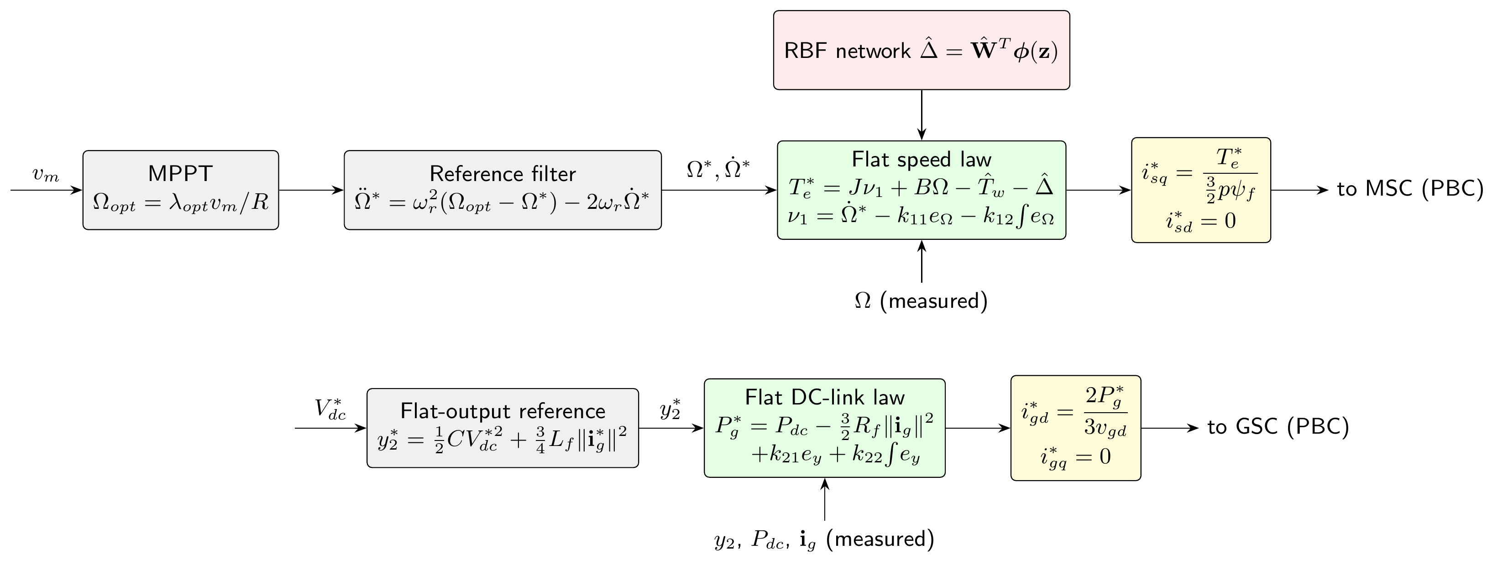
Figure 2. Flatness-based reference generation for the MSC (top) and for the GSC (bottom).

4.1. Speed Loop
For the PMSG and the shaft, $\left(Ω,i_{sd}\right)$ is a flat output: from (7) and (5),
 | $$T_{e}=J\dot{Ω}+BΩ−T_{w}, i_{sq}=\frac{T_{e}}{\frac{3}{2}pψ_{f}},$$ | (13)
and the voltages follow from (3)–(4) with $i_{sd}$, $i_{sq}$ and their derivatives. Imposing $\dot{Ω}=ν_{1}$ with
 | $$ν_{1}={\dot{Ω}}^{*}−k_{11}e_{Ω}−k_{12}​∫​e_{Ω} dt, e_{Ω}=Ω−Ω^{*},$$ | (14)
gives the torque and current references
 | $$T_{e}^{*}=Jν_{1}+BΩ−{\hat{T}}_{w}−\hat{Δ}, i_{sq}^{*}=\frac{T_{e}^{*}}{\frac{3}{2}pψ_{f}}, i_{sd}^{*}=0,$$ | (15)
where ${\hat{T}}_{w}$ is computed from (1)–(2) with $v_{m}$, and $\hat{Δ}$ is the neural compensation of Section 6 ($\hat{Δ}=0$ for the nominal controller). $T_{e}^{*}$ is limited to $\left[−1.2T_{n},0\right]$, with the integration frozen at the limit.

4.2. DC-Link Loop
For the GSC, the flat output is the energy stored in the DC link and in the filter, $y_{2}=\frac{1}{2}CV_{dc}^{2}+\frac{3}{4}L_{f}∥i_{g}∥^{2}$, together with $i_{gq}$. From (8)–(9),
 | $${\dot{y}}_{2}=P_{dc}−P_{g}−\frac{3}{2}R_{f}∥i_{g}∥^{2},$$ | (16)
which is a linear power balance [18]. Imposing ${\dot{y}}_{2}=−k_{21}e_{y}−k_{22}∫e_{y} dt$, with $e_{y}=y_{2}−y_{2}^{*}$ and $y_{2}^{*}=\frac{1}{2}CV_{dc}^{*2}+\frac{3}{4}L_{f}∥i_{g}^{*}∥^{2}$, gives
 | $$P_{g}^{*}=P_{dc}−\frac{3}{2}R_{f}∥i_{g}∥^{2}+k_{21}e_{y}+k_{22}​∫​e_{y} dt, i_{gd}^{*}=\frac{2P_{g}^{*}}{3v_{gd}}, i_{gq}^{*}=0.$$ | (17)
The feedforward of $P_{dc}$, computed from the applied MSC voltages and the measured currents, passes the generator power to the grid before it changes $V_{dc}$.
Table 2. Flat outputs, reference variables and required derivatives.
Subsystem | Flat output | References generated | Required derivatives
PMSG and shaft (MSC) | $Ω$, $i_{sd}$ | $T_{e}^{*}$, $i_{sq}^{*}$ (15); $i_{sd}^{*}=0$ | ${\dot{Ω}}^{*}$ from (12); ${\dot{i}}_{s}^{*}$
DC link and filter (GSC) | $y_{2}$, $i_{gq}$ | $P_{g}^{*}$, $i_{gd}^{*}$ (17); $i_{gq}^{*}=0$ | ${\dot{y}}_{2}$ from (16); ${\dot{i}}_{g}^{*}$
Current loops (PBC) | – | $v_{s}^{*}$, $v_{i}^{*}$ (Section 5) | first-order filters (2 ms)

5. Passivity-Based Inner Control Design

5.1. Port-Controlled Hamiltonian Form
With the stored magnetic energy $H_{s}=\frac{1}{2}L_{s}∥i_{s}∥^{2}$, the generator model (6) is a port-controlled Hamiltonian system with dissipation [20]:
 | $$L_{s}{\dot{i}}_{s}=\left(ω_{e}L_{s}J−R_{s}I\right)i_{s}+v_{s}−ω_{e}ψ_{f}e_{q}, {\dot{H}}_{s}=−R_{s}∥i_{s}∥^{2}+i_{s}^{T}\left(v_{s}−ω_{e}ψ_{f}e_{q}\right).$$ | (18)
The interconnection term $ω_{e}L_{s}J$ is skew-symmetric, so it does not produce or dissipate energy. PBC keeps this workless term instead of cancelling it, shapes the energy of the error dynamics, and injects damping [19]. The structure is shown in Figure 3.
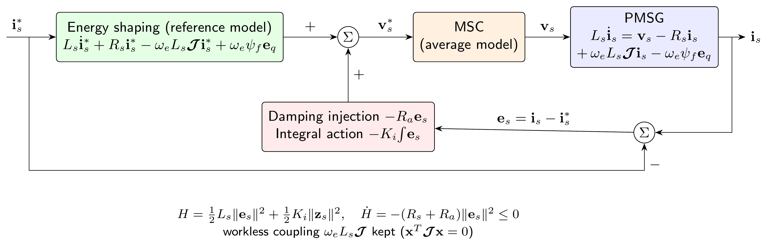
Figure 3. Energy-shaping and damping-injection structure of the passivity-based current control (MSC).

5.2. Machine-Side Control Law
With $e_{s}=i_{s}−i_{s}^{*}$ and ${\dot{z}}_{s}=e_{s}$, the MSC voltage reference is
 | $$v_{s}^{*}=\underset{\text{energy shaping}}{\underset{⏟}{L_{s}{\dot{i}}_{s}^{*}+R_{s}i_{s}^{*}−ω_{e}L_{s}Ji_{s}^{*}+ω_{e}ψ_{f}e_{q}}}\underset{\text{damping}}{\underset{⏟}{−R_{a}e_{s}}}−K_{i}z_{s}.$$ | (19)
Inserting (19) into (6) gives the error dynamics
 | $$L_{s}{\dot{e}}_{s}=−\left(R_{s}+R_{a}\right)e_{s}+ω_{e}L_{s}Je_{s}−K_{i}z_{s},$$ | (20)
which keep the skew-symmetric coupling of the machine, with the total damping $R_{s}+R_{a}$.

5.3. Grid-Side Control Law
The same design is applied to the filter (9). With $e_{g}=i_{g}−i_{g}^{*}$ and ${\dot{z}}_{g}=e_{g}$,
 | $$v_{i}^{*}=L_{f}{\dot{i}}_{g}^{*}+R_{f}i_{g}^{*}−ω_{g}L_{f}Ji_{g}^{*}+v_{g}−R_{b}e_{g}−K_{ig}z_{g},$$ | (21)
which gives $L_{f}{\dot{e}}_{g}=−\left(R_{f}+R_{b}\right)e_{g}+ω_{g}L_{f}Je_{g}−K_{ig}z_{g}$. The reference derivatives are obtained by first-order filters with a time constant of 2 ms, and the integrals are frozen when the voltage reaches $V_{dc}/\sqrt{3}$.
Proposition 1. With $R_{a},K_{i}>0$, the storage function $H_{e}=\frac{1}{2}L_{s}∥e_{s}∥^{2}+\frac{1}{2}K_{i}∥z_{s}∥^{2}$ of the error dynamics (20) satisfies ${\dot{H}}_{e}=−\left(R_{s}+R_{a}\right)∥e_{s}∥^{2}≤0$. The same holds for the grid side with $H_{g}=\frac{1}{2}L_{f}∥e_{g}∥^{2}+\frac{1}{2}K_{ig}∥z_{g}∥^{2}$ and ${\dot{H}}_{g}=−\left(R_{f}+R_{b}\right)∥e_{g}∥^{2}$.
Proof. From (20), ${\dot{H}}_{e}=e_{s}^{T}L_{s}{\dot{e}}_{s}+K_{i}z_{s}^{T}e_{s}=−\left(R_{s}+R_{a}\right)∥e_{s}∥^{2}+ω_{e}L_{s}e_{s}^{T}Je_{s}=−\left(R_{s}+R_{a}\right)∥e_{s}∥^{2}$, since $e_{s}^{T}Je_{s}=0$. The grid side is identical. $▫$
The gains place double closed-loop poles: $R_{s}+R_{a}=2ω_{i}L_{s}$, $K_{i}=ω_{i}^{2}L_{s}$, $R_{f}+R_{b}=2ω_{i}L_{f}$, $K_{ig}=ω_{i}^{2}L_{f}$, $k_{11}=2ω_{Ω}$, $k_{12}=ω_{Ω}^{2}$, $k_{21}=2ω_{v}$ and $k_{22}=ω_{v}^{2}$, with $ω_{i}=500$, $ω_{v}=60$ and $ω_{Ω}=2$ rad/s, so that the bandwidths are separated by more than one decade (Table 3).

6. Adaptive RBF Neural Compensation

6.1. Lumped Uncertainty
The flat speed law (15) uses the model ${\hat{T}}_{w}$ of the aerodynamic torque. The $C_{p}$ model, the anemometer, which measures the wind at one point and with a delay, the magnet flux and the other parameters of the generator are uncertain. Their effects are gathered in the lumped uncertainty
 | $$Δ\left(x,t\right)=T_{w}−{\hat{T}}_{w},$$ | (22)
and, with $i_{sq}=i_{sq}^{*}$, the speed error obeys
 | $$J\left({\dot{e}}_{Ω}+k_{11}e_{Ω}+k_{12}​∫​e_{Ω} dt\right)=Δ−\hat{Δ}.$$ | (23)

6.2. RBF Approximation
The uncertainty depends mainly on the operating point, i.e., on the rotor speed and on the wind speed. The input vector of the network is
 | $$z={\left[\frac{Ω}{Ω_{n}} \frac{v_{m}}{v_{n}}\right]}^{T},$$ | (24)
and, on a compact operating region $Ω_{z}$, the uncertainty is approximated by [21]
 | $$Δ=W^{*T}Φ\left(z\right)+ε, \left|ε\right|≤\overset{‾}{ε}, Φ_{j}\left(z\right)=exp\left(−\frac{∥z−c_{j}∥^{2}}{2b^{2}}\right),$$ | (25)
where $W^{*}$ is an ideal weight vector and $ε$ the approximation error. The network has 25 Gaussian units centred on a $5×5$ grid of ${\left[0.5,1.1\right]}^{2}$ with the width $b=0.15$ (Table 3). The compensation term is
 | $$\hat{Δ}\left(z\right)={\hat{W}}^{T}Φ\left(z\right).$$ | (26)
When the network is used, it replaces the integral action of the speed loop ($k_{12}=0$); otherwise the integral would absorb the slowly varying part of $Δ$ and the network would not learn it.

6.3. Adaptation Law
The weights are adapted online by the Lyapunov-based law with $σ$-modification [23]
 | $$\dot{\hat{W}}=Γ\left(Φ\left(z\right) e_{Ω}−σ\hat{W}\right), \hat{W}\left(0\right)=0,$$ | (27)
where $Γ>0$ is the adaptation gain and $σ>0$ limits the drift of the weights in the presence of noise and approximation error. The adaptation is frozen when $T_{e}^{*}$ reaches its limit. The complete controller is shown in Figure 4.
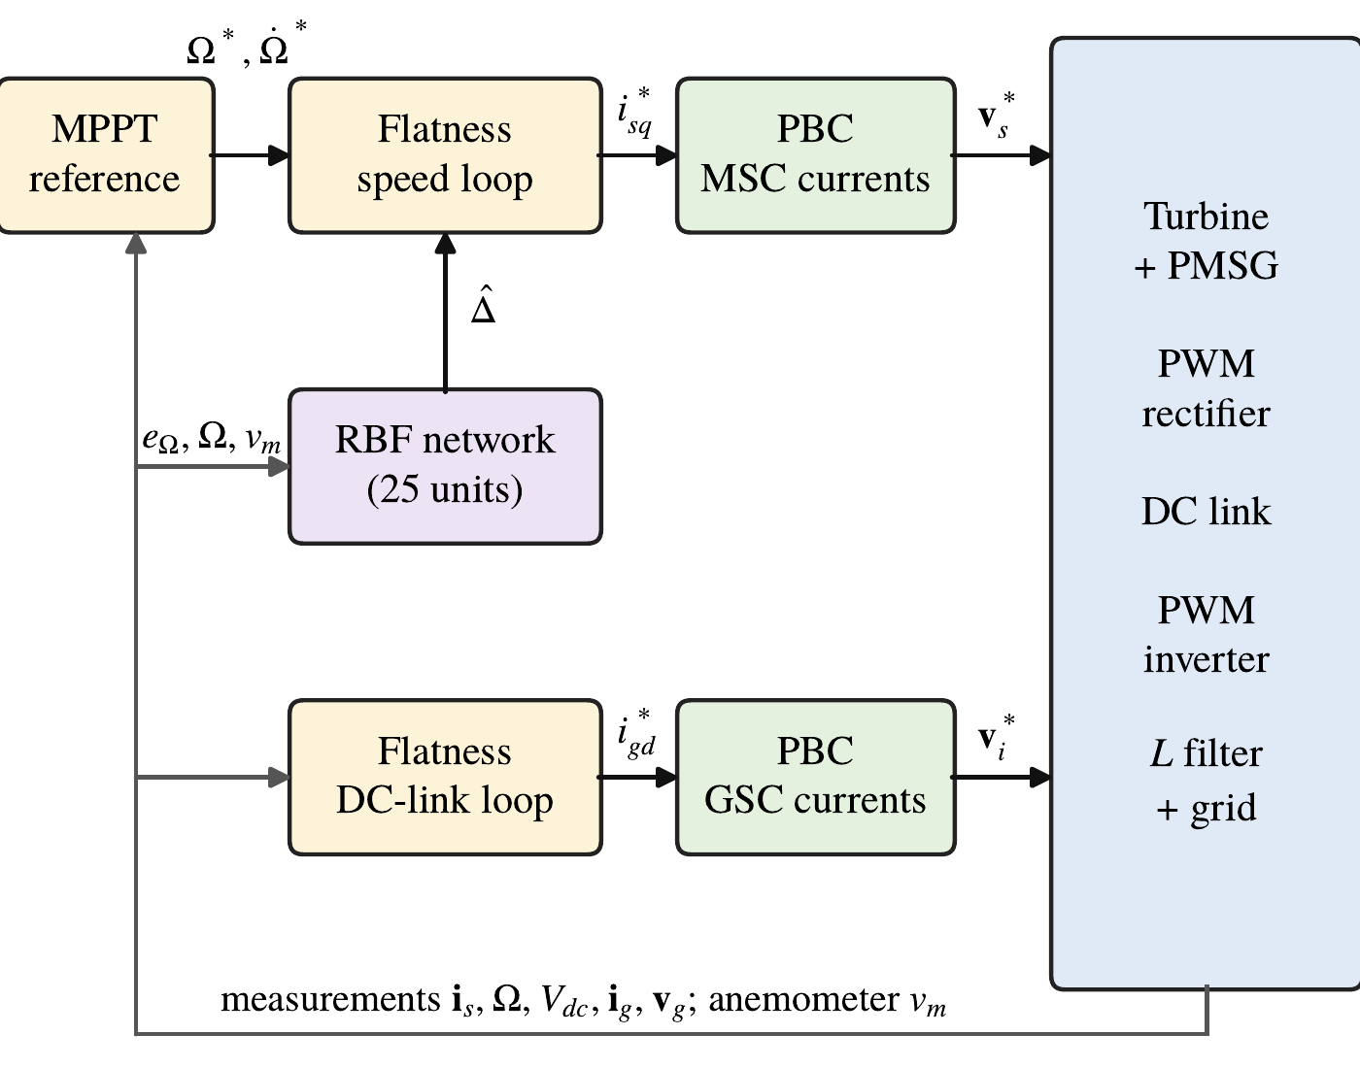
Figure 4. Complete proposed controller: flatness-based references, passivity-based current loops and adaptive RBF compensation.
Table 3. RBF network and controller parameters.
Parameter | Value
RBF inputs | $z={\left[Ω/Ω_{n}, v_{m}/v_{n}\right]}^{T}$
Number of neurons | 25 Gaussian units
Centres | $5×5$ grid of ${\left[0.5,1.1\right]}^{2}$
Width | $b=0.15$
Adaptation gains | $Γ={10}^{7}$, $σ=0.02$ s⁻¹, $\hat{W}\left(0\right)=0$
Speed loop (FBC) | $ω_{Ω}=2$ rad/s: $k_{11}=4$, $k_{12}=4$ (0 with the network); $ω_{r}=1$ rad/s
DC-link loop (FBC) | $ω_{v}=60$ rad/s: $k_{21}=120$, $k_{22}=3600$
MSC current loop (PBC) | $ω_{i}=500$ rad/s: $R_{a}=1.57 Ω$, $K_{i}=393 Ω$/s
GSC current loop (PBC) | $ω_{i}=500$ rad/s: $R_{b}=0.148 Ω$, $K_{ig}=37.5 Ω$/s

7. Stability Analysis
The analysis is made under the following assumptions.
Assumption 1. On the compact set $Ω_{z}$ that contains $z\left(t\right)$, the approximation (25) holds with $\left|ε\right|≤\overset{‾}{ε}$ and $∥W^{*}∥≤\overset{‾}{W}$.
Assumption 2. $J$ and $B$ are known, the parameter mismatch is included in $Δ$, the torque and voltage limits are not reached, and $Ω^{*}$, ${\dot{Ω}}^{*}$, $ω_{e}$ and $v_{g}$ are bounded.
Theorem 1. Consider the system (6)–(9) with the flat laws (15) ($k_{12}=0$) and (17), the PBC laws (19)–(21), the compensation (26) and the adaptation law (27) with $Γ,σ>0$. Under Assumptions 1 and 2:
(i) the current errors $e_{s}$, $e_{g}$ and the integrals $z_{s}$, $z_{g}$ are bounded, and $e_{s},e_{g}→0$;
(ii) the speed error $e_{Ω}$ and the weight error $\tilde{W}=W^{*}−\hat{W}$ are uniformly ultimately bounded, with
 | $$\underset{t→∞}{limsup}\left(\frac{1}{2}Je_{Ω}^{2}+\frac{1}{2Γ}∥\tilde{W}∥^{2}\right)≤\frac{β}{c}, β=\frac{{\overset{‾}{ε}}^{2}}{Jk_{11}}+\frac{σ{\overset{‾}{W}}^{2}}{2}, c=min\left(k_{11},σΓ\right);$$ | (28)
(iii) the DC-link energy error $e_{y}$ is bounded and converges to a neighborhood of zero whose size is proportional to the bound of ${\dot{y}}_{2}^{*}$.
Hence all closed-loop signals remain bounded.
Proof. (i) By Proposition 1, $H_{e}$ and $H_{g}$ are non-increasing, so $e_{s}$, $z_{s}$, $e_{g}$, $z_{g}$ are bounded, and
 | $$\int_{0}^{∞}{∥}e_{s}∥^{2}dt≤\frac{H_{e}\left(0\right)}{R_{s}+R_{a}}.$$ | (29)
Since ${\dot{e}}_{s}$ is bounded by (20), ${\dot{H}}_{e}$ is uniformly continuous and Barbalat’s lemma [30] gives $e_{s}→0$; the grid side is identical.
(ii) With $κ=\frac{3}{2}pψ_{f}$, the generator torque is $T_{e}=T_{e}^{*}+κe_{sq}$, where $e_{sq}$ is the $q$ component of $e_{s}$. From (7), (15), (25) and (26) with $k_{12}=0$,
 | $$J{\dot{e}}_{Ω}=−Jk_{11}e_{Ω}+{\tilde{W}}^{T}Φ+ε+κe_{sq}.$$ | (30)
Consider the composite Lyapunov function, made of the kinetic energy of the speed error and of the energy of the weight error,
 | $$V=\frac{1}{2}Je_{Ω}^{2}+\frac{1}{2Γ}∥\tilde{W}∥^{2}.$$ | (31)
Since $\dot{\tilde{W}}=−\dot{\hat{W}}$ and from (27),
 | $$\dot{V}=−Jk_{11}e_{Ω}^{2}+e_{Ω}ε+κe_{Ω}e_{sq}+σ{\tilde{W}}^{T}\hat{W}.$$ | (32)
With $e_{Ω}ε≤\frac{Jk_{11}}{4}e_{Ω}^{2}+\frac{{\overset{‾}{ε}}^{2}}{Jk_{11}}$, $κe_{Ω}e_{sq}≤\frac{Jk_{11}}{4}e_{Ω}^{2}+\frac{κ^{2}}{Jk_{11}}e_{sq}^{2}$ and ${\tilde{W}}^{T}\hat{W}≤\frac{1}{2}∥W^{*}∥^{2}−\frac{1}{2}∥\tilde{W}∥^{2}$,
 | $$\dot{V}≤−\frac{Jk_{11}}{2}e_{Ω}^{2}−\frac{σ}{2}∥\tilde{W}∥^{2}+β+δ\left(t\right)≤−cV+β+δ\left(t\right), δ\left(t\right)=\frac{κ^{2}}{Jk_{11}}e_{sq}^{2}\left(t\right).$$ | (33)
By the comparison lemma, $V\left(t\right)≤V\left(0\right)e^{−ct}+β/c+\int_{0}^{t}{e^{−c\left(t−τ\right)}}δ\left(τ\right) dτ$. By (29), $δ$ is bounded and integrable, so the last term vanishes as $t→∞$, which gives (28).
(iii) With $P_{g}=\frac{3}{2}v_{gd}i_{gd}=P_{g}^{*}+\frac{3}{2}v_{gd}e_{gd}$, (16) and (17) give $\ddot{η}+k_{21}\dot{η}+k_{22}η=−\frac{3}{2}v_{gd}e_{gd}−{\dot{y}}_{2}^{*}$ with $η=∫e_{y} dt$. The polynomial $s^{2}+k_{21}s+k_{22}$ is Hurwitz, $e_{gd}→0$ and ${\dot{y}}_{2}^{*}=\frac{3}{2}L_{f}i_{g}^{*T}{\dot{i}}_{g}^{*}$ is bounded, which proves (iii). $▫$
Remark 1. The ultimate bound (28) decreases when the approximation error $\overset{‾}{ε}$ decreases. It also decreases when $k_{11}$ increases, but $k_{11}$ multiplies the speed measurement noise by $Jk_{11}$ in (15). The network reduces the speed error without increasing this gain. The analysis does not cover the sampling, the saturations and the measurement noise; their effect is evaluated by simulation in Section 8.

8. Simulation Results and Discussion

8.1. Simulation Setup
The system of Section 2 and the controller were implemented in MATLAB with a fixed-step fourth-order Runge–Kutta solver at the step $T_{s}$ (Table 1); a Simulink version built with standard blocks was used to cross-check the model. To obtain realistic results, the controller only uses measured signals: white noise is added to the current measurements (standard deviation 5 A), to the DC voltage and grid voltage measurements (1 V) and to the encoder speed (2 mrad/s, filtered with a 5-ms time constant), the feedforward $P_{dc}$ and the grid voltage $v_{gd}$ used in (17) are filtered with a 2-ms time constant, and the anemometer is modeled by a first-order lag of 1 s. The grid voltage contains background harmonics of order 5 (2 %, negative sequence) and 7 (1.5 %, positive sequence).
Four cases are considered: (1) step wind with nominal parameters; (2) random wind with nominal parameters; (3) random wind with parameter uncertainty, the true plant having $C_{p}×1.1$, $J×1.2$, $R_{s}×1.5$, $L_{s}×1.2$, $ψ_{f}×0.95$, $R_{f}×1.5$ and $L_{f}×1.25$; (4) a 50 % grid voltage dip between 25 and 25.15 s, applied in the simulation of case 3. Each case is simulated over 40 s, without the network (nominal FBC–PBC controller) and with the network, with the same gains. The wind profiles are shown in Figure 5. The step profile is 9 m/s, then 11 m/s at 10 s and 8 m/s at 25 s [8]. The random profile is
 | $$v\left(t\right)=V_{mean}+\sum_{k=1}^{3}{A_{k}}sin\left(2πf_{k}t\right)+v_{turb}\left(t\right),$$ | (34)
with $V_{mean}=8.5$ m/s, $A=\left[1.5, 0.2, 0.3\right]$ m/s, $f=\left[0.03, 0.16, 0.17\right]$ Hz [27], and a first-order coloured turbulence $v_{turb}$ with a standard deviation of 0.5 m/s and a correlation time of 1.5 s; it remains between 6.0 and 10.9 m/s.
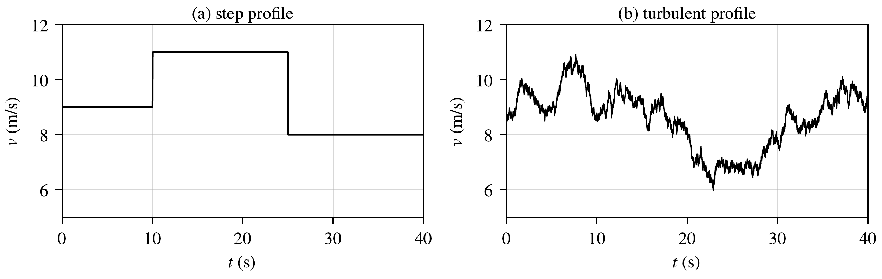
Figure 5. Wind profiles: (a) step wind; (b) random wind.
The speed tracking is evaluated from $t=1$ s by
 | $$\begin{matrix}RMSE=\sqrt{\frac{1}{N}\sum_{k=1}^{N}{e_{Ω}^{2}}\left(k\right)}, MAE=\frac{1}{N}\sum_{k=1}^{N}{\left|e_{Ω}\left(k\right)\right|}, e_{max}=\max_{k}\left|e_{Ω}\left(k\right)\right|, \\ IAE=∫\left|e_{Ω}\right| dt, ISE=∫e_{Ω}^{2} dt.\end{matrix}$$ | (35)

8.2. Case 1: Step Wind
Figure 6a shows that the measured rotor speed follows the MPPT reference from 1.82 to 2.23 and then 1.62 rad/s. After each wind step, the speed error returns within 2 mrad/s in 1.9 s with the network, instead of 3.9 to 4.4 s without it. Figure 8 shows that $i_{sq}$ and $i_{gd}$ follow their references during the transients, while $i_{sd}$ and $i_{gq}$ remain around zero with the measurement noise and, for the grid current, the 300 Hz ripple due to the grid harmonics. Figure 9a shows that the electromagnetic torque follows its reference; the torque ripple is 0.55 % of $T_{n}$ (standard deviation). The difference between $−T_{e}$ and $T_{w}$ accelerates or decelerates the rotor towards the new optimal speed. Figure 10a shows that the DC-link voltage stays within 7 V (0.6 %) of 1200 V during the steps, thanks to the feedforward of $P_{dc}$.
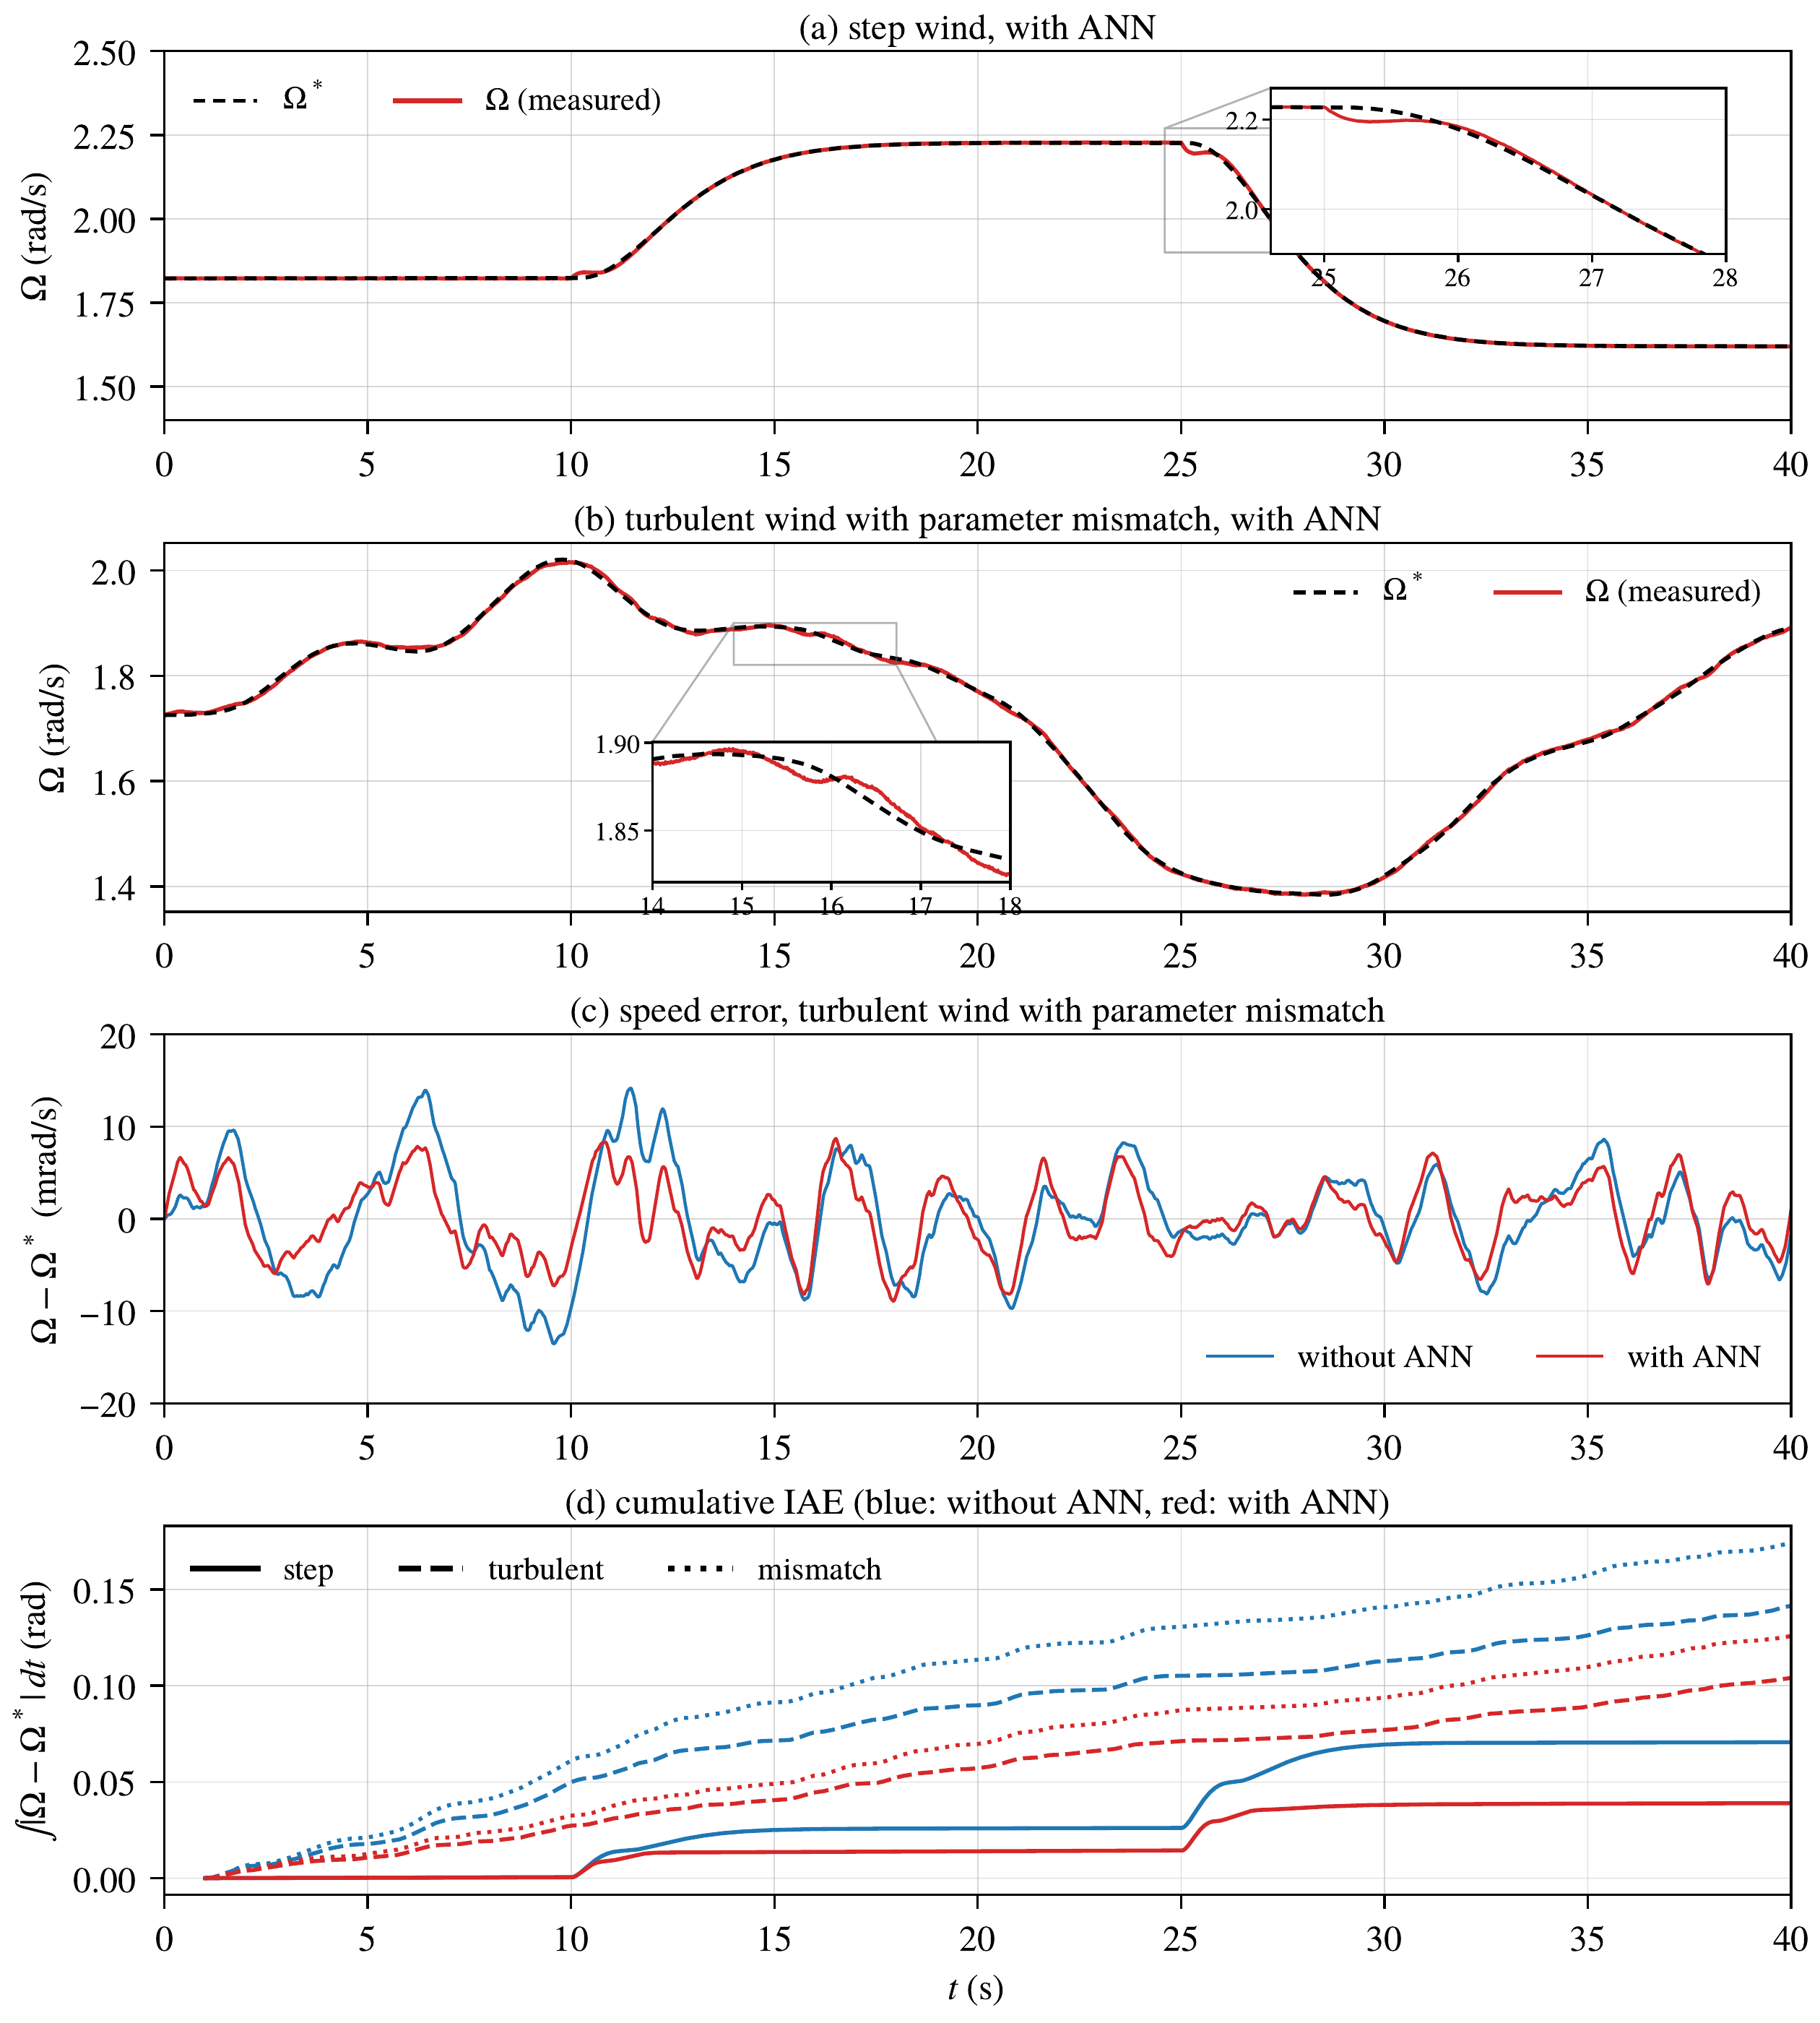
Figure 6. Rotor speed tracking: (a) step wind; (b) random wind with parameter uncertainty; (c) speed error without and with the RBF network in case 3; (d) cumulative IAE in cases 1 to 3.
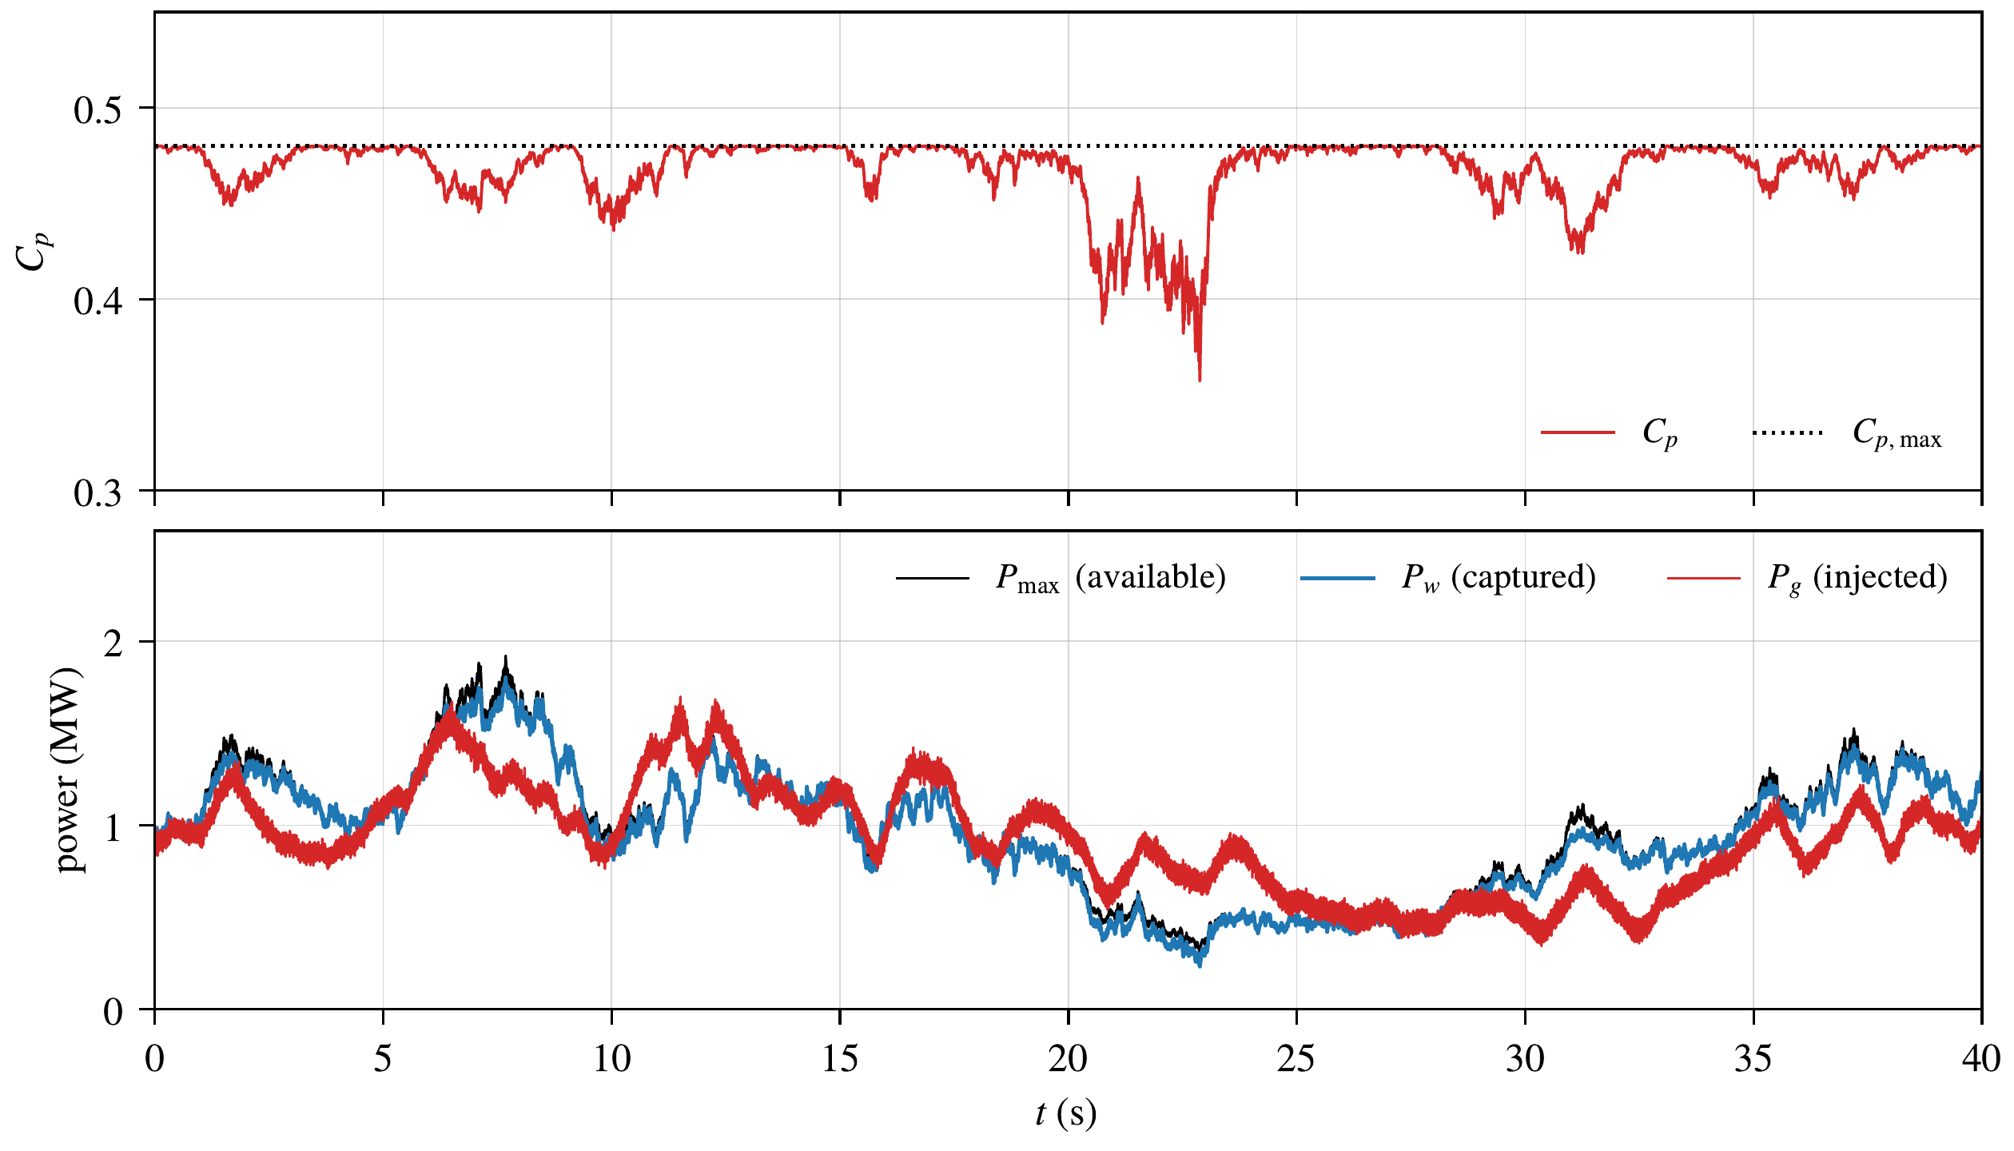
Figure 7. Random wind with nominal parameters: power coefficient (top) and maximum available, captured and injected powers (bottom).

8.3. Case 2: Random Wind
Figure 7 shows the MPPT performance under random wind. The power coefficient stays close to $C_{p,max}$, except during the fast wind decrease around 22 s, where the inertia prevents the rotor from slowing down quickly. The captured power follows the maximum available power, and the difference between the captured and the injected powers corresponds to the kinetic energy stored in or released by the rotor. The MPPT efficiency, i.e., the ratio between the captured energy and the maximum available energy, is 97.7 %. Figure 12 shows the grid current at 20 s: its THD is 3.9 %, mainly due to the 5th (3.6 %) and 7th (1.6 %) harmonics imposed by the grid voltage, and every harmonic is below the limit of IEEE Std 519 [31].
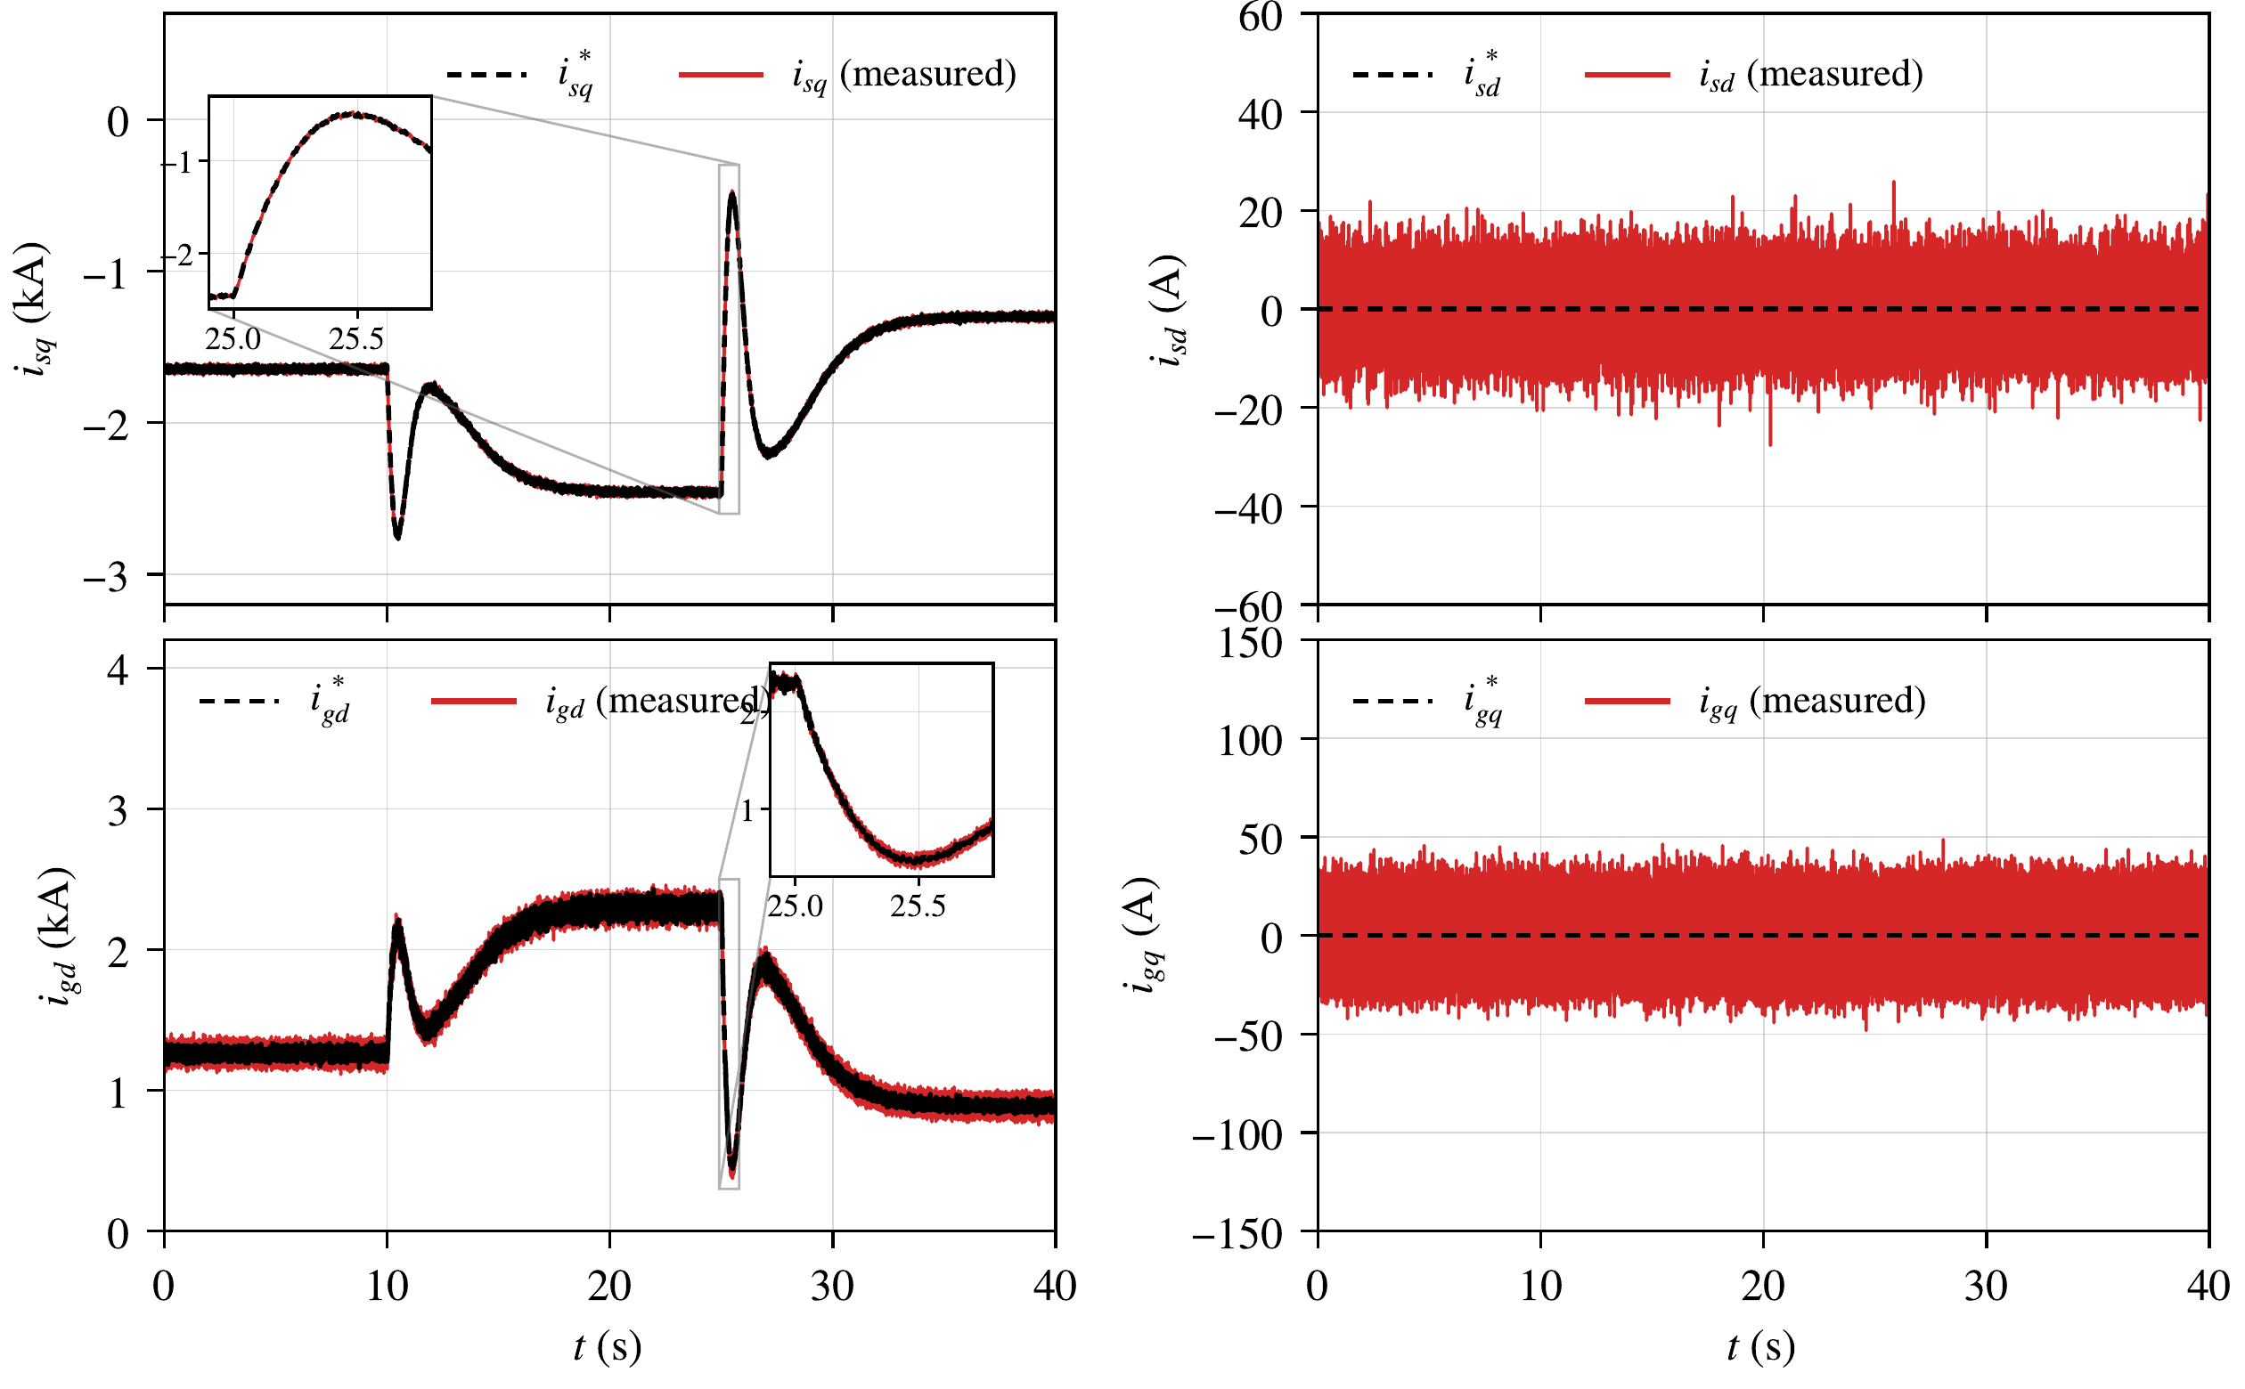
Figure 8. Step wind, control with the RBF network: references (dashed) and measured values (solid) of the stator and grid currents.
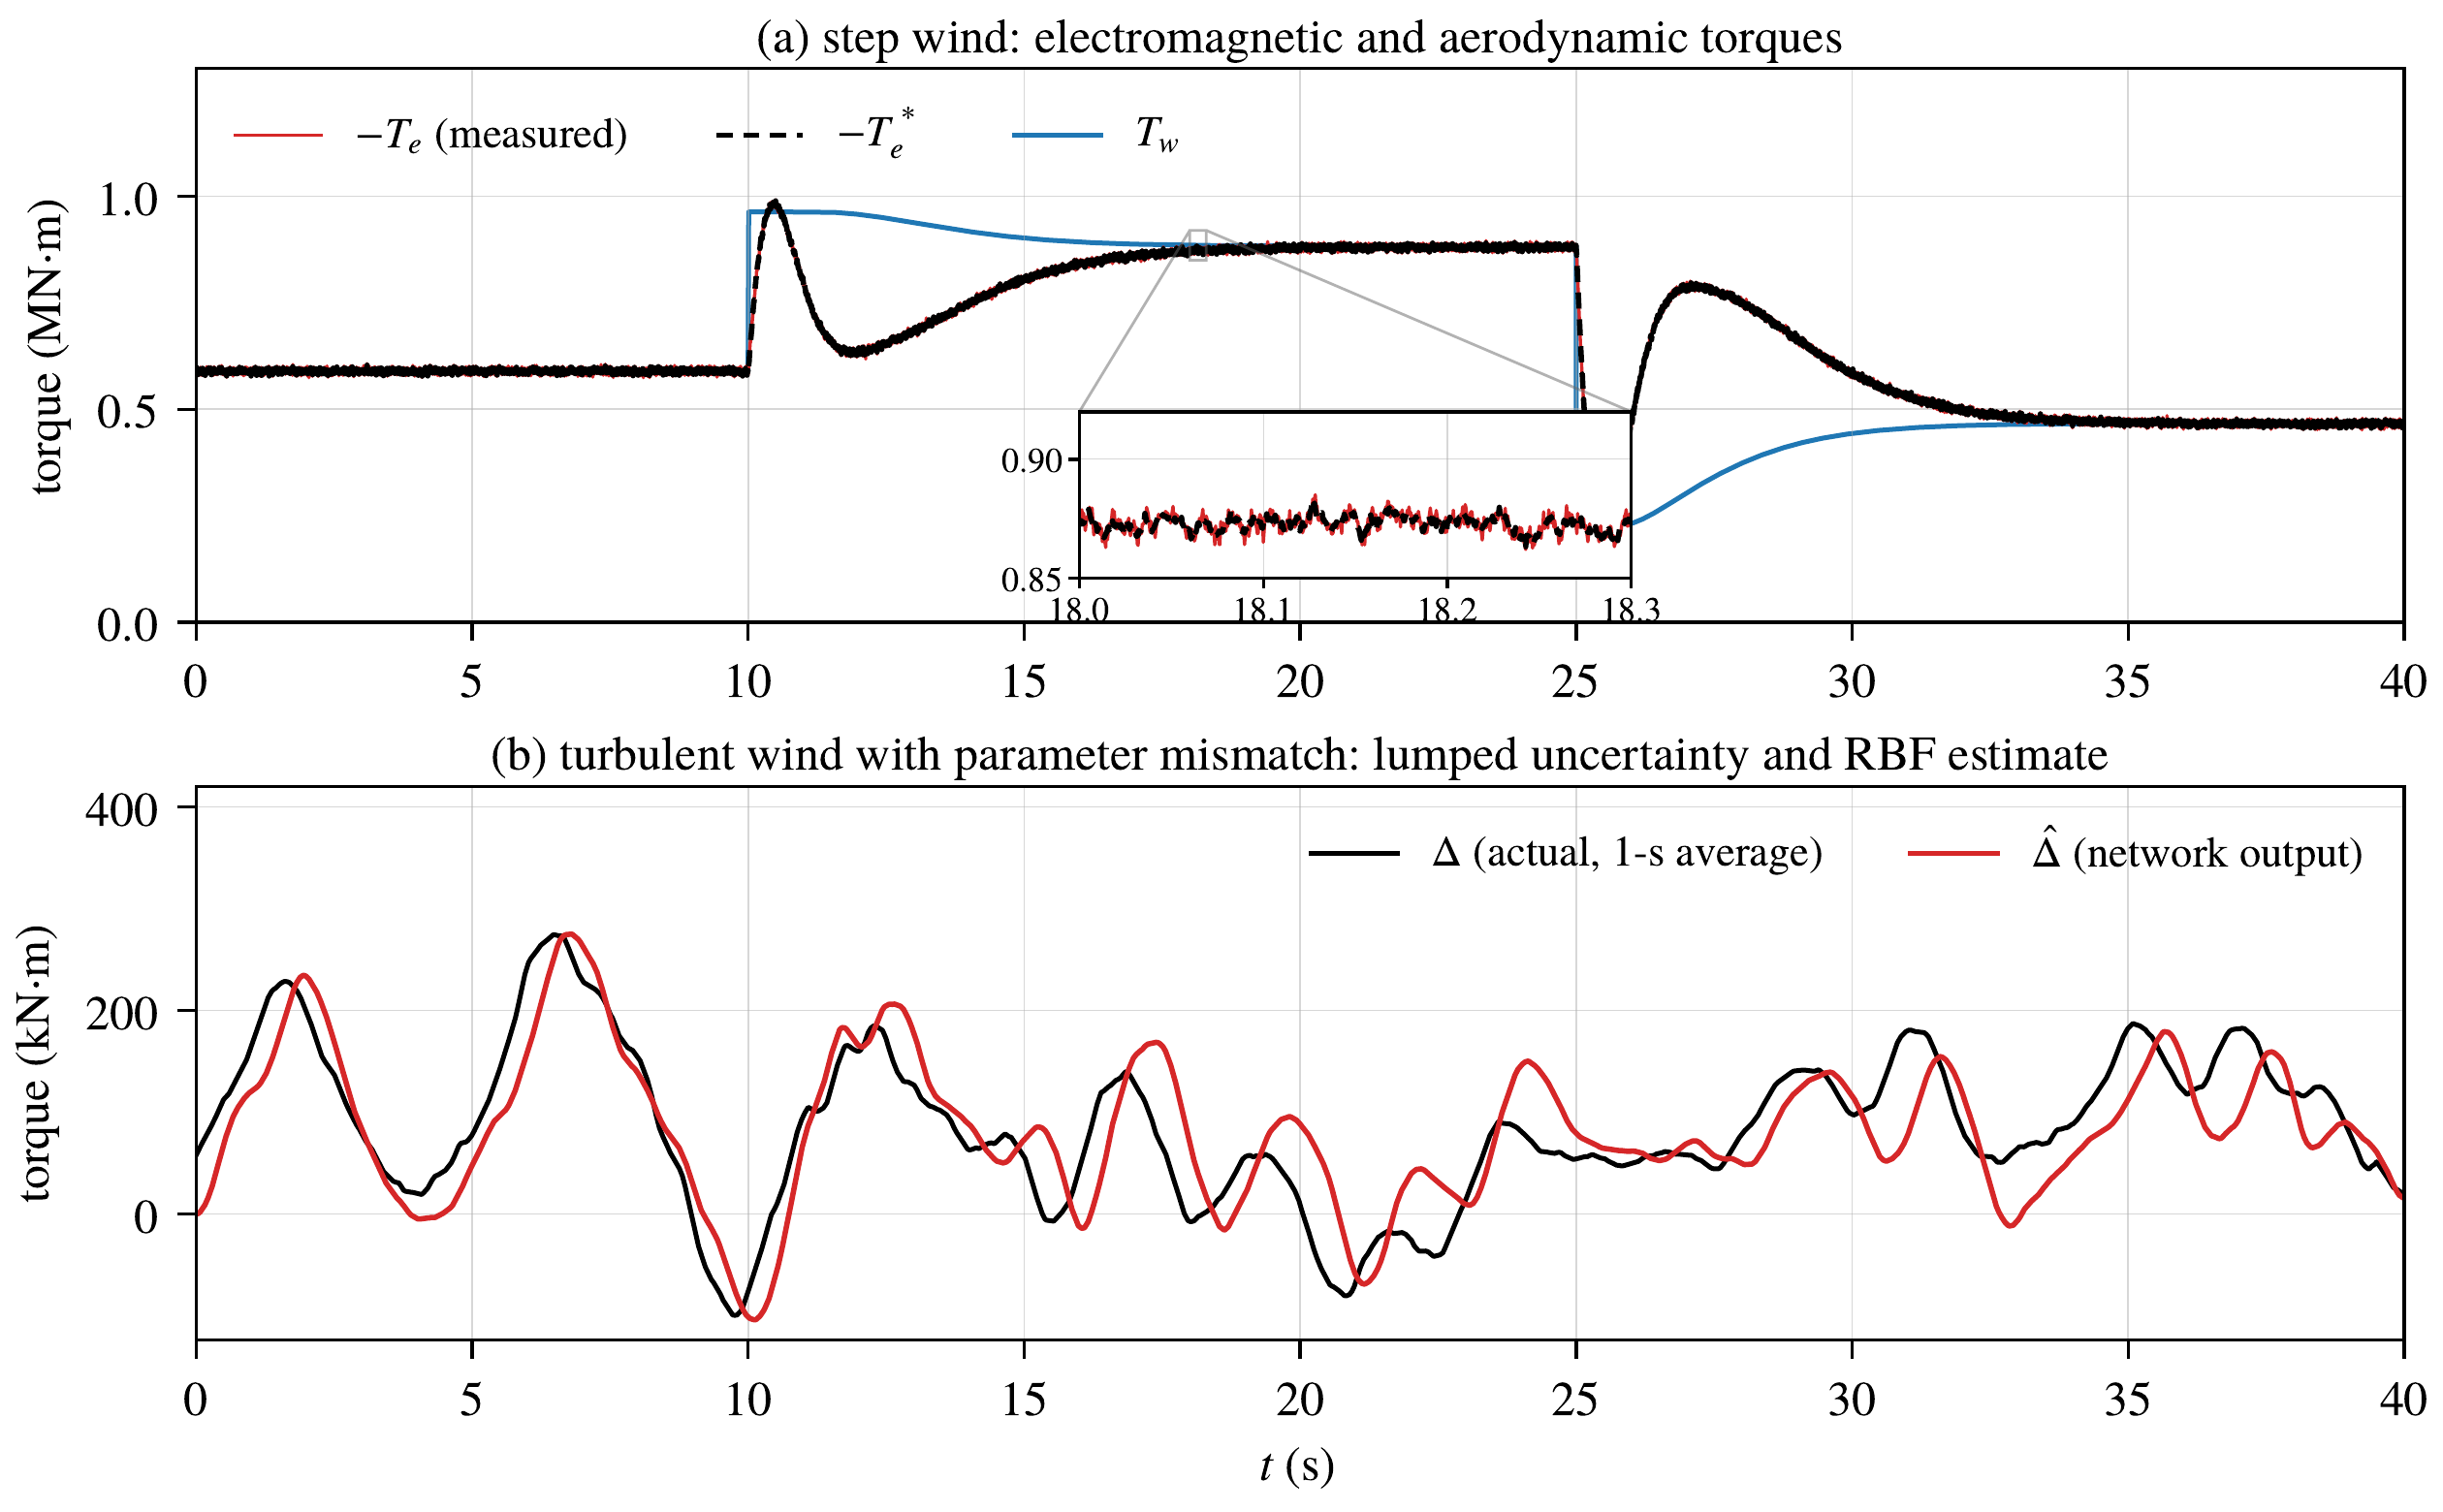
Figure 9. (a) Electromagnetic torque, its reference and aerodynamic torque under step wind, with an enlarged view of the torque ripple; (b) lumped uncertainty $Δ$ and its RBF estimate $\hat{Δ}$ in case 3.

8.4. Case 3: Parameter Uncertainty
With the parameter mismatch, the rotor speed still follows its reference (Figure 6b). The speed error is smaller with the network (Figure 6c), and the cumulative IAE grows more slowly in the three cases (Figure 6d). Figure 9b shows that the network output follows the lumped uncertainty: their mean values are 82.5 and 83.4 kN$⋅$m, i.e., about 14 % of the aerodynamic torque. Figure 11a shows that the injected active power follows the wind power and that the reactive power remains around zero; the power factor is 1.00.
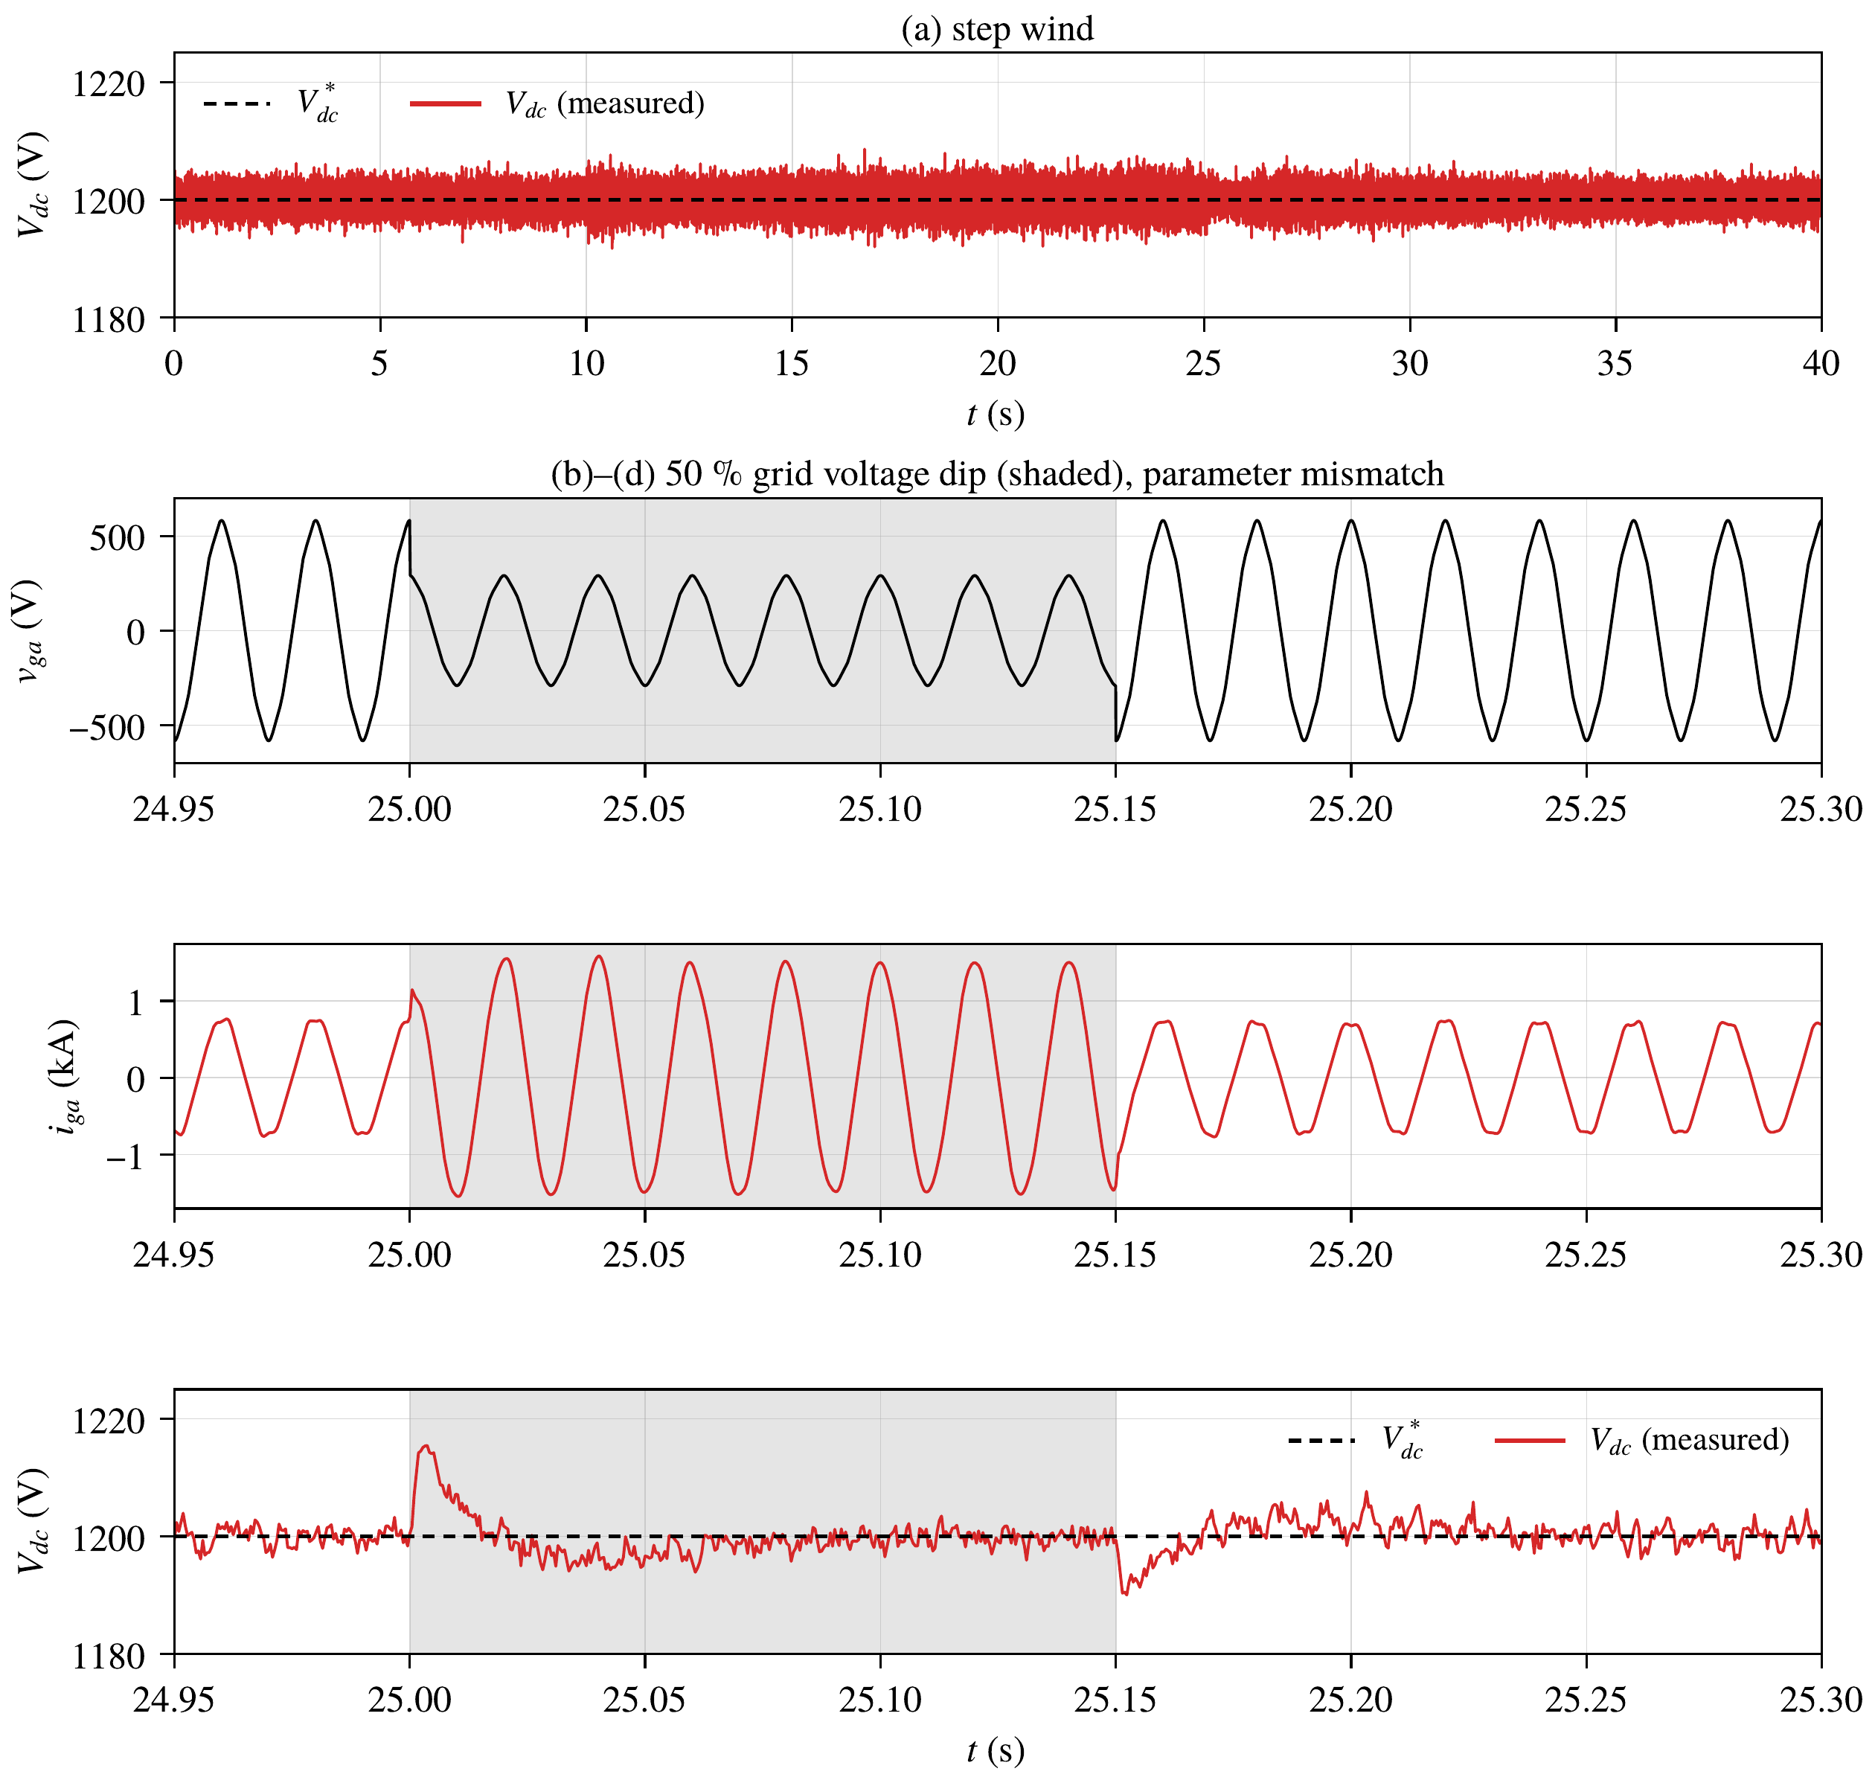
Figure 10. DC-link voltage under step wind (a), and grid voltage (b), grid current (c) and DC-link voltage (d) during the 50 % voltage dip of case 4.
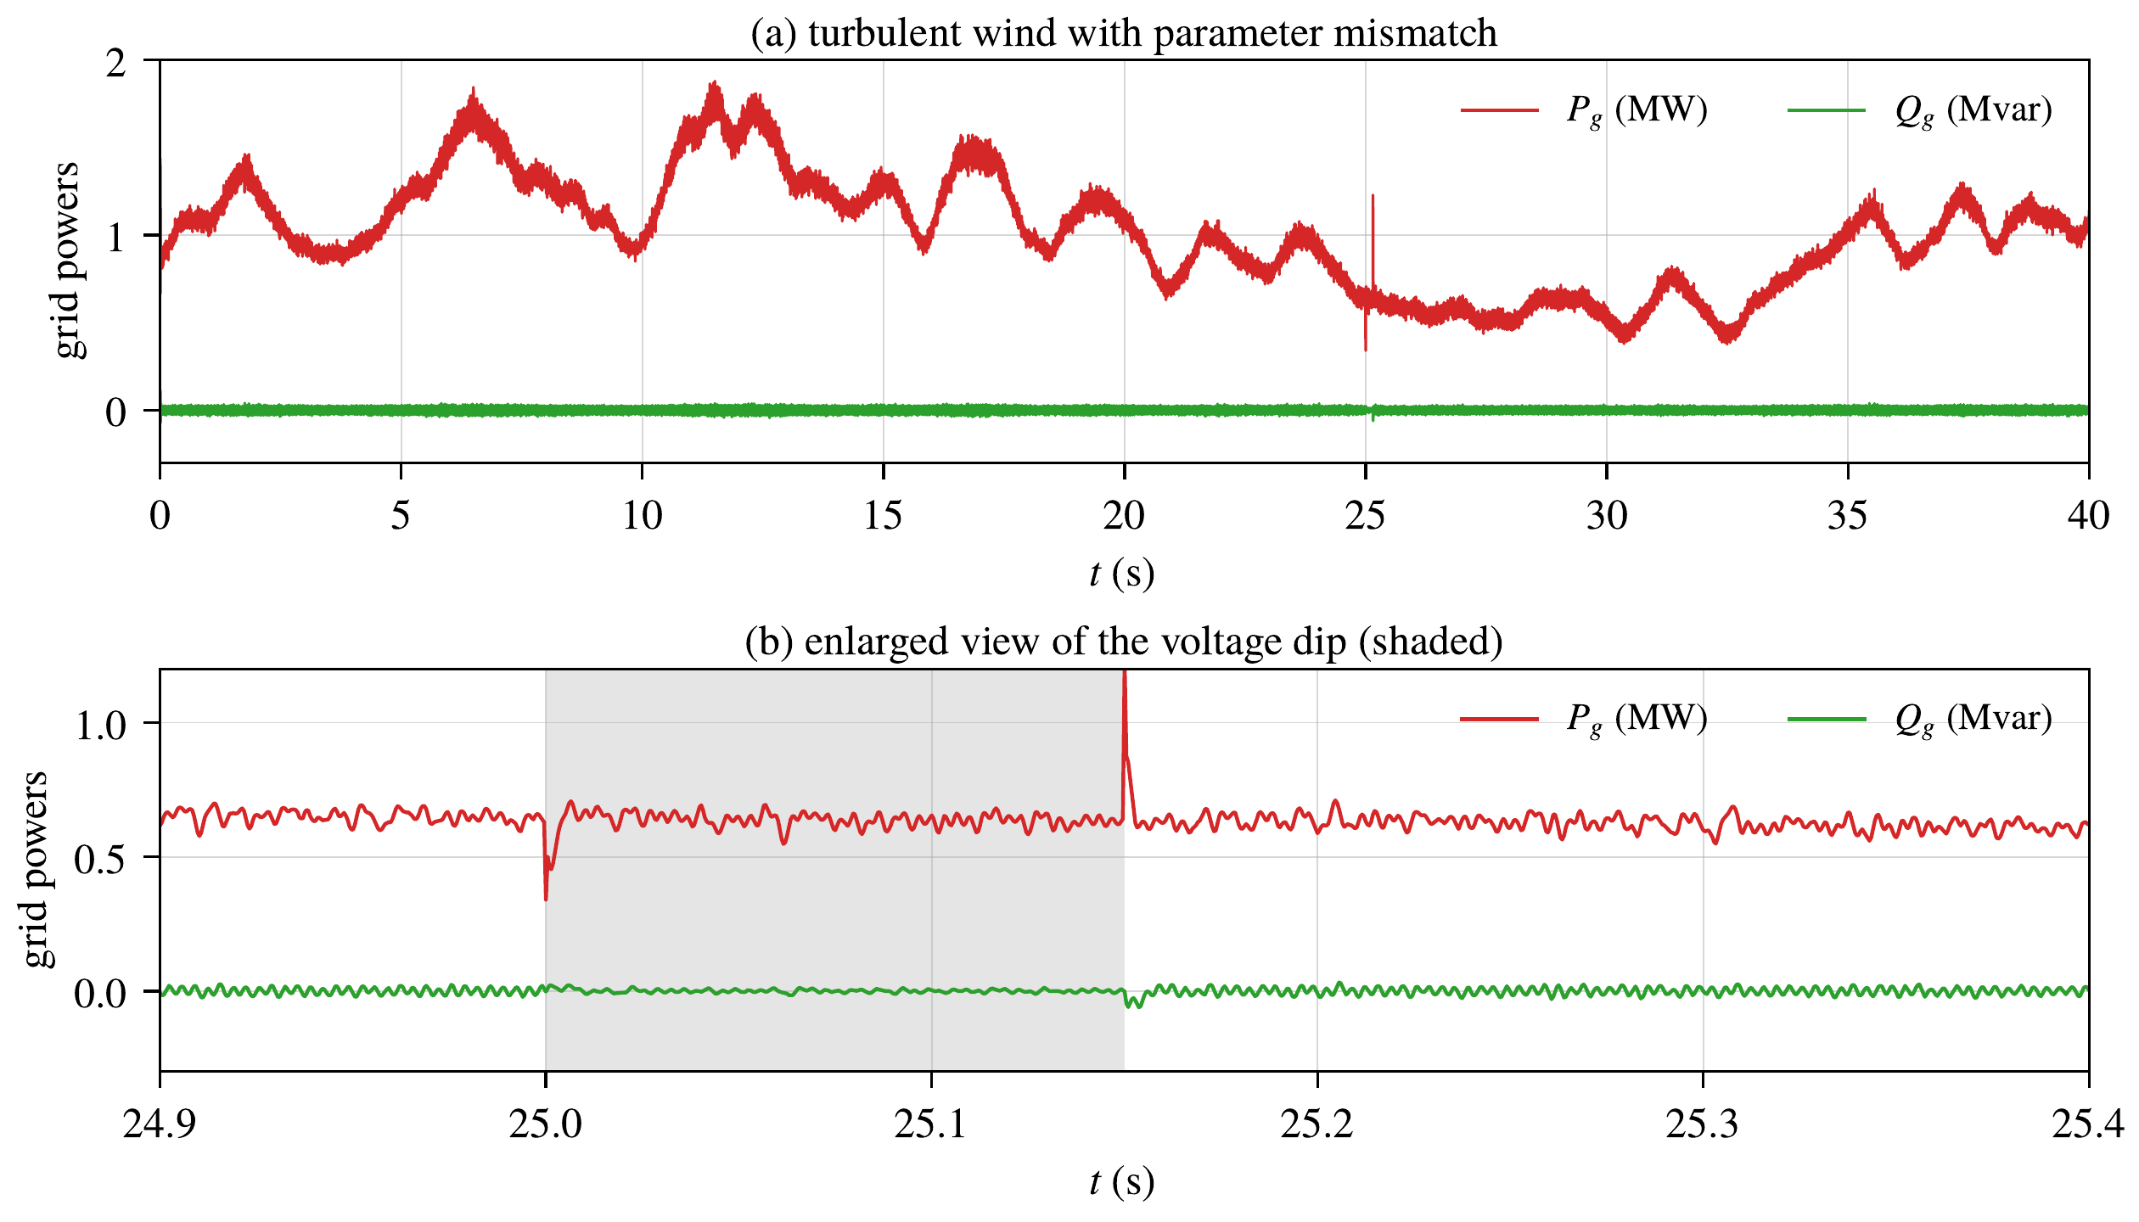
Figure 11. Active and reactive grid powers in cases 3 and 4: (a) whole simulation; (b) enlarged view of the voltage dip.
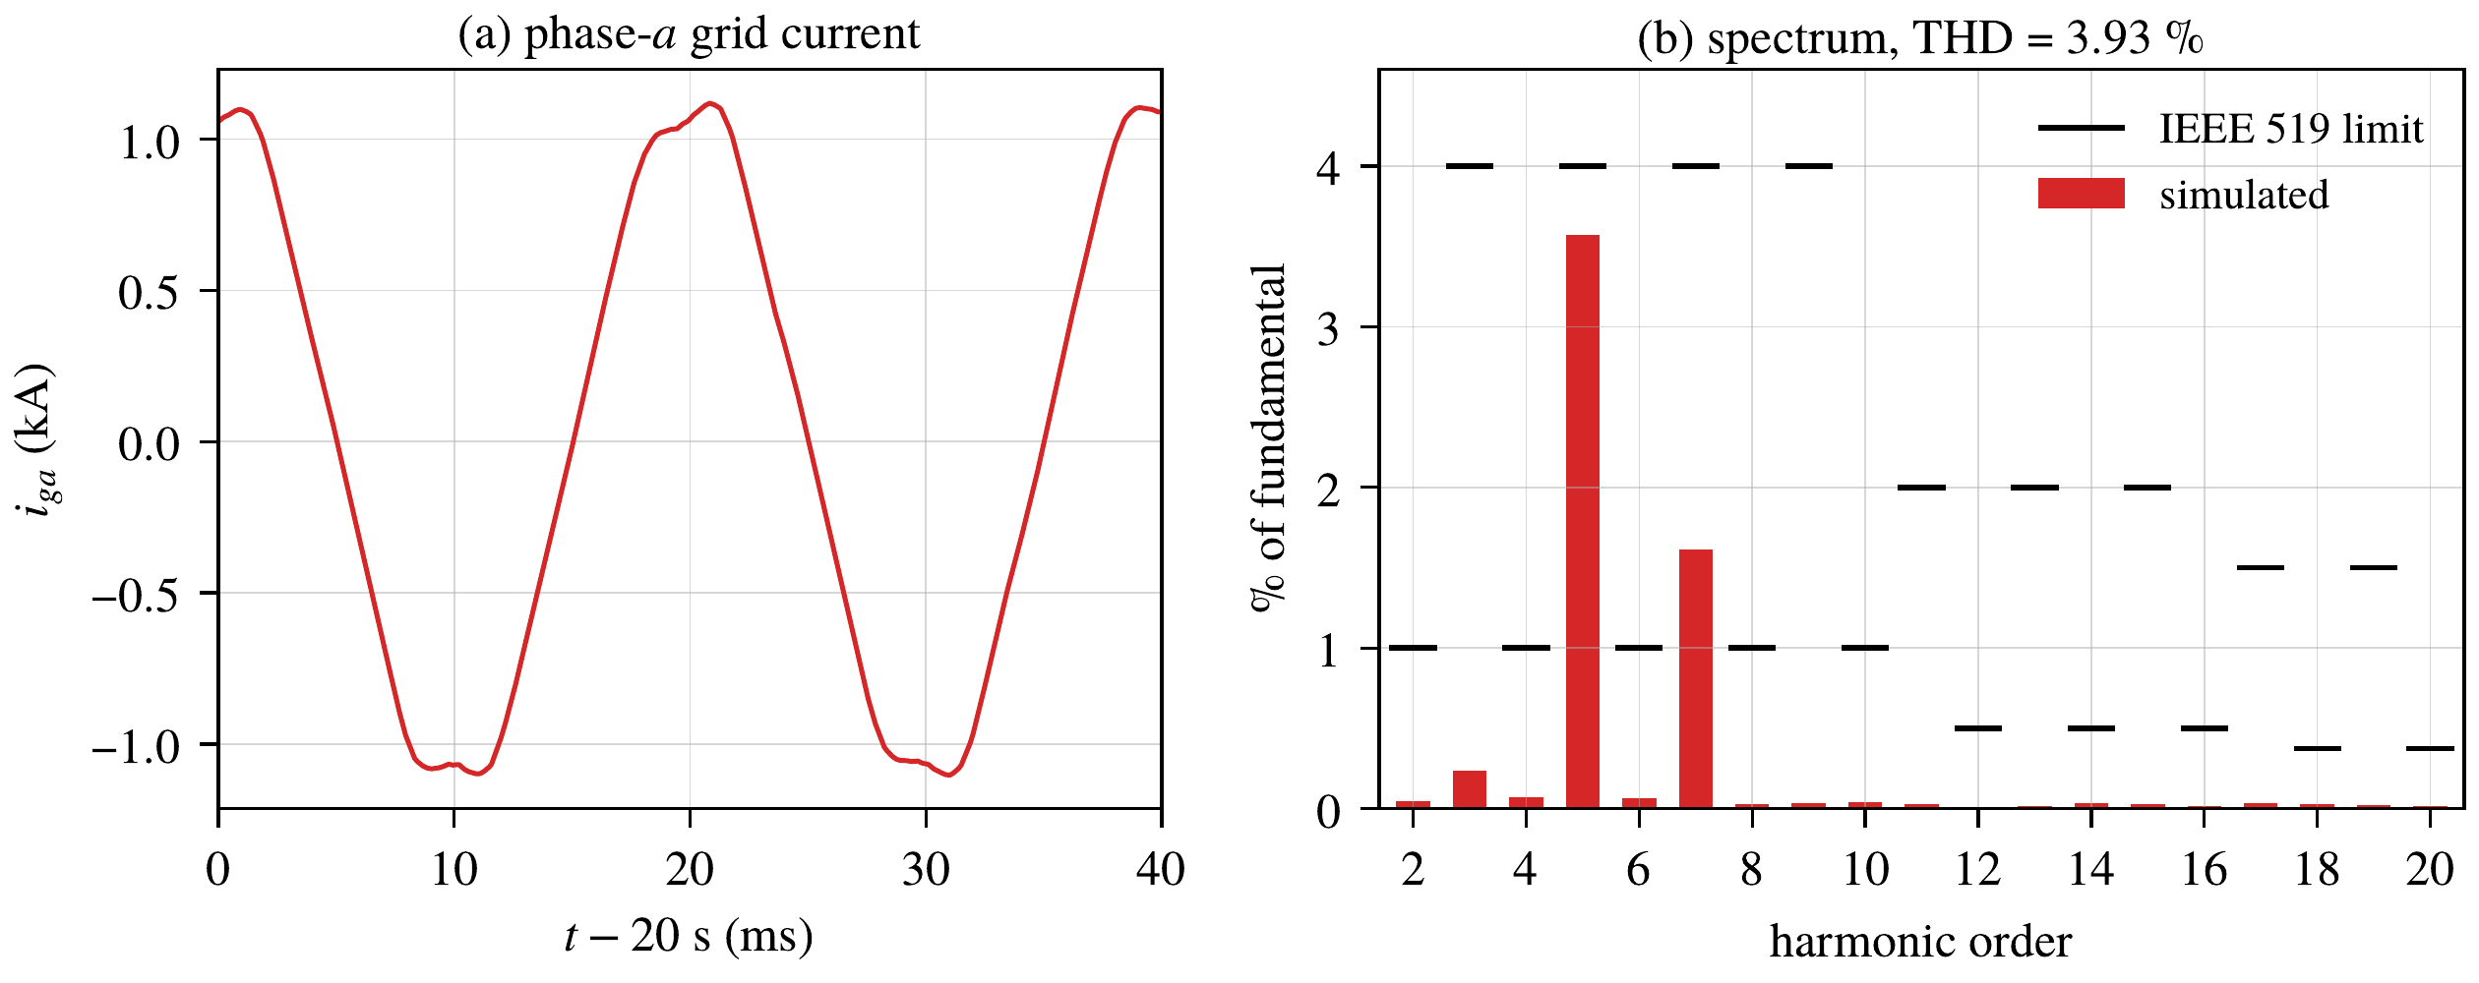
Figure 12. Random wind, $t=20$ s: (a) phase-$a$ grid current; (b) harmonic spectrum and individual limits of IEEE Std 519.

8.5. Case 4: Grid Voltage Dip
During the 50 % voltage dip (Figure 10b–d), the grid current doubles, from 0.77 to 1.50 kA, to keep the injected power, which remains below the current limit of the converter. The DC-link voltage deviates by 16 V (1.3 %) at the beginning of the dip and returns within 5 V of 1200 V about 50 ms after its end. The active power is maintained, with short transients at the beginning and at the end of the dip, and the reactive power remains below 61 kvar (Figure 11b).

8.6. Quantitative Assessment
Table 4 summarizes the speed tracking. With the network, the IAE decreases by 44.8 % in case 1, 26.5 % in case 2 and 27.9 % in case 3, and the ISE decreases by 46 to 52 %, with the same nominal gains. Table 5 shows that the other variables are practically unchanged: the current errors, the DC-link deviation, the torque ripple and the grid-current THD are the same, and the captured energy and the MPPT efficiency are equal. The network therefore improves the variable that it compensates, the rotor speed, without degrading the rest of the system. Its price is a slightly more active torque, with a 9 to 12 % larger standard deviation of the rate of the 50-ms averaged torque. The remaining speed error comes mainly from the anemometer delay, which no model-based compensation can remove, and from the measurement noise.
Table 4. Speed tracking performance without and with the adaptive RBF compensation (best values in bold).
Case | Metric | Without ANN | With ANN | Improvement (%)
1. Step wind | RMSE (mrad/s) | 4.99 | 3.67 | 26.5
 | MAE (mrad/s) | 1.81 | 1.00 | 44.8
 | $e_{max}$ (mrad/s) | 33.2 | 30.1 | 9.5
 | IAE (mrad) | 70.6 | 39.0 | 44.8
 | ISE (${10}^{−4}$ rad²/s) | 9.71 | 5.24 | 46.0
 | settling to 2 mrad/s (s) | 3.85–4.35 | 1.88 | 51–57
2. Random wind | RMSE (mrad/s) | 4.61 | 3.25 | 29.6
 | MAE (mrad/s) | 3.63 | 2.66 | 26.5
 | $e_{max}$ (mrad/s) | 12.7 | 7.42 | 41.4
 | IAE (mrad) | 141.4 | 103.9 | 26.5
 | ISE (${10}^{−4}$ rad²/s) | 8.28 | 4.11 | 50.4
3. Uncertainty | RMSE (mrad/s) | 5.55 | 3.87 | 30.4
 | MAE (mrad/s) | 4.47 | 3.22 | 27.9
 | $e_{max}$ (mrad/s) | 14.2 | 8.93 | 37.0
 | IAE (mrad) | 174.3 | 125.7 | 27.9
 | ISE (${10}^{−4}$ rad²/s) | 12.0 | 5.83 | 51.5
Table 5. Performance of the whole system without and with the adaptive RBF compensation (40 s, from $t=1$ s; best values in bold, both in bold when the difference is negligible).
 | 1. Step wind |  | 2. Random wind |  | 3–4. Uncertainty, dip
Metric | Without | With | Without | With | Without | With
Max $\left|V_{dc}−V_{dc}^{*}\right|$ (V)¹ | 6.96 | 6.94 | 7.03 | 6.90 | 9.32 | 9.10
Max $\left|V_{dc}−V_{dc}^{*}\right|$ in the dip (V) | – | – | – | – | 16.1 | 15.6
RMS error of $i_{sq}$ (A) | 5.83 | 5.80 | 5.85 | 5.81 | 5.81 | 5.79
RMS error of $i_{gd}$ (A) | 41.5 | 41.4 | 42.3 | 42.3 | 35.1 | 35.0
Torque ripple (% of $T_{n}$)² | 0.55 | 0.54 | 0.60 | 0.60 | 0.61 | 0.60
Grid-current THD (%) | 1.45 | 1.45 | 3.86 | 3.92 | 2.55 | 2.58
Energy (kWh) | 13.86 | 13.86 | 10.05 | 10.04 | 10.98 | 10.97
MPPT efficiency (%) | 98.0 | 98.0 | 97.7 | 97.7 | 97.7 | 97.7
Torque rate std (MN$⋅$m/s)³ | 0.239 | 0.267 | 0.212 | 0.231 | 0.210 | 0.233
¹ outside the voltage dip; ² standard deviation of $T_{e}$ minus its 50-ms average; ³ of the 50-ms averaged torque.

9. Conclusions
This paper proposed a hybrid control for a 2 MW direct-drive PMSG wind energy conversion system in which flatness generates the references, passivity-based control guarantees the energy structure and the damping of the current loops of both converters, and an adaptive RBF network compensates the aerodynamic-torque and parameter uncertainty. The system was modeled from the wind to the grid with an exact energy balance, and a composite Lyapunov analysis showed that all closed-loop signals remain bounded, that the current errors converge to zero and that the speed error converges to a neighborhood of zero that depends on the approximation error of the network. Simulations with sensor noise and grid harmonics under step wind, random wind, parameter uncertainty and a 50 % voltage dip showed that all the controlled variables track their references, that the DC-link voltage remains within 0.8 % of its reference outside the dip and within 1.3 % during it, that the grid-current THD stays below 4 %, and that the network reduces the integral absolute speed error by 26.5 to 44.8 % with the same nominal gains and the same captured energy.
The validation was made with the average model of the converters, so the switching ripple is not represented, with an ideal synchronization to the grid and one realization of the random wind. No experimental or hardware-in-the-loop (HIL) validation has yet been performed, and the stability analysis does not include the sampling and the saturations. Future work will consider a switching model with an $LCL$ filter, the dynamics of the phase-locked loop, HIL implementation, and comparisons with other nonlinear controllers.
Author Contributions: Conceptualization, M.M. and K.K.; Methodology, S.R.; Validation, S.R. and K.K.; Investigation, S.R.; Writing—original draft, S.R., M.M. and K.K.; Supervision, M.M. and K.K.; Project administration, M.M. and K.K. All authors have read and agreed to the published version of the manuscript.
Funding: This research received no external funding.
Data Availability Statement: The original contributions presented in this study are included in the article. Further inquiries can be directed to the corresponding author.
Conflicts of Interest: The authors declare no conflicts of interest.

References
[1] Barthelmie, R.J.; Pryor, S.C. Climate Change Mitigation Potential of Wind Energy. Climate 2021, 9, 136. https://doi.org/10.3390/cli9090136.
[2] International Energy Agency (IEA). World Energy Outlook 2024; IEA: Paris, France, 2024.
[3] Global Wind Energy Council (GWEC). Global Wind Report 2024; GWEC: Brussels, Belgium, 2024.
[4] Polinder, H.; Ferreira, J.A.; Jensen, B.B.; Abrahamsen, A.B.; Atallah, K.; McMahon, R.A. Trends in Wind Turbine Generator Systems. IEEE J. Emerg. Sel. Top. Power Electron. 2013, 1, 174–185.
[5] Yaramasu, V.; Wu, B.; Sen, P.C.; Kouro, S.; Narimani, M. High-Power Wind Energy Conversion Systems: State-of-the-Art and Emerging Technologies. Proc. IEEE 2015, 103, 740–788.
[6] Wu, B.; Lang, Y.; Zargari, N.; Kouro, S. Power Conversion and Control of Wind Energy Systems; Wiley-IEEE Press: Hoboken, NJ, USA, 2011.
[7] Rolán, A.; Luna, A.; Vázquez, G.; Aguilar, D.; Azevedo, G. Modeling of a Variable Speed Wind Turbine with a Permanent Magnet Synchronous Generator. In Proceedings of the IEEE International Symposium on Industrial Electronics (ISIE), Seoul, Republic of Korea, 2009; pp. 734–739. https://doi.org/10.1109/ISIE.2009.5218120.
[8] Aimene, M.; Payman, A.; Dakyo, B. Comparative Study between Flatness-Based and Field-Oriented Control Methods of a Grid-Connected Wind Energy Conversion System. Processes 2022, 10, 378. https://doi.org/10.3390/pr10020378.
[9] Chinchilla, M.; Arnaltes, S.; Burgos, J.C. Control of Permanent-Magnet Generators Applied to Variable-Speed Wind-Energy Systems Connected to the Grid. IEEE Trans. Energy Convers. 2006, 21, 130–135.
[10] Yazdani, A.; Iravani, R. Voltage-Sourced Converters in Power Systems: Modeling, Control, and Applications; Wiley-IEEE Press: Hoboken, NJ, USA, 2010.
[11] Blaabjerg, F.; Teodorescu, R.; Liserre, M.; Timbus, A.V. Overview of Control and Grid Synchronization for Distributed Power Generation Systems. IEEE Trans. Ind. Electron. 2006, 53, 1398–1409.
[12] Mechter, A.; Kemih, K.; Ghanes, M. Sliding Mode Control of a Wind Turbine with Exponential Reaching Law. Acta Polytech. Hung. 2015, 12, 167–183.
[13] Benabdeeseelam, A.; Messadi, M.; Kemih, K.; Hamiche, H. Chattering-Free Terminal Sliding Mode Control Based on Adaptive Exponential Reaching Barrier Function for a Chaotic Permanent Magnet Synchronous Generator in Offshore Wind Turbine System. Chin. Phys. B 2025, 34, 090501.
[14] Mechter, A.; Kemih, K.; Ghanes, M. Backstepping Control of a Wind Turbine for Low Wind Speeds. Nonlinear Dyn. 2016, 84, 2435–2445. https://doi.org/10.1007/s11071-016-2655-y.
[15] Messadi, M.; Mellit, A.; Kemih, K.; Ghanes, M. Predictive Control of a Chaotic Permanent Magnet Synchronous Generator in a Wind Turbine System. Chin. Phys. B 2015, 24, 010502.
[16] Yang, L.; Yang, F.; Sheng, W.; Zhou, K.; Huang, T. Fuzzy Chaos Control of Fractional Order D-PMSG for Wind Turbine with Uncertain Parameters by State Feedback Design. Energies 2021, 14, 7369.
[17] Fliess, M.; Lévine, J.; Martin, P.; Rouchon, P. Flatness and Defect of Non-Linear Systems: Introductory Theory and Examples. Int. J. Control 1995, 61, 1327–1361.
[18] Thounthong, P.; Pierfederici, S.; Davat, B. Analysis of Differential Flatness-Based Control for a Fuel Cell Hybrid Power Source. IEEE Trans. Energy Convers. 2010, 25, 909–920.
[19] Ortega, R.; Loría, A.; Nicklasson, P.J.; Sira-Ramírez, H. Passivity-Based Control of Euler-Lagrange Systems; Springer: London, UK, 1998.
[20] Ortega, R.; van der Schaft, A.; Maschke, B.; Escobar, G. Interconnection and Damping Assignment Passivity-Based Control of Port-Controlled Hamiltonian Systems. Automatica 2002, 38, 585–596.
[21] Park, J.; Sandberg, I.W. Universal Approximation Using Radial-Basis-Function Networks. Neural Comput. 1991, 3, 246–257.
[22] Lewis, F.L.; Jagannathan, S.; Yeşildirek, A. Neural Network Control of Robot Manipulators and Nonlinear Systems; Taylor & Francis: London, UK, 1999.
[23] Ioannou, P.A.; Sun, J. Robust Adaptive Control; Prentice Hall: Upper Saddle River, NJ, USA, 1996.
[24] Li, Y.; Sun, W.; Yu, D. RBFNN-Based Global Fast Terminal Sliding Mode Control for Fully Controlled Doubly Fed Induction Generator. J. Frankl. Inst. 2024, 361, 107196. https://doi.org/10.1016/j.jfranklin.2024.107196.
[25] Bounar, N.; Boulkroune, A.; Labdai, S.; Chrifi-Alaoui, L.; Khebbache, H. Disturbance Observer-Based Finite-Time Adaptive Neural Control Scheme of DFIG-Wind Turbine. Wind Eng. 2025, 49, 271–289. https://doi.org/10.1177/0309524X241263517.
[26] Dardabi, C.; Djebli, A.; Chojaa, H. Enhancing the Control of Doubly Fed Induction Generators Using Artificial Neural Networks in the Presence of Real Wind Profiles. PLoS ONE 2024, 19, e0300527. https://doi.org/10.1371/journal.pone.0300527.
[27] Regani, S.; Messadi, M.; Kemih, K. A Novel Chaos Control Approach with Adaptive ANN Compensation for a DFIG-Based Wind Turbine. Mathematics 2026, 14, 3739. https://doi.org/10.3390/math14203739.
[28] Hasan, S.M.M.; Shatil, A.H.M. Design and Comparison of Grid Connected Permanent Magnet Synchronous Generator Non-Salient Pole and Salient Pole Rotor Wind Turbine. AIUB J. Sci. Eng. 2021, 20, 40–46.
[29] Heier, S. Grid Integration of Wind Energy: Onshore and Offshore Conversion Systems, 3rd ed.; Wiley: Chichester, UK, 2014.
[30] Khalil, H.K. Nonlinear Systems, 3rd ed.; Prentice Hall: Upper Saddle River, NJ, USA, 2002.
[31] IEEE Std 519-2014; IEEE Recommended Practice and Requirements for Harmonic Control in Electric Power Systems. IEEE: New York, NY, USA, 2014.

