**The 100 best footballers in the world have been ranked**

[Andrew Smyth](https://acefootball.com/football-news/author/andrewsmyth/)December 25, 2021 10:59 am

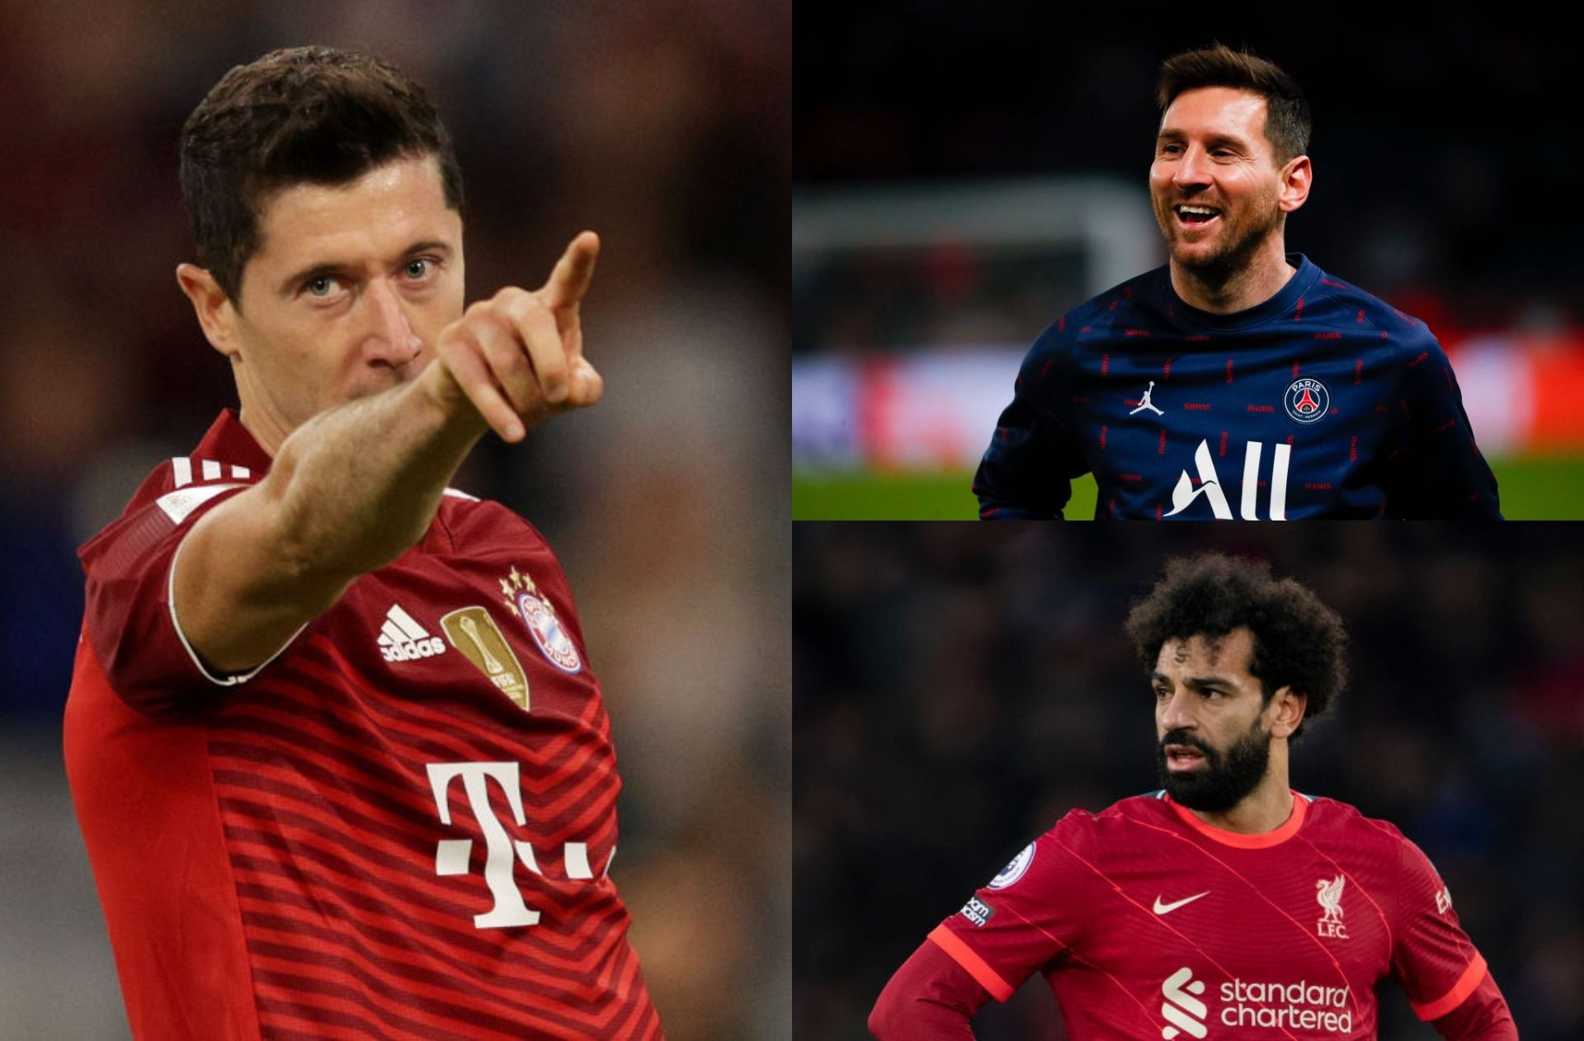

Getty Images

Advertisement

**219 judges made 8,760 votes in a poll to determine the 100 best footballers of 2021.**

Robert Lewandowski has been crowned as the best footballer in the world ahead of Lionel Messi and Mohamed Salah.

The Bayern Munich striker produced more mind-blowing stats in 2021, scoring a record 41 Bundesliga goals in only 29 matches last season. He has continued his form this term, and also helped himself to three goals in three games for Poland in the summer’s Euro 2020 tournament.

Lewandowski may have finished runner-up to Messi in [*the Ballon d’Or race*](https://acefootball.com/football-news/2021-ballon-dor-points-standings-in-full-as-messi-wins-record-seventh-title/), but he managed to pip the Paris Saint-Germain star for top spot on [*The Guardian’s*](https://www.theguardian.com/football/ng-interactive/2021/dec/21/the-100-best-male-footballers-in-the-world-2021) annual list of the best players on the planet.

**How was the voting done?**

The voting panel consisted of 219 judges around the world that included former players, coaches, technical staff, and journalists.

Each judge had to name their top 40 picks from a shortlist of over 300 players from 2021. The Guardian awarded 40 points for each voter’s first-choice candidate, 39 points for second, 38 points for third, right down to one point for 40th.

To qualify, a player needed to receive votes from at least five judges. Individual votes were to be used as a tie-breaker in the event where two or more players finished level on points.

**The 100 best footballers in the world**

Below are the final results of The Guardian’s best footballers in 2021.

| **Pos** | **Player** | **Country** | **Club** |
| --- | --- | --- | --- |
| 1. | Robert Lewandowski | 🇵🇱 | Bayern Munich |
| 2. | Lionel Messi | 🇦🇷 | PSG |
| 3. | Mohamed Salah | 🇪🇬 | Liverpool |
| 4. | Karim Benzema | 🇫🇷 | Real Madrid |
| 5. | Jorginho | 🇮🇹 | Chelsea |
| 6. | Kylian Mbappe | 🇫🇷 | PSG |
| 7. | Erling Haaland | 🇳🇴 | Dortmund |
| 8. | Cristiano Ronaldo | 🇵🇹 | Man United |
| 9. | N’Golo Kante | 🇫🇷 | Chelsea |
| 10. | Kevin De Bruyne | 🇧🇪 | Man City |
| 11. | Romelu Lukaku | 🇧🇪 | Chelsea |
| 12. | Gianluigi Donnarumma | 🇮🇹 | PSG |
| 13. | Neymar | 🇧🇷 | PSG |
| 14. | Ruben Dias | 🇵🇹 | Man City |
| 15. | Harry Kane | 🏴󠁧󠁢󠁥󠁮󠁧󠁿 | Tottenham |
| 16. | Bruno Fernandes | 🇵🇹 | Man United |
| 17. | Federico Chiesa | 🇮🇹 | Juventus |
| 18. | Joshua Kimmich | 🇩🇪 | Bayern Munich |
| 19. | Luis Suarez | 🇺🇾 | Atletico Madrid |
| 20. | Edouard Mendy | 🇸🇳 | Chelsea |
| 21. | Pedri | 🇪🇸 | FC Barcelona |
| 22. | Leonardo Bonucci | 🇮🇹 | Juventus |
| 23. | Sadio Mane | 🇸🇳 | Liverpool |
| 24. | Giorgio Chiellini | 🇮🇹 | Juventus |
| 25. | Phil Foden | 🏴󠁧󠁢󠁥󠁮󠁧󠁿 | Man City |
| 26. | Nicolo Barella | 🇮🇹 | Inter Milan |
| 27. | Mason Mount | 🏴󠁧󠁢󠁥󠁮󠁧󠁿 | Chelsea |
| 28. | Thomas Muller | 🇩🇪 | Bayern Munich |
| 29. | Raheem Sterling | 🏴󠁧󠁢󠁥󠁮󠁧󠁿 | Man City |
| 30. | Lautaro Martinez | 🇦🇷 | Inter Milan |
| 31. | Vinicius Junior | 🇧🇷 | Real Madrid |
| 32. | Angel Di Maria | 🇦🇷 | PSG |
| 33. | Jan Oblak | 🇸🇮 | Atletico Madrid |
| 34. | Trent Alexander-Arnold | 🏴󠁧󠁢󠁥󠁮󠁧󠁿 | Liverpool |
| 35. | Ilkay Gundogan | 🇩🇪 | Man City |
| 36. | Manuel Neuer | 🇩🇪 | Bayern Munich |
| 37. | Marco Verratti | 🇮🇹 | PSG |
| 38. | Achraf Hakimi | 🇲🇦 | PSG |
| 39. | Son Heung-min | 🇰🇷 | Tottenham |
| 40. | Luka Modric | 🇭🇷 | Real Madrid |
| 41. | Serge Gnabry | 🇩🇪 | Bayern Munich |
| 42. | Alphonso Davies | 🇨🇦 | Bayern Munich |
| 43. | Virgil van Dijk | 🇳🇱 | Liverpool |
| 44. | Marquinhos | 🇧🇷 | PSG |
| 45. | Bernardo Silva | 🇵🇹 | Man City |
| 46. | Rodrigo De Paul | 🇦🇷 | Atletico Madrid |
| 47. | Kai Havertz | 🇩🇪 | Chelsea |
| 48. | Antonio Rudiger | 🇩🇪 | Chelsea |
| 49. | Memphis Depay | 🇳🇱 | FC Barcelona |
| 50. | Cesar Azpilicueta | 🇪🇸 | Chelsea |
| 51. | Gerard Moreno | 🇪🇸 | Villarreal |
| 52. | Emiliano Martinez | 🇦🇷 | Aston Villa |
| 53. | Thibaut Courtois | 🇧🇪 | Real Madrid |
| 54. | Simon Kjaer | 🇩🇰 | AC Milan |
| 55. | David Alaba | 🇦🇹 | Real Madrid |
| 56. | Zlatan Ibrahimovic | 🇸🇪 | AC Milan |
| 57. | Dusan Vlahovic | 🇷🇸 | Fiorentina |
| 58. | Thiago Silva | 🇧🇷 | Chelsea |
| 59. | Declan Rice | 🏴󠁧󠁢󠁥󠁮󠁧󠁿 | West Ham |
| 60. | Riyad Mahrez | 🇩🇿 | Man City |
| 61. | Jack Grealish | 🏴󠁧󠁢󠁥󠁮󠁧󠁿 | Man City |
| 62. | Lorenzo Insigne | 🇮🇹 | Napoli |
| 63. | Joao Cancelo | 🇵🇹 | Man City |
| 64. | Leon Goretzka | 🇩🇪 | Bayern Munich |
| 65. | Toni Kroos | 🇩🇪 | Real Madrid |
| 66. | Ciro Immobile | 🇮🇹 | Lazio |
| 67. | Alisson Becker | 🇧🇷 | Liverpool |
| 68. | Casemiro | 🇧🇷 | Real Madrid |
| 69. | Paul Pogba | 🇫🇷 | Man United |
| 70. | Reece James | 🏴󠁧󠁢󠁥󠁮󠁧󠁿 | Chelsea |
| 71. | Marcos Llorente | 🇪🇸 | Atletico Madrid |
| 72. | Jude Bellingham | 🏴󠁧󠁢󠁥󠁮󠁧󠁿 | Dortmund |
| 73. | Leonardo Spinazzola | 🇮🇹 | AS Roma |
| 74. | Kyle Walker | 🏴󠁧󠁢󠁥󠁮󠁧󠁿 | Man City |
| 75. | Ederson | 🇧🇷 | Man City |
| 76. | Antoine Griezmann | 🇫🇷 | Atletico Madrid |
| 77. | Kasper Schmeichel | 🇩🇰 | Leicester City |
| 78. | Luke Shaw | 🏴󠁧󠁢󠁥󠁮󠁧󠁿 | Man United |
| 79. | Patrik Schick | 🇨🇿 | Bayer Leverkusen |
| 80. | Roberto Firmino | 🇧🇷 | Liverpool |
| 81. | Marcelo Brozovic | 🇭🇷 | Inter Milan |
| 82. | Sergio Busquets | 🇪🇸 | FC Barcelona |
| 83. | Duvan Zapata | 🇨🇴 | Atalanta |
| 84. | Joao Felix | 🇵🇹 | Atletico Madrid |
| 85. | Burak Yilmaz | 🇹🇷 | Lille |
| 86. | Mikel Oyarzabel | 🇪🇸 | Real Sociedad |
| 87. | Luis Diaz | 🇨🇴 | FC Porto |
| 88. | Diogo Jota | 🇵🇹 | Liverpool |
| 89. | Dusan Tadic | 🇷🇸 | Ajax |
| 90. | Dani Olmo | 🇪🇸 | RB Leipzig |
| 91. | Julian Alvarez | 🇦🇷 | River Plate |
| 92. | Rodri | 🇪🇸 | Man City |
| 93. | Sebastien Haller | 🇨🇮 | Ajax |
| 94. | Keylor Navas | 🇨🇷 | PSG |
| 95. | Bukayo Saka | 🏴󠁧󠁢󠁥󠁮󠁧󠁿 | Arsenal |
| 96. | Joakim Maehle | 🇩🇰 | Atalanta |
| 97. | Fabinho | 🇧🇷 | Liverpool |
| 98. | Gavi | 🇪🇸 | FC Barcelona |
| 99. | Youri Tielemans | 🇧🇪 | Leicester City |
| 100. | Pierre-Emile Hojbjerg | 🇩🇰 | Tottenham |