BHAVESH VEERAMACHANENI

CLASS ID: 38

DEEP LEARNING LAB 2

INTRODUCTION:

Text classification using CNN. CNN means Convolutional Neural Networks. Its mainly developed for classifying images. Here we use same method to classify images.

OBJECTIVES:

Implement CNN-Text-Classification in 5 classes using Tendorflow.

APPROACHES:

Here you can consider different approaches like:

1. Making ANN for text analysis.
2. Using RNN for text analysis.
3. Using CNN for text analysis.

WORKFLOW:

* Here first we convolute the given data by using convolution filters. Here by doing this we identify the features in the given data. We also apply Rectifier layer to correctly identify them.
* Next, we making Pooling or Max Pooling. Here the data must be identified if there is a distortion, rotation, etc.
* Next, we flatten the given data into an array and then pass this into CNN.
* Here we will classify data.

DATASETS:

The dataset we have is consumer complaints narrative and output is credit reporting.

PARAMETRES:

* num_epochs: 1,
* batch_size: 37,
* num_filters: 32,
* filter_sizes: "3,4,5",
* embedding_dim: 50,
* l2_reg_lambda: 0.0,
* evaluate_every: 200,
* dropout_keep_prob: 0.5

OUTPUT:

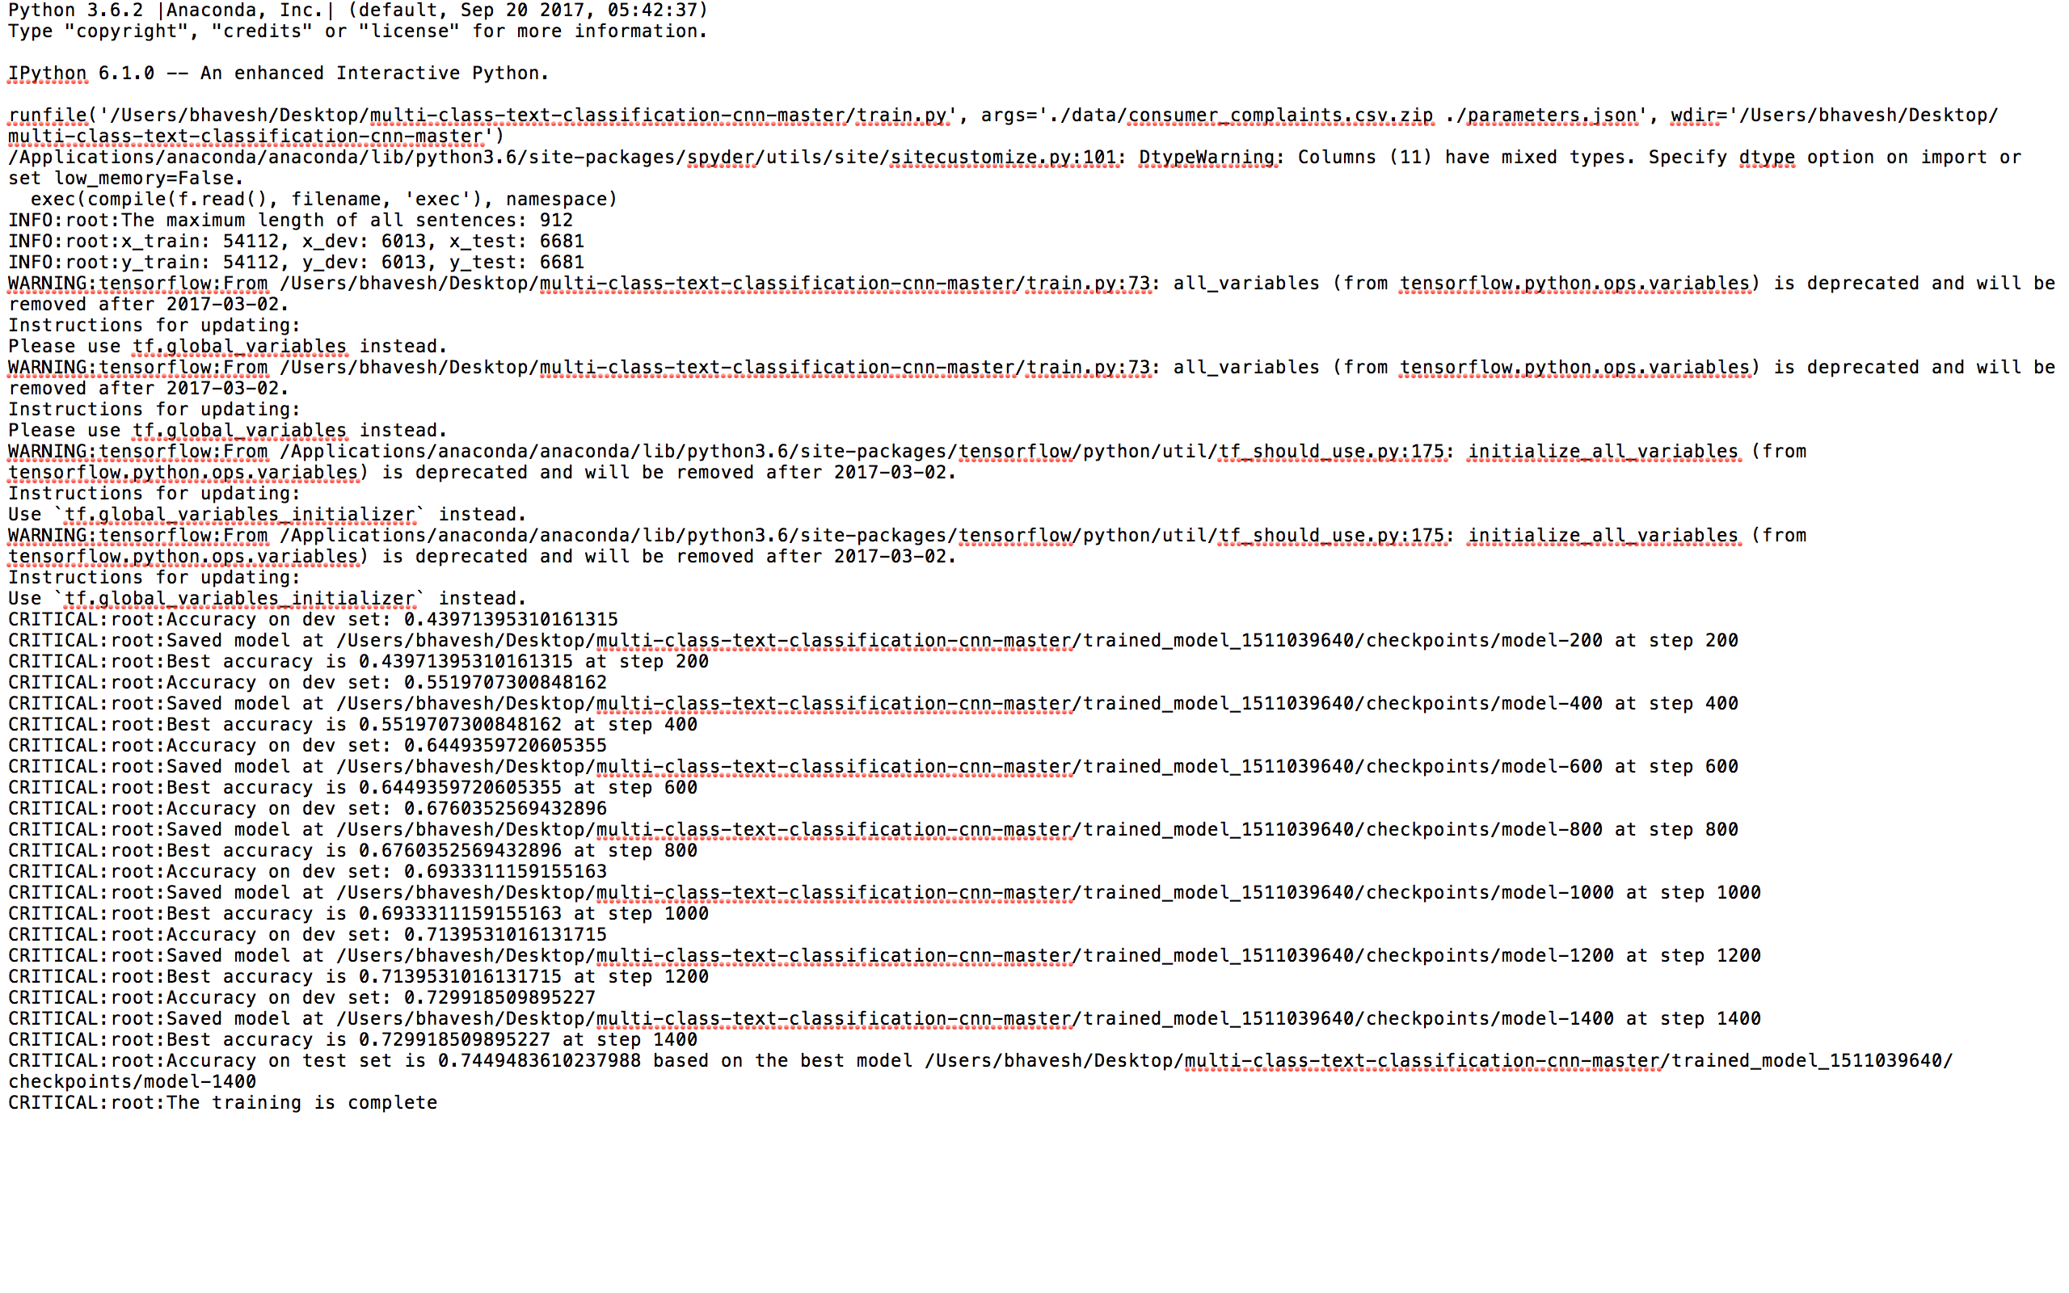

EVALUATION:

* Here we use loss and accuracy from “sklearn.metrics “ to make the evaluation.
* Another option is using Confusion Matrix where you can see how many are positive, negative, false positive, false negative.

CONCLUSION:

Making classification by CNN seems very advanced and complex but we can learn diverse applications in diverse concepts.