



<!DOCTYPE html>

<html lang="en">

<head>

<meta charset="UTF-8">

<meta name="viewport" content="width=device-width, initial-scale=1.0">

<meta http-equiv="X-UA-Compatible" content="ie=edge">

<link rel="stylesheet" href="font-awesome-4.7.0/css/font-awesome.css">

<link rel="stylesheet" type="text/css" href="css/materialize.min.css">

<link rel="stylesheet" type="text/css" href="iconfont/material-icons.css">

<link rel="stylesheet" href="font-awesome-4.7.0/css/font-awesome.css">

<link rel="stylesheet" type="text/css" href="css/style.css">

</head>

<body>

<div class="navbar-fixed">

<nav class="purple accent-3">

<div class="container">

<div class="nav-wrapper">

<a href="#" class="brand-logo">StarDos KidsZone</a>

<a href="#" data-target="mobile-view" class="sidenav-trigger">

<i class="material-icons">menu</i>

</a>

<ul class="right hide-on-med-and-down">

<li>

<a href="#">Home</a>

</li>

<li>

<a href="#service">Service</a>

</li>

<li>

<a href="#contact">Contact</a>

</li>

</ul>

</div>

</div>

</nav>

</div>

<ul class="sidenav" id="mobile-view">

<li>

<a href="#">Home</a>

</li>

<li>

<a href="#service">Service</a>

</li>

<li>

<a href="#contact">Contact</a>

</li>

</ul>

<!---Lide SECTION-->

<section class="slider">

<ul class="slides">

<li>

<img src="img/040028c8dd3c04de206684c4a73acbfdff4d44dd.jpg" class="responsive-img" alt="">

<div class="caption center-align">

<h3>Teaching Kids</h3>

</div>

</li>

<li>

<img src="img/larn.jpg" class="responsive-img" alt="">

<div class="caption right-align">

<h3>Learning in Class</h3>

</div>

</li>

</ul>

</section>

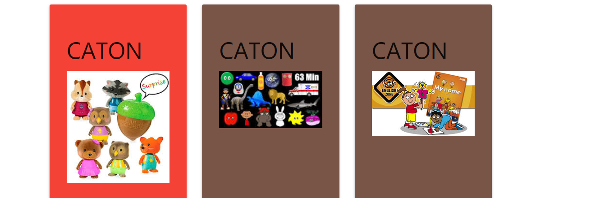

<!---Service-->

<section class="scrollspy" id="service">

<div class="continer">

<div class="row">

<div class="col s6 m3 push-m1">

<div class="card-panel red">

<h4>CATON</h4>

<img src="img/images (2).jpg" class="responsive-img" alt="">

</div>

</div>

<div class="col s6 m3 push-m1">

<div class="card-panel brown">

<h4>CATON</h4>

<img src="img/cat.jpg" width="214" height="235" class="responsive-img" alt="">

<br><br> <br><br> <br>

</div>

</div>

<div class="col s6 m3 push-m1">

<div class="card-panel brown">

<h4>CATON</h4>

<img src="img/caton2.jpg" width="214" height="235" class="responsive-img" alt="">

<br><br> <br><br> <br>

</div>

</div>

</div>

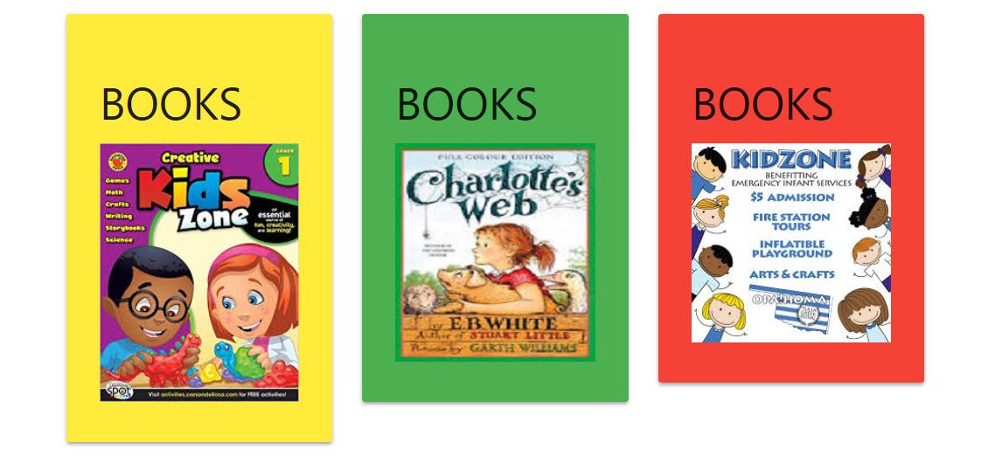

<div class="row">

<div class="col s6 m3 push-m1">

<div class="card-panel yellow">

<h4>BOOKS</h4>

<img src="img/book.jpg" width="214" height="235" class="responsive-img" alt="">

</div>

</div>

<div class="col s6 m3 push-m1">

<div class="card-panel green">

<h4>BOOKS</h4>

<img src="img/books.jpg" width="214" height="235" class="responsive-img" alt="">

<br>

</div>

</div>

<div class="col s6 m3 push-m1">

<div class="card-panel red">

<h4>BOOKS</h4>

<img src="img/bk.jpg" width="214" height="235" class="responsive-img" alt="">

</div>

</div>

</div>

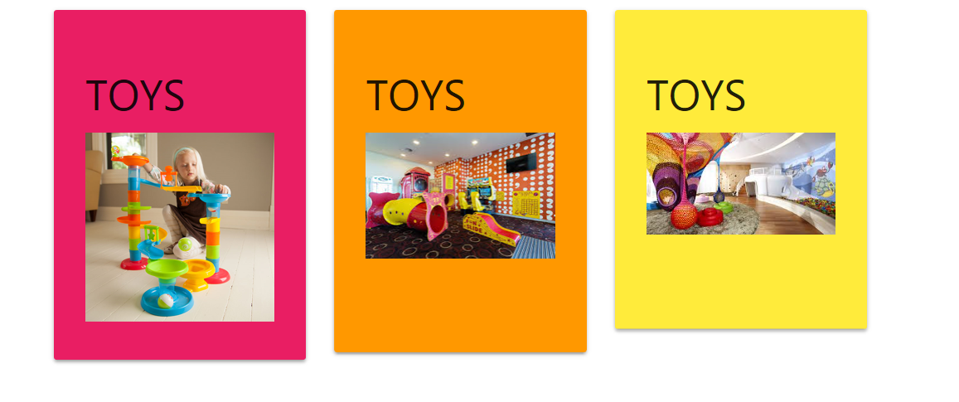

<div class="col s6 m3 push-m1">

<div class="card-panel pink">

<h4>TOYS</h4>

<img src="img/toy.jpg" width="214" height="235" class="responsive-img" alt="">

</div>

</div>

<div class="col s6 m3 push-m1">

<div class="card-panel orange">

<h4>TOYS</h4>

<img src="img/download.jpg" width="214" height="235" class="responsive-img" alt="">

<br><br> <br>

</div>

</div>

<div class="col s6 m3 push-m1">

<div class="card-panel yellow">

<h4>TOYS</h4>

<img src="img/tooy.jpg" width="214" height="235" class="responsive-img" alt="">

<br> <br> <br>

</div>

</div>

</div>

</div>

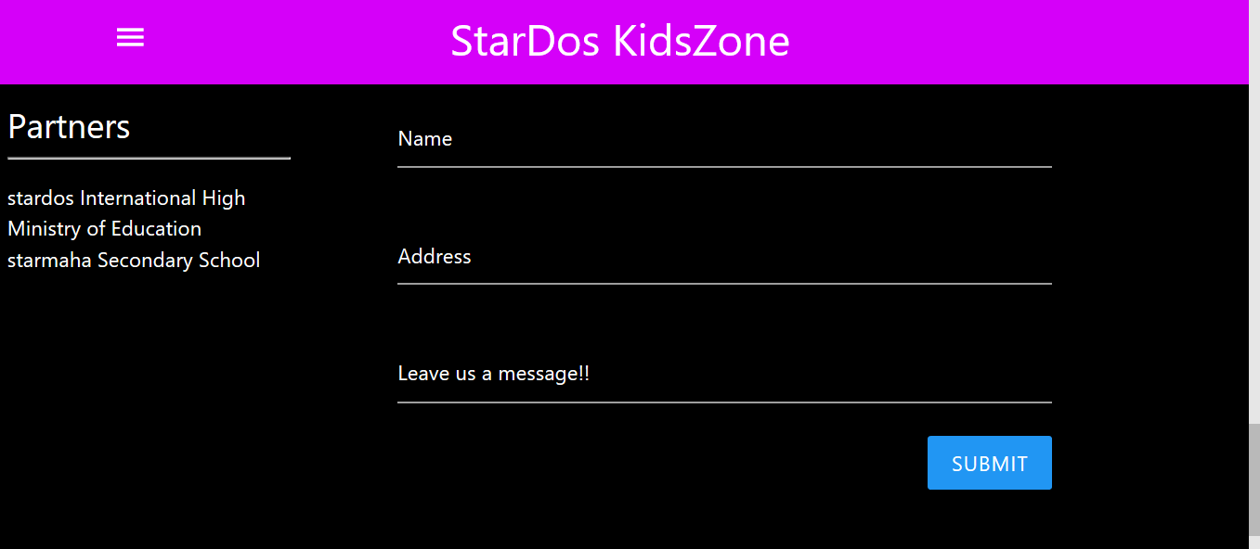



<!---Conatct-->

<section class="scrollspy" id="contact">

<div class="container black bl">

<div class="row">

<div class="col s12 m3 white-text">

<h5>Partners</h5>

<hr>

<ul>

<li>stardos International High</li>

<li>Ministry of Education</li>

<li>starmaha Secondary School</li>

</ul>

</div>

<div class="col s12 m8 white-text">

<div class="container">

<div class="col s12 m12">

<div class="input-field white-text">

<input type="text" class=" white-text" id="name" for="name" name="name">

<label for="name" class="white-text">Name</label>

</div>

</div>

<div class="col s12 m12">

<div class="input-field white-text">

<input type="text" class=" white-text" id="name" for="name" name="name">

<label for="name" class="white-text">Address</label>

</div>

</div>

<div class="col s12 m12">

<div class="input-field">

<textarea type="text" id="message" name="message" class="white-text materialize-textarea"></textarea>

<label for="textarea" class="white-text">Leave us a message!!</label>

</div>

<input type="button" class="btn blue right" value="submit" name="">

</div>

</div>

</div>

</div>

<div class="row">

<div class="col s12 m4 white-text">

<h5>Contact Details</h5>

<p>Do not hesistate to contact us on the following </p>

<hr>

<ul>

<li>Tel: +23277703478</li>

<li>Email: saidujalloh48@gmail.com</li>

<li>Address: 9 alpha terrace</li>

</ul>

</div>

</div>

</section>

<script type="text/javascript" src="js/materialize.min.js"></script>

<script type ="text/javascript" src ="js/jquery-3.3.1.min.js"> </script>

<script>

//side bar

const sideNav = document.querySelector('.sidenav');

M.Sidenav.init(sideNav, {});

//Tabs

const tabs = document.querySelector('.tabs');

M.Tabs.init(tabs, {});

//Scrollspy jqueryk

const sc = document.querySelectorAll('.scrollspy');

M.ScrollSpy.init(sc, {

scrollOffset: 60

});

//Slider jquery

const slider = document.querySelector('.slider');

M.Slider.init(slider, {

indicators: false,

height: 550,

transition: 500,

speed: 1000

});

</script>

</body>

</html>