Drop Your Complain

By

Md Mushrif Hoque

ID : 161-35-1429

This Report Presented in Partial Fulfillment of the Requirements for the Degree of Bachelor of Software Engineering.

Supervised By

**Khalid Been Md.Badruzzaman**

Lecturer

Department of SWE

Daffodil International University



APPROVAL

This project entitled on “Drop Your Complain(An Online Platform)” submitted by **Mushrif Hoque** bearing ID:161-35-1429 to the Department of Software Engineering of Daffodil International University has been accepted as satisfactory for the partial fulfillment of the requirements for the degree of Bachelor of Science in Software Engineering and approval as to its style and contents.

**BOARD OF EXAMINERS**

Dr. Touhid Bhuiyan

Professor & Head

Department of Software Engineering

Faculty of Science and Information Technology

Daffodil International University

Internal Examiner

Internal Examiner

External Examiner

Declaration

I hereby declare that I have taken this project under the supervision of **Khalid Been Md.Badruzzaman**, Senior Lecturer, Department of Software Engineering, Daffodil International University. I also declare that neither this report nor any part of this has been submitted elsewhere for award of any degree.

------------------------

**Md Mushrif Hoque**

**ID:** 161-35-1429

**Batch:** 19th

Department of Software Engineering

Faculty of Science & Information Technology

**ACKNOLEDGEMENT**

At first, I am grateful to The Almighty Allah for making me eligible to complete this project. Then I would like to thank my supervisor Senior Lecturer, **Khalid Been Md.Badruzzaman** Department of Software Engineering. We are extremely grateful and indebted to her expert, sincere and valuable guidance and encouragement extended to us.

We wish to express our sincere thanks to **Dr. Touhid Bhuiyan**, Professor & Head of Software Engineering department for his constant encouragement.

Last but not least, we would like to thank our parents, for their unconditional support, love and without this we would not have come this far.

Above all, we would like to thank to The Almighty Allah for giving me strength to complete this project.

A project submitted in partial fulfillment of the requirement for the degree of Bachelor of Science in Software Engineering.

**Department of Software Engineering**

**Daffodil International University**

Table of Contents

INTRODUCTION(Chapter 1) 1

Type chapter title (level 2)2

Type chapter title (level 3)3

PROJECT PLANNING(Chapter 2) 4

Type chapter title (level 2)5

Type chapter title (level 3)6

Software Requirements Specification (Chapter 3) 4

System Analysis (Chapter 4) 4

System Testing (Chapter 5) 4

System Design Specification (Chapter 6) 4

Project Summery(Chapter7) 4

**CHAPTER 1**

**INTRODUCTION**

**1. INTRODUCTION**

**1.1. Project Overview**

Problem under Dhaka city corporation like: Garbage problem,Drainage problem ,Manhole missing problem, Road damage problem ,To complain this kind of problem through online to city corporation.

**1.2. The Purpose of the Project**

When someone face this kind of problem then he/she can complain easily to the city corporation without waste of time and energy through this application. By this application authority can understand the problem under the city corporation and take the essential steps to solve the problem.

**1.2.1. Background of the Project Effort**

In Dhaka city we often face this kind of problem and we don’t do anything and because we don’t want to go city corporation office or most of the time we haven’t any option to do something .To solve this problem I develop a website to drop complain . Where When someone face this kind of problem then he/she can complain and check the work status of complain .

**1.2.2. Goals of the Project**

By Using this system when anyone face problem like road damage , dustbin problem he or she can complain with proper location and complain details and admin can verify the problem ,and then admin can upload the status of work .Complainer can see the work by Complain Id which provide by system. By using this system it will save lots of time ,energy and add value in people life of under Dhaka city corporation.

**1.4. Beneficiaries and Benefits**

This projects are mainly beneficiaries for Complainers and Admin. Benefits are,

* To Complain by complainer is fully functional and flexible.

* Complainer can check work status.

* Admin can keep records.

* Admin upload work status.

*It saves a lot of time, energy of complainer.

* People start believing in online complain system

**CHAPTER 2**

**PROJECT PLANNING**

**2. PROJECT PLANNING**

**2.1. Project Scenario**

Complainer can submit the problem to authority with exact location  with details and photography. After submit any problem to the authority the system will give him a Complain Id in Website UI and also sent the Complain Id in complainer Email so that complainer can view work status by complain id. City corporation check the problem with proper location and verify the problem . City corporation will upload the work status. The system have only 3 type of user , Admin and register and non-register Complainer .

* + 1. **Scenario 1:- User (Admin) Based**
* Admin login into the systems
* Check or view the complain list
* Upload work status
* Then Admin can logout

* + 1. **Scenario 2:- User (Complainer) Based**

1. Complainer can complain when he/she face
2. Complainer get complain Id in System UI
3. Complainer also get Complain Id in his/her Email which she/he provide while submit Complain
4. Complainer can registration to system
5. Complainer can log in to view or check work status of complain
6. Then complainer can logout

**2.2. Stakeholders**

**2.2.1. The Admin**

1.View complainer complain

2.Upload work status

**2.2.2The user(Complainer)**

1. Submit Complain

3.Can registration

2.Check Work status

**2.2.3The user(Complainer, Non-Register)**

1. Submit Complain

### 2.3. Mandated Constraints

#### 2.3.1. Budget Constraints

Primary budget – 5k

Yearly maintenance cost – 2k

### 2.4. Project Schedule

### 2.4.1 Gantt chart

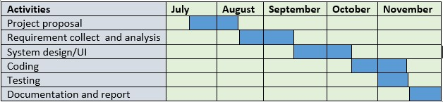

## Fig-2.01: Gantt chart

### 2.4.2. Release Plan/Milestone

### 

|  |  |  |
| --- | --- | --- |
| Task No | Task Name | **Time** |
| 1 | Requirements gathering and analysis | 2 weeks |
| 2 | Project proposal | 1 week |
| 3 | Database design | 2 week |
| 4 | UI design | 2 Days |
| 5 | Implementing | 3 weeks |
| 6 | Testing | 2 weeks |
| 7 | Evaluation The Project | 1 week |

### 

# 

# **Chapter 3**

## **Software Requirements Specification**

## 

## **3.1:Requirement Specification**

|  |  |  |  |
| --- | --- | --- | --- |
| **FRQ_ID** | **FRQ_Name** | **Description** | **Priority** |
| FRQ01 | Complain Submit | Anyone can complain by using this System. | High |
| FRQ02 | View Complain Status | Register can view complain status by using this system if provide complain id. | Low |
| FRQ03 | Login[Admin] | Admin Can login to view complain list ,without login admin cant view complain list and upload status | High |
| FRQ04 | Upload Status | Admin Can Upload status | High |
| FRQ05 | Complain Id | Complainer get complain Id by Email | Medium |
| FR06 | Admin Logout | Admin can close connection to system by logout . | Medium |
| FR07 | Registration[Complainer] | Complainer can registration to view the complain status. | Medium |
| FR08 | Login[Register Complainer] | Register Complainer can login to view the complain status. | Medium |

**3.2:Data Requirement:**

Table 2.2: Data Requirements

|  |  |  |
| --- | --- | --- |
| **No** | **Description** | **Priority** |
| DR01 | Complain type , Complain Area, Road Number , Photograph , Complain details , Complainer Name , Complainer Email , Complainer Contact Number requires when submit Complain by complainer . | High |
| DR02 | Admin have to insert the login credentials accurately otherwise system will show an error with message. | High |
| DR03 | Complainer have to registration to view complain status | low |
| DR04 | Complainer must have to login to view complain status | Medium |
| DR05 | Complainer must provide complain id to check complain status | Medium |

## **3.3:Performance Requirements**

### 3.3.1:Speed and Latency Requirements

Table 3.3.1: Speed and Latency Requirements

|  |  |
| --- | --- |
| **No** | **Description** |
| SLR01 | Maximum 2 seconds to load data from SQL server to System . |
| SLR02 | Maximum 2 seconds to upload data in SQL server from System. |
| SLR03 | The system must have a high speed to reply to the user request. |

### 2.3.2.Precision and Accuracy Requirements

Table 233.2: Precision and Accuracy Requirements

|  |  |
| --- | --- |
| **No** | **Description** |
| SLR01 | The input data should be accurate when Complainer or Admin provide data to the system. |
| SLR02 | All data should be in place accurately where it is associated |

### 3.3.3. Capacity Requirements

Table 3.3.3: Capacity Requirements

|  |  |
| --- | --- |
| **No** | **Description** |
| CR01 | The system will be managed all the insertion of data in database. |
| CR02 | The server database size must be able to load the system data. |

## **3.4. Dependability Requirements**

### 3.4.1. Reliability Requirements

Table 2.4.1: Reliability Requirements

|  |  |
| --- | --- |
| **No** | **Description** |
| RR01 | All data should collect from users by permission and by accepting privacy policy |
| RR02 | No one can use user’s data for any other purpose except system needs. |

### 3.4.2.Availability Requirements

Table 2.4.2: Availability Requirements

|  |  |
| --- | --- |
| **No** | **Description** |
| AR01 | The system should work 24 hours a day. |
| AR02 | The system should provide the desired data to the user in time. |

### 3.4.3.Robustness or Fault-Tolerance Requirement

Table 2.4.3: Robustness or Fault Tolerance Requirements

|  |  |
| --- | --- |
| **No** | **Description** |
| FTR01 | If the system has been crashed, it should not be more than an hour. |

## **Maintainability and Supportability Requirements**

### 3.5.1.Maintenance Requirements

Table 2.5.1: Maintenance Requirements

|  |  |
| --- | --- |
| **No** | **Description** |
| MR01 | The system maintenance should be quick. |

### 3.5.2.Supportability Requirements

Table 2.5.2: Supportability Requirements

|  |  |
| --- | --- |
| **No** | **Description** |
| SR01 | The system should support Google crome ,firefox . |

**3.5.3 Adaptability Requirements**

No visible adaptability requirements

**3.5.4 Scalability or Extensibility Requirements**

No visible adaptability requirements

* 1. **Security Requirements** 
     1. **Access Requirements**

**Table-3.11: Access Requirements**

|  |  |
| --- | --- |
| **No** | **Description** |
| SR01 | To get access to the system, the system provides session way.. |

* + 1. **Integrity Requirements**

To protect credentials of user from being stolen, all passwords are stored in encrypted form. The Requirements significantly reduces the value of stolen user credentials, it’s not easy to decrypt the password.

### 3.6.3.Privacy Requirements

Table 2.6.2: Privacy Requirements

|  |  |
| --- | --- |
| **No** | **Description** |
| PR01 | The user data should not contain any private issues. |
| PR02 | All the confidential data should be encrypted. |

**3.7Look and field Requirements**

### 3.7.1Appearance Requirements

Table 2.8.1: Appearance Requirements

|  |  |
| --- | --- |
| **No** | **Description** |
| AR01 | The user interface must be attractive. |
| AR02 | The user interface must be user friendly. |
| AR03 | The user interface must be user interactive with user experiences. |

### 3.7.2. Style Requirements

Table 2.8.2: Style Requirements

|  |  |
| --- | --- |
| SR01 | The interface color should be material. |

# **Chapter 4**

**System Analysis**

**4.1. Use case**

A use case is a software and system engineering term that describes how a user uses a system to accomplish a particular goal. A use case acts as a software modeling technique that defines the features to be implemented .

**4.1.1 Use case diagram**

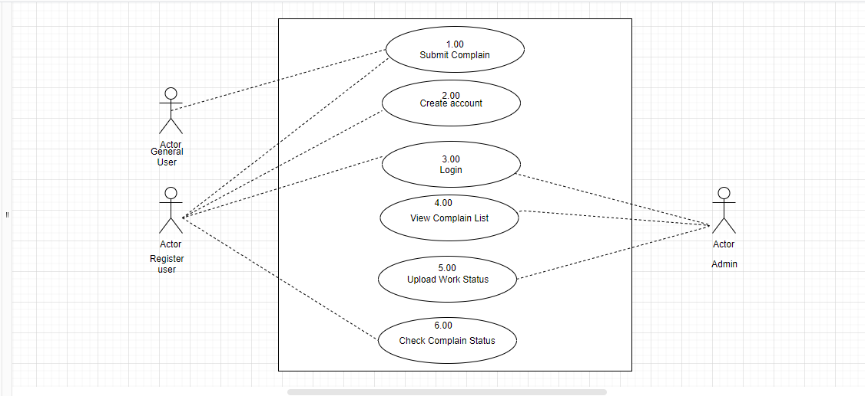

Fig: Use case Diagram

**4.1.1.1 Submit Complain**

4.1: Submit Complain

|  |  |  |  |  |
| --- | --- | --- | --- | --- |
| Use case no | 1.00 | | |  |
| Use case  name | Submit complain | | |
| scenario | Any user can submit complain to system | | |
| Brief  description | Users can enter the system and submit the problem with proper location , photograph and details | | |
| Actors | General user  Register user  Admin | | |
| preconditions | Enter into the system | | |
| Post  conditions | Get complain Id | | |
| Flow of event | **ACTOR SYSTEM** | | |
|  | 1.Enter All the required filed  2.Press submit button | 1.1 check validation if field are empty |  |
| Exception  conditions | 2.1 If complain is already exist in system which is submit by other complainer and if the work status is pending the system will show complain in already exist by other complaier | | |  |

**4.1.1.2 Create account**

4.1 create account

|  |  |  |  |  |
| --- | --- | --- | --- | --- |
| Use case no | 2.00 | | |  |
| Use case  name | Create account | | |
| scenario | Any complainer can registration for create account in the system | | |
| Brief  description | Any complainer can registration for create account in the system if he/she wants to view the complain work status | | |
| Actors | General user | | |
| preconditions | Enter the system | | |
| Post  conditions | Can check work status of complain view | | |
| Flow of event | **ACTOR SYSTEM** | | |
|  | 1.Enter username and password and email  2.Press singUp button  3. System give Acoount open message | 1.1 check validation if field are empty |  |
| Exception  conditions | 2.1 If username , email is exist the show all ready register in the system | | |  |

**4.1.1.3 Login**

Table 4.1: Login

|  |  |  |  |  |
| --- | --- | --- | --- | --- |
| Use case no | UC1.0 | | |  |
| Use case  name | Login | | |
| scenario | All user are need to login this web site | | |
| Brief  description | Users can enter the system and use their account | | |
| Actors | Tutor  Parent  Admin | | |
| preconditions | Registration for Tutor and parent, user must be exist | | |
| Post  conditions | Enter the system | | |
| Flow of event | **ACTOR SYSTEM** | | |
|  | 1.Enter username and password  2.Press login button | 1.1 check validation if field are empty |  |
| Exception  conditions | 2.1 If username and password is not exist the show wrong username and  password | | |  |
| Use case no | 3.00 | | |  |
| Use case  name | Login | | |
| scenario | Register user and Admin need to login the system | | |
| Brief  description | Users can enter the system and use their account | | |
| Actors | Admin  Register user  Admin | | |
| preconditions | Registration for Register user must exist in database of the system | | |
| Post  conditions | Enter the system and go to the login page | | |
| Flow of event | **ACTOR SYSTEM** | | |
|  | 1.Enter username and password  2.Press login button | 1.1 check validation if field are empty |  |
| Exception  conditions | 2.1 If username and password is not exist the show wrong username and  password | | |  |

**4.1.1.4 View Complain list**

Table :View Complain list

|  |  |  |  |  |
| --- | --- | --- | --- | --- |
| Use case no | 4.00 | | |  |
| Use case  name | View Complain list | | |
| scenario | Admin need to login this web site | | |
| Brief  description | Admin Can enter in the module and view the complain list | | |
| Actors | Admin | | |
| preconditions | Must have to login the system | | |
| Post  conditions | Enter the system | | |
| Flow of event | **ACTOR SYSTEM** | | |
|  | 1.Enter username and password  2.View the Complain list | 1.1 check validation if field are empty |  |
| Exception  conditions | 2.1 If username and password is not exist the show wrong username and  password | | |  |

**4.1.1.1 Upload status**

Table 4.1: upload status

|  |  |  |  |  |
| --- | --- | --- | --- | --- |
| Use case no | 5.00 | | |  |
| Use case  name | Upload status | | |
| scenario | Admin upload the work status of complain | | |
| Brief  description | Admin view the complain list and upload the work status | | |
| Actors | Admin | | |
| preconditions | Login and view the complain details | | |
| Post  conditions | Enter the system | | |
| Flow of event | **ACTOR SYSTEM** | | |
|  | 1.Click on upload status button  2. Go to the upload status page  2.Press upload button  3. System show data update | 1.1 check validation |  |
| Exception  conditions | 2.1 If username and password is not exist the show wrong username and  Password while loging | | |  |

**4.1.1.1 Check complain status**

Table 4.1:**complain complain status**

|  |  |  |  |  |
| --- | --- | --- | --- | --- |
| Use case no | 6.00 | | |  |
| Use case  name | **Check complain status** | | |
| scenario | Register user can view work status of complain | | |
| Brief  description | Register user can check work status of complain by complain id | | |
| Actors | Register user | | |
| preconditions | Login in the system | | |
| Post  conditions | View the complain status | | |
| Flow of event | **ACTOR SYSTEM** | | |
|  | 1.Give id in search box  2. press search button  3. show the result | 1.1 check validation is field is empty |  |
| Exception  conditions | 2.1 If complain id is not exist the show nothing | | |  |

**4.2. Activity Diagram:**

**4.3.1. Activity Diagram for Register user:**

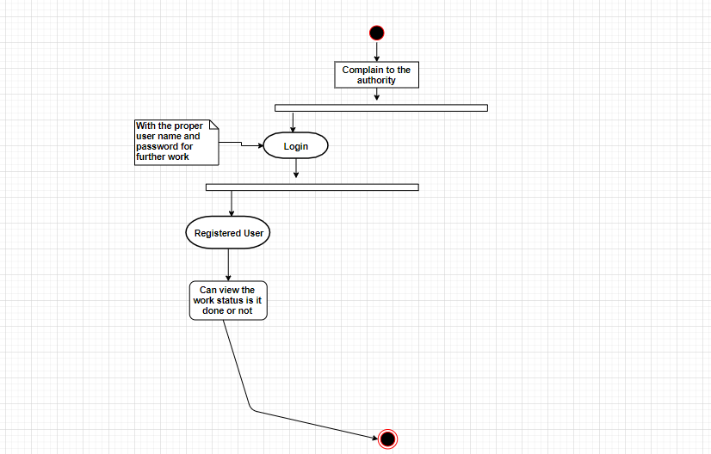

Fig: Activity Diagram for Register user

**4.3.1. Activity Diagram for General user:**

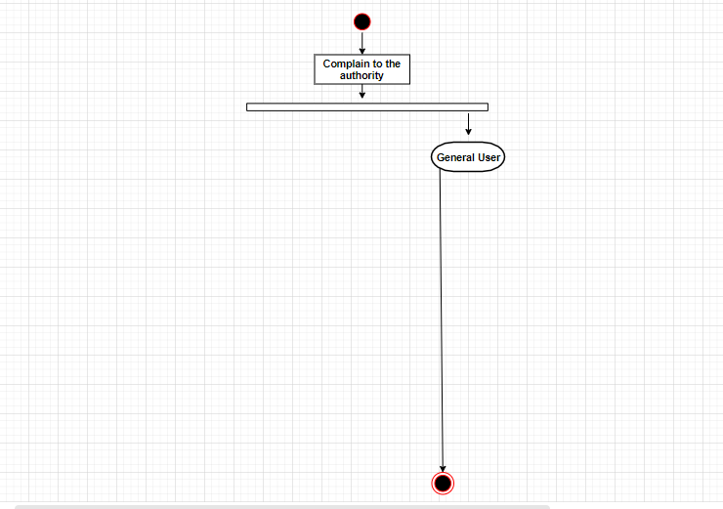

Fig: Activity Diagram for Register user

**4.3.1. Activity Diagram for Admin city corporation:**

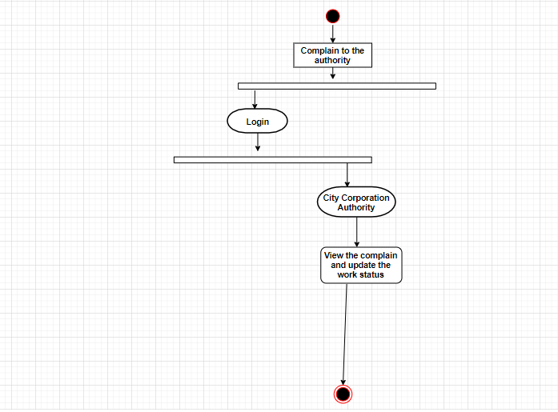

**4.3.1. Activity Diagram for All users:**

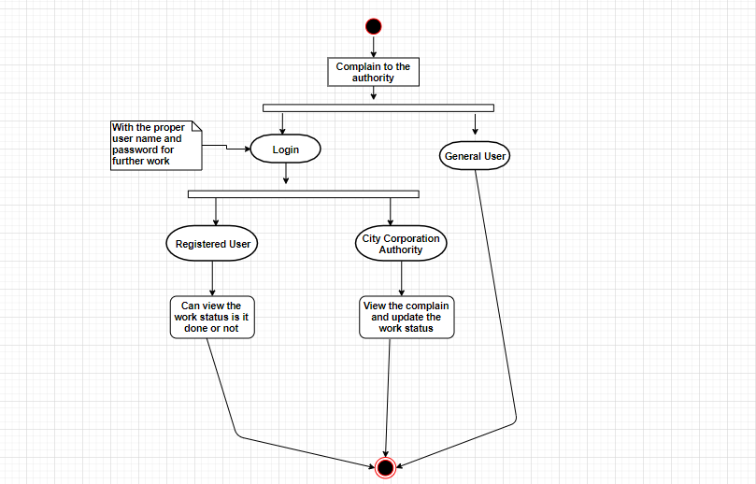

**3.4. Sequence Diagram:**

UML Sequence diagrams are interaction diagrams that detail how operation are carried out.

**3.1.1. System sequence diagram for general user**

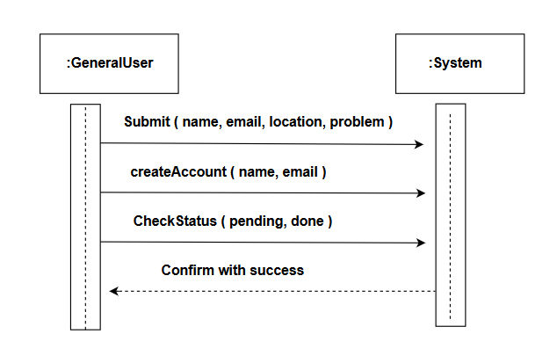

**3.1.1. System sequence diagram between system and city corporation admin**

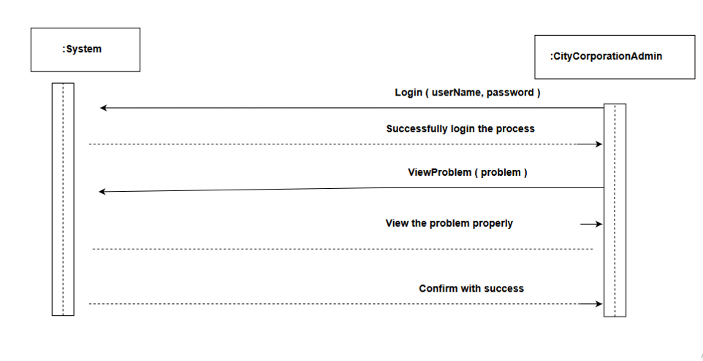

**3.2.14Sequence diagram between System &Complain**

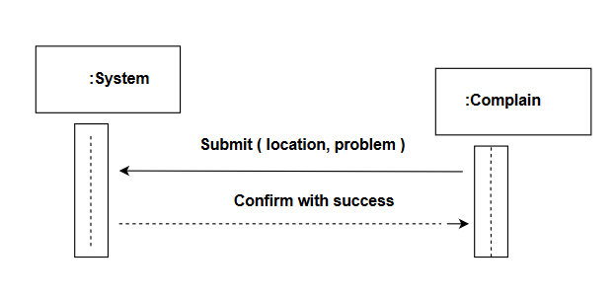

**4.3.4. All User Sequence Diagram**

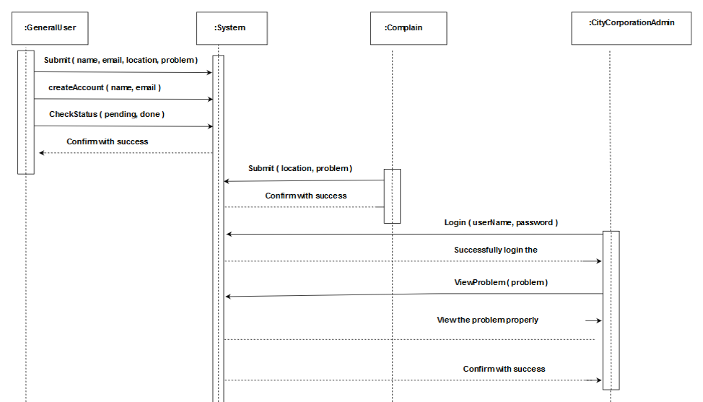

**Chapter 5**

**System Testing**

**5.1. System Testing:**

Software testing is defined as an activity to check whether the actual results match the expected results and to ensure that the software system is  error free. It involves execution of a software component or system component to evaluate one or more properties of interest.

**5.1.1. Features to be tested**

|  |  |  |  |
| --- | --- | --- | --- |
| **Featured Id** | **Featured Name** | **Description** | **Involved User** |
| ST001 | Submit Complain | User can Submit Complain | Register, General |
| ST002 | Create account | User can create account to view work status | Register |
| ST003 | Login | Login as authenticated user | Admin , Register user |
| ST004 | Upload Work status | Admin need to login to upload work status | Admin |

**5.1.2. Features not to be tested**

Table-6.2: Feature not to be tasted

|  |  |  |  |
| --- | --- | --- | --- |
| **Featured Id** | **Featured Name** | **Description** | **Involved User** |
| ST001 | View Complain Photograph | Admin will see the Complain Photograph. | admin |

**5.2. Testing Strategies:**

**5.3.1.2. Test Case Table**

Table-6.3: Test Case Submit Complain

|  |  |  |  |  |  |
| --- | --- | --- | --- | --- | --- |
| Test case #ST001 | | | Test case name: Submit Complain | | |
| Test Priority: High | | | System: | | |
| Designed By: Md Mushrif Hoque | | | Designed Date: 19.11.19 | | |
| Executed by: Md Mushrif Hoque | | | Executed date:19.11.19 | | |
| Short Description: This section cover the functionalities of submit complain of complainer | | | | | |
| Pre-conditions: Enter the system | | | | | |
|  | | | | | |
| Step | Action | Expected Result | | Pass/ Fail | Actual Result |
| 01 | Complainer | Display successful message | | pass |  |
| 02 | Enter empty value for  any required field | Display error message | | pass |  |
| 03 | All the input field is filled but complain is exist in database with pending status | Display Complain is exist by Other Complainer | | pass |  |
| Post-conditions: Submit information is inserted into the database successfully | | | | | |

**5.3.1.3. Test Case Table**

Table-6.3: Test Case Create account

|  |  |  |  |  |  |
| --- | --- | --- | --- | --- | --- |
| Test case #ST002 | | | Test case name: Create account | | |
| Test Priority: Medium | | | System: | | |
| Designed By: Md Mushrif Hoque | | | Designed Date: 21.11.19 | | |
| Executed by: Md Mushrif Hoque | | | Executed date:21.11.19 | | |
| Short Description: This section cover the functionnalities of registration e new user. | | | | | |
| Pre-conditions: Enter the system | | | | | |
|  | | | | | |
| Step | Action | Expected Result | | Pass/ Fail | Actual Result |
| 01 | New user | Display successful message | | pass |  |
| 02 | Enter empty value for  any required field | Display error message | | pass |  |
| Post-conditions: Registration information is inserted into the database successfully | | | | | |

**5.3.1.3. Test Case Table**

Table-6.3: Test Case login

|  |  |  |  |  |  |
| --- | --- | --- | --- | --- | --- |
| Test case #ST003 | | | Test case name: login | | |
| Test Priority: Medium | | | System: | | |
| Designed By: Md Mushrif Hoque | | | Designed Date: 21.11.19 | | |
| Executed by: Md Mushrif Hoque | | | Executed date:21.11.19 | | |
| Short Description: This section cover the functionnalities of login . | | | | | |
| Pre-conditions: Have account in system | | | | | |
|  | | | | | |
| Step | Action | Expected Result | | Pass/ Fail | Actual Result |
| 01 | Match Username and password | Display successful message | | pass |  |
| 02 | Enter empty value for  any required field | Display error message | | pass |  |
| Post-conditions: Get access in the system | | | | | |

**5.3.1.3. Test Case Table**

Table-6.3: Upload work status

|  |  |  |  |  |  |
| --- | --- | --- | --- | --- | --- |
| Test case #ST004 | | | Test case name: Upload work status | | |
| Test Priority: Medium | | | System: | | |
| Designed By: Md Mushrif Hoque | | | Designed Date: 21.11.19 | | |
| Executed by: Md Mushrif Hoque | | | Executed date:21.11.19 | | |
| Short Description: This section cover the functionnalities of upload work status | | | | | |
| Pre-conditions: Have account in system as a Admin | | | | | |
|  | | | | | |
| Step | Action | Expected Result | | Pass/ Fail | Actual Result |
| 01 | Upload Work status | Display successful message | | pass |  |
| Post-conditions: View update complain report | | | | | |

**CHAPTER 6**

**System Design Specification**

**6. User Manual**

**6.1 Home Page**

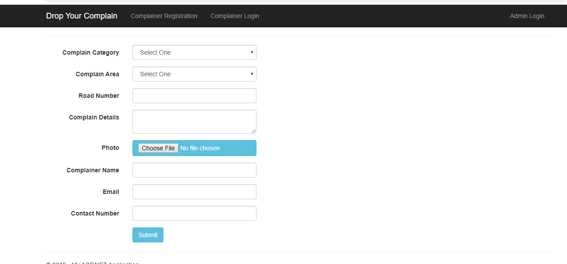

**6.2 Registration**

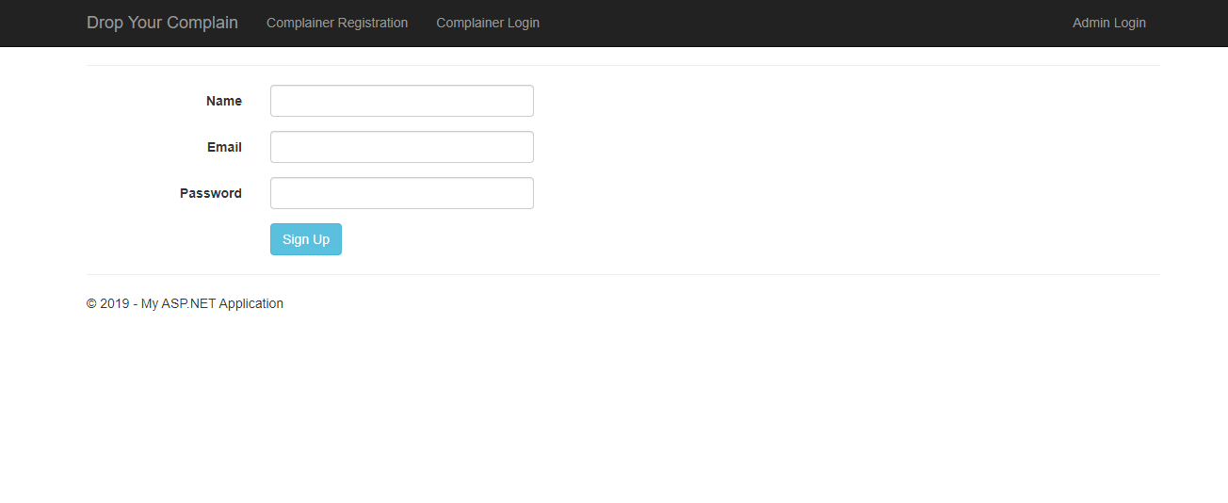

**6.3 Admin login**

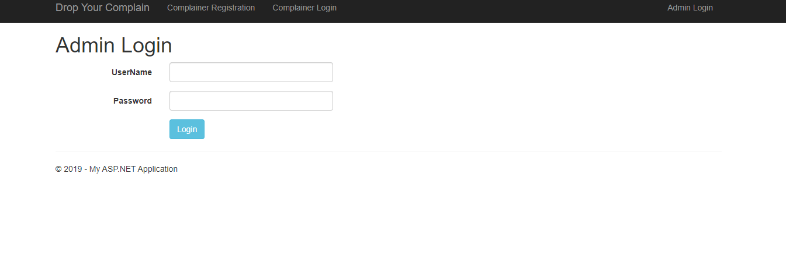

**6.3 Admin view complain list**

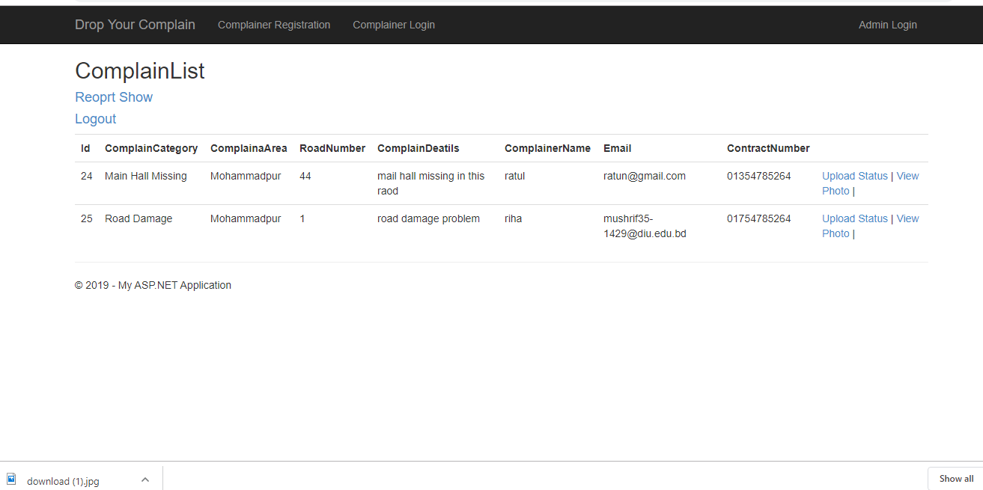

**6.3 Admin view upload work status**

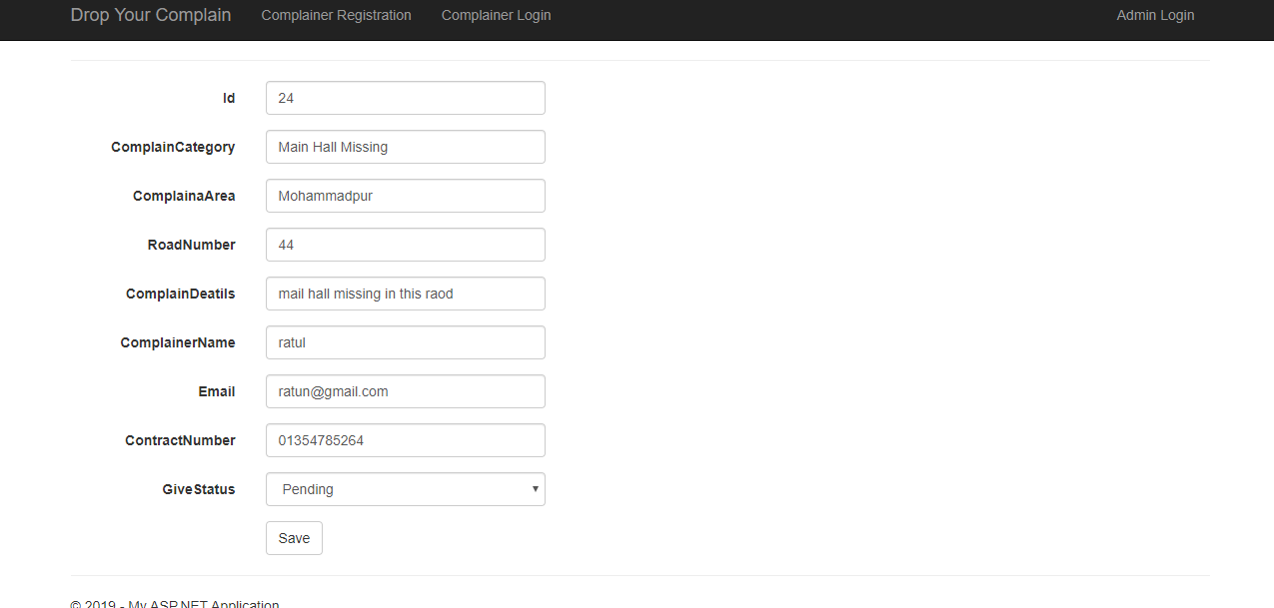

**6.4 Admin view complain photograph and details**

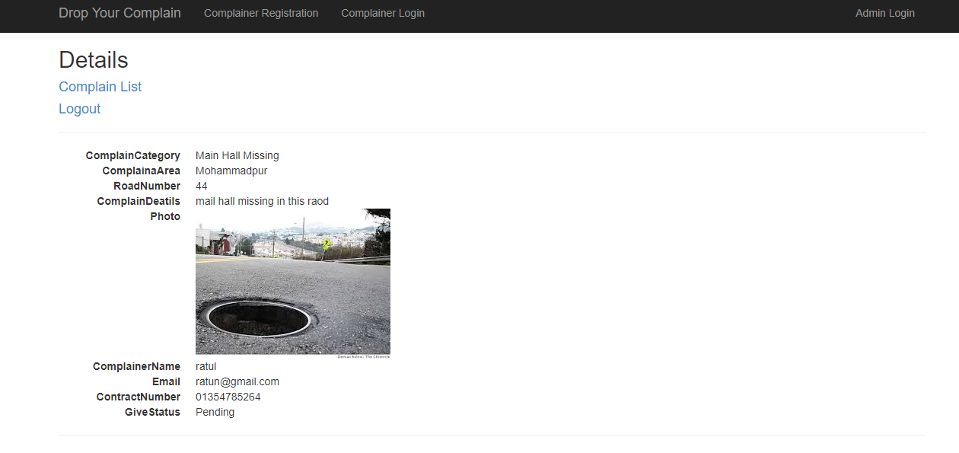

**6.4 Admin view complain report**

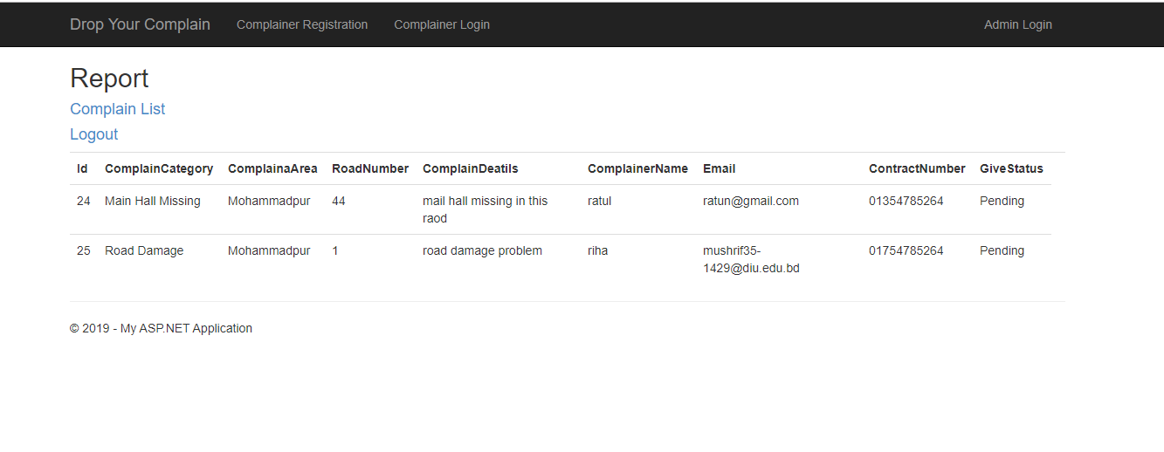

**6.4 Register user login**

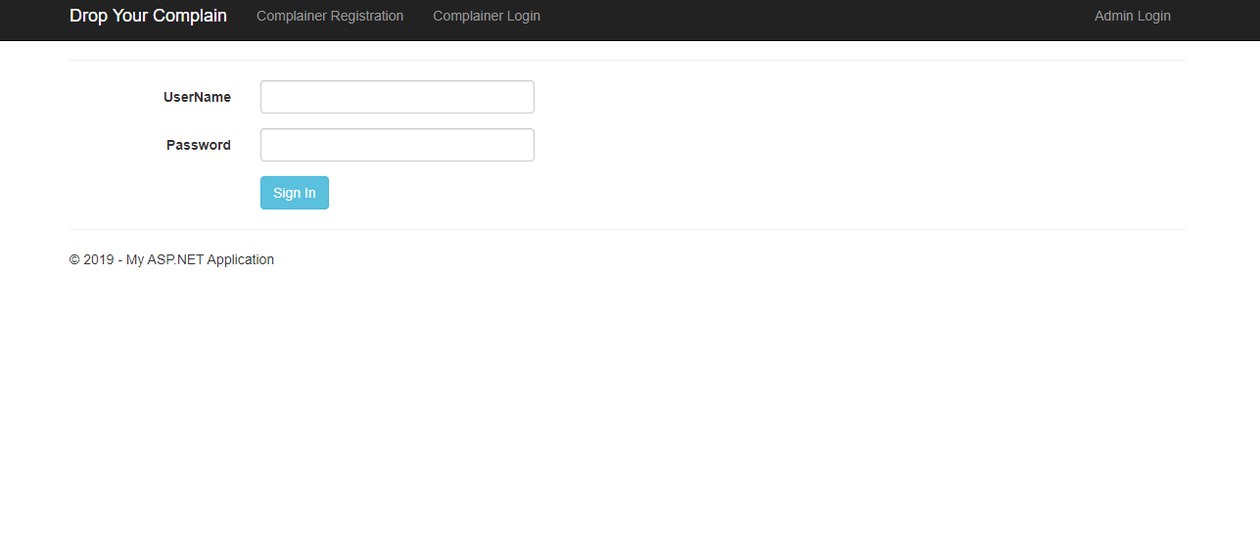

**6.4 Register Check work status**

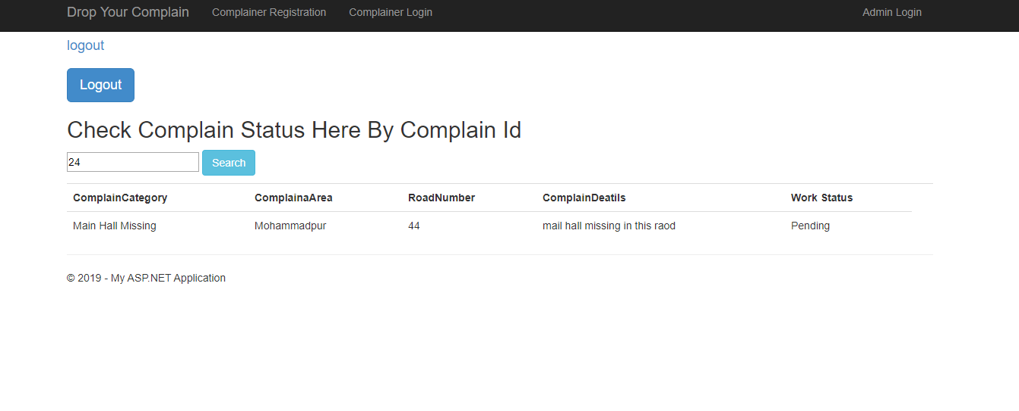

**Chapter 7**

**Project Summery**

**7.1. GitHub link:** <https://github.com/prantoshon/ProjectFinalYear>

**7.2. Limitations:**

* Cant Attach Google map.
* Limited Complain Id can sent in Email

**7.3. Obstacles & Achievements:**

I have to face many obstacles to complete this project as example add photograph of complain in database and then show in complain details, email verification , catch duplicate request . Although I have done it by taking help from my supervisor, searching the concept from google ,friends . I achieve my confident to develop this project alone.

**7.4 FUTURE IMPROVEMENT**

1.Attach Google map

2. Sent Complain Id in Phone Number

**8.5 References**

To complete audit application, I have taken help from many places. Some references are given bellow:

[1] <https://www.tutorialsteacher.com/mvc/mvc-architecture>

[2] <http://csharp-video-tutorials.blogspot.com/p/aspnet-mvc-tutorial-for-beginners.html>

[3] <https://www.c-sharpcorner.com/article/introduction-to-asp-net-mvc2/>

[4] www.w3schools.com

[5] www.jquery.com