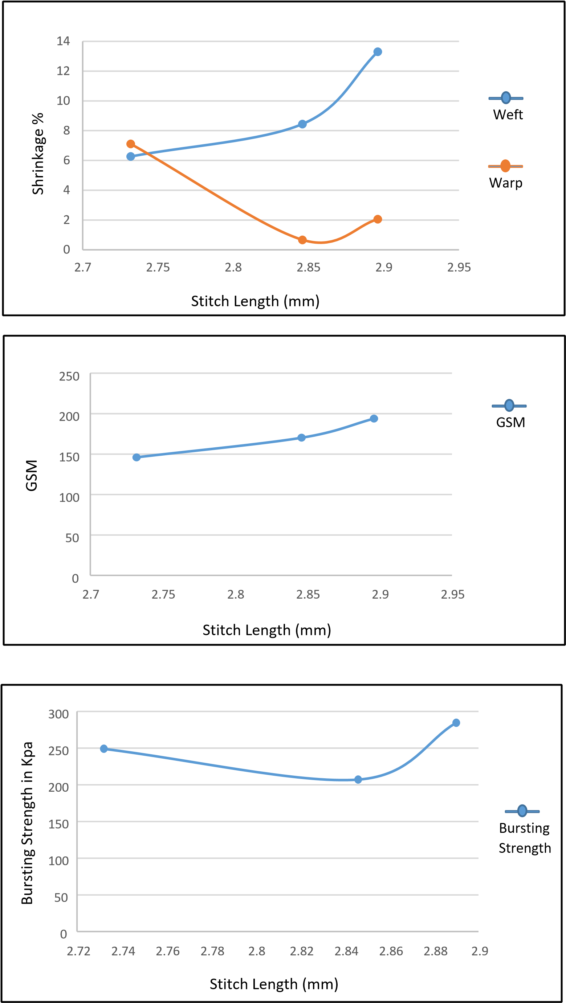

Stitch Length (mm)

Stitch Density (Loops/inch2)