Identification and Characterization of Novel Biomarkers for Myelodysplastic Syndrome Diagnosis and Prognosis: A Single Cell RNA-Sequencing and Bioinformatics Approach
Saidul Islam Nayan^{a,} †, Md. Arju Hossain^{d,e}, Md Shofiqul Islam^{f}, Siddique Akber Ansari^{g}, Md Habibur Rahman^{∗,b,c,}†
ªDepartment of Computer Science & Engineering, University of Global Village, Barisal, 8200, Bangladesh
^{b}Department of Computer Science and Engineering, Islamic University, Kushtia, 7002, Bangladesh ^{c}Center for Advanced Bioinformatics and Artificial Intelligent Research, Islamic University, Kushtia, 7002, Bangladesh
^{d}Department of Biotechnology and Genetic Engineering, Mawlana Bhashani Science and Technology University, Santosh, Tangail, 1902, Bangladesh.
^{e}Department of Microbiology, Primeasia University, Banani, Dhaka-1213, Bangladesh.
^{f}Institute for Intelligent Systems Research and Innovation (IISRI), Deakin University, 75 Pigdons Rd, Warunponds, Victoria 3216, Australia
^{g}Department of Pharmaceutical Chemistry, College of Pharmacy, King Saud University, P.O Box 2457, Riyadh 11451, Saudi Arabia
Equal contribution and first authorship (†): Saidul Islam Nayan^{a,†}, Md Habibur Rahman^{b,c,†,}*. These authors contributed equally to this work and shared first authorship.
Corresponding Author (*): Md Habibur Rahman (habib@iu.ac.bd)

Abstract

Myelodysplastic Syndrome (MDS) is a kind of blood cancer that targets the bone marrow stem cells and generates immature blood cells, resulting in anemia, acute myeloid leukemia, and thrombocytopenia. The precise etiology of MDS is unknown, but it is believed to be linked to various molecular mechanisms and genetic abnormalities. Hence, the identification of key factors, molecular mechanisms, and signaling pathways is vital in comprehending and diagnosing the initiation and advancement of MDS. Therefore, this study aims to identify novel biomarkers using scRNA-seq data for MDS prognosis and diagnosis via bioinformatics approaches. We identified 54 significant DEGs by analyzing RNA-seq transcriptomic data. The combined analysis of KEGG, WIKI, and REACTOME pathways revealed significant pathways like Graft-versus-host disease, Antigen processing and presentation, miR-517 relationship with ARCN1 and USP1. Subsequently, the significant GO terms like fat cell differentiation, positive regulation of immune system process, and immune response including THBS1, DDIT4, and PSMB8 key genes were identified. Finally, the toxicity analysis and molecular docking substantiated GSK1070916 and NPK76−II−72−1 as the most effective potential drugs for treating MDS. Our research could significantly aid in the diagnosis and prognosis of MDS, providing insights into critical disease pathways, key biomarkers, and gene ontologies.

Keywords: Myelodysplastic Syndrome, Blood cancer, Single Cell RNA Sequencing, Critical disease pathways, Key biomarkers, Bioinformatics

Key Points

- constructed a bioinformatics pipeline for identifying key biomarkers of MDS and showed its use in knowledge mining from public datasets.

Identified 54 significant DEGs through scRNA-seq, offering potential MDS biomarkers.

Pathway analysis unveiled critical pathways like Graft-versus-host disease, deepening understanding of MDS mechanisms.

Highlighted miR-517's association with ARCN1 and USP1, suggesting therapeutic targets.

Key genes like THBS1, DDIT4, and PSMB8 linked to vital MDS processes were identified.

Proposed GSK1070916 and NPK76-II-72-1 as promising MDS drugs via toxicity and docking analysis.
Introduction

Myelodysplastic syndrome (MDS) comprises a diverse set of hematologic neoplasms that are traditionally defined by a clonal disease affecting hematopoietic stem cells leading to bone marrow dysplasia and ineffective hematopoiesis [1]. This specific kind of blood cancer occurs when the bone marrow creates aberrant blood cells, leading to conditions like leukopenia, anemia, and thrombocytopenia [2]. About 30% of MDS patients progress to acute myeloid leukemia (AML) [3]. A study of 112 individuals with t-MDS indicated that 55% developed acute myeloid leukemia, but de novo MDS only changed into AML about 30% of the time. The prevalence of de novo MDS in the United States is estimated to be about 4.9 per individual, with the majority of cases emerging after the age of 65 and most commonly in individuals over the age of 80 [4].
The bone marrow of healthy people generates blood stem cells, that transform into grown-up blood cells in due course. These cells can develop into granulocytes, platelets, or red blood cells. They can also be lymphoid or myeloid [5]. This is depicted clearly in Fig. 1. However, immature blood cells known as blasts do not develop and die in the blood or bone marrow in individuals with myelodysplastic syndrome (MDS). Reduced numbers of healthy blood cells follow, increasing the risk of infections, easy bleeding, and anemia. Several forms of MDS can be distinguished according to the quantity of impacted blood cell types as well as additional variables. MDS may have a severe physical impact since red blood cells carry oxygen across our body, white blood cells fight against infection, and platelets assist our blood to clot. These also include fatigue, shortness of breath, and swelling of the spleen or liver [6].
While some MDS instances are tied to specific external circumstances, most cases have no apparent explanation. Older age, radiation therapy or chemotherapy, exposure to pesticides, tobacco, and heavy metals like lead, mercury, or other harmful substances are the known external factors for MDS development [7]. Although the precise internal precursors of MDS formation are not fully understood, somatic mutations caused by an oncogenic pathway are thought to be the cause. The developments in gene sequencing have allowed researchers to find driver mutations in 80–90% of patients; these include common variants in SF3B1, SRSF2, TET2, TP53, ASXL1, RUNX1, DNMT3A, U2AF1, and EZH. In MDS, recurrent mutations have been discovered in over 100 genes that impact clinical characteristics such as blast proportion, cytogenetics, severity of cytopenia, and overall survival [4]. The transcriptional regulation, signal transduction, and cohesion complex are respectively controlled by the genes (ETV6 and BCOR), (NRAS, CBL, JAK2), and (STAG2) [8], [9]. Mutations in the TP53 gene are linked

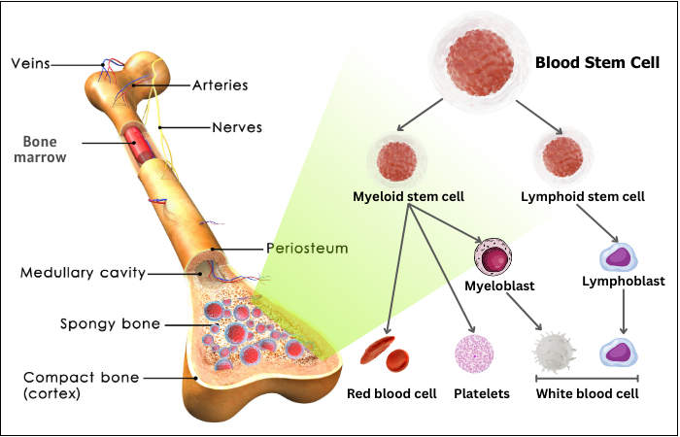
Fig. 1: The development of blood cells from bone marrow stem cells
to poor survival, high risk, and swift transformation to leukemia [10]. Mesenchymal stromal cells release interleukins (IL-6 and IL-10), essential for controlling hematopoietic stem and progenitor cells [11]. They also help maintain the clonal authority of MDS cells by inhibiting T-cell activation and proliferation [12]. Thus, gene mutation profiling and biomarkers aid in enhancing risk categorization and identifying suitable therapies, including targeted ones, for patients with specific mutations.
The complexity and heterogeneity of MDS progression pose a challenge for researchers seeking novel biomarkers. Newer technologies are being developed constantly, and several studies have been conducted. But the age of precision medicine in clinical oncology has been ushered in by the advancement of sequencing technologies [13]. A new chapter in transcriptomics has been opened by the technology known as single-cell RNA sequencing (scRNA-seq) allowing researchers to undertake genome-wide gene analysis at the precise cell level. It seeks to determine which genes are differentially expressed and assess the changes that occur during cell differentiation [14]. In comparison to bulk RNA-seq, this method has transformed our knowledge about biological processes at the individual cell level as taken from tissue samples. It addresses intricate topics and necessitates a more sophisticated processing procedure [15]. Bulk RNA sequencing offers limited information regarding the clonal makeup of malignancies and tumor microenvironments (TME) [16]. But the most extensively used sequencing technology at present, scRNA-seq has evolved from classic bulk sequencing. It provides insights into paracrine signaling, interactions between different cell types, and the molecular mechanisms underlying tissue functions [17].
ScRNA-seq identifies cellular identities, tumor heterogeneity, and new biomarkers [15]. Bulk sequencing analyses alongside expression profiling have influenced cancer understanding, but single-cell genomic techniques offer a more precise understanding of human tumors, allowing for detailed cell dissection. It has revolutionized the understanding of tumor biology through cell subpopulation identification, dissecting TME, and characterizing genomic mutations. They are now widely used in human cancer research [15]. scRNA-seq enables the discovery of previously unknown or rare cell states and transitions between different cellular states. This can lead to the identification of new cell types or transitional states that might be missed in bulk analyses. It can be used to identify disease-specific cell types, uncover molecular mechanisms underlying diseases, and discover potential therapeutic targets [14]. A thorough understanding of a patient's molecular profile is necessary for precision medicine [18], [19]. scRNA-seq has applications in personalized medicine by characterizing individual patient profiles.
We have discovered differentially expressed genes (DEGs), associated pathways, and the PPI network for identifying key genes (KGs) for individualized diagnosis and future projection using scRNA-seq technology. RNA-seq is a valuable tool for understanding cancer development mechanisms and developing novel strategies for prevention and treatment by analyzing gene expression [13]. We used computational models and recent in silico techniques [20] for analyzing the scRNA-seq data to uncover pharmacological hypotheses utilizing data mining, data analysis, network analysis, and databases. This bioinformatics analysis will provide valuable insights into cancer research by identifying important genes, GOs, as well as signaling pathways related to MDS. Identifying the shared genes and pathways presents a viable approach for creating more potent therapies and minimizing healthcare expenditures.

Methodology

- Data Collection

  - Single Cell Data Collection
We used the PBMC dataset that is included in the SeuratData package [21], [22]. It contains peripheral blood mononuclear cell samples in this dataset. For a single-cell dataset, the Seurat object acts as a container for data such as the count matrix, principal component analysis (PCA), or grouping findings. We use the "LogNormalize" global-scaling normalization technique [23]. The next step is to do a linear transformation, or "scaling" which is a common pre-processing step before using dimensional reduction methods like PCA [24].

  - RNA-seq Data Collection
For this investigation, we used RNA-seq data obtained from the GREIN public repository, An interactive online tool that offers capabilities for exploring and analyzing GEO RNA-seq data [25]. We took the datasets into account which contain ten or more samples to enhance the caliber of our research outcome. We excluded non-human and non-zero-bias samples. Datasets comprising both control and case samples were chosen. The dataset with an FDR-adjusted P-Value ≤0.01 and a logFC value higher than absolute 1 was included. It is recommended to consider FDR-adjusted p-value for critical diseases like cancer which retains more significance [26]. We utilized 3 datasets for our work: GSE55689, an RNA-seq dataset of MDS patients with a total size of 73 samples comprising 22 controls and 51 cases from hematopoietic stem and progenitor cells [27]; GSE63569, an RNA-seq dataset of MDS patients with a total size of 17 samples comprising 5 controls and 12 cases from CD34+ [28]; and GSE63816, an RNA-seq dataset with a total size of 22 samples comprising 5 controls and 12 MDS cases from bone marrow cell [29]. The table I is presenting the details of these datasets.

Table 1: Details of the GSE RNA-Seq Datasets Along With Disease Correlation, Sample Source and Size.
Dataset | Disease Name | Source | Data Type | Participants |  | Total Sample | Reference
 |  |  |  | Normal | MDS | Total Sample | Reference
GSE55689 | MDS | hematopoietic stem and progenitor cells | RNA-seq | 22 | 51 | 73 | [27]
GSE63569 | MDS | CD34+ | RNA-seq | 5 | 12 | 17 | [28]
GSE63816 | MDS | Bone marrow | RNA-seq | 4 | 12 | 16 | [29]
Total |  |  |  | 31 | 75 | 106

- Clustering Single Cell Data
We used PCA on the stepped data to minimize the dimensionality. The first ten main components that comprise t-distributed stochastic neighbor embedding (t-SNE) were utilized to illustrate two-dimensional data [30]. A K-nearest neighbor (KNN) network in which cells with comparable feature expression patterns are connected by edges. Next, we cluster the cells by iteratively grouping them together using modularity optimization approaches such as the Louvain algorithm or SLM [31], with the aim of maximizing the standard modularity function. From the 28 total obtained clusters, we combined 6 clusters of only NK cells for comparison since it is highly associated with MDS progression [32].
- Identification of Common DEGs
The overlapping genes of single-cell and the RNA-seq data of the three GSEs are the common DEGs. The DEGs were compared with the genes from combined clusters of NK cells using Venny, an online tool to graphically identify the overlapping list of data [33]. Each significant DEG was determined based on FDR-adjusted p-value < 0.01 and |logFC| > 1.0.
- Functional Enrichment Analysis
For functional enrichment analysis, we feed the significant common genes to DAVID, an online bioinformatics database for discovery, Visualization, and functional annotation [34]. Genes were categorized in the functions of DEGs at the cellular, molecular, and biological levels known as Gene Ontology (GO) [35]. The significant criterion of p-value < 0.05 was upheld in all the GO functions in this study.
- Pathway Enrichment Analysis
Genes that work jointly for biological activities are referred to as pathways [36]. By utilizing the significant common DEG's, the online tool DAVID provided different pathways. Here we considered KEGG [37], WIKI [38], and REACTOME [39] pathways. The most significant pathways from the combination of these three pathways were sorted using the p-value.
- PPI Network Analysis
Understanding the functional relationship between proteins in numerous biological processes depends heavily on protein-protein interactions or PPIs. The PPI network of common DEGs in this study was built utilizing the online Search Tool for the Retrieval of Interacting Genes (STRING) database [40]. A medium confidence score (0.40) was applied to all the PPIs in the network. We used Cytoscape to further identify the PPI networks connecting the DEGs [41]. Each protein appears as a node, and relationships between proteins are displayed as edges in the network.
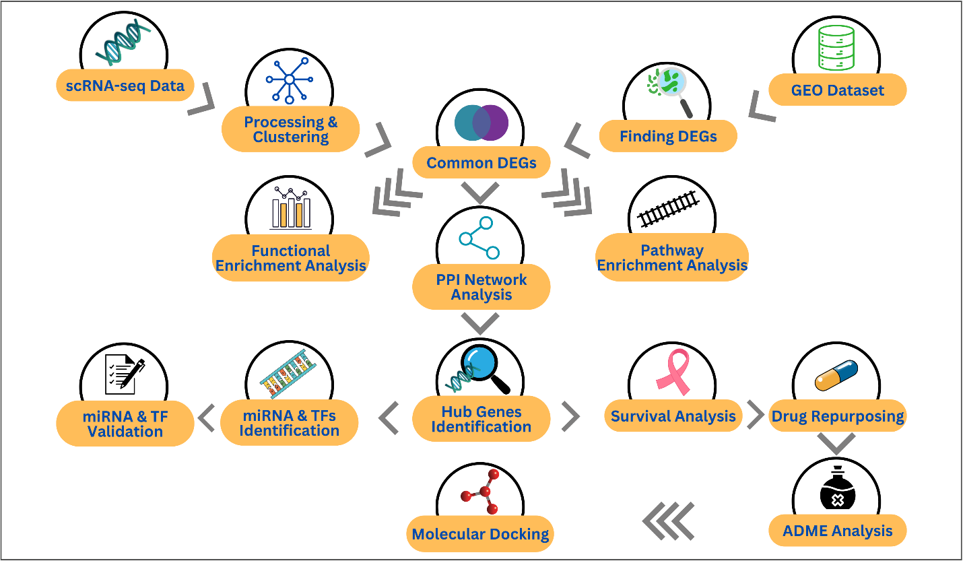
Fig. 2: The complete work flow diagram of this research work

- Hub Genes Identification
A hub gene, a gene with numerous interactions to different genes, is crucial in gene regulation and biological processes within gene networks. The PPI network obtained from String was further analyzed using Cytoscape. The top 6 most significant hub genes were identified using the CytoHubba plugin by performing 11 different topological measurements (MCC, DMNC, MNC, Degree value, EPC, BottleNeck, Radiality, EcCentricity, Closeness, Betweenness, and Stress)[42]. CytoHubba took 11 distinct methods into account to determine the hub genes. In this phase, all other settings were left at default.
- Hub Gene Expression and Survival Analysis
Survival analysis has been frequently utilized to assess the clinical significance of a particular gene since this makes it possible to identify relationships between the levels of gene expression and predictive outcomes. To determine the cancer patient's survival probability, the Kaplan-Meier (K-M) survival possibility plot is often used. Therefore, we employed the K-M approach to independently assess the hub gene expression levels and predictive roles in MDS. The analysis was conducted using the GEPIA (Gene Expression Profiling Interactive Analysis), a web server for the study of gene expression using normal and tumor samples from the GTEx and TCGA datasets. A 95% confidence interval for the hazard ratio and medium group cutoff was maintained throughout the process. The threshold value of 0.05 was set to finalize the key biomarkers from the hub genes.
- Key miRNAs and TFs Identification
Since TFs are crucial for regulating the process of transcription of genetic information, they are essential components for understanding molecules [43]. this study used the NetworkAnalyst server, a web application that uses gene lists to facilitate network analysis as well as visualization [44]. To create a topologically reliable TFs-DEGs interaction network, we employed the JASPAR [45]. Once more, miRNAs that connect to gene transcripts to affect protein production during the post-transcriptional phase were found using Tarbase, a noteworthy database of true miRNA–target gene association [46]. The most significant 10 miRNAs and TFs were detected according to betweenness and degree value.

- Key miRNAs and TFs Validation
This study used two separate datasets,(1) Cistrome Data Browser (a web tool to examine the factors that control the relevant gene) for further validation of cancer-related TFs, and (2) dbDEMC (a unified database to store and present miRNAs that exhibit differences in expression in cancers) for miRNAs [47], [48]. We also analyzed previously published publications that corroborate our findings.

- Repurposing Potential Candidate Drug

Repurposing pharmaceuticals is a viable approach to exploring new therapeutic uses for already-approved medications, with the goal of overcoming the difficulties and obstacles associated with starting from scratch when discovering new therapies. The GSCA database, which enables us to examine and observe the link between the set of cancer genes and medications, was used in this study [49]. GSCA is a web platform that collects and analyzes data from the database of cancer therapeutics response portal and the genomics of drug sensitivity in cancer. To make our path filtering the prospective pharmaceuticals easier, GSCA computed the value of FDR and presented the correlation between the hub genes and existing drugs.

- ADME Analysis and Toxicity Profiling

ADME studies examine the process of a drug compound in living organisms, examining its movement and processing throughout the body [50]. Toxicity profiling is a crucial method for identifying potential adverse consequences of chemicals [51]. For ADME analysis the study utilizes SwissADME which enables the computation of physicochemical descriptors, pharmacokinetic properties , prediction of ADME parameters, and the druglike nature of small molecules for drug discovery [52]. Toxicity profiling was conducted by ProTox-II: a web based server for chemical toxicity prediction [53].

- Perform Molecular Docking
Docking predicts the interactions between ligand and target at the molecular level, making it possible to identify new molecules with therapeutic potential. It makes predictions about a ligand's desired orientation, interaction and binding affinity at the protein binding site [54]. For protein and ligand preparation the study used Discovery Studio, an all-inclusive software package made for drug discovery molecular modeling and simulation [55]. Subsequently, the molecular docking was performed with PyRx, a virtual screening tool for computerized drug discovery through molecular docking [56].

Results

- Identification of the Common DEGs
All three distinct GSEA datasets of MDS related samples were compared with the integrated six NK cells single-cell data. The 3 RNA-seq signature datasets GSE55689, GSE63569, and GSE63816 from the GEO database have 592, 588, and 806 up-regulated while 473, 1032, and 504 down-regulated values respectively. These datasets further went through conditional filtering of FDR-adjusted p-value < 0.01 and |logFC| > 1.0 to finally obtain the DEGs data. After applying filters GSE55689 got 25 up and 46 down, GSE63569 got 21 up and 197 down whereas GSE63816 got 1 up and 19 down regulated genes. The bar graphs below depict these statistical data quite effortlessly. All the differentially expressed up and down-regulated genes were compared with the six combined lists of NK cells clusters to find the common genes. NK cells datasets have total 4220 unique genes among which 16 were found common in GSE55689, 34 in GSE63569, and 6 in GSE63816. Overall, 54 genes were found to be common among all the RNA-seq datasets with NK cells clusters. The Ven diagram below is generated based on these numerical data values. From the identified common DEGs, 5 up-regulated genes are from GSE55689, 4 from GSE63569, while GSE63816 contributed none. When it comes to the proportion of down-regulated genes, GSE55689 aided 11, 30 from GSE63569, and GSE63816 contributed only 6 genes. To recapitulate the entire thing, 83% was down-regulated while almost 17% was up-regulated among the 54 unique common genes presented in the donut chart of Figure 3. Each common DEGs including 2 duplicates are listed in Table 2.
Table 2: All the Common DEGs of RNA-seq Datasets Divided into Up-regulated and Down-regulated
Dataset | Common Up-Regulated Genes | Common Down-Regulated Genes | Total
GSE55689 | GNG11, PSMB8, MTRNR2L1,  THBS1, MTRNR2L8 | ERAP1, TMEM173, G3BP1, IK, LARS, ERAP2, APOL3, KLRB1, DAXX, S1PR5, LINC00861 | 16
GSE63569 | RPS4Y1, DDX3Y, MT1E, EIF1AY | SYAP1, INSIG1, EZR, ADAM8, ZNF331, ZC3H12A, MALT1, SLC2A3, PDE4D, ID2, TIPARP, BIRC3, SLC43A2, BHLHE40, DDIT4, GPR183, FOSL2, CRIP1, CREM, RPS9, NR4A2, SPARCL1, SYTL3, HLA-DMA, PRR26, THBS1, IL1B, CDKN1A, METRNL, ECEL1 | 34
GSE63816 | - | CYTH4, CD8A, DDIT4, DNAJB1, PPP1R11, KIR2DL3 | 6
Total | 9 | 47 | 56

- Functional Enrichment Analysis Results
To further understand the biological significance and gain more understanding of the possible roles of DEGs, functional enrichment analysis was performed. Figure 4 represents the crucial GO terms. Based on fold enrichment values, oxysterol binding and ATPase binding from molecular function GO term while antigen processing and presentation, T cell receptor signaling pathway, and fat cell differentiation from biological process appeared to be noteworthy. The GO terms with the lowest p-value are the most significant. The GO terms arranged in ascending order based on their respective p-values puts fat cell differentiation in the first place followed by positive regulation of immune system process, immune response, immune system process, and regulation of immune system process all from BP. The size of the bubbles in the plot represents the count of genes interrelated. Binding, cytoplasm, signal transduction, and immune system process being bigger in size simply indicating higher genes count ratio among which binding appears to be connected to all the 10 significant DEGs in the chord plot.
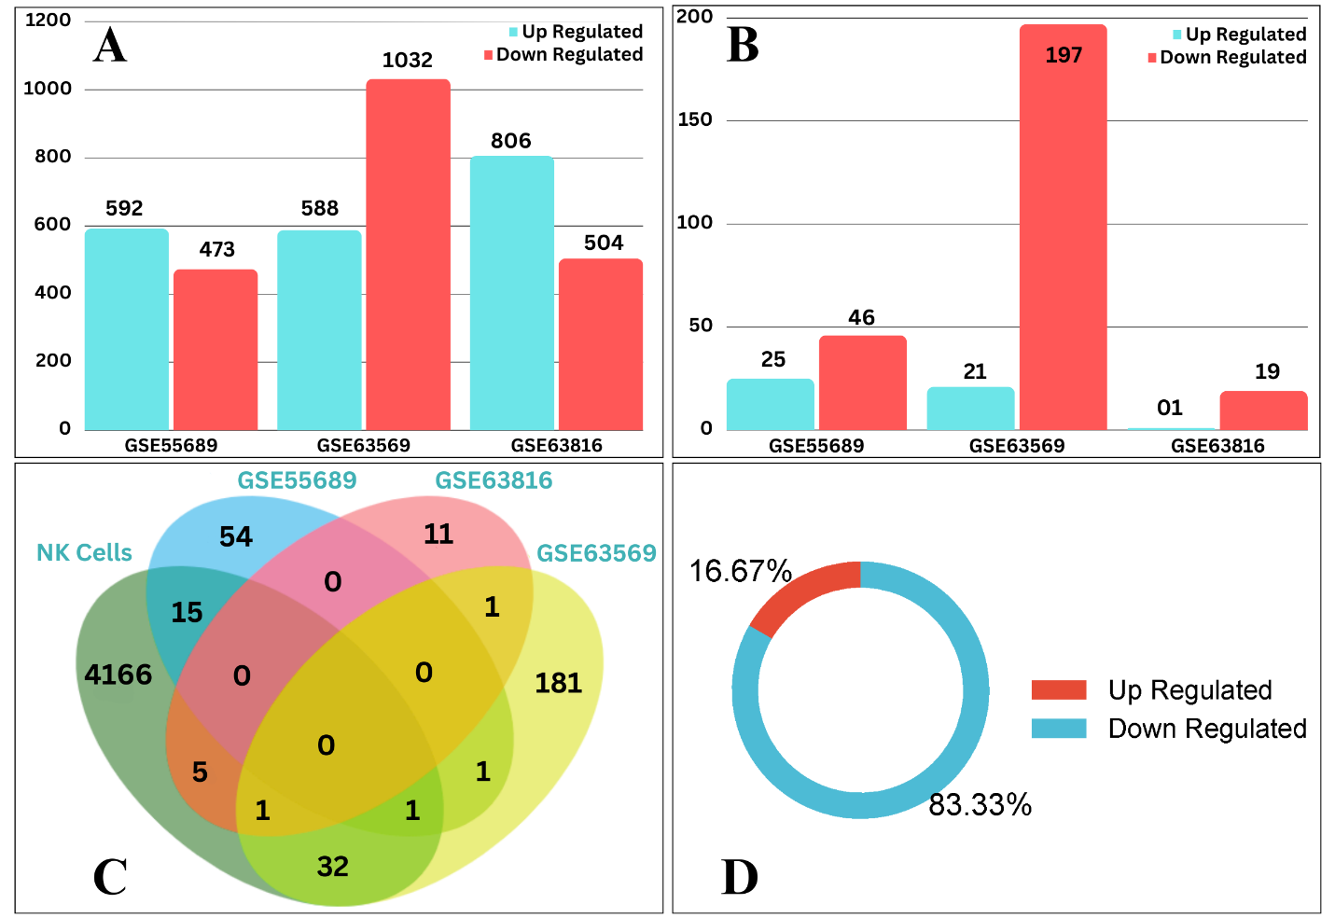
Fig. 3: Statistical details of the study data. A) Up-regulated and Down-regulated Genes of Raw Signature RNA-seq Datasets; B) Up-regulated and Down-regulated Genes of DEG Datasets; C) Ven Diagram of Common Genes Between NK Cells Clusters and GSE Datasets of MDS; D) Donut Chart Representing the Proportion of the Final DEGs.
- Pathway Enrichment Analysis Results
Pathway Analysis is a preferred method for understanding the biology behind DEGs and proteins. All the significant related pathways are presented in the bubble plot in Figure 5. The shapes of the bubbles represent the pathways classes. Here KEGG, WIKI, and REACTOME pathways are considered. According to p-values, the top 5 pathways are Graft-versus-host disease, Malaria, miR-517 relationship with ARCN1 and USP1, CLEC7A/inflammasome pathway, and Antigen processing and presentation. Graft-versus-host disease pathway mentioned in KEGG class is also present in the top 3 along with miR-517 relationship with ARCN1 and USP1 and CLEC7A/inflammasome pathway based on fold enrichment values. In accordance to count factor, Immune System, Generic Transcription Pathway, Adaptive Immune System, and Infectious disease are the top 4 pathways in the figure.
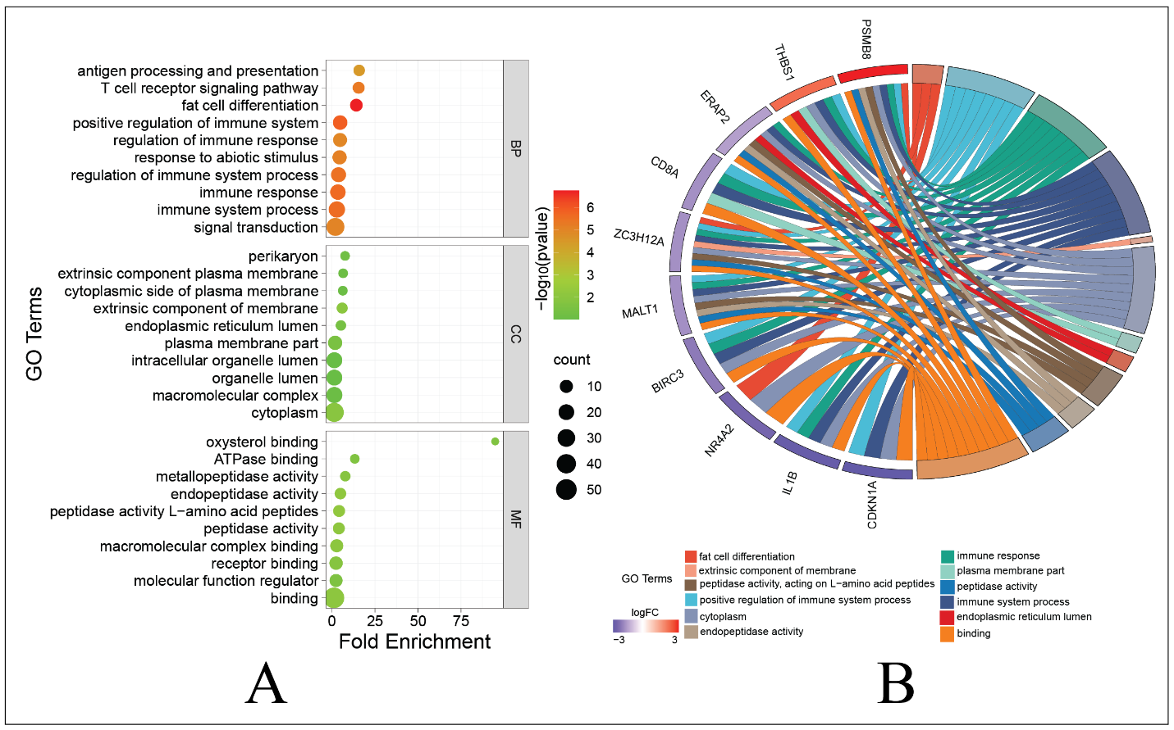

Fig 4: A) The Bubble Plot Represents the Significant GO Terms of the DEGs in BP, CC, and MF; B) The Chord Plot Depicts the Interaction Between Significant DEGs and GO Terms.

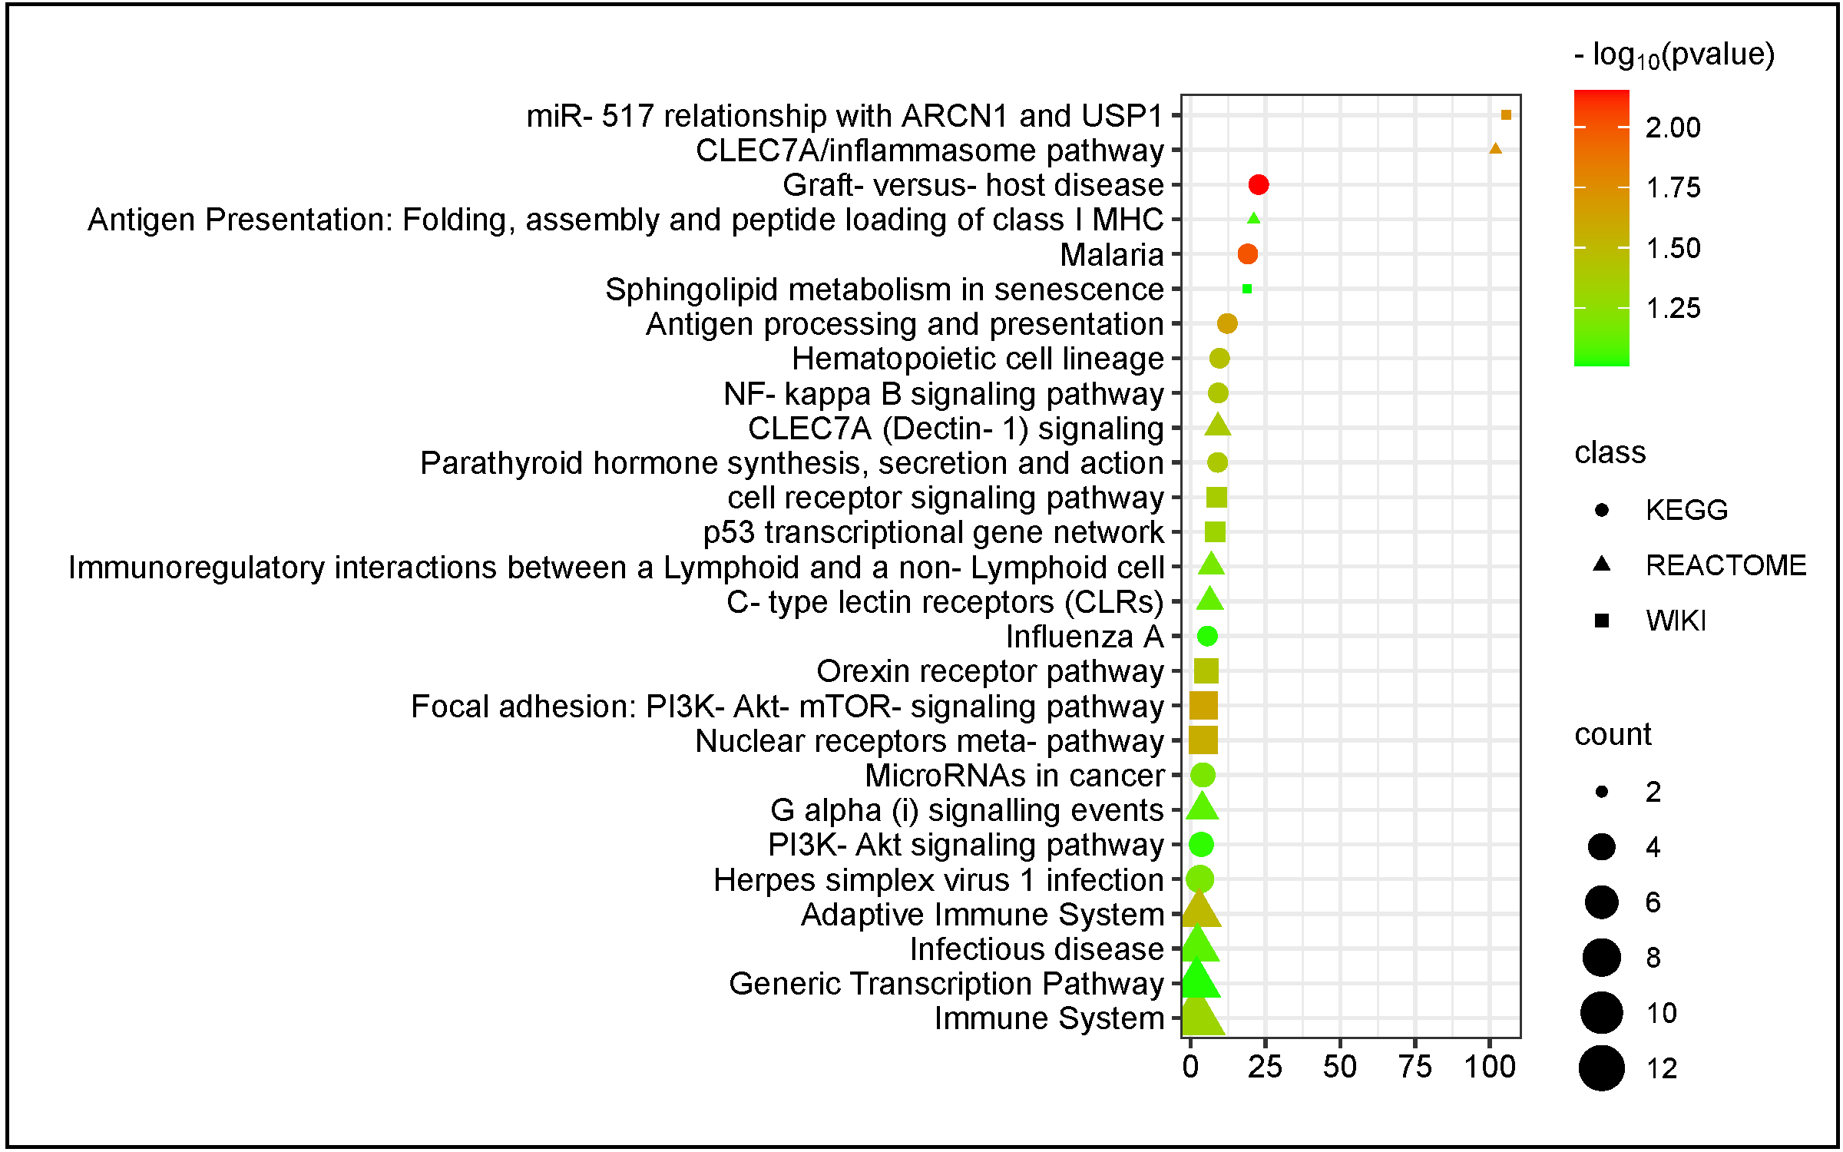

Fig 5: Bubble Plot of the Significant Pathways of the DEGs.

- PPI Network Analysis and Hub Genes Identification
The molecular and cellular mechanisms governing both healthy and unhealthy organisms are determined by protein interaction networks. Figure 6 is the network of protein-protein interactions derived from the significant DEGs. Here proteins are represented as network nodes, while protein-protein connections are represented by edges. Further analyzing these proteins in the Cytoscape app, top 10 hub proteins were identified based on 11 different Hubba nodes. The connection point in the lower right side of the upset plot in Figure 7 is representing the most frequent hub proteins among different nodes. The last connecting line at the right most side of the figure reveals 2 hub proteins THBS1 and CDKN1A which appeared in all the 11 nodes. The second last line discloses a single protein NR4A2 followed by the two frequent proteins IL1B and PSMB8 found out to be present in 10 different nodes. These 5 proteins are the most frequent and significant ones among the 21 unique key proteins. The rest 16 hub nodes are CD8A, BIRC3, DNAJB1, RPS9, KLRB1, ERAP2, RPS4Y1, BHLHE40, ID2, MALT1, EIF1AY, STING1, DDIT4, ERAP1, ZC3H12A, and FOSL2. All the 21 hub proteins were further validated by Funrich, a network analysis and functional enrichment tool [57]. Here hub protein STRING1 is not recognized by the software. Therefore, we got total 20 unique and valid hub proteins.
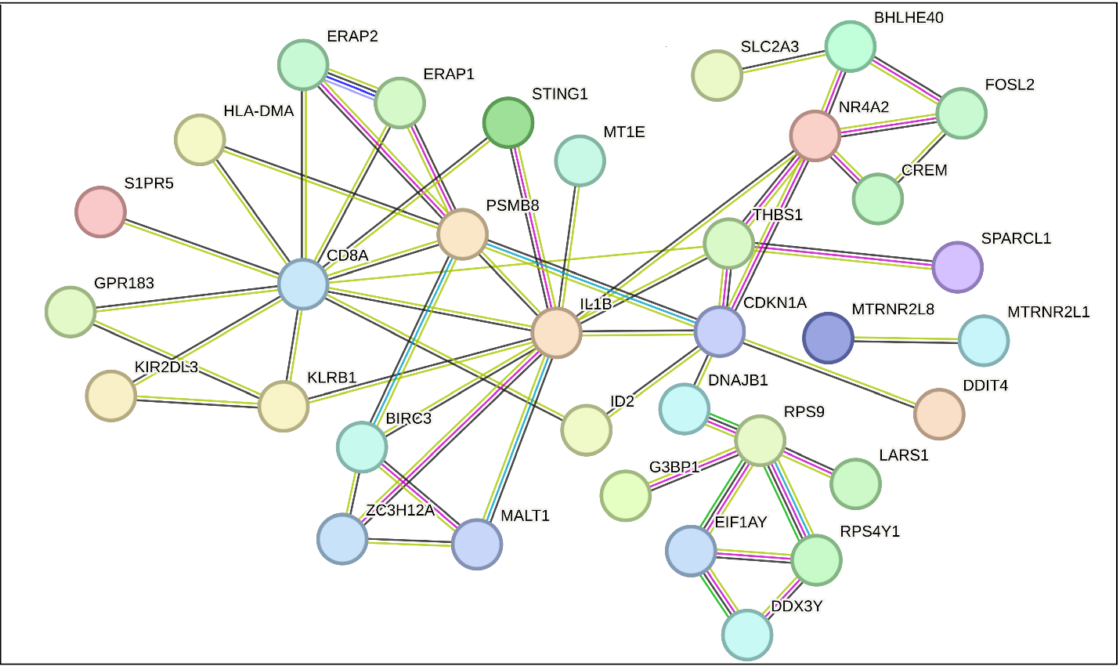
Fig 6: Protein-protein Interaction Network Generated from the DEGs.
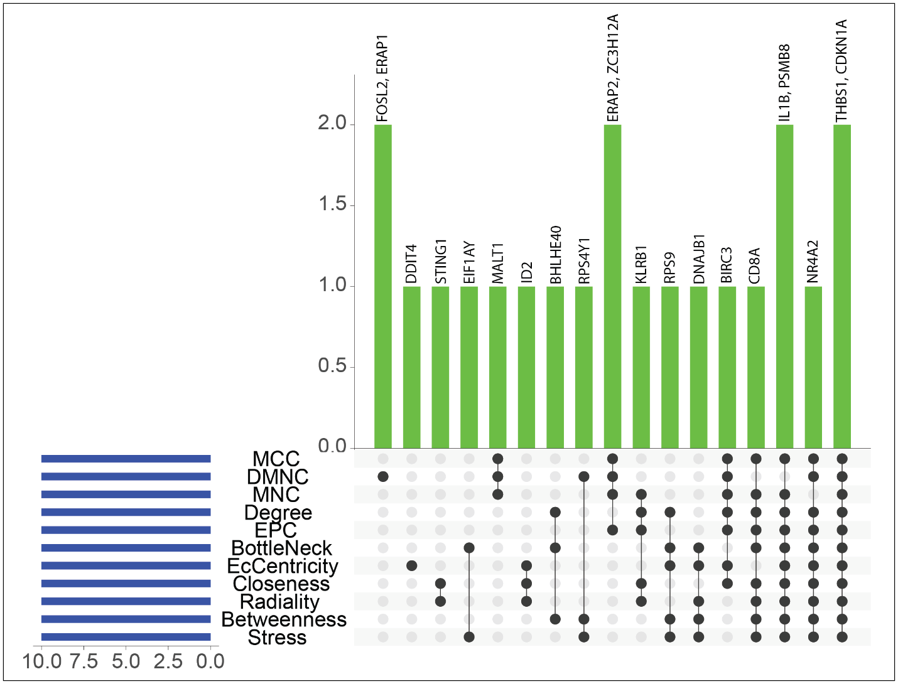
Fig 7: Upset Plot Shows the Significant Hub Proteins Among Different Nodes.
- Hub Gene Expression and Survival Analysis Results
To validate the expression levels of all 20 hub genes, the K-M survival curve was created, as shown in Figure 8. Among the 20 hub genes, there was a strong correlation found between the survival of MDS patients and the expression levels of THBS1, DDIT4, and PSMB8 having a log-rank p-value less than 0.05. These 3 hub proteins are considered as the key biomarkers with green outlined curves in the figure. The expression levels of these biomarkers are presented as the box plots in Figure 9.

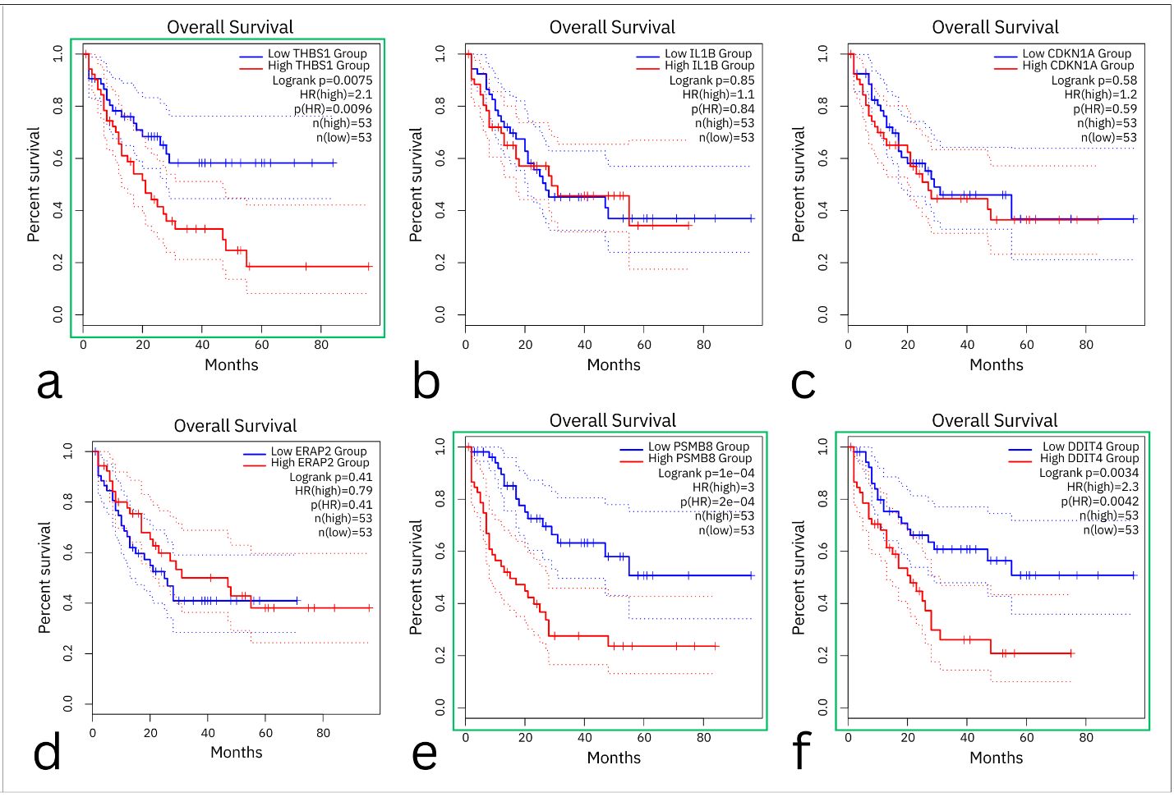
Fig 8: K-M plots display the patient's survival rate as influenced by the hub gene expression level. The noteworthy outcomes are shown by the green borders.
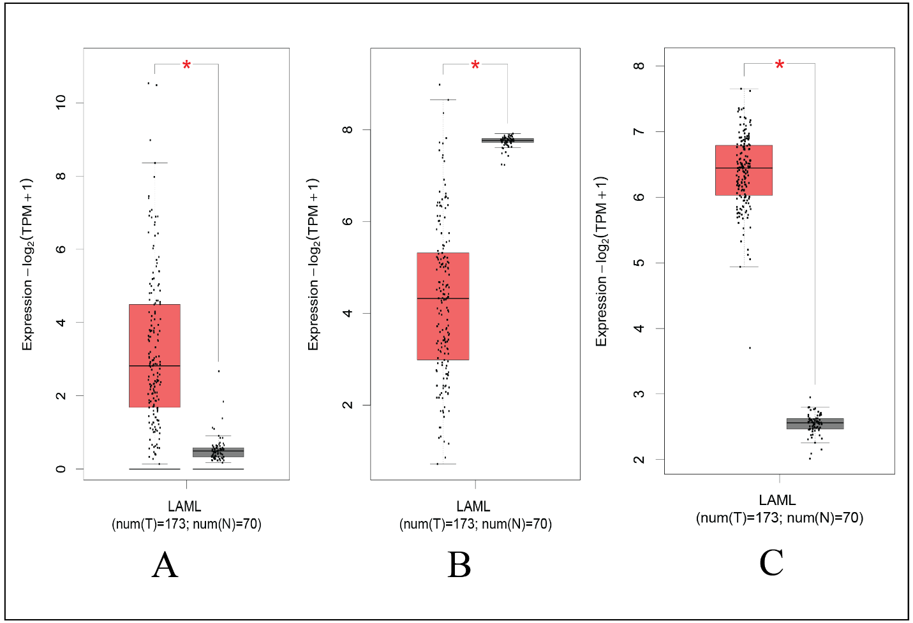
Fig 9: The expression levels of the biomarkers THBS1, DDIT4, and PSMB8 are shown in gray for normal AML samples and red for AML cancer samples.
- Identified Key miRNAs and TFs
To get an understanding of the significant alterations that are taking place at the transcriptional levels, this study created interaction networks between TFs/miRNAs and DEGs. The TFs-DEGs network is shown in Figure 10(A), with emphasis on the important TFs (NFKB1, JUN, HINFP, FOXC1, FOXL1, GATA2, SRF, CREB1, TFAP2A, NFIC). Additionally, Figure 10 (B) highlights the pivotal miRNAs (hsa-mir-16-5p, hsa-mir-129-2-3p, hsa-mir-27a-3p, hsa-mir-155-5p, hsa-mir-1-3p, hsa-mir-374a-5p, hsa-mir-34a-5p, hsa-mir-146a-5p, hsa-mir-124-3p, hsa-mir-7-5p) in contrast to the other interaction.

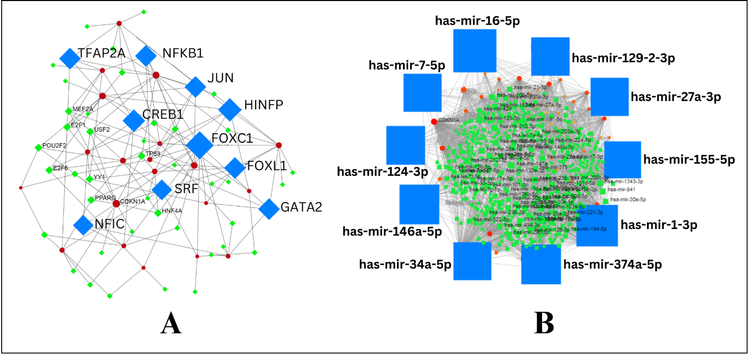
Fig 10: Regulatory Network of Key TFs and miRNAs. (A) Key TFs Are highlighted as Blue Squares (B) Key miRNAs Are Highlighted as Blue Squares Around the Network.
- Validation Results of Key miRNAs and TFs
The identified key TFs and miRNAs are further validated by online database of related studies. Among the 10 TFs, 6 are crosschecked by Cistrome data browser with references. These TFs are: NFKB1, JUN, FOXC1, FOXL1, GATA2, SRF, and CREB1 mentioned in Table 3. Similarly, 8 out of the 10 miRNAs are cross-checked using dbDEMC. The 2 Unconfirmed miRNAs are hsa-mir-129-2-3p and hsa-mir-124-3p. Table 4 is addressing them a dashed line in the center column.
Table 3: Key TFs validation through extensive literature review database.
Label |  | Independent Database | Literature Search
Label | Cistrome Data Browser  - |  | Literature Search
NFKB1 | 1 |  | [58], [59]
JUN | 1 |  | [60]
HINFP | -
FOXC1 | 1 |  | [61]
FOXL1 | -
GATA2 | 1 |  | [62]
SRF | 1 |  | [63]
CREB1 | 1 |  | [64]
TFAP2A | -
NFIC | -

Table 4: Key miRNAs validation through extensive literature review database.
Label | Independent Database | Literature Search
Label | dbDEMC
hsa-mir-16-5p | 1 | [65], [66]
hsa-mir-27a-3p | 1 | [67], [68], [69]
hsa-mir-129-2-3p | -
hsa-mir-155-5p | 1 | [66], [67], [68]
hsa-mir-1-3p | 1 | [48]
hsa-mir-374a-5p | 1 | [67]
hsa-mir-34a-5p | 1 | [70]
hsa-mir-146a-5p | 1 | [70]
hsa-mir-124-3p | -
hsa-mir-7-5p | 1 | [66]

- Repurposing Candidate Drugs Results
Our study yielded six therapeutic candidates that showed statistically significant correlations with the three MDS biomarkers (THBS1, DDIT4, PSMB8): AR−42, BX−912, GSK1070916, Navitoclax, NPK76−II−72−1, CP466722, I−BET−762. The FDR scores and correlation between the medication compounds and the key biomarkers are shown in Figure 8. Based on FDR score and correlation value, biomarker THBS1 is significantly interconnected with all the six candidate drugs than the other two biomarkers.

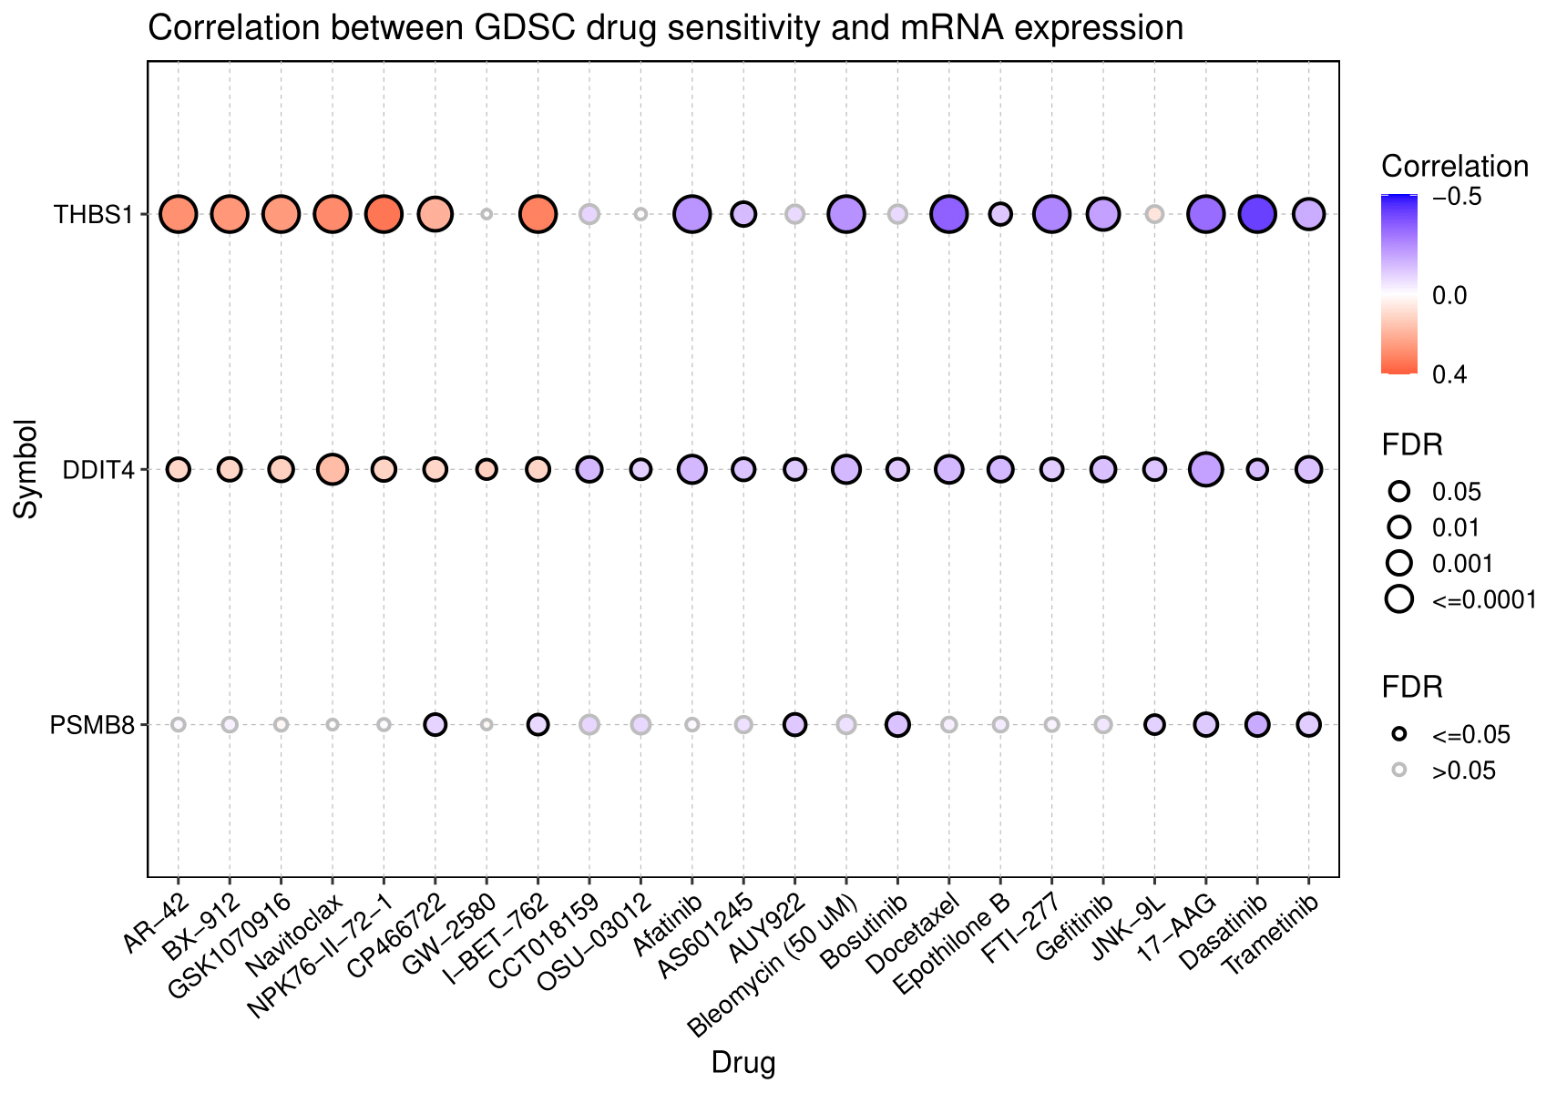
Fig 11: The Correlation of Associated Drug Compounds with Key Biomarkers. The upward and downward correlation is symbolized by the red and blue nodes, respectively. The node size reflects the strength of the correlation.

- ADME Analysis and Toxicity Profiling Results
To further validate the candidate drugs with toxicity profiling, pharmacokinetic and physicochemical properties, we performed ADME analysis and toxicity profiling. Table 5 is representing the results of these analysis. Here, toxicity score is acceptably good since all over 3. Each candidate drug is soluble or moderately soluble except Navitoclax having the highest molecular weight and heavy atoms.

Table 5: Toxicity Profile and Pharmacokinetic Properties of the Candidate Drugs
Molecule | PubChem  CID | Molecular  Weight  (gm/mol) | Heavy atoms | H-bond acceptors | H-bond donors | ESOL Class | Lipinski violations | Toxicity  Score | LD50 (mg/kg)
AR-42 | 6918848 | 312.36 | 23 | 3 | 3 | Soluble | 0 | 4 | 1600
GSK1070916 | 46885626 | 507.63 | 38 | 4 | 2 | Moderately soluble | 1 | 4 | 565
Navitoclax | 24978538 | 974.61 | 65 | 11 | 2 | Insoluble | 3 | 4 | 560
NPK76−II−72−1 | 46843648 | 521.65 | 38 | 6 | 2 | Moderately soluble | 1 | 5 | 3000
CP466722 | 44551660 | 349.35 | 26 | 7 | 1 | Soluble | 0 | 4 | 1000
I−BET−762 | 46943432 | 423.9 | 30 | 5 | 1 | Moderately soluble | 0 | 5 | 2500

- Molecular Docking Results
We carried out a series of molecular docking experiments using the configured ligand structures to further evaluate the potential drugs and investigate the binding affinities associated with the candidate drugs and the key biomarkers. Almost all the six candidate drugs binding affinity with the biomarkers are less than -5.0 and four of them namely AR-42, GSK1070916, CP466722, and NPK76−II−72−1 scored the best. Higher molecular weight and insolubility have made to keep Navitoclax under crucial consideration though it scored the highest binding affinity of -10 with the protein structure 1UX6 of the biomarker THBS1. Second highest binding affinity is scored by NPK76−II−72−1 with 1UX6 followed by CP466722 and GSK1070916. The binding affinity of the protein structures of the biomarker THBS1 with 6 candidate drugs are given in Table 6. Among the 3 biomarkers the protein structures of the THBS1 specially 2ES3 and 1UX6 showed the strongest binding affinity with the ligand structures. The molecular docking images of the biomarker PDB id of 1UX6 with the drug ligands AR-42, GSK1070916 is shown in Figure 12.

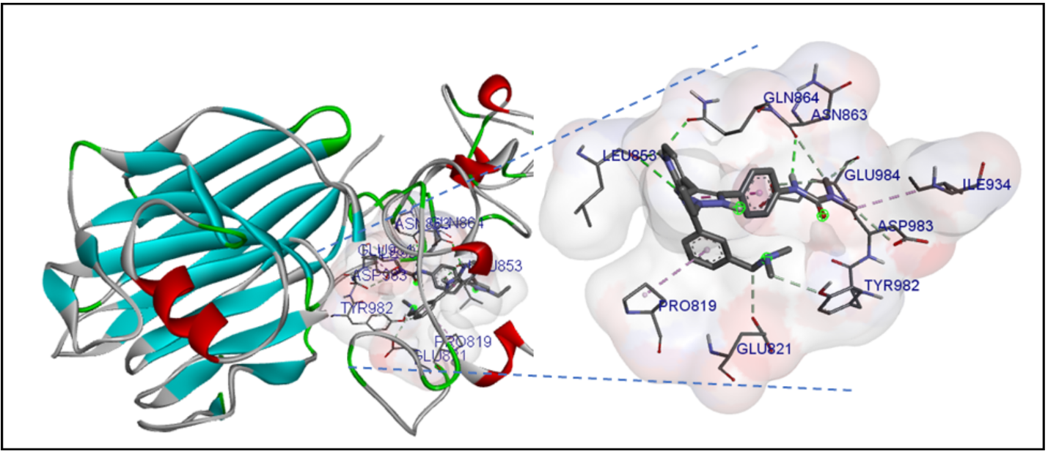
Fig 12: Molecular Docking of Biomarker Protein Structure 1UX6 with Candidate Drug GSK1070916.

Table 6: Binding Affinity Scores of the Molecular Docking Results of Significant Protein Structures with the Candidate Drugs.

Biomarker | PDB ID | Resolution (Å) | Binding Affinity
Biomarker | PDB ID | Resolution (Å) | AR-42 | GSK1070916 | Navitoclax | NPK76−II−72−1 | CP466722 | I−BET−762
THBS1 | 1ZA4 | 1.90 Å | -6.8 | -7.3 | -7.9 | -7.3 | -6.6 | -7
THBS1 | 1Z78 | 1.80 Å | -6.6 | -7.7 | -7.9 | -8 | -7 | -6.6
THBS1 | 2ERF | 1.45 Å | -6.9 | -6.9 | -7.4 | -7.9 | -7.2 | -6.6
THBS1 | 2ES3 | 1.85 Å | -7.6 | -8.5 | -7.9 | -7.9 | -7.7 | -8
THBS1 | 2OUJ | 1.90 Å | -6.5 | -7.5 | -8 | -7.8 | -7.1 | -7.7
THBS1 | 1UX6 | 1.90 Å | -7.6 | -8.5 | -10 | -9.4 | -8.8 | -7.8
THBS1 | 1LSL | 1.90 Å | -5.3 | -6.2 | -7.4 | -6.4 | -6 | -5.5

Discussion

Due to its heterogeneity, MDS is a highly concerning and potentially fatal disease. Personalized therapy and specialized care are required. Enhancing customized and targeted therapy requires the identification of new biomarkers that incorporate heterogeneity and scRNA-seq records. scRNA-seq is a powerful technology for studying gene expression at the individual cell level.
In this work, we performed a bioinformatic exploration of cellular heterogeneity, DEGs, connected biological pathways, PPI networks, hub genes, miRNAs, TFs, and key biomarkers. We integrated RNA-seq data obtained from the case-control pair samples of 3 MDS datasets and single-cell data from 6 distinct clusters of NK cells of peripheral blood samples. We collected the single-cell data from the PBMC dataset and performed clustering based on sample cell types. We only considered the NK cells in this study since the prognosis of MDS patients may be associated with NK cell depletion and dysfunction [71], [72], [73]. The 6 clusters have a total number of 4220 unique gene symbols among which 3338 are up-regulated and 882 are down-regulated. The RNA-seq data was obtained from 3 different datasets (GSE55689, GSE63569, GSE63816) of MDS human samples. The number of datasets utilized in this study is not enough because of limited number of suitable datasets are available. On top of that we followed some certain criteria to select the datasets. We considered only those datasets having at least 10 samples and case-control pairs. After filtering the datasets based on LogFC and FDR-adjusted p-value, we got the most significant DEGs among which 48 were up-regulated and 263 were down-regulated. The DEGs were then compared with the 6 NK cell clusters to get the common DEGs. We identified 54 common DEGs including 8 up-regulated and 46 down-regulated. Based on these common DEGs, we perform our next analysis studies in this research. GO term analysis is performed afterward on the common DEGs. The molecular function GO term of oxysterol binding and ATPase binding was shown to have significant fold enrichment values, however the biological process of fat cell differentiation, T cell receptor signaling pathway, and antigen processing and presentation seemed to be of note. The most important GO keywords are those with the lowest p-value. Fat cell differentiation is listed first among the GO keywords, which are ordered in increasing order according to their individual p-values. Positive regulation of the immune system process, immunological response, immune system process, and regulation of the immune system process are all from BP. It termed out be biological process and molecular function are more likely to MDS related GO terms. The combined pathways (KEGG, WIKI, REACTOME) analysis revealed the top 5 pathways in the study: Graft-versus-host disease, Malaria, miR-517 relationship with ARCN1 and USP1, CLEC7A/inflammasome pathway, and Antigen processing and presentation. Immune System, Generic Transcription Pathway, Adaptive Immune System, and Infectious disease are also notable pathways.
We additionally identified 20 valid hub genes through PPI network analysis in this study. It is believed that these hub genes represent the main molecular processes that underlie CC. THBS1, CDKN1A, NR4A2, IL1B, and PSMB8 are significantly associated with MDS. Considering the findings from survival data, our research designates THBS1, PSMB8, and DDIT4 as MDS biomarkers that may be extremely important and critical targets for MDS diagnosis, prognosis, and treatments. The experiment on 9 healthy and 116 patients discovered that patients with AML had reduced expression of THBS1, which may be caused by promoter methylation and fewer survival times [74]. The importance of overexpression of PSMB8 in AML suggests it could be a favoring molecular target for AML treatment [75]. AML cell growth is stimulated by IL-1b through p38MAPK phosphorylation [76]. DDIT4 plays a crucial role in regulating the proliferation-promotive effect of IL-34 in acute monocytic leukemia(AMoL) cells [77]. It has been demonstrated that NR4A2 and NR4A3 positively control neutrophil survival [78].
Both TFs and miRNAs influence gene expression in the human organism. They thus play important roles in the course and evolution of a disease. From the miRNA-DEGs and TFs-DEGs networks, this study determined the major key TFs and miRNAs. It has previously been demonstrated in the form of crosschecking through data browsers that MDS is associated with NFKB1, JUN, FOXC1, GATA2, SRF, and CREB1 TFs. The expression of key genes involved in the leukemic process was considerably affected by NF-kB suppression [79]. About 20% of initial AML samples were identified as having overexpressed FOXC1, which has been linked to the blockade of monocyte/macrophage differentiation [80]. GATA2, a zinc finger transcription factor, controls the development and function of hematopoietic stem and progenitor cells. Mutations in GATA2 cause myelodysplastic neoplasm and AML [81]. According to many studies, most bone marrow samples from individuals with acute myeloid and lymphoid leukemia show upregulation of CREB [82]. hsa-mir-16-5p, hsa-mir-27a-3p, and hsa-mir-155-5p mi RNAs are mostly connected with MDS and validated by more than one experimental data. Five promising miRNAs including hsa-mir-16-5p were tested in 224 CLL cases employing an embedded case-control study [83].
Our study tailored the medication repurposing technique and found six drug candidates to investigate better treatments for MDS. Subsequently, a thorough molecular docking investigation identified Navitoclax showed strongest binding with THBS1 (1UX6). GSK1070916 and NPK76−II−72−1 had significant binding affinities and were also very effective candidates. But further ADME Analysis and toxicity Profiling reveals that Navitoclax has some limitations of higher molecular weight, Lipinski violations, insolubility, and lower LD50 value. Other candidates passed these checkpoints well. However, the molecular weight of GSK1070916 and NPK76−II−72−1 is a little higher than considered standard value of less than 500 gm/mol. Having toxicity score of 5 and LD50 value of 3000 mg/kg makes NPK76−II−72−1 a great fit but its single Lipinski violation is questionable. The same allegations are not applicable to CP466722 and I−BET−762 but the average binding affinity scores have made them reconsiderable. With an IC50 of 3.5nM/6.5nM, GSK1070916 is an ATP-competitive, reversible inhibitor of Aurora B/C. The control of mitosis depends heavily on the Aurora kinases, which are often overexpressed in human malignancies. For the treatment of malignancies with Aurora kinase amplification, selective inhibitors may offer a novel therapeutic option [84]. Replication and the cell cycle are concentrated in the modules of drugs that target mitosis. More specifically, NPK76-II-72-1, which has the highest coverage of genes connected to Myc, has an excess of genes associated with the Myc transcription factor [85]. This process is crucial for cell proliferation and growth. However, cancer cells often have dysregulated mitotic machinery, leading to uncontrolled cell division and tumor formation. The candidate drugs identified through computational methods need experimentally validated, Preclinical Development, and Investigational New Drug (IND) application to confirm their efficacy and safety.
Our work, therefore, helped to understand the underlying molecular processes of MDS, identifying common DEGs, related pathways, enriched GO terms, key biomarkers, miRNAs, TFs, and suggested potential candidate drugs by performing molecular docking and toxicity analysis following the bioinformatics, transcriptomics, and cheminformatics strategy. But there are some limitations in our study since we it lacks of in vivo and in vitro test data. The data used in this study is a combination of single-cell and RNA-sequence data from two different data sources but of the related subject. Single-cell RNA sequencing (scRNA-seq) offers powerful insights into cellular heterogeneity but noise, dropout events, and amplification biases can affect data quality. Besides high costs and complex bioinformatics analyses pose barriers to widespread adoption. Standardization and advancements in computational methods are needed to address these challenges and unlock scRNA-seq's full potential in unraveling biological complexity. We first identified the common DEGs across MDS which has limitations due to tumor heterogeneity, differing genetic backgrounds, and varied responses to treatment. Integration of multi-omics data and robust statistical methods are essential to overcome these challenges and enhance the discovery of actionable DEGs for personalized cancer treatment strategies. Therefore, we integrated six different clusters of NK cells data compared with three MDS related RNA-seq data after filtering with certain criteria’s. The higher the number of datasets the high chance of accurate results. Additionally, hub gene identification relies on data from specific experimental conditions, which may not fully capture the dynamic nature of cancer progression. Integration of diverse datasets and validation in clinical cohorts are necessary to address these limitations and enhance the understanding of hub genes' roles in cancer biology. Hub gene identification helps unravel key molecular players and pathways driving cancer progression and aiding in understanding disease mechanisms. Common DEGs analysis allows for the identification of shared molecular signatures across cancer subtypes, providing insights into common pathways dysregulated in cancer and facilitating the development of targeted therapies. We also identified potential drug candidates through computer-aided drug design (CADD) procedures. CADD methods rely on computational algorithms to predict molecular interactions and properties. While these predictions can be highly accurate, they are not infallible. Biological systems are highly complex, and many factors influence drug-target interactions, including protein flexibility, solvent effects, and ligand conformational changes. CADD methods often simplify these complexities, which can lead to inaccuracies in predictions. The approaches primarily focus on interactions between drugs and their intended targets. However, drugs often interact with multiple biological targets, leading to off-target effects that can cause adverse reactions or unintended therapeutic outcomes. So, computational predictions require experimental validation to confirm their accuracy and relevance. Though this study has some limitations like any other scientific research, it has enhanced our understanding of MDS progression, disease mechanisms, and identification of potential therapeutic targets.

Conclusion

The intended goal of this work was to get an integrative understanding of the molecular underpinnings of MDS using bioinformatics methods. We extract 54 common DEGs across 3 MDS datasets and 6 clusters of single-cell data. Additionally, functional annotations, significant pathways, and PPI networks stated the MDS progression. Subsequently, the survival analysis of the 20 discovered hub genes from PPI analysis led us to identify the 3 key biomarkers including THBS1, PSMB8, and DDIT4. Targeting these biomarkers with GSK1070916 and NPK76−II−72−1 appeared to be safe and efficacious, according to the results of cheminformatics investigations. Fat cell differentiation and Positive regulation of the immune system process are the most significant GO terms during Antigen processing and presentation. Immune System, Generic Transcription Pathway, Adaptive Immune System, and Infectious disease are crucial related pathways. Multiple TFs as well as miRNAs were also identified in this investigation along with molecular docking. The findings and followed methodology of this study will guide therapeutic targeting, gene therapy, patient-centered treatment, customized genomic medicine, pathway selection, and cancer risk reduction. Peripheral blood scRNA-seq data provide additional insight into the pathophysiology of MDS and enabled the identification of unique cell types. From the perspective of cluster analysis, we deduce that MDS exhibits heterogeneity in several dimensions. However, there are some limitations since the scRNA-seq technology is still evolving, and there can be technical variability in data quality between different platforms and protocols. It could also be expensive especially when dealing with variant cells. Therefore, locating a suitable dataset with a larger sample size is difficult. Again, the ability to detect both highly expressed and lowly expressed genes in the same cell can be limited. Besides molecular docking often relies on simplified binding models, assuming rigid structures for both ligands and receptors. This may not accurately represent the dynamic nature of molecular interactions in biological systems. Hence, further studies on MDS prognosis, diagnosis, and therapeutics should be performed. To validate the results, more in vivo and in vitro medical and biochemical studies are recommended.
Data availability statement
Data included in articles will be provided upon the author's request.
Declaration of conflict of interest
We wish to confirm that there has been no financial support for this study that could have influenced our outcome and also, there are no known conflicts of interest with all authors.
Additional information
No additional information is available for this paper.
Authorship contribution statement
Saidul Islam Nayan: Methodology, Software, Validation, Writing - Original Draft. Md. Arju Hossain: Software, Data curation, Writing, Validation, Writing - Original Draft. Md Shofiqul Islam: Data curation, Writing - Original Draft. Siddique Akber Ansari: Writing - Review & Editing. Md Habibur Rahman: Conceptualization, Methodology, Software, Validation, Writing - reviewing & editing, and Supervision.
Acknowledgments
Researchers Supporting Project number (RSPD2024R744), King Saud University, Riyadh, Saudi Arabia

References

[1] L. Adès, R. Itzykson, and P. Fenaux, “Myelodysplastic syndromes,” The Lancet, vol. 383, no. 9936, pp. 2239–2252, 2014.
[2] S. D. Nimer, “Myelodysplastic syndromes,” Blood J. Am. Soc. Hematol., vol. 111, no. 10, pp. 4841–4851, 2008.
[3] E. Estey, R. P. Hasserjian, and H. Döhner, “Distinguishing AML from MDS: a fixed blast percentage may no longer be optimal,” Blood J. Am. Soc. Hematol., vol. 139, no. 3, pp. 323–332, 2022.
[4] J. L. Dotson and Y. Lebowicz, “Myelodysplastic Syndrome,” in StatPearls, Treasure Island (FL): StatPearls Publishing, 2023. Accessed: Nov. 26, 2023. [Online]. Available: http://www.ncbi.nlm.nih.gov/books/NBK534126/
[5] PDQ Adult Treatment Editorial Board, “Myelodysplastic Syndromes Treatment (PDQ®): Health Professional Version,” in PDQ Cancer Information Summaries, Bethesda (MD): National Cancer Institute (US), 2002. Accessed: Nov. 26, 2023. [Online]. Available: http://www.ncbi.nlm.nih.gov/books/NBK66015/
[6] N. Gattermann and E. A. Rachmilewitz, “Iron overload in MDS—pathophysiology, diagnosis, and complications,” Ann. Hematol., vol. 90, pp. 1–10, 2011.
[7] T. I. Kozarezova and N. V. Borisevich, “Myelodisplastic syndrome and aplastic anemia epidemiological analysis among children of the Republic of Belarus in the post-Chernobyl period,” 1998, Accessed: Nov. 26, 2023. [Online]. Available: https://www.osti.gov/etdeweb/servlets/purl/20050035
[8] N. Gangat, M. M. Patnaik, and A. Tefferi, “Myelodysplastic syndromes: Contemporary review and how we treat,” Am. J. Hematol., vol. 91, no. 1, pp. 76–89, 2016, doi: 10.1002/ajh.24253.
[9] Z. D. Epstein-Peterson, B. Spitzer, J. McCarter, E. McGovern, R. L. Levine, and M. S. Tallman, “De novo myelodysplastic syndromes in patients 20-50 years old characterized by frequent mutations in TP53 and transcription-related genes,” Blood, vol. 134, p. 2708, 2019.
[10] “Implications of TP53 allelic state for genome stability, clinical presentation and outcomes in myelodysplastic syndromes | Nature Medicine.” Accessed: Nov. 26, 2023. [Online]. Available: https://www.nature.com/articles/s41591-020-1008-z
[11] D. A. Pollyea et al., “Myelodysplastic syndrome-associated spliceosome gene mutations enhance innate immune signaling,” Haematologica, vol. 104, no. 9, pp. e388–e392, Sep. 2019, doi: 10.3324/haematol.2018.214155.
[12] “Old Dogs, New Tricks: Revisiting Immune Modulatory Approache... : HemaSphere.” Accessed: Nov. 26, 2023. [Online]. Available: https://journals.lww.com/hemasphere/fulltext/2018/12000/old_dogs,_new_tricks__revisiting_immune_modulatory.4.aspx
[13] X. Zhang and H. L. Grimes, “Why Single-Cell Sequencing Has Promise in MDS,” Front. Oncol., vol. 11, 2021, Accessed: Nov. 26, 2023. [Online]. Available: https://www.frontiersin.org/articles/10.3389/fonc.2021.769753
[14] D. Huang et al., “Advances in single-cell RNA sequencing and its applications in cancer research,” J. Hematol. Oncol.J Hematol Oncol, vol. 16, no. 1, p. 98, Aug. 2023, doi: 10.1186/s13045-023-01494-6.
[15] X. Li and C.-Y. Wang, “From bulk, single-cell to spatial RNA sequencing,” Int. J. Oral Sci., vol. 13, no. 1, Art. no. 1, Nov. 2021, doi: 10.1038/s41368-021-00146-0.
[16] Y. Zhang et al., “Single‐cell RNA sequencing in cancer research,” J. Exp. Clin. Cancer Res., vol. 40, no. 1, p. 81, Mar. 2021, doi: 10.1186/s13046-021-01874-1.
[17] P. Upadhyay et al., “Recurrent transcriptional responses in AML and MDS patients treated with decitabine,” Exp. Hematol., vol. 111, pp. 50–65, Jul. 2022, doi: 10.1016/j.exphem.2022.04.002.
[18] E. R. Malone, M. Oliva, P. J. B. Sabatini, T. L. Stockley, and L. L. Siu, “Molecular profiling for precision cancer therapies,” Genome Med., vol. 12, no. 1, p. 8, Jan. 2020, doi: 10.1186/s13073-019-0703-1.
[19] M. Cirillo, A. F. M. Craig, S. Borchmann, and D. M. Kurtz, “Liquid biopsy in lymphoma: Molecular methods and clinical applications,” Cancer Treat. Rev., vol. 91, p. 102106, Dec. 2020, doi: 10.1016/j.ctrv.2020.102106.
[20] “In Silico Methods | SpringerLink.” Accessed: Nov. 26, 2023. [Online]. Available: https://link.springer.com/referenceworkentry/10.1007/978-3-642-25240-2_55
[21] A. Butler, P. Hoffman, P. Smibert, E. Papalexi, and R. Satija, “Integrating single-cell transcriptomic data across different conditions, technologies, and species,” Nat. Biotechnol., vol. 36, no. 5, Art. no. 5, May 2018, doi: 10.1038/nbt.4096.
[22] J. Ding et al., “Systematic comparative analysis of single cell RNA-sequencing methods.” bioRxiv, p. 632216, May 09, 2019. doi: 10.1101/632216.
[23] S. Seth, S. Mallik, T. Bhadra, and Z. Zhao, “Dimensionality Reduction and Louvain Agglomerative Hierarchical Clustering for Cluster-Specified Frequent Biomarker Discovery in Single-Cell Sequencing Data,” Front. Genet., vol. 13, 2022, Accessed: Nov. 29, 2023. [Online]. Available: https://www.frontiersin.org/articles/10.3389/fgene.2022.828479
[24] A. Maćkiewicz and W. Ratajczak, “Principal components analysis (PCA),” Comput. Geosci., vol. 19, no. 3, pp. 303–342, Mar. 1993, doi: 10.1016/0098-3004(93)90090-R.
[25] N. A. Mahi, M. F. Najafabadi, M. Pilarczyk, M. Kouril, and M. Medvedovic, “GREIN: An Interactive Web Platform for Re-analyzing GEO RNA-seq Data,” Sci. Rep., vol. 9, no. 1, Art. no. 1, May 2019, doi: 10.1038/s41598-019-43935-8.
[26] M. Jafari and N. Ansari-Pour, “Why, When and How to Adjust Your P Values?,” Cell J. Yakhteh, vol. 20, no. 4, pp. 604–607, 2019, doi: 10.22074/cellj.2019.5992.
[27] P. S. Woll et al., “Myelodysplastic syndromes are propagated by rare and distinct human cancer stem cells in vivo,” Cancer Cell, vol. 25, no. 6, pp. 794–808, Jun. 2014, doi: 10.1016/j.ccr.2014.03.036.
[28] H. Dolatshad et al., “Disruption of SF3B1 results in deregulated expression and splicing of key genes and pathways in myelodysplastic syndrome hematopoietic stem and progenitor cells,” Leukemia, vol. 29, no. 5, pp. 1092–1103, May 2015, doi: 10.1038/leu.2014.331.
[29] V. Madan et al., “Aberrant splicing of U12-type introns is the hallmark of ZRSR2 mutant myelodysplastic syndrome,” Nat. Commun., vol. 6, p. 6042, Jan. 2015, doi: 10.1038/ncomms7042.
[30] M. C. Cieslak, A. M. Castelfranco, V. Roncalli, P. H. Lenz, and D. K. Hartline, “t-Distributed Stochastic Neighbor Embedding (t-SNE): A tool for eco-physiological transcriptomic analysis,” Mar. Genomics, vol. 51, p. 100723, Jun. 2020, doi: 10.1016/j.margen.2019.100723.
[31] V. D. Blondel, J.-L. Guillaume, R. Lambiotte, and E. Lefebvre, “Fast unfolding of communities in large networks,” J. Stat. Mech. Theory Exp., vol. 2008, no. 10, p. P10008, Oct. 2008, doi: 10.1088/1742-5468/2008/10/P10008.
[32] P. K. Epling-Burnette et al., “Reduced natural killer (NK) function associated with high-risk myelodysplastic syndrome (MDS) and reduced expression of activating NK receptors,” Blood J. Am. Soc. Hematol., vol. 109, no. 11, pp. 4816–4824, 2007.
[33] O. J. C, “VENNY. An interactive tool for comparing lists with Venn diagrams,” http://bioinfogp.cnb.csic.es/tools/venny/index.html, 2007, Accessed: Nov. 29, 2023. [Online]. Available: https://cir.nii.ac.jp/crid/1571698599214673920
[34] D. W. Huang et al., “DAVID Bioinformatics Resources: expanded annotation database and novel algorithms to better extract biology from large gene lists,” Nucleic Acids Res., vol. 35, no. suppl_2, pp. W169–W175, Jul. 2007, doi: 10.1093/nar/gkm415.
[35] L. du Plessis, N. Škunca, and C. Dessimoz, “The what, where, how and why of gene ontology—a primer for bioinformaticians,” Brief. Bioinform., vol. 12, no. 6, pp. 723–735, Nov. 2011, doi: 10.1093/bib/bbr002.
[36] “Pathway enrichment analysis and visualization of omics data using g:Profiler, GSEA, Cytoscape and EnrichmentMap | Nature Protocols.” Accessed: Nov. 29, 2023. [Online]. Available: https://www.nature.com/articles/s41596-018-0103-9
[37] “KEGG as a reference resource for gene and protein annotation | Nucleic Acids Research | Oxford Academic.” Accessed: Nov. 29, 2023. [Online]. Available: https://academic.oup.com/nar/article/44/D1/D457/2502600
[38] “WikiPathways: a multifaceted pathway database bridging metabolomics to other omics research | Nucleic Acids Research | Oxford Academic.” Accessed: Nov. 29, 2023. [Online]. Available: https://academic.oup.com/nar/article/46/D1/D661/4612963
[39] A. Fabregat et al., “The Reactome Pathway Knowledgebase,” Nucleic Acids Res., vol. 46, no. D1, pp. D649–D655, Jan. 2018, doi: 10.1093/nar/gkx1132.
[40] D. Szklarczyk et al., “STRING v11: protein–protein association networks with increased coverage, supporting functional discovery in genome-wide experimental datasets,” Nucleic Acids Res., vol. 47, no. D1, pp. D607–D613, Jan. 2019, doi: 10.1093/nar/gky1131.
[41] P. Shannon et al., “Cytoscape: A Software Environment for Integrated Models of Biomolecular Interaction Networks,” Genome Res., vol. 13, no. 11, pp. 2498–2504, Nov. 2003, doi: 10.1101/gr.1239303.
[42] C.-H. Chin, S.-H. Chen, H.-H. Wu, C.-W. Ho, M.-T. Ko, and C.-Y. Lin, “cytoHubba: identifying hub objects and sub-networks from complex interactome,” BMC Syst. Biol., vol. 8, no. S4, p. S11, Dec. 2014, doi: 10.1186/1752-0509-8-S4-S11.
[43] D. S. Latchman, “Transcription factors: an overview,” Int. J. Biochem. Cell Biol., vol. 29, no. 12, pp. 1305–1312, 1997.
[44] G. Zhou, O. Soufan, J. Ewald, R. E. Hancock, N. Basu, and J. Xia, “NetworkAnalyst 3.0: a visual analytics platform for comprehensive gene expression profiling and meta-analysis,” Nucleic Acids Res., vol. 47, no. W1, pp. W234–W241, 2019.
[45] J. A. Castro-Mondragon et al., “JASPAR 2022: the 9th release of the open-access database of transcription factor binding profiles,” Nucleic Acids Res., vol. 50, no. D1, pp. D165–D173, 2022.
[46] G. Skoufos et al., “TarBase-v9. 0 extends experimentally supported miRNA–gene interactions to cell-types and virally encoded miRNAs,” Nucleic Acids Res., vol. 52, no. D1, pp. D304–D310, 2024.
[47] R. Zheng et al., “Cistrome Data Browser: expanded datasets and new tools for gene regulatory analysis,” Nucleic Acids Res., vol. 47, no. D1, pp. D729–D735, 2019.
[48] “dbDEMC.” Accessed: Jan. 05, 2024. [Online]. Available: https://www.biosino.org/dbDEMC/experiment/detail/EXP00631
[49] C.-J. Liu et al., “GSCA: an integrated platform for gene set cancer analysis at genomic, pharmacogenomic and immunogenomic levels,” Brief. Bioinform., vol. 24, no. 1, p. bbac558, 2023.
[50] H. E. Selick, A. P. Beresford, and M. H. Tarbit, “The emerging importance of predictive ADME simulation in drug discovery,” Drug Discov. Today, vol. 7, no. 2, pp. 109–116, 2002.
[51] R. Gupta, S. Polaka, K. Rajpoot, M. Tekade, M. C. Sharma, and R. K. Tekade, “Importance of toxicity testing in drug discovery and research,” in Pharmacokinetics and toxicokinetic considerations, Elsevier, 2022, pp. 117–144. Accessed: Mar. 01, 2024. [Online]. Available: https://www.sciencedirect.com/science/article/pii/B9780323983679000160
[52] A. Daina, O. Michielin, and V. Zoete, “SwissADME: a free web tool to evaluate pharmacokinetics, drug-likeness and medicinal chemistry friendliness of small molecules,” Sci. Rep., vol. 7, no. 1, p. 42717, 2017.
[53] P. Banerjee, A. O. Eckert, A. K. Schrey, and R. Preissner, “ProTox-II: a webserver for the prediction of toxicity of chemicals,” Nucleic Acids Res., vol. 46, no. W1, pp. W257–W263, 2018.
[54] G. M. Morris and M. Lim-Wilby, “Molecular Docking,” in Molecular Modeling of Proteins, vol. 443, A. Kukol, Ed., in Methods in Molecular Biology, vol. 443. , Totowa, NJ: Humana Press, 2008, pp. 365–382. doi: 10.1007/978-1-59745-177-2_19.
[55] B. L. Jejurikar and S. H. Rohane, “Drug designing in discovery studio,” 2021, Accessed: Mar. 02, 2024. [Online]. Available: https://www.indianjournals.com/ijor.aspx?target=ijor:ajrc&volume=14&issue=2&article=008
[56] S. Dallakyan and A. J. Olson, “Small-Molecule Library Screening by Docking with PyRx,” in Chemical Biology, vol. 1263, J. E. Hempel, C. H. Williams, and C. C. Hong, Eds., in Methods in Molecular Biology, vol. 1263. , New York, NY: Springer New York, 2015, pp. 243–250. doi: 10.1007/978-1-4939-2269-7_19.
[57] M. Pathan et al., “FunRich: An open access standalone functional enrichment and interaction network analysis tool,” PROTEOMICS, vol. 15, no. 15, pp. 2597–2601, Aug. 2015, doi: 10.1002/pmic.201400515.
[58] D. Calderon et al., “Landscape of stimulation-responsive chromatin across diverse human immune cells,” Nat. Genet., vol. 51, no. 10, pp. 1494–1505, 2019.
[59] “GEO Accession viewer.” Accessed: Jan. 14, 2024. [Online]. Available: https://www.ncbi.nlm.nih.gov/geo/query/acc.cgi?acc=GSM486316
[60] “GEO Accession viewer.” Accessed: Jan. 14, 2024. [Online]. Available: https://www.ncbi.nlm.nih.gov/geo/query/acc.cgi?acc=GSM2945834
[61] F. A. Elian, E. Yan, and M. A. Walter, “FOXC1, the new player in the cancer sandbox,” Oncotarget, vol. 9, no. 8, pp. 8165–8178, Nov. 2017, doi: 10.18632/oncotarget.22742.
[62] J. R. Shearstone et al., “Chemical inhibition of histone deacetylases 1 and 2 induces fetal hemoglobin through activation of GATA2,” PloS One, vol. 11, no. 4, p. e0153767, 2016.
[63] J. Gertz et al., “Distinct properties of cell-type-specific and shared transcription factor binding sites,” Mol. Cell, vol. 52, no. 1, pp. 25–36, 2013.
[64] G. L. Boulting et al., “Activity-dependent regulome of human GABAergic neurons reveals new patterns of gene regulation and neurological disease heritability,” Nat. Neurosci., vol. 24, no. 3, pp. 437–448, 2021.
[65] J. Lu et al., “MicroRNA expression profiles classify human cancers,” Nature, vol. 435, no. 7043, pp. 834–838, Jun. 2005, doi: 10.1038/nature03702.
[66] L. He et al., “A microRNA polycistron as a potential human oncogene,” Nature, vol. 435, no. 7043, pp. 828–833, Jun. 2005, doi: 10.1038/nature03552.
[67] M. Yamagishi et al., “Polycomb-mediated loss of miR-31 activates NIK-dependent NF-κB pathway in adult T cell leukemia and other cancers,” Cancer Cell, vol. 21, no. 1, pp. 121–135, Jan. 2012, doi: 10.1016/j.ccr.2011.12.015.
[68] Y. S. Tan, M. Kim, T. J. Kingsbury, C. I. Civin, and W.-C. Cheng, “Regulation of RAB5C is important for the growth inhibitory effects of MiR-509 in human precursor-B acute lymphoblastic leukemia,” PloS One, vol. 9, no. 11, p. e111777, 2014, doi: 10.1371/journal.pone.0111777.
[69] “E-MTAB-1454 - MicroRNA profiling by array of 217 cases of chronic lymphocytic leukemia (CLL) comparing CLL-affected B-cells against normal B-cells isolated from CLL patients - OmicsDI.” Accessed: Jan. 04, 2024. [Online]. Available: https://www.omicsdi.org/dataset/arrayexpress-repository/E-MTAB-1454
[70] “dbDEMC.” Accessed: Jan. 05, 2024. [Online]. Available: https://www.biosino.org/dbDEMC/experiment/detail/EXP00565
[71] Z. Liu et al., “Bone marrow mesenchymal stem cells regulate the dysfunction of NK cells via the T cell immunoglobulin and ITIM domain in patients with myelodysplastic syndromes,” Cell Commun. Signal., vol. 20, no. 1, p. 169, Oct. 2022, doi: 10.1186/s12964-022-00985-2.
[72] H. Arellano-Ballestero, M. Sabry, and M. W. Lowdell, “A Killer Disarmed: Natural Killer Cell Impairment in Myelodysplastic Syndrome,” Cells, vol. 12, no. 4, p. 633, Feb. 2023, doi: 10.3390/cells12040633.
[73] V. A. Cianga et al., “Natural Killer Cell Subpopulations and Inhibitory Receptor Dynamics in Myelodysplastic Syndromes and Acute Myeloid Leukemia,” Front. Immunol., vol. 12, 2021, Accessed: Jan. 03, 2024. [Online]. Available: https://www.frontiersin.org/articles/10.3389/fimmu.2021.665541
[74] “THBS1 Is a Novel Serum Prognostic Factors of Acute Myeloid Leukemia - PubMed.” Accessed: Mar. 05, 2024. [Online]. Available: https://pubmed.ncbi.nlm.nih.gov/32117788/
[75] Y. Zhang, S. Xue, Q. Hao, F. Liu, W. Huang, and J. Wang, “Galectin-9 and PSMB8 overexpression predict unfavorable prognosis in patients with AML,” J. Cancer, vol. 12, no. 14, p. 4257, 2021.
[76] A. Carey et al., “Identification of interleukin-1 by functional screening as a key mediator of cellular expansion and disease progression in acute myeloid leukemia,” Cell Rep., vol. 18, no. 13, pp. 3204–3218, 2017.
[77] X. Lv et al., “DDIT4 mediates the proliferation-promotive effect of IL-34 in human monocytic leukemia cells,” Blood Sci., vol. 3, no. 2, pp. 48–56, Apr. 2021, doi: 10.1097/BS9.0000000000000069.
[78] S. E. Mullican et al., “Abrogation of nuclear receptors Nr4a3 andNr4a1 leads to development of acute myeloid leukemia,” Nat. Med., vol. 13, no. 6, pp. 730–735, 2007.
[79] H. Reikvam, “Inhibition of NF-κB signaling alters acute myelogenous leukemia cell transcriptomics,” Cells, vol. 9, no. 7, p. 1677, 2020.
[80] E. Fabiani et al., “The forkhead box C1 (FOXC1) transcription factor is downregulated in acute promyelocytic leukemia,” Oncotarget, vol. 8, no. 48, p. 84074, 2017.
[81] D. J. Robbins et al., “Linking GATA2 to myeloid dysplasia and complex cytogenetics in adult myelodysplastic neoplasm and acute myeloid leukemia,” Blood Adv., vol. 8, no. 1, pp. 80–92, 2024.
[82] E.-C. Cho, B. Mitton, and K. Sakamoto, “CREB and leukemogenesis,” Crit. Rev. Oncog., vol. 16, no. 1–2, 2011, Accessed: Mar. 05, 2024. [Online]. Available: https://www.dl.begellhouse.com/journals/439f422d0783386a,049e8a5e62fb019e,03cfd5880124c82c.html
[83] D. Casabonne et al., “Serum levels of hsa‐miR‐16‐5p , hsa‐miR‐29a‐3p , hsa‐miR‐150‐5p , hsa‐miR‐155‐5p and hsa‐miR ‐ 223‐3p and subsequent risk of chronic lymphocytic leukemia in the EPIC study,” Int. J. Cancer, vol. 147, no. 5, pp. 1315–1324, Sep. 2020, doi: 10.1002/ijc.32894.
[84] N. D. Adams et al., “Discovery of GSK1070916, a Potent and Selective Inhibitor of Aurora B/C Kinase,” J. Med. Chem., vol. 53, no. 10, pp. 3973–4001, May 2010, doi: 10.1021/jm901870q.
[85] A. Fernández-Torras, M. Duran-Frigola, and P. Aloy, “Encircling the regions of the pharmacogenomic landscape that determine drug response,” Genome Med., vol. 11, no. 1, p. 17, Mar. 2019, doi: 10.1186/s13073-019-0626-x.

